  - 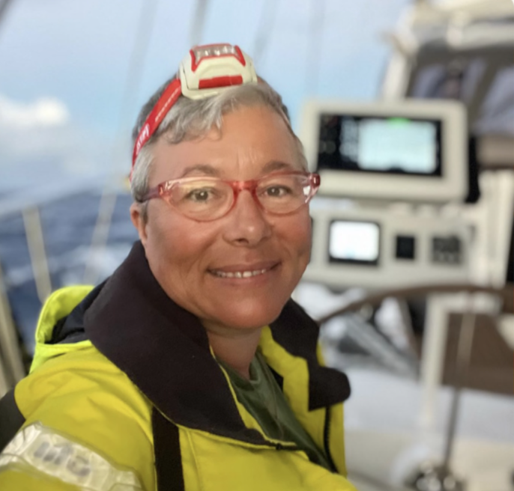Karima Cherif Sailor & Ocean Conservationist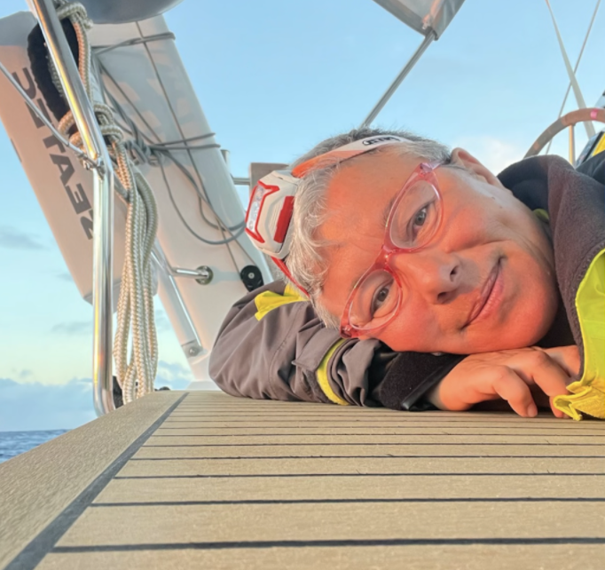
I have been sailing for 29 years, including 23 as the owner of a 1971 Islander Bahamas 30’ on San Francisco Bay. Over 9,500 nautical miles and more than 200 days at sea have taken me from coastal cruising to two ocean crossings—Oahu to Port Angeles and Lanzarote to Guadeloupe. I hold American Sailing certifications (101, 103, 104, 114), completed Offshore Training with 59° North in Portugal, and am working toward my USGS 6-Pack Captain’s License.
Sailing has given me unforgettable experiences, from rafting up with the Washed-Up Yacht Club in San Francisco Bay to sailing the Sacramento Delta for Ephemerisle. Now based in Vero Beach, Florida, I volunteer as a sailing instructor with Adaptive YSF and continue exploring the Caribbean.
My career centers on ocean conservation, fighting illegal fishing, and promoting zero-carbon technology for sustainable marine enforcement. I aim to partner with coastal communities to design green monitoring systems that protect marine ecosystems and food security.
Sailing Experience Summary
Category | Details
Years of Sailing Experience | 29 years
Total Sea Miles | 9,528 nm
US Sailing & ASA Certifications | ASA 101 (Basic Keelboat), ASA 103 (Basic Coastal Cruising), ASA 104 (Bareboat Cruising), ASA 114 (Cruising Catamaran)
Current Role Feb 2023 – Present | Volunteer Sailing Instructor – Adaptive Program, Vero Beach YSF Community Sailing Club (Indian River Lagoon, FL)
Atlantic Crossing – Lanzarote to Guadeloupe Nov-Dec 2024  Circumnavigation of Florida St. Pierce to Tampa June 2025 | 25 days at sea, 3,174 nm  2 days
59° North Offshore Training – Lagos, Portugal Nov 2023 | 7 days at sea, 450 nm aboard Bruce Farr 65’, 11 crew ( Nov 11–18, 2023)
St. Vincent & the Grenadines Oct 2023 | 5 days, 100 nm aboard Lagoon 39, 5 crew (Oct 21–27, 2023)
Pacific Ocean Crossing | 15 days, 2,303 nm – Oahu, HI to Port Angeles, WA, 5 crew  (May 29–Jun 13, 2014)
Mexico Expedition | 1,980 nm – Sausalito to Magdalena Bay, Mexico (2003–2007)
San Francisco Bay Rolex Big Boat Series 2022 | 5 days, 208 nm racing aboard Wahine, Express 36’ 6 crew (2022)
San Francisco Bay Experience | Modern Sailing Academy – 150 hrs / ~400 nm; Red Bra Regatta (2014–2017)
Catalina Island Sailing | 2.5 months of weekend passages, 276 nm (1994)
Cape Breton Deliveries Ingonish to North Sydney, Nova Scotia C&C 31’ and C&C 42’ Sept 2024 | 2 days 33 nm each day 7 hrs each and Deep Cove to Chester, NS with Bogus Szemioth
Tow Operations Experience Boston Whaler  Ballena Bay to Mandeville Island SF to Sacremento Delta 98 nm 7 days | Crew for SeaTow under Erik Christiansen (2 years, emergency & scheduled tow services)
Islander Bahama 30’ (1971) | 350 skipper days (1999–2022)
Roberts 45’ Custom | 16 days (Oahu–Port Angeles, 2014)
Beneteau 40’  Halberg Rassy 36’ 2018  Hirishoff 36” 2017 | 120 days (Sausalito–Mexico, 2003–2007)
Alberg 36’ | 3 days (San Francisco–Point Reyes via Farallones, 2015)
Farr 65’ | 7 days (Portugal, 2023)
Marine 4 / Hobie Cat Getaway / Wave / Boston Whale / Pontoon boat | Instructor vessel (Vero Beach, 2024)

