

April 2025
In our Ash Wednesday morning devotion, we read what Martin Luther, in his Smalcald Articles (a sort of last will and testament) stated:
This is what true repentance means. Here a person needs to hear something like this, “You are all of no account, whether you are obvious sinners or saints in your own opinions. You have to become different from what you are now. You have to act differently than you are now acting, whether you are as great, wise, powerful, and holy as you can be. Here no one is godly.”
But to this office of the Law, the New Testament immediately adds the consoling promise of grace through the Gospel. This must be believed. As Christ declares, “Repent and believe in the gospel” (Mark 1:15). That is, become different, act differently, and believe My promise. John the Baptist (preceding Christ) is called a preacher of repentance, but this is for the forgiveness of sins. That is, John was to accuse all and convict them of being sinners. This is so they can know what they are before God and acknowledge that they are lost. So they can be prepared for the Lord [Mark 1:3] to receive grace and to expect and accept from Him the forgiveness of sins. This is what Christ Himself says, “Repentance and forgiveness of sins should be proclaimed in [My] name to all nations” (Luke 24:47).
- Smalcald Articles III III 3 – 6

During the rest of our Lenten season, and into the Easter season, let us repent of our sins. Let us come to grips that we are all of no account. We must become different from what we are now. Here (at this time and place) no one is godly. It is only when we repent that we are able to believe in the Gospel. A person who doesn’t acknowledge their sin (believe that they have sinned), has no use for the Gospel. May this hardening of the heart never happen to us.
The youth group garage sale had a good day on Friday. Due to the weather, the Saturday portion of the garage sale was postponed until a later date and time. CJ and Monica Mayfield have donated a firepit as an auction item to benefit the youth group and their trip to the youth gathering.
The axe throwing event for the Adult Fellowship Group was a complete success. The pictures have been added to the end of this newsletter. Due to overscheduling, the orchid farm visit is not possible. Instead, we are talking about attending the Titanic Exhibit in Dallas. Date to be announced.
As a reminder, the church’s custom of doing a “spring cleaning” of the church and grounds normally happens on the Saturday before Palm Sunday would schedule it for April 12th. Please join us in sprucing up the appearance both outside and inside our buildings. — Pastor De Young
To continue the thought on repentance and forgiveness, I refer to the article from March 2024:
About Lutheran Worship Parts of the Liturgy
Confession and Absolution:
We can indeed approach God with confidence. And yet, because we stand on this side of our Lord’s final return, we still have with us the devil, the world, and our sinful flesh. We have not yet faced the final judgment.
And so, with sin still working in us, the condemnation of God’s Law must still confront us, lest we have any delusions that we might have something to boast of before our mighty Judge.
Above all else, Confession and Absolution keep us honest — honest with ourselves and honest before God. The act of confession is not some work that we lay before the Father’s throne; rather, it is the simple acknowledgment that God’s Word is true and right and that when we measure ourselves against its demands, we come up short.
God’s Word says “you shall not give false testimony,” but in truth we have lied and gossiped and slandered. And so, the Christian confesses: “Lord, Your Word is true; I have sinned.”
There are three basic ways to handle sin and guilt. One is to ignore or minimize them. We’ve all been tempted in that direction more than a few times. Isn’t that, after all, what our sinful human nature is all about?
Another way is to institutionalize them, especially the guilt part. After all, if you can keep people feeling just guilty enough, you will keep them coming back for more.
The third way is to give sin and guilt their proper due, and then to silence them. That is the way of God’s absolution. With his forgiveness, our sin is removed from us as far as the east is from the west.
Christians know that, but they also need to hear it often. We need to be reminded that those familiar words, “I forgive you all your sins,” are not just some impersonal announcement. They say what they mean and accomplish what they promise. Jesus himself said to his disciples that the sins they forgive are forgiven (John 20:23).
The last and greatest absolution that will ever be spoken to us will be at the last judgment. In the final pages of the Chronicles of Narnia, C.S. Lewis provides a marvelous description of this event.
As each individual comes before Aslan — the lion who is Lewis’ figure for Christ — one of two things happens: either the person gazes directly into Aslan’s face and recognizes his forgiving countenance, or, upon seeing the lion’s stern demeanor, passes into his long shadow, forever to be separated from Christ.
In the Confession and Absolution we are being readied for our appearance before Christ on the Last Day. And hidden behind those comforting words that our sins are forgiven is the invitation, “Come, you who are blessed by my father, inherit the kingdom prepared for you from the foundation of the world” (Matt. 25:34).
When our Lord speaks those words to us at the Last Day, Confession and Absolution as we know it will cease, for we will then bask in the eternal absolution of the Lamb.



Celebrate April’s Baptism Birthdays
& their years as heirs of God’s kingdom!

Date | Name | Years
1st | Travis Fechtler | 28
 | Darlene Geis | 60
 | Viola Robinson | 82
11th | Scott Wolsey | 43
12th | Waldo Roth | 83
19th | Max Gilmore | 10
21st | Gabrielle McComack | 29
 | Sharon Rainwater | 68
25th | Daniel Rainwater | 43
27th | William Pickett | 28
29th | Raegan Hughes | 13
30th | Linford Roth | 86

Serving in God’s House this month
Elder of the Month | William Pickett
Counters | Darren Gill & Gary Rainwater
Altar Guild | Lisa Lawson / Jeannine Yowell
Altar Care | Moll Atkinson / Amanda Gilmore / Karen George
Visitor Greeter | Belinda Anderson / Jo Kleinhans/ Viola Robinson
Week | Acolytes | Reader
April 06 | Davin George & Dillon George | Arn Anderson
April 13 | Emily Keyes, Parker Lawson, Annallee Osbon | Bryan Roth
April 20 | Max Gilmore & Kegaan Gilmore | William Pickett
April 27 | Avery Henry & Aiden Henry | Lee Hughes




The AFG went to see The Sound of Music



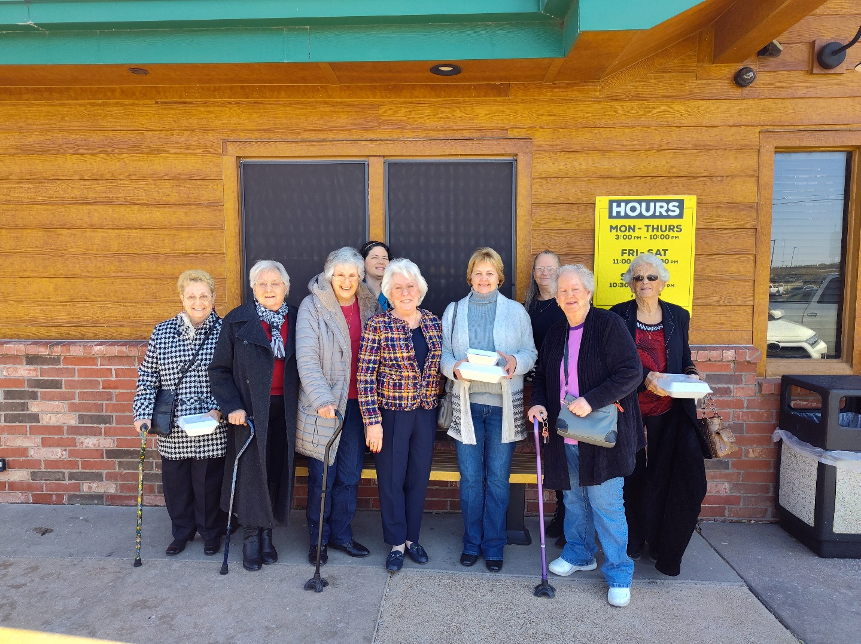




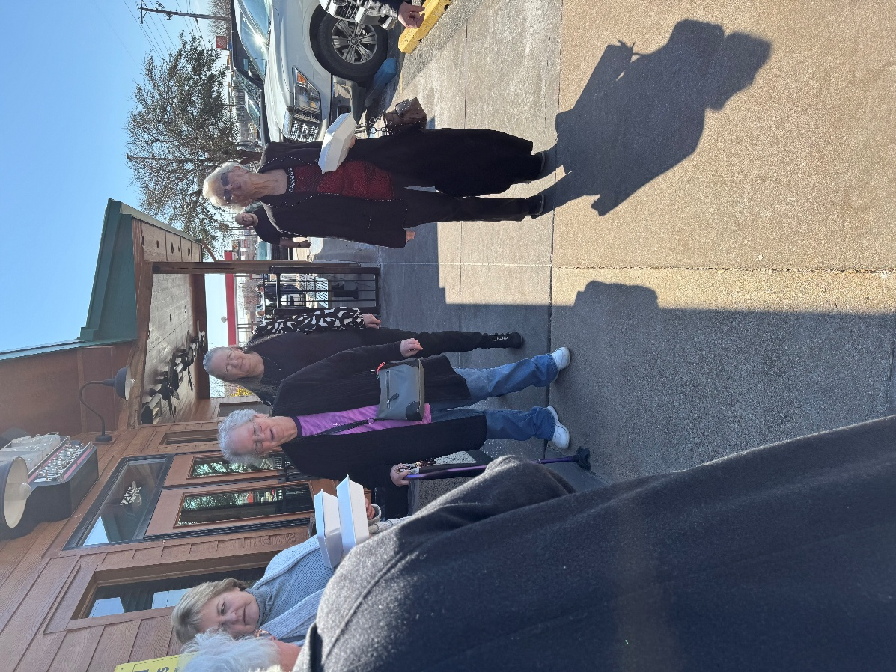
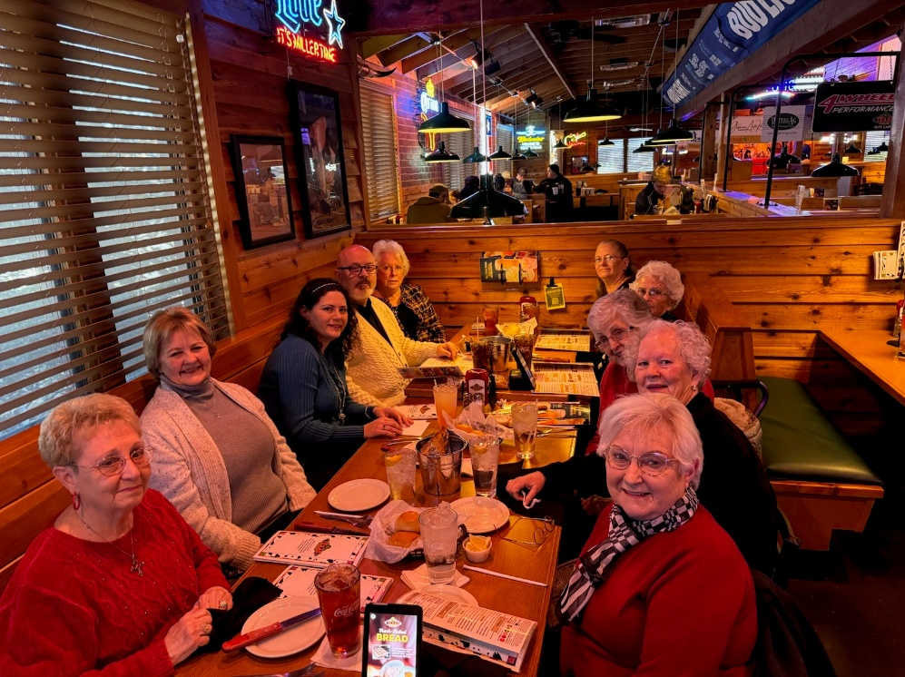






The Midweek Kids are having tons
of fun!
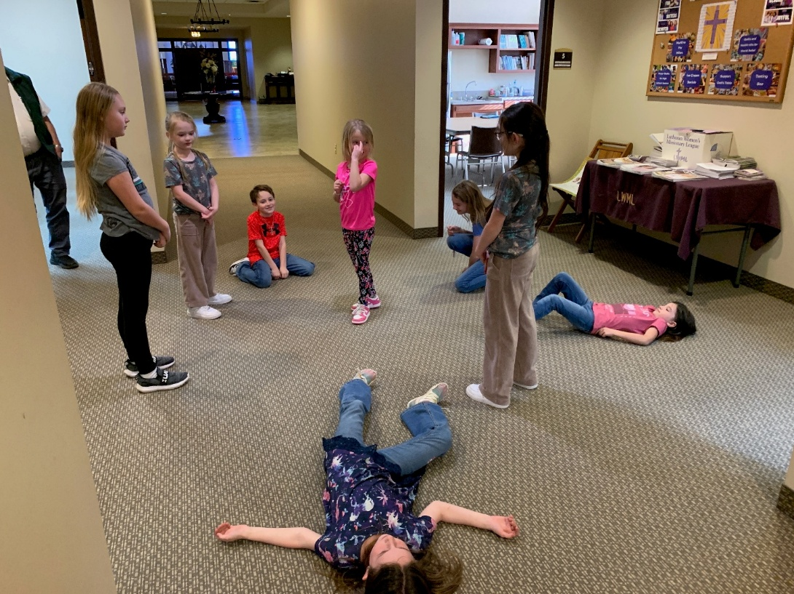






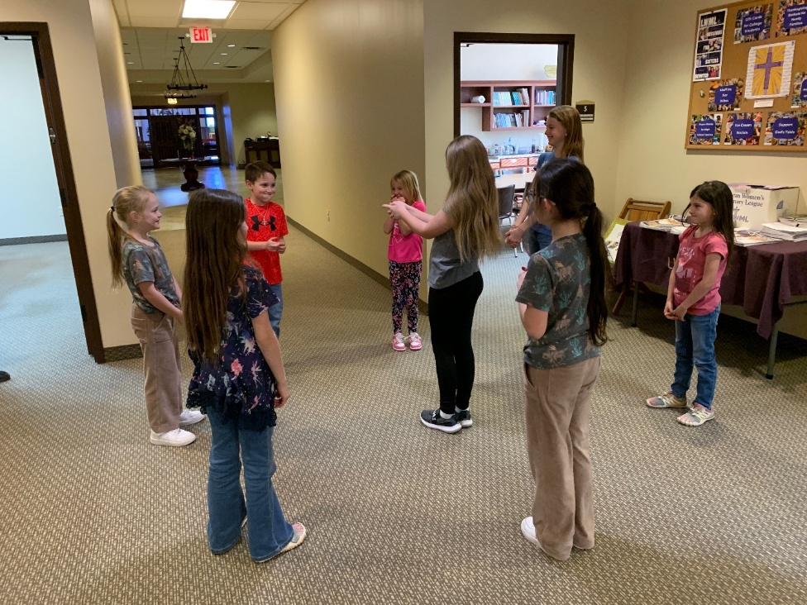





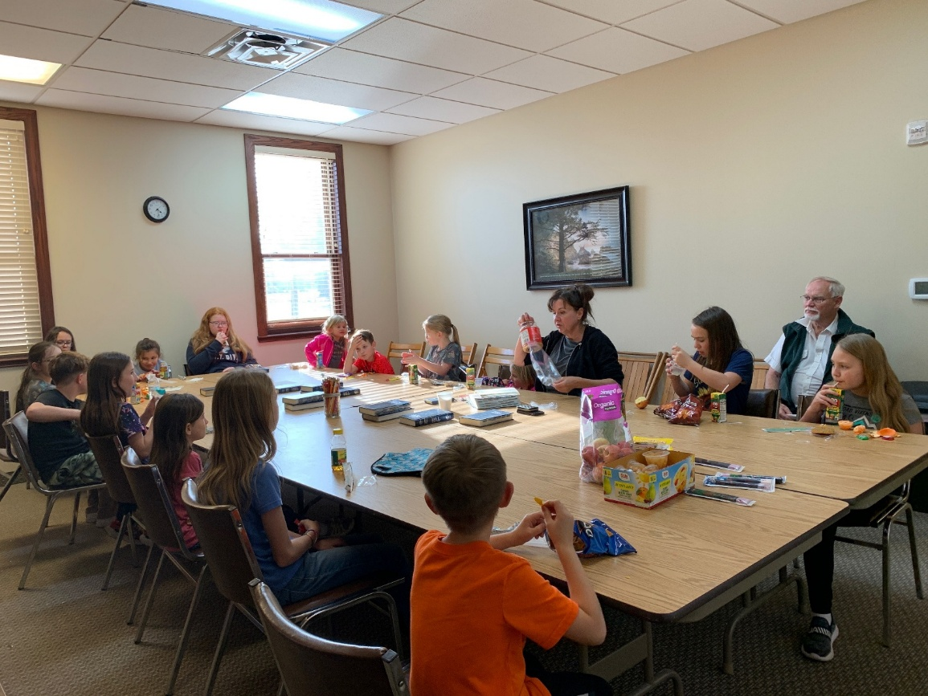


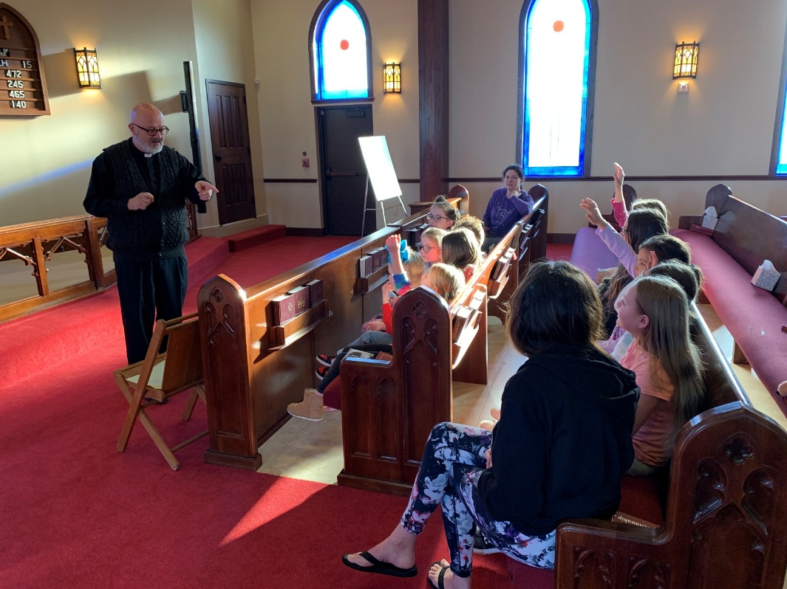
Midweek learned about Ash Wednesday
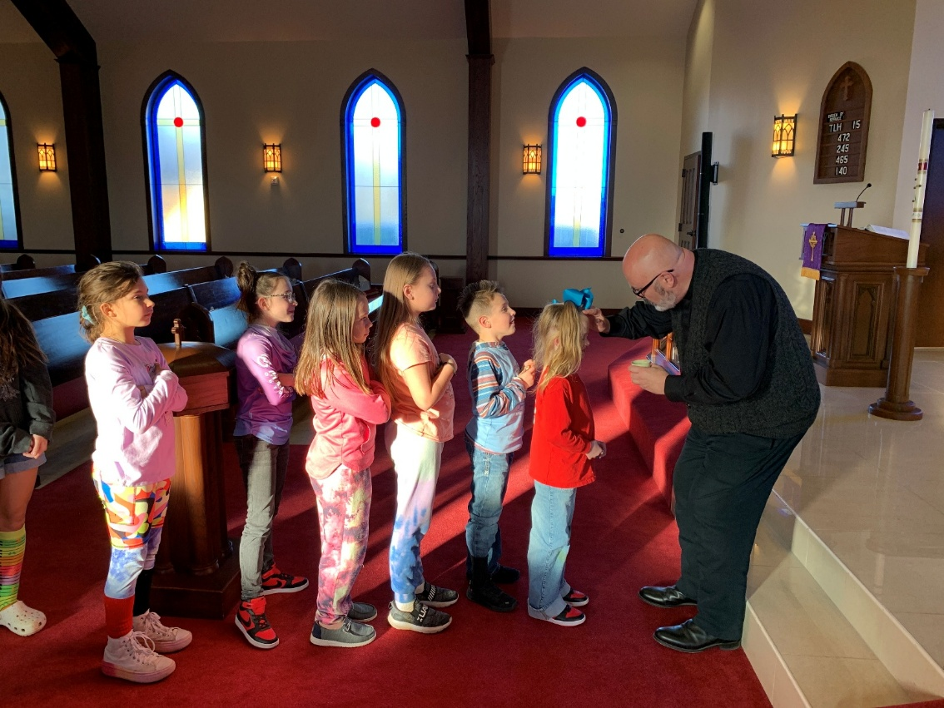

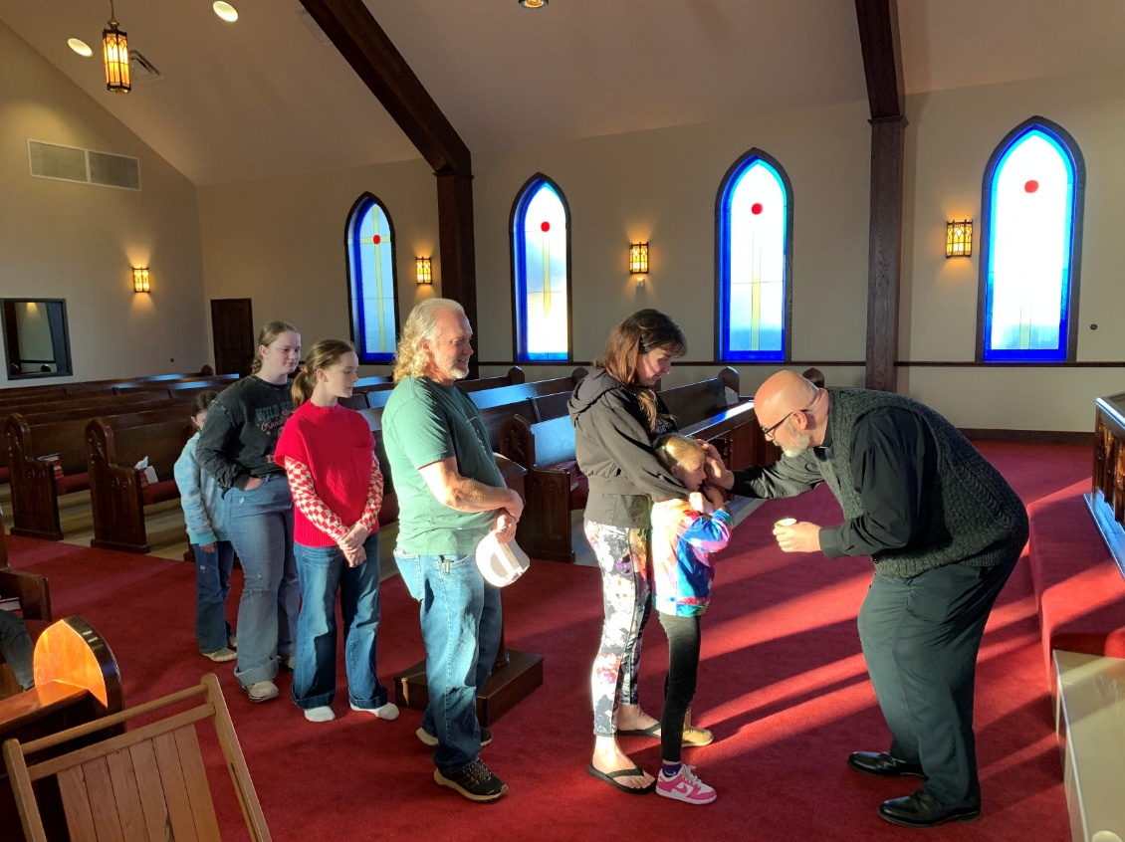



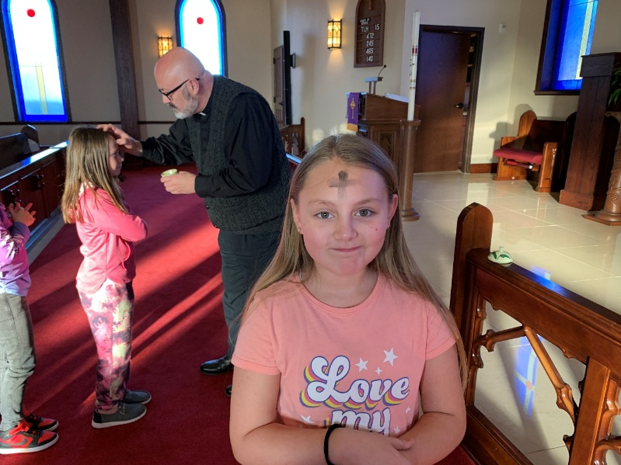


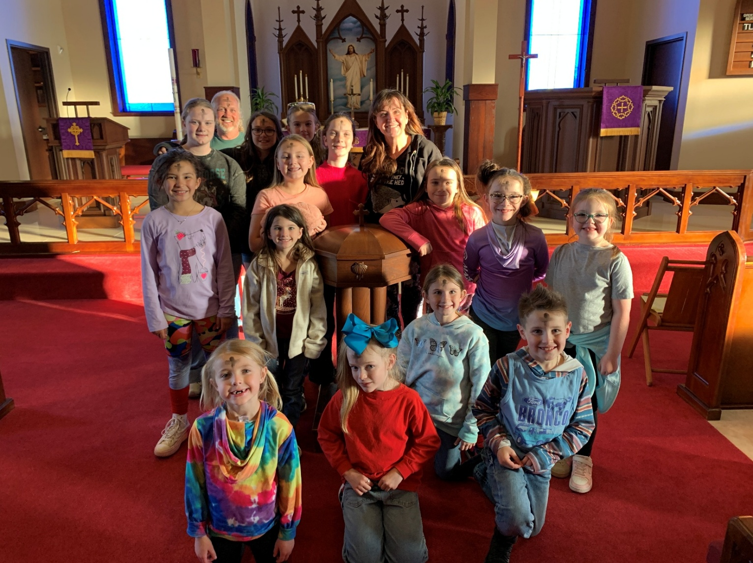




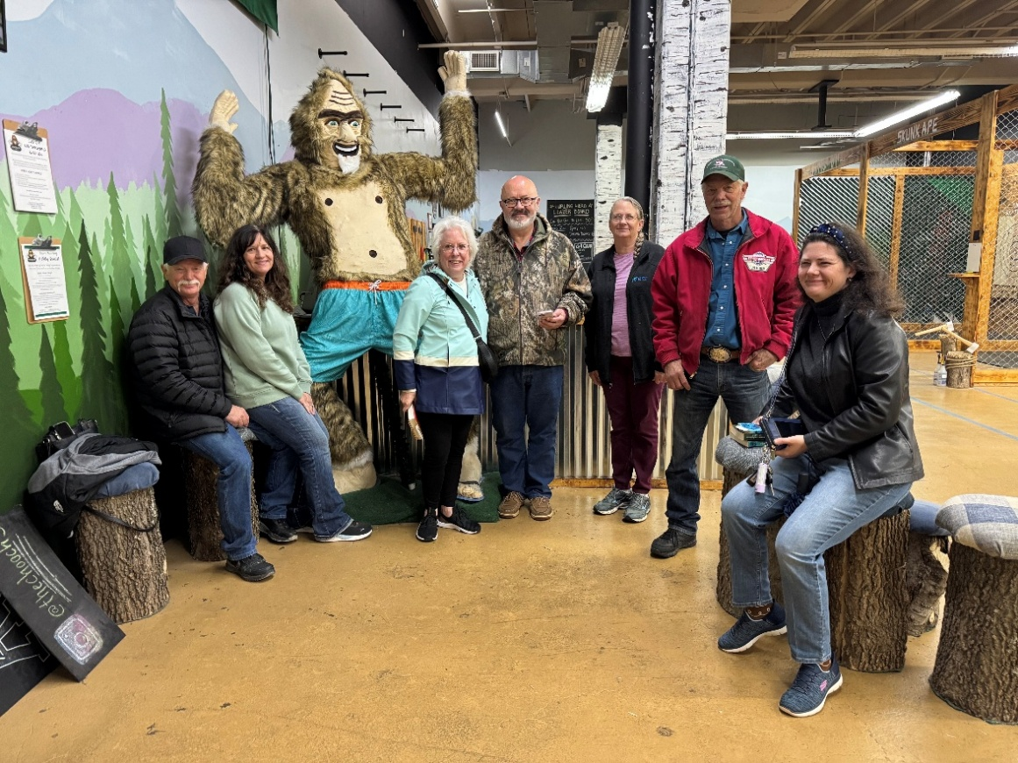
The AFG went Axe Throwing






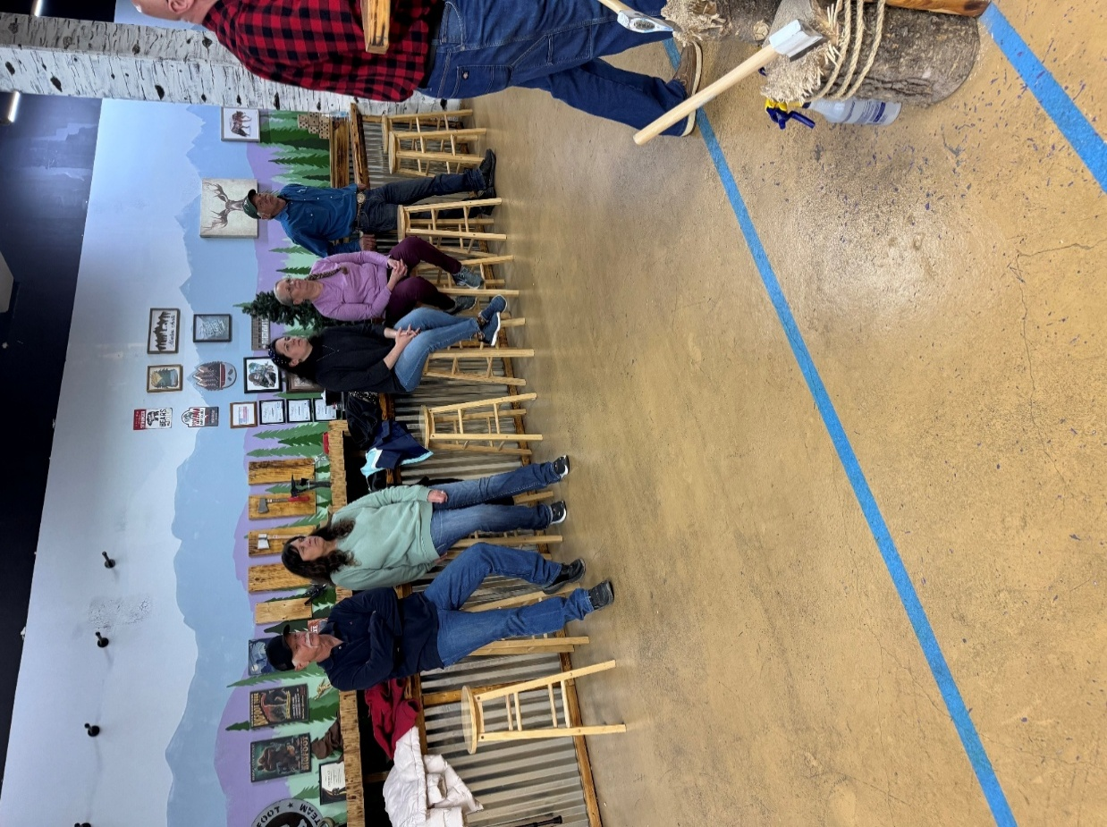












We welcome Charlotte Jean Horton, Daughter of Shelby Horton…







…and Henry Riker Dyson, son of Travis and Camerin Dyson, into the world!


The Youth Group had a successful Garage Sale








Firepit donated for auction by:



