504 Father Most Holy
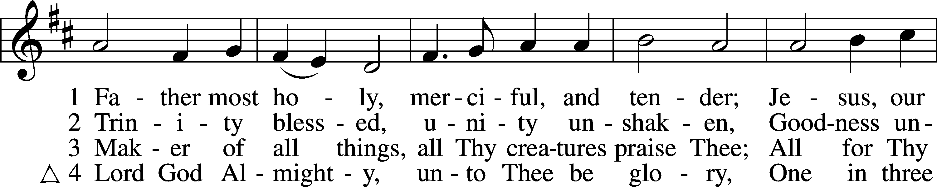
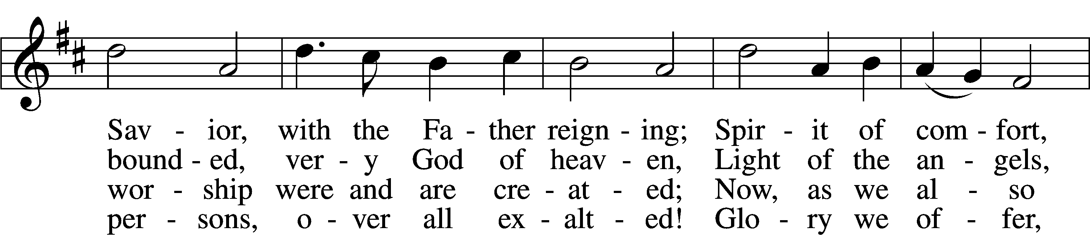
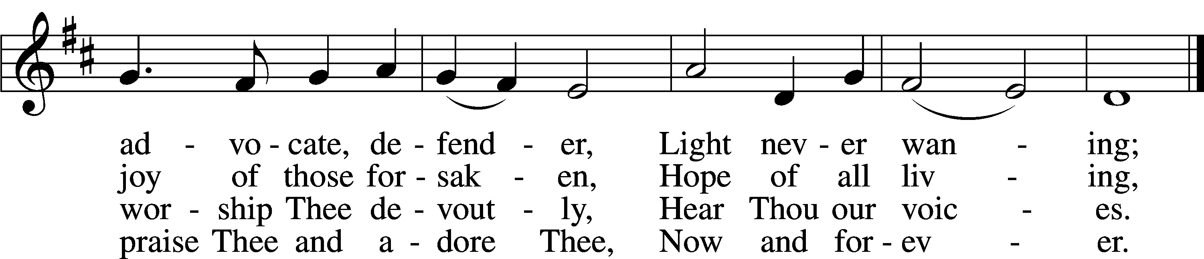
Text: Latin, c. 10th cent.; tr. Percy Dearmer, 1867–1936, alt.
Tune: Antiphoner, 1681, Paris
Text and tune: Public domain

Confession and Absolution

Stand

The sign of the cross may be made by all in remembrance of their Baptism.

Invocation Matthew 28:19b; 18:20
P In the name of the Father and of the T Son and of the Holy Spirit.
C Amen.

Exhortation Hebrews 10:22; Psalm 124:8; Psalm 32:5
P Beloved in the Lord! Let us draw near with a true heart and confess our sins unto God our Father, beseeching Him in the name of our Lord Jesus Christ to grant us forgiveness.

P Our help is in the name of the Lord,
C who made heaven and earth.
P I said, I will confess my transgressions unto the Lord,
C and You forgave the iniquity of my sin.

Kneel/Stand

Silence for reflection on God’s Word and for self-examination.

Confession of Sins
P O almighty God, merciful Father,
C I, a poor, miserable sinner, confess unto You all my sins and iniquities with which I have ever offended You and justly deserved Your temporal and eternal punishment. But I am heartily sorry for them and sincerely repent of them, and I pray You of Your boundless mercy and for the sake of the holy, innocent, bitter sufferings and death of Your beloved Son, Jesus Christ, to be gracious and merciful to me, a poor, sinful being.

Absolution [John 20:19–23]
P Upon this your confession, I, by virtue of my office, as a called and ordained servant of the Word, announce the grace of God unto all of you, and in the stead and by the command of my Lord Jesus Christ I forgive you all your sins in the name of the Father and of the T Son and of the Holy Spirit.
C Amen.

Stand

Service of the Word

Introit Psalm 16:8–11; antiphon: Liturgical Text
Blessèd be the Holy Trinity and the undivided Unity.
Let us give glory to him because he has shown his mercy to us.
I have set the Lord always before me;
because he is at my right hand, I shall not be shaken.
Therefore my heart is glad, and my whole being rejoices;
my flesh also dwells secure.
For you will not abandon my soul to Sheol,
or let your holy one see corruption.
You make known to me the path of life;
in your presence there is fullness of joy; at your right hand are pleasures forevermore.
Gloria Patri
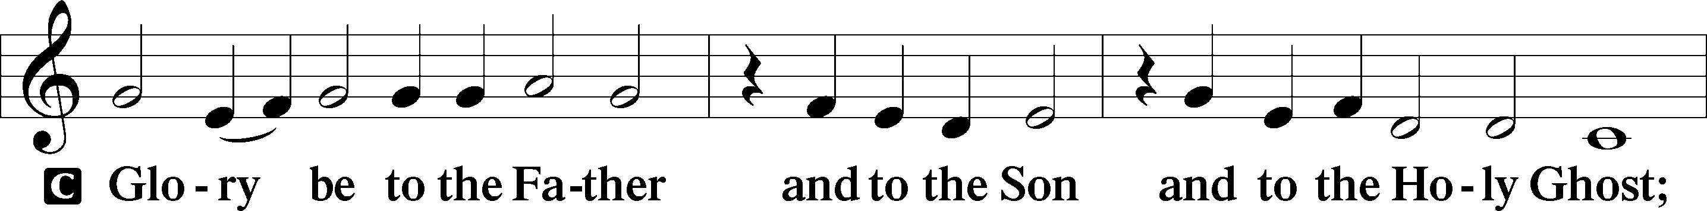
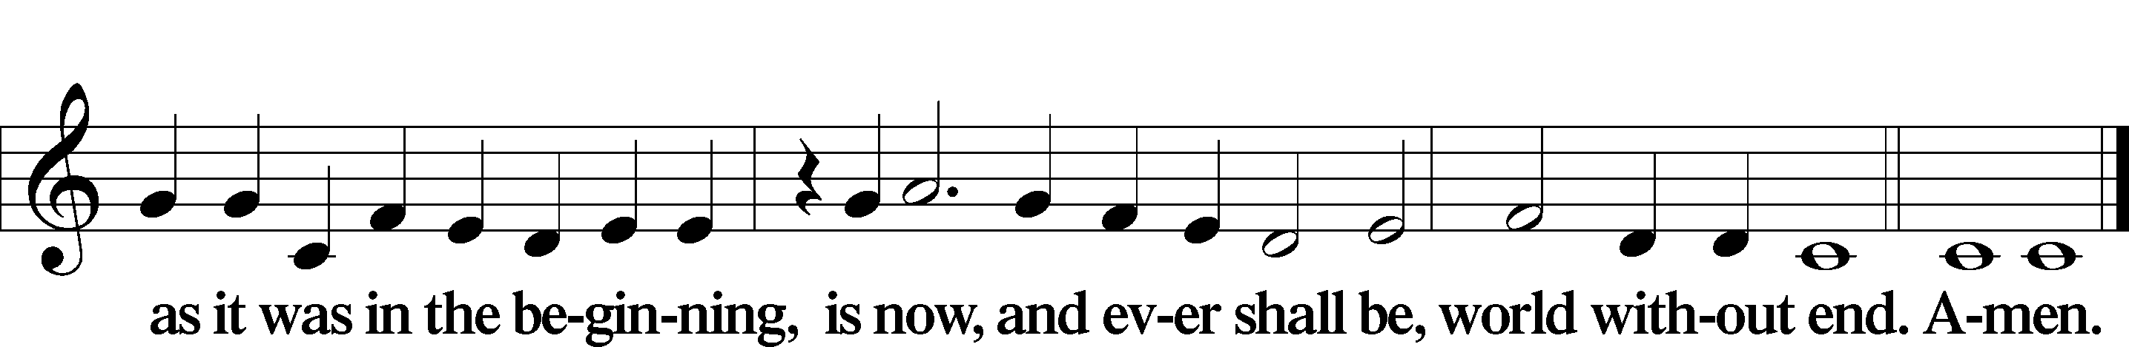

Kyrie Mark 10:47
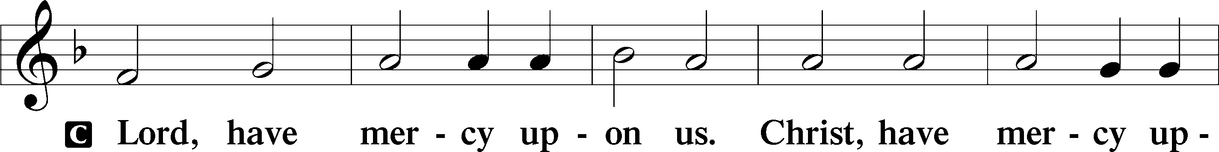
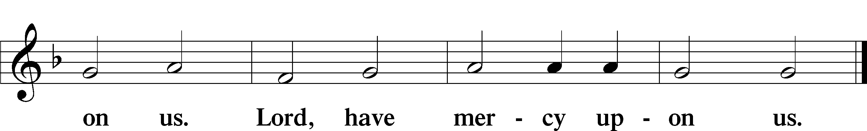

Gloria in Excelsis Luke 2:14; John 1:29
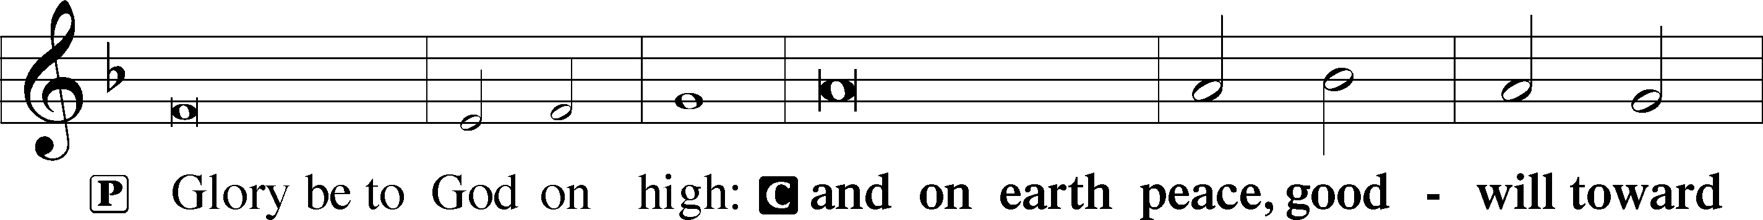
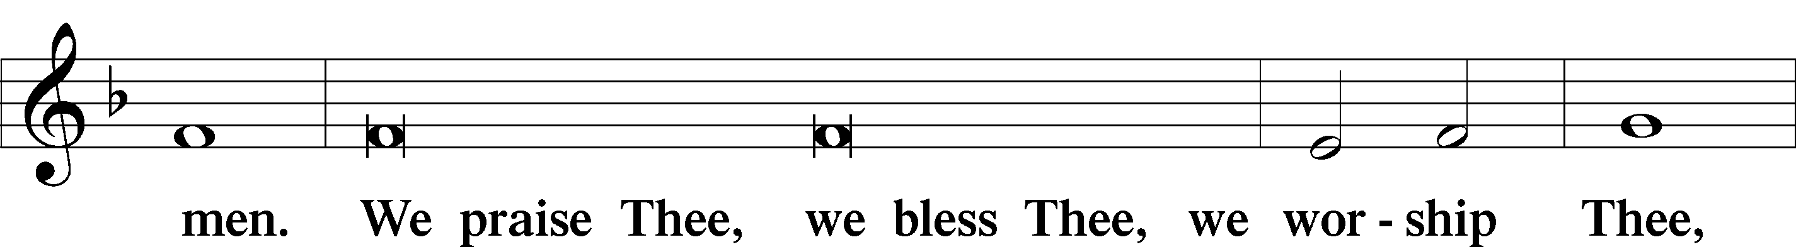
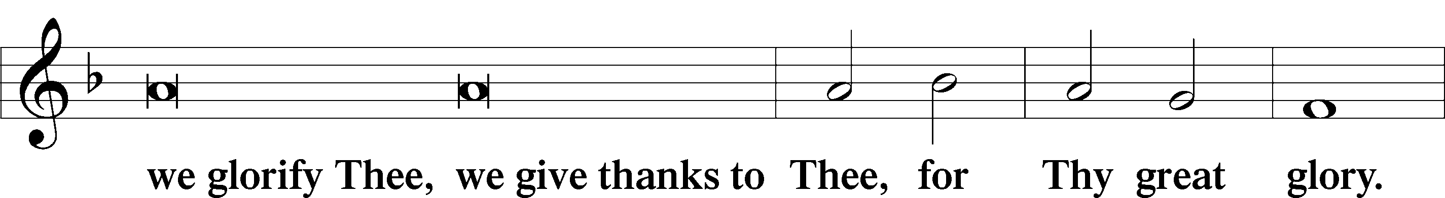
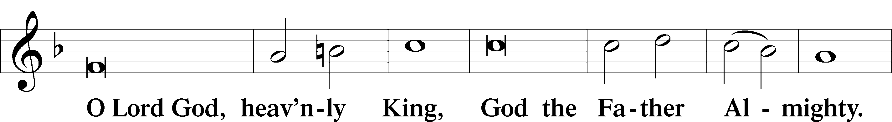
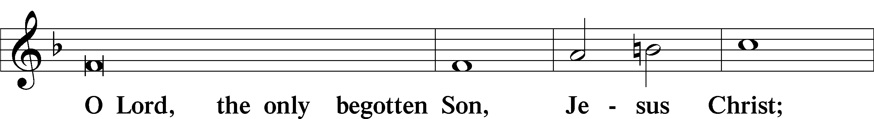
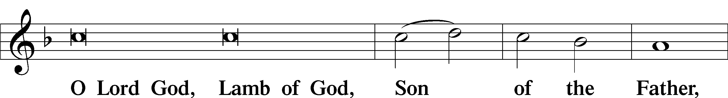
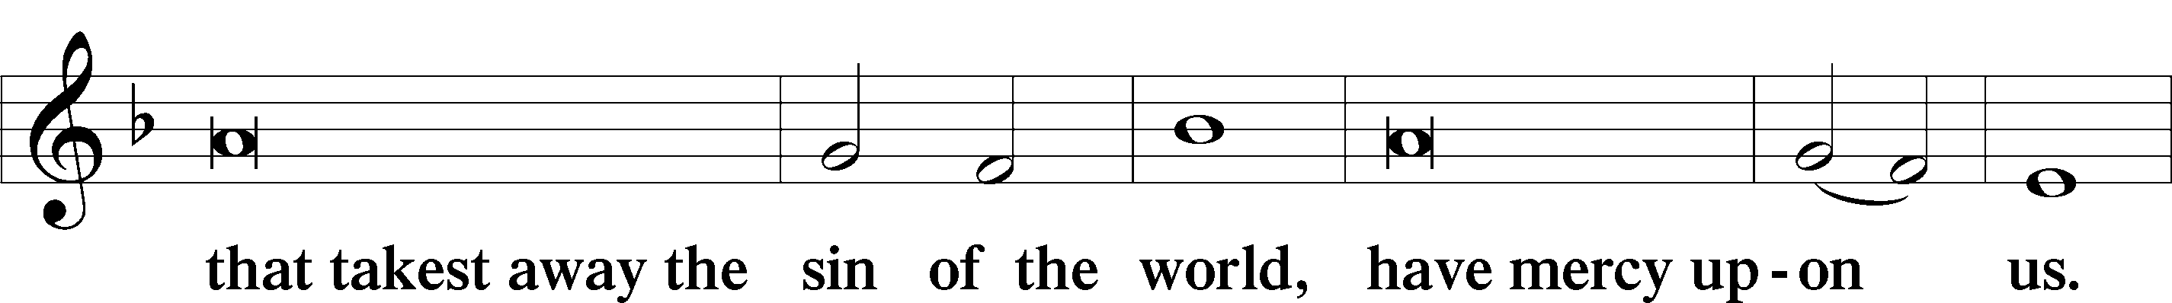
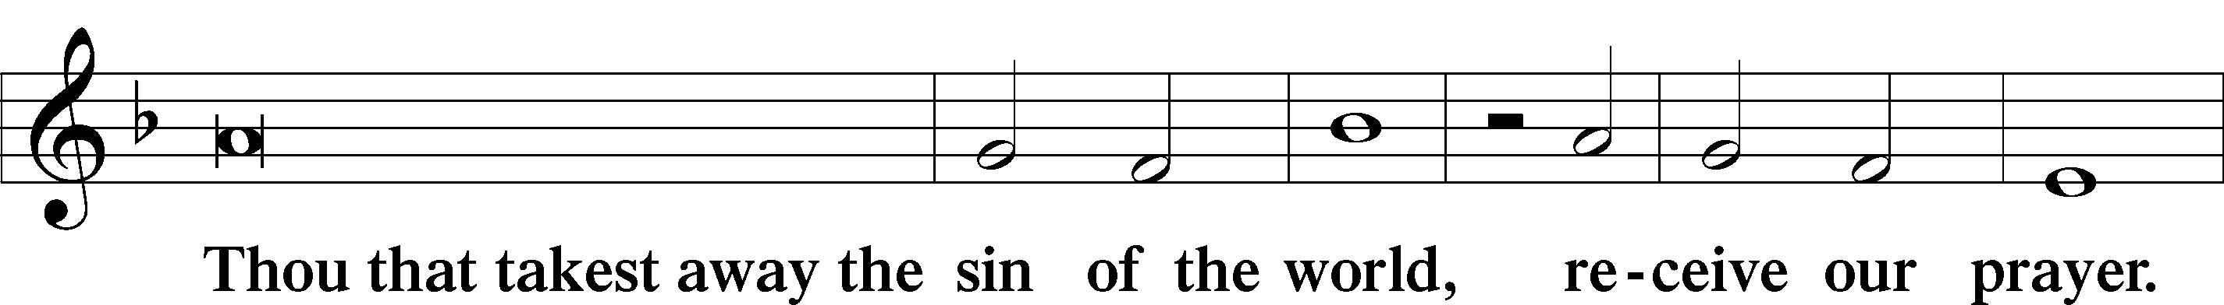
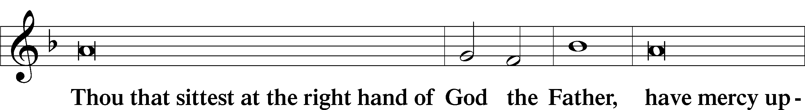
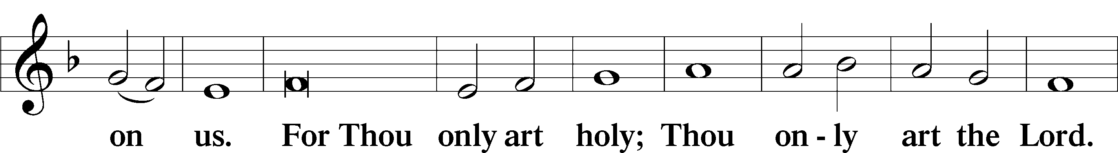
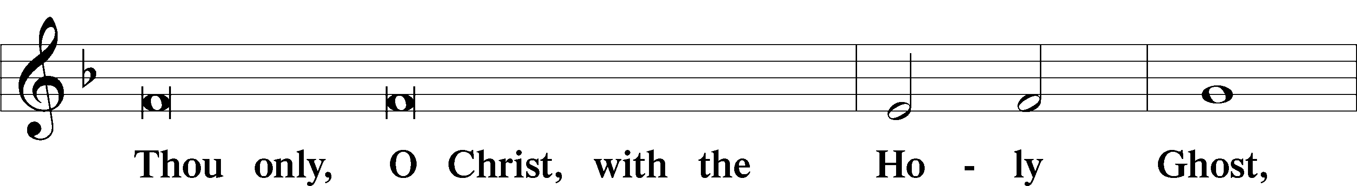
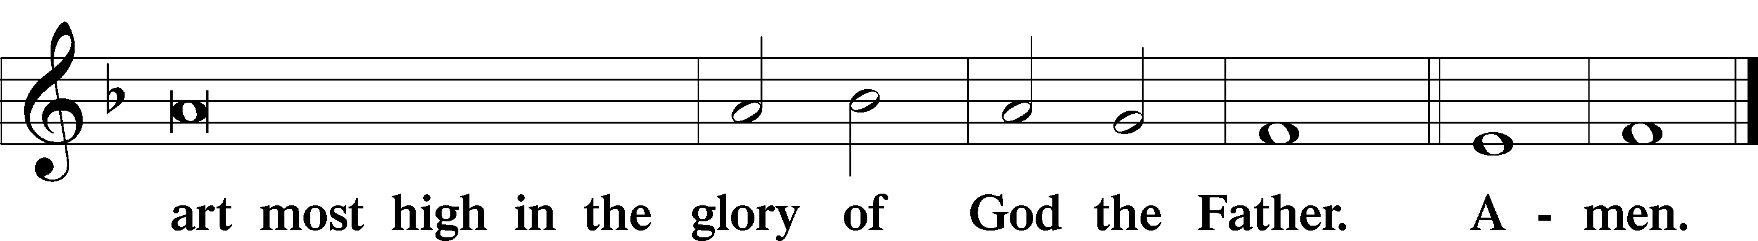

Salutation and Collect of the Day
P The Lord be with you.
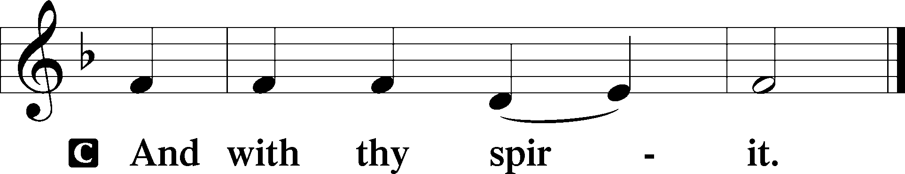

P Let us pray.
Almighty and everlasting God, You have given us grace to acknowledge the glory of the eternal Trinity by the confession of a true faith and to worship the Unity in the power of the Divine Majesty. Keep us steadfast in this faith and defend us from all adversities; for You, O Father, Son, and Holy Spirit, live and reign, one God, now and forever.

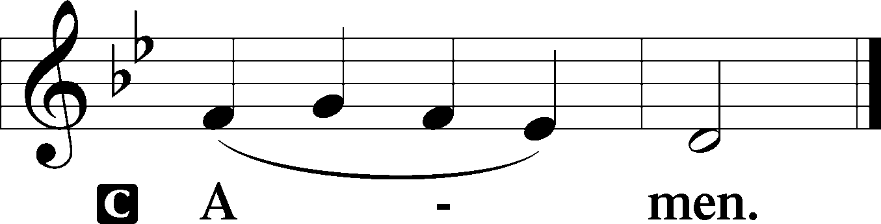

Sit

Old Testament Reading Genesis 1:1—2:4a
1In the beginning, God created the heavens and the earth. 2The earth was without form and void, and darkness was over the face of the deep. And the Spirit of God was hovering over the face of the waters.
3And God said, “Let there be light,” and there was light. 4And God saw that the light was good. And God separated the light from the darkness. 5God called the light Day, and the darkness he called Night. And there was evening and there was morning, the first day.
6And God said, “Let there be an expanse in the midst of the waters, and let it separate the waters from the waters.” 7And God made the expanse and separated the waters that were under the expanse from the waters that were above the expanse. And it was so. 8And God called the expanse Heaven. And there was evening and there was morning, the second day.
9And God said, “Let the waters under the heavens be gathered together into one place, and let the dry land appear.” And it was so. 10God called the dry land Earth, and the waters that were gathered together he called Seas. And God saw that it was good.
11And God said, “Let the earth sprout vegetation, plants yielding seed, and fruit trees bearing fruit in which is their seed, each according to its kind, on the earth.” And it was so. 12The earth brought forth vegetation, plants yielding seed according to their own kinds, and trees bearing fruit in which is their seed, each according to its kind. And God saw that it was good. 13And there was evening and there was morning, the third day.
14And God said, “Let there be lights in the expanse of the heavens to separate the day from the night. And let them be for signs and for seasons, and for days and years, 15and let them be lights in the expanse of the heavens to give light upon the earth.” And it was so. 16And God made the two great lights—the greater light to rule the day and the lesser light to rule the night—and the stars. 17And God set them in the expanse of the heavens to give light on the earth, 18to rule over the day and over the night, and to separate the light from the darkness. And God saw that it was good. 19And there was evening and there was morning, the fourth day.
20And God said, “Let the waters swarm with swarms of living creatures, and let birds fly above the earth across the expanse of the heavens.” 21So God created the great sea creatures and every living creature that moves, with which the waters swarm, according to their kinds, and every winged bird according to its kind. And God saw that it was good. 22And God blessed them, saying, “Be fruitful and multiply and fill the waters in the seas, and let birds multiply on the earth.” 23And there was evening and there was morning, the fifth day.
24And God said, “Let the earth bring forth living creatures according to their kinds—livestock and creeping things and beasts of the earth according to their kinds.” And it was so. 25And God made the beasts of the earth according to their kinds and the livestock according to their kinds, and everything that creeps on the ground according to its kind. And God saw that it was good.
26Then God said, “Let us make man in our image, after our likeness. And let them have dominion over the fish of the sea and over the birds of the heavens and over the livestock and over all the earth and over every creeping thing that creeps on the earth.”27So God created man in his own image, in the image of God he created him; male and female he created them.
28And God blessed them. And God said to them, “Be fruitful and multiply and fill the earth and subdue it and have dominion over the fish of the sea and over the birds of the heavens and over every living thing that moves on the earth.” 29And God said, “Behold, I have given you every plant yielding seed that is on the face of all the earth, and every tree with seed in its fruit. You shall have them for food. 30And to every beast of the earth and to every bird of the heavens and to everything that creeps on the earth, everything that has the breath of life, I have given every green plant for food.” And it was so. 31And God saw everything that he had made, and behold, it was very good. And there was evening and there was morning, the sixth day.
1Thus the heavens and the earth were finished, and all the host of them. 2And on the seventh day God finished his work that he had done, and he rested on the seventh day from all his work that he had done. 3So God blessed the seventh day and made it holy, because on it God rested from all his work that he had done in creation.
4These are the generations of the heavens and the earth when they were created.

A This is the Word of the Lord.
C Thanks be to God.

Gradual Psalm 145:3, 5b, 6b
Great is the Lord, and greatly to be praised,
and his greatness is unsearchable.
On your wondrous works, I will meditate,
and I will declare your greatness.

Epistle Acts 2:14a, 22–36
14Peter, standing with the eleven, lifted up his voice and addressed them, . . .
22“Men of Israel, hear these words: Jesus of Nazareth, a man attested to you by God with mighty works and wonders and signs that God did through him in your midst, as you yourselves know— 23this Jesus, delivered up according to the definite plan and foreknowledge of God, you crucified and killed by the hands of lawless men. 24God raised him up, loosing the pangs of death, because it was not possible for him to be held by it. 25For David says concerning him, “‘I saw the Lord always before me, for he is at my right hand that I may not be shaken; 26therefore my heart was glad, and my tongue rejoiced; my flesh also will dwell in hope. 27For you will not abandon my soul to Hades, or let your Holy One see corruption. 28You have made known to me the paths of life; you will make me full of gladness with your presence.’
29“Brothers, I may say to you with confidence about the patriarch David that he both died and was buried, and his tomb is with us to this day. 30Being therefore a prophet, and knowing that God had sworn with an oath to him that he would set one of his descendants on his throne, 31he foresaw and spoke about the resurrection of the Christ, that he was not abandoned to Hades, nor did his flesh see corruption. 32This Jesus God raised up, and of that we all are witnesses. 33Being therefore exalted at the right hand of God, and having received from the Father the promise of the Holy Spirit, he has poured out this that you yourselves are seeing and hearing. 34For David did not ascend into the heavens, but he himself says, “‘The Lord said to my Lord,
Sit at my right hand, 35until I make your enemies your footstool.’
36Let all the house of Israel therefore know for certain that God has made him both Lord and Christ, this Jesus whom you crucified.”

A This is the Word of the Lord.
C Thanks be to God.

Stand

Alleluia
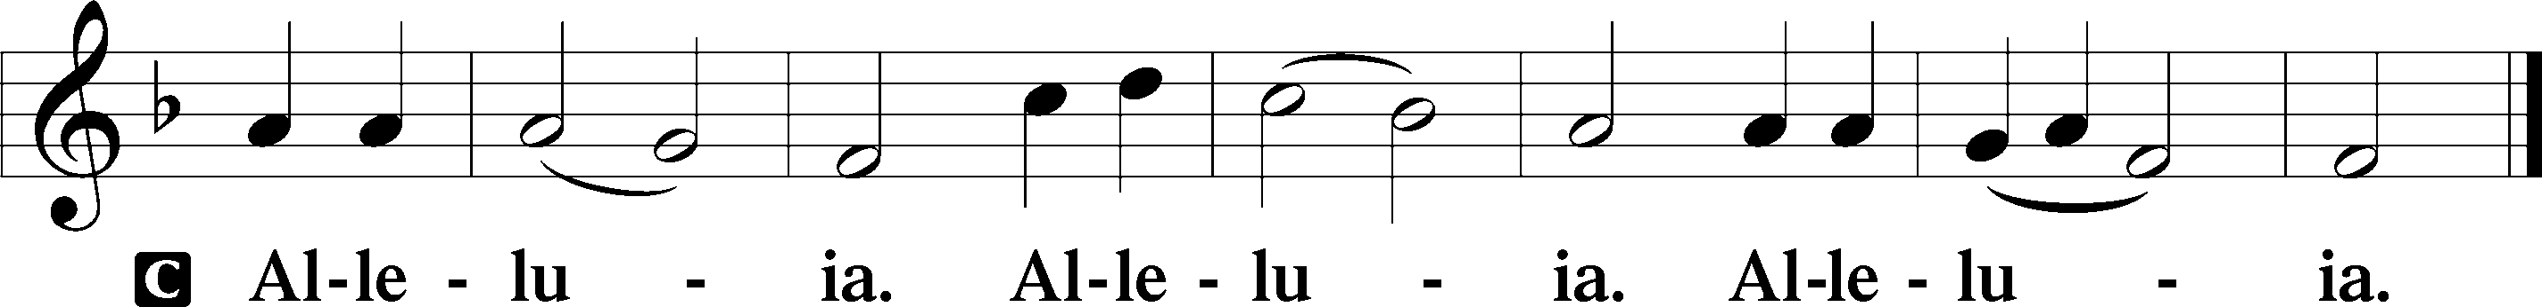

Holy Gospel Matthew 28:16–20
P The Holy Gospel according to St. Matthew, the twenty-eighth chapter.

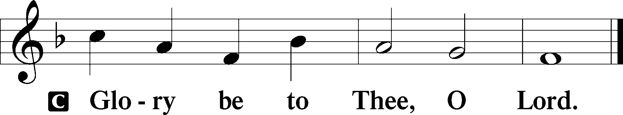

16Now the eleven disciples went to Galilee, to the mountain to which Jesus had directed them. 17And when they saw him they worshiped him, but some doubted. 18And Jesus came and said to them, “All authority in heaven and on earth has been given to me. 19Go therefore and make disciples of all nations, baptizing them in the name of the Father and of the Son and of the Holy Spirit, 20teaching them to observe all that I have commanded you. And behold, I am with you always, to the end of the age.”

P This is the Gospel of the Lord.

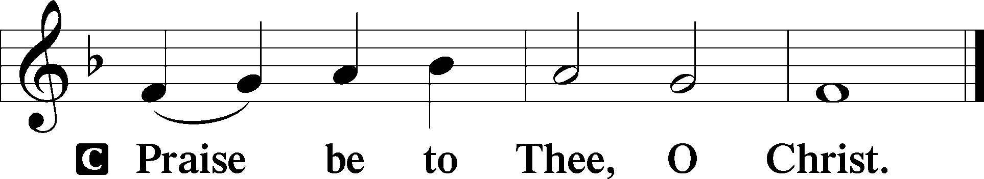

Nicene Creed
C I believe in one God,
the Father Almighty,
maker of heaven and earth
and of all things visible and invisible.

And in one Lord Jesus Christ,
the only-begotten Son of God,
begotten of His Father before all worlds,
God of God, Light of Light,
very God of very God,
begotten, not made,
being of one substance with the Father,
by whom all things were made;
who for us men and for our salvation came down from heaven
and was incarnate by the Holy Spirit of the virgin Mary
and was made man;
and was crucified also for us under Pontius Pilate.
He suffered and was buried.
And the third day He rose again according to the Scriptures
and ascended into heaven
and sits at the right hand of the Father.
And He will come again with glory to judge both the living and the dead,
whose kingdom will have no end.

And I believe in the Holy Spirit,
the Lord and giver of life,
who proceeds from the Father and the Son,
who with the Father and the Son together is worshiped and glorified,
who spoke by the prophets.
And I believe in one holy Christian and apostolic Church,
I acknowledge one Baptism for the remission of sins,
and I look for the resurrection of the dead
and the life T of the world to come. Amen.

Sit

Children's Sermon

506 Glory Be to God the Father
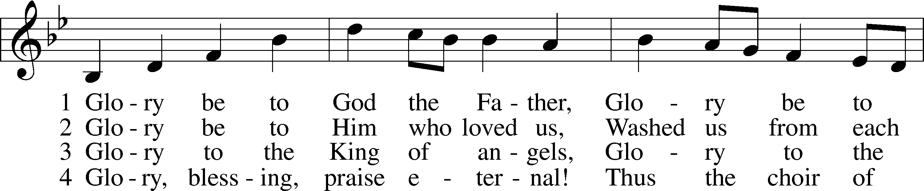
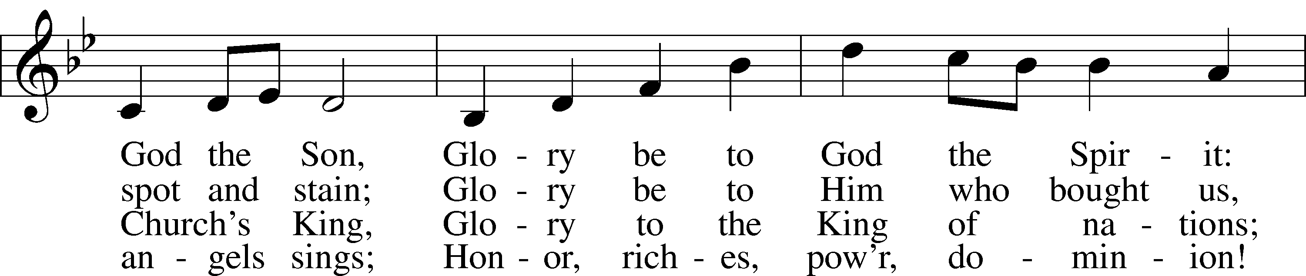
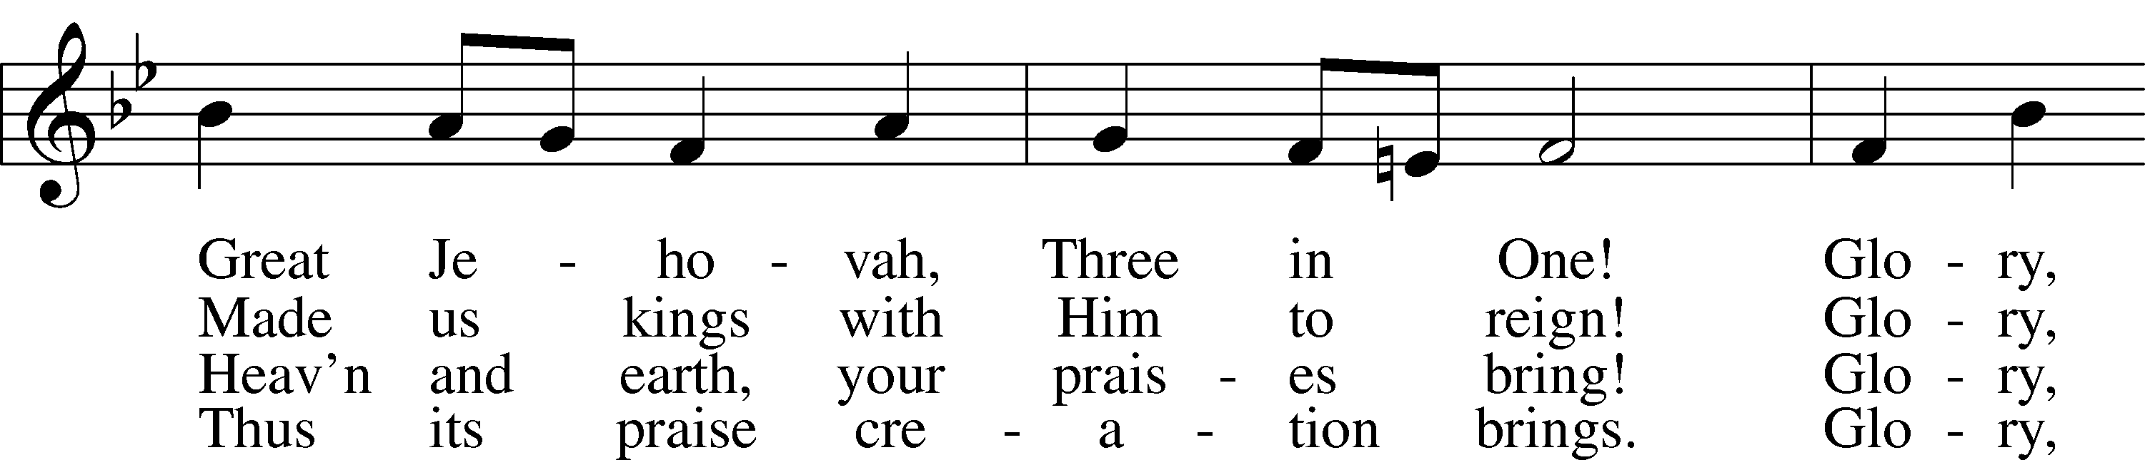
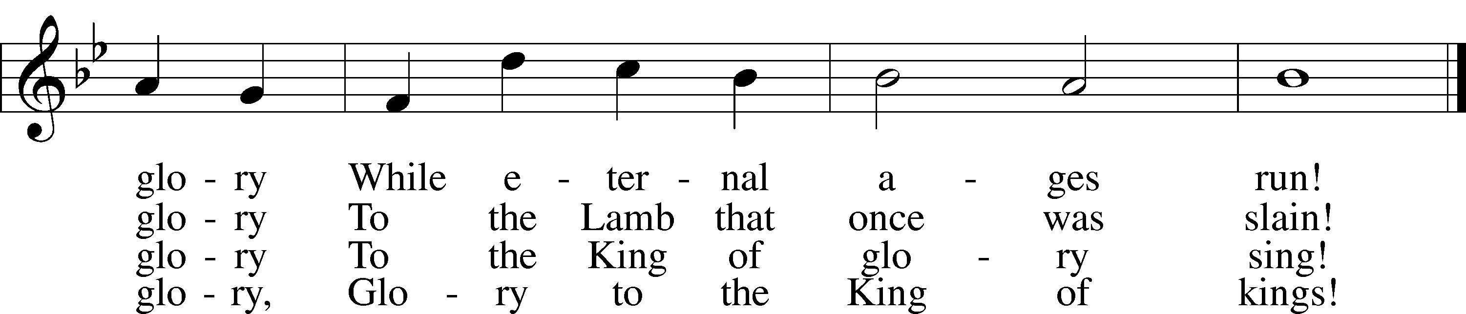
Text: Horatius Bonar, 1808–89
Tune: Walter G. Whinfield, 1865–1919
Text and tune: Public domain

Sermon “God in a Box.”

Votum
P The peace of God, which passes all understanding, keep your hearts and minds in Christ Jesus.
C Amen.

Stand

Offertory Psalm 51:10–12
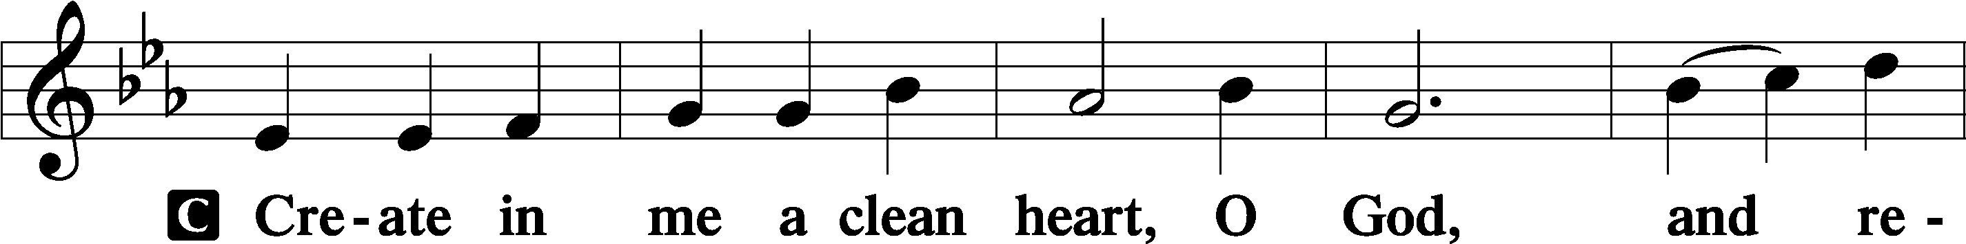
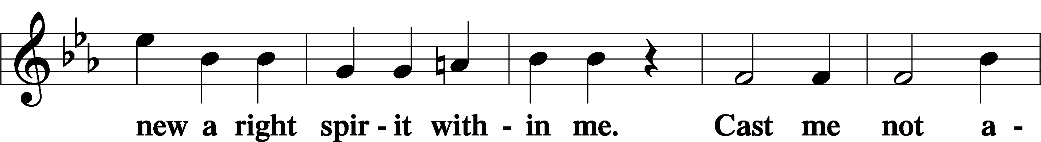
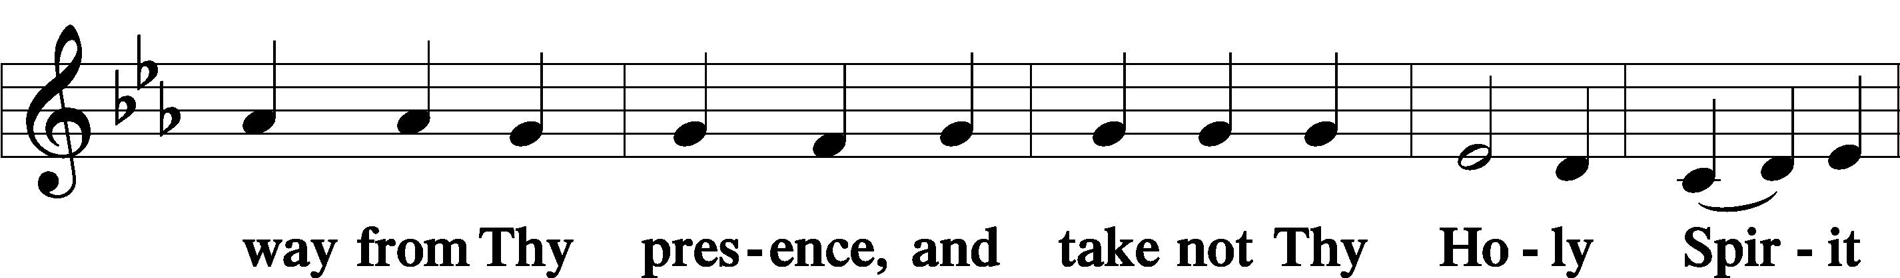
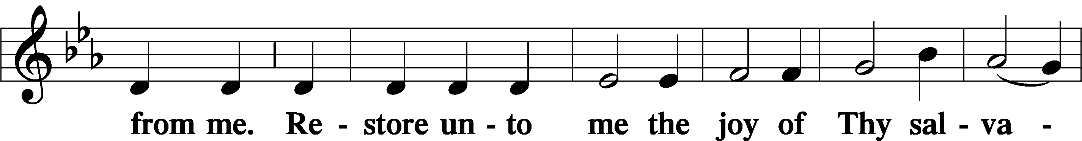
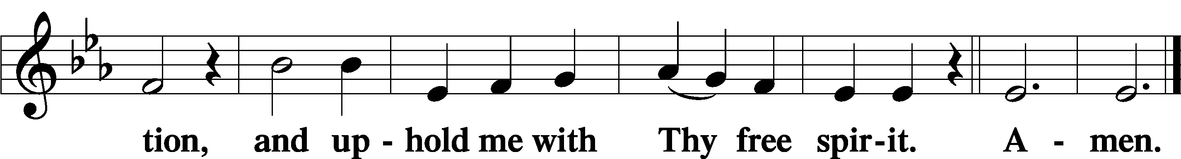

Sit

Offering

805 Praise God, from Whom All Blessings Flow
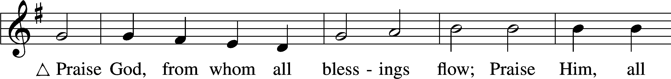
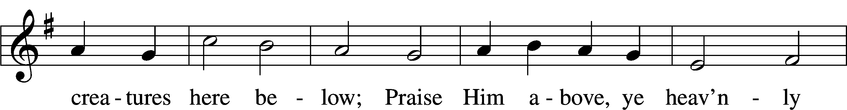
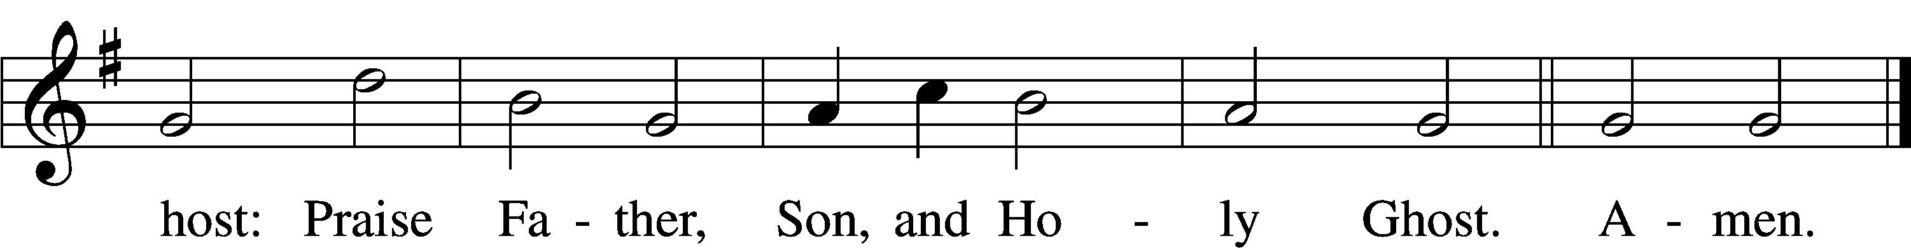
Text: Thomas Ken, 1637–1711
Tune: Trente quatre Pseaumes de David, 1551, Geneva, ed. Louis Bourgeois
Text and tune: Public domain

Stand

Prayer of the Church

Service of the Sacrament

Preface 2 Timothy 4:22; [Colossians 3:1]; [Psalm 136]
P The Lord be with you.
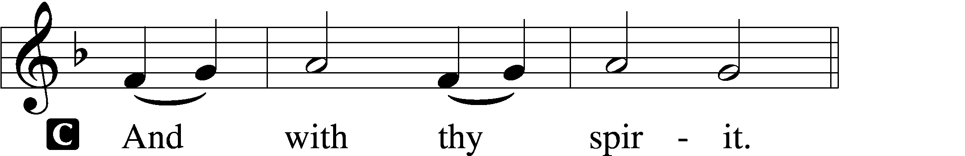

P Lift up your hearts.
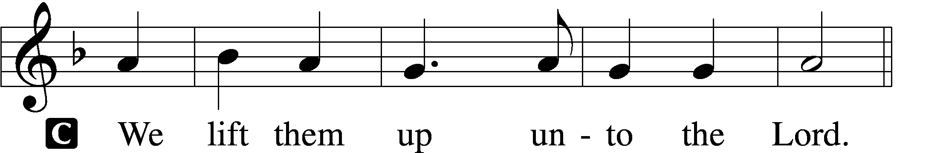

P Let us give thanks unto the Lord, our God.
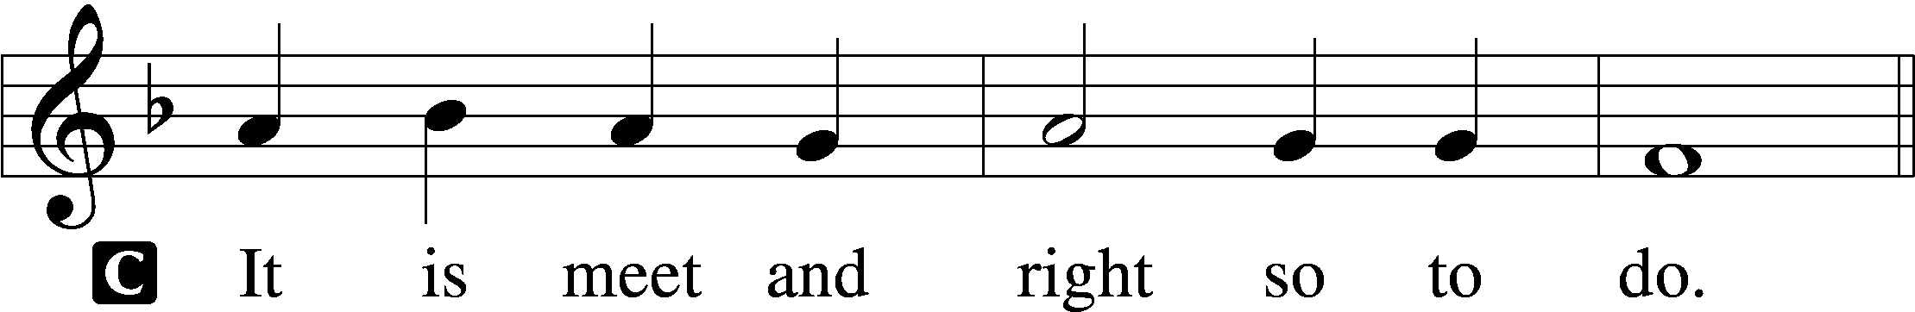

Proper Preface (Full)
P It is truly meet, right, and salutary that we should at all times and in all places give thanks to You, holy Lord, almighty Father, everlasting God, who with Your only-begotten Son and the Holy Spirit are one God, one Lord. In the confession of the only true God, we worship the Trinity in person and the Unity in substance, of majesty coequal. Therefore with angels and archangels and with all the company of heaven we laud and magnify Your glorious name, evermore praising You and saying:

Sanctus Isaiah 6:3; Matthew 21:9
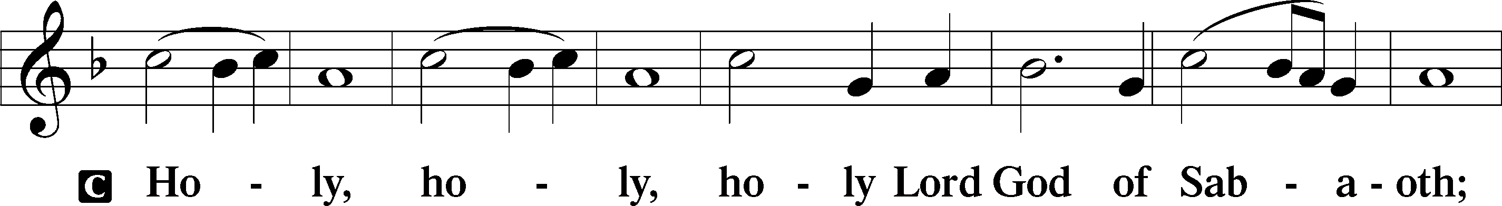
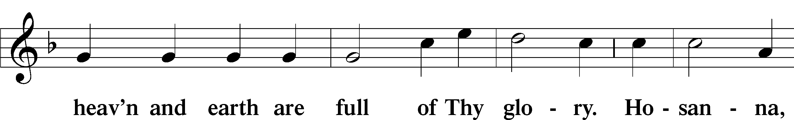
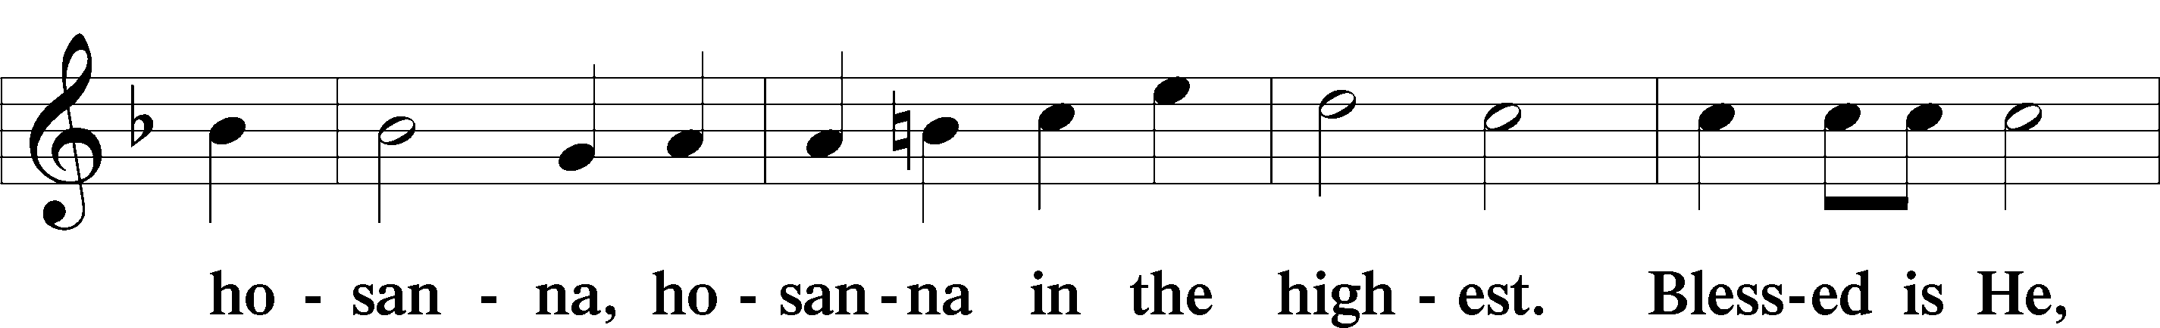
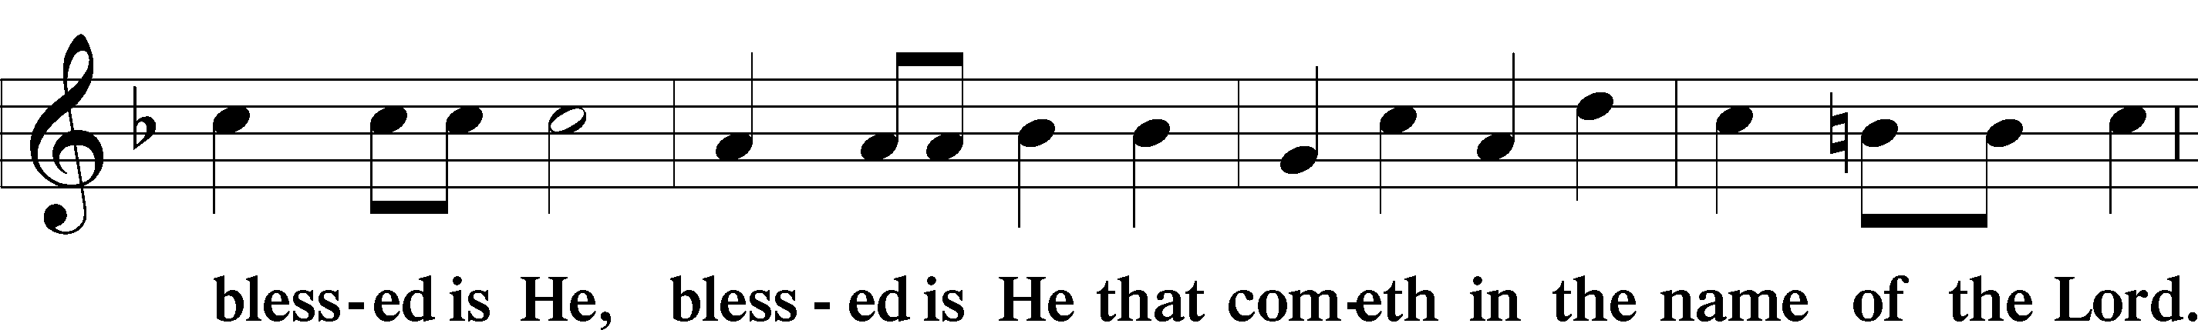
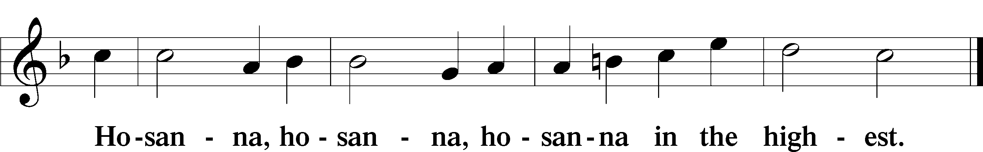

Lord’s Prayer Matthew 6:9–13
P Our Father who art in heaven,
hallowed be Thy name,
Thy kingdom come,
Thy will be done on earth as it is in heaven;
give us this day our daily bread;
and forgive us our trespasses as we forgive those who trespass against us;
and lead us not into temptation,
but deliver us from evil.
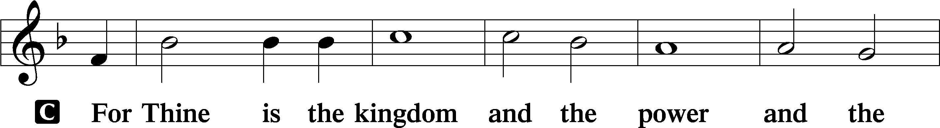
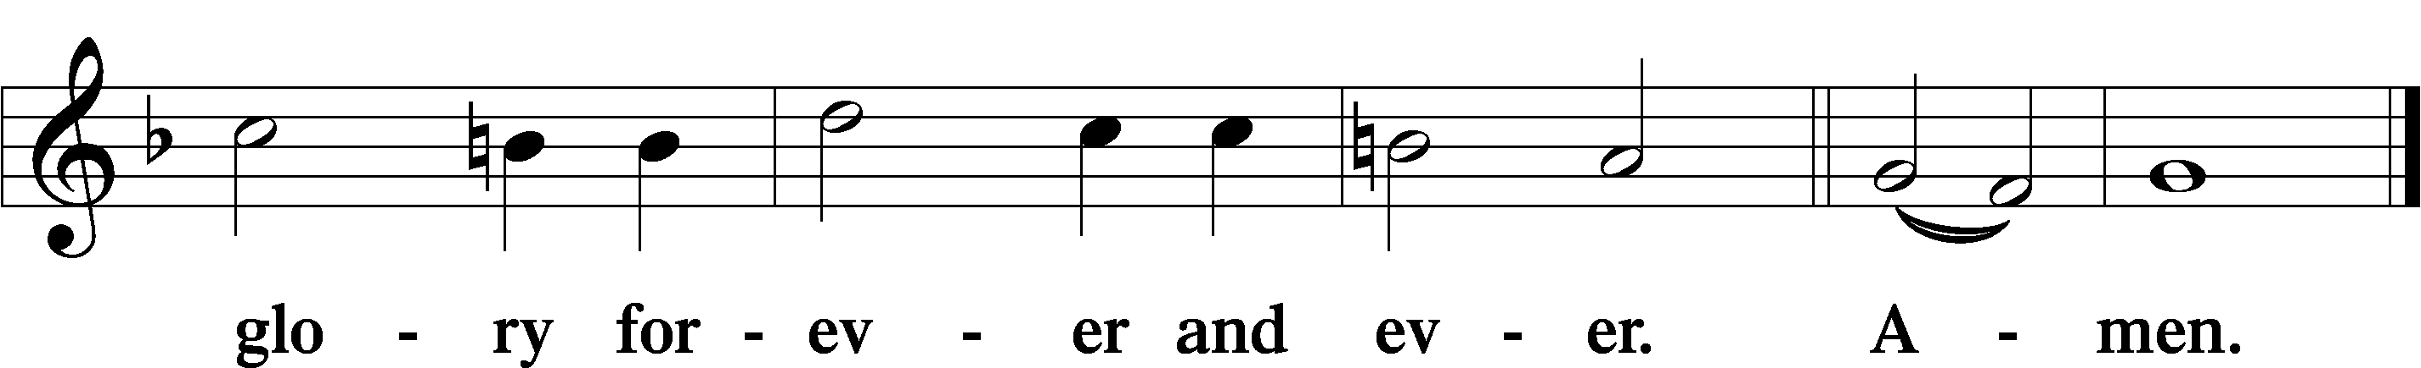

The Words of Our Lord Matthew 26:26–28; Mark 14:22–24; Luke 22:19–20; 1 Corinthians 11:23–25
P Our Lord Jesus Christ, on the night when He was betrayed, took bread, and when He had given thanks, He broke it and gave it to the disciples and said: “Take, eat; this is My T body, which is given for you. This do in remembrance of Me.”

In the same way also He took the cup after supper, and when He had given thanks, He gave it to them, saying: “Drink of it, all of you; this cup is the new testament in My T blood, which is shed for you for the forgiveness of sins. This do, as often as you drink it, in remembrance of Me.”

Pax Domini John 20:19
P The peace of the Lord be with you always.

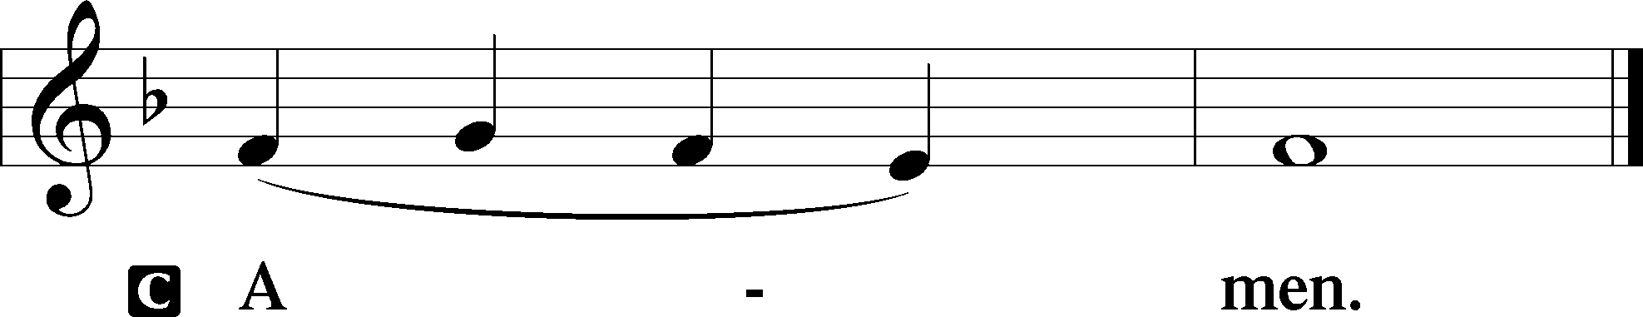

Agnus Dei John 1:29
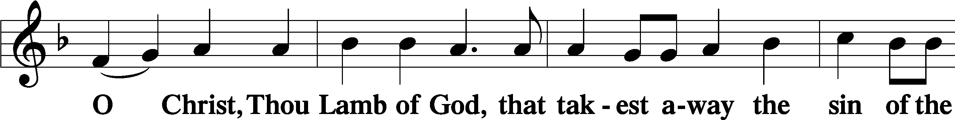
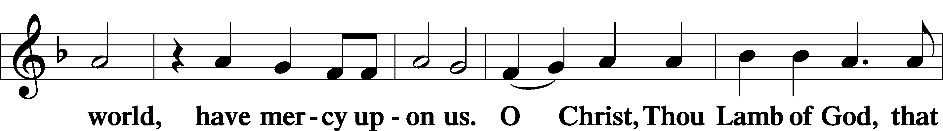
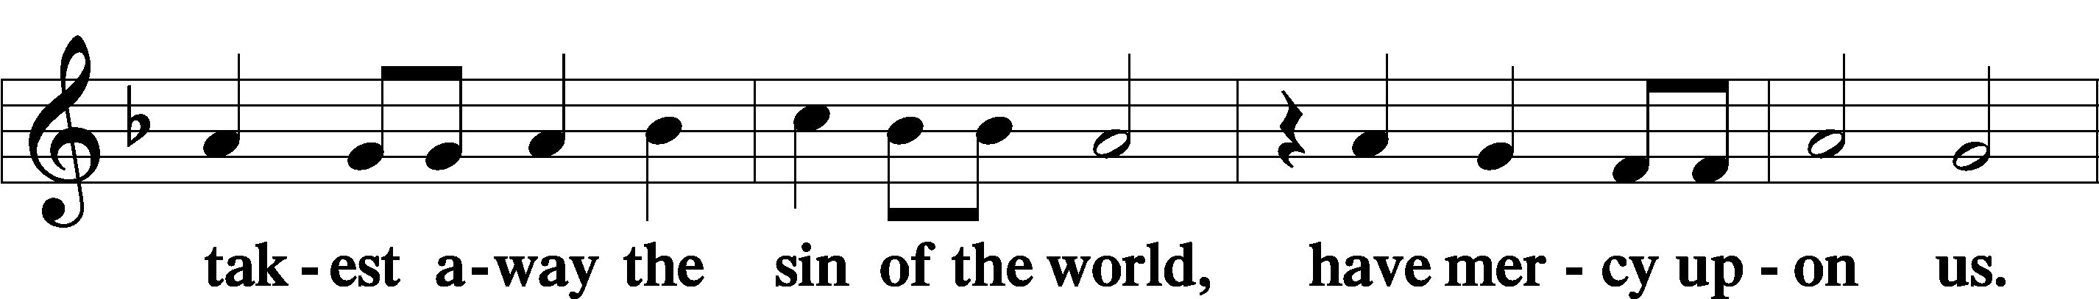
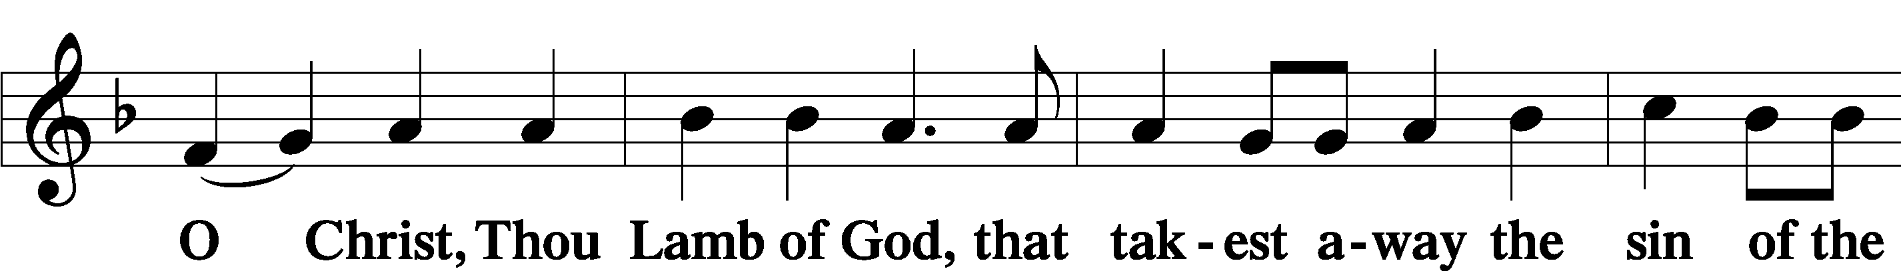
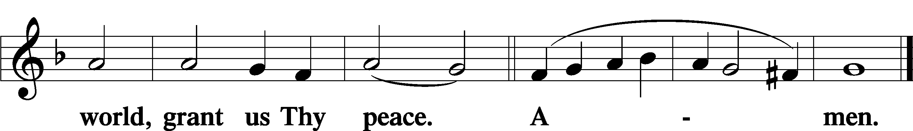

Sit

Distribution

The pastor and those who assist him receive the body and blood of Christ first and then distribute them to those who come to receive, saying:

Take, eat; this is the true body of our Lord and Savior Jesus Christ, given into death for your sins.
Amen.

Take, drink; this is the true blood of our Lord and Savior Jesus Christ, shed for the forgiveness of your sins.
Amen.

In dismissing the communicants, the following is said:

The Dismissal
P The body and blood of our Lord Jesus Christ strengthen and preserve you in body and soul to life everlasting. Depart T in peace.
C Amen.

948 All Glory Be to God Alone
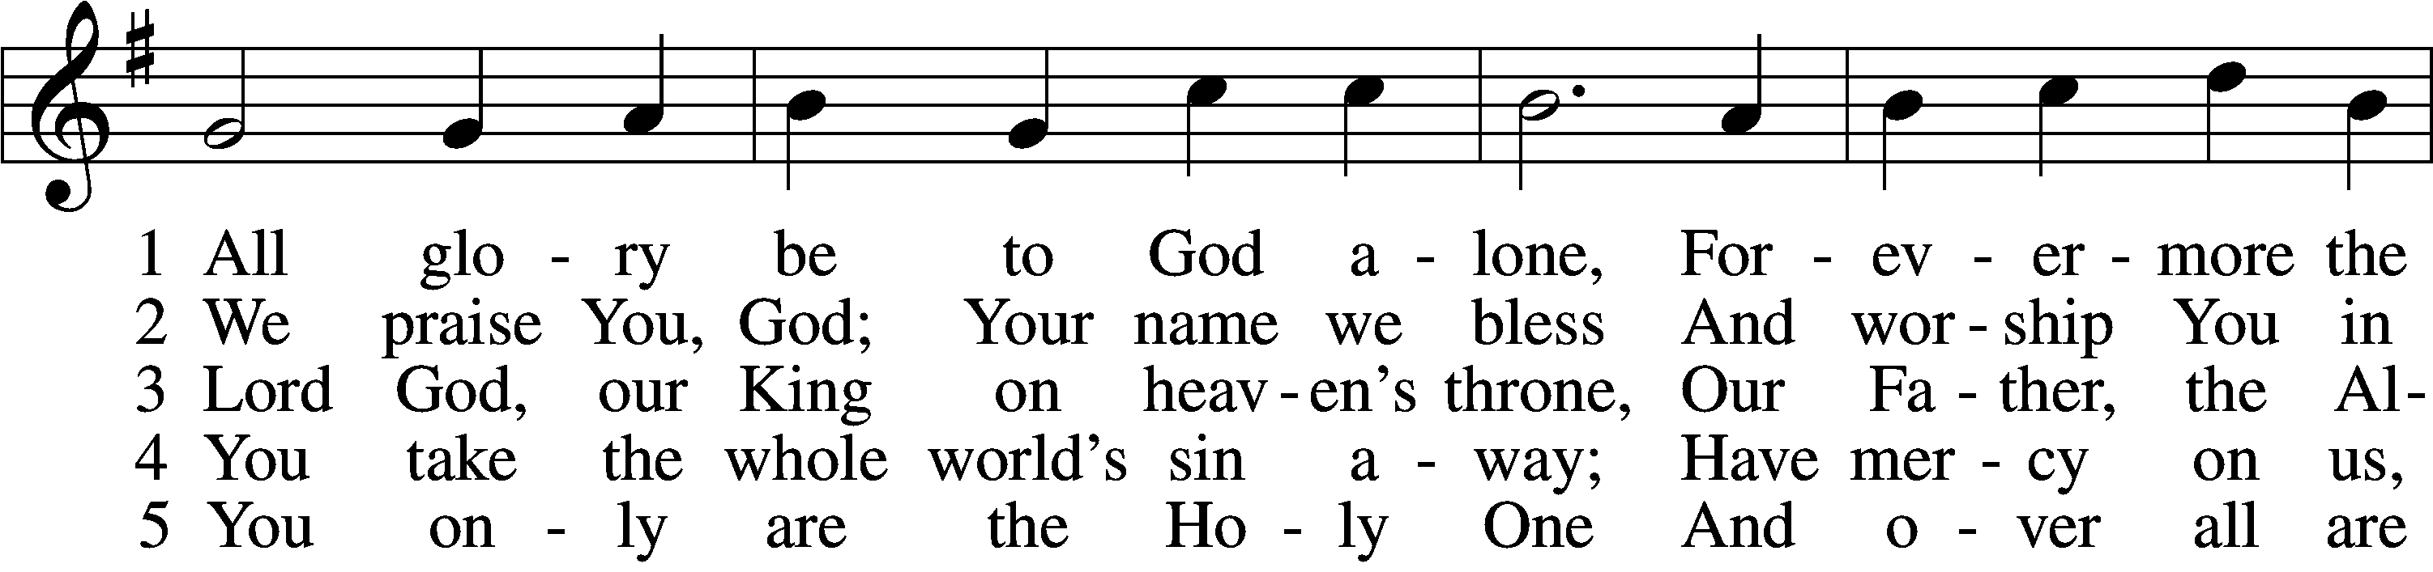
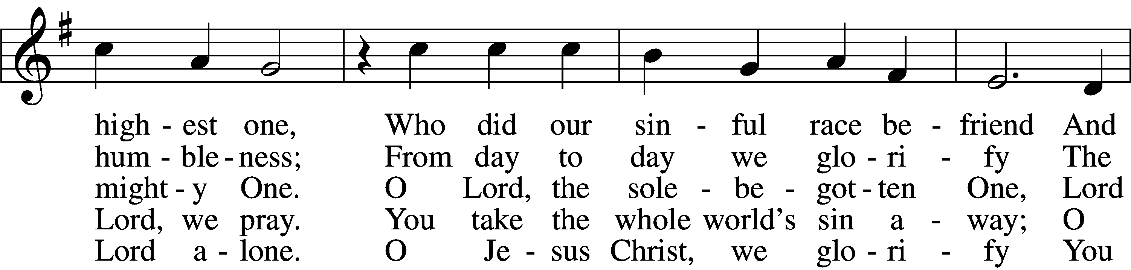
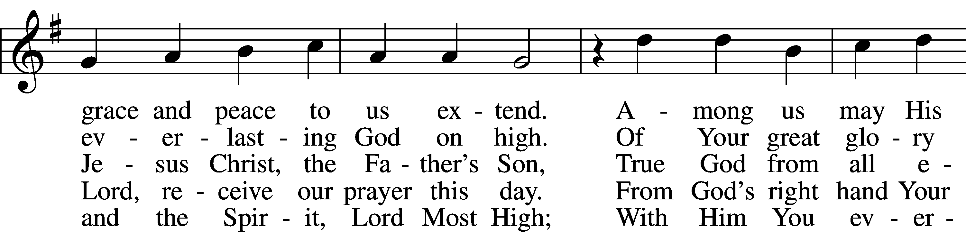
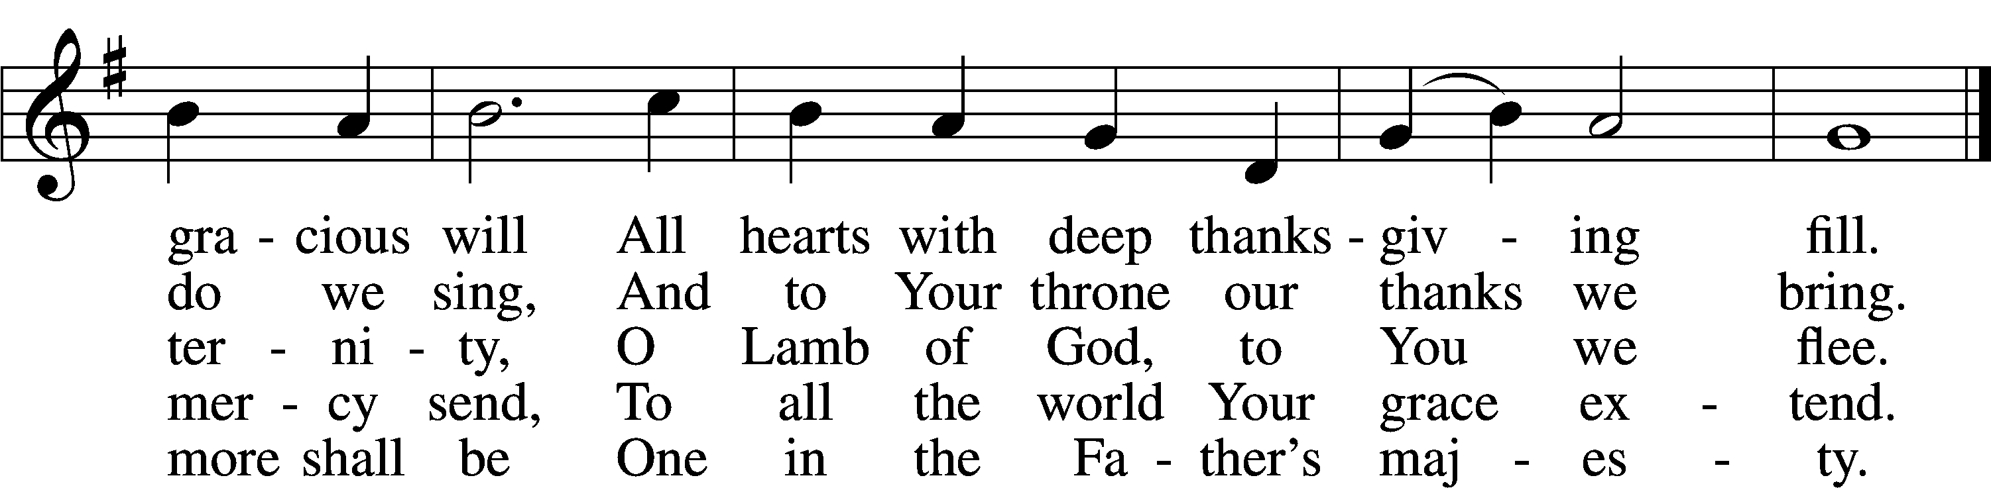
Text: attr. Martin Luther, 1483–1546, abr.; tr. W. Gustave Polack, 1890–1950, alt.
Tune: Gesangbuch . . . Psalmen, Geistliche Lieder, 1541, Strassburg, alt.
Text: © 1941 Concordia Publishing House. Used by permission: LSB Hymn License no. 110005011
Tune: Public domain

876 O Blessed, Holy Trinity
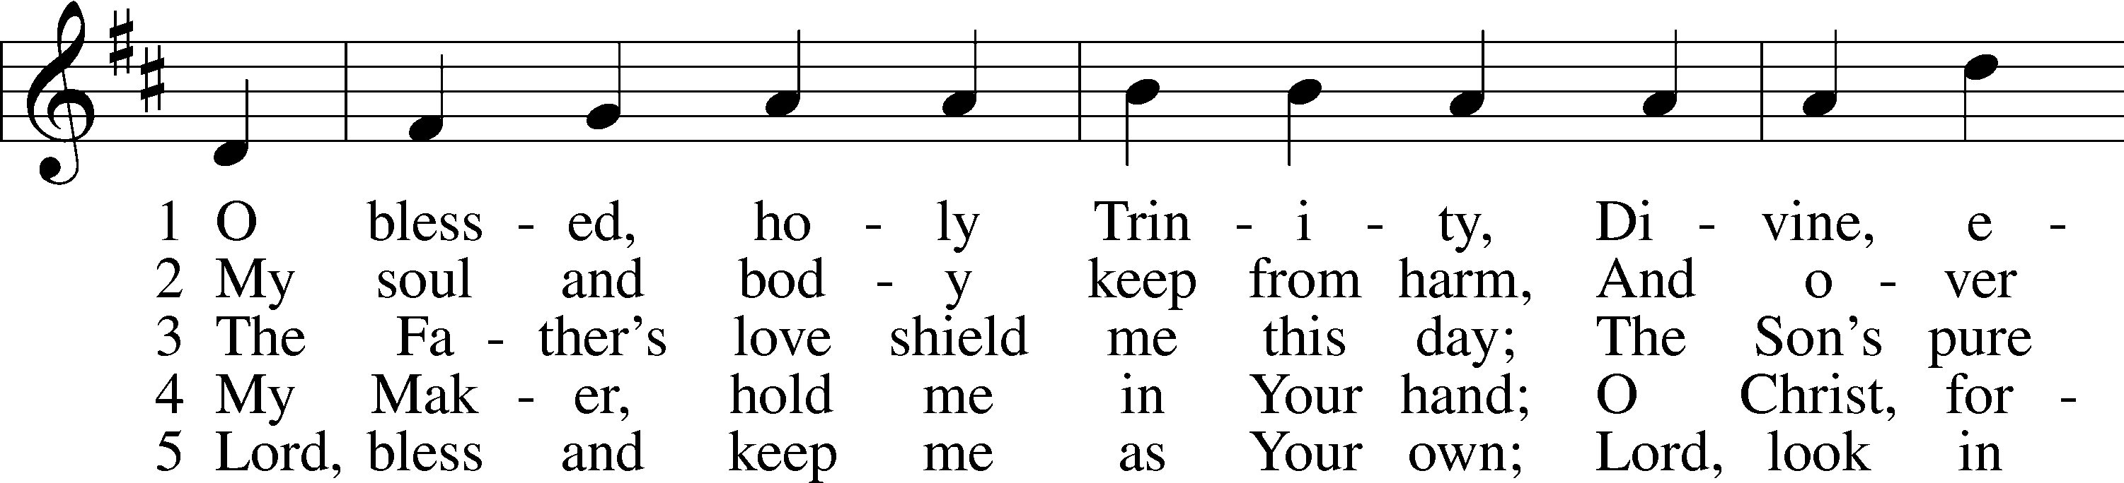
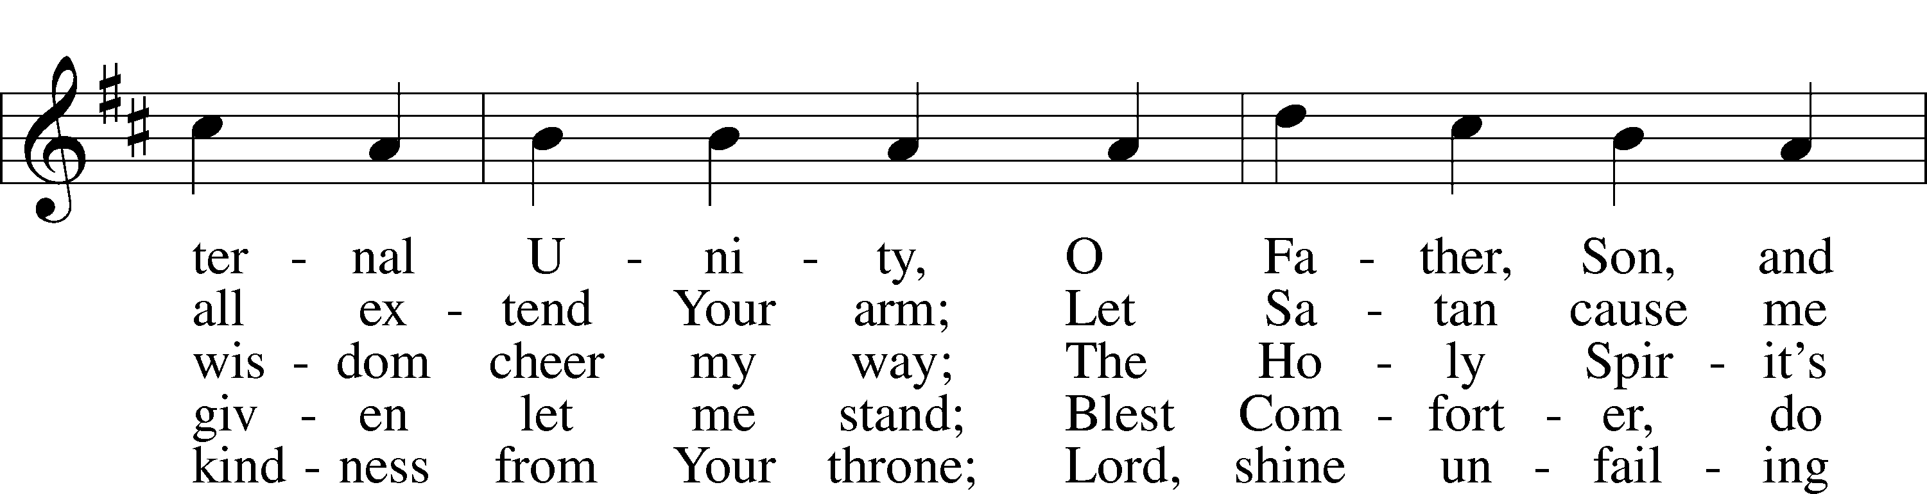
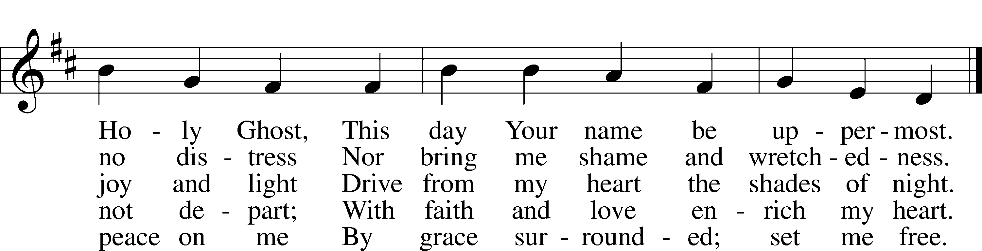
Text: Martin Behm, 1557–1622; tr. Conrad H. L. Schuette, 1843–1926, alt.
Tune: Nicolaus Herman, c. 1480–1561
Text and tune: Public domain

953 We All Believe in One True God
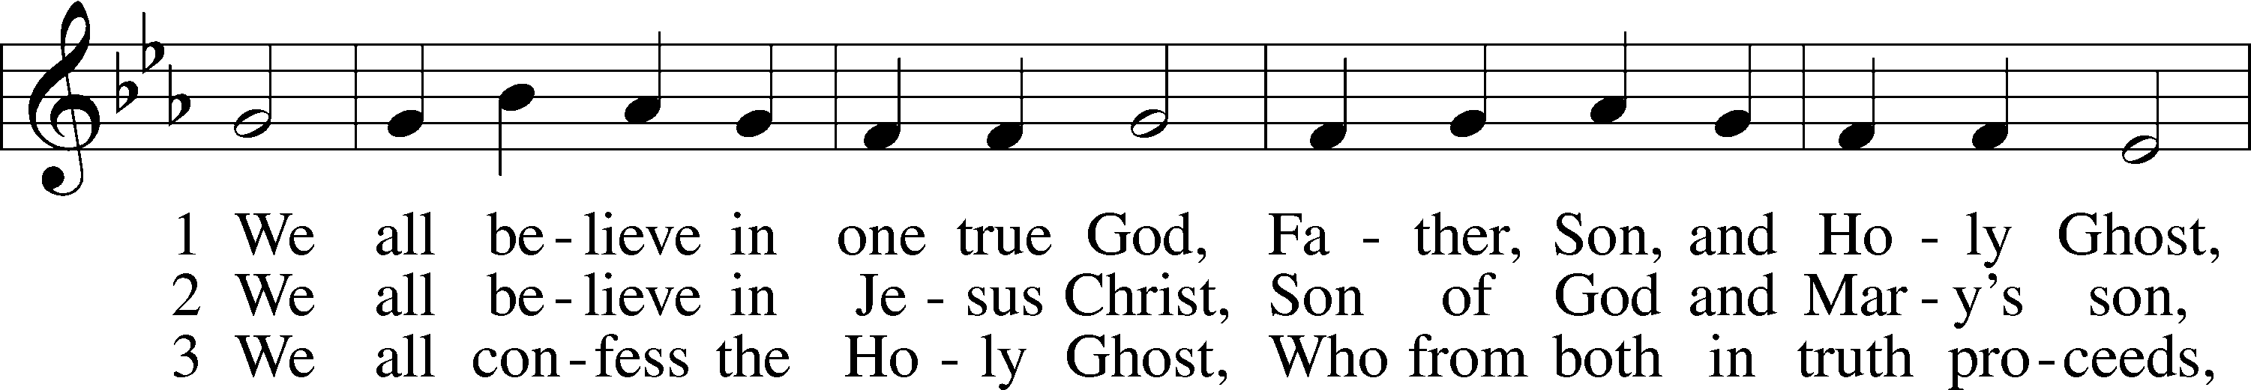
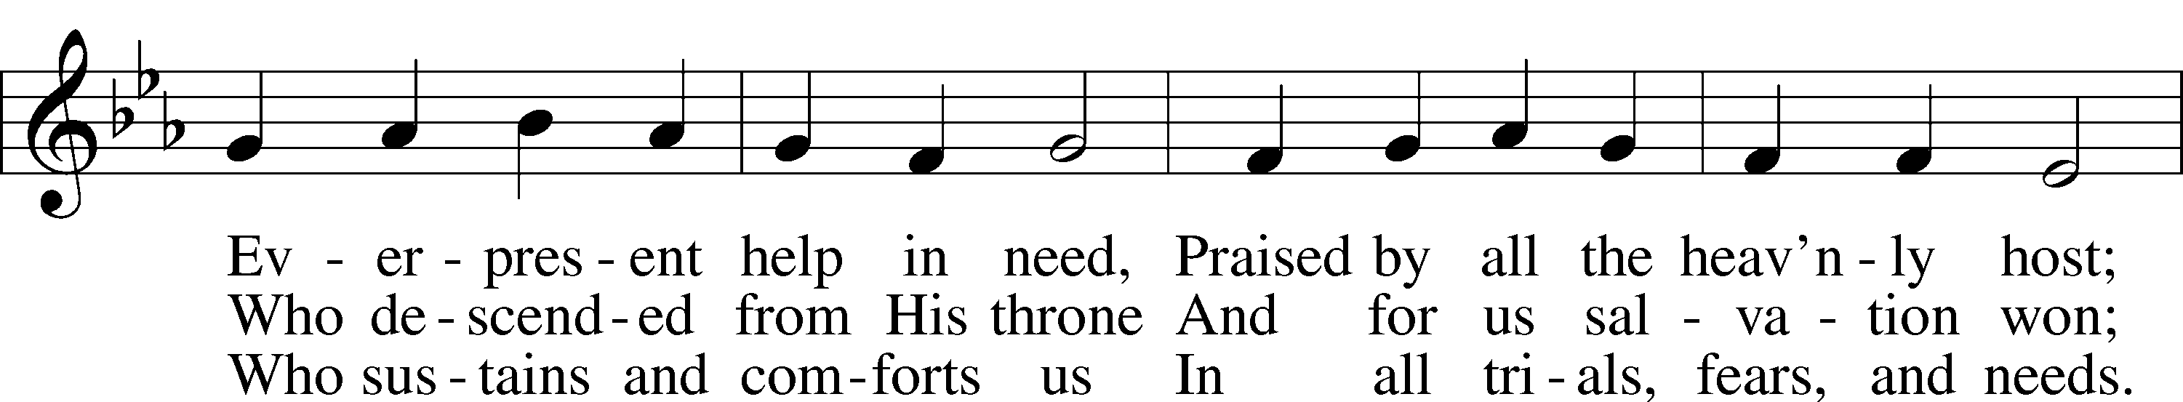
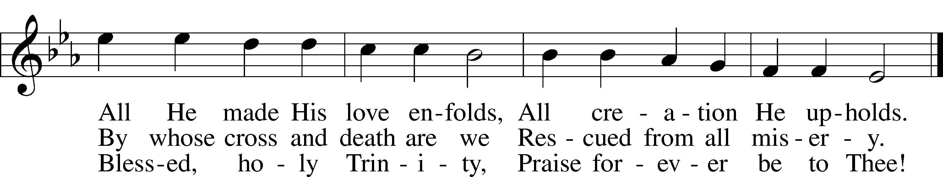
Text: Tobias Clausnitzer, 1619–84; tr. Catherine Winkworth, 1827–78, alt.
Tune: Neu-vermehrtes . . . Gesangbuch, 1693, 3rd ed., Meiningen
Text and tune: Public domain

947 All Glory Be to God on High
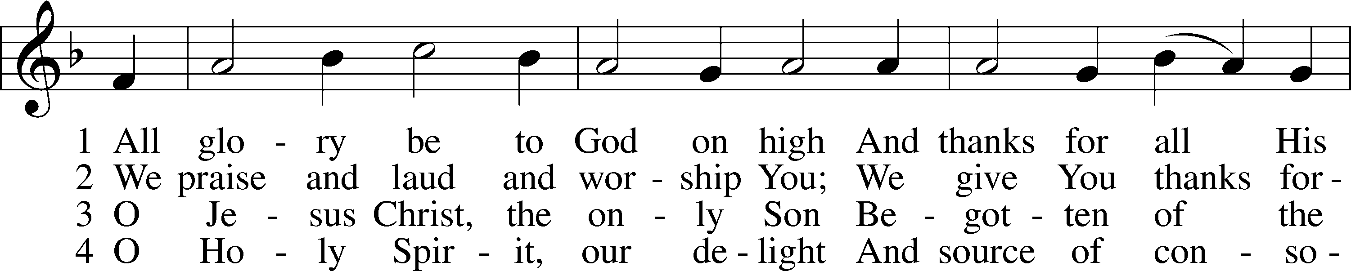
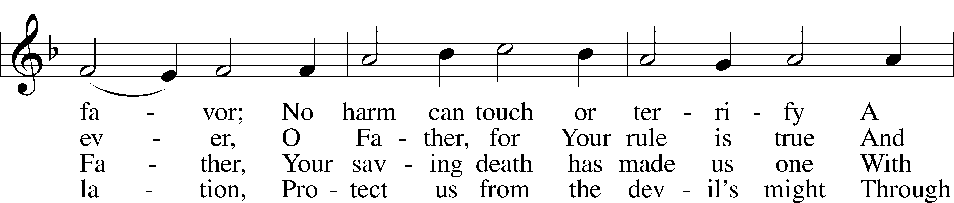
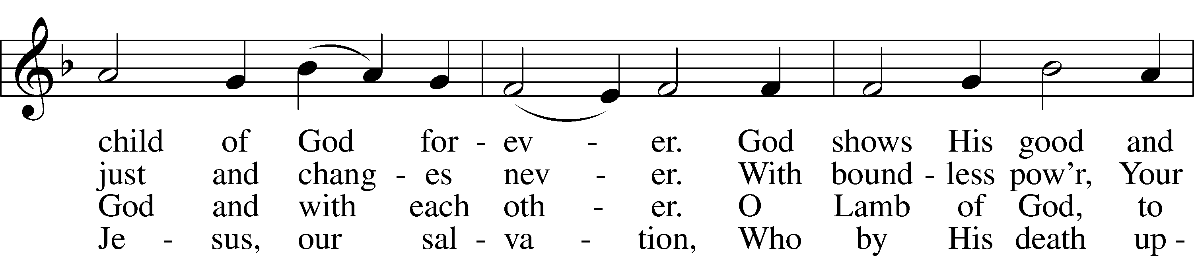
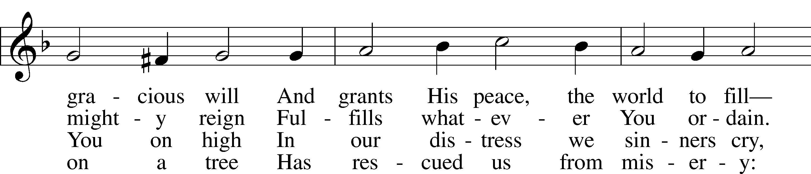
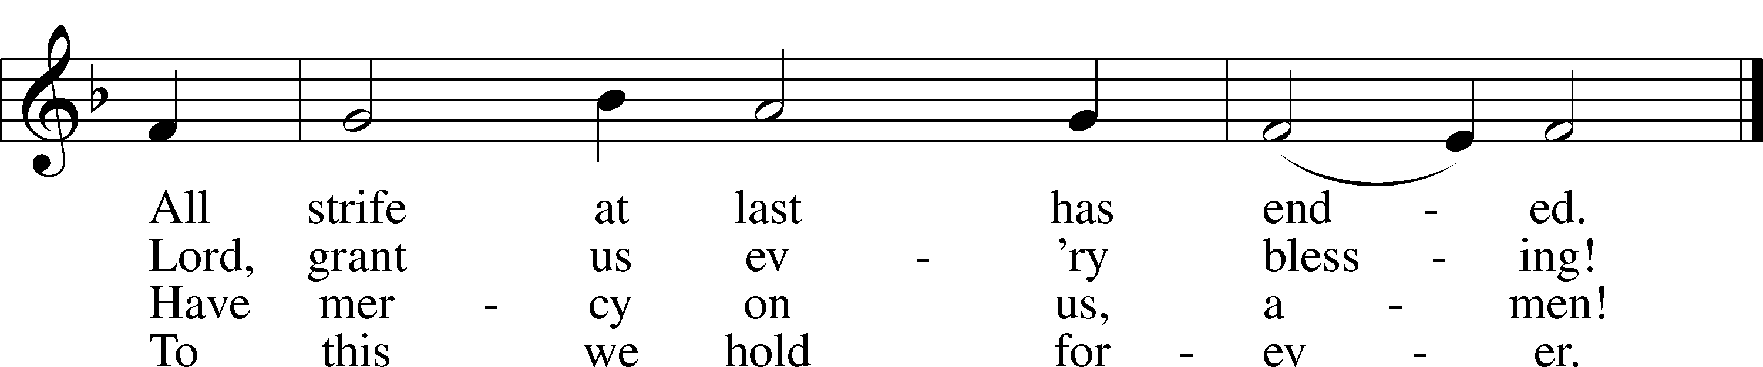
Text: Nicolaus Decius, c. 1485–after 1546; tr. Lutheran Service Book, 2006
Tune: attr. Nicolaus Decius, c. 1485–after 1546
Text: © 2006 Concordia Publishing House. Used by permission: LSB Hymn License no. 110005011
Tune: Public domain

Stand

Nunc Dimittis Luke 2:29–32
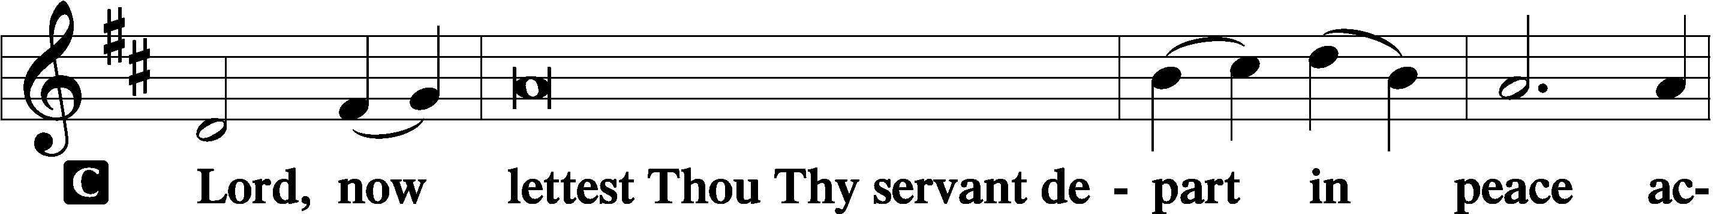

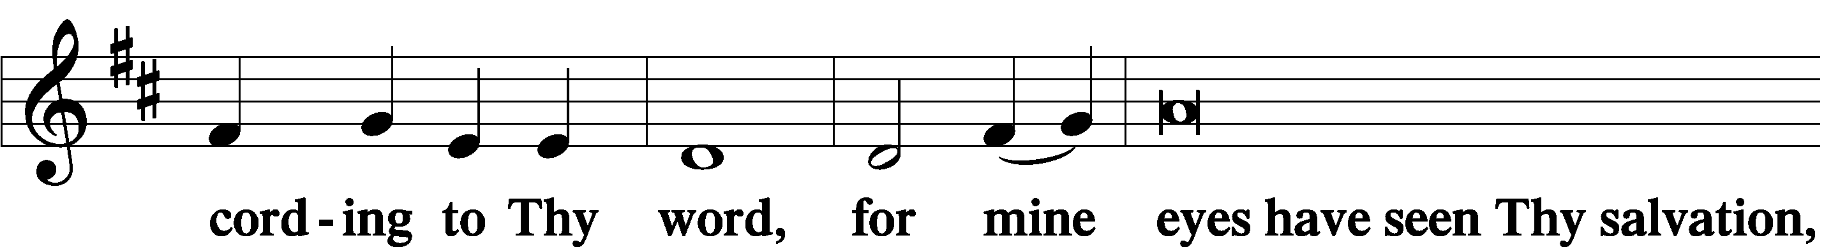

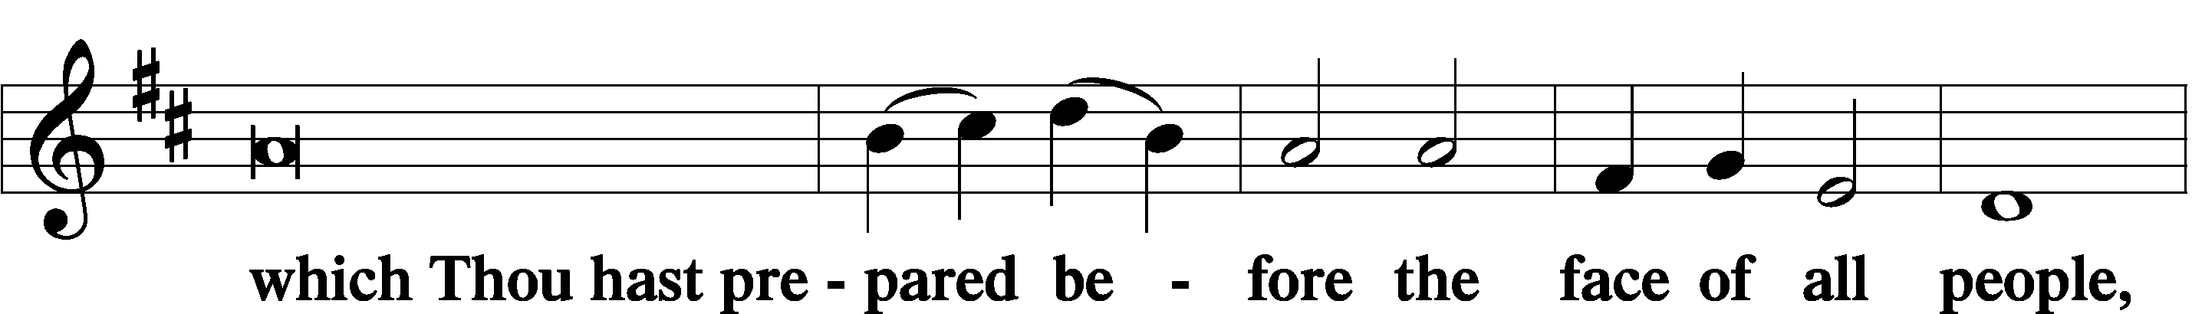

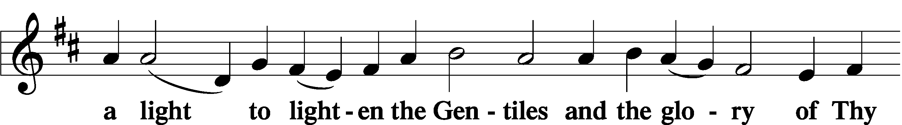

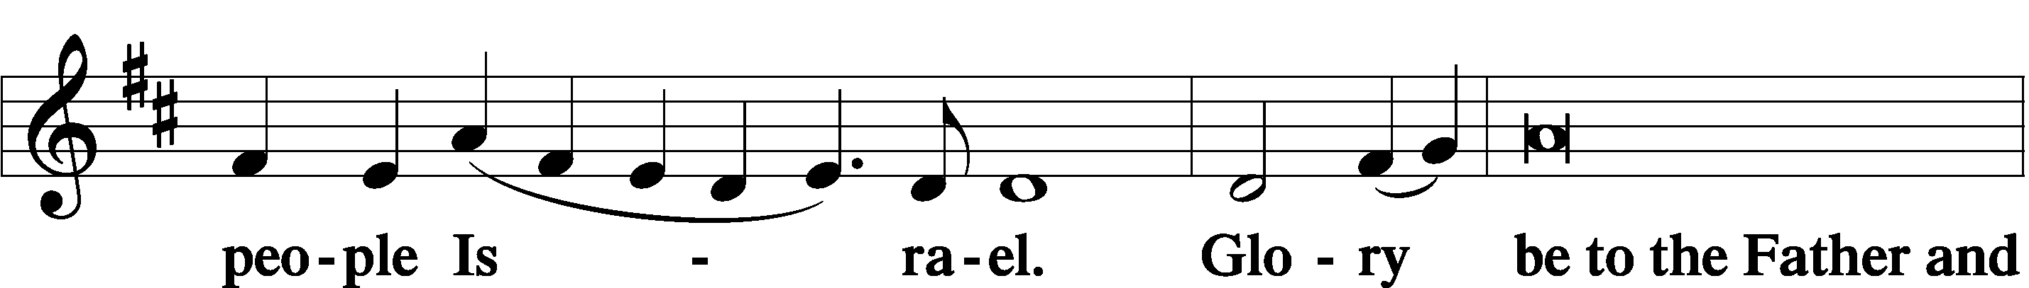

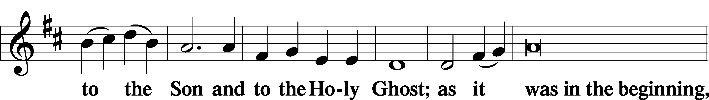

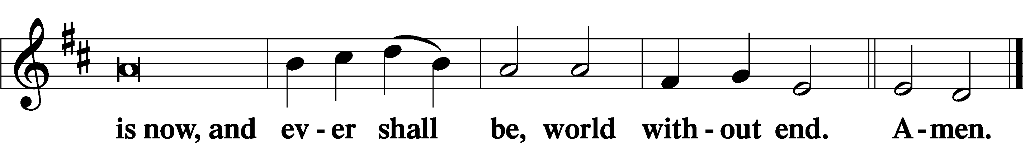

Thanksgiving Psalm 107:1
A O give thanks unto the Lord, for He is good,

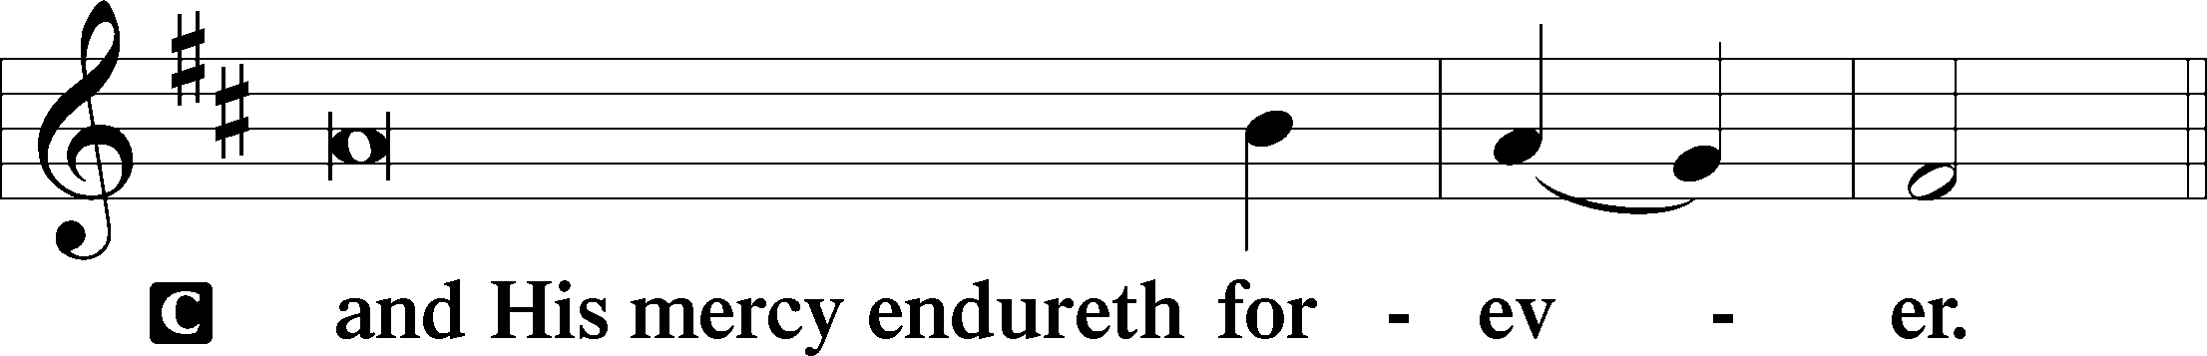

Post-Communion Collect
A Let us pray.
We give thanks to You, almighty God, that You have refreshed us through this salutary gift, and we implore You that of Your mercy You would strengthen us through the same in faith toward You and in fervent love toward one another; through Jesus Christ, Your Son, our Lord, who lives and reigns with You and the Holy Spirit, one God, now and forever.

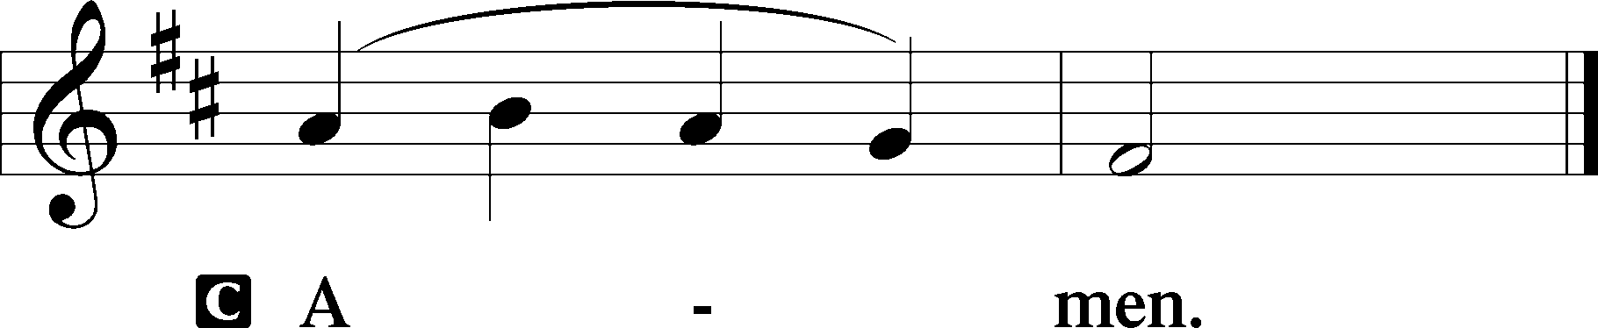

Salutation 2 Timothy 4:22
P The Lord be with you.

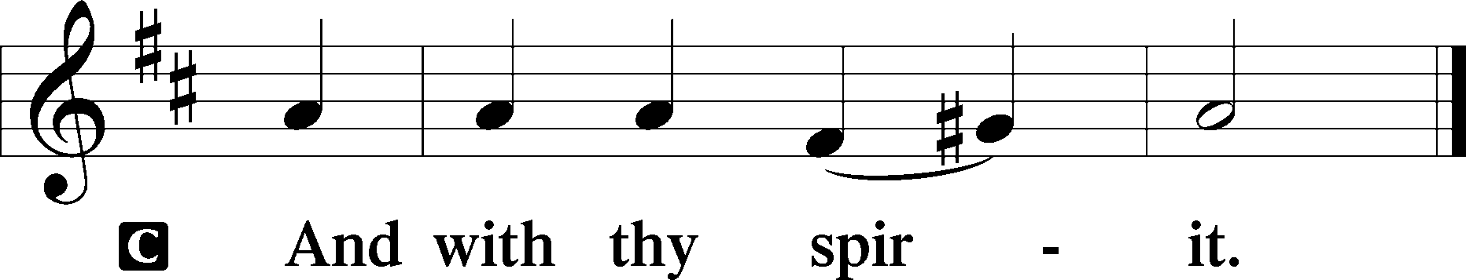

Benedicamus Psalm 103:1
A Bless we the Lord.

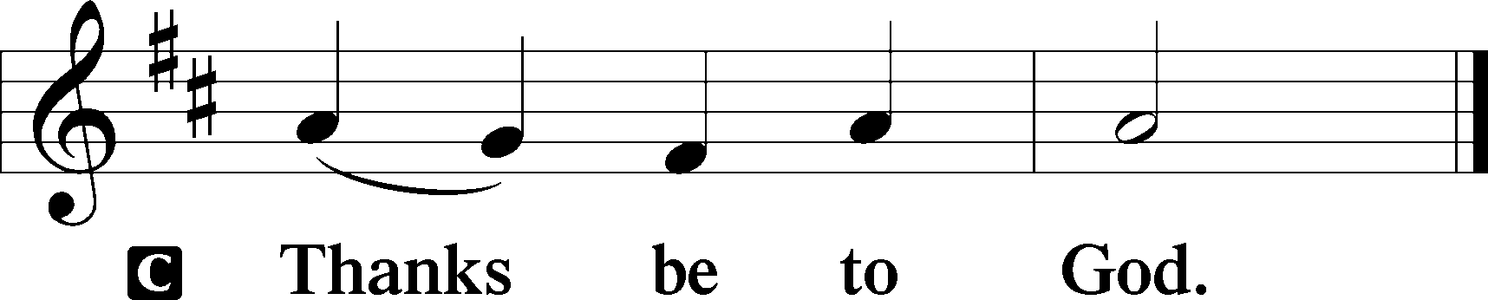

Benediction Numbers 6:24–26
P The Lord bless you and keep you.
The Lord make His face shine upon you and be gracious unto you.
The Lord lift up His countenance upon you and T give you peace.
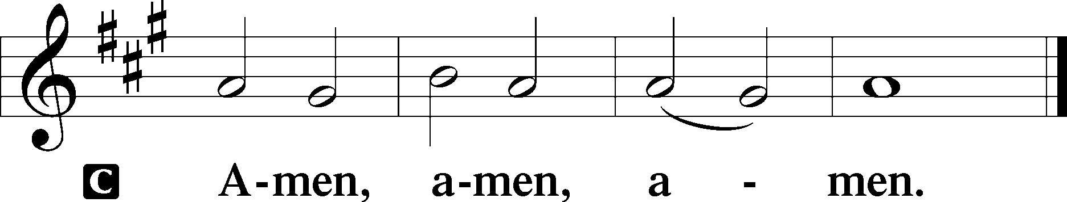

507 Holy, Holy, Holy sts. 1–4
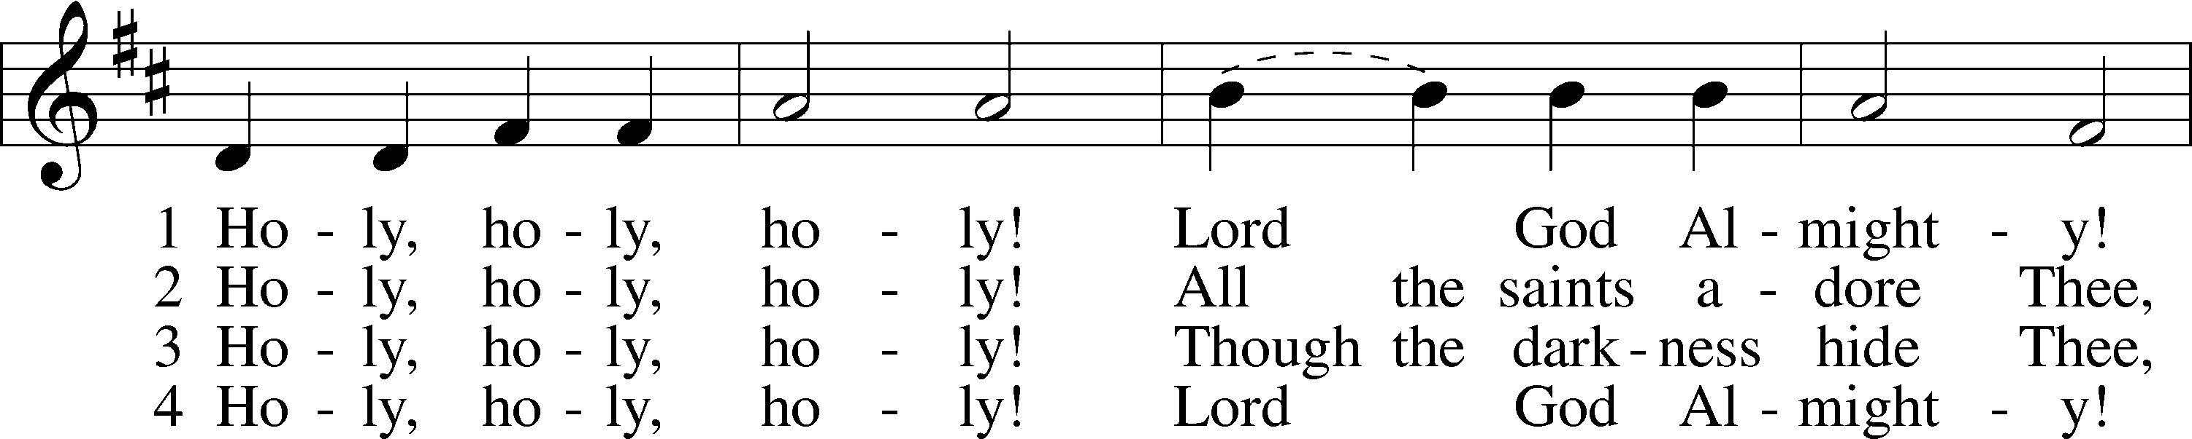
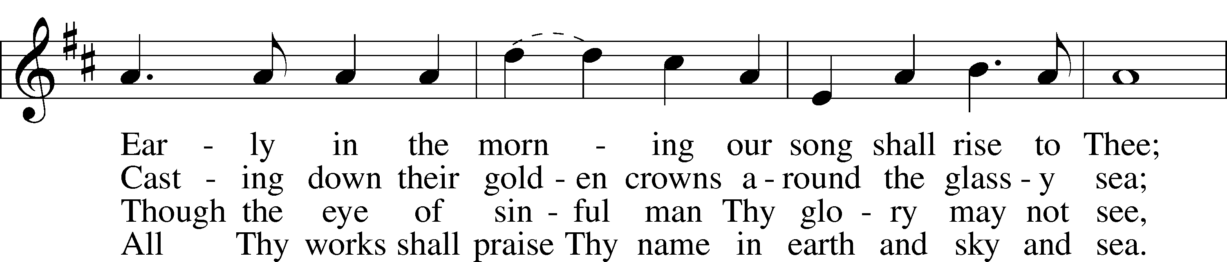
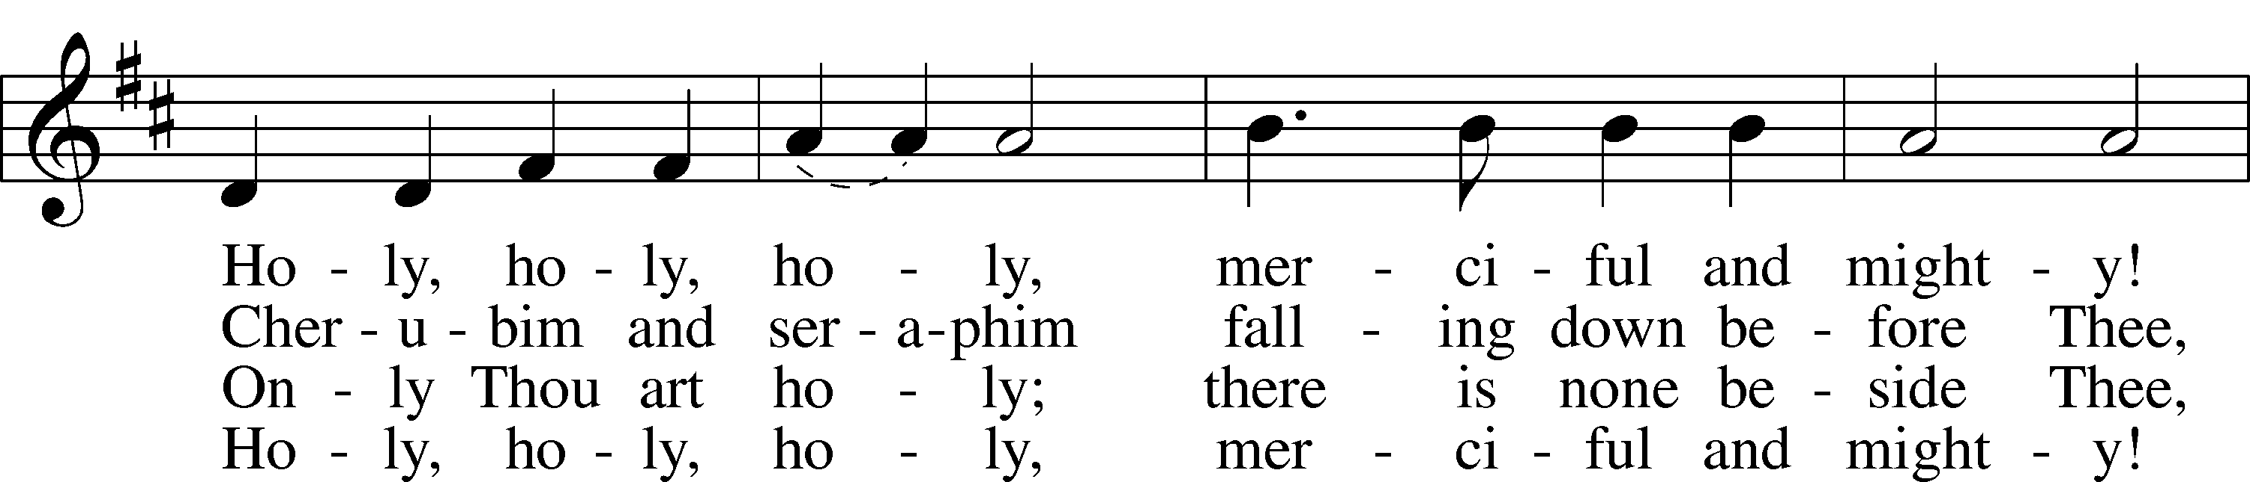
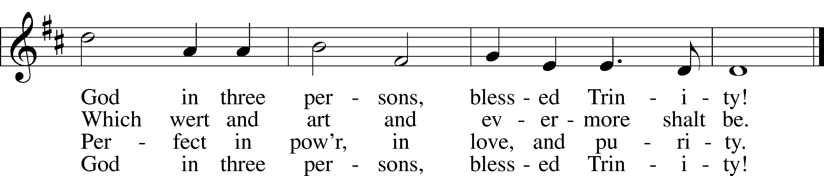
Text: Reginald Heber, 1783–1826
Tune: John B. Dykes, 1823–76
Text and tune: Public domain
Acknowledgments
Divine Service, Setting Three from Lutheran Service Book
Unless otherwise indicated, Scripture quotations are from the ESV® Bible (The Holy Bible, English Standard Version®), copyright © 2001 by Crossway, a publishing ministry of Good News Publishers. Used by permission. All rights reserved.
Created by Lutheran Service Builder © 2026 Concordia Publishing House.

