

December 2024

The Lord bless you and keep you.

The Lord make His face shine upon you and be gracious unto you.

The Lord lift up His countenance upon you and give you peace.

These three sentences are spoken at the end of each service. As we close this past church year and look forward to the next, these blessings of Aaron to the Israelites seem appropriate.
We are entering the Advent season. While I was growing up, the color of Advent was purple. Advent was a penitential season, a season of being sorry for our sins. In order to be forgiven of our sins, we must first be penitent of them. Later on, around the time that the church transitioned from The Lutheran Hymnal (red hymnal) to Lutheran Worship (blue hymnal), the color for Advent was changed to blue.
Blue, is the more contemporary color increasingly used by many congregations in their observance of a new church year. Advent, a preparatory time of waiting and watching, communicates the message of hope. Blue, the color of the sky, helps convey that powerful message. Our Christian faith rests on the hope that Christ, who came in history assuming our flesh, will also return on the last day of time from that same blue sky he ascended long ago.
Advent is still preparing us for the coming of the Christ. We remember the first coming, the virgin birth in the manger. We also look forward to the second coming, the judgement day of our Lord.

⁸ And in the same region there were shepherds out in the field, keeping watch over their flock by night. ⁹ And an angel of the Lord appeared to them, and the glory of the Lord shone around them, and they were filled with great fear. ¹⁰ And the angel said to them, “Fear not, for behold, I bring you good news of great joy that will be for all the people. ¹¹ For unto you is born this day in the city of David a Savior, who is Christ the Lord. ¹² And this will be a sign for you: you will find a baby wrapped in swaddling cloths and lying in a manger.” ¹³ And suddenly there was with the angel a multitude of the heavenly host praising God and saying,
¹⁴ “Glory to God in the highest,
and on earth peace among those with whom he is pleased!”

Pastor De Young
<><

From the Pastor:
In our divine service, there are many parts of the liturgy (order of service) that should be explained. Over the next series of newsletters, we will be including an explanation of what is happening during each of these parts of the service (these explanations are found on the LCMS website).

About Lutheran Worship Parts of the Liturgy
Benediction
“The Lord bless you and keep you.”
Recall again the words of Jesus in the parable of the sheep and the goats: “Come, you who are blessed by my father, inherit the kingdom.”
The blessing that God speaks to us in the Benediction prepares us for that final summons. Throughout the Divine Service, God is forming us in his likeness as he establishes in us a deeper and more lasting faith toward him and a persistent and steadfast love for one another.
“The Lord make His face shine upon you and be gracious unto you.”
In their reports of Jesus' Transfiguration, the evangelists tell us that Jesus shone more brightly than the sun, prompting Peter to say, “Lord, it is good for us to be here.”
In heaven we will have the same response because it will be good — very good — to be in the presence of the Light of the world.
For the moment, we see only dimly, but then we will see face to face. Still, it is good to be here even now, in this heaven on earth that we call worship, for already here God showers us with his grace.
“The Lord lift up his countenance upon you and give you peace.”
We Christians are truly blessed in that God does not hide his face from us. In all other religions there is ultimately doubt as to their gods' attitudes toward them.
How can it be otherwise, given that their gods are the creation of their own imaginations? But ours is the creator of heaven and earth.
To be sure, he is a stern judge who holds the sinner accountable. But in the person of his only Son, we see our Father's true nature, his fatherly heart of love. That is the countenance that he lifts up toward us in his holy Word and Sacraments as he reveals his mercy and grace.
Where the Lord blesses and makes his face shine and lifts up his gracious countenance on us, there is peace. Not the peace of this world, but peace between God and his faithful people.
We know that peace because even now, in Word and Sacraments, we have Jesus and all his benefits. And in heaven we will rest in his eternal peace.

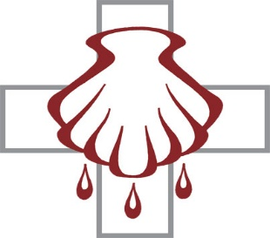
Celebrate December’s Baptism Birthdays
& their years as heirs of God’s kingdom!

Date | Name | Years
1st | Amanda Gilmore | 34
 | Brent Shaw | 27
3rd | Debbie Jones | 35
8th | Ethan Lindley | 22
13th | Todd Hammer | 65
20th | Cody Lawson | 43
25th | Bailey Anderson | 30
 | Grace George | 5
31st | Davin George | 7

Serving in God’s House this month
Elder of the Month | William Pickett
Counters | Brent Husfeld / Darren Gill
Altar Guild | Kristin Henry / Rebecca Horton
Altar Care | Maci Ferguson / Jana Gilmore / Monica Mayfield

Week | Acolytes | Reader
December 01 | Parker Lawson and Annallee Osbon | Lee Hughes
December 08 | Davin George and Max Gilmore | Arn Anderson
December 15 | Charlie Pace & Rayleigh Pace | Bryan Roth
December 22 | Karlee Hughes & Emily Keyes | William Pickett
December 29 | Bella Caswell & Ailey Pickett | Lee Hughes








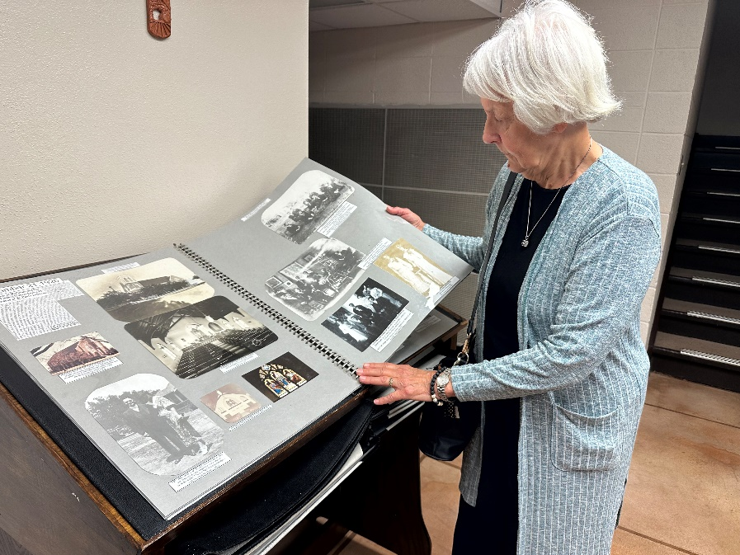
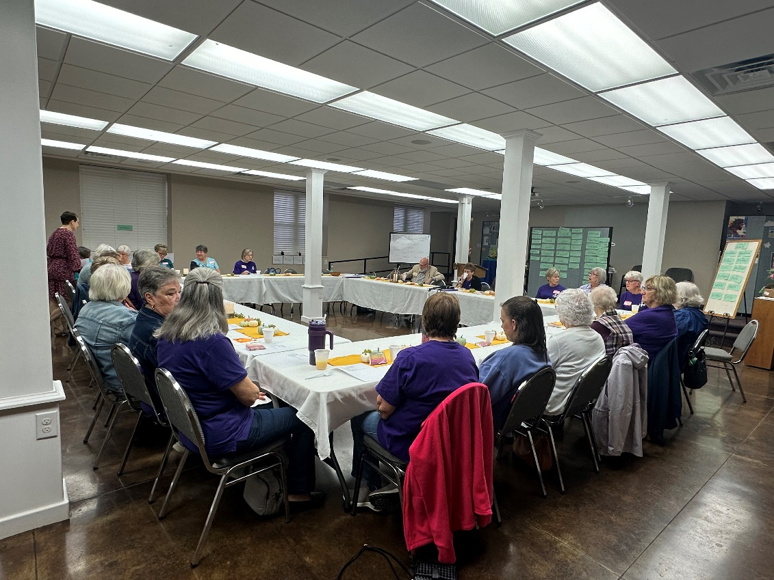
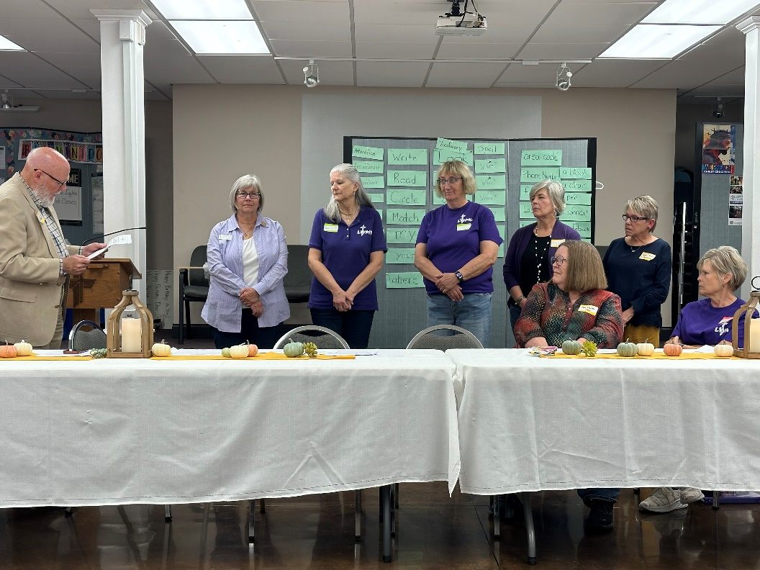
The LWML Red River Fall Rally Appointed New Officers




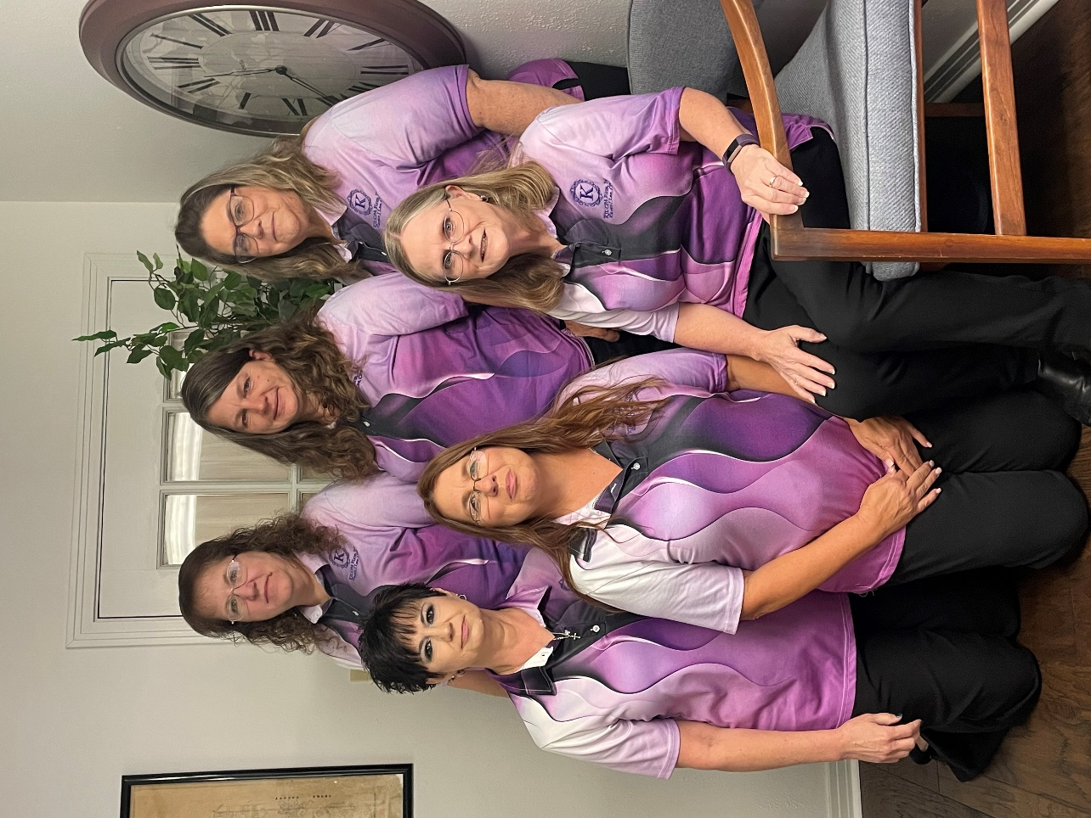



Karen Lee’s Firm had a Ribbon-Cutting Ceremony




The Midweek kids are having fun!
