Baptism of Henry Riker Dyson pg. 268

On entering the church

P Lord, I love the habitation of Your house and the place

where Your glory dwells. In the multitude of Your tender

mercies prepare my heart that I may enter Your house to

worship and confess Your holy name; through Jesus Christ,

my God and Lord.

Before worship

C O Lord, our creator, redeemer, and comforter, as we come

together to worship You in spirit and in truth, we humbly

pray that You would open our hearts to the preaching of

Your Word so that we may repent of our sins, believe in

Jesus Christ as our only Savior, and grow in grace and

holiness. Hear us for His sake.

912 Christ Is Our Cornerstone

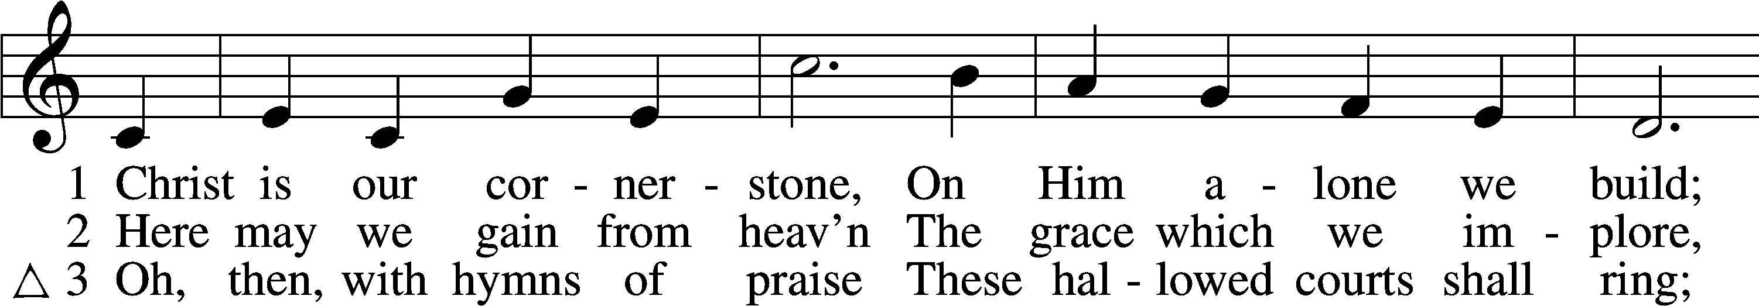

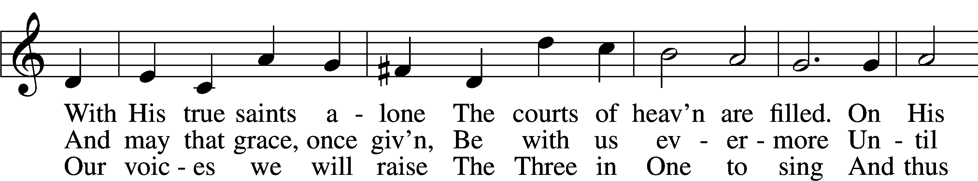

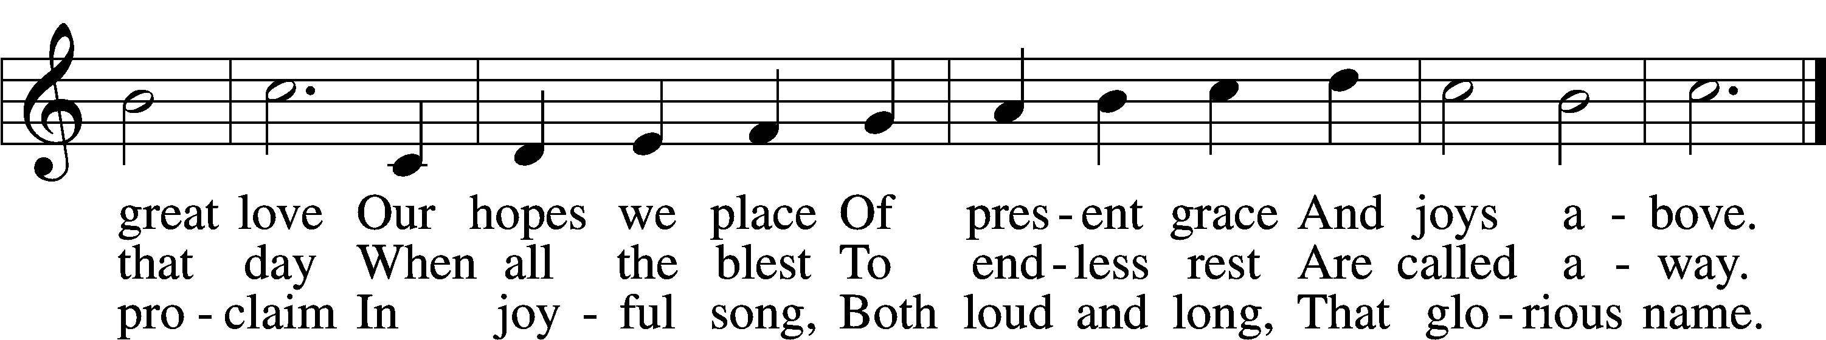

Text: Latin, c. 8th cent.; tr. John Chandler, 1806–76, alt.  
Tune: John Darwall, 1731–89  
Text and tune: Public domain

# Confession and Absolution

Stand

The sign of the cross may be made by all in remembrance of their Baptism.

Invocation Matthew 28:19b; 18:20

P In the name of the Father and of the T Son and of the Holy Spirit.

C **Amen.**

Exhortation Hebrews 10:22; Psalm 124:8; Psalm 32:5

P Beloved in the Lord! Let us draw near with a true heart and confess our sins unto God our Father, beseeching Him in the name of our Lord Jesus Christ to grant us forgiveness.

P Our help is in the name of the Lord,

C **who made heaven and earth.**

P I said, I will confess my transgressions unto the Lord,

C **and You forgave the iniquity of my sin.**

Kneel/Stand

Silence for reflection on God’s Word and for self-examination.

Confession of Sins

P O almighty God, merciful Father,

C **I, a poor, miserable sinner, confess unto You all my sins and iniquities with which I have ever offended You and justly deserved Your temporal and eternal punishment. But I am heartily sorry for them and sincerely repent of them, and I pray You of Your boundless mercy and for the sake of the holy, innocent, bitter sufferings and death of Your beloved Son, Jesus Christ, to be gracious and merciful to me, a poor, sinful being.**

Absolution [John 20:19–23]

P Upon this your confession, I, by virtue of my office, as a called and ordained servant of the Word, announce the grace of God unto all of you, and in the stead and by the command of my Lord Jesus Christ I forgive you all your sins in the name of the Father and of the T Son and of the Holy Spirit.

C **Amen.**

Stand

# Service of the Word

Introit Psalm 3:3–6; antiphon: v. 8

Salvation belongs to the Lord;  
 your blessing be on your people!  
**But you, O Lord, are a shield about me,  
 my glory, and the lifter of my head.**I cried aloud to the Lord,  
 and he answered me from his holy hill.  
**I lay down and slept;  
 I woke again, for the Lord sustained me.**I will not be afraid of many thousands of people  
 who have set themselves against me all around.

Gloria Patri

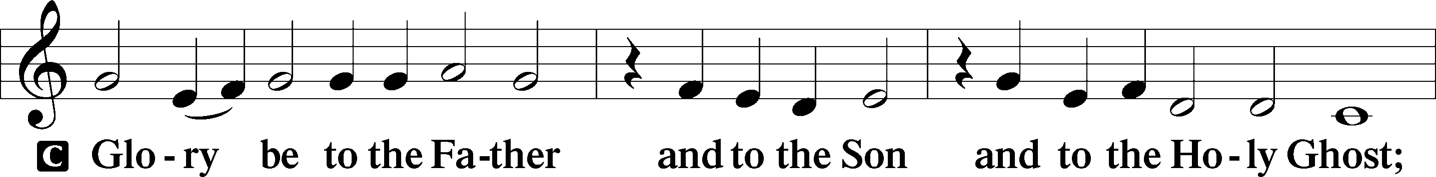

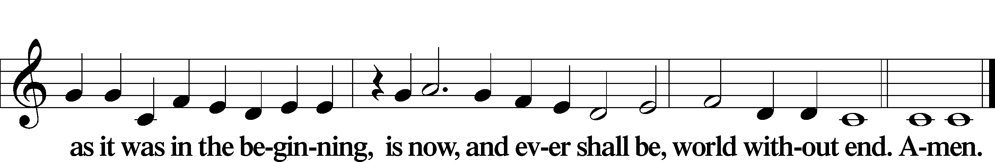

Kyrie Mark 10:47

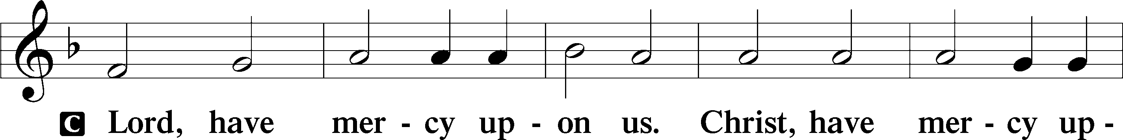

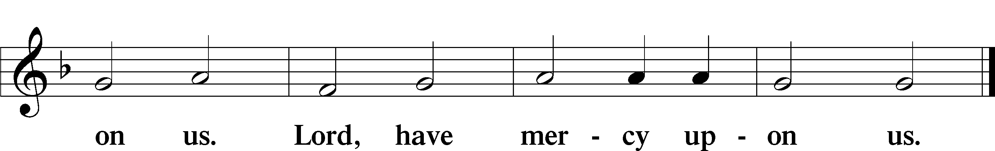

Salutation and Collect of the Day

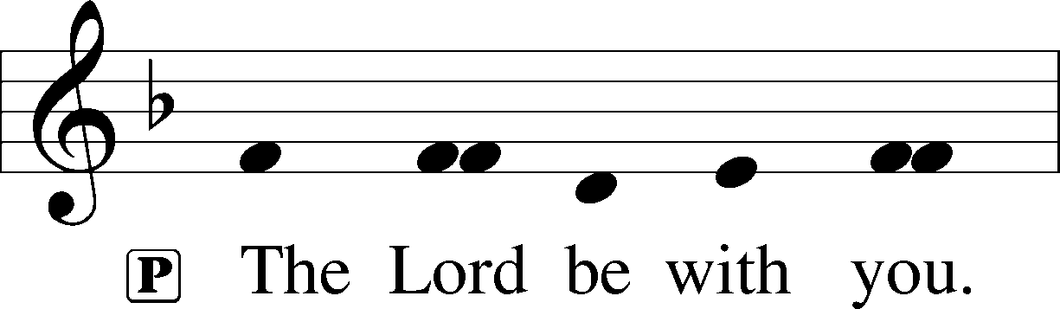

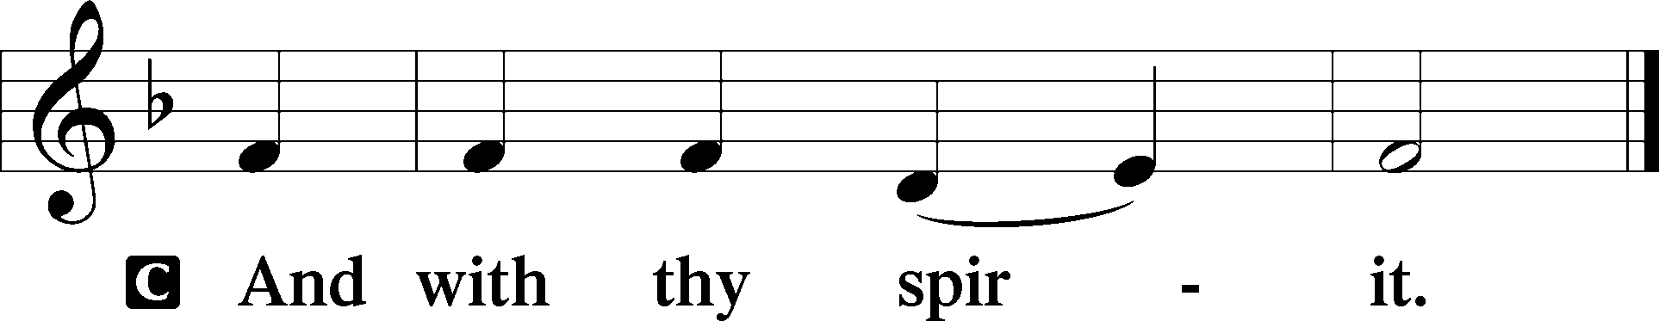

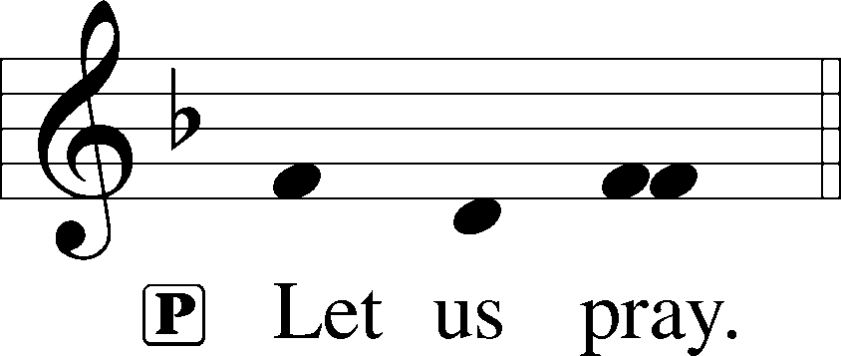

P Almighty God, by Your great goodness mercifully look upon Your people that we may be governed and preserved evermore in body and soul; through Jesus Christ, Your Son, our Lord, who lives and reigns with You and the Holy Spirit, one God, now and forever.

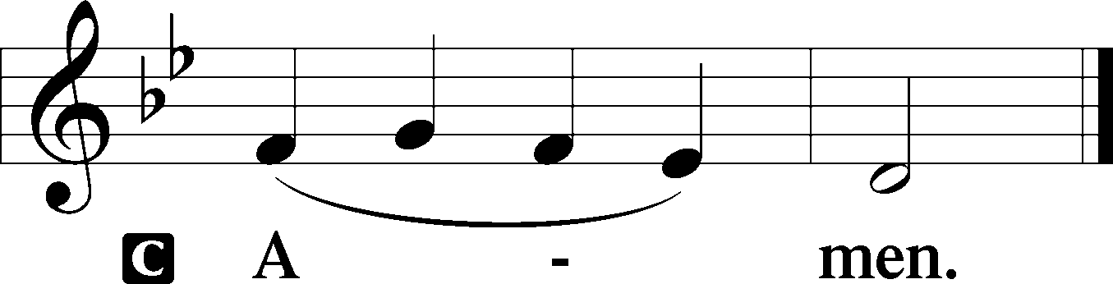

Sit

Old Testament Reading Isaiah 43:16–21

16Thus says the Lord,  
 who makes a way in the sea,  
 a path in the mighty waters,  
17who brings forth chariot and horse,  
 army and warrior;  
they lie down, they cannot rise,  
 they are extinguished, quenched like a wick:  
18“Remember not the former things,  
 nor consider the things of old.  
19Behold, I am doing a new thing;  
 now it springs forth, do you not perceive it?  
I will make a way in the wilderness  
 and rivers in the desert.  
20The wild beasts will honor me,  
 the jackals and the ostriches,  
for I give water in the wilderness,  
 rivers in the desert,  
to give drink to my chosen people,  
 21the people whom I formed for myself  
that they might declare my praise.”

A This is the Word of the Lord.

C **Thanks be to God.**

Gradual Hebrews 12:2

[O come, let us fix our eyes on] Jesus,  
 the founder and perfecter of our faith,  
**who for the joy that was set before him endured the cross, despising the shame,  
 and is seated at the right hand of the throne of God.**

Epistle Philippians 3:8–14

8Indeed, I count everything as loss because of the surpassing worth of knowing Christ Jesus my Lord. For his sake I have suffered the loss of all things and count them as rubbish, in order that I may gain Christ 9and be found in him, not having a righteousness of my own that comes from the law, but that which comes through faith in Christ, the righteousness from God that depends on faith— 10that I may know him and the power of his resurrection, and may share his sufferings, becoming like him in his death, 11that by any means possible I may attain the resurrection from the dead.

12Not that I have already obtained this or am already perfect, but I press on to make it my own, because Christ Jesus has made me his own. 13Brothers, I do not consider that I have made it my own. But one thing I do: forgetting what lies behind and straining forward to what lies ahead, 14I press on toward the goal for the prize of the upward call of God in Christ Jesus.

A This is the Word of the Lord.

C **Thanks be to God.**

Stand

Holy Gospel Luke 20:9–20

P The Holy Gospel according to St. Luke, the twentieth chapter.

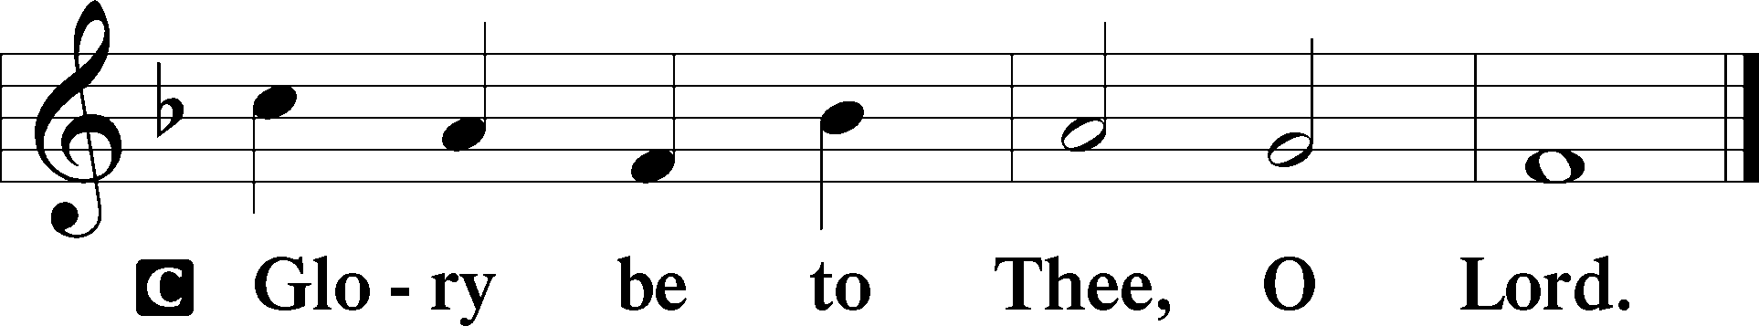

9[Jesus] began to tell the people this parable: “A man planted a vineyard and let it out to tenants and went into another country for a long while. 10When the time came, he sent a servant to the tenants, so that they would give him some of the fruit of the vineyard. But the tenants beat him and sent him away empty-handed. 11And he sent another servant. But they also beat and treated him shamefully, and sent him away empty-handed. 12And he sent yet a third. This one also they wounded and cast out. 13Then the owner of the vineyard said, ‘What shall I do? I will send my beloved son; perhaps they will respect him.’ 14But when the tenants saw him, they said to themselves, ‘This is the heir. Let us kill him, so that the inheritance may be ours.’ 15And they threw him out of the vineyard and killed him. What then will the owner of the vineyard do to them? 16He will come and destroy those tenants and give the vineyard to others.” When they heard this, they said, “Surely not!” 17But he looked directly at them and said, “What then is this that is written:

‘The stone that the builders rejected  
 has become the cornerstone’?

18Everyone who falls on that stone will be broken to pieces, and when it falls on anyone, it will crush him.”

19The scribes and the chief priests sought to lay hands on him at that very hour, for they perceived that he had told this parable against them, but they feared the people. 20So they watched him and sent spies, who pretended to be sincere, that they might catch him in something he said, so as to deliver him up to the authority and jurisdiction of the governor.

P This is the Gospel of the Lord.

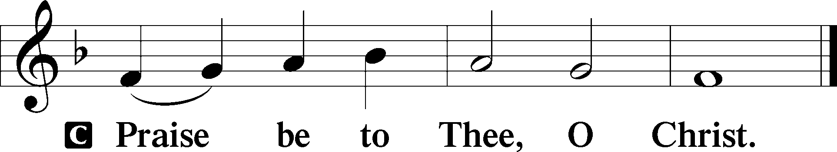

Nicene Creed

C **I believe in one God,**

**the Father Almighty,**

**maker of heaven and earth**

**and of all things visible and invisible.**

**And in one Lord Jesus Christ,**

**the only-begotten Son of God,**

**begotten of His Father before all worlds,**

**God of God, Light of Light,**

**very God of very God,**

**begotten, not made,**

**being of one substance with the Father,**

**by whom all things were made;**

**who for us men and for our salvation came down from heaven**

**and was incarnate by the Holy Spirit of the virgin Mary**

**and was made man;**

**and was crucified also for us under Pontius Pilate.**

**He suffered and was buried.**

**And the third day He rose again according to the Scriptures**

**and ascended into heaven**

**and sits at the right hand of the Father.**

**And He will come again with glory to judge both the living and the dead,**

**whose kingdom will have no end.**

**And I believe in the Holy Spirit,**

**the Lord and giver of life,**

**who proceeds from the Father and the Son,**

**who with the Father and the Son together is worshiped and glorified,**

**who spoke by the prophets.**

**And I believe in one holy Christian and apostolic Church,**

**I acknowledge one Baptism for the remission of sins,**

**and I look for the resurrection of the dead**

**and the life** T **of the world to come. Amen.**

Sit

Children's Sermon

644 The Church’s One Foundation sts. 1–5

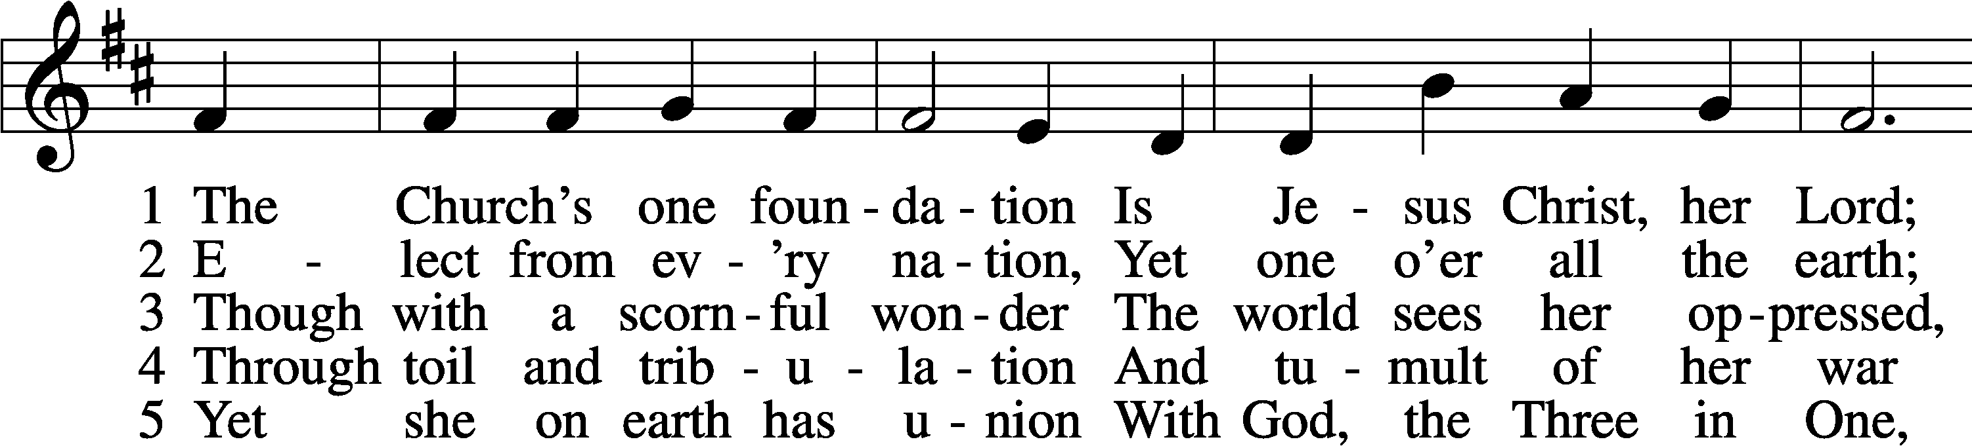

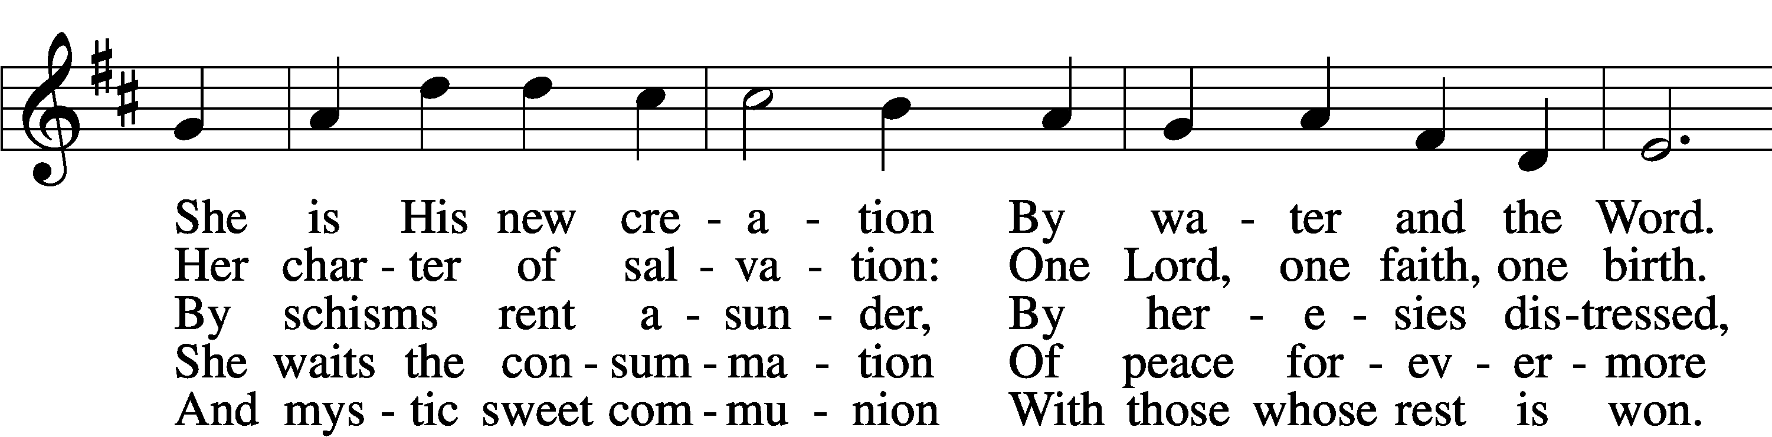

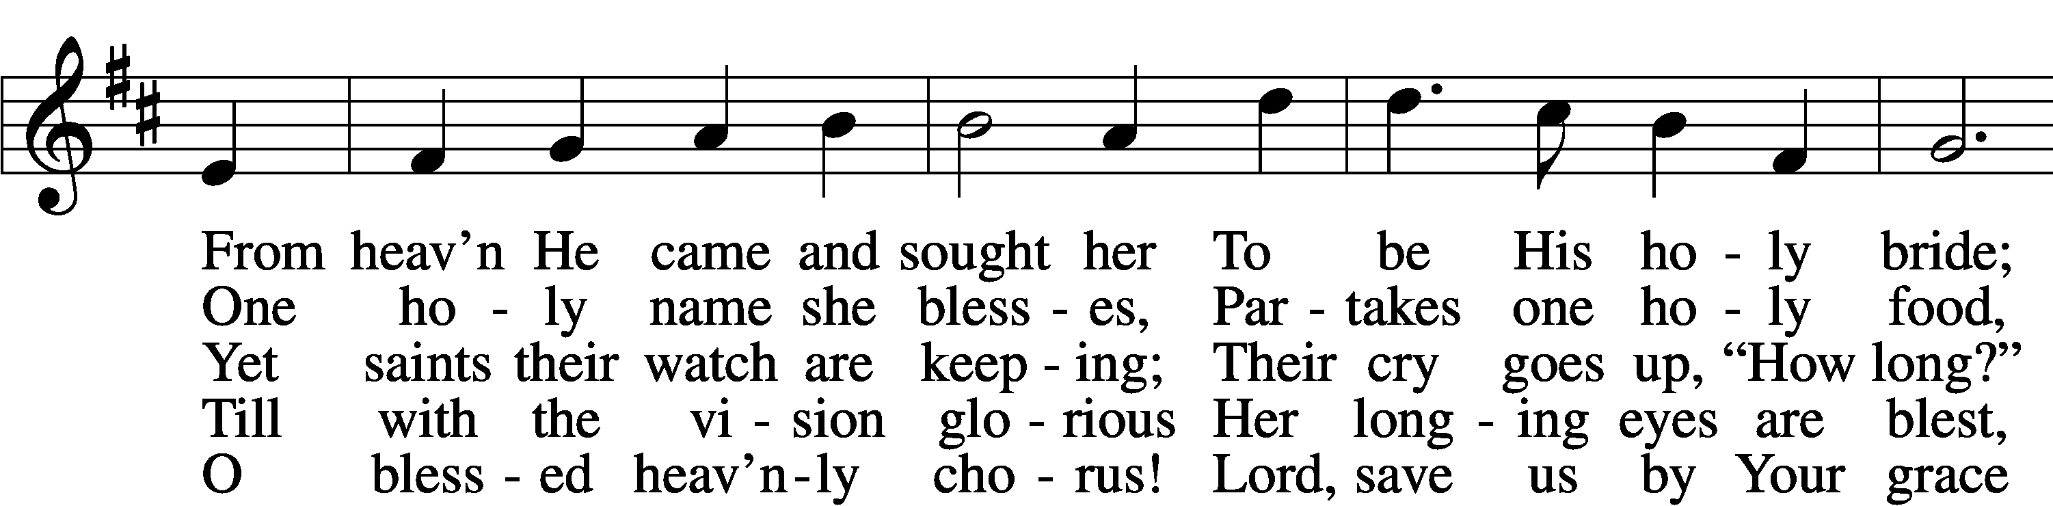

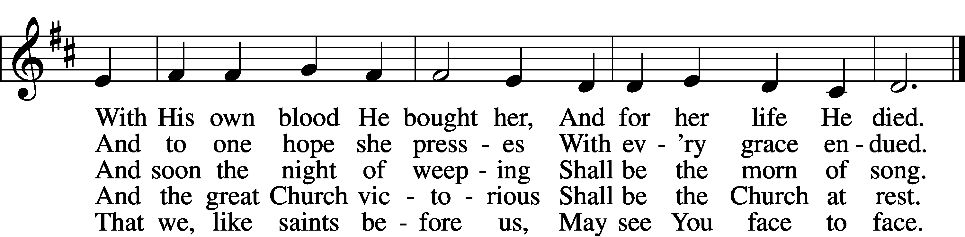

Text: Samuel J. Stone, 1839–1900, alt.  
Tune: Samuel S. Wesley, 1810–76  
Text and tune: Public domain

Sermon

Votum

P The peace of God, which passes all understanding, keep your hearts and minds in Christ Jesus.

C **Amen.**

Stand

Offertory Psalm 51:10–12

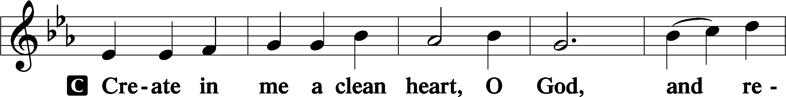

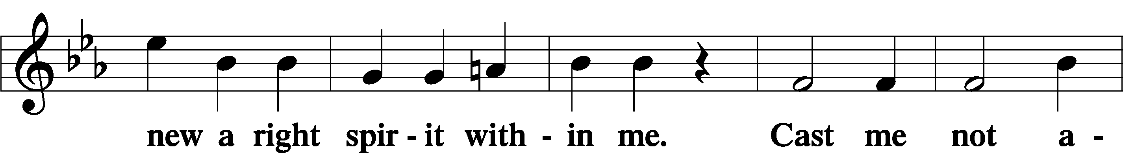

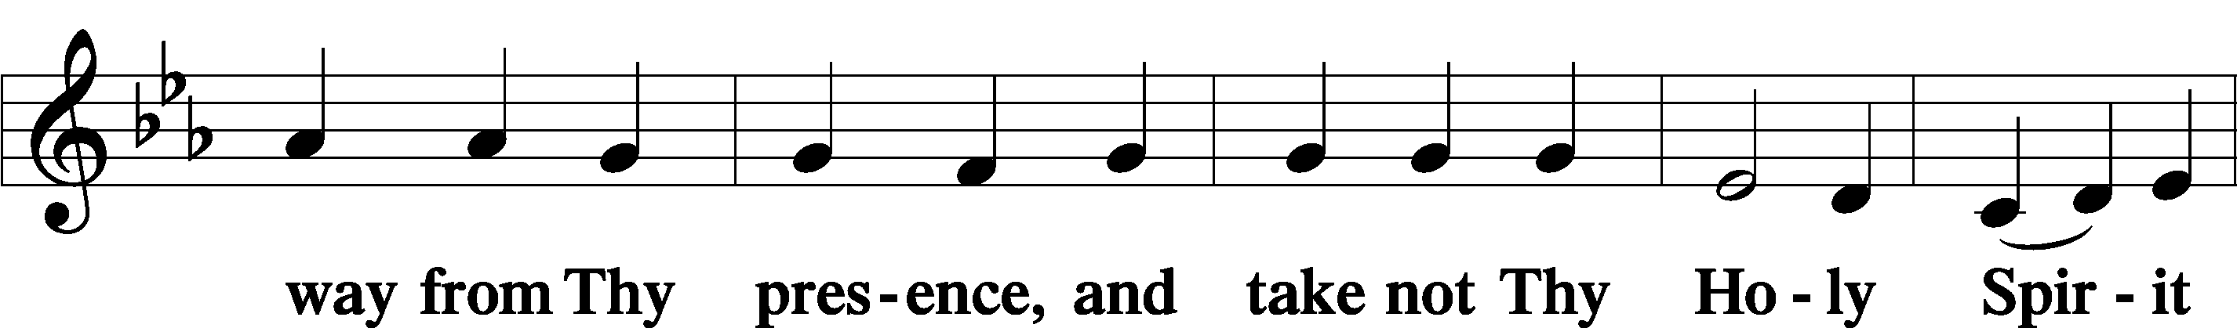

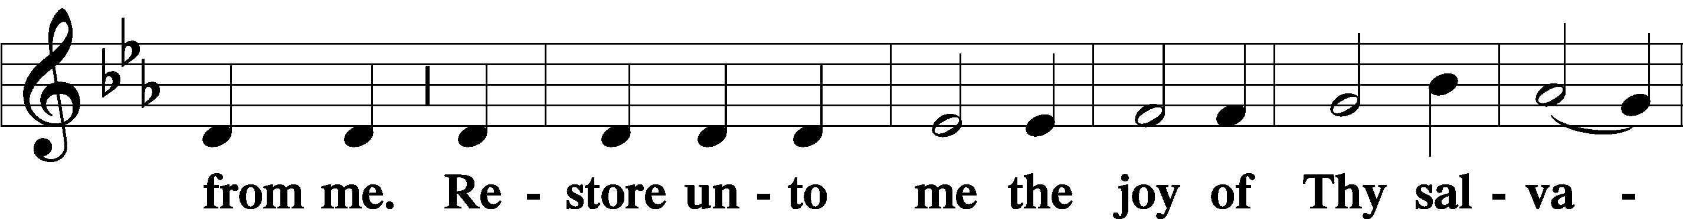

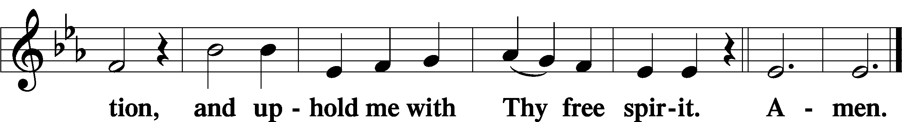

Sit

Offering

805 Praise God, from Whom All Blessings Flow

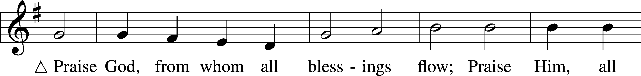

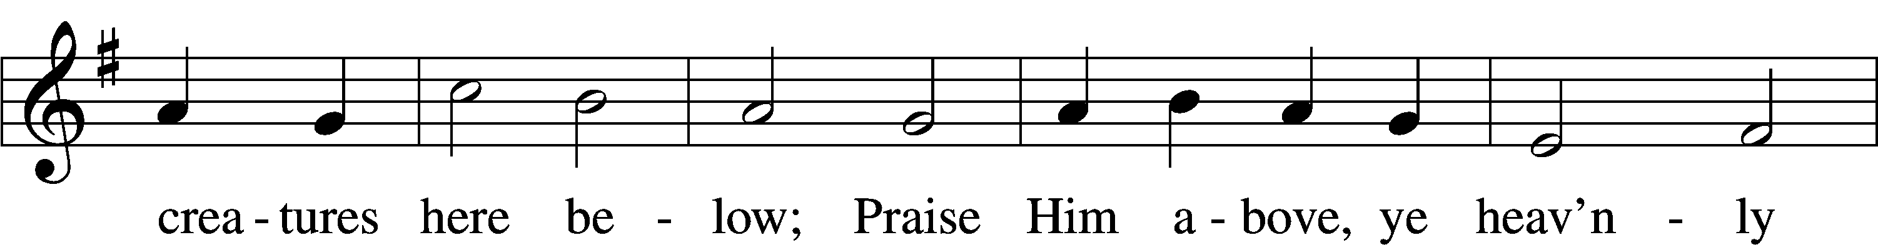

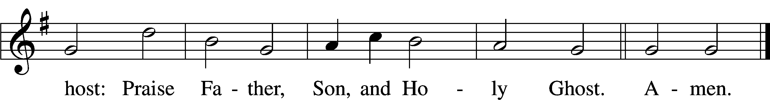

Text: Thomas Ken, 1637–1711  
Tune: Trente quatre Pseaumes de David, 1551, Geneva, ed. Louis Bourgeois  
Text and tune: Public domain

Stand

Prayer of the Church

# Service of the Sacrament

Preface 2 Timothy 4:22; [Colossians 3:1]; [Psalm 136]

P The Lord be with you.

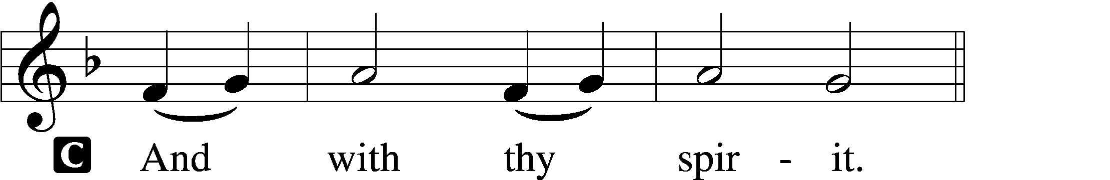

P Lift up your hearts.

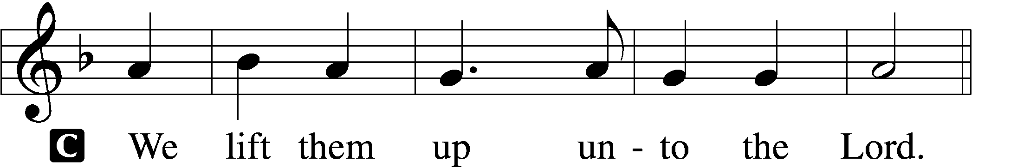

P Let us give thanks unto the Lord, our God.

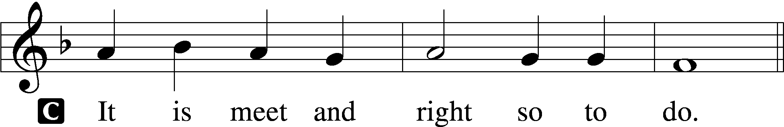

Proper Preface (Full)

P It is truly meet, right, and salutary that we should at all times and in all places give thanks to You, holy Lord, almighty Father, everlasting God, through Jesus Christ, our Lord, who overcame the assaults of the devil and gave His life as a ransom for many that with cleansed hearts we might be prepared joyfully to celebrate the paschal feast in sincerity and truth. Therefore with angels and archangels and with all the company of heaven we laud and magnify Your glorious name, evermore praising You and saying:

Sanctus Isaiah 6:3; Matthew 21:9

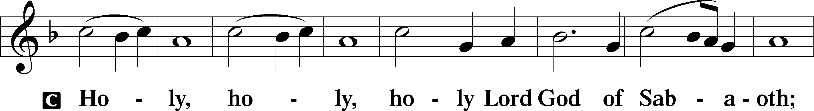

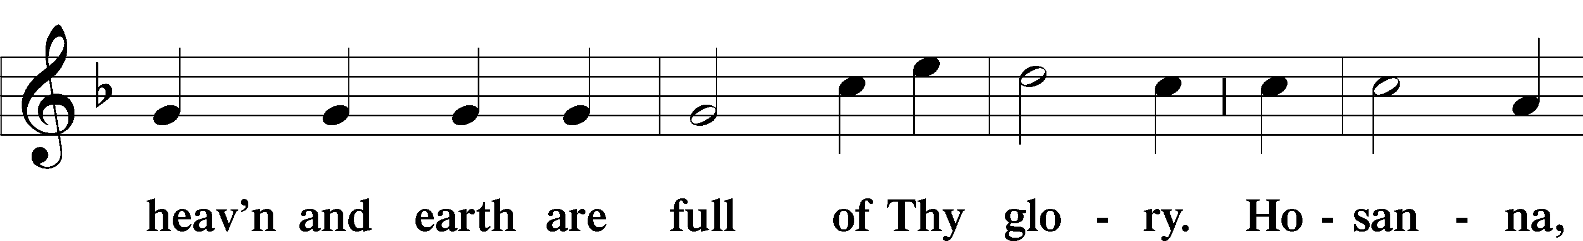

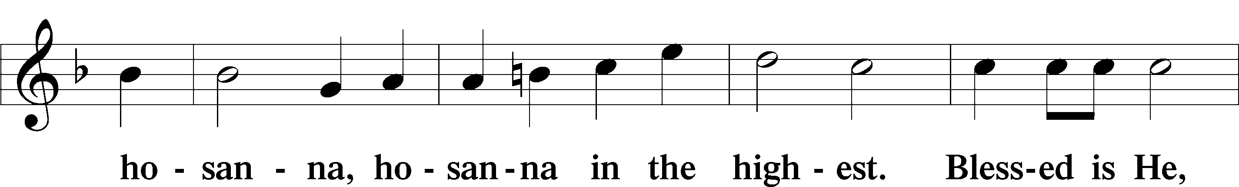

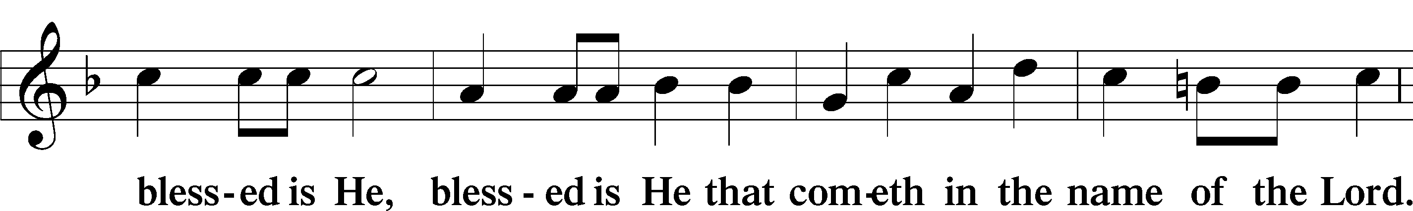

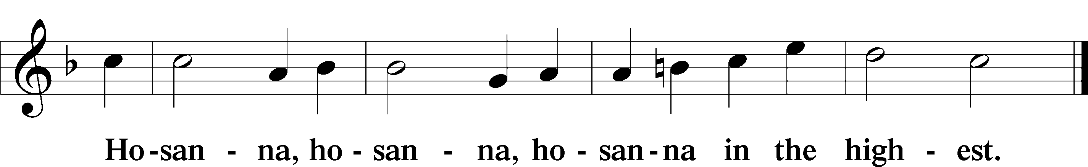

Lord’s Prayer Matthew 6:9–13

P Our Father who art in heaven,

hallowed be Thy name,

Thy kingdom come,

Thy will be done on earth as it is in heaven;

give us this day our daily bread;

and forgive us our trespasses as we forgive those who trespass against us;

and lead us not into temptation,

but deliver us from evil.

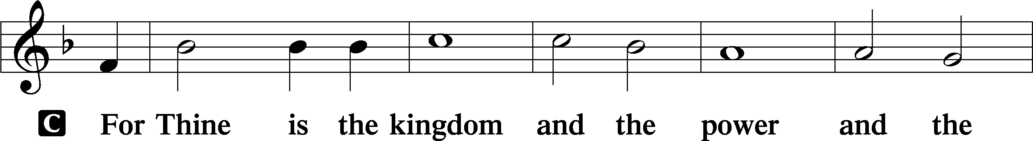

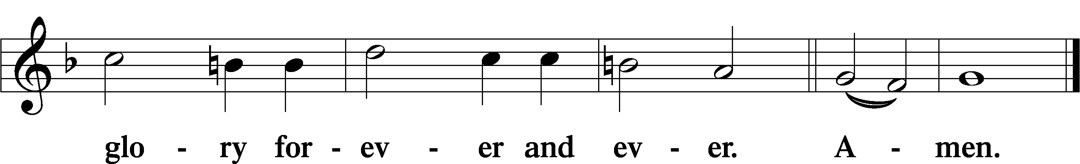

The Words of Our Lord Matthew 26:26–28; Mark 14:22–24; Luke 22:19–20; 1 Corinthians 11:23–25

P Our Lord Jesus Christ, on the night when He was betrayed, took bread, and when He had given thanks, He broke it and gave it to the disciples and said: “Take, eat; this is My T body, which is given for you. This do in remembrance of Me.”

In the same way also He took the cup after supper, and when He had given thanks, He gave it to them, saying: “Drink of it, all of you; this cup is the new testament in My T blood, which is shed for you for the forgiveness of sins. This do, as often as you drink it, in remembrance of Me.”

Pax Domini John 20:19

P The peace of the Lord be with you always.

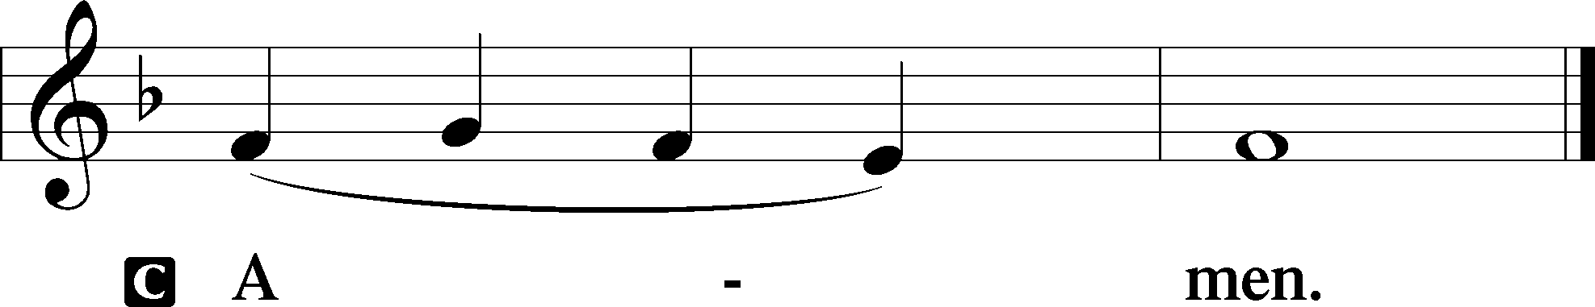

Agnus Dei John 1:29

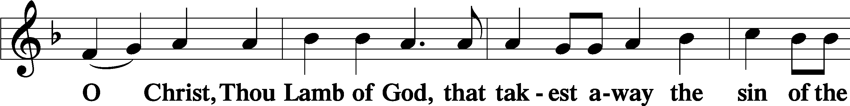

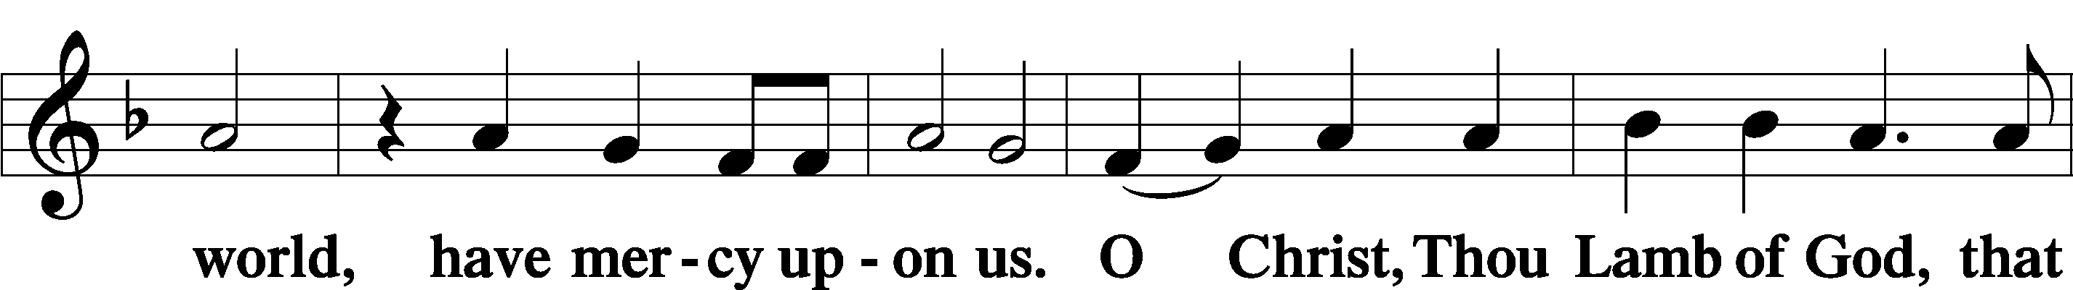

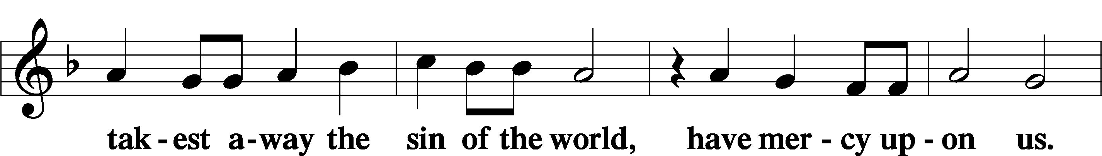

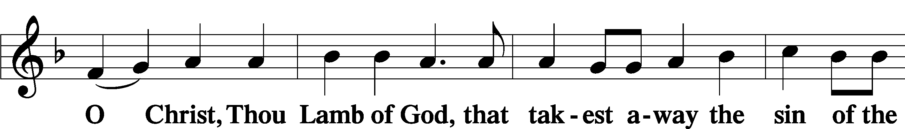

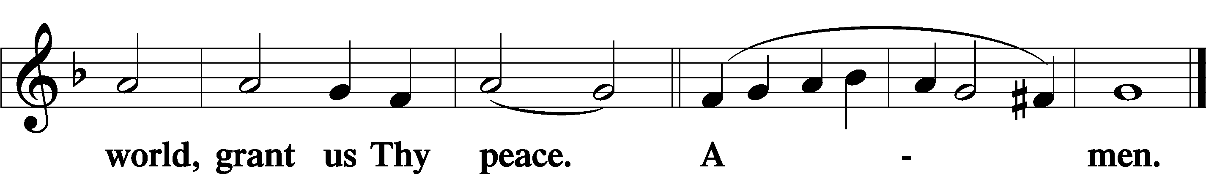

Sit

Distribution

The pastor and those who assist him receive the body and blood of Christ first and then distribute them to those who come to receive, saying:

Take, eat; this is the true body of our Lord and Savior Jesus Christ, given into death for your sins.

**Amen.**

Take, drink; this is the true blood of our Lord and Savior Jesus Christ, shed for the forgiveness of your sins.

**Amen.**

In dismissing the communicants, the following is said:

The Dismissal

P The body and blood of our Lord Jesus Christ strengthen and preserve you in body and soul to life everlasting. Depart T in peace.

C **Amen.**

571 God Loved the World So That He Gave

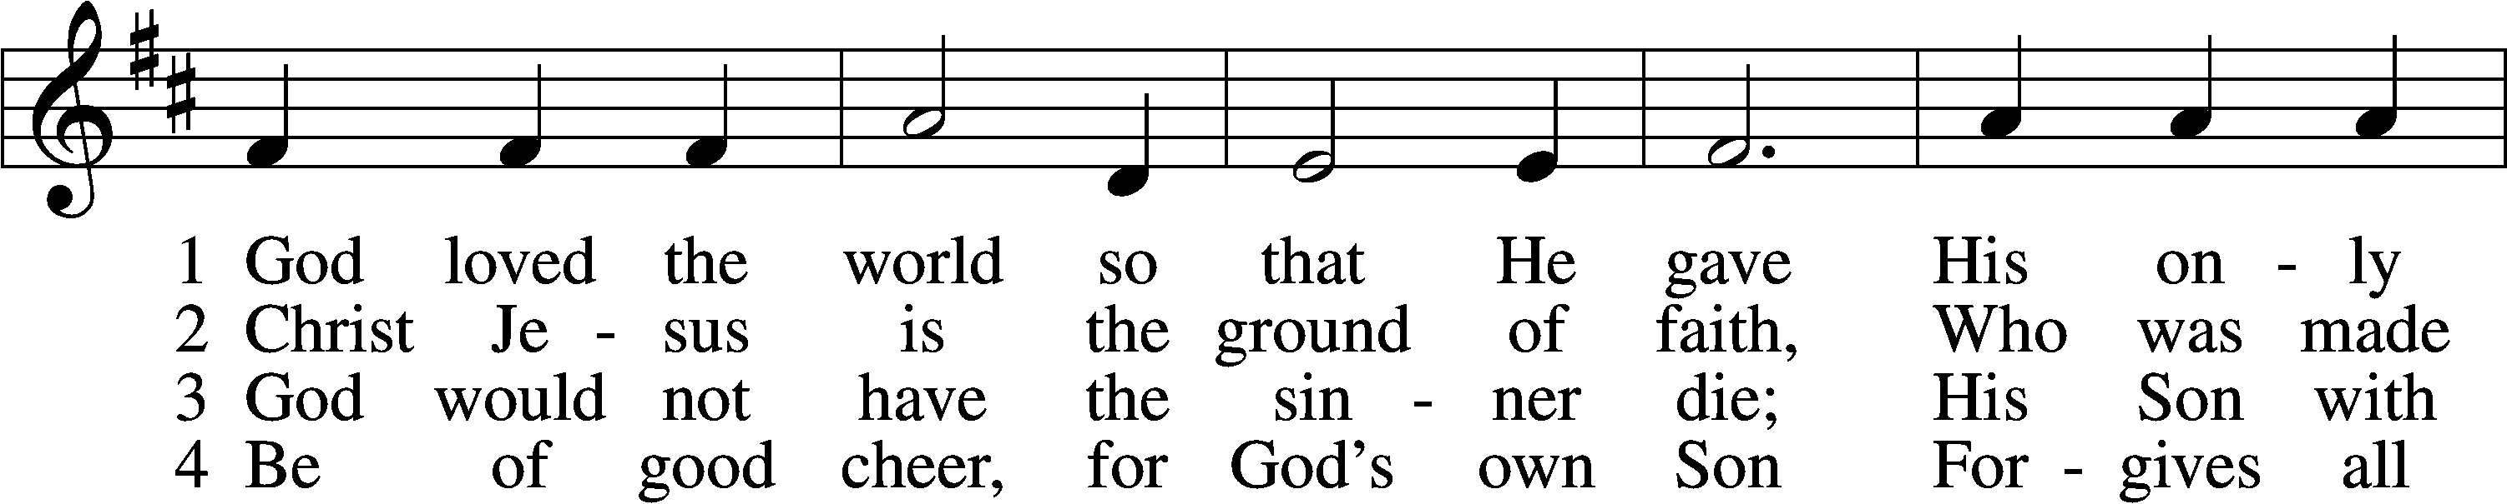

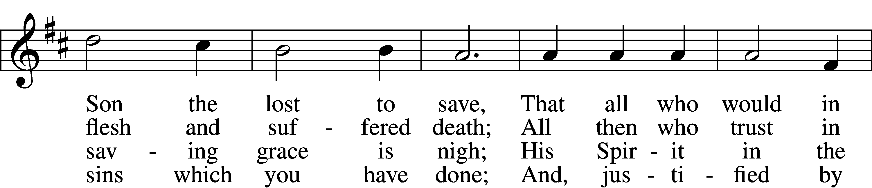

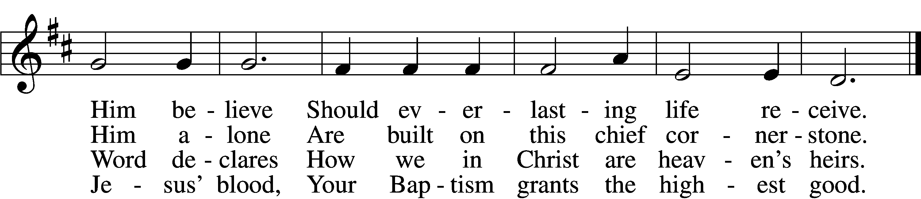

5 If you are sick, if death is near,  
This truth your troubled heart can cheer:  
Christ Jesus saves your soul from death;  
That is the firmest ground of faith.

D 6 Glory to God the Father, Son,  
And Holy Spirit, Three in One!  
To You, O blessèd Trinity,  
Be praise now and eternally!

Text: Heiliges Lippen- und Hertzens-Opffer, c. 1778, Stettin; tr. August Crull, 1845–1923, alt.  
Tune: George J. Elvey, 1816–93  
Text and tune: Public domain

425 When I Survey the Wondrous Cross

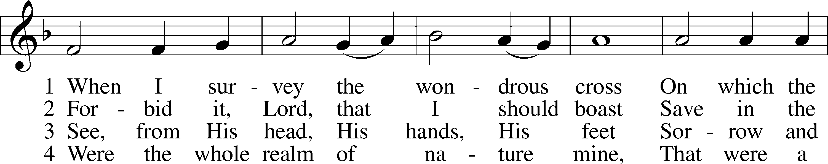

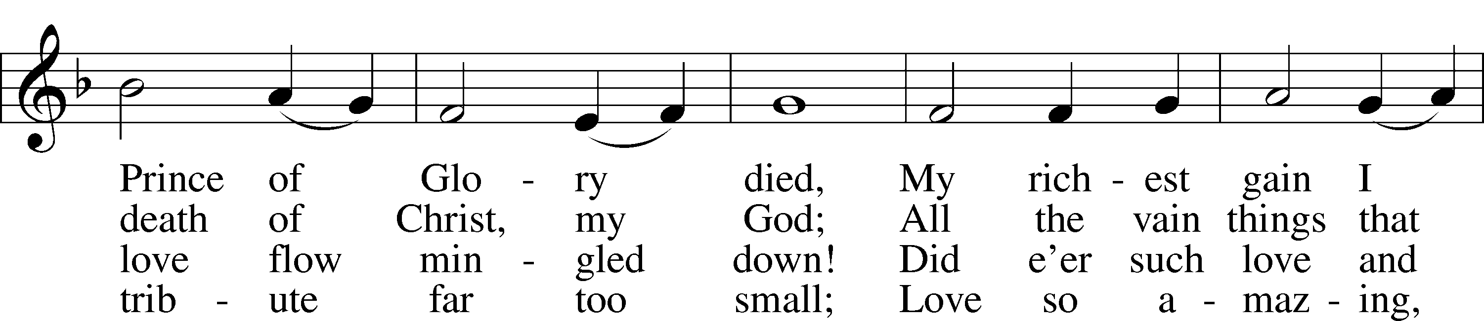

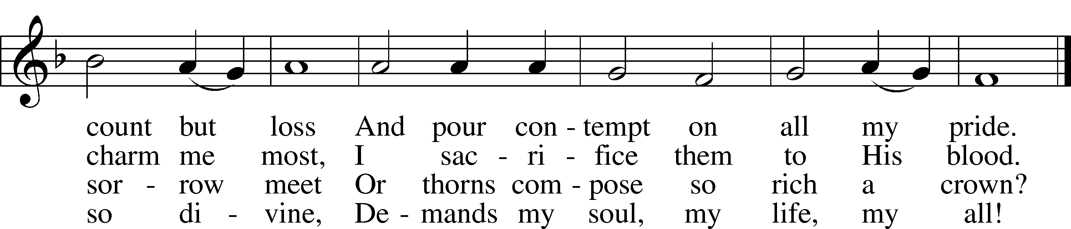

Text: Isaac Watts, 1674–1748  
Tune: Lowell Mason, 1792–1872  
Text and tune: Public domain

625 Lord Jesus Christ, Life-Giving Bread

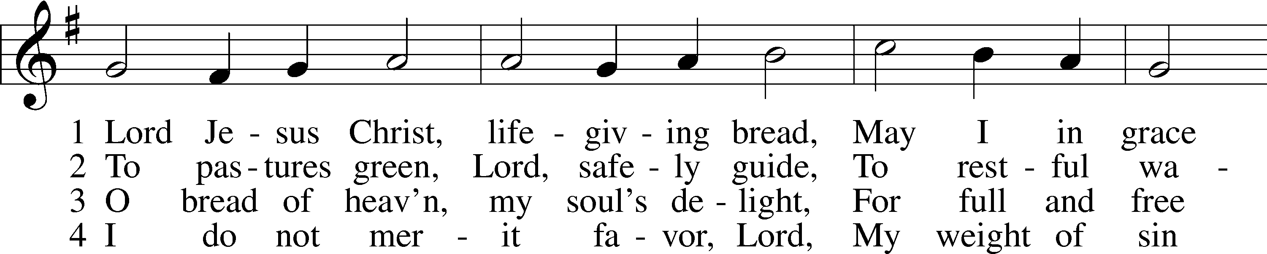

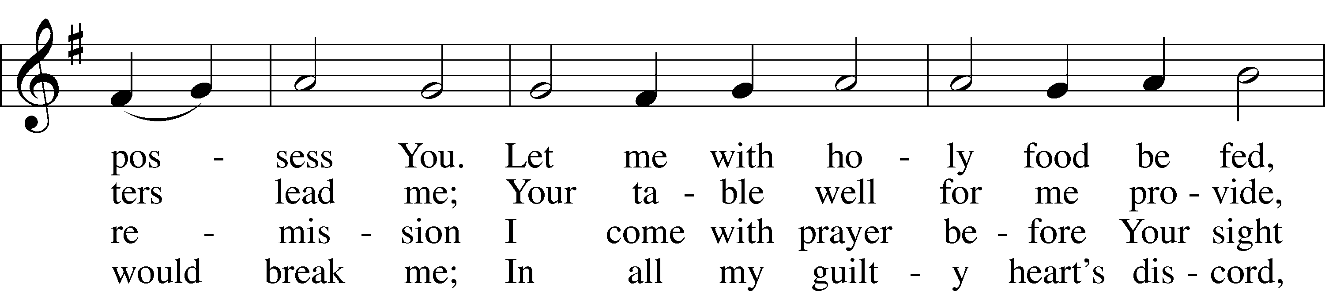

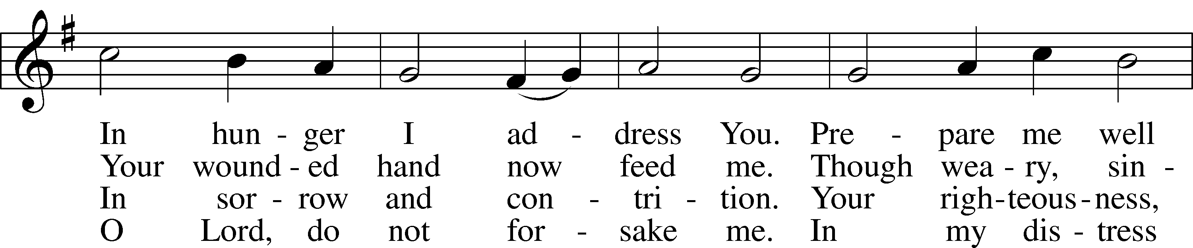

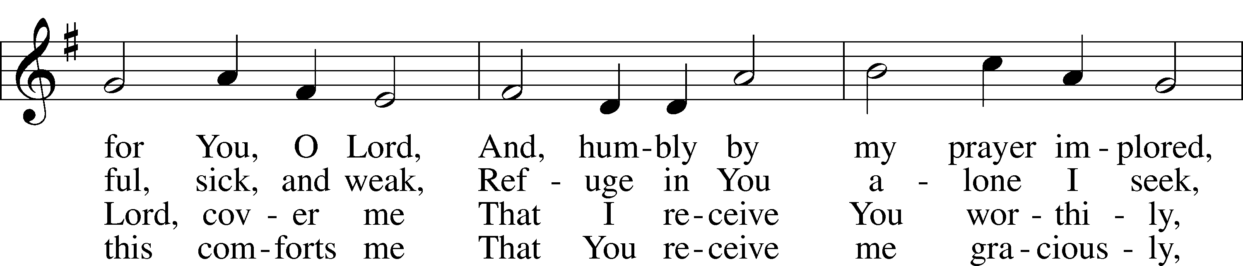

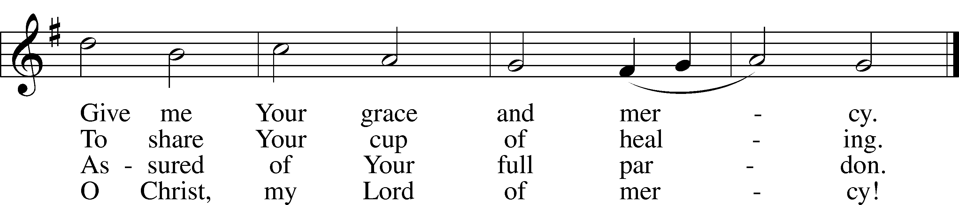

Text: Johann Rist, 1607–67; tr. Arthur T. Russell, 1806–74, alt.  
Tune: Theütsch kirchen ampt, 1525, Strassburg  
Text and tune: Public domain

618 I Come, O Savior, to Thy Table

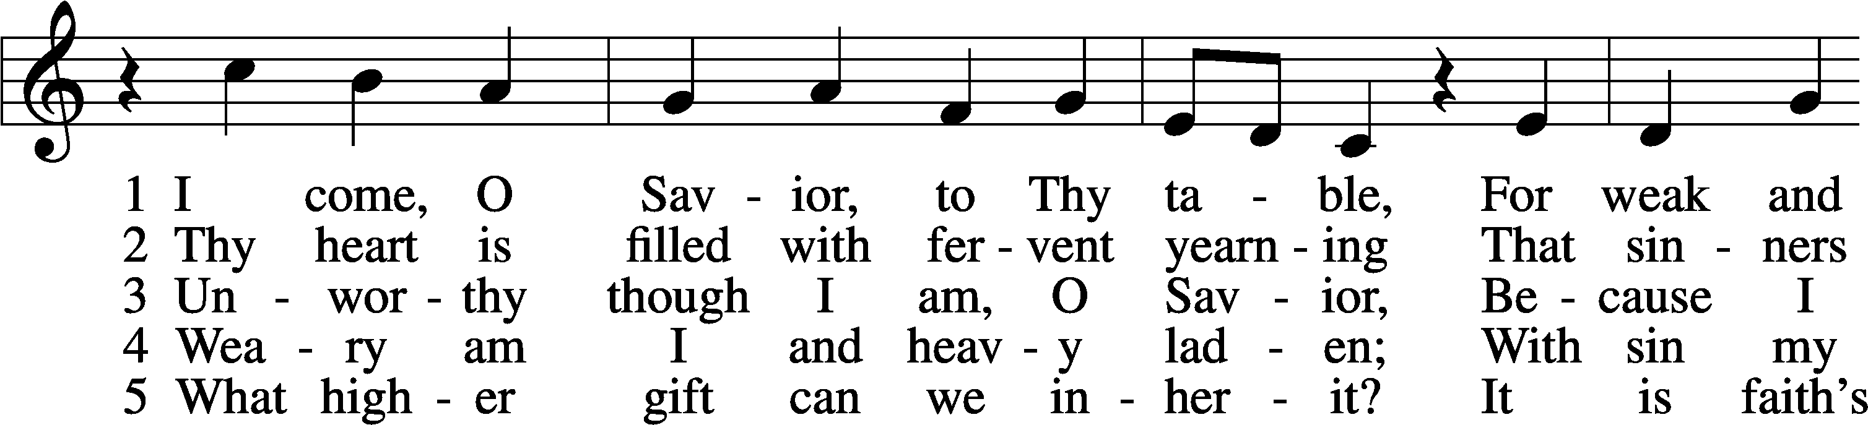

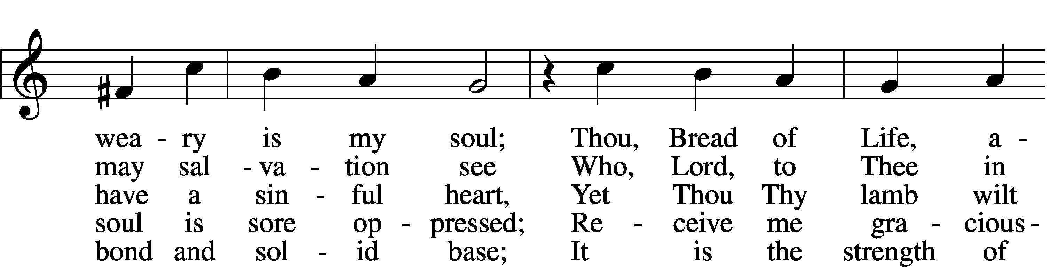

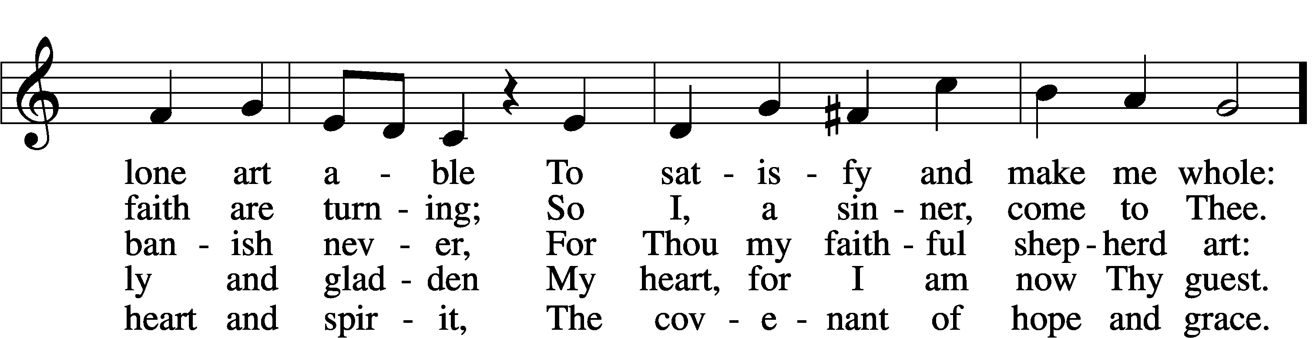

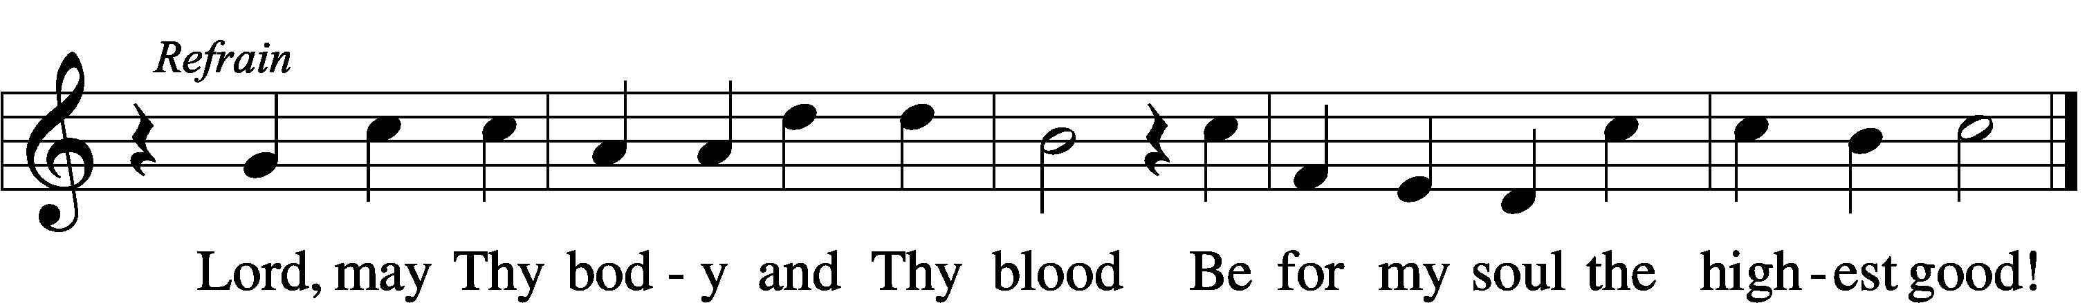

Text: Friedrich Christian Heyder, 1677–1754; tr. The Lutheran Hymnal, 1941, abr.  
Tune: Emskirchner Choral-Buch, 1756, Leipzig  
Text: © 1941 Concordia Publishing House. Used by permission: LSB Hymn License no. 110005011  
Tune: Public domain

Stand

Nunc Dimittis Luke 2:29–32

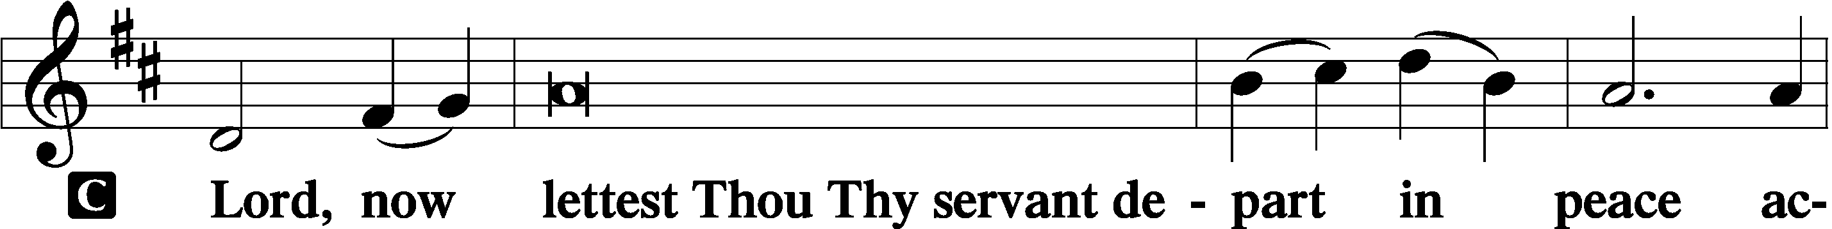

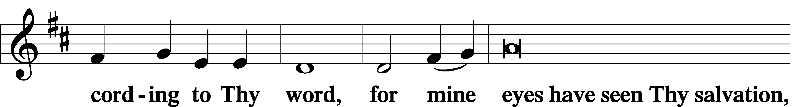

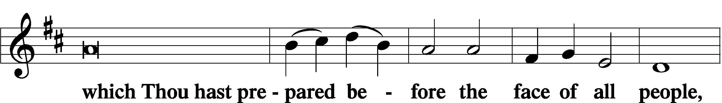

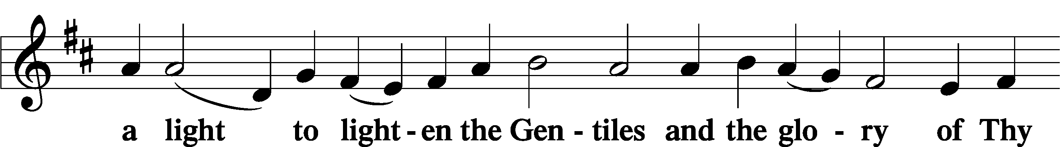

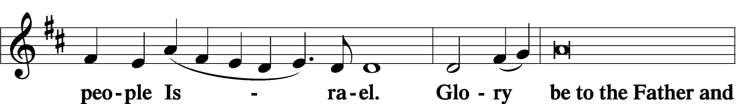

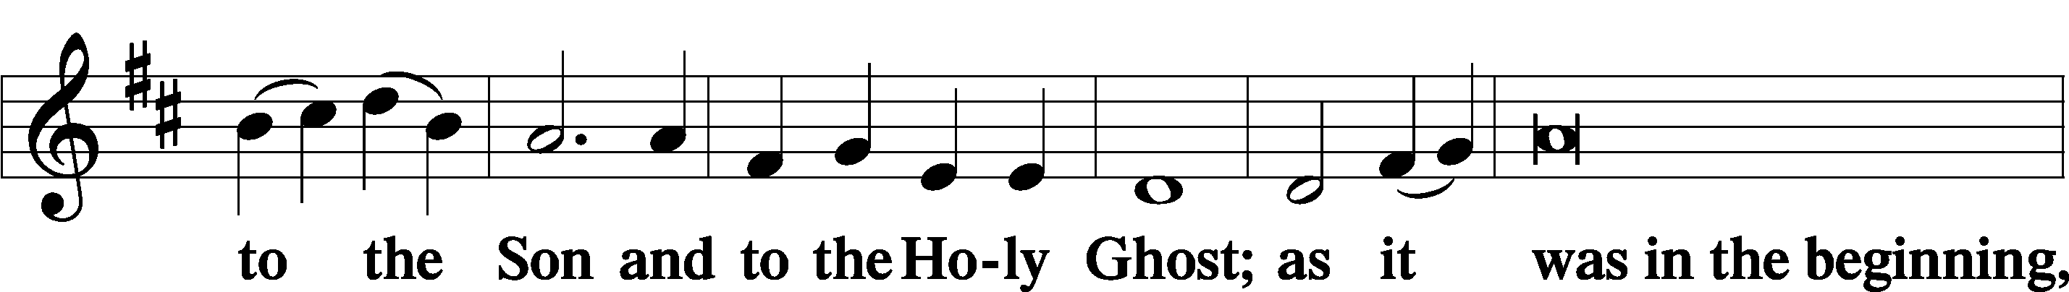

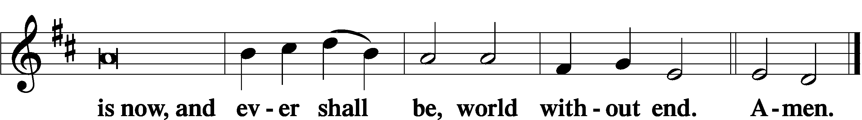

Thanksgiving Psalm 107:1

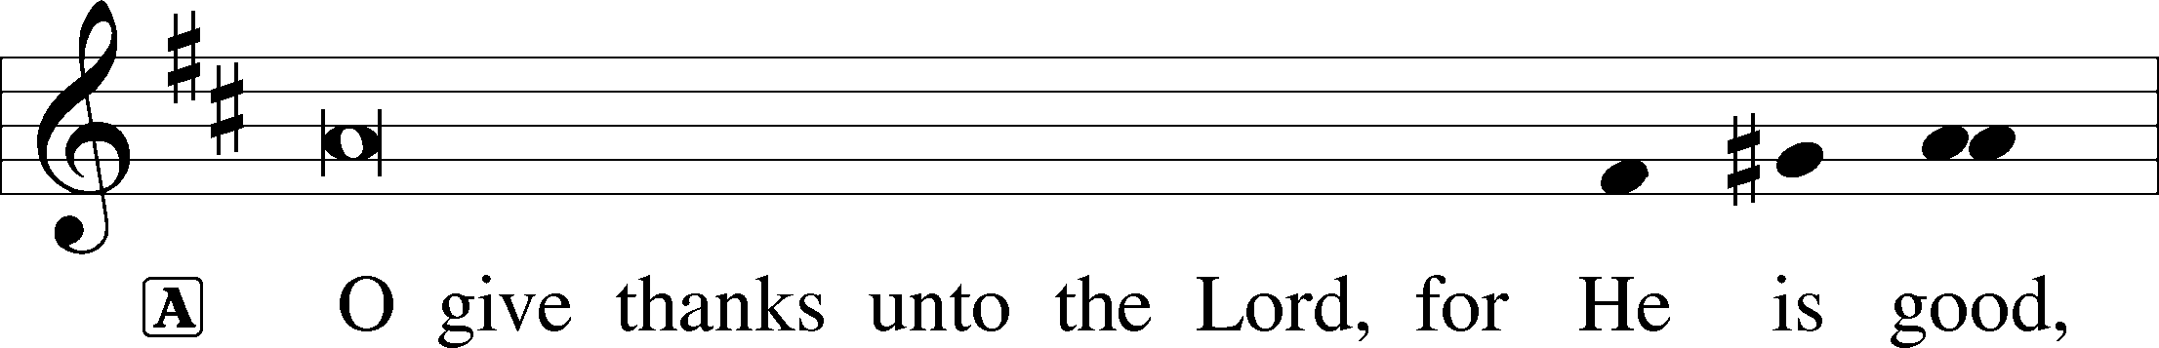

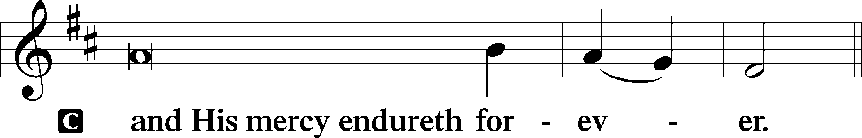

Post-Communion Collect

A Let us pray.

We give thanks to You, almighty God, that You have refreshed us through this salutary gift, and we implore You that of Your mercy You would strengthen us through the same in faith toward You and in fervent love toward one another; through Jesus Christ, Your Son, our Lord, who lives and reigns with You and the Holy Spirit, one God, now and forever.

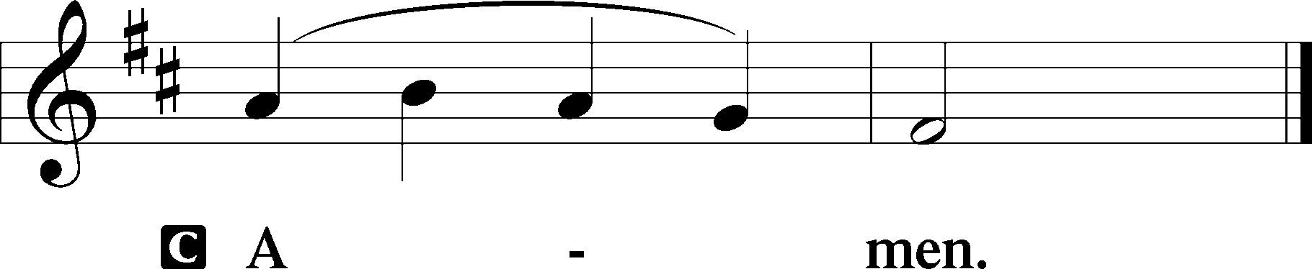

Salutation 2 Timothy 4:22

P The Lord be with you.

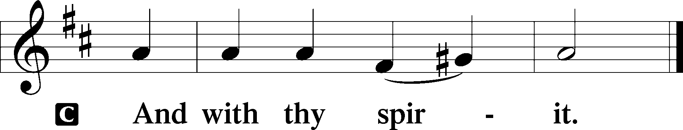

Benedicamus Psalm 103:1

A Bless we the Lord.

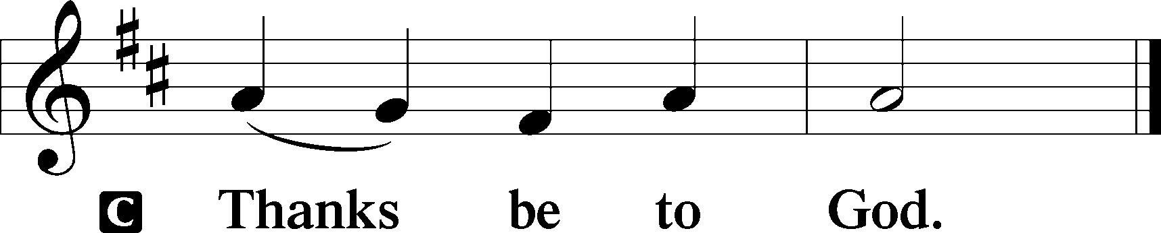

Benediction Numbers 6:24–26

P The Lord bless you and keep you.

The Lord make His face shine upon you and be gracious unto you.

The Lord lift up His countenance upon you and T give you peace.

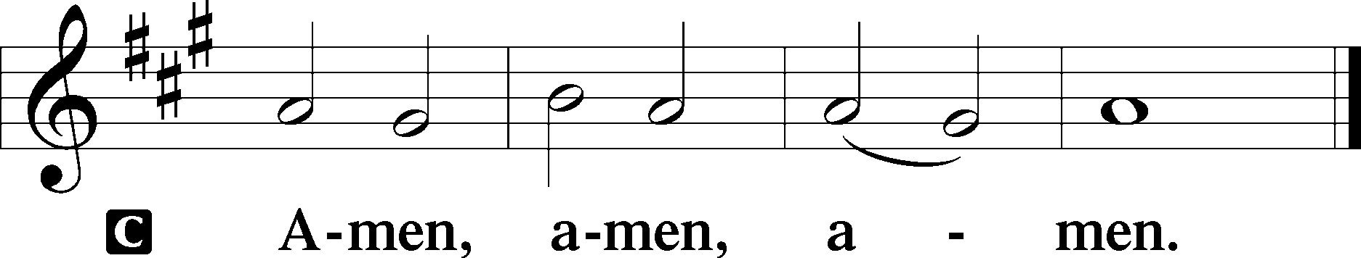

803 Joyful, Joyful We Adore Thee

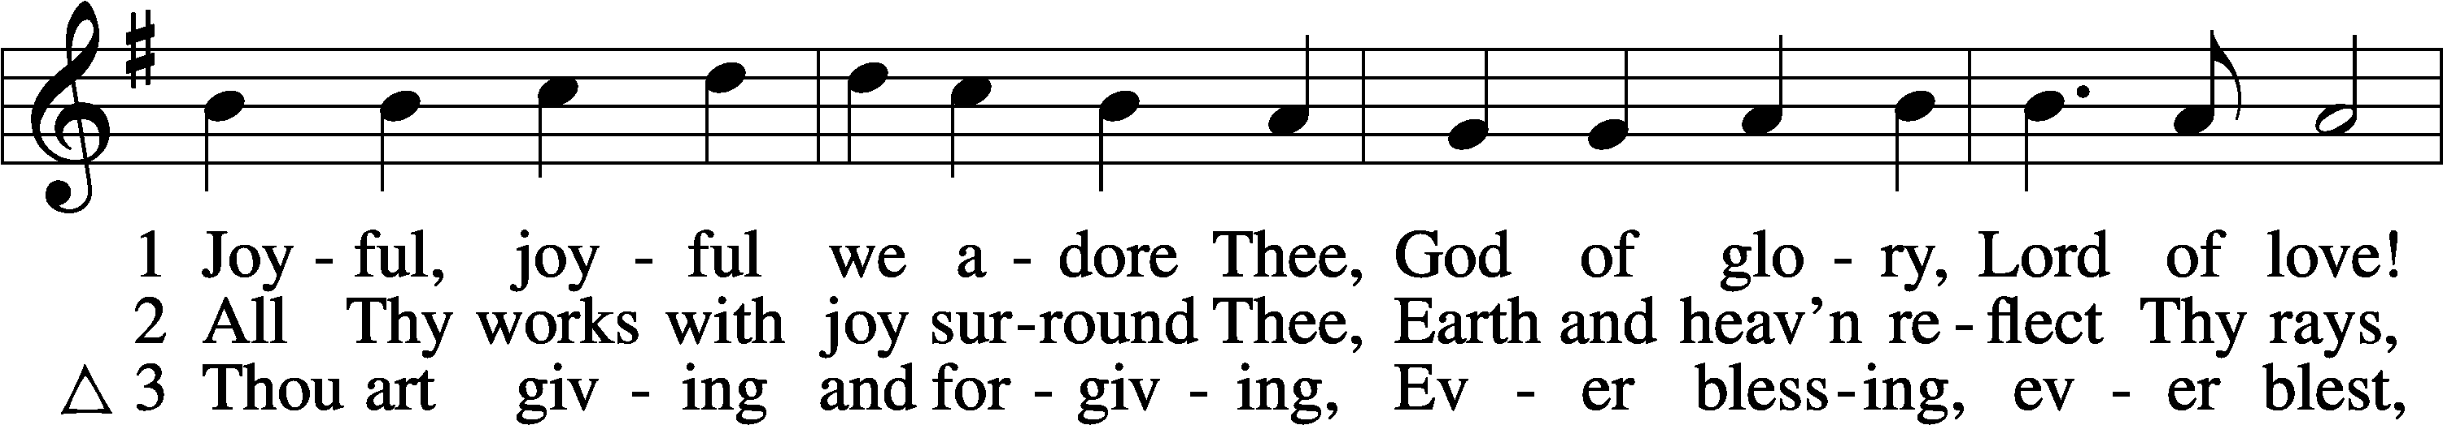

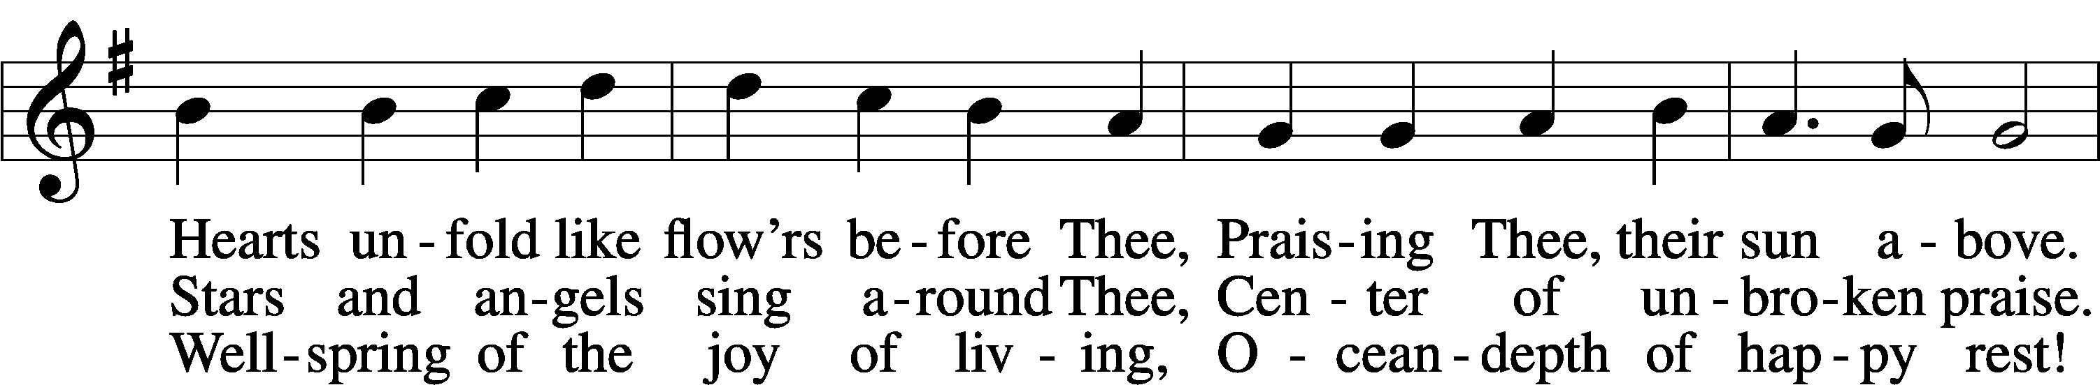

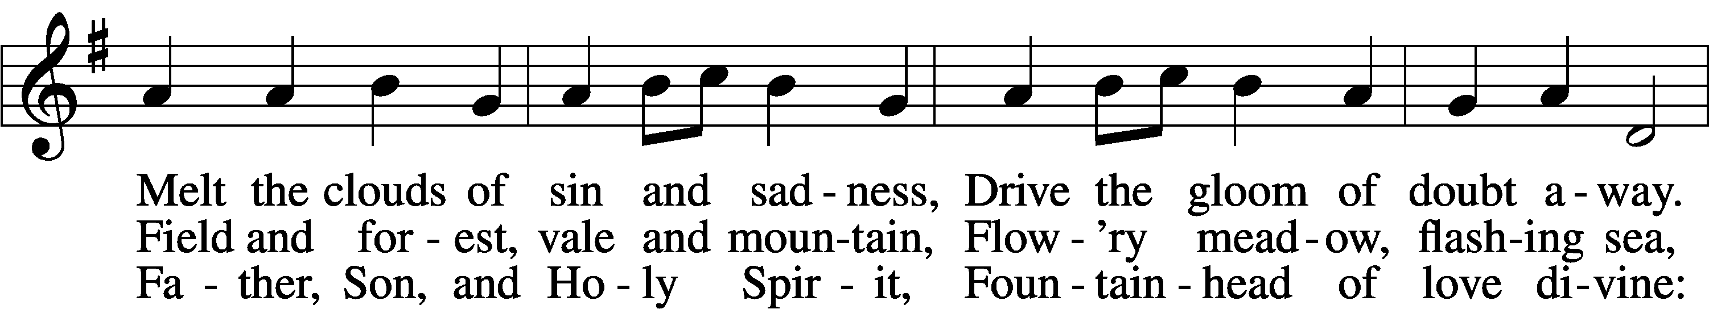

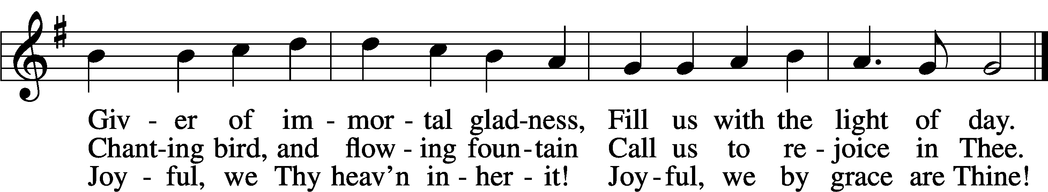

Text: Henry Van Dyke, 1852–1933, alt.  
Tune: Ludwig van Beethoven, 1770–1827; adapt. Edward Hodges, 1796–1867  
Text and tune: Public domain

Acknowledgments

Divine Service, Setting Three from Lutheran Service Book

Unless otherwise indicated, Scripture quotations are from the ESV® Bible (The Holy Bible, English Standard Version®), copyright © 2001 by Crossway, a publishing ministry of Good News Publishers. Used by permission. All rights reserved.

Created by Lutheran Service Builder © 2025 Concordia Publishing House.