

December 2025
Merry Christmas!

From all the different stores in the area, you would think that we have been in the “Christmas Season” for the last month and a half. There were displays put up in some stores in late September already. In the past, I would not want to put up a Christmas Tree or decorate the house until after Thanksgiving. The Friday after Thanksgiving, that is fair game for decorating. This year, however, the decision is not my decision. Now that I am married, Deborah and I came to an agreement to decorate a bit early. While this feels awkward, it is not a bad thing.
Having two Christmas tree’s worth of decorations, two nativity scenes, and other such issues; we were able to make decisions on how to decorate our tree and our house. There are still some things that need to be set out. We are, for the most part, ready for the season. Now we will be dealing with which menu items we will be eating and when that happens.
Some of the plans for the Christmas season also involve Deborah’s children and grandchildren. I will not lie, while my life has been uprooted from quiet bachelorhood to having children and grandchildren, I am greatly blessed by their addition into my life. I genuinely look forward to seeing each and every one of them. That they have accepted me into their family life is truly a blessing.
We, the people of St. Peter Lutheran Church, have been blessed over the past years. With Dan, Jo and Annellee, Larry and Rhonda, and Avni, along with Trig, Walker, and Henry; all of these individuals being added to our church family truly has been a blessing. Seeing each of them in church brings much joy into my life.
As we enter the Advent season, let us reflect on everything that God has done for us. All the blessings in our lives that are due to God’s grace. Let us give thanks and praise God from whom all blessings flow. Also, during this Advent and Christmas season, please remember to keep our shut–ins and our service members in your prayers.
In closing, I leave you with Linus’ words of wisdom from “A Charlie Brown Christmas”:

"And there were in the same country shepherds abiding in the field, keeping watch over their flock by night. And lo, the angel of the Lord came upon them, and the glory of the Lord shone round about them: and they were sore afraid. And the angel said unto them, 'Fear not:"
[Linus drops his security blanket on purpose]
"for behold, I bring unto you good tidings of great joy, which shall be to all people. For unto you is born this day in the City of David a Savior, which is Christ the Lord. And this shall be a sign unto you; Ye shall find the babe wrapped in swaddling clothes, lying in a manger.' And suddenly there was with the angel a multitude of the heavenly host, praising God, and saying, 'Glory to God in the highest, and on earth peace, good will toward men.'"

A blessed Christmas to y’all, from Deborah and me. — Pastor De Young
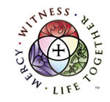
Christian living in a nutshell:
Witness (martyria), Mercy (Diakonia), and Life Together (Koinonia).

Back in 2011, President Harrison launched a new program in the LCMS. The three parts of this program were: Witness (martyria), Mercy (Diakonia), and Life Together (Koinonia).

In the past three newsletters, I covered Witness, Mercy, and Life Together. This month I will be covering the conclusion.

The Witness, Mercy, and Life Together of the Church centers on the cross of Jesus. The Church’s Witness to the world proceeds from the cross of Jesus, where He died to forgive the sins of the entire world. The Church’s work of Mercy is enabled by the cross, where Jesus showed His love for us. As He loved us, we go and love our neighbor, helping, serving, and showing mercy to them when in need. The Church’s Life Together is lived under the cross of Jesus. Each of these is held together and connected by His cross. Each overlaps and flows into the other yet retains a distinctive emphasis and purpose. The words behind Witness, Mercy, and Life Together are found throughout the Scriptures. These or similar words are used by churches throughout the world to describe the purpose of the Church. Martyria, diakonia, koinonia are ecumenical words, known by the Church worldwide.

Represented as three equal circles, they serve as a reminder that no one area should dominate the other. When Witness (martyria) is emphasized to the diminishment of the other two, the focus becomes mission, evangelism or witness without care for the neighbor or for a Life Together gathered around the Word and Sacraments. When Mercy (diakonia) is emphasized above the others, the end result is a social gospel, where feeding the poor or caring for those in need is seen as equal to or more important than the forgiveness of sins. When Life Together (koinonia) is emphasized above the others, some sort of rabid ecumenicism is created, where the confession is lost and honest differences in the Church are no longer seen, where unity is the overarching principle. None of these three extremes represents health for the Church.

The work and life of the Church engages in Witness (martyria), Mercy (diakonia), and Life Together (koinonia) with the cross of Jesus at the center. These aspects flow into one another. One begins with Jesus, and each aspect complements and flows into the others. Jesus bore witness to His Father by going to the cross. Jesus served and showed mercy to those in need. And Jesus has called us into a Life Together with Him. As the Church lives in Christ, the Church also follows this pattern, this threefold emphasis of Witness, Mercy, and Life Together—for the Church and for the world.
.



Celebrate December’s Baptism Birthdays
& their years as heirs of God’s kingdom!

Date | Name | Years
1st | Amanda Gilmore | 35
 | Brent Shaw | 28
3rd | Debbie Jones | 36
13th | Todd Hammer | 66
25th | Bailey Anderson | 31
 | Grace George | 6
31st | Davin George | 8

Serving in God’s House this month

Elder of the Month | William Pickett
Counters | Brent Husfeld / Darren Gill
Altar Guild | Kristin Henry / Rebecca Horton
Altar Care | Maci Furguson / Jana Gilmore / Monica Mayfield
Guest Monitor | Tonda Rice

Week | Acolytes | Reader
December 07 | Emily Keyes & Parker Lawson | Lee Hughes
December 14 | Molly Gilmore & Max Gilmore | Arn Anderson
December 21 | Avery Henry & Karlee Hughes | Bryan Roth
December 28 | Annalle Osbon & Davin George | William Pickett

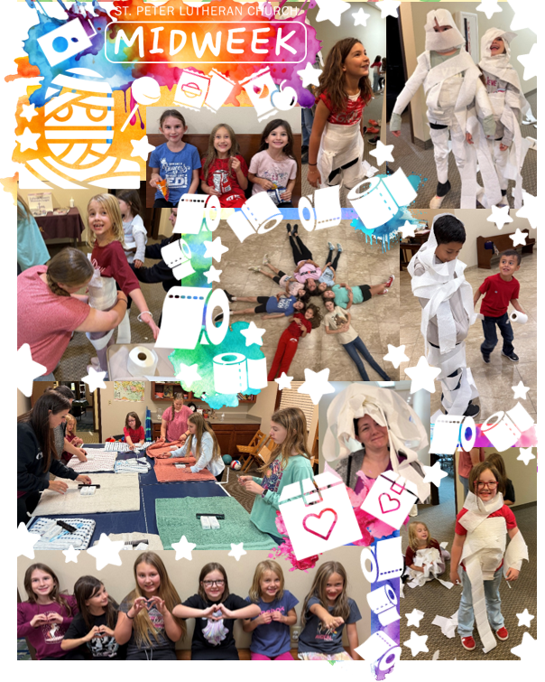


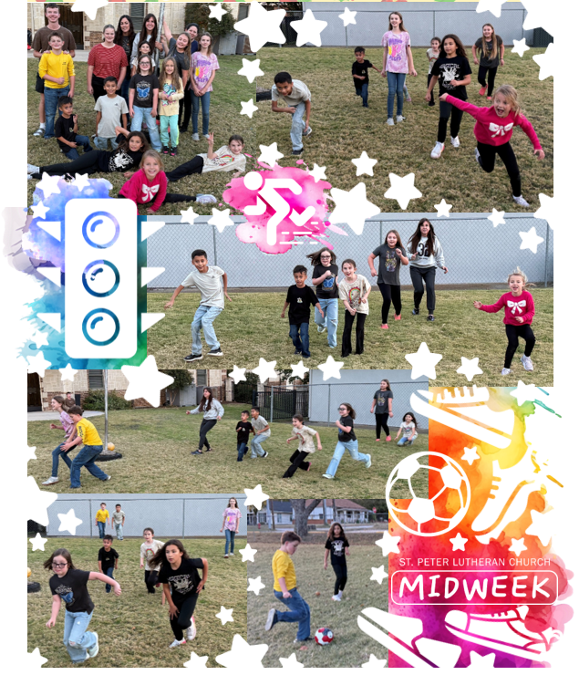

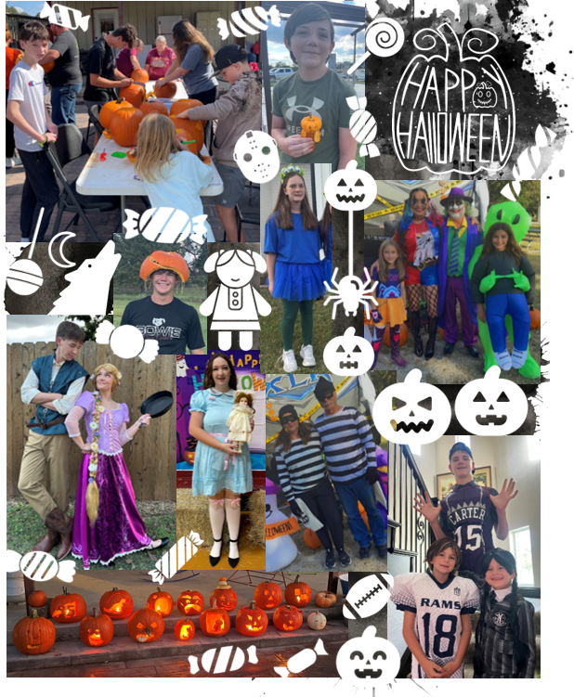

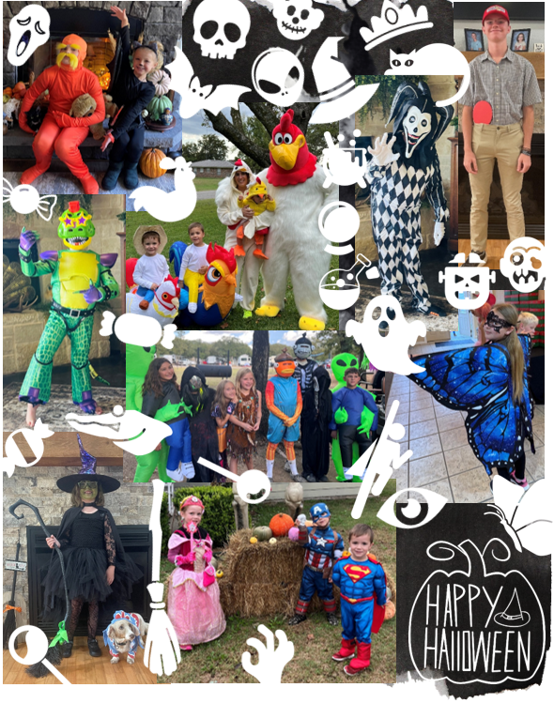

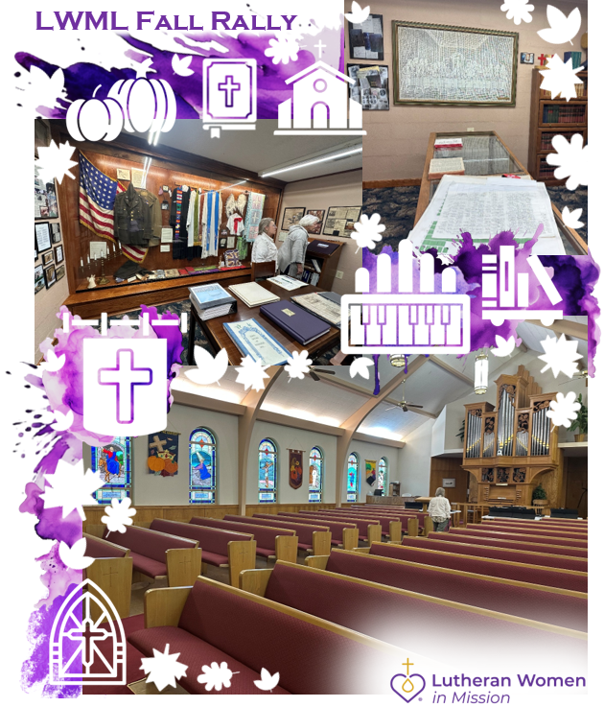









Did you know we have a Facebook & Instagram?

You can find the links to our socials on our website at: www.stpetertex.com


Follow us for important updates, verse-of-the-week posts, and more!

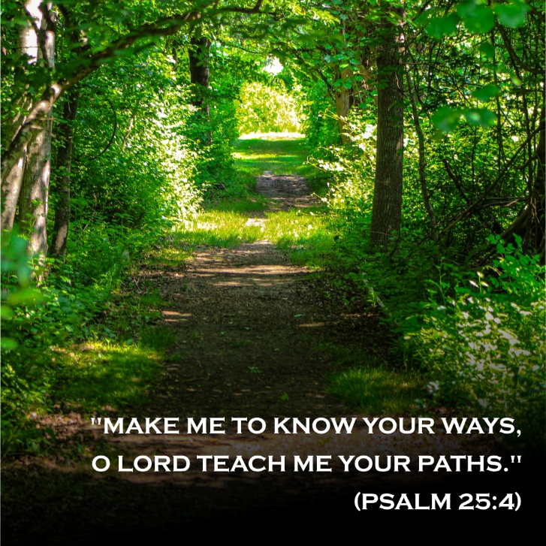
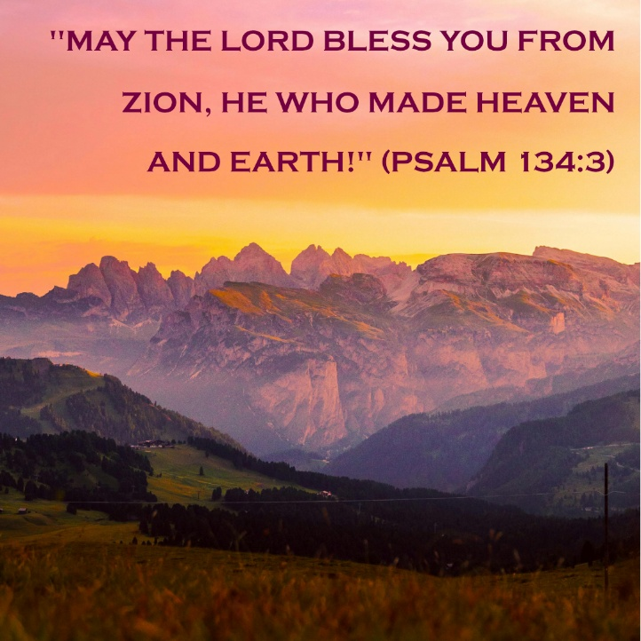
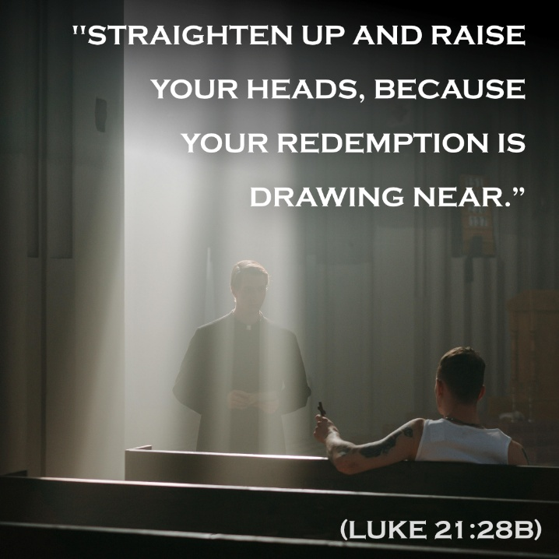
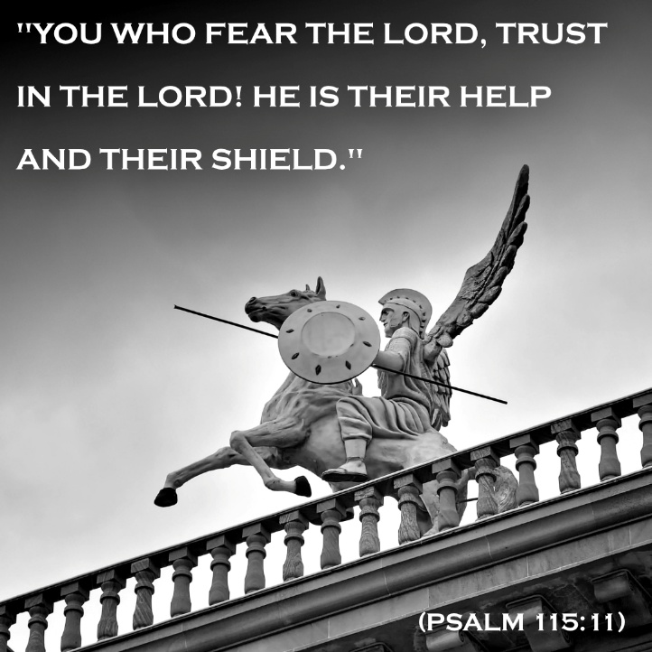
In case you missed November’s weekly verse posts:

