On entering the church

P Lord, I love the habitation of Your house and the place

where Your glory dwells. In the multitude of Your tender

mercies prepare my heart that I may enter Your house to

worship and confess Your holy name; through Jesus Christ,

my God and Lord.

Before worship

C O Lord, our creator, redeemer, and comforter, as we come

together to worship You in spirit and in truth, we humbly

pray that You would open our hearts to the preaching of

Your Word so that we may repent of our sins, believe in

Jesus Christ as our only Savior, and grow in grace and

holiness. Hear us for His sake.

666 O Little Flock, Fear Not the Foe

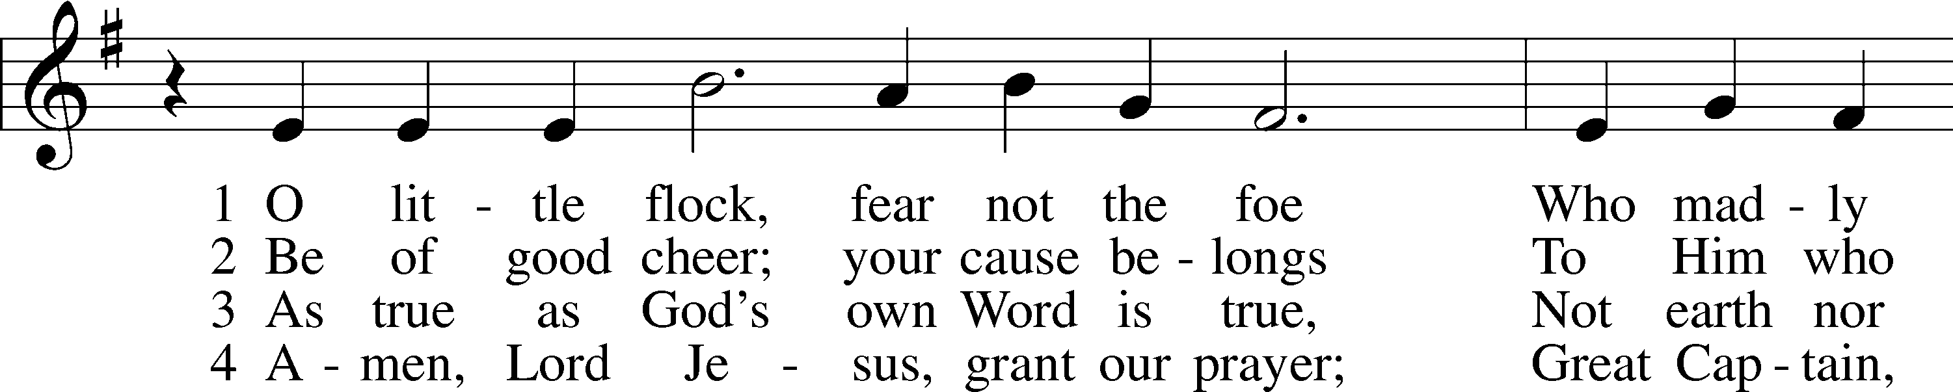

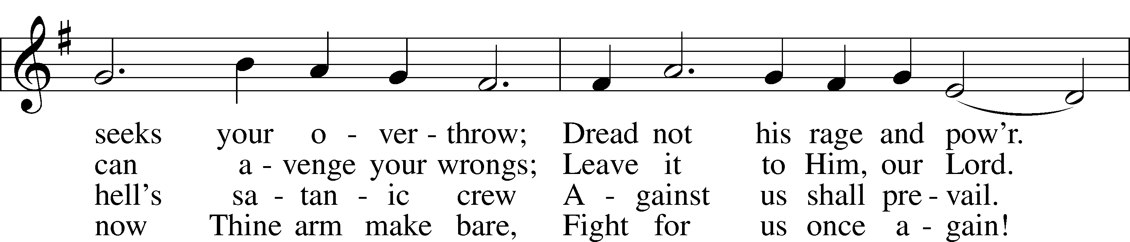

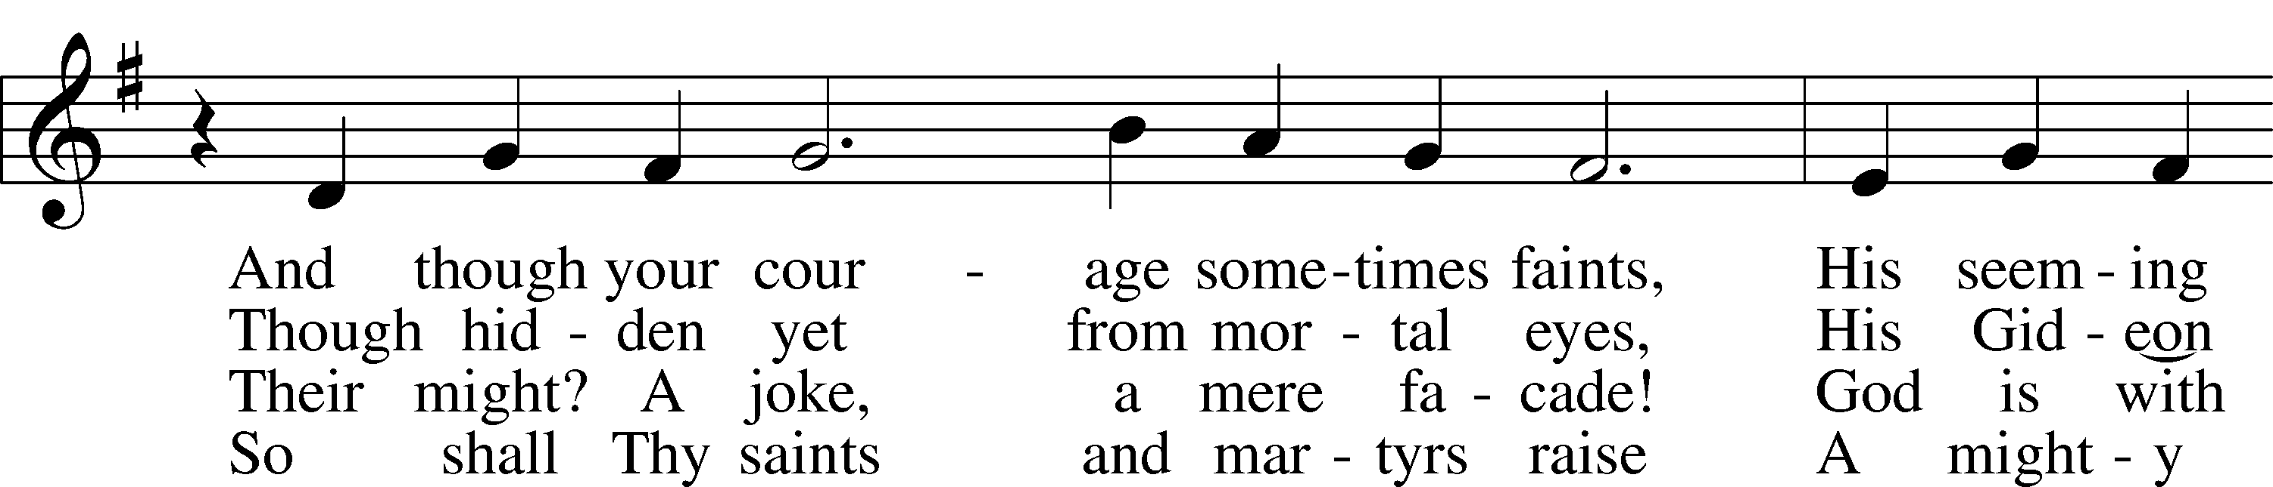

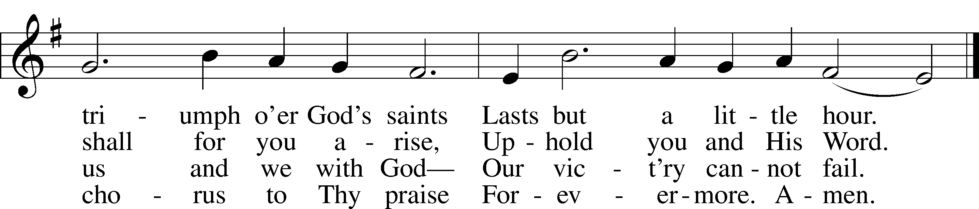

Text: Jacob Fabricius, 1593–1654; tr. Catherine Winkworth, 1827–78, alt.  
Tune: German, 1534, Nürnberg  
Text and tune: Public domain

# Confession and Absolution

Stand

The sign of the cross may be made by all in remembrance of their Baptism.

Invocation Matthew 28:19b; 18:20

P In the name of the Father and of the T Son and of the Holy Spirit.

C **Amen.**

Exhortation Psalm 124:8; Psalm 130:3–4; Luke 18:13

P Our help is in the name of the Lord,

C **who made heaven and earth.**

P If You, O Lord, kept a record of sins, O Lord, who could stand?

C **But with You there is forgiveness; therefore You are feared.**

P Since we are gathered to hear God’s Word, call upon Him in prayer and praise, and receive the body and blood of our Lord Jesus Christ in the fellowship of this altar, let us first consider our unworthiness and confess before God and one another that we have sinned in thought, word, and deed, and that we cannot free ourselves from our sinful condition. Together as His people let us take refuge in the infinite mercy of God, our heavenly Father, seeking His grace for the sake of Christ, and saying: God, be merciful to me, a sinner.

Kneel/Stand

Confession of Sins

C **Almighty God, have mercy upon us, forgive us our sins, and lead us to everlasting life. Amen.**

Absolution [John 20:19–23]

P Almighty God in His mercy has given His Son to die for you and for His sake forgives you all your sins. As a called and ordained servant of Christ, and by His authority, I therefore forgive you all your sins in the name of the Father and of the T Son and of the Holy Spirit.

C **Amen.**

Stand

# Service of the Word

Introit Psalm 74:1–3; antiphon: Psalm 69:9

For zeal for your house has consumed me,  
 and the reproaches of those who reproach you have fallen on me.  
**O God, why do you cast us off forever?  
 Why does your anger smoke against the sheep of your pasture?**Remember your congregation, which you have purchased of old, which you have redeemed to be the tribe of your heritage!  
 Remember Mount Zion, where you have dwelt.  
**Direct your steps to the perpetual ruins;  
 the enemy has destroyed everything in the sanctuary!**  
**Glory be to the Father and to the Son**  
 **and to the Holy Spirit;**  
**as it was in the beginning,**  
 **is now, and will be forever. Amen.**  
For zeal for your house has consumed me,  
 and the reproaches of those who reproach you have fallen on me.

Kyrie Mark 10:47

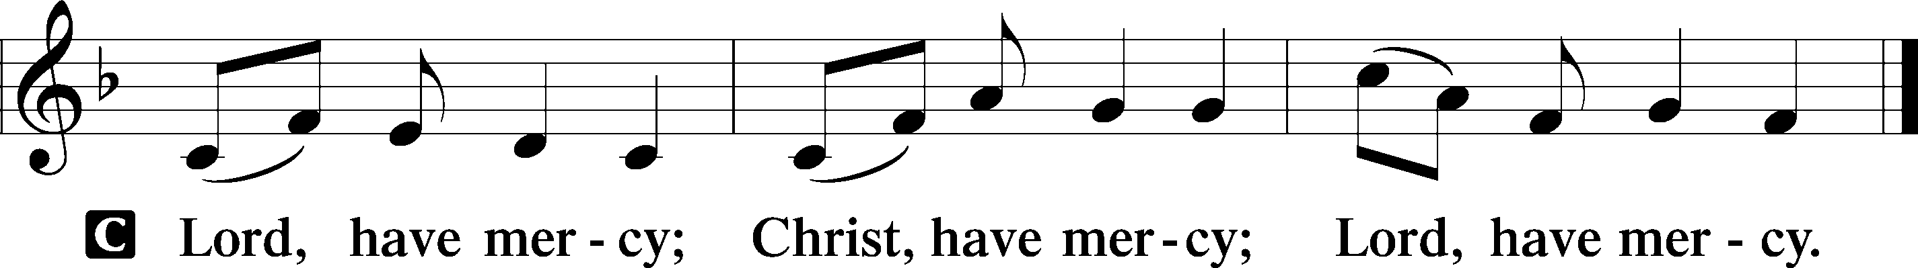

Salutation and Collect of the Day

P The Lord be with you.

C **And also with you.**

P Let us pray.

O God, You see that of ourselves we have no strength. By Your mighty power defend us from all adversities that may happen to the body and from all evil thoughts that may assault and hurt the soul; through Jesus Christ, Your Son, our Lord, who lives and reigns with You and the Holy Spirit, one God, now and forever.

C **Amen.**

Sit

Old Testament Reading Jeremiah 26:8–15

8When Jeremiah had finished speaking all that the Lord had commanded him to speak to all the people, then the priests and the prophets and all the people laid hold of him, saying, “You shall die! 9Why have you prophesied in the name of the Lord, saying, ‘This house shall be like Shiloh, and this city shall be desolate, without inhabitant’?” And all the people gathered around Jeremiah in the house of the Lord.

10When the officials of Judah heard these things, they came up from the king’s house to the house of the Lord and took their seat in the entry of the New Gate of the house of the Lord. 11Then the priests and the prophets said to the officials and to all the people, “This man deserves the sentence of death, because he has prophesied against this city, as you have heard with your own ears.”

12Then Jeremiah spoke to all the officials and all the people, saying, “The Lord sent me to prophesy against this house and this city all the words you have heard. 13Now therefore mend your ways and your deeds, and obey the voice of the Lord your God, and the Lord will relent of the disaster that he has pronounced against you. 14But as for me, behold, I am in your hands. Do with me as seems good and right to you. 15Only know for certain that if you put me to death, you will bring innocent blood upon yourselves and upon this city and its inhabitants, for in truth the Lord sent me to you to speak all these words in your ears.”

A This is the Word of the Lord.

C **Thanks be to God.**

Gradual Hebrews 12:2

[O come, let us fix our eyes on] Jesus,  
 the founder and perfecter of our faith,  
**who for the joy that was set before him endured the cross, despising the shame,  
 and is seated at the right hand of the throne of God.**

Epistle Philippians 3:17—4:1

17Brothers, join in imitating me, and keep your eyes on those who walk according to the example you have in us. 18For many, of whom I have often told you and now tell you even with tears, walk as enemies of the cross of Christ. 19Their end is destruction, their god is their belly, and they glory in their shame, with minds set on earthly things. 20But our citizenship is in heaven, and from it we await a Savior, the Lord Jesus Christ, 21who will transform our lowly body to be like his glorious body, by the power that enables him even to subject all things to himself.

1Therefore, my brothers, whom I love and long for, my joy and crown, stand firm thus in the Lord, my beloved.

A This is the Word of the Lord.

C **Thanks be to God.**

Stand

Verse John 20:31

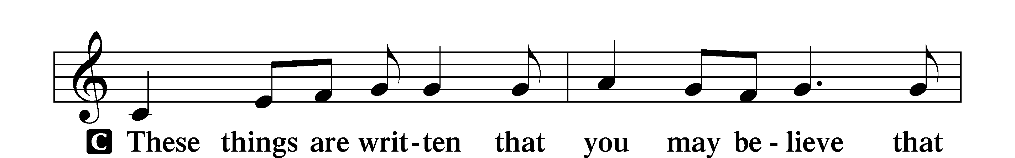

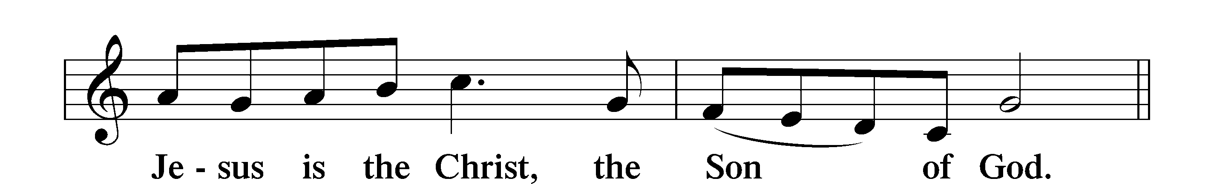

Alleluia

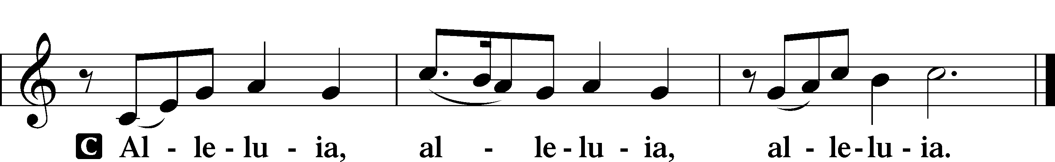

Holy Gospel Luke 13:31–35

P The Holy Gospel according to St. Luke, the thirteenth chapter.

C **Glory to You, O Lord.**

31At that very hour some Pharisees came and said to [Jesus], “Get away from here, for Herod wants to kill you.” 32And he said to them, “Go and tell that fox, ‘Behold, I cast out demons and perform cures today and tomorrow, and the third day I finish my course. 33Nevertheless, I must go on my way today and tomorrow and the day following, for it cannot be that a prophet should perish away from Jerusalem.’ 34O Jerusalem, Jerusalem, the city that kills the prophets and stones those who are sent to it! How often would I have gathered your children together as a hen gathers her brood under her wings, and you would not! 35Behold, your house is forsaken. And I tell you, you will not see me until you say, ‘Blessed is he who comes in the name of the Lord!’”

P This is the Gospel of the Lord.

C **Praise to You, O Christ.**

Nicene Creed

C **I believe in one God,**

**the Father Almighty,**

**maker of heaven and earth**

**and of all things visible and invisible.**

**And in one Lord Jesus Christ,**

**the only-begotten Son of God,**

**begotten of His Father before all worlds,**

**God of God, Light of Light,**

**very God of very God,**

**begotten, not made,**

**being of one substance with the Father,**

**by whom all things were made;**

**who for us men and for our salvation came down from heaven**

**and was incarnate by the Holy Spirit of the virgin Mary**

**and was made man;**

**and was crucified also for us under Pontius Pilate.**

**He suffered and was buried.**

**And the third day He rose again according to the Scriptures**

**and ascended into heaven**

**and sits at the right hand of the Father.**

**And He will come again with glory to judge both the living and the dead,**

**whose kingdom will have no end.**

**And I believe in the Holy Spirit,**

**the Lord and giver of life,**

**who proceeds from the Father and the Son,**

**who with the Father and the Son together is worshiped and glorified,**

**who spoke by the prophets.**

**And I believe in one holy Christian and apostolic Church,**

**I acknowledge one Baptism for the remission of sins,**

**and I look for the resurrection of the dead**

**and the life** T **of the world to come. Amen.**

Sit

Children's Sermon

708 Lord, Thee I Love with All My Heart

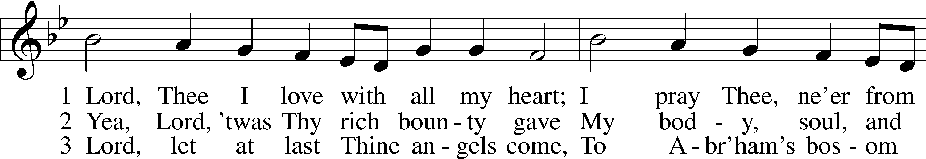

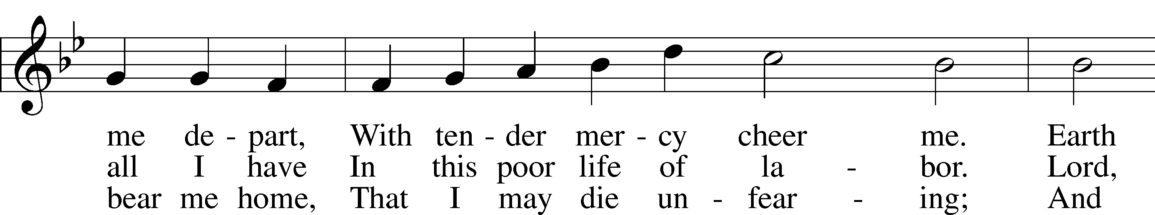

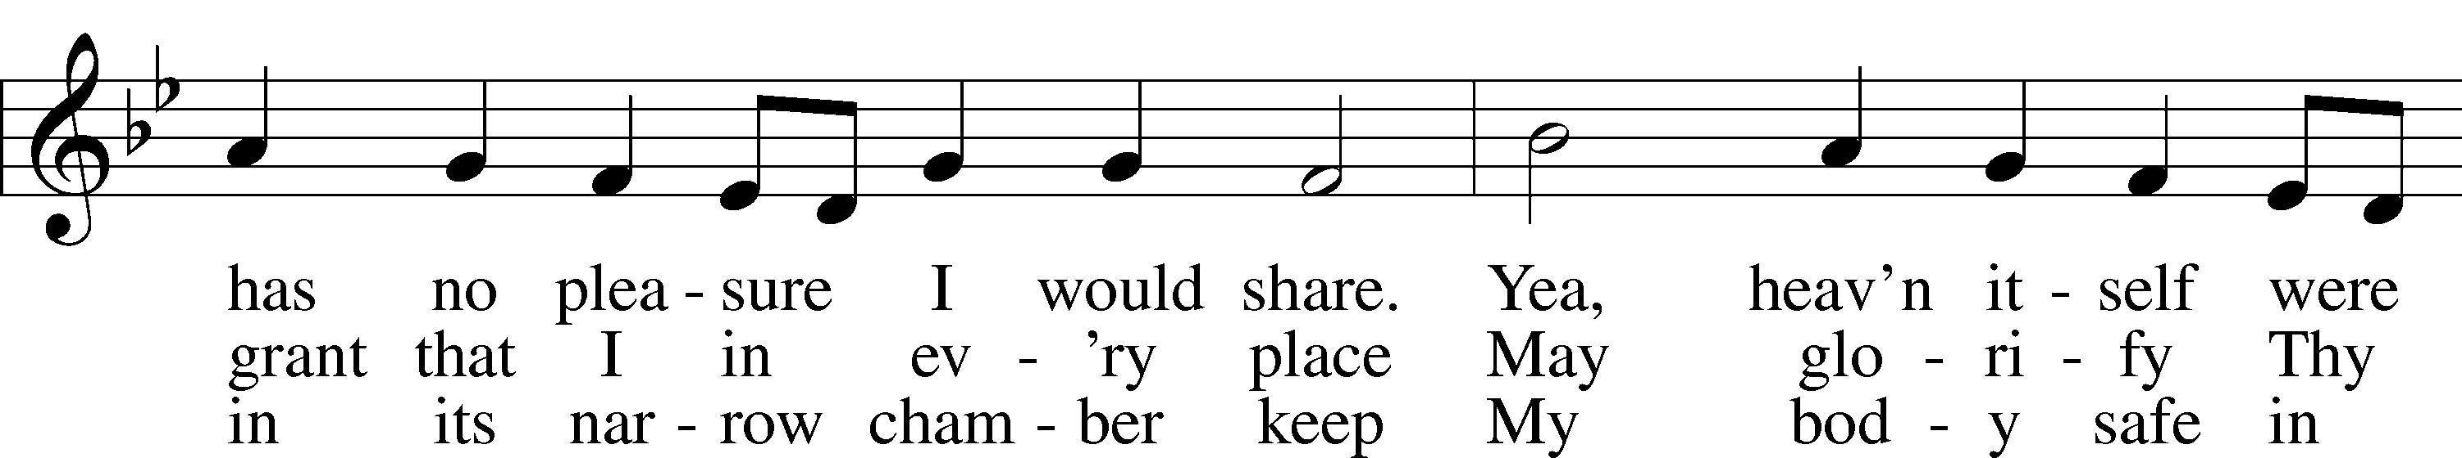

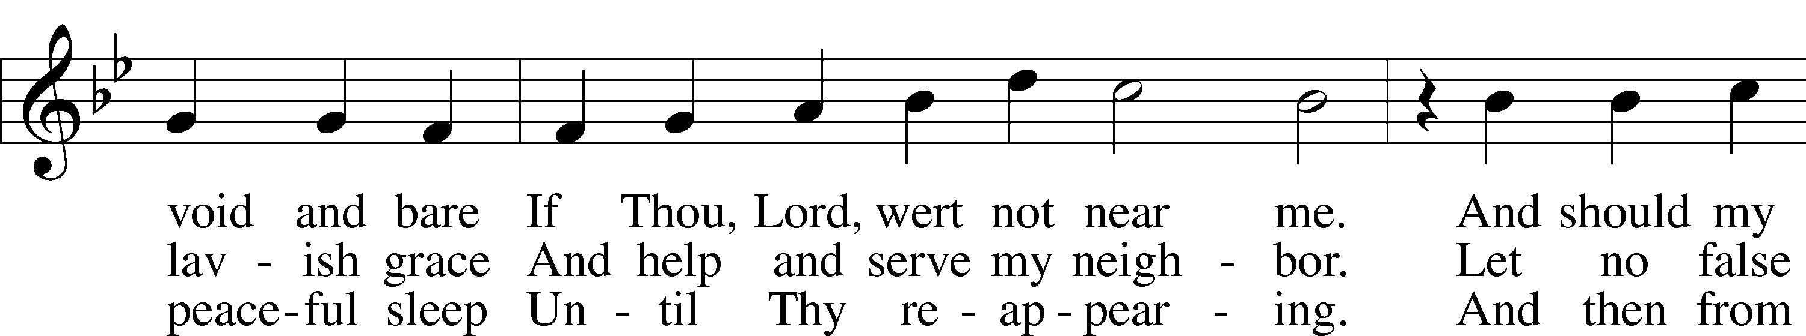

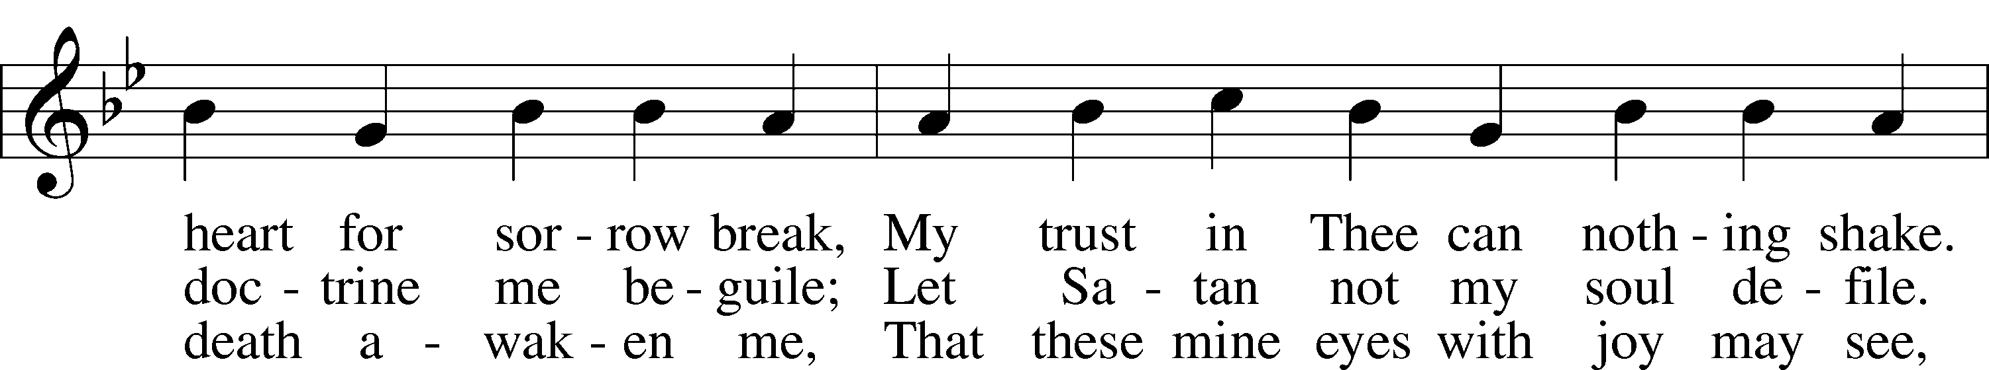

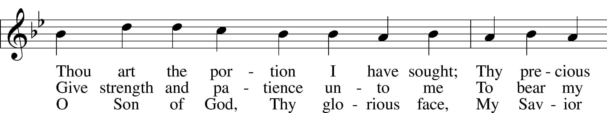

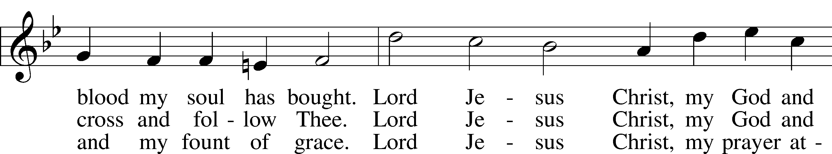

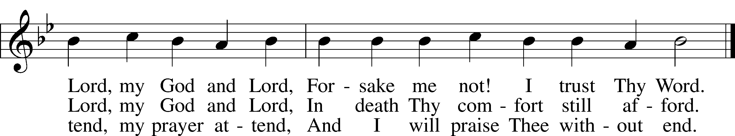

Text: Martin Schalling, 1532–1608; tr. Catherine Winkworth, 1827–78, alt.  
Tune: Zwey Bücher . . . Tabulatur, 1577, Strassburg  
Text and tune: Public domain

Sermon

Stand

Prayer of the Church

Following the prayers, the people may greet one another in the name of the Lord, saying, “Peace be with you,” as a sign of reconciliation and of the unity of the Spirit in the bond of peace (Matt. 5:22–24; Eph. 4:1–3).

Sit

Offering

805 Praise God, from Whom All Blessings Flow

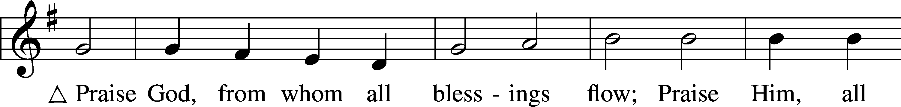

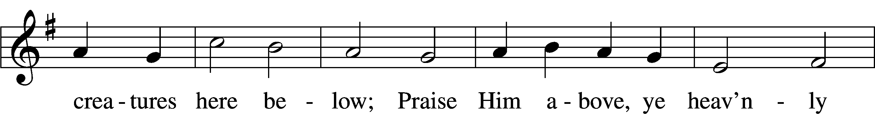

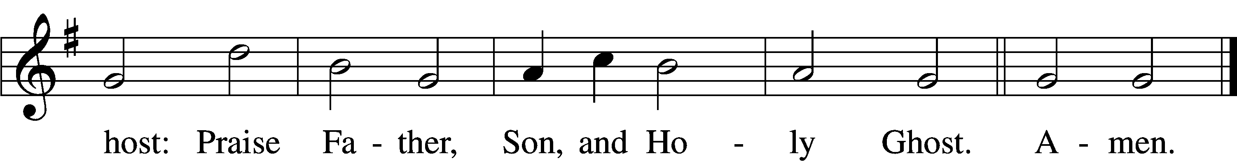

Text: Thomas Ken, 1637–1711  
Tune: Trente quatre Pseaumes de David, 1551, Geneva, ed. Louis Bourgeois  
Text and tune: Public domain

# Service of the Sacrament

Stand

Preface 2 Timothy 4:22; [Colossians 3:1]; [Psalm 136]

P The Lord be with you.

C **And also with you.**

P Lift up your hearts.

C **We lift them to the Lord.**

P Let us give thanks to the Lord our God.

C **It is right to give Him thanks and praise.**

P It is truly good, right, and salutary that we should at all times and in all places give thanks to You, O Lord, holy Father, almighty and everlasting God, for the countless blessings You so freely bestow on us and all creation. Above all, we give thanks for Your boundless love shown to us when You sent Your only-begotten Son, Jesus Christ, into our flesh and laid on Him our sin, giving Him into death that we might not die eternally. Because He is now risen from the dead and lives and reigns to all eternity, all who believe in Him will overcome sin and death and will rise again to new life. Therefore with angels and archangels and with all the company of heaven we laud and magnify Your glorious name, evermore praising You and saying:

Sanctus Isaiah 6:3; Matthew 21:9

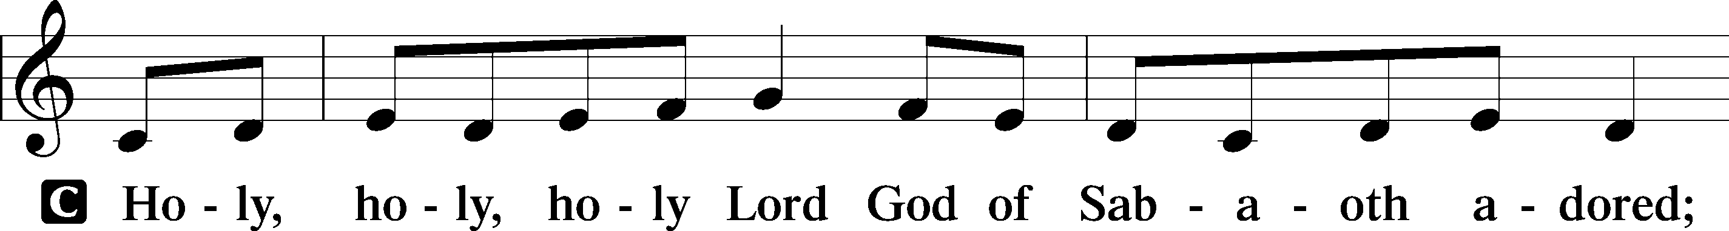

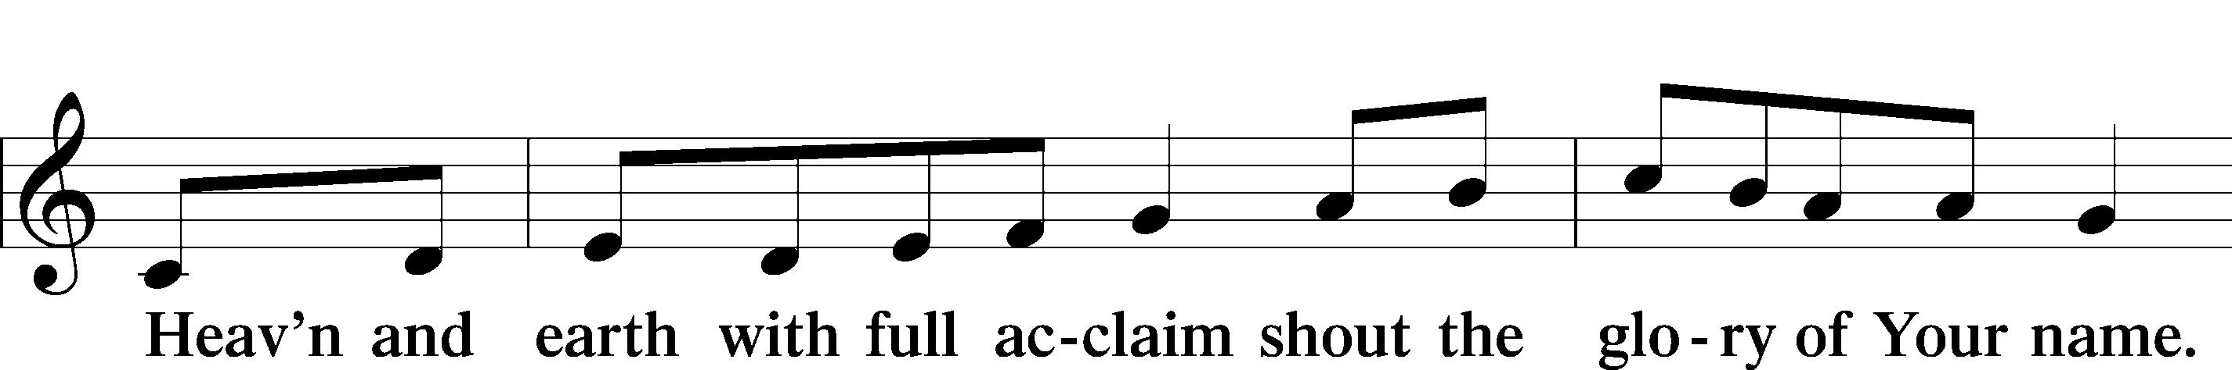

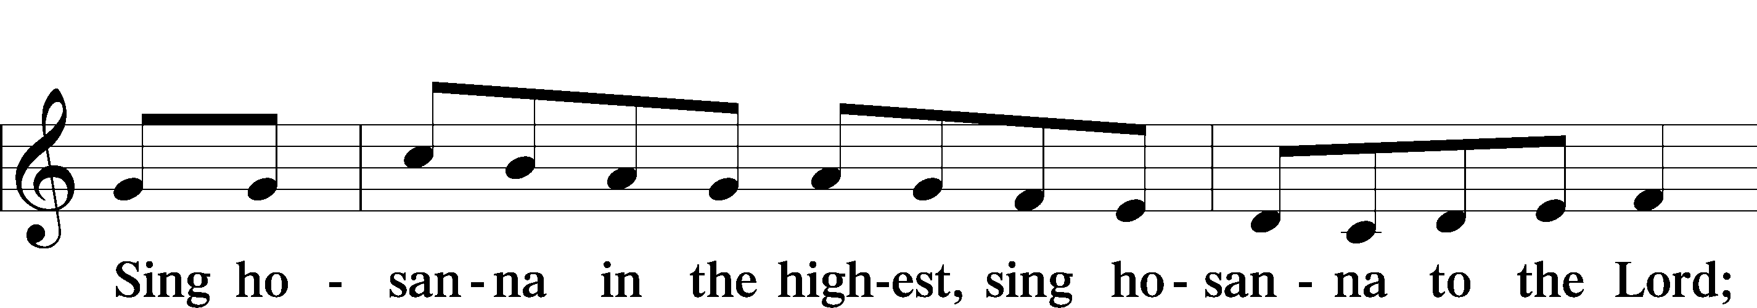

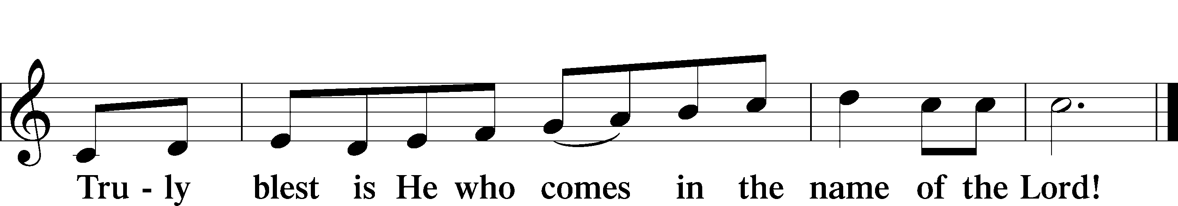

Text: Stephen P. Starke

Prayer of Thanksgiving

P Blessed are You, O Lord our God, king of all creation, for You have had mercy on us and given Your only-begotten Son that whoever believes in Him should not perish but have eternal life.

At Your command, Abraham prepared to offer his son Isaac as a sacrifice on the mountain; yet, in mercy You provided a ram as a substitute. We give You thanks that on Calvary You spared not Your only Son but sent Him to offer His life as a ransom for many.

As we eat and drink His body and blood, grant us, like Abraham our father, to trust in Your promise now fulfilled in Christ, the Lamb of God, who takes away the sin of the world.

Hear us as we pray in His name and as He has taught us:

Lord’s Prayer

C **Our Father who art in heaven,**

**hallowed be Thy name,**

**Thy kingdom come,**

**Thy will be done on earth**

**as it is in heaven;**

**give us this day our daily bread;**

**and forgive us our trespasses**

**as we forgive those**

**who trespass against us;**

**and lead us not into temptation,**

**but deliver us from evil.**

**For Thine is the kingdom**

**and the power and the glory**

**forever and ever. Amen.**

The Words of Our Lord

P Our Lord Jesus Christ, on the night when He was betrayed, took bread, and when He had given thanks, He broke it and gave it to the disciples and said: “Take, eat; this is My T body, which is given for you. This do in remembrance of Me.”

In the same way also He took the cup after supper, and when He had given thanks, He gave it to them, saying: “Drink of it, all of you; this cup is the new testament in My T blood, which is shed for you for the forgiveness of sins. This do, as often as you drink it, in remembrance of Me.”

Pax Domini

P The peace of the Lord be with you always.

C **Amen.**

Agnus Dei John 1:29

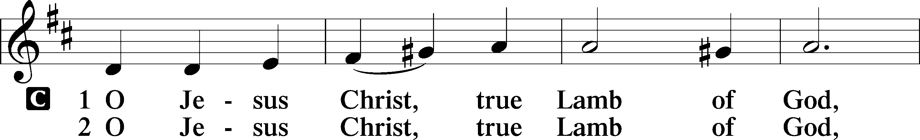

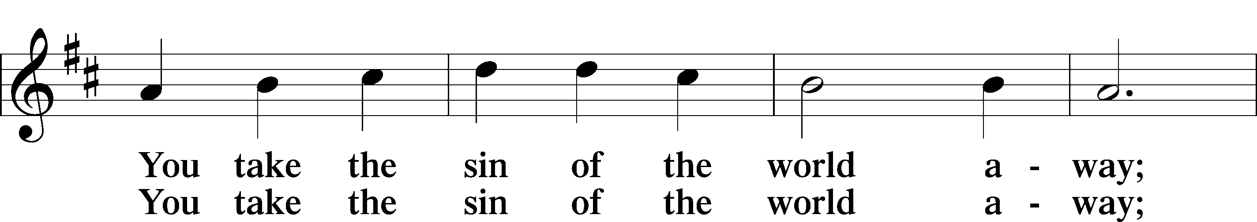

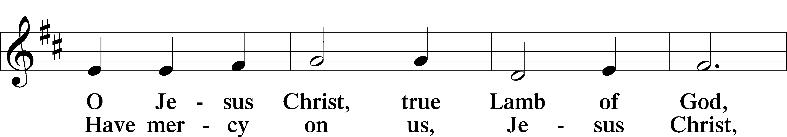

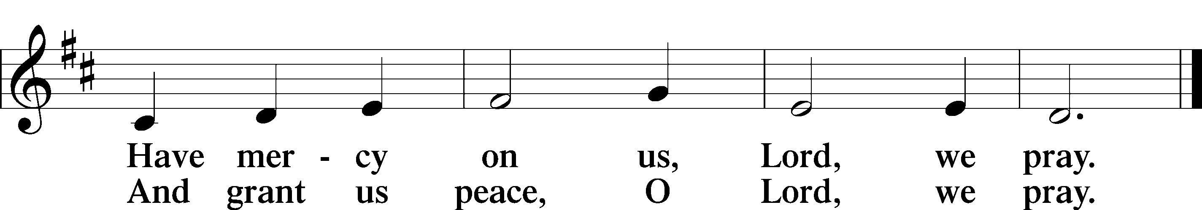

Text: Stephen P. Starke

Sit

Distribution

The pastor and those who assist him receive the body and blood of Christ first and then distribute them to those who come to receive, saying:

Take, eat; this is the true body of our Lord and Savior Jesus Christ, given into death for your sins.

**Amen.**

Take, drink; this is the true blood of our Lord and Savior Jesus Christ, shed for the forgiveness of your sins.

**Amen.**

In dismissing the communicants, the following is said:

The Dismissal

P The body and blood of our Lord Jesus Christ strengthen and preserve you in body and soul to life everlasting. Depart T in peace.

C **Amen.**

623 Lord Jesus Christ, We Humbly Pray

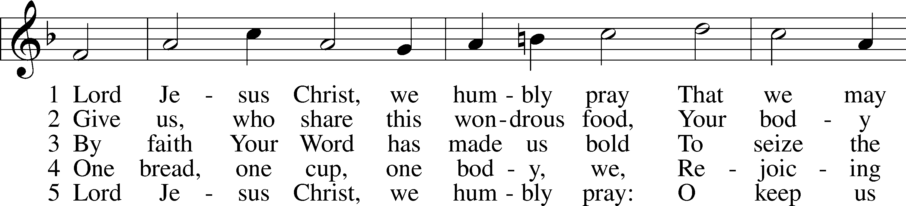

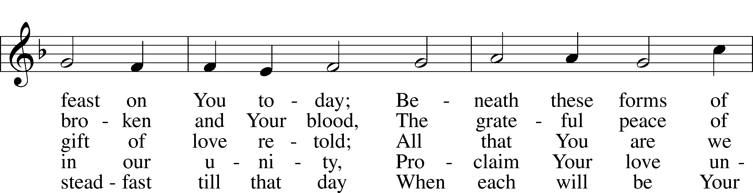

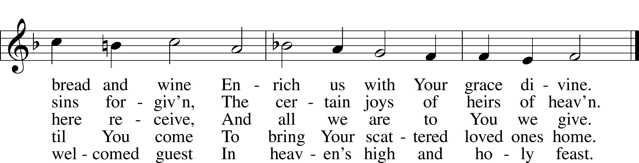

Text: Henry E. Jacobs, 1844–1932, alt.  
Tune: Cantionale Germanicum, 1628, Gochsheim  
Text and tune: Public domain

628 Your Table I Approach

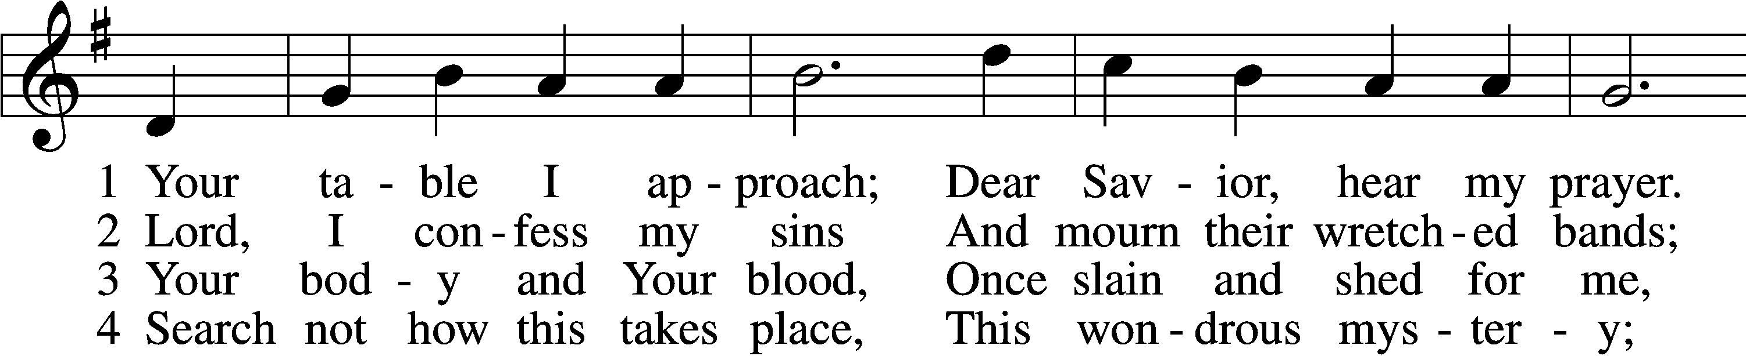

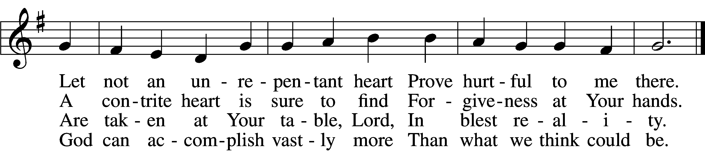

5 O grant, most blessèd Lord,  
 That earth and hell combined  
May not about this sacrament  
 Raise doubt within my mind.

6 Oh, may I never fail  
 To thank You day and night  
For Your true body and true blood,  
 O God, my peace and light.

Text: Gerhard Wolter Molanus, 1633–1722; tr. Matthias Loy, 1828–1915, alt.  
Tune: Trente quatre Pseaumes de David, 1551, Geneva, ed. Louis Bourgeois  
Text and tune: Public domain

642 O Living Bread from Heaven

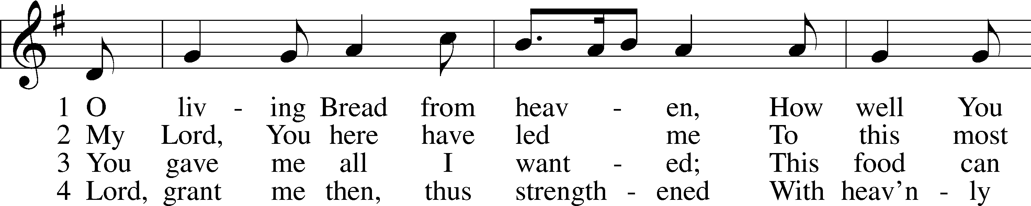

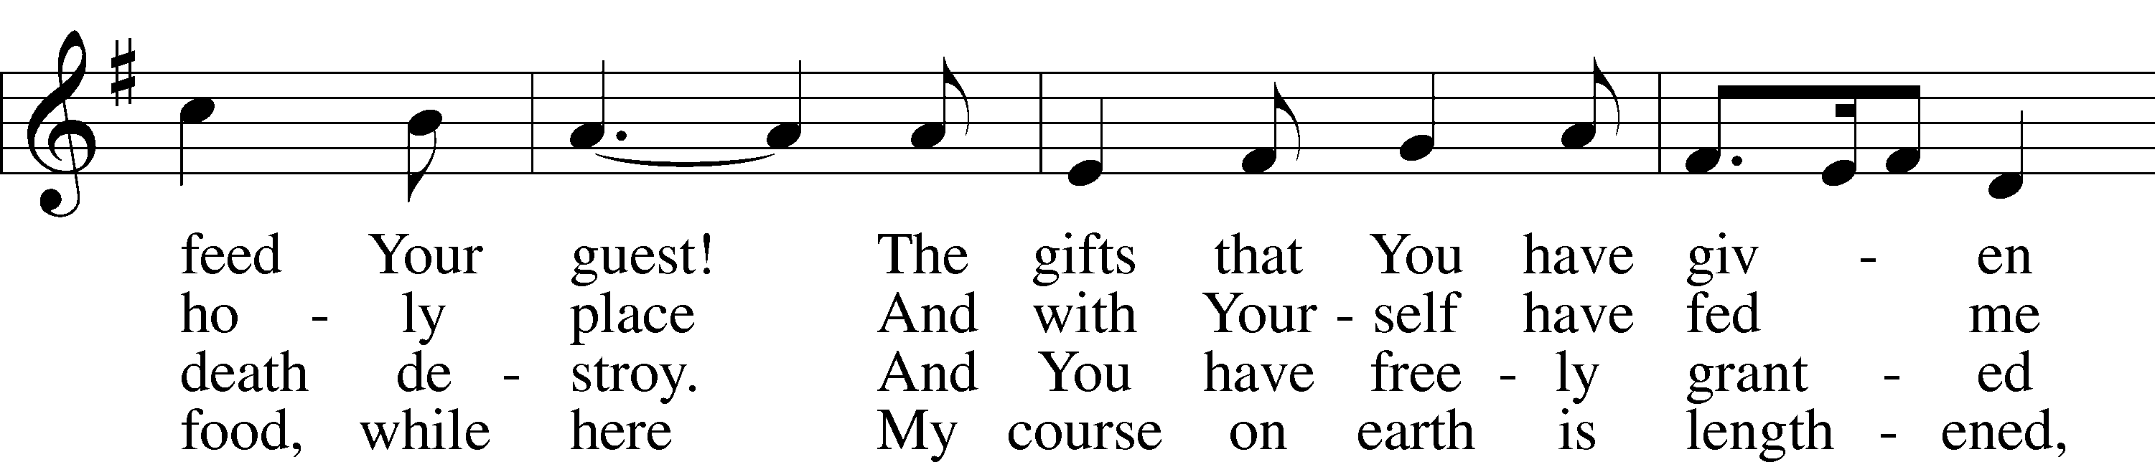

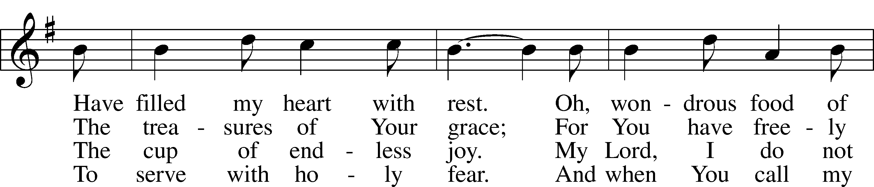

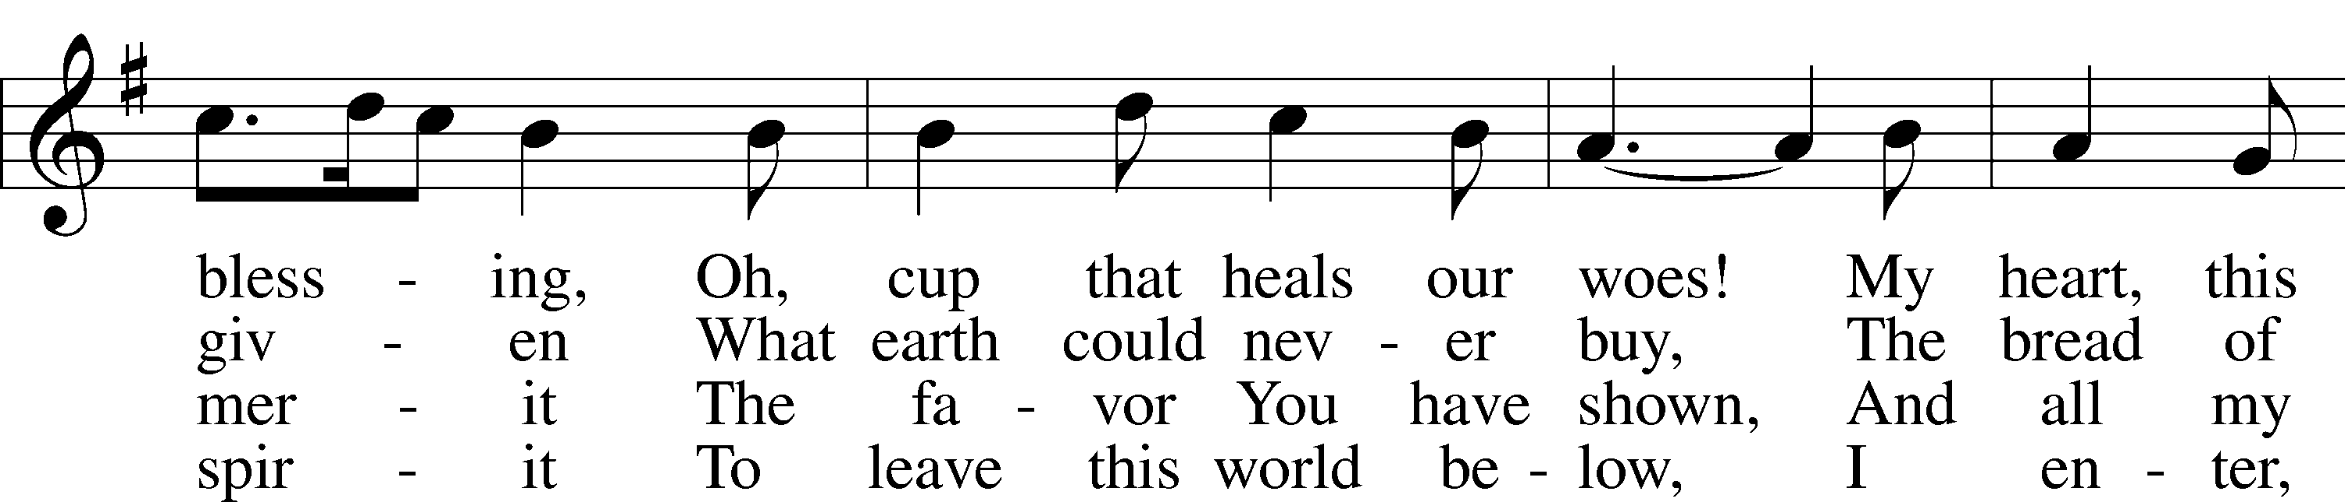

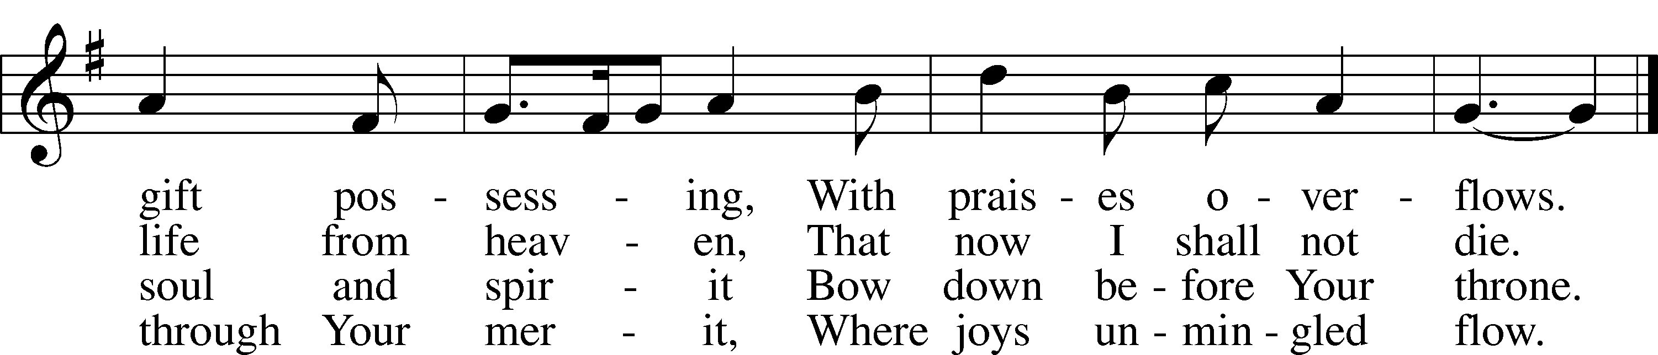

Text: Johann Rist, 1607–67; tr. Catherine Winkworth, 1827–78, alt.  
Tune: Musae Sioniae, 1609, vol. 7, Wolfenbüttel, ed. Michael Praetorius  
Text and tune: Public domain

637 Draw Near and Take the Body of the Lord

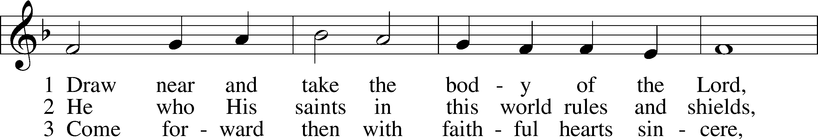

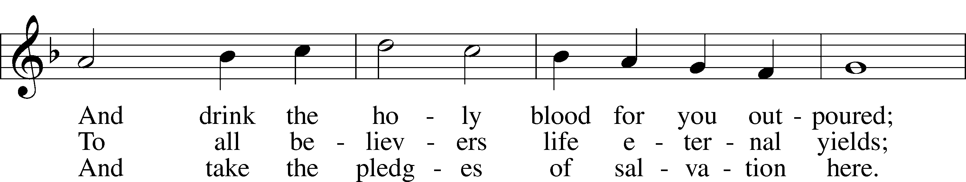

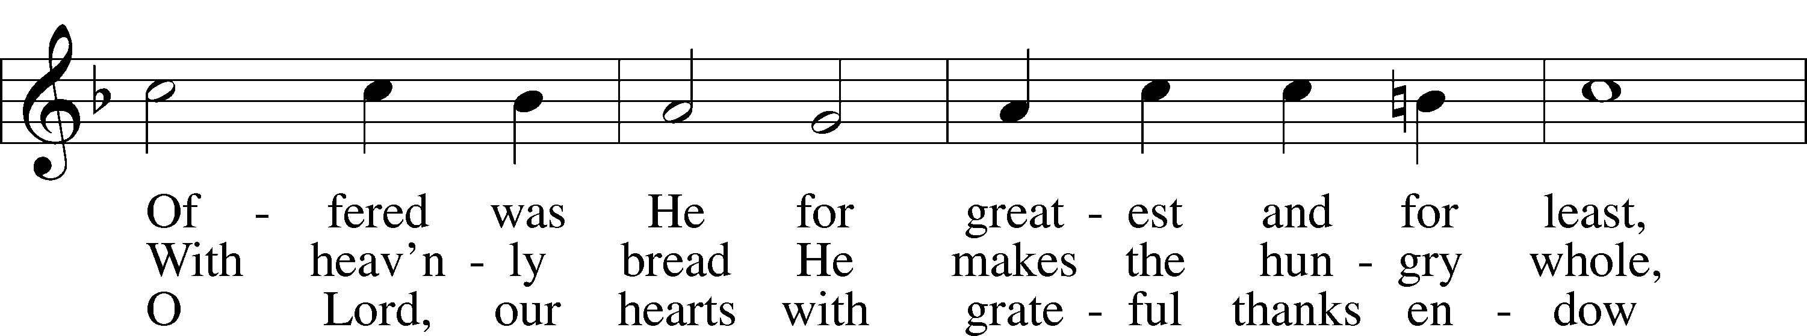

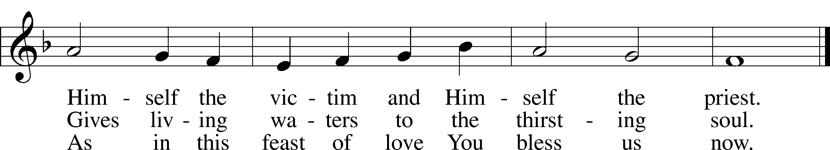

Text: Latin, 7th cent.; tr. John Mason Neale, 1818–66, alt.  
Tune: Trente quatre Pseaumes de David, 1551, Geneva, ed. Louis Bourgeois  
Text and tune: Public domain

Stand

Nunc Dimittis Luke 2:29–32

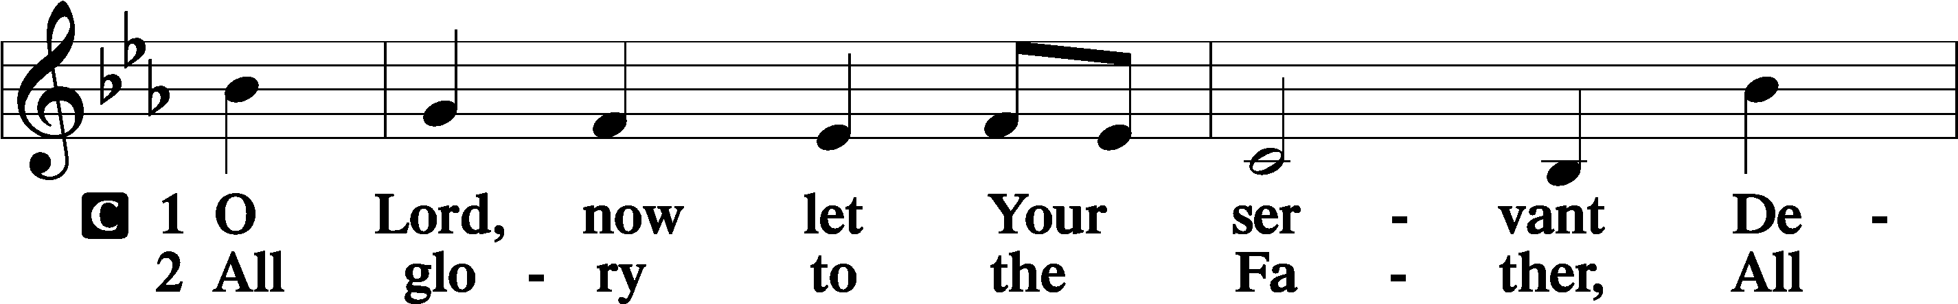

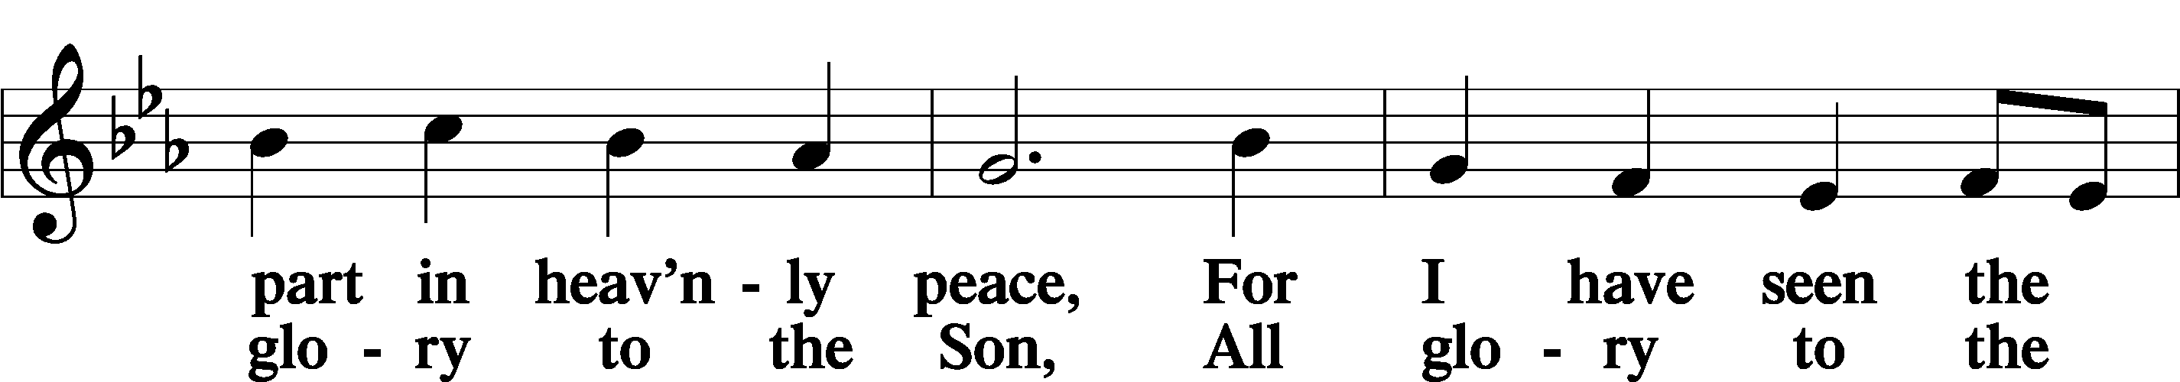

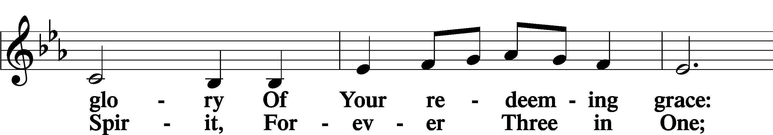

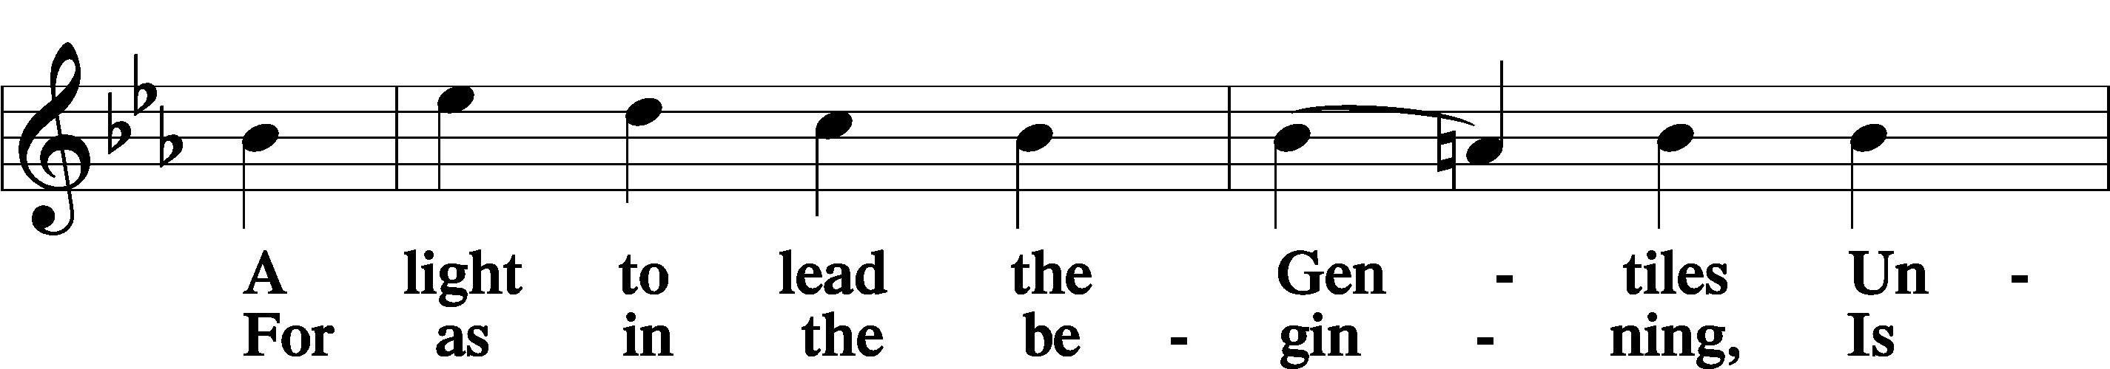

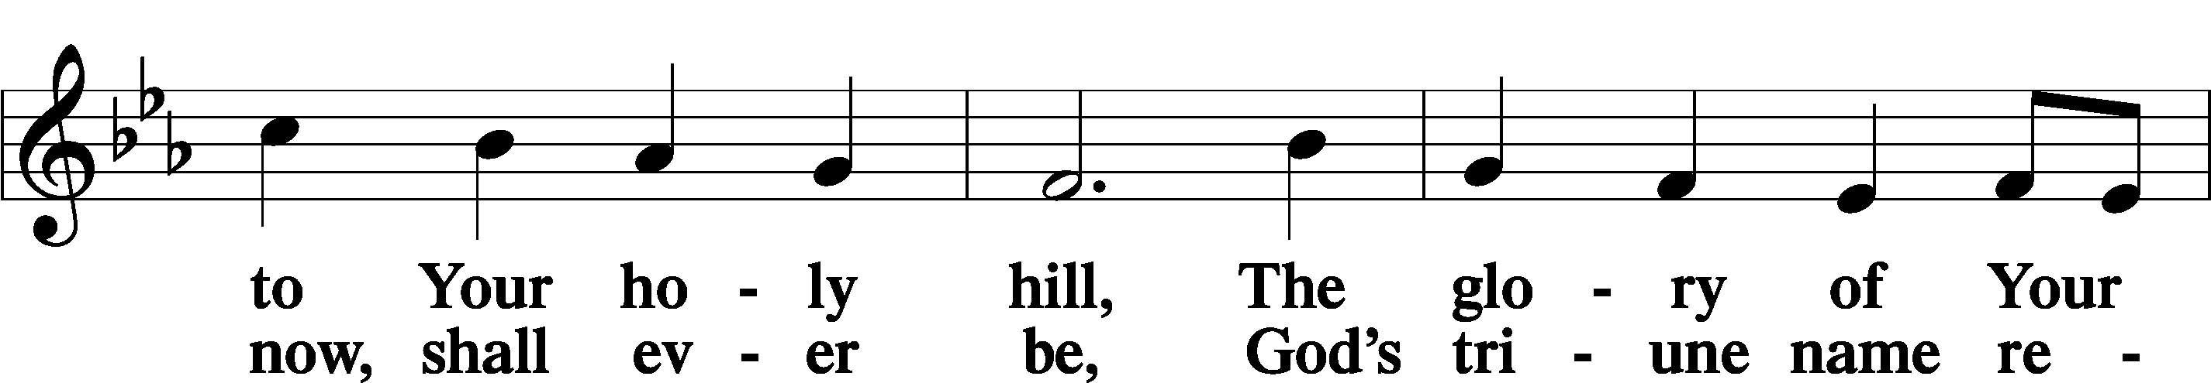

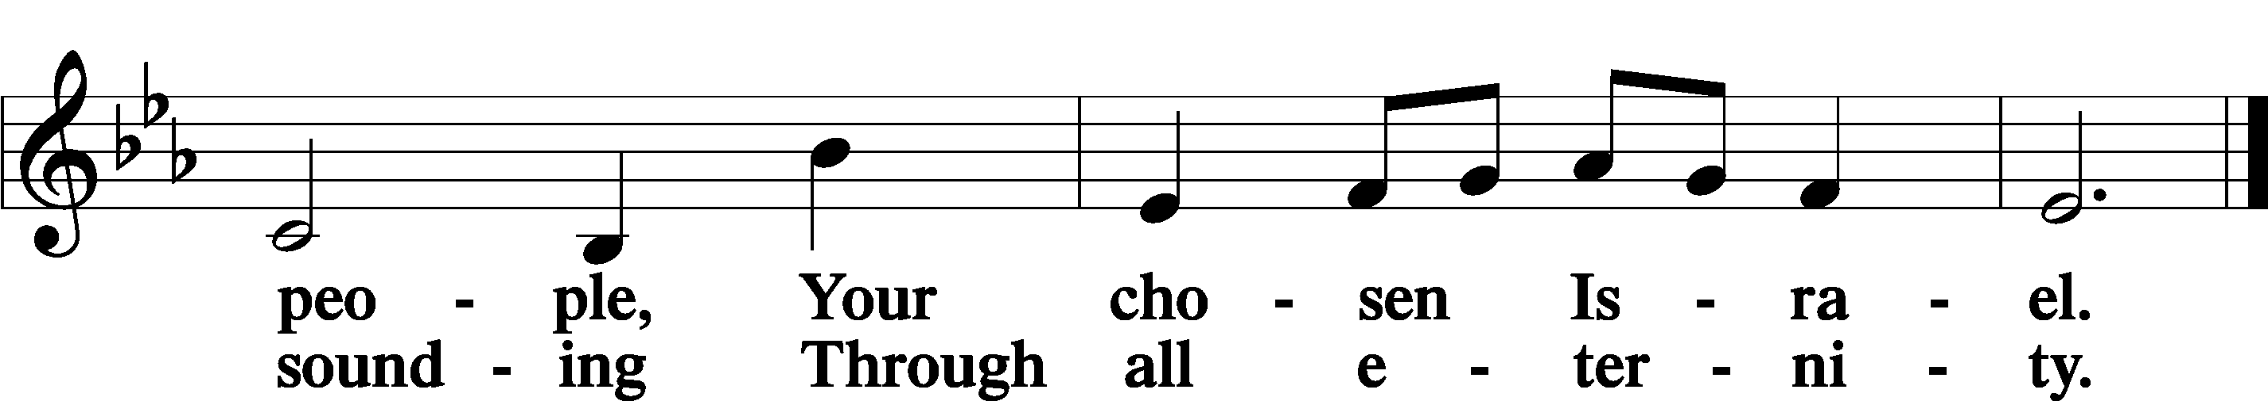

Post-Communion Collect

A Let us pray.

We give thanks to You, almighty God, that You have refreshed us through this salutary gift, and we implore You that of Your mercy You would strengthen us through the same in faith toward You and in fervent love toward one another; through Jesus Christ, Your Son, our Lord, who lives and reigns with You and the Holy Spirit, one God, now and forever.

C **Amen.**

Benedicamus Psalm 103:1

A Let us bless the Lord.

C **Thanks be to God.**

Benediction

P The Lord bless you and keep you.

The Lord make His face shine on you and be gracious to you.

The Lord look upon you with favor and T give you peace.

C **Amen.**

730 What Is the World to Me

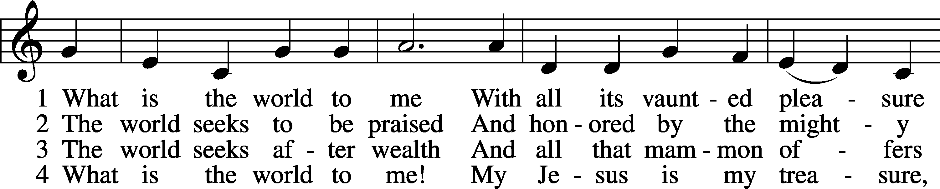

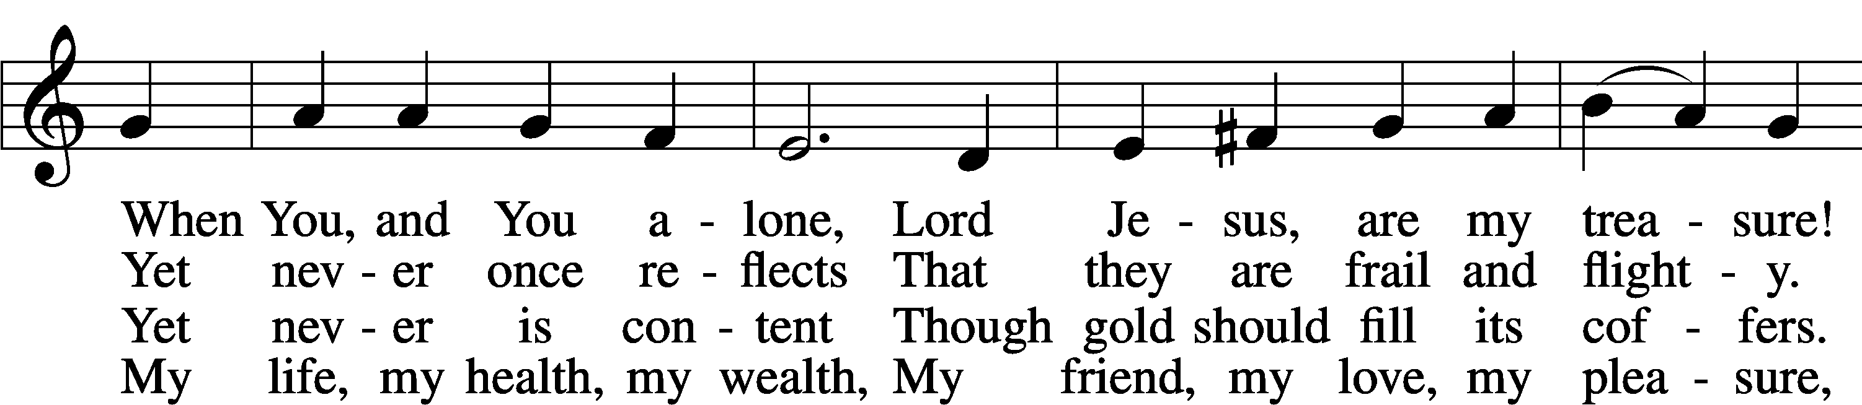

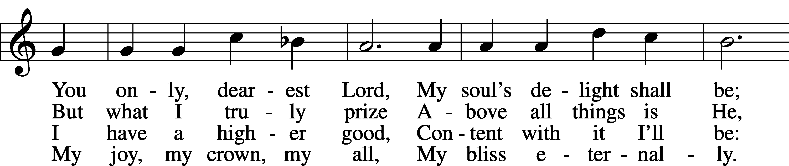

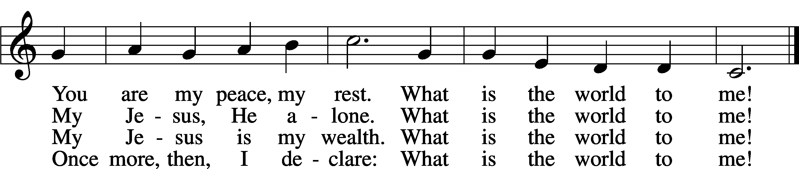

Text: Georg Michael Pfefferkorn, 1645–1732; tr. August Crull, 1845–1923, alt.  
Tune: Ahasverus Fritsch, 1629–1701  
Text and tune: Public domain

Acknowledgments

Divine Service, Setting Four from Lutheran Service Book

Unless otherwise indicated, Scripture quotations are from the ESV® Bible (The Holy Bible, English Standard Version®), copyright © 2001 by Crossway, a publishing ministry of Good News Publishers. Used by permission. All rights reserved.

Created by Lutheran Service Builder © 2025 Concordia Publishing House.