

**September 2024**



**Where has the year gone?**

We recently hired Mary Atkinson as our new secretary / graphic designer. She is learning the tasks of her position and is making it her “own”. Mary works Tuesday through Friday, from 9:00 – 3:00. She has been working on improving our website and has shared many ideas for improving the newsletter.

It seems like it was yesterday when we started this year. With Labor Day looming, summer is over. The swimming pool is closed for the year. School is back in session. Midweek school has been in session for the last two weeks. We might even be done with the 100°+ days.

September has many activities planned. The singles group will be meeting on September 7th in order to plan out their activities for the year. The Tasting Bee will be taking place on September 23rd. I even heard a rumor about a possible chili cookoff taking place in the near future. These are exciting times.

We have been celebrating Matins on Wednesday mornings at 9:30 for almost two months. What a meaningful way to start our day.

This week, we gathered with the Atkinson family to mourn the death of Diana. While we are mourning her death, this is also a reason to celebrate. Diana is no longer in fragile health. She doesn’t need to have an oxygen concentrator with her. Her broken bones aren’t hurting her. Diana is in perfect health and is seated at the table with Jesus.

Pastor De Young

**From the Pastor:**

**In our divine service, there are many parts of the liturgy (order of service) that should be explained. Over the next series of newsletters, we will be including an explanation of what is happening during each of these parts of the service (these explanations are found on the LCMS website).**

**About Lutheran Worship 🡪 Parts of the Liturgy**

Agnus Dei

Turning again to the Revelation to St. John, at one point John sees a scroll in the right hand of the One who was sitting on the throne. A “strong angel” puts forth the challenge, “Who is worthy to open the scroll and break its seals?”

Then, between the throne and the elders, the Lamb comes into view. Undoubtedly the most significant feature in John's description of this Lamb is that it is a lamb who appears to have been slain.

When we sing the Agnus Dei, “Lamb of God, you take away the sin of the world, have mercy on us,” we are preaching and praying all at once. It was, after all, with these very words that John the Baptizer pointed his disciples to Jesus (John 1:29, 36).

As we prepare to feast on the Lamb of our salvation, we do indeed proclaim him who gave his life for us. Here is the Lamb of God! Yet we also pray to him who is now present in his body and blood.

We pray for mercy, mercy from the One who showed the true depths of mercy and compassion as he was silently led to slaughter, dying like a lamb shorn of all its honor.

Returning one more time to the apostle John's vision of heaven, we later hear his description of the saints in white robes.

“Who are they?” John is asked. The answer: “These are the ones coming out of the great tribulation. They have washed their robes and made them white in the blood of the Lamb” (Rev. 7:13-14).

This is the blood of our redemption, the propitiatory sacrifice that was foreshadowed at the first Passover when the blood of the year-old lambs was sprinkled on the doorpost as a sign that blood had already been shed in that house.

In his Easter hymn, Martin Luther applies that incident to us, thus revealing our standing before the Father:

See, his blood now marks our door;  
Faith points to it;  
Death passes o'er,  
And Satan cannot harm us.  
(*Lutheran Service Book,*458)

So it is at every celebration of the Lord's Supper. The blood of the Lamb is poured out for our drinking and his flesh for our eating. Clearly, God's mercy is shown, and his peace rests on us.



Celebrate September’s Baptism Birthdays

& their years as heirs of God’s kingdom!

|  |  |  |
| --- | --- | --- |
| **Date** | **Name** | **Years** |
| 2nd | Shelby Horton | 24 |
| 11th | Adalyn Bohn | 8 |
|  | Bryan Roth | 58 |
| 12th | Kristin Henry | 42 |
|  | Levi Yowell | 42 |
| 18th | Emily Keyes | 9 |
|  | Vicki Wolsey | 42 |
| 21st | Bella Caswell | 9 |
| 22nd | Karlee Hughes | 11 |
| 27th | Gary Rainwater | 60 |
|  | Gail Sharp | 60 |
|  | Wren Shaw | 9 |
| 28th | Sid Mayfield | 21 |
|  |  |  |
|  |  |  |
|  |  |  |
|  |  |  |

**Serving in God’s House this month**

|  |  |
| --- | --- |
| **Elder of the Month** | Rich Lee |
| **Counters** | John Belcher / Terry Henry |
| **Altar Guild** | Kristin Henry / Rebecca Horton |
| **Altar Care** | Viola Robinson / Sally Morgan |

|  |  |  |
| --- | --- | --- |
| **Week** | **Acolytes** | **Reader** |
| September 01 | Kegaan Gilmore and Max Gilmore | William Pickett |
| September 08 | Annellee Osbon and Parker Lawson | Lee Hughes |
| September 15 | Bella Caswell and Ailey Pickett | Arn Anderson |
| September 22 | Karlee Hughes and Raegan Hughes | Bryan Roth |
| September 30 | Emily Keyes and Parker Lawson | William Pickett |

**Kleinhans 70th Anniversary!**

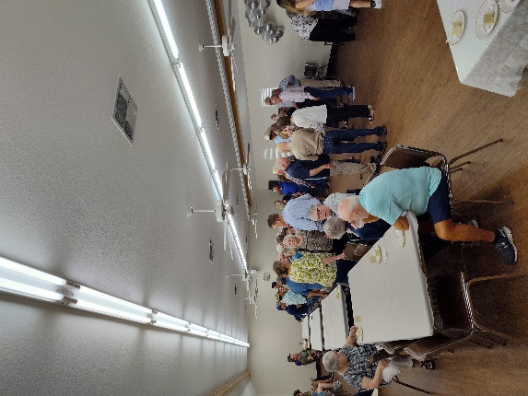 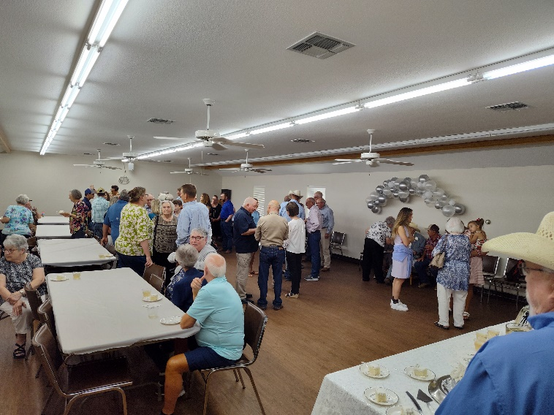



**Back to School Breakfast**

**August**

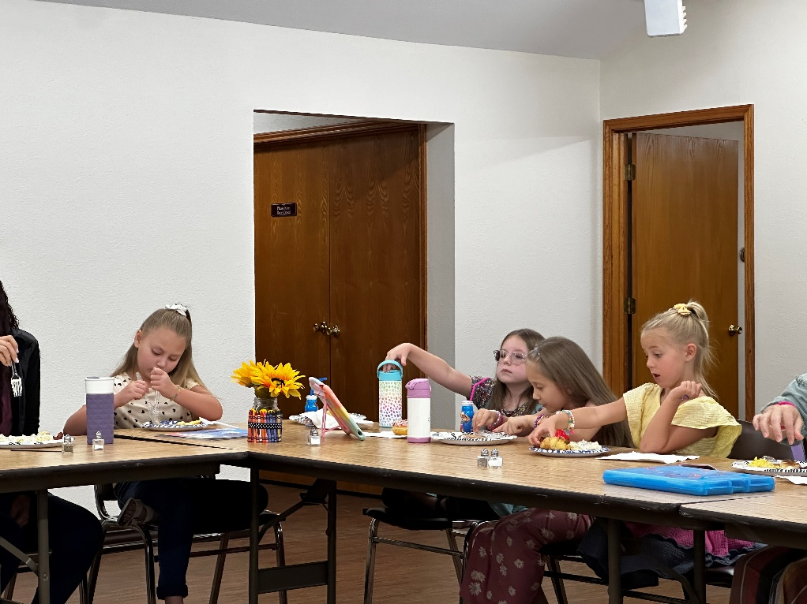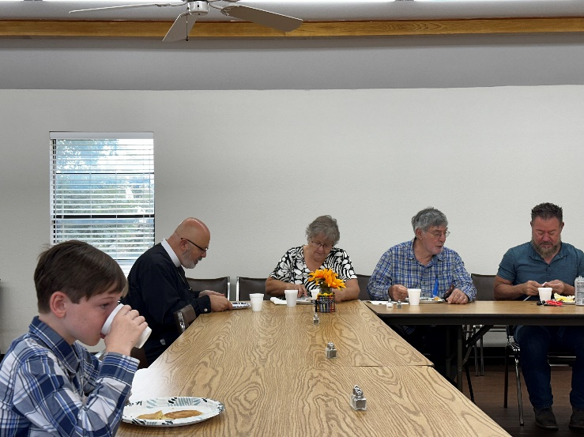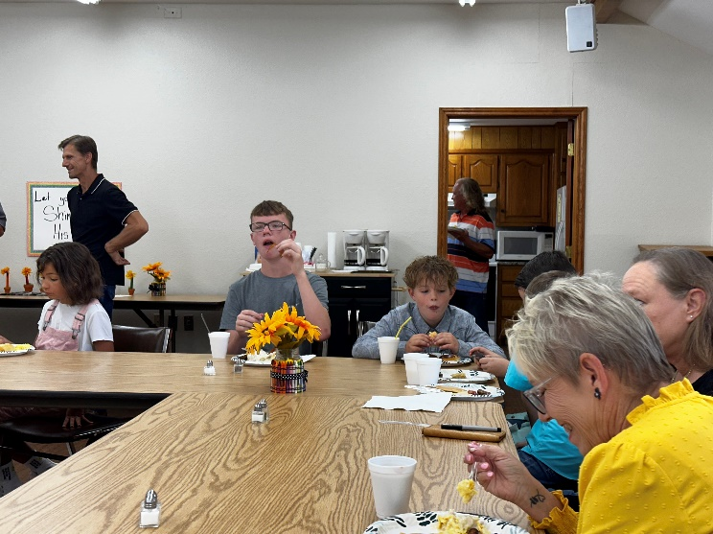

**Back to School**

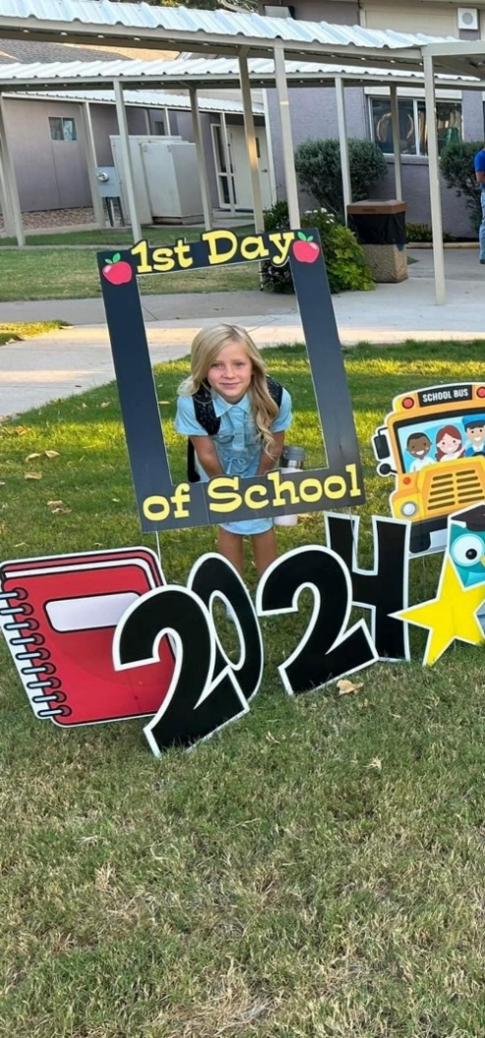 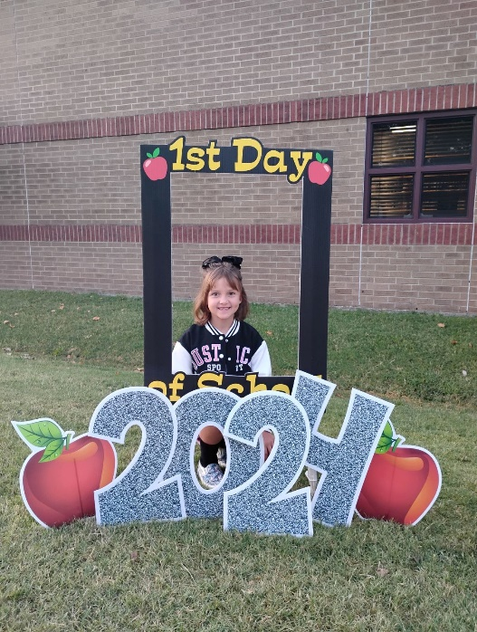

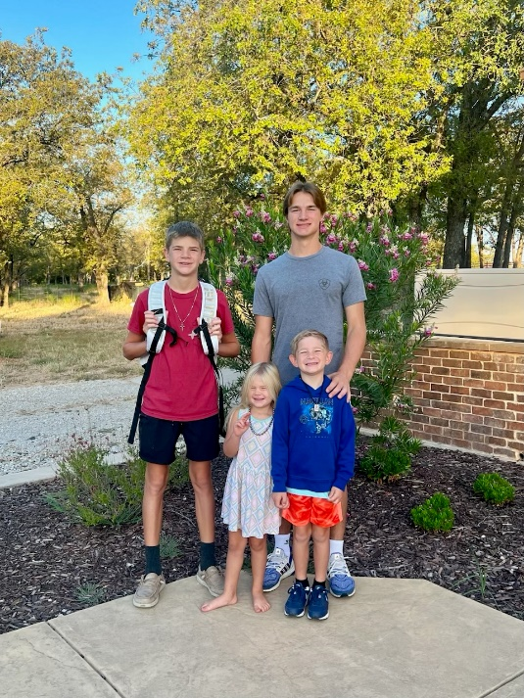 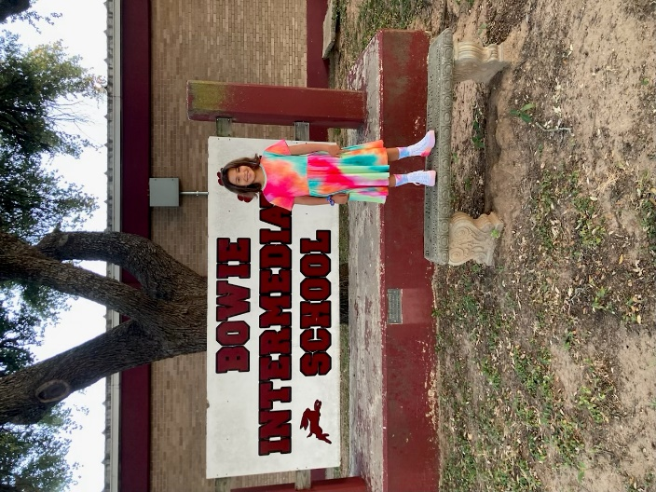

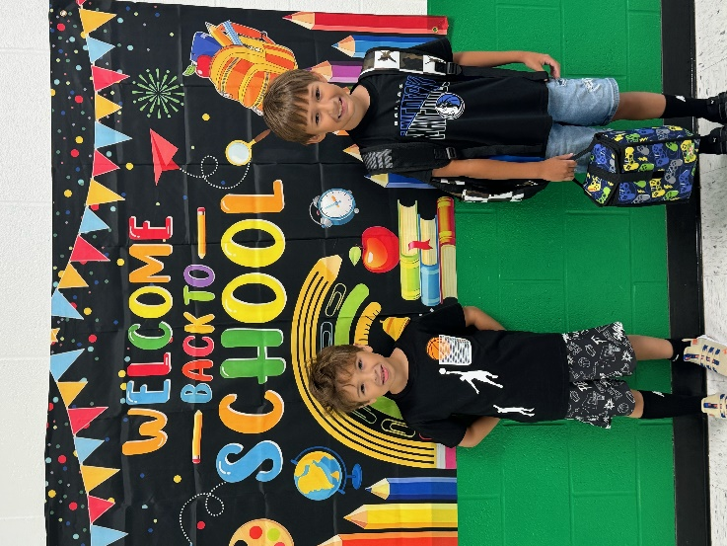 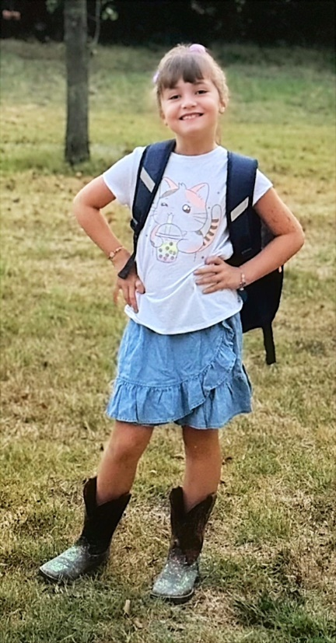

 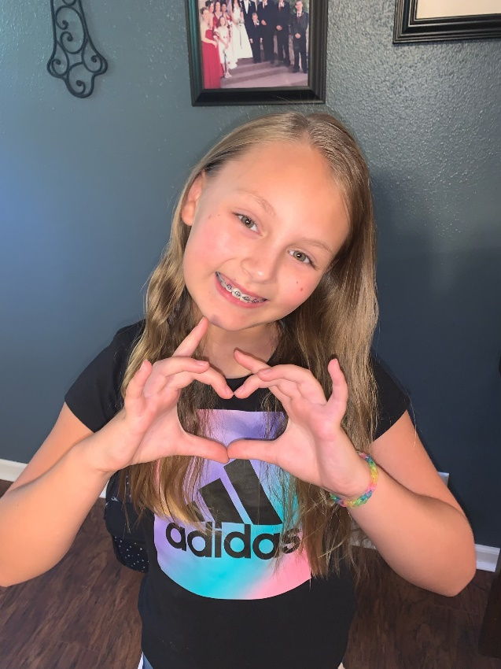

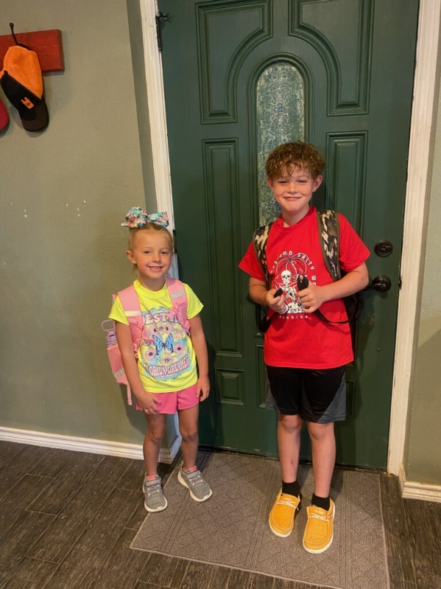 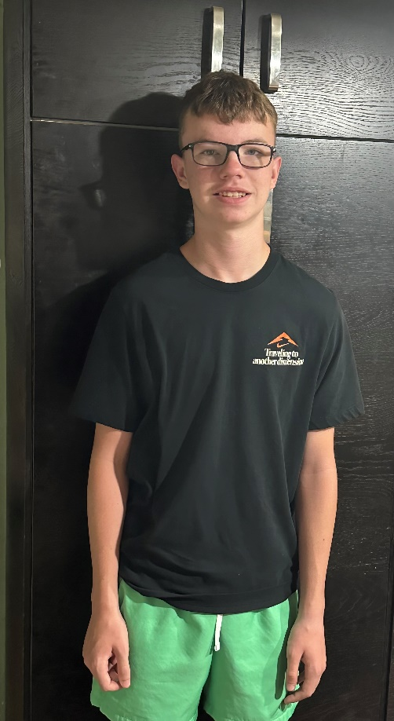

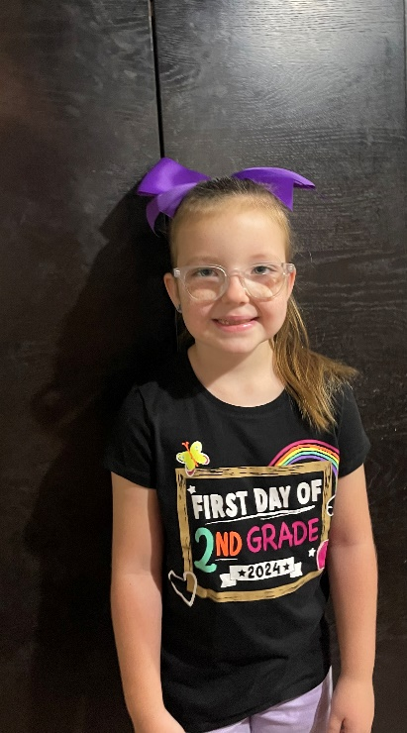 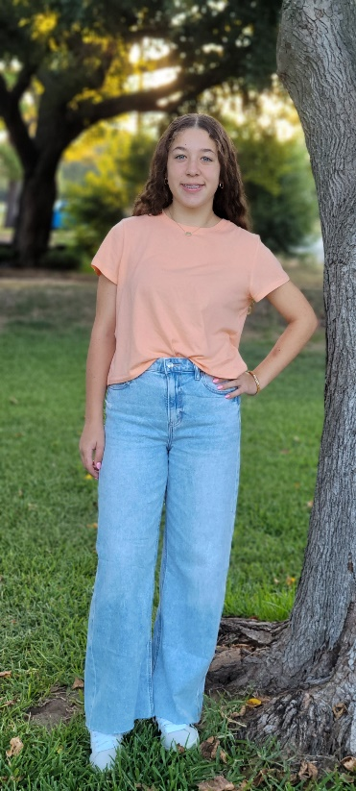

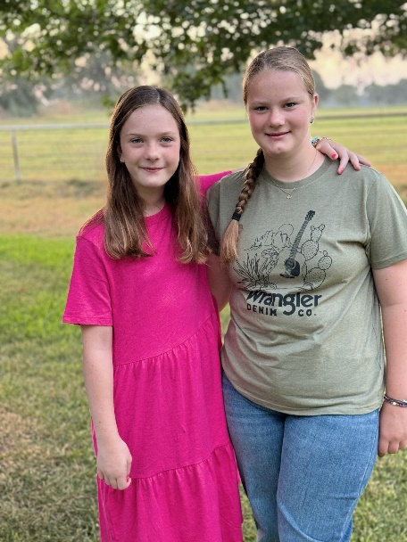 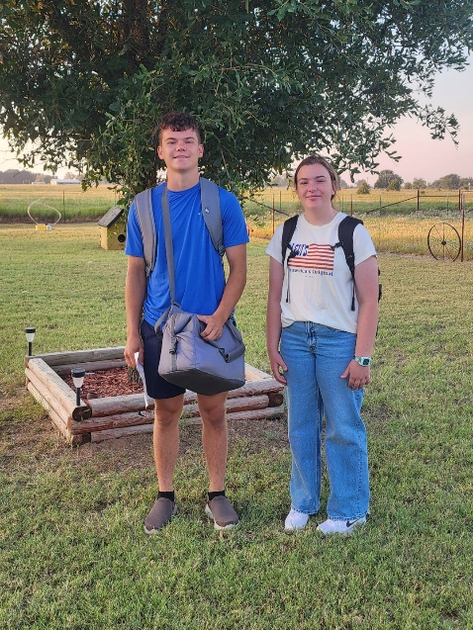

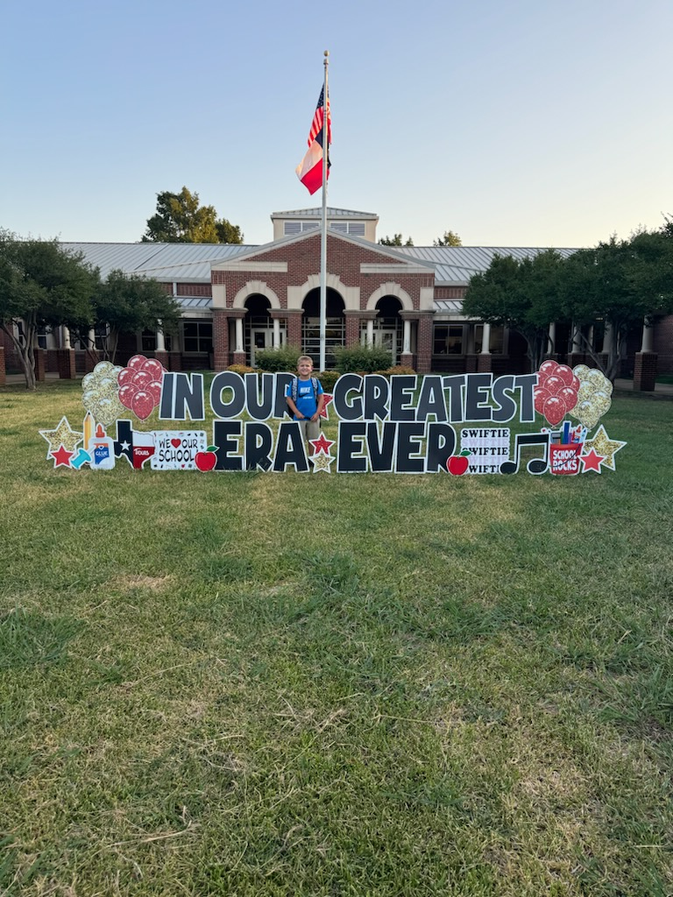

**Montague County 4-H Banquet**

**Congraulations**

Karlee 4th Place Record Book

&

Raegan 1st place District Intermediate Record Book

