427 In the Cross of Christ I Glory
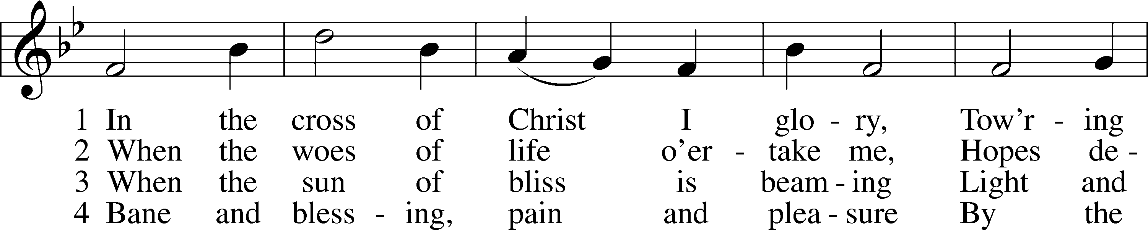
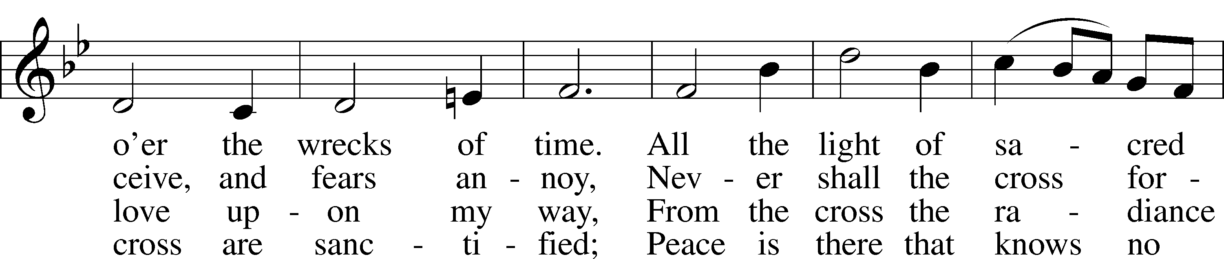
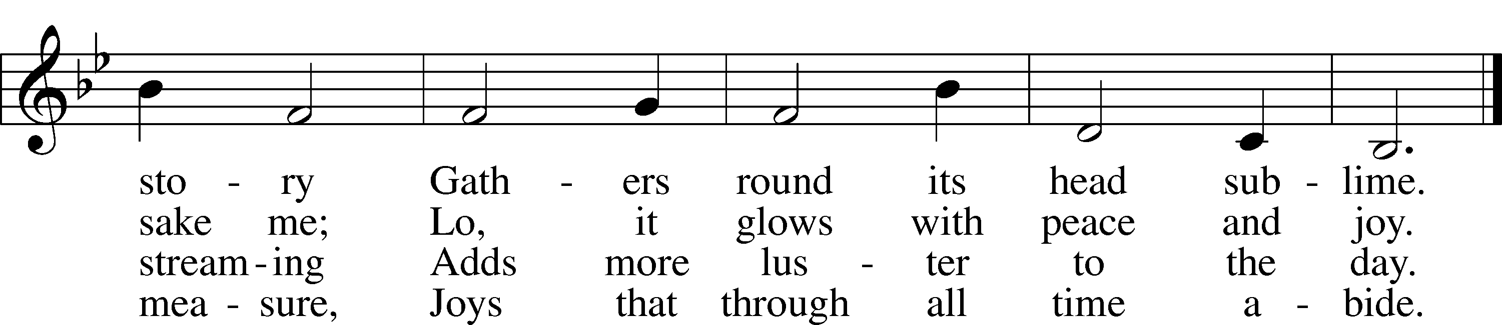
Text: John Bowring, 1792–1872
Tune: Ithamar Conkey, 1815–67
Text and tune: Public domain
Confession and Absolution
The sign of the cross may be made by all in remembrance of their Baptism.

Invocation Matthew 28:19b; 18:20
P In the name of the Father and of the T Son and of the Holy Spirit.
C Amen.

Exhortation Hebrews 10:22; Psalm 124:8; Psalm 32:5
P Beloved in the Lord! Let us draw near with a true heart and confess our sins unto God our Father, beseeching Him in the name of our Lord Jesus Christ to grant us forgiveness.

P Our help is in the name of the Lord,
C who made heaven and earth.
P I said, I will confess my transgressions unto the Lord,
C and You forgave the iniquity of my sin.

Silence for reflection on God’s Word and for self-examination.

Confession of Sins
P O almighty God, merciful Father,
C I, a poor, miserable sinner, confess unto You all my sins and iniquities with which I have ever offended You and justly deserved Your temporal and eternal punishment. But I am heartily sorry for them and sincerely repent of them, and I pray You of Your boundless mercy and for the sake of the holy, innocent, bitter sufferings and death of Your beloved Son, Jesus Christ, to be gracious and merciful to me, a poor, sinful being.

Absolution [John 20:19–23]
P Upon this your confession, I, by virtue of my office, as a called and ordained servant of the Word, announce the grace of God unto all of you, and in the stead and by the command of my Lord Jesus Christ I forgive you all your sins in the name of the Father and of the T Son and of the Holy Spirit.
C Amen.

Service of the Word

Psalm Psalm 130
1Out of the depths
I cry to you, O Lord!
2O Lord, hear my voice!
Let your ears be attentive
to the voice of my pleas for mercy!
3If you, O Lord, should mark iniquities,
O Lord, who could stand?
4But with you there is forgiveness,
that you may be feared.
5I wait for the Lord, my soul waits,
and in his word I hope;
6my soul waits for the Lord
more than watchmen for the morning,
more than watchmen for the morning.
7O Israel, hope in the Lord!
For with the Lord there is steadfast love,
and with him is plentiful redemption.
8And he will redeem Israel
from all his iniquities.

Gloria Patri
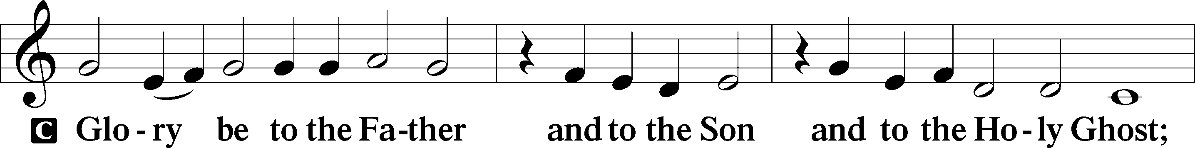
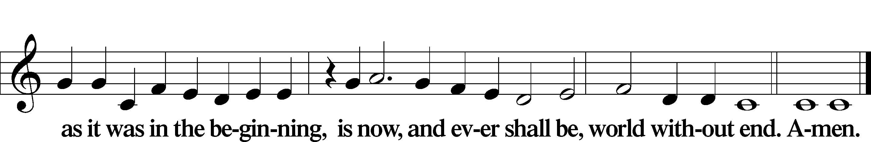

Kyrie Mark 10:47
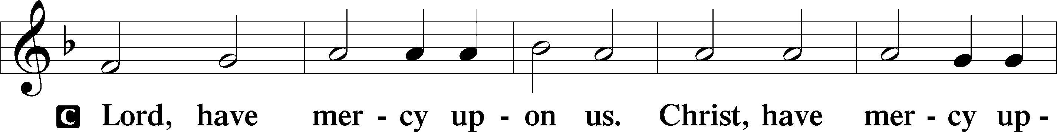
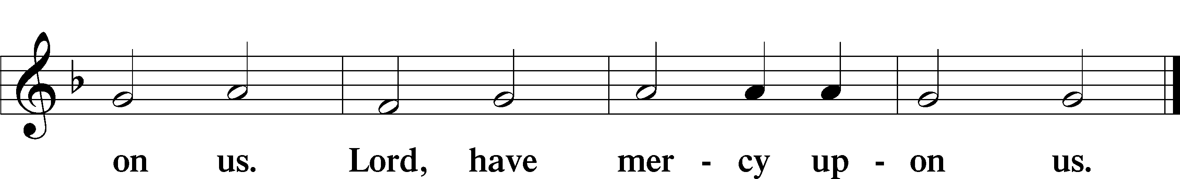

Salutation and Collect of the Day
P The Lord be with you.
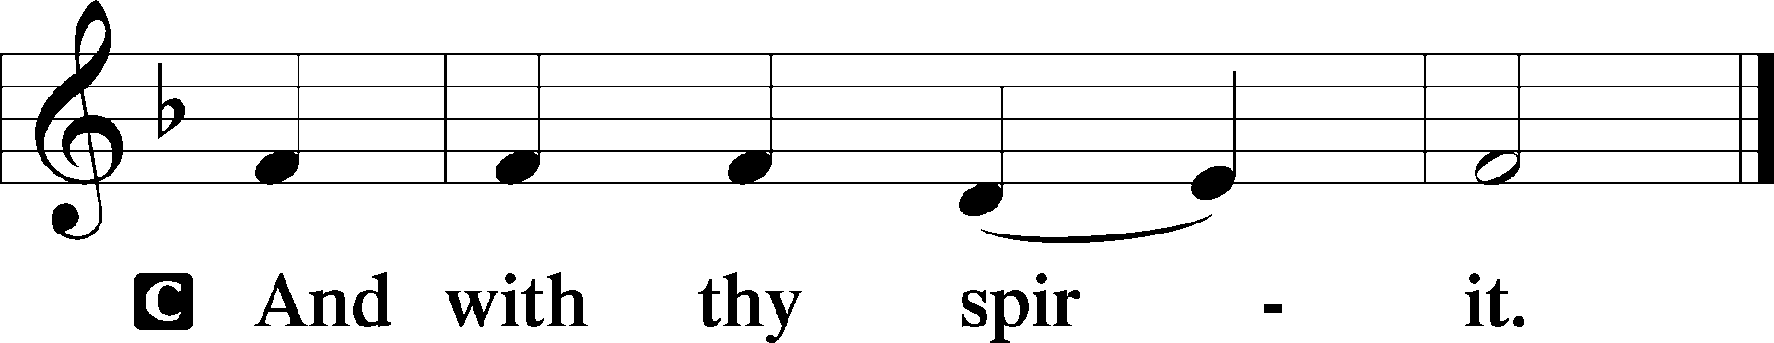

P Let us pray.
Almighty God, by Your great goodness mercifully look upon Your people that we may be governed and preserved evermore in body and soul; through Jesus Christ, Your Son, our Lord, who lives and reigns with You and the Holy Spirit, one God, now and forever.

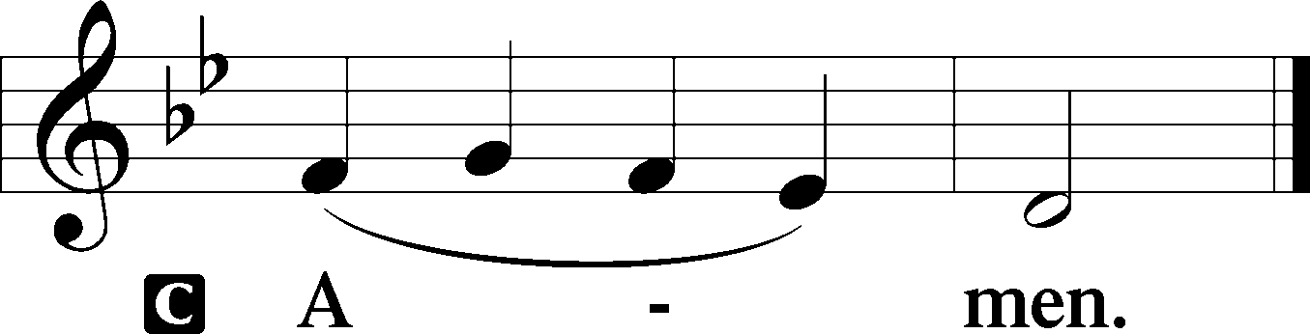

Sit

Old Testament Reading Ezekiel 37:1–14
1The hand of the Lord was upon me, and he brought me out in the Spirit of the Lord and set me down in the middle of the valley; it was full of bones. 2And he led me around among them, and behold, there were very many on the surface of the valley, and behold, they were very dry. 3And he said to me, “Son of man, can these bones live?” And I answered, “O Lord God, you know.” 4Then he said to me, “Prophesy over these bones, and say to them, O dry bones, hear the word of the Lord. 5Thus says the Lord God to these bones: Behold, I will cause breath to enter you, and you shall live. 6And I will lay sinews upon you, and will cause flesh to come upon you, and cover you with skin, and put breath in you, and you shall live, and you shall know that I am the Lord.”
7So I prophesied as I was commanded. And as I prophesied, there was a sound, and behold, a rattling, and the bones came together, bone to its bone. 8And I looked, and behold, there were sinews on them, and flesh had come upon them, and skin had covered them. But there was no breath in them. 9Then he said to me, “Prophesy to the breath; prophesy, son of man, and say to the breath, Thus says the Lord God: Come from the four winds, O breath, and breathe on these slain, that they may live.” 10So I prophesied as he commanded me, and the breath came into them, and they lived and stood on their feet, an exceedingly great army.
11Then he said to me, “Son of man, these bones are the whole house of Israel. Behold, they say, ‘Our bones are dried up, and our hope is lost; we are clean cut off.’ 12Therefore prophesy, and say to them, Thus says the Lord God: Behold, I will open your graves and raise you from your graves, O my people. And I will bring you into the land of Israel. 13And you shall know that I am the Lord, when I open your graves, and raise you from your graves, O my people. 14And I will put my Spirit within you, and you shall live, and I will place you in your own land. Then you shall know that I am the Lord; I have spoken, and I will do it, declares the Lord.”

A This is the Word of the Lord.
C Thanks be to God.

Gradual Hebrews 12:2
[O come, let us fix our eyes on] Jesus,
the founder and perfecter of our faith,
who for the joy that was set before him endured the cross, despising the shame,
and is seated at the right hand of the throne of God.

Epistle Romans 8:1–11
1There is therefore now no condemnation for those who are in Christ Jesus. 2For the law of the Spirit of life has set you free in Christ Jesus from the law of sin and death. 3For God has done what the law, weakened by the flesh, could not do. By sending his own Son in the likeness of sinful flesh and for sin, he condemned sin in the flesh, 4in order that the righteous requirement of the law might be fulfilled in us, who walk not according to the flesh but according to the Spirit. 5For those who live according to the flesh set their minds on the things of the flesh, but those who live according to the Spirit set their minds on the things of the Spirit. 6To set the mind on the flesh is death, but to set the mind on the Spirit is life and peace. 7For the mind that is set on the flesh is hostile to God, for it does not submit to God’s law; indeed, it cannot. 8Those who are in the flesh cannot please God.
9You, however, are not in the flesh but in the Spirit, if in fact the Spirit of God dwells in you. Anyone who does not have the Spirit of Christ does not belong to him. 10But if Christ is in you, although the body is dead because of sin, the Spirit is life because of righteousness. 11If the Spirit of him who raised Jesus from the dead dwells in you, he who raised Christ Jesus from the dead will also give life to your mortal bodies through his Spirit who dwells in you.

Stand

Holy Gospel John 11:1–45
P The Holy Gospel according to St. John, the eleventh chapter.

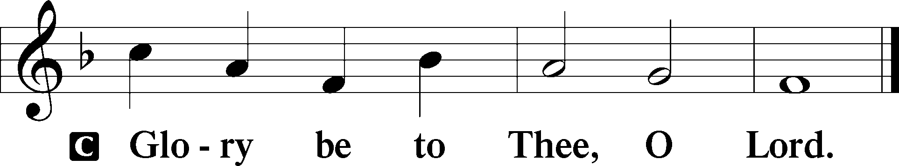

1Now a certain man was ill, Lazarus of Bethany, the village of Mary and her sister Martha. 2It was Mary who anointed the Lord with ointment and wiped his feet with her hair, whose brother Lazarus was ill. 3So the sisters sent to him, saying, “Lord, he whom you love is ill.” 4But when Jesus heard it he said, “This illness does not lead to death. It is for the glory of God, so that the Son of God may be glorified through it.”
5Now Jesus loved Martha and her sister and Lazarus. 6So, when he heard that Lazarus was ill, he stayed two days longer in the place where he was. 7Then after this he said to the disciples, “Let us go to Judea again.” 8The disciples said to him, “Rabbi, the Jews were just now seeking to stone you, and are you going there again?” 9Jesus answered, “Are there not twelve hours in the day? If anyone walks in the day, he does not stumble, because he sees the light of this world. 10But if anyone walks in the night, he stumbles, because the light is not in him.” 11After saying these things, he said to them, “Our friend Lazarus has fallen asleep, but I go to awaken him.” 12The disciples said to him, “Lord, if he has fallen asleep, he will recover.” 13Now Jesus had spoken of his death, but they thought that he meant taking rest in sleep. 14Then Jesus told them plainly, “Lazarus has died, 15and for your sake I am glad that I was not there, so that you may believe. But let us go to him.” 16So Thomas, called the Twin, said to his fellow disciples, “Let us also go, that we may die with him.”
17Now when Jesus came, he found that Lazarus had already been in the tomb four days. 18Bethany was near Jerusalem, about two miles off, 19and many of the Jews had come to Martha and Mary to console them concerning their brother. 20So when Martha heard that Jesus was coming, she went and met him, but Mary remained seated in the house. 21Martha said to Jesus, “Lord, if you had been here, my brother would not have died. 22But even now I know that whatever you ask from God, God will give you.” 23Jesus said to her, “Your brother will rise again.” 24Martha said to him, “I know that he will rise again in the resurrection on the last day.” 25Jesus said to her, “I am the resurrection and the life. Whoever believes in me, though he die, yet shall he live, 26and everyone who lives and believes in me shall never die. Do you believe this?” 27She said to him, “Yes, Lord; I believe that you are the Christ, the Son of God, who is coming into the world.”
28When she had said this, she went and called her sister Mary, saying in private, “The Teacher is here and is calling for you.” 29And when she heard it, she rose quickly and went to him. 30Now Jesus had not yet come into the village, but was still in the place where Martha had met him. 31When the Jews who were with her in the house, consoling her, saw Mary rise quickly and go out, they followed her, supposing that she was going to the tomb to weep there. 32Now when Mary came to where Jesus was and saw him, she fell at his feet, saying to him, “Lord, if you had been here, my brother would not have died.” 33When Jesus saw her weeping, and the Jews who had come with her also weeping, he was deeply moved in his spirit and greatly troubled. 34And he said, “Where have you laid him?” They said to him, “Lord, come and see.” 35Jesus wept. 36So the Jews said, “See how he loved him!” 37But some of them said, “Could not he who opened the eyes of the blind man also have kept this man from dying?”
38Then Jesus, deeply moved again, came to the tomb. It was a cave, and a stone lay against it. 39Jesus said, “Take away the stone.” Martha, the sister of the dead man, said to him, “Lord, by this time there will be an odor, for he has been dead four days.” 40Jesus said to her, “Did I not tell you that if you believed you would see the glory of God?” 41So they took away the stone. And Jesus lifted up his eyes and said, “Father, I thank you that you have heard me. 42I knew that you always hear me, but I said this on account of the people standing around, that they may believe that you sent me.” 43When he had said these things, he cried out with a loud voice, “Lazarus, come out.” 44The man who had died came out, his hands and feet bound with linen strips, and his face wrapped with a cloth. Jesus said to them, “Unbind him, and let him go.”
45Many of the Jews therefore, who had come with Mary and had seen what he did, believed in him.

P This is the Gospel of the Lord.

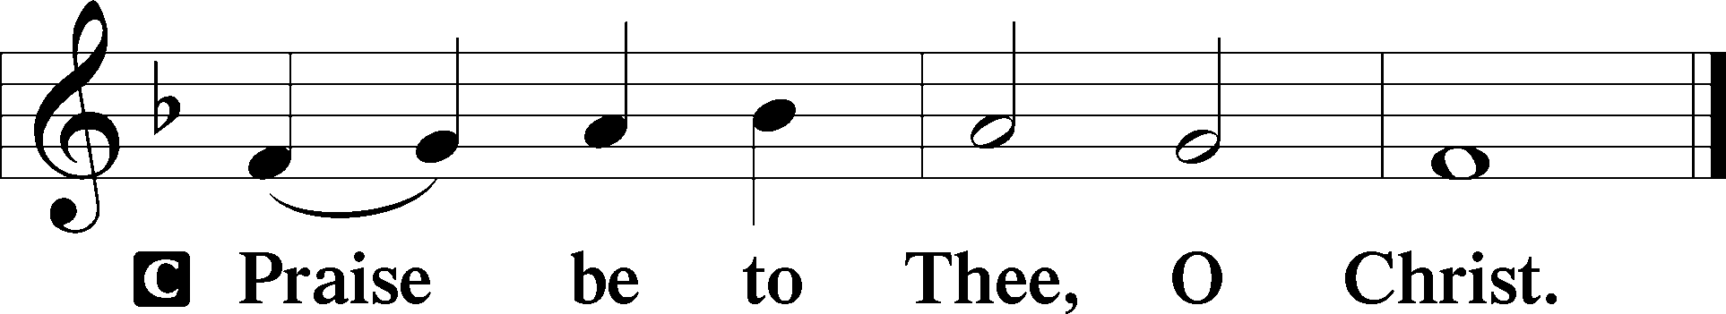

Apostles’ Creed
C I believe in God, the Father Almighty,
maker of heaven and earth.

And in Jesus Christ, His only Son, our Lord,
who was conceived by the Holy Spirit,
born of the virgin Mary,
suffered under Pontius Pilate,
was crucified, died and was buried.
He descended into hell.
The third day He rose again from the dead.
He ascended into heaven
and sits at the right hand of God the Father Almighty.
From thence He will come to judge the living and the dead.

I believe in the Holy Spirit,
the holy Christian Church,
the communion of saints,
the forgiveness of sins,
the resurrection of the body,
and the life T everlasting. Amen.

Sit

Children's Sermon

490 Jesus Lives! The Victory’s Won
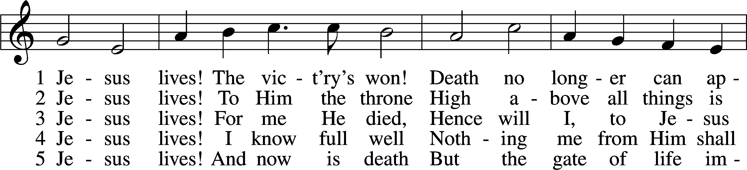
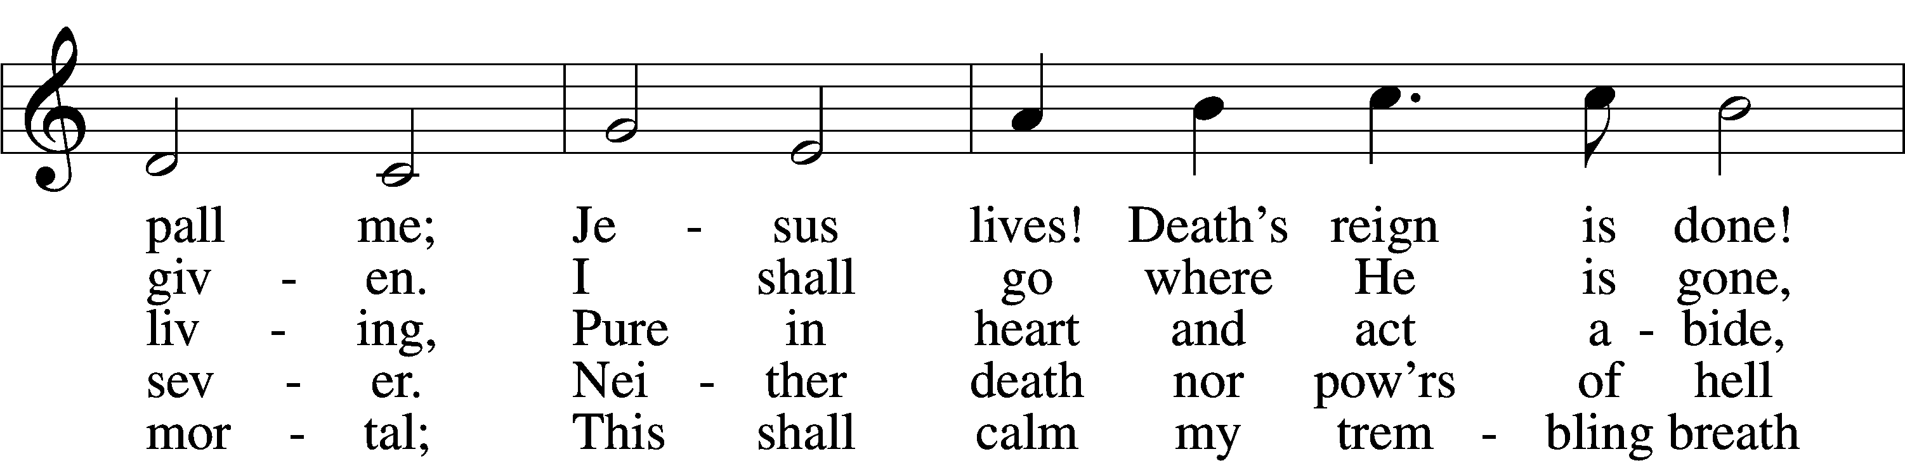
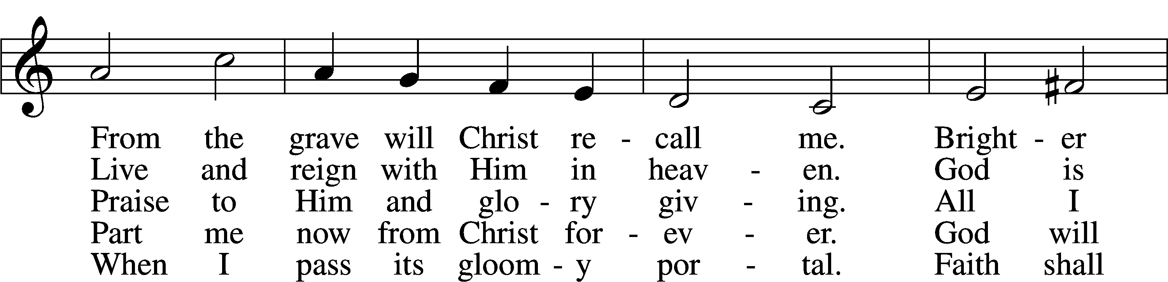
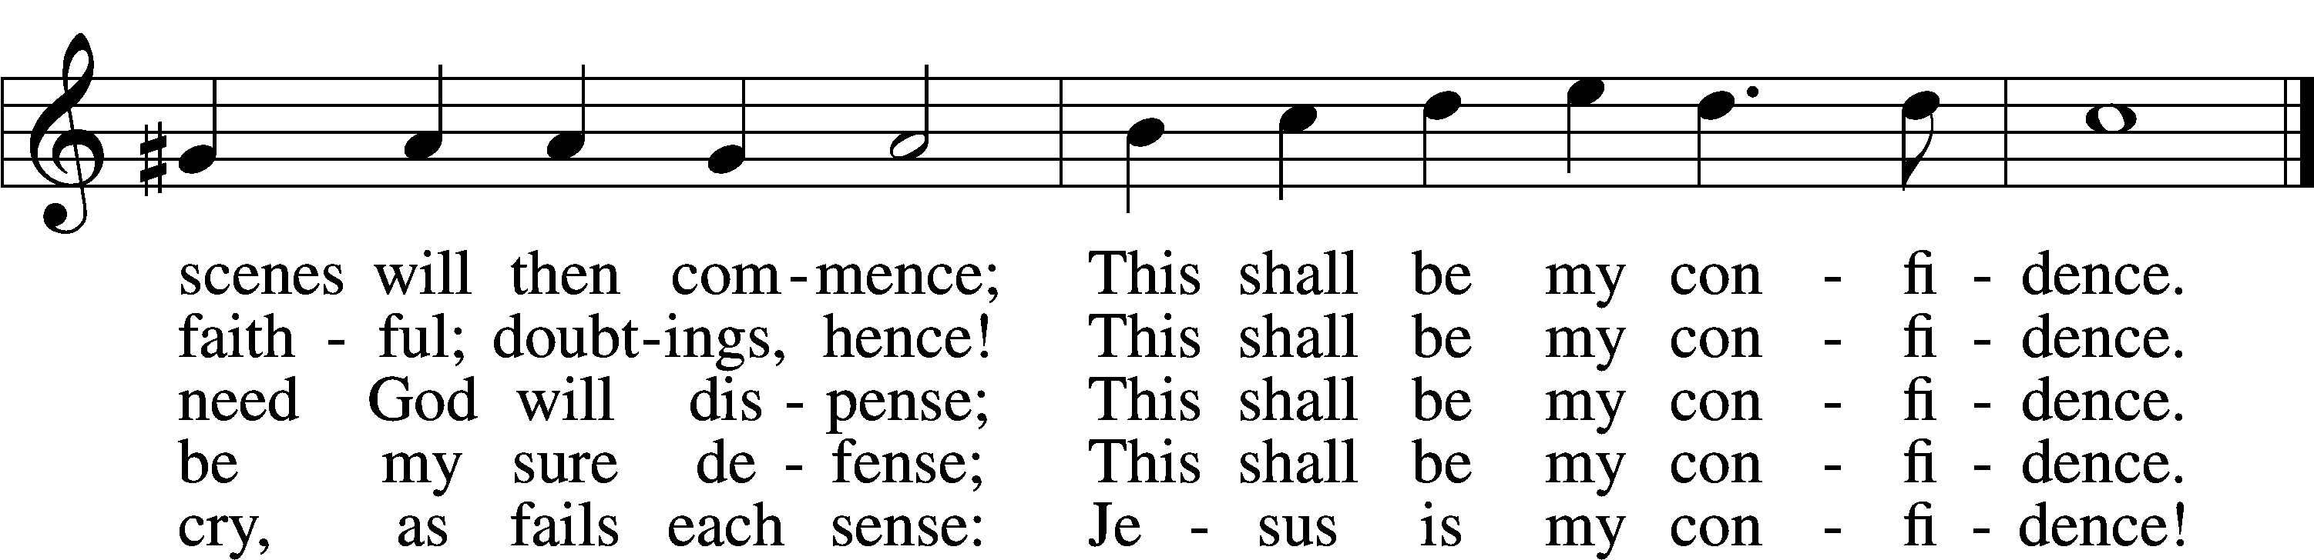
Text: Christian Fürchtegott Gellert, 1715–69; tr. Frances E. Cox, 1812–97, alt.
Tune: Johann Crüger, 1598–1662
Text and tune: Public domain

Sermon

Votum
P The peace of God, which passes all understanding, keep your hearts and minds in Christ Jesus.
C Amen.

Stand

Offertory Psalm 51:10–12
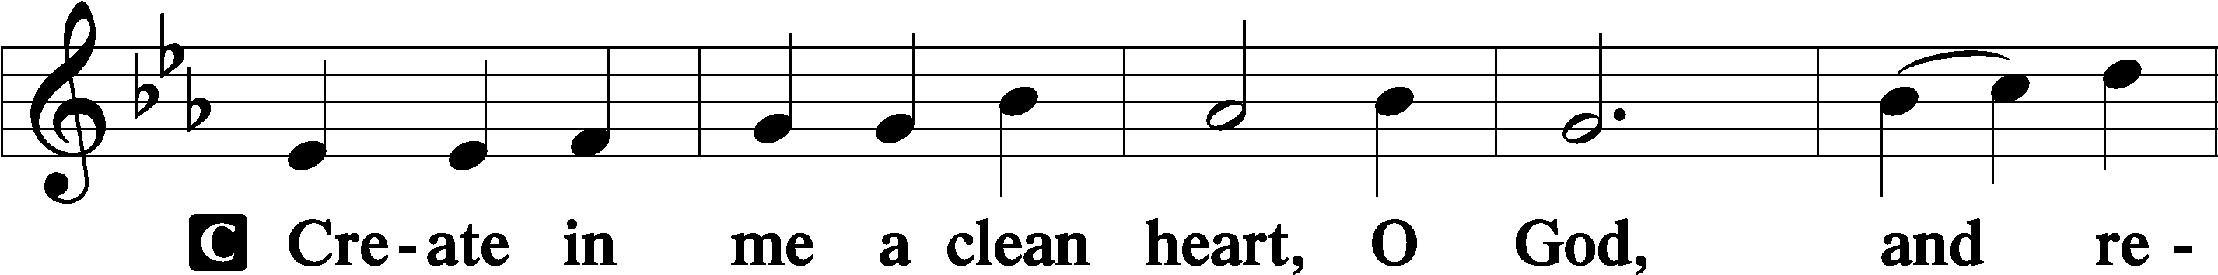
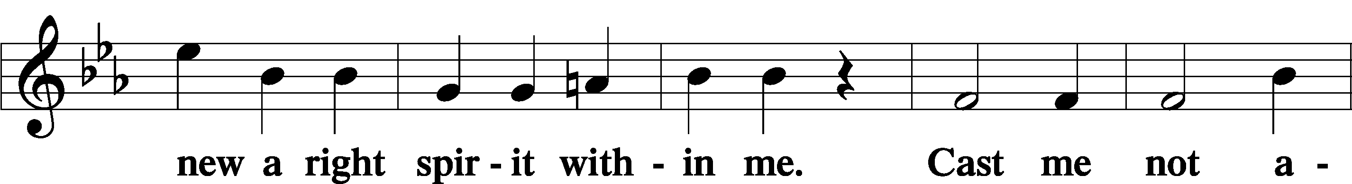
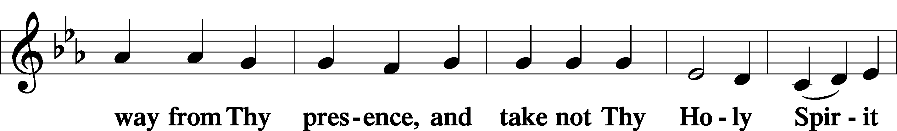
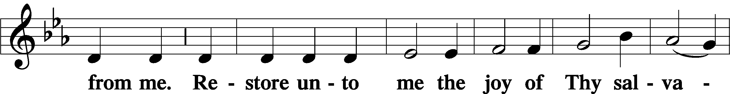
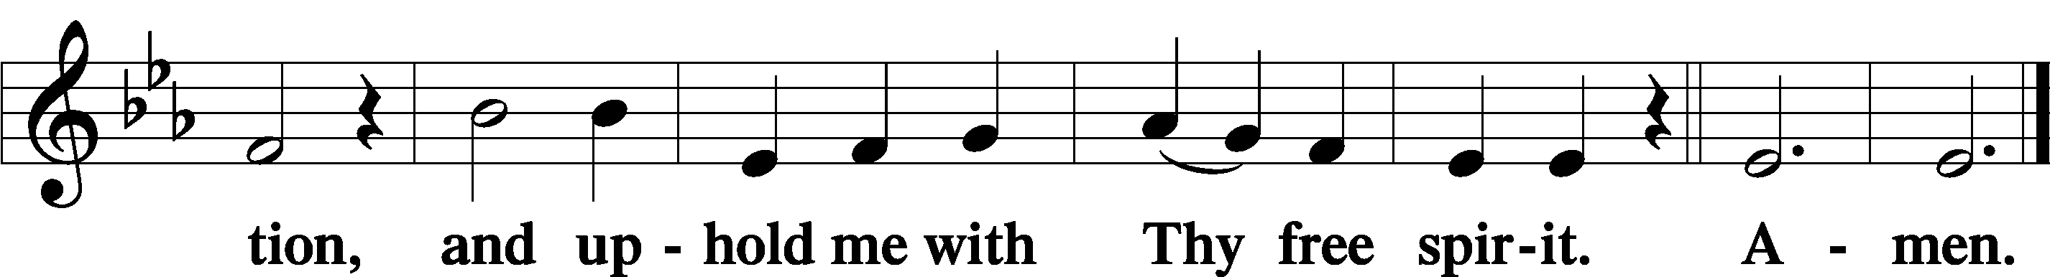

Offering

805 Praise God, from Whom All Blessings Flow
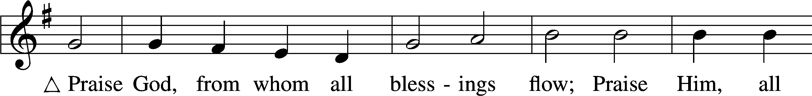
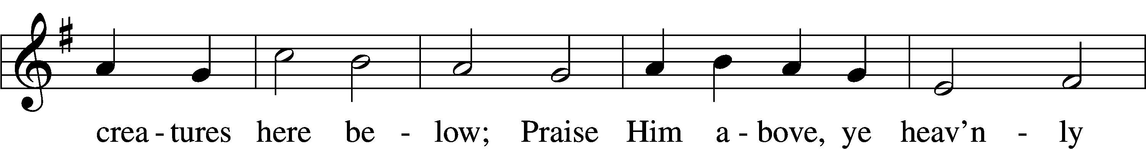
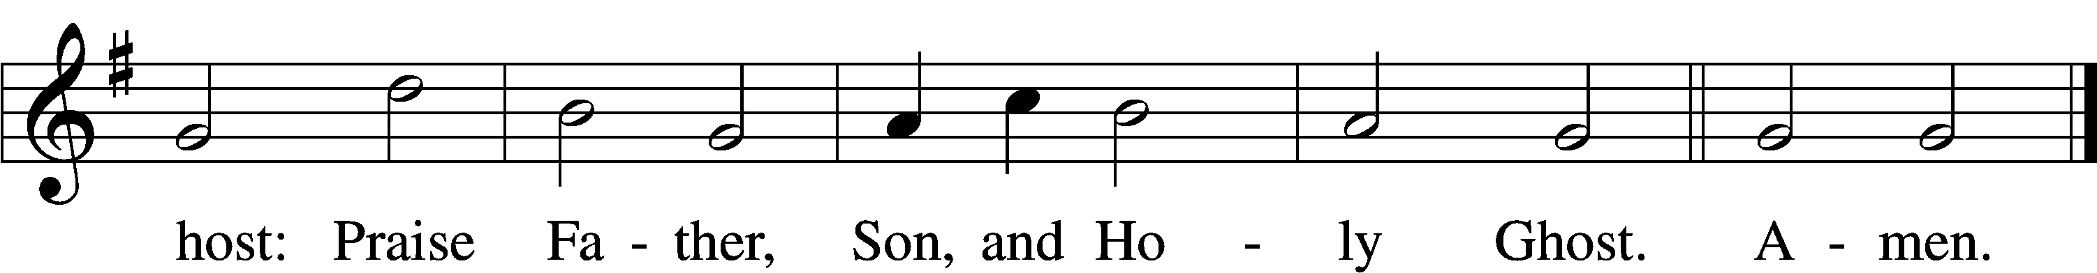
Text: Thomas Ken, 1637–1711
Tune: Trente quatre Pseaumes de David, 1551, Geneva, ed. Louis Bourgeois
Text and tune: Public domain
Prayer of the Church

Lord’s Prayer Matthew 6:9–13
P Lord, remember us in Your kingdom and teach us to pray:
C Our Father who art in heaven,
hallowed be Thy name,
Thy kingdom come,
Thy will be done on earth
as it is in heaven;
give us this day our daily bread;
and forgive us our trespasses
as we forgive those
who trespass against us;
and lead us not into temptation,
but deliver us from evil.
For Thine is the kingdom
and the power and the glory
forever and ever. Amen.

Collect for the Word

Blessed Lord, You have caused all Holy Scriptures to be written for our learning. Grant that we may so hear them, read, mark, learn, and inwardly digest them that, by the patience and comfort of Your holy Word, we may embrace and ever hold fast the blessed hope of everlasting life; through Jesus Christ, Your Son, our Lord, who lives and reigns with You and the Holy Spirit, one God, now and forever.

Benediction
P The Lord bless you and keep you.
The Lord make His face shine on you and be gracious to you.
The Lord look upon you with favor and T give you peace.
C Amen.

878 Abide with Me
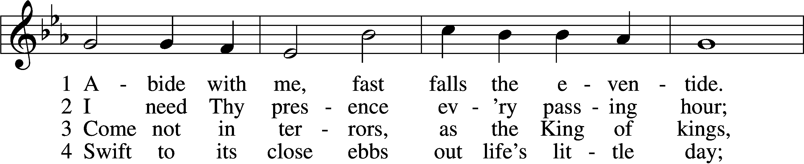
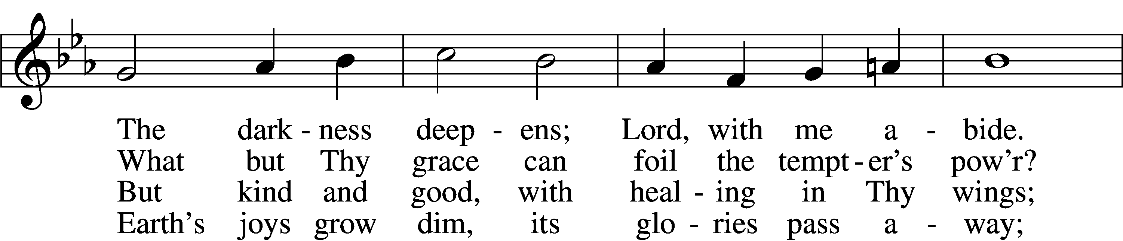
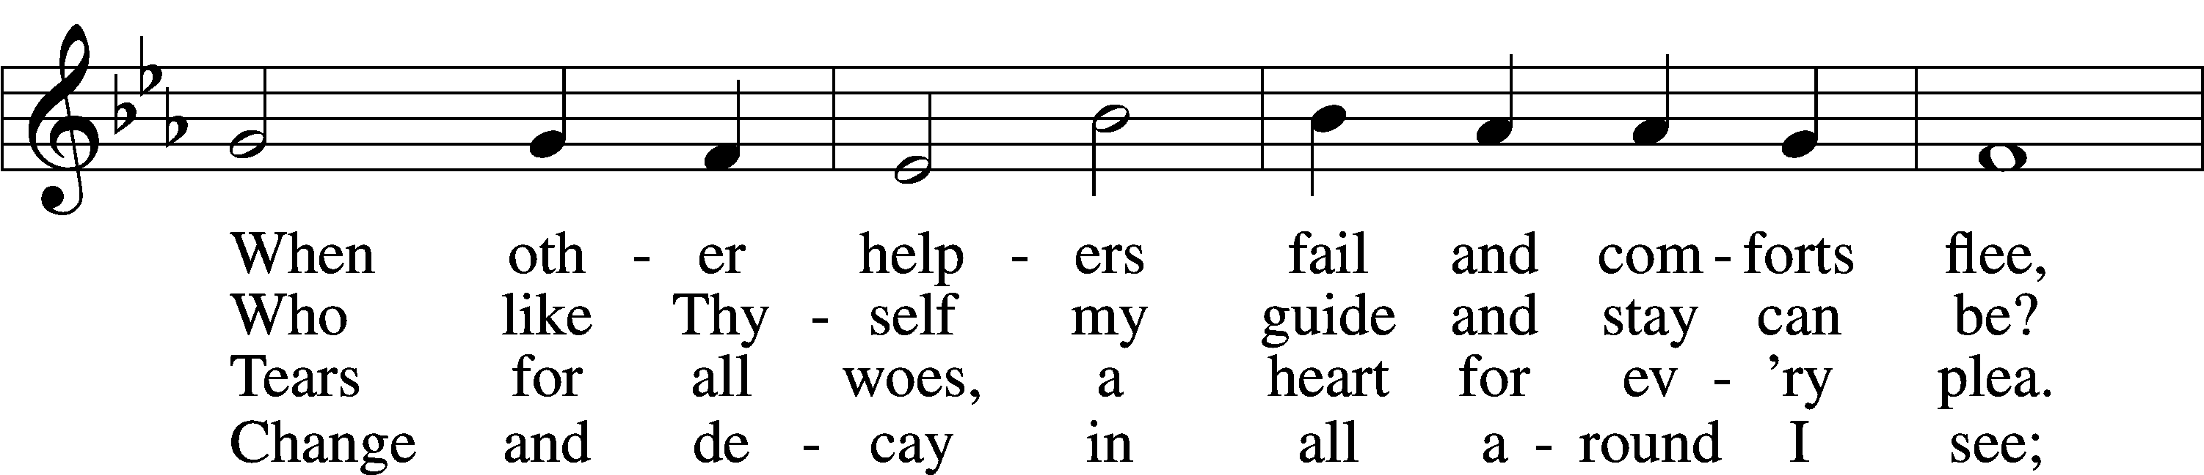
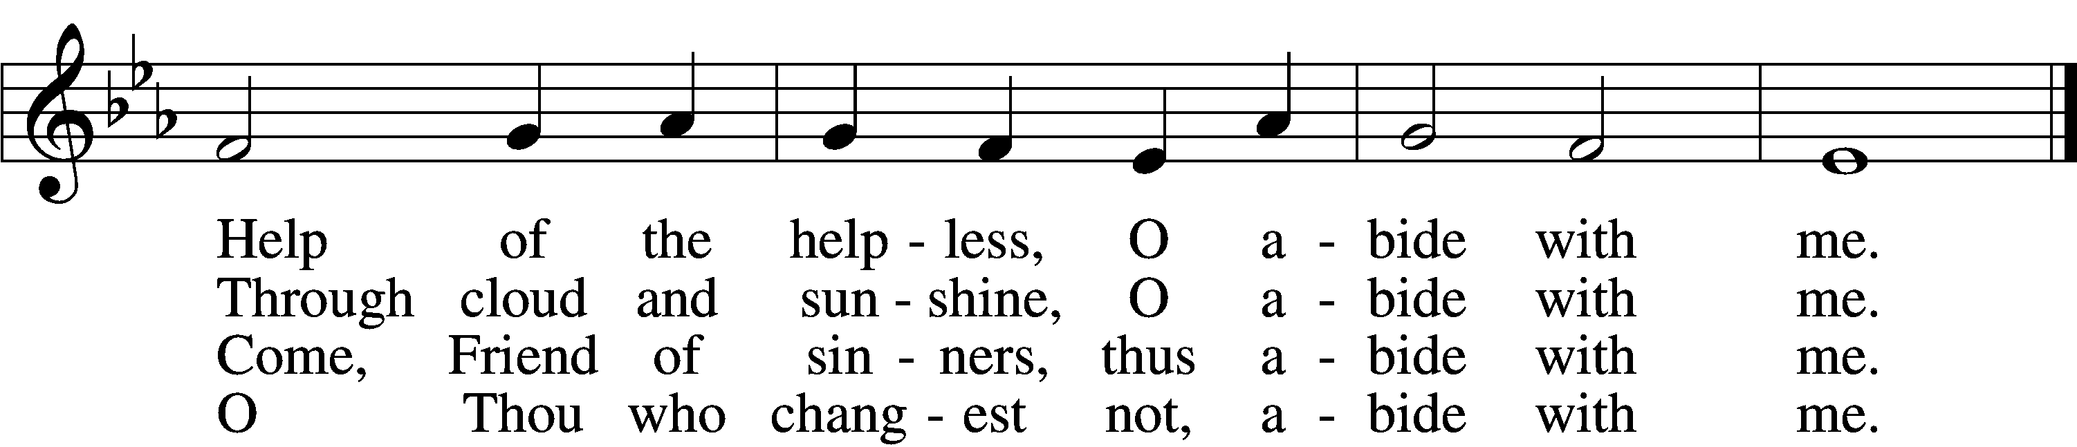

5 I fear no foe with Thee at hand to bless;
Ills have no weight and tears no bitterness.
Where is death’s sting? Where, grave, thy victory?
I triumph still if Thou abide with me!

6 Hold Thou Thy cross before my closing eyes;
Shine through the gloom, and point me to the skies.
Heav’n’s morning breaks, and earth’s vain shadows flee;
In life, in death, O Lord, abide with me.
Text: Henry F. Lyte, 1793–1847, alt.
Tune: William H. Monk, 1823–89
Text and tune: Public domain
Acknowledgments
Unless otherwise indicated, Scripture quotations are from the ESV® Bible (The Holy Bible, English Standard Version®), copyright © 2001 by Crossway, a publishing ministry of Good News Publishers. Used by permission. All rights reserved.
Created by Lutheran Service Builder © 2026 Concordia Publishing House.

