465 Now All the Vault of Heaven Resounds
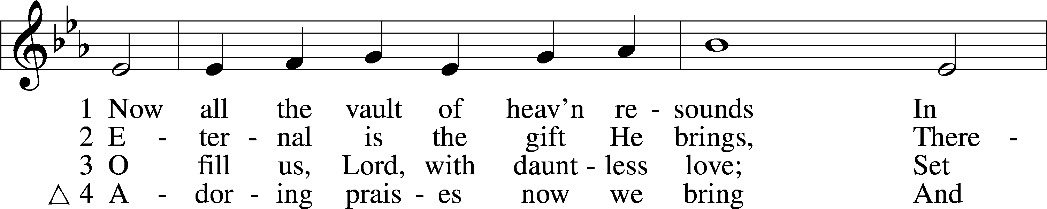
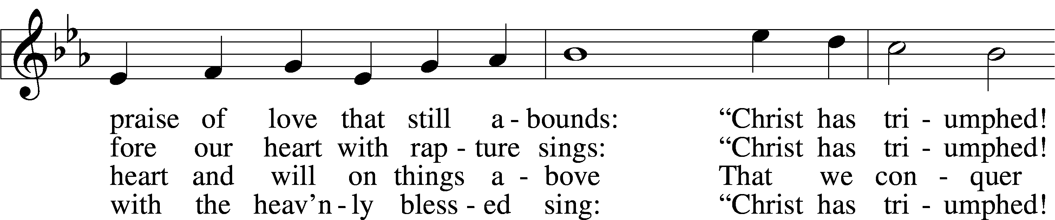
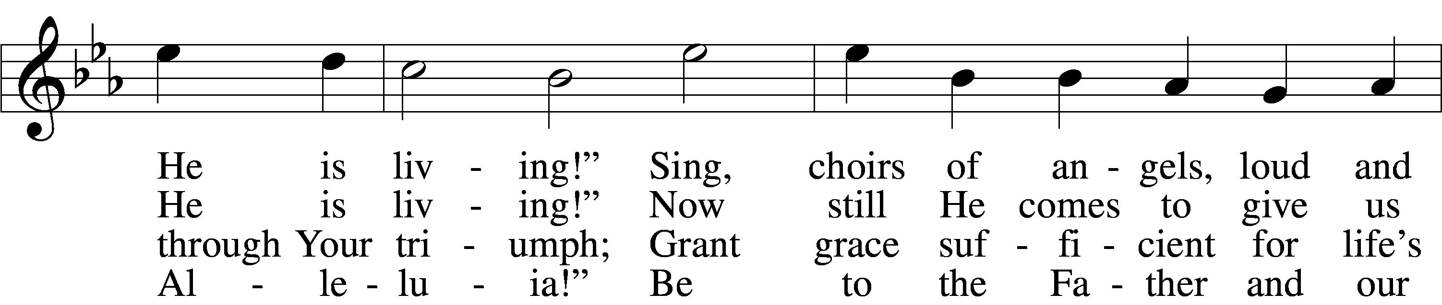
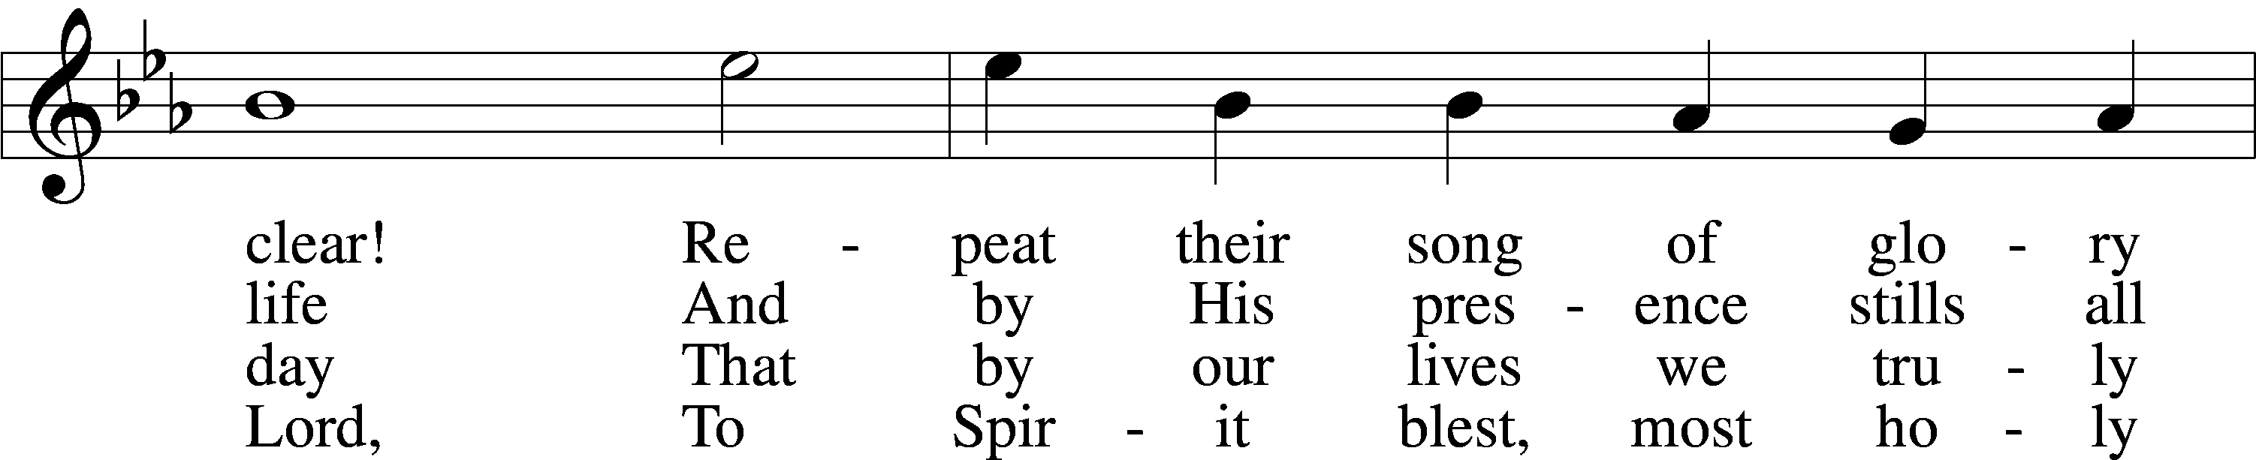
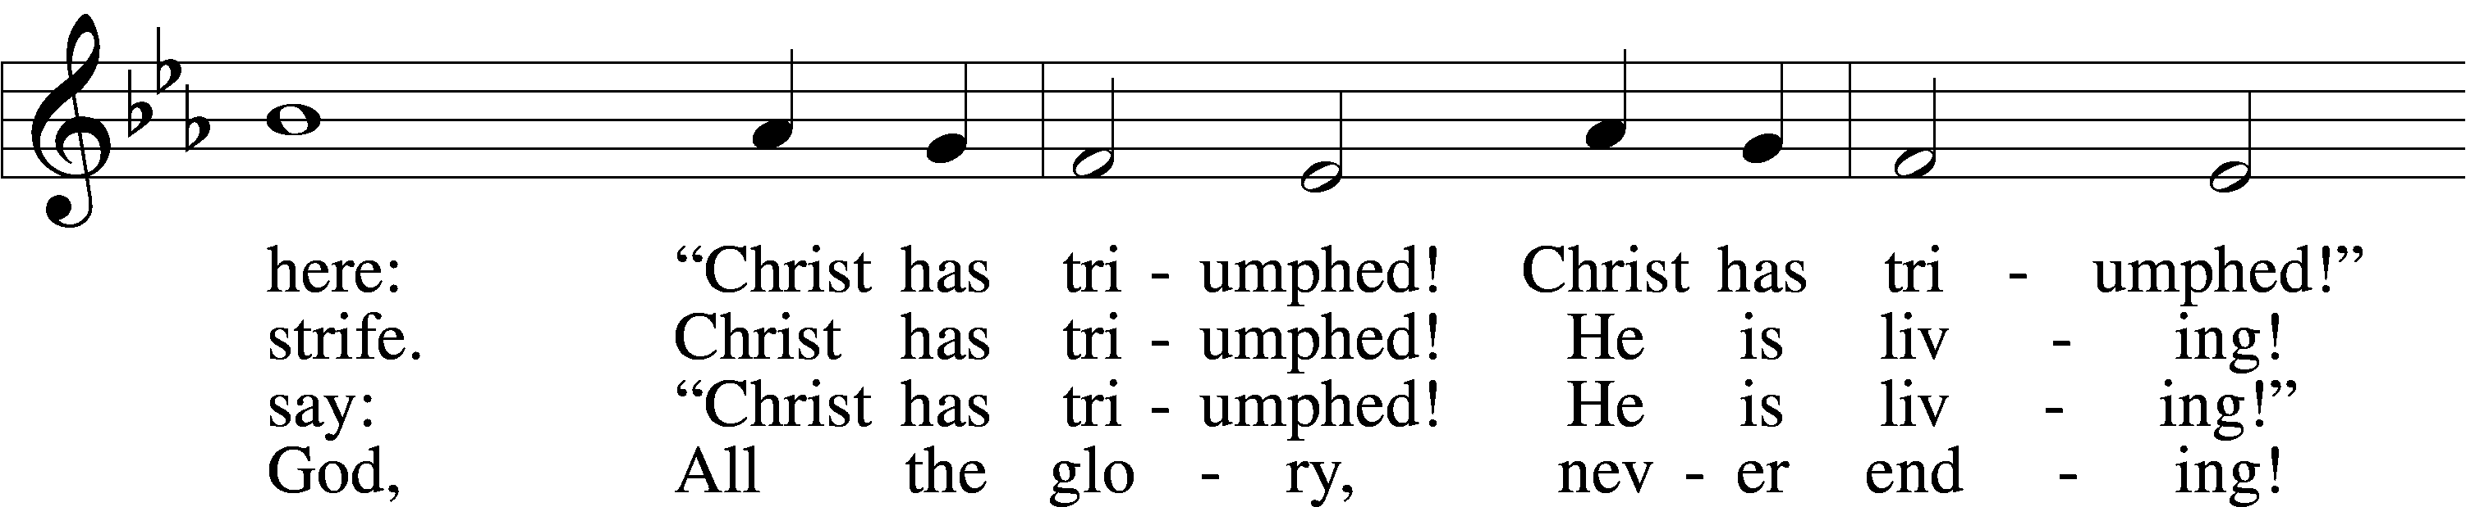
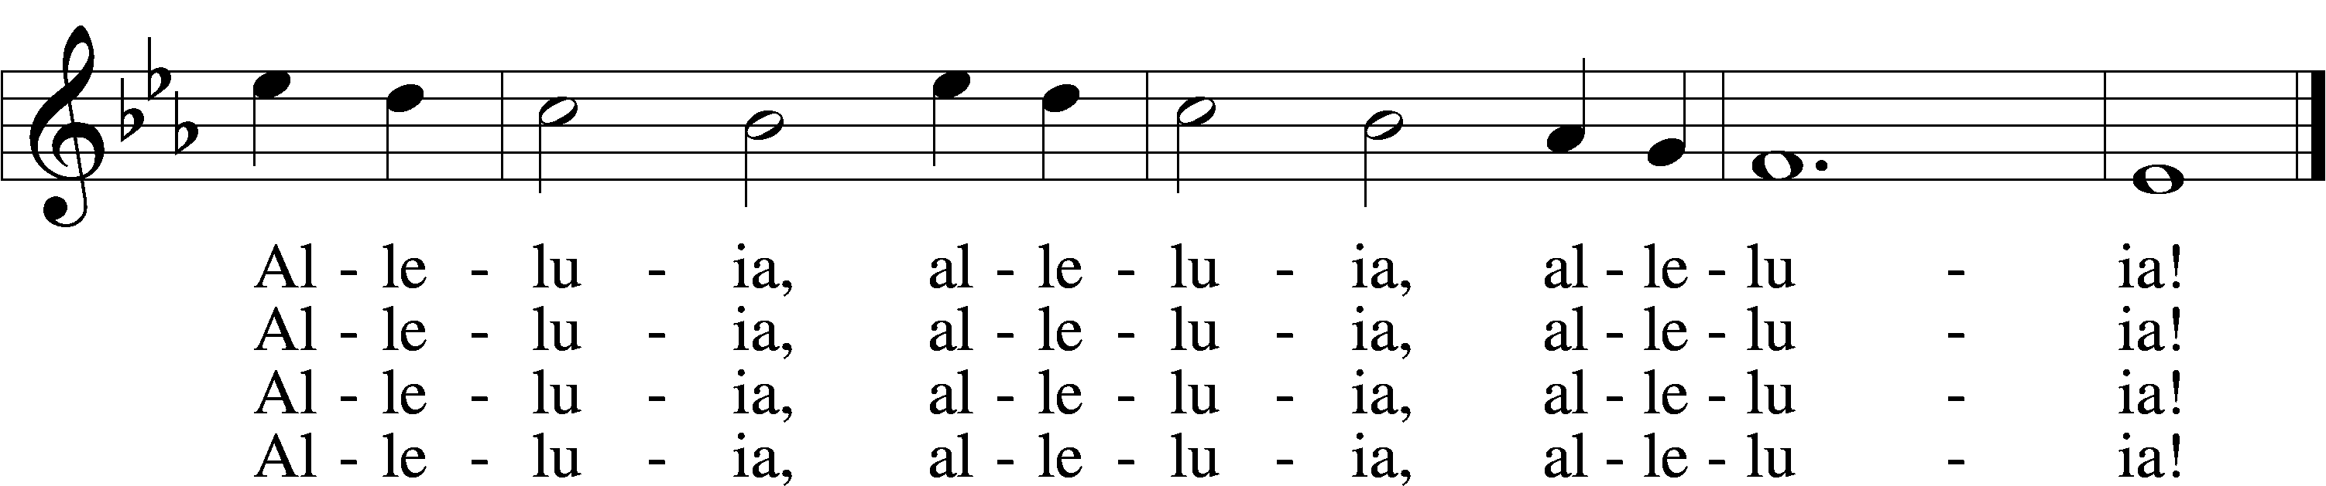
Text: Paul Z. Strodach, 1876–1947, alt.
Tune: Geistliche Kirchengesäng, 1623, Köln
Text: © 1958 Augsburg Publishing House. Used by permission: LSB Hymn License no. 110005011
Tune: Public domain

Confession and Absolution

The sign of the cross may be made by all in remembrance of their Baptism.

Invocation Matthew 28:19b; 18:20
P In the name of the Father and of the T Son and of the Holy Spirit.
C Amen.

Exhortation Hebrews 10:22; Psalm 124:8; Psalm 32:5
P Beloved in the Lord! Let us draw near with a true heart and confess our sins unto God our Father, beseeching Him in the name of our Lord Jesus Christ to grant us forgiveness.

P Our help is in the name of the Lord,
C who made heaven and earth.
P I said, I will confess my transgressions unto the Lord,
C and You forgave the iniquity of my sin.

Silence for reflection on God’s Word and for self-examination.

Confession of Sins
P O almighty God, merciful Father,
C I, a poor, miserable sinner, confess unto You all my sins and iniquities with which I have ever offended You and justly deserved Your temporal and eternal punishment. But I am heartily sorry for them and sincerely repent of them, and I pray You of Your boundless mercy and for the sake of the holy, innocent, bitter sufferings and death of Your beloved Son, Jesus Christ, to be gracious and merciful to me, a poor, sinful being.

Absolution [John 20:19–23]
P Upon this your confession, I, by virtue of my office, as a called and ordained servant of the Word, announce the grace of God unto all of you, and in the stead and by the command of my Lord Jesus Christ I forgive you all your sins in the name of the Father and of the T Son and of the Holy Spirit.
C Amen.

Service of the Word

Introit Psalm 105:1–5, 8; antiphon: 1 Peter 2:2–3
Like newborn infants, long for the pure spiritual milk, that by it you may grow up to salvation—
if indeed you have tasted that the Lord is good.
Oh give thanks to the Lord; call upon his name;
make known his deeds among the peoples!
Sing to him, sing praises to him;
tell of all his wondrous works!
Glory in his holy name;
let the hearts of those who seek the Lord rejoice!
Seek the Lord and his strength;
seek his presence continually!
Remember the wondrous works that he has done,
his miracles, and the judgments he uttered.
He remembers his covenant forever,
the word that he commanded, for a thousand generations.
Gloria Patri
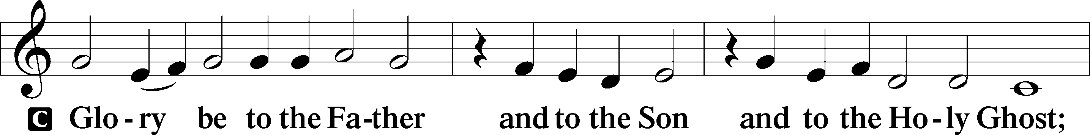
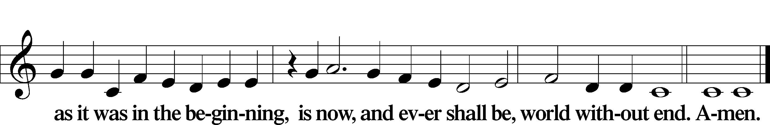

Kyrie Mark 10:47
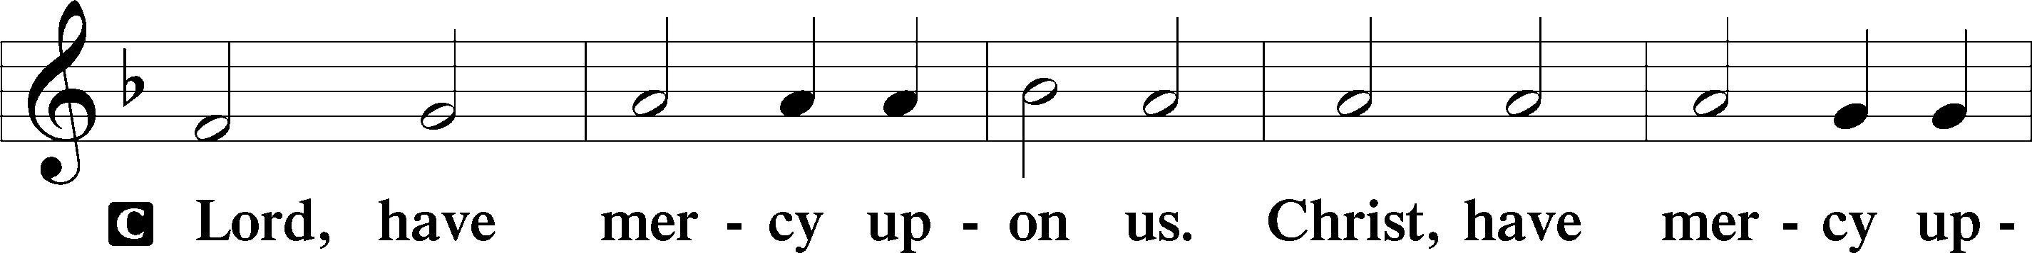
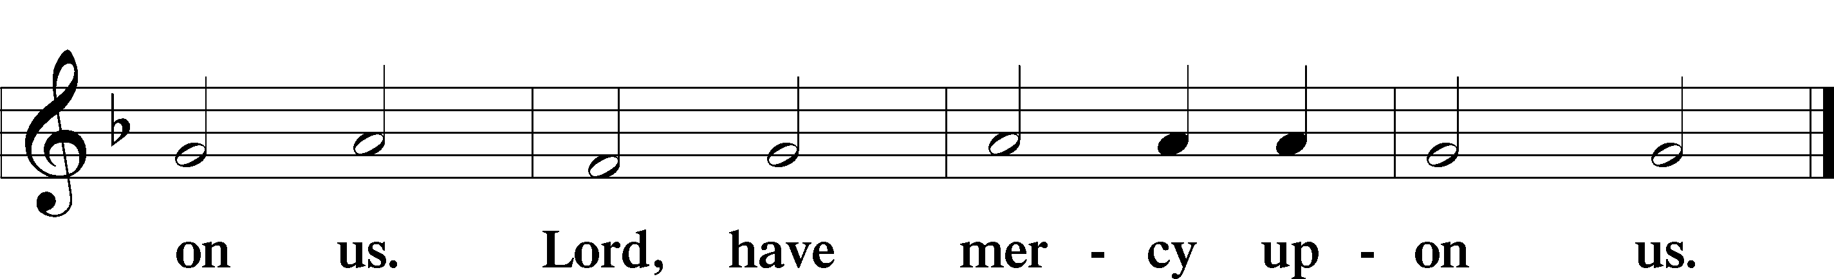

Gloria in Excelsis Luke 2:14; John 1:29
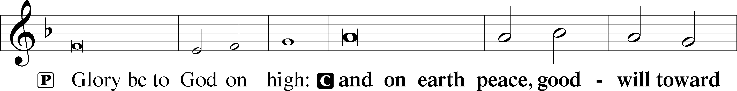
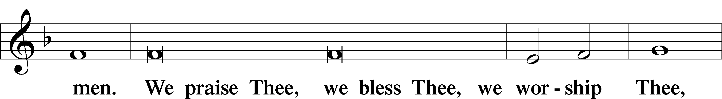
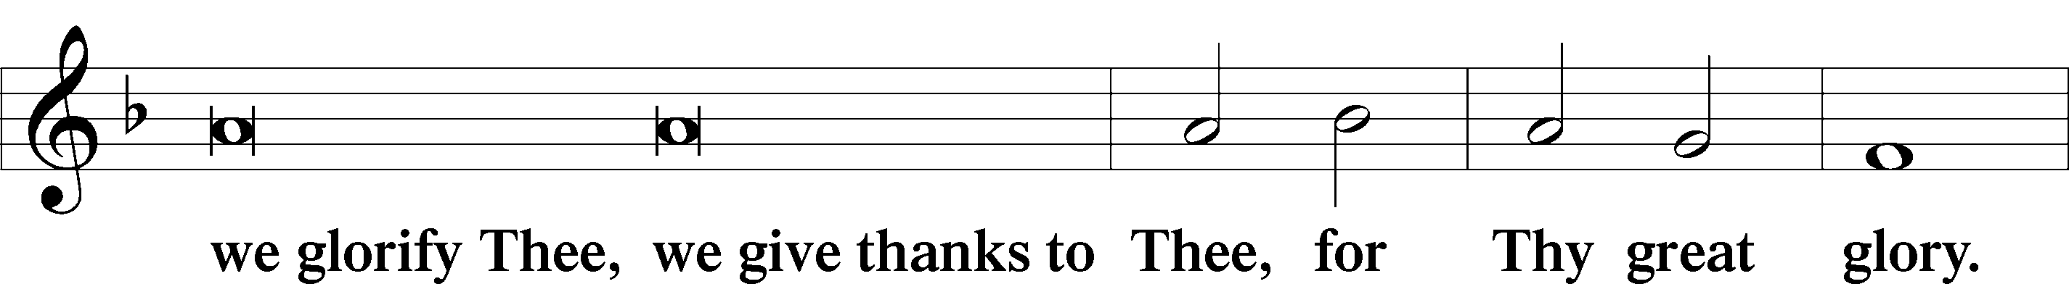
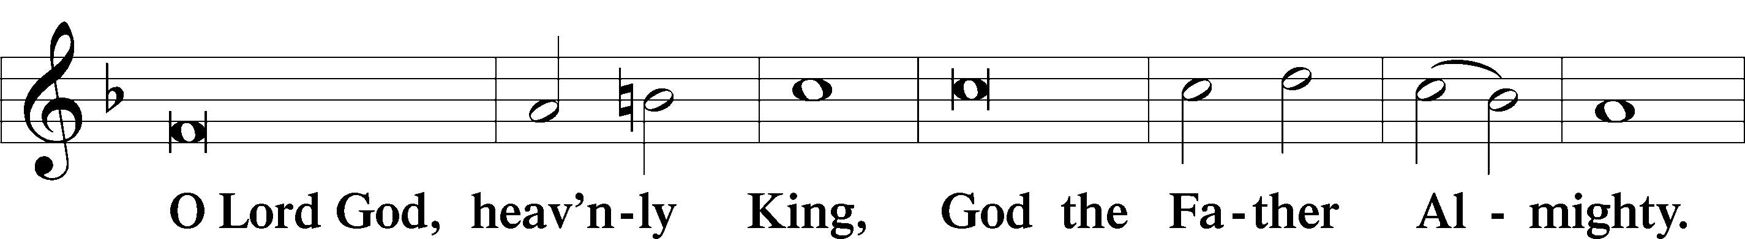
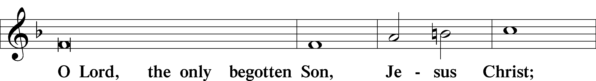
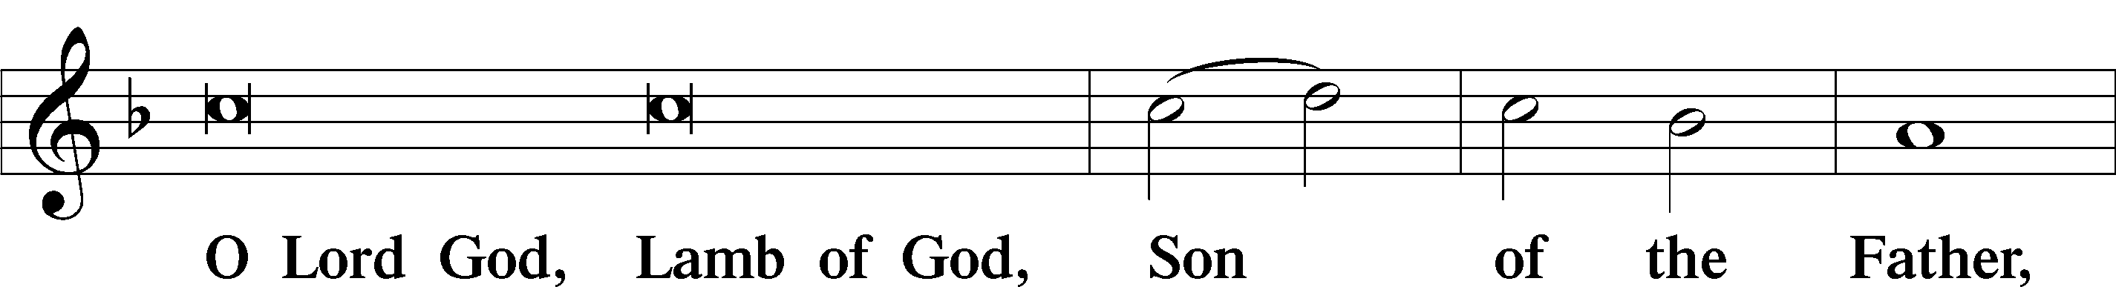
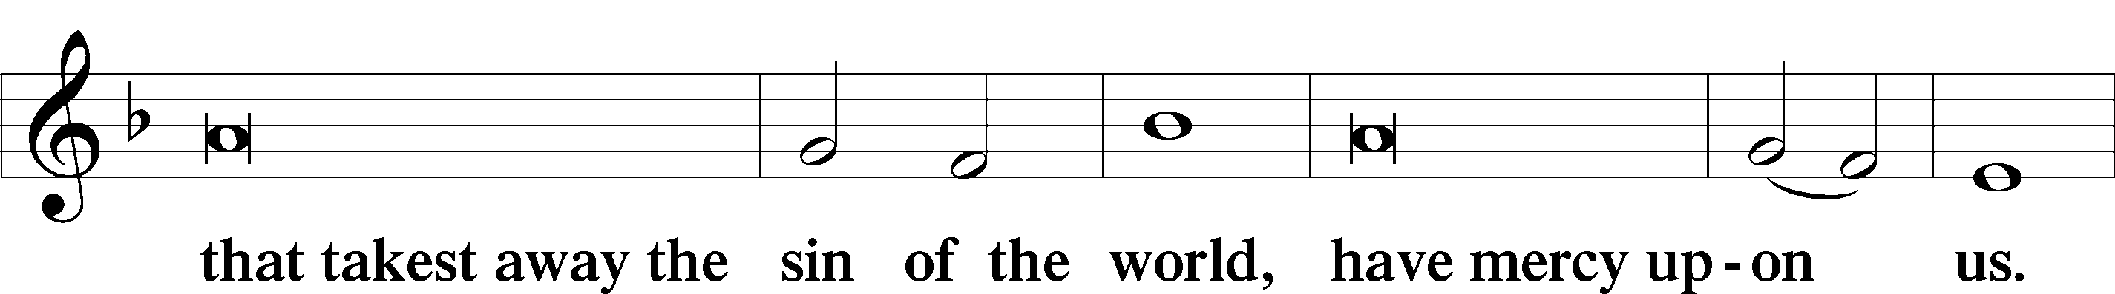
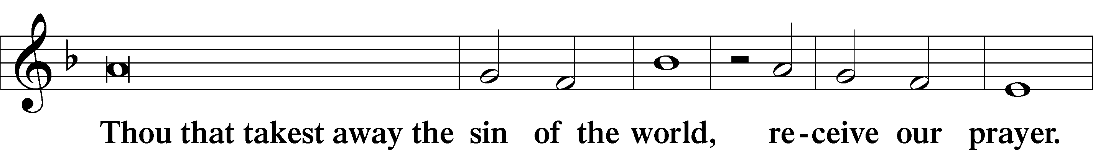
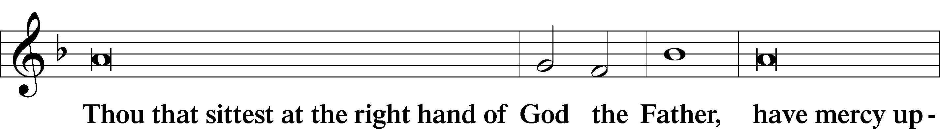
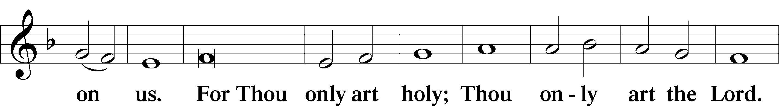
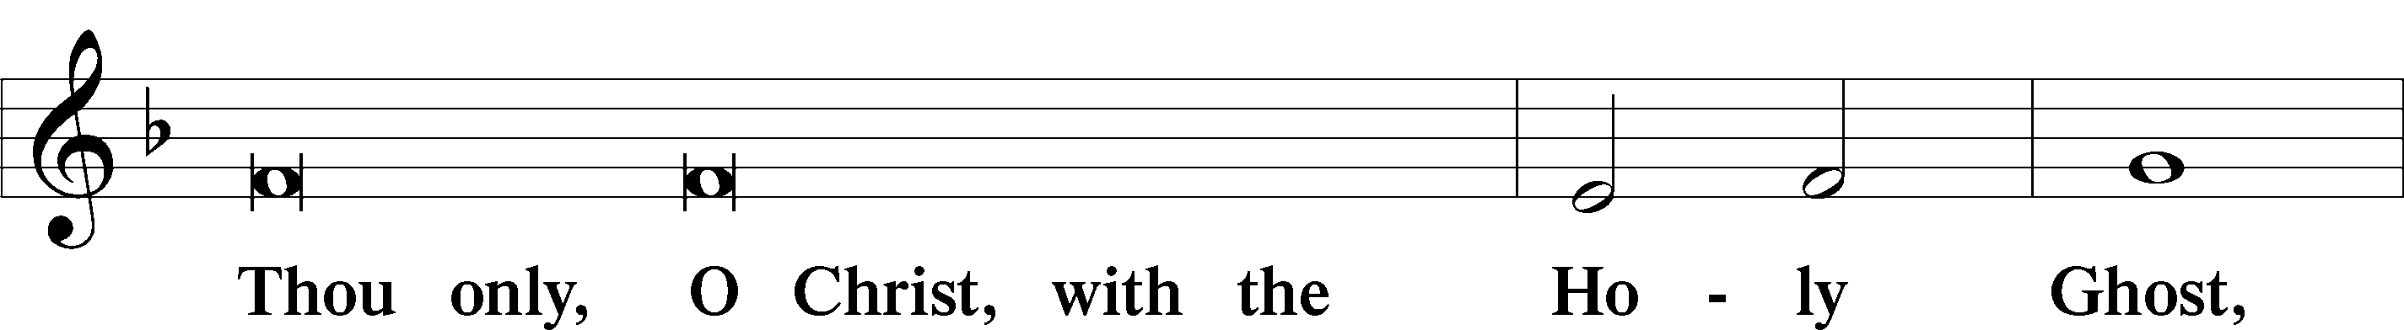
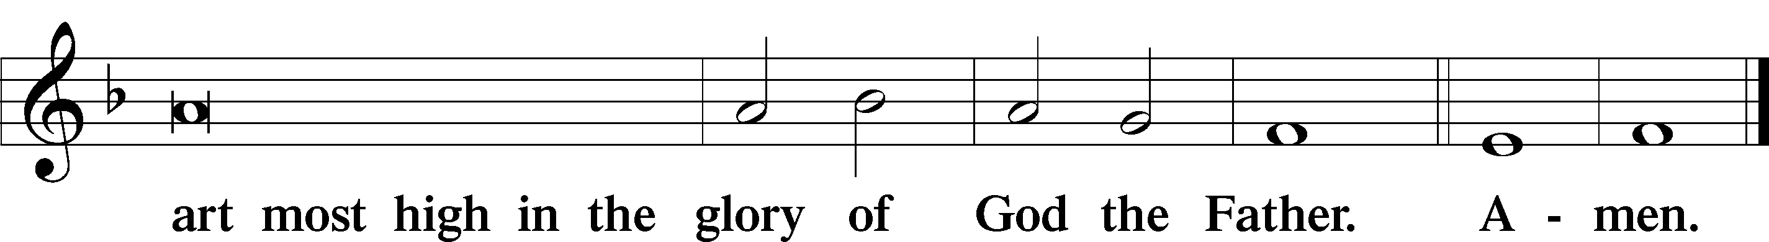

Salutation and Collect of the Day
P The Lord be with you.
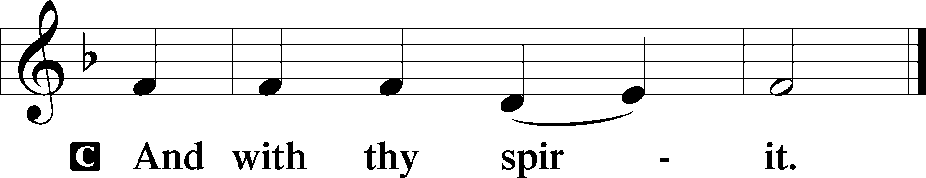

P Let us pray.
Almighty God, grant that we who have celebrated the Lord’s resurrection may by Your grace confess in our life and conversation that Jesus is Lord and God; through the same Jesus Christ, Your Son, who lives and reigns with You and the Holy Spirit, one God, now and forever.

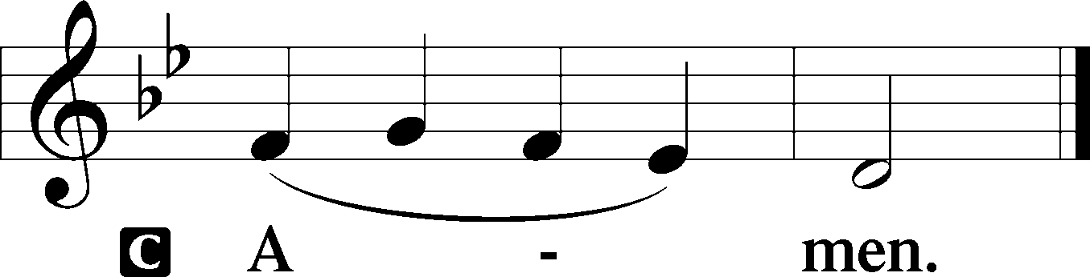

Sit

Old Testament Acts 5:29–42
29But Peter and the apostles answered, “We must obey God rather than men. 30The God of our fathers raised Jesus, whom you killed by hanging him on a tree. 31God exalted him at his right hand as Leader and Savior, to give repentance to Israel and forgiveness of sins. 32And we are witnesses to these things, and so is the Holy Spirit, whom God has given to those who obey him.”
33When they heard this, they were enraged and wanted to kill them. 34But a Pharisee in the council named Gamaliel, a teacher of the law held in honor by all the people, stood up and gave orders to put the men outside for a little while. 35And he said to them, “Men of Israel, take care what you are about to do with these men. 36For before these days Theudas rose up, claiming to be somebody, and a number of men, about four hundred, joined him. He was killed, and all who followed him were dispersed and came to nothing. 37After him Judas the Galilean rose up in the days of the census and drew away some of the people after him. He too perished, and all who followed him were scattered. 38So in the present case I tell you, keep away from these men and let them alone, for if this plan or this undertaking is of man, it will fail; 39but if it is of God, you will not be able to overthrow them. You might even be found opposing God!” So they took his advice, 40and when they had called in the apostles, they beat them and charged them not to speak in the name of Jesus, and let them go. 41Then they left the presence of the council, rejoicing that they were counted worthy to suffer dishonor for the name. 42And every day, in the temple and from house to house, they did not cease teaching and preaching Jesus as the Christ.

A This is the Word of the Lord.
C Thanks be to God.

Gradual adapt. from Matthew 28:7; Hebrews 2:7; Psalm 8:6
Christ has risen from the dead.
[God the Father] has crowned him with glory and honor.
He has given him dominion over the works of his hands;
he has put all things under his feet.

Epistle 1 Peter 1:3–9
3Blessed be the God and Father of our Lord Jesus Christ! According to his great mercy, he has caused us to be born again to a living hope through the resurrection of Jesus Christ from the dead, 4to an inheritance that is imperishable, undefiled, and unfading, kept in heaven for you, 5who by God’s power are being guarded through faith for a salvation ready to be revealed in the last time. 6In this you rejoice, though now for a little while, if necessary, you have been grieved by various trials, 7so that the tested genuineness of your faith—more precious than gold that perishes though it is tested by fire—may be found to result in praise and glory and honor at the revelation of Jesus Christ. 8Though you have not seen him, you love him. Though you do not now see him, you believe in him and rejoice with joy that is inexpressible and filled with glory, 9obtaining the outcome of your faith, the salvation of your souls.

Stand

Alleluia
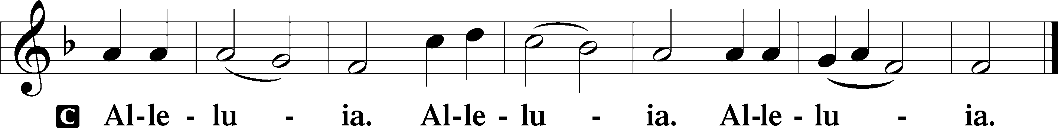

Holy Gospel John 20:19–31
P The Holy Gospel according to St. John, the twentieth chapter.

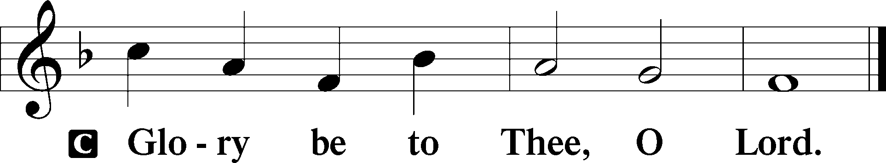

19On the evening of that day, the first day of the week, the doors being locked where the disciples were for fear of the Jews, Jesus came and stood among them and said to them, “Peace be with you.” 20When he had said this, he showed them his hands and his side. Then the disciples were glad when they saw the Lord. 21Jesus said to them again, “Peace be with you. As the Father has sent me, even so I am sending you.” 22And when he had said this, he breathed on them and said to them, “Receive the Holy Spirit. 23If you forgive the sins of anyone, they are forgiven; if you withhold forgiveness from anyone, it is withheld.”
24Now Thomas, one of the Twelve, called the Twin, was not with them when Jesus came. 25So the other disciples told him, “We have seen the Lord.” But he said to them, “Unless I see in his hands the mark of the nails, and place my finger into the mark of the nails, and place my hand into his side, I will never believe.”
26Eight days later, his disciples were inside again, and Thomas was with them. Although the doors were locked, Jesus came and stood among them and said, “Peace be with you.” 27Then he said to Thomas, “Put your finger here, and see my hands; and put out your hand, and place it in my side. Do not disbelieve, but believe.” 28Thomas answered him, “My Lord and my God!” 29Jesus said to him, “Have you believed because you have seen me? Blessed are those who have not seen and yet have believed.”
30Now Jesus did many other signs in the presence of the disciples, which are not written in this book; 31but these are written so that you may believe that Jesus is the Christ, the Son of God, and that by believing you may have life in his name.

P This is the Gospel of the Lord.

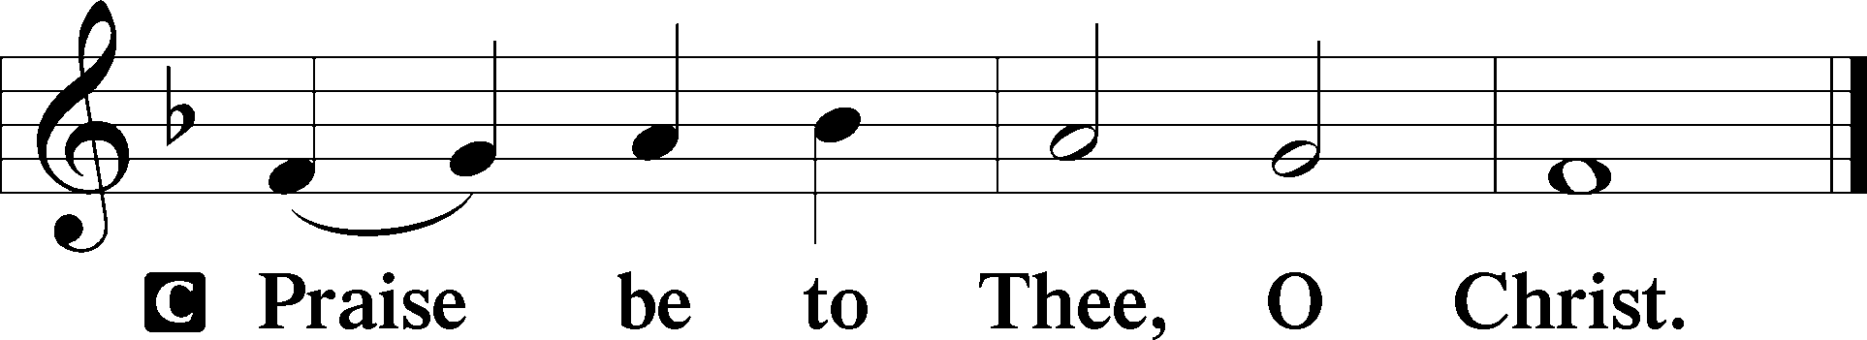

Apostles’ Creed
C I believe in God, the Father Almighty,
maker of heaven and earth.

And in Jesus Christ, His only Son, our Lord,
who was conceived by the Holy Spirit,
born of the virgin Mary,
suffered under Pontius Pilate,
was crucified, died and was buried.
He descended into hell.
The third day He rose again from the dead.
He ascended into heaven
and sits at the right hand of God the Father Almighty.
From thence He will come to judge the living and the dead.

I believe in the Holy Spirit,
the holy Christian Church,
the communion of saints,
the forgiveness of sins,
the resurrection of the body,
and the life T everlasting. Amen.

Sit

Children's Sermon

483 With High Delight Let Us Unite
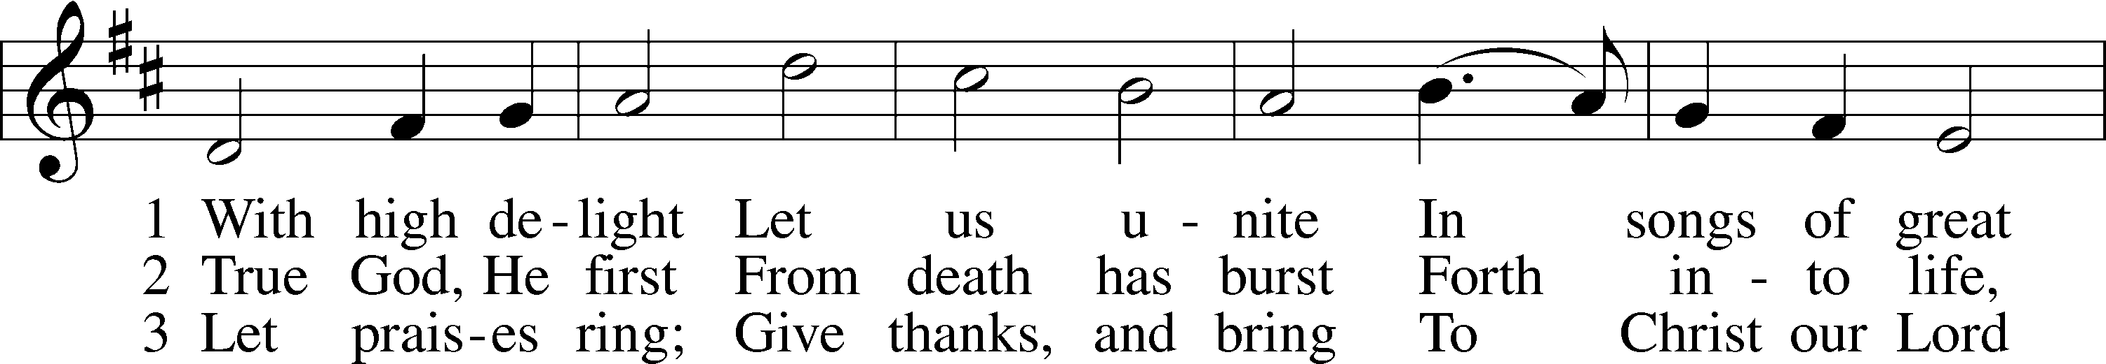
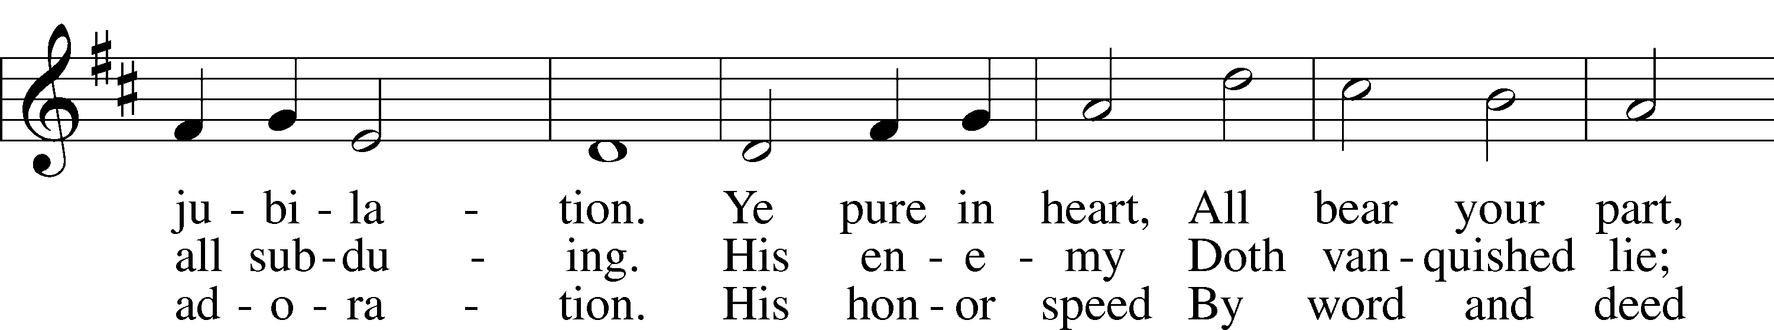
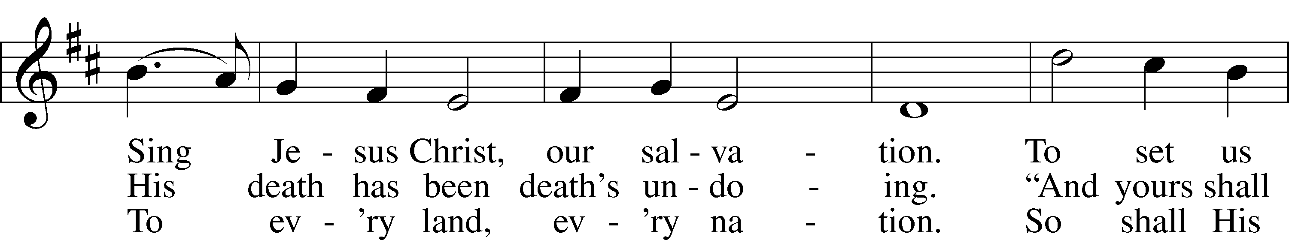
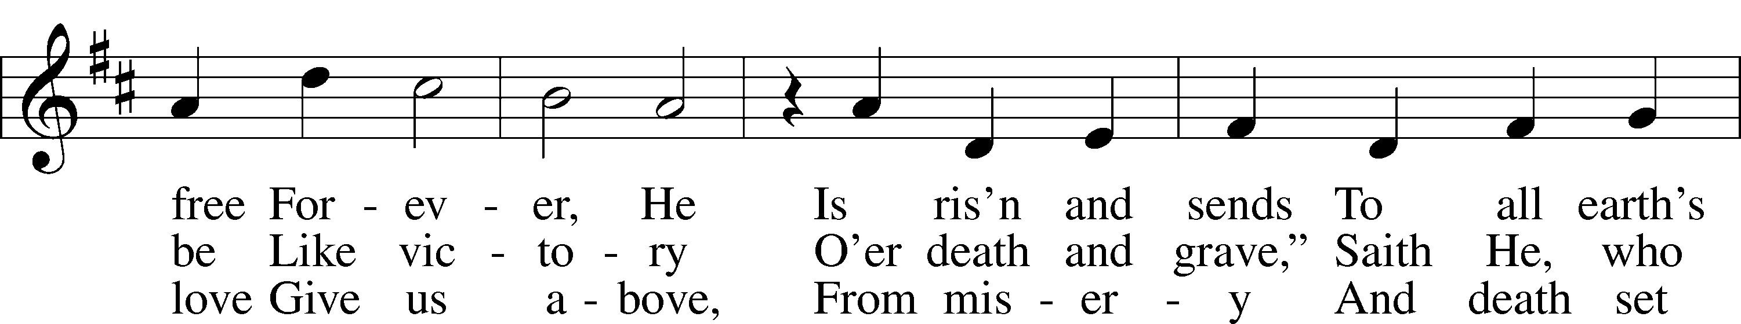
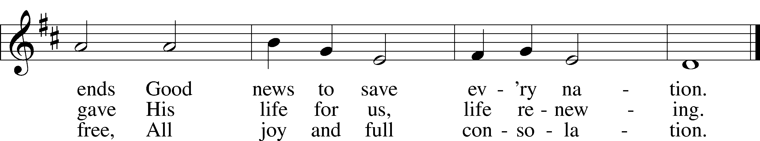
Text: Georg Vetter, 1536–99; tr. Martin H. Franzmann, 1907–76
Tune: Cinquante Pseaumes, 1543, Geneva
Text: © 1969 Concordia Publishing House. Used by permission: LSB Hymn License no. 110005011
Tune: Public domain

Sermon

Votum
P The peace of God, which passes all understanding, keep your hearts and minds in Christ Jesus.
C Amen.

Stand

Offertory Psalm 51:10–12
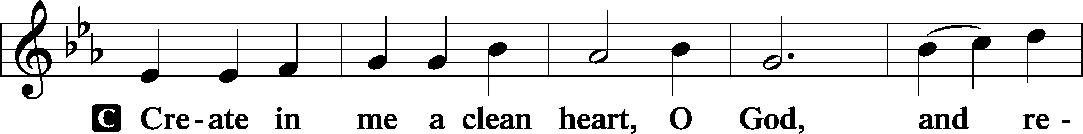
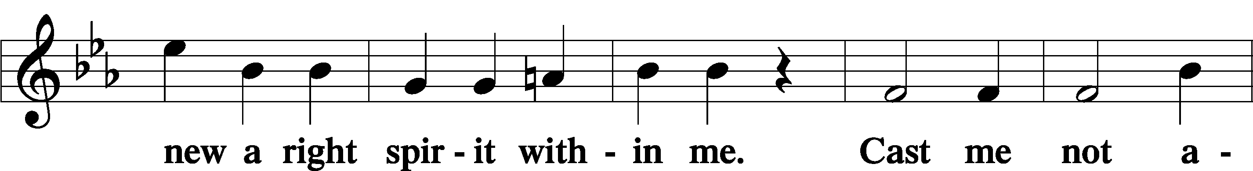
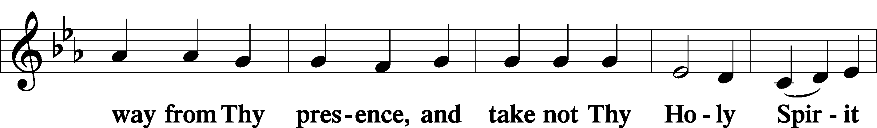
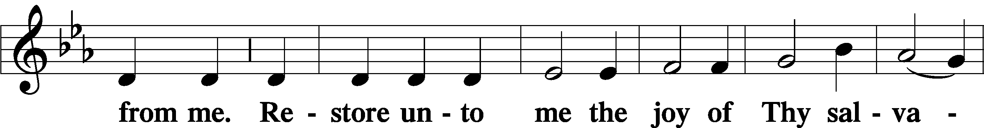
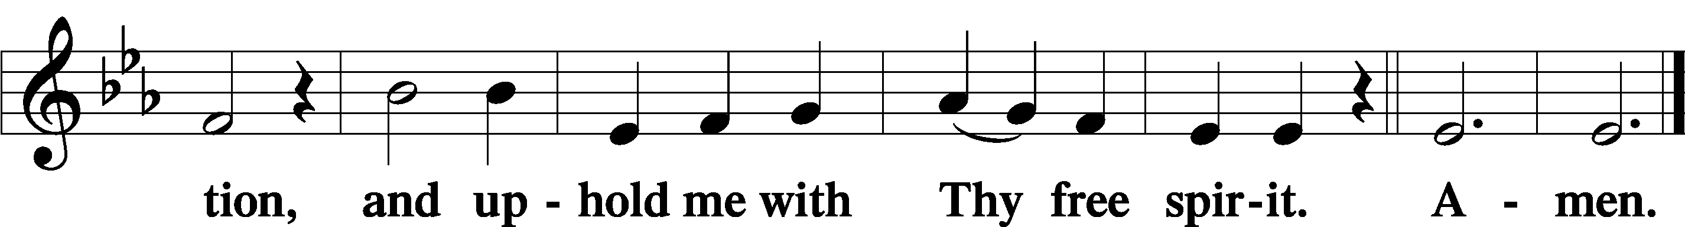

Offering

805 Praise God, from Whom All Blessings Flow
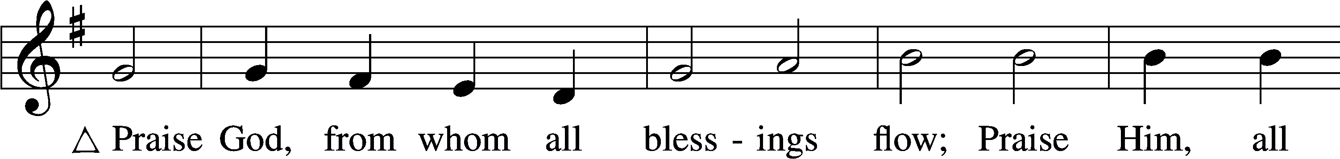
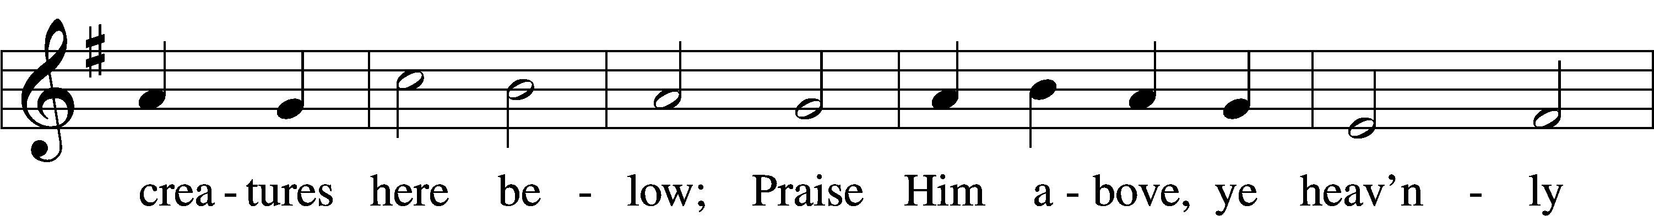
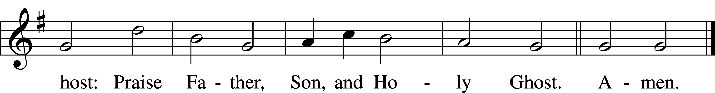
Text: Thomas Ken, 1637–1711
Tune: Trente quatre Pseaumes de David, 1551, Geneva, ed. Louis Bourgeois
Text and tune: Public domain

Prayer of the Church

Lord’s Prayer Matthew 6:9–13
P Lord, remember us in Your kingdom and teach us to pray:
C Our Father who art in heaven,
hallowed be Thy name,
Thy kingdom come,
Thy will be done on earth
as it is in heaven;
give us this day our daily bread;
and forgive us our trespasses
as we forgive those
who trespass against us;
and lead us not into temptation,
but deliver us from evil.
For Thine is the kingdom
and the power and the glory
forever and ever. Amen.

Collect for the Word

Blessed Lord, You have caused all Holy Scriptures to be written for our learning. Grant that we may so hear them, read, mark, learn, and inwardly digest them that, by the patience and comfort of Your holy Word, we may embrace and ever hold fast the blessed hope of everlasting life; through Jesus Christ, Your Son, our Lord, who lives and reigns with You and the Holy Spirit, one God, now and forever.

Benediction
P The Lord bless you and keep you.
The Lord make His face shine on you and be gracious to you.
The Lord look upon you with favor and T give you peace.
C Amen.

466 Christ Has Arisen, Alleluia
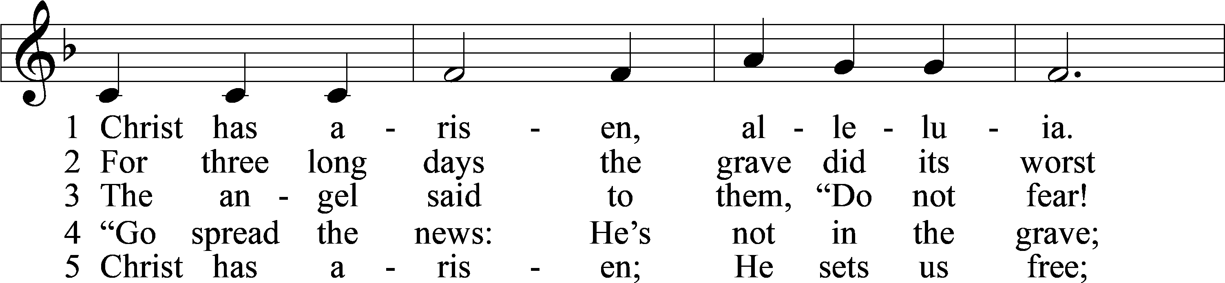
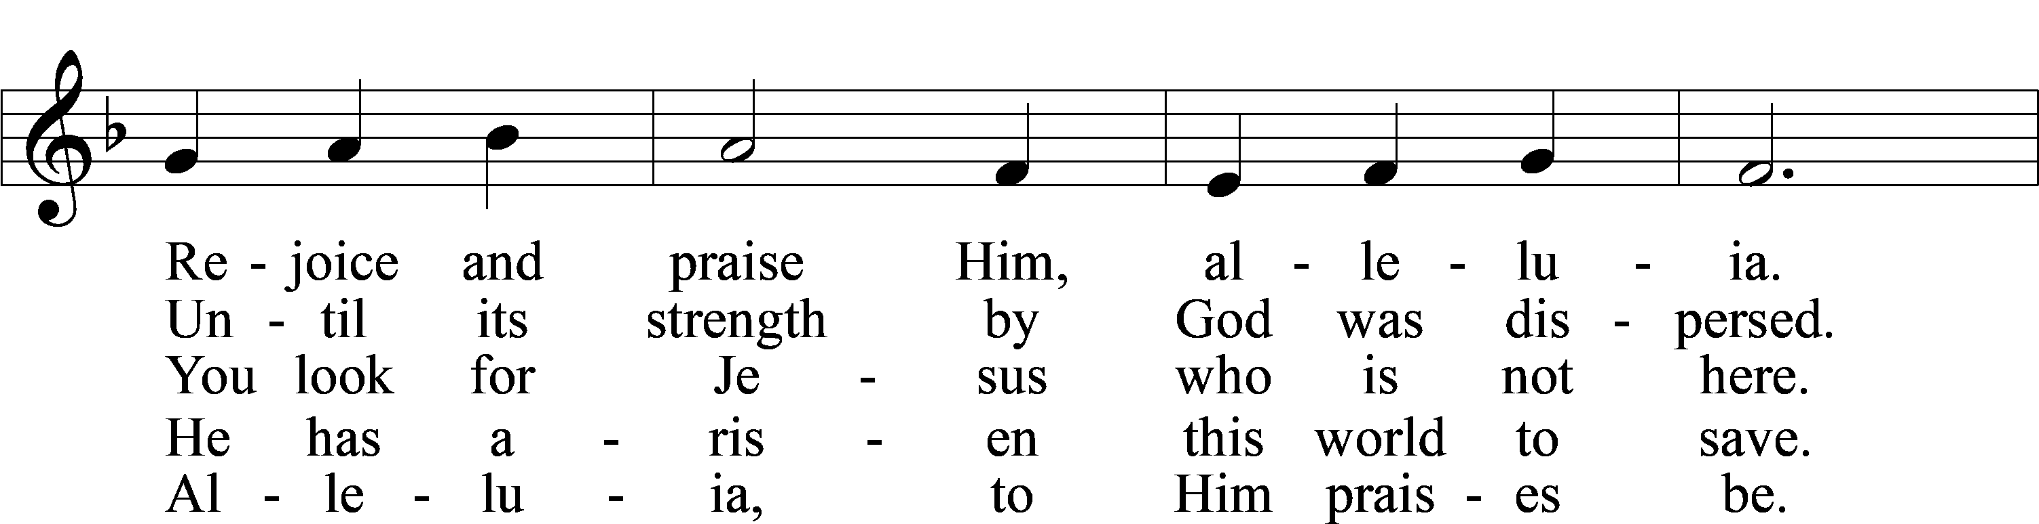
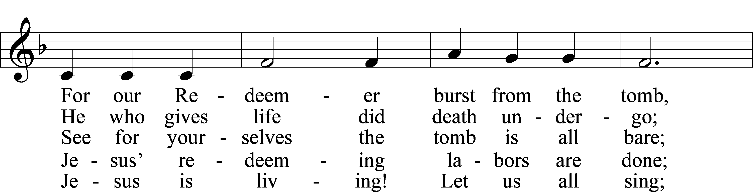
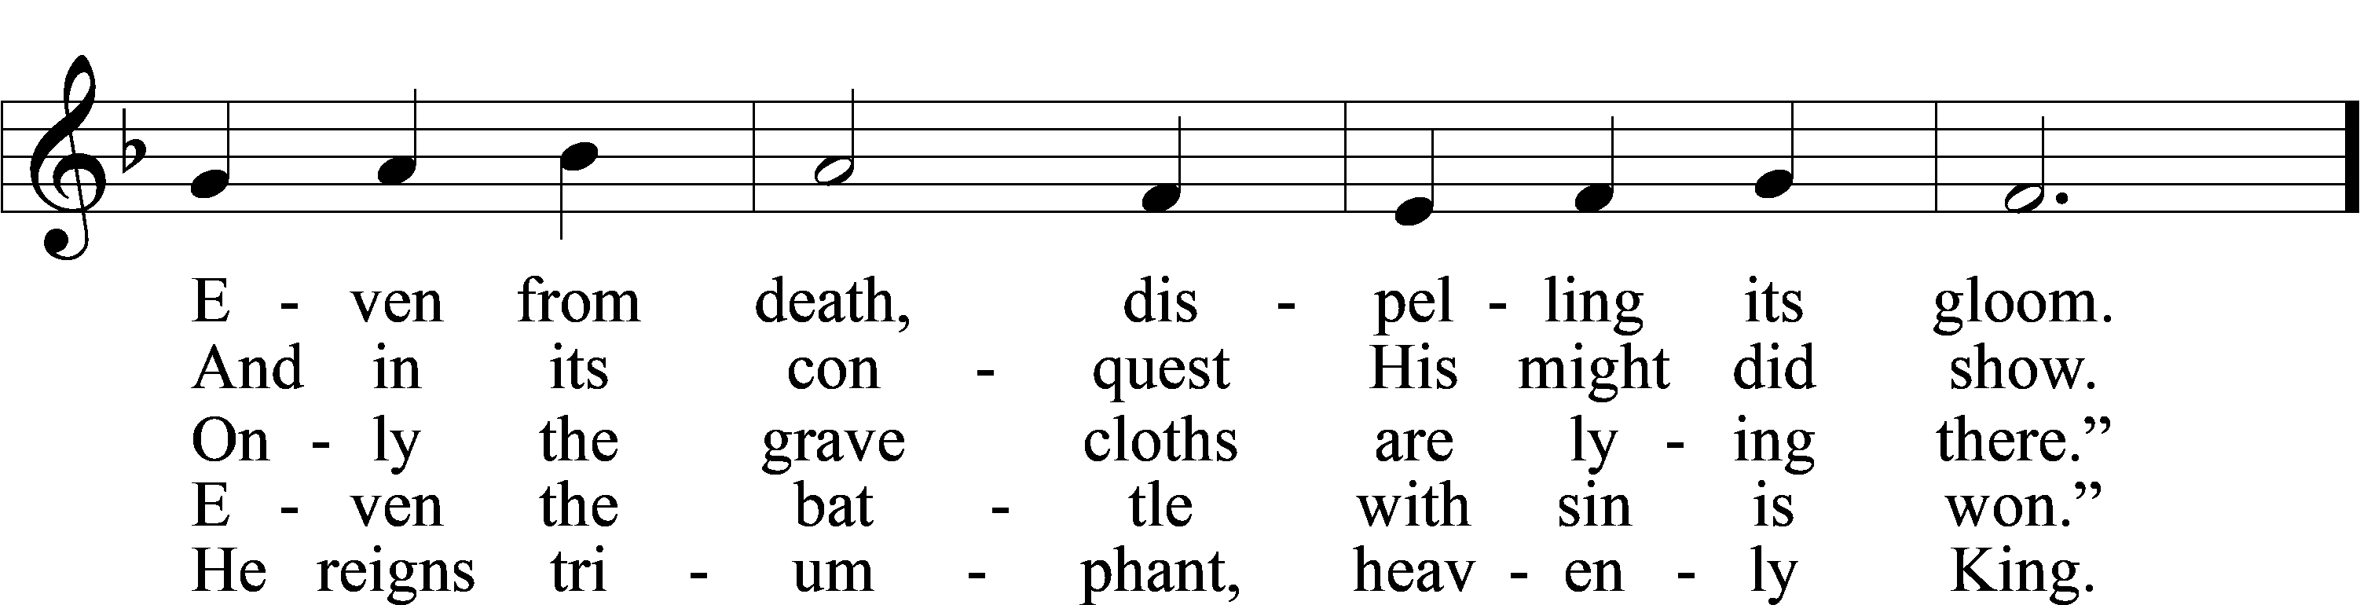
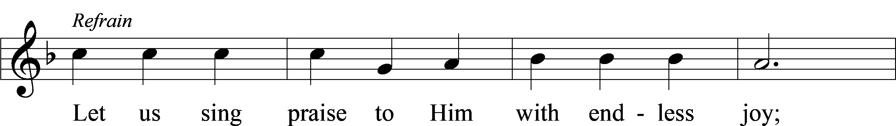
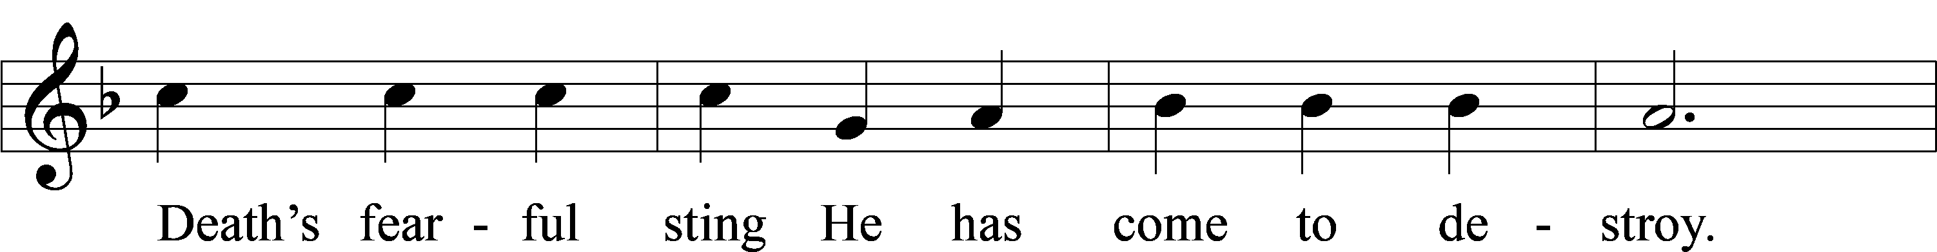
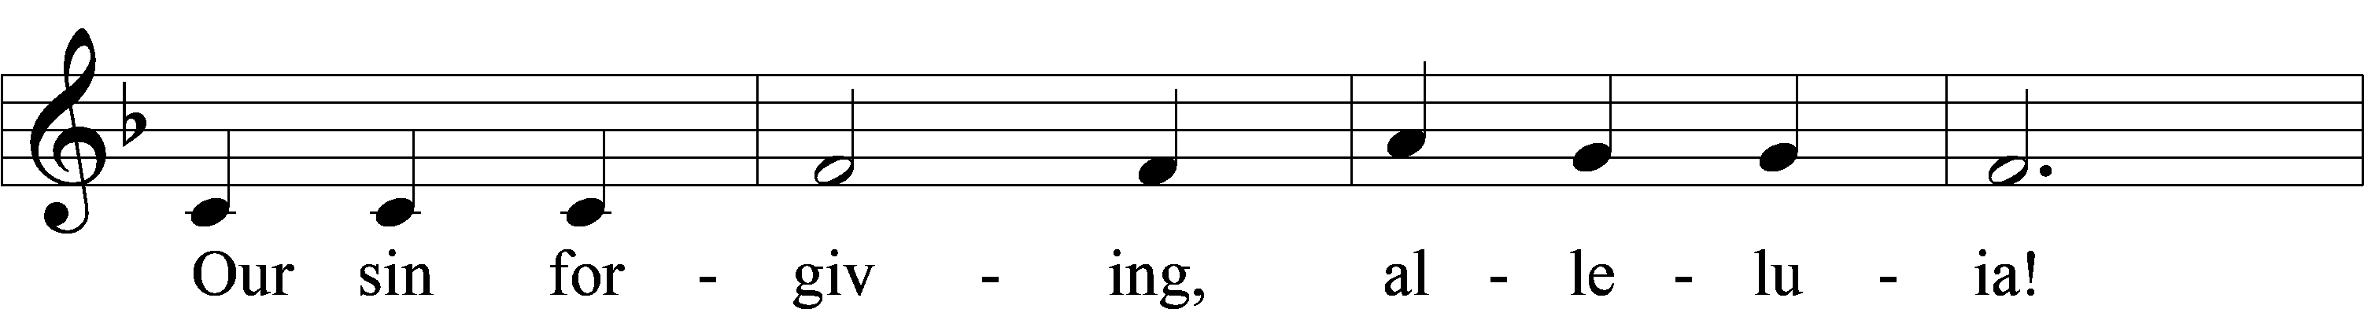
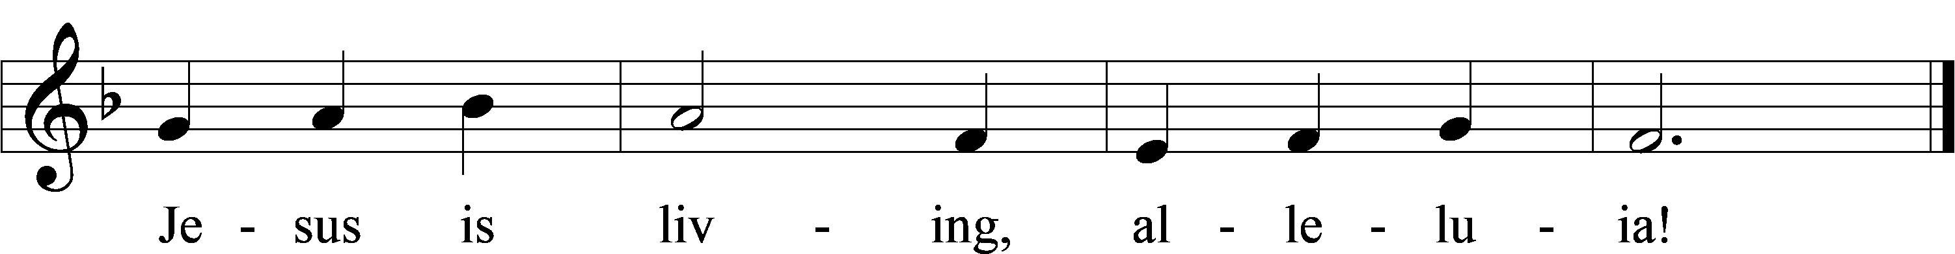
Text: Bernard Kyamanywa, 1938–2021; tr. Howard S. Olson, 1922–2010
Tune: Tanzanian
Text: © 1977 Howard S. Olson. Used by permission: LSB Hymn License no. 110005011
Tune: Public domain

Acknowledgments
Unless otherwise indicated, Scripture quotations are from the ESV® Bible (The Holy Bible, English Standard Version®), copyright © 2001 by Crossway, a publishing ministry of Good News Publishers. Used by permission. All rights reserved.
Created by Lutheran Service Builder © 2026 Concordia Publishing House.

