On entering the church

P Lord, I love the habitation of Your house and the place

where Your glory dwells. In the multitude of Your tender

mercies prepare my heart that I may enter Your house to

worship and confess Your holy name; through Jesus Christ,

my God and Lord.

Before worship

C O Lord, our creator, redeemer, and comforter, as we come

together to worship You in spirit and in truth, we humbly

pray that You would open our hearts to the preaching of

Your Word so that we may repent of our sins, believe in

Jesus Christ as our only Savior, and grow in grace and

holiness. Hear us for His sake.

427 In the Cross of Christ I Glory

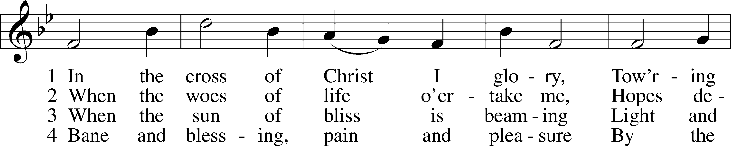

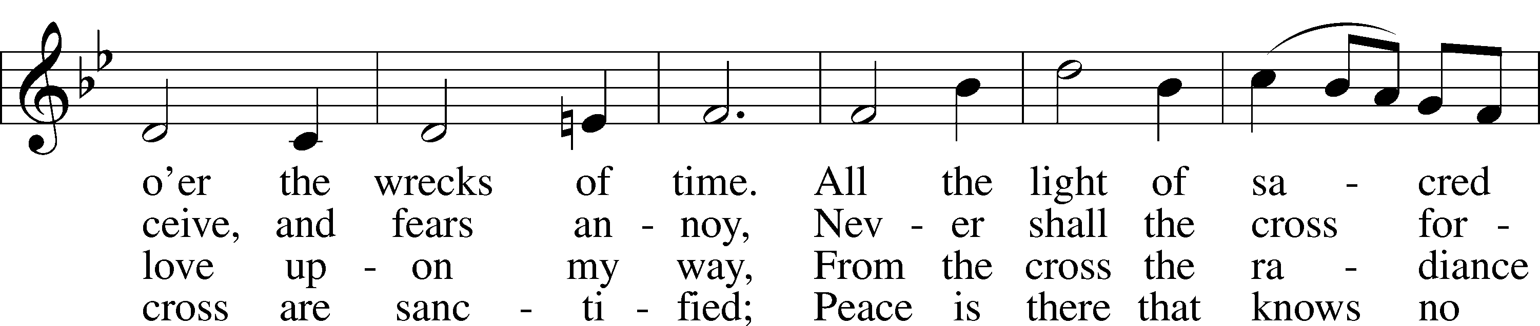

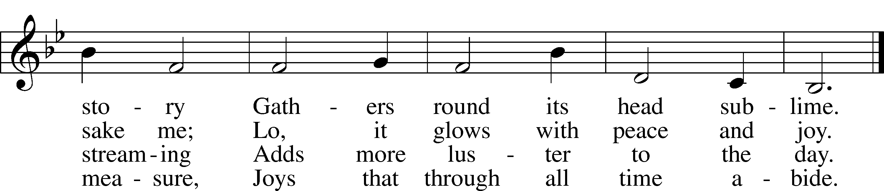

Text: John Bowring, 1792–1872  
Tune: Ithamar Conkey, 1815–67  
Text and tune: Public domain

# Confession and Absolution

Stand

The sign of the cross may be made by all in remembrance of their Baptism.

Invocation Matthew 28:19b; 18:20

P In the name of the Father and of the T Son and of the Holy Spirit.

C **Amen.**

Exhortation Hebrews 10:22; Psalm 124:8; Psalm 32:5

P Beloved in the Lord! Let us draw near with a true heart and confess our sins unto God our Father, beseeching Him in the name of our Lord Jesus Christ to grant us forgiveness.

P Our help is in the name of the Lord,

C **who made heaven and earth.**

P I said, I will confess my transgressions unto the Lord,

C **and You forgave the iniquity of my sin.**

Kneel/Stand

Silence for reflection on God’s Word and for self-examination.

Confession of Sins

P O almighty God, merciful Father,

C **I, a poor, miserable sinner, confess unto You all my sins and iniquities with which I have ever offended You and justly deserved Your temporal and eternal punishment. But I am heartily sorry for them and sincerely repent of them, and I pray You of Your boundless mercy and for the sake of the holy, innocent, bitter sufferings and death of Your beloved Son, Jesus Christ, to be gracious and merciful to me, a poor, sinful being.**

Absolution [John 20:19–23]

P Upon this your confession, I, by virtue of my office, as a called and ordained servant of the Word, announce the grace of God unto all of you, and in the stead and by the command of my Lord Jesus Christ I forgive you all your sins in the name of the Father and of the T Son and of the Holy Spirit.

C **Amen.**

Stand

# Service of the Word

Introit Psalm 19:2, 4–6; antiphon: v. 1

The heavens declare the glory of God,  
 and the sky above proclaims his handiwork.  
**Day to day pours out speech,  
 and night to night reveals knowledge.**Their measuring line goes out through all the earth, and their words to the end of the world.  
In them he has set a tent for the sun,  
**which comes out like a bridegroom leaving his chamber,  
 and, like a strong man, runs its course with joy.**Its rising is from the end of the heavens, and its circuit to the end of them,  
 and there is nothing hidden from its heat.

Gloria Patri

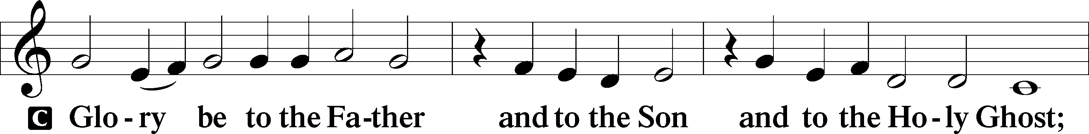

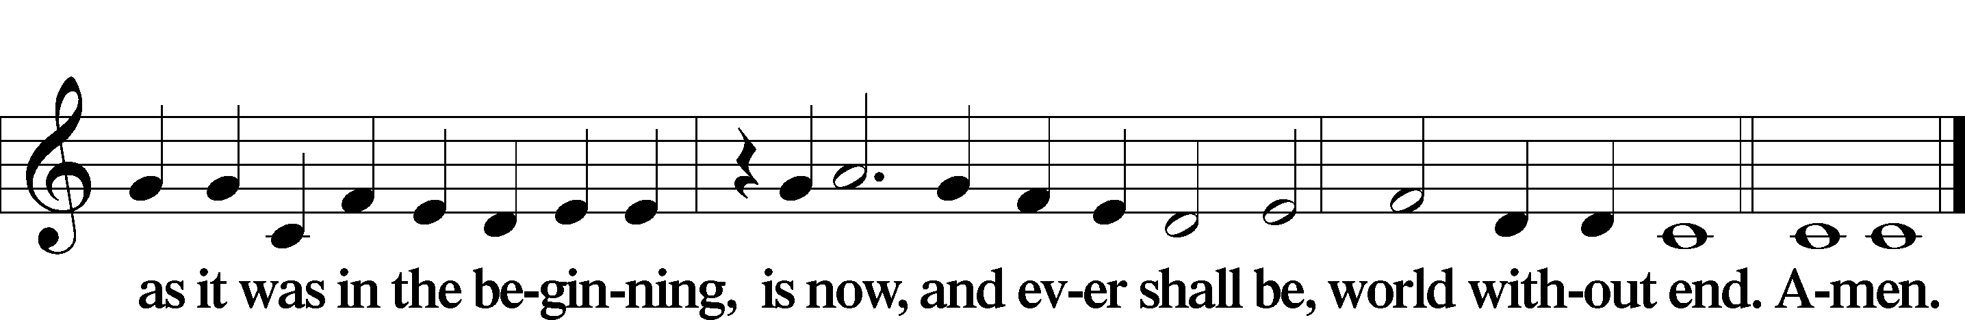

Kyrie Mark 10:47

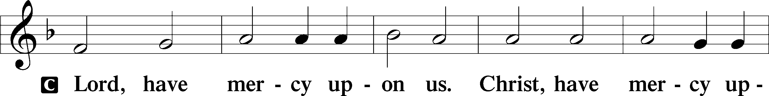

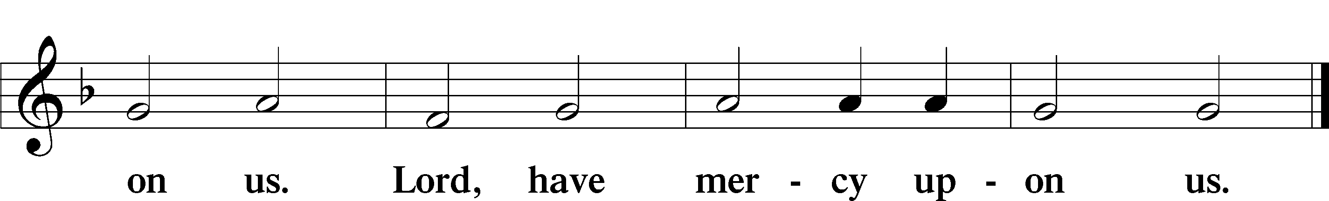

Gloria in Excelsis Luke 2:14; John 1:29

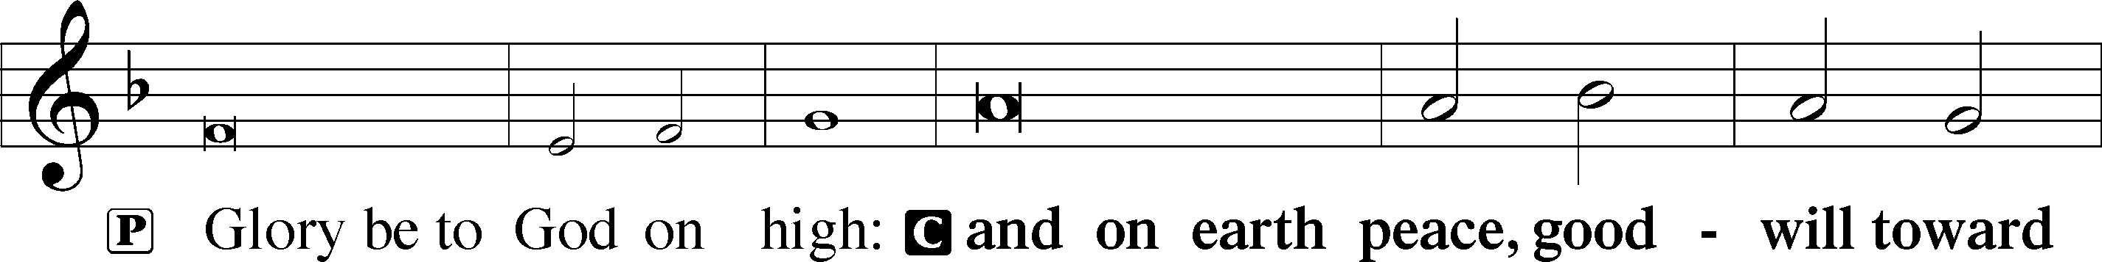

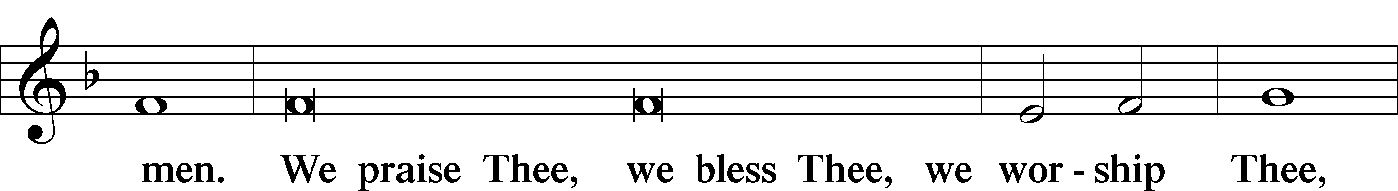

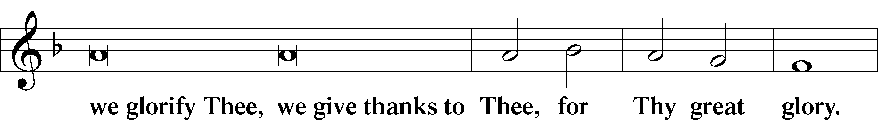

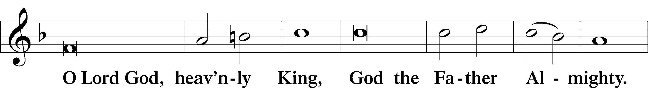

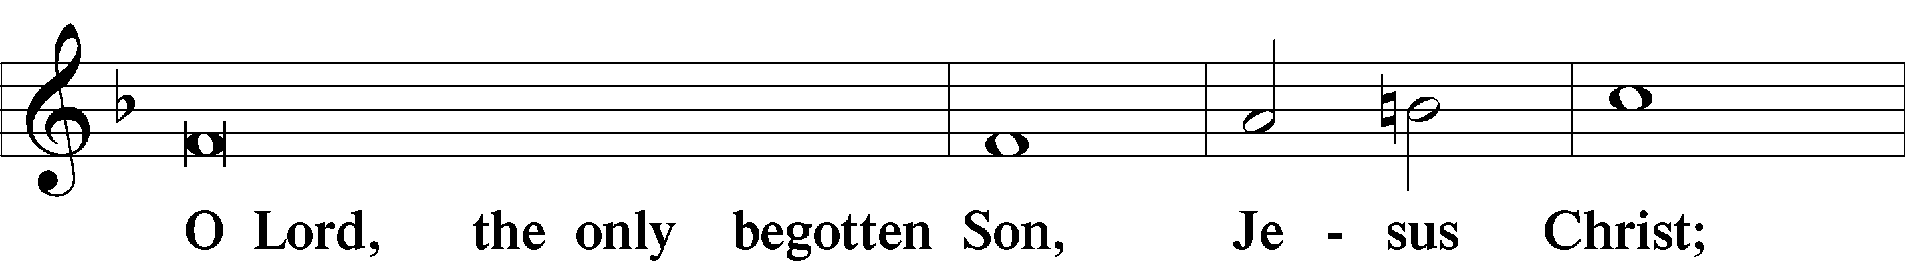

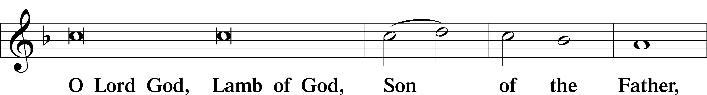

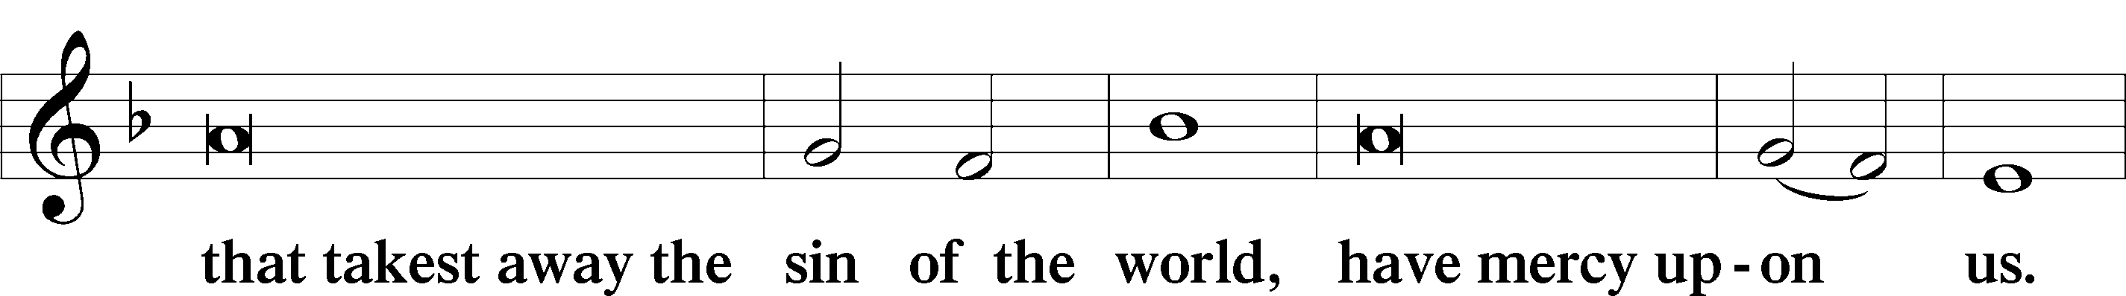

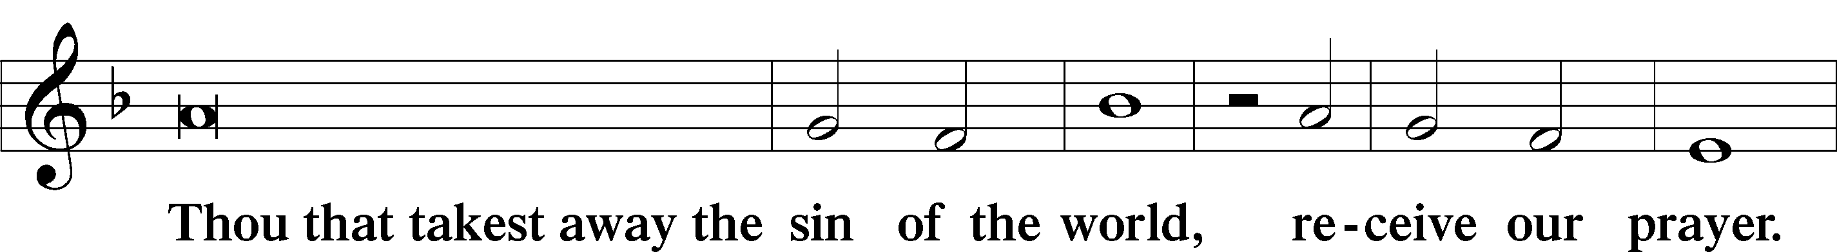

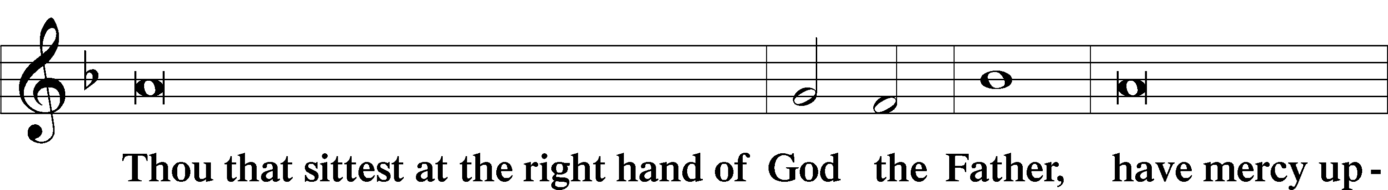

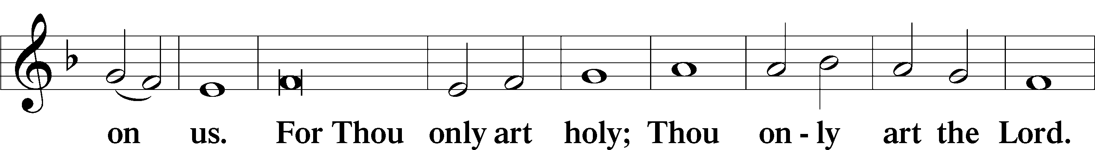

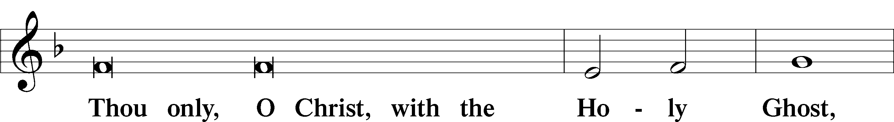

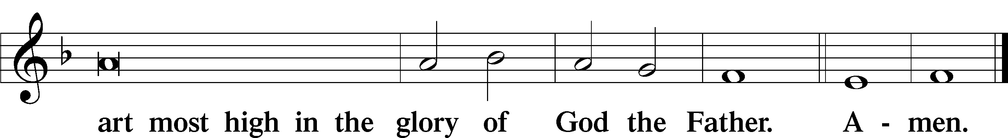

Salutation and Collect of the Day

P The Lord be with you.

C **And with thy spirit.**

P Let us pray.

Almighty God, You have built Your Church on the foundation of the apostles and prophets with Christ Jesus Himself as the cornerstone. Continue to send Your messengers to preserve Your people in true peace that, by the preaching of Your Word, Your Church may be kept free from all harm and danger; through Jesus Christ, Your Son, our Lord, who lives and reigns with You and the Holy Spirit, one God, now and forever.

C **Amen.**

Sit

Old Testament Reading Isaiah 66:10–14

10“Rejoice with Jerusalem, and be glad for her,  
 all you who love her;  
rejoice with her in joy,  
 all you who mourn over her;  
11that you may nurse and be satisfied  
 from her consoling breast;  
that you may drink deeply with delight  
 from her glorious abundance.”  
12For thus says the Lord:  
“Behold, I will extend peace to her like a river,  
 and the glory of the nations like an overflowing stream;  
and you shall nurse, you shall be carried upon her hip,  
 and bounced upon her knees.  
13As one whom his mother comforts,  
 so I will comfort you;  
 you shall be comforted in Jerusalem.  
14You shall see, and your heart shall rejoice;  
 your bones shall flourish like the grass;  
and the hand of the Lord shall be known to his servants,  
 and he shall show his indignation against his enemies.”

A This is the Word of the Lord.

C **Thanks be to God.**

Gradual Romans 10:15b, 18b; Isaiah 52:7b, alt.

How beautiful are the feet of those who preach the good news,  
 who publish peace and bring good news of salvation.  
**Their voice has gone out to all the earth,  
 and their words to the ends of the world.**

Epistle Galatians 6:1–10, 14–18

1Brothers, if anyone is caught in any transgression, you who are spiritual should restore him in a spirit of gentleness. Keep watch on yourself, lest you too be tempted. 2Bear one another’s burdens, and so fulfill the law of Christ. 3For if anyone thinks he is something, when he is nothing, he deceives himself. 4But let each one test his own work, and then his reason to boast will be in himself alone and not in his neighbor. 5For each will have to bear his own load.

6One who is taught the word must share all good things with the one who teaches. 7Do not be deceived: God is not mocked, for whatever one sows, that will he also reap. 8For the one who sows to his own flesh will from the flesh reap corruption, but the one who sows to the Spirit will from the Spirit reap eternal life. 9And let us not grow weary of doing good, for in due season we will reap, if we do not give up. 10So then, as we have opportunity, let us do good to everyone, and especially to those who are of the household of faith. . . .

14But far be it from me to boast except in the cross of our Lord Jesus Christ, by which the world has been crucified to me, and I to the world. 15For neither circumcision counts for anything, nor uncircumcision, but a new creation. 16And as for all who walk by this rule, peace and mercy be upon them, and upon the Israel of God.

17From now on let no one cause me trouble, for I bear on my body the marks of Jesus.

18The grace of our Lord Jesus Christ be with your spirit, brothers. Amen.

A This is the Word of the Lord.

C **Thanks be to God.**

Stand

Alleluia

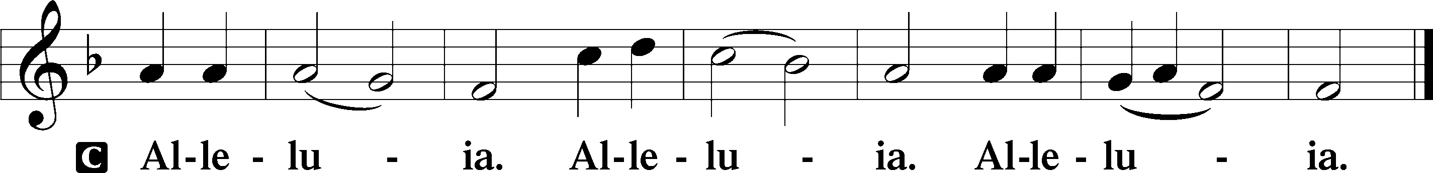

Holy Gospel Luke 10:1–20

P The Holy Gospel according to St. Luke, the tenth chapter.

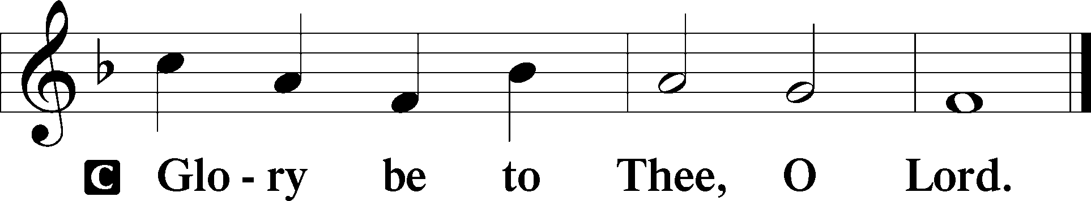

1After this the Lord appointed seventy-two others and sent them on ahead of him, two by two, into every town and place where he himself was about to go. 2And he said to them, “The harvest is plentiful, but the laborers are few. Therefore pray earnestly to the Lord of the harvest to send out laborers into his harvest. 3Go your way; behold, I am sending you out as lambs in the midst of wolves. 4Carry no moneybag, no knapsack, no sandals, and greet no one on the road. 5Whatever house you enter, first say, ‘Peace be to this house!’ 6And if a son of peace is there, your peace will rest upon him. But if not, it will return to you. 7And remain in the same house, eating and drinking what they provide, for the laborer deserves his wages. Do not go from house to house. 8Whenever you enter a town and they receive you, eat what is set before you. 9Heal the sick in it and say to them, ‘The kingdom of God has come near to you.’ 10But whenever you enter a town and they do not receive you, go into its streets and say, 11‘Even the dust of your town that clings to our feet we wipe off against you. Nevertheless know this, that the kingdom of God has come near.’ 12I tell you, it will be more bearable on that day for Sodom than for that town.

13“Woe to you, Chorazin! Woe to you, Bethsaida! For if the mighty works done in you had been done in Tyre and Sidon, they would have repented long ago, sitting in sackcloth and ashes. 14But it will be more bearable in the judgment for Tyre and Sidon than for you. 15And you, Capernaum, will you be exalted to heaven? You shall be brought down to Hades.

16“The one who hears you hears me, and the one who rejects you rejects me, and the one who rejects me rejects him who sent me.”

17The seventy-two returned with joy, saying, “Lord, even the demons are subject to us in your name!” 18And he said to them, “I saw Satan fall like lightning from heaven. 19Behold, I have given you authority to tread on serpents and scorpions, and over all the power of the enemy, and nothing shall hurt you. 20Nevertheless, do not rejoice in this, that the spirits are subject to you, but rejoice that your names are written in heaven.”

P This is the Gospel of the Lord.

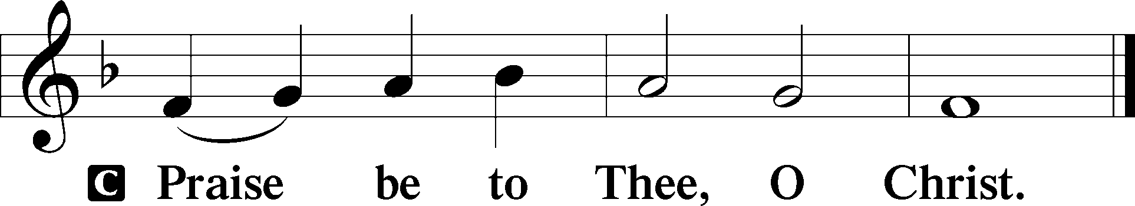

Nicene Creed

C **I believe in one God,**

**the Father Almighty,**

**maker of heaven and earth**

**and of all things visible and invisible.**

**And in one Lord Jesus Christ,**

**the only-begotten Son of God,**

**begotten of His Father before all worlds,**

**God of God, Light of Light,**

**very God of very God,**

**begotten, not made,**

**being of one substance with the Father,**

**by whom all things were made;**

**who for us men and for our salvation came down from heaven**

**and was incarnate by the Holy Spirit of the virgin Mary**

**and was made man;**

**and was crucified also for us under Pontius Pilate.**

**He suffered and was buried.**

**And the third day He rose again according to the Scriptures**

**and ascended into heaven**

**and sits at the right hand of the Father.**

**And He will come again with glory to judge both the living and the dead,**

**whose kingdom will have no end.**

**And I believe in the Holy Spirit,**

**the Lord and giver of life,**

**who proceeds from the Father and the Son,**

**who with the Father and the Son together is worshiped and glorified,**

**who spoke by the prophets.**

**And I believe in one holy Christian and apostolic Church,**

**I acknowledge one Baptism for the remission of sins,**

**and I look for the resurrection of the dead**

**and the life** T **of the world to come. Amen.**

Sit

Children's Sermon

601 All Who Believe and Are Baptized

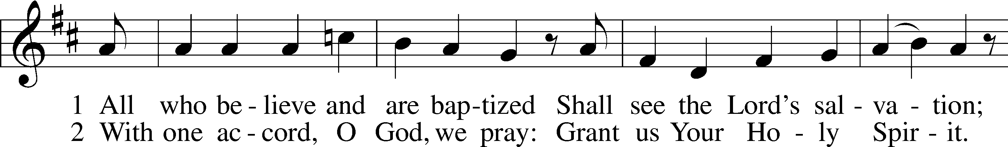

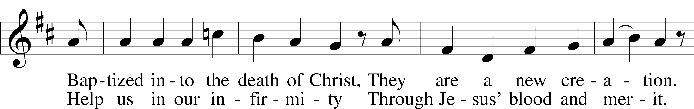

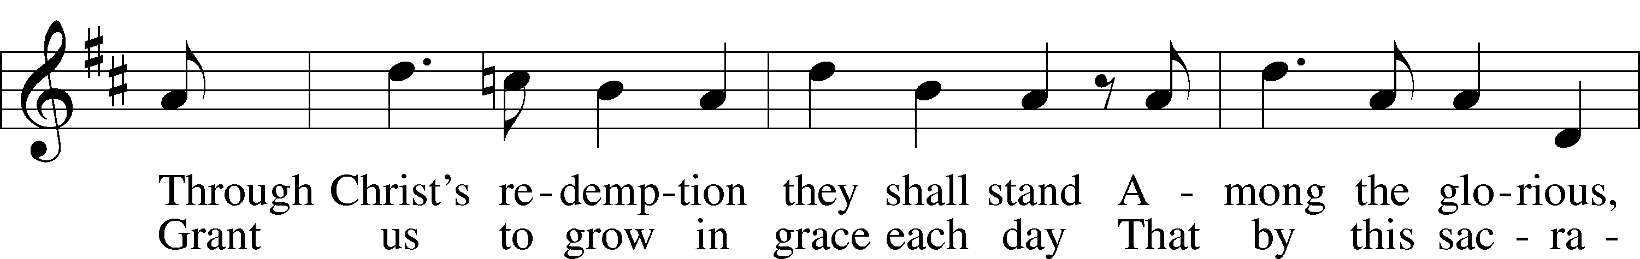

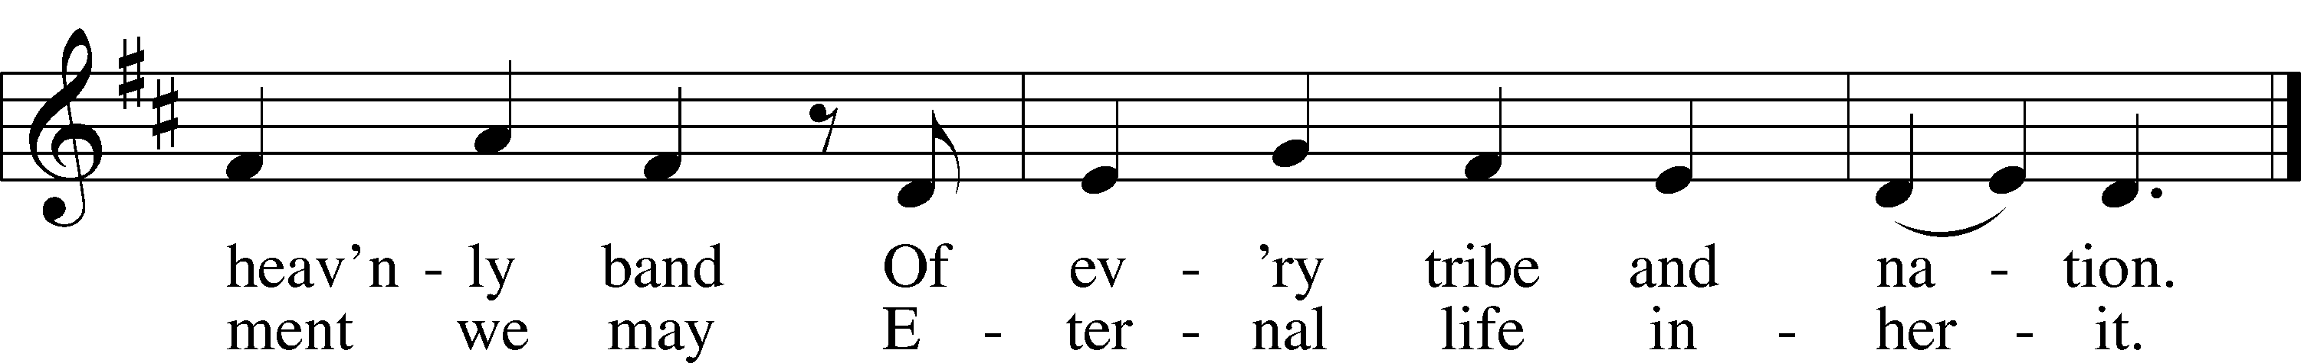

Text: Thomas Hansen Kingo, 1634–1703; tr. George A. T. Rygh, 1860–1942, alt.  
Tune: Etlich Cristlich lider, 1524, Wittenberg  
Text and tune: Public domain

Sermon

Votum

P The peace of God, which passes all understanding, keep your hearts and minds in Christ Jesus.

C **Amen.**

Stand

Offertory Psalm 51:10–12

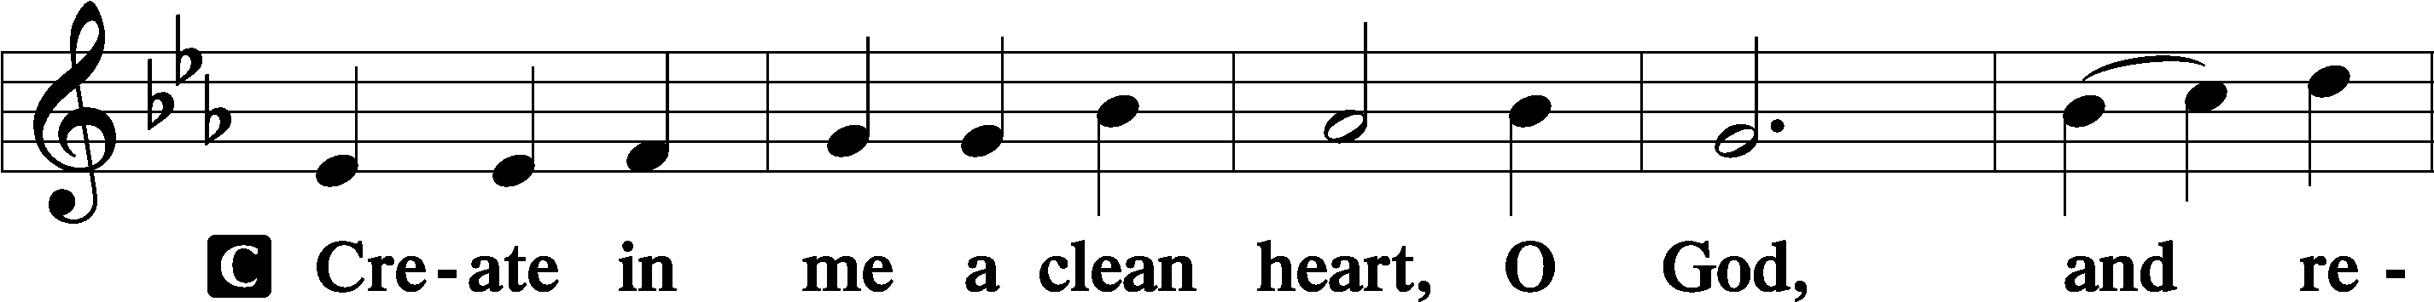

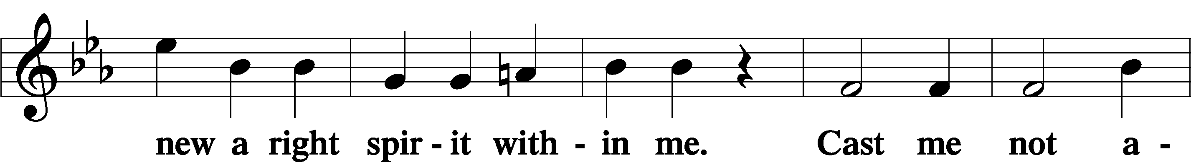

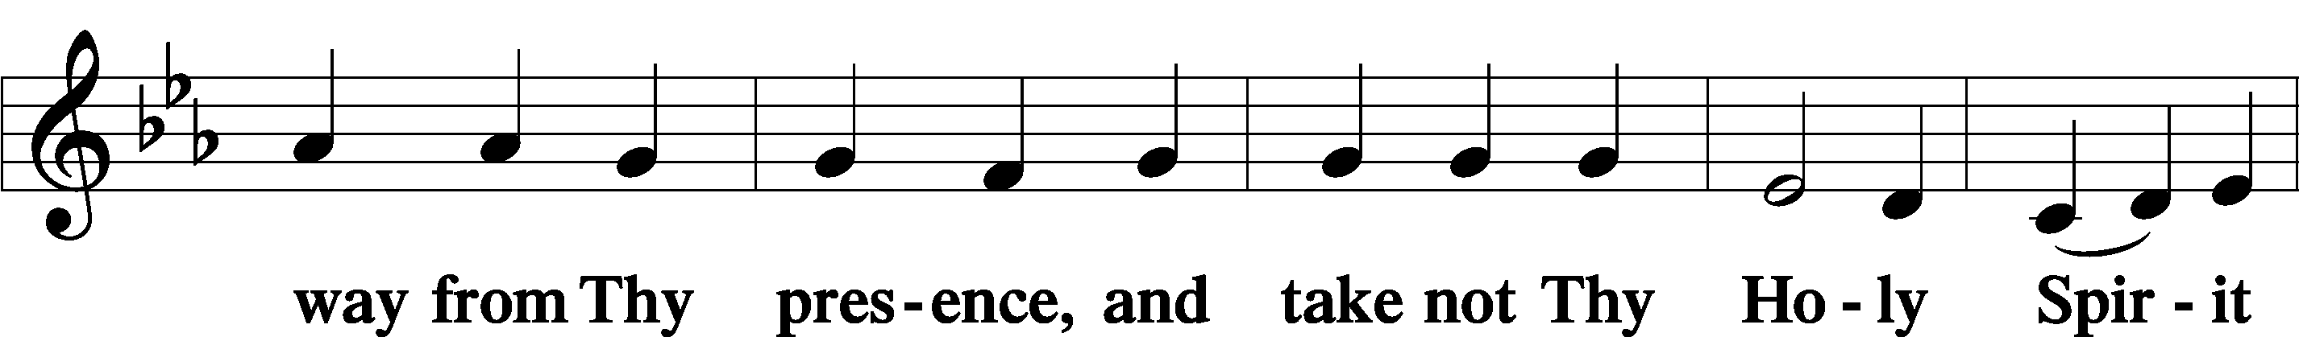

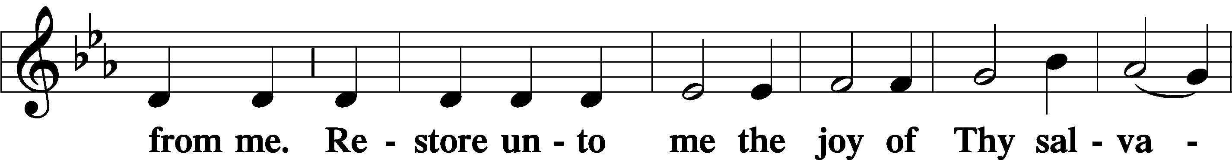

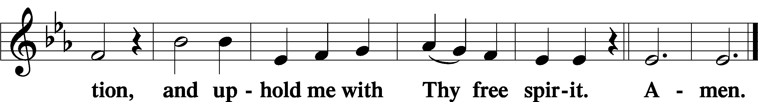

Sit

Offering

805 Praise God, from Whom All Blessings Flow

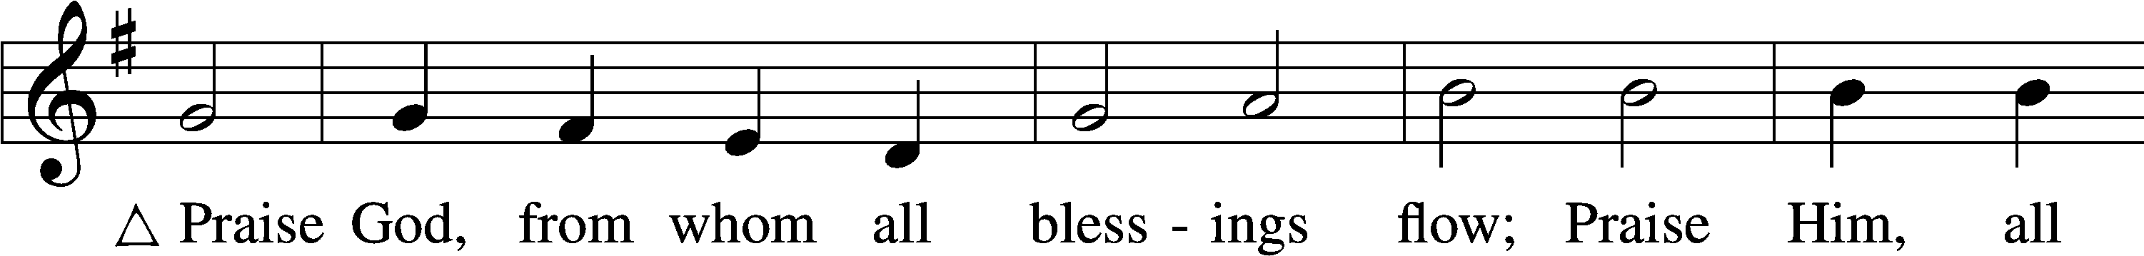

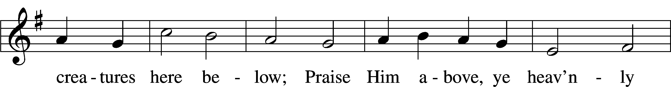

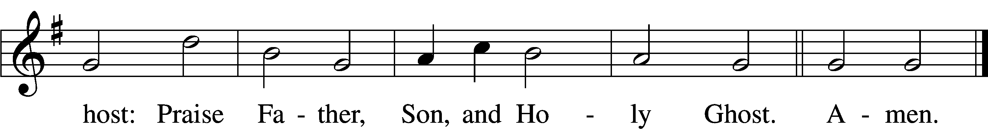

Text: Thomas Ken, 1637–1711  
Tune: Trente quatre Pseaumes de David, 1551, Geneva, ed. Louis Bourgeois  
Text and tune: Public domain

Stand

Prayer of the Church

# Service of the Sacrament

Preface 2 Timothy 4:22; [Colossians 3:1]; [Psalm 136]

P The Lord be with you.



P Lift up your hearts.

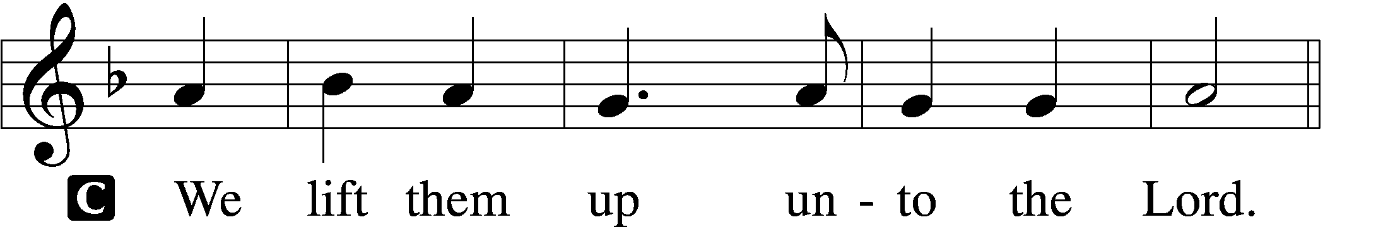

P Let us give thanks unto the Lord, our God.

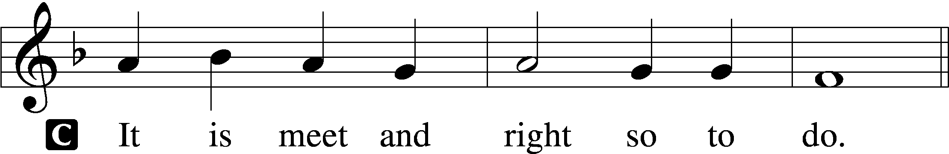

Proper Preface (Full)

P It is truly meet, right, and salutary that we should at all times and in all places give thanks to You, holy Lord, almighty Father, everlasting God, through Jesus Christ, our Lord, who, having created all things, took on human flesh and was born of the virgin Mary. For our sake He died on the cross and rose from the dead to put an end to death, thus fulfilling Your will and gaining for You a holy people. Therefore with angels and archangels and with all the company of heaven we laud and magnify Your glorious name, evermore praising You and saying:

Sanctus Isaiah 6:3; Matthew 21:9

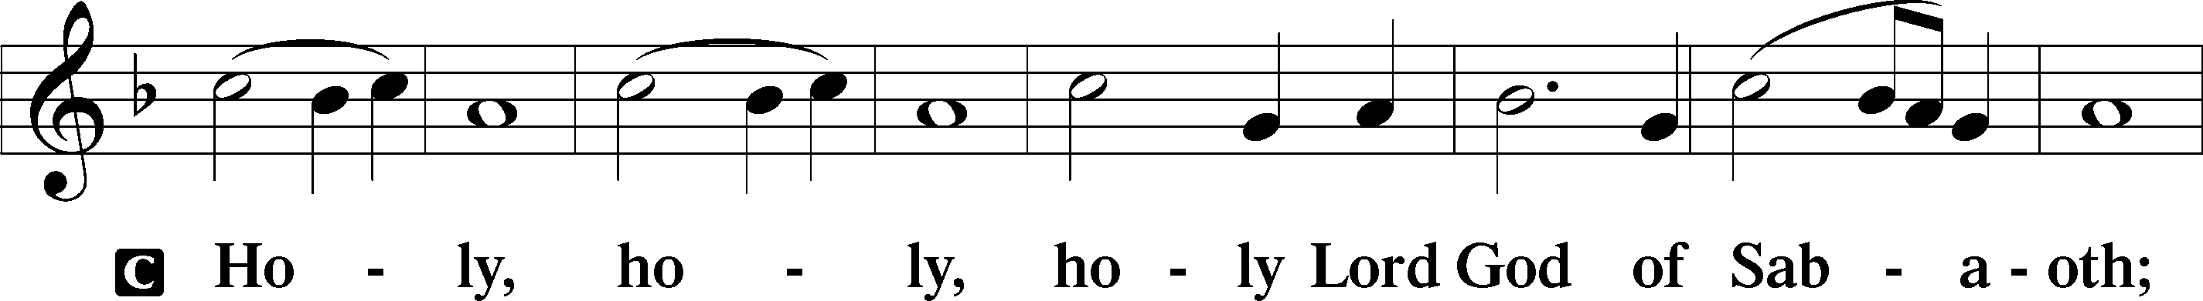

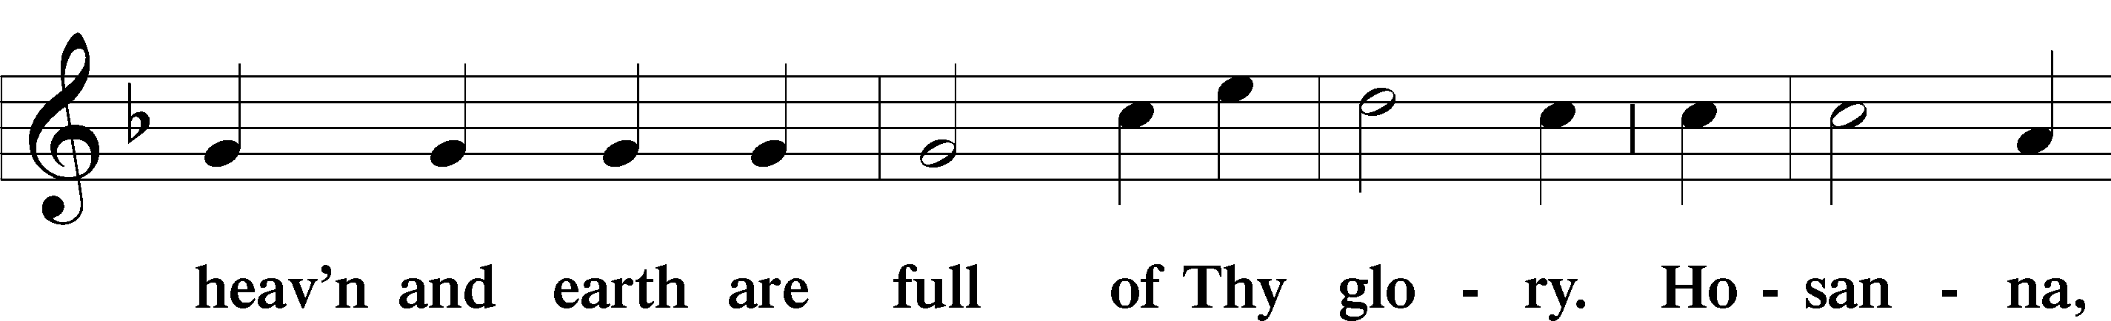

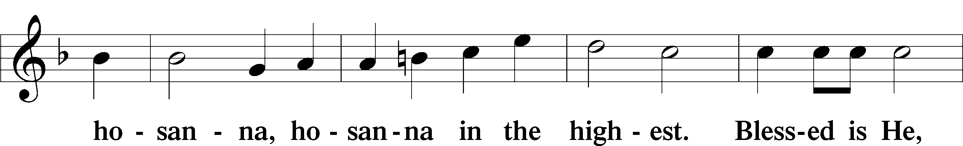

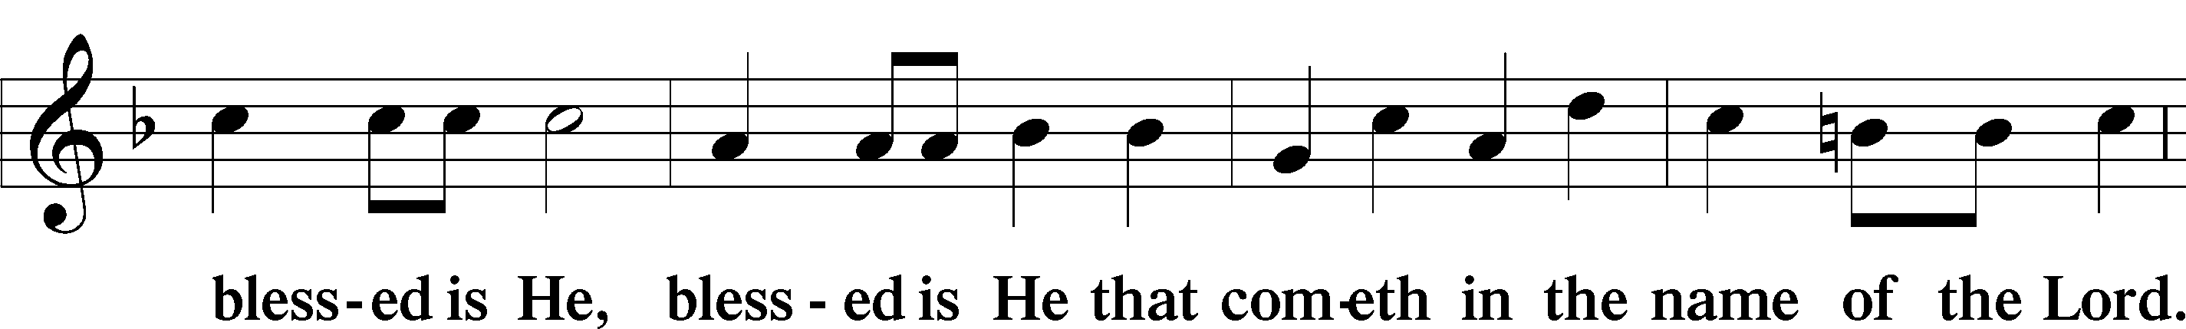

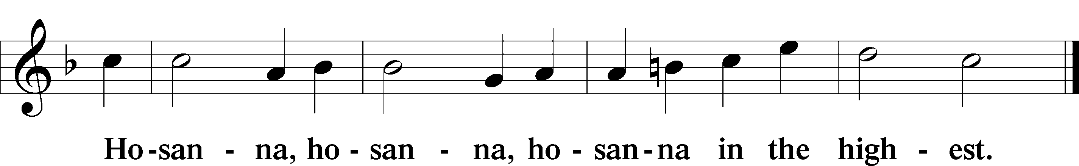

Lord’s Prayer Matthew 6:9–13

P Our Father who art in heaven,

hallowed be Thy name,

Thy kingdom come,

Thy will be done on earth as it is in heaven;

give us this day our daily bread;

and forgive us our trespasses as we forgive those who trespass against us;

and lead us not into temptation,

but deliver us from evil.

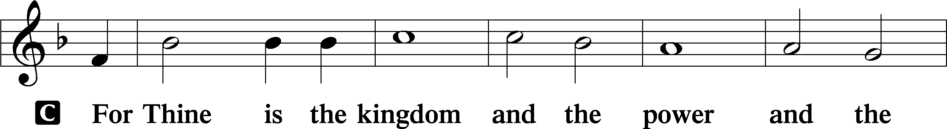

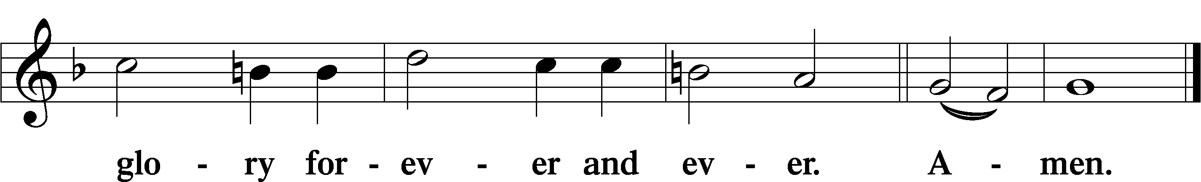

The Words of Our Lord Matthew 26:26–28; Mark 14:22–24; Luke 22:19–20; 1 Corinthians 11:23–25

P Our Lord Jesus Christ, on the night when He was betrayed, took bread, and when He had given thanks, He broke it and gave it to the disciples and said: “Take, eat; this is My T body, which is given for you. This do in remembrance of Me.”

In the same way also He took the cup after supper, and when He had given thanks, He gave it to them, saying: “Drink of it, all of you; this cup is the new testament in My T blood, which is shed for you for the forgiveness of sins. This do, as often as you drink it, in remembrance of Me.”

Pax Domini John 20:19

P The peace of the Lord be with you always.

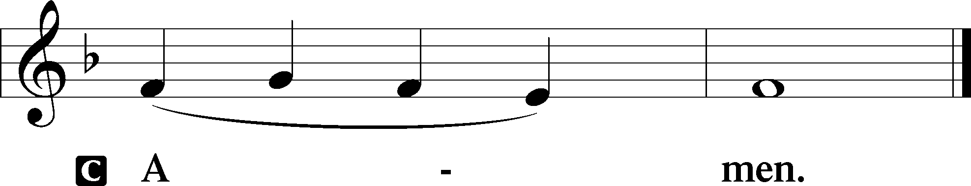

Agnus Dei John 1:29

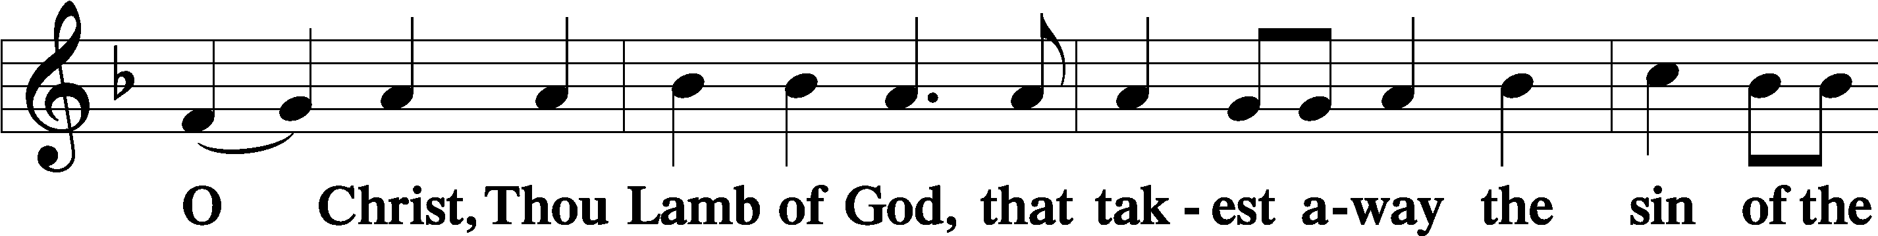

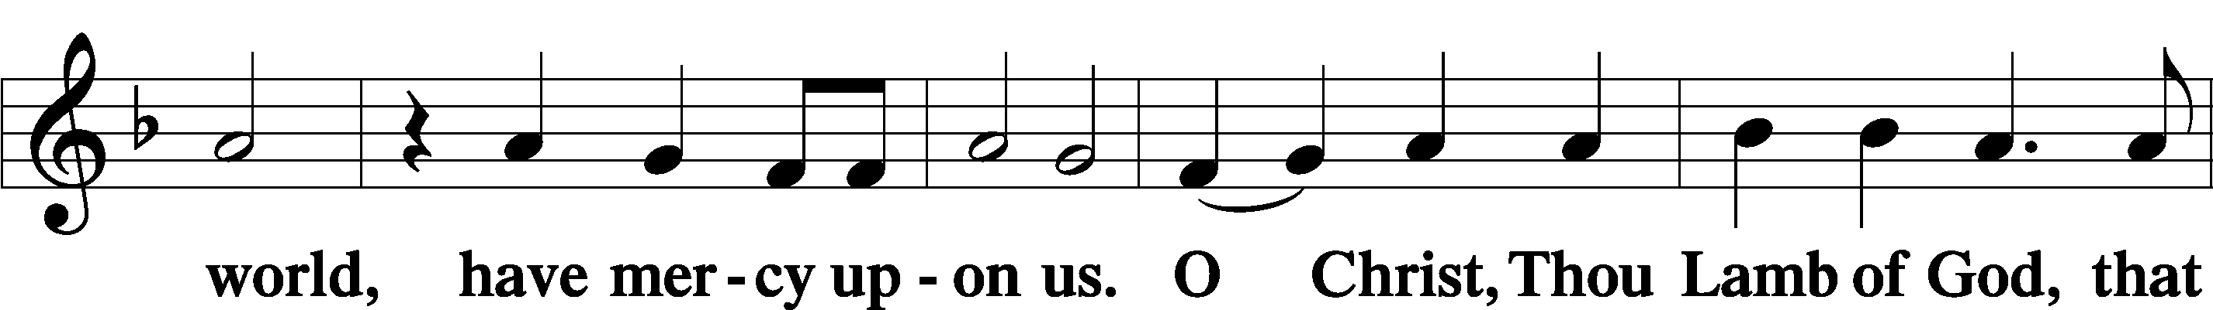

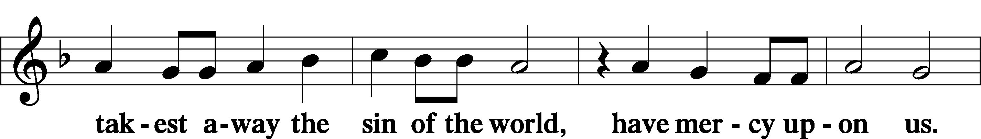

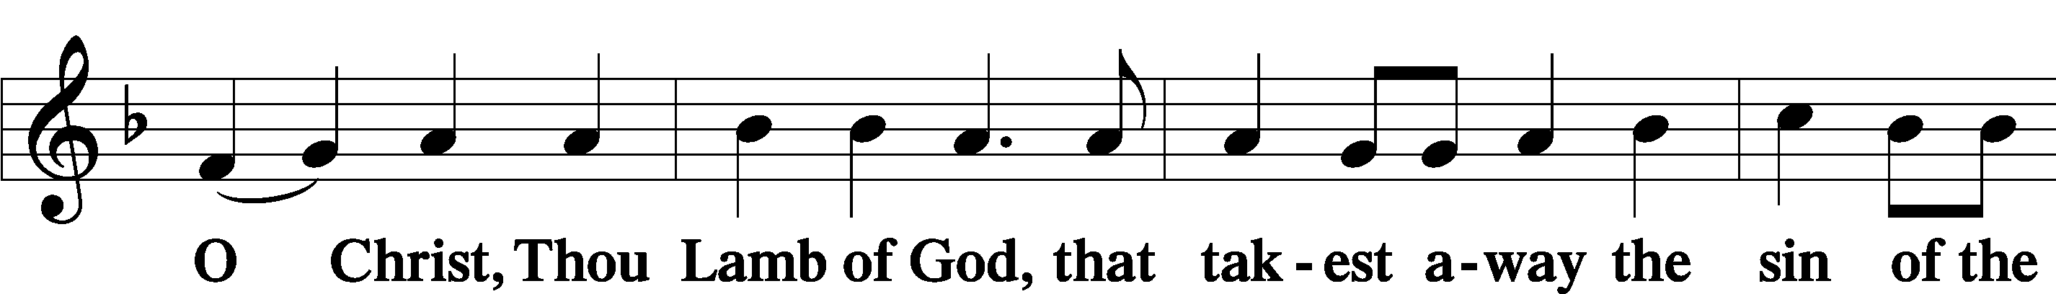



Sit

Distribution

The pastor and those who assist him receive the body and blood of Christ first and then distribute them to those who come to receive, saying:

Take, eat; this is the true body of our Lord and Savior Jesus Christ, given into death for your sins.

**Amen.**

Take, drink; this is the true blood of our Lord and Savior Jesus Christ, shed for the forgiveness of your sins.

**Amen.**

In dismissing the communicants, the following is said:

The Dismissal

P The body and blood of our Lord Jesus Christ strengthen and preserve you in body and soul to life everlasting. Depart T in peace.

C **Amen.**

649 Blest Be the Tie That Binds

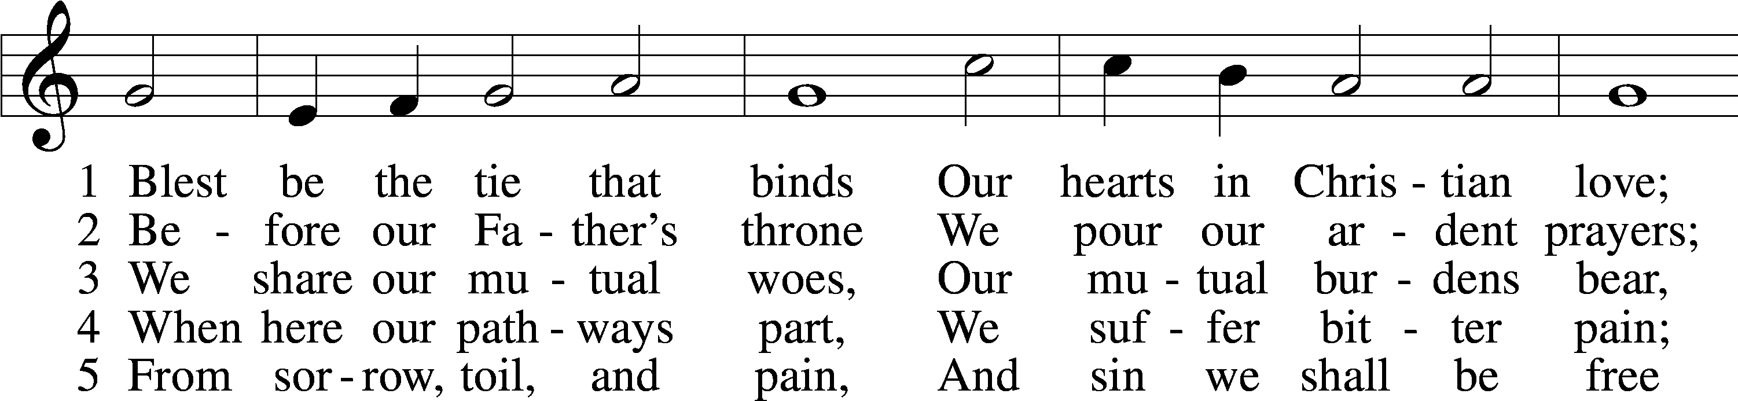

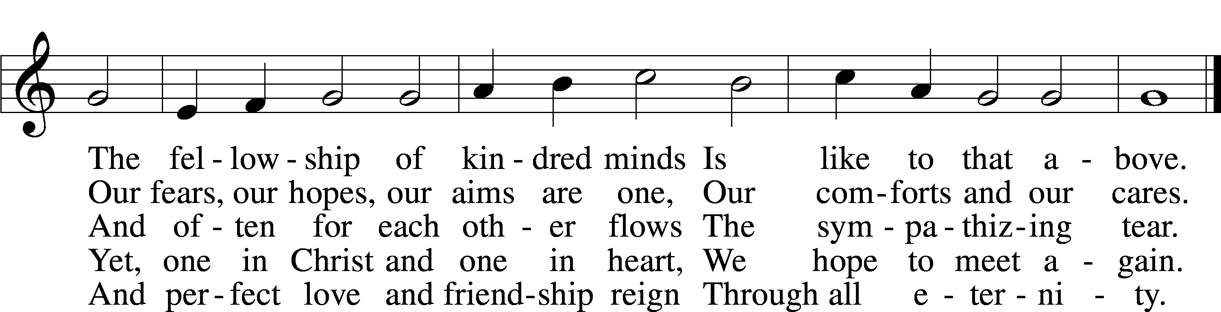

Text: John Fawcett, 1740–1817, alt.  
Tune: Lowell Mason, 1792–1872, alt.  
Text and tune: Public domain

700 Love Divine, All Loves Excelling

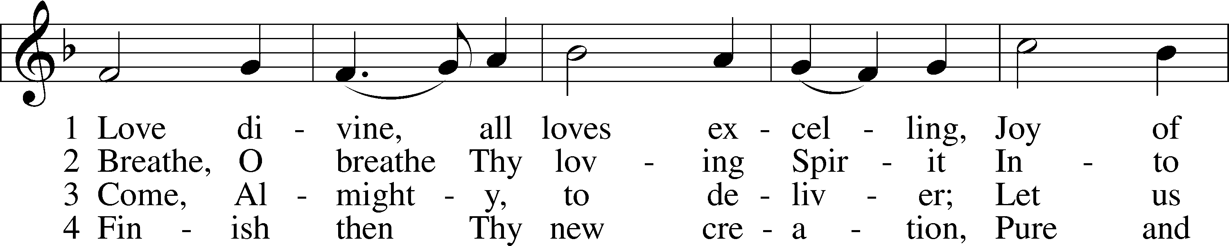

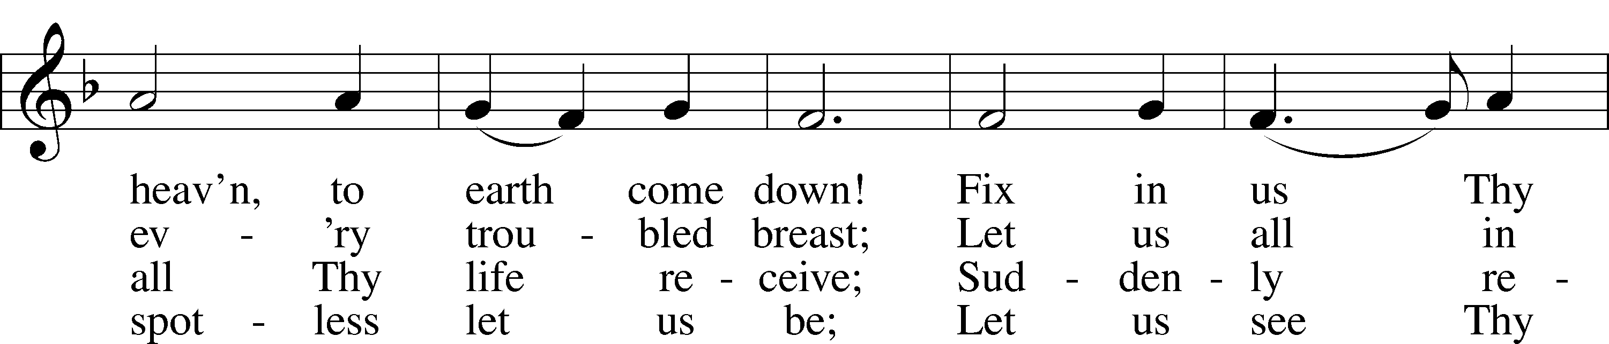

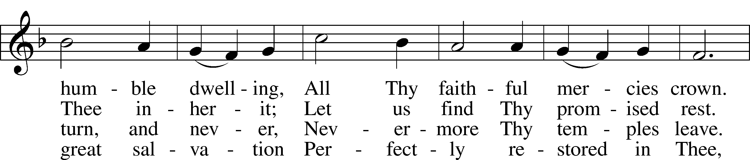

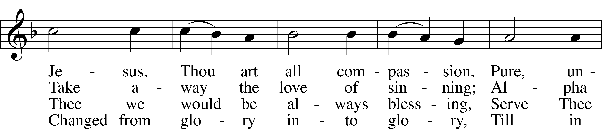

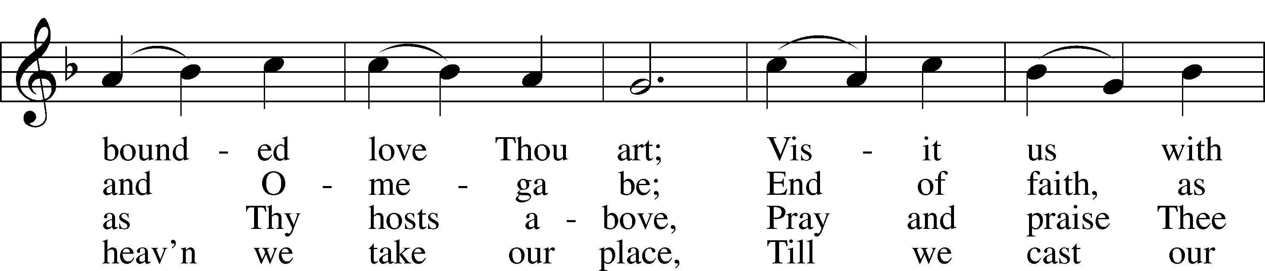

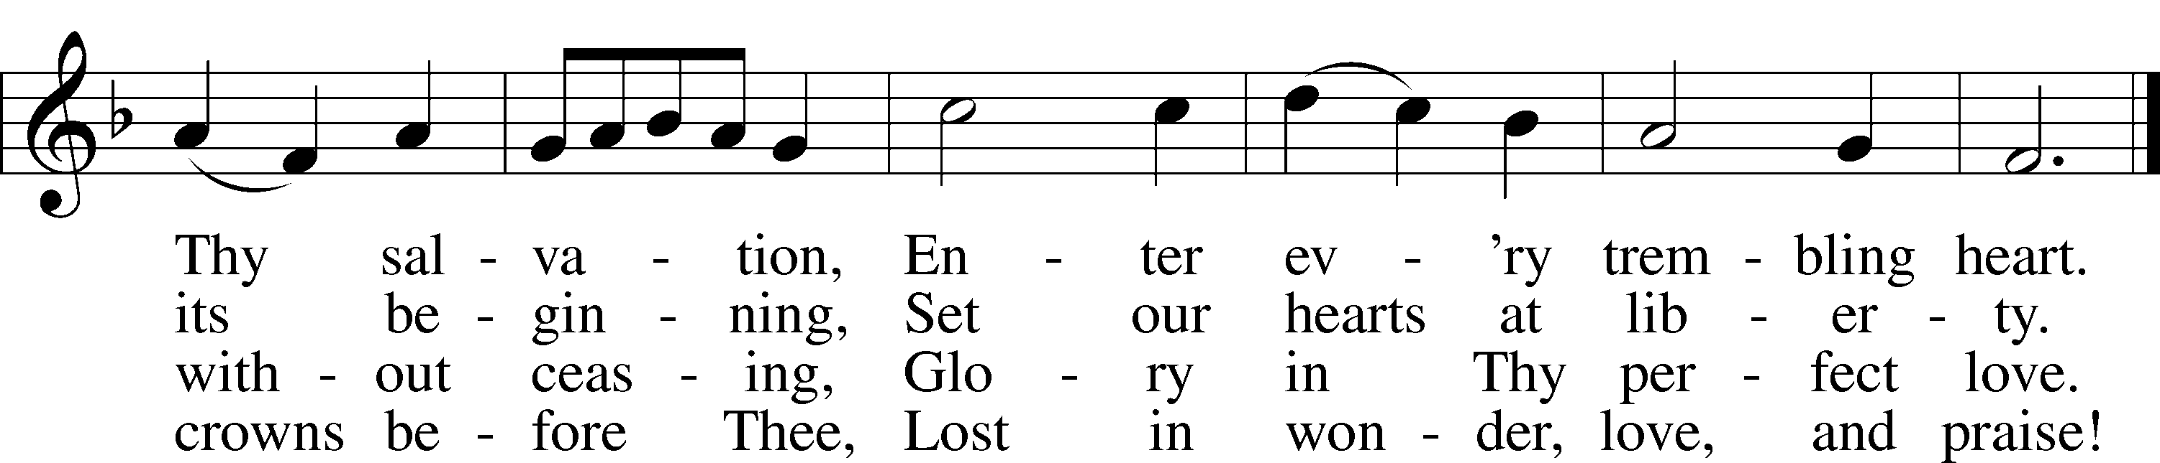

Text: Charles Wesley, 1707–88  
Tune: Rowland H. Prichard, 1811–87  
Text and tune: Public domain

832 Jesus Shall Reign

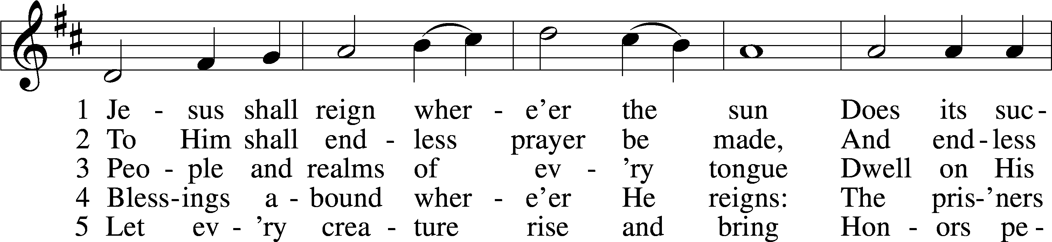

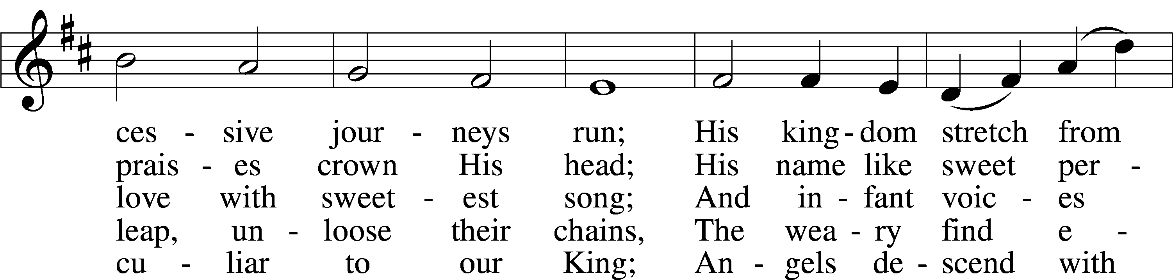

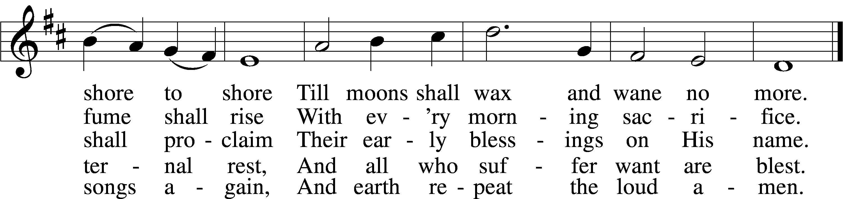

Text: Isaac Watts, 1674–1748, alt.  
Tune: attr. John C. Hatton, d. 1793  
Text and tune: Public domain

816 From All That Dwell Below the Skies

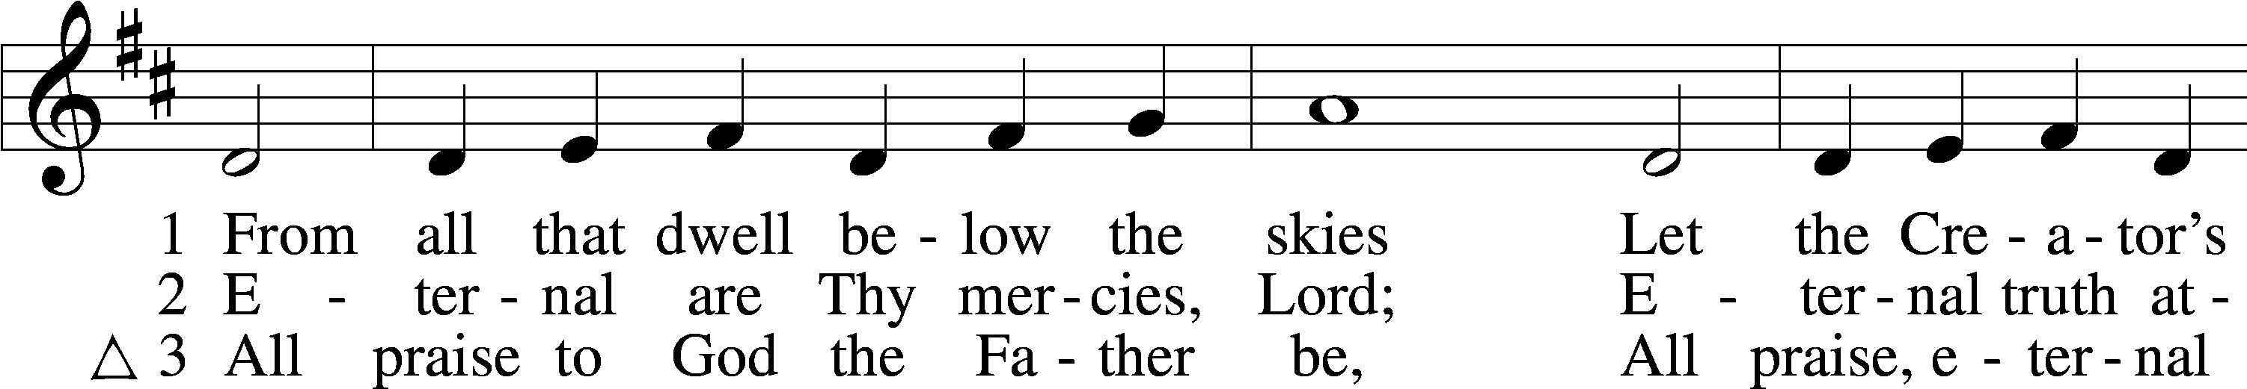

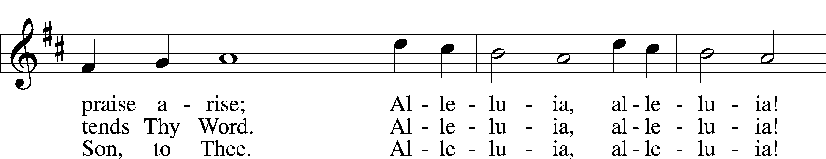

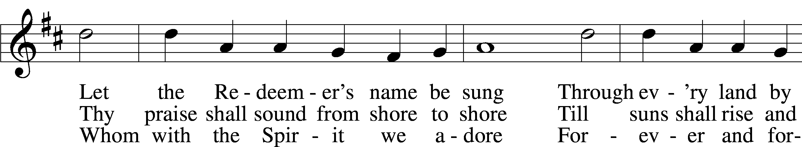

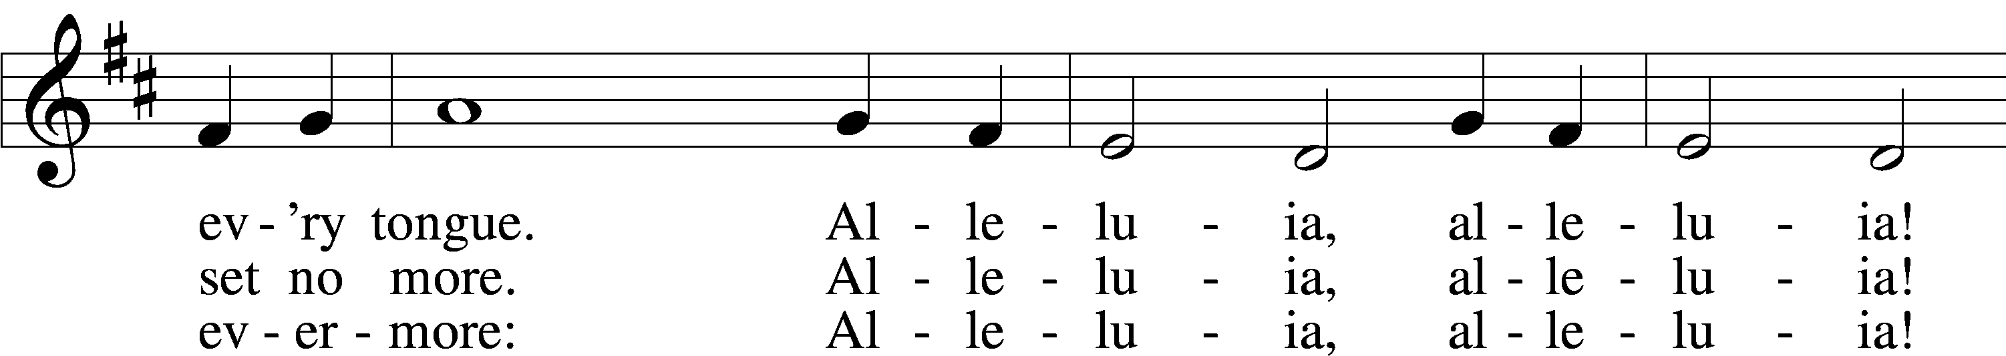

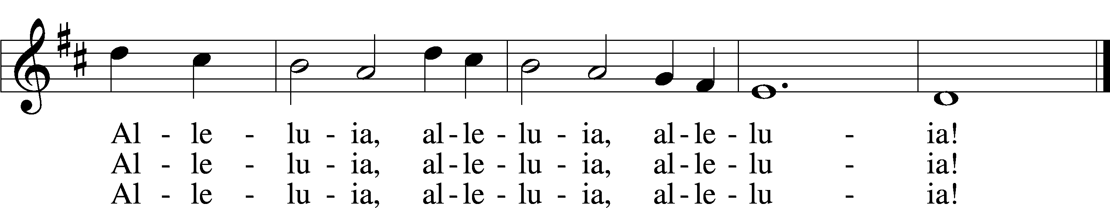

Text (sts. 1–2): Isaac Watts, 1674–1748; (st. 3): William W. How, 1823–97  
Tune: Geistliche Kirchengesäng, 1623, Köln  
Text and tune: Public domain

Stand

Nunc Dimittis Luke 2:29–32

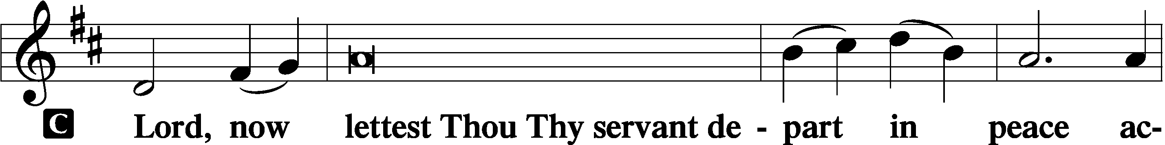

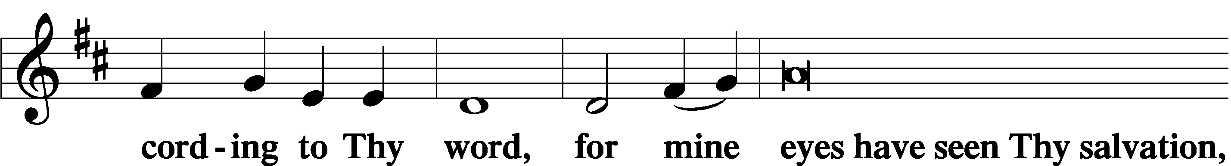

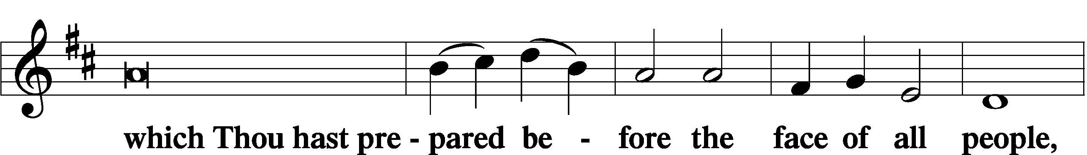

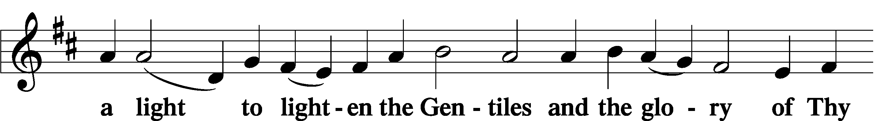

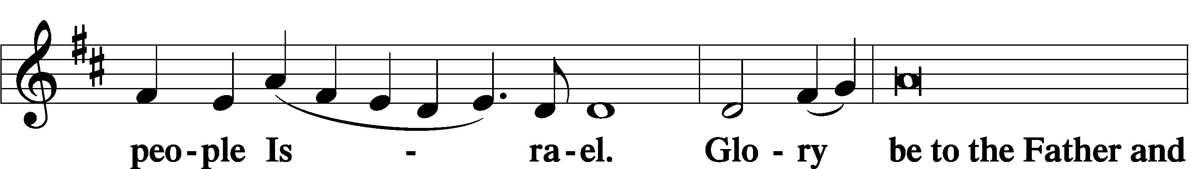

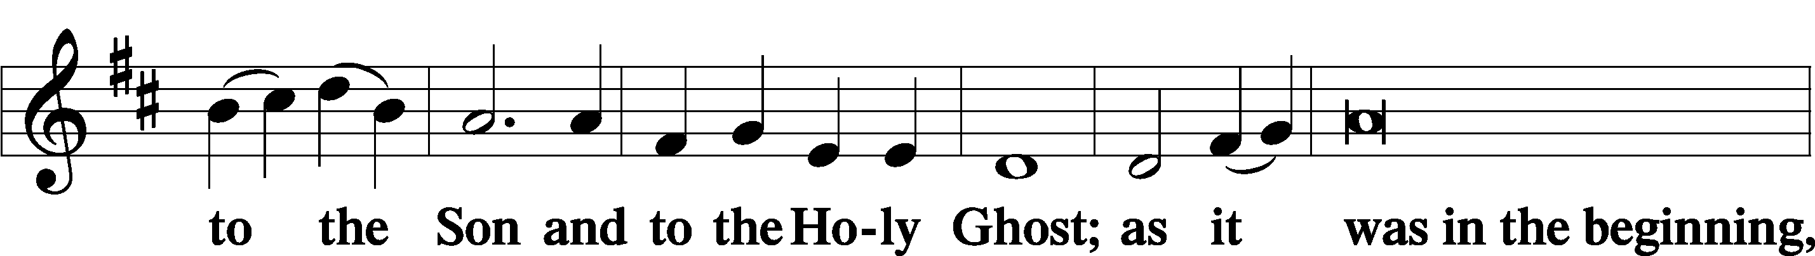

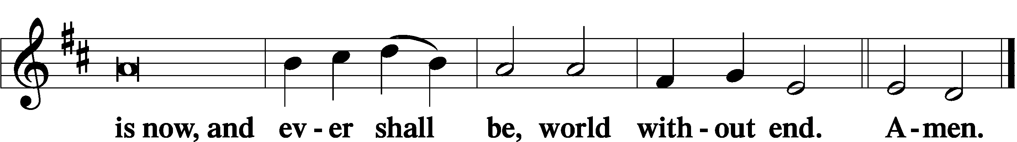

Thanksgiving Psalm 107:1

A O give thanks unto the Lord, for He is good,

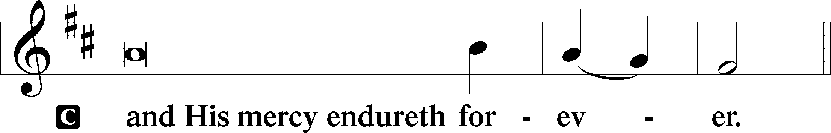

Post-Communion Collect

A Let us pray.

We give thanks to You, almighty God, that You have refreshed us through this salutary gift, and we implore You that of Your mercy You would strengthen us through the same in faith toward You and in fervent love toward one another; through Jesus Christ, Your Son, our Lord, who lives and reigns with You and the Holy Spirit, one God, now and forever.



Salutation 2 Timothy 4:22

P The Lord be with you.

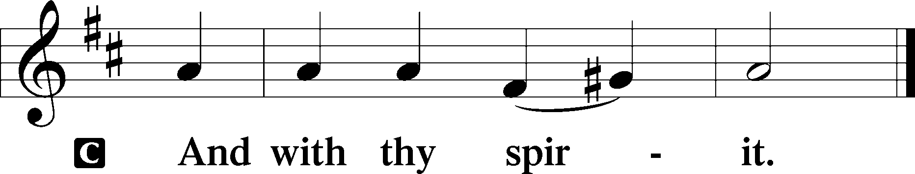

Benedicamus Psalm 103:1

A Bless we the Lord.

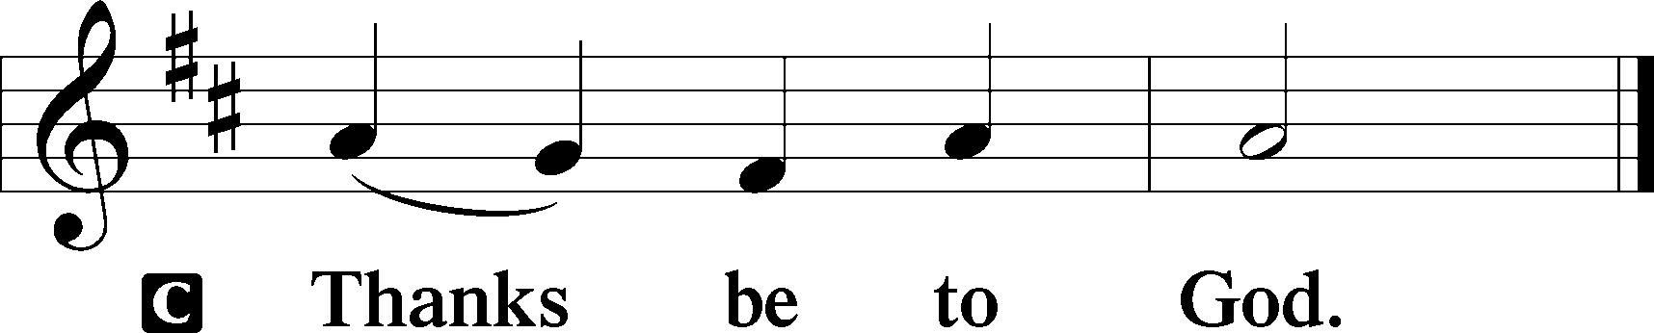

Benediction Numbers 6:24–26

P The Lord bless you and keep you.

The Lord make His face shine upon you and be gracious unto you.

The Lord lift up His countenance upon you and T give you peace.

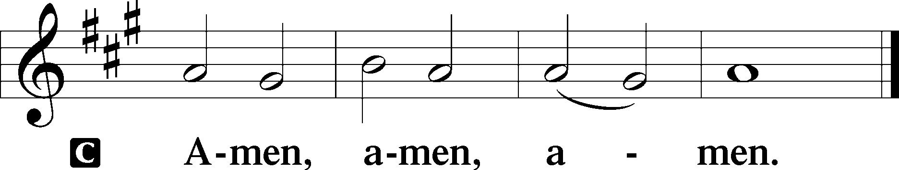

685 Let Us Ever Walk with Jesus

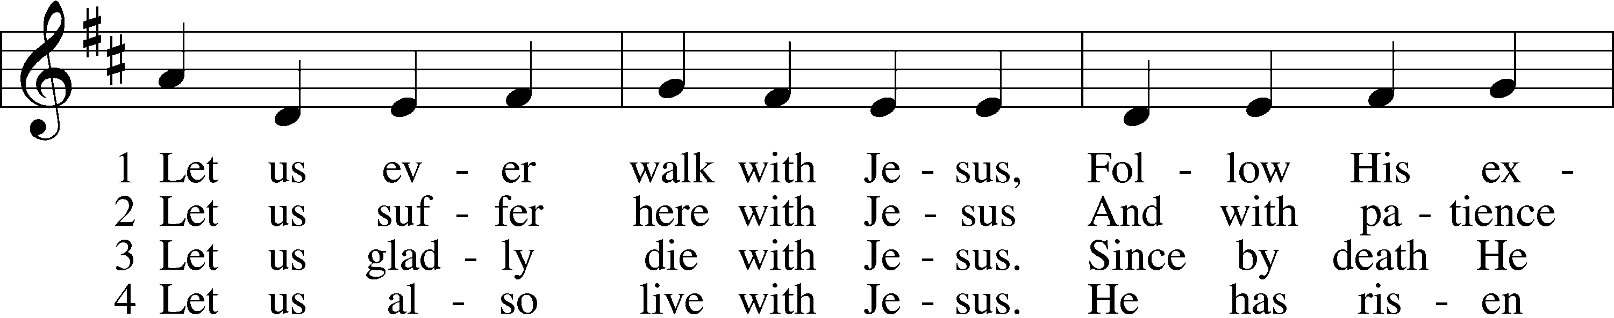

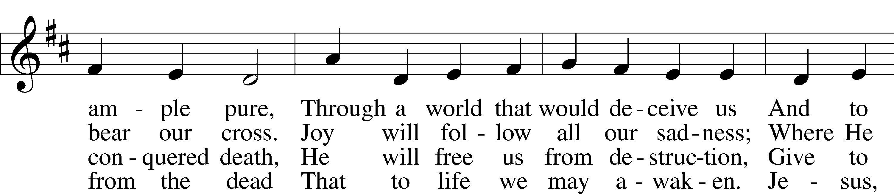

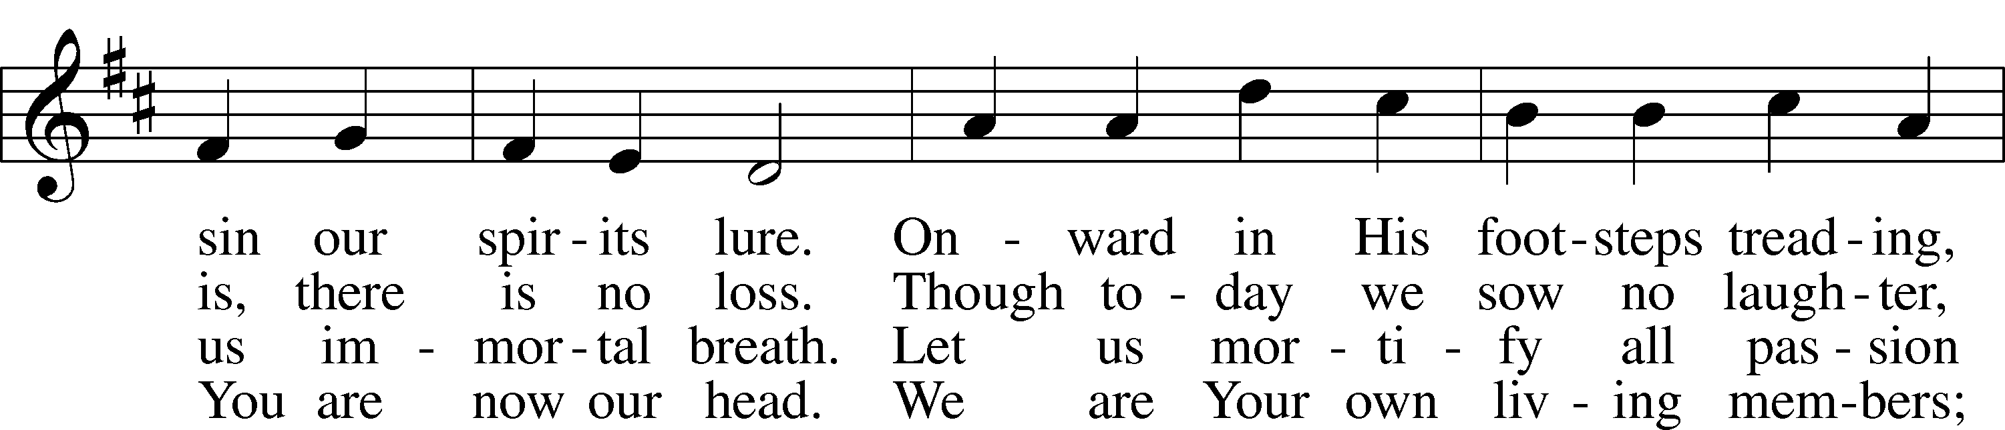

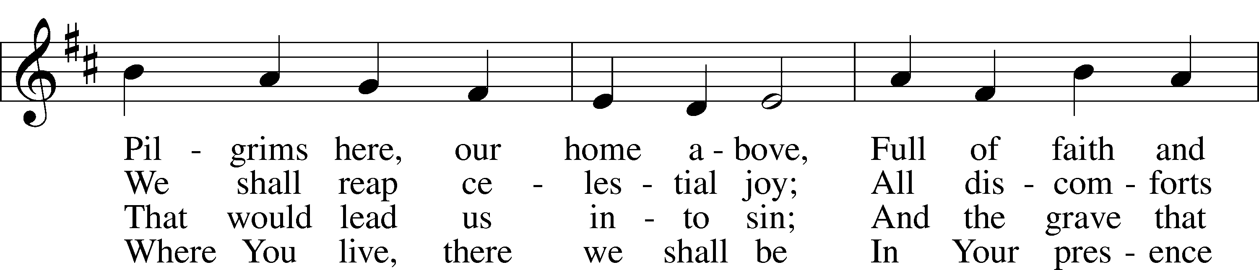

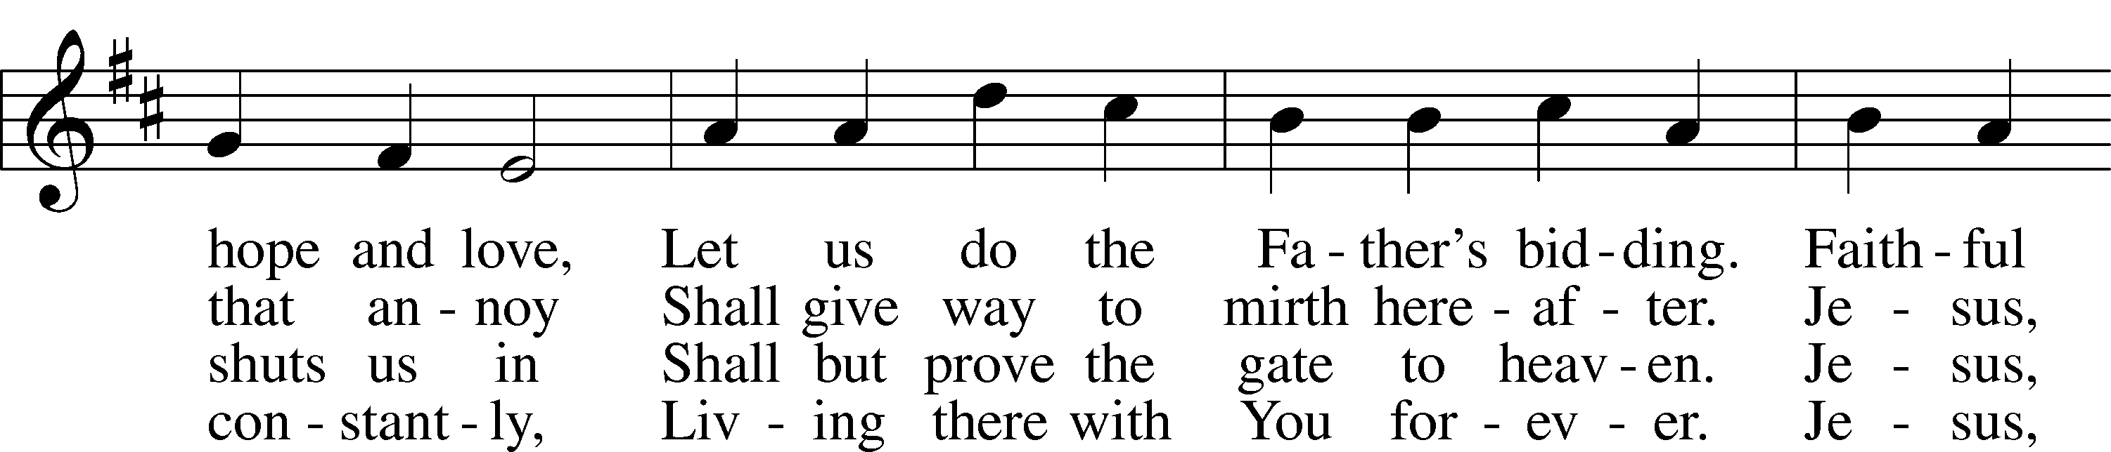

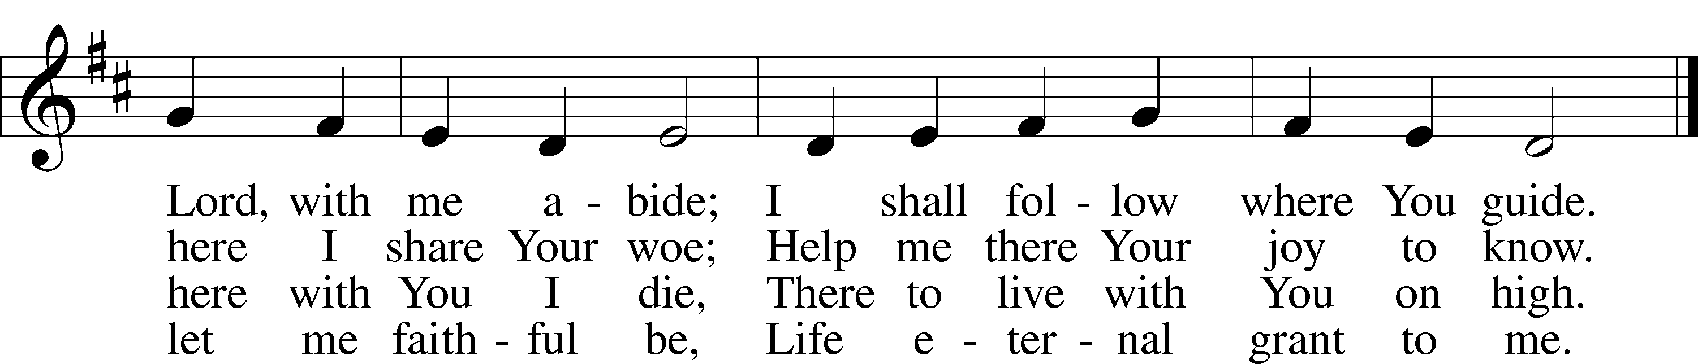

Text: Sigismund von Birken, 1626–81; tr. Lutheran Book of Worship, 1978, alt.  
Tune: Georg G. Boltze, 18th cent.  
Text: © 1978 Lutheran Book of Worship. Used by permission: LSB Hymn License no. 110005011  
Tune: Public domain

Acknowledgments

Divine Service, Setting Three from Lutheran Service Book

Unless otherwise indicated, Scripture quotations are from the ESV® Bible (The Holy Bible, English Standard Version®), copyright © 2001 by Crossway, a publishing ministry of Good News Publishers. Used by permission. All rights reserved.

Created by Lutheran Service Builder © 2025 Concordia Publishing House.