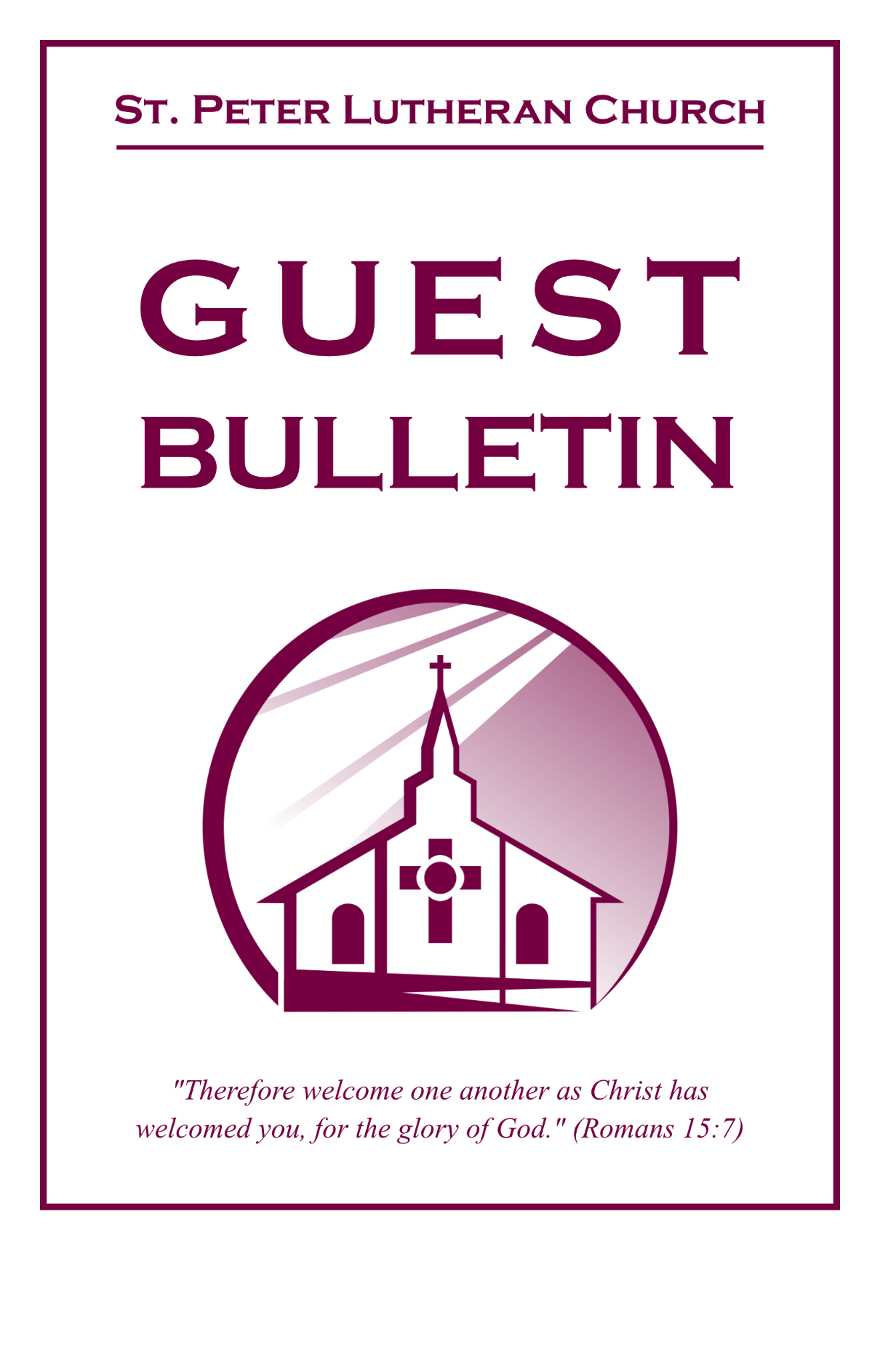

October 4, 2026



St. Peter Lutheran Church
Missouri Synod
906 Highway 59N, P.O. Box 133

Bowie, Texas 76230

Church (940) 872-1886 Fax ((940) 872-8837

Church E-mail: stpetertexscty@gmail.com
To Our Guests and Visitors:

We welcome all our friends in Christ who have come to worship with us. If you are a guest, please feel at home with us, sign our guest register, and worship with us whenever you are able. If you do not have a church home, we invite you to
consider becoming a part of our church family.

Website: www.stpetertex.com
Communion Statement:

The Lord’s Supper is celebrated at this congregation in the confession and glad confidence that, as He says, our Lord gives into our mouths not only bread and wine but His very Body and Blood to eat and drink for the forgiveness of sins and to strengthen our union with Him and one another.

Our Lord invites to His table those who trust in His words, repent of all sin, and set aside any refusal to forgive and love as He forgives and loves us, that they may show forth His death until He comes.

Because those who eat and drink our Lord’s Body and Blood unworthily do so to their great harm, and because Holy Communion is a confession of the faith, which is confessed at this altar, guests who are not confirmed members of an LCMS congregation and have not previously communed at this altar, are asked to first speak with our pastor.

If you are unable to do so before the service, it is out of Christian love and care for your souls that we ask you to refrain from communing this morning.

For further study, please see Matthew 5:23ff, 10:32ff, 18:15–35, 26:26–29; 1 Corinthians 11:17–34.

If you desire to receive a blessing for yourself or your children, please approach during
communion, cross your arms over your chest and bow your head as you kneel at the
altar rail.

Who Receives the Sacrament of the Altar Worthily?
Fasting and bodily preparation are certainly fine outward training. But that person is truly worthy and well prepared who has faith in these words: “Given and shed for you for the forgiveness of sins.” But anyone who does not believe these words or doubts them is unworthy and unprepared; for the words “for you” require all hearts to believe.
How May I Prepare?
See Dr. Luther’s self–examination questions and answers in the
LSB Hymnal on page 329

Upon entering the Sanctuary. please turn off cell phones, pagers. etc. Use the time as a quiet time for personal reflection and meditation in preparation for worship. This is a time for anyone to join in praying for the service, and for the church in general.
904 Blessed Jesus, at Your Word
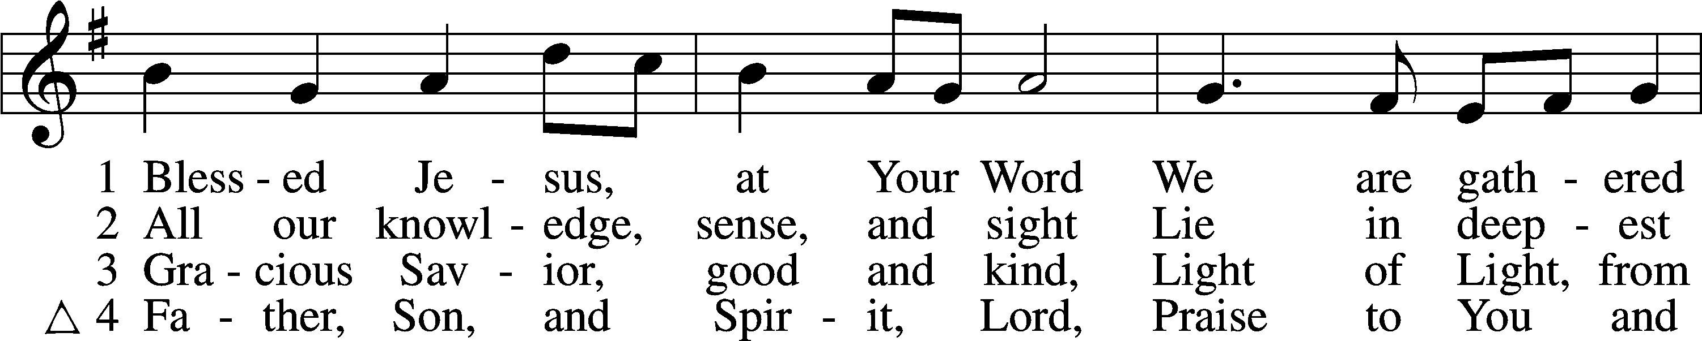
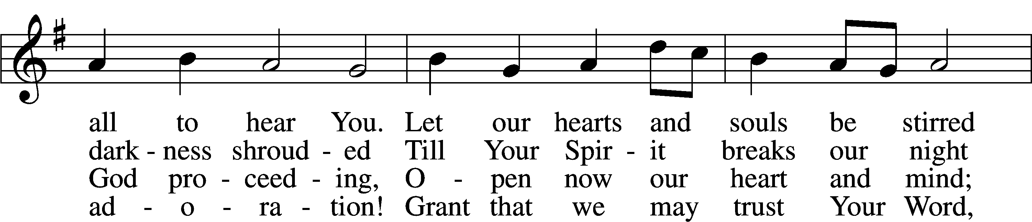
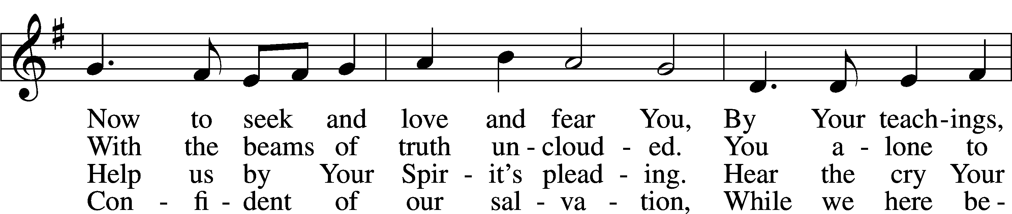
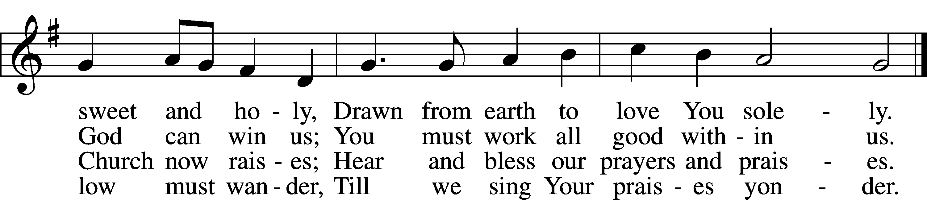
Text (sts. 1–3): Tobias Clausnitzer, 1619–84; (sts. 1–3): tr. Catherine Winkworth, 1827–78, alt.; (st. 4): Geistreiches Gesang-Büchlein, 1707, Berlin; (st. 4): tr. unknown, alt.
Tune: Johann Rudolph Ahle, 1625–73, alt.
Text and tune: Public domain

Confession and Absolution

Stand

The sign of the cross may be made by all in remembrance of their Baptism.

Invocation Matthew 28:19b; 18:20
P In the name of the Father and of the T Son and of the Holy Spirit.
C Amen.

Exhortation Hebrews 10:22; Psalm 124:8; Psalm 32:5
P Beloved in the Lord! Let us draw near with a true heart and confess our sins unto God our Father, beseeching Him in the name of our Lord Jesus Christ to grant us forgiveness.

P Our help is in the name of the Lord,
C who made heaven and earth.
P I said, I will confess my transgressions unto the Lord,
C and You forgave the iniquity of my sin.

Kneel/Stand

Silence for reflection on God’s Word and for self-examination.

Confession of Sins
P O almighty God, merciful Father,
C I, a poor, miserable sinner, confess unto You all my sins and iniquities with which I have ever offended You and justly deserved Your temporal and eternal punishment. But I am heartily sorry for them and sincerely repent of them, and I pray You of Your boundless mercy and for the sake of the holy, innocent, bitter sufferings and death of Your beloved Son, Jesus Christ, to be gracious and merciful to me, a poor, sinful being.

Absolution [John 20:19–23]
P Upon this your confession, I, by virtue of my office, as a called and ordained servant of the Word, announce the grace of God unto all of you, and in the stead and by the command of my Lord Jesus Christ I forgive you all your sins in the name of the Father and of the T Son and of the Holy Spirit.
C Amen.

Stand

Service of the Word

Introit Psalm 118:22–24; antiphon: v. 1
Oh give thanks to the Lord, for he is good;
for his steadfast love endures forever!
The stone that the builders rejected
has become the cornerstone.
This is the Lord’s doing;
it is marvelous in our eyes.
This is the day that the Lord has made;
let us rejoice and be glad in it.

Gloria Patri
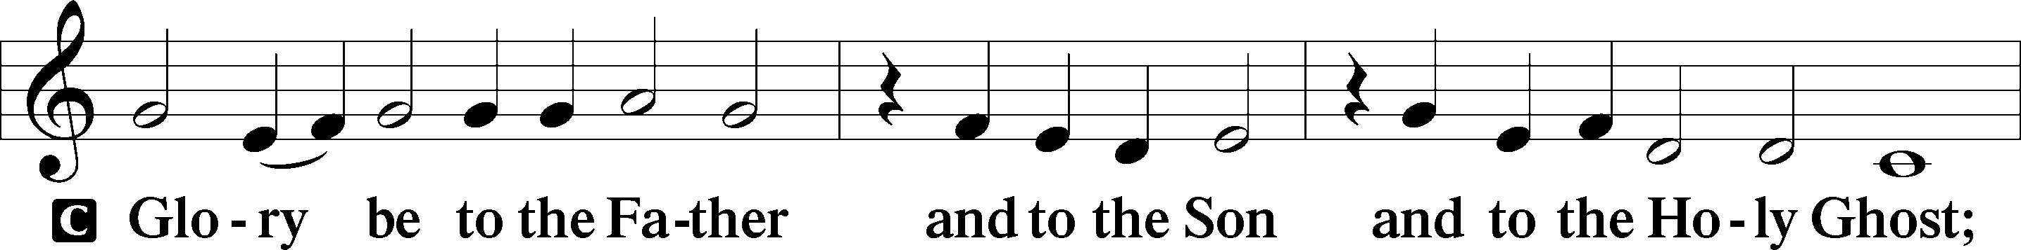
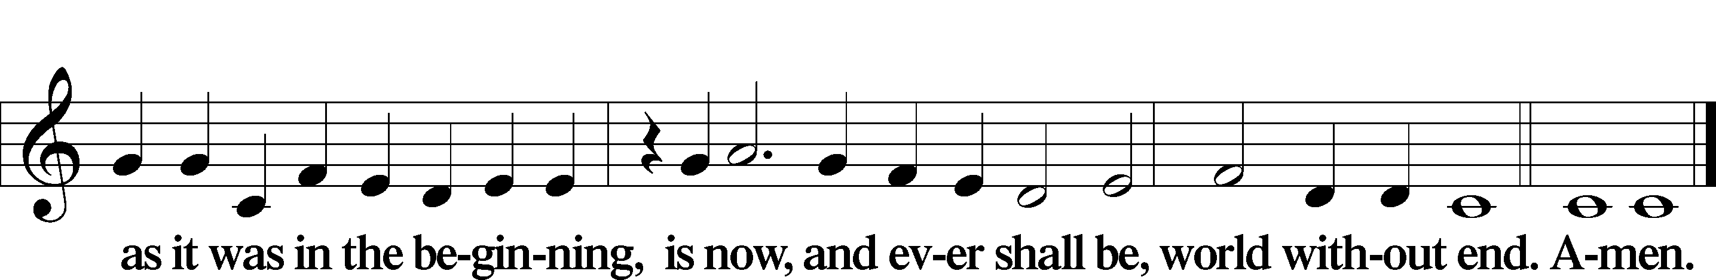

Kyrie Mark 10:47
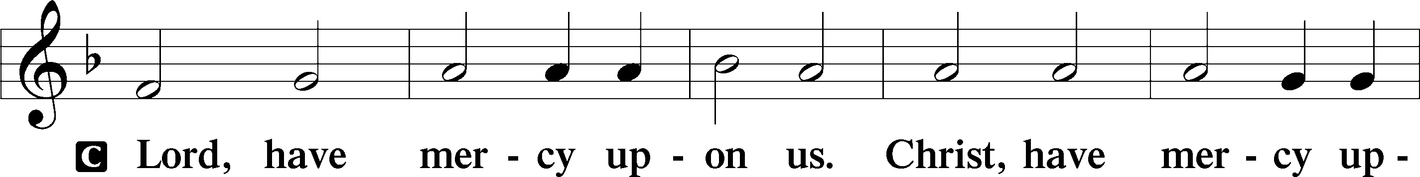
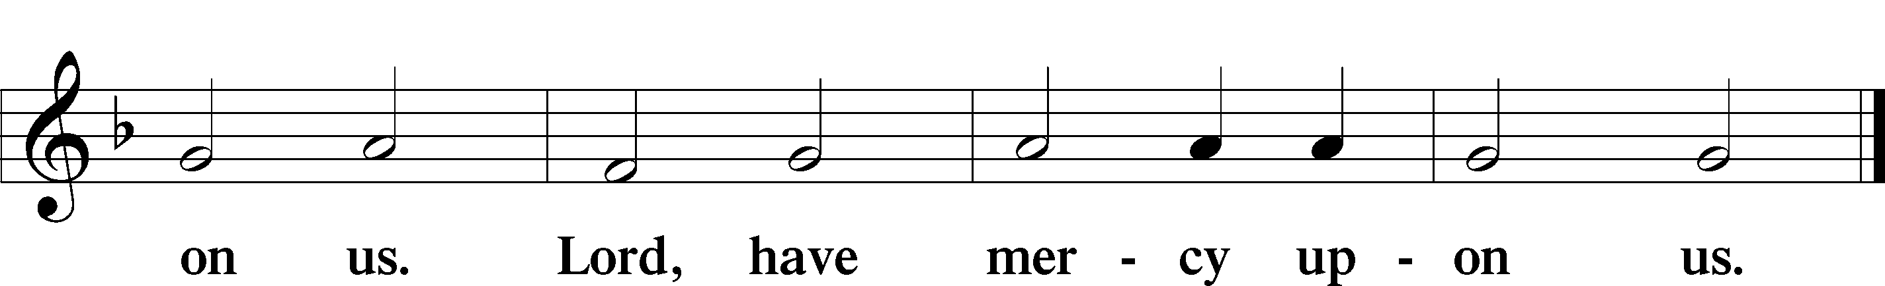

Gloria in Excelsis Luke 2:14; John 1:29
P Glory be to God on high:
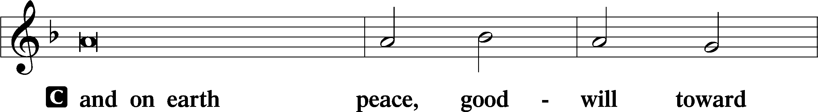
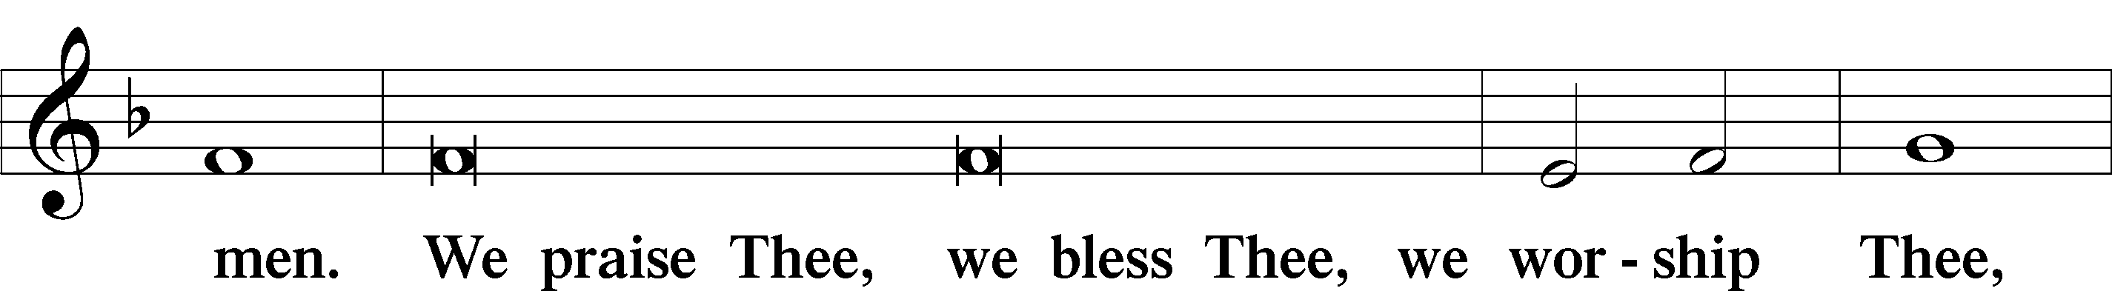
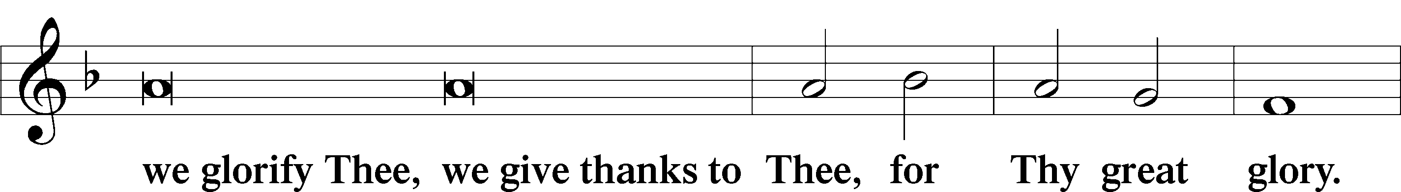
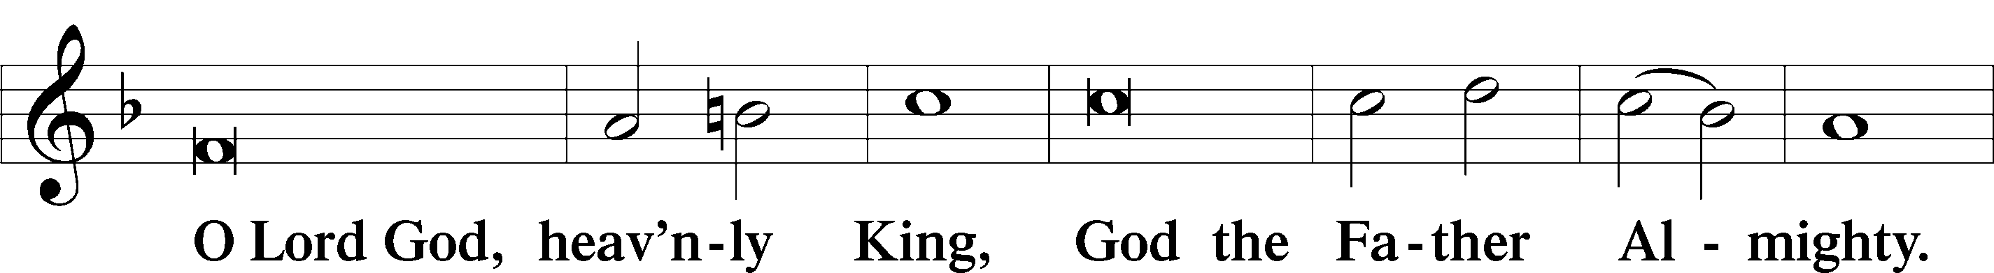
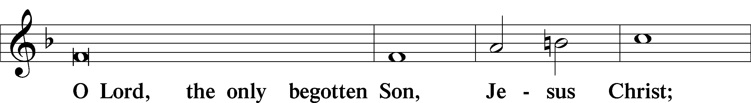
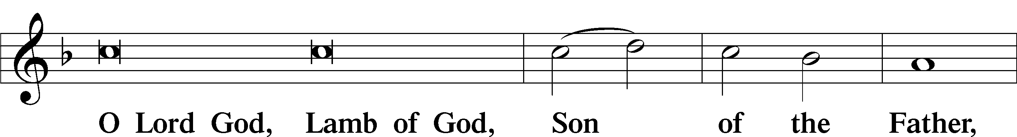
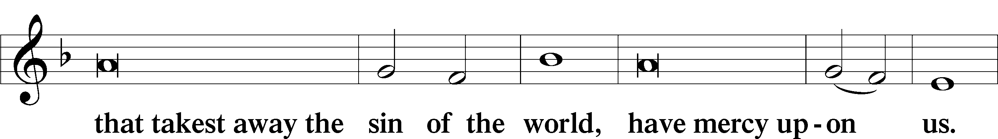
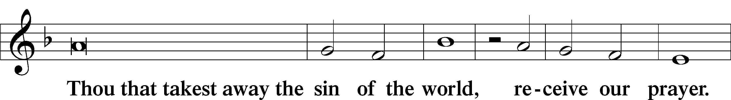
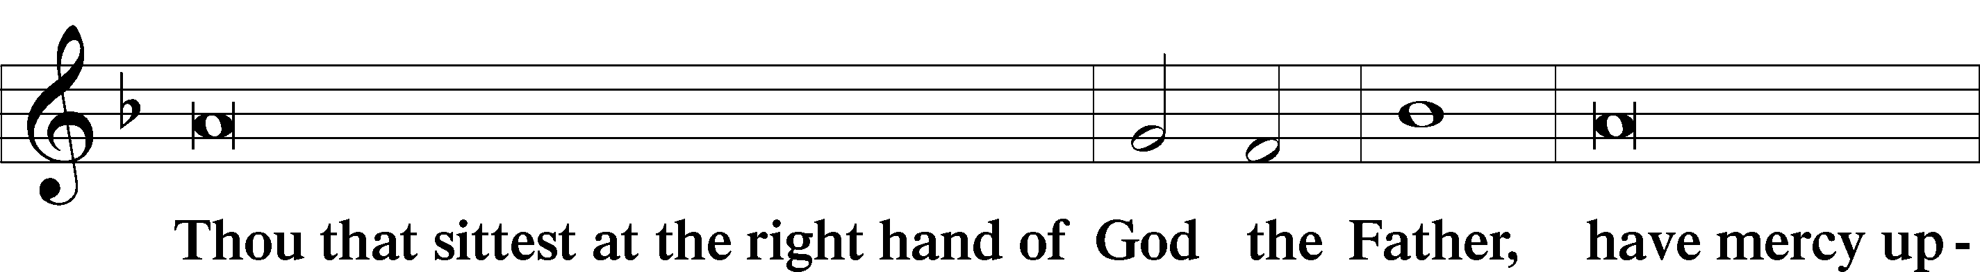
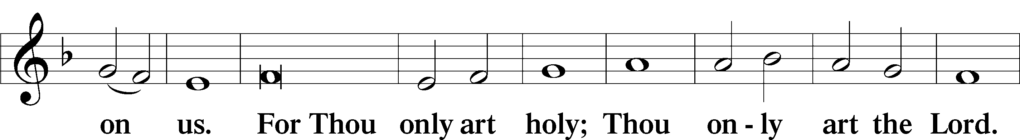
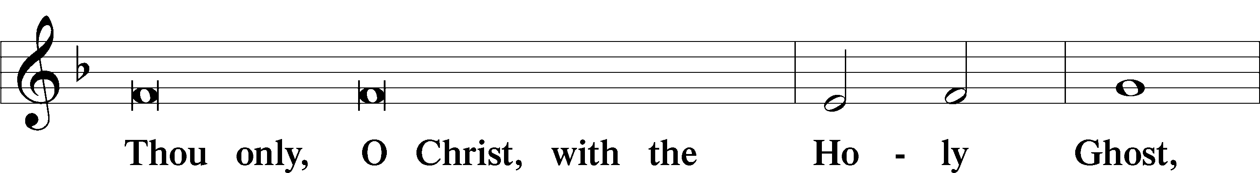
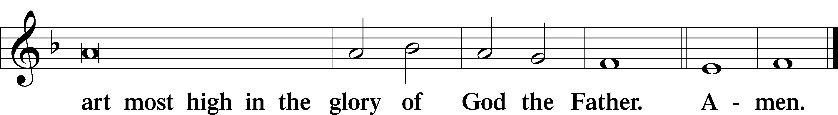

Salutation and Collect of the Day
P The Lord be with you.
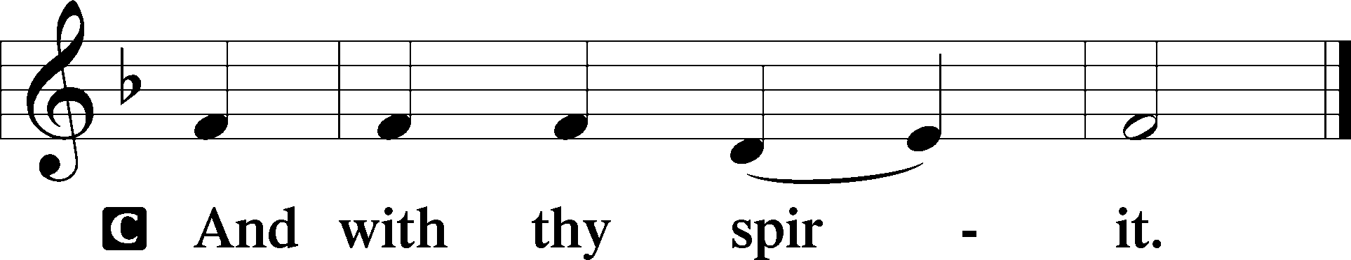

P Let us pray.
Gracious God, You gave Your Son into the hands of sinful men who killed Him. Forgive us when we reject Your unfailing love, and grant us the fullness of Your salvation; through Jesus Christ, Your Son, our Lord, who lives and reigns with You and the Holy Spirit, one God, now and forever.

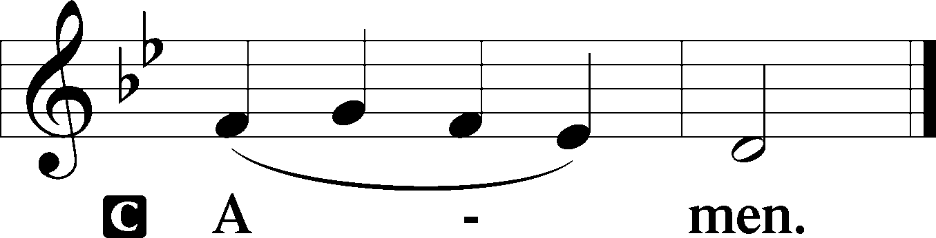

Sit

Old Testament Reading Isaiah 5:1–7
1Let me sing for my beloved my love song concerning his vineyard: My beloved had a vineyard on a very fertile hill. 2He dug it and cleared it of stones, and planted it with choice vines; he built a watchtower in the midst of it, and hewed out a wine vat in it; and he looked for it to yield grapes, but it yielded wild grapes. 3And now, O inhabitants of Jerusalem and men of Judah, judge between me and my vineyard. 4What more was there to do for my vineyard, that I have not done in it? When I looked for it to yield grapes, why did it yield wild grapes? 5And now I will tell you what I will do to my vineyard. I will remove its hedge, and it shall be devoured; I will break down its wall, and it shall be trampled down. 6I will make it a waste; it shall not be pruned or hoed, and briers and thorns shall grow up; I will also command the clouds that they rain no rain upon it. 7For the vineyard of the Lord of hosts is the house of Israel, and the men of Judah are his pleasant planting; and he looked for justice, but behold, bloodshed; for righteousness, but behold, an outcry!

A This is the Word of the Lord.
C Thanks be to God.

Gradual Psalm 91:11; 103:1
He will command his angels concerning you
to guard you in all your ways.
Bless the Lord, O my soul,
and all that is within me, bless his holy name!

Epistle Philippians 3:4b–14
If anyone else thinks he has reason for confidence in the flesh, I have more: 5circumcised on the eighth day, of the people of Israel, of the tribe of Benjamin, a Hebrew of Hebrews; as to the law, a Pharisee; 6as to zeal, a persecutor of the church; as to righteousness, under the law blameless. 7But whatever gain I had, I counted as loss for the sake of Christ. 8Indeed, I count everything as loss because of the surpassing worth of knowing Christ Jesus my Lord. For his sake I have suffered the loss of all things and count them as rubbish, in order that I may gain Christ 9and be found in him, not having a righteousness of my own that comes from the law, but that which comes through faith in Christ, the righteousness from God that depends on faith— 10that I may know him and the power of his resurrection, and may share his sufferings, becoming like him in his death, 11that by any means possible I may attain the resurrection from the dead. 12Not that I have already obtained this or am already perfect, but I press on to make it my own, because Christ Jesus has made me his own. 13Brothers, I do not consider that I have made it my own. But one thing I do: forgetting what lies behind and straining forward to what lies ahead, 14I press on toward the goal for the prize of the upward call of God in Christ Jesus.

A This is the Word of the Lord.
C Thanks be to God.

Stand

Alleluia
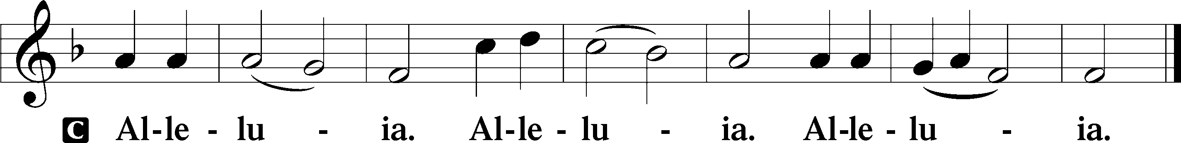

Holy Gospel Matthew 21:33–46
P The Holy Gospel according to St. Matthew, the twenty-first chapter.

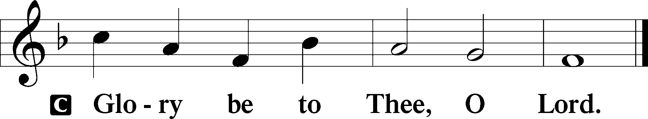

33[Jesus said:] “Hear another parable. There was a master of a house who planted a vineyard and put a fence around it and dug a winepress in it and built a tower and leased it to tenants, and went into another country. 34When the season for fruit drew near, he sent his servants to the tenants to get his fruit. 35And the tenants took his servants and beat one, killed another, and stoned another. 36Again he sent other servants, more than the first. And they did the same to them. 37Finally he sent his son to them, saying, ‘They will respect my son.’ 38But when the tenants saw the son, they said to themselves, ‘This is the heir. Come, let us kill him and have his inheritance.’ 39And they took him and threw him out of the vineyard and killed him. 40When therefore the owner of the vineyard comes, what will he do to those tenants?” 41They said to him, “He will put those wretches to a miserable death and let out the vineyard to other tenants who will give him the fruits in their seasons.” 42Jesus said to them, “Have you never read in the Scriptures: “‘The stone that the builders rejected has become the cornerstone; this was the Lord’s doing, and it is marvelous in our eyes’? 43Therefore I tell you, the kingdom of God will be taken away from you and given to a people producing its fruits. 44And the one who falls on this stone will be broken to pieces; and when it falls on anyone, it will crush him.” 45When the chief priests and the Pharisees heard his parables, they perceived that he was speaking about them. 46And although they were seeking to arrest him, they feared the crowds, because they held him to be a prophet.

P This is the Gospel of the Lord.

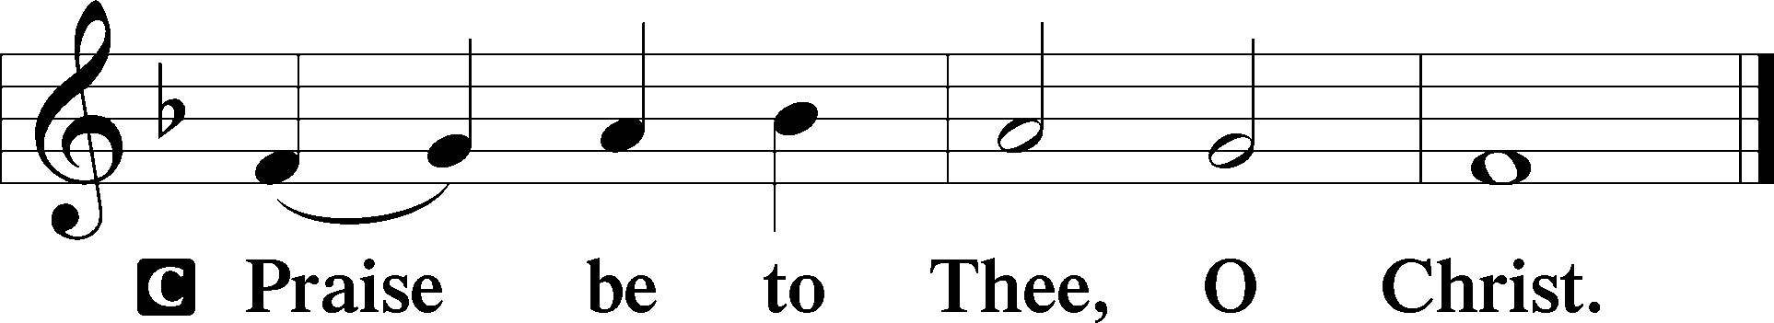

Nicene Creed
C I believe in one God,
the Father Almighty,
maker of heaven and earth
and of all things visible and invisible.

And in one Lord Jesus Christ,
the only-begotten Son of God,
begotten of His Father before all worlds,
God of God, Light of Light,
very God of very God,
begotten, not made,
being of one substance with the Father,
by whom all things were made;
who for us men and for our salvation came down from heaven
and was incarnate by the Holy Spirit of the virgin Mary
and was made man;
and was crucified also for us under Pontius Pilate.
He suffered and was buried.
And the third day He rose again according to the Scriptures
and ascended into heaven
and sits at the right hand of the Father.
And He will come again with glory to judge both the living and the dead,
whose kingdom will have no end.

And I believe in the Holy Spirit,
the Lord and giver of life,
who proceeds from the Father and the Son,
who with the Father and the Son together is worshiped and glorified,
who spoke by the prophets.
And I believe in one holy Christian and apostolic Church,
I acknowledge one Baptism for the remission of sins,
and I look for the resurrection of the dead
and the life T of the world to come. Amen.

Sit

Children's Sermon

912 Christ Is Our Cornerstone
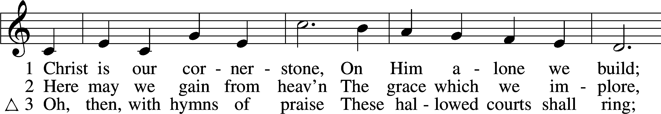
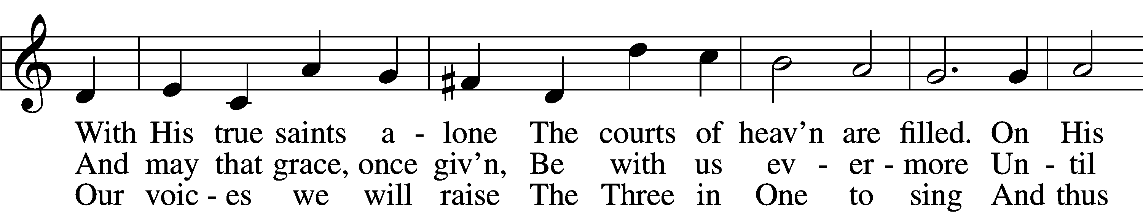
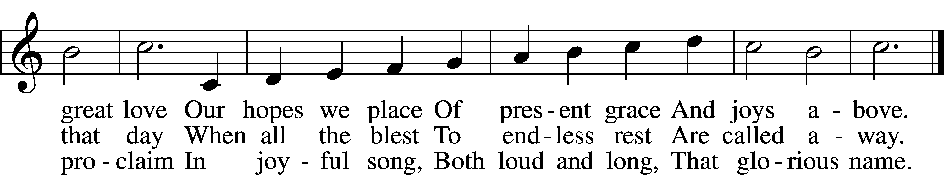
Text: Latin, c. 8th cent.; tr. John Chandler, 1806–76, alt.
Tune: John Darwall, 1731–89
Text and tune: Public domain

Sermon “God’s Vinyard”

Votum
P The peace of God, which passes all understanding, keep your hearts and minds in Christ Jesus.
C Amen.

Stand

Offertory Psalm 51:10–12
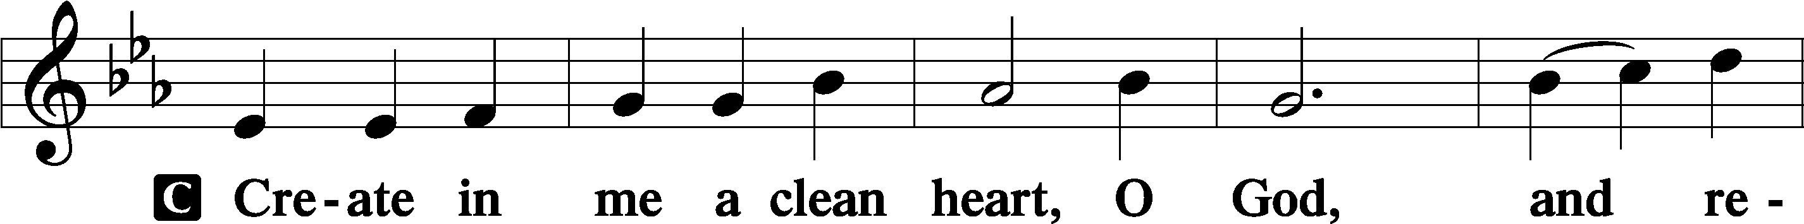
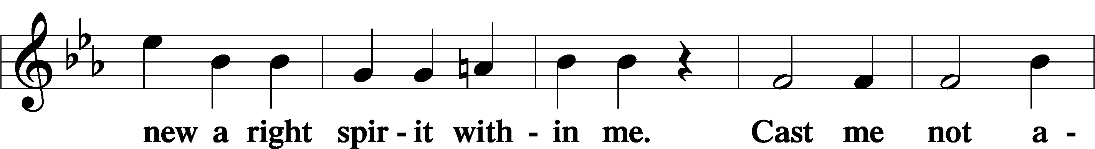
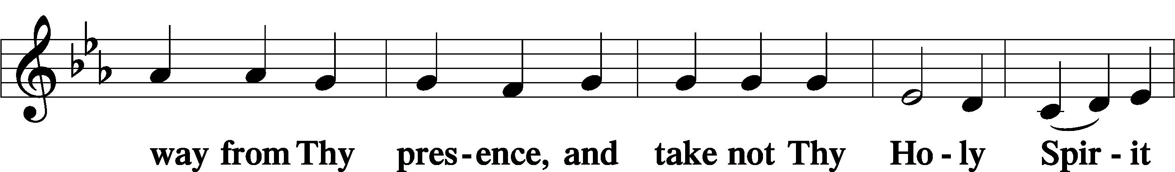
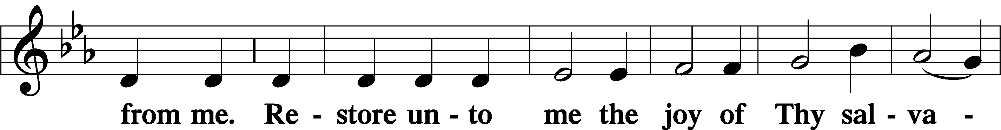
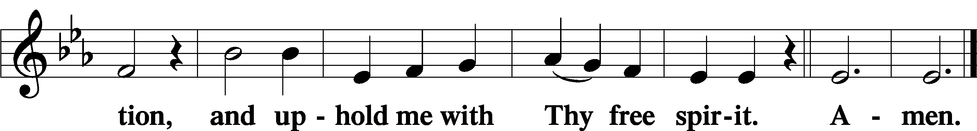

Sit

Offering

805 Praise God, from Whom All Blessings Flow
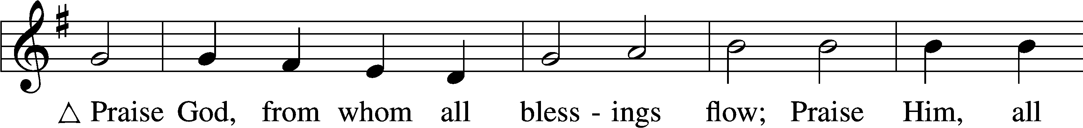
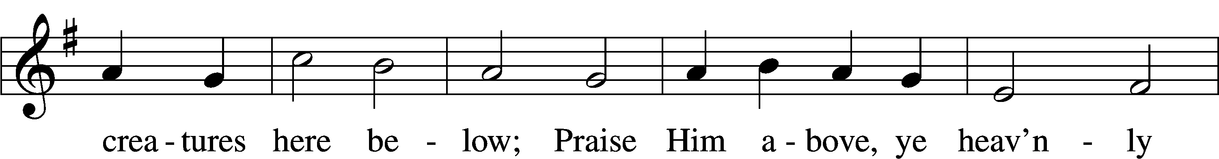
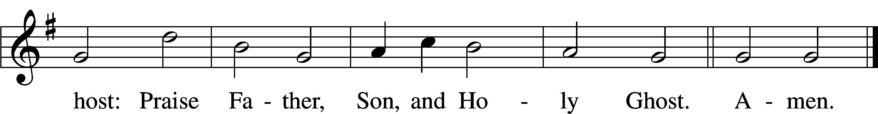
Text: Thomas Ken, 1637–1711
Tune: Trente quatre Pseaumes de David, 1551, Geneva, ed. Louis Bourgeois
Text and tune: Public domain

Stand

Prayer of the Church

Service of the Sacrament

Preface 2 Timothy 4:22; [Colossians 3:1]; [Psalm 136]
P The Lord be with you.
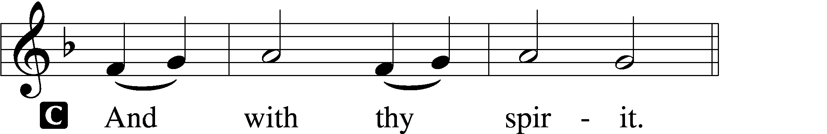

P Lift up your hearts.
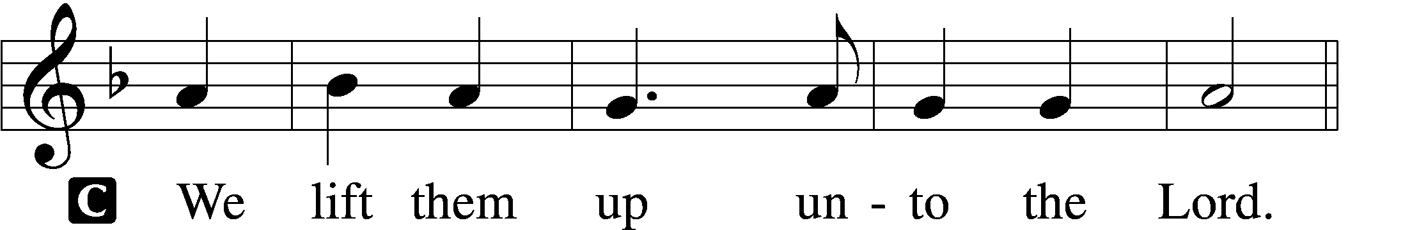

P Let us give thanks unto the Lord, our God.
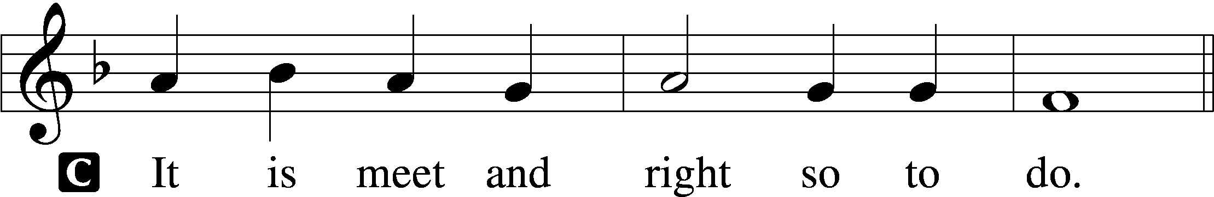

Proper Preface (Full)
P It is truly meet, right, and salutary that we should at all times and in all places give thanks to You, holy Lord, almighty Father, everlasting God, through Jesus Christ, our Lord, who, having created all things, took on human flesh and was born of the virgin Mary. For our sake He died on the cross and rose from the dead to put an end to death, thus fulfilling Your will and gaining for You a holy people. Therefore with angels and archangels and with all the company of heaven we laud and magnify Your glorious name, evermore praising You and saying:

Sanctus Isaiah 6:3; Matthew 21:9
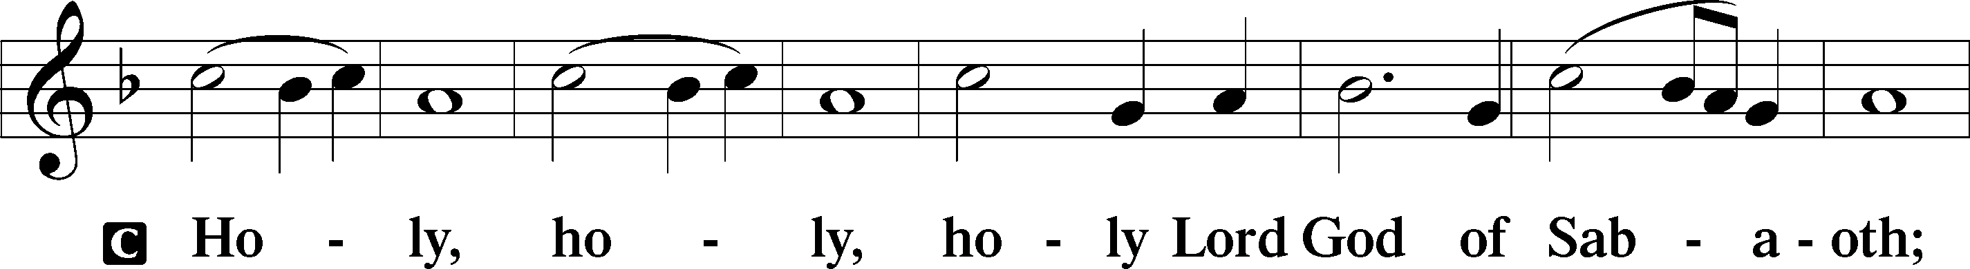
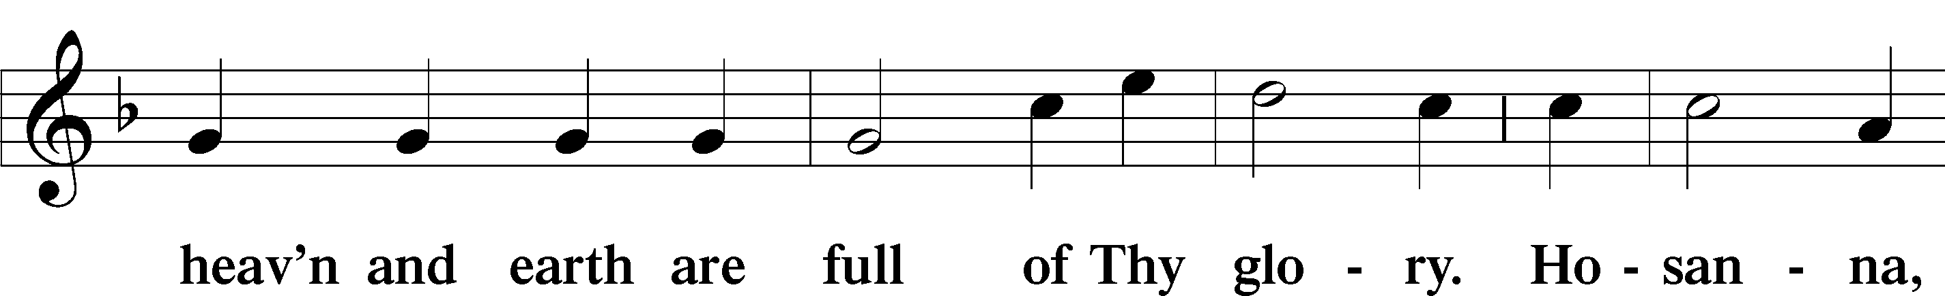
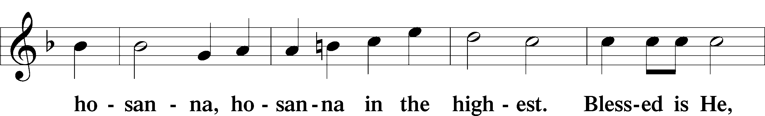
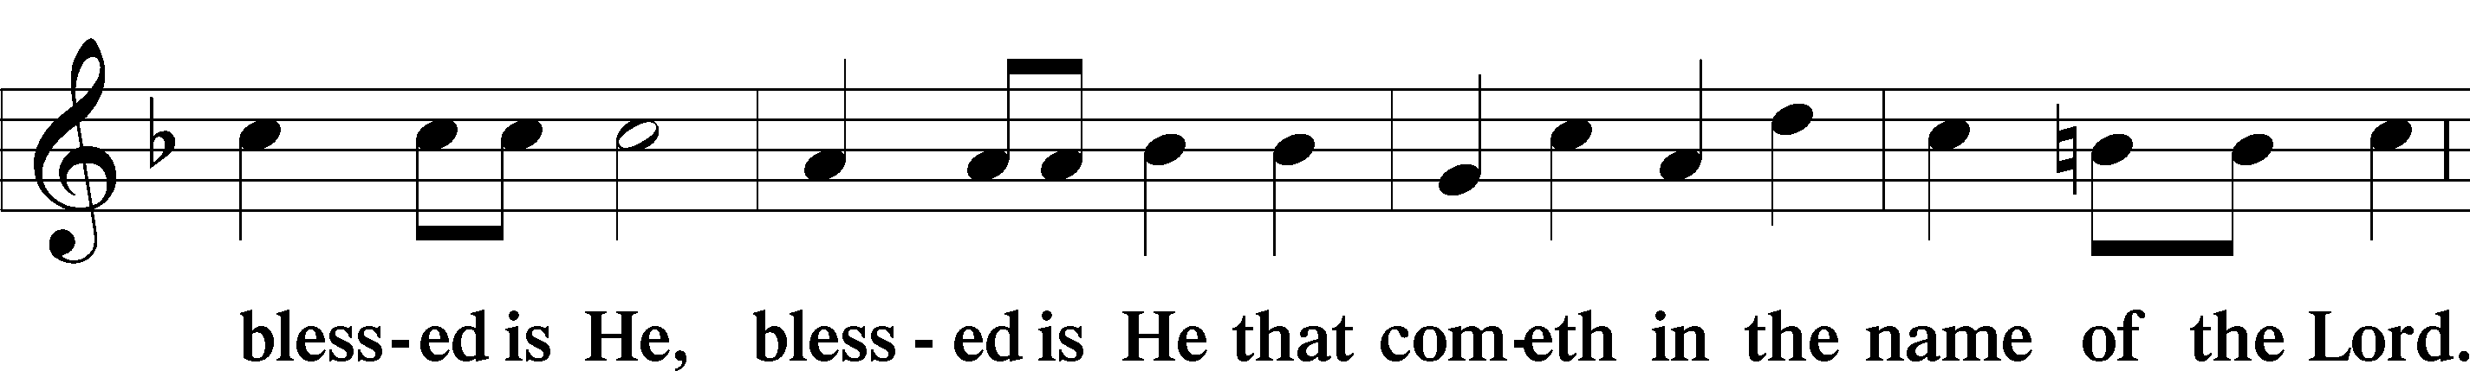
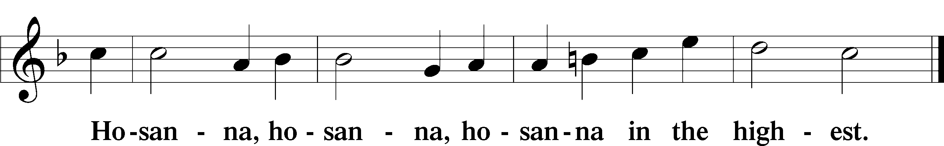

Lord’s Prayer Matthew 6:9–13
P Our Father who art in heaven,
hallowed be Thy name,
Thy kingdom come,
Thy will be done on earth as it is in heaven;
give us this day our daily bread;
and forgive us our trespasses as we forgive those who trespass against us;
and lead us not into temptation,
but deliver us from evil.
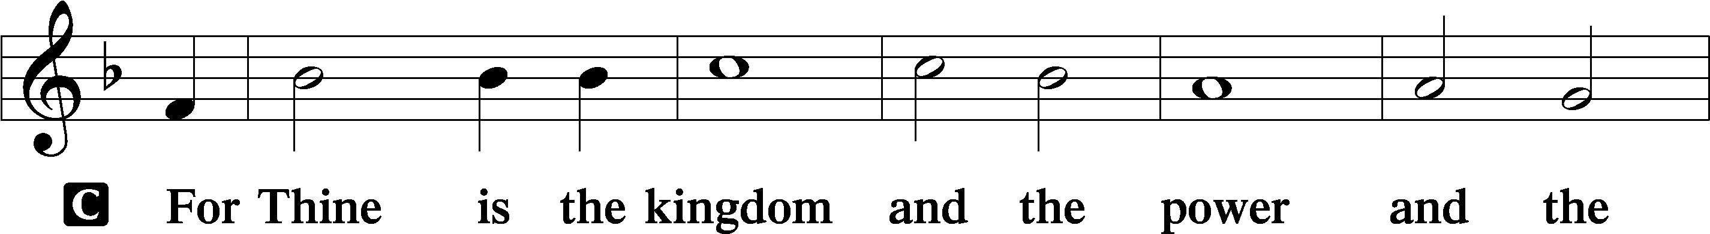
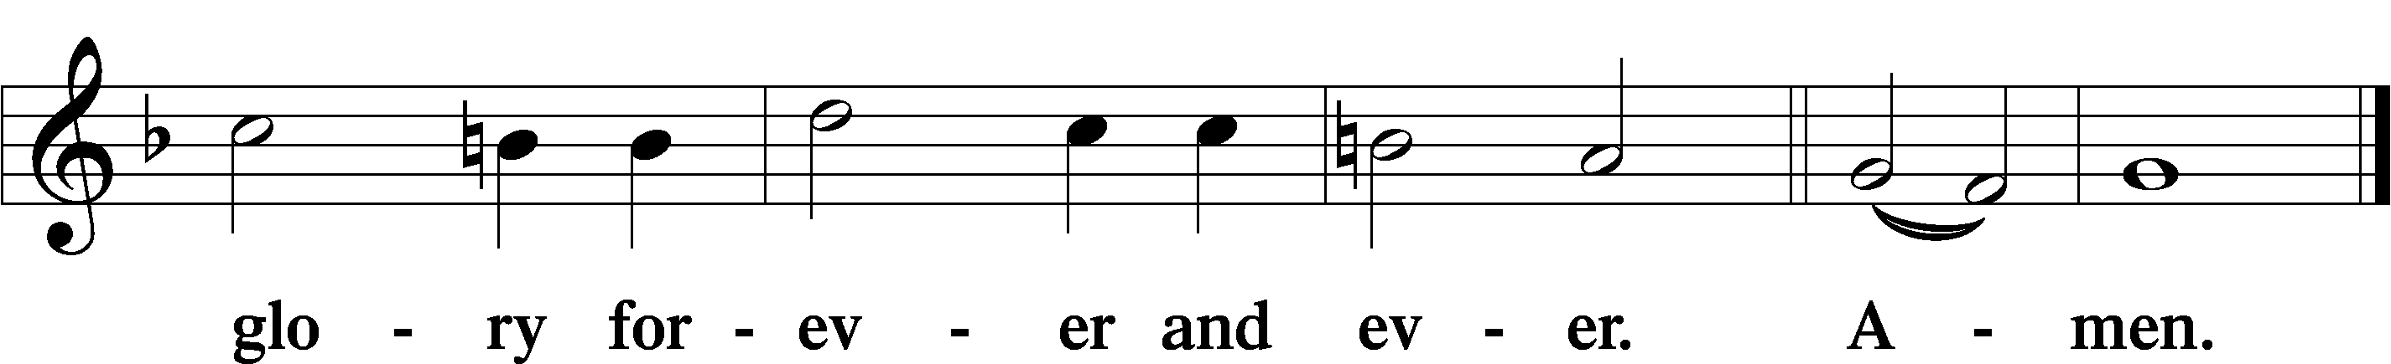

The Words of Our Lord Matthew 26:26–28; Mark 14:22–24; Luke 22:19–20; 1 Corinthians 11:23–25
P Our Lord Jesus Christ, on the night when He was betrayed, took bread, and when He had given thanks, He broke it and gave it to the disciples and said: “Take, eat; this is My T body, which is given for you. This do in remembrance of Me.”

In the same way also He took the cup after supper, and when He had given thanks, He gave it to them, saying: “Drink of it, all of you; this cup is the new testament in My T blood, which is shed for you for the forgiveness of sins. This do, as often as you drink it, in remembrance of Me.”

Pax Domini John 20:19
P The peace of the Lord be with you always.

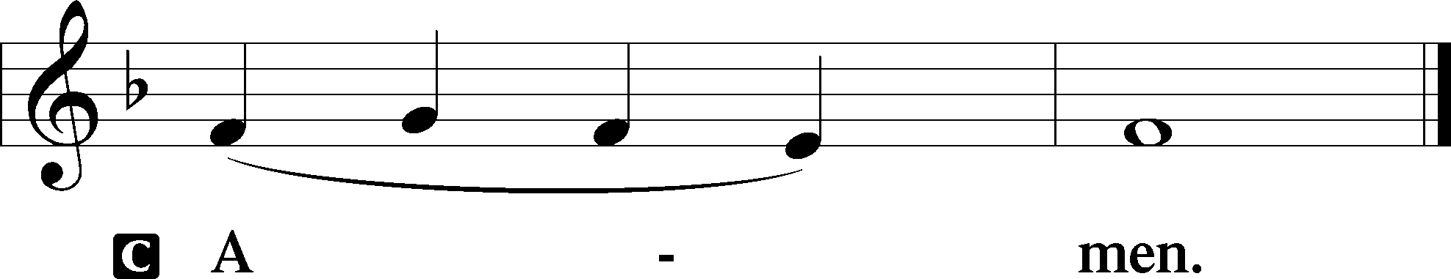

Agnus Dei John 1:29
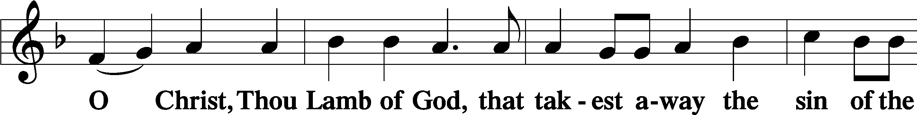
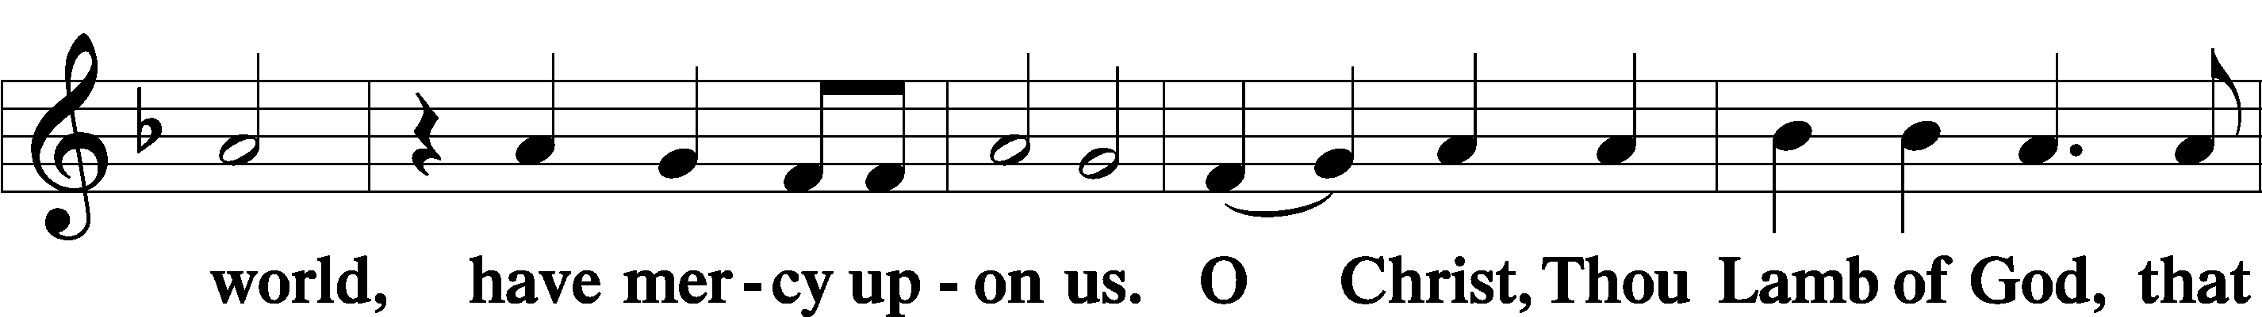
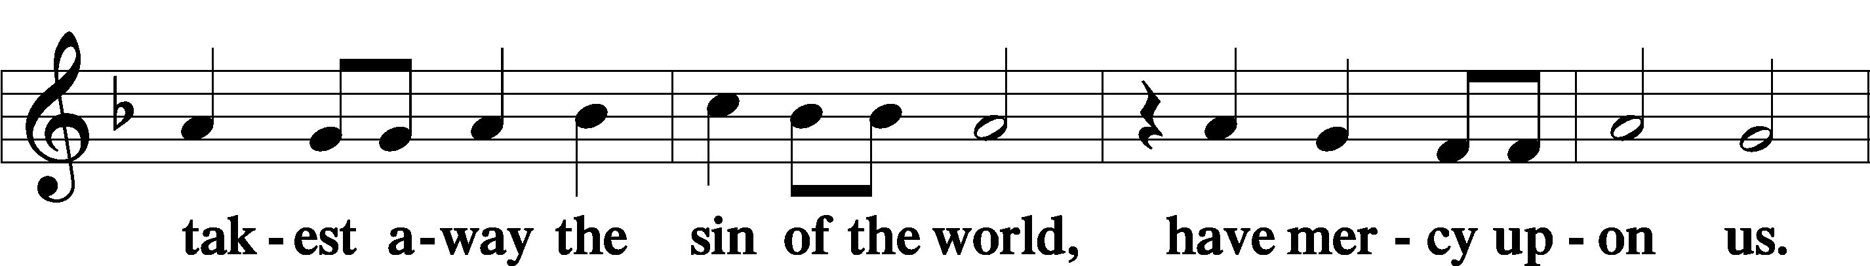
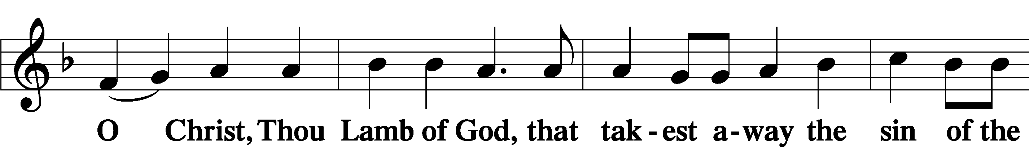
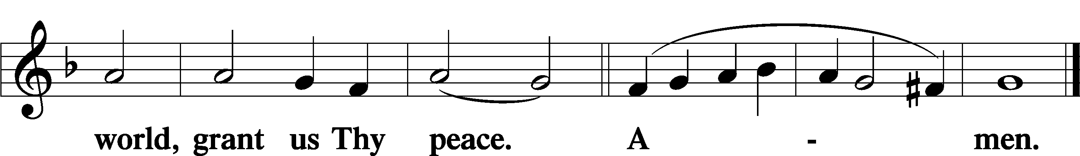

Sit

Distribution

The pastor and those who assist him receive the body and blood of Christ first and then distribute them to those who come to receive, saying:

Take, eat; this is the true body of our Lord and Savior Jesus Christ, given into death for your sins.
Amen.

Take, drink; this is the true blood of our Lord and Savior Jesus Christ, shed for the forgiveness of your sins.
Amen.

In dismissing the communicants, the following is said:

The Dismissal
P The body and blood of our Lord Jesus Christ strengthen and preserve you in body and soul to life everlasting. Depart T in peace.
C Amen.

560 Drawn to the Cross, Which Thou Hast Blessed
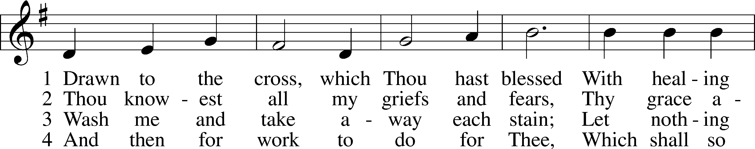
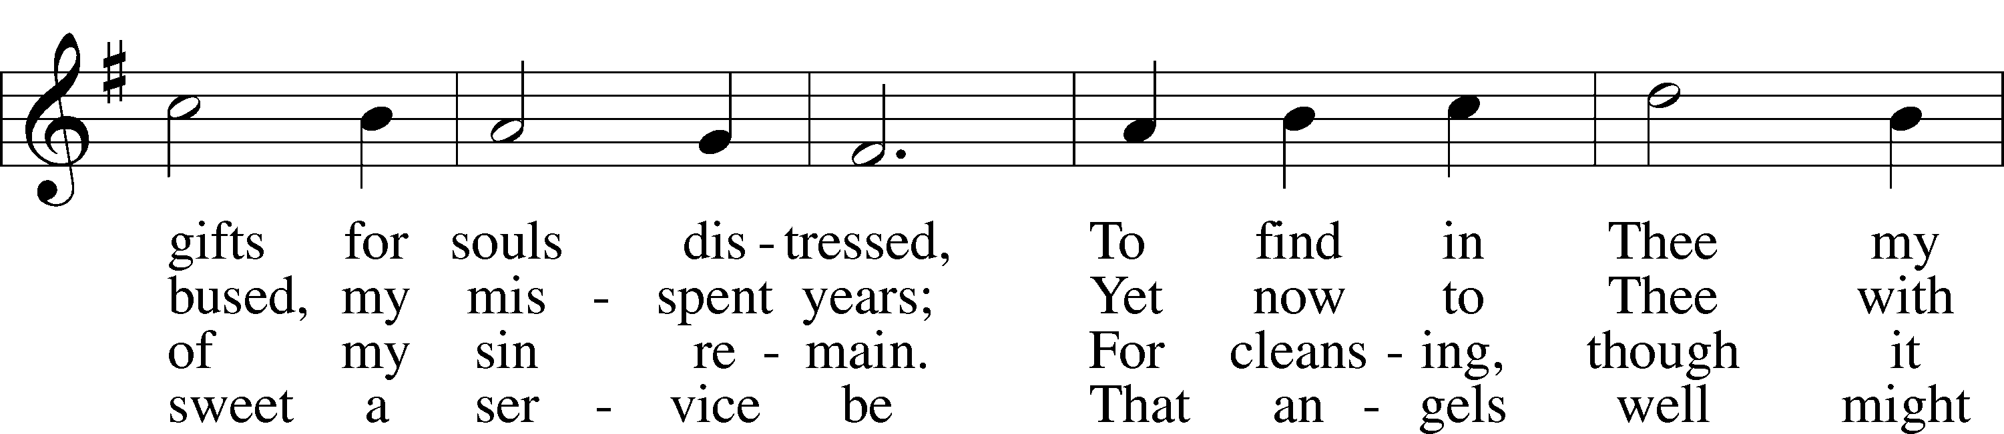
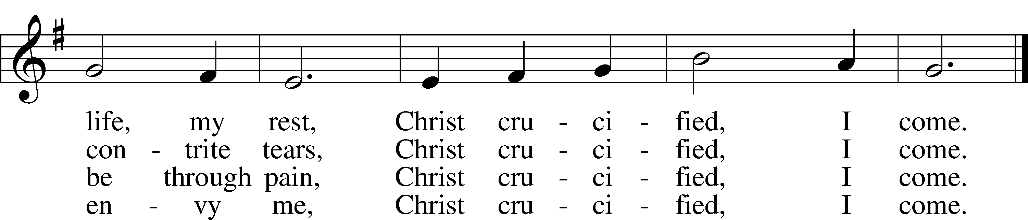
Text: Genevieve M. Irons, 1855–1928
Tune: Joseph Barnby, 1838–96
Text and tune: Public domain

637 Draw Near and Take the Body of the Lord
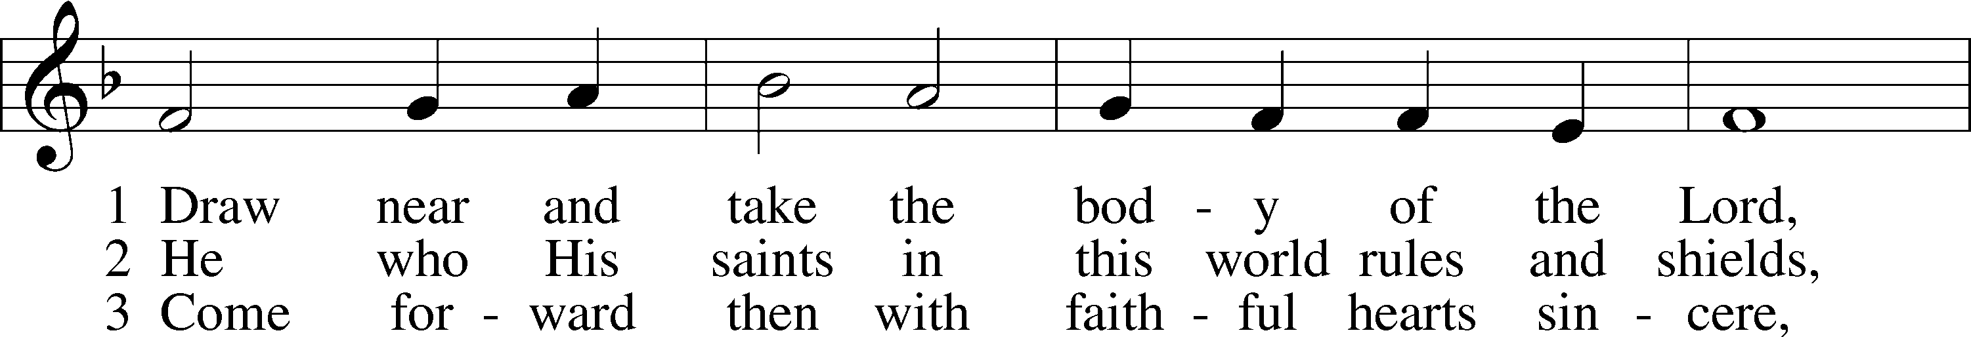
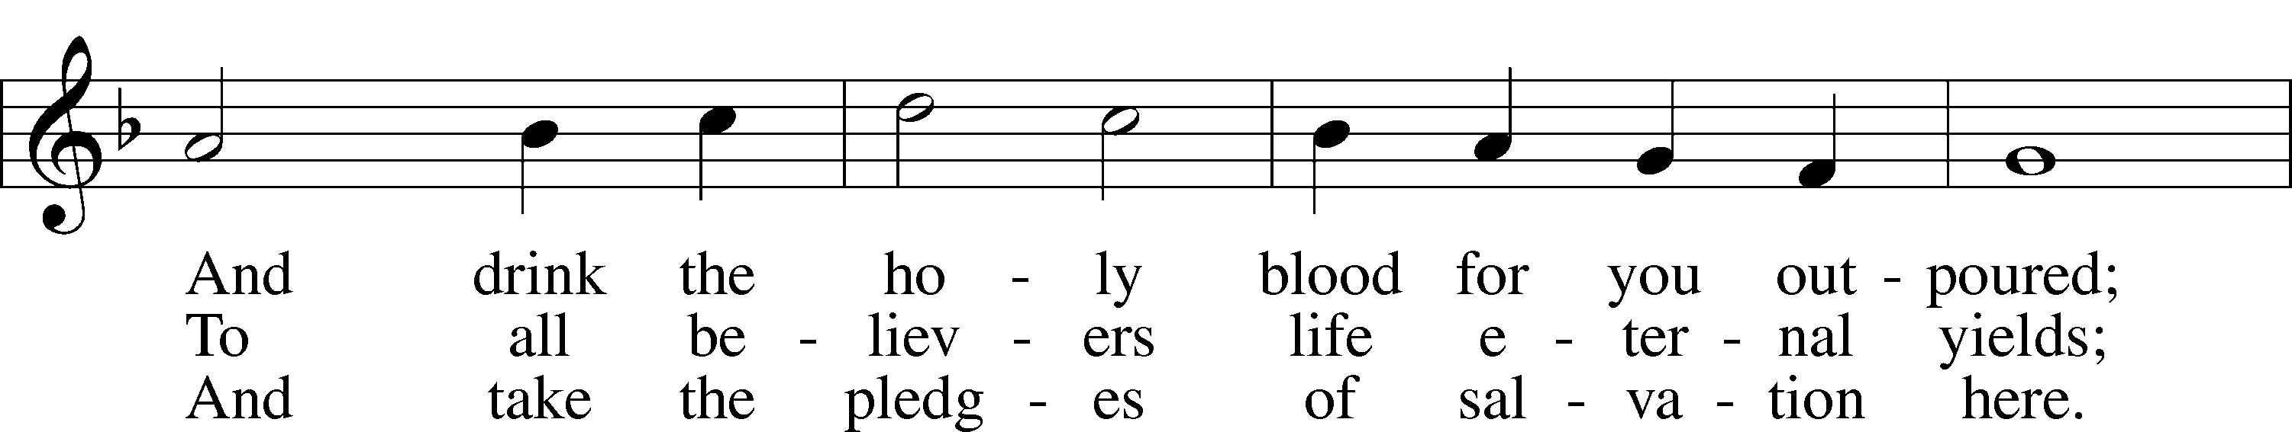
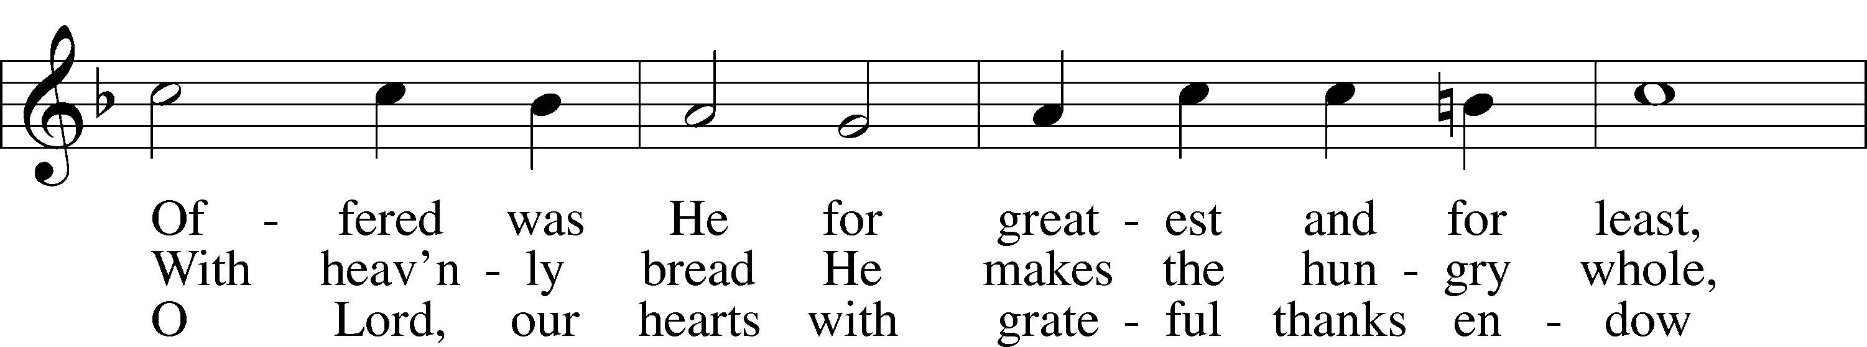
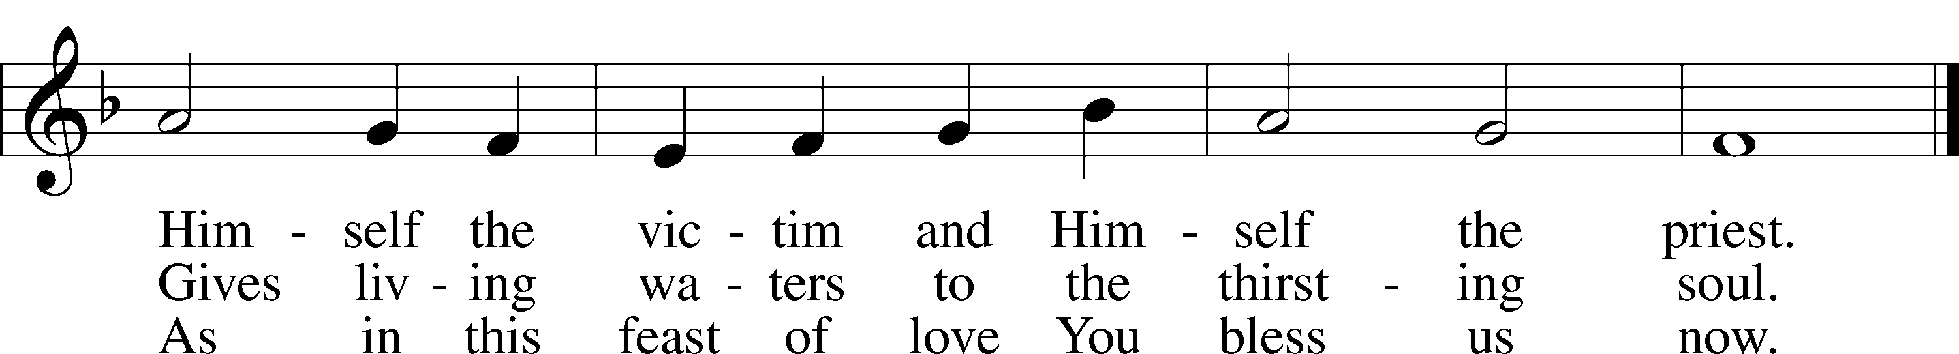
Text: Latin, 7th cent.; tr. John Mason Neale, 1818–66, alt.
Tune: Trente quatre Pseaumes de David, 1551, Geneva, ed. Louis Bourgeois
Text and tune: Public domain

643 Sent Forth by God’s Blessing
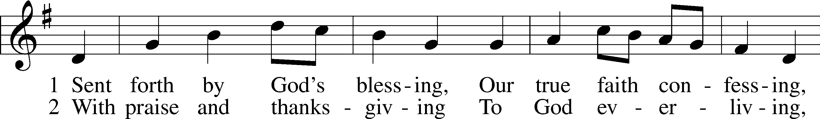
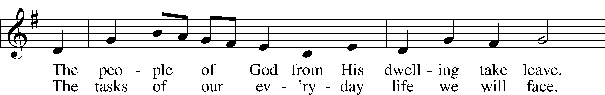
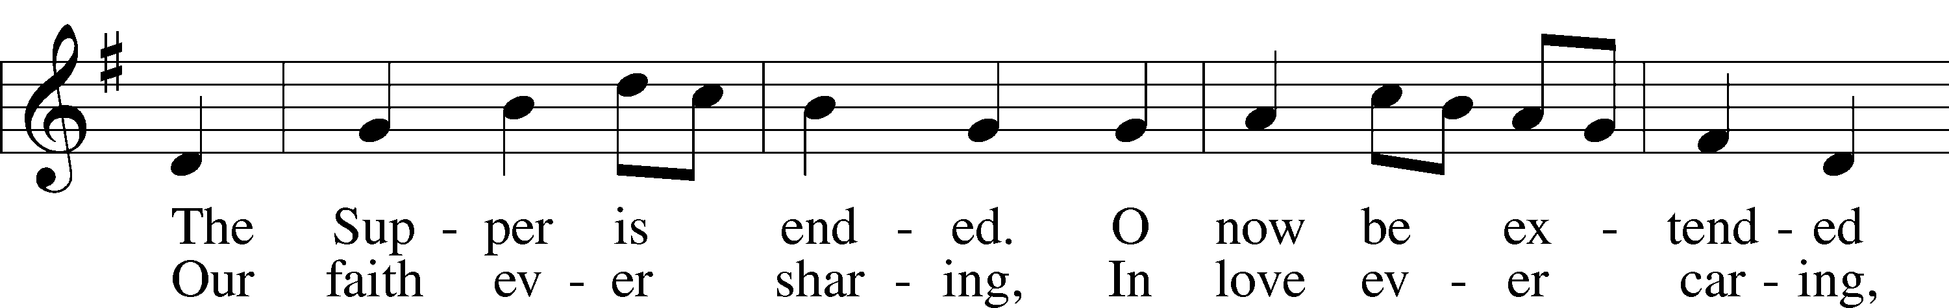
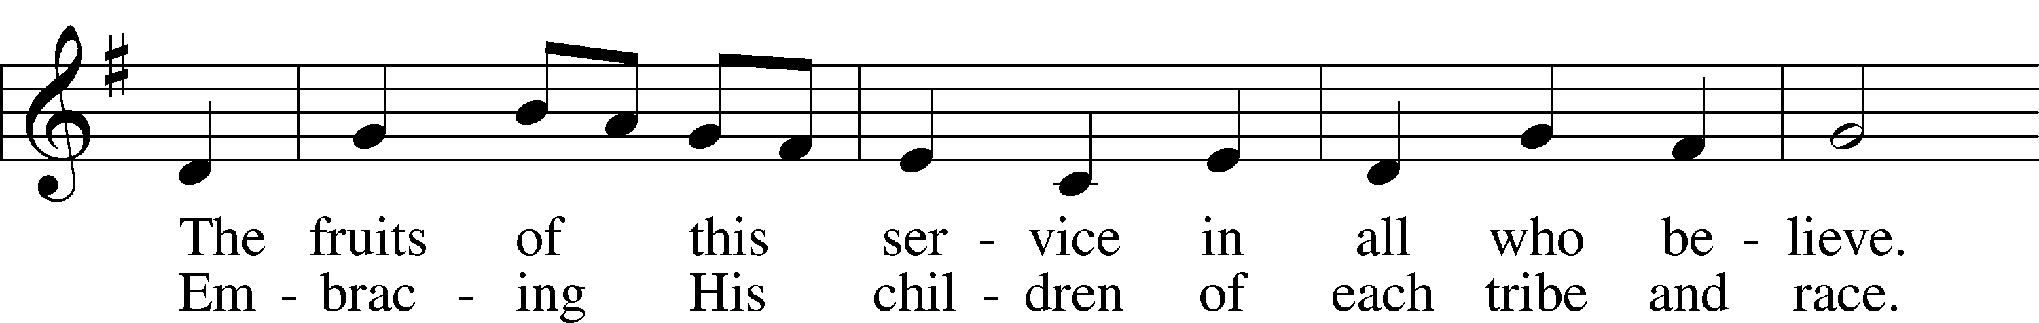
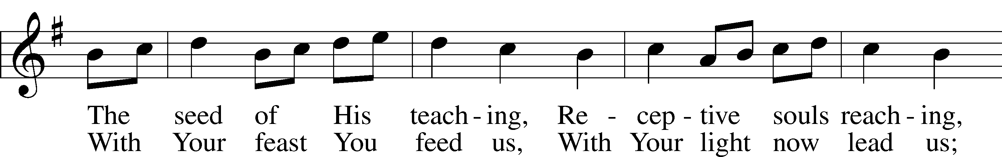
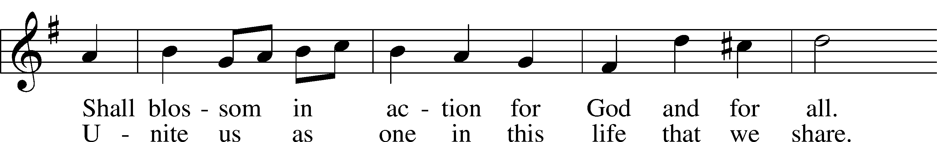
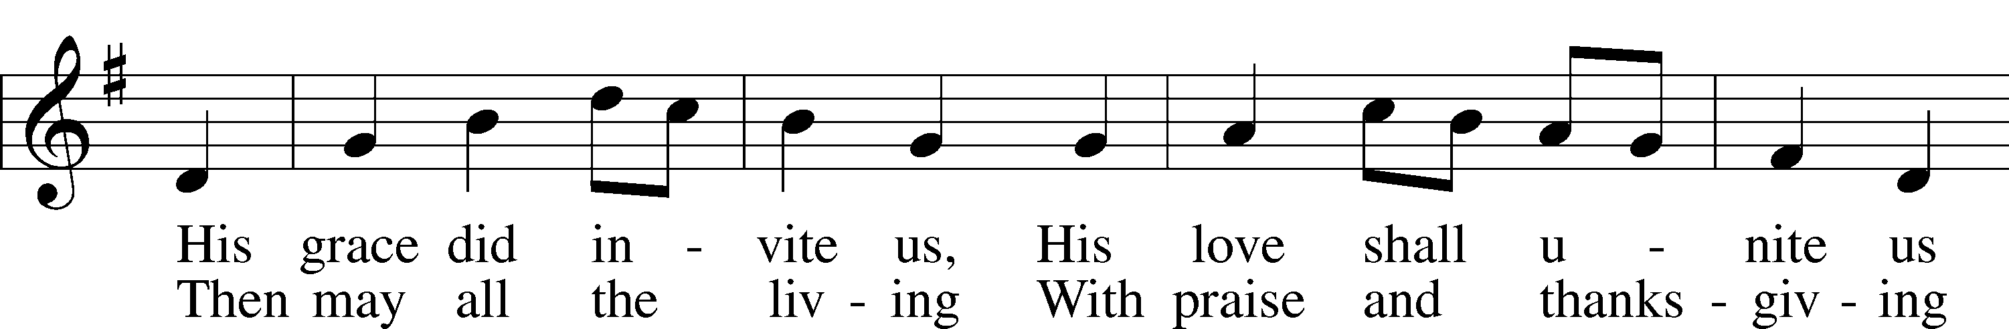
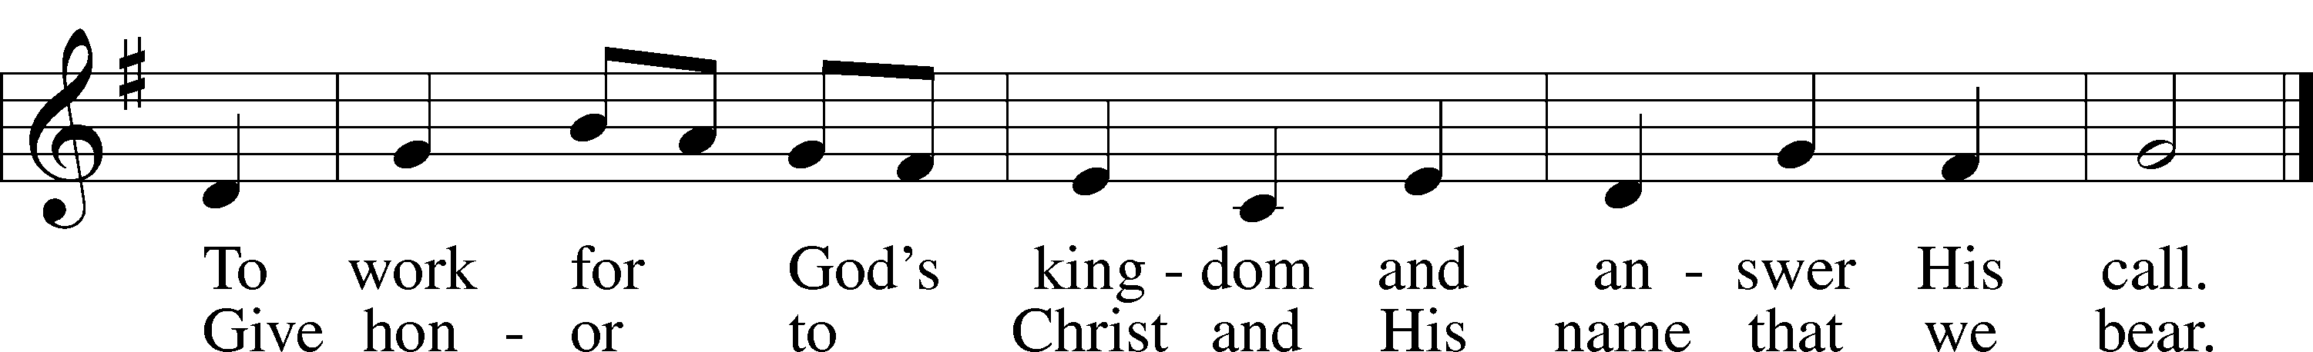
Text: Omer E. Westendorf, 1916–97, alt.
Tune: Welsh
Text: © 1964 World Library Publications. Used by permission: LSB Hymn License no. 110005011
Tune: Public domain

Stand

Nunc Dimittis Luke 2:29–32
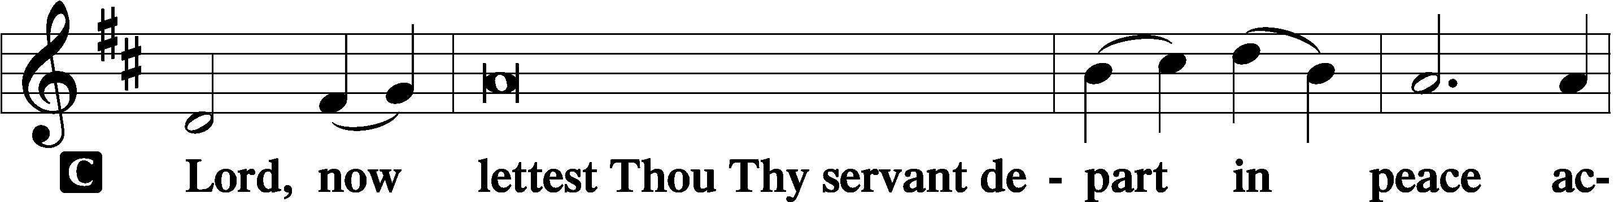

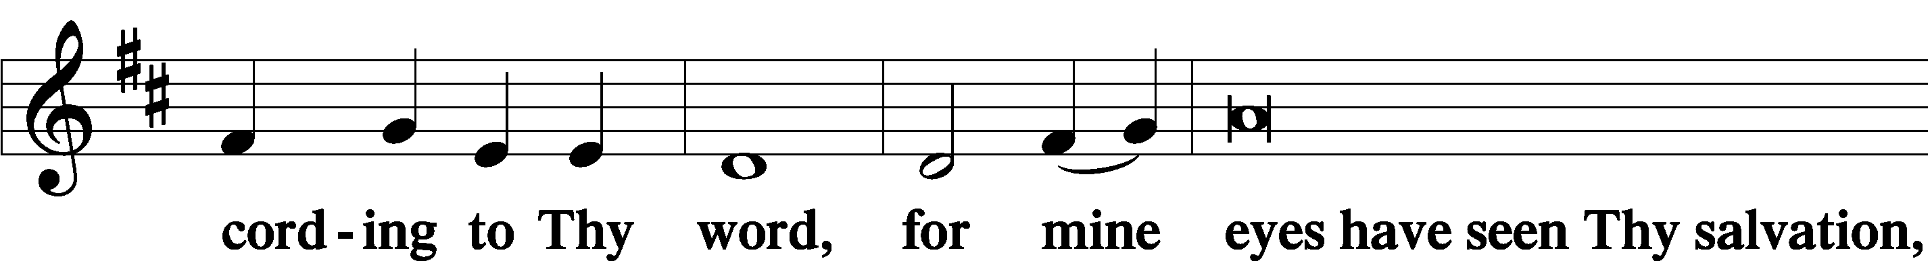

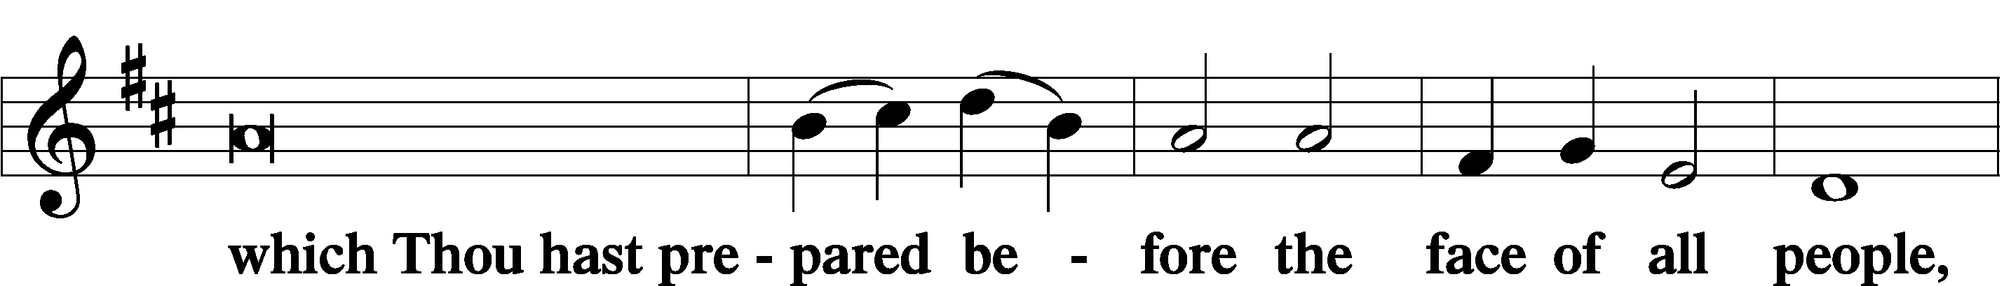

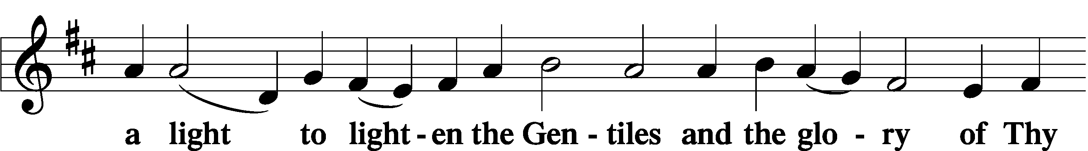

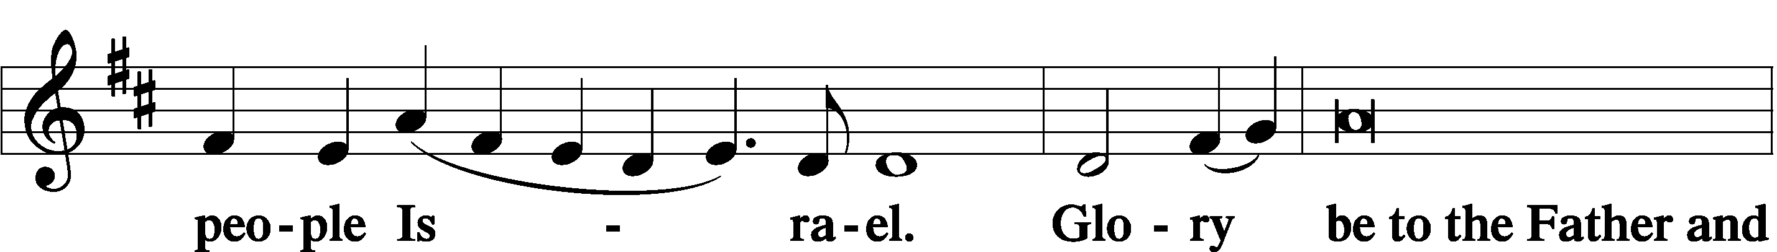

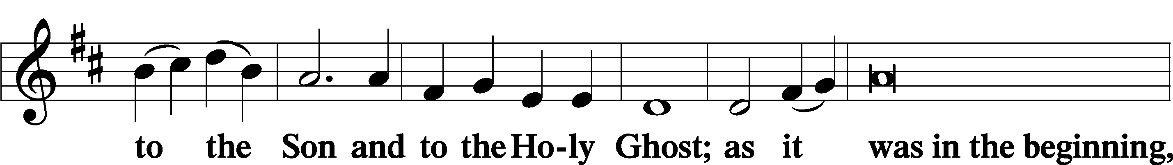

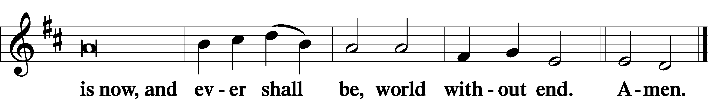

Thanksgiving Psalm 107:1
A O give thanks unto the Lord, for He is good,

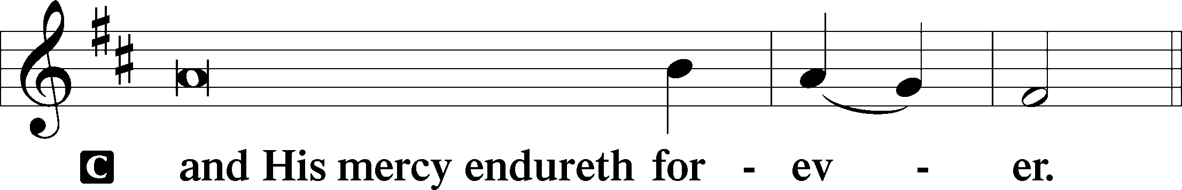

Post-Communion Collect
A Let us pray.
We give thanks to You, almighty God, that You have refreshed us through this salutary gift, and we implore You that of Your mercy You would strengthen us through the same in faith toward You and in fervent love toward one another; through Jesus Christ, Your Son, our Lord, who lives and reigns with You and the Holy Spirit, one God, now and forever.

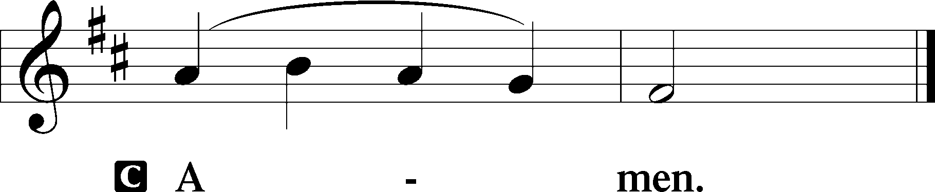

Salutation 2 Timothy 4:22
P The Lord be with you.

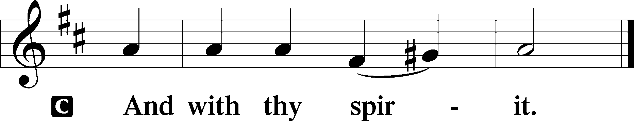

Benedicamus Psalm 103:1
A Bless we the Lord.

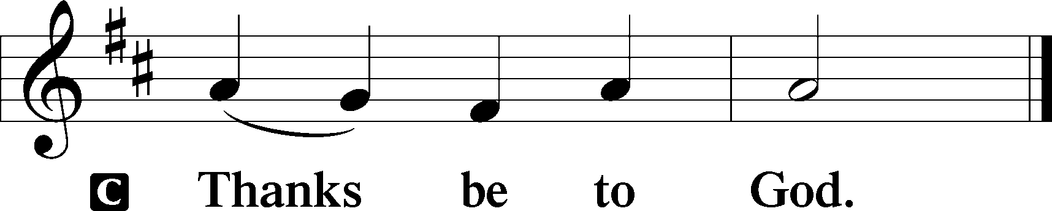

Benediction Numbers 6:24–26
P The Lord bless you and keep you.
The Lord make His face shine upon you and be gracious unto you.
The Lord lift up His countenance upon you and T give you peace.
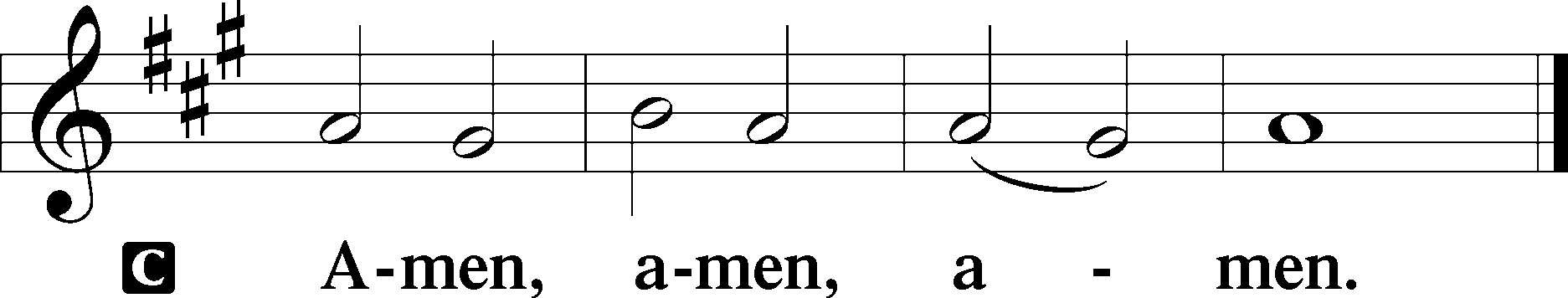

861 Christ Be My Leader
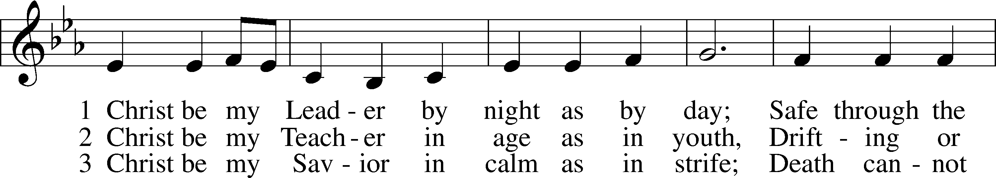
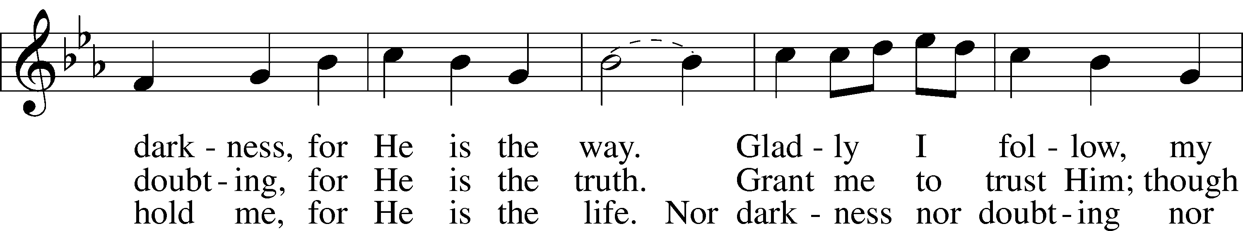
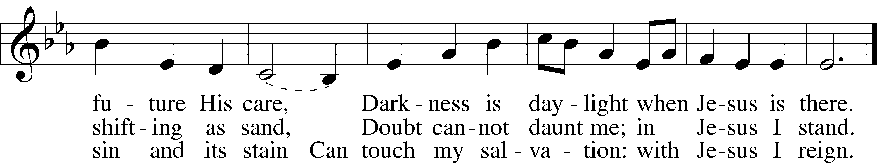
Text: Timothy Dudley-Smith, 1926–2024
Tune: Irish
Text: © 1964, renewed 1992 Hope Publishing Co. Used by permission: LSB Hymn License no. 110005011
Tune: Public domain
Acknowledgments
Divine Service, Setting Three from Lutheran Service Book
Unless otherwise indicated, Scripture quotations are from the ESV® Bible (The Holy Bible, English Standard Version®), copyright © 2001 by Crossway, a publishing ministry of Good News Publishers. Used by permission. All rights reserved.
Created by Lutheran Service Builder © 2026 Concordia Publishing House.

