On entering the church

P Lord, I love the habitation of Your house and the place
where Your glory dwells. In the multitude of Your tender
mercies prepare my heart that I may enter Your house to
worship and confess Your holy name; through Jesus Christ,
my God and Lord.

Before worship

C O Lord, our creator, redeemer, and comforter, as we come
together to worship You in spirit and in truth, we humbly
pray that You would open our hearts to the preaching of
Your Word so that we may repent of our sins, believe in
Jesus Christ as our only Savior, and grow in grace and
holiness. Hear us for His sake.

849 Praise the One Who Breaks the Darkness
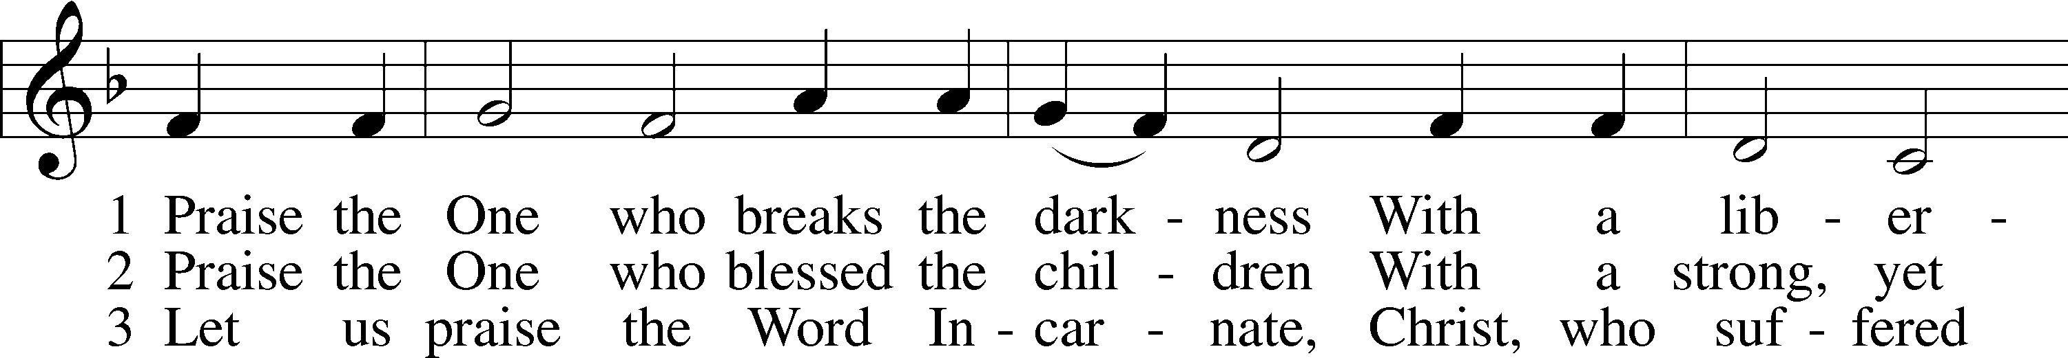
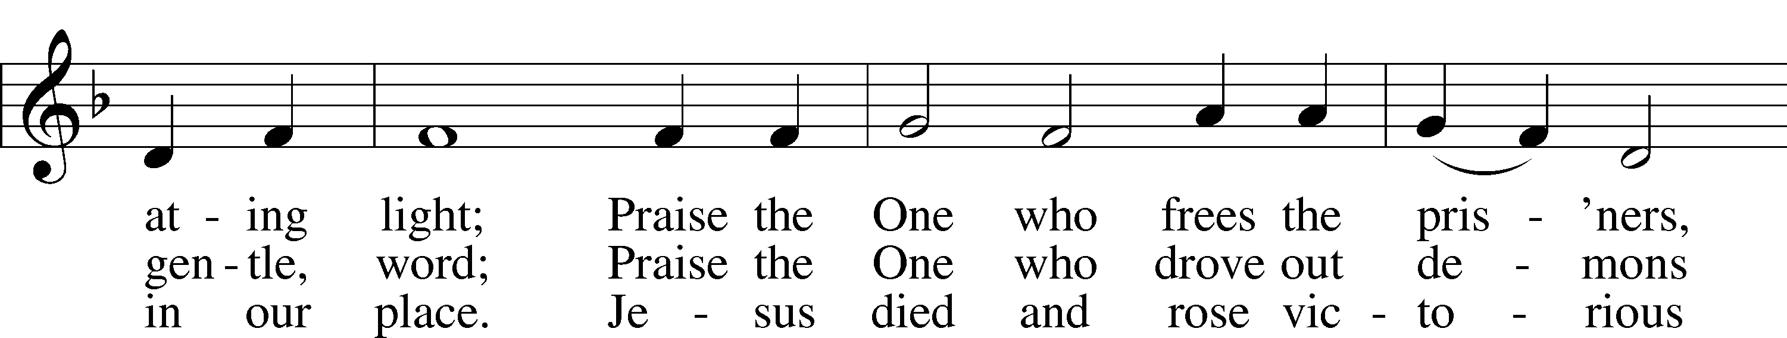
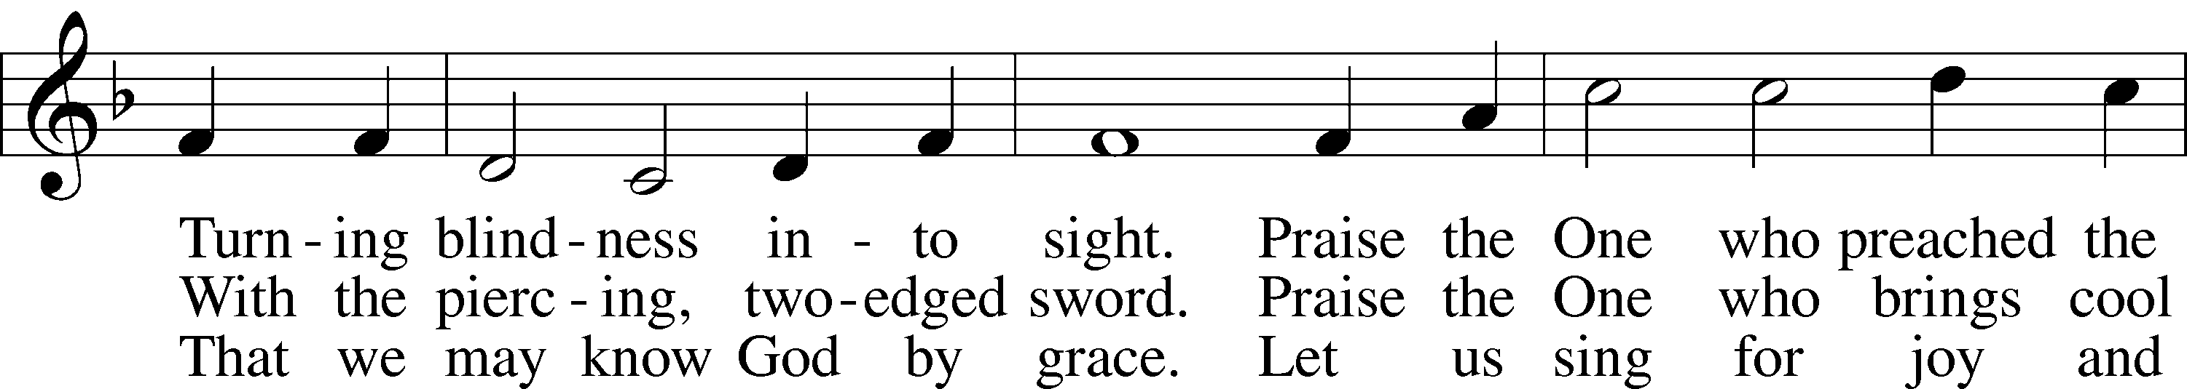
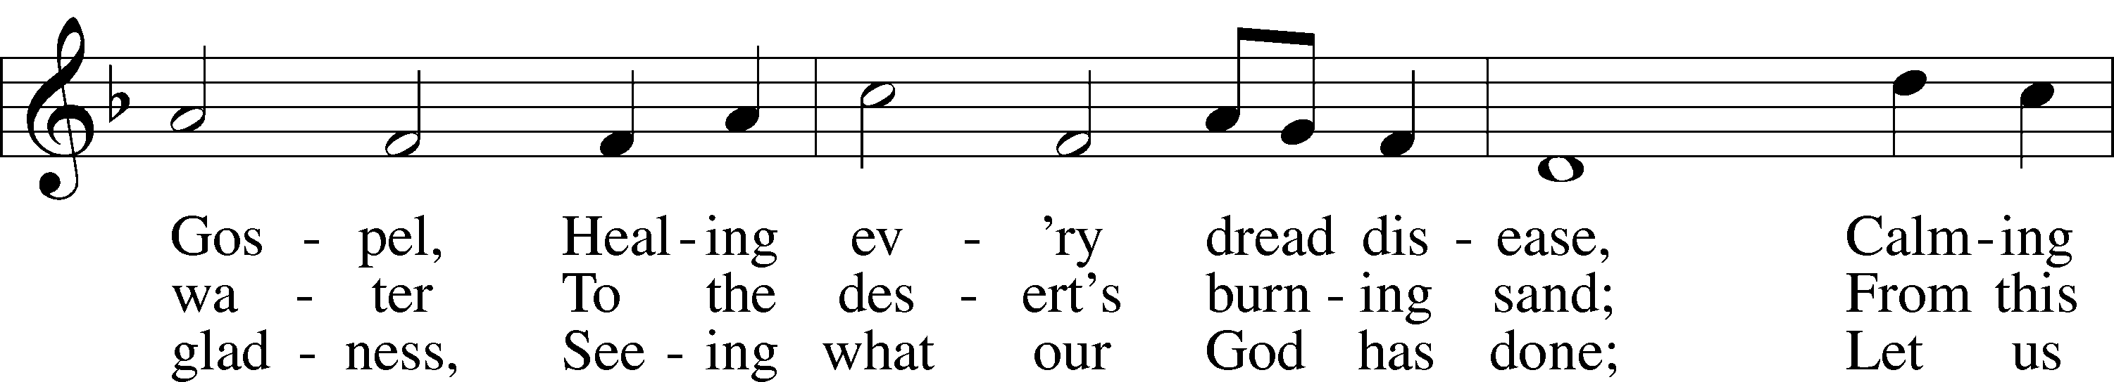
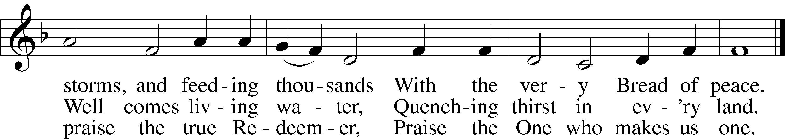
Text: Rusty Edwards, 1955
Tune: The Sacred Harp, 1844, Philadelphia
Text: © 1987 Hope Publishing Co. Used by permission: LSB Hymn License no. 110005011
Tune: Public domain
Confession and Absolution
Stand

The sign of the cross may be made by all in remembrance of their Baptism.

Invocation Matthew 28:19b; 18:20
P In the name of the Father and of the T Son and of the Holy Spirit.
C Amen.

Exhortation Psalm 124:8; Psalm 130:3–4; Luke 18:13
P Our help is in the name of the Lord,
C who made heaven and earth.

P If You, O Lord, kept a record of sins, O Lord, who could stand?
C But with You there is forgiveness; therefore You are feared.

P Since we are gathered to hear God’s Word, call upon Him in prayer and praise, and receive the body and blood of our Lord Jesus Christ in the fellowship of this altar, let us first consider our unworthiness and confess before God and one another that we have sinned in thought, word, and deed, and that we cannot free ourselves from our sinful condition. Together as His people let us take refuge in the infinite mercy of God, our heavenly Father, seeking His grace for the sake of Christ, and saying: God, be merciful to me, a sinner.

Kneel/Stand

Confession of Sins
C Almighty God, have mercy upon us, forgive us our sins, and lead us to everlasting life. Amen.

Absolution [John 20:19–23]
P Almighty God in His mercy has given His Son to die for you and for His sake forgives you all your sins. As a called and ordained servant of Christ, and by His authority, I therefore forgive you all your sins in the name of the Father and of the T Son and of the Holy Spirit.
C Amen.

Stand
Service of the Word
Introit Psalm 31:1, 5, 9, 16; antiphon: vv. 2b–3
Be a rock of refuge for me,
a strong fortress to save me!
For you are my rock and my fortress;
and for your name’s sake you lead me and guide me.
In you, O Lord, do I take refuge; let me never be put to shame;
in your righteousness deliver me!
Into your hand I commit my spirit;
you have redeemed me, O Lord, faithful God.
Be gracious to me, O Lord, for I am in distress;
my eye is wasted from grief; my soul and my body also.
Make your face shine on your servant;
save me in your steadfast love!

Kyrie Mark 10:47
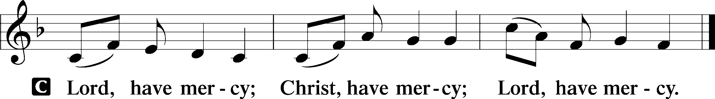

Salutation and Collect of the Day
P The Lord be with you.
C And also with you.
P Let us pray.
O Lord, mercifully hear our prayers and having set us free from the bonds of our sins deliver us from every evil; through Jesus Christ, Your Son, our Lord, who lives and reigns with You and the Holy Spirit, one God, now and forever.
C Amen.

Sit

Old Testament Reading 1 Samuel 16:1–13
1The Lord said to Samuel, “How long will you grieve over Saul, since I have rejected him from being king over Israel? Fill your horn with oil, and go. I will send you to Jesse the Bethlehemite, for I have provided for myself a king among his sons.” 2And Samuel said, “How can I go? If Saul hears it, he will kill me.” And the Lord said, “Take a heifer with you and say, ‘I have come to sacrifice to the Lord.’ 3And invite Jesse to the sacrifice, and I will show you what you shall do. And you shall anoint for me him whom I declare to you.” 4Samuel did what the Lord commanded and came to Bethlehem. The elders of the city came to meet him trembling and said, “Do you come peaceably?” 5And he said, “Peaceably; I have come to sacrifice to the Lord. Consecrate yourselves, and come with me to the sacrifice.” And he consecrated Jesse and his sons and invited them to the sacrifice.
6When they came, he looked on Eliab and thought, “Surely the Lord’s anointed is before him.” 7But the Lord said to Samuel, “Do not look on his appearance or on the height of his stature, because I have rejected him. For the Lord sees not as man sees: man looks on the outward appearance, but the Lord looks on the heart.” 8Then Jesse called Abinadab and made him pass before Samuel. And he said, “Neither has the Lord chosen this one.” 9Then Jesse made Shammah pass by. And he said, “Neither has the Lord chosen this one.” 10And Jesse made seven of his sons pass before Samuel. And Samuel said to Jesse, “The Lord has not chosen these.” 11Then Samuel said to Jesse, “Are all your sons here?” And he said, “There remains yet the youngest, but behold, he is keeping the sheep.” And Samuel said to Jesse, “Send and get him, for we will not sit down till he comes here.” 12And he sent and brought him in. Now he was ruddy and had beautiful eyes and was handsome. And the Lord said, “Arise, anoint him, for this is he.” 13Then Samuel took the horn of oil and anointed him in the midst of his brothers. And the Spirit of the Lord rushed upon David from that day forward. And Samuel rose up and went to Ramah.
A This is the Word of the Lord.
C Thanks be to God.

Gradual Psalm 77:14–15
You are the God who works wonders;
you have made known your might among the peoples.
You with your arm redeemed your people,
the children of Jacob and Joseph.

Epistle 1 Corinthians 13:1–13
1If I speak in the tongues of men and of angels, but have not love, I am a noisy gong or a clanging cymbal. 2And if I have prophetic powers, and understand all mysteries and all knowledge, and if I have all faith, so as to remove mountains, but have not love, I am nothing. 3If I give away all I have, and if I deliver up my body to be burned, but have not love, I gain nothing.
4Love is patient and kind; love does not envy or boast; it is not arrogant 5or rude. It does not insist on its own way; it is not irritable or resentful; 6it does not rejoice at wrongdoing, but rejoices with the truth. 7Love bears all things, believes all things, hopes all things, endures all things.
8Love never ends. As for prophecies, they will pass away; as for tongues, they will cease; as for knowledge, it will pass away. 9For we know in part and we prophesy in part, 10but when the perfect comes, the partial will pass away. 11When I was a child, I spoke like a child, I thought like a child, I reasoned like a child. When I became a man, I gave up childish ways. 12For now we see in a mirror dimly, but then face to face. Now I know in part; then I shall know fully, even as I have been fully known.
13So now faith, hope, and love abide, these three; but the greatest of these is love.
A This is the Word of the Lord.
C Thanks be to God.

Stand

Holy Gospel Luke 18:31–43
P The Holy Gospel according to St. Luke, the eighteenth chapter.
C Glory to You, O Lord.
31Taking the twelve, [Jesus] said to them, “See, we are going up to Jerusalem, and everything that is written about the Son of Man by the prophets will be accomplished. 32For he will be delivered over to the Gentiles and will be mocked and shamefully treated and spit upon. 33And after flogging him, they will kill him, and on the third day he will rise.” 34But they understood none of these things. This saying was hidden from them, and they did not grasp what was said.
35As he drew near to Jericho, a blind man was sitting by the roadside begging. 36And hearing a crowd going by, he inquired what this meant. 37They told him, “Jesus of Nazareth is passing by.” 38And he cried out, “Jesus, Son of David, have mercy on me!” 39And those who were in front rebuked him, telling him to be silent. But he cried out all the more, “Son of David, have mercy on me!” 40And Jesus stopped and commanded him to be brought to him. And when he came near, he asked him, 41“What do you want me to do for you?” He said, “Lord, let me recover my sight.” 42And Jesus said to him, “Recover your sight; your faith has made you well.” 43And immediately he recovered his sight and followed him, glorifying God. And all the people, when they saw it, gave praise to God.
P This is the Gospel of the Lord.
C Praise to You, O Christ.

Nicene Creed
C I believe in one God,
the Father Almighty,
maker of heaven and earth
and of all things visible and invisible.
And in one Lord Jesus Christ,
the only-begotten Son of God,
begotten of His Father before all worlds,
God of God, Light of Light,
very God of very God,
begotten, not made,
being of one substance with the Father,
by whom all things were made;
who for us men and for our salvation came down from heaven
and was incarnate by the Holy Spirit of the virgin Mary
and was made man;
and was crucified also for us under Pontius Pilate.
He suffered and was buried.
And the third day He rose again according to the Scriptures
and ascended into heaven
and sits at the right hand of the Father.
And He will come again with glory to judge both the living and the dead,
whose kingdom will have no end.
And I believe in the Holy Spirit,
the Lord and giver of life,
who proceeds from the Father and the Son,
who with the Father and the Son together is worshiped and glorified,
who spoke by the prophets.
And I believe in one holy Christian and apostolic Church,
I acknowledge one Baptism for the remission of sins,
and I look for the resurrection of the dead
and the life T of the world to come. Amen.

Sit

Children's Sermon

556 Dear Christians, One and All, Rejoice sts. 1–5
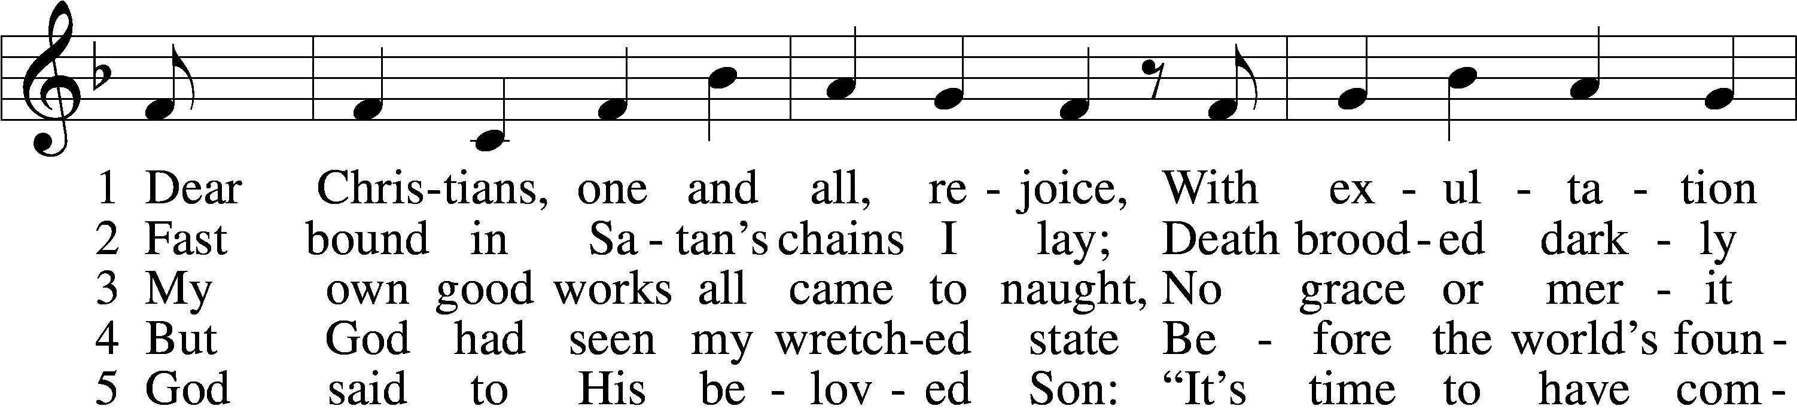
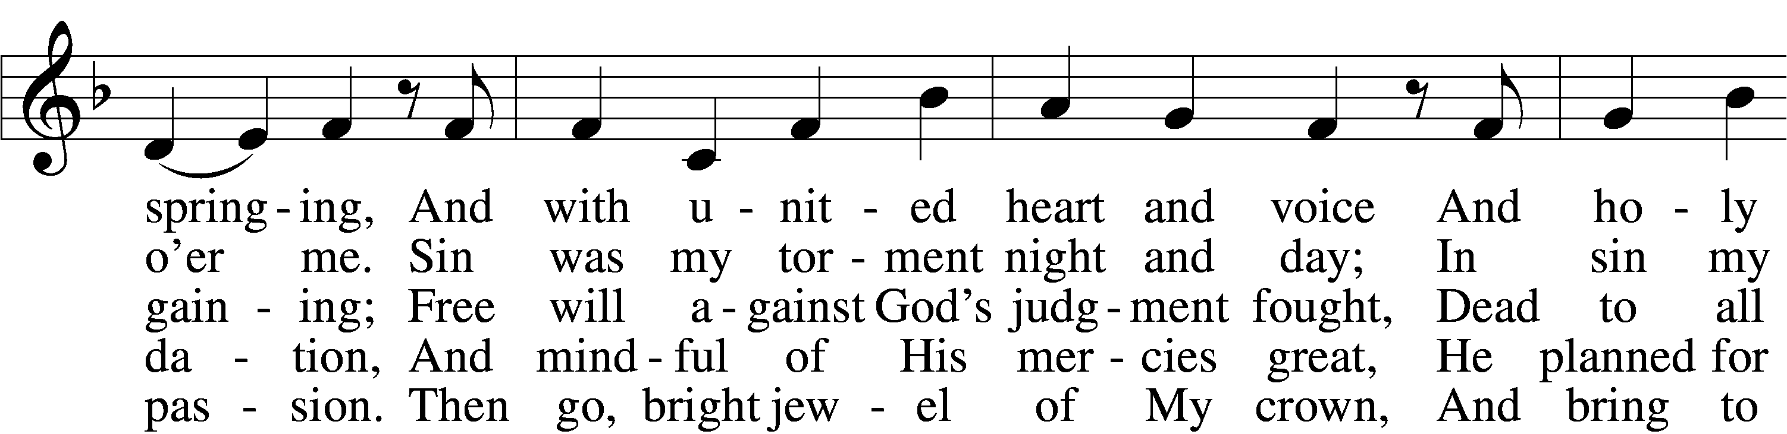
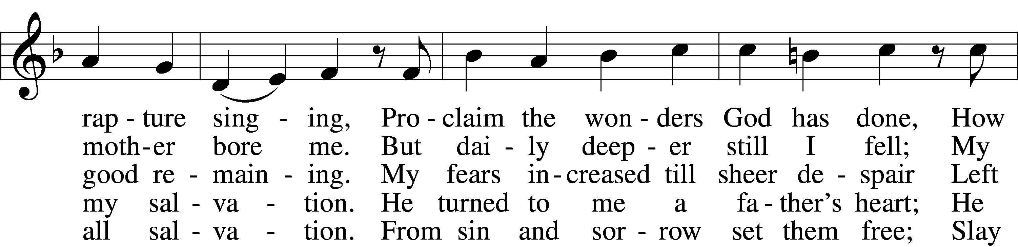
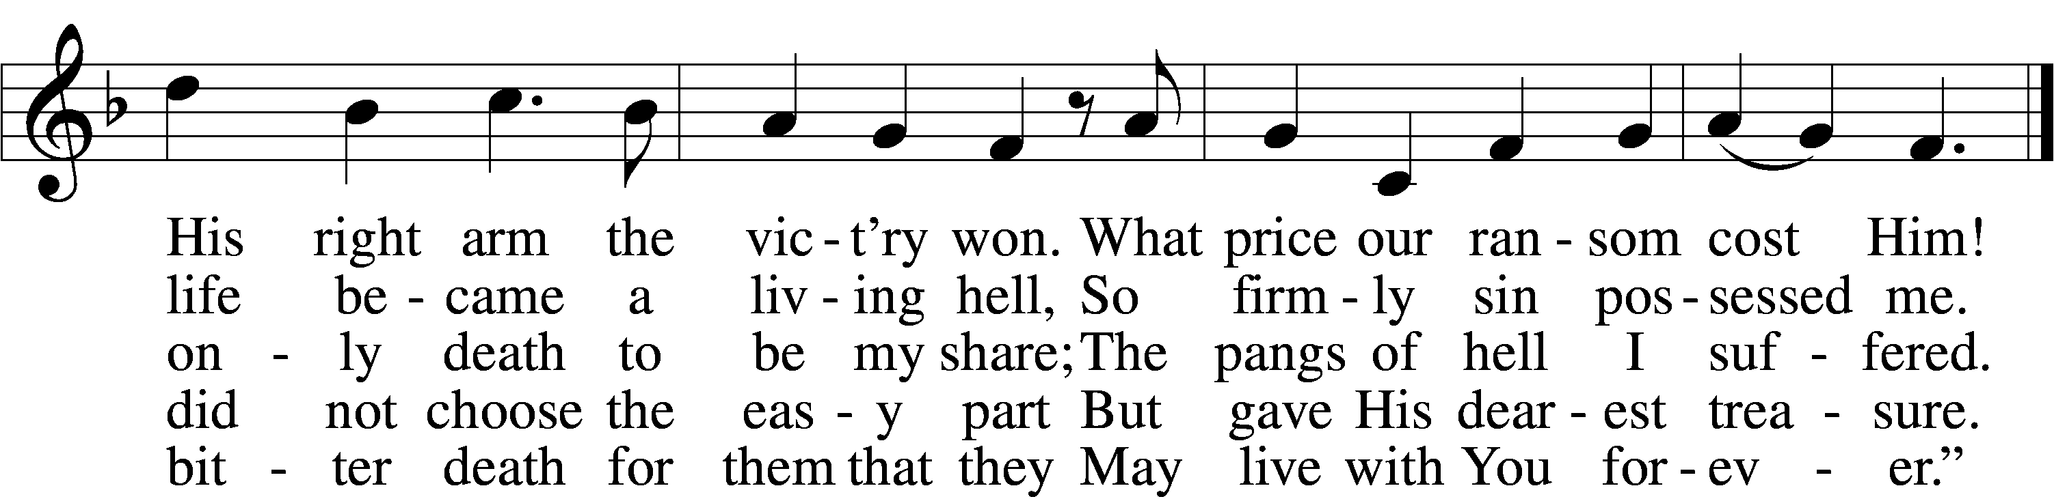
Text: Martin Luther, 1483–1546; tr. Richard Massie, 1800–87, alt.
Tune: Etlich Cristlich lider, 1524, Wittenberg
Text and tune: Public domain

Sermon

556 Dear Christians, One and All, Rejoice sts. 6–10
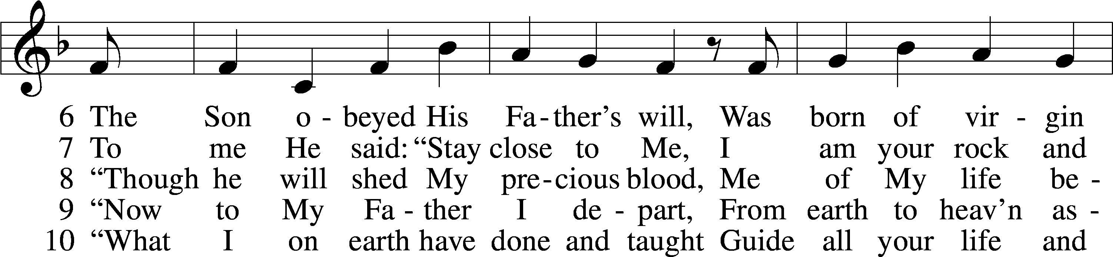
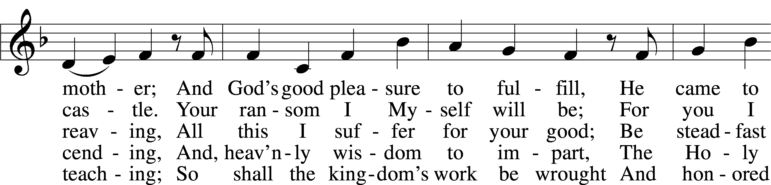
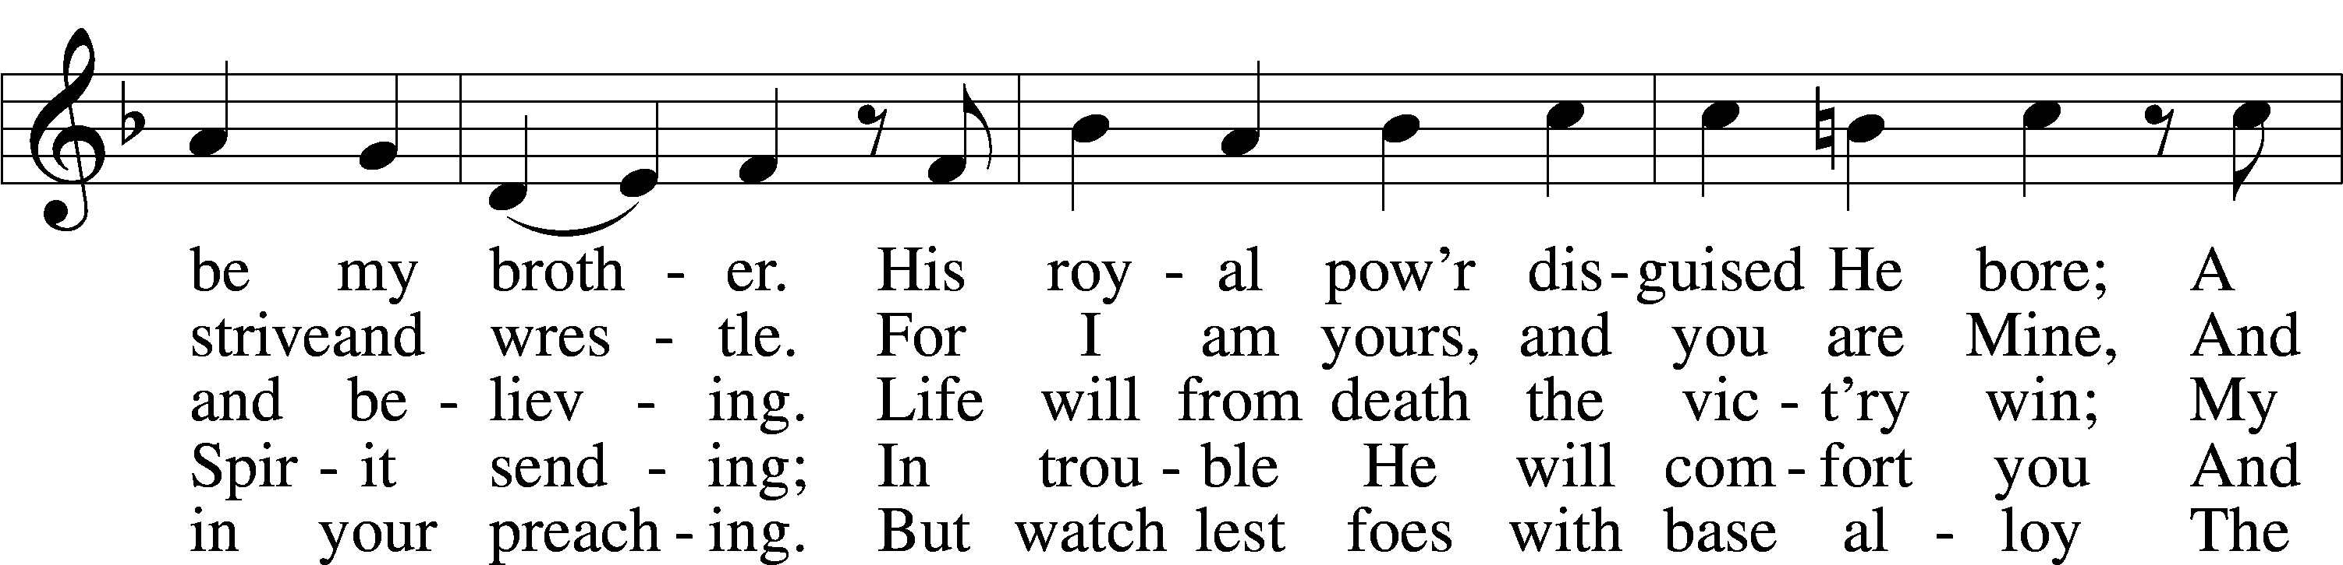
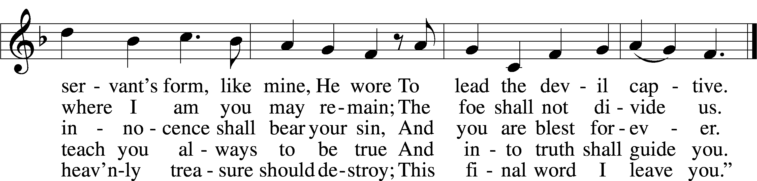
Text: Martin Luther, 1483–1546; tr. Richard Massie, 1800–87, alt.
Tune: Etlich Cristlich lider, 1524, Wittenberg
Text and tune: Public domain

Stand

Prayer of the Church

Following the prayers, the people may greet one another in the name of the Lord, saying, “Peace be with you,” as a sign of reconciliation and of the unity of the Spirit in the bond of peace (Matt. 5:22–24; Eph. 4:1–3).

Sit

Offering

805 Praise God, from Whom All Blessings Flow
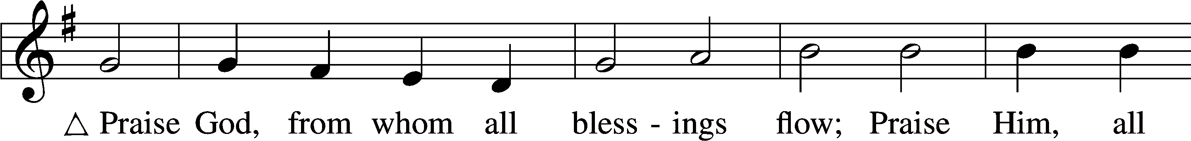
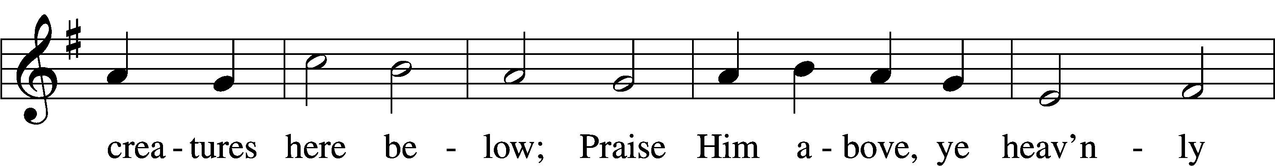
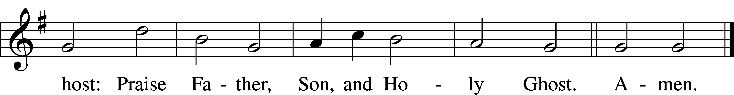
Text: Thomas Ken, 1637–1711
Tune: Trente quatre Pseaumes de David, 1551, Geneva, ed. Louis Bourgeois
Text and tune: Public domain
Service of the Sacrament
Stand

Preface 2 Timothy 4:22; [Colossians 3:1]; [Psalm 136]
P The Lord be with you.
C And also with you.
P Lift up your hearts.
C We lift them to the Lord.
P Let us give thanks to the Lord our God.
C It is right to give Him thanks and praise.

P It is truly good, right, and salutary that we should at all times and in all places give thanks to You, O Lord, holy Father, almighty and everlasting God, for the countless blessings You so freely bestow on us and all creation. Above all, we give thanks for Your boundless love shown to us when You sent Your only-begotten Son, Jesus Christ, into our flesh and laid on Him our sin, giving Him into death that we might not die eternally. Because He is now risen from the dead and lives and reigns to all eternity, all who believe in Him will overcome sin and death and will rise again to new life. Therefore with angels and archangels and with all the company of heaven we laud and magnify Your glorious name, evermore praising You and saying:

Sanctus Isaiah 6:3; Matthew 21:9
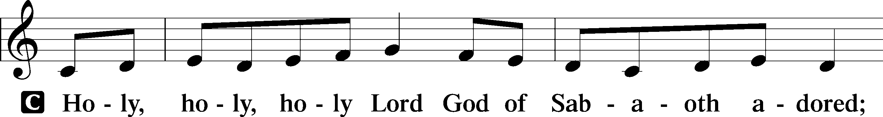
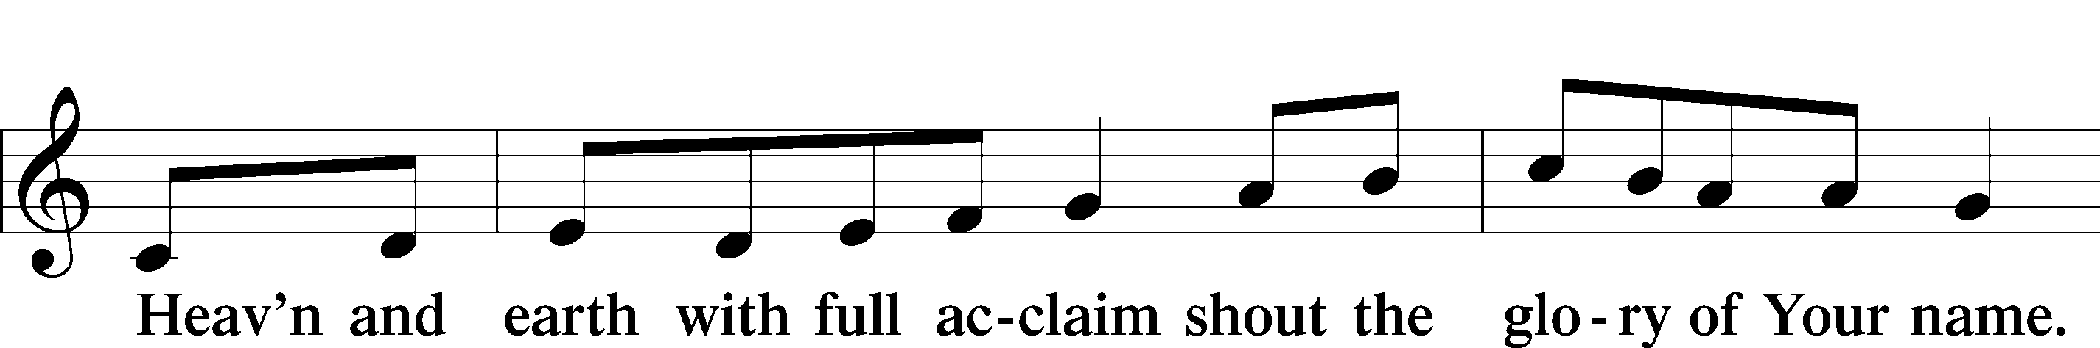
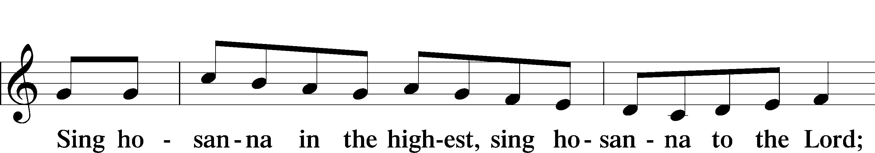
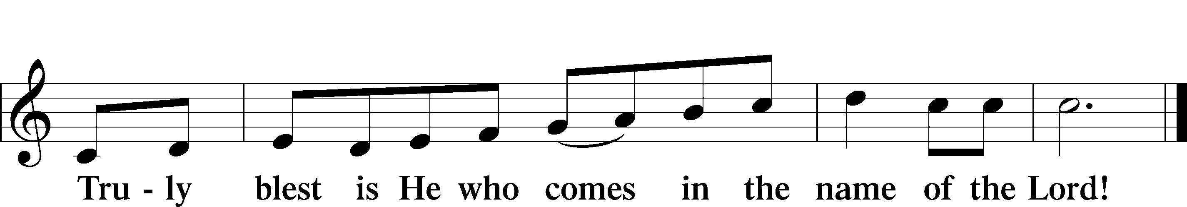
Text: Stephen P. Starke

Prayer of Thanksgiving
P Blessed are You, O Lord our God, king of all creation, for You have had mercy on us and given Your only-begotten Son that whoever believes in Him should not perish but have eternal life.
As the glory of Your presence once filled Your ancient temple, so in the incarnation of Your Son, Jesus Christ, You manifested the fullness of Your glory in human flesh.
We give You thanks that in His most Holy Supper You reveal Your glory to us. Grant us faithfully to eat His body and drink His blood so that we may one day behold Your glory face to face.
Hear us as we pray in His name and as He has taught us:

Lord’s Prayer
C Our Father who art in heaven,
hallowed be Thy name,
Thy kingdom come,
Thy will be done on earth
as it is in heaven;
give us this day our daily bread;
and forgive us our trespasses
as we forgive those
who trespass against us;
and lead us not into temptation,
but deliver us from evil.
For Thine is the kingdom
and the power and the glory
forever and ever. Amen.

The Words of Our Lord
P Our Lord Jesus Christ, on the night when He was betrayed, took bread, and when He had given thanks, He broke it and gave it to the disciples and said: “Take, eat; this is My T body, which is given for you. This do in remembrance of Me.”
In the same way also He took the cup after supper, and when He had given thanks, He gave it to them, saying: “Drink of it, all of you; this cup is the new testament in My T blood, which is shed for you for the forgiveness of sins. This do, as often as you drink it, in remembrance of Me.”

Pax Domini
P The peace of the Lord be with you always.
C Amen.

Agnus Dei John 1:29
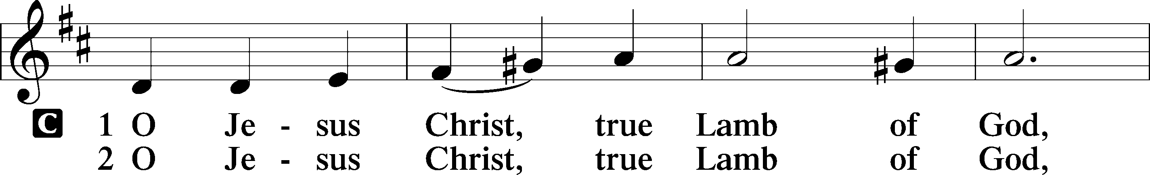
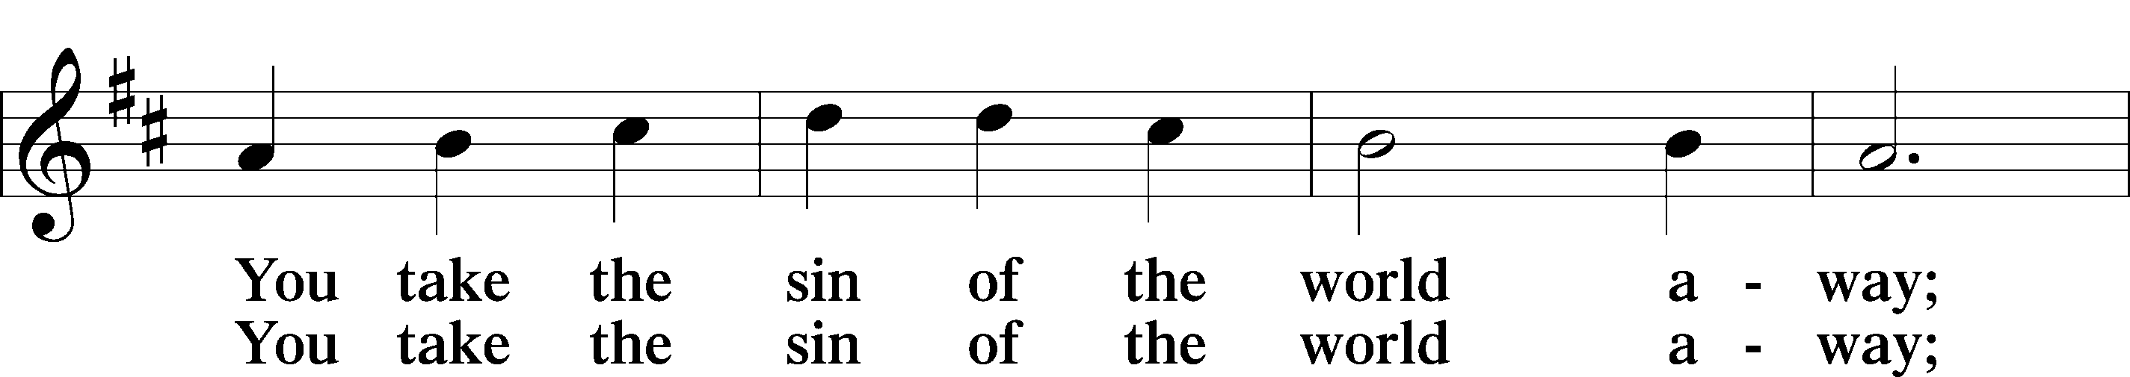
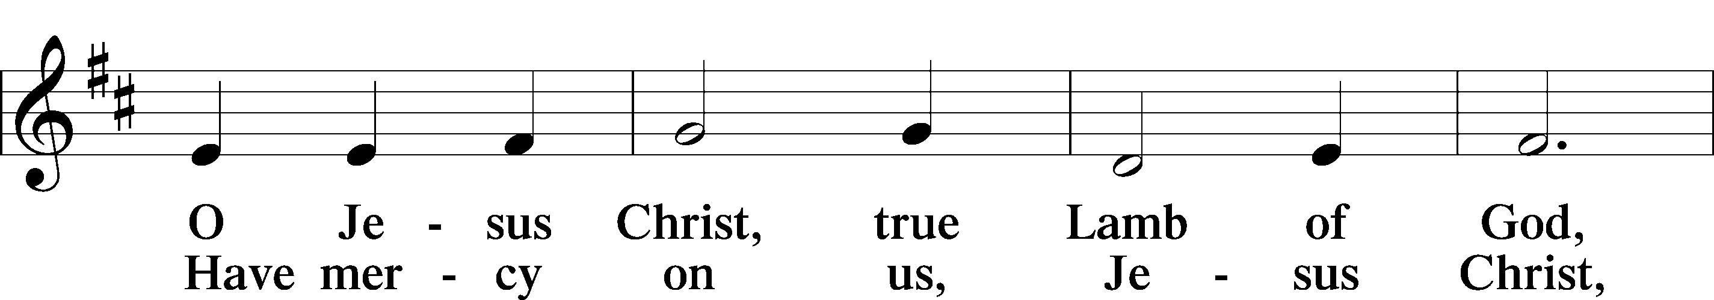
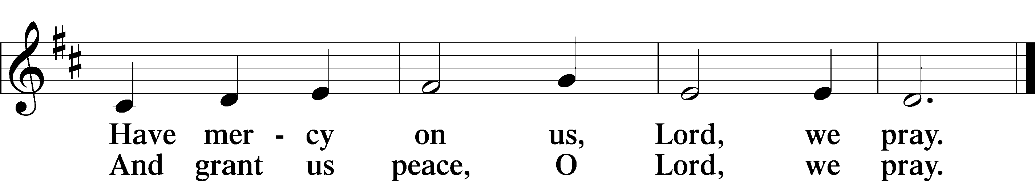
Text: Stephen P. Starke

Sit

Distribution

The pastor and those who assist him receive the body and blood of Christ first and then distribute them to those who come to receive, saying:

Take, eat; this is the true body of our Lord and Savior Jesus Christ, given into death for your sins.
Amen.

Take, drink; this is the true blood of our Lord and Savior Jesus Christ, shed for the forgiveness of your sins.
Amen.

In dismissing the communicants, the following is said:

The Dismissal
P The body and blood of our Lord Jesus Christ strengthen and preserve you in body and soul to life everlasting. Depart T in peace.
C Amen.

618 I Come, O Savior, to Thy Table
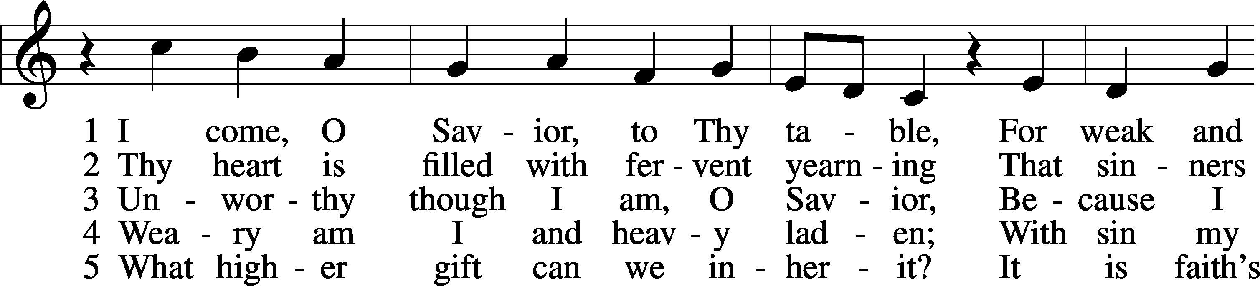
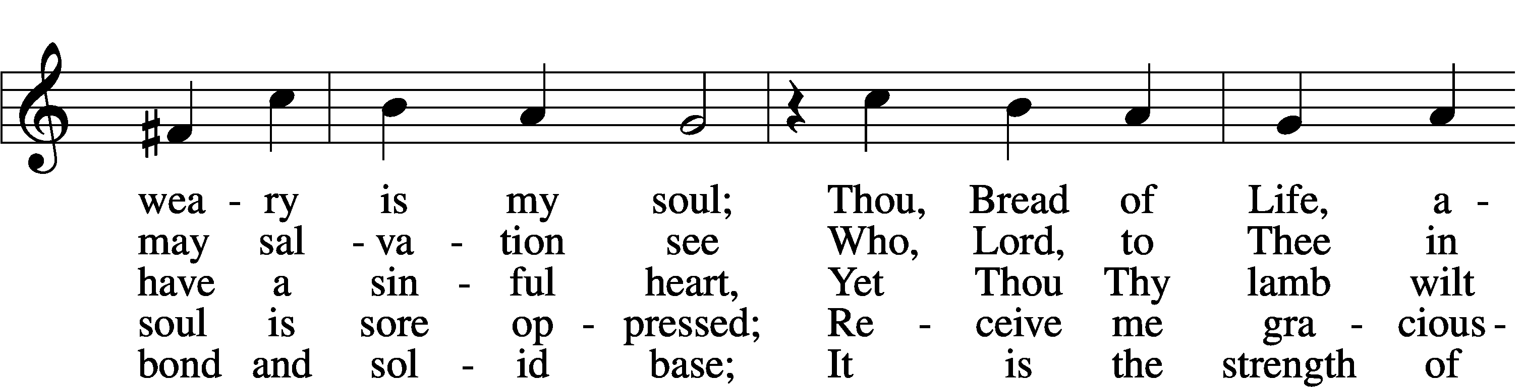
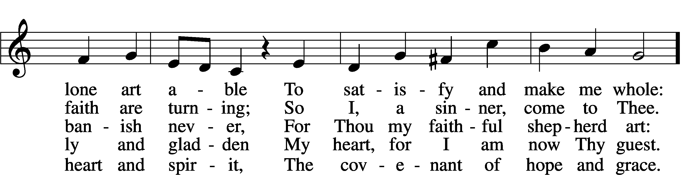
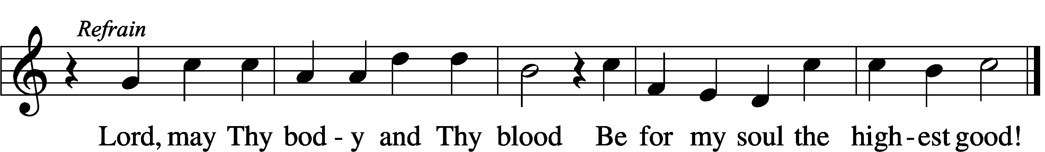
Text: Friedrich Christian Heyder, 1677–1754; tr. The Lutheran Hymnal, 1941, abr.
Tune: Emskirchner Choral-Buch, 1756, Leipzig
Text: © 1941 Concordia Publishing House. Used by permission: LSB Hymn License no. 110005011
Tune: Public domain

694 Thee Will I Love, My Strength, My Tower
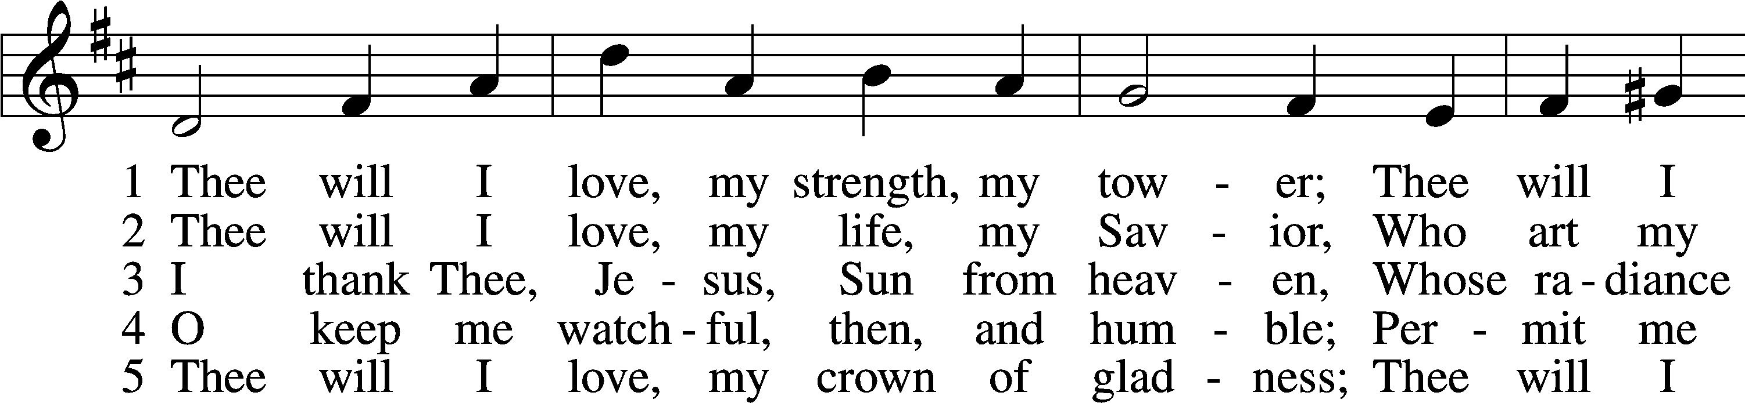
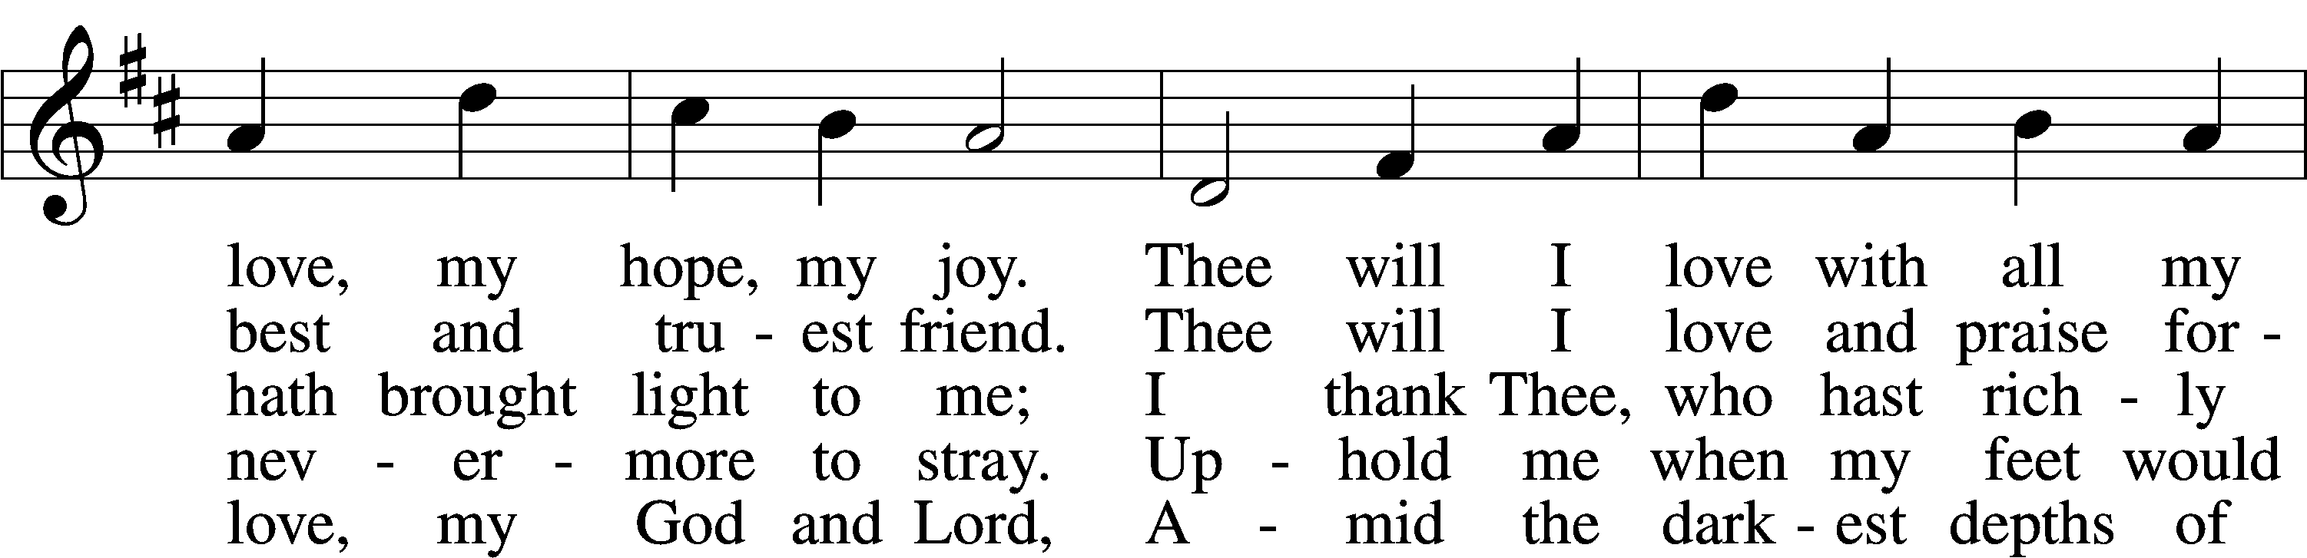
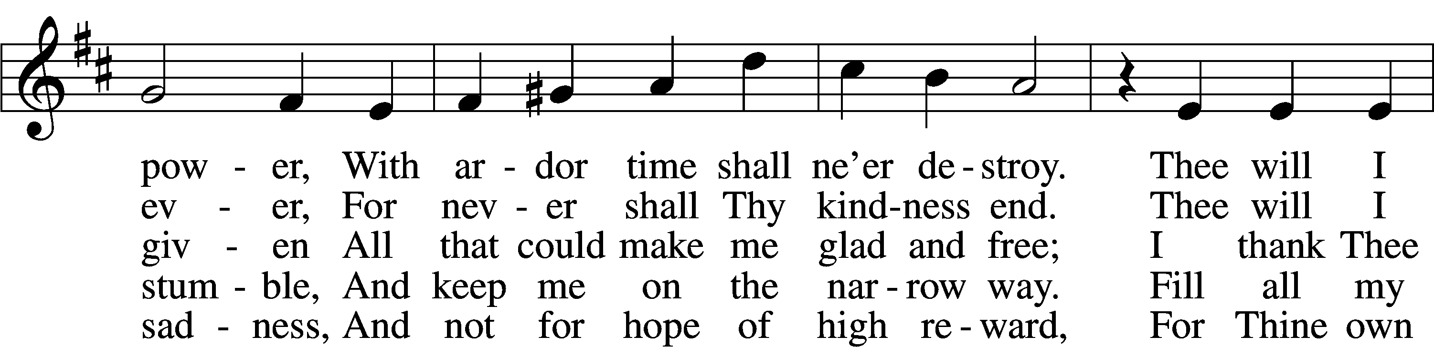
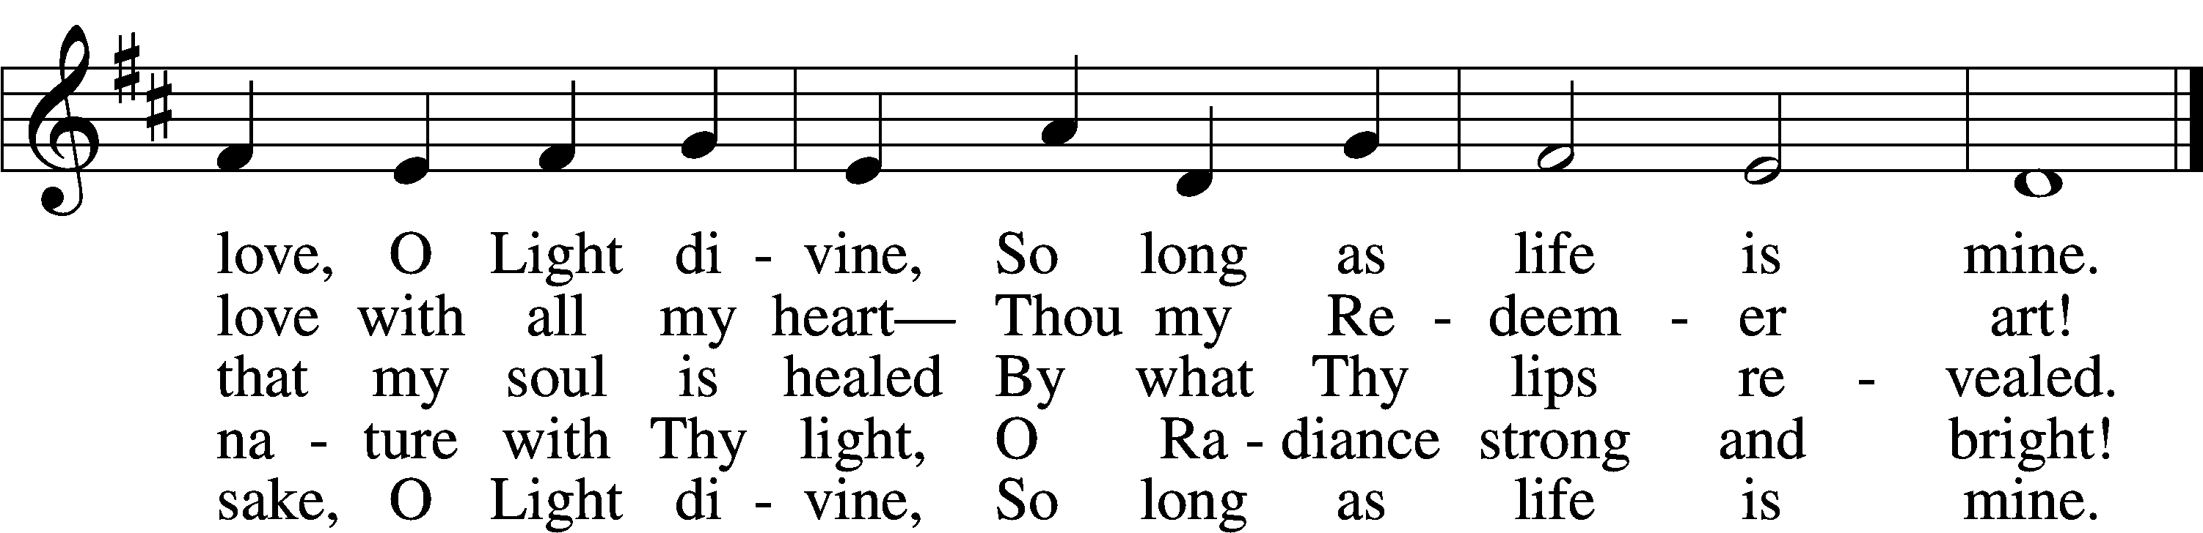
Text: Johann Scheffler, 1624–77; tr. Catherine Winkworth, 1827–78, alt.
Tune: Harmonischer Lieder-Schatz, 1738, Frankfurt
Text and tune: Public domain

571 God Loved the World So That He Gave
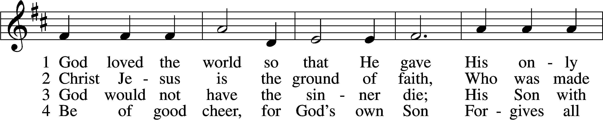
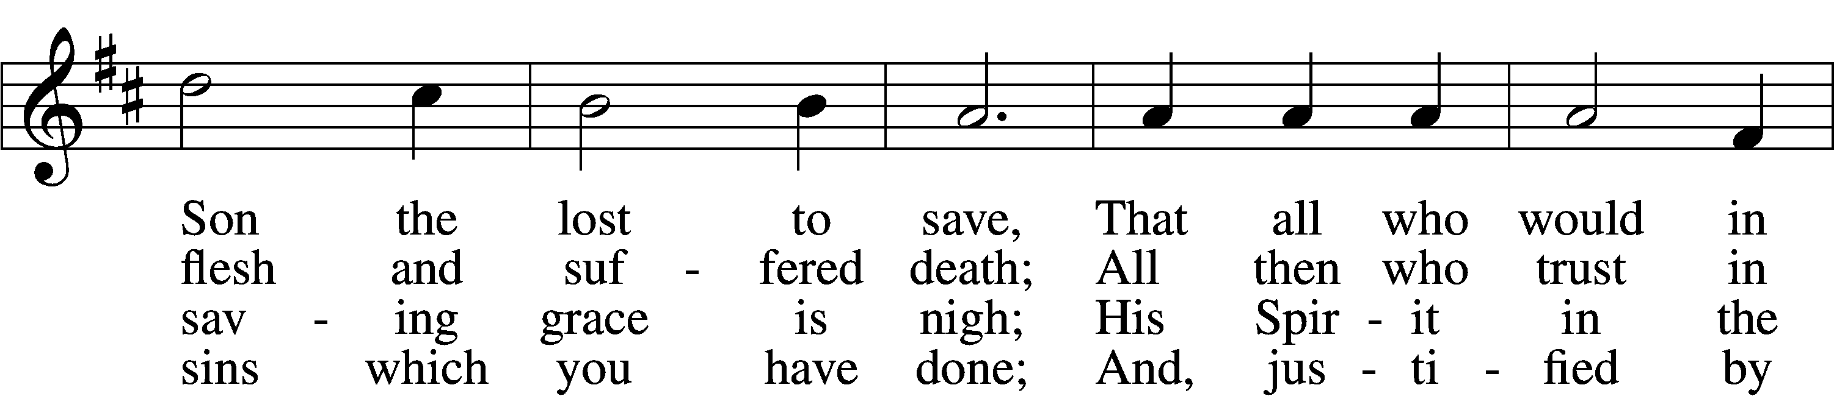
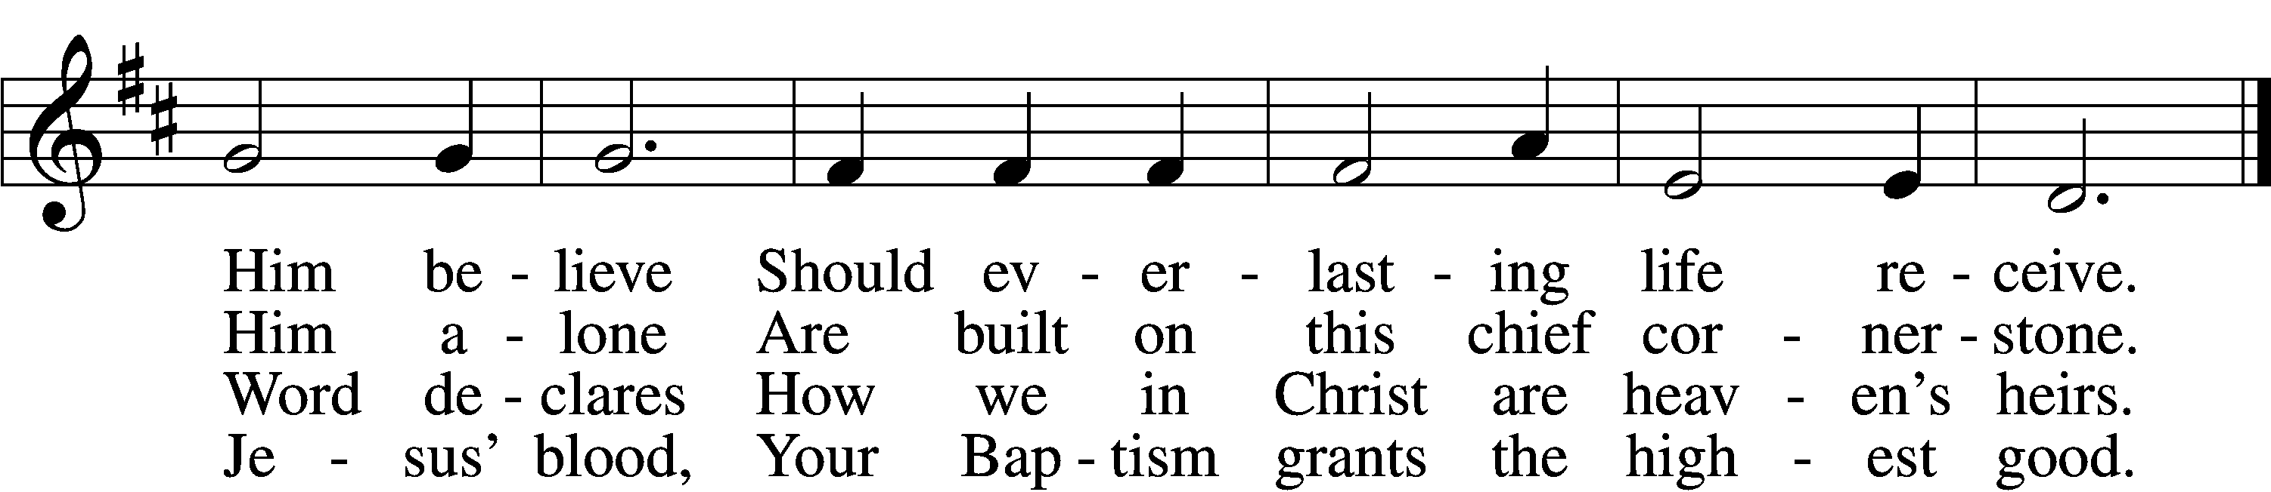

5 If you are sick, if death is near,
This truth your troubled heart can cheer:
Christ Jesus saves your soul from death;
That is the firmest ground of faith.

D 6 Glory to God the Father, Son,
And Holy Spirit, Three in One!
To You, O blessèd Trinity,
Be praise now and eternally!
Text: Heiliges Lippen- und Hertzens-Opffer, c. 1778, Stettin; tr. August Crull, 1845–1923, alt.
Tune: George J. Elvey, 1816–93
Text and tune: Public domain

617 O Lord, We Praise Thee
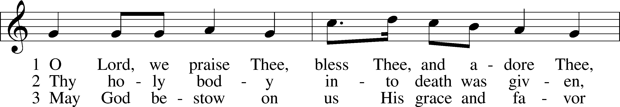
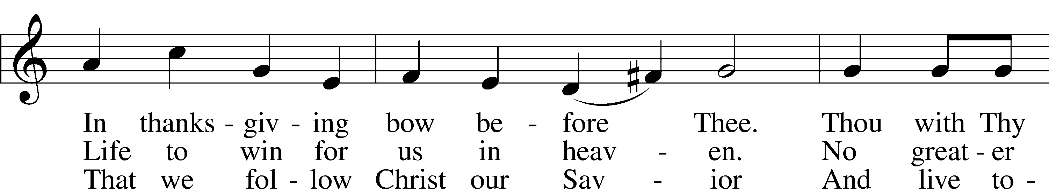
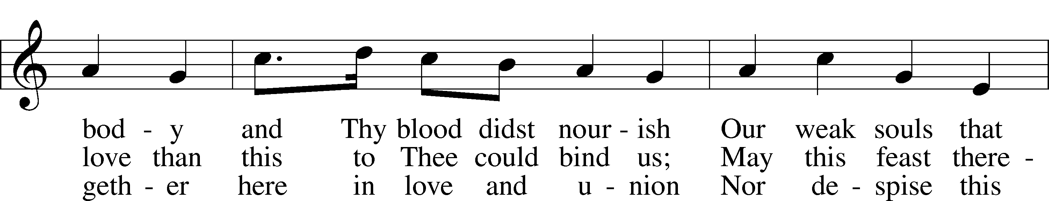
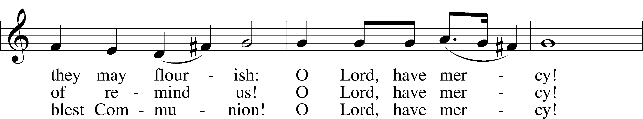
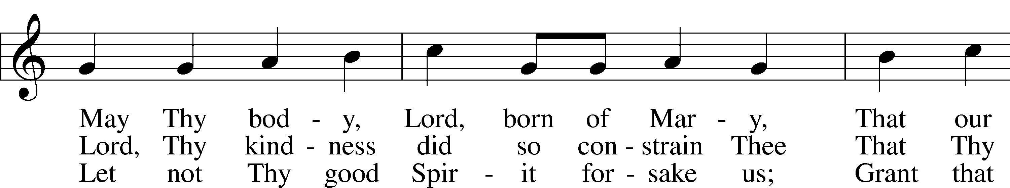
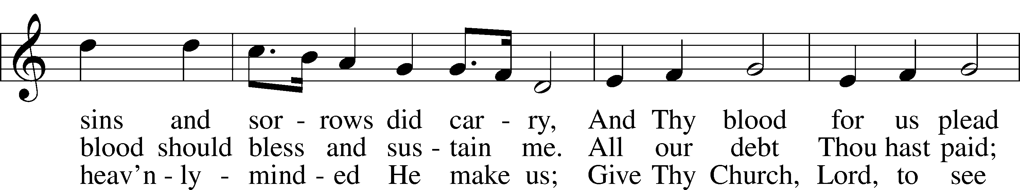
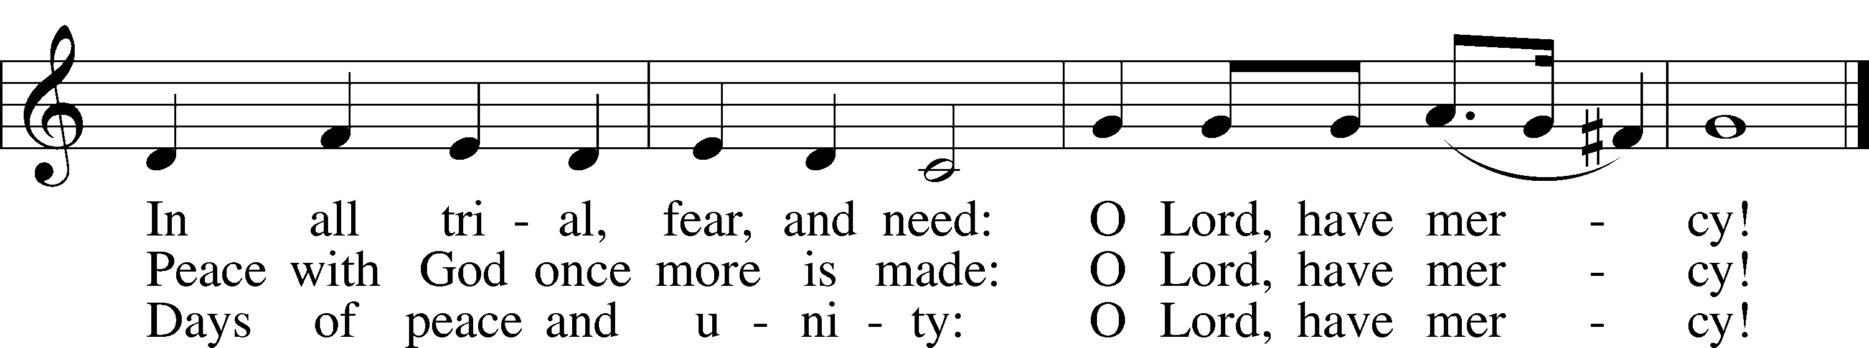
Text: tr. The Lutheran Hymnal, 1941, alt.; (st. 1): German, 14th cent.; (sts. 2–3): Martin Luther, 1483–1546
Tune: Geystliche gesangk Buchleyn, 1524, Wittenberg, ed. Johann Walter
Text: © 1941 Concordia Publishing House. Used by permission: LSB Hymn License no. 110005011
Tune: Public domain

Stand

Nunc Dimittis Luke 2:29–32
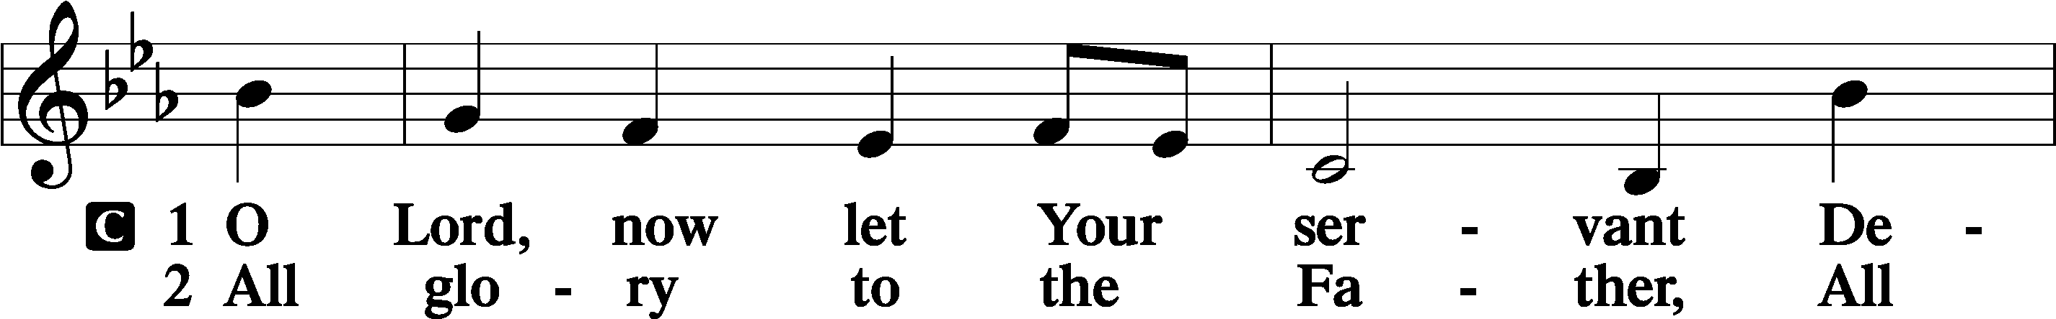
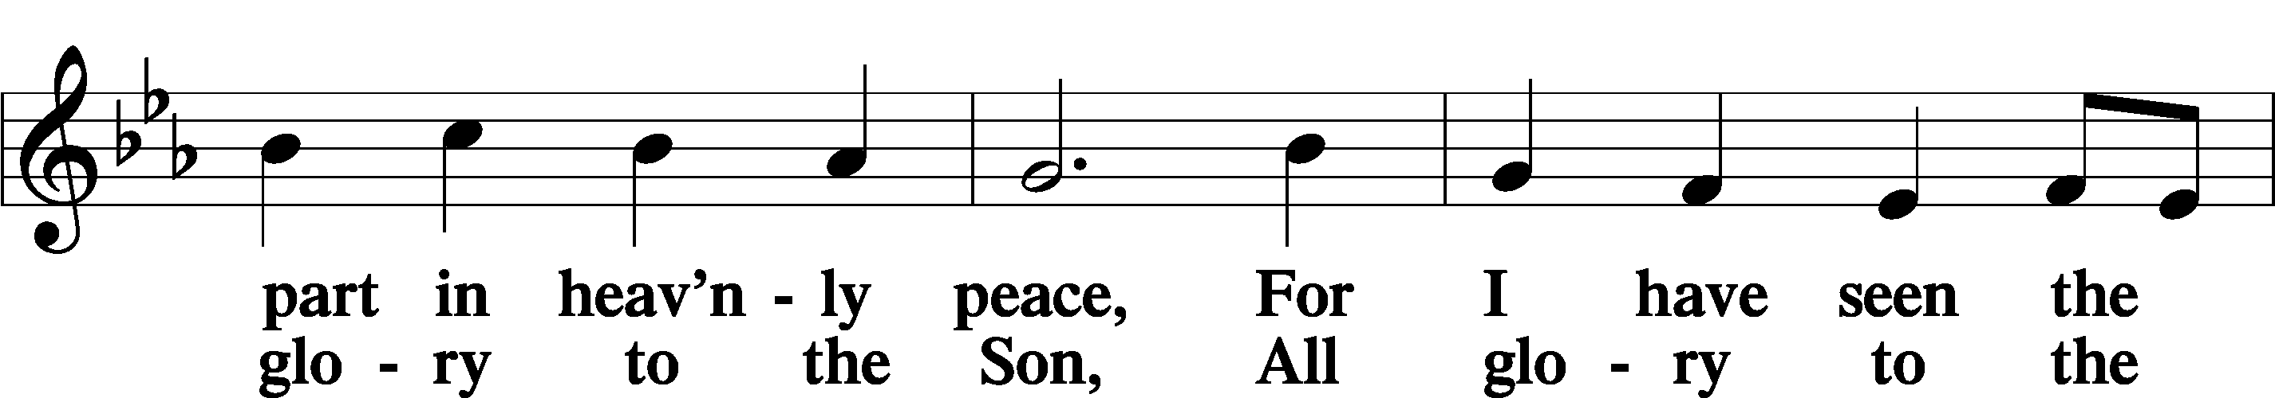
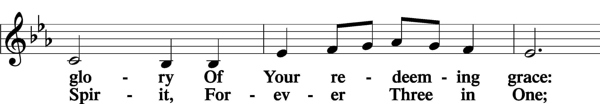
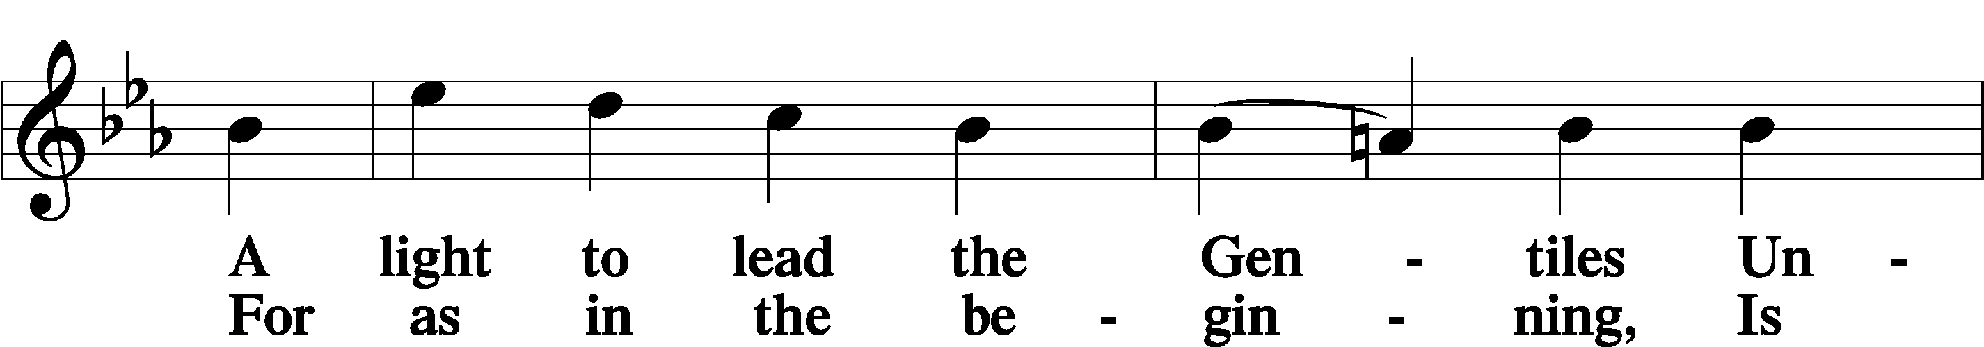
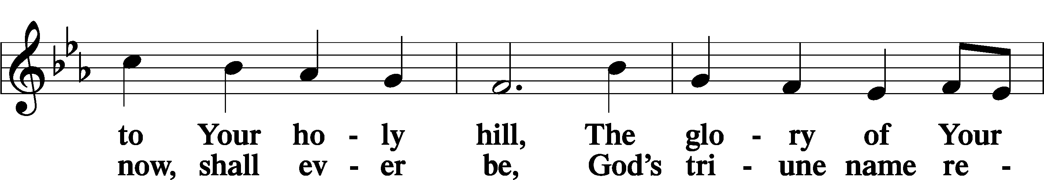
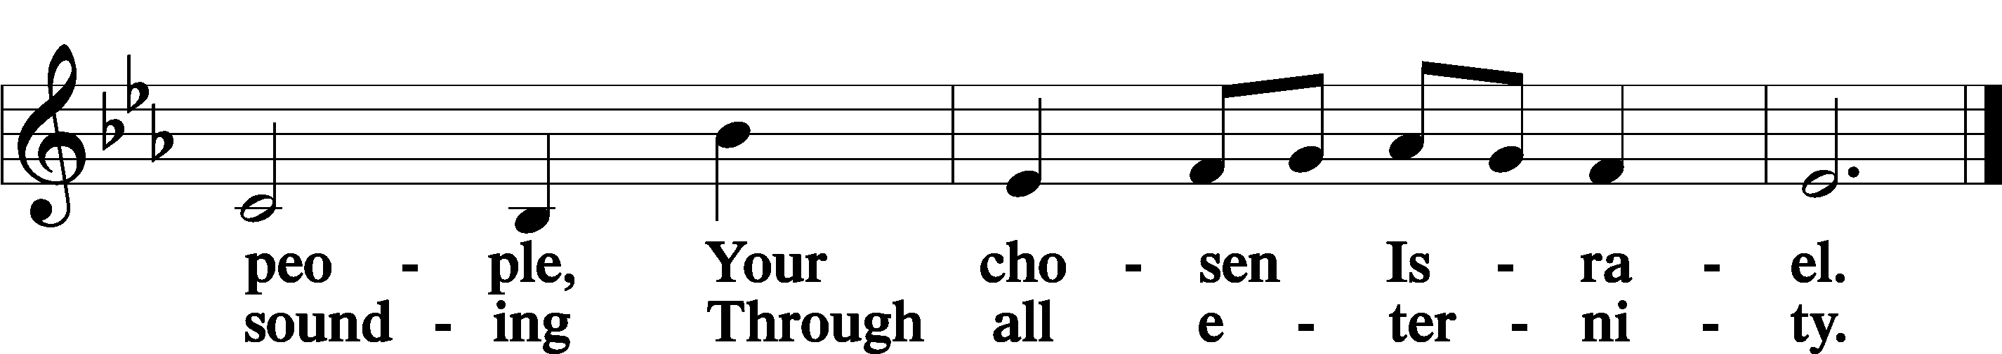

Post-Communion Collect
A Let us pray.
We give thanks to You, almighty God, that You have refreshed us through this salutary gift, and we implore You that of Your mercy You would strengthen us through the same in faith toward You and in fervent love toward one another; through Jesus Christ, Your Son, our Lord, who lives and reigns with You and the Holy Spirit, one God, now and forever.
C Amen.

Benedicamus Psalm 103:1
A Let us bless the Lord.
C Thanks be to God.

Benediction
P The Lord bless you and keep you.
The Lord make His face shine on you and be gracious to you.
The Lord look upon you with favor and T give you peace.
C Amen.

819 Sing Praise to God, the Highest Good
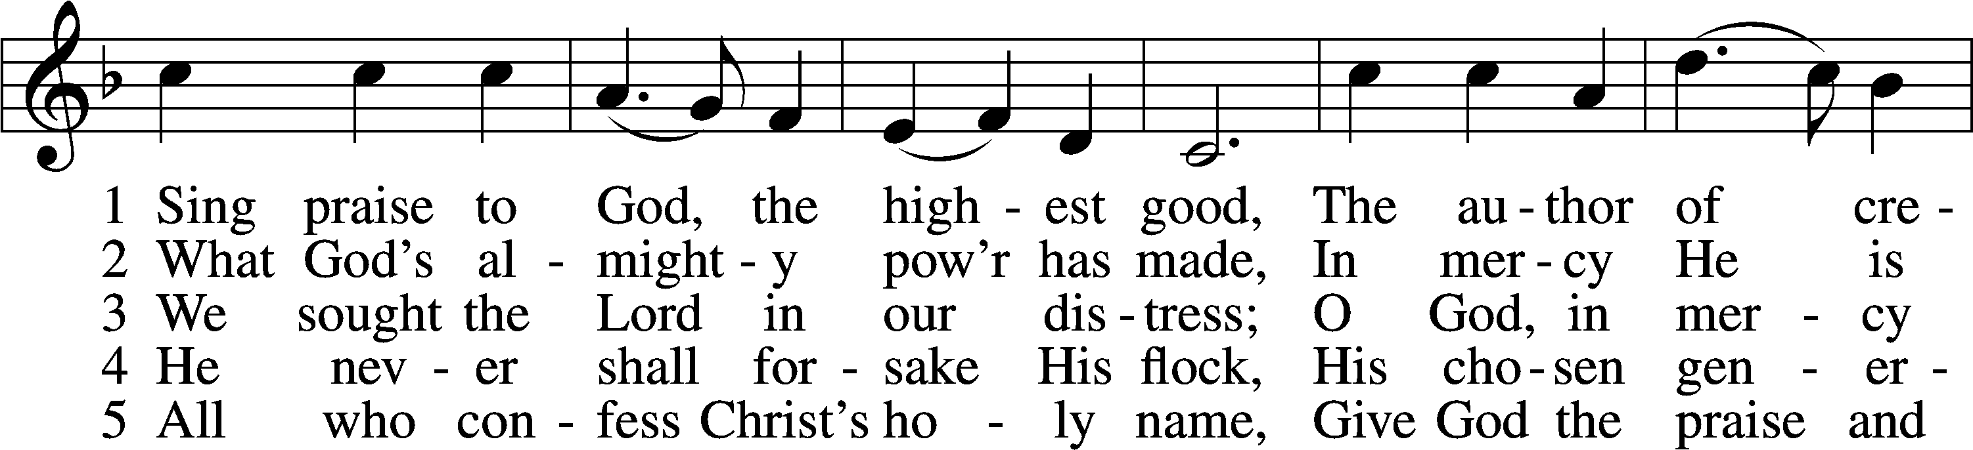
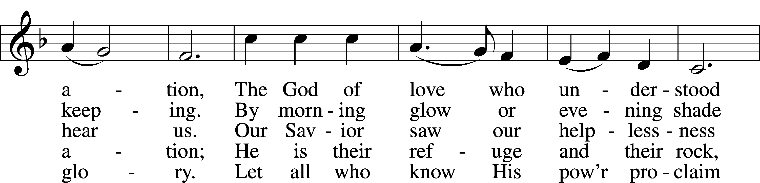
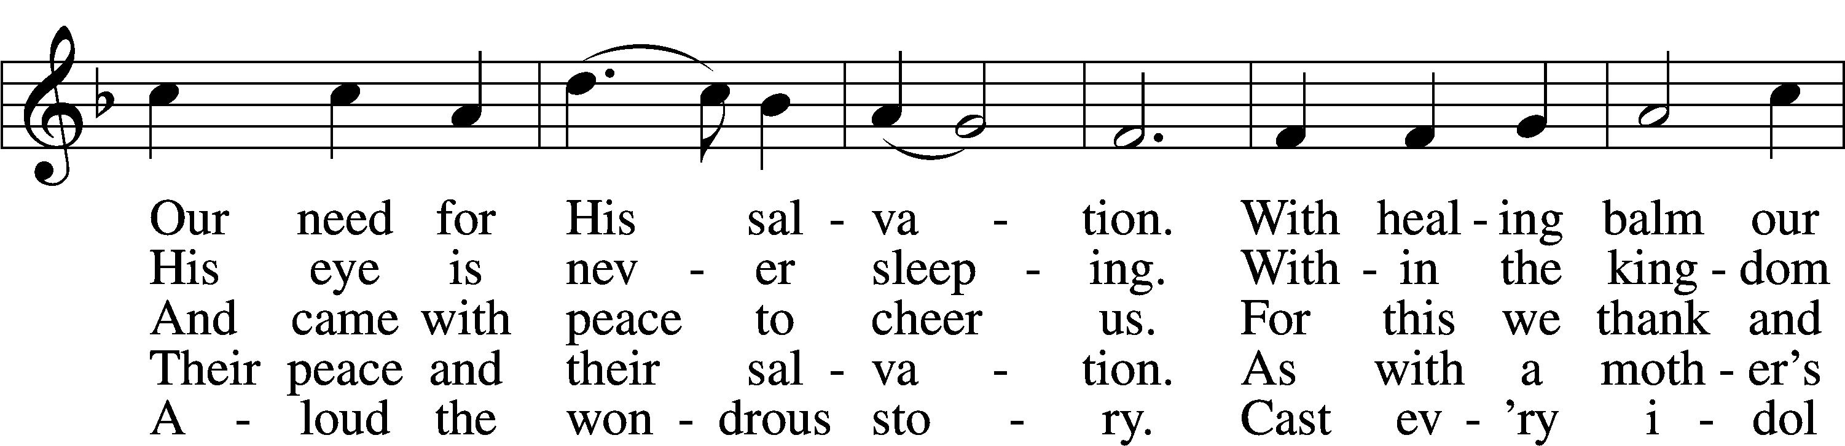
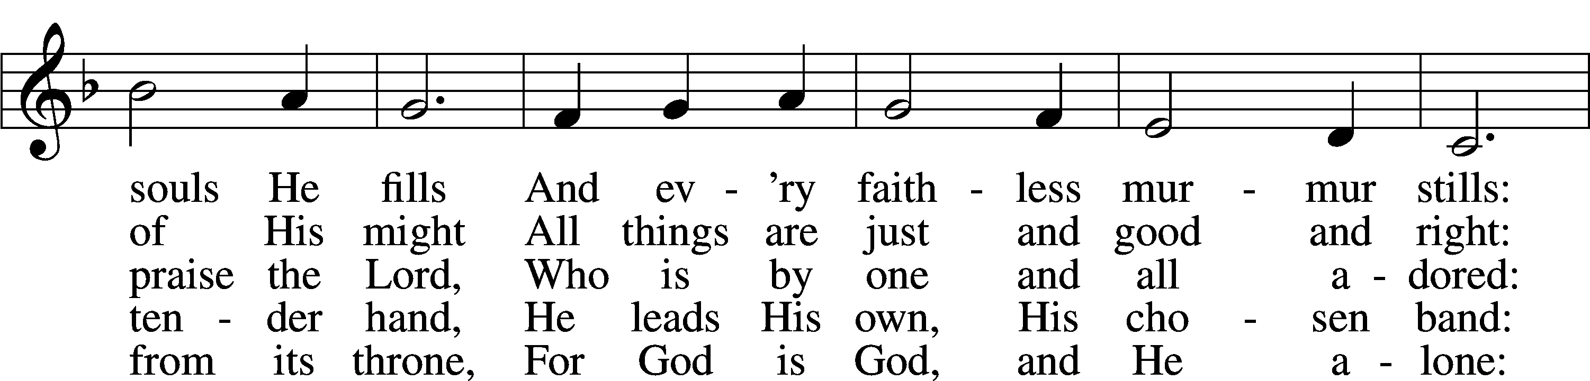
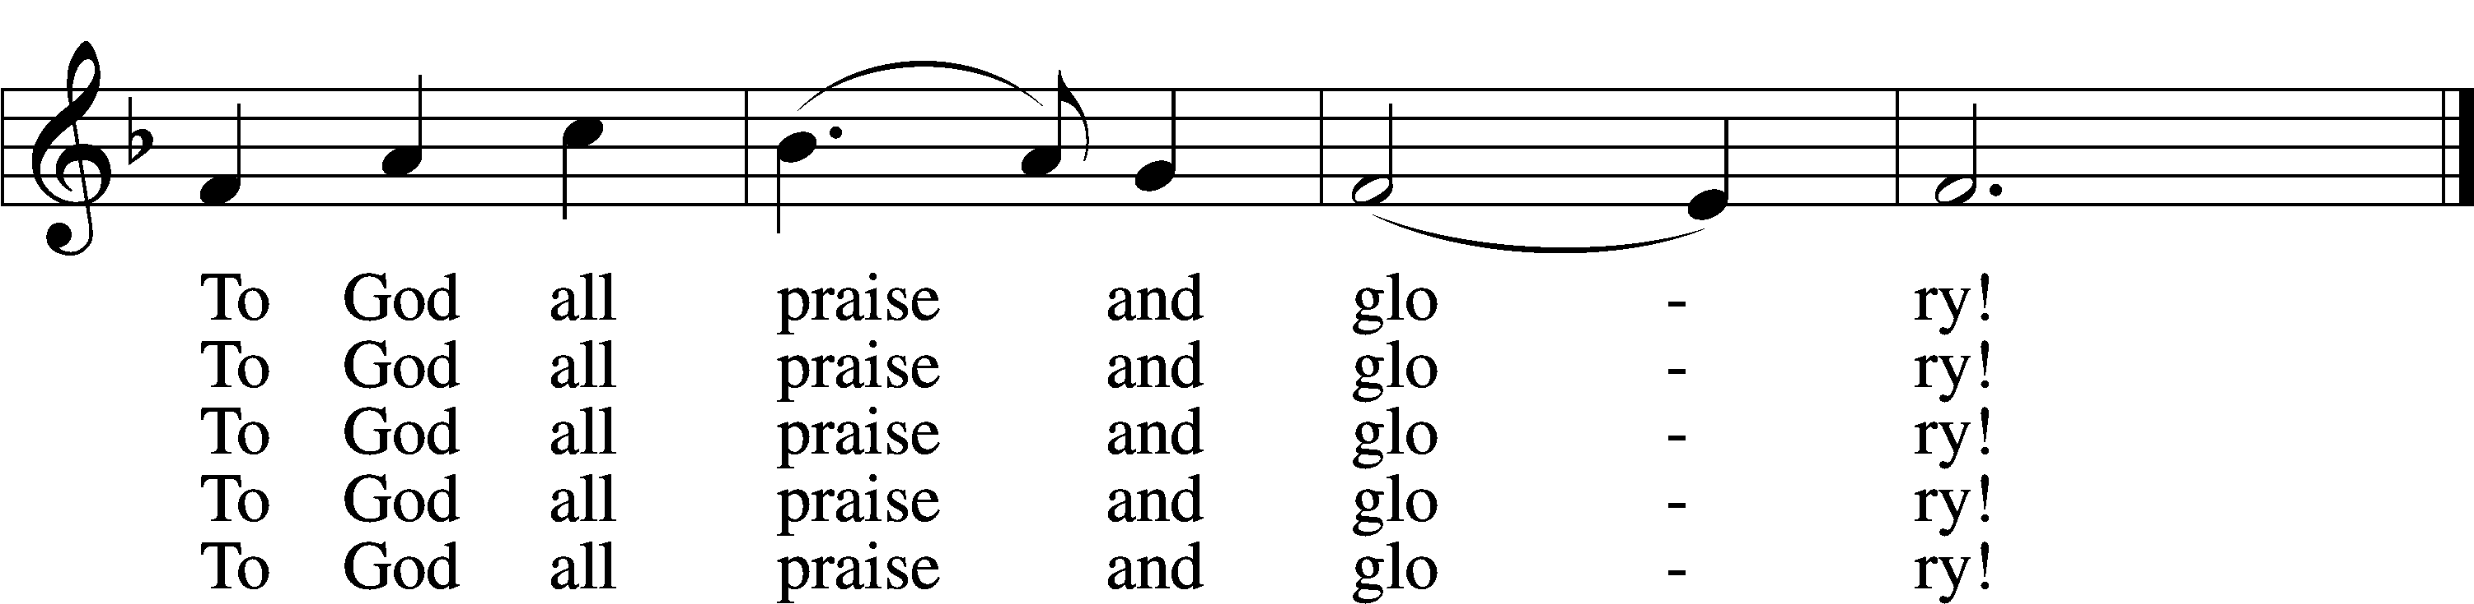
Text: Johann Jacob Schütz, 1640–90; (sts. 1–3, 5): tr. Frances E. Cox, 1812–97, adapt.; (st. 4): tr. Catherine Winkworth, 1827–78, adapt.
Tune: Melchior Vulpius, c. 1570–1615
Text and tune: Public domain
Acknowledgments
Divine Service, Setting Four from Lutheran Service Book
Unless otherwise indicated, Scripture quotations are from the ESV® Bible (The Holy Bible, English Standard Version®), copyright © 2001 by Crossway, a publishing ministry of Good News Publishers. Used by permission. All rights reserved.
Created by Lutheran Service Builder © 2026 Concordia Publishing House.

