On entering the church

P Lord, I love the habitation of Your house and the place

where Your glory dwells. In the multitude of Your tender

mercies prepare my heart that I may enter Your house to

worship and confess Your holy name; through Jesus Christ,

my God and Lord.

Before worship

C O Lord, our creator, redeemer, and comforter, as we come

together to worship You in spirit and in truth, we humbly

pray that You would open our hearts to the preaching of

Your Word so that we may repent of our sins, believe in

Jesus Christ as our only Savior, and grow in grace and

holiness. Hear us for His sake.

716 I Walk in Danger All the Way

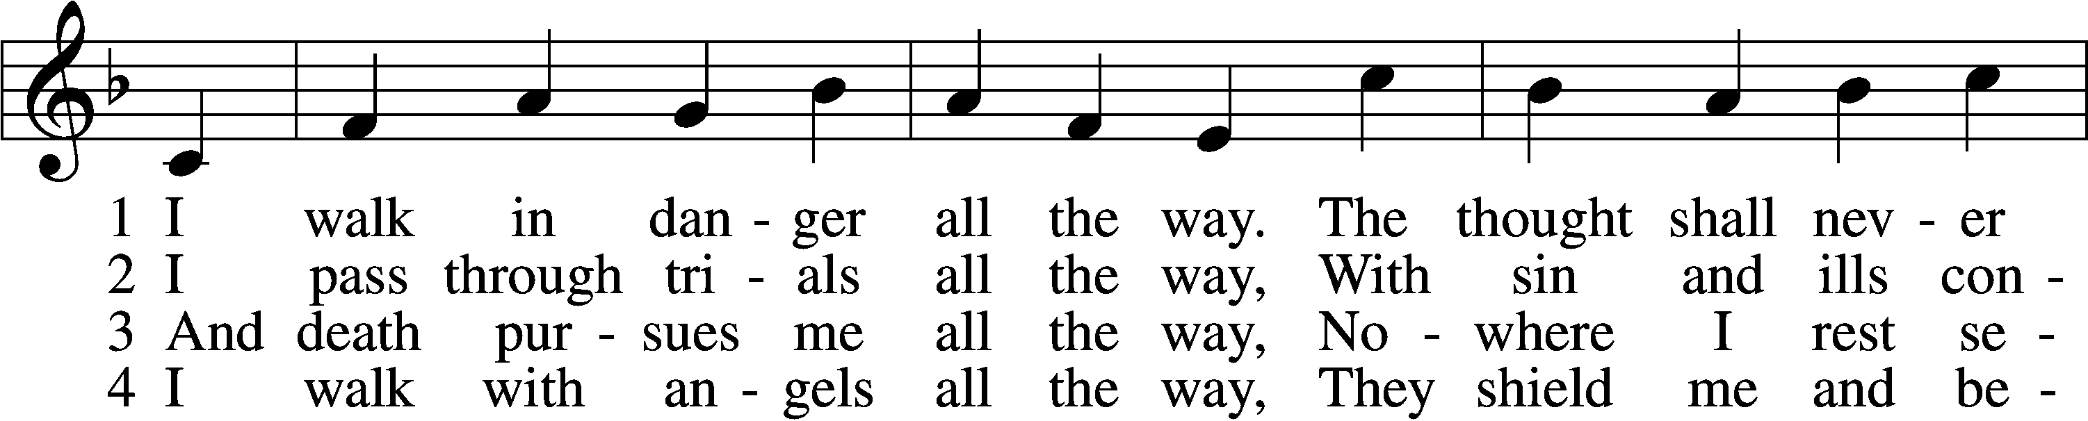

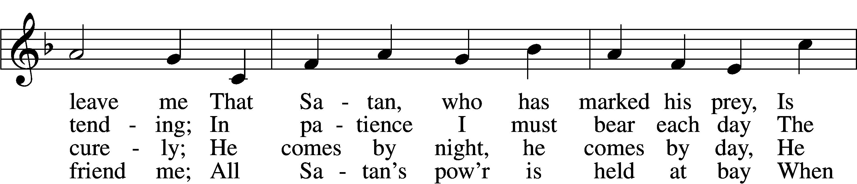

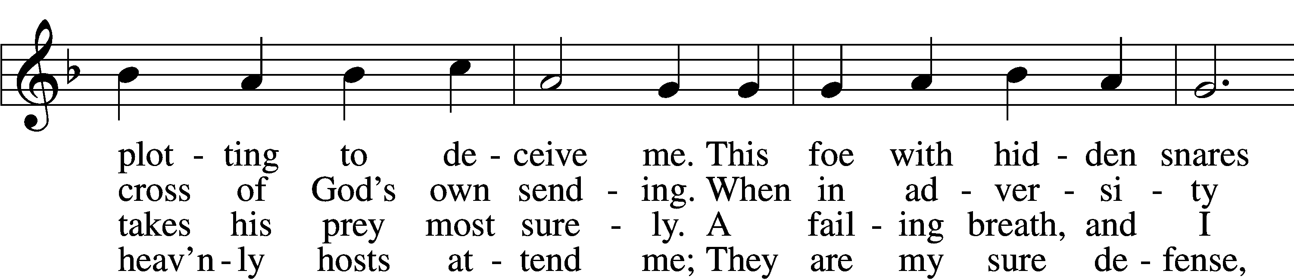

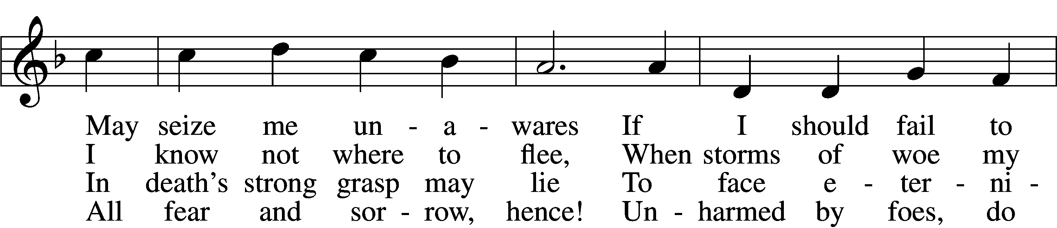

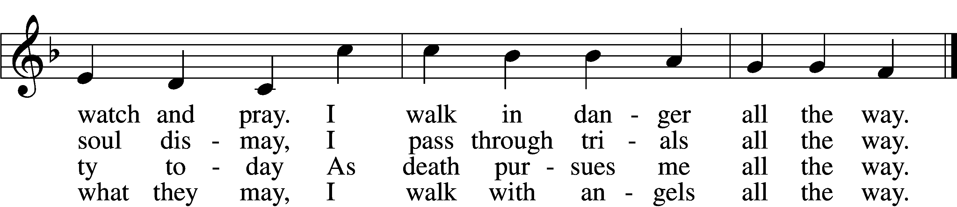

5 I walk with Jesus all the way,  
 His guidance never fails me;  
Within His wounds I find a stay  
 When Satan’s pow’r assails me;  
And by His footsteps led,  
My path I safely tread.  
 No evil leads my soul astray;  
 I walk with Jesus all the way.

6 My walk is heav’nward all the way;  
 Await, my soul, the morrow,  
When God’s good healing shall allay  
 All suff’ring, sin, and sorrow.  
Then, worldly pomp, begone!  
To heav’n I now press on.  
 For all the world I would not stay;  
 My walk is heav’nward all the way.

Text: Hans Adolf Brorson, 1694–1764; tr. Ditlef G. Ristad, 1863–1938, alt.  
Tune: Geist-reiches Gesang-Buch, 1708, 4th ed., Halle, ed. Johann A. Freylinghausen  
Text and tune: Public domain

# Confession and Absolution

The sign of the cross may be made by all in remembrance of their Baptism.

Invocation Matthew 28:19b; 18:20

P In the name of the Father and of the T Son and of the Holy Spirit.

C **Amen.**

Exhortation Hebrews 10:22; Psalm 124:8; Psalm 32:5

P Beloved in the Lord! Let us draw near with a true heart and confess our sins unto God our Father, beseeching Him in the name of our Lord Jesus Christ to grant us forgiveness.

P Our help is in the name of the Lord,

C **who made heaven and earth.**

P I said, I will confess my transgressions unto the Lord,

C **and You forgave the iniquity of my sin.**

Silence for reflection on God’s Word and for self-examination.

Confession of Sins

P Almighty God, our maker and redeemer, we poor sinners confess unto You that we are by nature sinful and unclean and that we have sinned against You by thought, word, and deed. Wherefore we flee for refuge to Your infinite mercy, seeking and imploring Your grace for the sake of our Lord Jesus Christ.

C **O most merciful God, who has given Your only-begotten Son to die for us, have mercy upon us and for His sake grant us remission of all our sins; and by Your Holy Spirit increase in us true knowledge of You and of Your will and true obedience to Your Word, to the end that by Your grace we may come to everlasting life; through Jesus Christ, our Lord. Amen.**

Declaration of Grace Mark 16:16; John 1:12

P Almighty God, our heavenly Father, has had mercy upon us and has given His only Son to die for us and for His sake forgives us all our sins. To those who believe on His name He gives power to become the children of God and has promised them His Holy Spirit. He that believes and is baptized shall be saved.  
  
Grant this, Lord, unto us all.

C **Amen.**

# Service of the Word

Introit Psalm 5:4–8; antiphon: Psalm 1:6

For the Lord knows the way of the righteous,  
 but the way of the wicked will perish.  
**For you are not a God who delights in wickedness;  
 evil may not dwell with you.**  
The boastful shall not stand before your eyes;  
 you hate all evildoers.  
**You destroy those who speak lies;  
 the Lord abhors the bloodthirsty and deceitful man.**  
But I, through the abundance of your steadfast love, will enter your house.  
 I will bow down toward your holy temple in the fear of you.  
**Lead me, O Lord, in your righteousness because of my enemies;  
 make your way straight before me.**

Gloria Patri

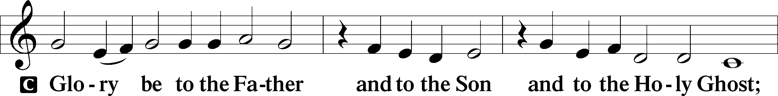

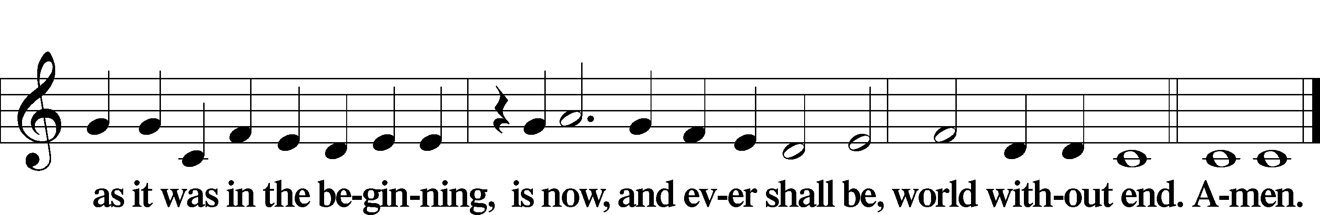

Kyrie Mark 10:47

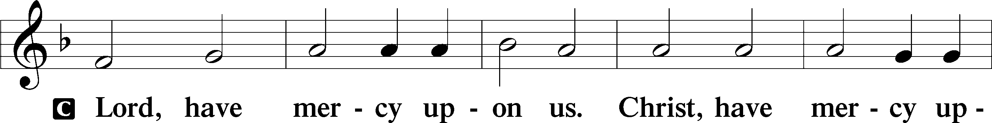

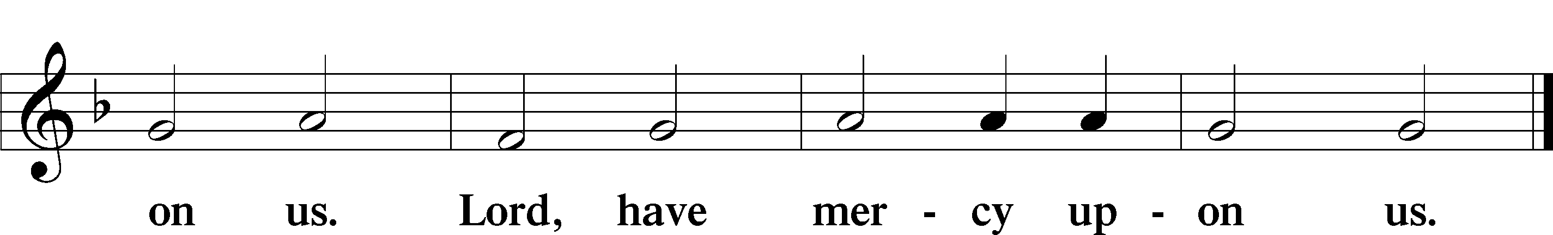

Salutation and Collect of the Day

P The Lord be with you.

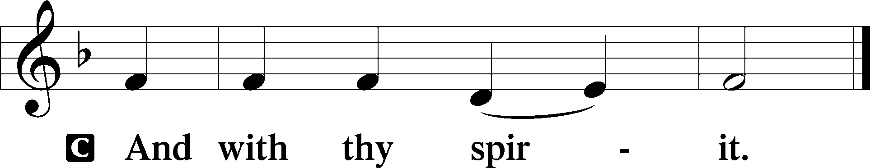

P Let us pray.

O God, whose glory it is always to have mercy, be gracious to all who have gone astray from Your ways and bring them again with penitent hearts and steadfast faith to embrace and hold fast the unchangeable truth of Your Word; through Jesus Christ, Your Son, our Lord, who lives and reigns with You and the Holy Spirit, one God, now and forever.

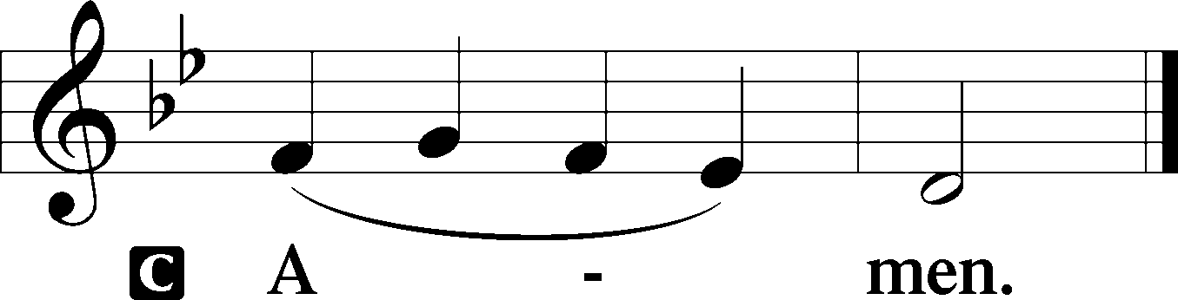

Sit

Old Testament Reading Ezekiel 33:7–20

7“So you, son of man, I have made a watchman for the house of Israel. Whenever you hear a word from my mouth, you shall give them warning from me. 8If I say to the wicked, O wicked one, you shall surely die, and you do not speak to warn the wicked to turn from his way, that wicked person shall die in his iniquity, but his blood I will require at your hand. 9But if you warn the wicked to turn from his way, and he does not turn from his way, that person shall die in his iniquity, but you will have delivered your soul.

10“And you, son of man, say to the house of Israel, Thus have you said: ‘Surely our transgressions and our sins are upon us, and we rot away because of them. How then can we live?’ 11Say to them, As I live, declares the Lord God, I have no pleasure in the death of the wicked, but that the wicked turn from his way and live; turn back, turn back from your evil ways, for why will you die, O house of Israel?

12“And you, son of man, say to your people, The righteousness of the righteous shall not deliver him when he transgresses, and as for the wickedness of the wicked, he shall not fall by it when he turns from his wickedness, and the righteous shall not be able to live by his righteousness when he sins. 13Though I say to the righteous that he shall surely live, yet if he trusts in his righteousness and does injustice, none of his righteous deeds shall be remembered, but in his injustice that he has done he shall die. 14Again, though I say to the wicked, ‘You shall surely die,’ yet if he turns from his sin and does what is just and right, 15if the wicked restores the pledge, gives back what he has taken by robbery, and walks in the statutes of life, not doing injustice, he shall surely live; he shall not die. 16None of the sins that he has committed shall be remembered against him. He has done what is just and right; he shall surely live.

17“Yet your people say, ‘The way of the Lord is not just,’ when it is their own way that is not just. 18When the righteous turns from his righteousness and does injustice, he shall die for it. 19And when the wicked turns from his wickedness and does what is just and right, he shall live by them. 20Yet you say, ‘The way of the Lord is not just.’ O house of Israel, I will judge each of you according to his ways.”

A This is the Word of the Lord.

C **Thanks be to God.**

Gradual Hebrews 12:2

[O come, let us fix our eyes on] Jesus,  
 the founder and perfecter of our faith,  
**who for the joy that was set before him endured the cross, despising the shame,  
 and is seated at the right hand of the throne of God.**

Epistle 1 Corinthians 10:1–13

1I want you to know, brothers, that our fathers were all under the cloud, and all passed through the sea, 2and all were baptized into Moses in the cloud and in the sea, 3and all ate the same spiritual food, 4and all drank the same spiritual drink. For they drank from the spiritual Rock that followed them, and the Rock was Christ. 5Nevertheless, with most of them God was not pleased, for they were overthrown in the wilderness.

6Now these things took place as examples for us, that we might not desire evil as they did. 7Do not be idolaters as some of them were; as it is written, “The people sat down to eat and drink and rose up to play.” 8We must not indulge in sexual immorality as some of them did, and twenty-three thousand fell in a single day. 9We must not put Christ to the test, as some of them did and were destroyed by serpents, 10nor grumble, as some of them did and were destroyed by the Destroyer. 11Now these things happened to them as an example, but they were written down for our instruction, on whom the end of the ages has come. 12Therefore let anyone who thinks that he stands take heed lest he fall. 13No temptation has overtaken you that is not common to man. God is faithful, and he will not let you be tempted beyond your ability, but with the temptation he will also provide the way of escape, that you may be able to endure it.

Stand

Holy Gospel Luke 13:1–9

P The Holy Gospel according to St. Luke, the thirteenth chapter.

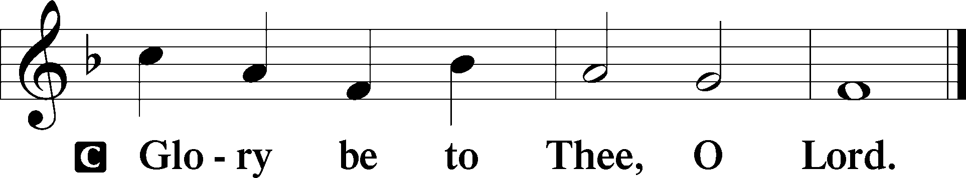

1There were some present at that very time who told [Jesus] about the Galileans whose blood Pilate had mingled with their sacrifices. 2And he answered them, “Do you think that these Galileans were worse sinners than all the other Galileans, because they suffered in this way? 3No, I tell you; but unless you repent, you will all likewise perish. 4Or those eighteen on whom the tower in Siloam fell and killed them: do you think that they were worse offenders than all the others who lived in Jerusalem? 5No, I tell you; but unless you repent, you will all likewise perish.”

6And he told this parable: “A man had a fig tree planted in his vineyard, and he came seeking fruit on it and found none. 7And he said to the vinedresser, ‘Look, for three years now I have come seeking fruit on this fig tree, and I find none. Cut it down. Why should it use up the ground?’ 8And he answered him, ‘Sir, let it alone this year also, until I dig around it and put on manure. 9Then if it should bear fruit next year, well and good; but if not, you can cut it down.’”

P This is the Gospel of the Lord.

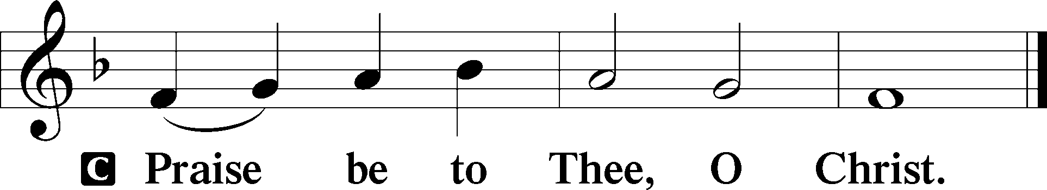

Apostles’ Creed

C **I believe in God, the Father Almighty,**

**maker of heaven and earth.**

**And in Jesus Christ, His only Son, our Lord,**

**who was conceived by the Holy Spirit,**

**born of the virgin Mary,**

**suffered under Pontius Pilate,**

**was crucified, died and was buried.**

**He descended into hell.**

**The third day He rose again from the dead.**

**He ascended into heaven**

**and sits at the right hand of God the Father Almighty.**

**From thence He will come to judge the living and the dead.**

**I believe in the Holy Spirit,**

**the holy Christian Church,**

**the communion of saints,**

**the forgiveness of sins,**

**the resurrection of the body,**

**and the life** T **everlasting. Amen.**

Sit

Children's Sermon

579 The Law of God Is Good and Wise

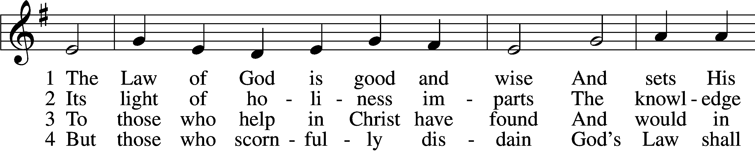

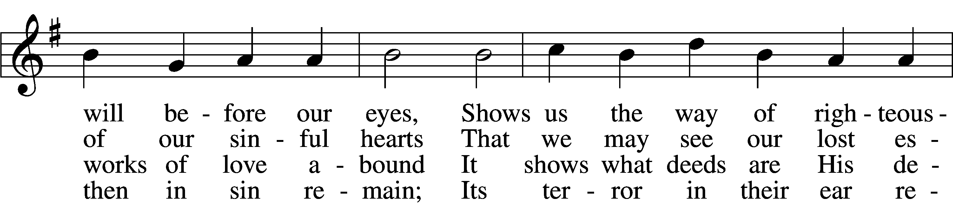

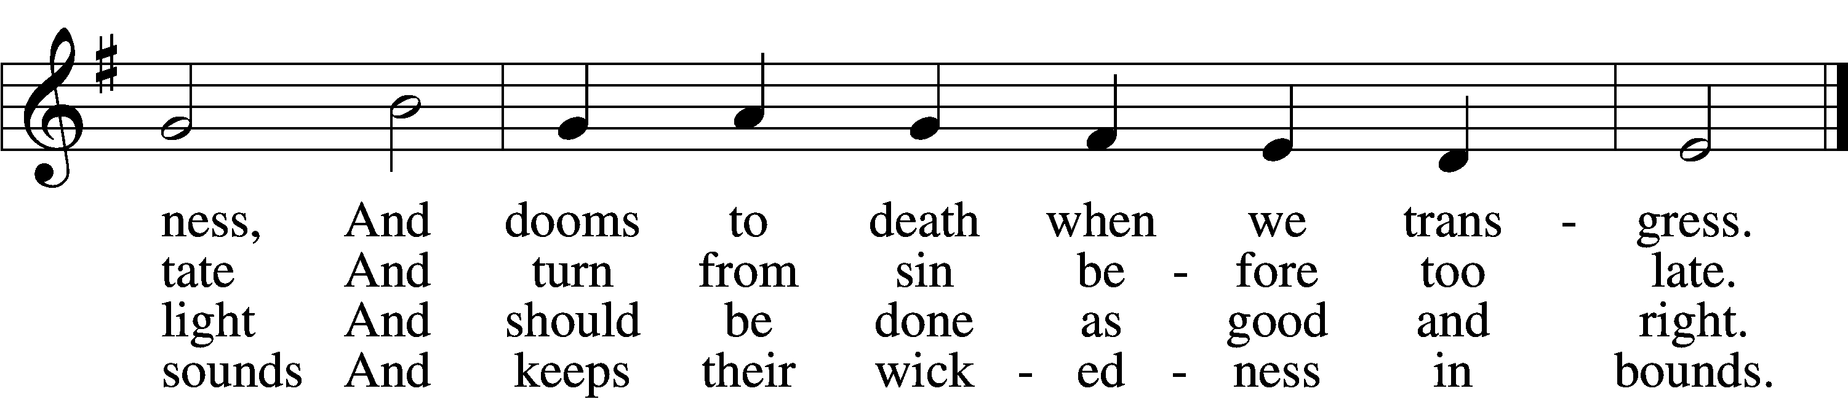

5 The Law is good; but since the fall  
Its holiness condemns us all;  
It dooms us for our sin to die  
And has no pow’r to justify.

6 To Jesus we for refuge flee,  
Who from the curse has set us free,  
And humbly worship at His throne,  
Saved by His grace through faith alone.

Text: Matthias Loy, 1828–1915, alt.  
Tune: Geistliche Lieder auffs new gebessert, 1543, Wittenberg, ed. Joseph Klug  
Text and tune: Public domain

Sermon

Votum

P The peace of God, which passes all understanding, keep your hearts and minds in Christ Jesus.

C **Amen.**

Stand

Offertory Psalm 51:10–12

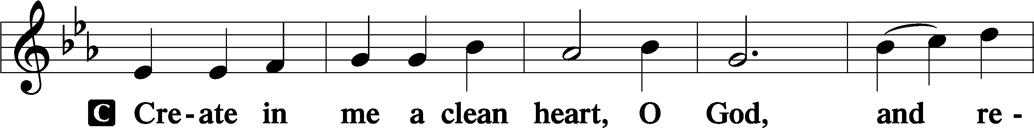

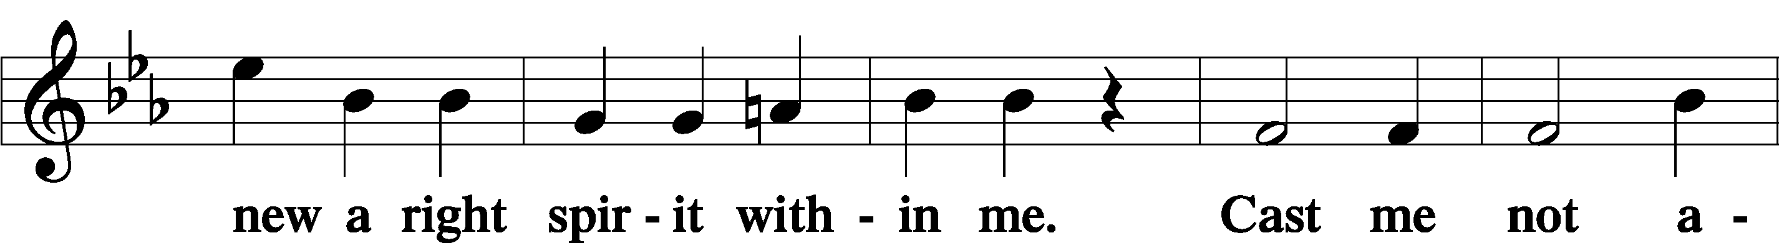

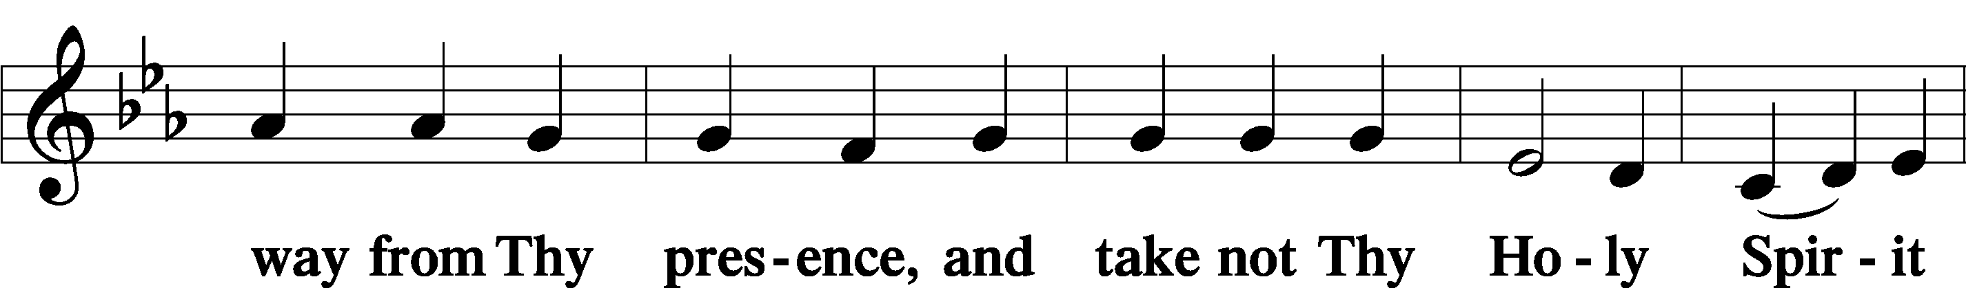

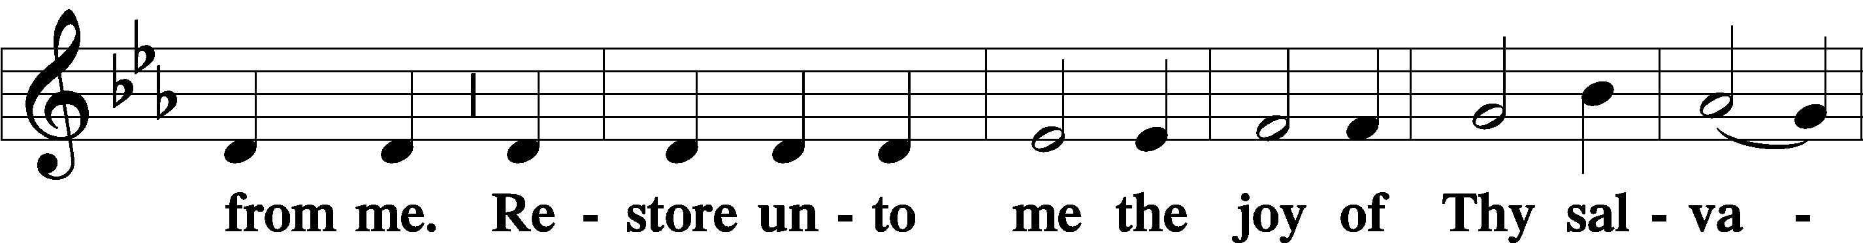

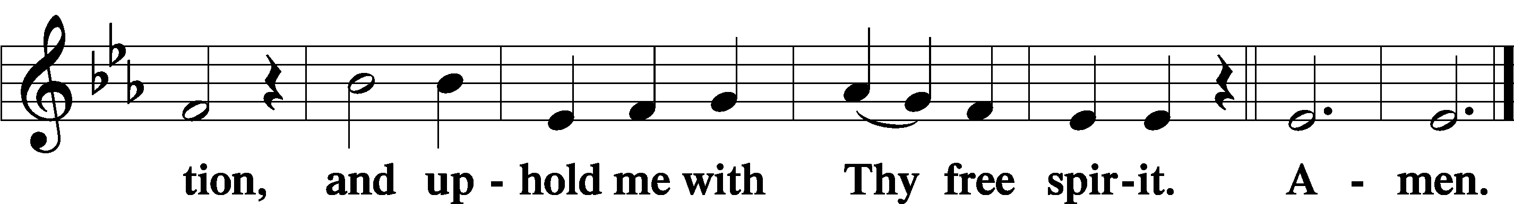

Offering

805 Praise God, from Whom All Blessings Flow

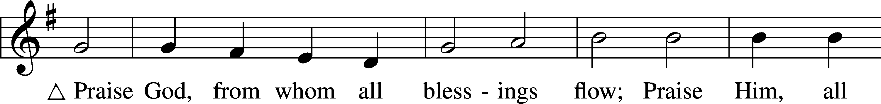

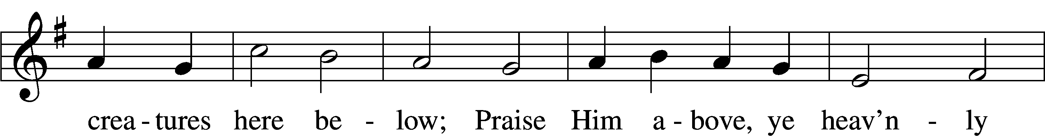

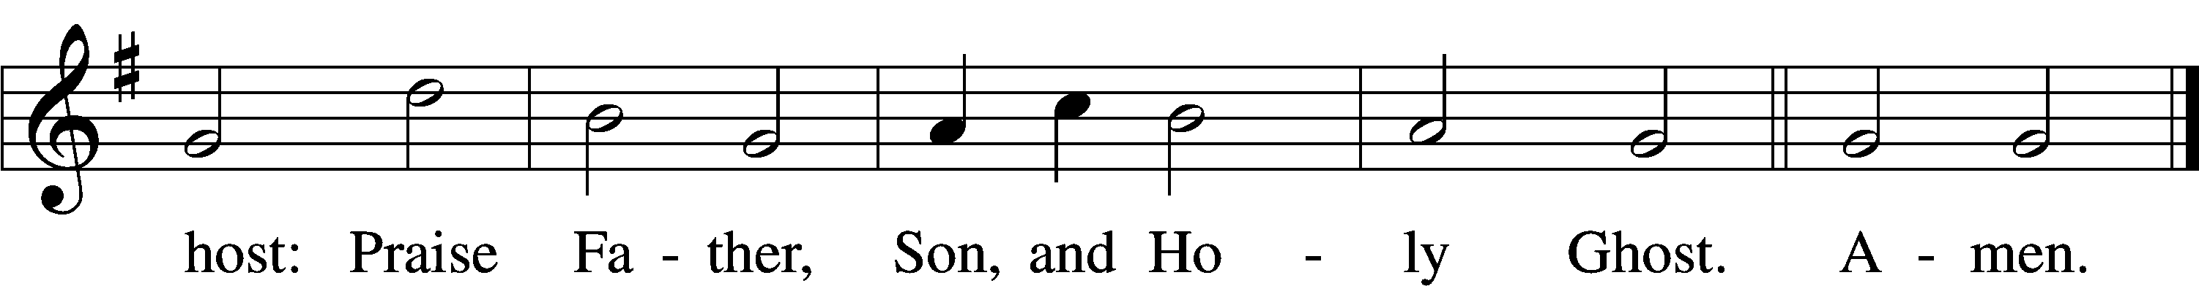

Text: Thomas Ken, 1637–1711  
Tune: Trente quatre Pseaumes de David, 1551, Geneva, ed. Louis Bourgeois  
Text and tune: Public domain

Prayer of the Church

Lord’s Prayer Matthew 6:9–13

P Lord, remember us in Your kingdom and teach us to pray:

C **Our Father who art in heaven,**

**hallowed be Thy name,**

**Thy kingdom come,**

**Thy will be done on earth**

**as it is in heaven;**

**give us this day our daily bread;**

**and forgive us our trespasses**

**as we forgive those**

**who trespass against us;**

**and lead us not into temptation,**

**but deliver us from evil.**

**For Thine is the kingdom**

**and the power and the glory**

**forever and ever. Amen.**

Collect for the Word

Blessed Lord, You have caused all Holy Scriptures to be written for our learning. Grant that we may so hear them, read, mark, learn, and inwardly digest them that, by the patience and comfort of Your holy Word, we may embrace and ever hold fast the blessed hope of everlasting life; through Jesus Christ, Your Son, our Lord, who lives and reigns with You and the Holy Spirit, one God, now and forever.

Benediction

P The Lord bless you and keep you.

The Lord make His face shine on you and be gracious to you.

The Lord look upon you with favor and T give you peace.

C **Amen.**

609 Jesus Sinners Doth Receive

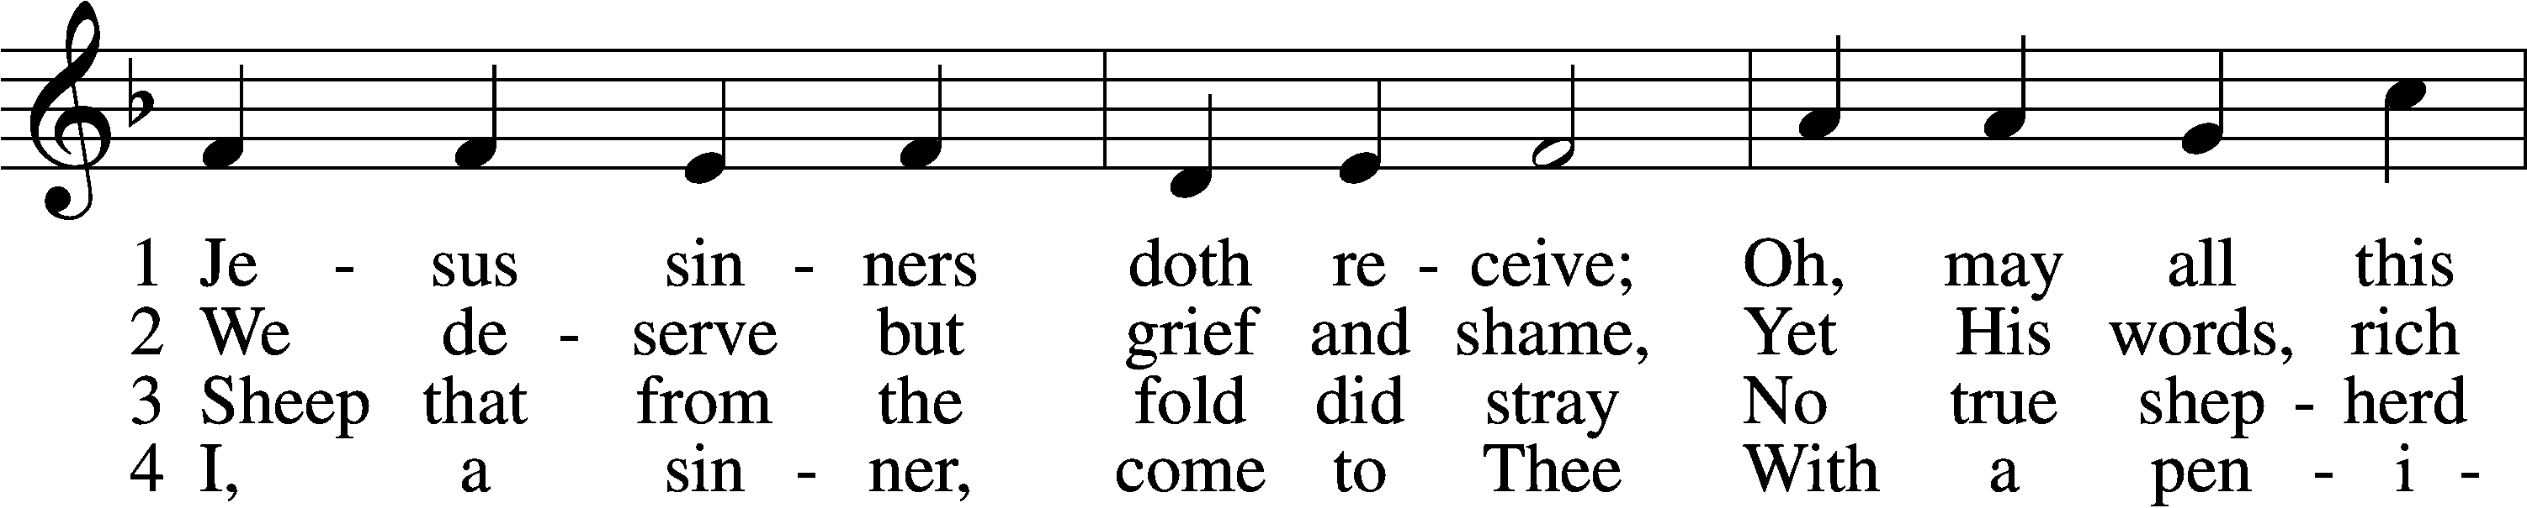

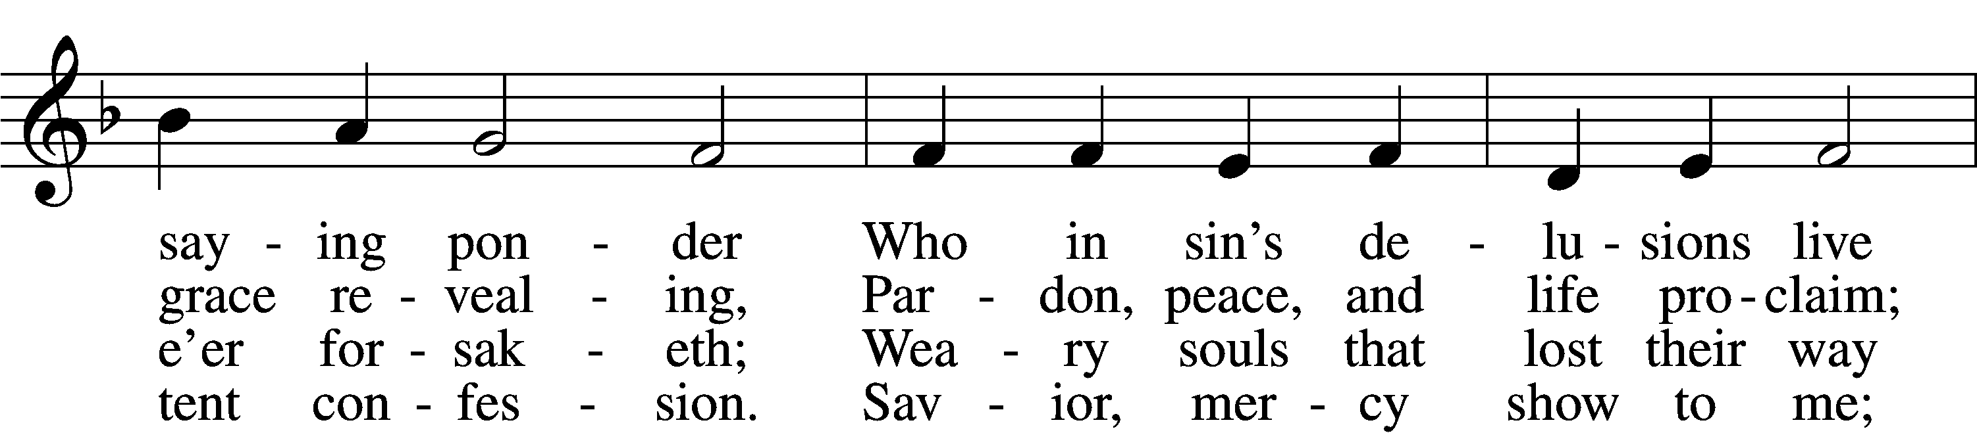

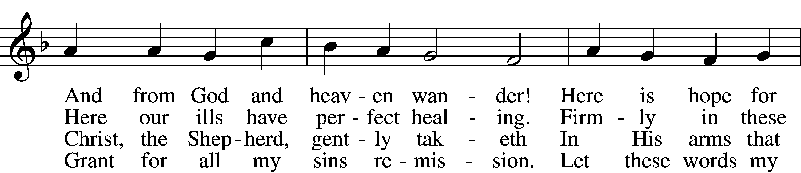

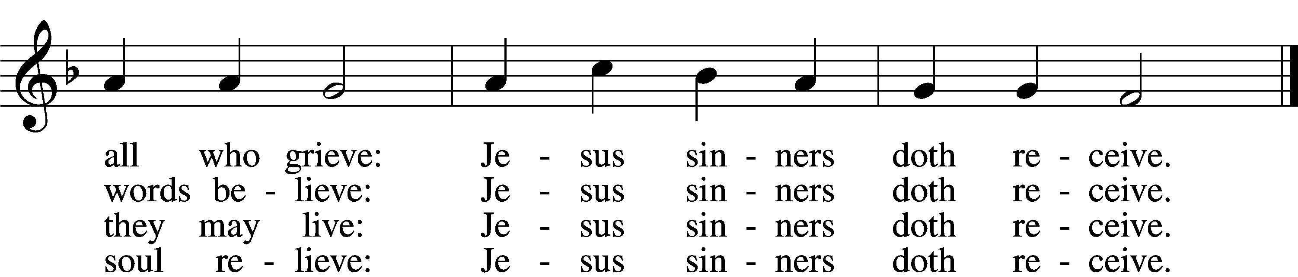

5 Oh, how blest it is to know:  
 Were as scarlet my transgression,  
It shall be as white as snow  
 By Thy blood and bitter passion;  
For these words I now believe:  
Jesus sinners doth receive.

6 Now my conscience is at peace;  
 From the Law I stand acquitted.  
Christ hath purchased my release  
 And my ev’ry sin remitted.  
Naught remains my soul to grieve:  
Jesus sinners doth receive.

7 Jesus sinners doth receive;  
 Also I have been forgiven;  
And when I this earth must leave,  
 I shall find an open heaven.  
Dying, still to Him I cleave:  
Jesus sinners doth receive.

Text: tr. The Lutheran Hymnal, 1941, alt.; Erdmann Neumeister, 1671–1756  
Tune: Neu-verfertigtes Darmstädtisches Gesang-Buch, 1699, Darmstadt  
Text and tune: Public domain

Acknowledgments

Unless otherwise indicated, Scripture quotations are from the ESV® Bible (The Holy Bible, English Standard Version®), copyright © 2001 by Crossway, a publishing ministry of Good News Publishers. Used by permission. All rights reserved.

Created by Lutheran Service Builder © 2025 Concordia Publishing House.