St. Peter Lutheran Church - LCMS, 906 Hwy 59 N – PO Box 133, Bowie, TX 76230
www.stpetertex.com stpetertex@att.net 940.872.1886

The Key to
St. Peter July 2022

The Pastor’s Pen
By Pastor Mark DeYoung

Grace and Peace to you from our Lord and Savior, Jesus Christ,

Jesus Christ states in Matthew 6:25-34

²⁵ “Therefore I tell you, do not be anxious about your life, what you will eat or what you will drink, nor about your body, what you will put on. Is not life more than food, and the body more than clothing? ²⁶ Look at the birds of the air: they neither sow nor reap nor gather into barns, and yet your heavenly Father feeds them. Are you not of more value than they? ²⁷ And which of you by being anxious can add a single hour to his span of life? ²⁸ And why are you anxious about clothing? Consider the lilies of the field, how they grow: they neither toil nor spin, ²⁹ yet I tell you, even Solomon in all his glory was not arrayed like one of these. ³⁰ But if God so clothes the grass of the field, which today is alive and tomorrow is thrown into the oven, will he not much more clothe you, O you of little faith? ³¹ Therefore do not be anxious, saying, ‘What shall we eat?’ or ‘What shall we drink?’ or ‘What shall we wear?’ ³² For the Gentiles seek after all these things, and your heavenly Father knows that you need them all. ³³ But seek first the kingdom of God and his righteousness, and all these things will be added to you.
³⁴ “Therefore do not be anxious about tomorrow, for tomorrow will be anxious for itself. Sufficient for the day is its own trouble.

We are hearing a lot in the news about Covid, increasing numbers, increasing hospitalizations. It is as though the mainstream media wants to instill as much fear as they can. They hope to motivate by fear. If Covid isn’t enough to instill fear, we have “Monkey Pox.” With each of these health “crises” (plural of crisis), their hope is keep you focused on their talking points, that you hop when they tell you to hop, and in this way, they defacto control you.

I would like to believe that there is no ulterior motive to the news broadcast, but I have seen too many times in my life where an anchorman outright lied over the air. Then they tried to have the lie investigated. The rest of the press corps supported his fabrication, all the way to the point that he was fired for continuing the lie without apology.

Just so you know, I experienced Covid twice. Once, before it was named (or at least before they reported on it) in December of 2019, the next time I got the Delta variant. Both times, it was brutal. But at no time, did I allow fear to stop me from worship. Even though I self-isolated, I tuned into the CTSFW chapel broadcast. I “attended” the Ascension Lutheran Church, Huntsville, AL daily devotional (Zoom meeting).

I encourage you to take care of yourself, but don’t give into fear.

Καὶ ὁ λόγος σὰρξ ἐγένετο καὶ ἐσκήνωσεν ἐν ἡμῖν
And the word flesh (He) became and (He) dwelt among us.

Pastor De Young

2022 Youth Gathering in Houston
“ In All Things “
Held every 3 years since 1980, the LCMS Youth Gathering provides thousands of youth and adults the opportunity to come together as a community of God’s people to be encouraged in their walk with Jesus Christ and learn about the Christian faith and their Lutheran identity. in our prayers are 3 of our youth, Adam Pickett, Monte Mayfield, and Reegen Ferguson, and counselors William and Rebecca Pickett as made the trip to was a blessing to these young people.
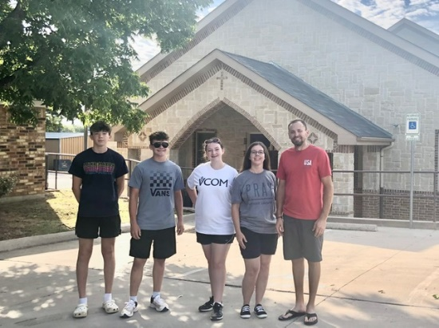
In All Things is a reminder that the Christian story encompasses all things. Nothing, and no one, is left out. In baptism, all things in our lives are brought under the gracious rule and reign of Jesus Christ. The story includes all of each of us. Christ is the single “big idea” in Paul’s letter to the Colossians, and he was be the single big idea at the 2022 LCMS Youth Gathering.

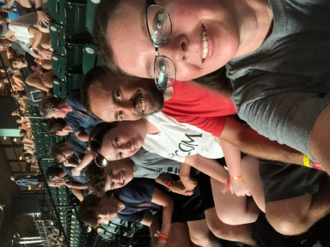
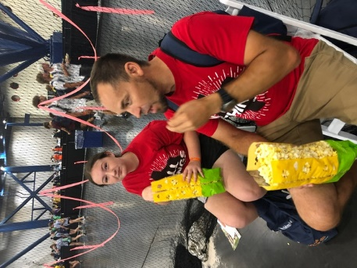

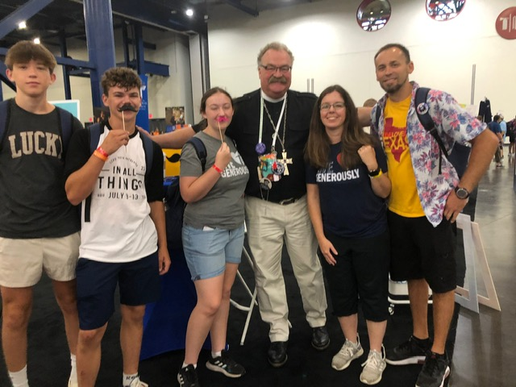
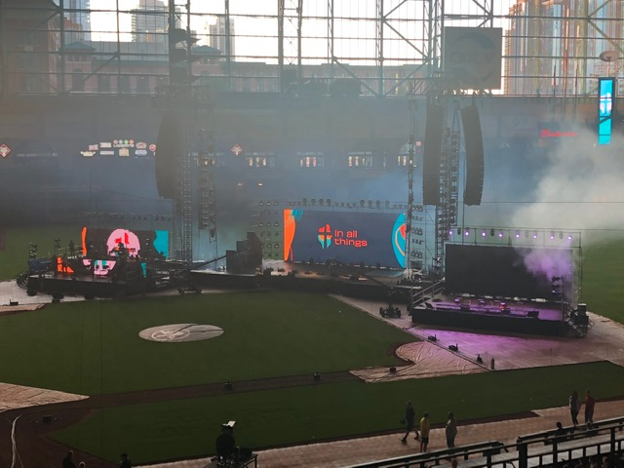

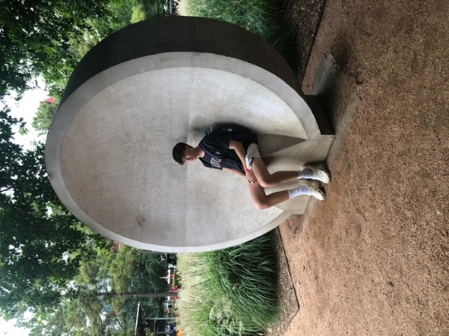

SERVING IN GOD’S HOUSE IN JULY
Elder
David Geis
July 3 – Bella Caswell
July 10 – Parker Lawson
July 17 – Raegan Hughes
July 24 – Aiden Henry
July 31 – Bella Caswell

Counters
Bryan Roth/John Belcher

Altar Care
Kelly Roth Maleisa Belcher

Altar Guild

Jeannine Yowell
Lisa Lawson

Altar Care
Lou McConeghy
Teresa Johnston Melissa Stephens

