The Key to

St. Peter **Oct 2022 2022 2022**

St. Peter Lutheran Church - LCMS, 906 Hwy 59 N – PO Box 133, Bowie, TX 76230 www.stpetertex.com

stpetertex@gmail.xom   940.872.1886

# The Pastor’s Pen

By Pastor Mark DeYoung

**505th Anniversary of the start of the Reformation.**

This year marks 505 years since Martin Luther nailed the 95 theses on the door of the Castle Church in Wittenberg, Saxony Anhalt, which is now part of Germany. The theses, were articles that he wished to debate regarding teachings of the Roman Catholic church that he believed were not in compliance with Holy Scripture.

One of the main points was the Catholic adherence to Purgatory and Penance. One of the first instances of penance being used was by the early church father Cyprian of Carthage (AD 200 – 258). Cyprian fled Carthage, during the persecution from Rome; when he returned to Carthage, he found Christians who had lapsed from their faith under the persecution. These same Christians wanted to return to the church. Cyprian stated that their restoration (to the church) could only take place after a period of penance (testing) that demonstrated their faithfulness.

In the time between Cyprian and Luther, Purgatory was introduced to the church. Penance was also demanded of all members. When they would confess their sins, they would be assigned certain acts of penance to cover their sins. Some of the acts of penance would be to say the Our Father (The Lord’s Prayer) so many times, to visit the relics (bones or other items believed to be of or from dead saints). Taking a pilgrimage to Rome or other holy city was another act of penance. Luther was sent with a letter from Wittenberg to Rome. He visited the relics; he performed many acts of penance. It was around this time that he understood that all the acts of penance that he performed were designed to bring money into “Mother Church” Rome.

[Worship] is not a function of the mouth but of the whole body. It is to bow the head, bend the body, fall on the knees, prostrate one’s self, and so forth, and to do such things as a sign and acknowledgement of an authority and power; just as people bow in silence before secular princes and Lords, and just as popes, bishops, abbots, and people generally, have themselves honored and adored by bowing and kneeling, and so forth. Such outward adoration is what the Scriptures really mean by worship…. From this understanding of outward worship you will also understand what Christ meant by true spiritual worship. It is the adoration or bowing of the heart, so that from the bottom of your heart you thereby show and confess yourself to be his subordinate creature. For from his you see that true worship can be nothing else from faith; it is faith’s sublimest activity with respect to God. --Martin Luther

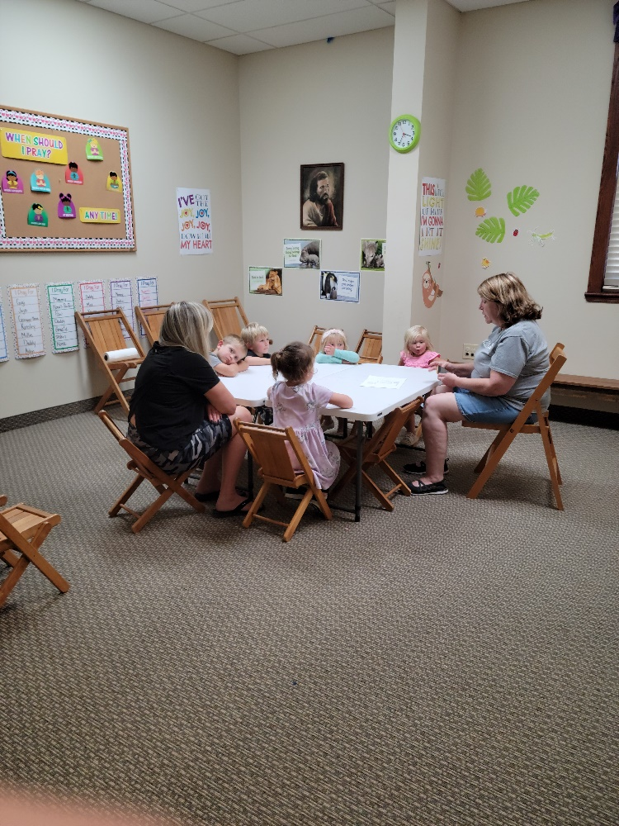 MIDWEEK SCHOOL

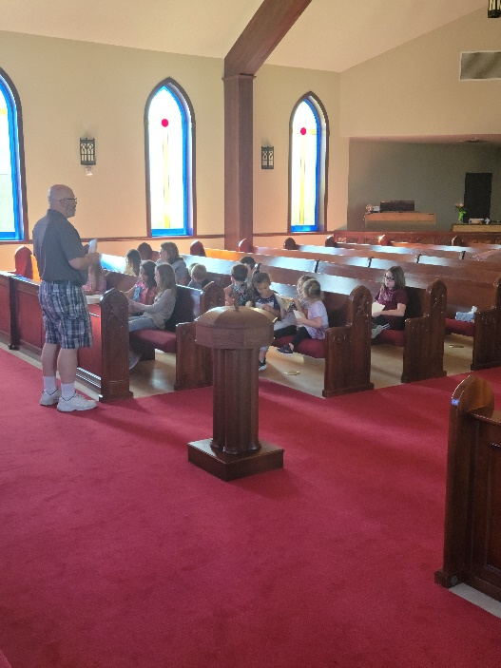

**MISSION FESTIVAL/RALLY DAY**

The date for this years Mission Sunday is October 19. This year’s guest speaker will be Rev. Daniel Fickenscher, Missionary-At-Large In Del Rio, Texas. He will be speaking concerning his work in this mission field and what we can due. All offerings from that Sunday will go to the Texas District Mission work.

**HAVE YOU LOOKED AT OUR NEW WEBSITE**

**stpetertex.com**

**It really says who we are and what we believe – great for travelers looking for a church to attend. If you would like to join the live morning devotion, install the ZOOM app; Open the St.Peter website. Go to the Calendar and there is a link on every day of the website calendar! Click that link and you will go right to the devotion. Immediately you will have the option to turn off your video if you want! Get to know fellow Lutherans in Huntsville, Alabama and Austin and start your day with the Lord!**

**Stpetertex.com is a work in progress and will continue to expand and enlighten!**

**LWML**

**October 16th is LWML Sunday. We will be treated to breakfast as LWML presents Muffins for Mites. This wonderful treat serves to emphasize the work that the little mite boxes enable and gives us a chance to help the many projects taken up all over the world.**

**LWML RED RIVER ZONE**

**FALL RALLY**

**ST. PAUL LUTHERAN CHURCH**

**WICHITA FALLS, TX REGISTRATION BEGINS AT 9:00 AM**

**PRAYER SERVICE WILL BE BASED ON LUKE 11:1 “Lord, Teach us to Pray,”**

We will have a Service Project supporting Patsy’s House (Child Advocacy Center) in Wichita Falls.  Patsy’s House serves Wichita, Archer, Clay, Wilbarger, Baylor, Foard, Cottle, and Hardeman Counties.

One of the many things they do for families is supplying them with items that can ultimately allow their children to remain in their homes.

So we are asking our societies to bring cleaning supplies that we will donate to Patsy’s House.

Items they need:

 Laundry Baskets                                 Rubber Gloves

Multi-purpose cleaner                Dish Soap Clorox or Lysol

Wipes                      Disinfectant Spray

Glass Cleaner                                 Baby Wipes

O’Cedar Mop & Bucket kit (Found at Walmart)

Thanks to all who supported and enjoyed the Tasting Bee. As usual the food was spectacular! Donation totaled around $1,000.00 which will be sent out to Texas District Seminarians – along with a cookbook.

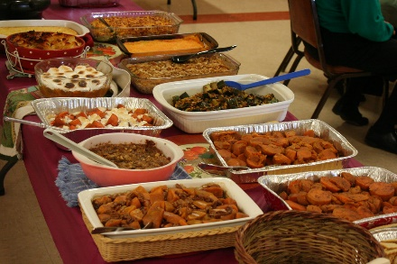

This Photo by Unknown Author is licensed under CC BY-SA-NC



**ACOLYTES**

October 2 – Aiden Henry

October 9 – Parker Lawson

October 16 – Dillon George

October 23 – Raegan Hughes

October 30 – Ailey Pickett/Bella Caswell

**Altar Guild**

Jeannine Yowell Lisa Lawson

**Altar Care**

Lou McConeghy

Teresa Johnston Melissa Stephens

**SERVING IN GOD’S HOUSE IN OCTOBER**

**Altar Care**

Maria Caswell

Kelly Roth

**Elder**

Arn Anderson

**Counters**

Bob Aune

Bryan Roth

William PICKETT