341 Lift Up Your Heads, Ye Mighty Gates
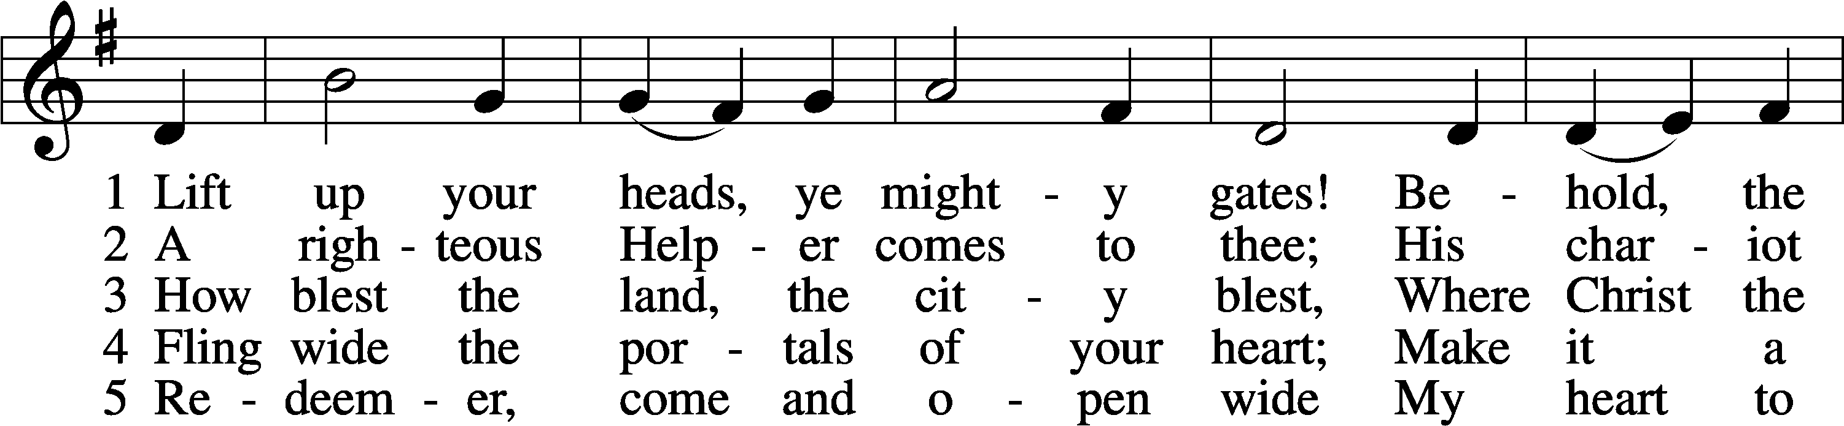
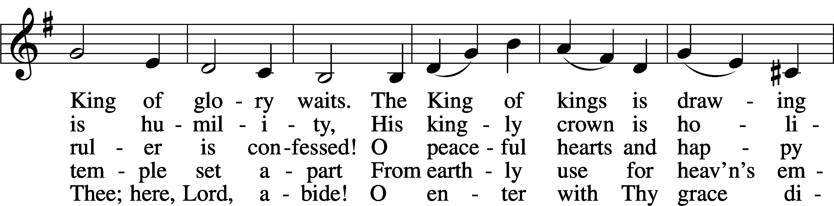
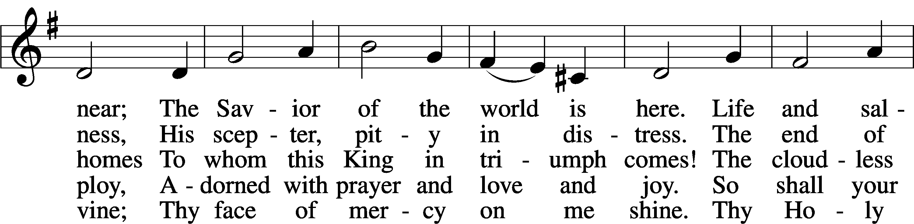
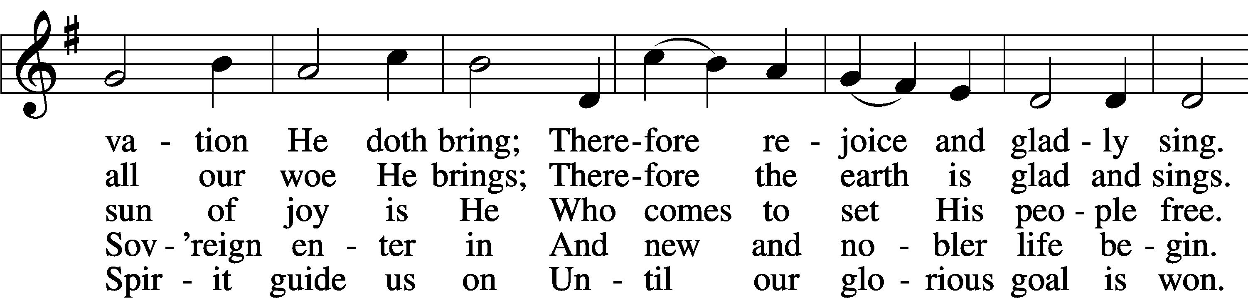
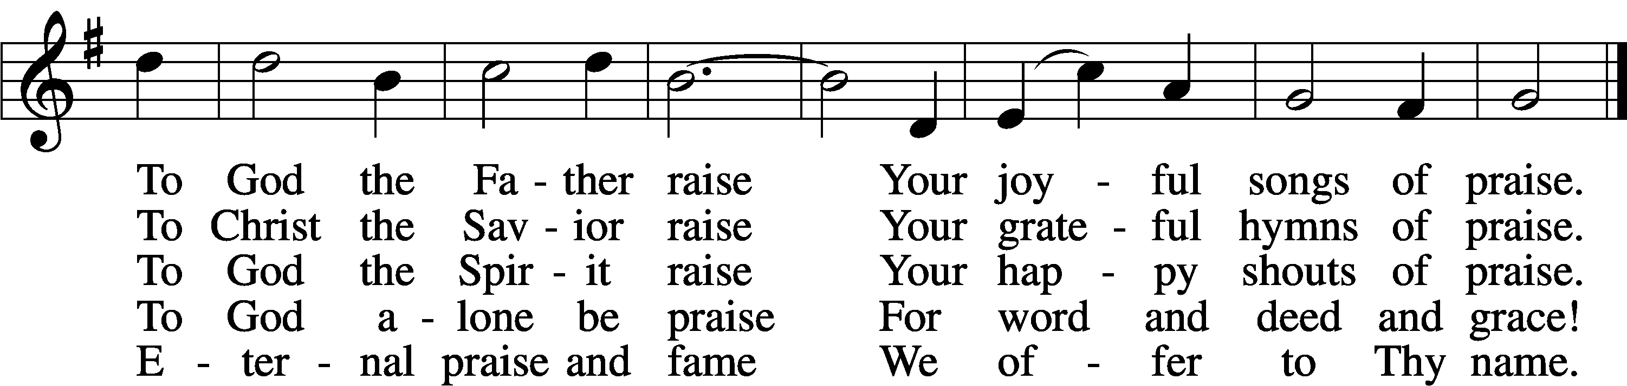
Text: Georg Weissel, 1590–1635; tr. Catherine Winkworth, 1827–78, alt.
Tune: August Lemke, 1820–1913
Text and tune: Public domain

Confession and Absolution

The sign of the cross may be made by all in remembrance of their Baptism.

Invocation Matthew 28:19b; 18:20
P In the name of the Father and of the T Son and of the Holy Spirit.
C Amen.

Exhortation Hebrews 10:22; Psalm 124:8; Psalm 32:5
P Beloved in the Lord! Let us draw near with a true heart and confess our sins unto God our Father, beseeching Him in the name of our Lord Jesus Christ to grant us forgiveness.

P Our help is in the name of the Lord,
C who made heaven and earth.
P I said, I will confess my transgressions unto the Lord,
C and You forgave the iniquity of my sin.

Silence for reflection on God’s Word and for self-examination.

Confession of Sins
P Almighty God, our maker and redeemer, we poor sinners confess unto You that we are by nature sinful and unclean and that we have sinned against You by thought, word, and deed. Wherefore we flee for refuge to Your infinite mercy, seeking and imploring Your grace for the sake of our Lord Jesus Christ.
C O most merciful God, who has given Your only-begotten Son to die for us, have mercy upon us and for His sake grant us remission of all our sins; and by Your Holy Spirit increase in us true knowledge of You and of Your will and true obedience to Your Word, to the end that by Your grace we may come to everlasting life; through Jesus Christ, our Lord. Amen.

Declaration of Grace Mark 16:16; John 1:12
P Almighty God, our heavenly Father, has had mercy upon us and has given His only Son to die for us and for His sake forgives us all our sins. To those who believe on His name He gives power to become the children of God and has promised them His Holy Spirit. He that believes and is baptized shall be saved.
Grant this, Lord, unto us all.
C Amen.

Service of the Word

Introit Psalm 118:25–28; antiphon: Zechariah 9:9b, alt.
Behold, your king is coming to you;
righteous and having salvation.
Save us, we pray, O Lord!
O Lord, we pray, give us success!
Blessèd is he who comes in the name of the Lord!
We bless you from the house of the Lord.
The Lord is God, and he has made his light to shine upon us.
Bind the festal sacrifice with cords, up to the horns of the altar!
You are my God, and I will give thanks to you;
you are my God; I will ex- | tol you.

Gloria Patri
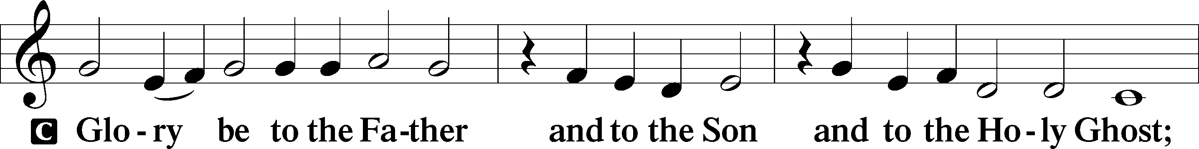
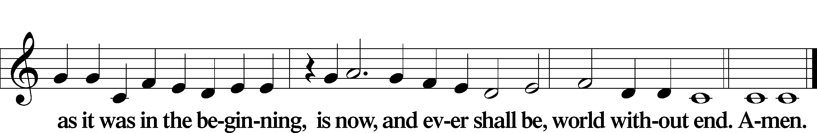

Kyrie Mark 10:47
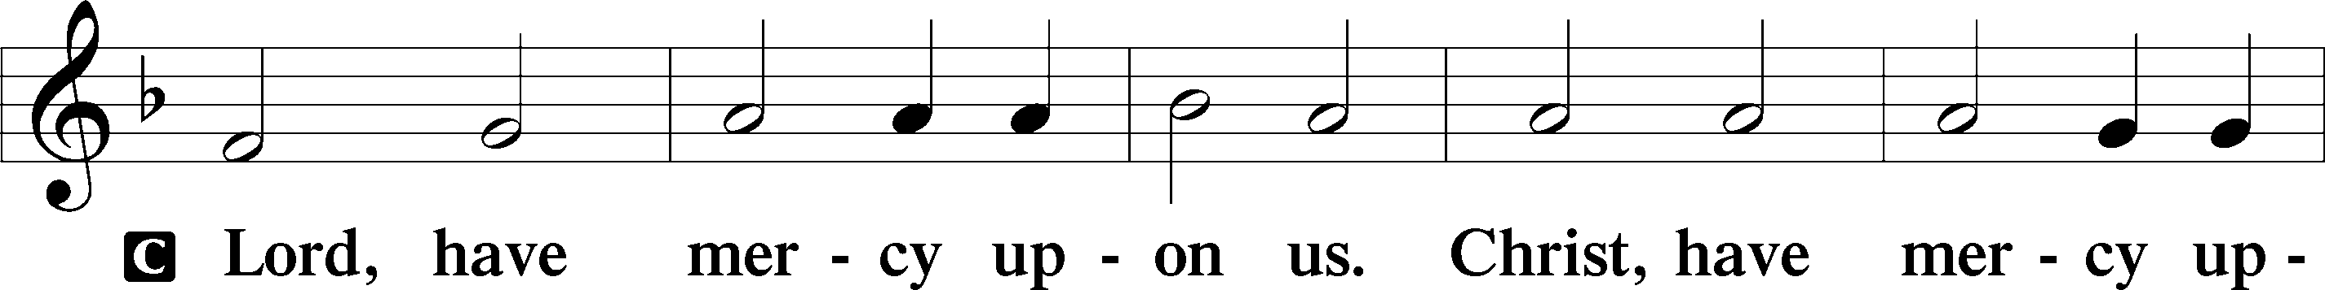
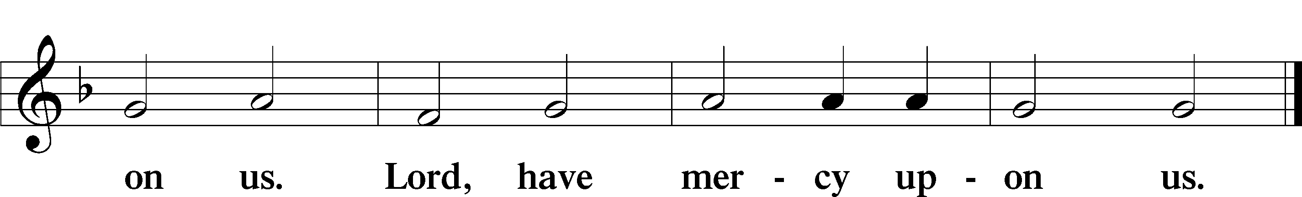

The Gloria Patri is omitted during Advent

Salutation and Collect of the Day
P The Lord be with you.
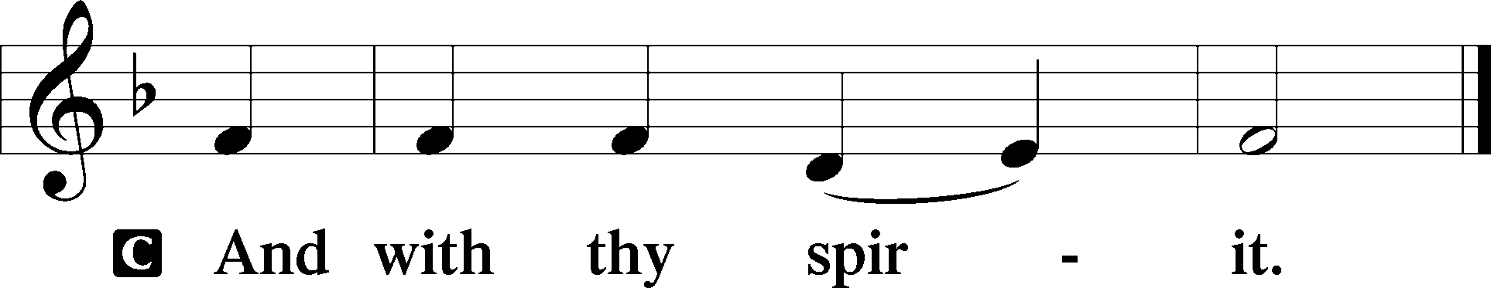

P Let us pray.
Stir up Your power, O Lord, and come, that by Your protection we may be rescued from the threatening perils of our sins and saved by Your mighty deliverance; for You live and reign with the Father and the Holy Spirit, one God, now and forever.

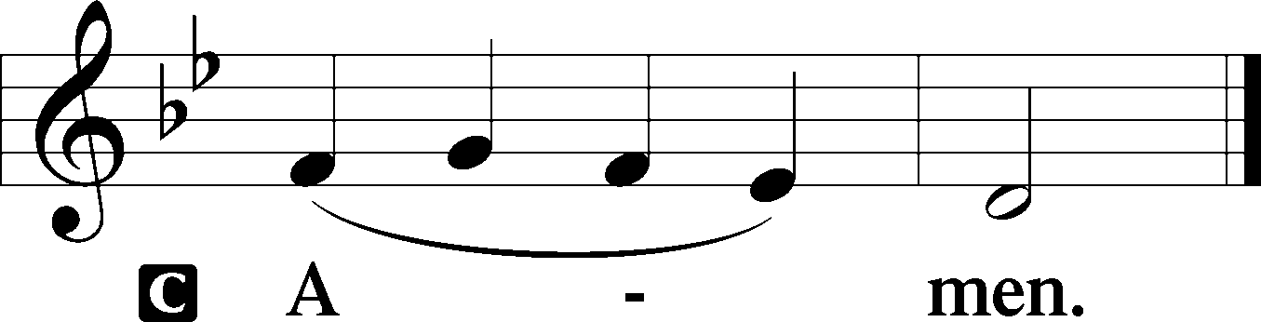

Sit

Old Testament Reading Isaiah 2:1–5
The Mountain of the Lord
1The word that Isaiah the son of Amoz saw concerning Judah and Jerusalem.
2It shall come to pass in the latter days
that the mountain of the house of the Lord
shall be established as the highest of the mountains,
and shall be lifted up above the hills;
and all the nations shall flow to it,
3and many peoples shall come, and say:
“Come, let us go up to the mountain of the Lord,
to the house of the God of Jacob,
that he may teach us his ways
and that we may walk in his paths.”
For out of Zion shall go the law,
and the word of the Lord from Jerusalem.
4He shall judge between the nations,
and shall decide disputes for many peoples;
and they shall beat their swords into plowshares,
and their spears into pruning hooks;
nation shall not lift up sword against nation,
neither shall they learn war anymore.
5O house of Jacob,
come, let us walk
in the light of the Lord.

A This is the Word of the Lord.
C Thanks be to God.

Gradual Zechariah 9:9; Psalm 118:26, alt.
Rejoice greatly, O daughter of Zion.
Shout aloud, O daughter of Jerusalem.
Behold, your king is coming to you;
righteous and having salvation.
Blessèd is he who comes in the name of the Lord.
From the house of the Lord we bless you.

Reading Romans 5:6–15
6For while we were still weak, at the right time Christ died for the ungodly. 7For one will scarcely die for a righteous person—though perhaps for a good person one would dare even to die— 8but God shows his love for us in that while we were still sinners, Christ died for us. 9Since, therefore, we have now been justified by his blood, much more shall we be saved by him from the wrath of God. 10For if while we were enemies we were reconciled to God by the death of his Son, much more, now that we are reconciled, shall we be saved by his life. 11More than that, we also rejoice in God through our Lord Jesus Christ, through whom we have now received reconciliation.
Death in Adam, Life in Christ
12Therefore, just as sin came into the world through one man, and death through sin, and so death spread to all men because all sinned— 13for sin indeed was in the world before the law was given, but sin is not counted where there is no law. 14Yet death reigned from Adam to Moses, even over those whose sinning was not like the transgression of Adam, who was a type of the one who was to come.
15But the free gift is not like the trespass. For if many died through one man’s trespass, much more have the grace of God and the free gift by the grace of that one man Jesus Christ abounded for many.

Stand

Alleluia
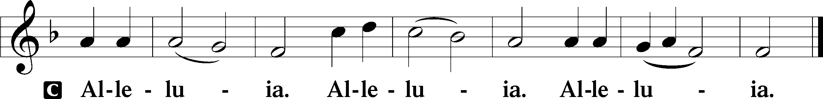

Holy Gospel Matthew 24:36–44
P The Holy Gospel according to St. Matthew, the twenty-fourth chapter.

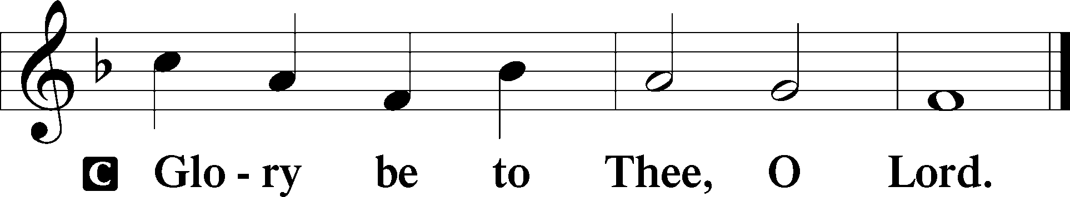

No One Knows That Day and Hour
36[Jesus said:] “But concerning that day and hour no one knows, not even the angels of heaven, nor the Son, but the Father only. 37As were the days of Noah, so will be the coming of the Son of Man. 38For as in those days before the flood they were eating and drinking, marrying and giving in marriage, until the day when Noah entered the ark, 39and they were unaware until the flood came and swept them all away, so will be the coming of the Son of Man. 40Then two men will be in the field; one will be taken and one left. 41Two women will be grinding at the mill; one will be taken and one left. 42Therefore, stay awake, for you do not know on what day your Lord is coming. 43But know this, that if the master of the house had known in what part of the night the thief was coming, he would have stayed awake and would not have let his house be broken into. 44Therefore you also must be ready, for the Son of Man is coming at an hour you do not expect.

P This is the Gospel of the Lord.

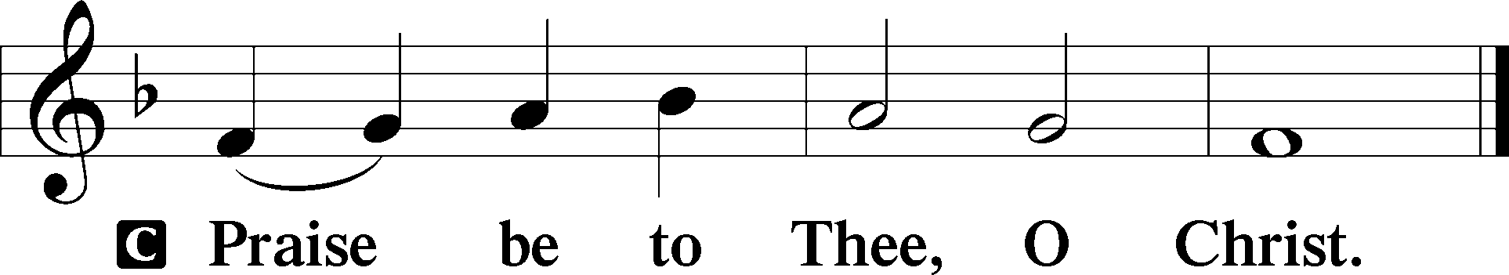

Apostles’ Creed
C I believe in God, the Father Almighty,
maker of heaven and earth.

And in Jesus Christ, His only Son, our Lord,
who was conceived by the Holy Spirit,
born of the virgin Mary,
suffered under Pontius Pilate,
was crucified, died and was buried.
He descended into hell.
The third day He rose again from the dead.
He ascended into heaven
and sits at the right hand of God the Father Almighty.
From thence He will come to judge the living and the dead.

I believe in the Holy Spirit,
the holy Christian Church,
the communion of saints,
the forgiveness of sins,
the resurrection of the body,
and the life T everlasting. Amen.

Children’s Message
332 Savior of the Nations, Come
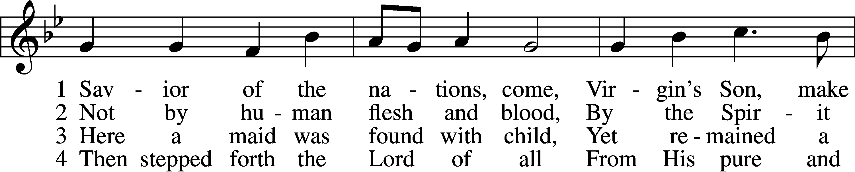
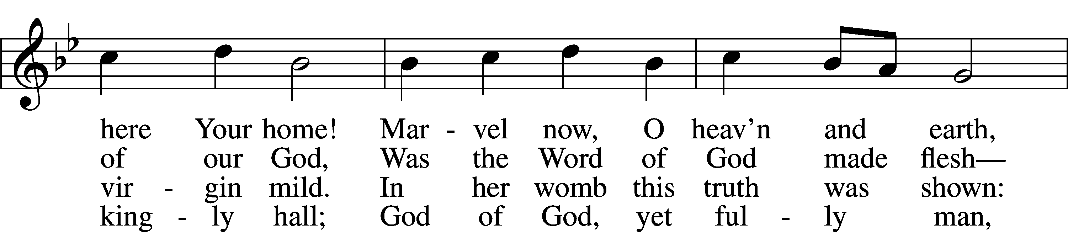
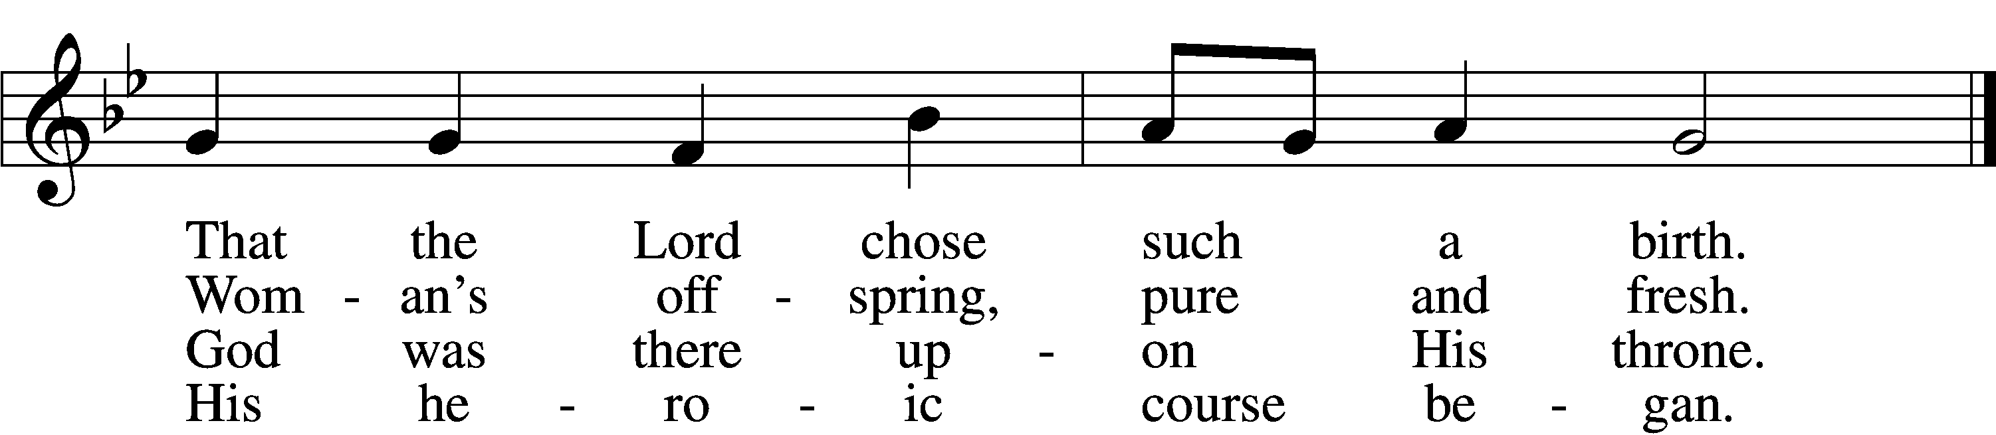

5 God the Father was His source,
Back to God He ran His course.
Into hell His road went down,
Back then to His throne and crown.

6 For You are the Father’s Son
Who in flesh the vict’ry won.
By Your mighty pow’r make whole
All our ills of flesh and soul.

7 From the manger newborn light
Shines in glory through the night.
Darkness there no more resides;
In this light faith now abides.

D 8 Glory to the Father sing,
Glory to the Son, our king,
Glory to the Spirit be
Now and through eternity.
Text: attr. Ambrose of Milan, 340–397; German version, Martin Luther, 1483–1546; (sts. 1–2): tr. William M. Reynolds, 1812–76; (sts. 3, 6): tr. Lutheran Service Book, 2006; (sts. 4–5, 8): tr. F. Samuel Janzow, 1913–2001; (st. 7): tr. Gifford A. Grobien, 1973
Tune: Geystliche gesangk Buchleyn, 1524, Wittenberg, ed. Johann Walter
Text (sts. 3, 6–7): © 2006 Concordia Publishing House; (sts. 4–5, 8): © 1978 Concordia Publishing House. Used by permission: LSB Hymn License no. 110005011
Text (sts. 1–2) and tune: Public domain

Sermon Déjà vu all over again

Votum
P The peace of God, which passes all understanding, keep your hearts and minds in Christ Jesus.
C Amen.

Stand

Offertory Psalm 51:10–12
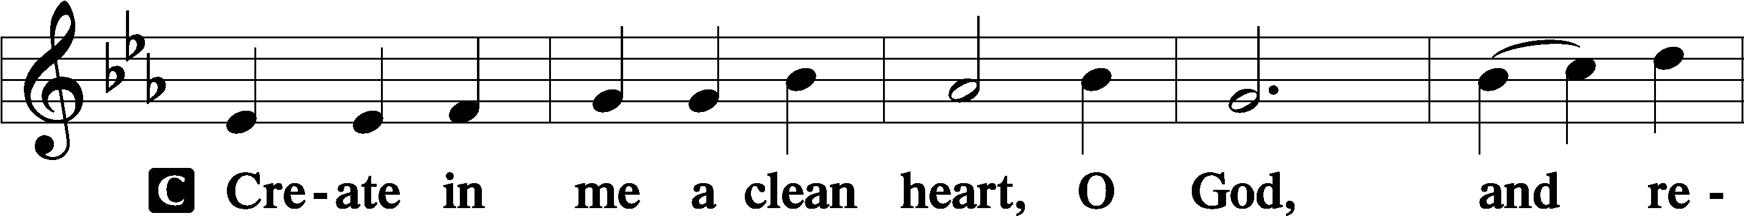
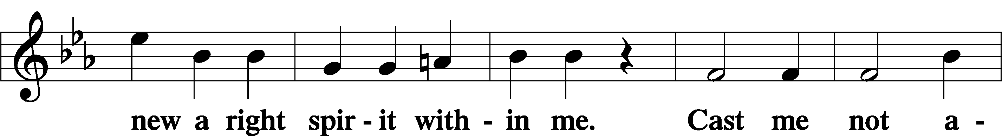
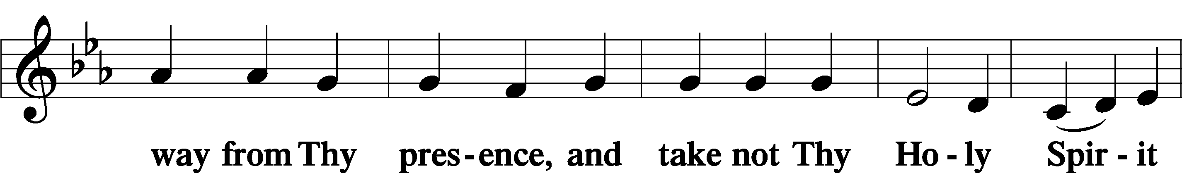
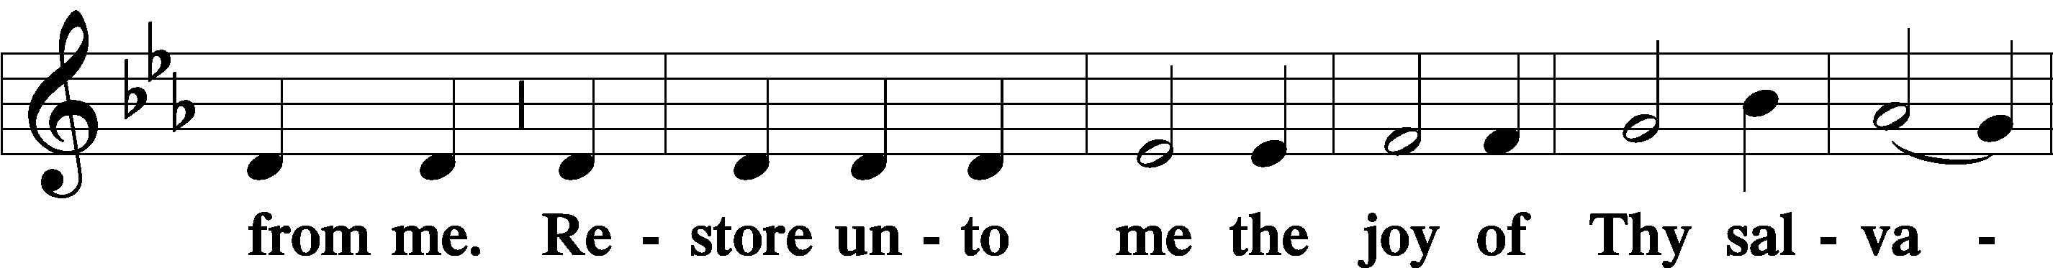
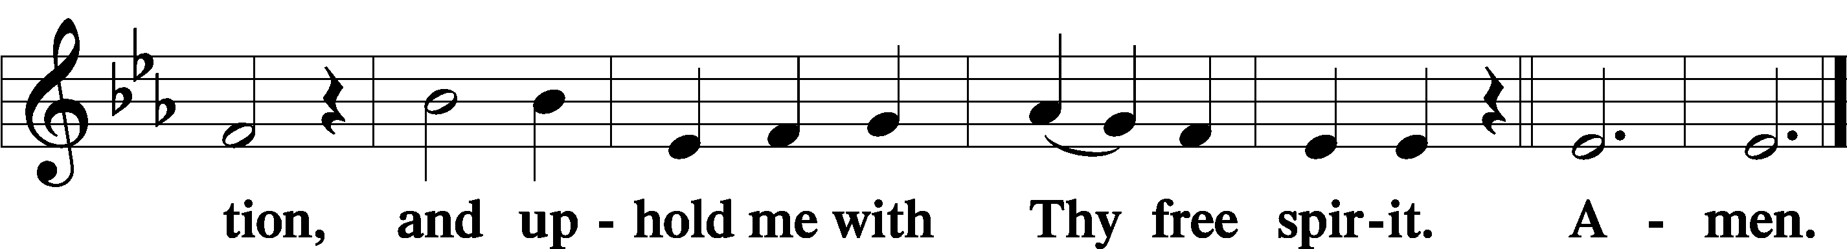

Offering

805 Praise God, from Whom All Blessings Flow
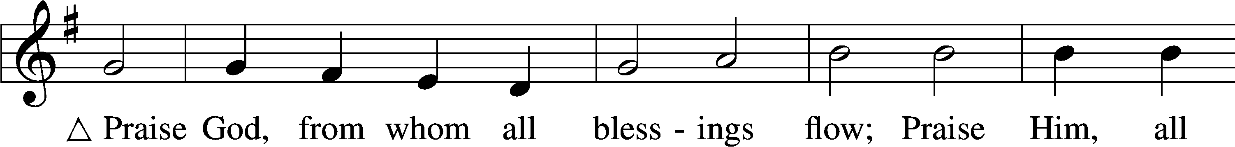
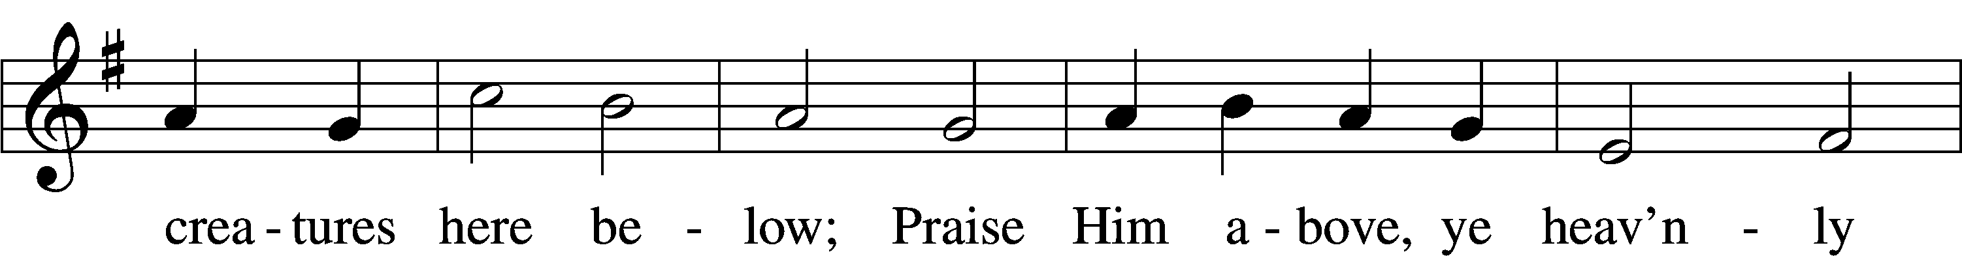
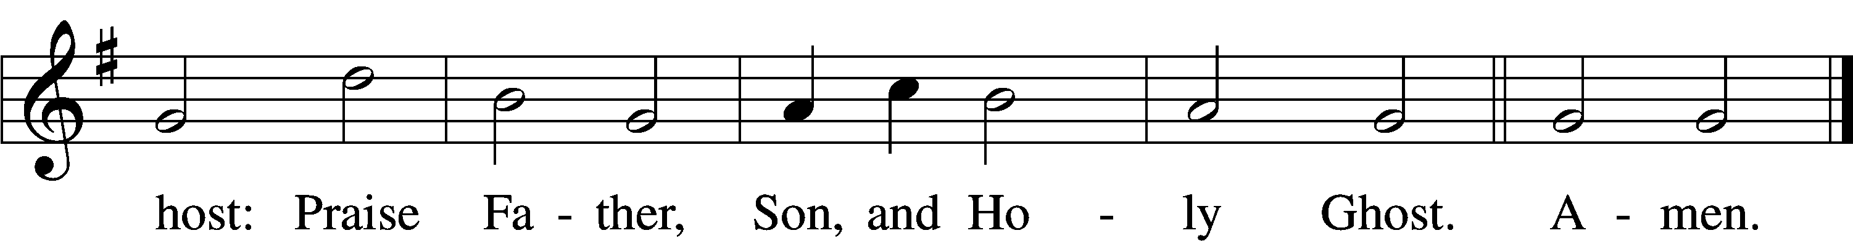
Text: Thomas Ken, 1637–1711
Tune: Trente quatre Pseaumes de David, 1551, Geneva, ed. Louis Bourgeois
Text and tune: Public domain

Prayer of the Church

Lord’s Prayer Matthew 6:9–13
P Lord, remember us in Your kingdom and teach us to pray:
C Our Father who art in heaven,
hallowed be Thy name,
Thy kingdom come,
Thy will be done on earth
as it is in heaven;
give us this day our daily bread;
and forgive us our trespasses
as we forgive those
who trespass against us;
and lead us not into temptation,
but deliver us from evil.
For Thine is the kingdom
and the power and the glory
forever and ever. Amen.

Collect for the Word

Blessed Lord, You have caused all Scripture to be written
for our learning. Grant that we may so hear, read mark, learn and inwardly digest them that, by the patience and comfort of Your Holy Word, we may embrace and ever hold fast the blessed hope of everlasting life; which You have given us in our Savior Jesus Christ, Your Son, our Lord, who lives and reigns with You and the Holy Spirit, one God, now and foreveer

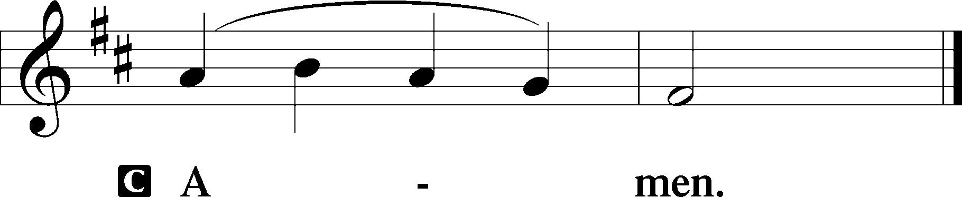

Salutation 2 Timothy 4:22
P The Lord be with you.

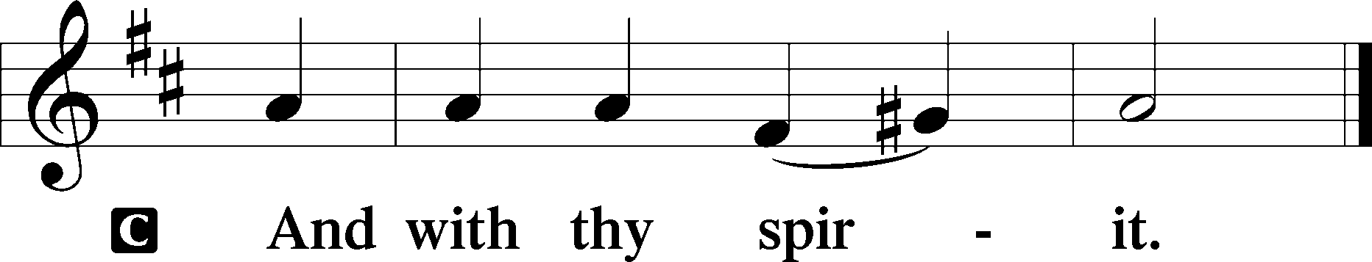

Benedicamus Psalm 103:1
A Bless we the Lord.

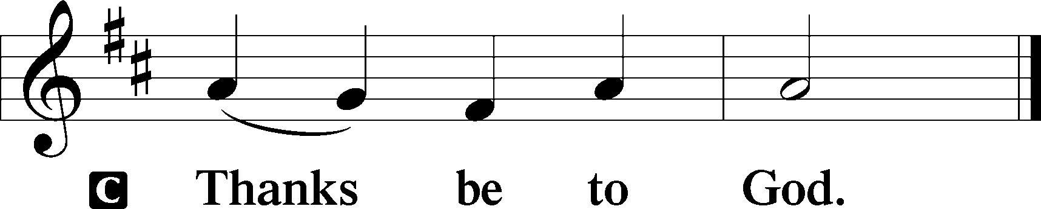

Benediction Numbers 6:24–26
P The Lord bless you and keep you.
The Lord make His face shine upon you and be gracious unto you.
The Lord lift up His countenance upon you and T give you peace.
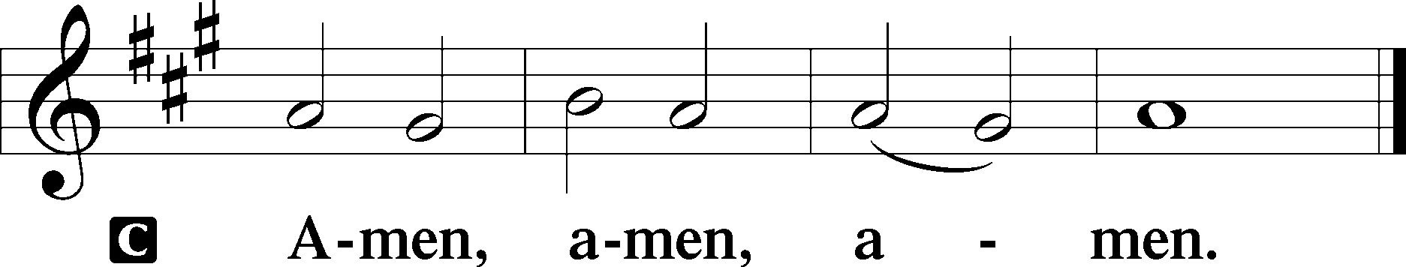

350 Come, Thou Precious Ransom, Come
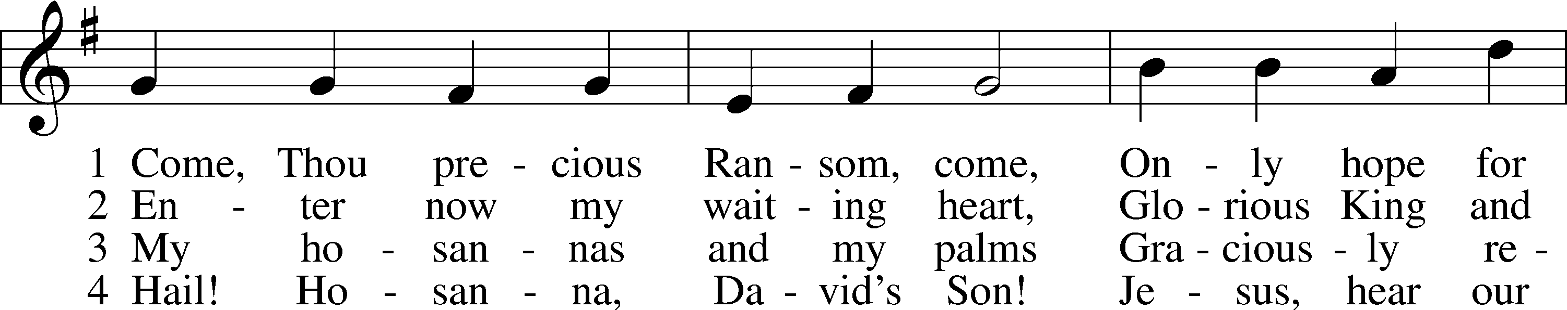
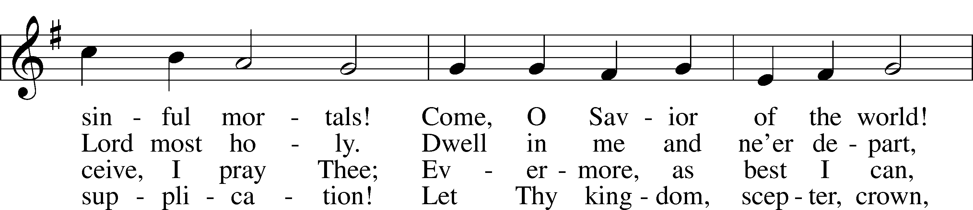
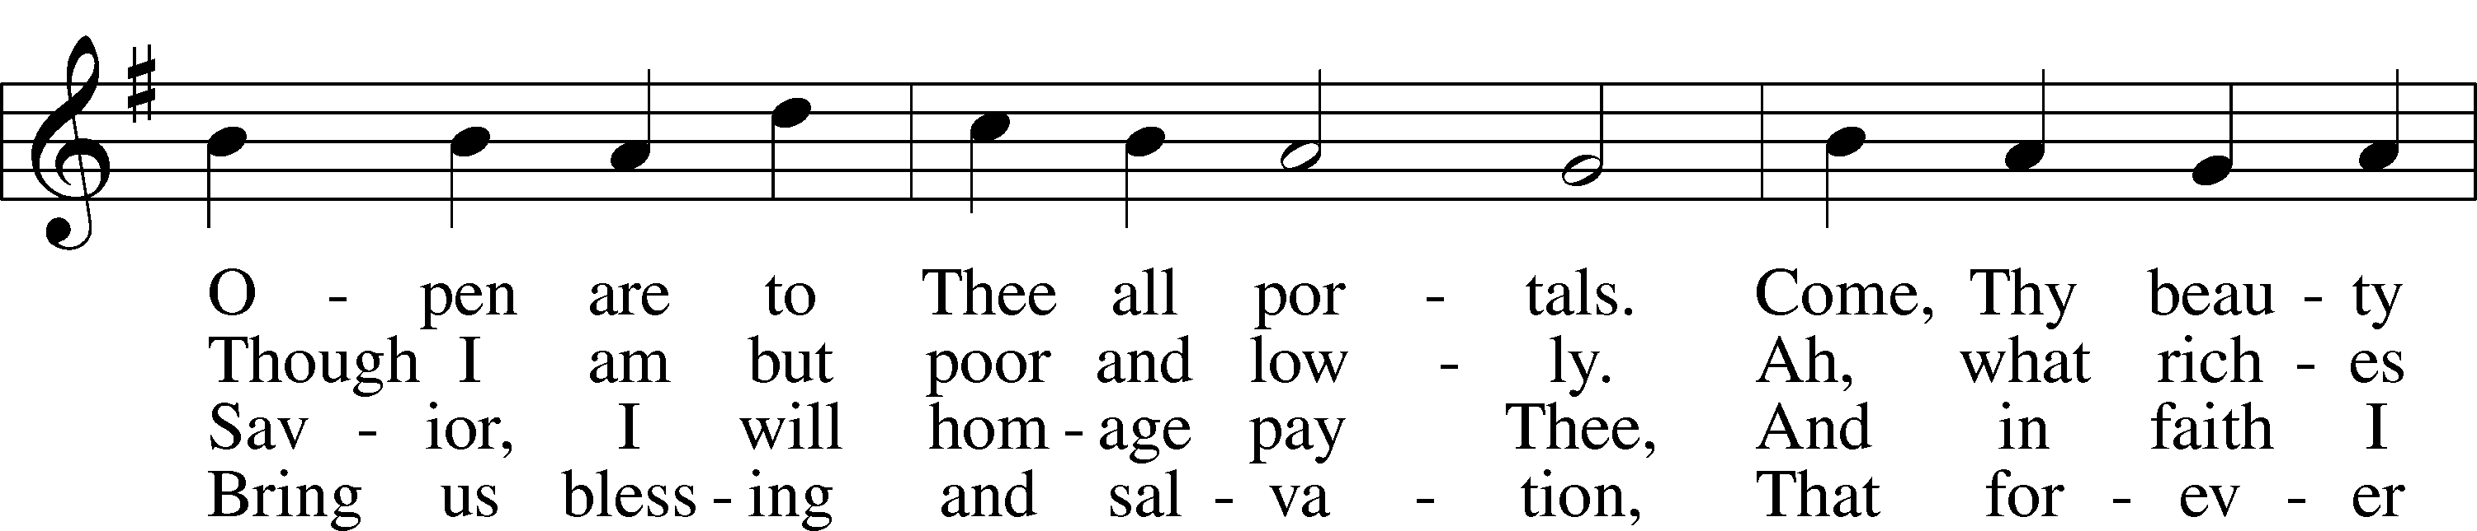
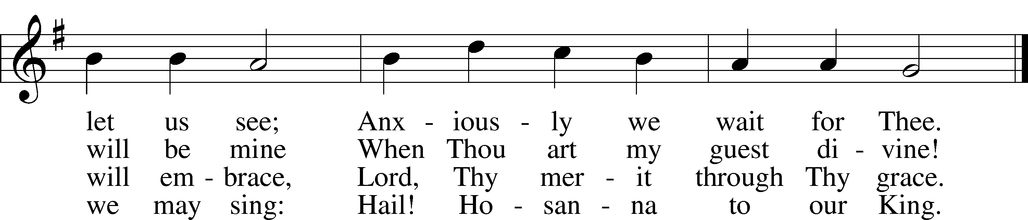
Text: Johann Gottfried Olearius, 1635–1711; tr. August Crull, 1845–1923, alt.
Tune: Neu-verfertigtes Darmstädtisches Gesang-Buch, 1699, Darmstadt
Text and tune: Public domain

Acknowledgments
Unless otherwise indicated, Scripture quotations are from the ESV® Bible (The Holy Bible, English Standard Version®), copyright © 2001 by Crossway, a publishing ministry of Good News Publishers. Used by permission. All rights reserved.
Created by Lutheran Service Builder © 2022 Concordia Publishing House.

