346 When All the World Was Cursed
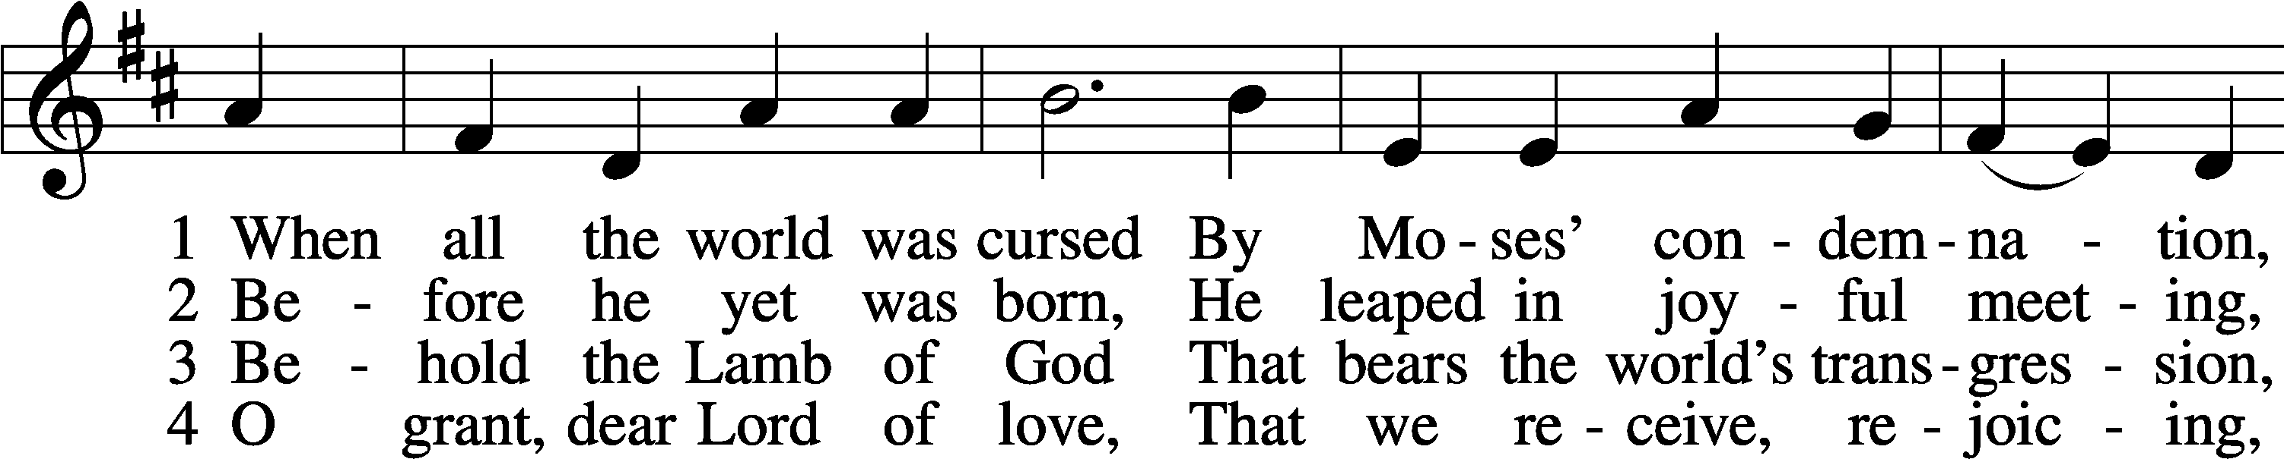
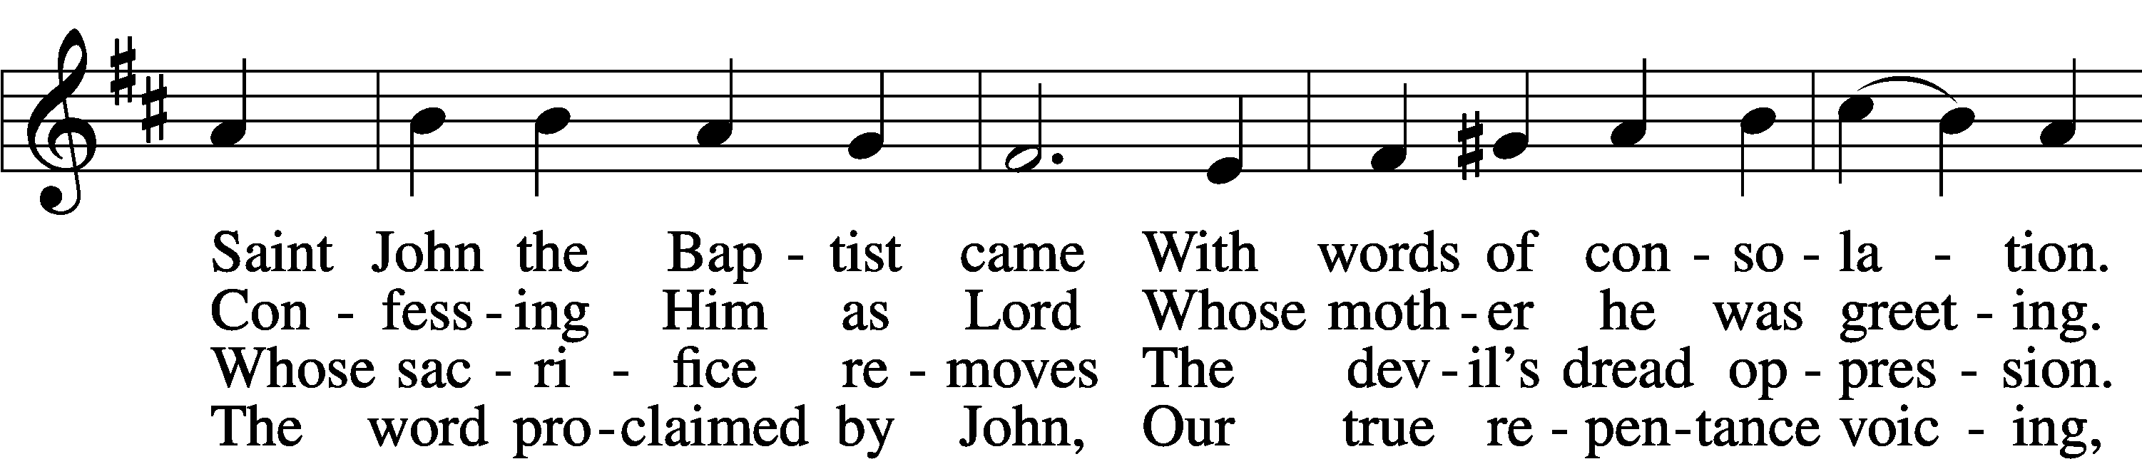
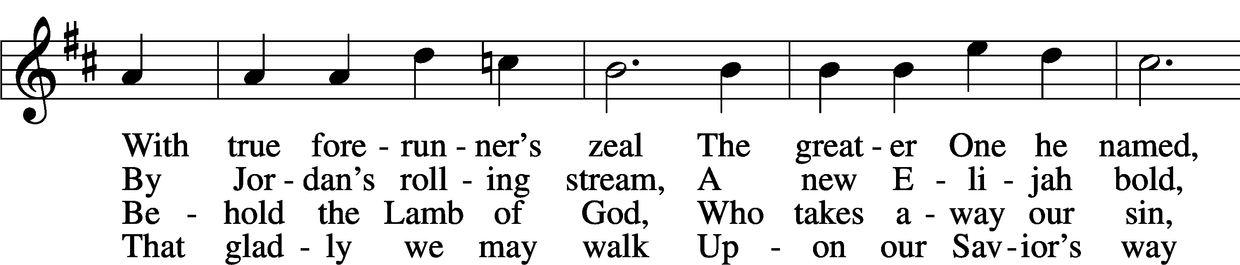
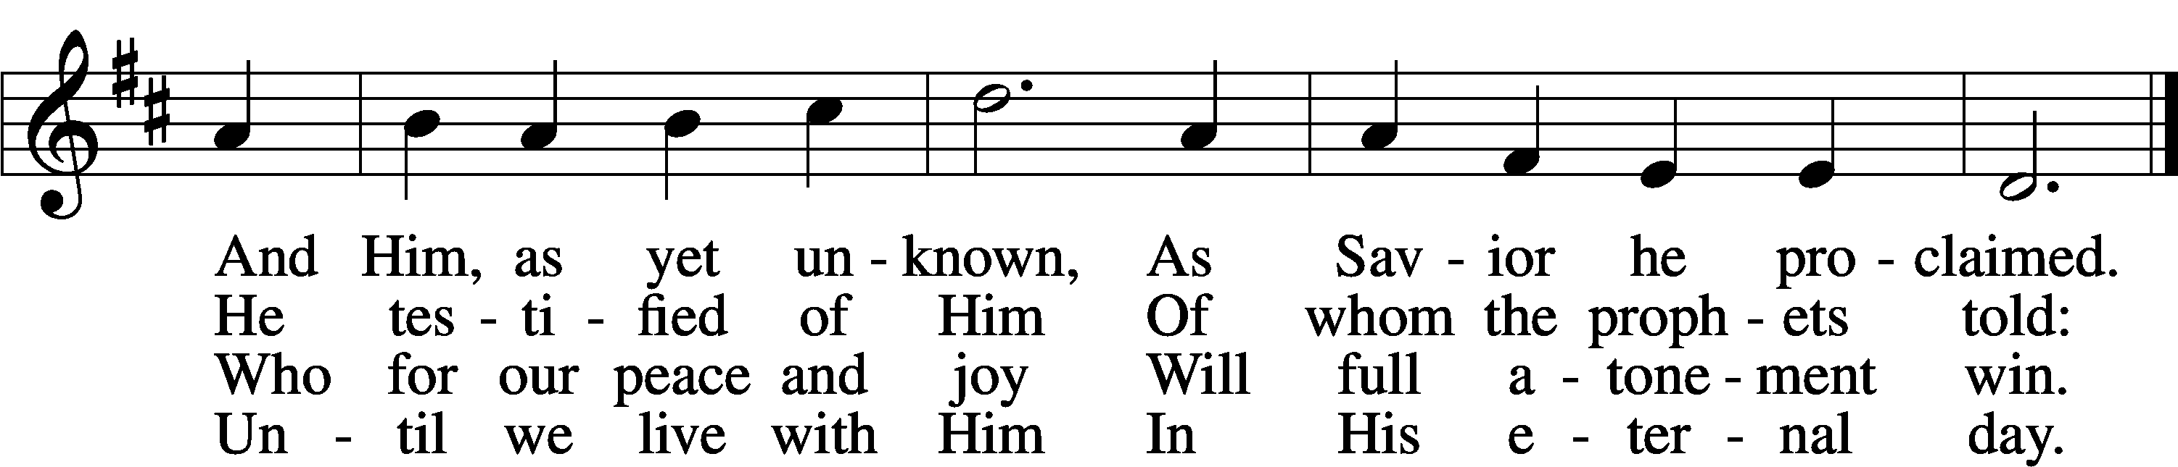
Text: Johann Gottfried Olearius, 1635–1711; tr. Paul E. Kretzmann, 1883–1965, alt.
Tune: Ahasverus Fritsch, 1629–1701
Text: © 1941 Concordia Publishing House. Used by permission: LSB Hymn License no. 110005011
Tune: Public domain

Confession and Absolution

Stand

The sign of the cross may be made by all in remembrance of their Baptism.

Invocation Matthew 28:19b; 18:20
P In the name of the Father and of the T Son and of the Holy Spirit.
C Amen.

Exhortation Hebrews 10:22; Psalm 124:8; Psalm 32:5
P Beloved in the Lord! Let us draw near with a true heart and confess our sins unto God our Father, beseeching Him in the name of our Lord Jesus Christ to grant us forgiveness.

P Our help is in the name of the Lord,
C who made heaven and earth.
P I said, I will confess my transgressions unto the Lord,
C and You forgave the iniquity of my sin.

Kneel/Stand

Silence for reflection on God’s Word and for self-examination.

Confession of Sins
P O almighty God, merciful Father,
C I, a poor, miserable sinner, confess unto You all my sins and iniquities with which I have ever offended You and justly deserved Your temporal and eternal punishment. But I am heartily sorry for them and sincerely repent of them, and I pray You of Your boundless mercy and for the sake of the holy, innocent, bitter sufferings and death of Your beloved Son, Jesus Christ, to be gracious and merciful to me, a poor, sinful being.

Absolution [John 20:19–23]
P Upon this your confession, I, by virtue of my office, as a called and ordained servant of the Word, announce the grace of God unto all of you, and in the stead and by the command of my Lord Jesus Christ I forgive you all your sins in the name of the Father and of the T Son and of the Holy Spirit.
C Amen.

Stand

Service of the Word

Introit Psalm 105:4–8; antiphon: Isaiah 40:3b
In the wilderness prepare the way of the Lord;
make straight in the desert a highway | for our God.
Seek the Lord | and his strength;
seek his presence continually!
Remember the wondrous works that he has done,
his miracles, and the judgments he uttered,
O offspring of Abraham, his servant,*
children of Jacob, his chosen ones!
He is the Lord our God;
his judgments are in all the earth.
He remembers his covenant for- ever,
the word that he commanded, for a thousand generations.

Gloria Patri
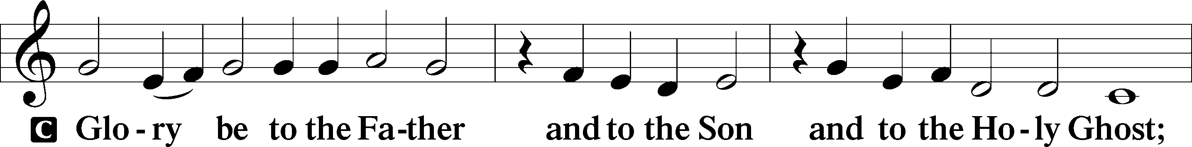
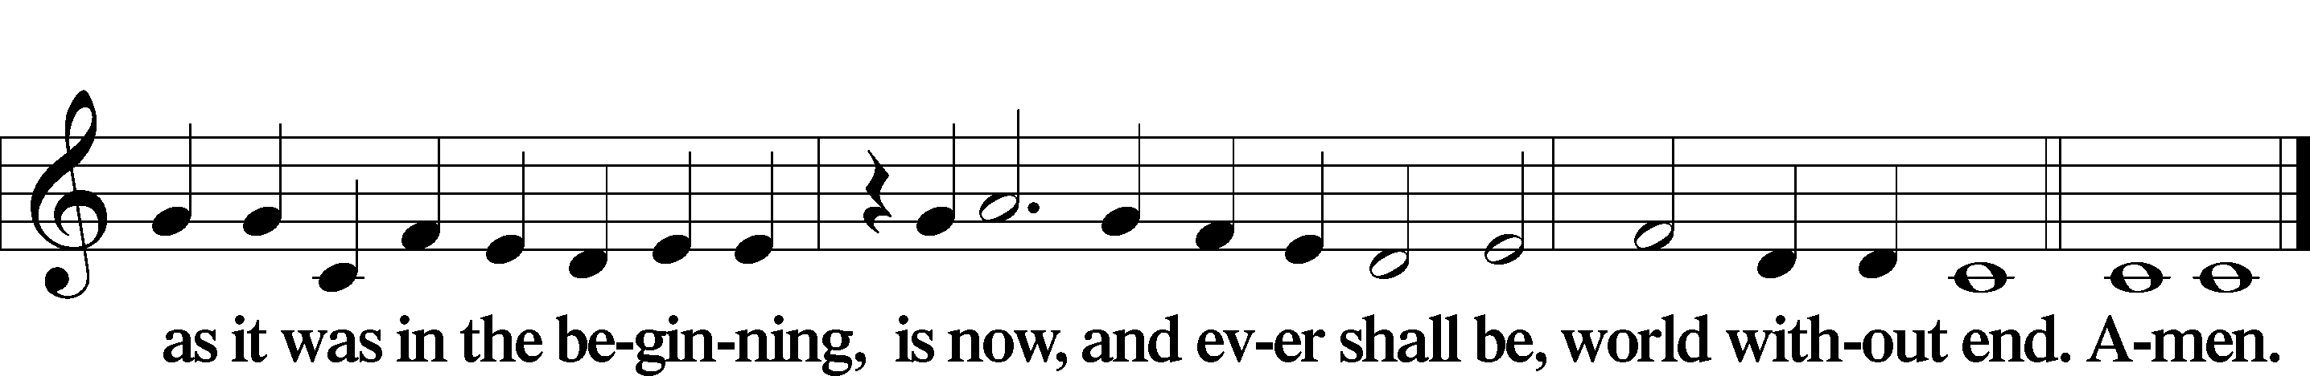

Kyrie Mark 10:47
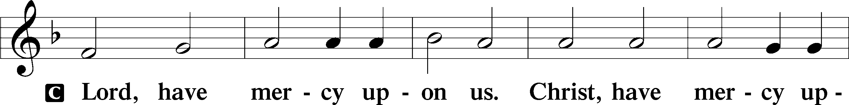
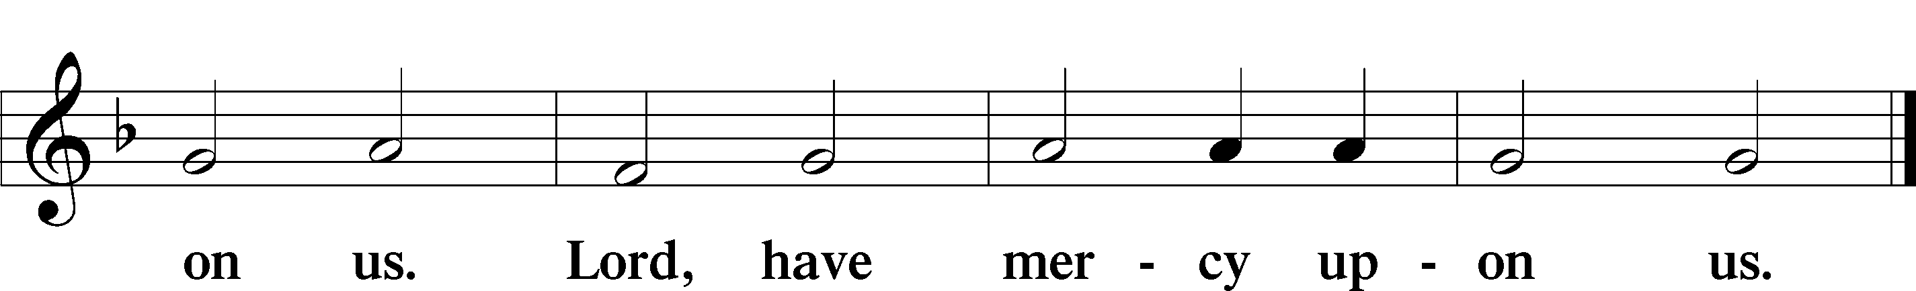

Salutation and Collect of the Day
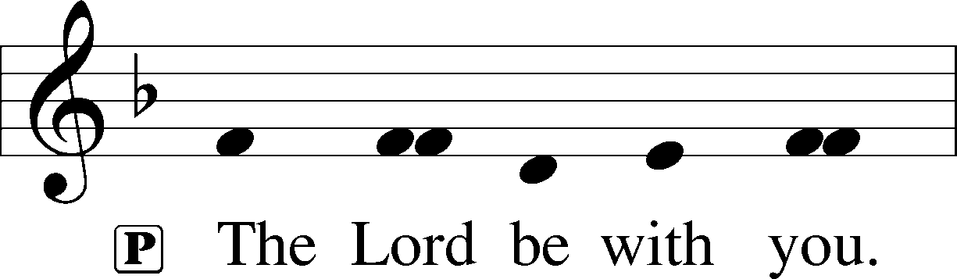
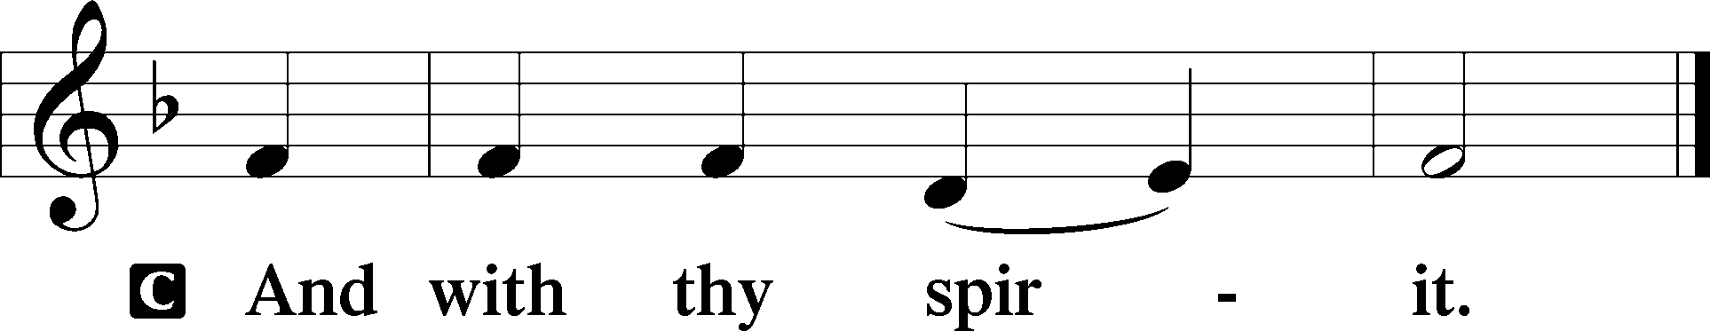

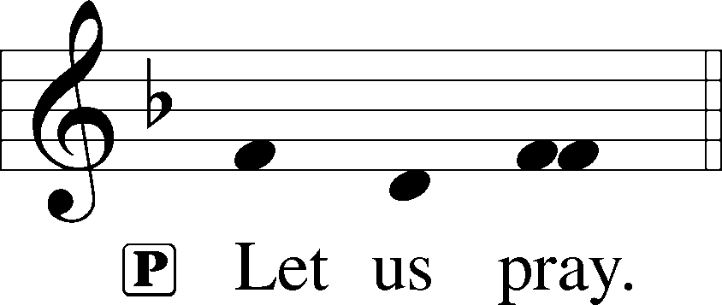

P Stir up our hearts, O Lord, to make ready the way of Your only-begotten Son, that by His coming we may be enabled to serve You with pure minds; through the same Jesus Christ, our Lord, who lives and reigns with You and the Holy Spirit, one God, now and forever.

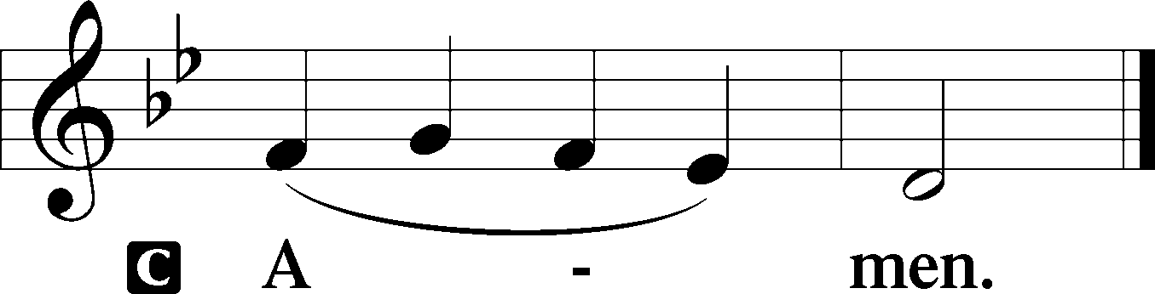

Sit

Old Testament Reading Isaiah 11:1–10
The Righteous Reign of the Branch
1There shall come forth a shoot from the stump of Jesse,
and a branch from his roots shall bear fruit.
2And the Spirit of the Lord shall rest upon him,
the Spirit of wisdom and understanding,
the Spirit of counsel and might,
the Spirit of knowledge and the fear of the Lord.
3And his delight shall be in the fear of the Lord.
He shall not judge by what his eyes see,
or decide disputes by what his ears hear,
4but with righteousness he shall judge the poor,
and decide with equity for the meek of the earth;
and he shall strike the earth with the rod of his mouth,
and with the breath of his lips he shall kill the wicked.
5Righteousness shall be the belt of his waist,
and faithfulness the belt of his loins.
6The wolf shall dwell with the lamb,
and the leopard shall lie down with the young goat,
and the calf and the lion and the fattened calf together;
and a little child shall lead them.
7The cow and the bear shall graze;
their young shall lie down together;
and the lion shall eat straw like the ox.
8The nursing child shall play over the hole of the cobra,
and the weaned child shall put his hand on the adder’s den.
9They shall not hurt or destroy
in all my holy mountain;
for the earth shall be full of the knowledge of the Lord
as the waters cover the sea.
10In that day the root of Jesse, who shall stand as a signal for the peoples—of him shall the nations inquire, and his resting place shall be glorious.

A This is the Word of the Lord.
C Thanks be to God.

Gradual Zechariah 9:9; Psalm 118:26, alt.
Rejoice greatly, O daughter of Zion.
Shout aloud, O daughter of Jerusalem.
Behold, your king is coming to you;
righteous and having salvation.
Blessèd is he who comes in the name | of the Lord.
From the house of the Lord we | bless you.

Epistle Romans 15:4–13
4Whatever was written in former days was written for our instruction, that through endurance and through the encouragement of the Scriptures we might have hope. 5May the God of endurance and encouragement grant you to live in such harmony with one another, in accord with Christ Jesus, 6that together you may with one voice glorify the God and Father of our Lord Jesus Christ. 7Therefore welcome one another as Christ has welcomed you, for the glory of God.
Christ the Hope of Jews and Gentiles
8For I tell you that Christ became a servant to the circumcised to show God’s truthfulness, in order to confirm the promises given to the patriarchs, 9and in order that the Gentiles might glorify God for his mercy. As it is written,
“Therefore I will praise you among the Gentiles,
and sing to your name.”
10And again it is said,
“Rejoice, O Gentiles, with his people.”
11And again,
“Praise the Lord, all you Gentiles,
and let all the peoples extol him.”
12And again Isaiah says,
“The root of Jesse will come,
even he who arises to rule the Gentiles;
in him will the Gentiles hope.”
13May the God of hope fill you with all joy and peace in believing, so that by the power of the Holy Spirit you may abound in hope.

A This is the Word of the Lord.
C Thanks be to God.

Stand

Alleluia
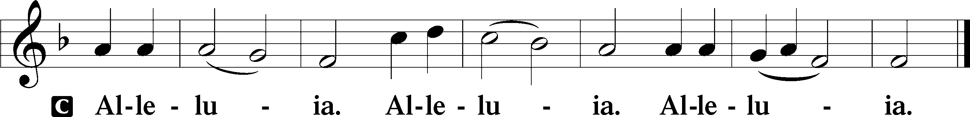

Holy Gospel Matthew 3:1–12
P The Holy Gospel according to St. Matthew, the third chapter.

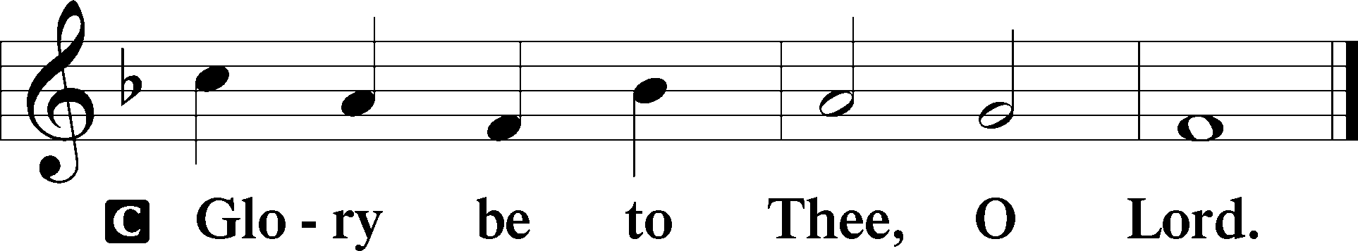

John the Baptist Prepares the Way
1In those days John the Baptist came preaching in the wilderness of Judea, 2“Repent, for the kingdom of heaven is at hand.” 3For this is he who was spoken of by the prophet Isaiah when he said,
“The voice of one crying in the wilderness:
‘Prepare the way of the Lord;
make his paths straight.’”
4Now John wore a garment of camel’s hair and a leather belt around his waist, and his food was locusts and wild honey. 5Then Jerusalem and all Judea and all the region about the Jordan were going out to him, 6and they were baptized by him in the river Jordan, confessing their sins.
7But when he saw many of the Pharisees and Sadducees coming for baptism, he said to them, “You brood of vipers! Who warned you to flee from the wrath to come? 8Bear fruit in keeping with repentance. 9And do not presume to say to yourselves, ‘We have Abraham as our father,’ for I tell you, God is able from these stones to raise up children for Abraham. 10Even now the axe is laid to the root of the trees. Every tree therefore that does not bear good fruit is cut down and thrown into the fire.
11“I baptize you with water for repentance, but he who is coming after me is mightier than I, whose sandals I am not worthy to carry. He will baptize you with the Holy Spirit and with fire. 12His winnowing fork is in his hand, and he will clear his threshing floor and gather his wheat into the barn, but the chaff he will burn with unquenchable fire.”

P This is the Gospel of the Lord.

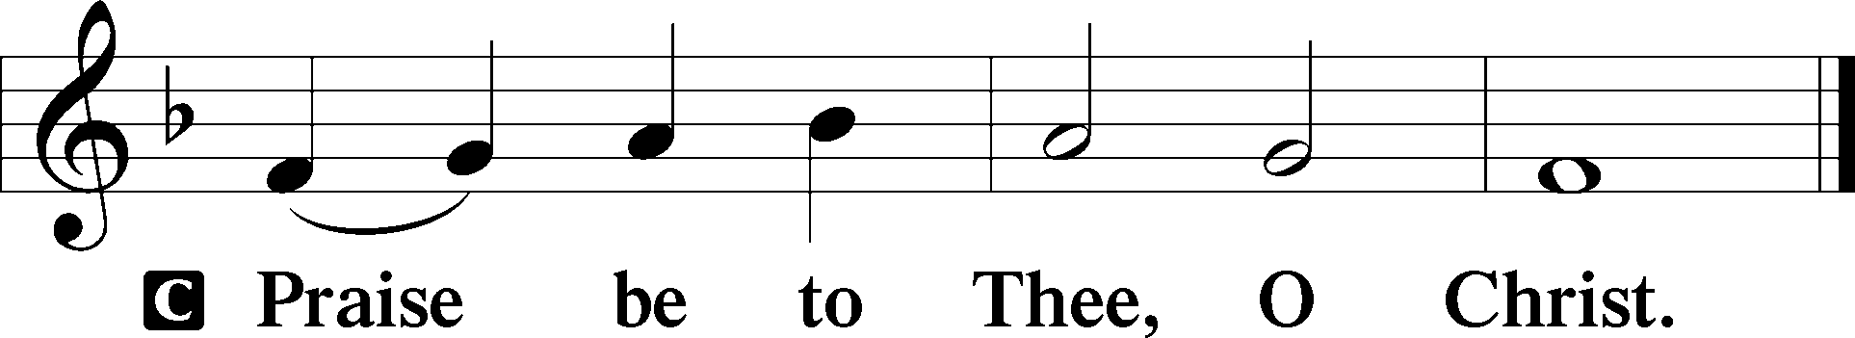

Nicene Creed
C I believe in one God,
the Father Almighty,
maker of heaven and earth
and of all things visible and invisible.

And in one Lord Jesus Christ,
the only-begotten Son of God,
begotten of His Father before all worlds,
God of God, Light of Light,
very God of very God,
begotten, not made,
being of one substance with the Father,
by whom all things were made;
who for us men and for our salvation came down from heaven
and was incarnate by the Holy Spirit of the virgin Mary
and was made man;
and was crucified also for us under Pontius Pilate.
He suffered and was buried.
And the third day He rose again according to the Scriptures
and ascended into heaven
and sits at the right hand of the Father.
And He will come again with glory to judge both the living and the dead,
whose kingdom will have no end.

And I believe in the Holy Spirit,
the Lord and giver of life,
who proceeds from the Father and the Son,
who with the Father and the Son together is worshiped and glorified,
who spoke by the prophets.
And I believe in one holy Christian and apostolic Church,
I acknowledge one Baptism for the remission of sins,
and I look for the resurrection of the dead
and the life T of the world to come. Amen.

Sit

Children's Message

344 On Jordan’s Bank the Baptist’s Cry
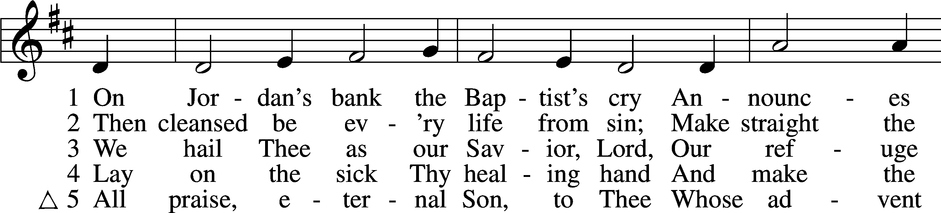
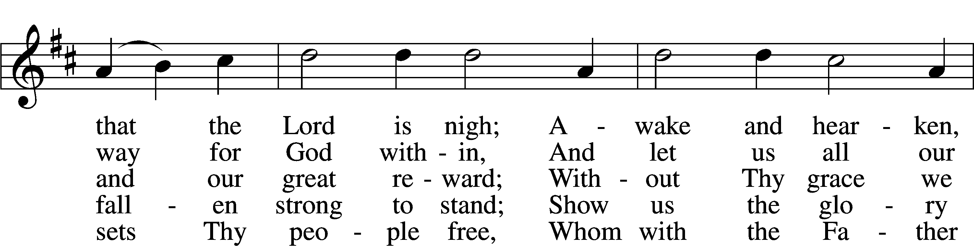
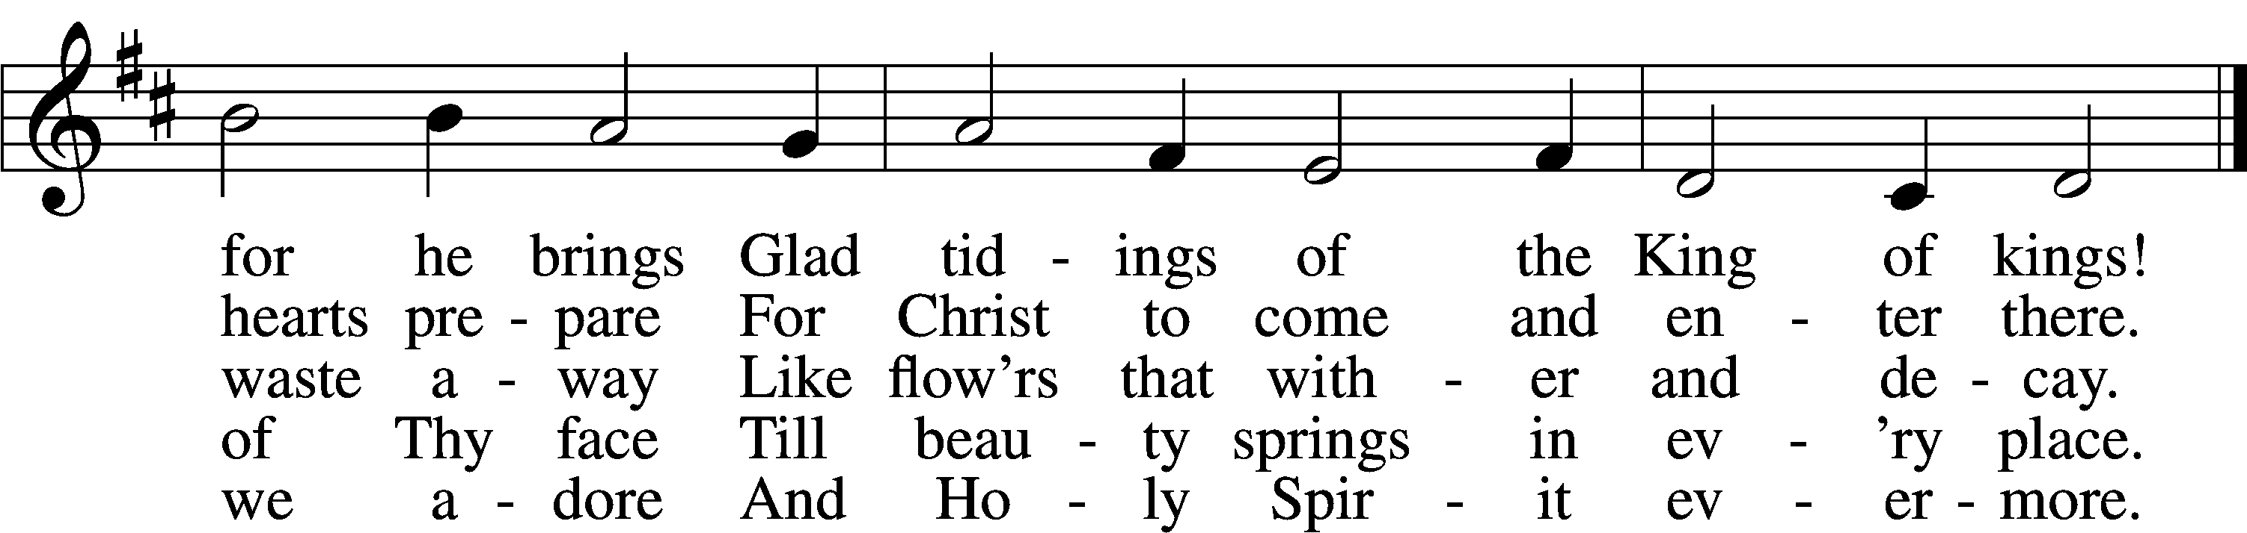
Text: Charles Coffin, 1676–1749; tr. composite
Tune: adapt. Michael Praetorius, 1571–1621
Text and tune: Public domain

Sermon

Votum
P The peace of God, which passes all understanding, keep your hearts and minds in Christ Jesus.
C Amen.

Stand

Offertory Psalm 51:10–12
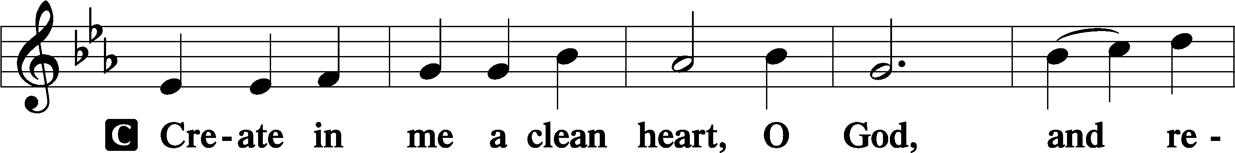
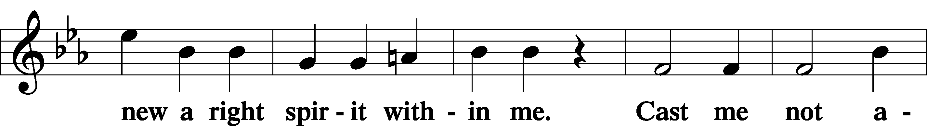
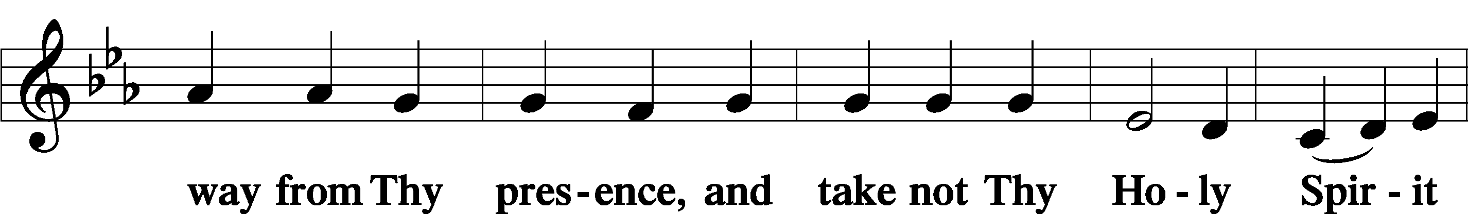
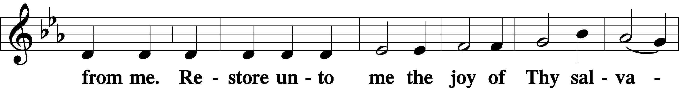
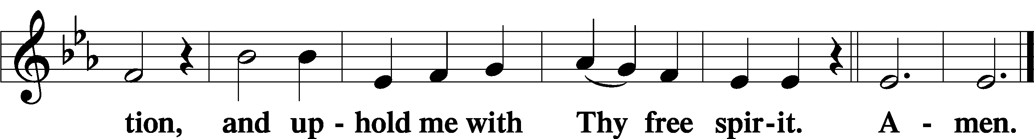

Sit

Offering

805 Praise God, from Whom All Blessings Flow
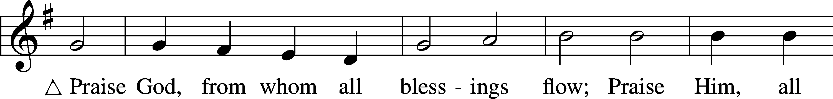
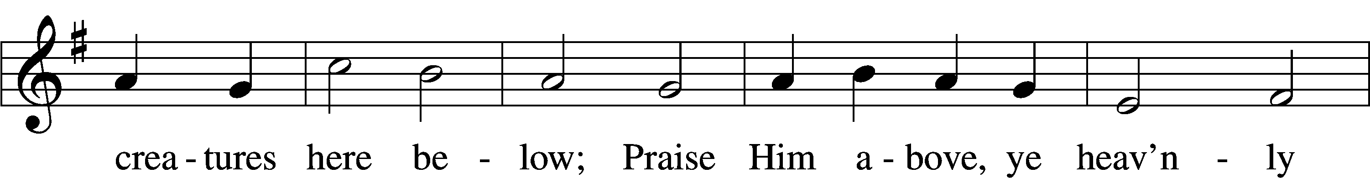
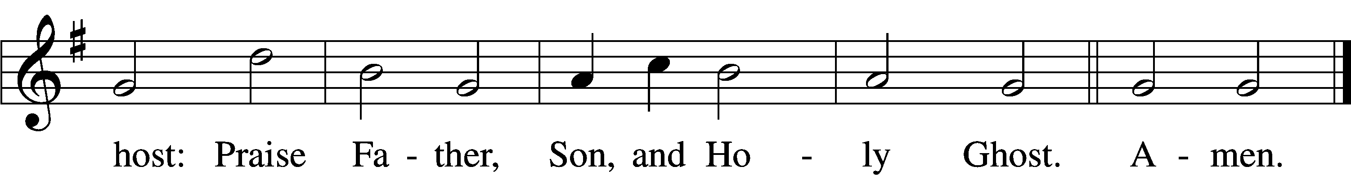
Text: Thomas Ken, 1637–1711
Tune: Trente quatre Pseaumes de David, 1551, Geneva, ed. Louis Bourgeois
Text and tune: Public domain

Stand

Prayer of the Church

Service of the Sacrament

Preface 2 Timothy 4:22; [Colossians 3:1]; [Psalm 136]
P The Lord be with you.
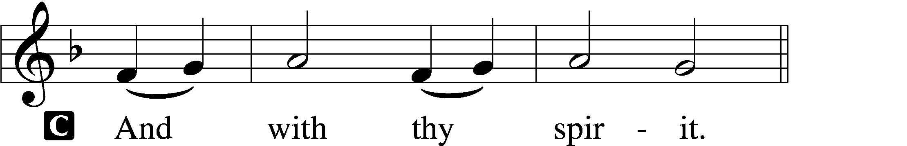

P Lift up your hearts.
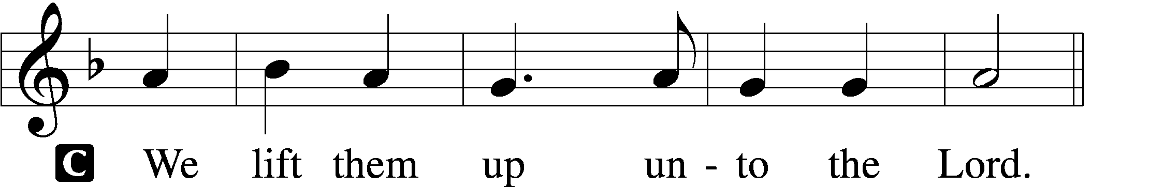

P Let us give thanks unto the Lord, our God.
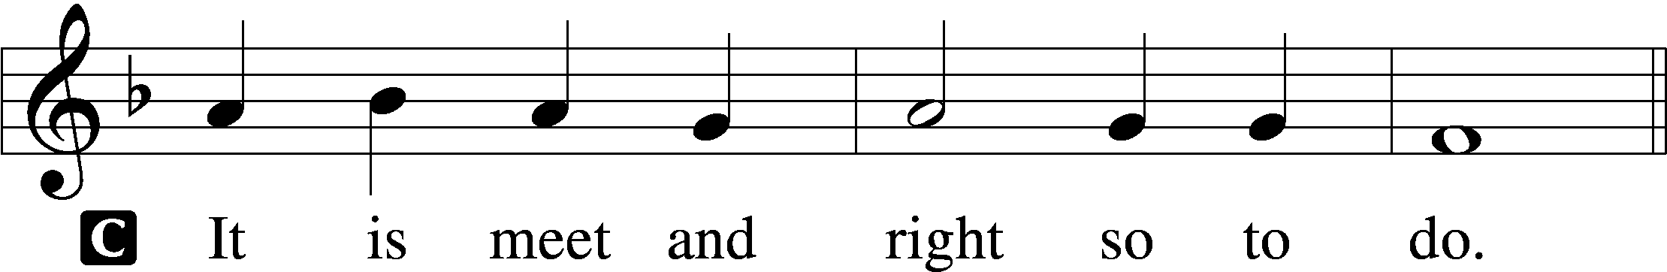

Proper Preface
P It is truly meet, right, and salutary that we should at all times and in all places give thanks to You, holy Lord, almighty Father, everlasting God, through Jesus Christ, our Lord, whose way John the Baptist prepared, proclaiming Him the promised Messiah, the very Lamb of God who takes away the sin of the world, and calling sinners to repentance that they might escape from the wrath to be revealed when He comes again in glory. Therefore with angels and archangels and with all the company of heaven we laud and magnify Your glorious name, evermore praising You and saying:

Sanctus Isaiah 6:3; Matthew 21:9
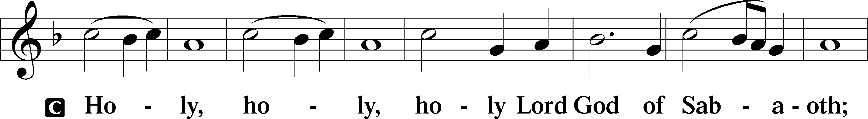
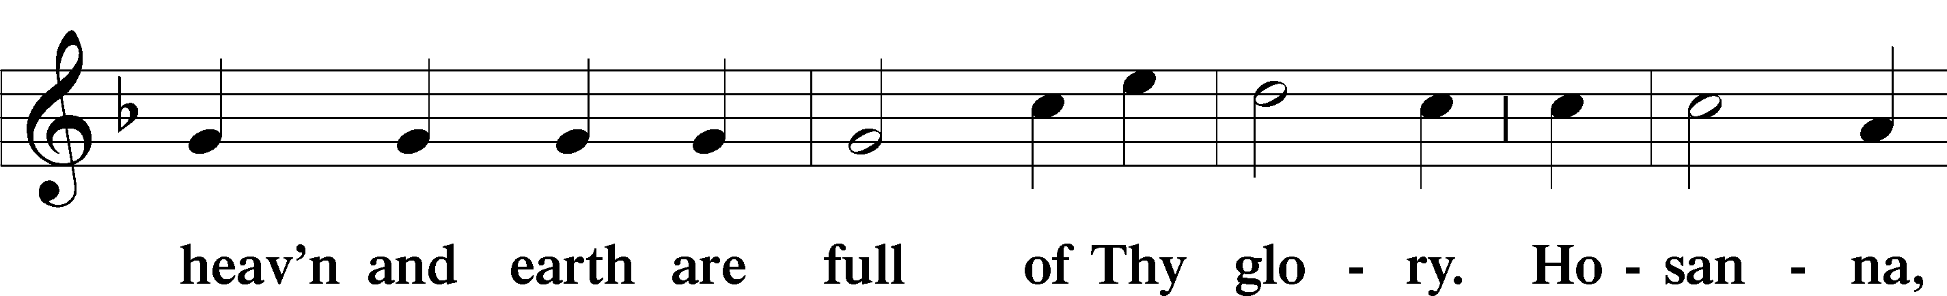
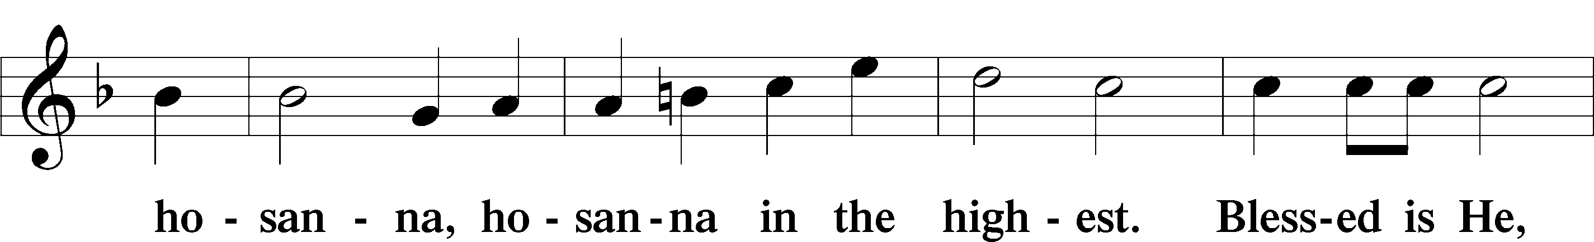
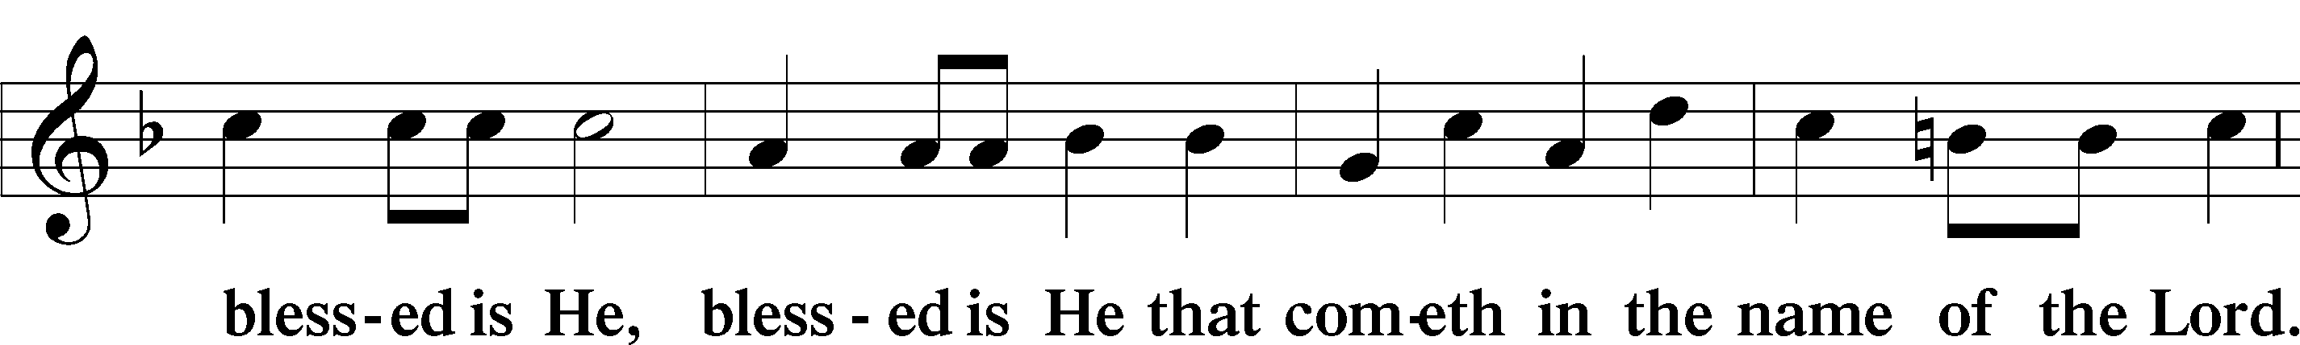
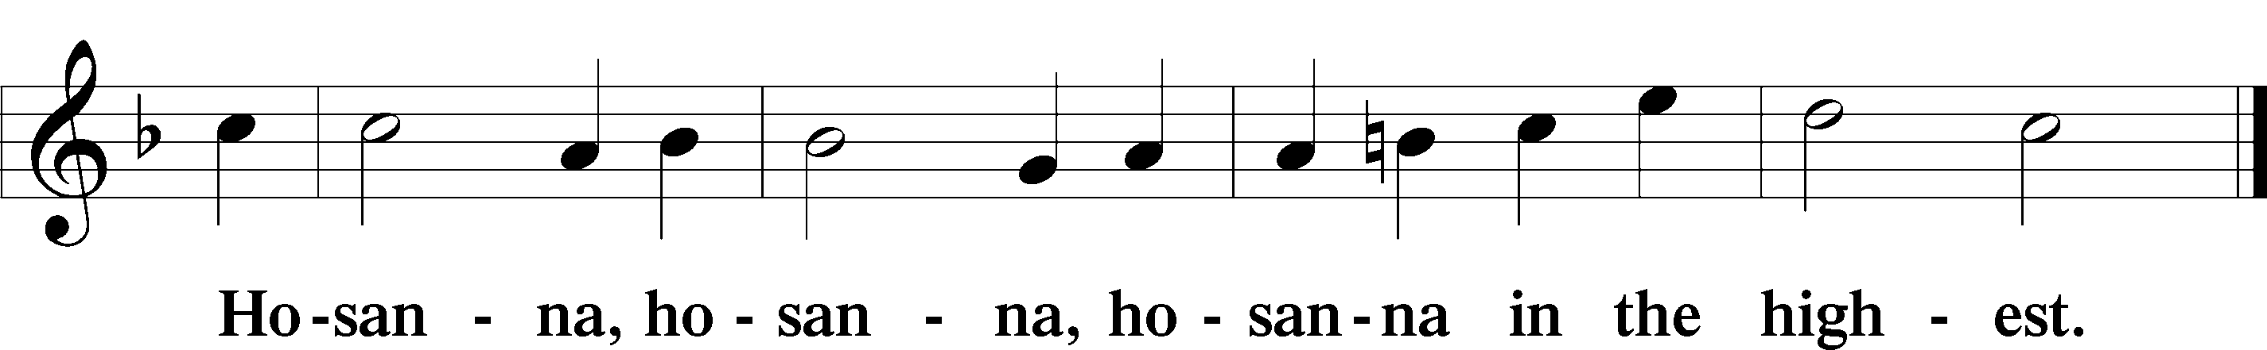

Lord’s Prayer Matthew 6:9–13
P Our Father who art in heaven,
hallowed be Thy name,
Thy kingdom come,
Thy will be done on earth as it is in heaven;
give us this day our daily bread;
and forgive us our trespasses as we forgive those who trespass against us;
and lead us not into temptation,
but deliver us from evil.
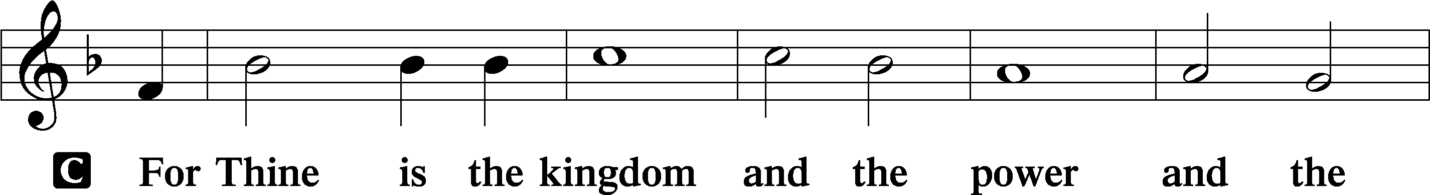
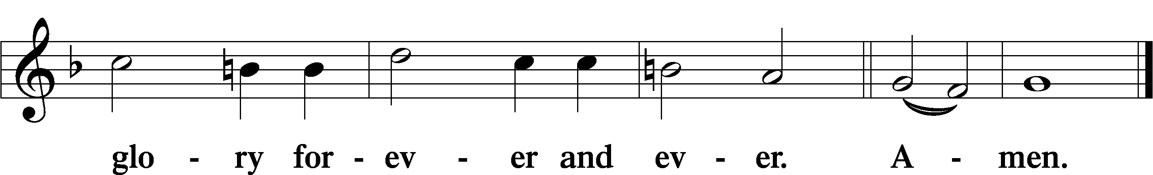

The Words of Our Lord Matthew 26:26–28; Mark 14:22–24; Luke 22:19–20; 1 Corinthians 11:23–25
P Our Lord Jesus Christ, on the night when He was betrayed, took bread, and when He had given thanks, He broke it and gave it to the disciples and said: “Take, eat; this is My T body, which is given for you. This do in remembrance of Me.”

In the same way also He took the cup after supper, and when He had given thanks, He gave it to them, saying: “Drink of it, all of you; this cup is the new testament in My T blood, which is shed for you for the forgiveness of sins. This do, as often as you drink it, in remembrance of Me.”

Pax Domini John 20:19
P The peace of the Lord be with you always.

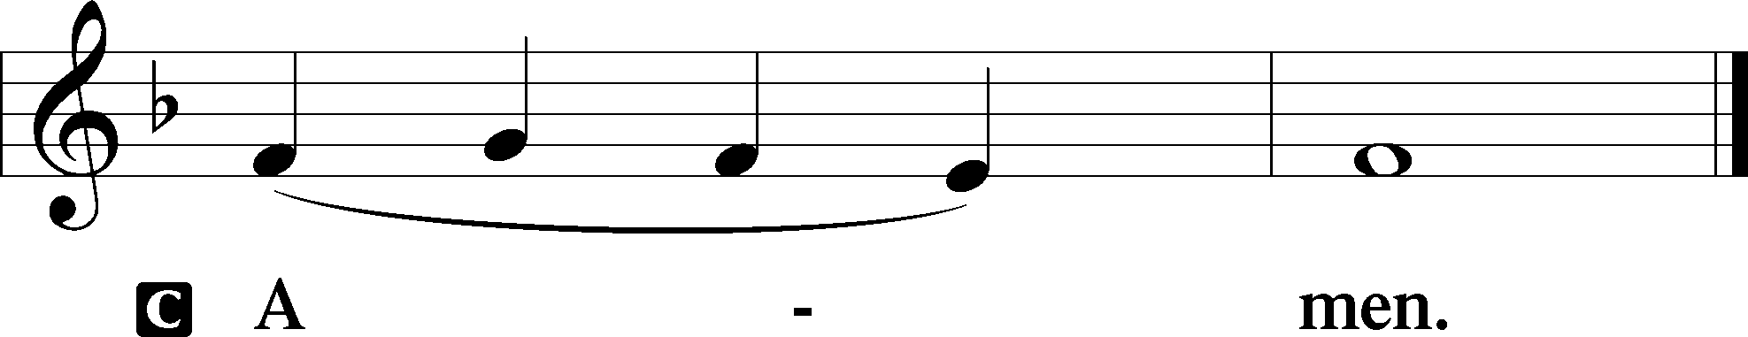

Agnus Dei John 1:29
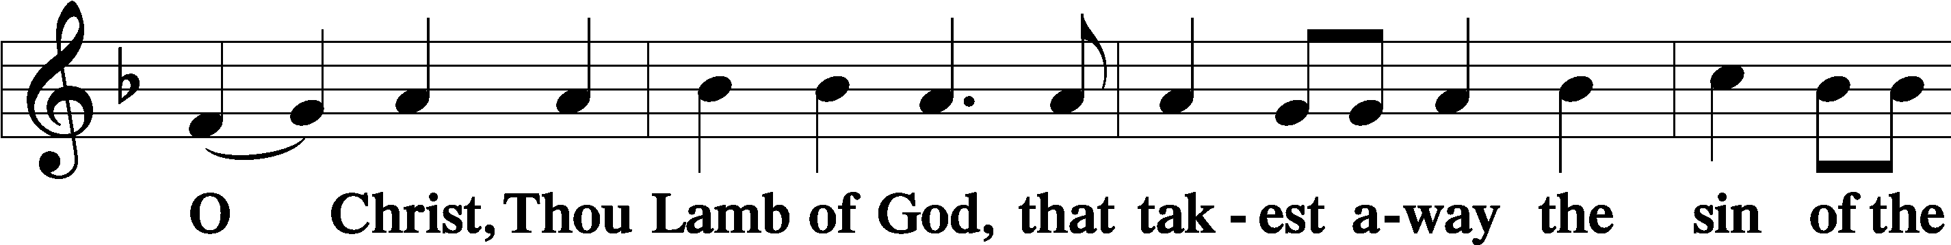
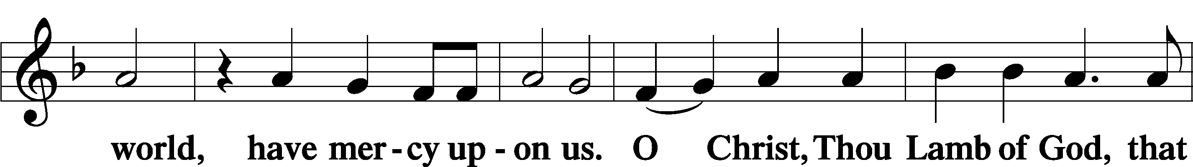
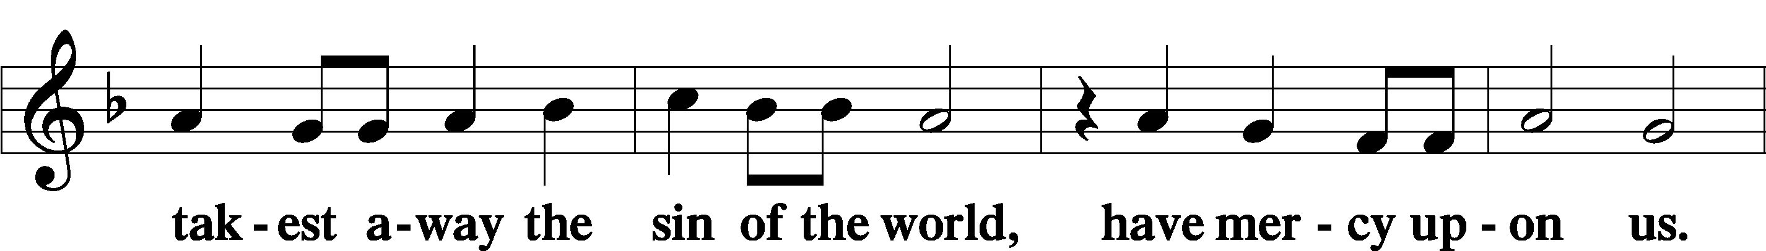
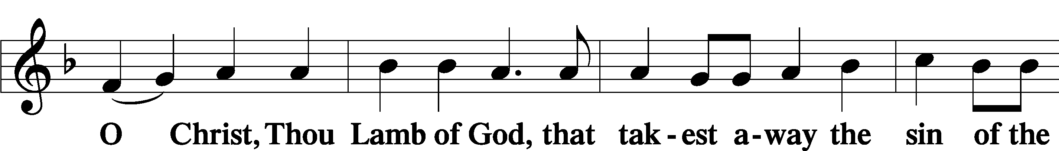
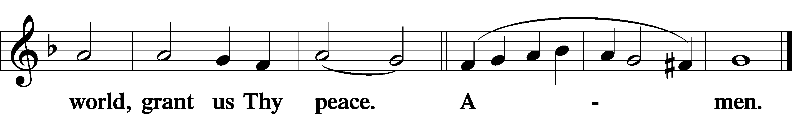

Sit

Distribution

628 Your Table I Approach
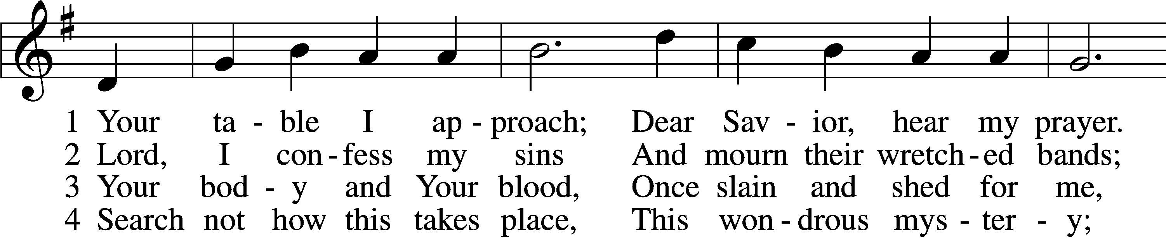
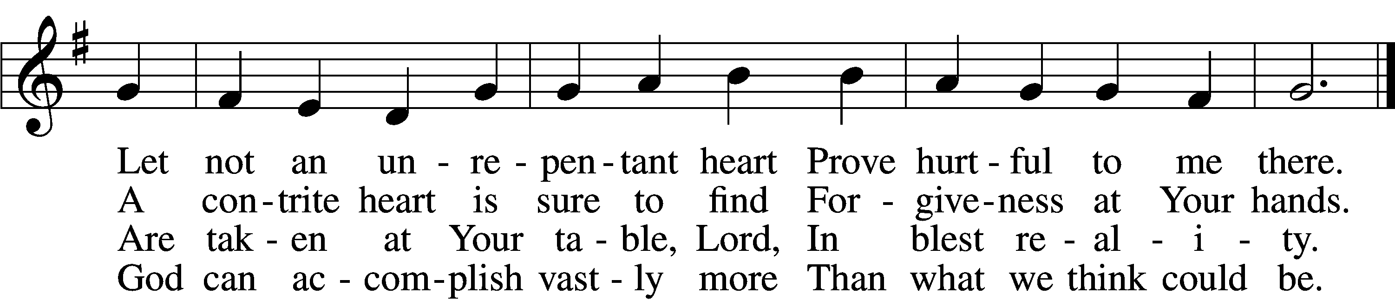

5 O grant, most blessèd Lord,
That earth and hell combined
May not about this sacrament
Raise doubt within my mind.

6 Oh, may I never fail
To thank You day and night
For Your true body and true blood,
O God, my peace and light.
Text: Gerhard Wolter Molanus, 1633–1722; tr. Matthias Loy, 1828–1915, alt.
Tune: Trente quatre Pseaumes de David, 1551, Geneva, ed. Louis Bourgeois
Text and tune: Public domain

606 I Lay My Sins on Jesus
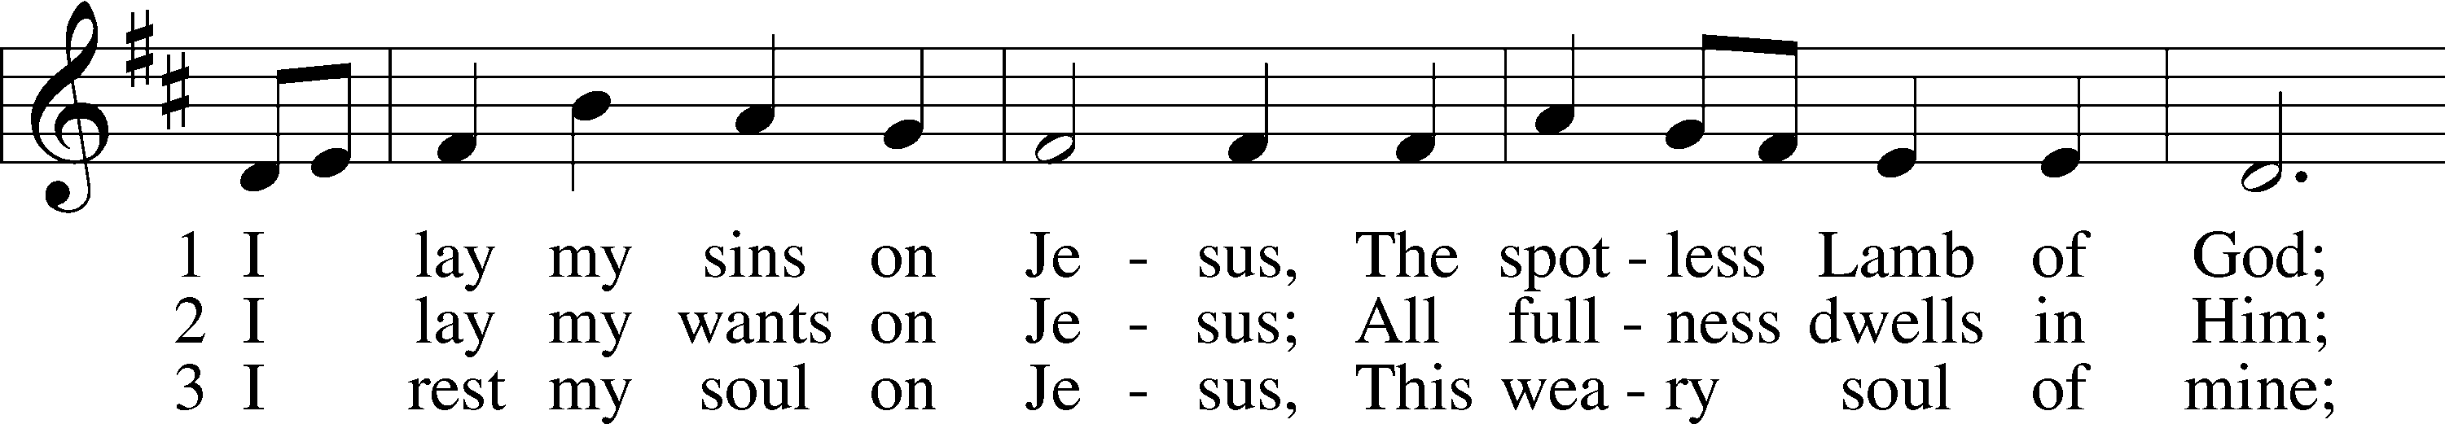
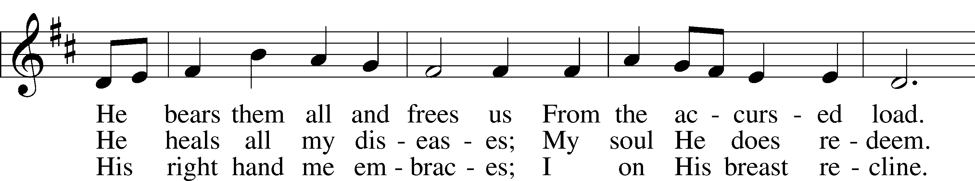
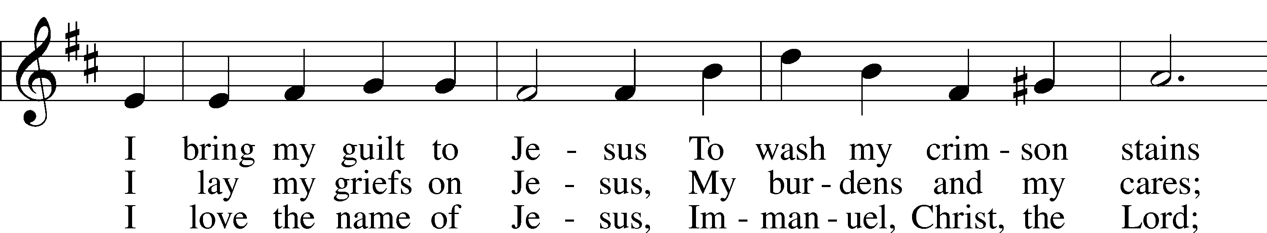
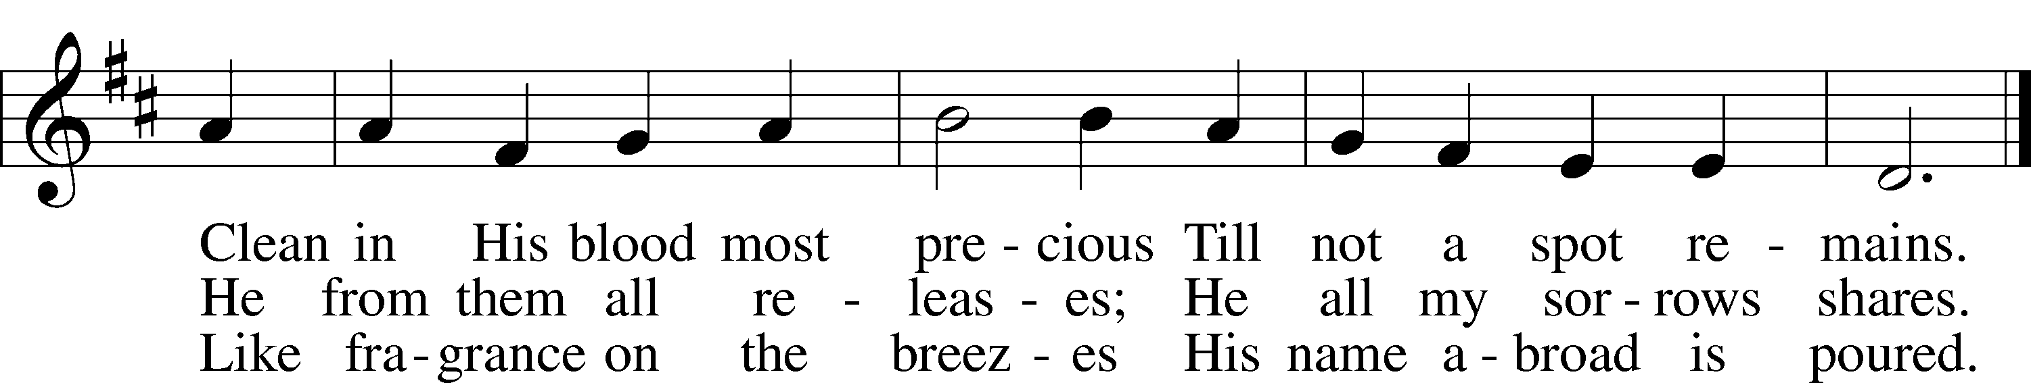
Text: Horatius Bonar, 1808–89
Tune: Neu-vermehrtes . . . Gesangbuch, 1693, 3rd ed., Meiningen
Text and tune: Public domain

348 The King Shall Come When Morning Dawns
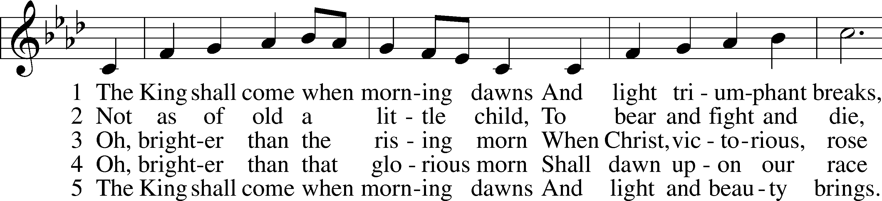
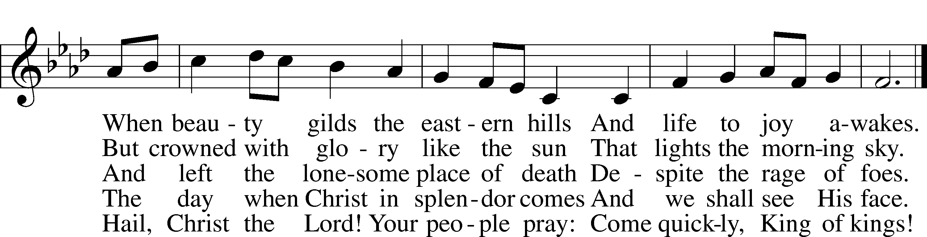
Text: John Brownlie, 1859–1925, alt.
Tune: Repository of Sacred Music, Part Second, 1813, Harrisburg, ed. John Wyeth
Text and tune: Public domain

610 Lord Jesus Think On Me
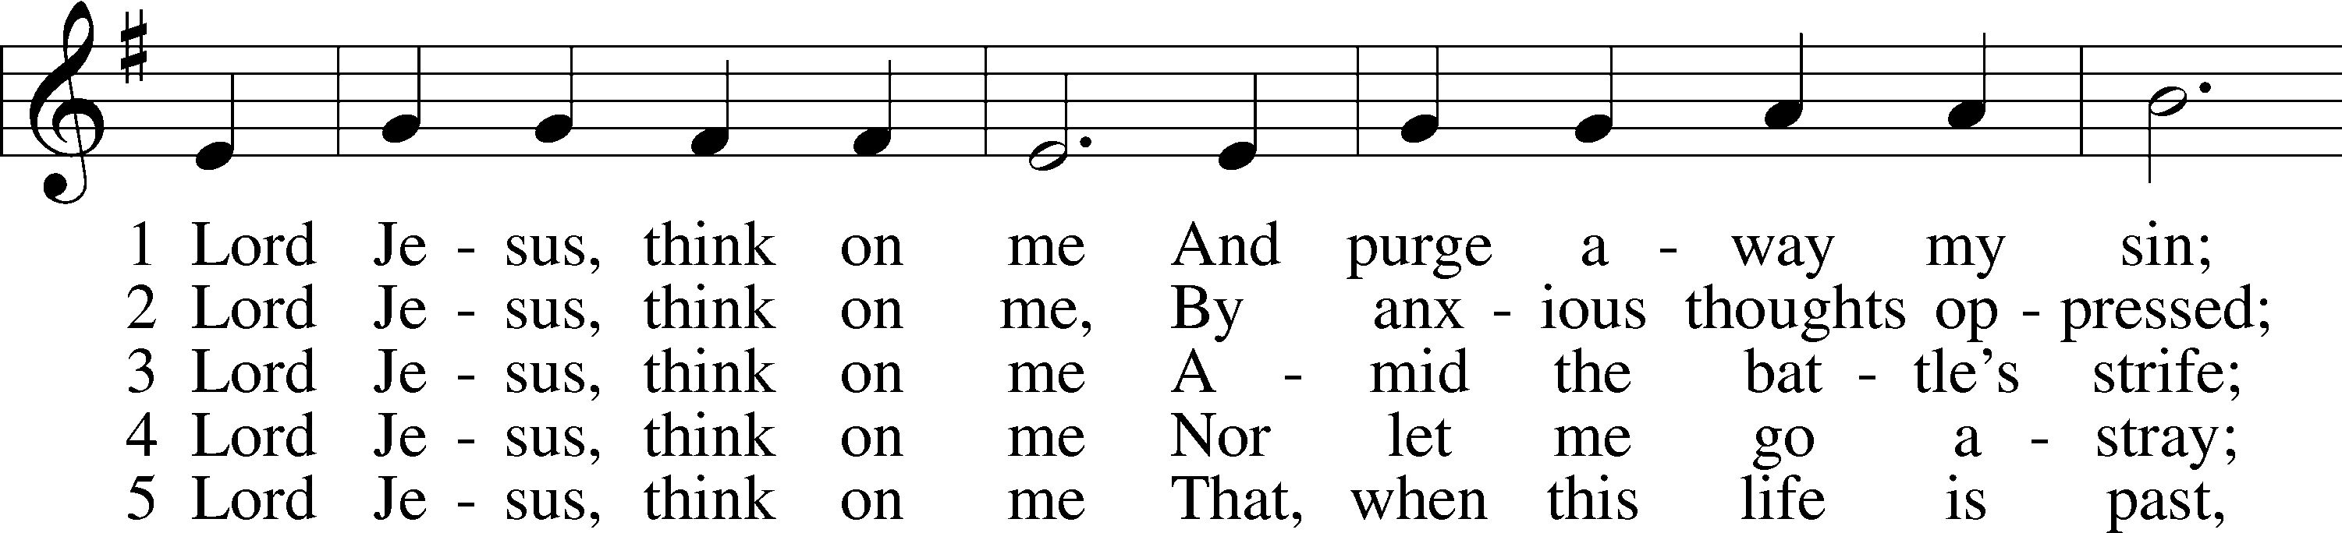
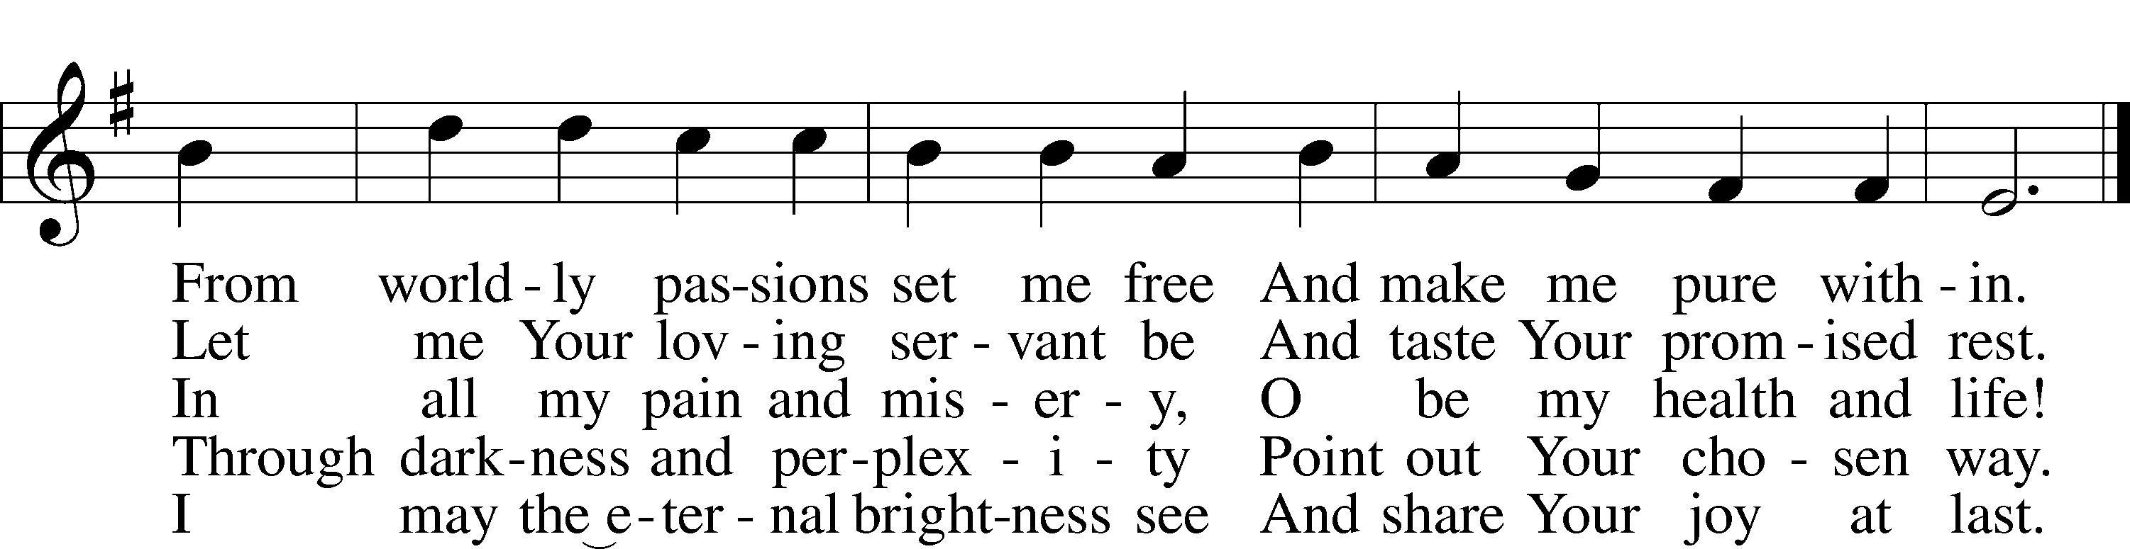
Text: Synesius of Cyrene, c. 365–c. 414; tr. Allen W. Chatfield, 1808–96, alt.
Tune: William Daman, c. 1540–1591
Text and tune: Public domain

Dismissal

Nunc Dimittis Luke 2:29–32
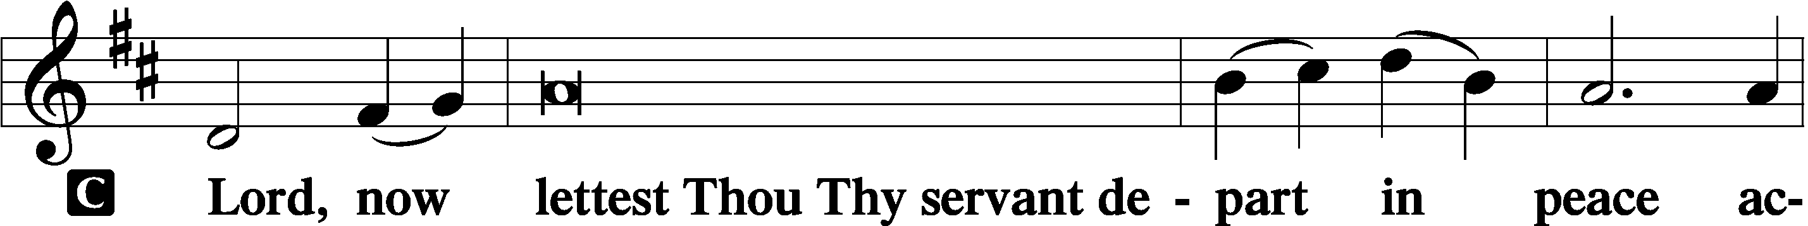

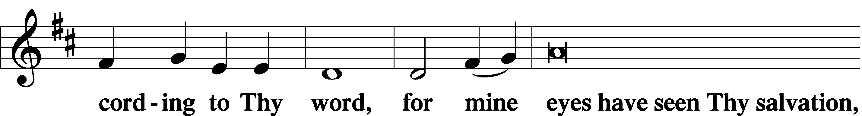

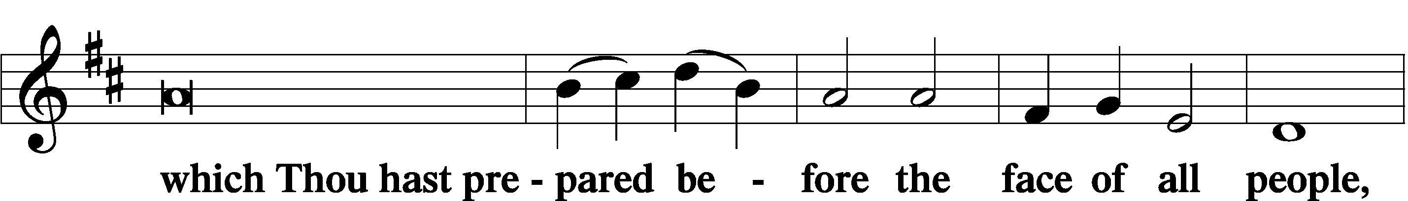

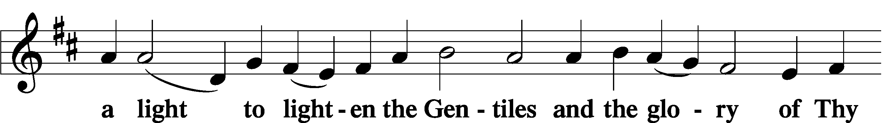

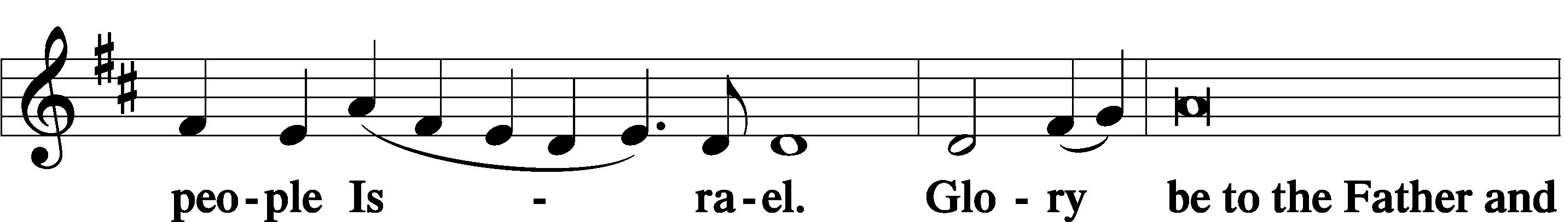

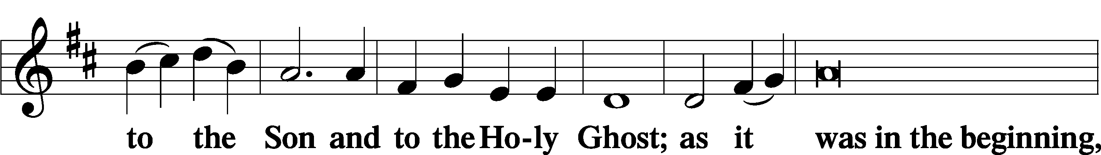

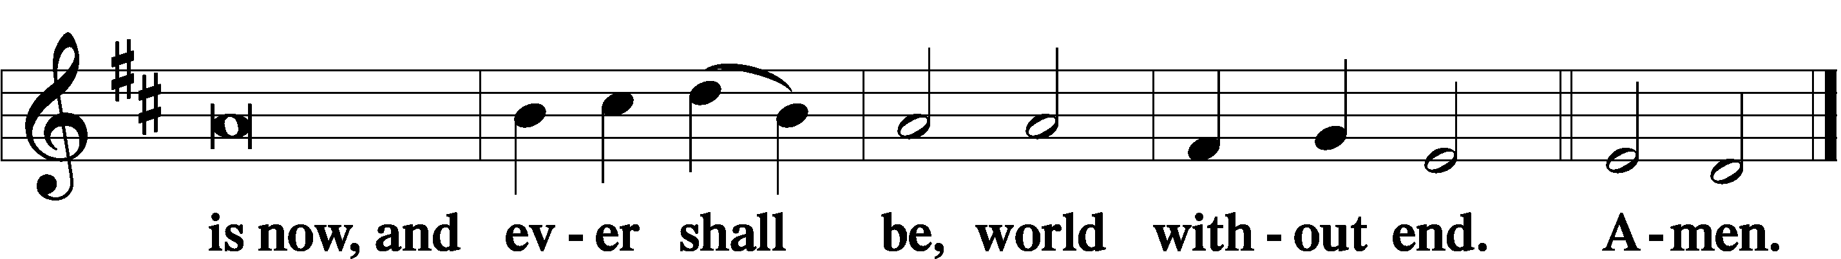

Thanksgiving Psalm 107:1
A O give thanks unto the Lord, for He is good,

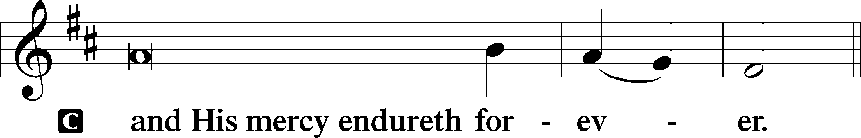

Post-Communion Collect
A Let us pray.
We give thanks to You, almighty God, that You have refreshed us through this salutary gift, and we implore You that of Your mercy You would strengthen us through the same in faith toward You and in fervent love toward one another; through Jesus Christ, Your Son, our Lord, who lives and reigns with You and the Holy Spirit, one God, now and forever.

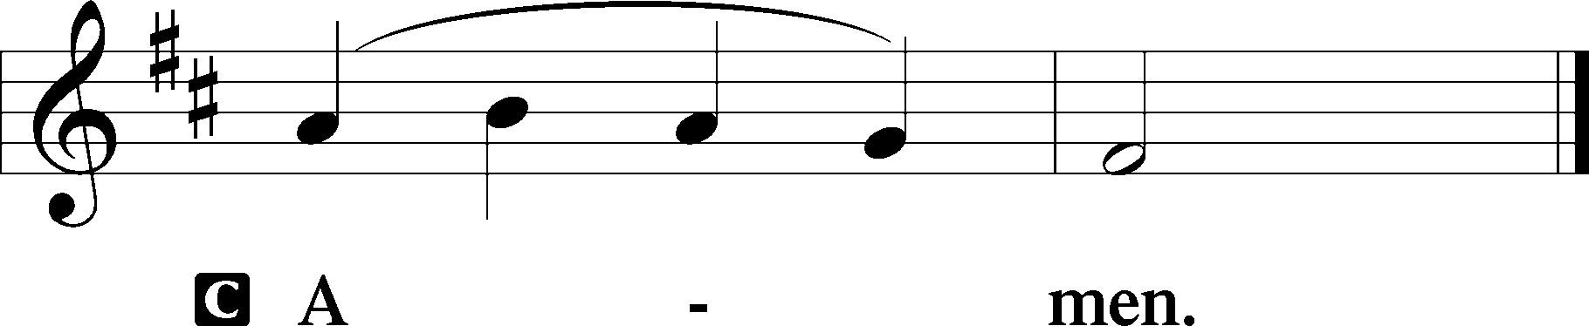

Salutation 2 Timothy 4:22
P The Lord be with you.

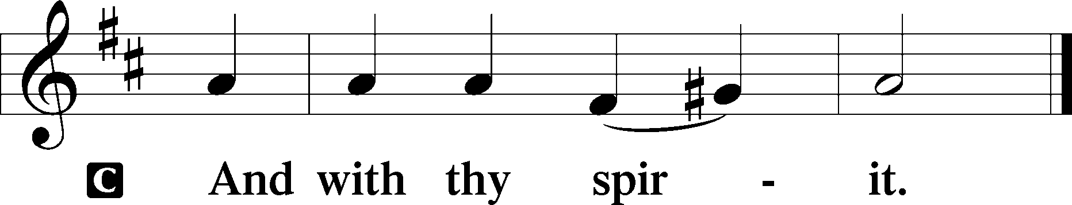

Benedicamus Psalm 103:1
A Bless we the Lord.

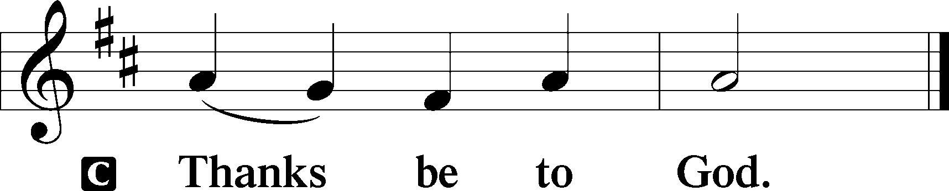

Benediction Numbers 6:24–26
P The Lord bless you and keep you.
The Lord make His face shine upon you and be gracious unto you.
The Lord lift up His countenance upon you and T give you peace.
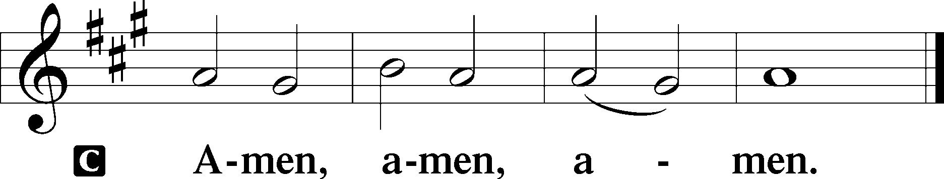

343 Prepare the Royal Highway
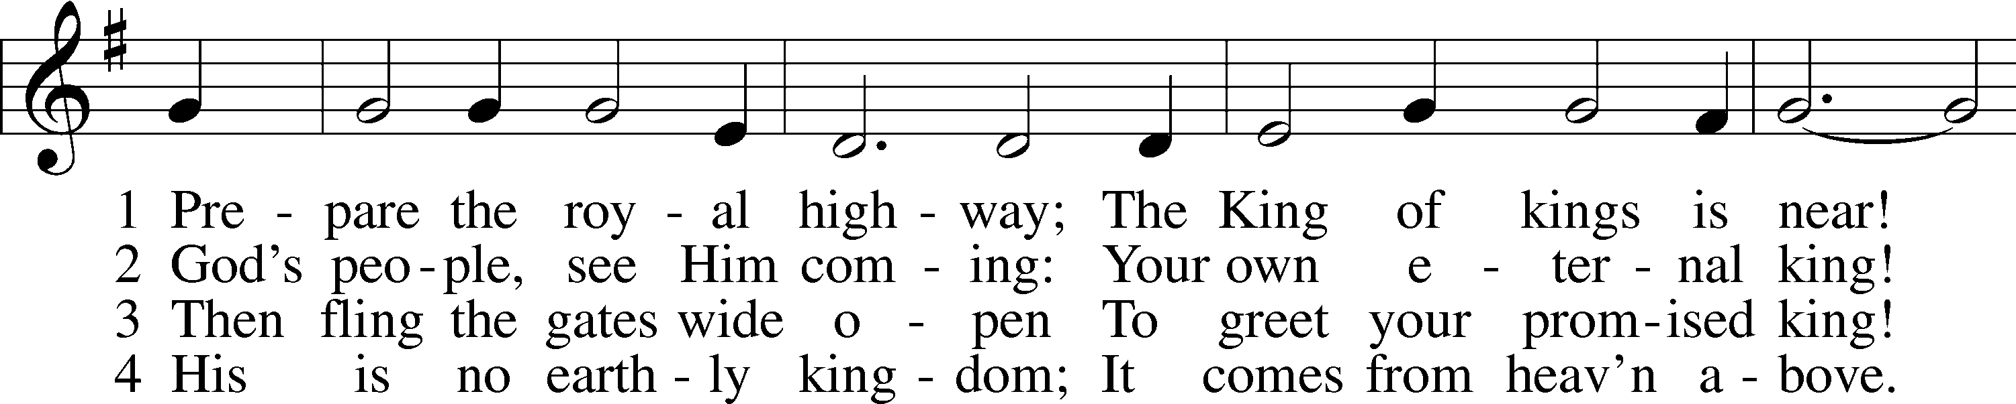
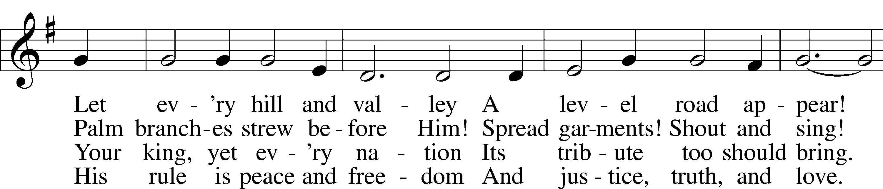
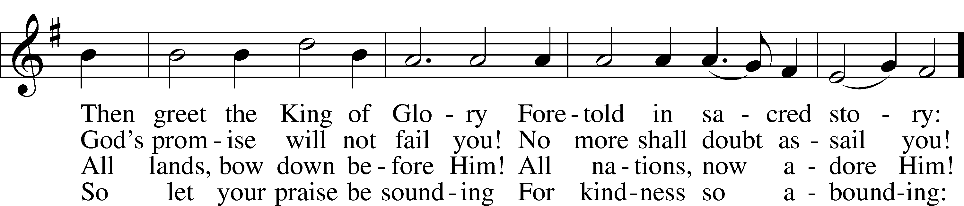
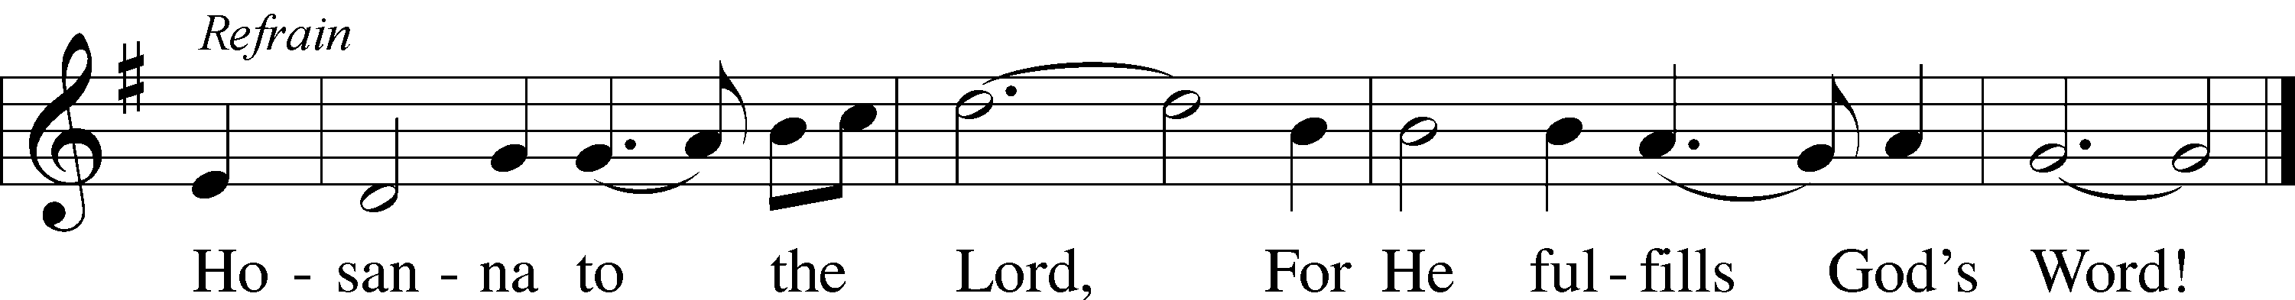
Text: Frans Mikael Franzén, 1772–1847; tr. Lutheran Book of Worship, 1978, alt.
Tune: Swedish, 17th cent.
Text: © 1978 Lutheran Book of Worship. Used by permission: LSB Hymn License no. 110005011
Tune: Public domain

Acknowledgments
Divine Service, Setting Three from Lutheran Service Book
Unless otherwise indicated, Scripture quotations are from the ESV® Bible (The Holy Bible, English Standard Version®), copyright © 2001 by Crossway, a publishing ministry of Good News Publishers. Used by permission. All rights reserved.
Created by Lutheran Service Builder © 2022 Concordia Publishing House.

