338 Come, Thou Long-Expected Jesus
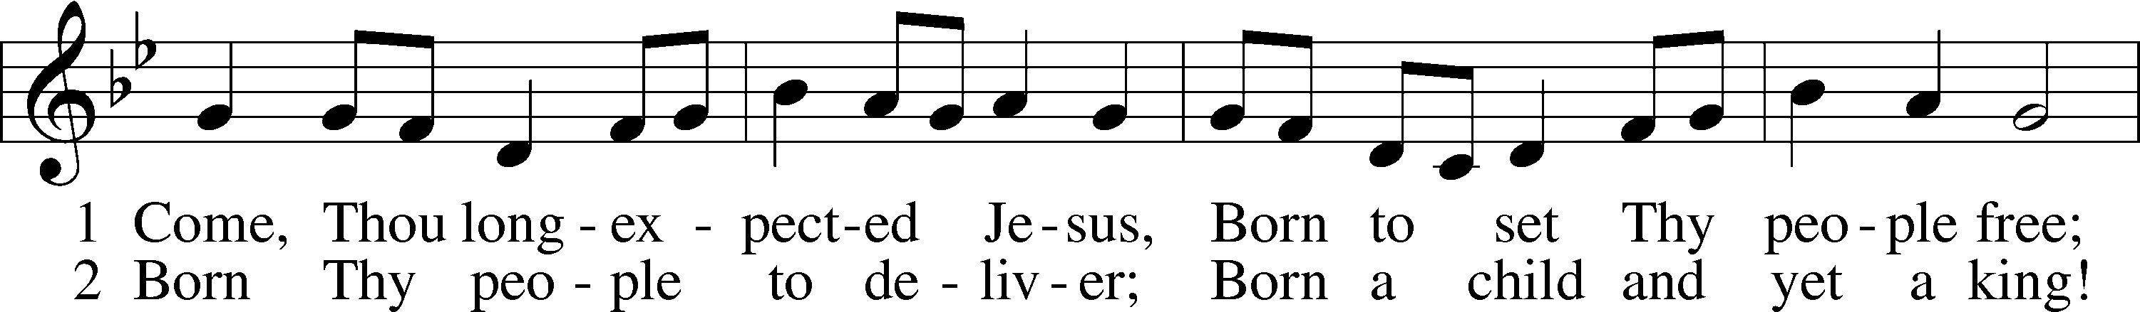
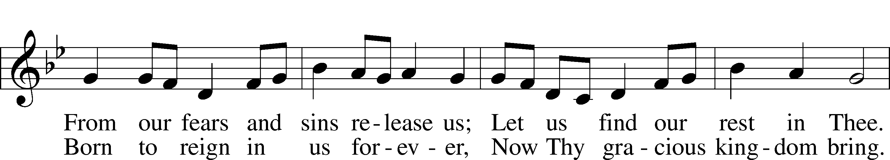
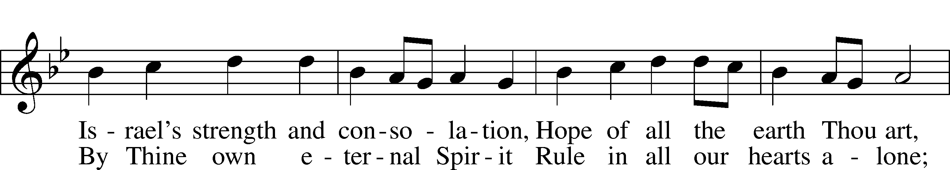
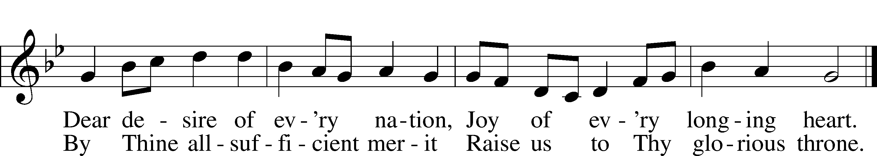
Text: Charles Wesley, 1707–88, alt.
Tune: Southern Harmony, 1835, New Haven
Text and tune: Public domain

Confession and Absolution

The sign of the cross may be made by all in remembrance of their Baptism.

Invocation Matthew 28:19b; 18:20
P In the name of the Father and of the T Son and of the Holy Spirit.
C Amen.

Exhortation Hebrews 10:22; Psalm 124:8; Psalm 32:5
P Beloved in the Lord! Let us draw near with a true heart and confess our sins unto God our Father, beseeching Him in the name of our Lord Jesus Christ to grant us forgiveness.

P Our help is in the name of the Lord,
C who made heaven and earth.
P I said, I will confess my transgressions unto the Lord,
C and You forgave the iniquity of my sin.

Silence for reflection on God’s Word and for self-examination.

Confession of Sins
P Almighty God, our maker and redeemer, we poor sinners confess unto You that we are by nature sinful and unclean and that we have sinned against You by thought, word, and deed. Wherefore we flee for refuge to Your infinite mercy, seeking and imploring Your grace for the sake of our Lord Jesus Christ.
C O most merciful God, who has given Your only-begotten Son to die for us, have mercy upon us and for His sake grant us remission of all our sins; and by Your Holy Spirit increase in us true knowledge of You and of Your will and true obedience to Your Word, to the end that by Your grace we may come to everlasting life; through Jesus Christ, our Lord. Amen.

Declaration of Grace Mark 16:16; John 1:12
P Almighty God, our heavenly Father, has had mercy upon us and has given His only Son to die for us and for His sake forgives us all our sins. To those who believe on His name He gives power to become the children of God and has promised them His Holy Spirit. He that believes and is baptized shall be saved.
Grant this, Lord, unto us all.
C Amen.

Service of the Word

Introit Psalm 71:14–18; antiphon: Philippians 4:4
Rejoice in the Lord always;
again I will say, Rejoice.
I will hope continually
and will praise you yet more and more.
My mouth will tell of your righteous acts, of your deeds of salvation all the day,
for their number is past my knowledge.
With the mighty deeds of the Lord God I will come;
I will remind them of your righteousness, yours alone.
O God, from my youth you have taught me,
and I still proclaim your wondrous deeds.
So even to old age and gray hairs, O God, do not forsake me,
until I proclaim your might to another generation, your power to all those to come.

Gloria Patri
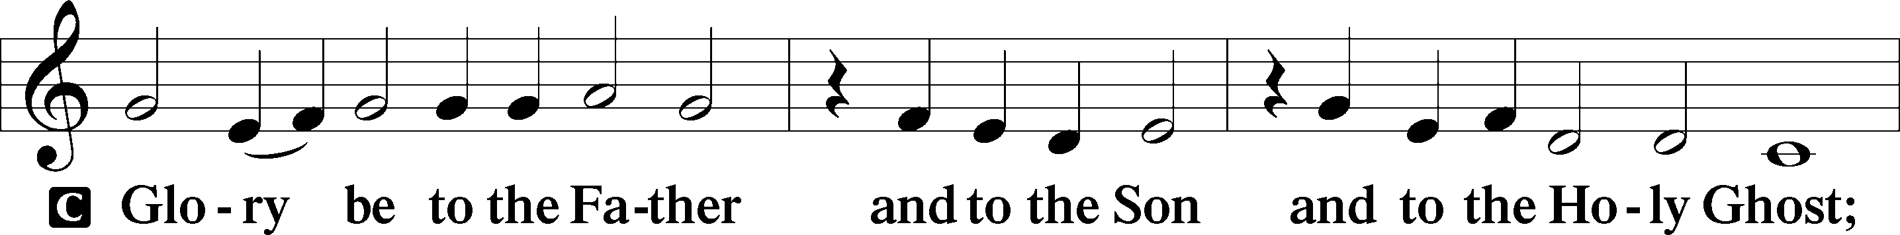
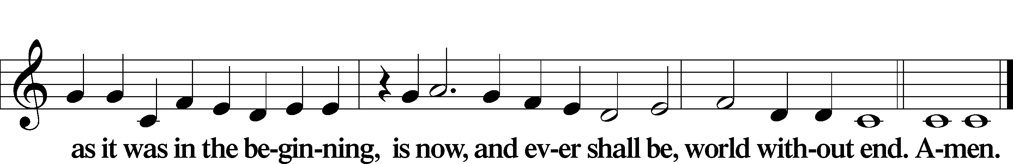

Kyrie Mark 10:47
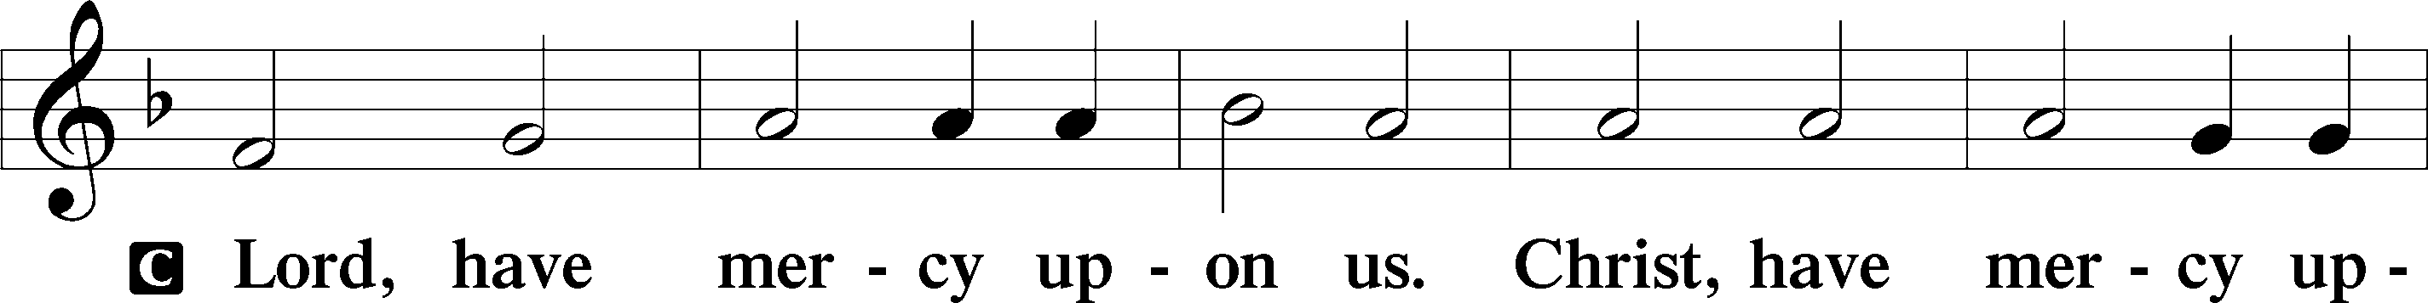
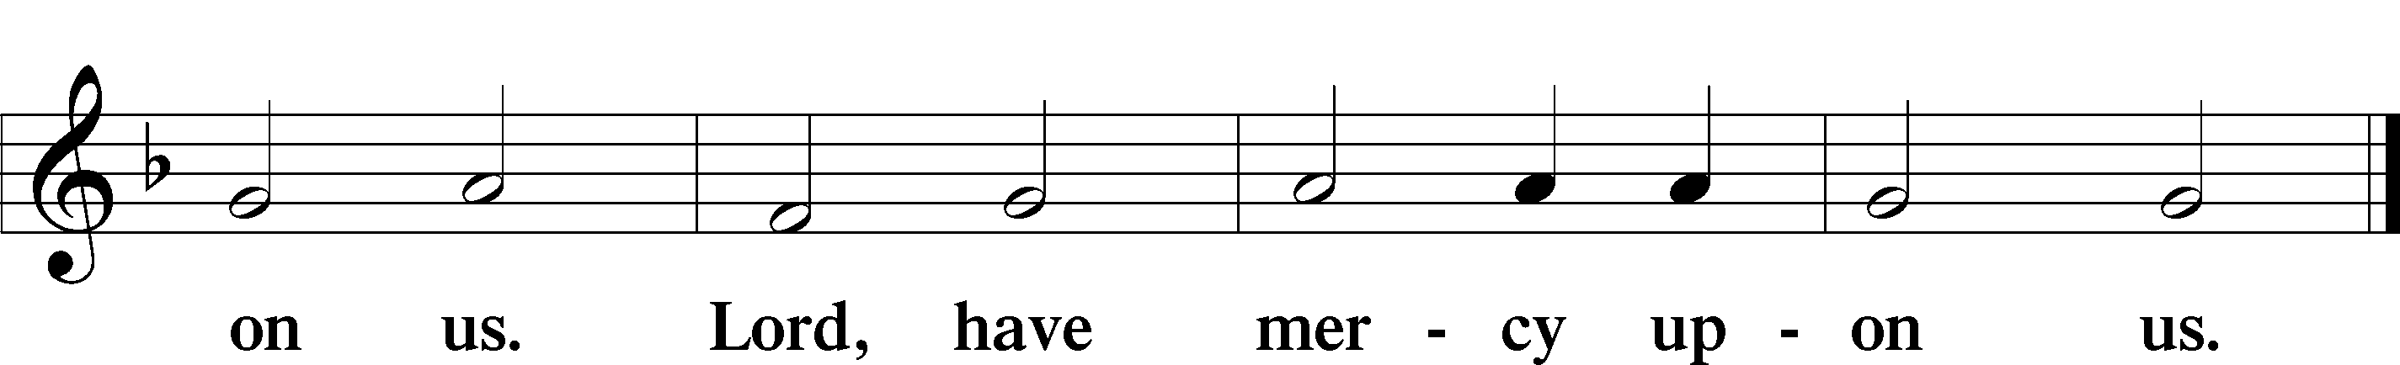

Salutation and Collect of the Day
P The Lord be with you.
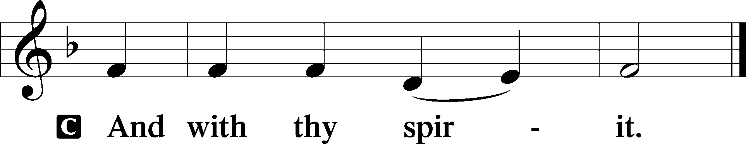

P Let us pray.
Lord Jesus Christ, we implore You to hear our prayers and to lighten the darkness of our hearts by Your gracious visitation; for You live and reign with the Father and the Holy Spirit, one God, now and forever.

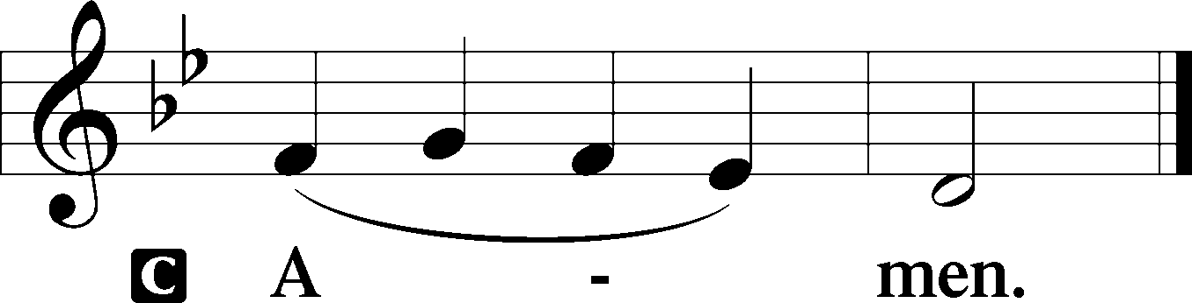

Sit

Old Testament Reading Isaiah 35:1–10
The Ransomed Shall Return
1The wilderness and the dry land shall be glad;
the desert shall rejoice and blossom like the crocus;
2it shall blossom abundantly
and rejoice with joy and singing.
The glory of Lebanon shall be given to it,
the majesty of Carmel and Sharon.
They shall see the glory of the Lord,
the majesty of our God.
3Strengthen the weak hands,
and make firm the feeble knees.
4Say to those who have an anxious heart,
“Be strong; fear not!
Behold, your God
will come with vengeance,
with the recompense of God.
He will come and save you.”
5Then the eyes of the blind shall be opened,
and the ears of the deaf unstopped;
6then shall the lame man leap like a deer,
and the tongue of the mute sing for joy.
For waters break forth in the wilderness,
and streams in the desert;
7the burning sand shall become a pool,
and the thirsty ground springs of water;
in the haunt of jackals, where they lie down,
the grass shall become reeds and rushes.
8And a highway shall be there,
and it shall be called the Way of Holiness;
the unclean shall not pass over it.
It shall belong to those who walk on the way;
even if they are fools, they shall not go astray.
9No lion shall be there,
nor shall any ravenous beast come up on it;
they shall not be found there,
but the redeemed shall walk there.
10And the ransomed of the Lord shall return
and come to Zion with singing;
everlasting joy shall be upon their heads;
they shall obtain gladness and joy,
and sorrow and sighing shall flee away.

A This is the Word of the Lord.
C Thanks be to God.

Gradual Zechariah 9:9; Psalm 118:26, alt.
Rejoice greatly, O daughter of Zion.
Shout aloud, O daughter of Jerusalem.
Behold, your king is coming to you;
righteous and having salvation.
Blessèd is he who comes in the name of the Lord.
From the house of the Lord we bless you.

Reading Romans 5:6–15
6For while we were still weak, at the right time Christ died for the ungodly. 7For one will scarcely die for a righteous person—though perhaps for a good person one would dare even to die— 8but God shows his love for us in that while we were still sinners, Christ died for us. 9Since, therefore, we have now been justified by his blood, much more shall we be saved by him from the wrath of God. 10For if while we were enemies we were reconciled to God by the death of his Son, much more, now that we are reconciled, shall we be saved by his life. 11More than that, we also rejoice in God through our Lord Jesus Christ, through whom we have now received reconciliation.
Death in Adam, Life in Christ
12Therefore, just as sin came into the world through one man, and death through sin, and so death spread to all men because all sinned— 13for sin indeed was in the world before the law was given, but sin is not counted where there is no law. 14Yet death reigned from Adam to Moses, even over those whose sinning was not like the transgression of Adam, who was a type of the one who was to come.
15But the free gift is not like the trespass. For if many died through one man’s trespass, much more have the grace of God and the free gift by the grace of that one man Jesus Christ abounded for many.

Stand

Alleluia
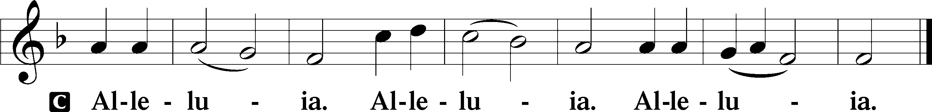

Holy Gospel Matthew 11:2–15
P The Holy Gospel according to St. Matthew, the eleventh chapter.

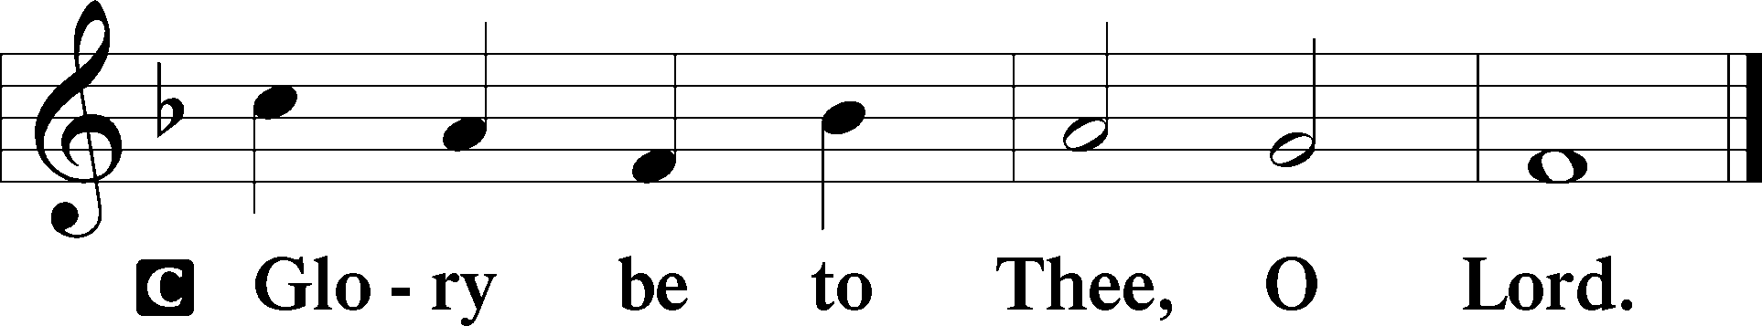

2When John heard in prison about the deeds of the Christ, he sent word by his disciples 3and said to him, “Are you the one who is to come, or shall we look for another?” 4And Jesus answered them, “Go and tell John what you hear and see: 5the blind receive their sight and the lame walk, lepers are cleansed and the deaf hear, and the dead are raised up, and the poor have good news preached to them. 6And blessed is the one who is not offended by me.”
7As they went away, Jesus began to speak to the crowds concerning John: “What did you go out into the wilderness to see? A reed shaken by the wind? 8What then did you go out to see? A man dressed in soft clothing? Behold, those who wear soft clothing are in kings’ houses. 9What then did you go out to see? A prophet? Yes, I tell you, and more than a prophet. 10This is he of whom it is written,
“‘Behold, I send my messenger before your face,
who will prepare your way before you.’
11Truly, I say to you, among those born of women there has arisen no one greater than John the Baptist. Yet the one who is least in the kingdom of heaven is greater than he. 12From the days of John the Baptist until now the kingdom of heaven has suffered violence, and the violent take it by force. 13For all the Prophets and the Law prophesied until John, 14and if you are willing to accept it, he is Elijah who is to come. 15He who has ears to hear, let him hear.”

P This is the Gospel of the Lord.

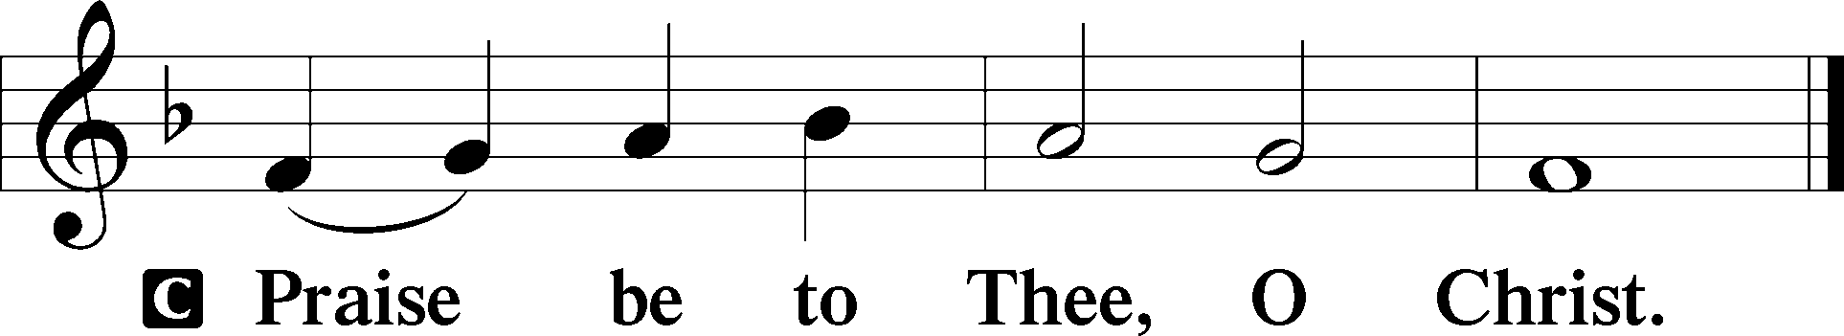

Apostles’ Creed
C I believe in God, the Father Almighty,
maker of heaven and earth.

And in Jesus Christ, His only Son, our Lord,
who was conceived by the Holy Spirit,
born of the virgin Mary,
suffered under Pontius Pilate,
was crucified, died and was buried.
He descended into hell.
The third day He rose again from the dead.
He ascended into heaven
and sits at the right hand of God the Father Almighty.
From thence He will come to judge the living and the dead.

I believe in the Holy Spirit,
the holy Christian Church,
the communion of saints,
the forgiveness of sins,
the resurrection of the body,
and the life T everlasting. Amen.

Sit

345 Hark! A Thrilling Voice Is Sounding
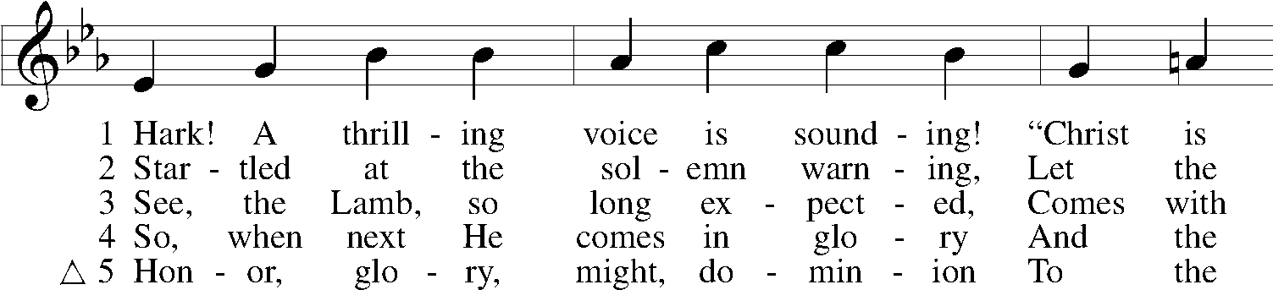
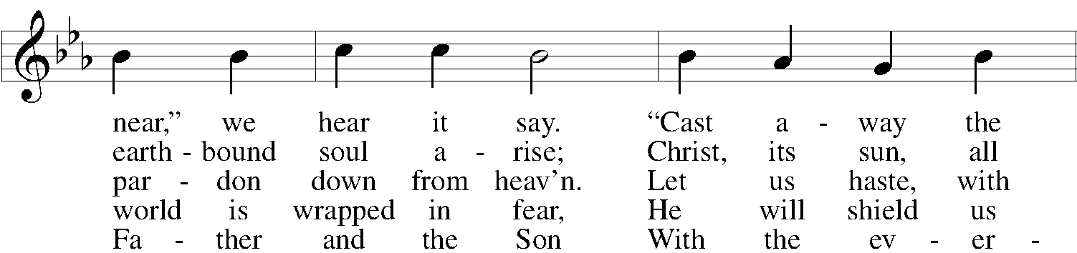
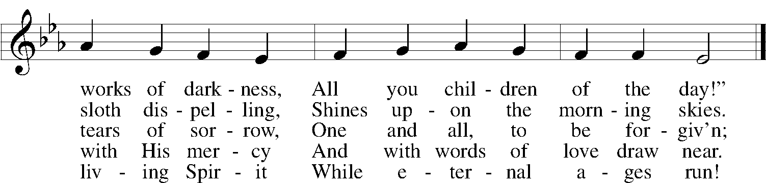
Text: Latin, c. 5th–10th cent.; tr. Edward Caswall, 1814–78, alt.
Tune: William H. Monk, 1823–89
Text and tune: Public domain

Sermon

Votum
P The peace of God, which passes all understanding, keep your hearts and minds in Christ Jesus.
C Amen.

Stand

Offertory Psalm 51:10–12
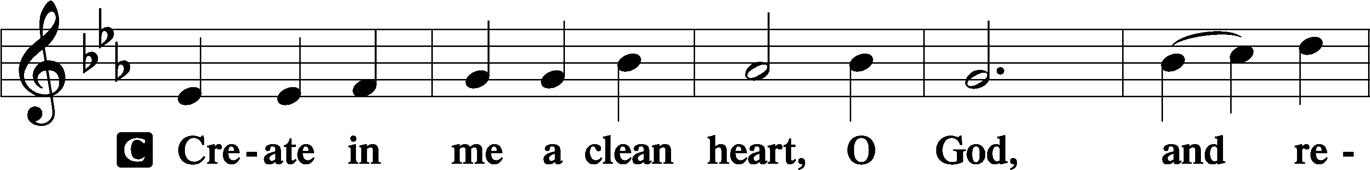
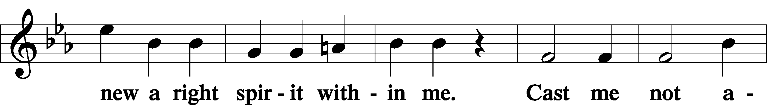
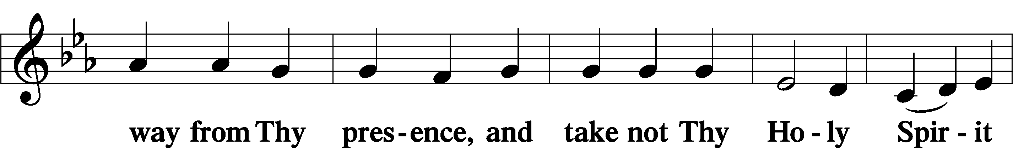
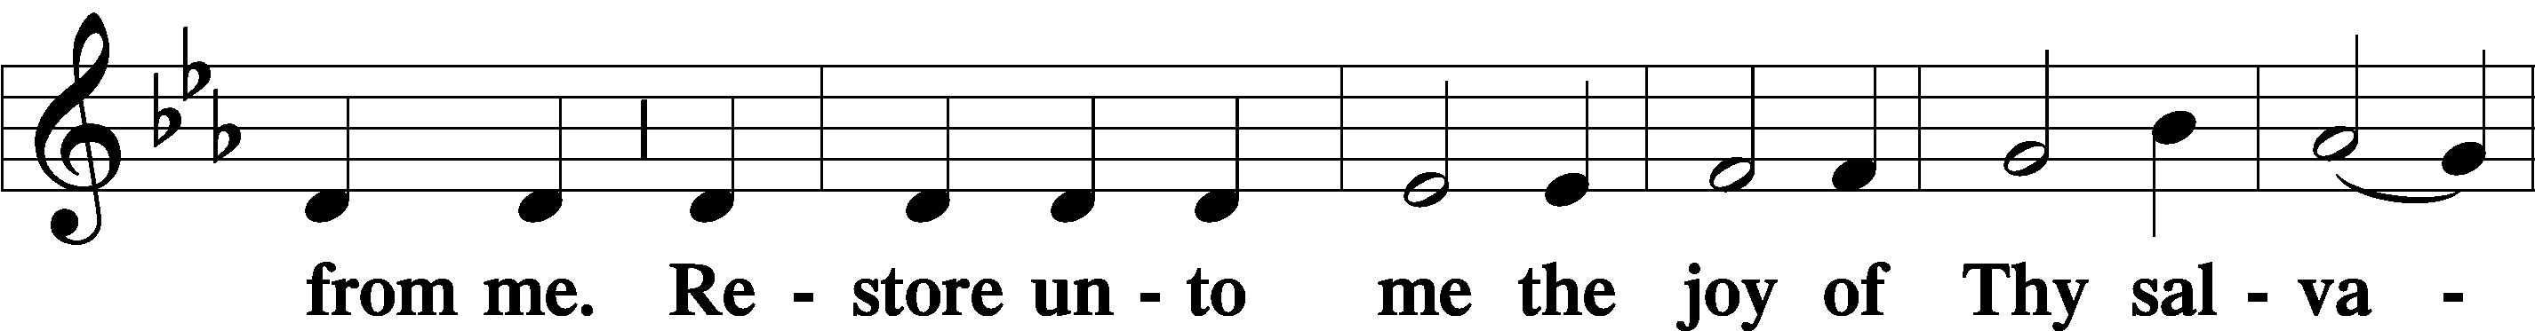
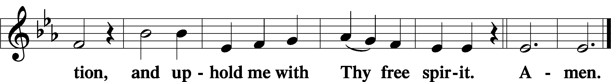

Offering

805 Praise God, from Whom All Blessings Flow
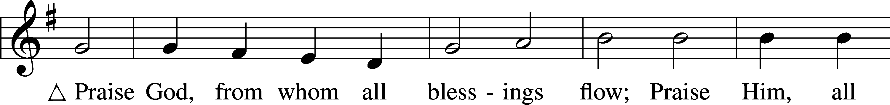
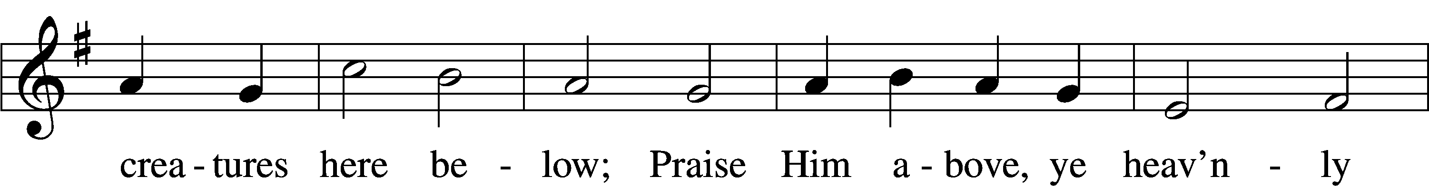
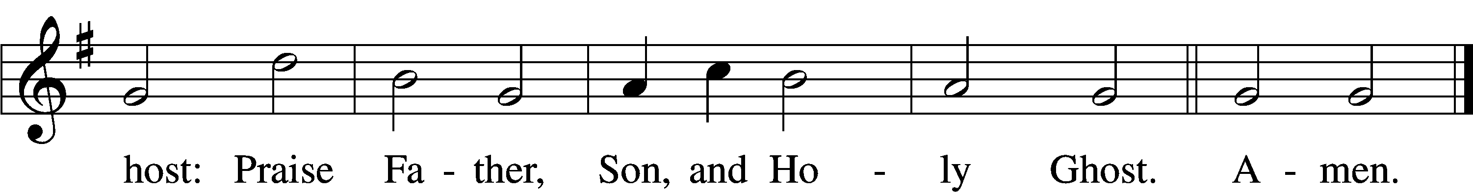
Text: Thomas Ken, 1637–1711
Tune: Trente quatre Pseaumes de David, 1551, Geneva, ed. Louis Bourgeois
Text and tune: Public domain

Prayer of the Church

Lord’s Prayer Matthew 6:9–13
C Our Father who art in heaven,
hallowed be Thy name,
Thy kingdom come,
Thy will be done on earth
as it is in heaven;
give us this day our daily bread;
and forgive us our trespasses
as we forgive those
who trespass against us;
and lead us not into temptation,
but deliver us from evil.
For Thine is the kingdom
and the power and the glory
forever and ever. Amen.
Collect for the Word
Blessed Lord, You have caused all Holy Scripture to be written for our learning. Grant that we may so hear them, read, mark, and inwardly digest them that, by the patience and comfort of Your Holy Word, we may embrace and ever hold fast the blessed hope of everlasting life; which You have given us in our Savior Jesus Christ, Your Son, our Lord, who lives and reigns with You and the Holy Spirit, one God, now and forever.

AMEN.

Benediction Numbers 6:24–26
P The Lord bless you and keep you.
The Lord make His face shine upon you and be gracious unto you.
The Lord lift up His countenance upon you and T give you peace.
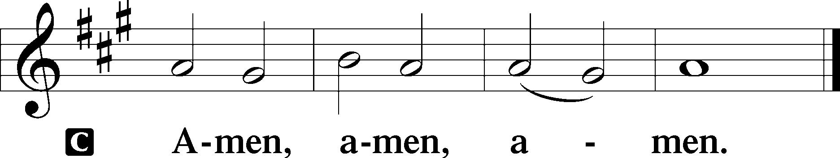

515 Rejoice, Rejoice, Believers
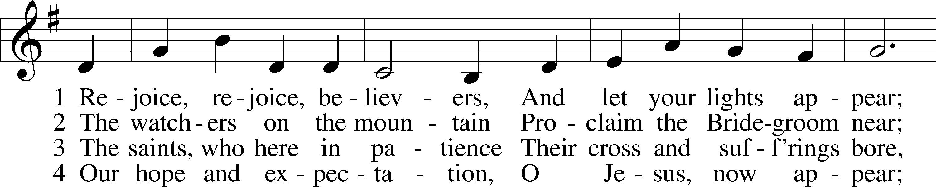
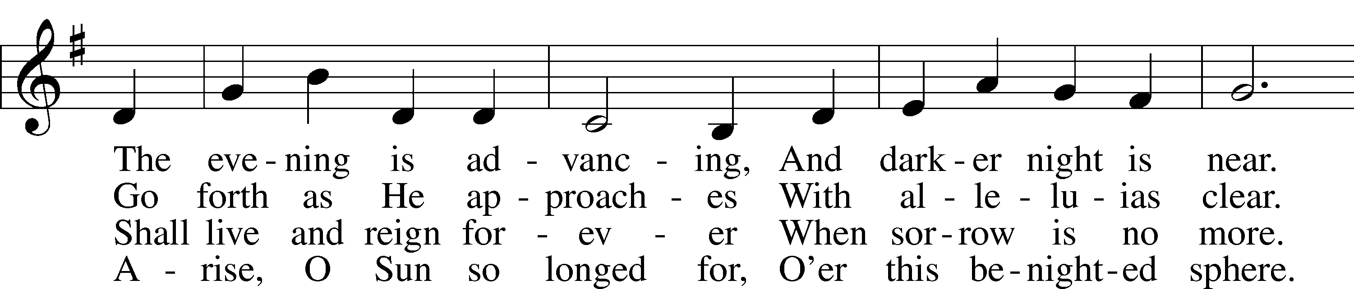
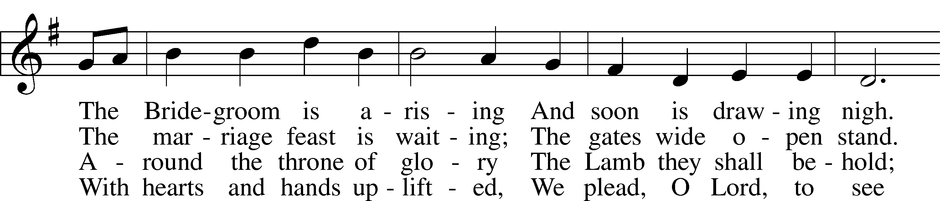
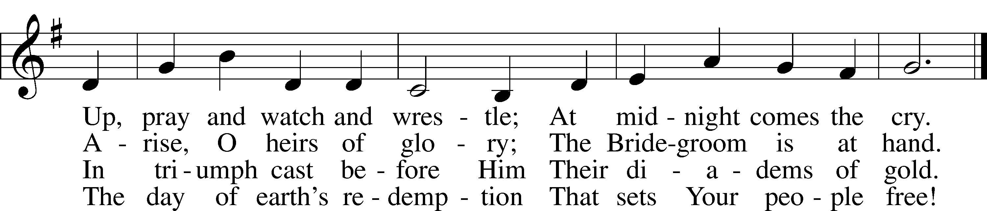
Text: Laurentius Laurenti, 1660–1722; tr. Sarah B. Findlater, 1823–1907, alt.
Tune: Swedish
Text and tune: Public domain

Acknowledgments
Unless otherwise indicated, Scripture quotations are from the ESV® Bible (The Holy Bible, English Standard Version®), copyright © 2001 by Crossway, a publishing ministry of Good News Publishers. Used by permission. All rights reserved.
Created by Lutheran Service Builder © 2022 Concordia Publishing House.

