367 Angels from the Realms of Glory

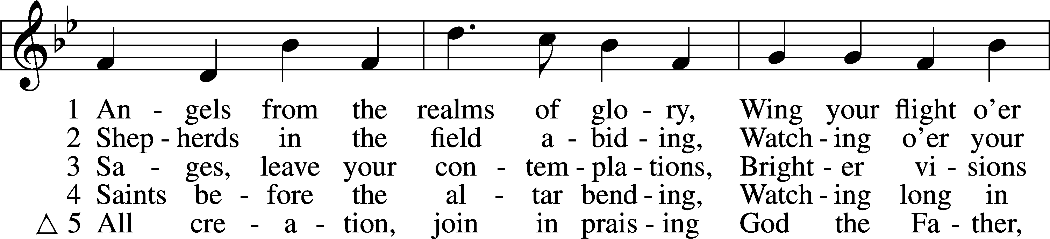

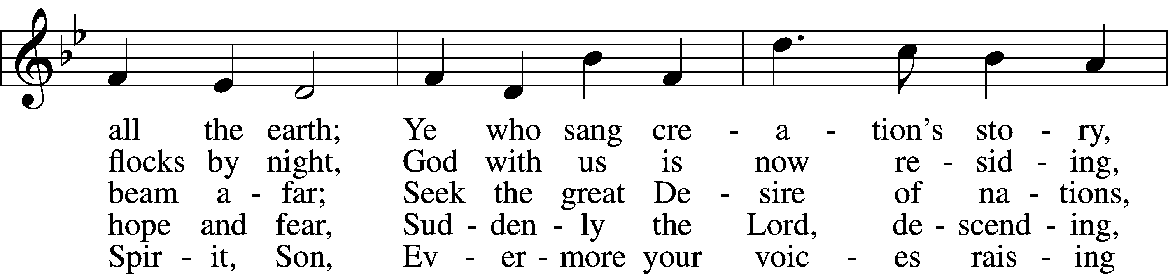

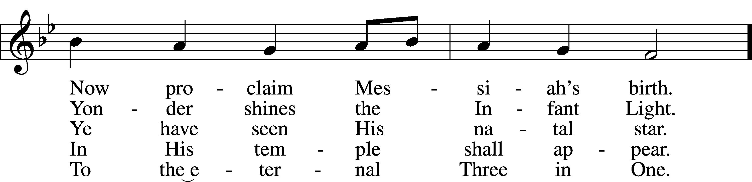

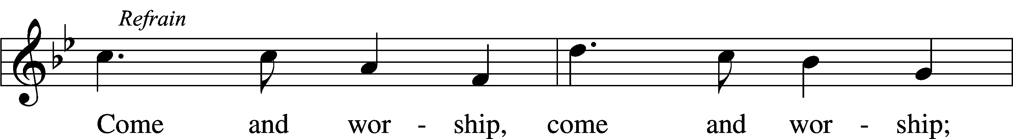

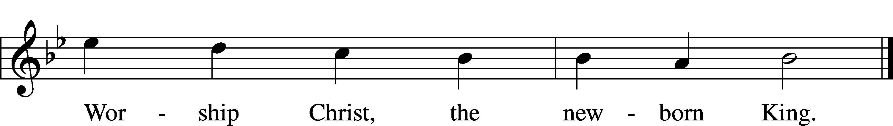

Text (sts. 1, ref, 2–4): James Montgomery, 1771–1854, alt.; (st. 5): Salisbury Hymn Book, 1857, Salisbury, alt.  
Tune: Henry T. Smart, 1813–79  
Text and tune: Public domain

# Confession and Absolution

Stand

The sign of the cross may be made by all in remembrance of their Baptism.

Invocation Matthew 28:19b; 18:20

P In the name of the Father and of the T Son and of the Holy Spirit.

C **Amen.**

Exhortation Hebrews 10:22; Psalm 124:8; Psalm 32:5

P Beloved in the Lord! Let us draw near with a true heart and confess our sins unto God our Father, beseeching Him in the name of our Lord Jesus Christ to grant us forgiveness.

P Our help is in the name of the Lord,

C **who made heaven and earth.**

P I said, I will confess my transgressions unto the Lord,

C **and You forgave the iniquity of my sin.**

Kneel/Stand

Silence for reflection on God’s Word and for self-examination.

Confession of Sins

P O almighty God, merciful Father,

C **I, a poor, miserable sinner, confess unto You all my sins and iniquities with which I have ever offended You and justly deserved Your temporal and eternal punishment. But I am heartily sorry for them and sincerely repent of them, and I pray You of Your boundless mercy and for the sake of the holy, innocent, bitter sufferings and death of Your beloved Son, Jesus Christ, to be gracious and merciful to me, a poor, sinful being.**

Absolution [John 20:19–23]

P Upon this your confession, I, by virtue of my office, as a called and ordained servant of the Word, announce the grace of God unto all of you, and in the stead and by the command of my Lord Jesus Christ I forgive you all your sins in the name of the Father and of the T Son and of the Holy Spirit.

C **Amen.**

Stand

# Service of the Word

Introit Psalm 98:1–4; antiphon: Isaiah 9:6

For to us a child is born, to us a son is|given;  
 and the government shall be upon his | shoulder,  
**and his name shall be called Wonderful Counselor,  
 Mighty God, Everlasting Father, Prince of Peace.**Oh sing to the Lord a new song, for he has done marvelous things!  
 His right hand and his holy arm have worked salvation for him.  
**The Lord has made known his salvation;  
 he has revealed his righteousness in the sight of the |nations.**He has remembered his steadfast love and faithfulness to the house of Israel.  
 All the ends of the earth have seen the salvation of our God.  
**Make a joyful noise to the Lord, all the earth;  
 break forth into joyous song and sing | praises!**

Gloria Patri

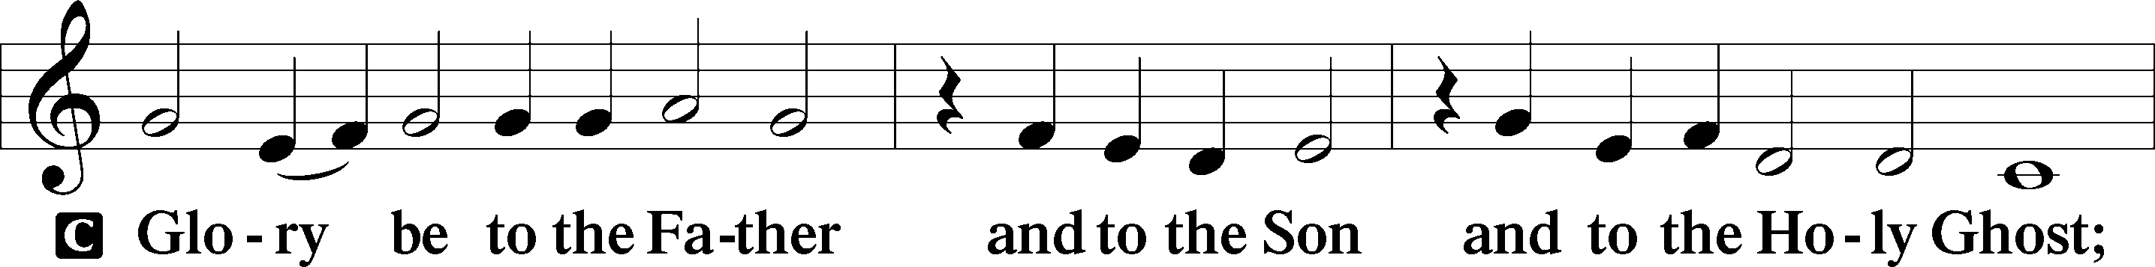

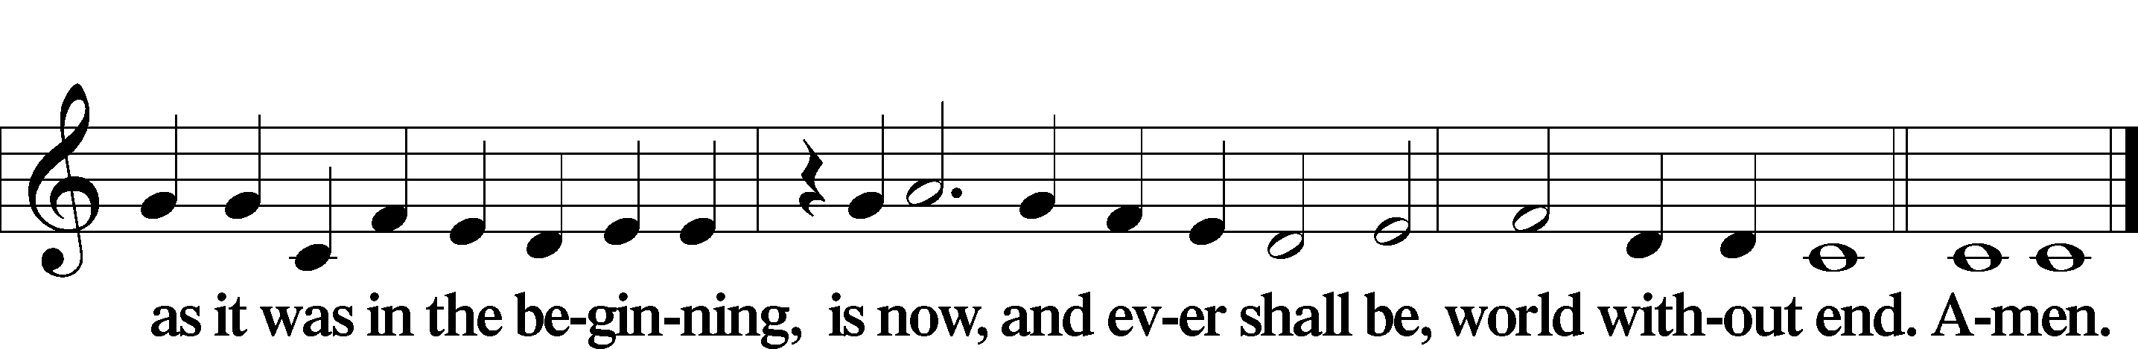

Kyrie Mark 10:47

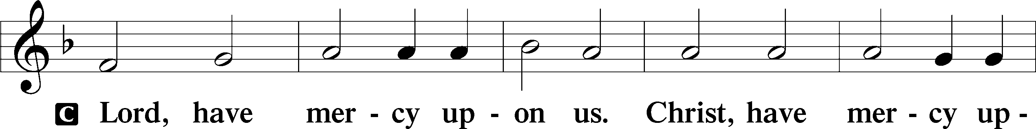

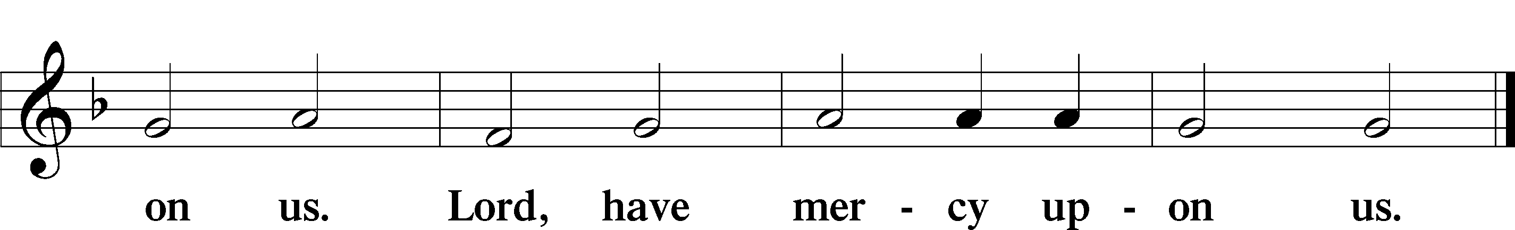

Gloria in Excelsis Luke 2:14; John 1:29

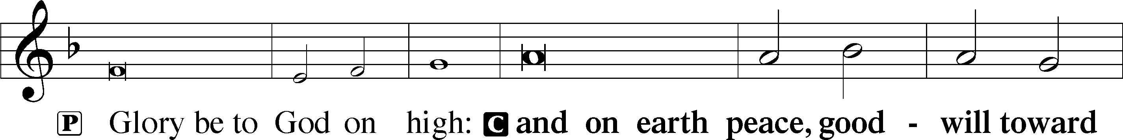

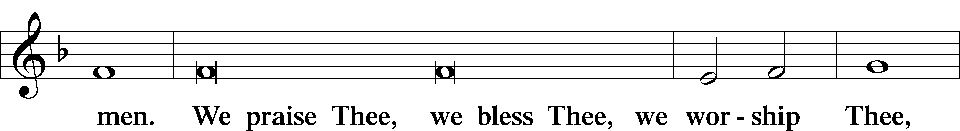

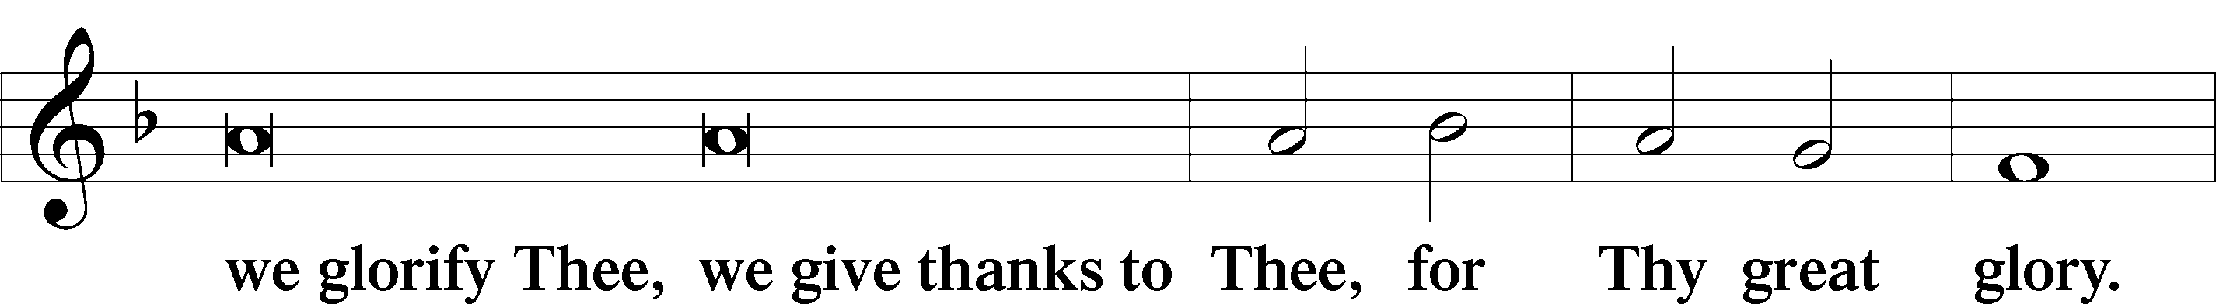

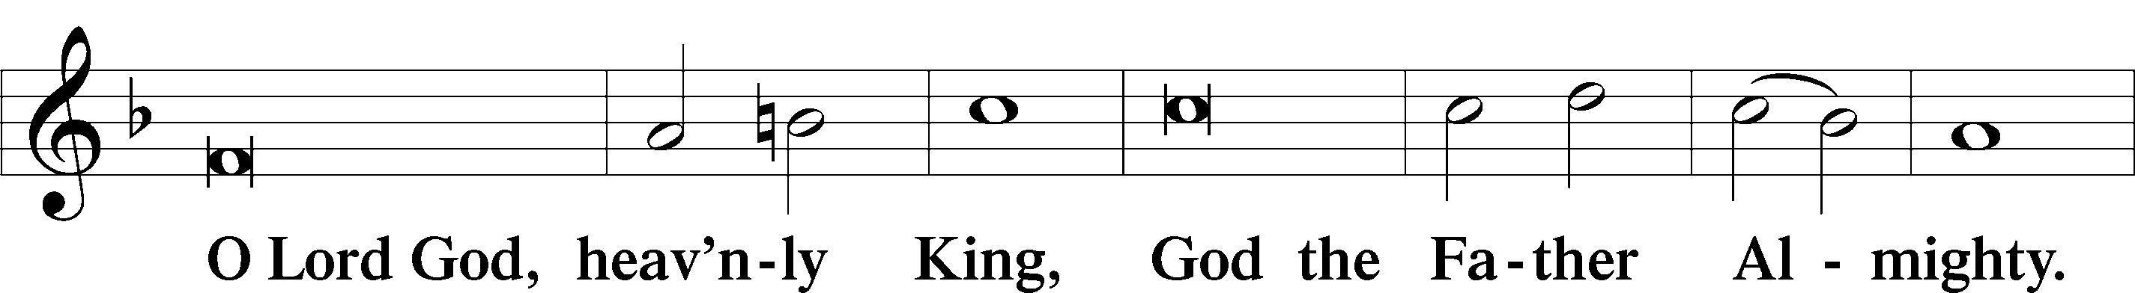

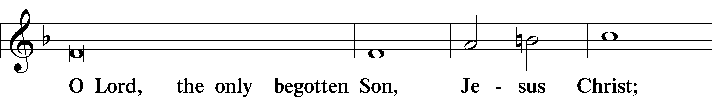

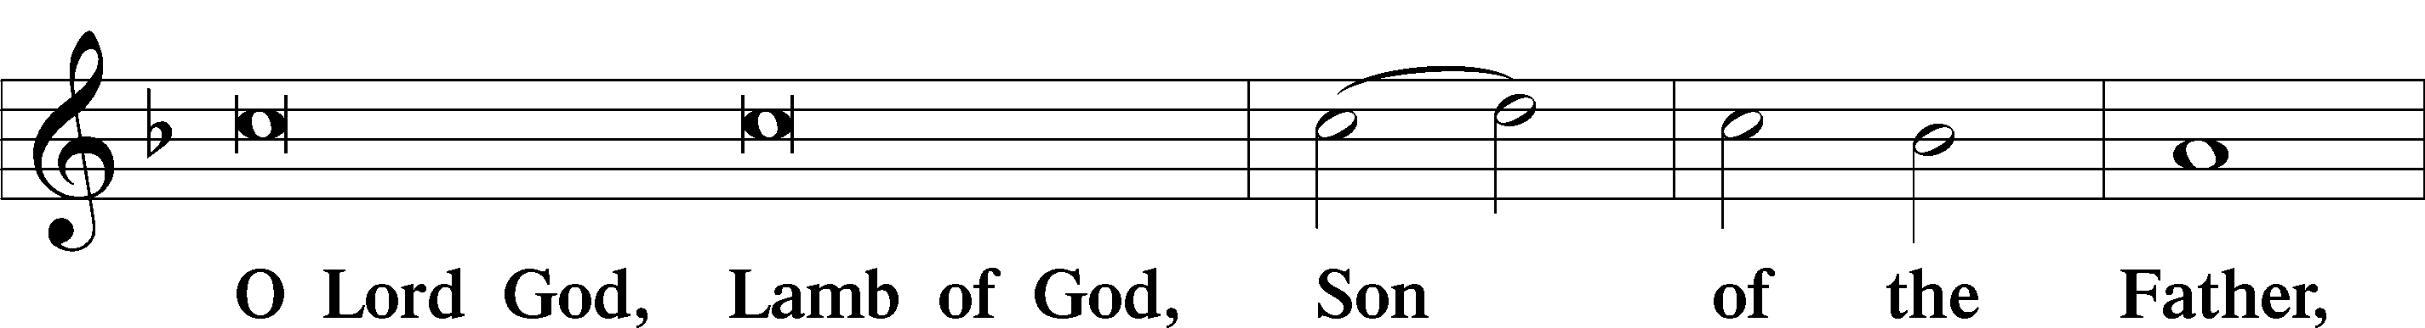

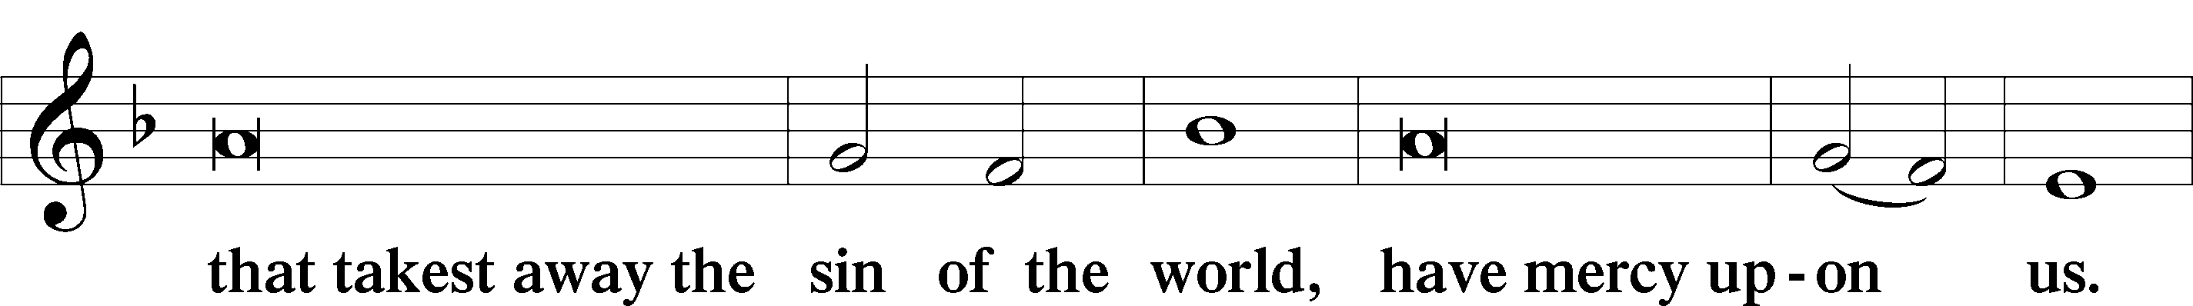

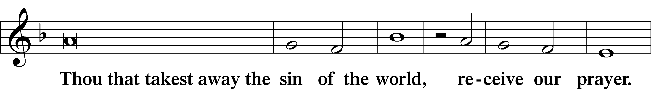

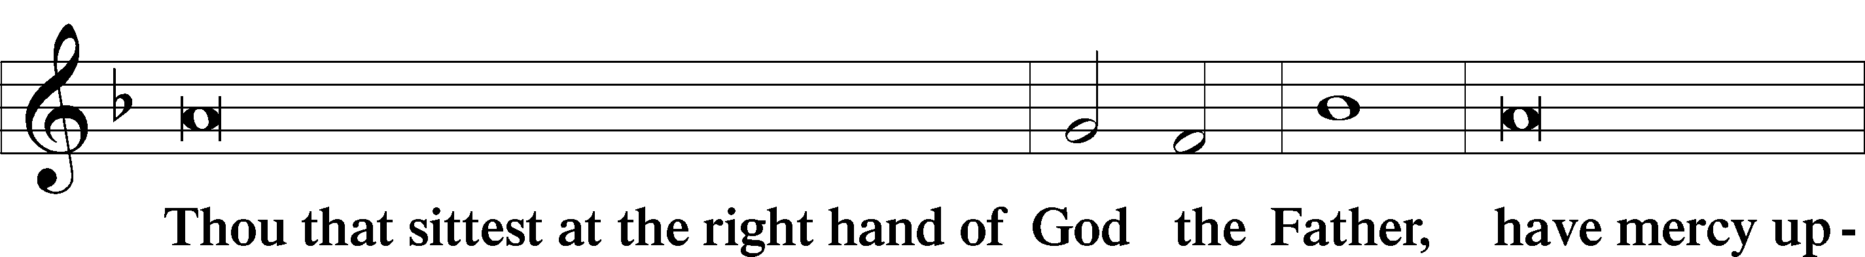

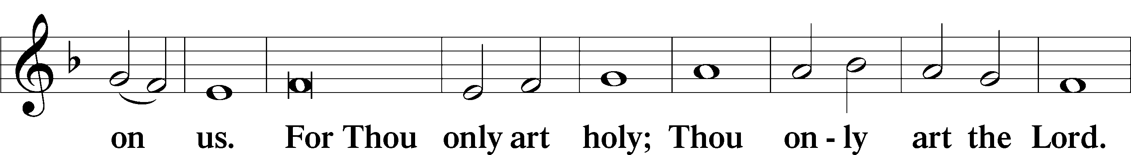

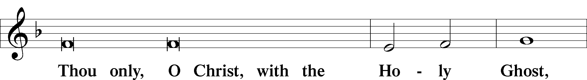

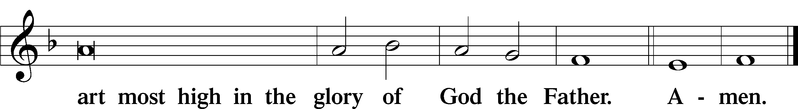

Salutation and Collect of the Day

P The Lord be with you.

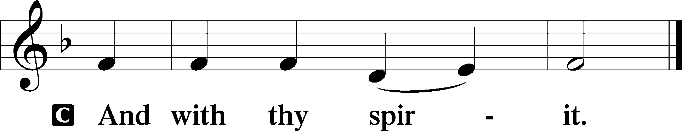

P Let us pray.

Almighty God, grant that the birth of Your only-begotten Son in the flesh may set us free from the bondage of sin; through Jesus Christ, Your Son, our Lord, who lives and reigns with You and the Holy Spirit, one God, now and forever.

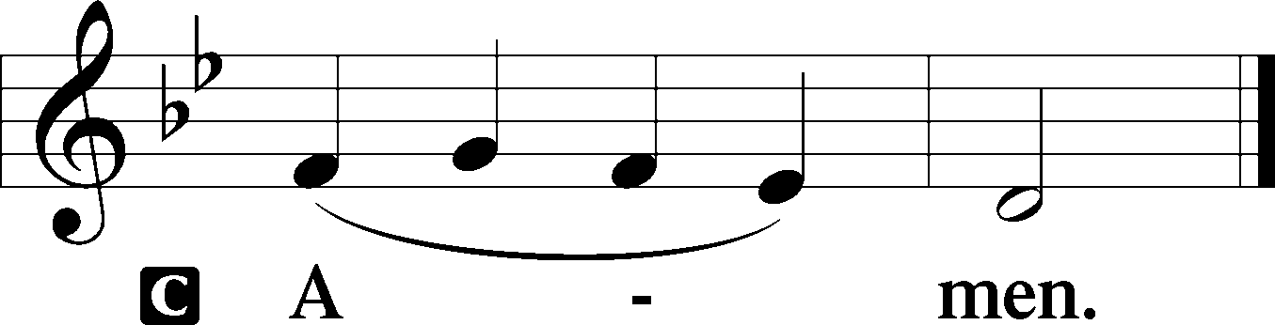

Sit

Old Testament Reading Isaiah 52:7–10

7How beautiful upon the mountains  
 are the feet of him who brings good news,  
who publishes peace, who brings good news of happiness,  
 who publishes salvation,  
 who says to Zion, “Your God reigns.”  
8The voice of your watchmen—they lift up their voice;  
 together they sing for joy;  
for eye to eye they see  
 the return of the Lord to Zion.  
9Break forth together into singing,  
 you waste places of Jerusalem,  
for the Lord has comforted his people;  
 he has redeemed Jerusalem.  
10The Lord has bared his holy arm  
 before the eyes of all the nations,  
and all the ends of the earth shall see  
 the salvation of our God.

A This is the Word of the Lord.

C **Thanks be to God.**

Gradual Isaiah 9:6; Psalm 98:1a

To us a child is born, to us a son is given;  
 and the government shall be upon his shoulder.  
**And his name shall be called Wonderful Counselor, Mighty God,  
 Everlasting Father, Prince of Peace.**Sing to the Lord a new song,  
 for he has done marvelous things!

Epistle Hebrews 1:1–12

The Supremacy of God’s Son

1Long ago, at many times and in many ways, God spoke to our fathers by the prophets, 2but in these last days he has spoken to us by his Son, whom he appointed the heir of all things, through whom also he created the world. 3He is the radiance of the glory of God and the exact imprint of his nature, and he upholds the universe by the word of his power. After making purification for sins, he sat down at the right hand of the Majesty on high, 4having become as much superior to angels as the name he has inherited is more excellent than theirs.

5For to which of the angels did God ever say,

“You are my Son,  
 today I have begotten you”?

Or again,

“I will be to him a father,  
 and he shall be to me a son”?

6And again, when he brings the firstborn into the world, he says,

“Let all God’s angels worship him.”

7Of the angels he says,

“He makes his angels winds,  
 and his ministers a flame of fire.”

8But of the Son he says,

“Your throne, O God, is forever and ever,  
 the scepter of uprightness is the scepter of your kingdom.  
9You have loved righteousness and hated wickedness;  
therefore God, your God, has anointed you  
 with the oil of gladness beyond your companions.”

10And,

“You, Lord, laid the foundation of the earth in the beginning,  
 and the heavens are the work of your hands;  
11they will perish, but you remain;  
 they will all wear out like a garment,  
12like a robe you will roll them up,  
 like a garment they will be changed.  
But you are the same,  
 and your years will have no end.”

A This is the Word of the Lord.

C **Thanks be to God.**

Stand

Alleluia

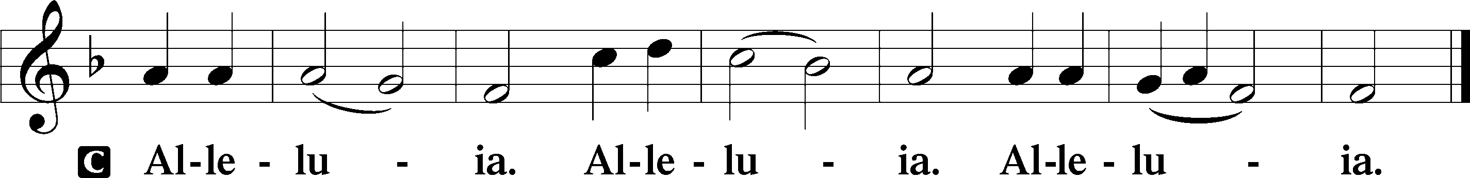

Holy Gospel John 1:1–18

P The Holy Gospel according to St. John, the first chapter.

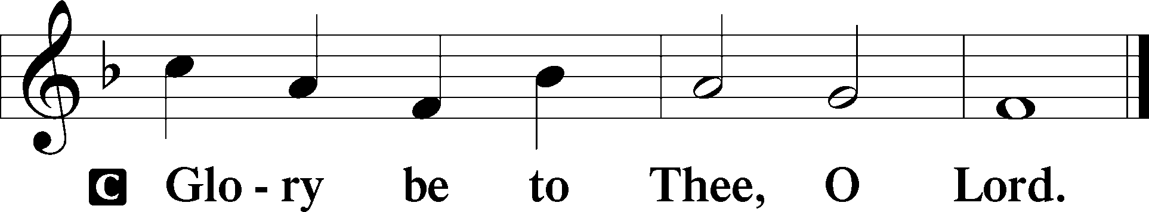

The Word Became Flesh

1In the beginning was the Word, and the Word was with God, and the Word was God. 2He was in the beginning with God. 3All things were made through him, and without him was not any thing made that was made. 4In him was life, and the life was the light of men. 5The light shines in the darkness, and the darkness has not overcome it.

6There was a man sent from God, whose name was John. 7He came as a witness, to bear witness about the light, that all might believe through him. 8He was not the light, but came to bear witness about the light.

9The true light, which enlightens everyone, was coming into the world. 10He was in the world, and the world was made through him, yet the world did not know him. 11He came to his own, and his own people did not receive him. 12But to all who did receive him, who believed in his name, he gave the right to become children of God, 13who were born, not of blood nor of the will of the flesh nor of the will of man, but of God.

14And the Word became flesh and dwelt among us, and we have seen his glory, glory as of the only Son from the Father, full of grace and truth. 15(John bore witness about him, and cried out, “This was he of whom I said, ‘He who comes after me ranks before me, because he was before me.’”) 16And from his fullness we have all received, grace upon grace. 17For the law was given through Moses; grace and truth came through Jesus Christ. 18No one has ever seen God; the only God, who is at the Father’s side, he has made him known.

P This is the Gospel of the Lord.

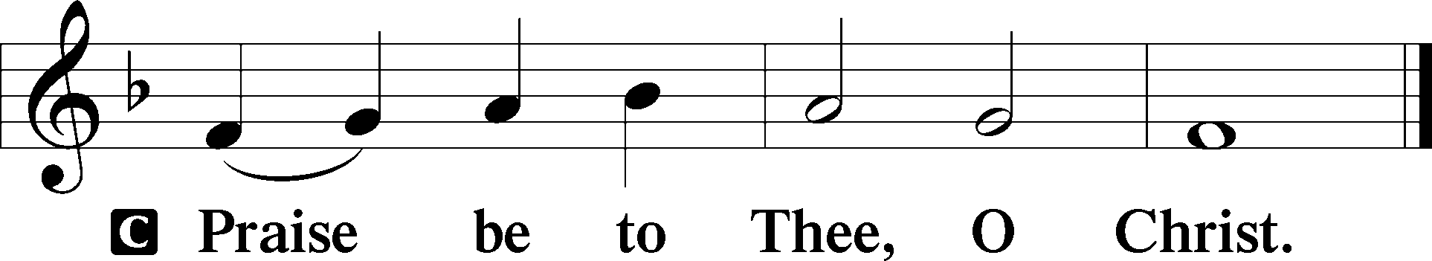

Nicene Creed

C **I believe in one God,**

**the Father Almighty,**

**maker of heaven and earth**

**and of all things visible and invisible.**

**And in one Lord Jesus Christ,**

**the only-begotten Son of God,**

**begotten of His Father before all worlds,**

**God of God, Light of Light,**

**very God of very God,**

**begotten, not made,**

**being of one substance with the Father,**

**by whom all things were made;**

**who for us men and for our salvation came down from heaven**

**and was incarnate by the Holy Spirit of the virgin Mary**

**and was made man;**

**and was crucified also for us under Pontius Pilate.**

**He suffered and was buried.**

**And the third day He rose again according to the Scriptures**

**and ascended into heaven**

**and sits at the right hand of the Father.**

**And He will come again with glory to judge both the living and the dead,**

**whose kingdom will have no end.**

**And I believe in the Holy Spirit,**

**the Lord and giver of life,**

**who proceeds from the Father and the Son,**

**who with the Father and the Son together is worshiped and glorified,**

**who spoke by the prophets.**

**And I believe in one holy Christian and apostolic Church,**

**I acknowledge one Baptism for the remission of sins,**

**and I look for the resurrection of the dead**

**and the life** T **of the world to come. Amen.**

Children's Message

380 Hark! The Herald Angels Sing

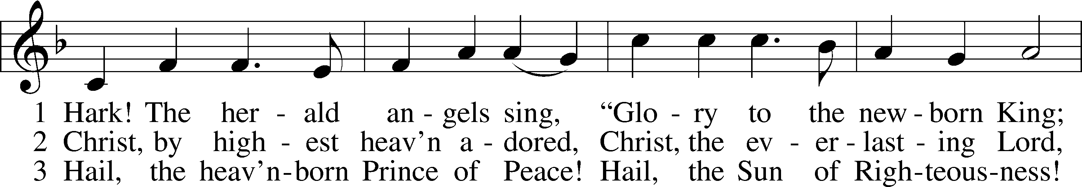

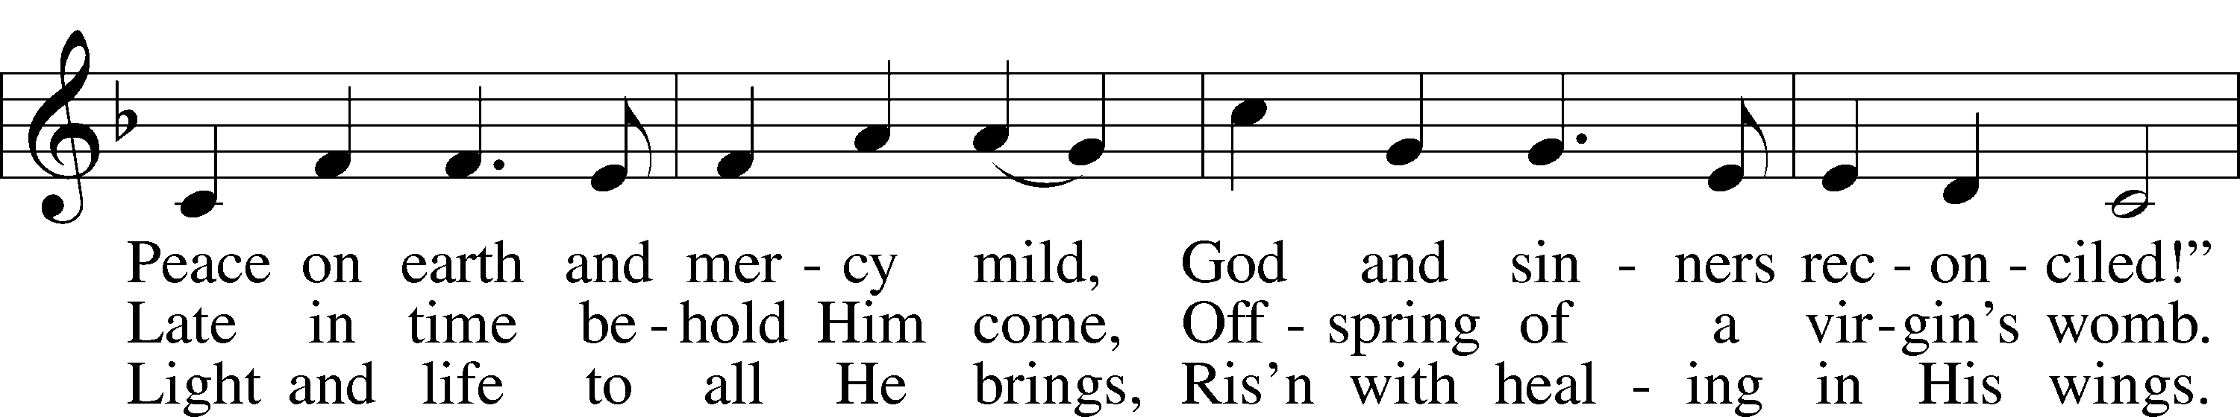

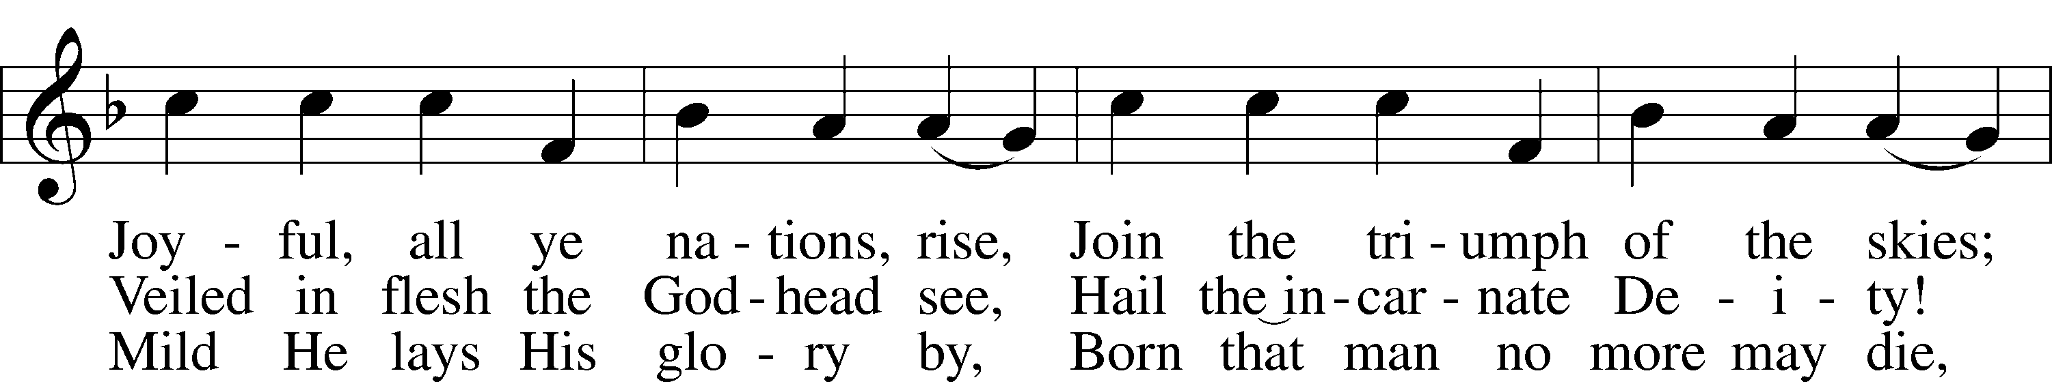

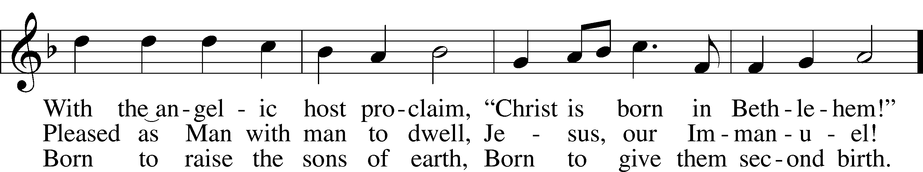

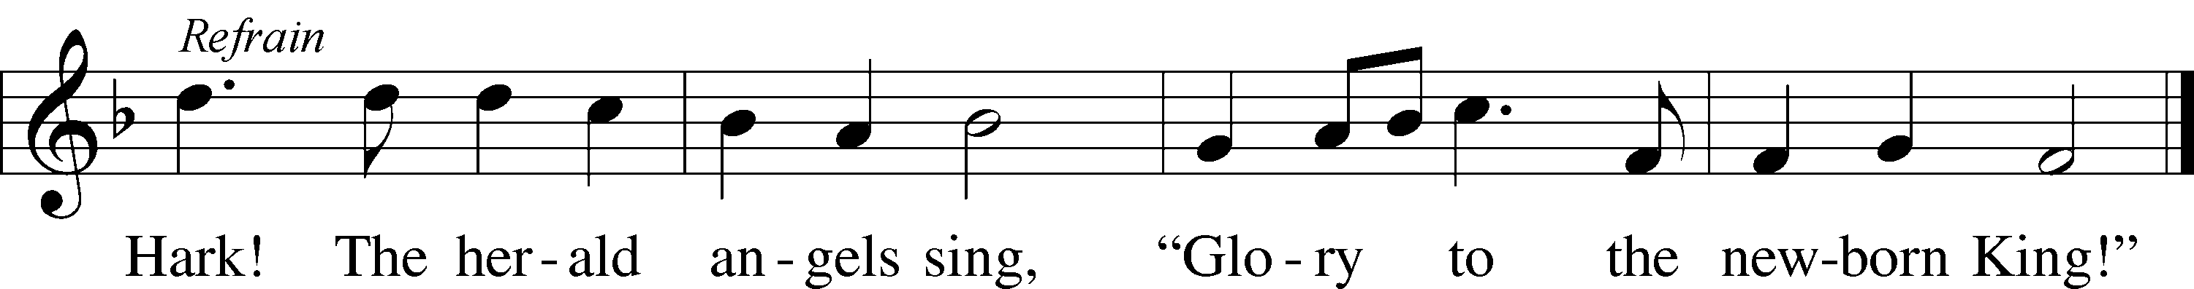

Text: Charles Wesley, 1707–88, alt.  
Tune: Felix Mendelssohn, 1809–47  
Text and tune: Public domain

Sermon

Votum

P The peace of God, which passes all understanding, keep your hearts and minds in Christ Jesus.

C **Amen.**

Stand

Offertory Psalm 51:10–12

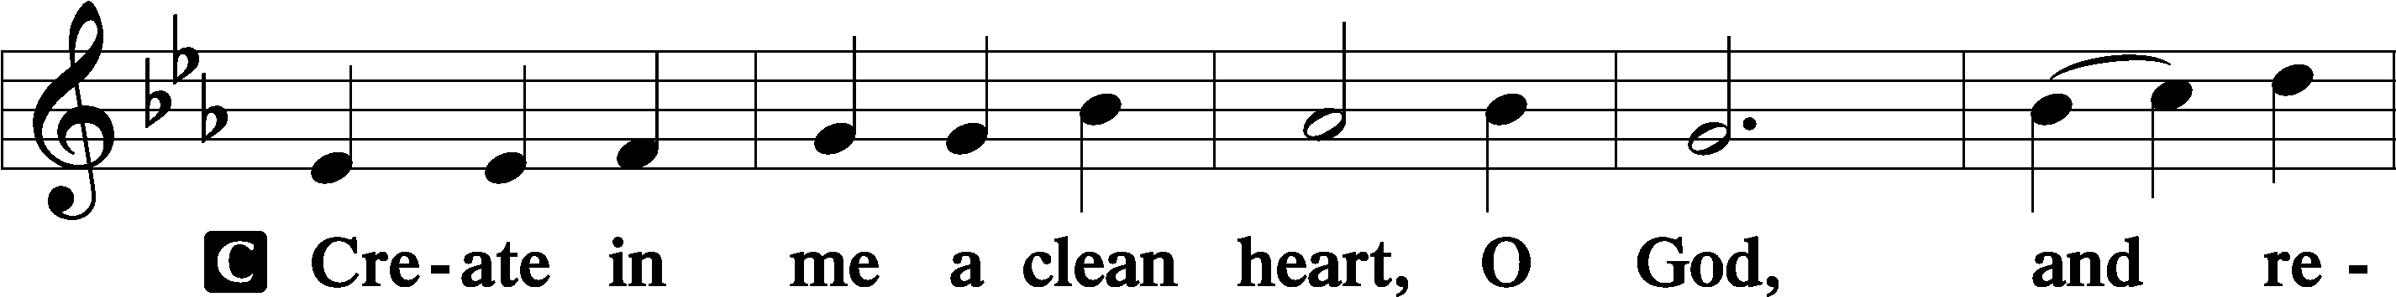

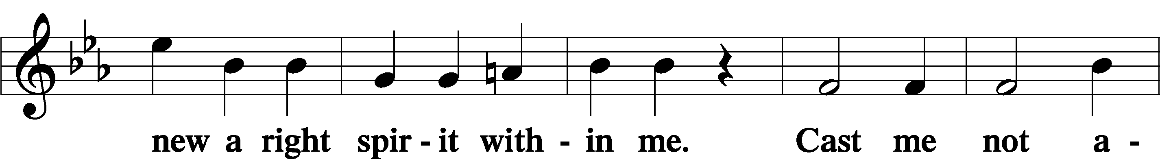

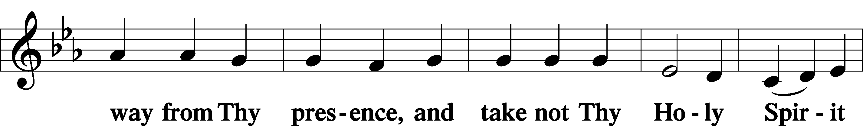

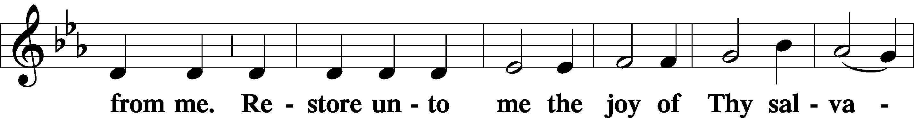

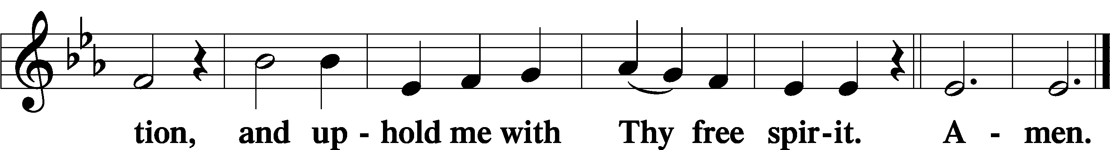

Sit

Offering

Stand

805 Praise God, from Whom All Blessings Flow

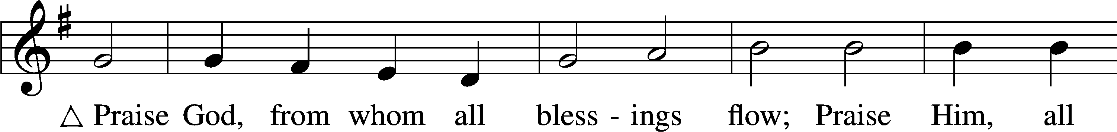

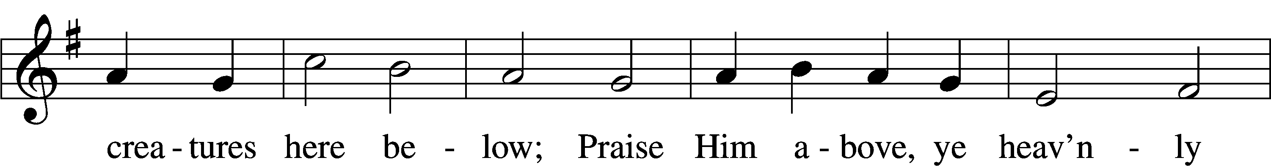

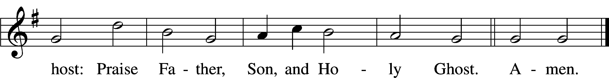

Text: Thomas Ken, 1637–1711  
Tune: Trente quatre Pseaumes de David, 1551, Geneva, ed. Louis Bourgeois  
Text and tune: Public domain

Prayer of the Church

# Service of the Sacrament

Preface 2 Timothy 4:22; [Colossians 3:1]; [Psalm 136]

P The Lord be with you.

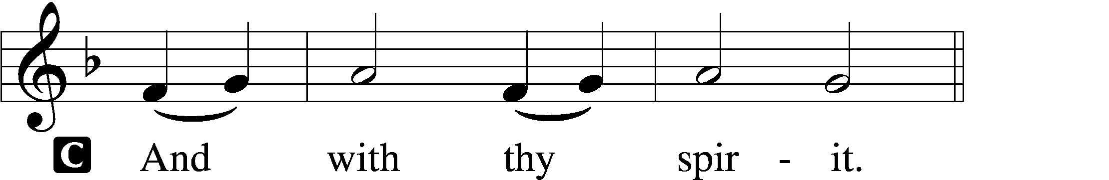

P Lift up your hearts.

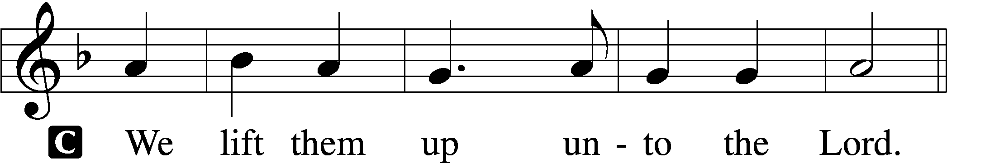

P Let us give thanks unto the Lord, our God.

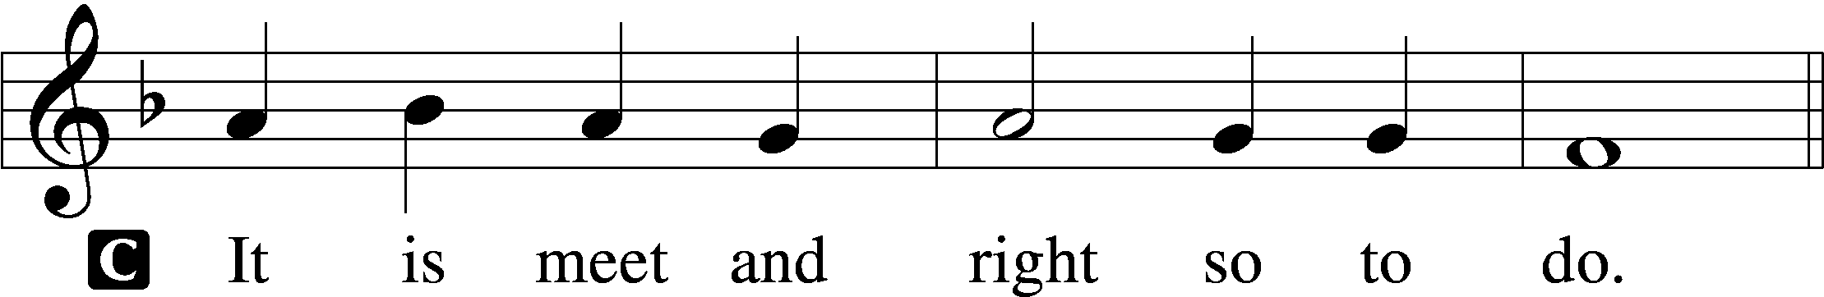

Proper Preface (Full)

P It is truly meet, right, and salutary that we should at all times and in all places give thanks to You, holy Lord, almighty Father, everlasting God, through Jesus Christ, our Lord; for in the mystery of the Word made flesh You have given us a new revelation of Your glory that, seeing You in the person of Your Son, we may know and love those things which are not seen. Therefore with angels and archangels and with all the company of heaven we laud and magnify Your glorious name, evermore praising You and saying:

Sanctus Isaiah 6:3; Matthew 21:9

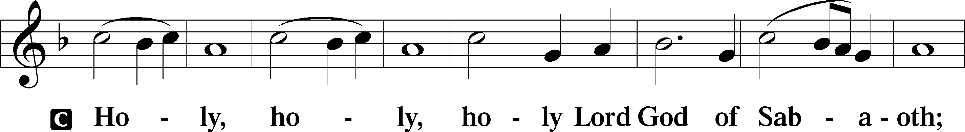

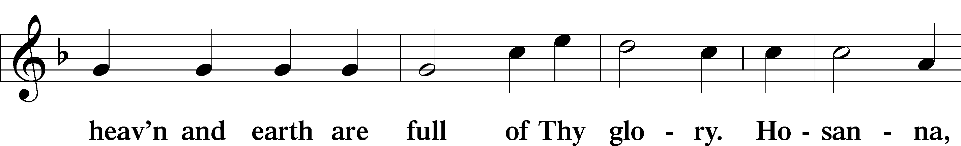

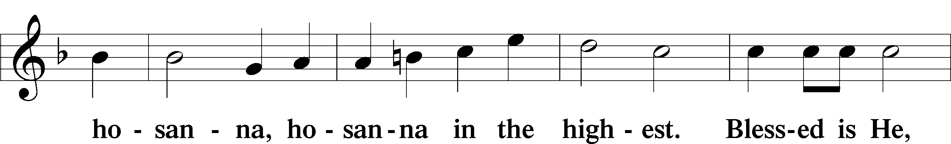

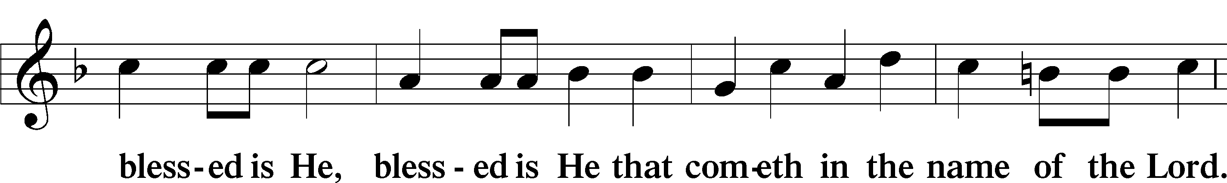

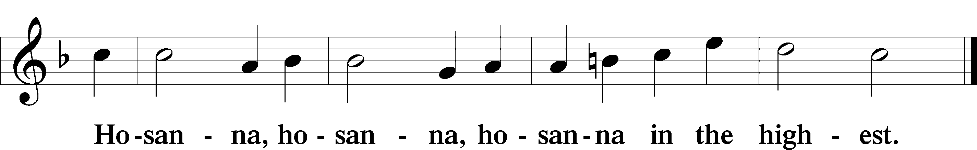

Lord’s Prayer Matthew 6:9–13

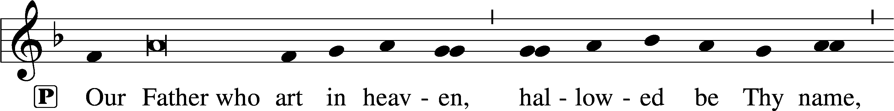

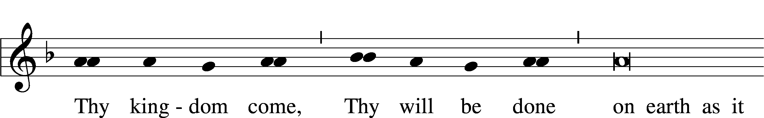

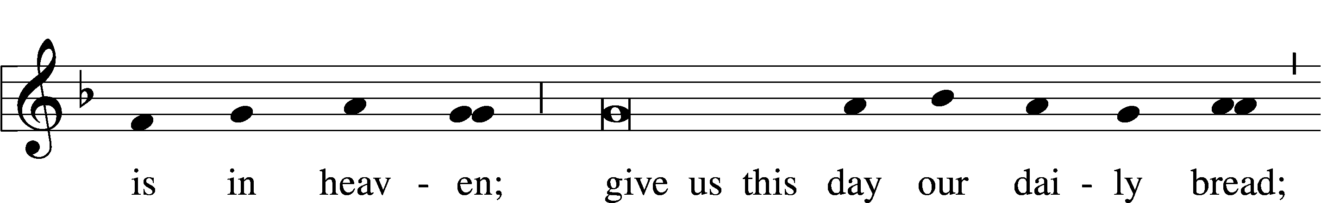

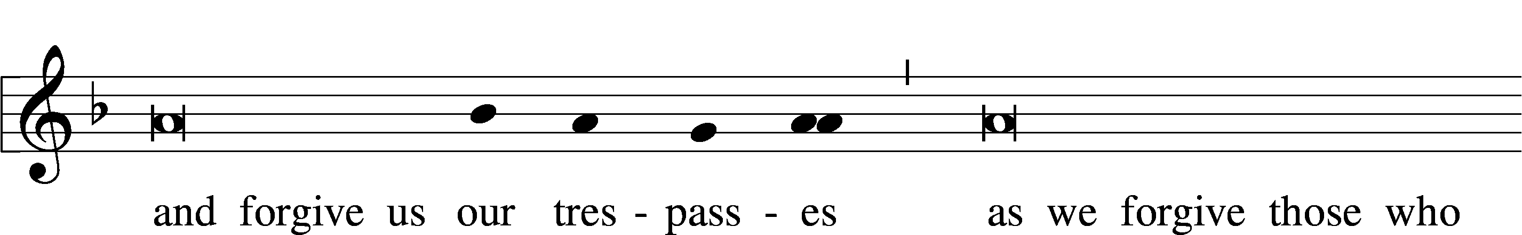

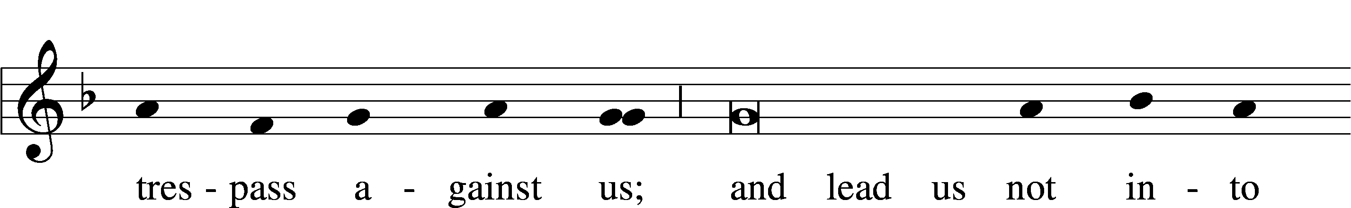

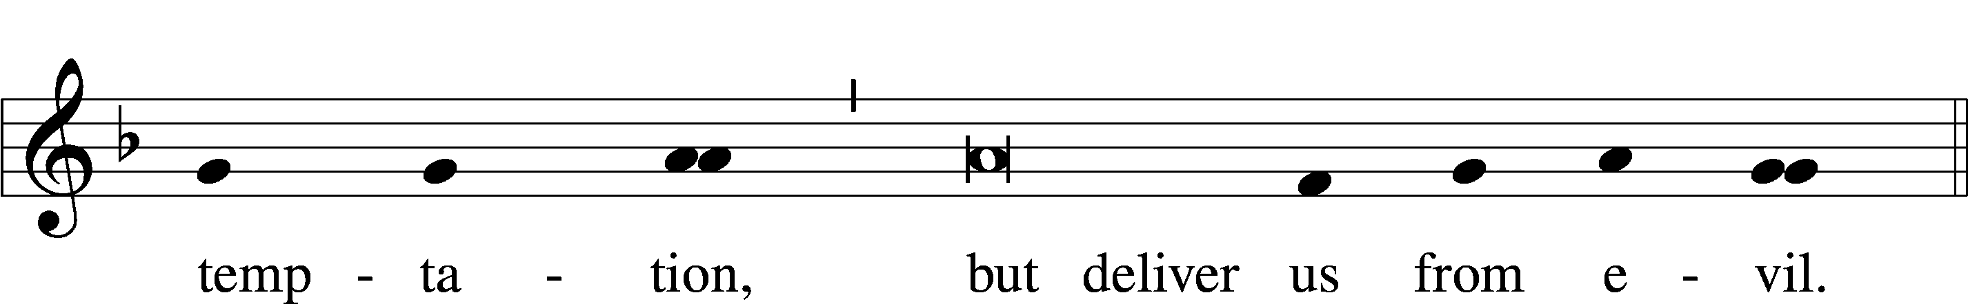

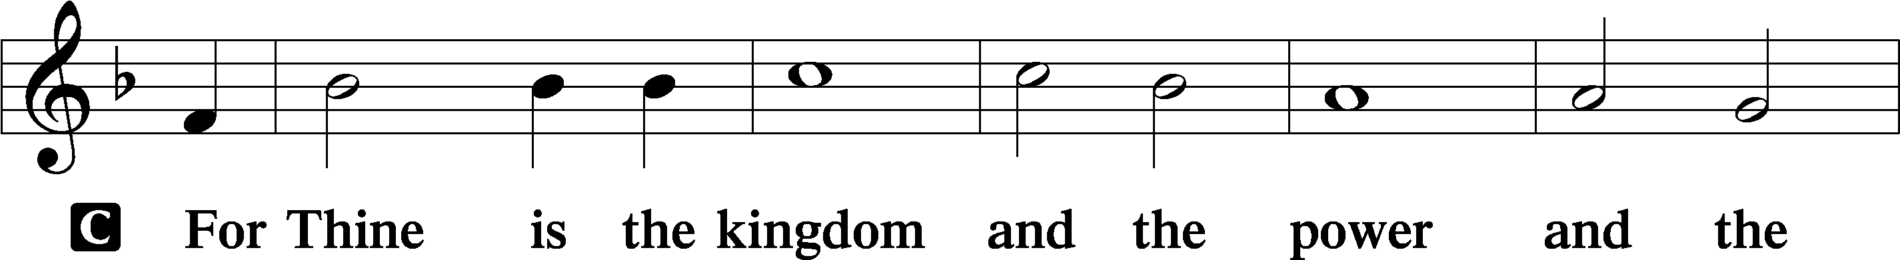

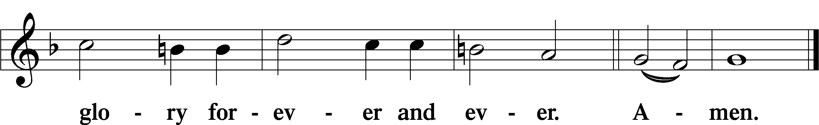

The Words of Our Lord Matthew 26:26–28; Mark 14:22–24; Luke 22:19–20; 1 Corinthians 11:23–25

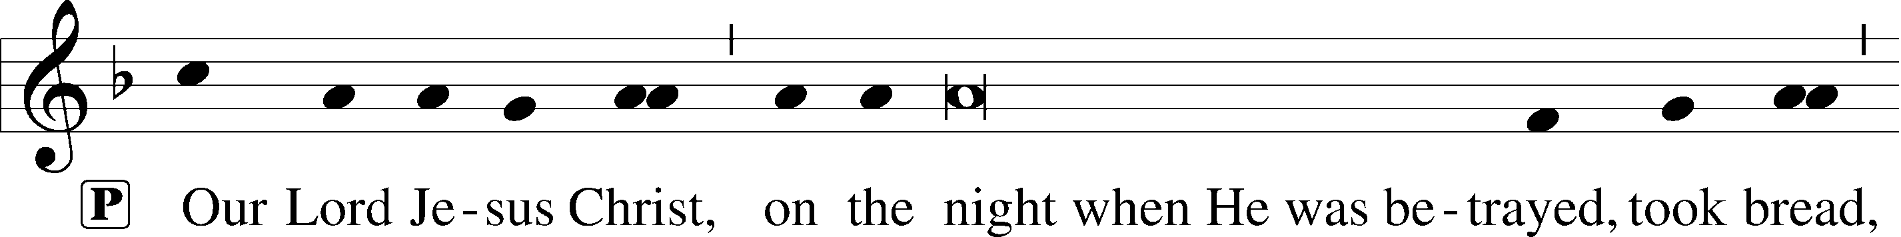

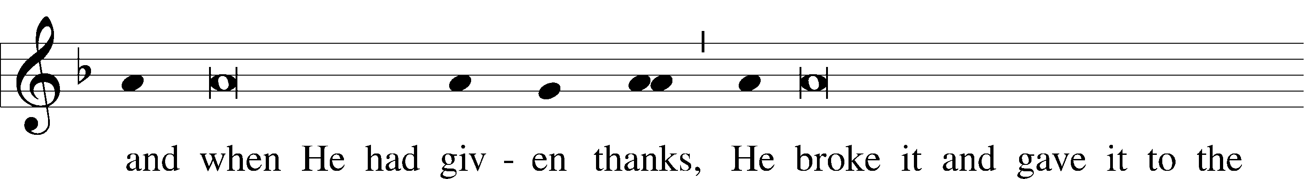

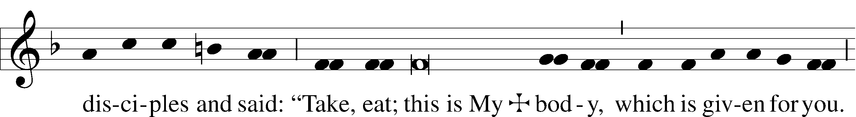

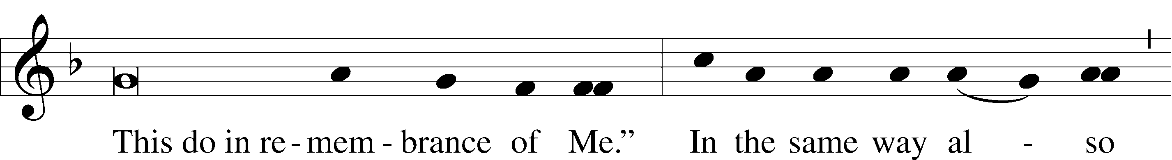

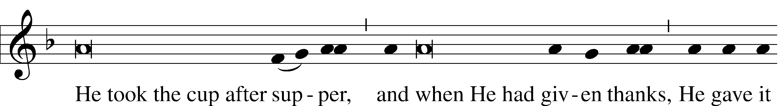

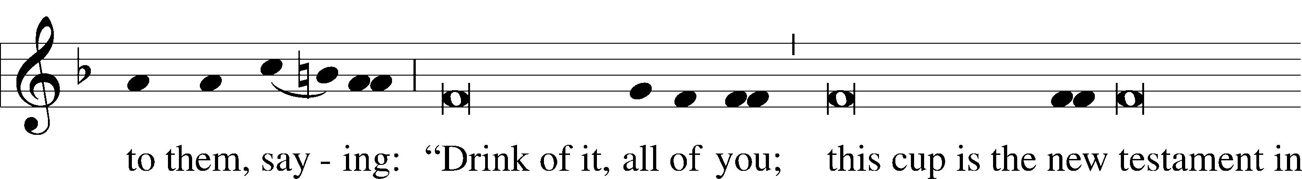

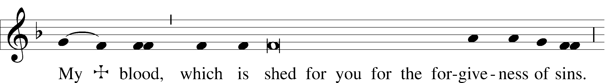

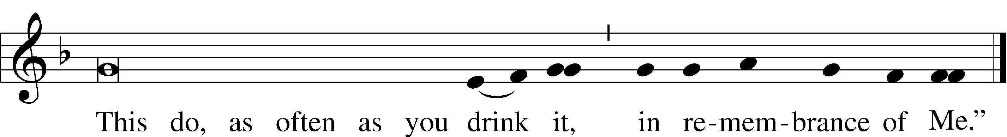

Pax Domini John 20:19

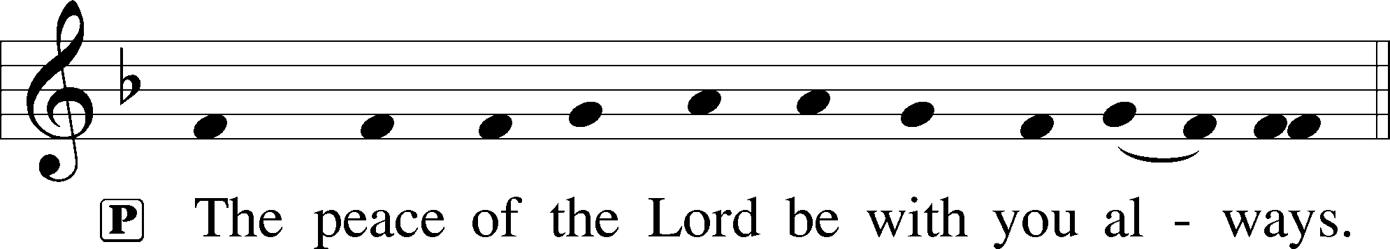

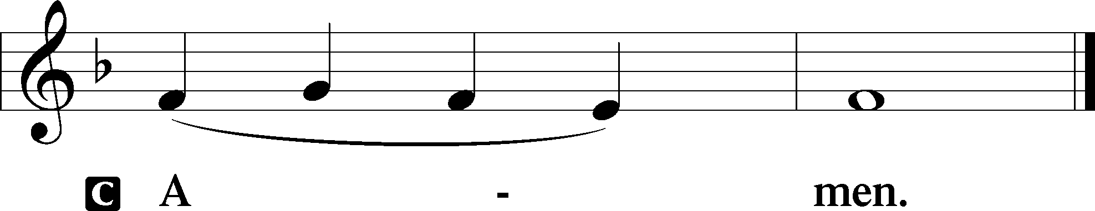

Agnus Dei John 1:29

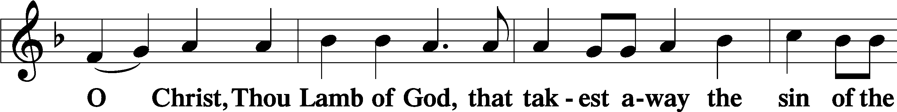

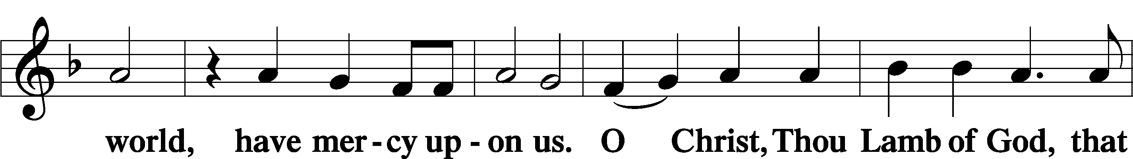

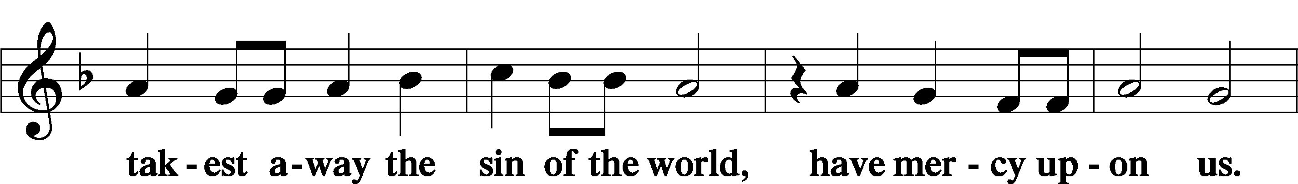

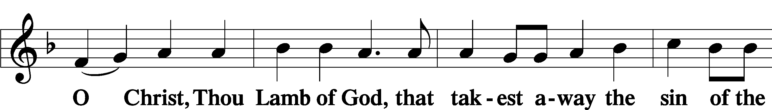

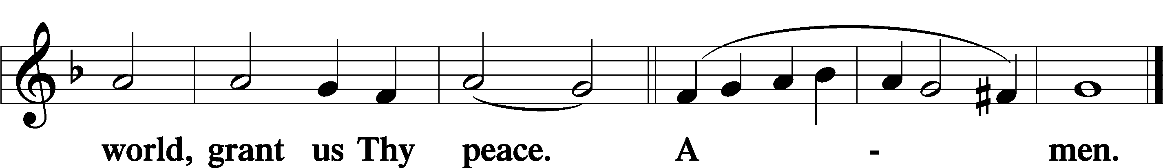

Sit

Distribution

387 Joy to the World

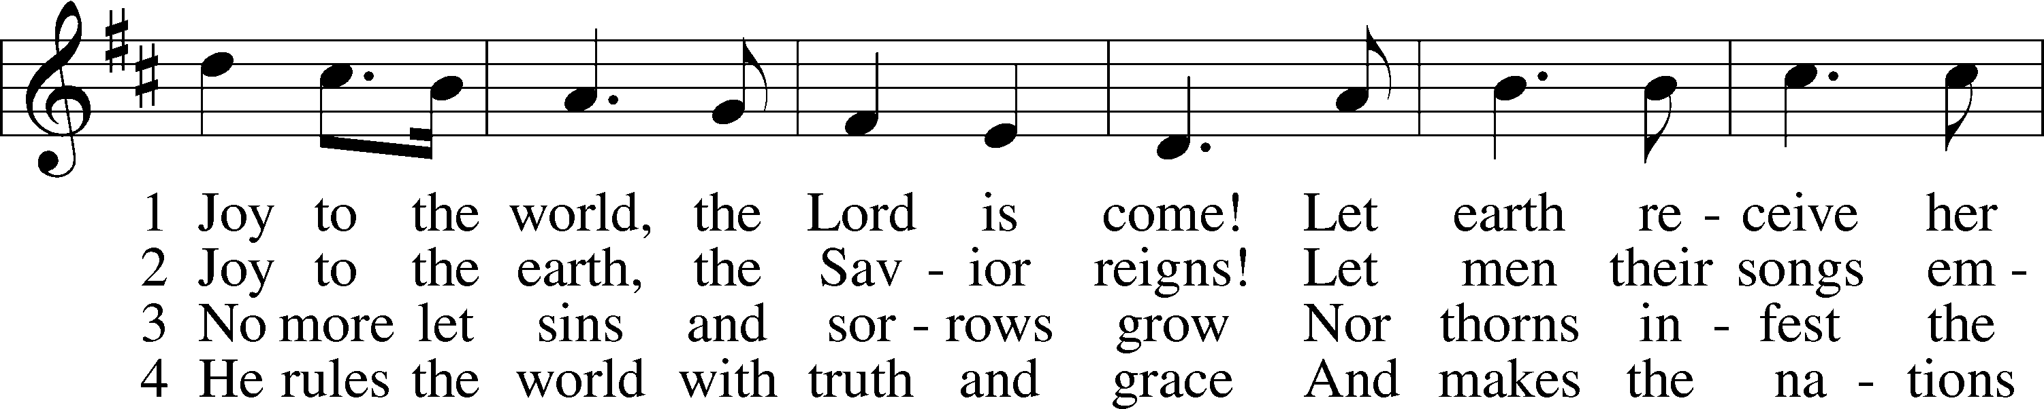

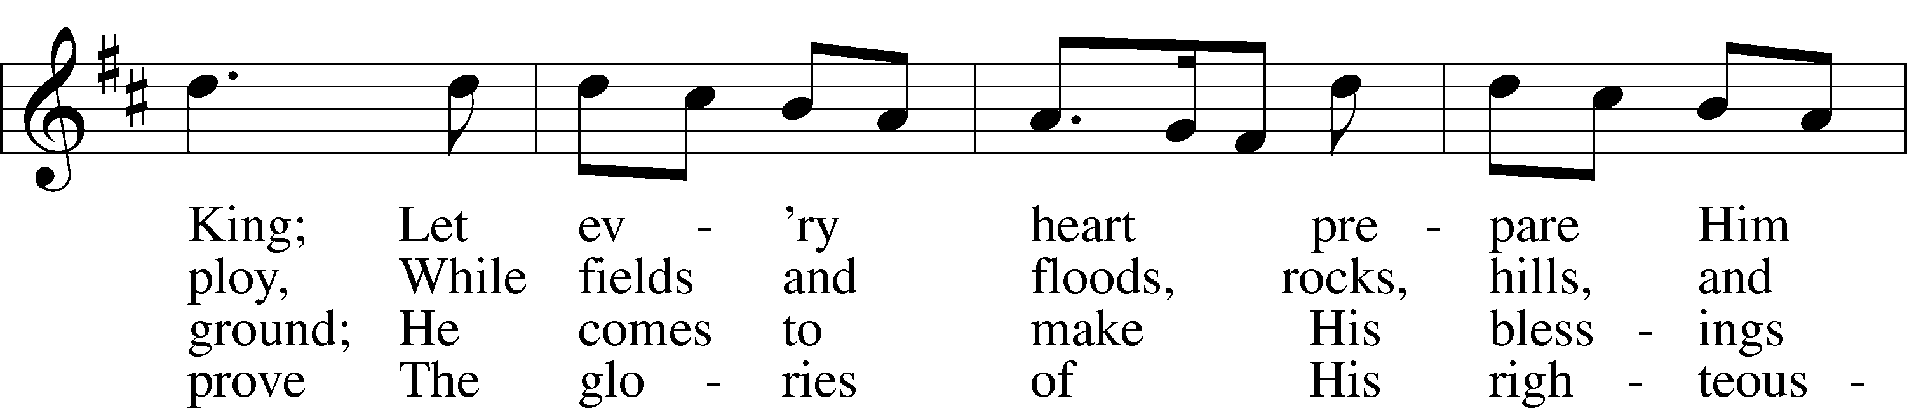

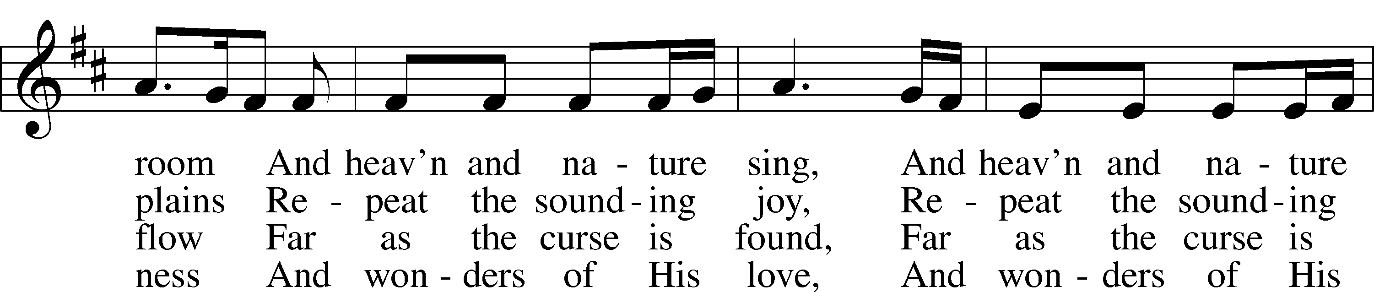

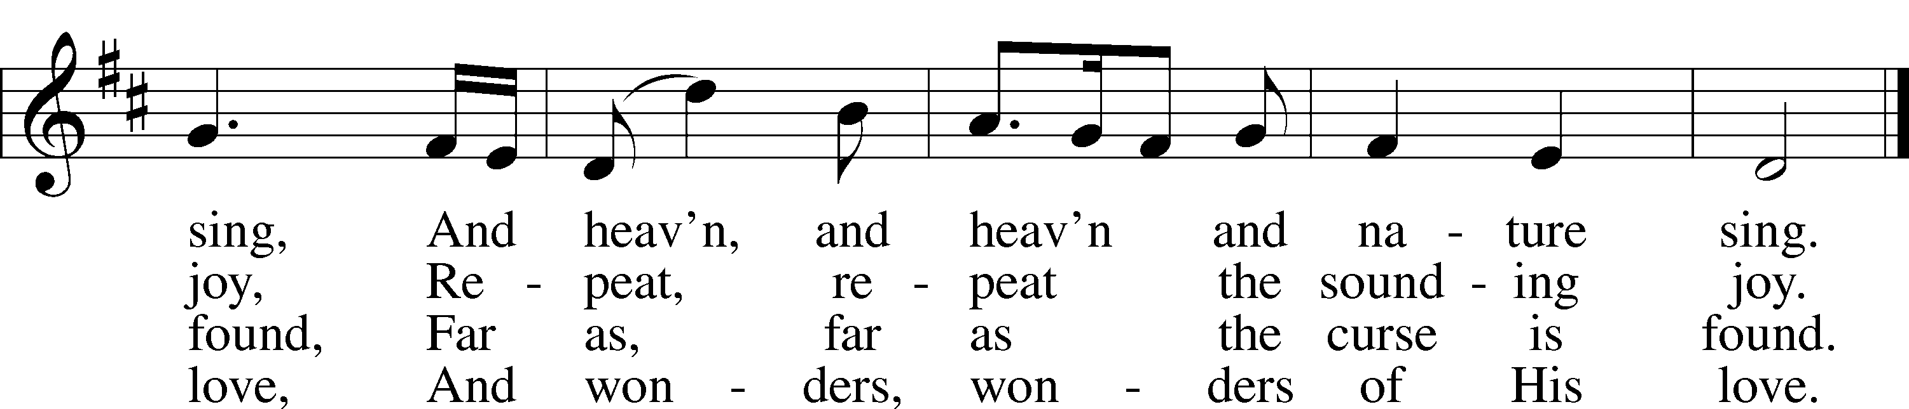

Text: Isaac Watts, 1674–1748  
Tune: George Frideric Handel, 1685–1759, adapt.  
Text and tune: Public domain

370 What Child Is This

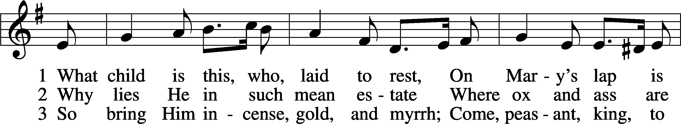

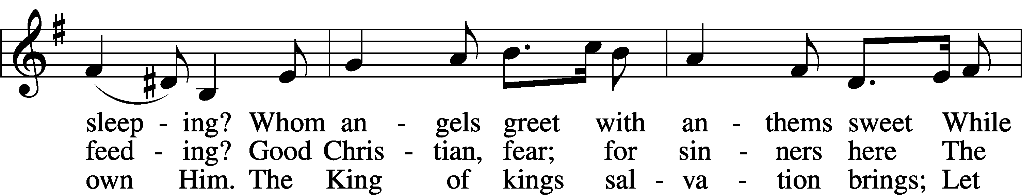

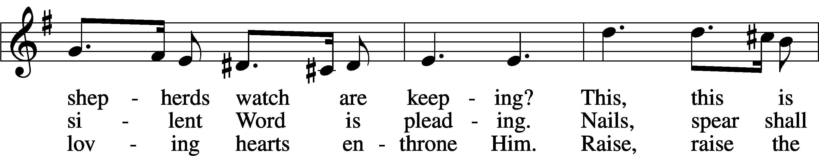

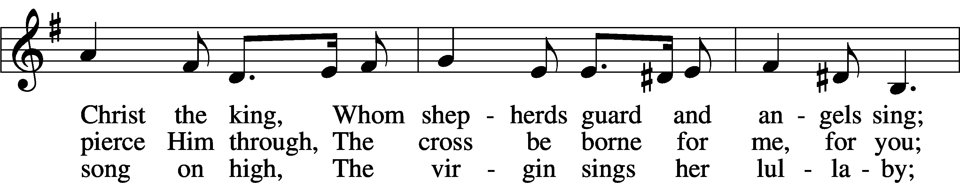

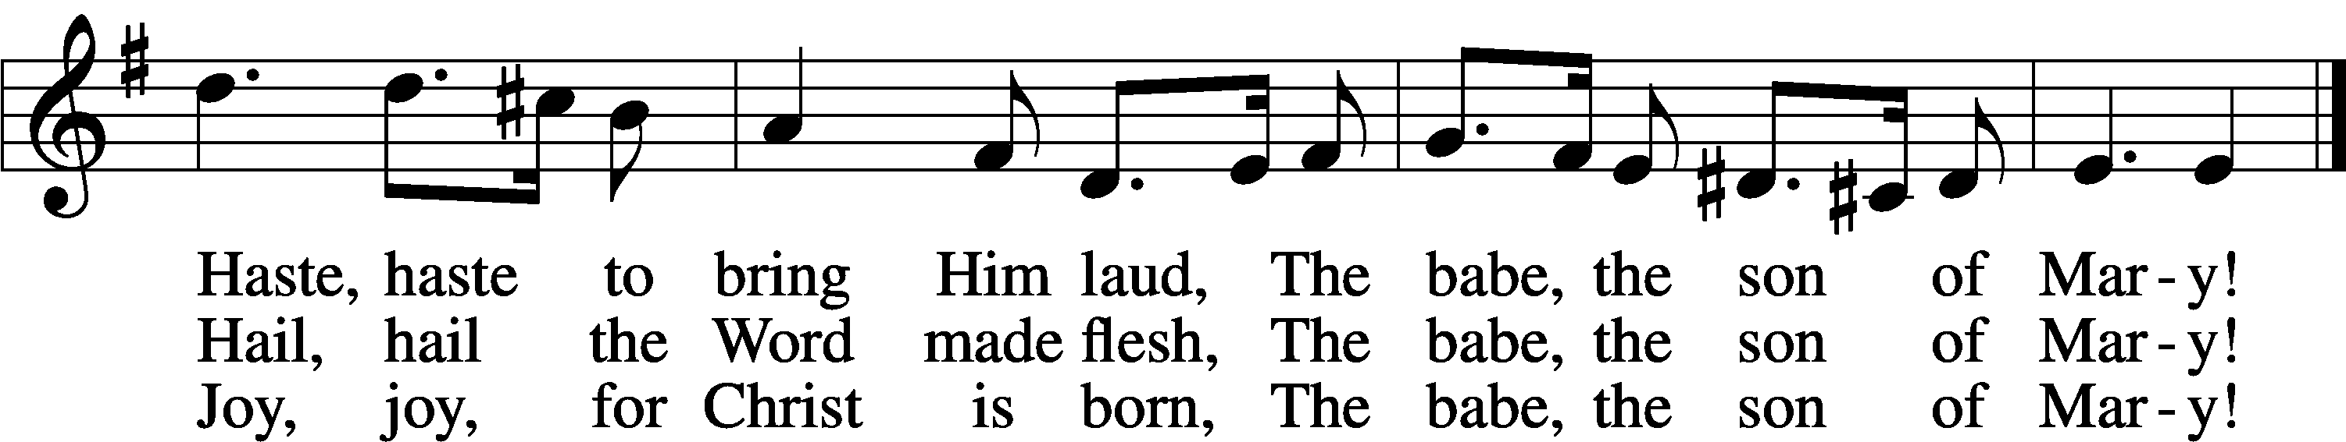

Text: William C. Dix, 1837–98  
Tune: English, 16th cent.  
Text and tune: Public domain

Stand

Dismissal

Nunc Dimittis Luke 2:29–32

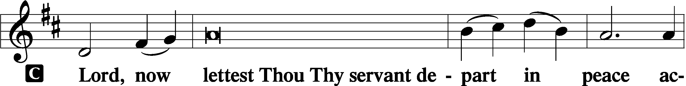

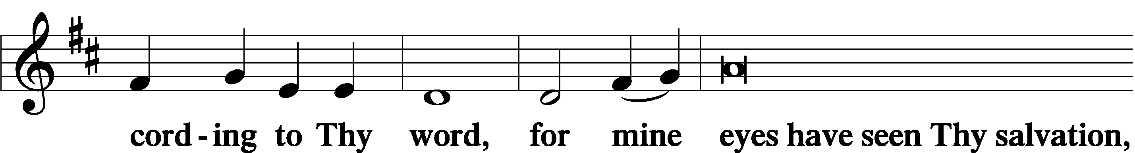

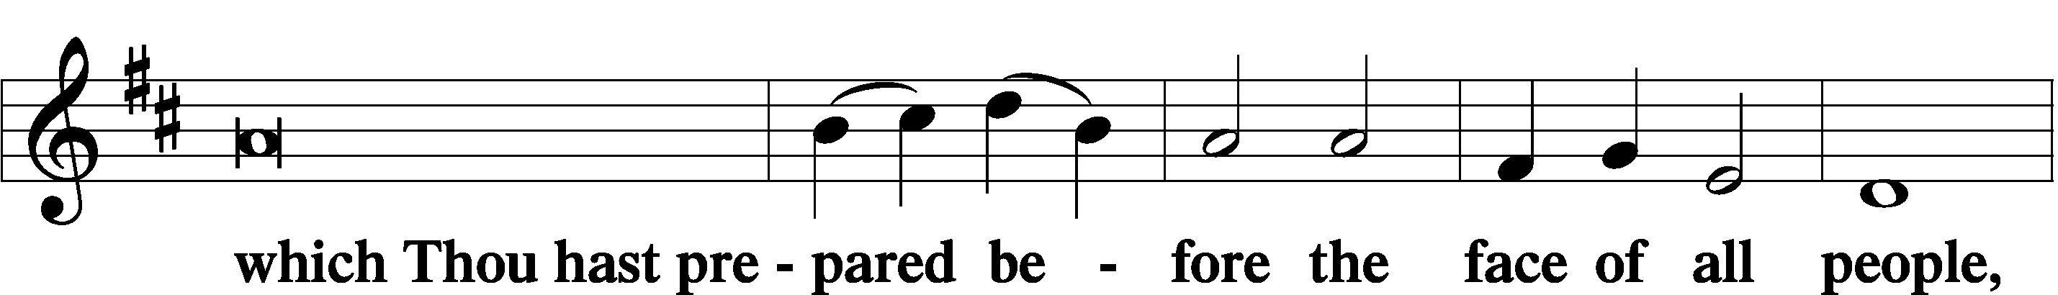

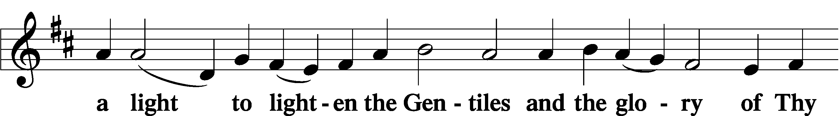

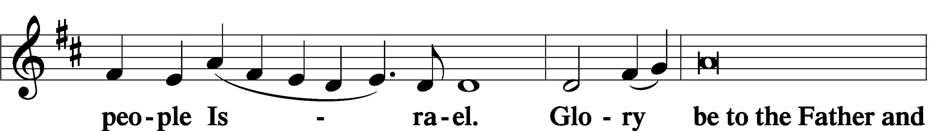

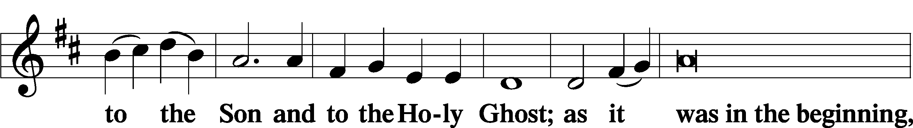

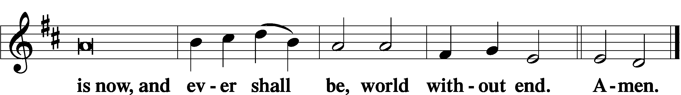

Thanksgiving Psalm 107:1

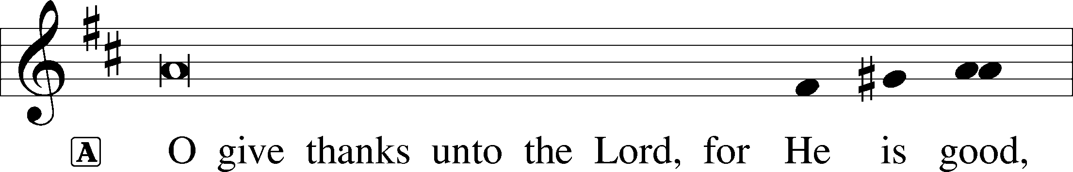

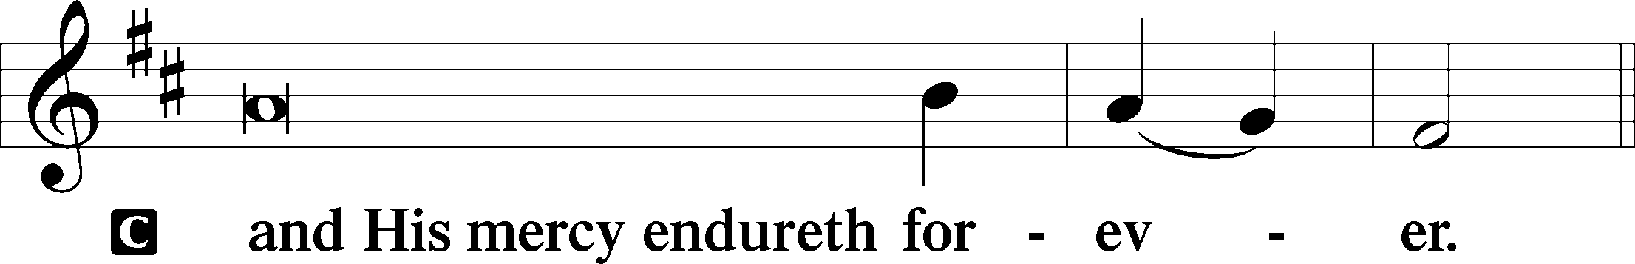

Post-Communion Collect

A Let us pray.

We give thanks to You, almighty God, that You have refreshed us through this salutary gift, and we implore You that of Your mercy You would strengthen us through the same in faith toward You and in fervent love toward one another; through Jesus Christ, Your Son, our Lord, who lives and reigns with You and the Holy Spirit, one God, now and forever.

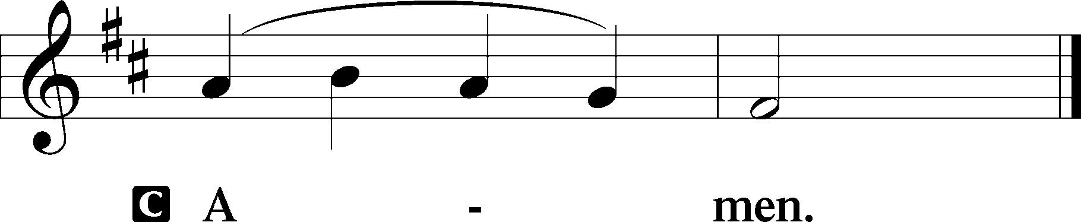

Salutation 2 Timothy 4:22

P The Lord be with you.

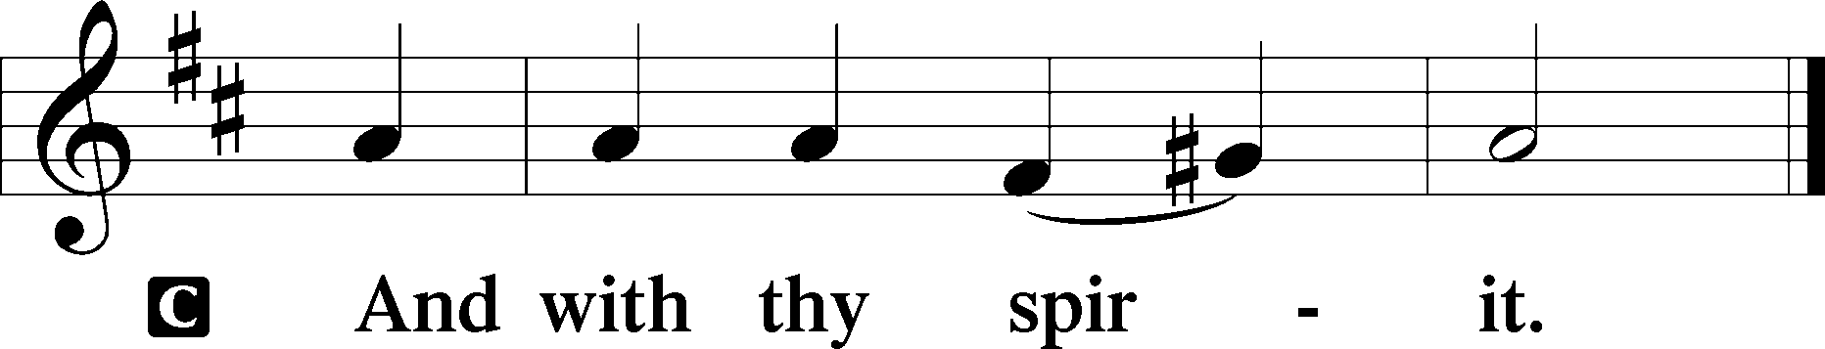

Benedicamus Psalm 103:1

A Bless we the Lord.

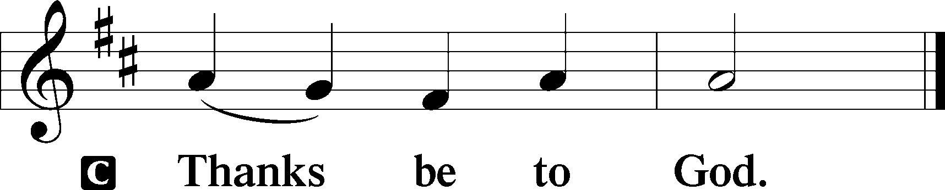

Benediction Numbers 6:24–26

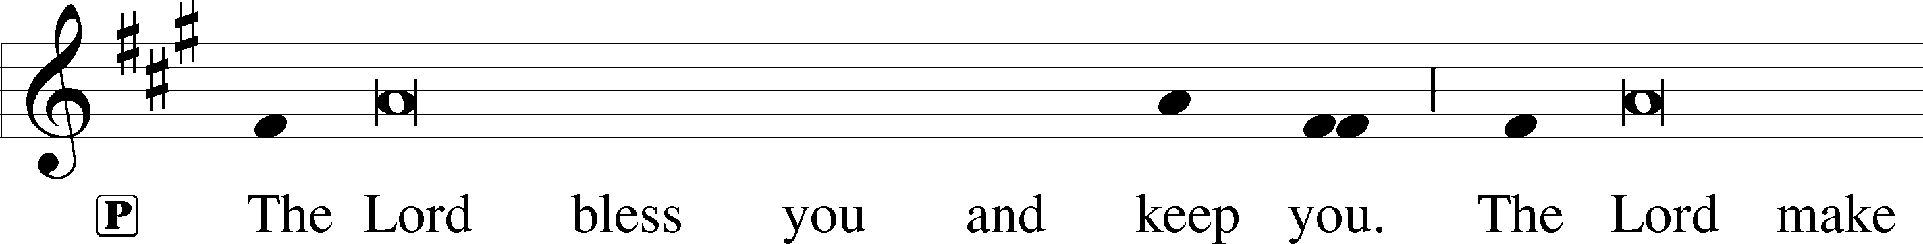

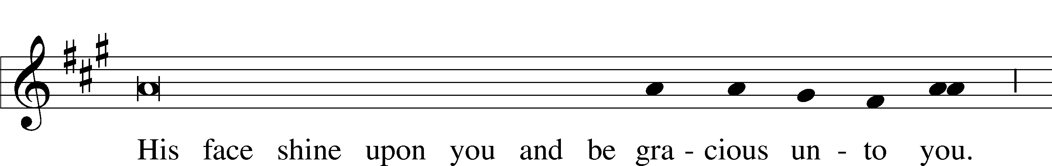

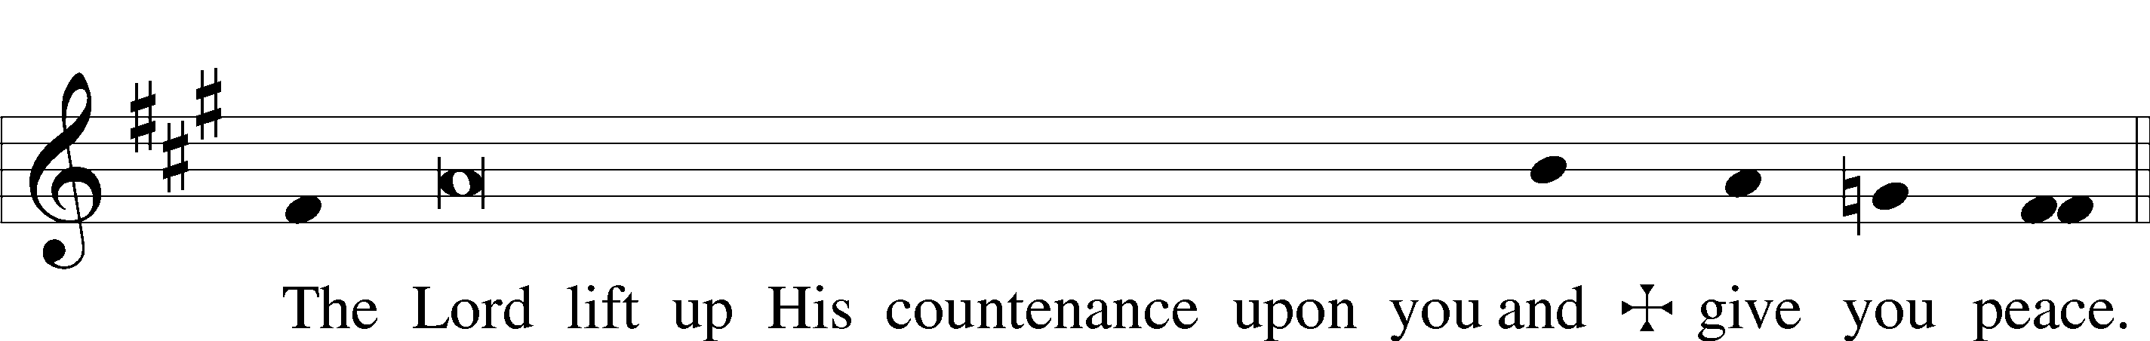

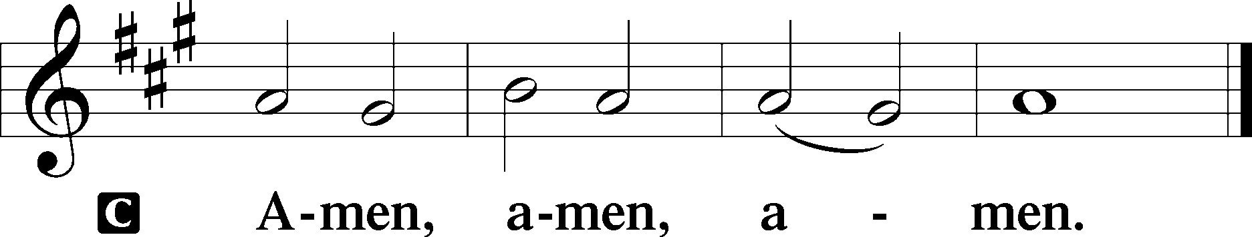

379 O Come, All Ye Faithful sts. 1, ref, 2–4

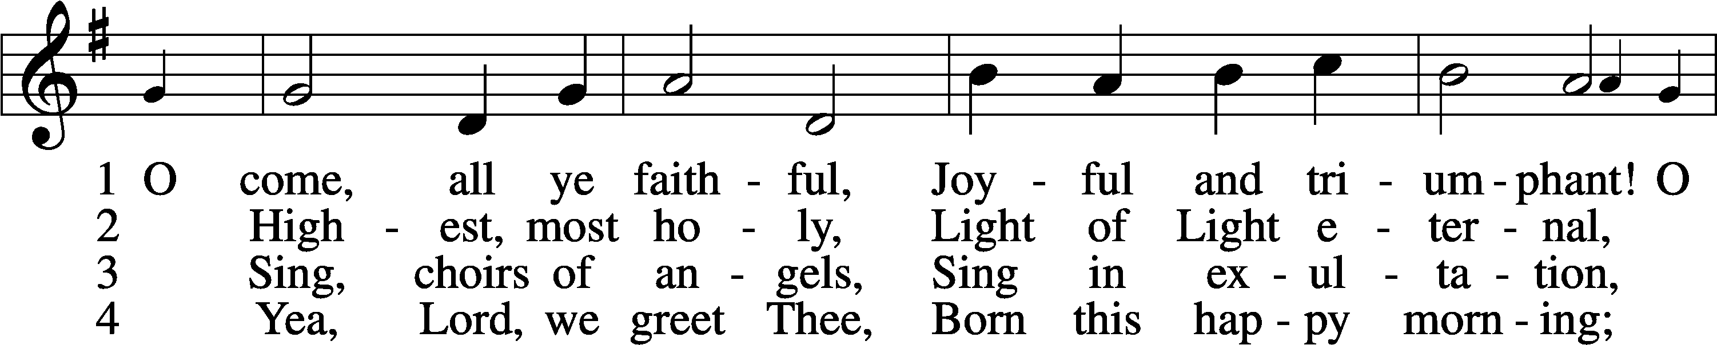

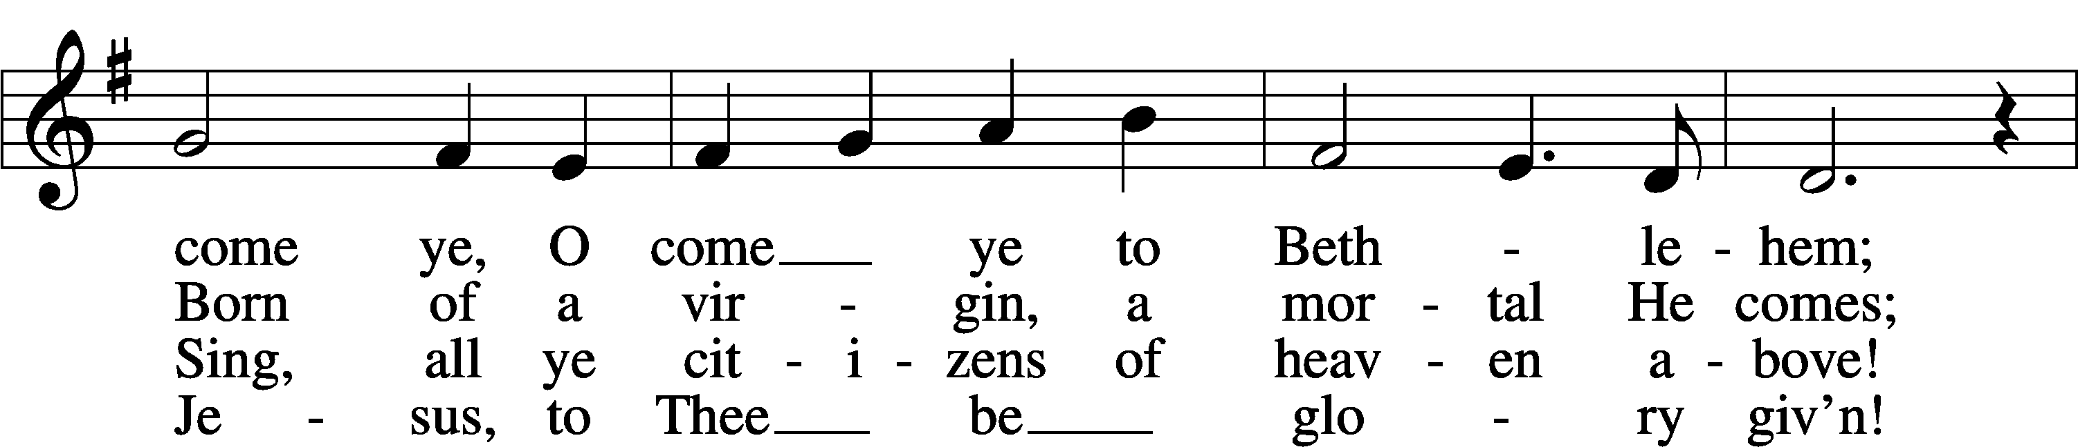

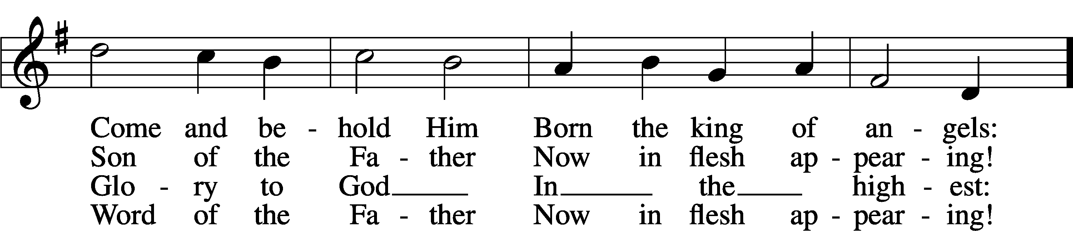

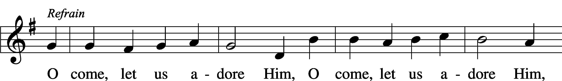

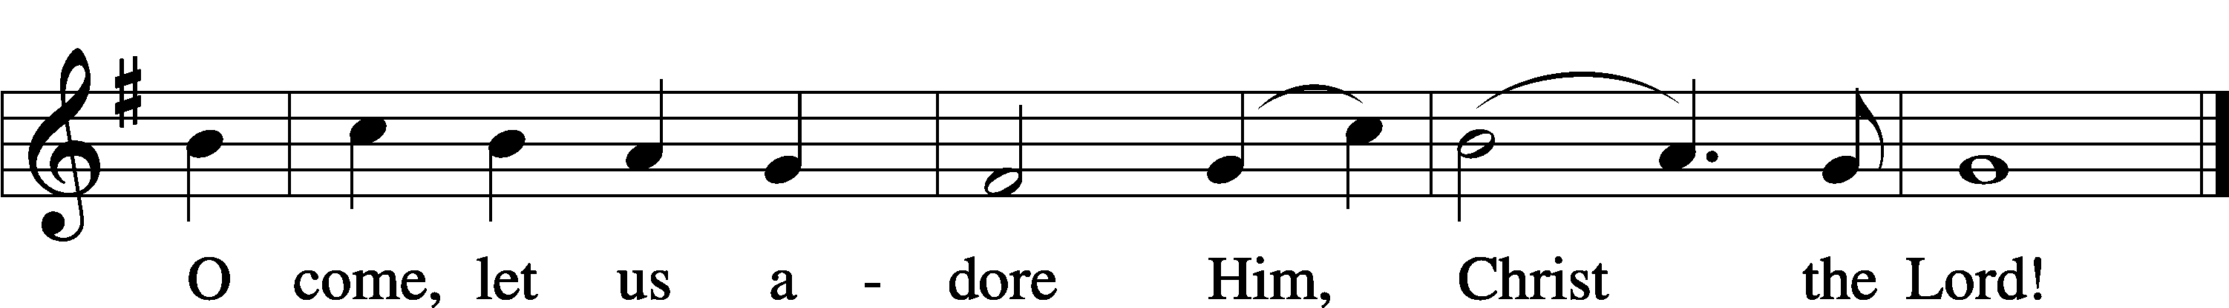

Text: tr. Frederick Oakeley, 1802–80, alt.  
Text and tune: John F. Wade, c. 1711–1786  
Text and tune: Public domain

Acknowledgments

Divine Service, Setting Three from Lutheran Service Book

Unless otherwise indicated, Scripture quotations are from the ESV® Bible (The Holy Bible, English Standard Version®), copyright © 2001 by Crossway, a publishing ministry of Good News Publishers. Used by permission. All rights reserved.

Created by Lutheran Service Builder © 2022 Concordia Publishing House.