The Key to

St. Peter **DEC 2022 2022 2022**

St. Peter Lutheran Church - LCMS, 906 Hwy 59 N – PO Box 133, Bowie, TX 76230 www.stpetertex.com

stpetertex@gmail.xom   940.872.1886

# The Pastor’s Pen

By Pastor Mark DeYoung



**And in the same region there were shepherds out in the field, keeping watch over their flock by night. And an angel of the Lord appeared to them, and the glory of the Lord shone around them, and they were filled with great fear.And the angel said to them, “Fear not, for behold, I bring you good news of great joy that will be for all the people. For unto you is born this day in the city of David a Savior, who is Christ the Lord. And this will be a sign for you: you will find a baby wrapped in swaddling cloths and lying in a manger.” And suddenly there was with the angel a multitude of the heavenly host praising God and saying,**

“Glory to God in the highest,  
     and on earth peace among those with whom he is pleased!”

Every year, when Christmas draws near, I pull out the “Christmas Movie” box, after watching Die Hard and Die Hard 2, I start to watch the more traditional Christmas movies. When it comes time for **A Charlie Brown Christmas**, I get all nostalgic. There is a scene in which I never realized the gravity, that scene is Linus recounts Luke’s nativity (Luke 2:1 – 20). When Linus gets to the line **“Fear not, …”** he drops his security blanket. Linus is physically relating what the scripture means.

Currently, we are still seeing horrific things happening around the world, but we need to listen to the message from the angel. **“Fear not,”**. When the time comes for God to gather us into His arms and bring us home, we will not be fearful or anxious. We will not need our security blanket.

During this time of the year, let us remember in our prayers all those who cannot be with us. Those serving in the armed forces, those living in independent living, dependent living, or nursing homes, and those living far away. May God bless all for whom we pray.

Pastor De Young

Text box 3

Deck the Halls

**Once again we are worshiping in the beauty that is Christmas! Thanks to those who worked so hard to get it done! The Chrismons, or Christian symbols that adorn our tree were made by the ladies of the LWML back in the 1980’s.**

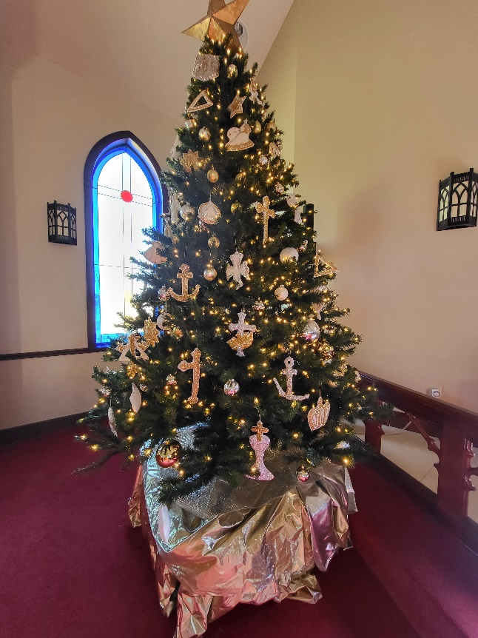

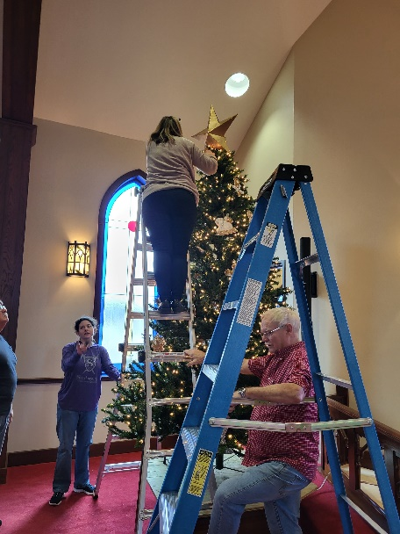

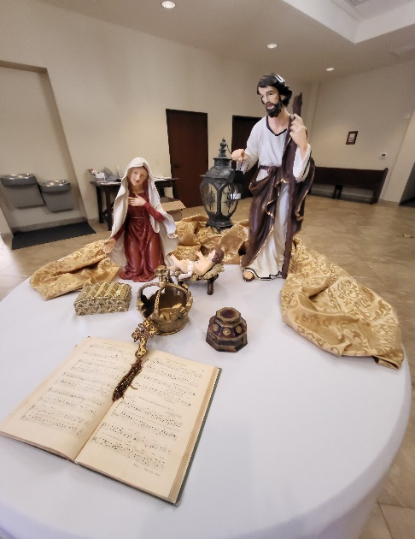

LWML will continue to collect items for the Clear Choice Pregnancy Center into the month of December.

Bassinets Highchairs

Diaper Bags Infant hats, bibs, mittens

Baby Wash Infant Tylenol/Motrin

Baby bathtubs Wipes

Diapers size 3-6 Women’s Hygiene products

NB Pacifiers 5-point harness front facing

Laundry Detergents car seats

**Please place items in the collection receptacle in the Narthex**

HOLIDAY SCHEDULE

LETS WORSHIP TOGETHER!

**Dec. 7, 14,21–Weekly Advent Service**

**7:00 pm**

**Christmas Eve – Children’s Presentation of the Nativity of Our Lord**

**7:00 pm**

**Sunday, December 25th, Christmas Day – With Holy Communion**

**We worship together at 10:30 am**

**Saturday, December 31st, New Years Eve Worship – With Holy Communion – 7:00 p.m.**

**Sunday, January 1st New Years Day -With Holy Communion- 10:30 am**

**SERVING IN GOD’ HOUSE IN DECEMBER**

**ACOLYTES**

Dec 4 – Archer Ferguson/ Keagan Gilmore

Dec 11 -Ray Davidson/Dillon George

Dec 18 – Bella Caswell/Ailey Pickett

Dec 25 -Aiden Henry

**Altar Guild**

Kristin Henry Rebecca Horton

**Altar Care**

Lou McConeghy

Teresa Johnston Melissa Stephens

**Altar Care**

Molly Atkinson Mary Atkinson Amanda Gilmore

**Counters**

Brent Husfeld

Lee Hughes William PICKETT



This Photo by Unknown Author is licensed under CC BY-NC-ND

**Elder**

David Geis