900 Children of the Heavenly Father
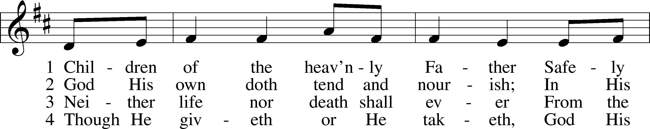
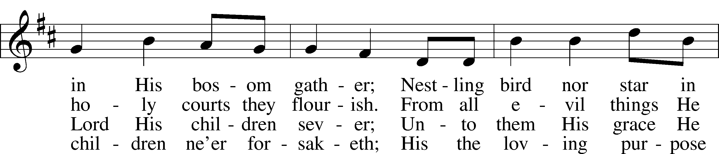
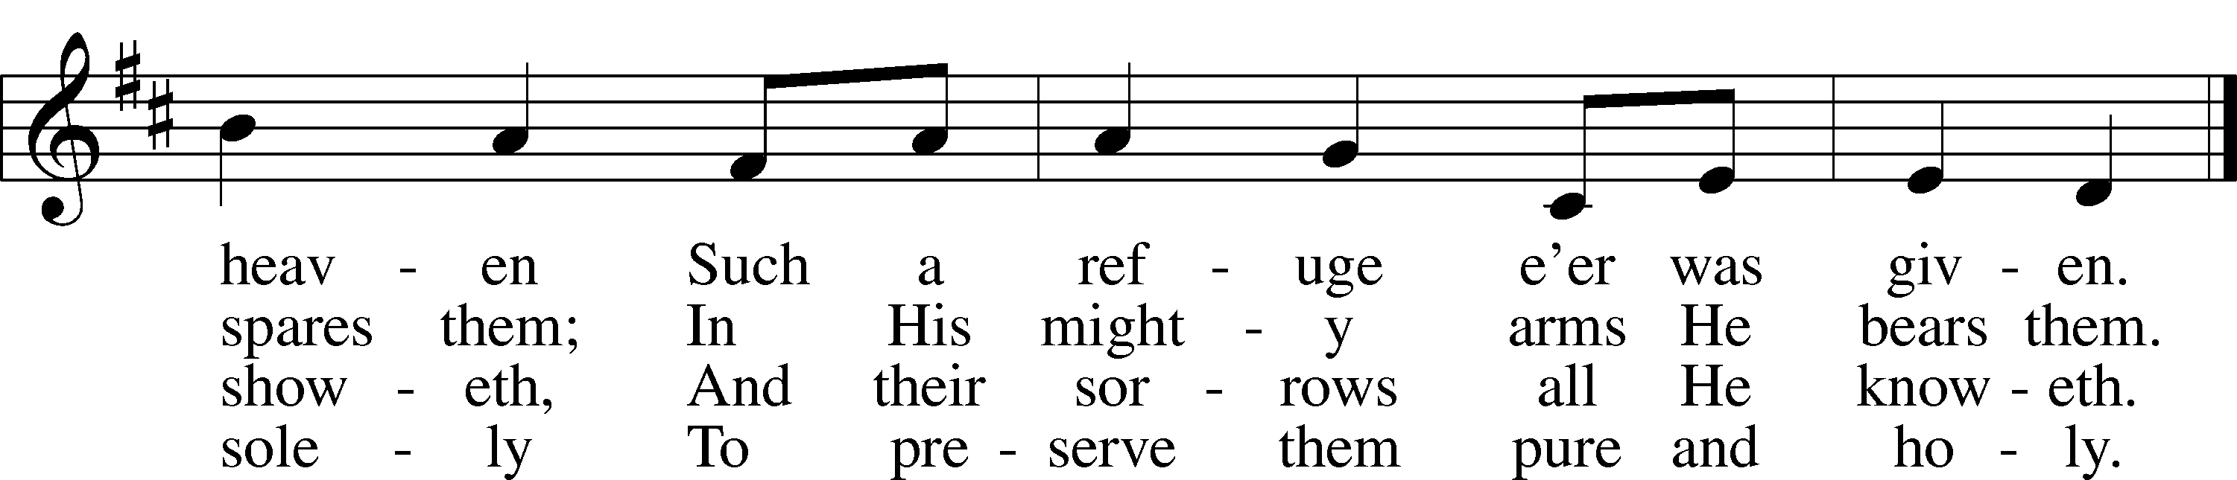
Text: Carolina Sandell Berg, 1832–1903; tr. Ernst W. Olson, 1870–1958
Tune: Lofsånger och andeliga wisor, 1873, Sweden
Text: Public domain
Tune: Public domain

Confession and Absolution

Stand

The sign of the cross may be made by all in remembrance of their Baptism.

Invocation Matthew 28:19b; 18:20
P In the name of the Father and of the T Son and of the Holy Spirit.
C Amen.

Exhortation Hebrews 10:22; Psalm 124:8; Psalm 32:5
P Beloved in the Lord! Let us draw near with a true heart and confess our sins unto God our Father, beseeching Him in the name of our Lord Jesus Christ to grant us forgiveness.

P Our help is in the name of the Lord,
C who made heaven and earth.
P I said, I will confess my transgressions unto the Lord,
C and You forgave the iniquity of my sin.

Kneel/Stand

Silence for reflection on God’s Word and for self-examination.

Confession of Sins
P O almighty God, merciful Father,
C I, a poor, miserable sinner, confess unto You all my sins and iniquities with which I have ever offended You and justly deserved Your temporal and eternal punishment. But I am heartily sorry for them and sincerely repent of them, and I pray You of Your boundless mercy and for the sake of the holy, innocent, bitter sufferings and death of Your beloved Son, Jesus Christ, to be gracious and merciful to me, a poor, sinful being.

Absolution [John 20:19–23]
P Upon this your confession, I, by virtue of my office, as a called and ordained servant of the Word, announce the grace of God unto all of you, and in the stead and by the command of my Lord Jesus Christ I forgive you all your sins in the name of the Father and of the T Son and of the Holy Spirit.
C Amen.

Stand

Service of the Word

Introit Psalm 40:6–8; antiphon: 40:16
May all who seek you rejoice and be glad in you;
may those who love your salvation say continually, “Great is the Lord!”
Sacrifice and offering you have not desired, but you have given me an open ear.
Burnt offering and sin offering you have not required.
Then I said, “Behold, I have come;
in the scroll of the book it is written of me:
I desire to do your will, O my God;
your law is within my heart.”

Gloria Patri
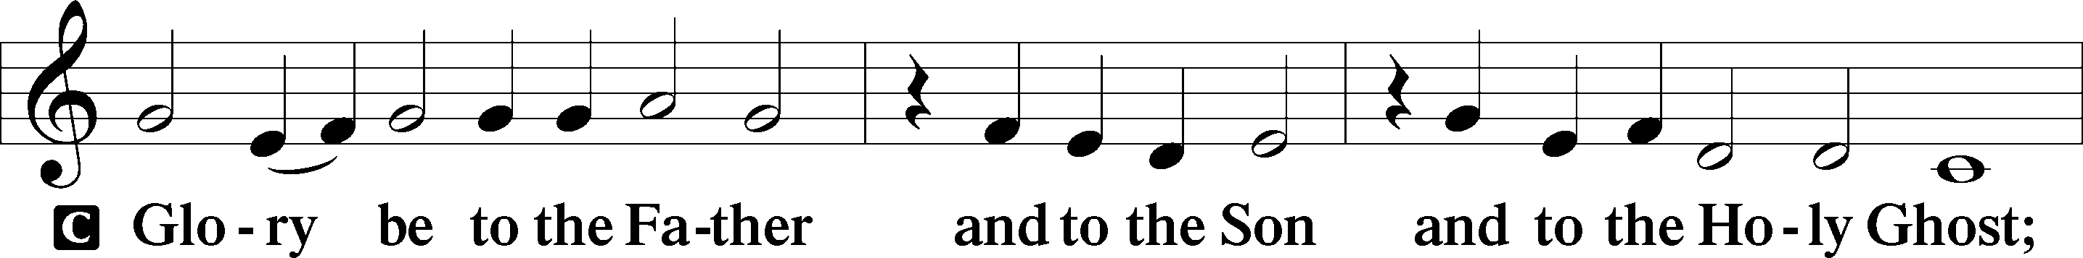
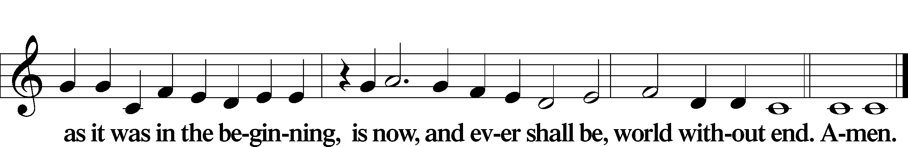

Kyrie Mark 10:47
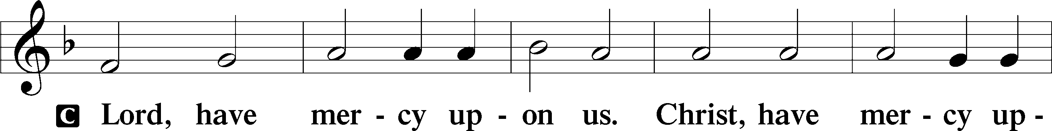
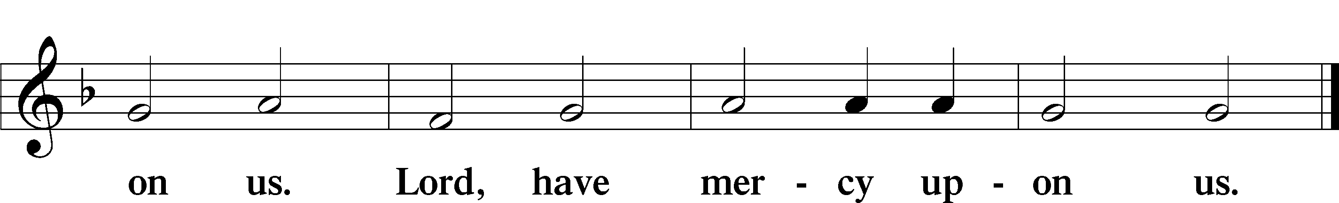

Gloria in Excelsis Luke 2:14; John 1:29
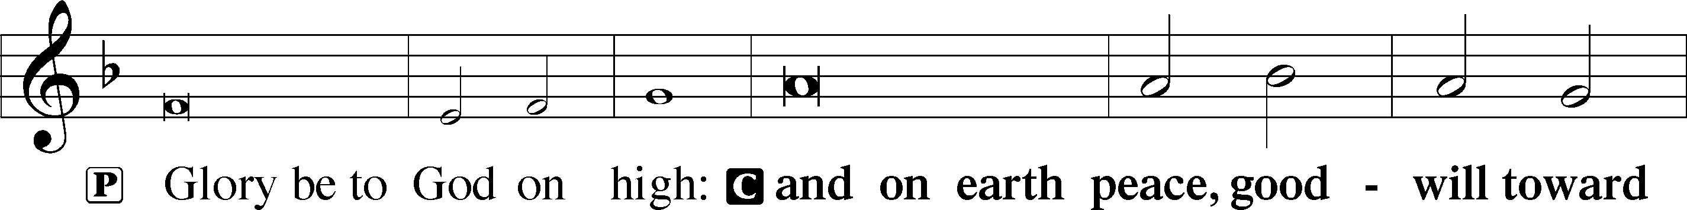
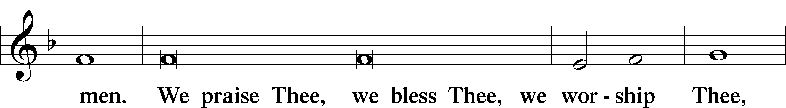
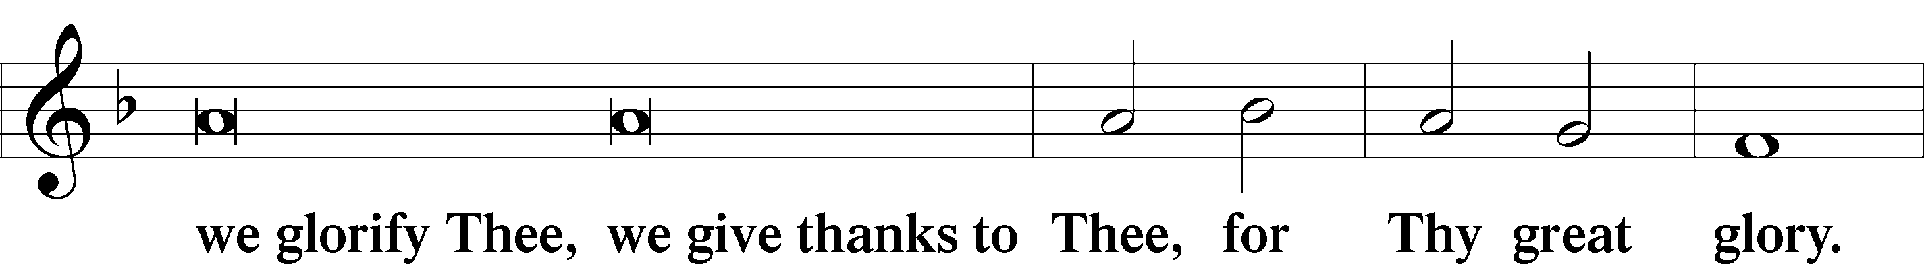
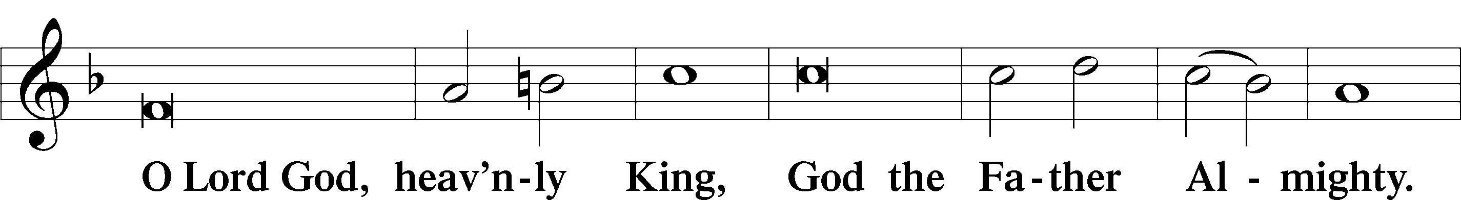
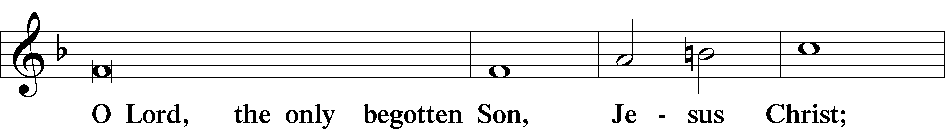
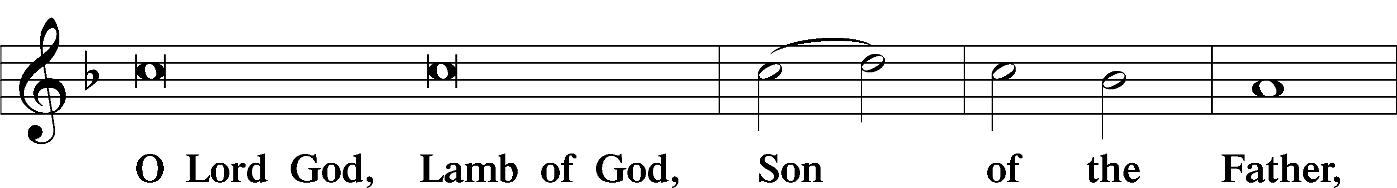
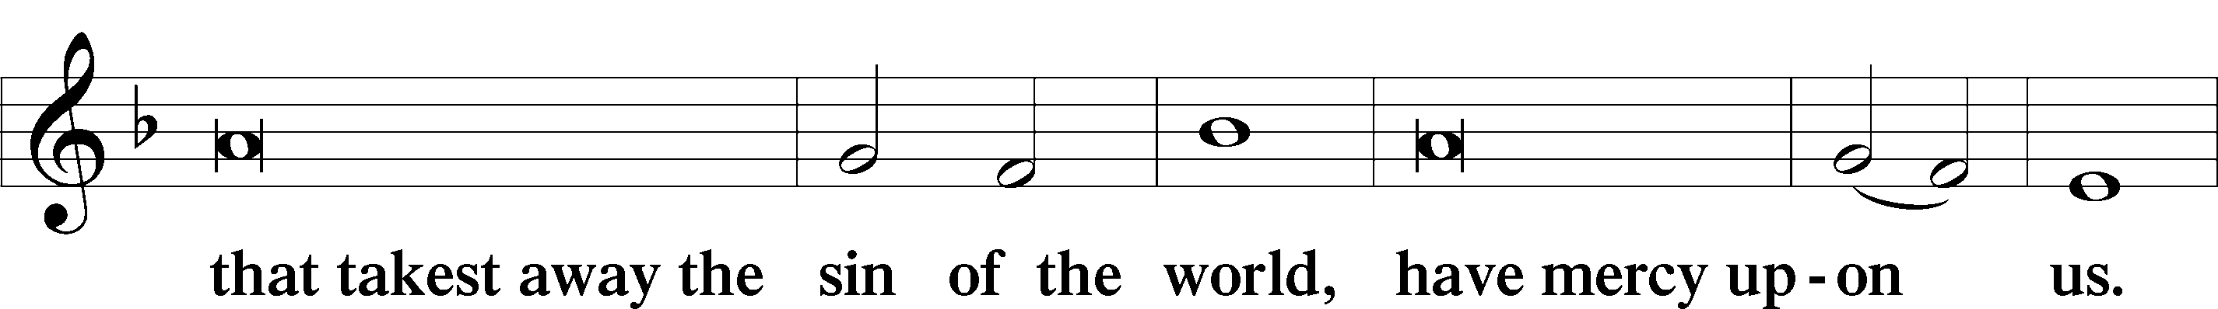
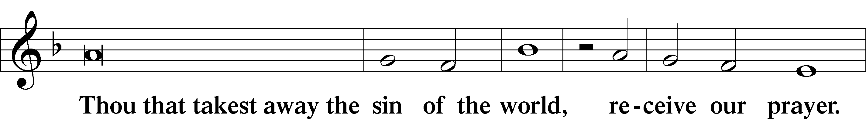
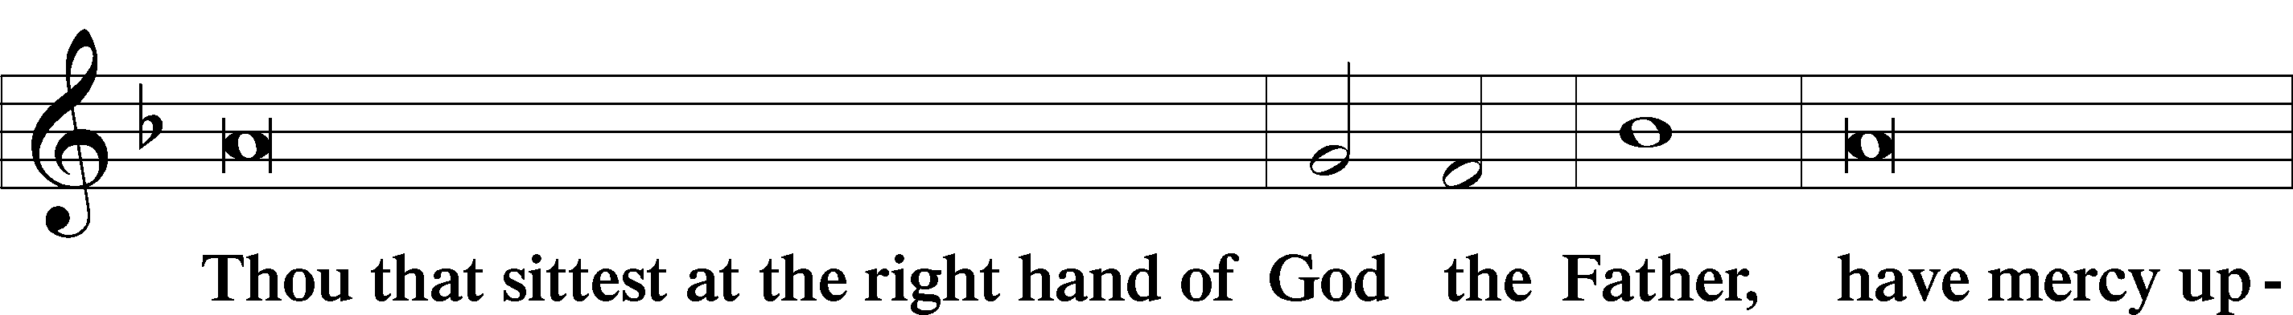
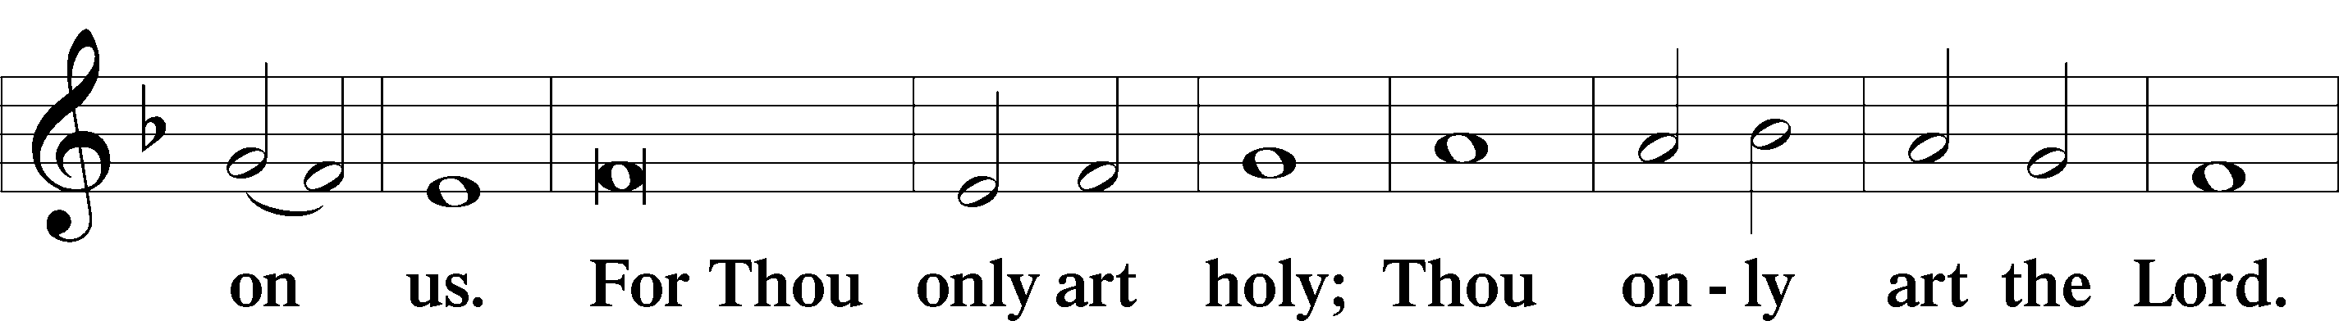
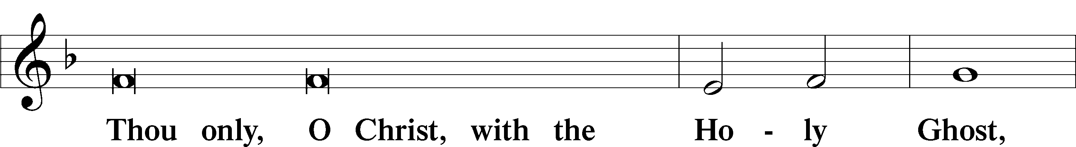
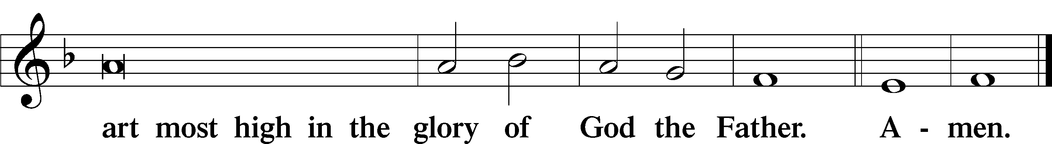

Salutation and Collect of the Day
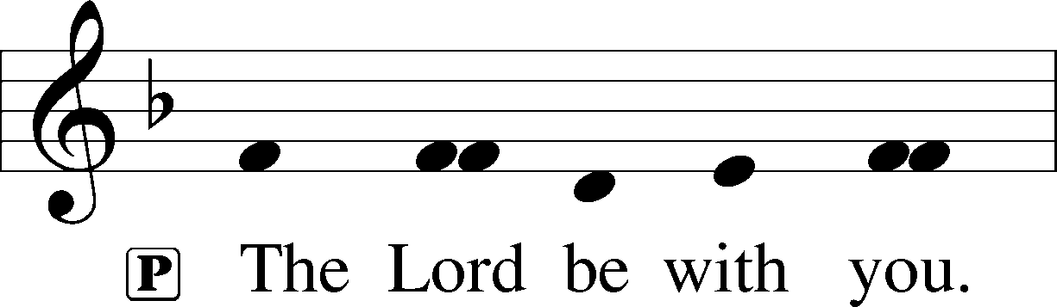
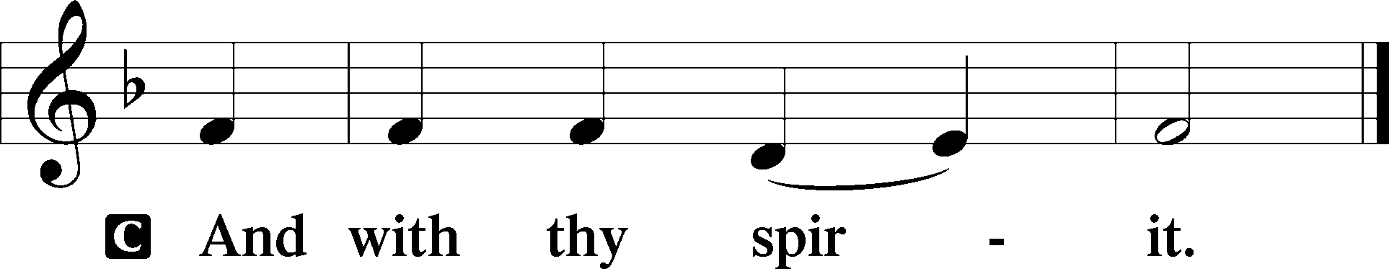

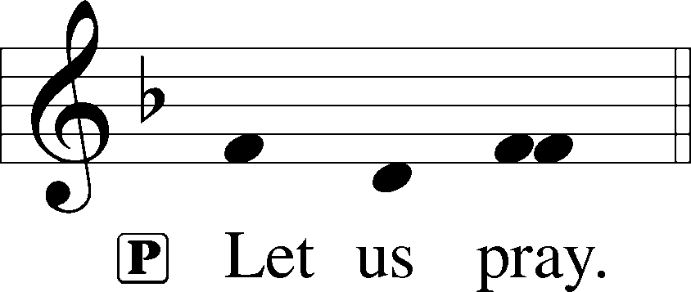

P Lord God, You made Your beloved Son, our Savior, subject to the Law and caused Him to shed His blood on our behalf. Grant us the true circumcision of the Spirit that our hearts may be made pure from all sins; through Jesus Christ, our Lord, who lives and reigns with You and the Holy Spirit, one God, now and forever.

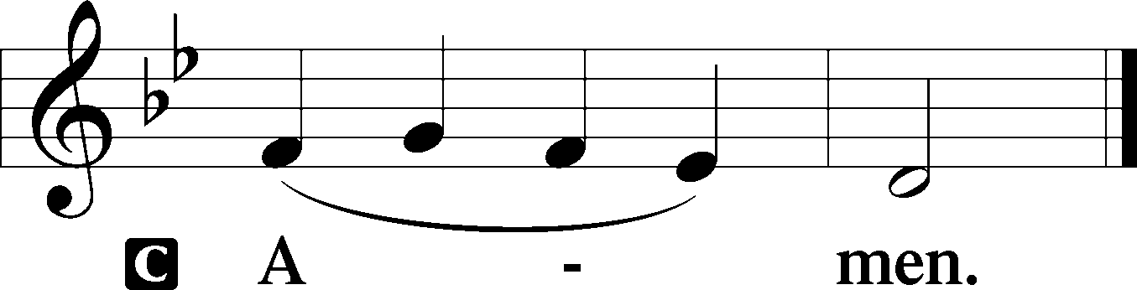

Sit

Old Testament Reading Numbers 6:22–27
Aaron’s Blessing
22The Lord spoke to Moses, saying, 23“Speak to Aaron and his sons, saying, Thus you shall bless the people of Israel: you shall say to them,
24The Lord bless you and keep you;
25the Lord make his face to shine upon you and be gracious to you;
26the Lord lift up his countenance upon you and give you peace.
27“So shall they put my name upon the people of Israel, and I will bless them.”

A This is the Word of the Lord.
C Thanks be to God.

Gradual Hebrews 8:10; 10:17
This is the covenant that I will make with the house of | Israel
after those days, de-clares the Lord:
I will put my laws into their minds,
and write them on their hearts.
I will be their God, and they shall be my people.
I will remember their sins and their lawless deeds no more.

Epistle Galatians 3:23–29
23Now before faith came, we were held captive under the law, imprisoned until the coming faith would be revealed. 24So then, the law was our guardian until Christ came, in order that we might be justified by faith. 25But now that faith has come, we are no longer under a guardian, 26for in Christ Jesus you are all sons of God, through faith. 27For as many of you as were baptized into Christ have put on Christ. 28There is neither Jew nor Greek, there is neither slave nor free, there is neither male nor female, for you are all one in Christ Jesus. 29And if you are Christ’s, then you are Abraham’s offspring, heirs according to promise.

A This is the Word of the Lord.
C Thanks be to God.

Stand

Alleluia
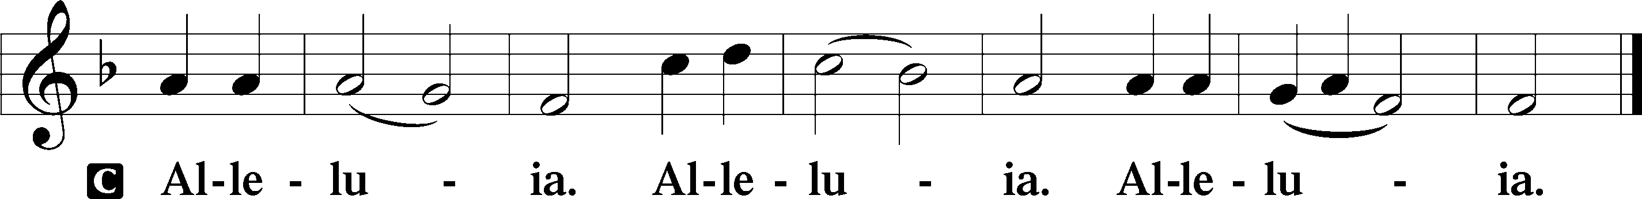

Holy Gospel Luke 2:21
P The Holy Gospel according to St. Luke, the second chapter.

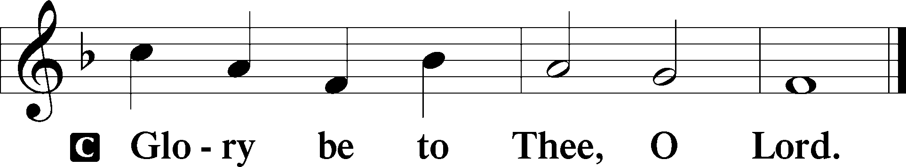

21And at the end of eight days, when he was circumcised, he was called Jesus, the name given by the angel before he was conceived in the womb.

P This is the Gospel of the Lord.

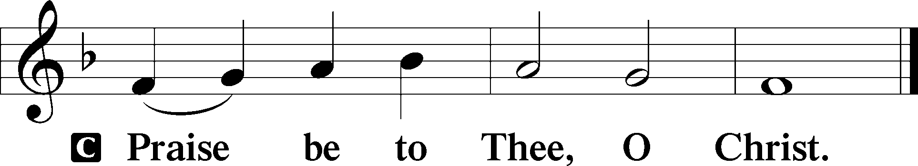

Nicene Creed
C I believe in one God,
the Father Almighty,
maker of heaven and earth
and of all things visible and invisible.

And in one Lord Jesus Christ,
the only-begotten Son of God,
begotten of His Father before all worlds,
God of God, Light of Light,
very God of very God,
begotten, not made,
being of one substance with the Father,
by whom all things were made;
who for us men and for our salvation came down from heaven
and was incarnate by the Holy Spirit of the virgin Mary
and was made man;
and was crucified also for us under Pontius Pilate.
He suffered and was buried.
And the third day He rose again according to the Scriptures
and ascended into heaven
and sits at the right hand of the Father.
And He will come again with glory to judge both the living and the dead,
whose kingdom will have no end.

And I believe in the Holy Spirit,
the Lord and giver of life,
who proceeds from the Father and the Son,
who with the Father and the Son together is worshiped and glorified,
who spoke by the prophets.
And I believe in one holy Christian and apostolic Church,
I acknowledge one Baptism for the remission of sins,
and I look for the resurrection of the dead
and the life T of the world to come. Amen.

Children's Message

900 Jesus! Name of Wondrous Love
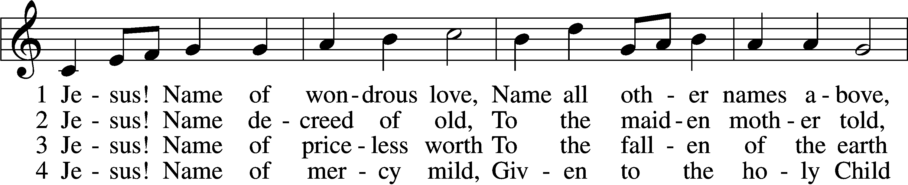
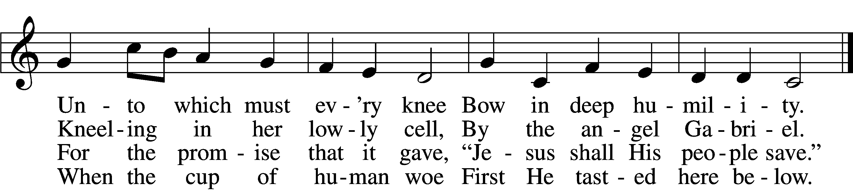

5 Jesus! Only name that’s giv’n
Under all the mighty heav’n
Whereby those to sin enslaved
Burst their fetters and are saved.

6 Jesus! Name of wondrous love,
Human name of God above;
Pleading only this, we flee
Helpless, O our God, to Thee.
Text: William W. How, 1823–97, alt.
Tune: Geist-reiches Gesang-Buch, 1704, Halle, ed. Johann A. Freylinghausen, alt.
Text and tune: Public domain

Sermon

Votum
P The peace of God, which passes all understanding, keep your hearts and minds in Christ Jesus.
C Amen.

Stand

Offertory Psalm 51:10–12
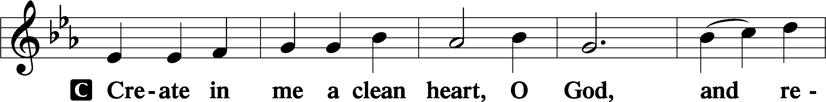
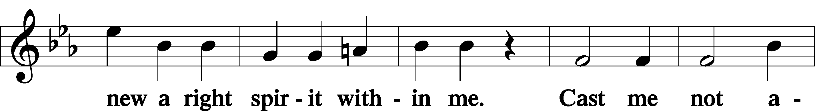
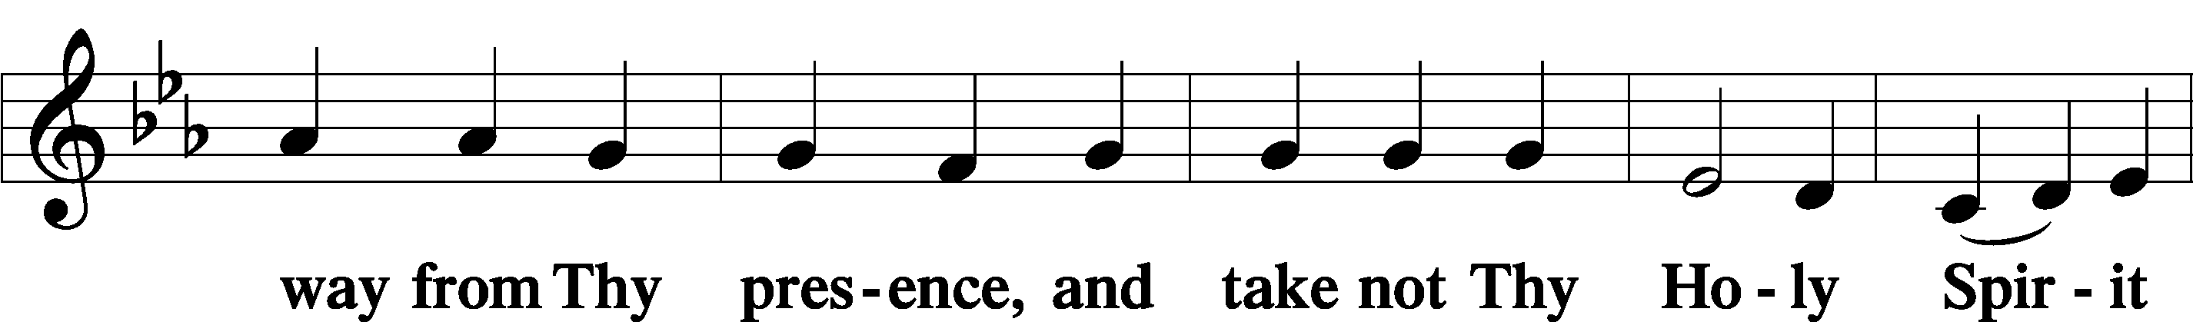
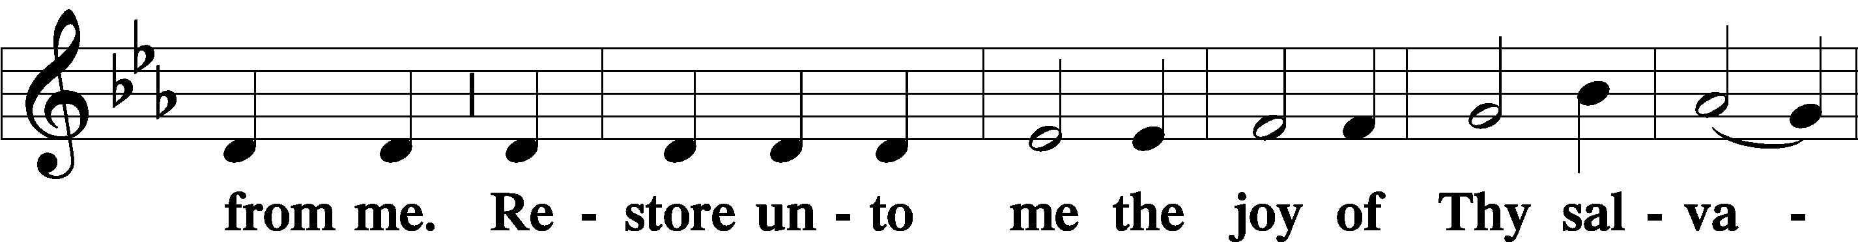
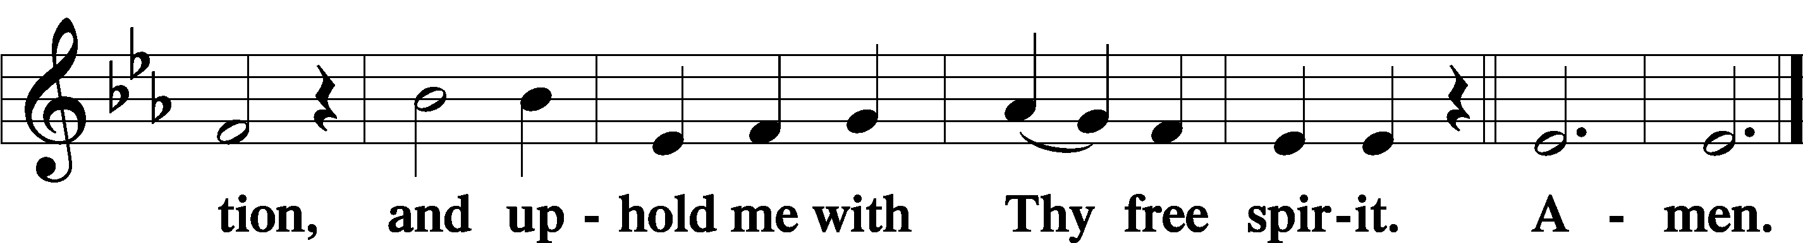

Sit

Offering

Stand

805 Praise God, from Whom All Blessings Flow
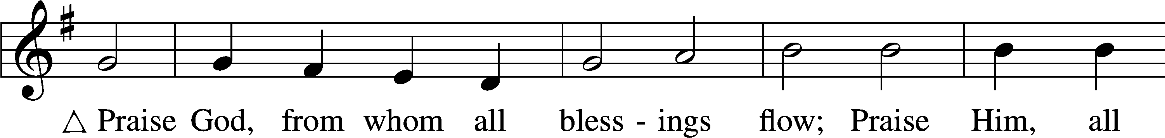
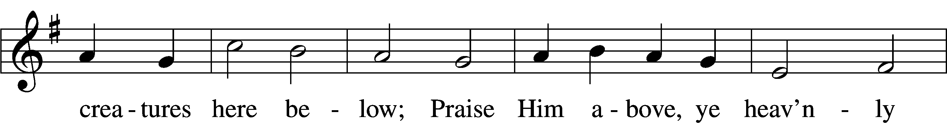
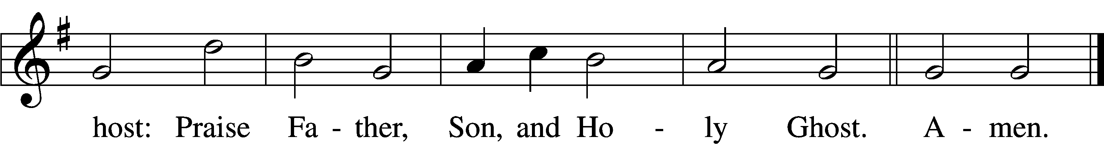
Text: Thomas Ken, 1637–1711
Tune: Trente quatre Pseaumes de David, 1551, Geneva, ed. Louis Bourgeois
Text and tune: Public domain

Prayer of the Church

Service of the Sacrament

Preface 2 Timothy 4:22; [Colossians 3:1]; [Psalm 136]
P The Lord be with you.
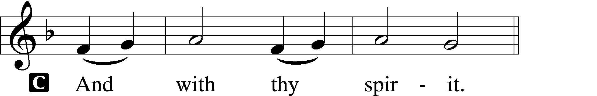

P Lift up your hearts.
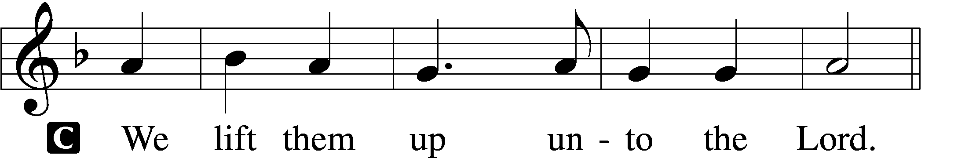

P Let us give thanks unto the Lord, our God.
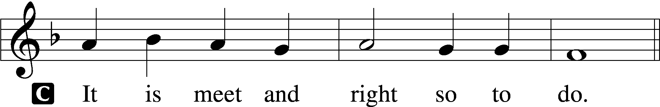

Proper Preface (Full)
P It is truly meet, right, and salutary that we should at all times and in all places give thanks to You, holy Lord, almighty Father, everlasting God, through Jesus Christ, our Lord; for in the mystery of the Word made flesh You have given us a new revelation of Your glory that, seeing You in the person of Your Son, we may know and love those things which are not seen. Therefore with angels and archangels and with all the company of heaven we laud and magnify Your glorious name, evermore praising You and saying:

Sanctus Isaiah 6:3; Matthew 21:9
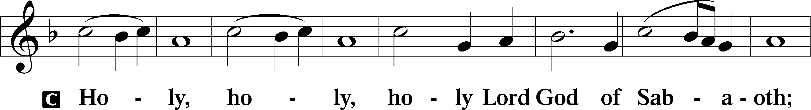
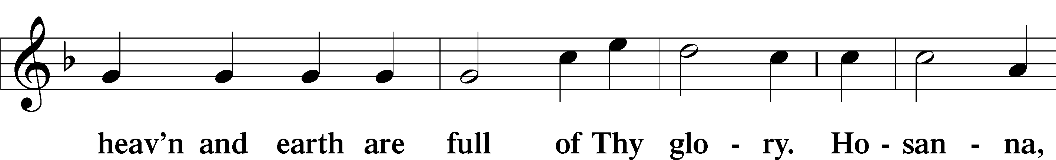
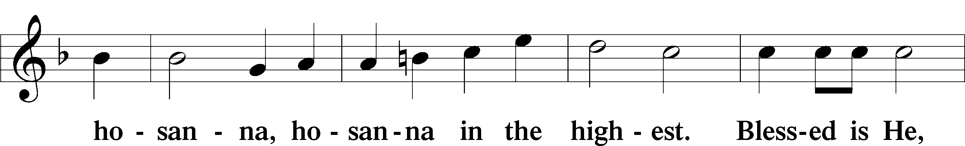
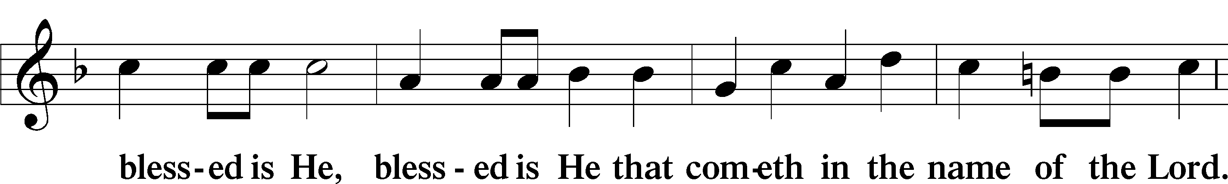
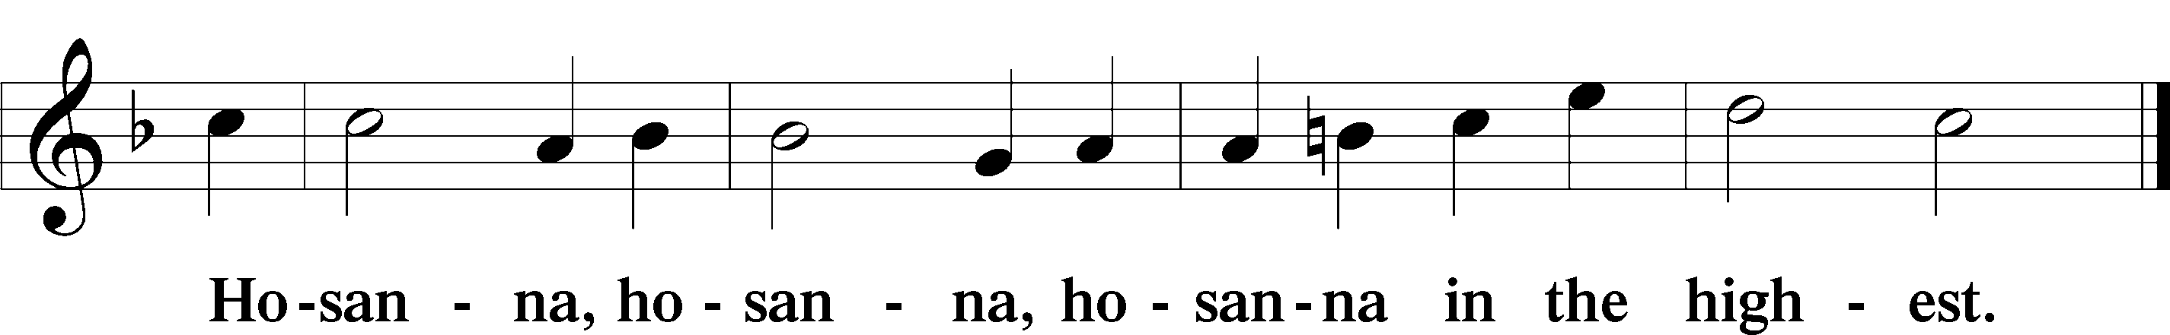

Lord’s Prayer Matthew 6:9–13
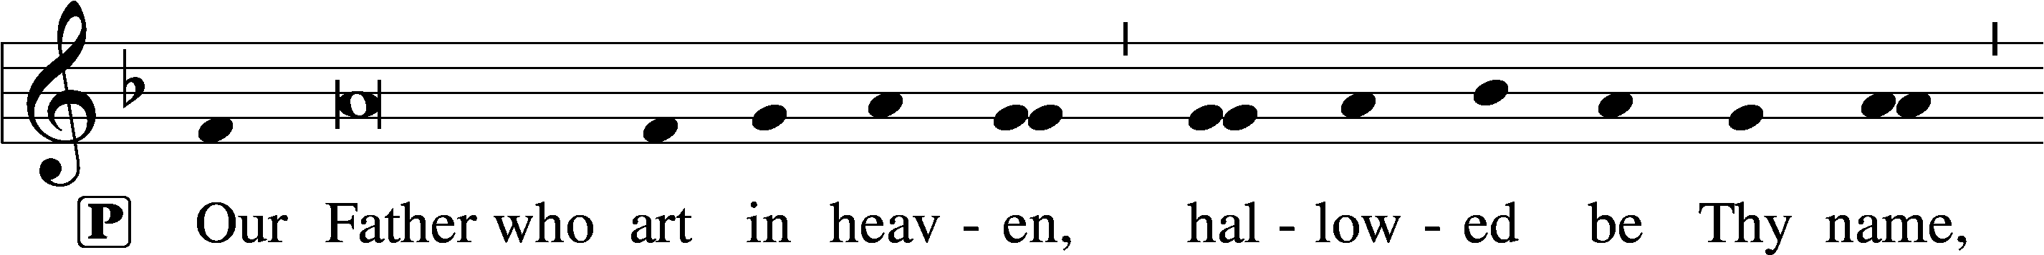
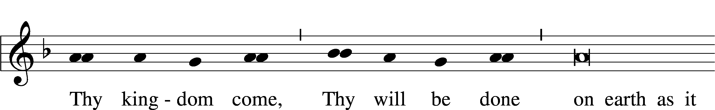
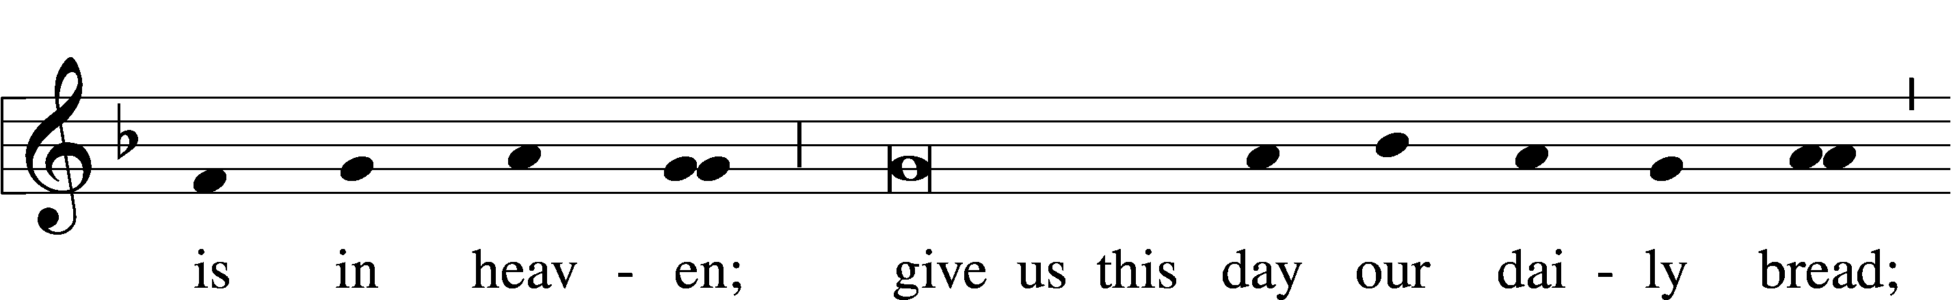
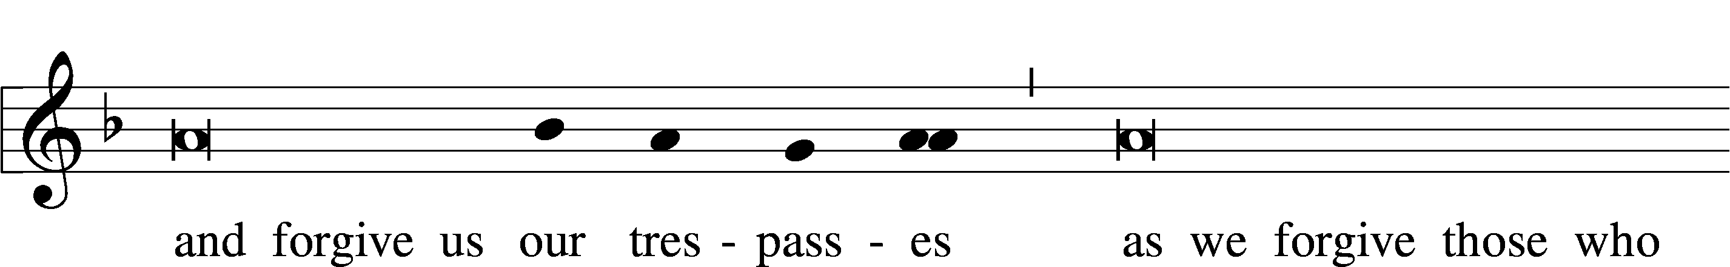
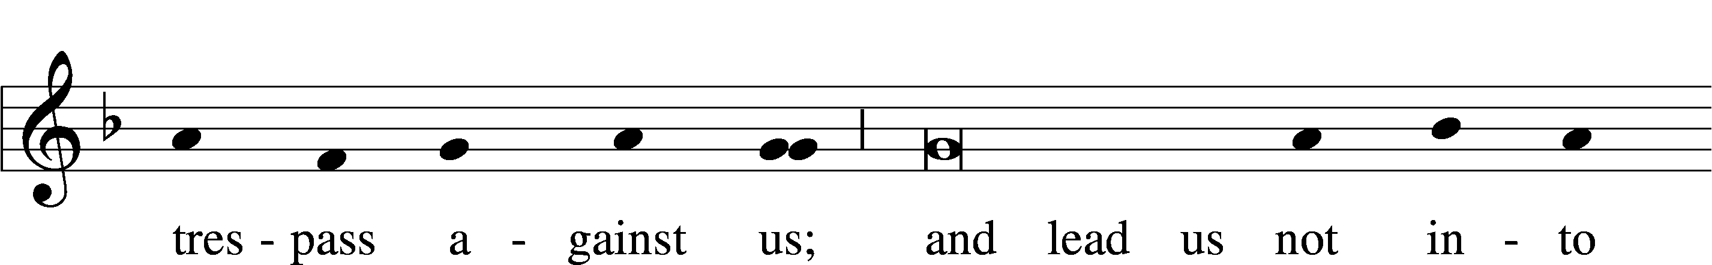
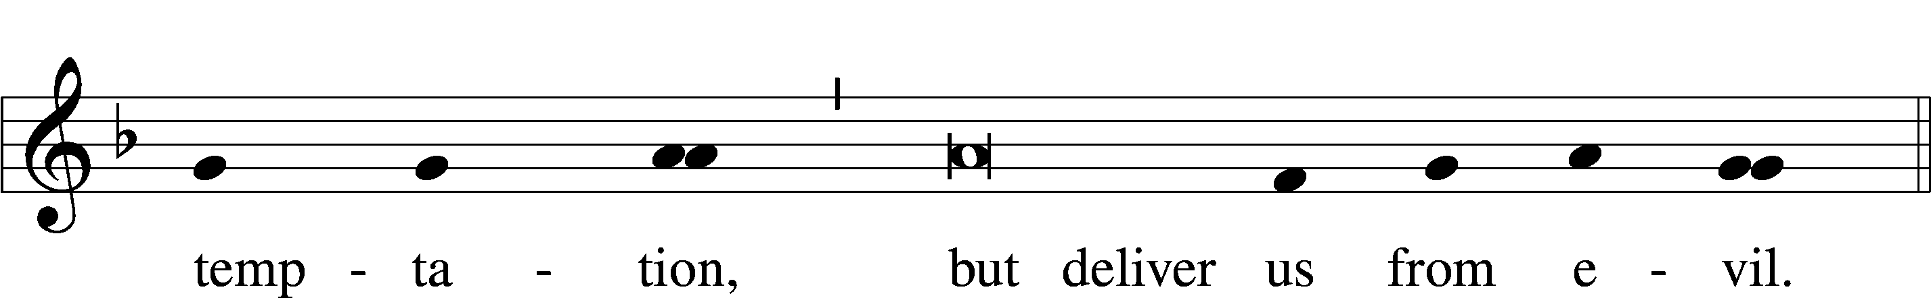

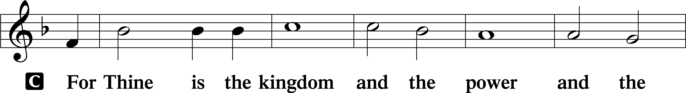
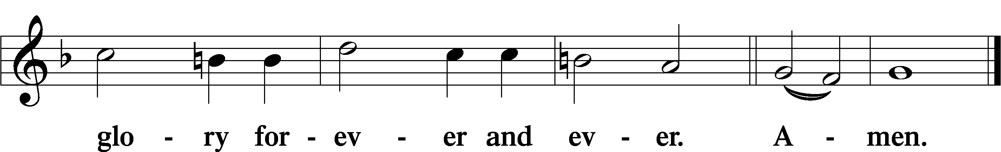

The Words of Our Lord Matthew 26:26–28; Mark 14:22–24; Luke 22:19–20; 1 Corinthians 11:23–25
P Our Lord Jesus Christ, on the night when He was betrayed, took bread, and when He had given thanks, He broke it and gave it to the disciples and said: “Take, eat; this is My T body, which is given for you. This do in remembrance of Me.”

In the same way also He took the cup after supper, and when He had given thanks, He gave it to them, saying: “Drink of it, all of you; this cup is the new testament in My T blood, which is shed for you for the forgiveness of sins. This do, as often as you drink it, in remembrance of Me.”

Pax Domini John 20:19
P The peace of the Lord be with you always.

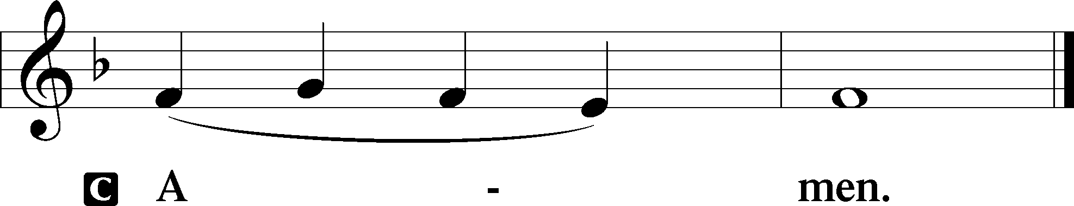

Agnus Dei John 1:29
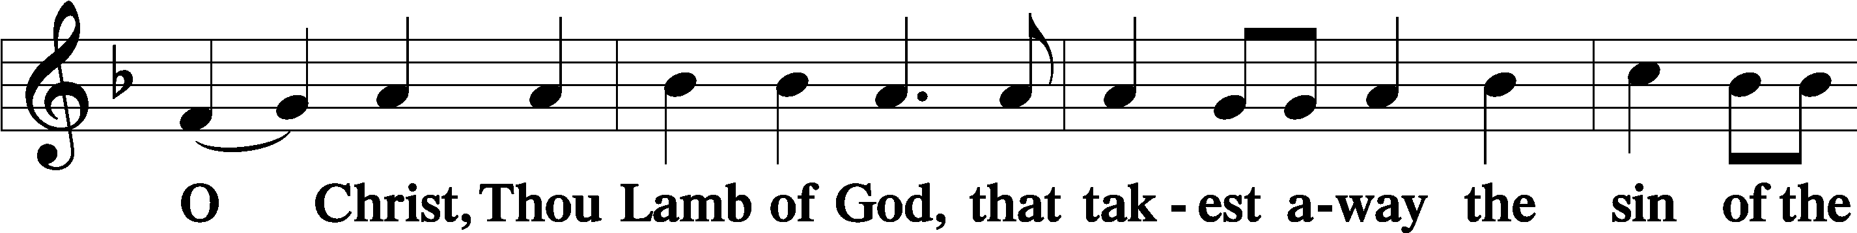
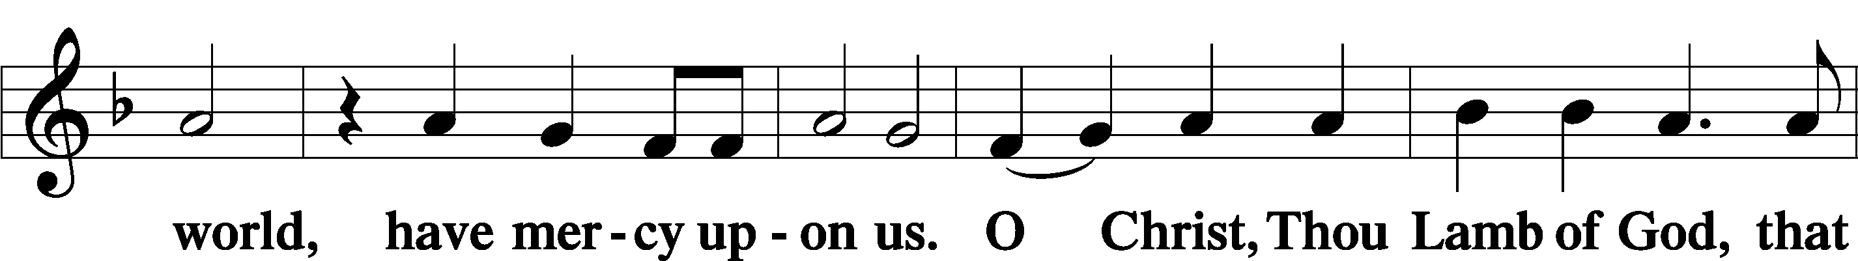
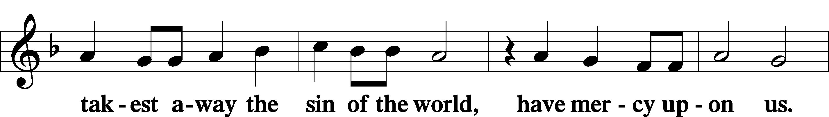
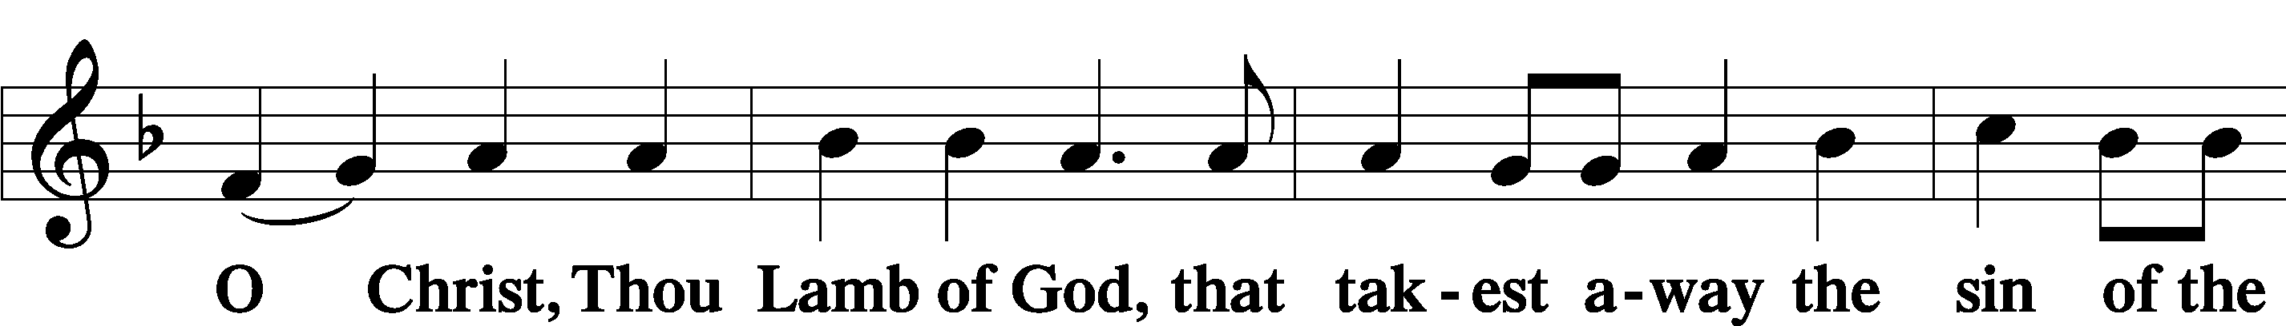
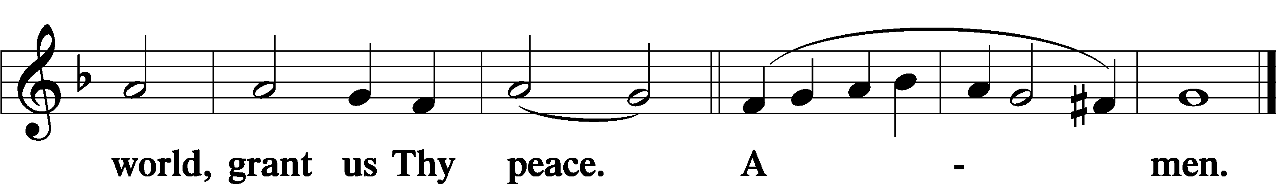

Sit

Distribution

352 Let the Earth Now Praise the Lord
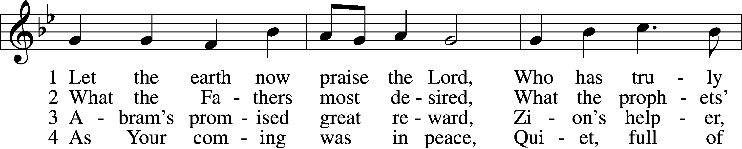
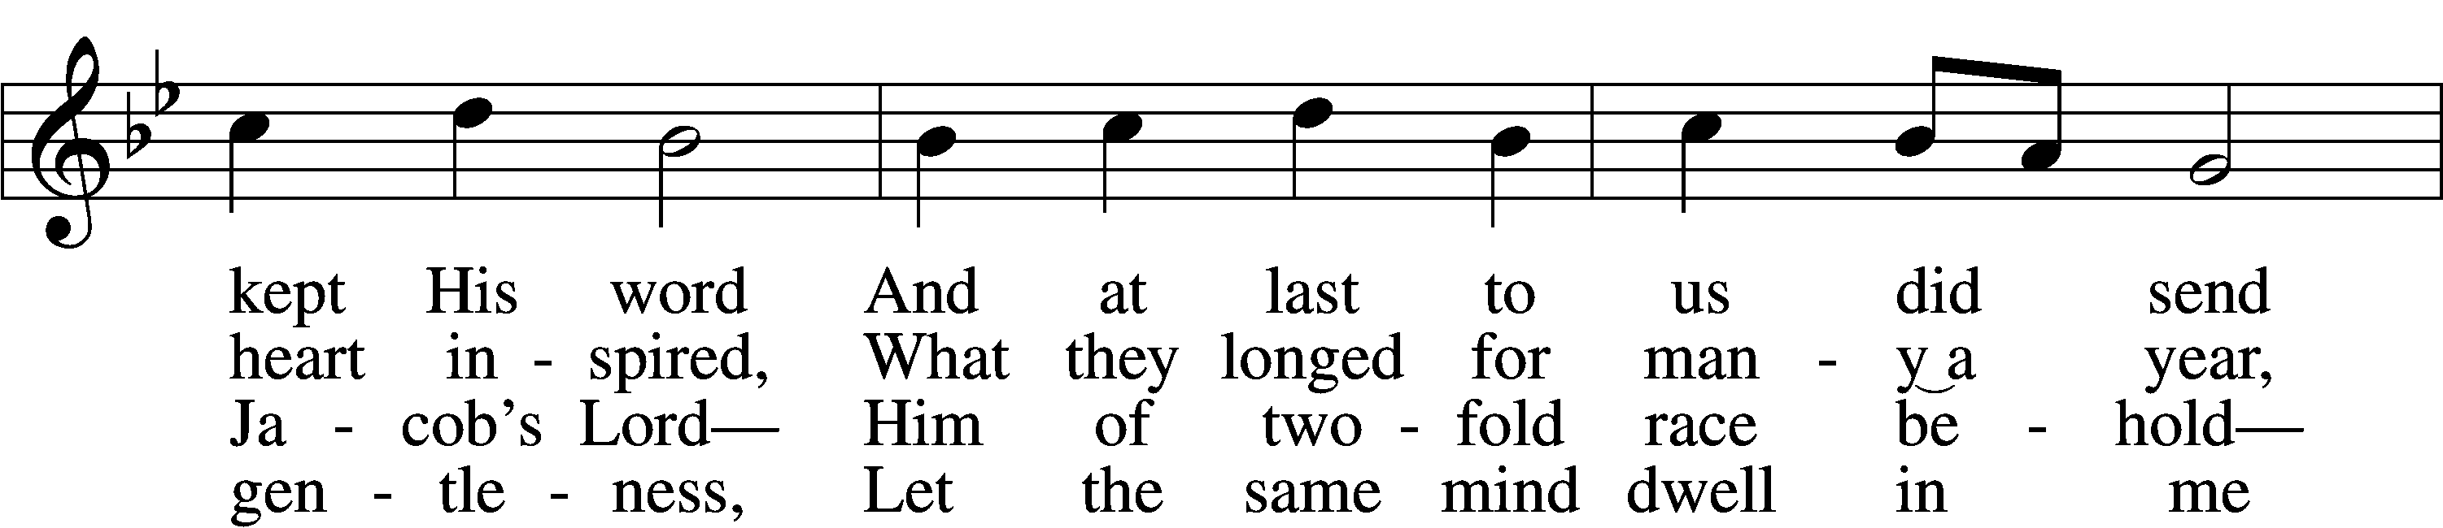
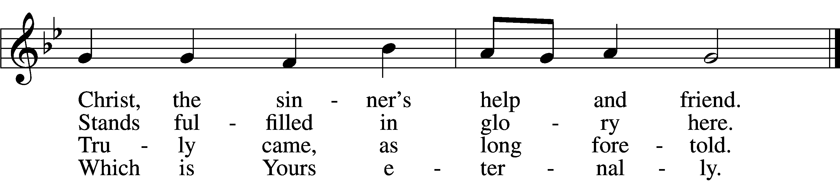

5 Bruise for me the serpent’s head
That, set free from doubt and dread,
I may cling to You in faith,
Safely kept through life and death.

6 Then when You will come again
As the glorious king to reign,
I with joy will see Your face,
Freely ransomed by Your grace.
Text: Heinrich Held, 1620–59; tr. Catherine Winkworth, 1827–78, alt.
Tune: Geystliche gesangk Buchleyn, 1524, Wittenberg, ed. Johann Walter
Text and tune: Public domain

922 Go, My Children, with My Blessing sts. 1–4
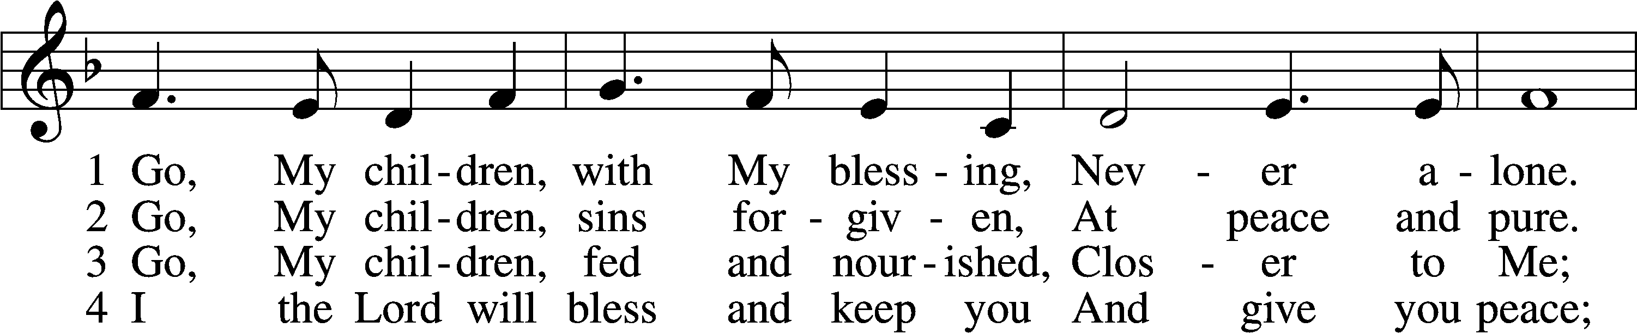
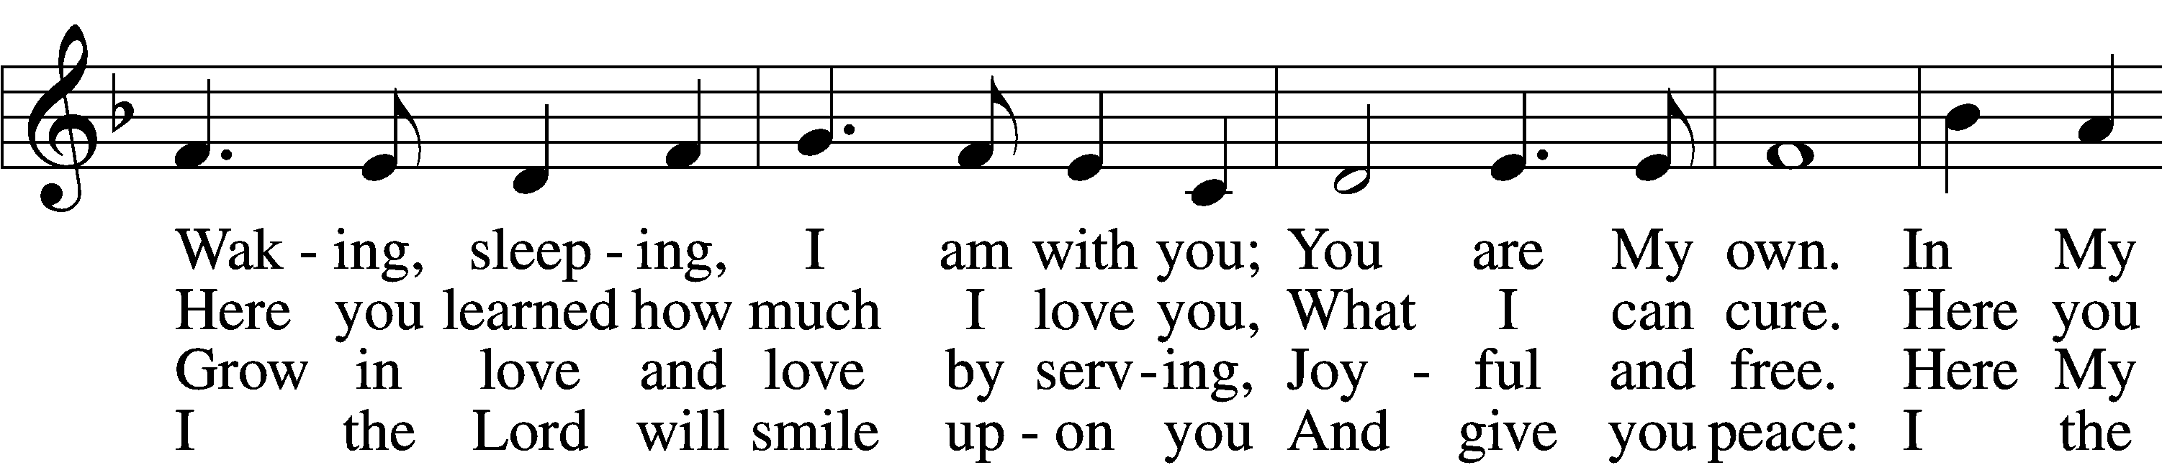
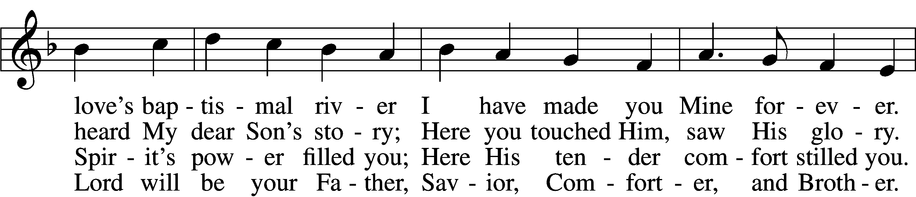
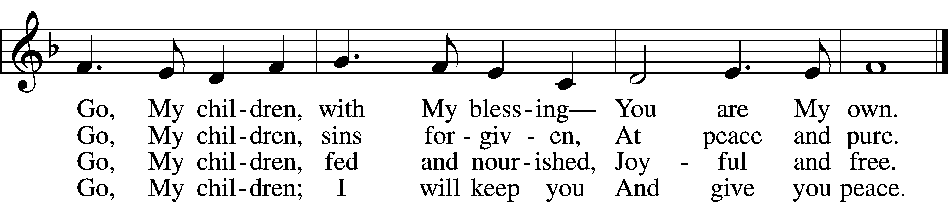
Text: Jaroslav J. Vajda, 1919–2008
Tune: Welsh, 18th cent.
Text: © 1983 Concordia Publishing House. Used by permission: LSB Hymn License no. 110005011
Tune: Public domain

368 Angels We Have Heard on High
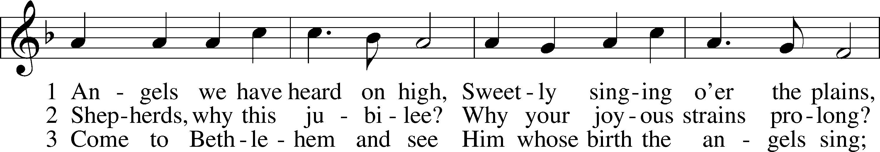
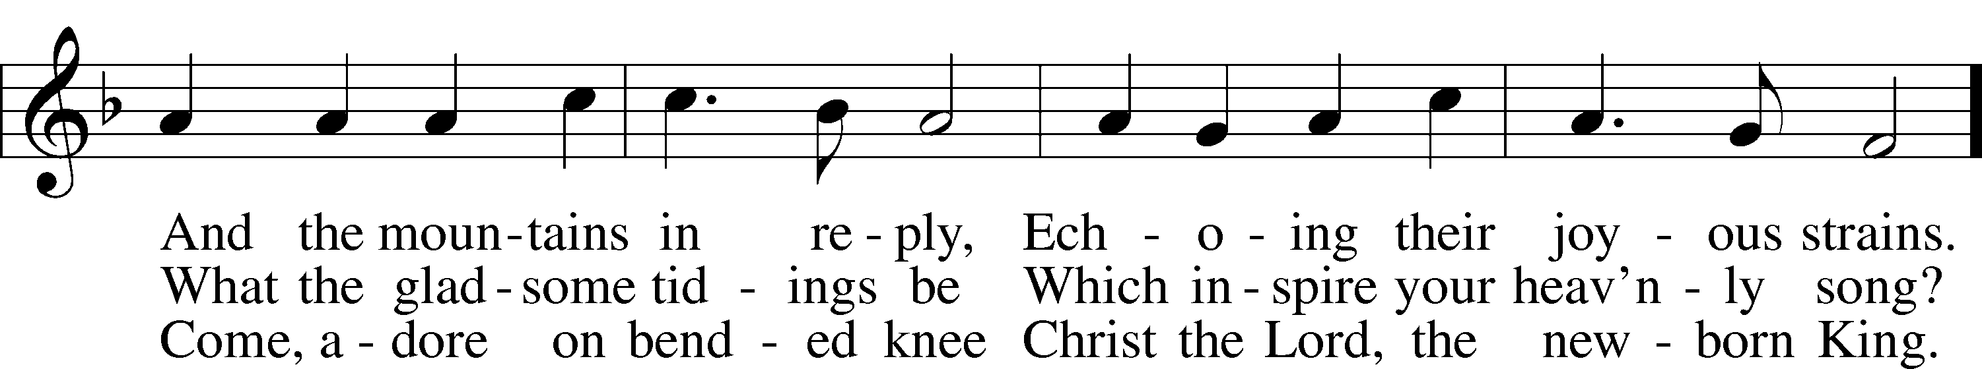
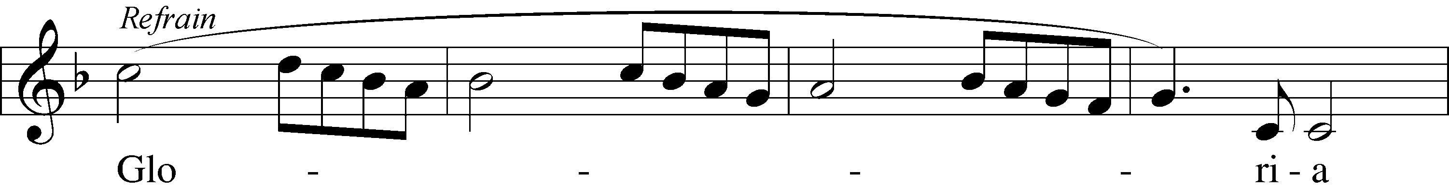
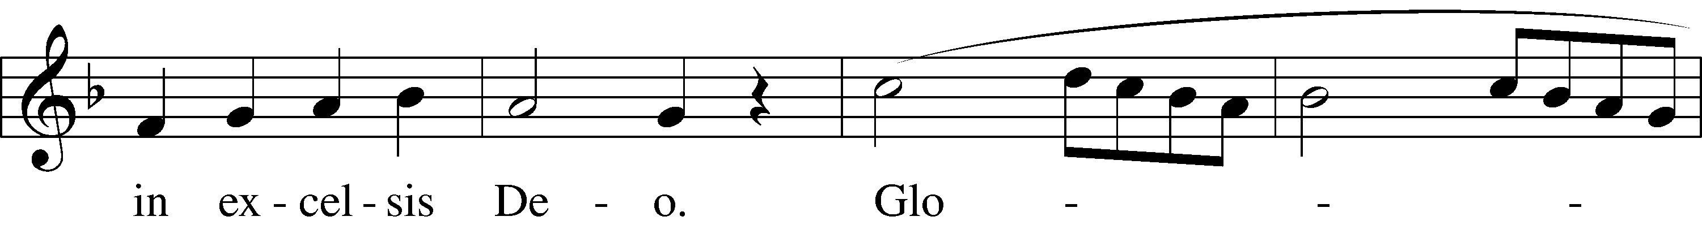
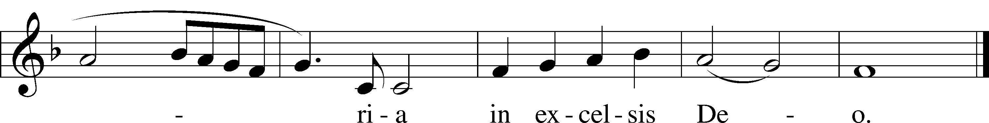
Text: tr. The Crown of Jesus, 1862, Part 2, London, alt.
Text and tune: French
Text and tune: Public domain

Stand

The Dismissal
P The body and blood of our Lord Jesus Christ strengthen and preserve you in body and soul to life everlasting. Depart T in peace.
C Amen.

Nunc Dimittis Luke 2:29–32
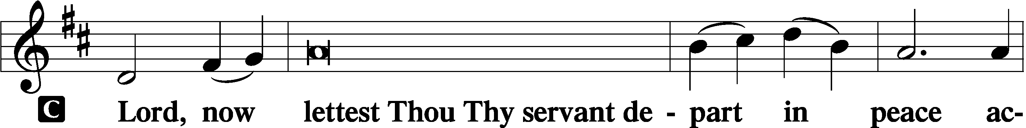

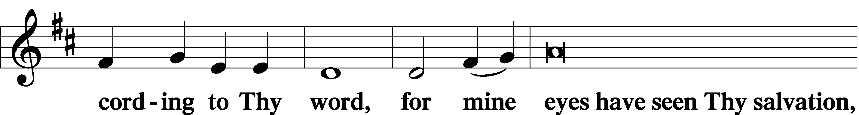

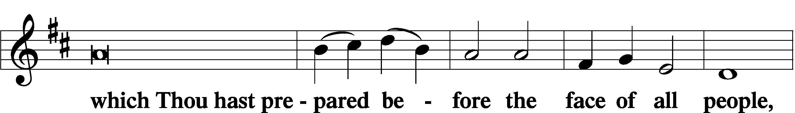

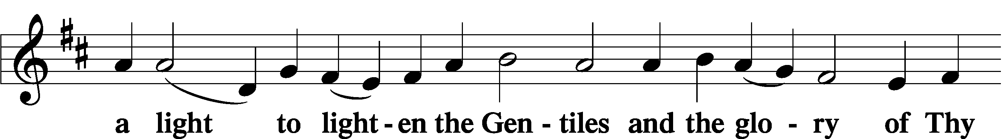

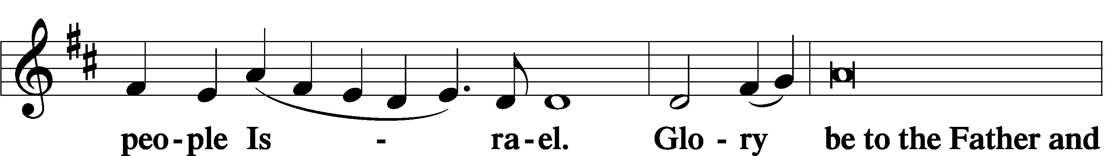

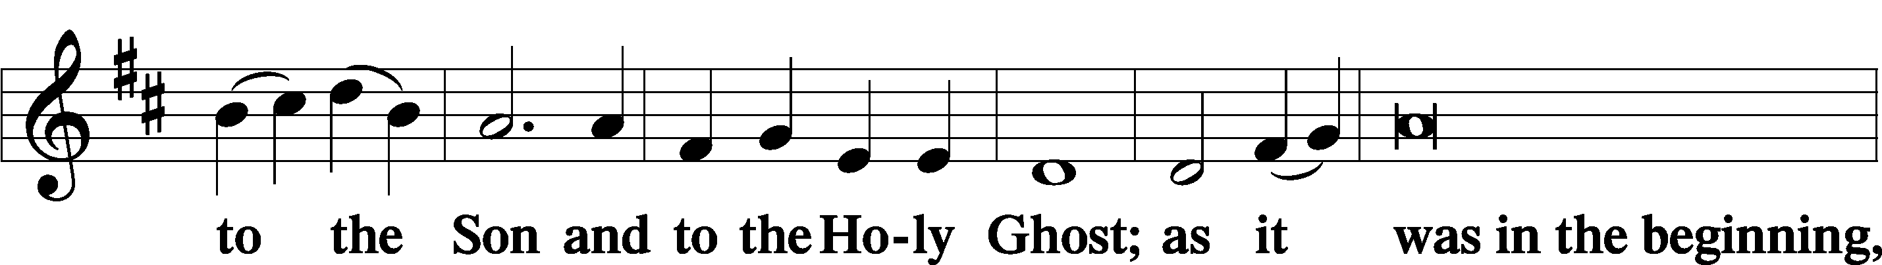

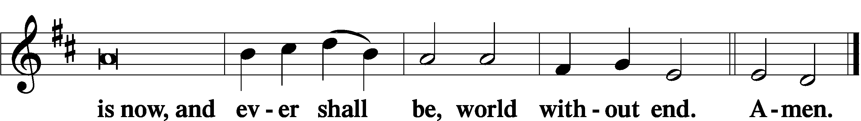

Thanksgiving Psalm 107:1
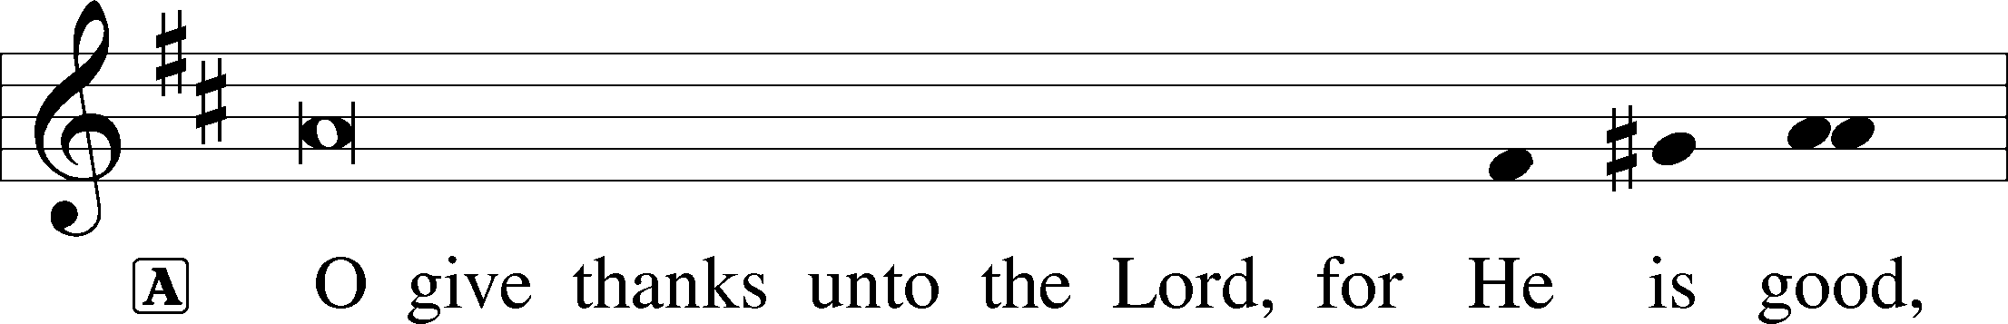

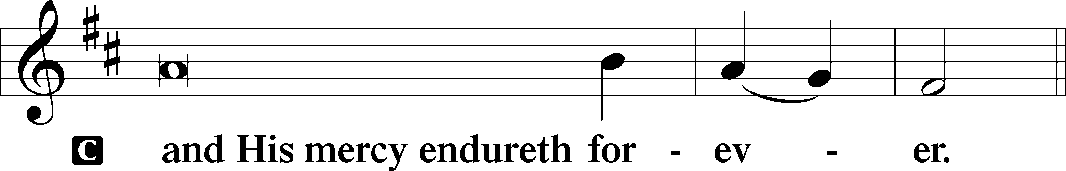

Post-Communion Collect
A Let us pray.
We give thanks to You, almighty God, that You have refreshed us through this salutary gift, and we implore You that of Your mercy You would strengthen us through the same in faith toward You and in fervent love toward one another; through Jesus Christ, Your Son, our Lord, who lives and reigns with You and the Holy Spirit, one God, now and forever.

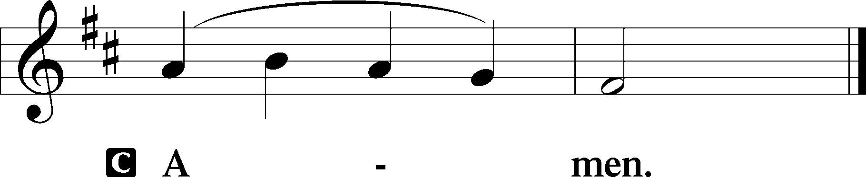

Salutation 2 Timothy 4:22
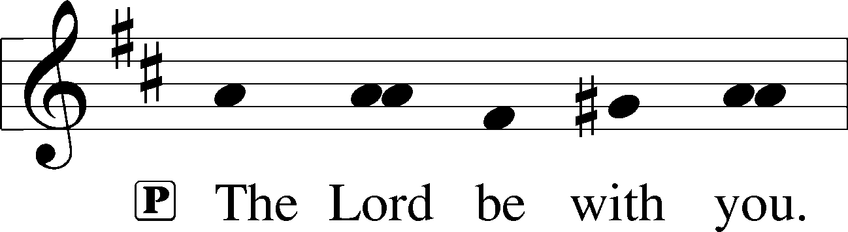

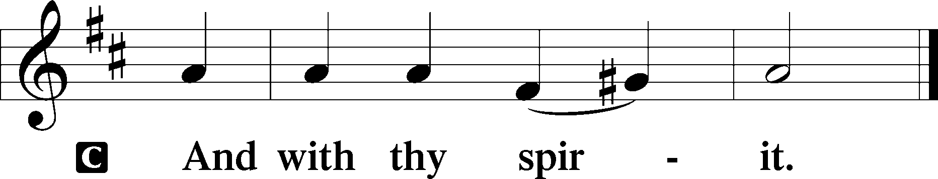

Benedicamus Psalm 103:1
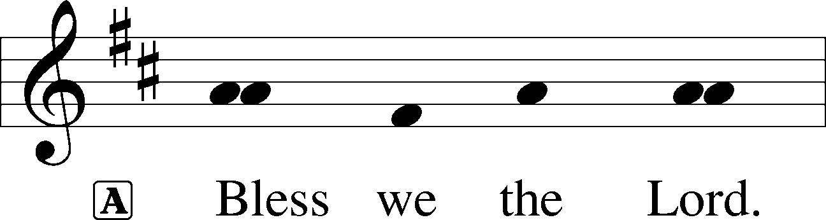

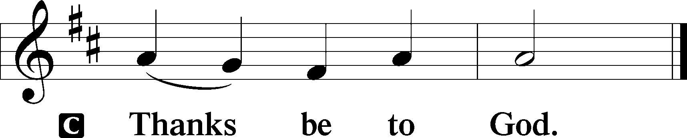

Benediction Numbers 6:24–26
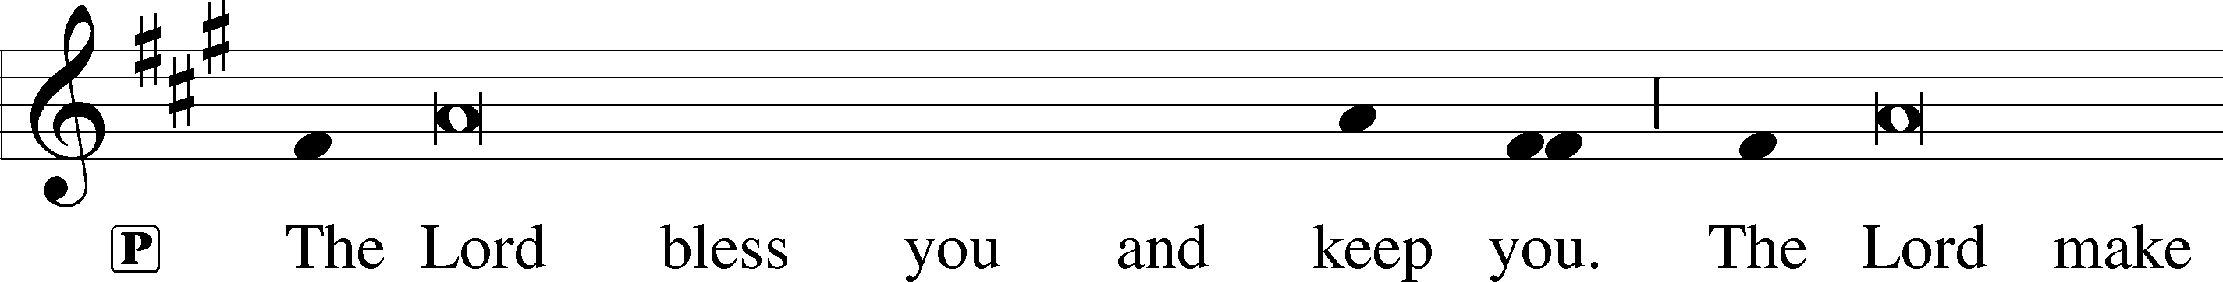
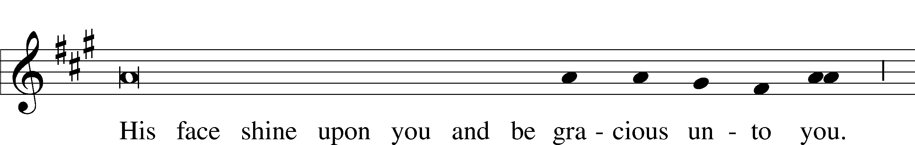
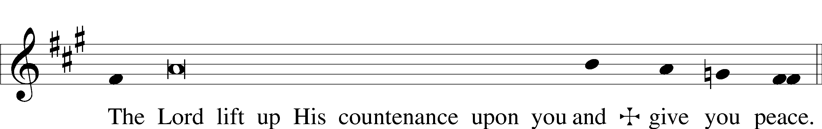

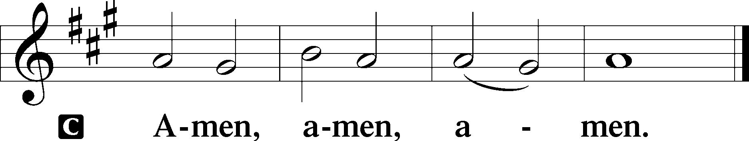

924 Lord, Dismiss Us with Your Blessing
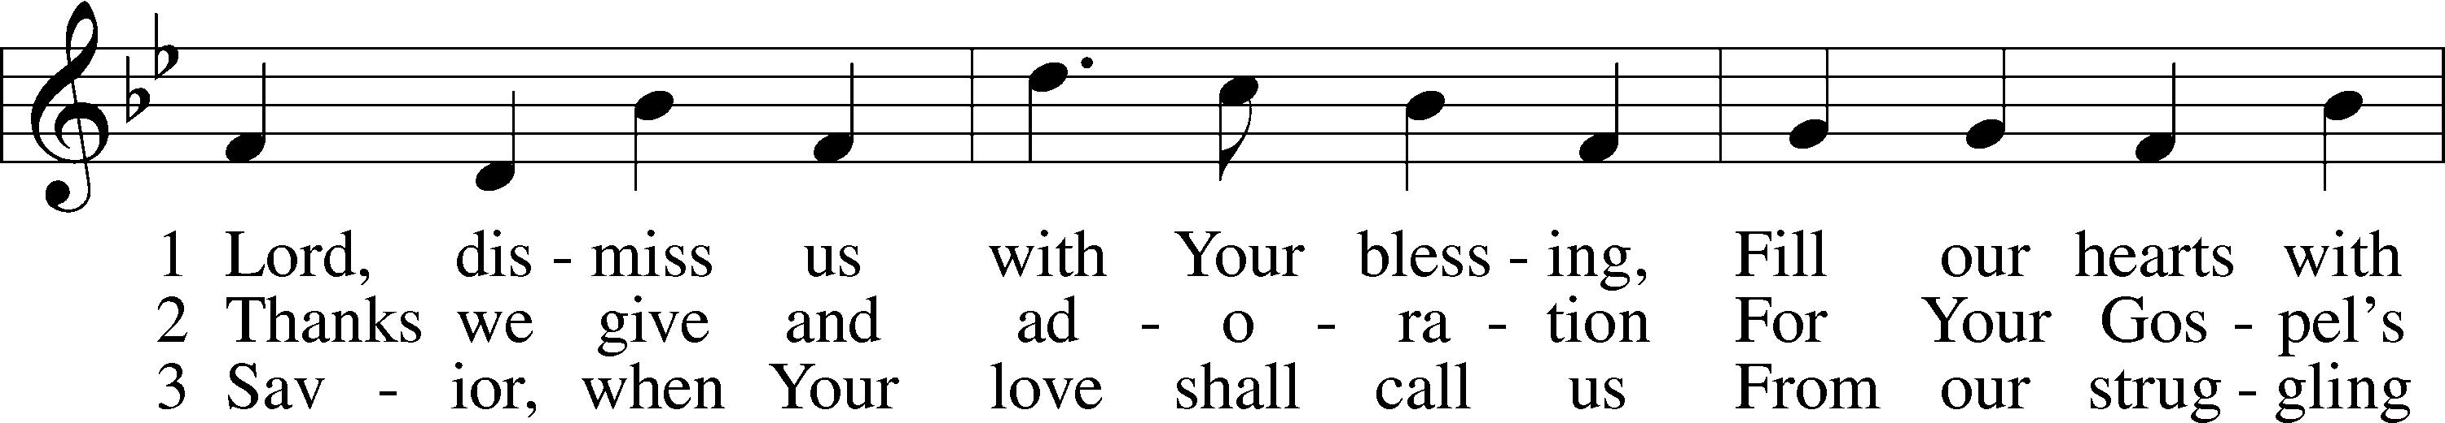
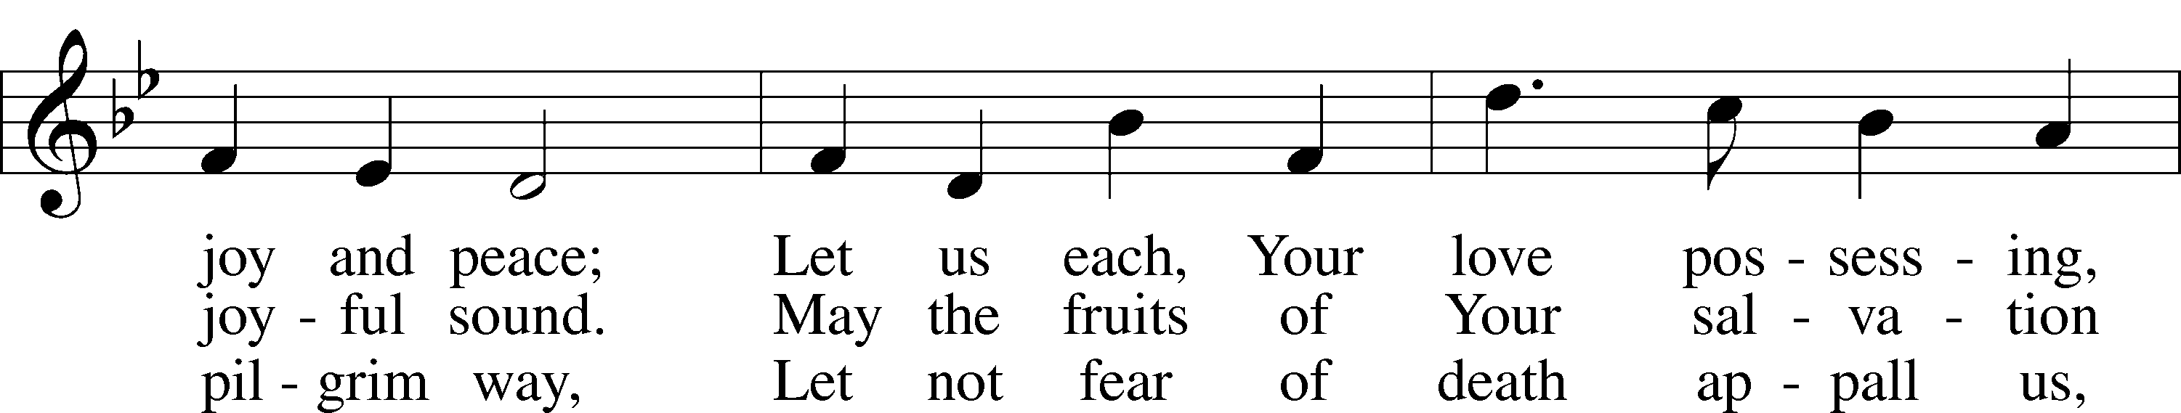
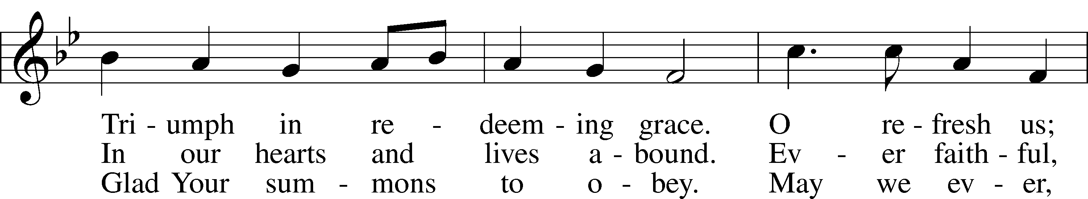
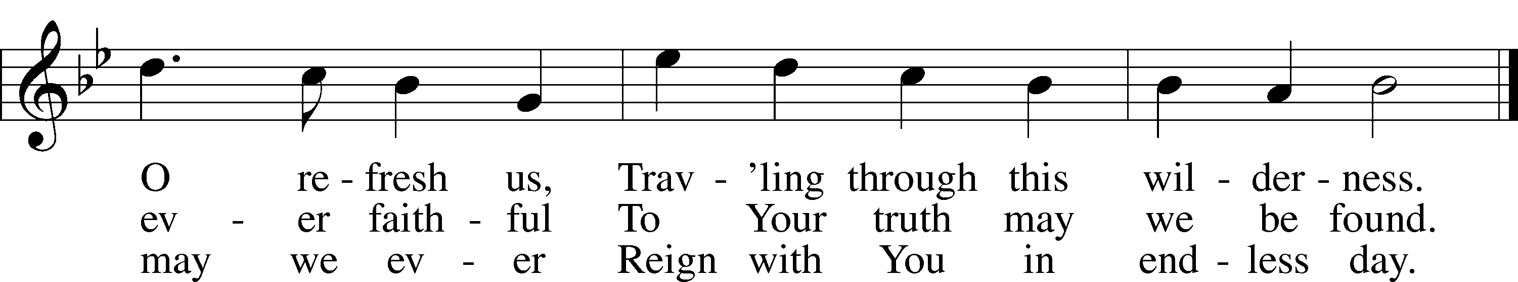
Text (sts. 1–2): attr. John Fawcett, 1740–1817, alt.; (st. 3): Godfrey Thring, 1823–1903, alt.
Tune: Henry T. Smart, 1813–79
Text and tune: Public domain

Acknowledgments
Divine Service, Setting Three from Lutheran Service Book
Unless otherwise indicated, Scripture quotations are from the ESV® Bible (The Holy Bible, English Standard Version®), copyright © 2001 by Crossway, a publishing ministry of Good News Publishers. Used by permission. All rights reserved.
Created by Lutheran Service Builder © 2022 Concordia Publishing House.

