578 Thy Strong Word

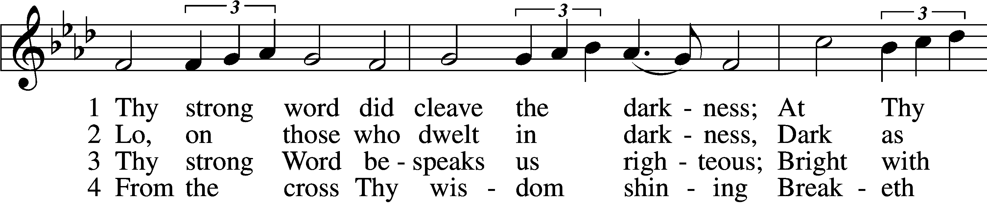

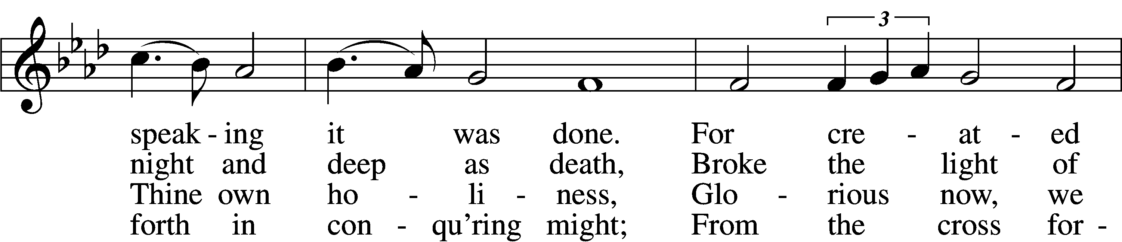

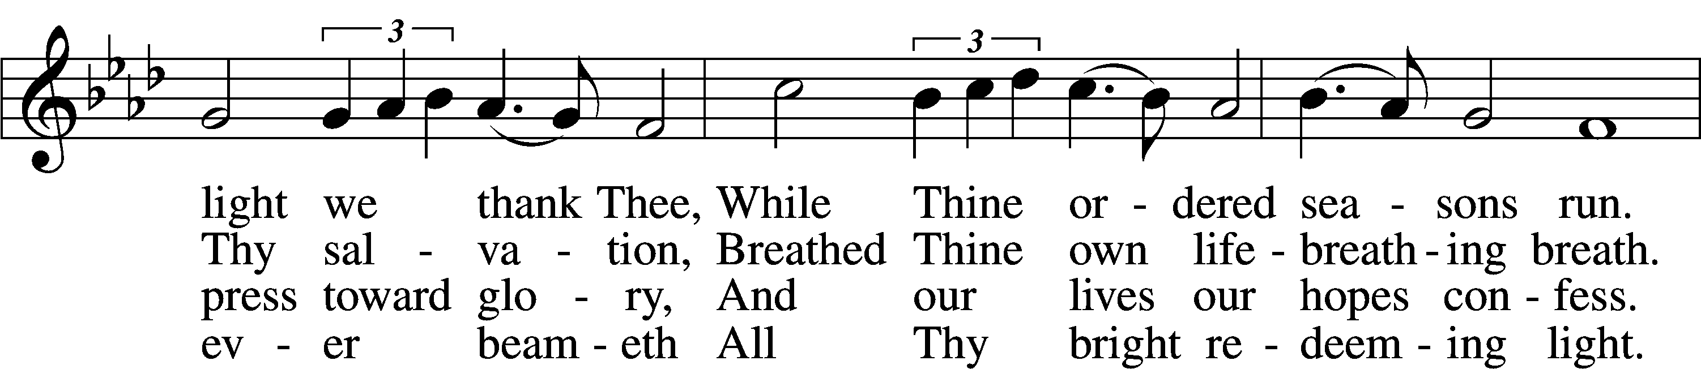

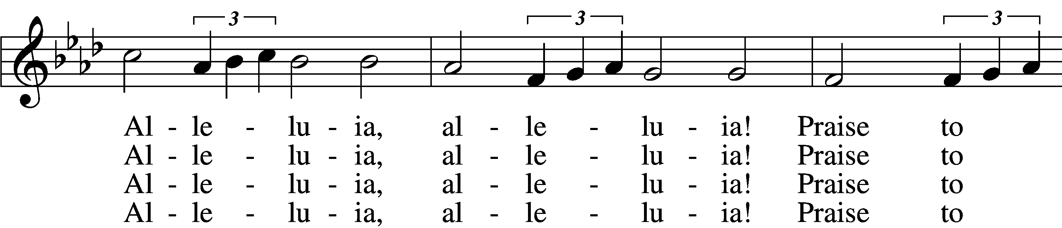

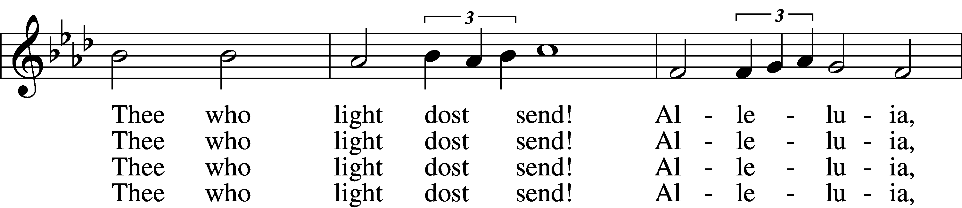

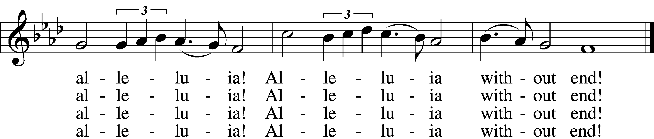

5 Give us lips to sing Thy glory,  
 Tongues Thy mercy to proclaim,  
Throats that shout the hope that fills us,  
 Mouths to speak Thy holy name.  
Alleluia, alleluia!  
 May the light which Thou dost send  
Fill our songs with alleluias,  
 Alleluias without end!

D 6 God the Father, light-creator,  
 To Thee laud and honor be.  
To Thee, Light of Light begotten,  
 Praise be sung eternally.  
Holy Spirit, light-revealer,  
 Glory, glory be to Thee.  
Mortals, angels, now and ever  
 Praise the holy Trinity!

Text: Martin H. Franzmann, 1907–76  
Tune: Thomas J. Williams, 1869–1944  
Text: © 1969 Concordia Publishing House. Used by permission: LSB Hymn License no. 110005011  
Tune: Public domain

# Confession and Absolution

The sign of the cross may be made by all in remembrance of their Baptism.

Invocation Matthew 28:19b; 18:20

P In the name of the Father and of the T Son and of the Holy Spirit.

C **Amen.**

Exhortation Hebrews 10:22; Psalm 124:8; Psalm 32:5

P Beloved in the Lord! Let us draw near with a true heart and confess our sins unto God our Father, beseeching Him in the name of our Lord Jesus Christ to grant us forgiveness.

P Our help is in the name of the Lord,

C **who made heaven and earth.**

P I said, I will confess my transgressions unto the Lord,

C **and You forgave the iniquity of my sin.**

Silence for reflection on God’s Word and for self-examination.

Confession of Sins

P Almighty God, our maker and redeemer, we poor sinners confess unto You that we are by nature sinful and unclean and that we have sinned against You by thought, word, and deed. Wherefore we flee for refuge to Your infinite mercy, seeking and imploring Your grace for the sake of our Lord Jesus Christ.

C **O most merciful God, who has given Your only-begotten Son to die for us, have mercy upon us and for His sake grant us remission of all our sins; and by Your Holy Spirit increase in us true knowledge of You and of Your will and true obedience to Your Word, to the end that by Your grace we may come to everlasting life; through Jesus Christ, our Lord. Amen.**

Declaration of Grace Mark 16:16; John 1:12

P Almighty God, our heavenly Father, has had mercy upon us and has given His only Son to die for us and for His sake forgives us all our sins. To those who believe on His name He gives power to become the children of God and has promised them His Holy Spirit. He that believes and is baptized shall be saved.  
  
Grant this, Lord, unto us all.

C **Amen.**

# Service of the Word

Introit Psalm 2:7–11, 12c; antiphon: Isaiah 42:1a

Behold my servant, whom I uphold,  
 my chosen, in whom my soul delights.  
**I will tell of the decree:  
 The Lord said to me, “You are my Son; today I have be- gotten you.**Ask of me, and I will make the nations your heritage,  
 and the ends of the earth your possession.  
**You shall break them with a rod of iron  
 and dash them in pieces like a potter’s vessel.”**  
Now therefore, O kings, be wise;  
 be warned, O rulers of the earth.  
**Serve the Lord with fear,  
 and rejoice with trembling,  
for his wrath is quickly kindled**.  
 Blessed are all who take refuge in him.  
Behold my servant, whom I uphold,  
 my chosen, in whom my soul delights.

Gloria Patri

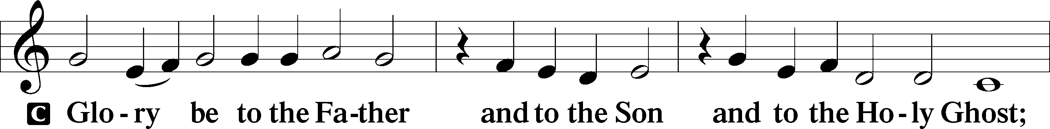

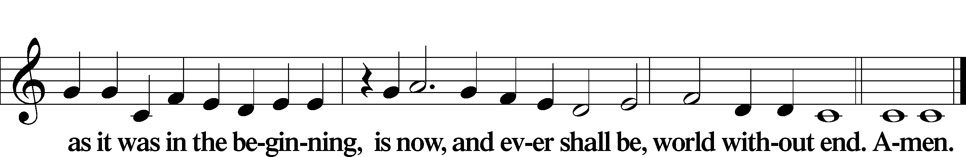

Kyrie Mark 10:47

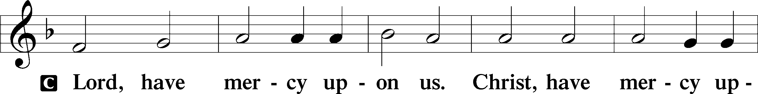

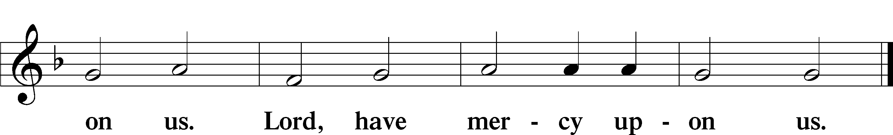

Gloria in Excelsis Luke 2:14; John 1:29

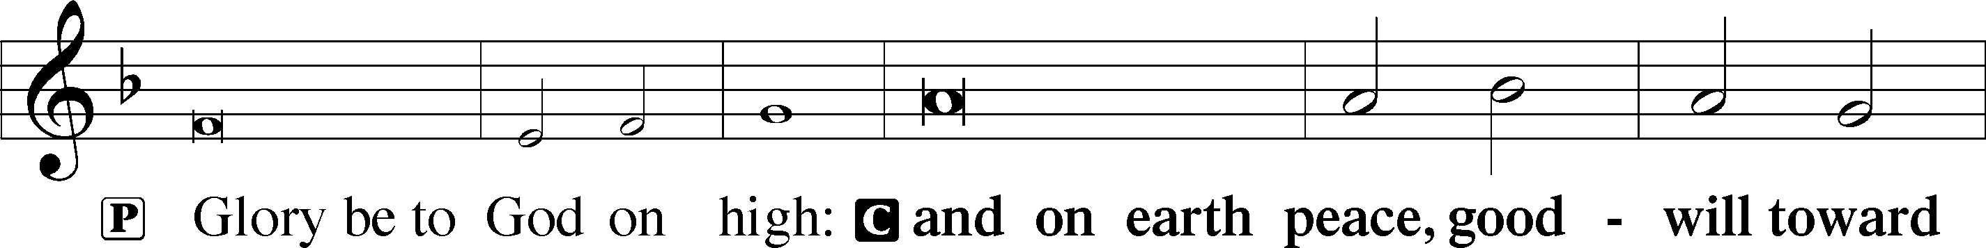

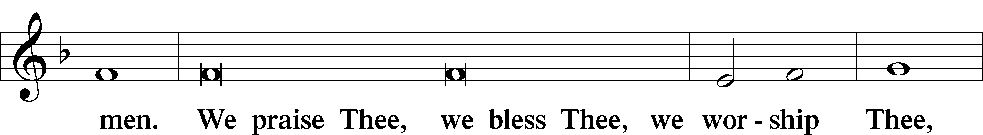

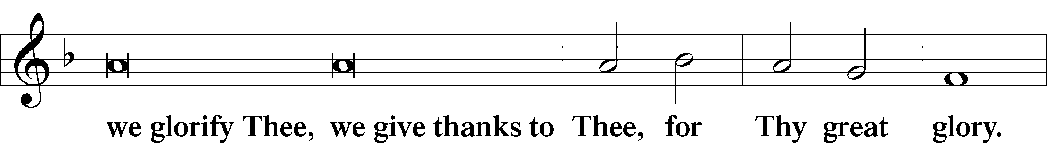

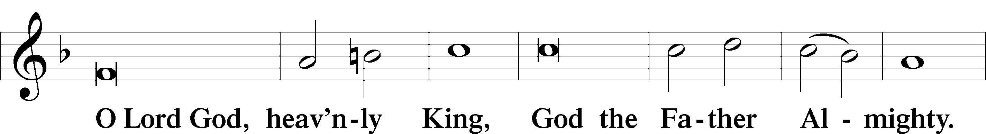

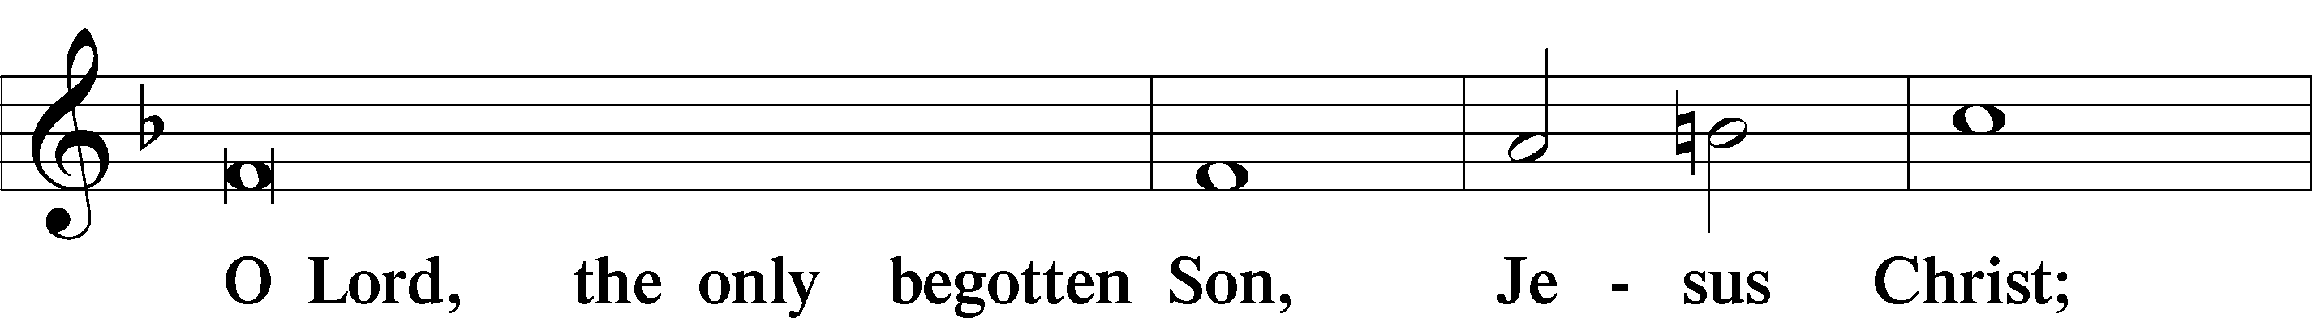

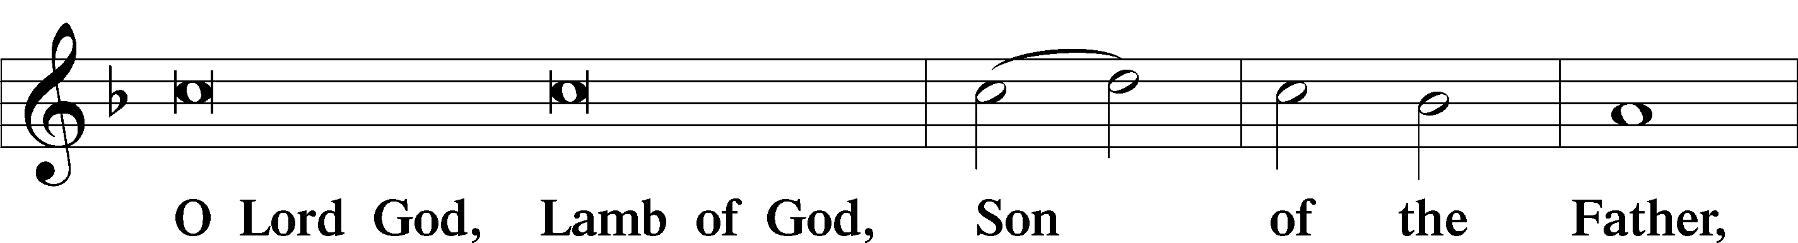

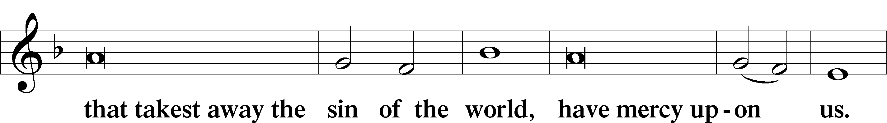

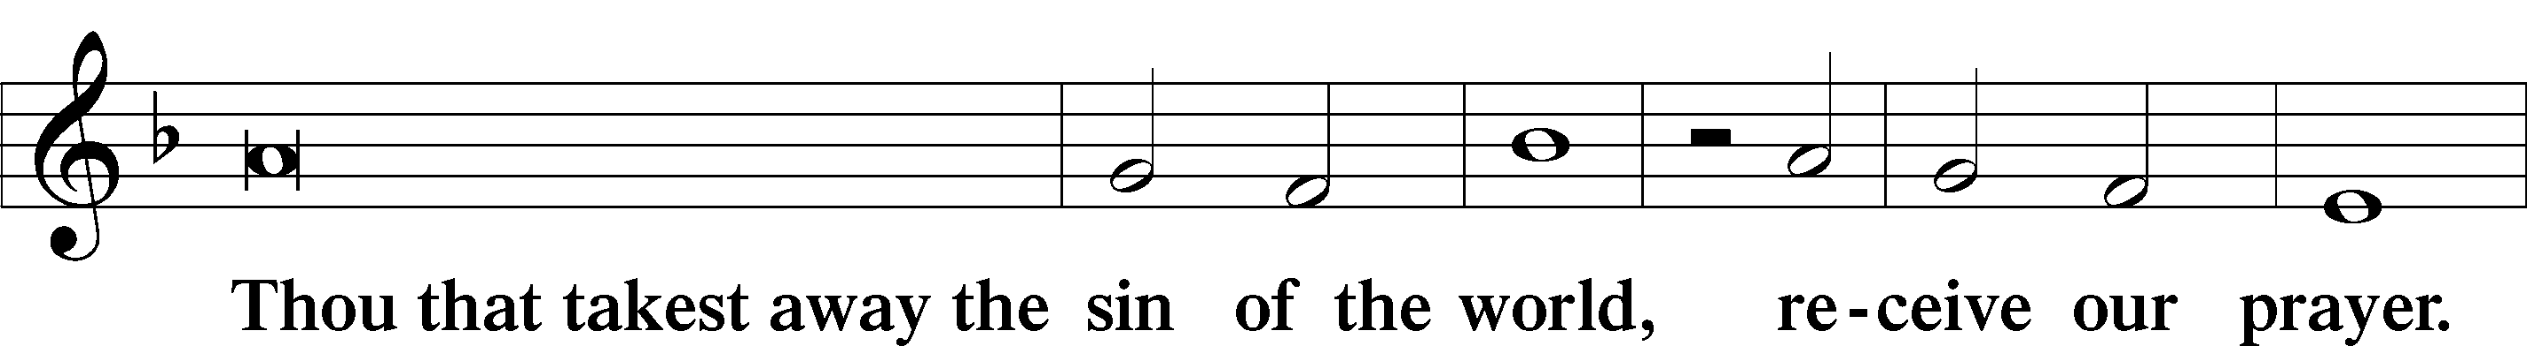

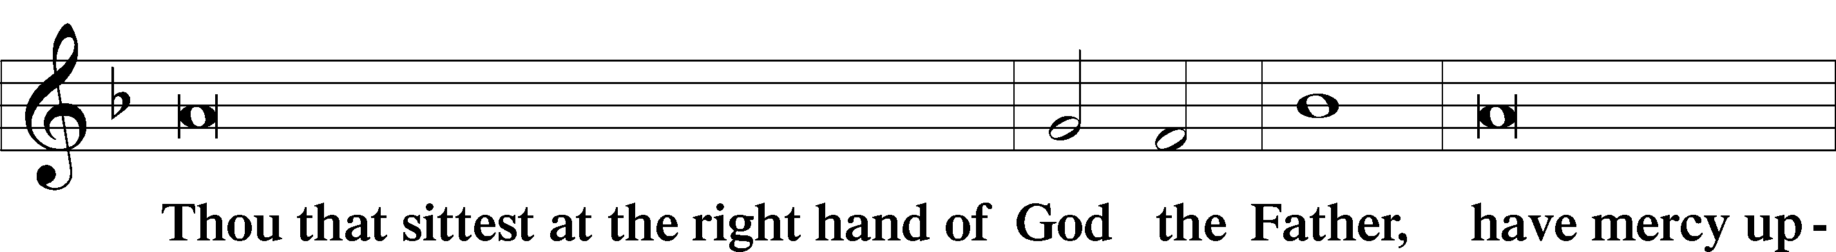

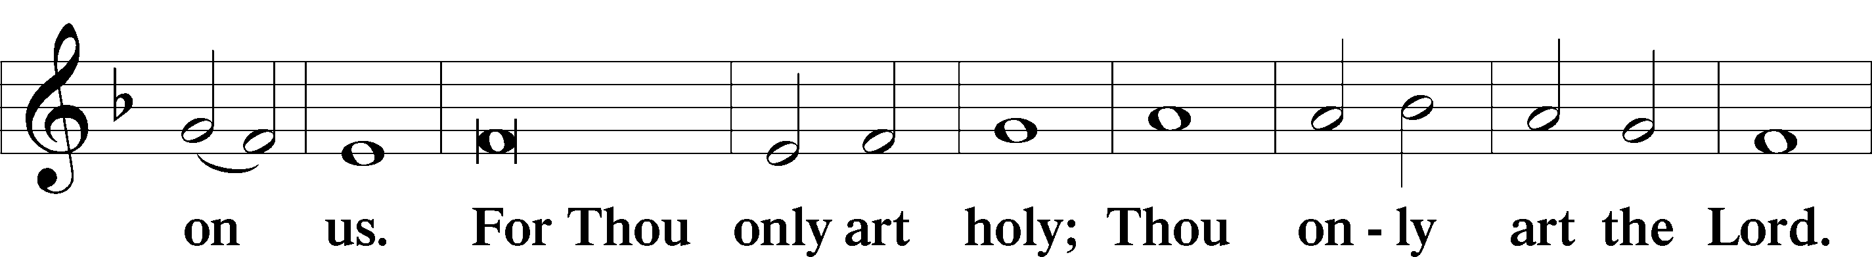

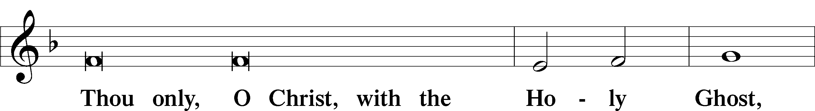

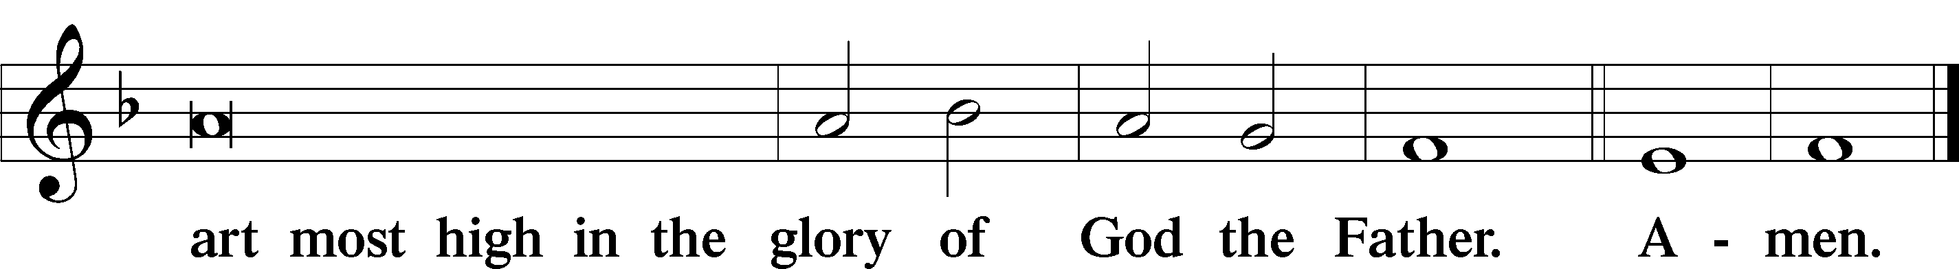

Salutation and Collect of the Day

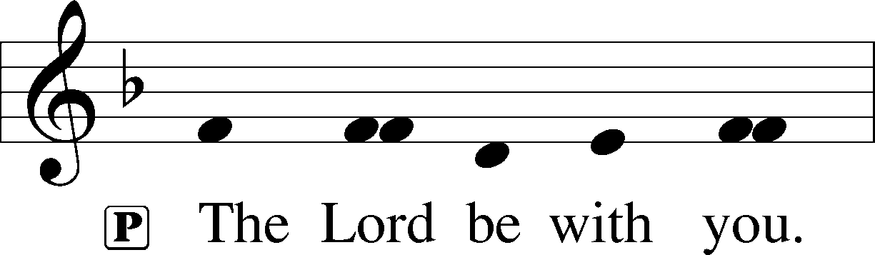

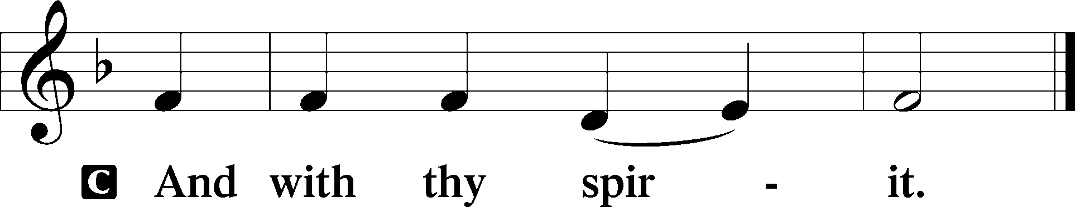

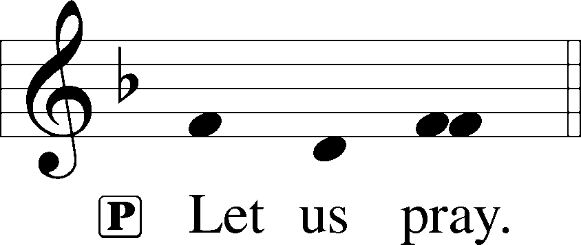

P Father in heaven, at the Baptism of Jesus in the Jordan River You proclaimed Him Your beloved Son and anointed Him with the Holy Spirit. Make all who are baptized in His name faithful in their calling as Your children and inheritors with Him of everlasting life; through the same Jesus Christ, our Lord, who lives and reigns with You and the Holy Spirit, one God, now and forever.

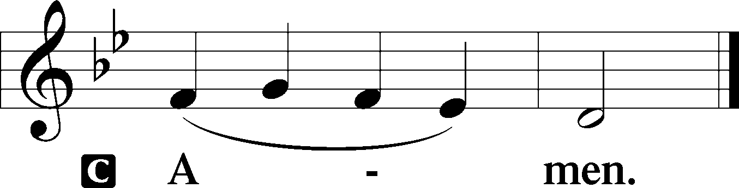

Sit

Old Testament Reading Isaiah 42:1–9

The Lord’s Chosen Servant

1Behold my servant, whom I uphold,  
 my chosen, in whom my soul delights;  
I have put my Spirit upon him;  
 he will bring forth justice to the nations.  
2He will not cry aloud or lift up his voice,  
 or make it heard in the street;  
3a bruised reed he will not break,  
 and a faintly burning wick he will not quench;  
 he will faithfully bring forth justice.  
4He will not grow faint or be discouraged  
 till he has established justice in the earth;  
 and the coastlands wait for his law.  
5Thus says God, the Lord,  
 who created the heavens and stretched them out,  
 who spread out the earth and what comes from it,  
who gives breath to the people on it  
 and spirit to those who walk in it:  
6“I am the Lord; I have called you in righteousness;  
 I will take you by the hand and keep you;  
I will give you as a covenant for the people,  
 a light for the nations,  
 7to open the eyes that are blind,  
to bring out the prisoners from the dungeon,  
 from the prison those who sit in darkness.  
8I am the Lord; that is my name;  
 my glory I give to no other,  
 nor my praise to carved idols.  
9Behold, the former things have come to pass,  
 and new things I now declare;  
before they spring forth  
 I tell you of them.”

A This is the Word of the Lord.

C **Thanks be to God.**

Gradual Psalm 117:1–2a; 96:8

Praise the Lord, all nations!  
 Extol him, all peoples!  
**For great is his steadfast love toward us,  
 and the faithfulness of the Lord endures for ever**.  
Ascribe to the Lord the glory due his name;  
 bring an offering, and come into his courts!

Reading Romans 5:6–15

6For while we were still weak, at the right time Christ died for the ungodly. 7For one will scarcely die for a righteous person—though perhaps for a good person one would dare even to die— 8but God shows his love for us in that while we were still sinners, Christ died for us. 9Since, therefore, we have now been justified by his blood, much more shall we be saved by him from the wrath of God. 10For if while we were enemies we were reconciled to God by the death of his Son, much more, now that we are reconciled, shall we be saved by his life. 11More than that, we also rejoice in God through our Lord Jesus Christ, through whom we have now received reconciliation.

Death in Adam, Life in Christ

12Therefore, just as sin came into the world through one man, and death through sin, and so death spread to all men because all sinned— 13for sin indeed was in the world before the law was given, but sin is not counted where there is no law. 14Yet death reigned from Adam to Moses, even over those whose sinning was not like the transgression of Adam, who was a type of the one who was to come.

15But the free gift is not like the trespass. For if many died through one man’s trespass, much more have the grace of God and the free gift by the grace of that one man Jesus Christ abounded for many.

Stand

Alleluia

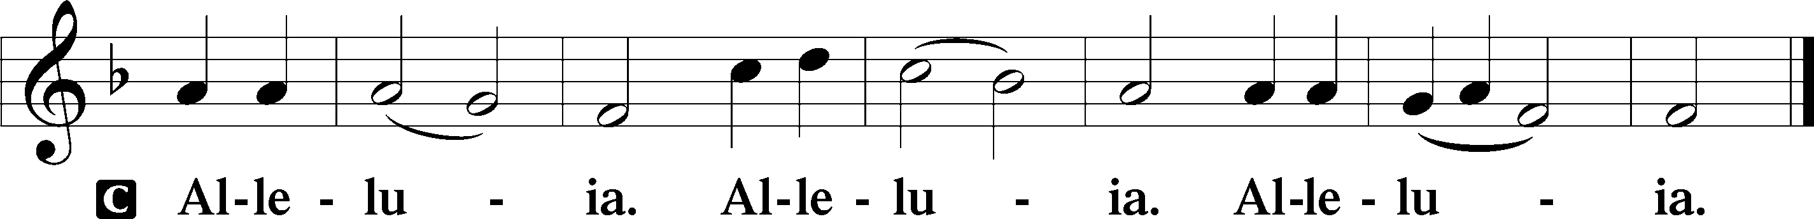

Holy Gospel Matthew 3:13–17

P The Holy Gospel according to St. Matthew, the third chapter.

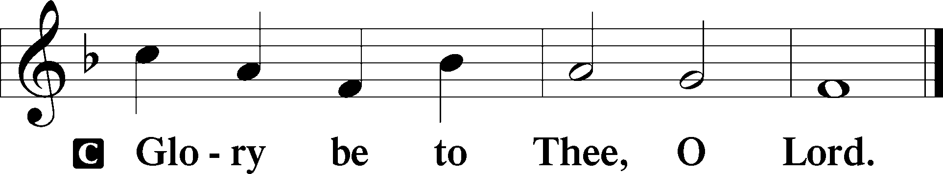

The Baptism of Jesus

13Then Jesus came from Galilee to the Jordan to John, to be baptized by him. 14John would have prevented him, saying, “I need to be baptized by you, and do you come to me?” 15But Jesus answered him, “Let it be so now, for thus it is fitting for us to fulfill all righteousness.” Then he consented. 16And when Jesus was baptized, immediately he went up from the water, and behold, the heavens were opened to him, and he saw the Spirit of God descending like a dove and coming to rest on him; 17and behold, a voice from heaven said, “This is my beloved Son, with whom I am well pleased.”

P This is the Gospel of the Lord.

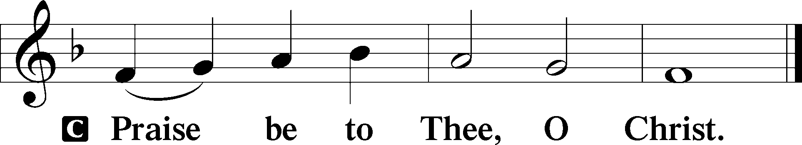

Apostles’ Creed

C **I believe in God, the Father Almighty,**

**maker of heaven and earth.**

**And in Jesus Christ, His only Son, our Lord,**

**who was conceived by the Holy Spirit,**

**born of the virgin Mary,**

**suffered under Pontius Pilate,**

**was crucified, died and was buried.**

**He descended into hell.**

**The third day He rose again from the dead.**

**He ascended into heaven**

**and sits at the right hand of God the Father Almighty.**

**From thence He will come to judge the living and the dead.**

**I believe in the Holy Spirit,**

**the holy Christian Church,**

**the communion of saints,**

**the forgiveness of sins,**

**the resurrection of the body,**

**and the life** T **everlasting. Amen.**

**Children’s Message**

405 To Jordan’s River Came Our Lord

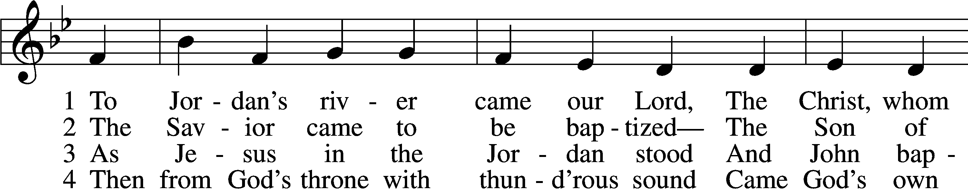

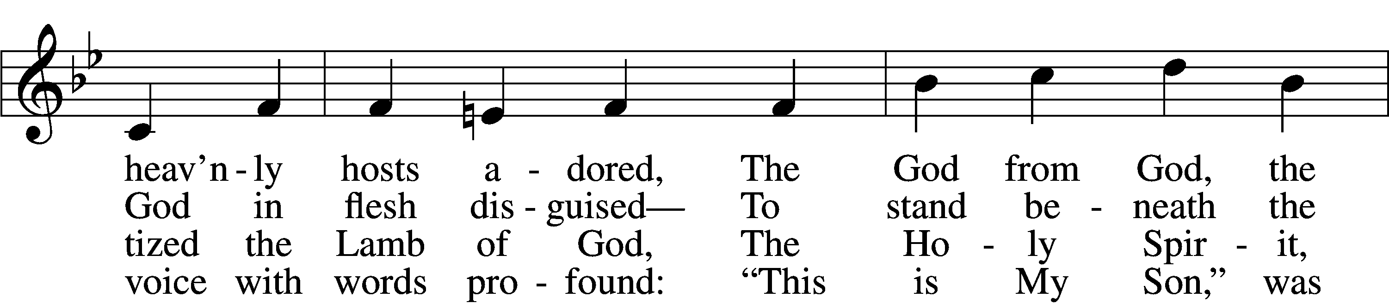

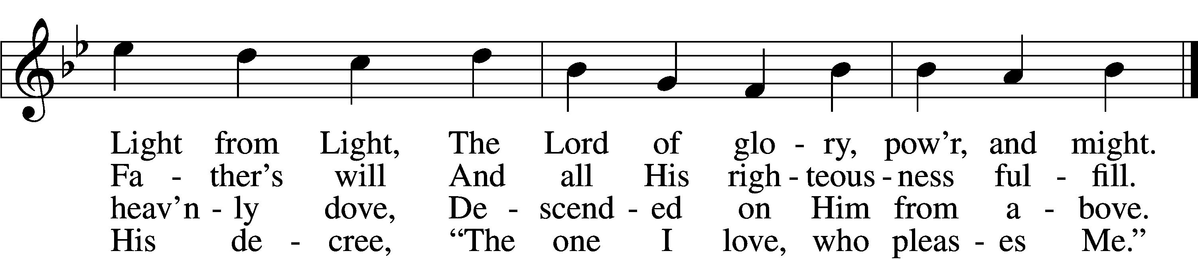

5 The Father’s word, the Spirit’s flight  
Anointed Christ in glorious sight  
As God’s own choice, from Adam’s fall  
To save the world and free us all.

6 Now rise, faint hearts, be resolute;  
This man is Christ, our substitute!  
He was baptized in Jordan’s stream,  
Proclaimed Redeemer, Lord supreme.

Text: James P. Tiefel, 1949, alt.  
Tune: Musicalisch Hand-Buch der Geistlichen Melodien, 1690, Hamburg, alt.  
Text: © 1993 James P. Tiefel. Used by permission: LSB Hymn License no. 110005011  
Tune: Public domain

Sermon

Votum

P The peace of God, which passes all understanding, keep your hearts and minds in Christ Jesus.

C **Amen.**

Stand

Offertory Psalm 51:10–12

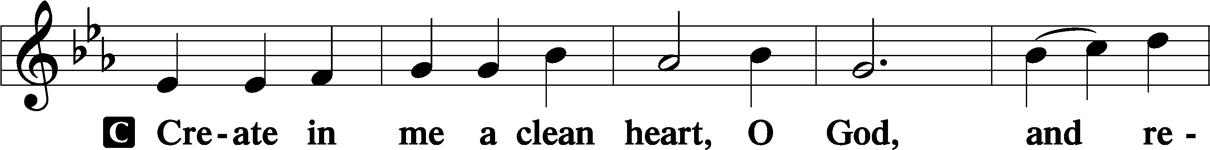

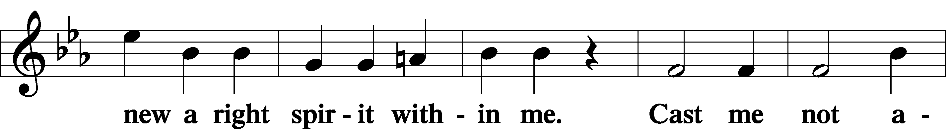

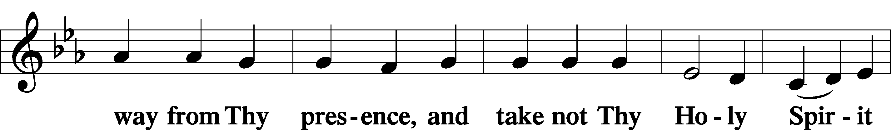

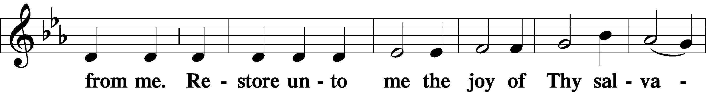

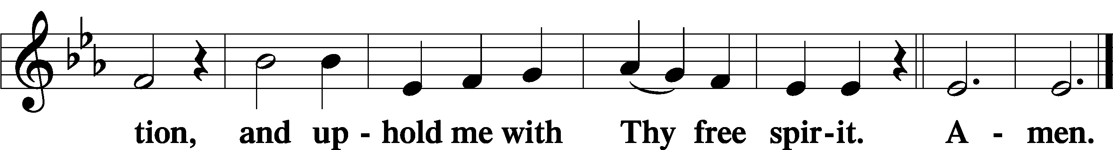

Offering

805 Praise God, from Whom All Blessings Flow

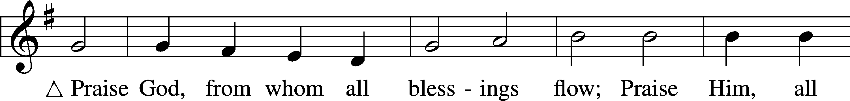

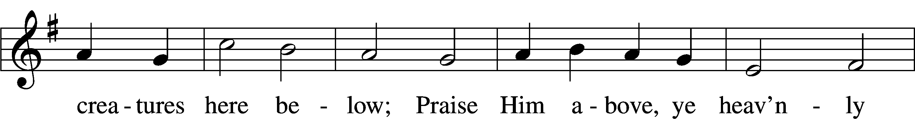

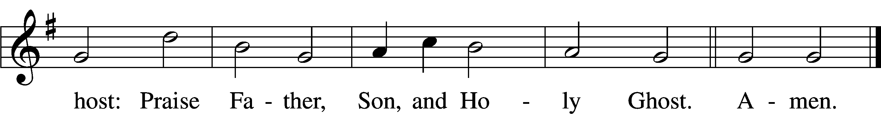

Text: Thomas Ken, 1637–1711  
Tune: Trente quatre Pseaumes de David, 1551, Geneva, ed. Louis Bourgeois  
Text and tune: Public domain

Prayer of the Church

Lord’s Prayer Matthew 6:9–13

P Lord, remember us in Your kingdom and teach us to pray:

C **Our Father who art in heaven,**

**hallowed be Thy name,**

**Thy kingdom come,**

**Thy will be done on earth**

**as it is in heaven;**

**give us this day our daily bread;**

**and forgive us our trespasses**

**as we forgive those**

**who trespass against us;**

**and lead us not into temptation,**

**but deliver us from evil.**

**For Thine is the kingdom**

**and the power and the glory**

**forever and ever. Amen.**

Collect for the Word

Blessed Lord, You have caused all Holy Scriptures to be written for our learning. Grant that we may so hear them, read, mark, learn, and inwardly digest them that, by the patience and comfort of Your holy Word, we may embrace and ever hold fast the blessed hope of everlasting life; which you have given us in our Savior Jesus Christ, Your Son, our Lord, who lives and reigns with You and the Holy Spirit, one God, now and forever.

Post-Communion Collect

A Let us pray.

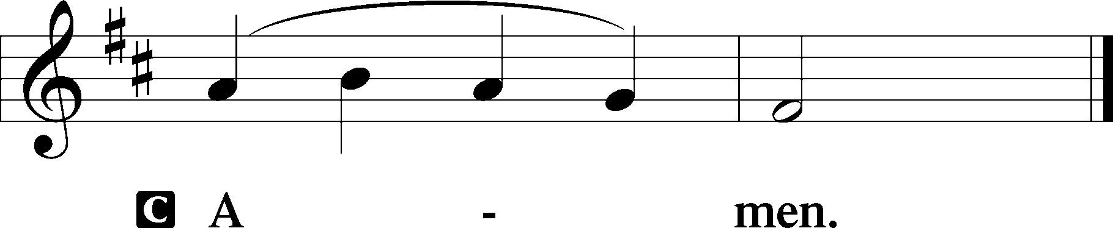

601 All Who Believe and Are Baptized

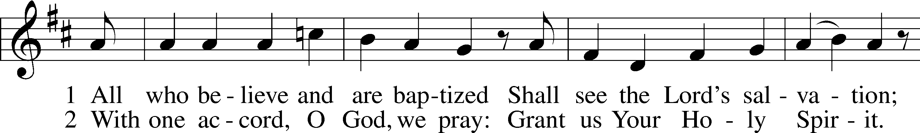

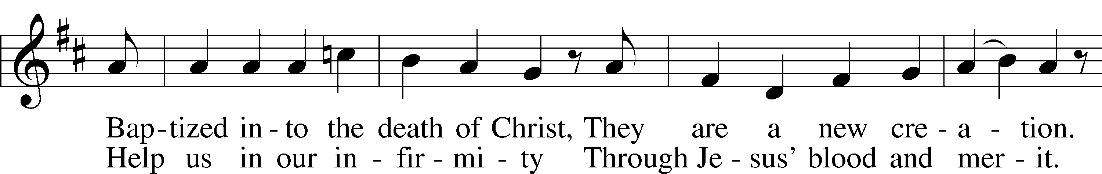

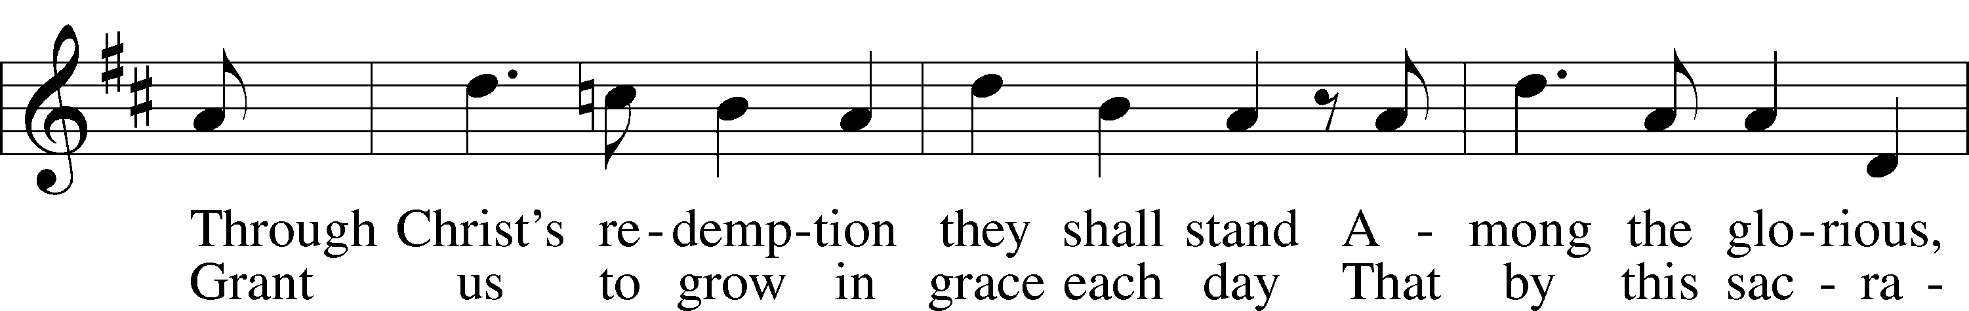

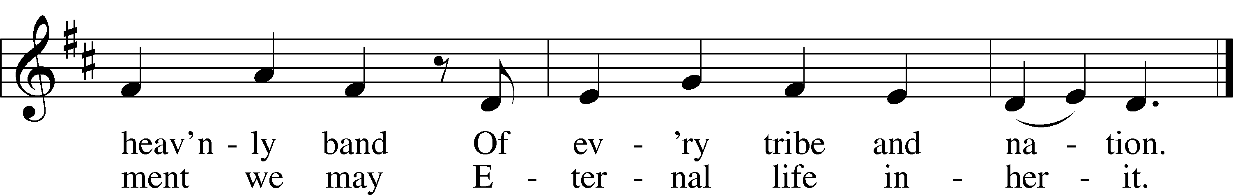

Text: Thomas Hansen Kingo, 1634–1703; tr. George A. T. Rygh, 1860–1942, alt.  
Tune: Etlich Cristlich lider, 1524, Wittenberg  
Text and tune: Public domain

Acknowledgments

Unless otherwise indicated, Scripture quotations are from the ESV® Bible (The Holy Bible, English Standard Version®), copyright © 2001 by Crossway, a publishing ministry of Good News Publishers. Used by permission. All rights reserved.

Created by Lutheran Service Builder © 2023 Concordia Publishing House.