547 The Lamb

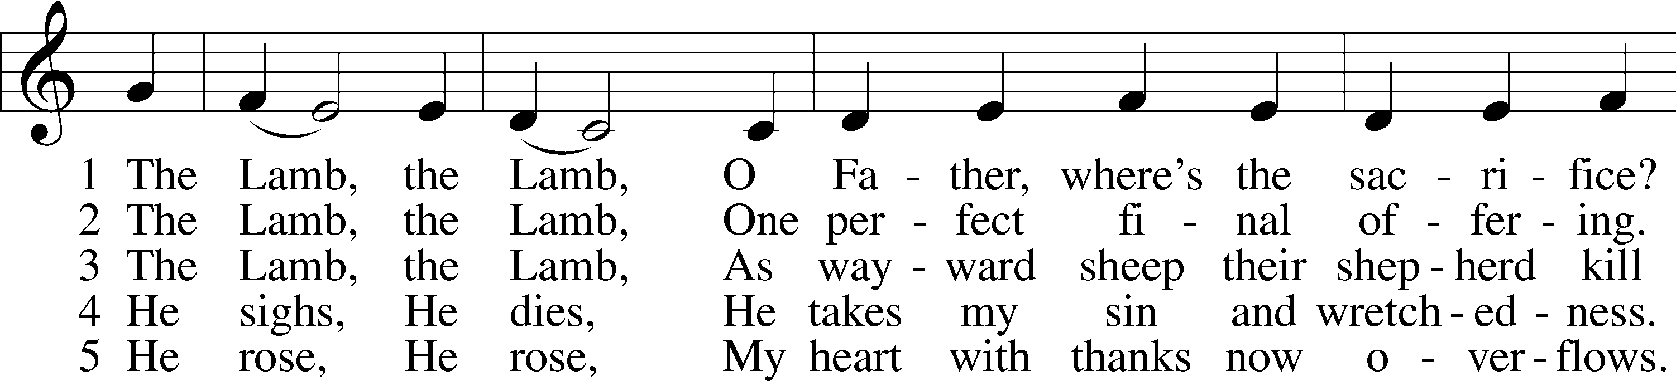

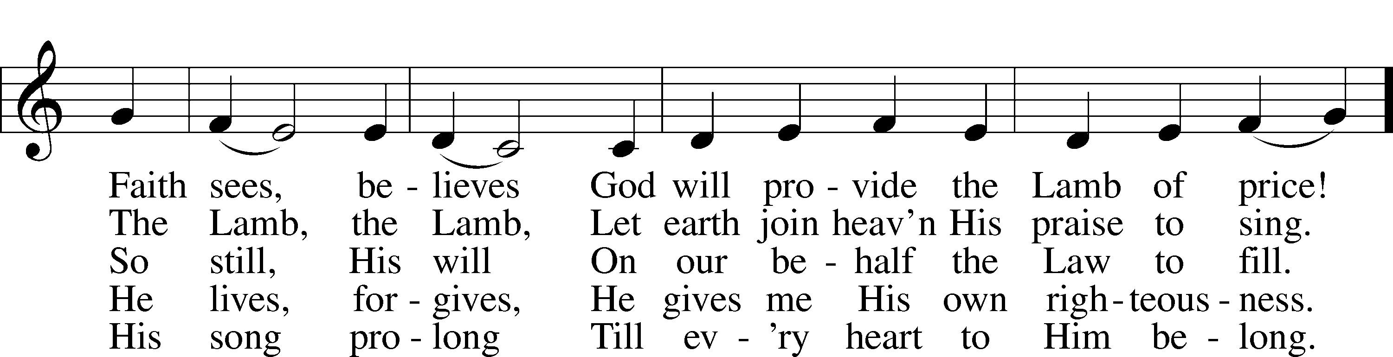

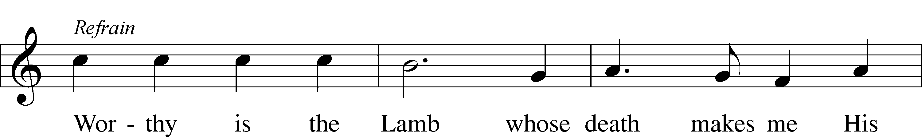



Text and tune: Gerald P. Coleman, 1953  
Text and tune: © 1987 and 1997 MorningStar Music Publishers. Used by permission: LSB Hymn License no. 110005011

# Confession and Absolution

Stand

The sign of the cross may be made by all in remembrance of their Baptism.

Invocation Matthew 28:19b; 18:20

P In the name of the Father and of the T Son and of the Holy Spirit.

C **Amen.**

Exhortation Psalm 124:8; Psalm 130:3–4; Luke 18:13

P Our help is in the name of the Lord,

C **who made heaven and earth.**

P If You, O Lord, kept a record of sins, O Lord, who could stand?

C **But with You there is forgiveness; therefore You are feared.**

P Since we are gathered to hear God’s Word, call upon Him in prayer and praise, and receive the body and blood of our Lord Jesus Christ in the fellowship of this altar, let us first consider our unworthiness and confess before God and one another that we have sinned in thought, word, and deed, and that we cannot free ourselves from our sinful condition. Together as His people let us take refuge in the infinite mercy of God, our heavenly Father, seeking His grace for the sake of Christ, and saying: God, be merciful to me, a sinner.

Kneel/Stand

Confession of Sins

C **Almighty God, have mercy upon us, forgive us our sins, and lead us to everlasting life. Amen.**

Prayer for Forgiveness

P Almighty God, merciful Father, in Holy Baptism You declared us to be Your children and gathered us into Your one, holy Church, in which You daily and richly forgive us our sins and grant us new life through Your Spirit. Be in our midst, enliven our faith, and graciously receive our prayer and praise; through Your Son, Jesus Christ, our Lord.

C **Amen.**

Stand

# Service of the Word

Introit Psalm 19:1–4a, b; antiphon: v. 14

Let the words of my mouth and the meditation of my heart be acceptable in your sight,  
 O Lord, my rock and my redeemer.  
**The heavens declare the glory of God,  
 and the sky above proclaims his handiwork.**  
Day to day pours out speech,  
 and night to night reveals knowledge.  
**There is no speech, nor are there words,  
 whose voice is not heard.**  
Their measuring line goes out through all the earth, and their words to the end of the world.  
 **In them he has set a tent for the sun.**

Kyrie Mark 10:47

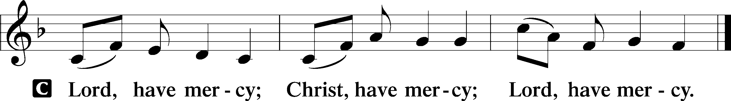

Gloria in Excelsis Luke 2:14; John 1:29

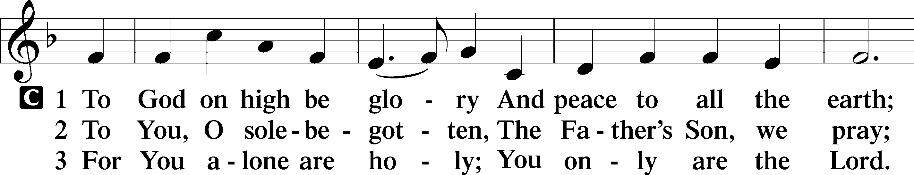

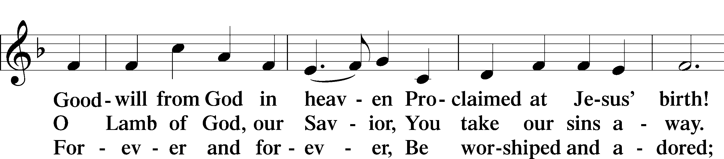

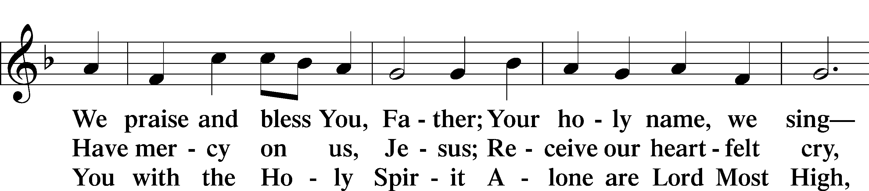

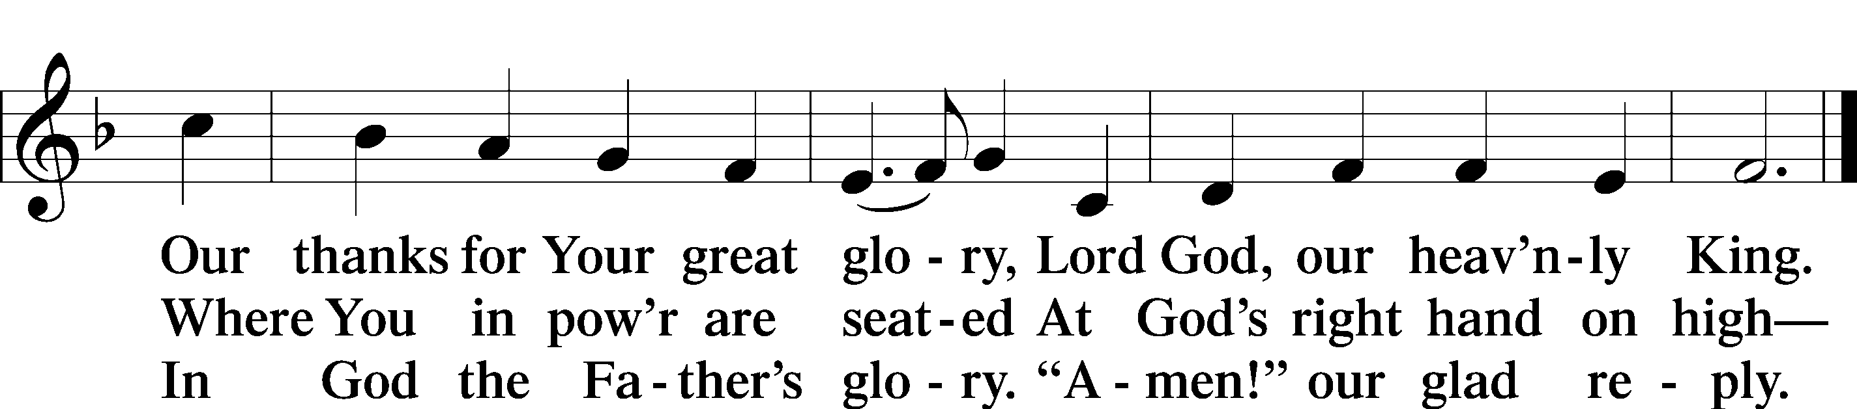

Text: Stephen P. Starke

Salutation and Collect of the Day

P The Lord be with you.

C **And also with you.**

P Let us pray.

Almighty and everlasting God, who governs all things in heaven and on earth, mercifully hear the prayers of Your people and grant us Your peace through all our days; through Jesus Christ, Your Son, our Lord, who lives and reigns with You and the Holy Spirit, one God, now and forever.

C **Amen.**

Sit

Old Testament Reading Isaiah 49:1–7

The Servant of the Lord

1Listen to me, O coastlands,  
 and give attention, you peoples from afar.  
The Lord called me from the womb,  
 from the body of my mother he named my name.  
2He made my mouth like a sharp sword;  
 in the shadow of his hand he hid me;  
he made me a polished arrow;  
 in his quiver he hid me away.  
3And he said to me, “You are my servant,  
 Israel, in whom I will be glorified.”  
4But I said, “I have labored in vain;  
 I have spent my strength for nothing and vanity;  
yet surely my right is with the Lord,  
 and my recompense with my God.”  
5And now the Lord says,  
 he who formed me from the womb to be his servant,  
to bring Jacob back to him;  
 and that Israel might be gathered to him—  
for I am honored in the eyes of the Lord,  
 and my God has become my strength—  
6he says:  
“It is too light a thing that you should be my servant  
 to raise up the tribes of Jacob  
 and to bring back the preserved of Israel;  
I will make you as a light for the nations,  
 that my salvation may reach to the end of the earth.”  
7Thus says the Lord,  
 the Redeemer of Israel and his Holy One,  
to one deeply despised, abhorred by the nation,  
 the servant of rulers:  
“Kings shall see and arise;  
 princes, and they shall prostrate themselves;  
because of the Lord, who is faithful,  
 the Holy One of Israel, who has chosen you.”

A This is the Word of the Lord.

C **Thanks be to God.**

Gradual Psalm 117:1–2a; 96:8

Praise the Lord, all nations!  
 Extol him, all peoples!  
**For great is his steadfast love toward us,  
 and the faithfulness of the Lord endures forever.**  
Ascribe to the Lord the glory due his name;  
 bring an offering, and come into his courts!

Epistle 1 Corinthians 1:1–9

Greeting

1Paul, called by the will of God to be an apostle of Christ Jesus, and our brother Sosthenes,

2To the church of God that is in Corinth, to those sanctified in Christ Jesus, called to be saints together with all those who in every place call upon the name of our Lord Jesus Christ, both their Lord and ours:

3Grace to you and peace from God our Father and the Lord Jesus Christ.

Thanksgiving

4I give thanks to my God always for you because of the grace of God that was given you in Christ Jesus, 5that in every way you were enriched in him in all speech and all knowledge—6even as the testimony about Christ was confirmed among you—7so that you are not lacking in any spiritual gift, as you wait for the revealing of our Lord Jesus Christ, 8who will sustain you to the end, guiltless in the day of our Lord Jesus Christ. 9God is faithful, by whom you were called into the fellowship of his Son, Jesus Christ our Lord.

A This is the Word of the Lord.

C **Thanks be to God.**

Stand

Alleluia and Verse

Alleluia

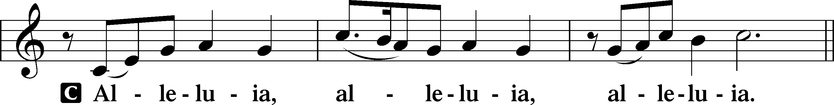

Verse John 20:31

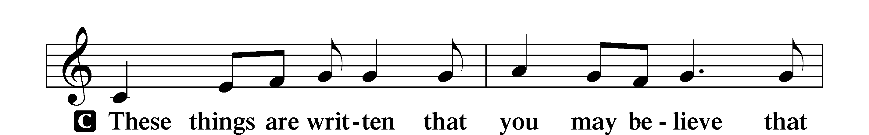

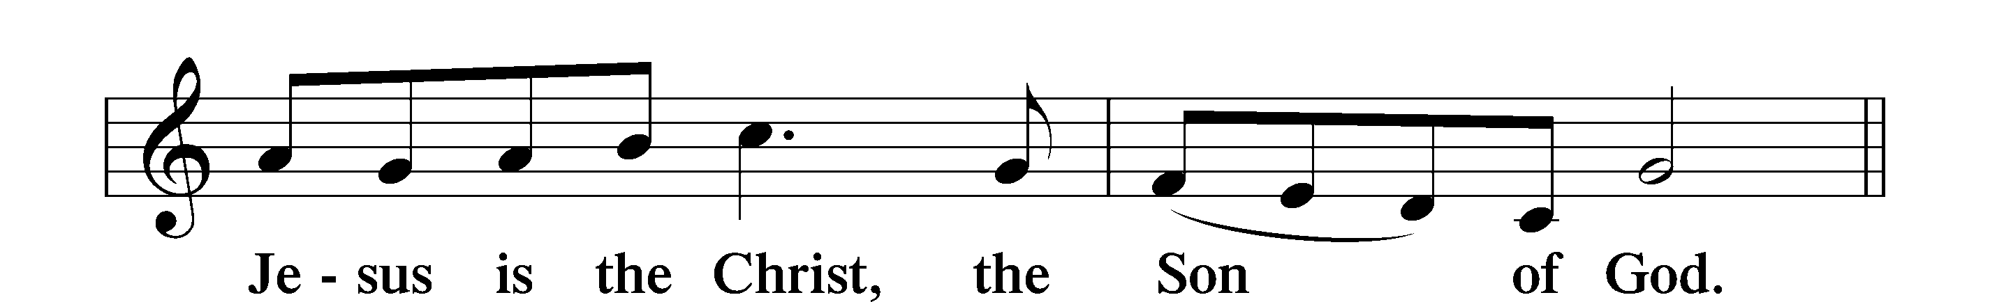

Alleluia

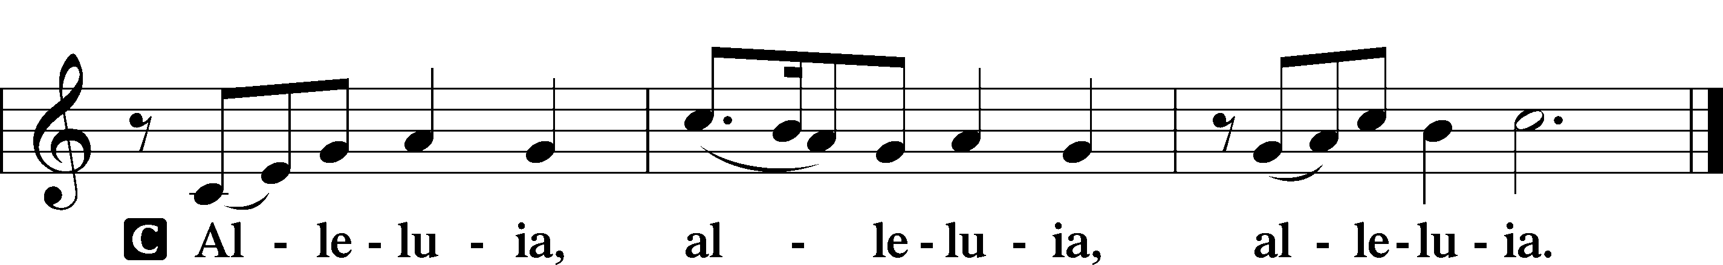

Holy Gospel John 1:29–42a

P The Holy Gospel according to St. John, the first chapter.

C **Glory to You, O Lord.**

Behold, the Lamb of God

29The next day [John] saw Jesus coming toward him, and said, “Behold, the Lamb of God, who takes away the sin of the world! 30This is he of whom I said, ‘After me comes a man who ranks before me, because he was before me.’ 31I myself did not know him, but for this purpose I came baptizing with water, that he might be revealed to Israel.” 32And John bore witness: “I saw the Spirit descend from heaven like a dove, and it remained on him. 33I myself did not know him, but he who sent me to baptize with water said to me, ‘He on whom you see the Spirit descend and remain, this is he who baptizes with the Holy Spirit.’ 34And I have seen and have borne witness that this is the Son of God.”

Jesus Calls the First Disciples

35The next day again John was standing with two of his disciples, 36and he looked at Jesus as he walked by and said, “Behold, the Lamb of God!” 37The two disciples heard him say this, and they followed Jesus. 38Jesus turned and saw them following and said to them, “What are you seeking?” And they said to him, “Rabbi” (which means Teacher), “where are you staying?” 39He said to them, “Come and you will see.” So they came and saw where he was staying, and they stayed with him that day, for it was about the tenth hour. 40One of the two who heard John speak and followed Jesus was Andrew, Simon Peter’s brother. 41He first found his own brother Simon and said to him, “We have found the Messiah” (which means Christ). 42He brought him to Jesus.

P This is the Gospel of the Lord.

C **Praise to You, O Christ.**

Nicene Creed

C **I believe in one God,**

**the Father Almighty,**

**maker of heaven and earth**

**and of all things visible and invisible.**

**And in one Lord Jesus Christ,**

**the only-begotten Son of God,**

**begotten of His Father before all worlds,**

**God of God, Light of Light,**

**very God of very God,**

**begotten, not made,**

**being of one substance with the Father,**

**by whom all things were made;**

**who for us men and for our salvation came down from heaven**

**and was incarnate by the Holy Spirit of the virgin Mary**

**and was made man;**

**and was crucified also for us under Pontius Pilate.**

**He suffered and was buried.**

**And the third day He rose again according to the Scriptures**

**and ascended into heaven**

**and sits at the right hand of the Father.**

**And He will come again with glory to judge both the living and the dead,**

**whose kingdom will have no end.**

**And I believe in the Holy Spirit,**

**the Lord and giver of life,**

**who proceeds from the Father and the Son,**

**who with the Father and the Son together is worshiped and glorified,**

**who spoke by the prophets.**

**And I believe in one holy Christian and apostolic Church,**

**I acknowledge one Baptism for the remission of sins,**

**and I look for the resurrection of the dead**

**and the life** T **of the world to come. Amen.**

**Children's Message**

688 “Come, Follow Me,” the Savior Spake

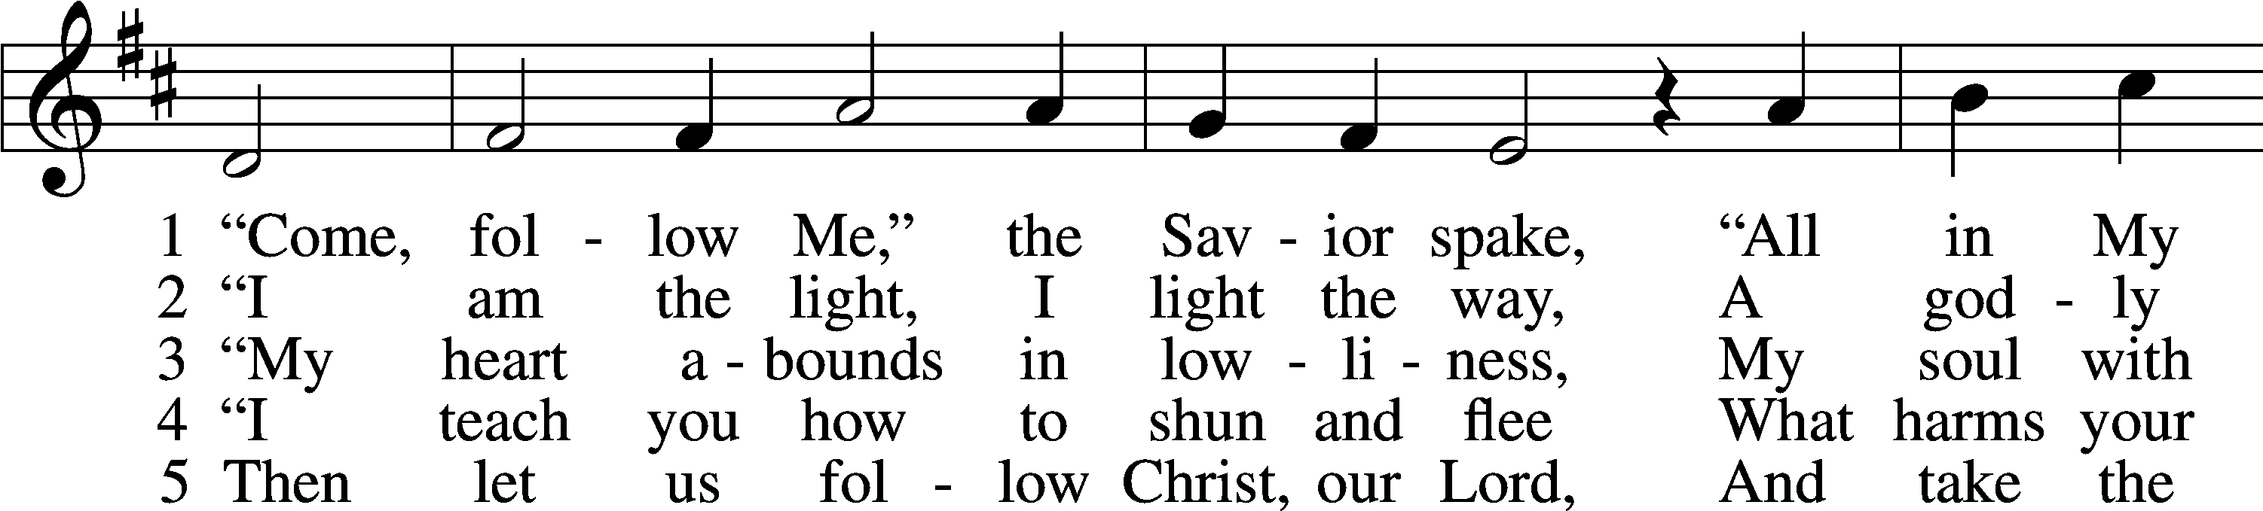

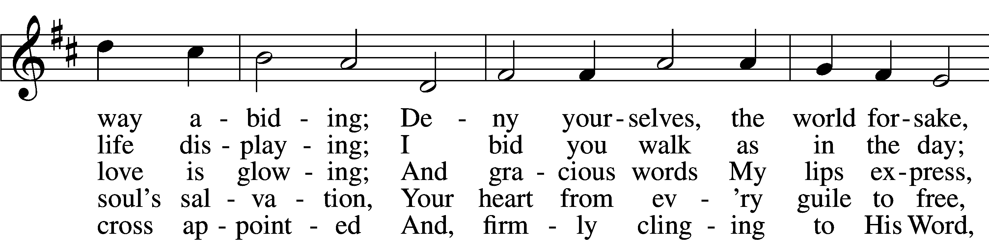

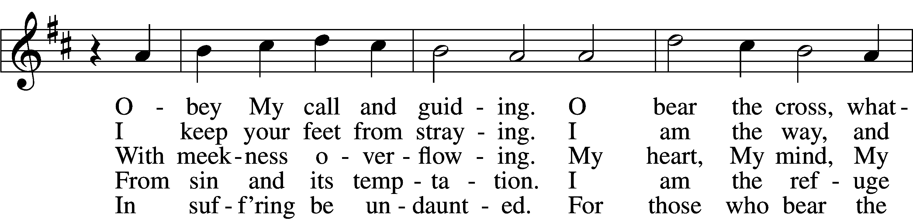

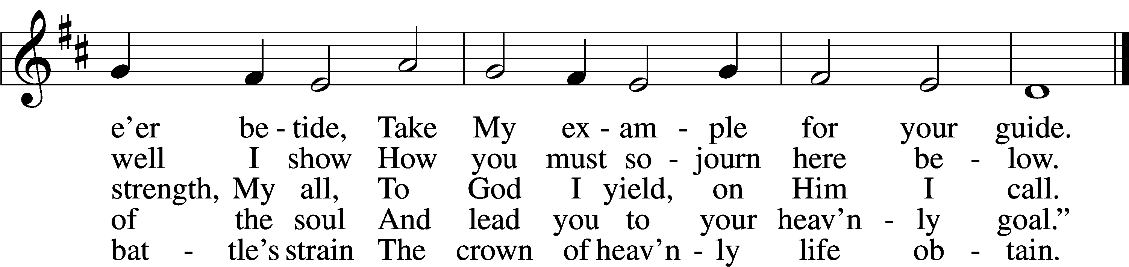

Text: tr. Charles W. Schaeffer, 1813–96; (sts. 1–3, 5): Johann Scheffler, 1624–77; (st. 4): Geistliche Lieder und Lobgesänge, 1695  
Tune: Bartholomäus Gesius, c. 1555–1613, adapt.  
Text and tune: Public domain

Sermon

Stand

Prayer of the Church

Sit

Offering

# Service of the Sacrament

Stand

Preface 2 Timothy 4:22; [Colossians 3:1]; [Psalm 136]

P The Lord be with you.

C **And also with you.**

P Lift up your hearts.

C **We lift them to the Lord.**

P Let us give thanks to the Lord our God.

C **It is right to give Him thanks and praise.**

P It is truly good, right, and salutary that we should at all times and in all places give thanks to You, O Lord, holy Father, almighty and everlasting God, for the countless blessings You so freely bestow on us and all creation. Above all, we give thanks for Your boundless love shown to us when You sent Your only-begotten Son, Jesus Christ, into our flesh and laid on Him our sin, giving Him into death that we might not die eternally. Because He is now risen from the dead and lives and reigns to all eternity, all who believe in Him will overcome sin and death and will rise again to new life. Therefore with angels and archangels and with all the company of heaven we laud and magnify Your glorious name, evermore praising You and saying:

Sanctus Isaiah 6:3; Matthew 21:9

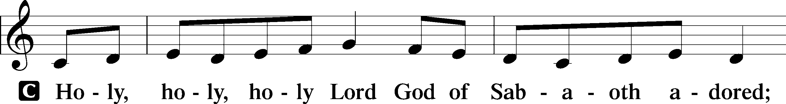

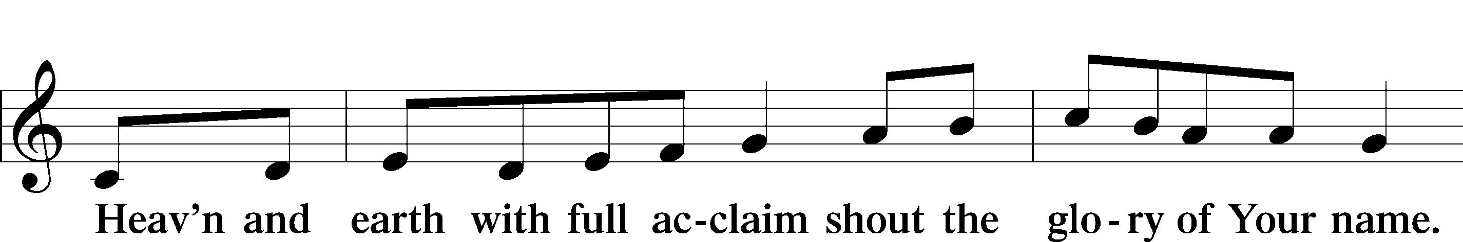

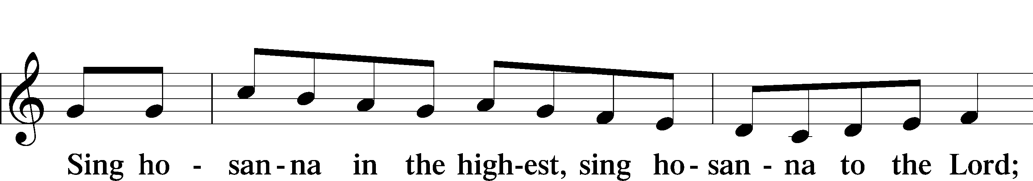

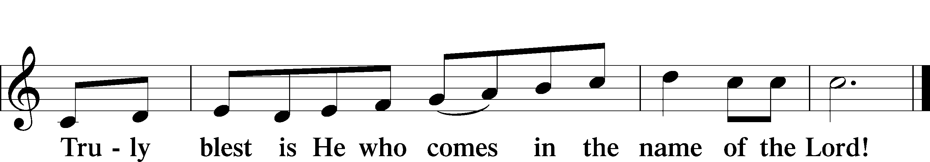

Text: Stephen P. Starke

Prayer of Thanksgiving

P Blessed are You, O Lord our God, king of all creation, for You have had mercy on us and given Your only-begotten Son that whoever believes in Him should not perish but have eternal life.

As the glory of Your presence once filled Your ancient temple, so in the incarnation of Your Son, Jesus Christ, You manifested the fullness of Your glory in human flesh.

We give You thanks that in His most Holy Supper You reveal Your glory to us. Grant us faithfully to eat His body and drink His blood so that we may one day behold Your glory face to face.

Hear us as we pray in His name and as He has taught us:

Lord’s Prayer

C **Our Father who art in heaven,**

**hallowed be Thy name,**

**Thy kingdom come,**

**Thy will be done on earth**

**as it is in heaven;**

**give us this day our daily bread;**

**and forgive us our trespasses**

**as we forgive those**

**who trespass against us;**

**and lead us not into temptation,**

**but deliver us from evil.**

**For Thine is the kingdom**

**and the power and the glory**

**forever and ever. Amen.**

The Words of Our Lord

P Our Lord Jesus Christ, on the night when He was betrayed, took bread, and when He had given thanks, He broke it and gave it to the disciples and said: “Take, eat; this is My T body, which is given for you. This do in remembrance of Me.”

In the same way also He took the cup after supper, and when He had given thanks, He gave it to them, saying: “Drink of it, all of you; this cup is the new testament in My T blood, which is shed for you for the forgiveness of sins. This do, as often as you drink it, in remembrance of Me.”

Pax Domini

P The peace of the Lord be with you always.

C **Amen.**

Agnus Dei John 1:29

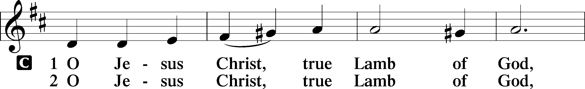

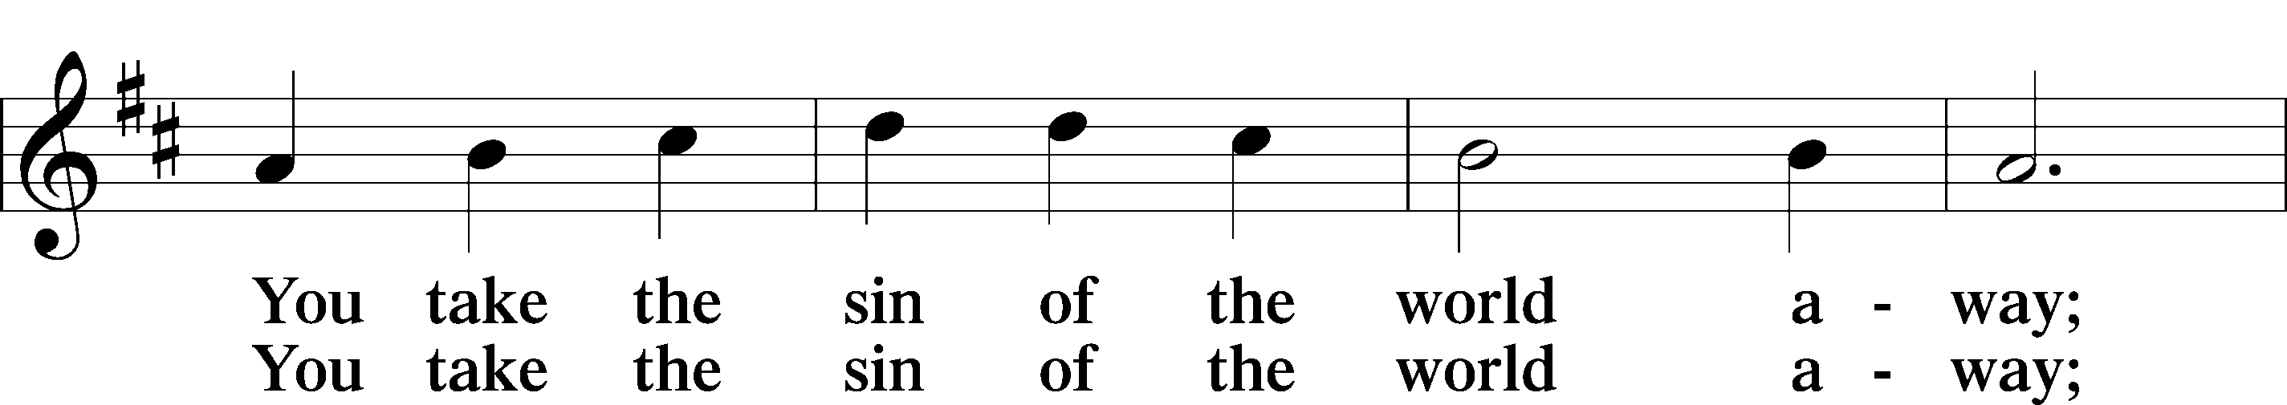

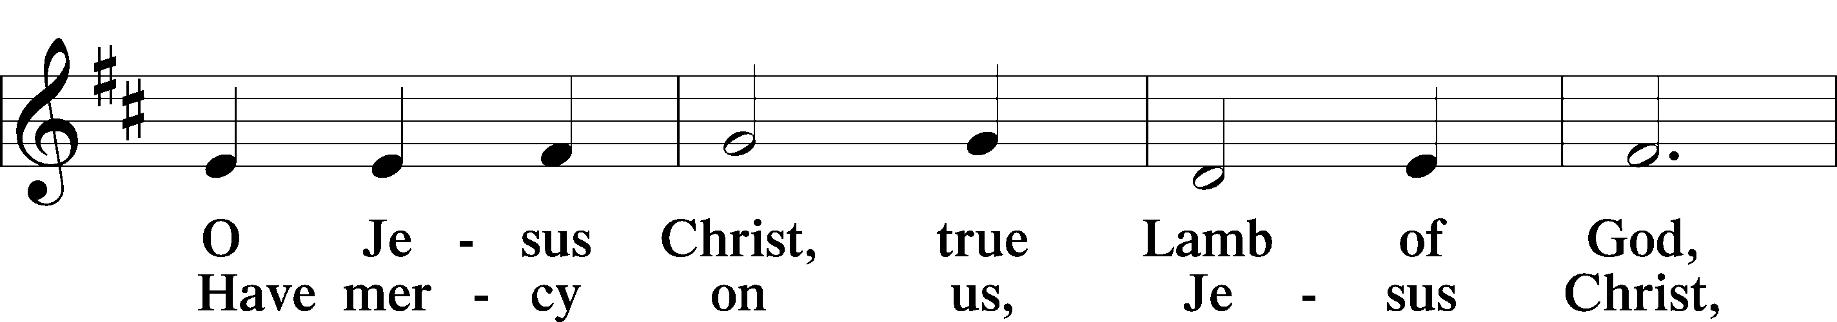

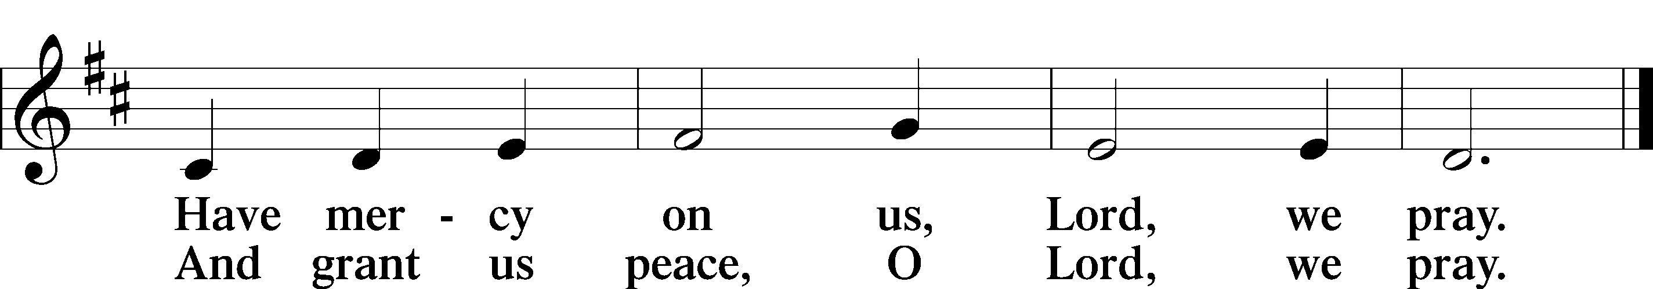

Text: Stephen P. Starke

Sit

Distribution

618 I Come, O Savior, to Thy Table

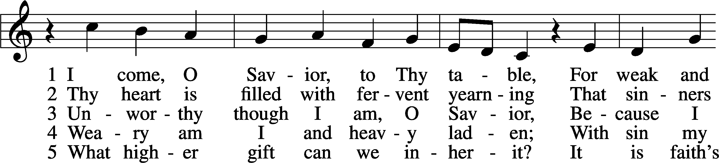

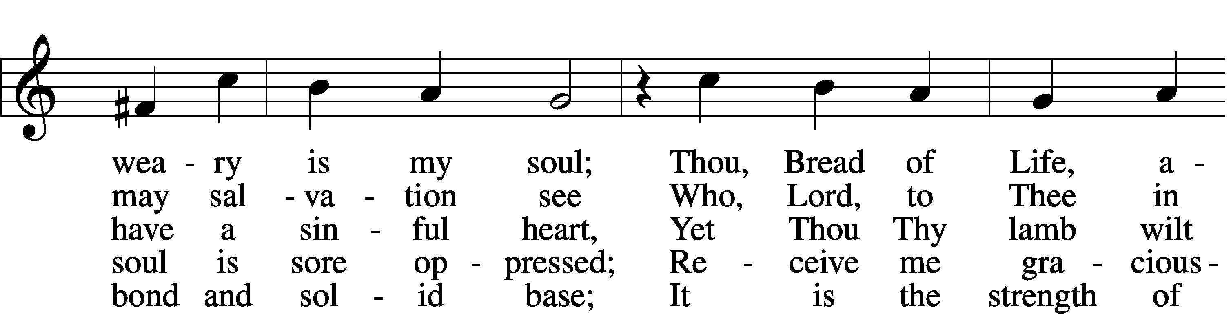

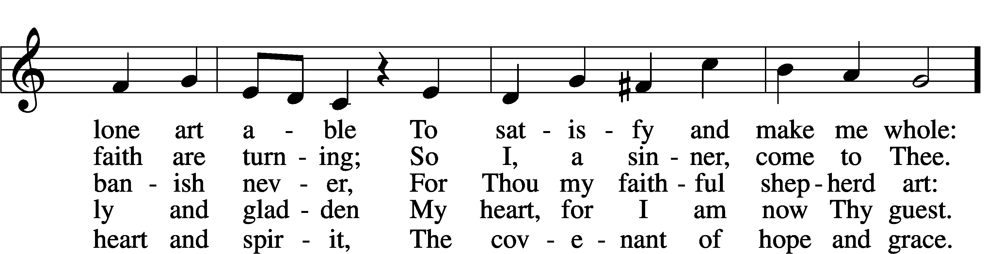

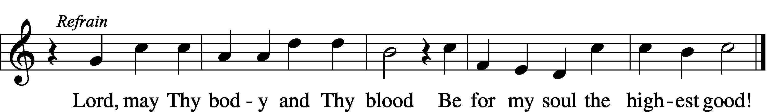

Text: Friedrich Christian Heyder, 1677–1754; tr. The Lutheran Hymnal, 1941, abr.  
Tune: Emskirchner Choral-Buch, 1756, Leipzig  
Text: © 1941 Concordia Publishing House. Used by permission: LSB Hymn License no. 110005011  
Tune: Public domain

620 Jesus Comes Today with Healing

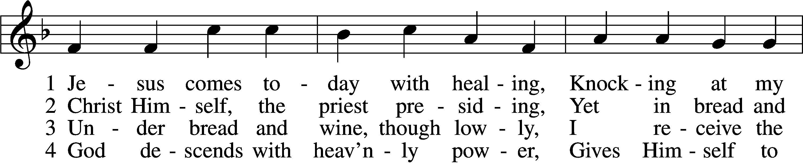

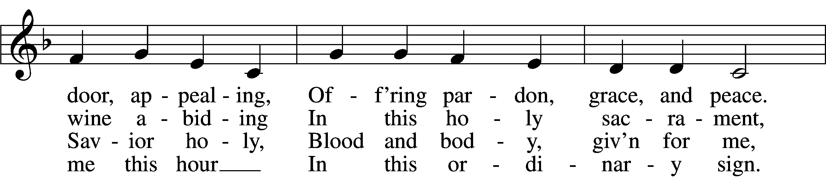

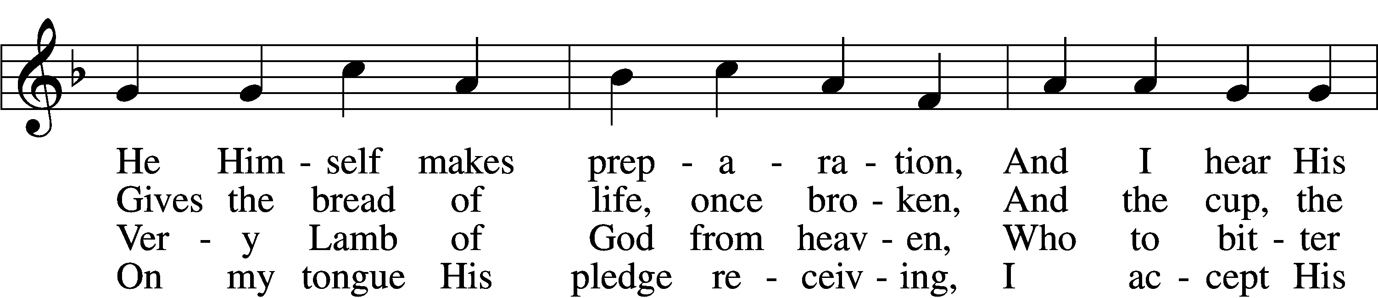

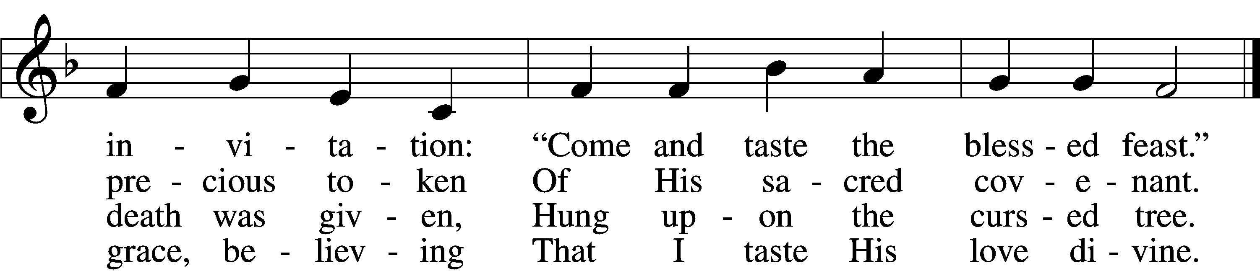

5 Let me praise God’s boundless favor,  
Whose own feast of love I savor,  
 Bidden by His gracious call.  
Wedding garments He provides me,  
With a robe of white He hides me,  
 Fits me for the royal hall.

6 Now have I found consolation,  
Comfort in my tribulation,  
 Balm to heal the troubled soul.  
God, my shield from ev’ry terror,  
Cleanses me from sin and error,  
 Makes my wounded spirit whole.

Text: Heinrich Puchta, 1808–58; tr. David W. Rogner, 1960  
Tune: Johann Löhner, 1645–1705; adapt. Johann Balthasar König, 1691–1758  
Text: © David W. Rogner. Used by permission: LSB Hymn License no. 110005011  
Tune: Public domain

537 Beautiful Savior

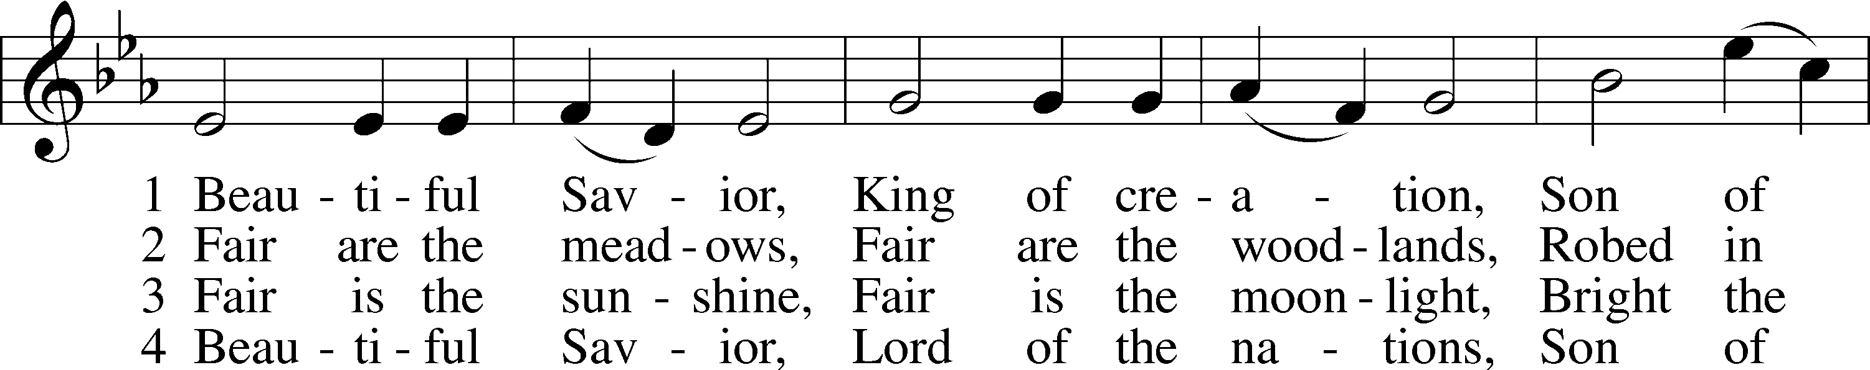

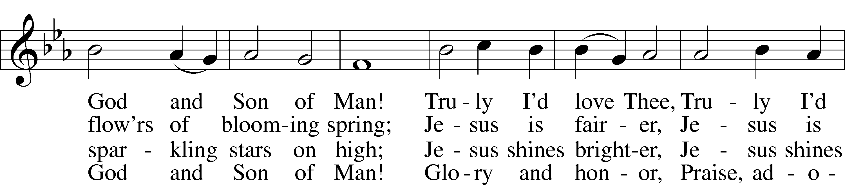

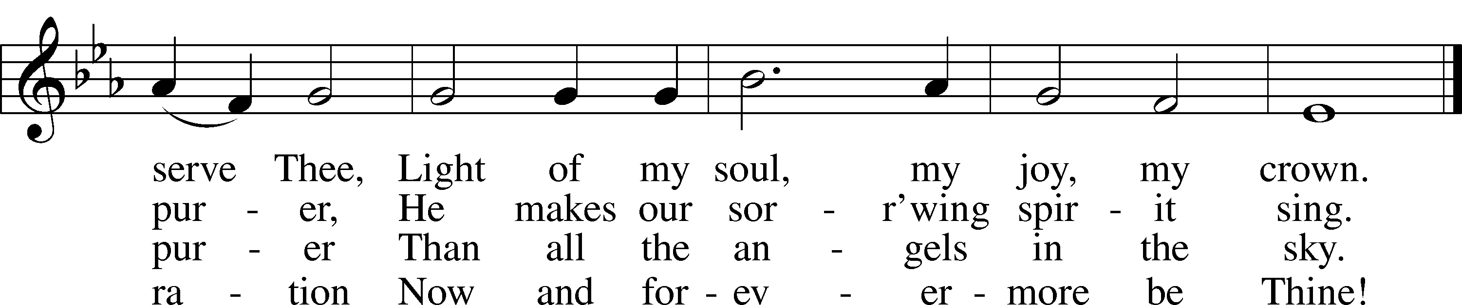

Text: Münsterisch Gesangbuch, 1677, Münster; tr. Joseph A. Seiss, 1823–1904  
Tune: Silesian, 19th cent.  
Text and tune: Public domain

The Dismissal

P The body and blood of our Lord Jesus Christ strengthen and preserve you in body and soul to life everlasting. Depart T in peace.

C **Amen.**

Stand

Nunc Dimittis Luke 2:29–32

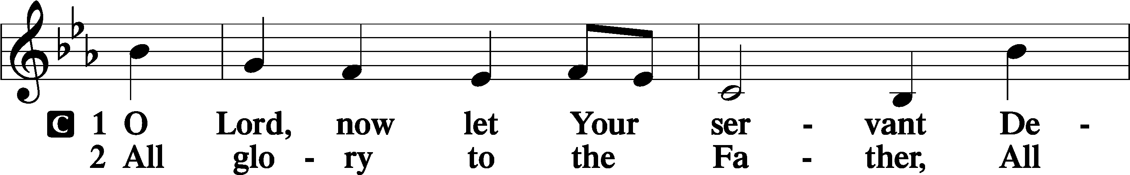

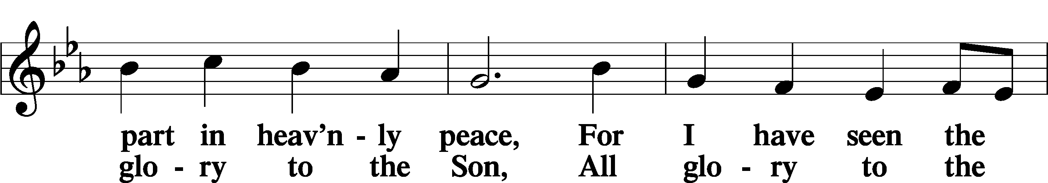

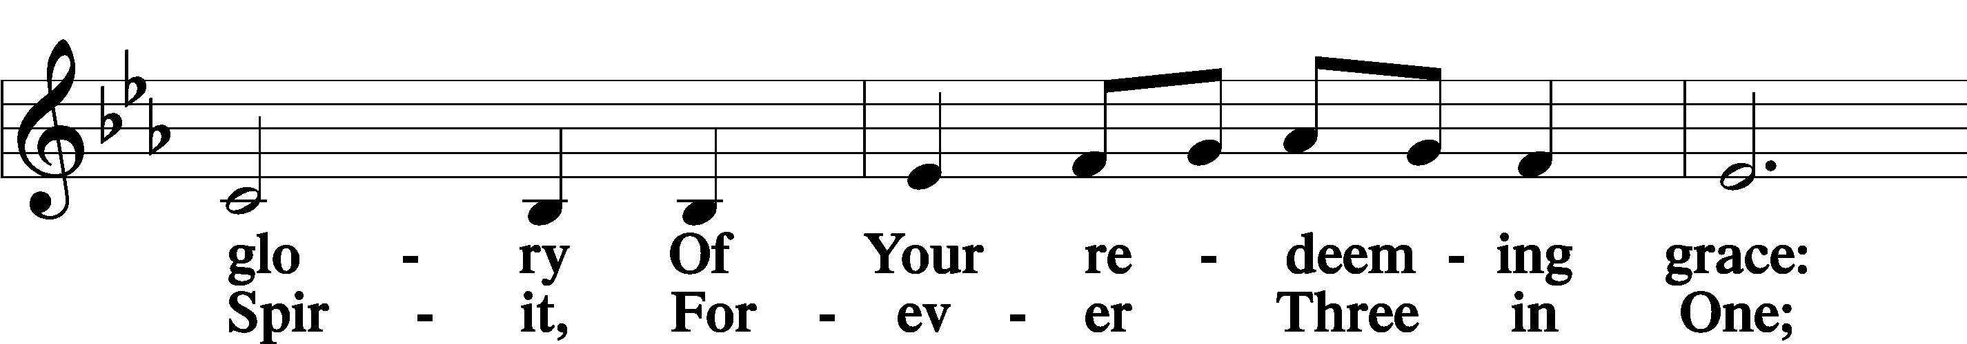

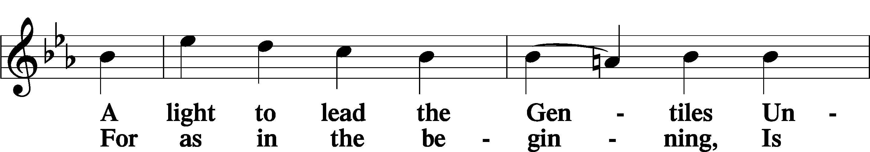

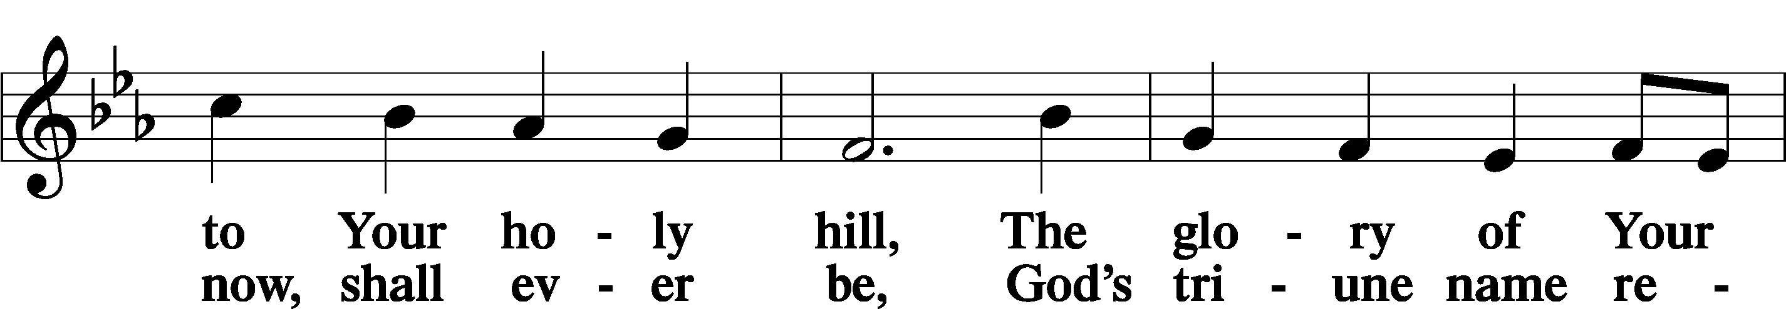

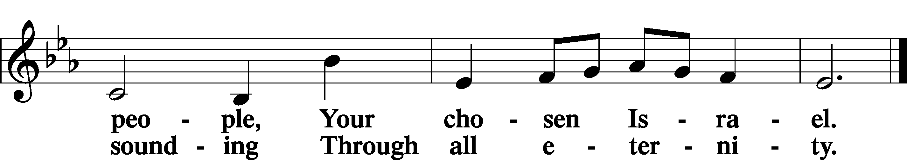

Post-Communion Collect

A Let us pray.

We give thanks to You, almighty God, that You have refreshed us through this salutary gift, and we implore You that of Your mercy You would strengthen us through the same in faith toward You and in fervent love toward one another; through Jesus Christ, Your Son, our Lord, who lives and reigns with You and the Holy Spirit, one God, now and forever.

C **Amen.**

Benedicamus Psalm 103:1

A Let us bless the Lord.

C **Thanks be to God.**

Benediction

P The Lord bless you and keep you.

The Lord make His face shine on you and be gracious to you.

The Lord look upon you with favor and T give you peace.

C **Amen.**

544 O Love, How Deep

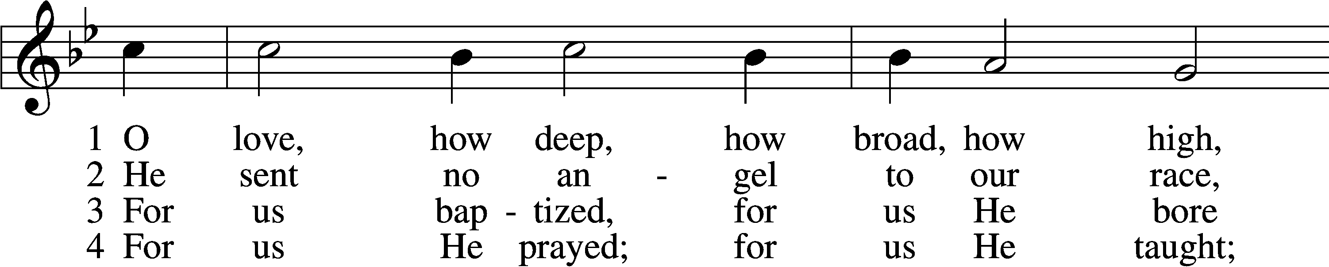

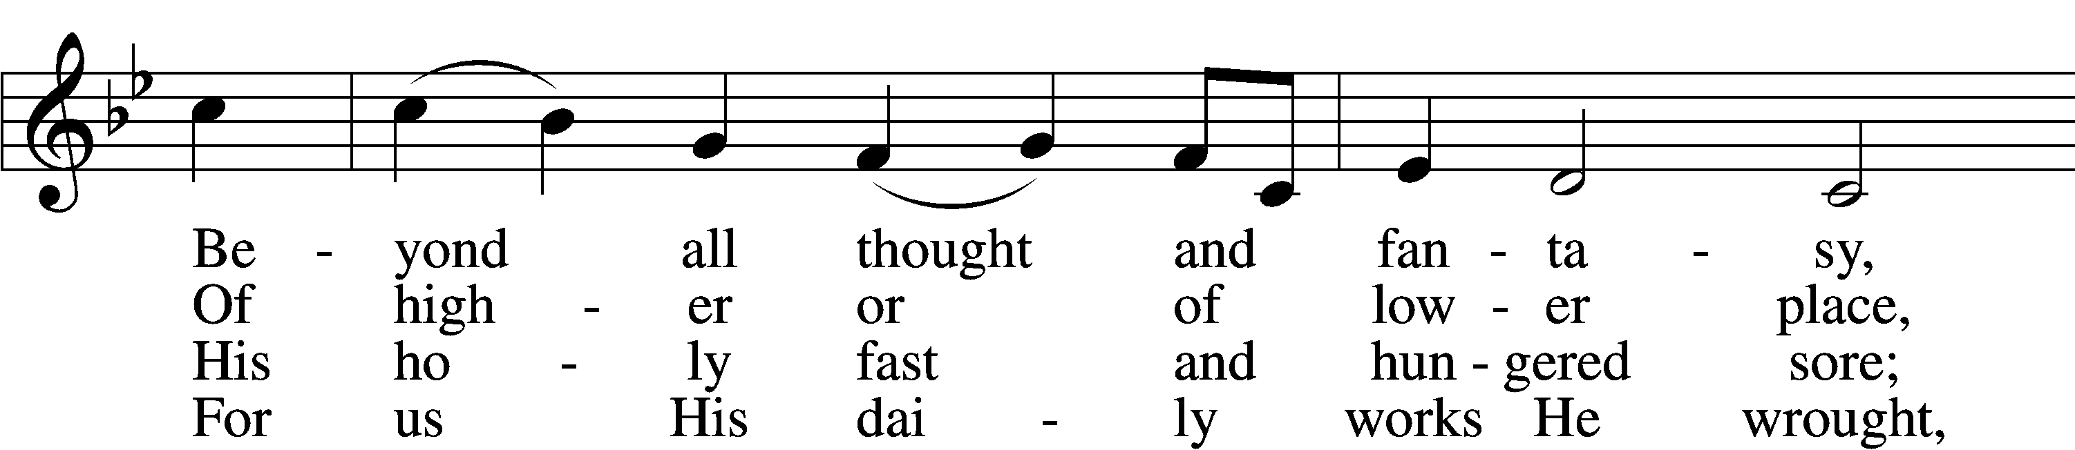

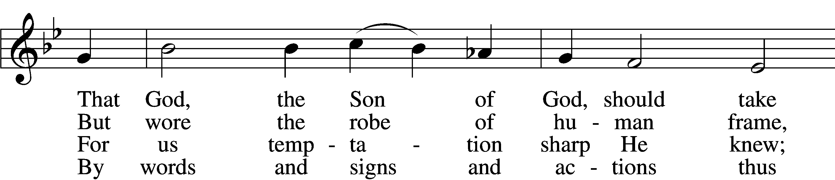

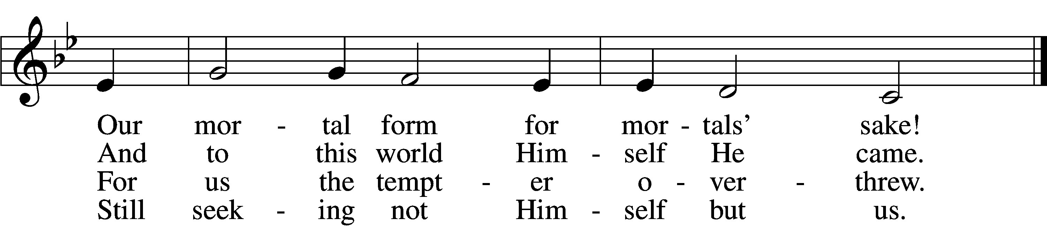

5 For us by wickedness betrayed,  
For us, in crown of thorns arrayed,  
He bore the shameful cross and death;  
For us He gave His dying breath.

6 For us He rose from death again;  
For us He went on high to reign;  
For us He sent His Spirit here  
To guide, to strengthen, and to cheer.

D 7 All glory to our Lord and God  
For love so deep, so high, so broad;  
The Trinity whom we adore  
Forever and forevermore.

Text: attr. Thomas à Kempis, 1380–1471; tr. Benjamin Webb, 1819–85, alt.  
Tune: English, 15th cent.  
Text: Public domain

Acknowledgments

Divine Service, Setting Four from Lutheran Service Book

Unless otherwise indicated, Scripture quotations are from the ESV® Bible (The Holy Bible, English Standard Version®), copyright © 2001 by Crossway, a publishing ministry of Good News Publishers. Used by permission. All rights reserved.

Created by Lutheran Service Builder © 2023 Concordia Publishing House.