856 O Christ, Who Called the Twelve
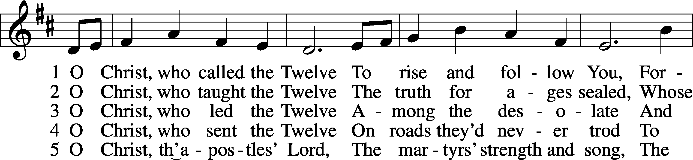
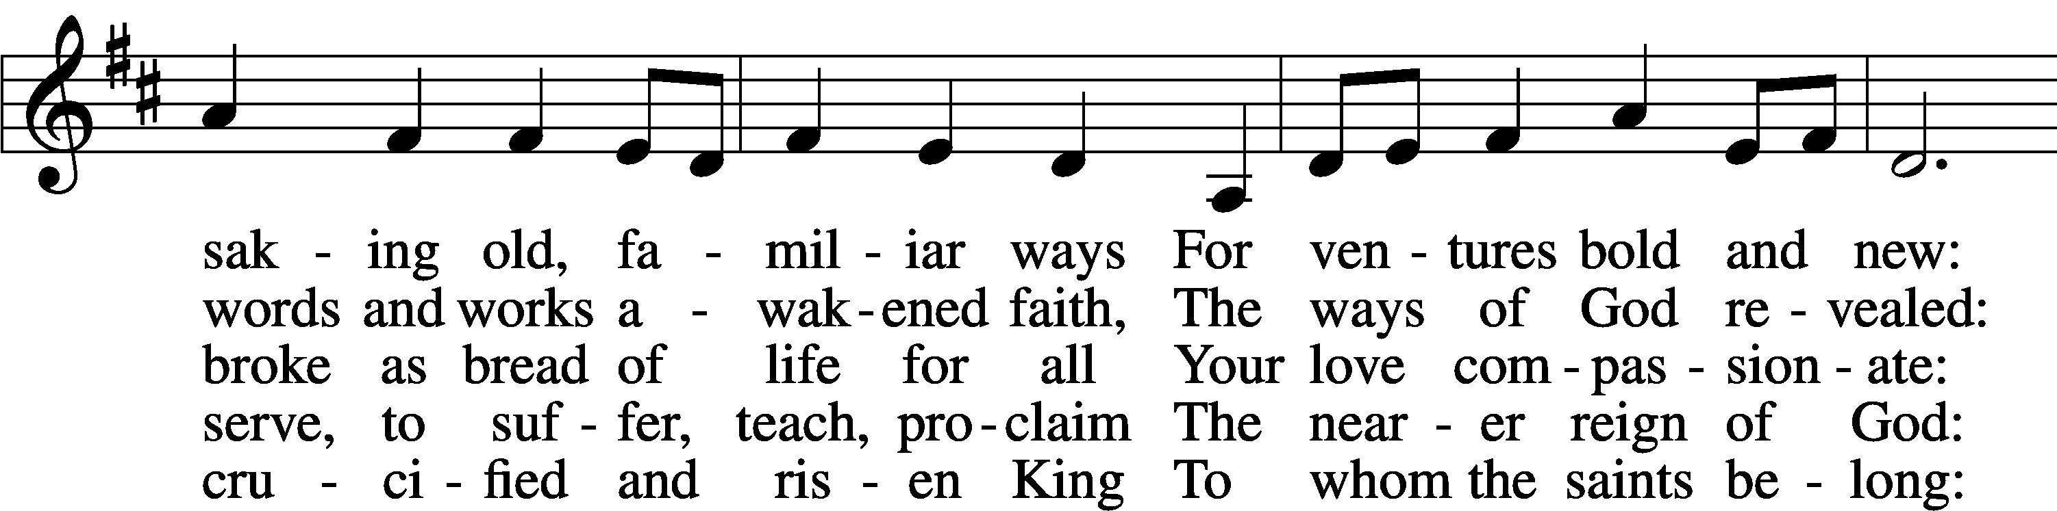
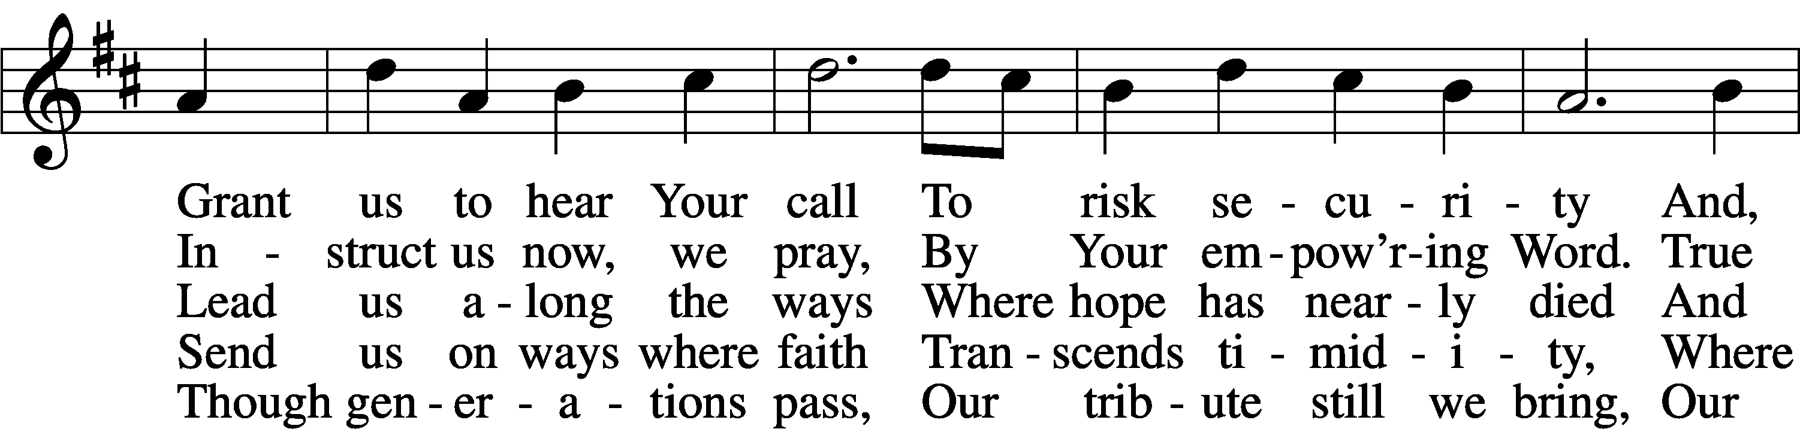
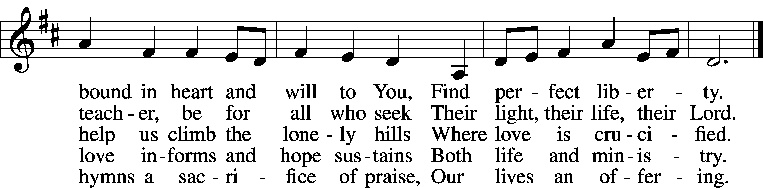
Text: Herman G. Stuempfle, Jr., 1923–2007
Tune: English; adapt. Franklin L. Sheppard, 1852–1930
Text: © 1993 GIA Publications, Inc. Used by permission: LSB Hymn License no. 110005011
Tune: Public domain

Confession and Absolution

The sign of the cross may be made by all in remembrance of their Baptism.

Invocation Matthew 28:19b; 18:20
P In the name of the Father and of the T Son and of the Holy Spirit.
C Amen.

Exhortation Hebrews 10:22; Psalm 124:8; Psalm 32:5
P Beloved in the Lord! Let us draw near with a true heart and confess our sins unto God our Father, beseeching Him in the name of our Lord Jesus Christ to grant us forgiveness.

P Our help is in the name of the Lord,
C who made heaven and earth.
P I said, I will confess my transgressions unto the Lord,
C and You forgave the iniquity of my sin.

Silence for reflection on God’s Word and for self-examination.

Confession of Sins
P Almighty God, our maker and redeemer, we poor sinners confess unto You that we are by nature sinful and unclean and that we have sinned against You by thought, word, and deed. Wherefore we flee for refuge to Your infinite mercy, seeking and imploring Your grace for the sake of our Lord Jesus Christ.
C O most merciful God, who has given Your only-begotten Son to die for us, have mercy upon us and for His sake grant us remission of all our sins; and by Your Holy Spirit increase in us true knowledge of You and of Your will and true obedience to Your Word, to the end that by Your grace we may come to everlasting life; through Jesus Christ, our Lord. Amen.

Declaration of Grace Mark 16:16; John 1:12
P Almighty God, our heavenly Father, has had mercy upon us and has given His only Son to die for us and for His sake forgives us all our sins. To those who believe on His name He gives power to become the children of God and has promised them His Holy Spirit. He that believes and is baptized shall be saved.
Grant this, Lord, unto us all.
C Amen.

Service of the Word

Introit Psalm 22:27–31; antiphon: v. 22
I will tell of your name to my brothers;
in the midst of the congregation I will praise you.
All the ends of the earth shall remember and turn to the Lord,
and all the families of the nations shall worship before you.
For kingship belongs to the Lord,
and he rules over the nations.
All the prosperous of the earth eat and worship;
before him shall bow all who go down to the dust, even the one who could not keep himself alive.
Posterity shall serve him;
it shall be told of the Lord to the coming generation;
they shall come and proclaim his righteousness to a people yet unborn,
that he has done it.
Gloria Patri
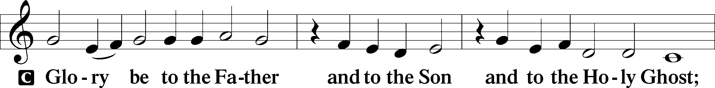
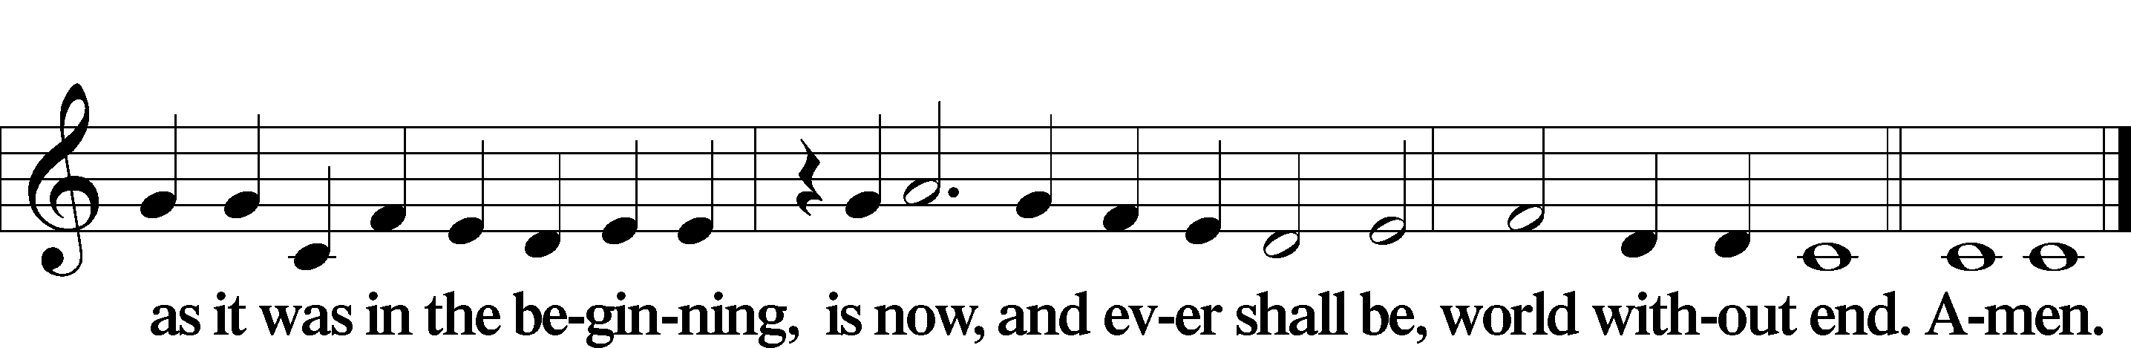

Kyrie Mark 10:47
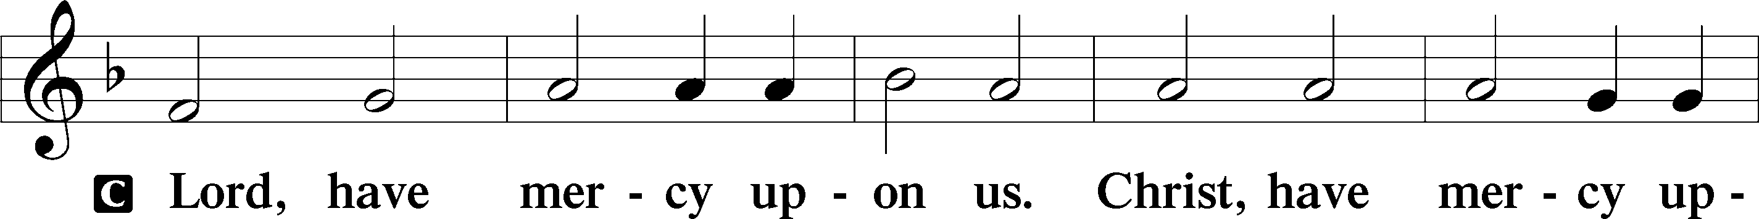
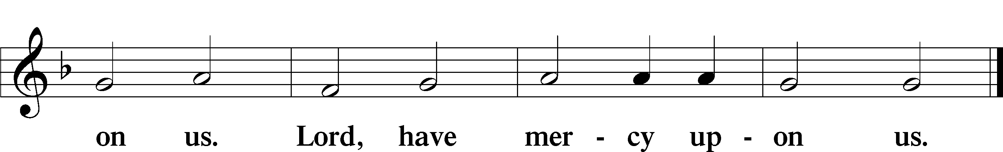

Gloria in Excelsis Luke 2:14; John 1:29
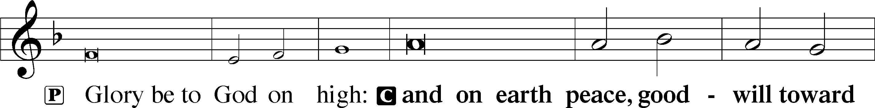
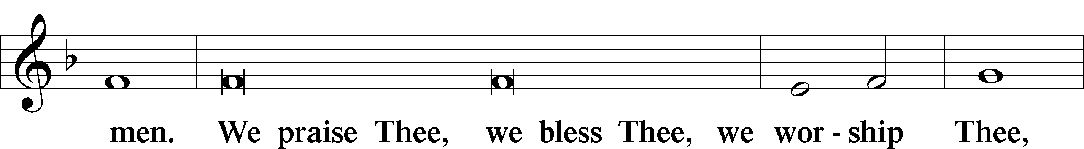
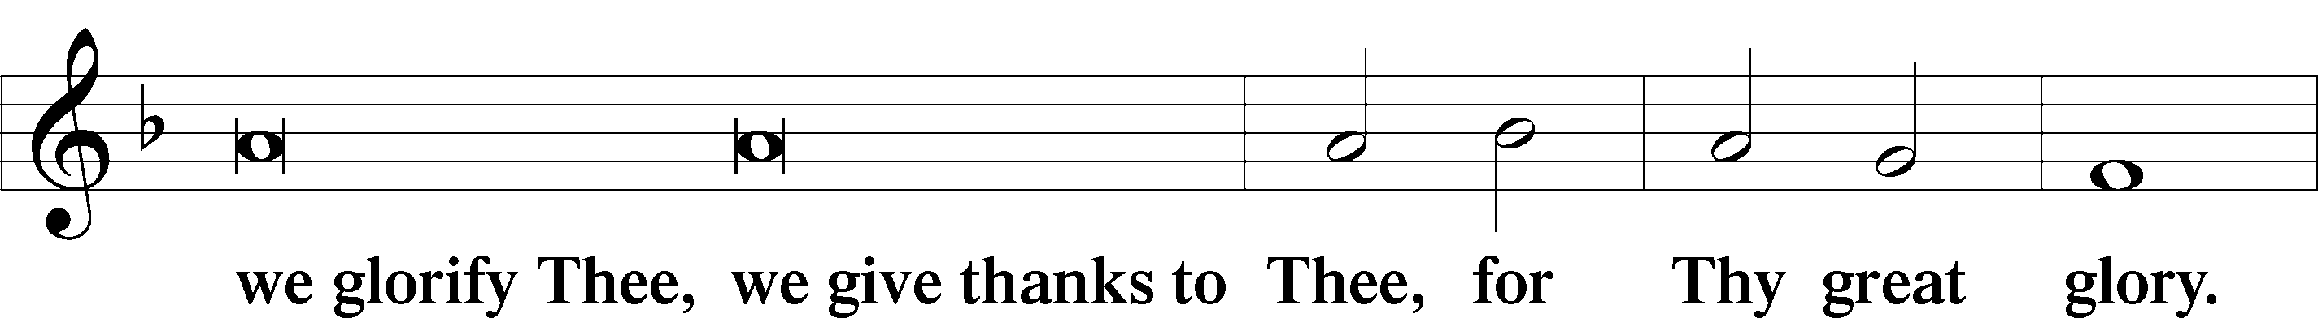
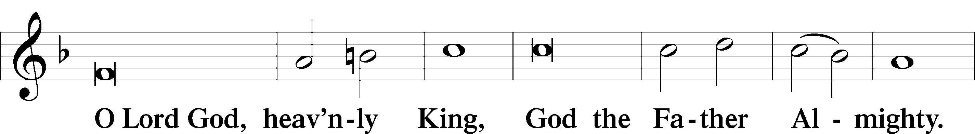
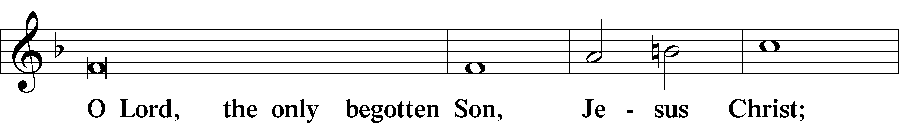
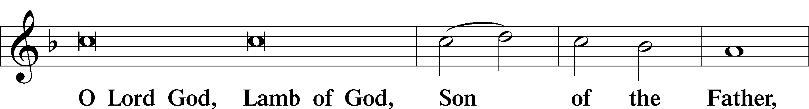
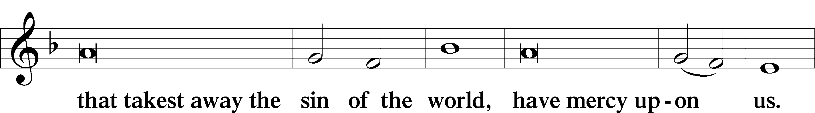
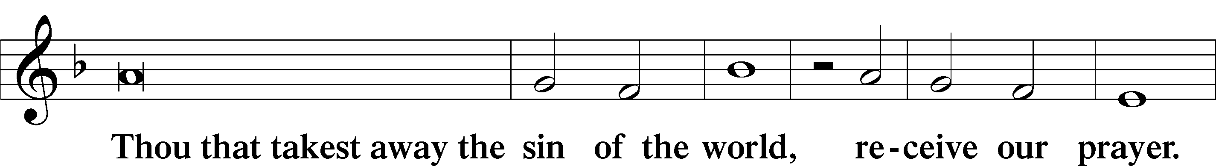
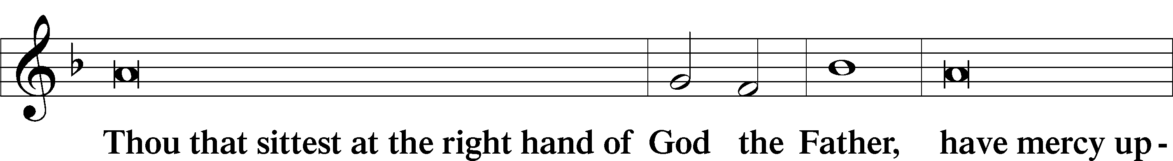
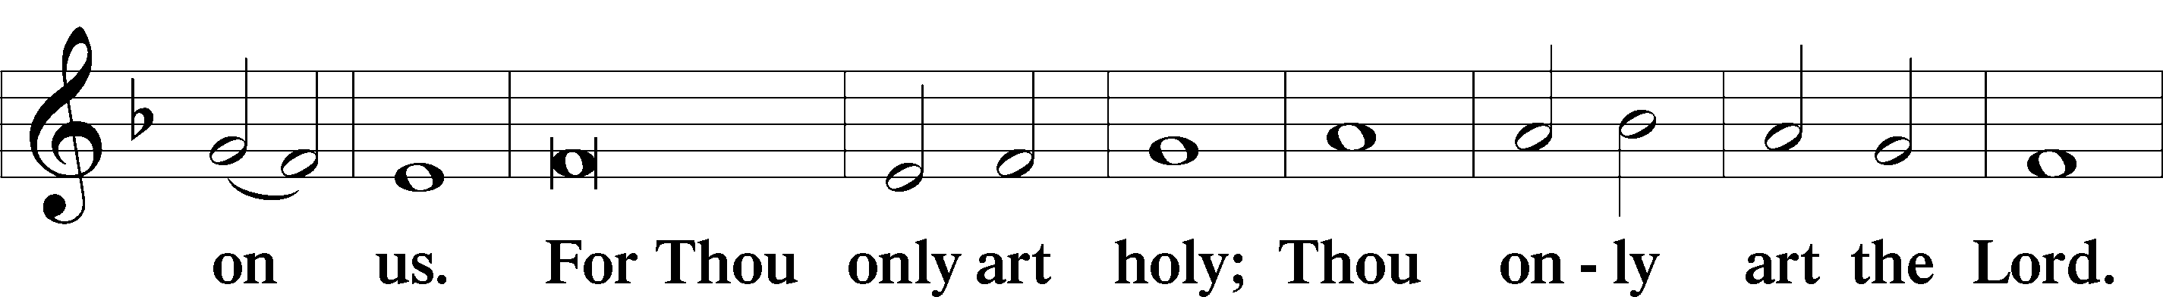
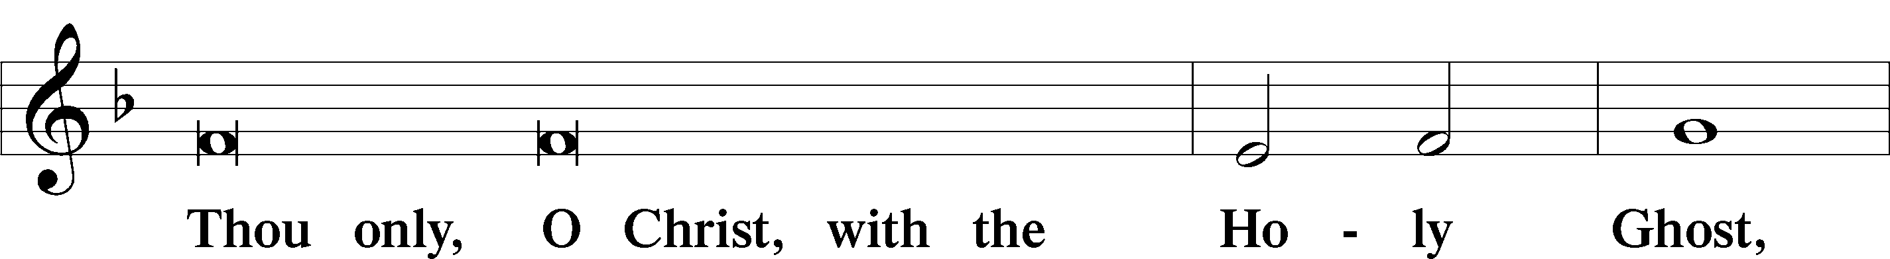
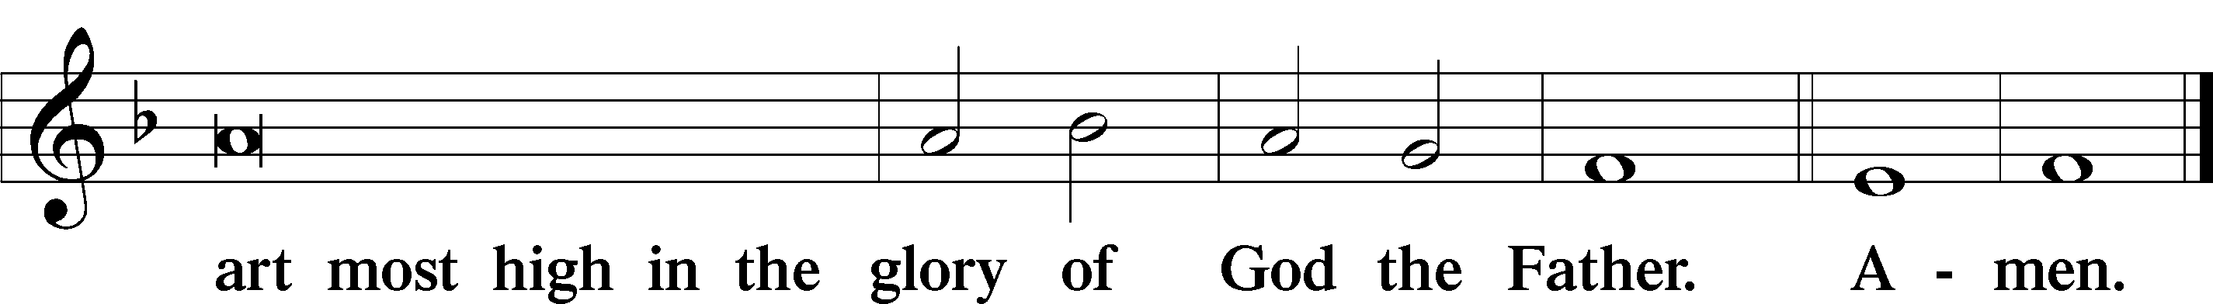

Salutation and Collect of the Day
P The Lord be with you.
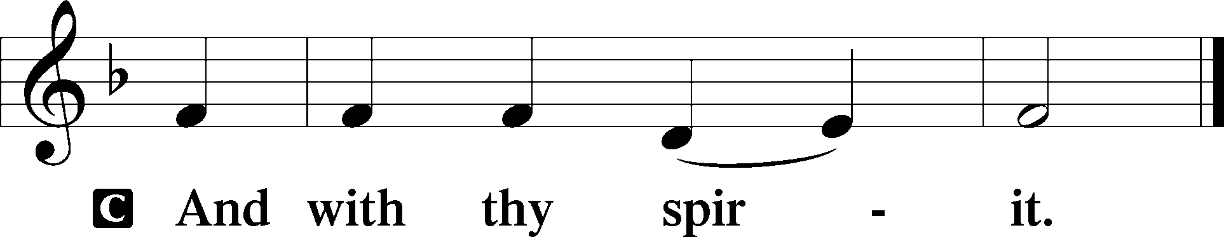

P Let us pray.
Almighty and everlasting God, mercifully look upon our infirmities and stretch forth the hand of Your majesty to heal and defend us; through Jesus Christ, Your Son, our Lord, who lives and reigns with You and the Holy Spirit, one God, now and forever.

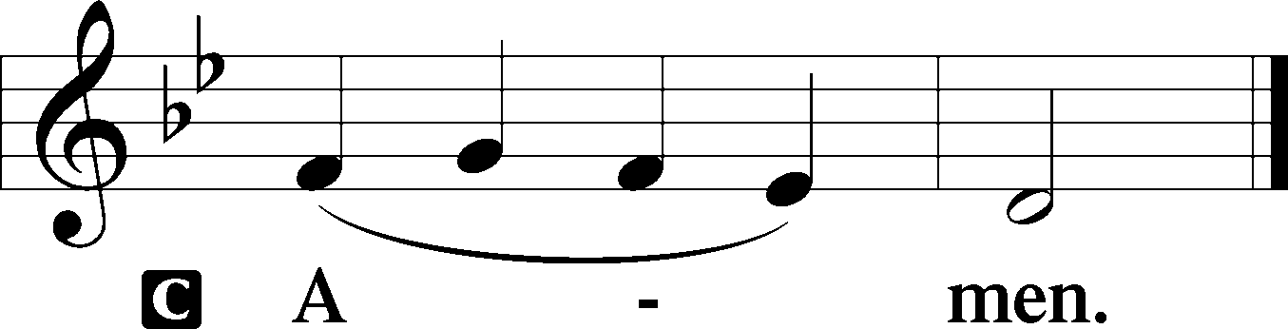

Sit

Old Testament Reading Isaiah 9:1–4
For to Us a Child Is Born
1 There will be no gloom for her who was in anguish. In the former time he brought into contempt the land of Zebulun and the land of Naphtali, but in the latter time he has made glorious the way of the sea, the land beyond the Jordan, Galilee of the nations.
2 The people who walked in darkness
have seen a great light;
those who dwelt in a land of deep darkness,
on them has light shined.
3You have multiplied the nation;
you have increased its joy;
they rejoice before you
as with joy at the harvest,
as they are glad when they divide the spoil.
4For the yoke of his burden,
and the staff for his shoulder,
the rod of his oppressor,
you have broken as on the day of Midian.

A This is the Word of the Lord.
C Thanks be to God.

Gradual Psalm 117:1–2a; 96:8
Praise the Lord, all nations!
Extol him, all peoples!
For great is his steadfast love toward us,
and the faithfulness of the Lord endures forever.
Ascribe to the Lord the glory due his name;
bring an offering, and come into his courts!

Reading Romans 5:6–15
6For while we were still weak, at the right time Christ died for the ungodly. 7For one will scarcely die for a righteous person—though perhaps for a good person one would dare even to die— 8but God shows his love for us in that while we were still sinners, Christ died for us. 9Since, therefore, we have now been justified by his blood, much more shall we be saved by him from the wrath of God. 10For if while we were enemies we were reconciled to God by the death of his Son, much more, now that we are reconciled, shall we be saved by his life. 11More than that, we also rejoice in God through our Lord Jesus Christ, through whom we have now received reconciliation.
Death in Adam, Life in Christ
12Therefore, just as sin came into the world through one man, and death through sin, and so death spread to all men because all sinned— 13for sin indeed was in the world before the law was given, but sin is not counted where there is no law. 14Yet death reigned from Adam to Moses, even over those whose sinning was not like the transgression of Adam, who was a type of the one who was to come.
15But the free gift is not like the trespass. For if many died through one man’s trespass, much more have the grace of God and the free gift by the grace of that one man Jesus Christ abounded for many.

Stand

Alleluia
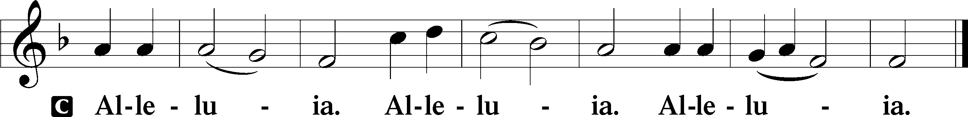

Holy Gospel Matthew 4:12–25
P The Holy Gospel according to St. Matthew, the fourth chapter.

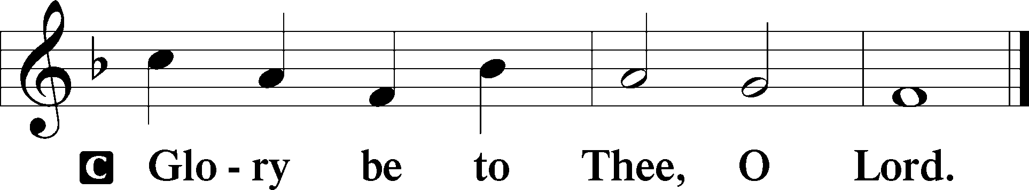

Jesus Begins His Ministry
12When [Jesus] heard that John had been arrested, he withdrew into Galilee. 13And leaving Nazareth he went and lived in Capernaum by the sea, in the territory of Zebulun and Naphtali, 14so that what was spoken by the prophet Isaiah might be fulfilled:
15“The land of Zebulun and the land of Naphtali,
the way of the sea, beyond the Jordan, Galilee of the Gentiles—
16the people dwelling in darkness
have seen a great light,
and for those dwelling in the region and shadow of death,
on them a light has dawned.”
17From that time Jesus began to preach, saying, “Repent, for the kingdom of heaven is at hand.”
Jesus Calls the First Disciples
18While walking by the Sea of Galilee, he saw two brothers, Simon (who is called Peter) and Andrew his brother, casting a net into the sea, for they were fishermen. 19And he said to them, “Follow me, and I will make you fishers of men.” 20Immediately they left their nets and followed him. 21And going on from there he saw two other brothers, James the son of Zebedee and John his brother, in the boat with Zebedee their father, mending their nets, and he called them. 22Immediately they left the boat and their father and followed him.
Jesus Ministers to Great Crowds
23And he went throughout all Galilee, teaching in their synagogues and proclaiming the gospel of the kingdom and healing every disease and every affliction among the people. 24So his fame spread throughout all Syria, and they brought him all the sick, those afflicted with various diseases and pains, those oppressed by demons, epileptics, and paralytics, and he healed them. 25And great crowds followed him from Galilee and the Decapolis, and from Jerusalem and Judea, and from beyond the Jordan.

P This is the Gospel of the Lord.

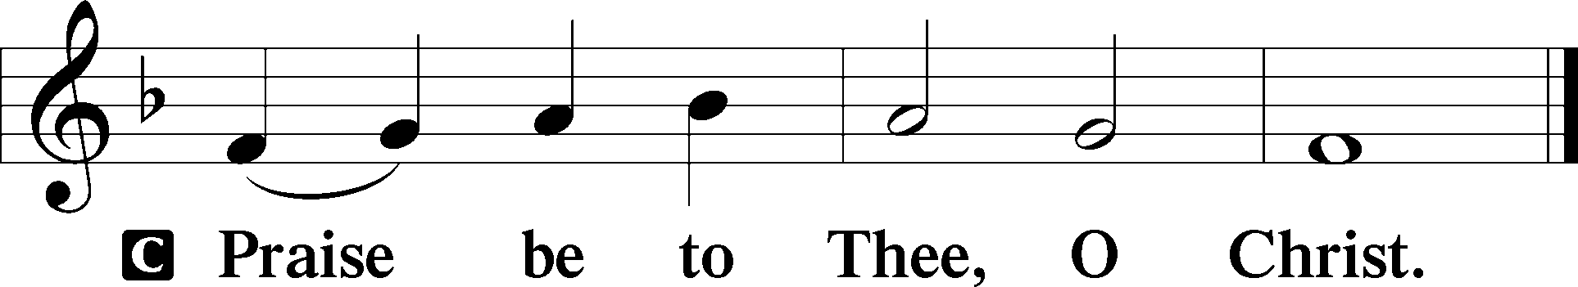

Apostles’ Creed
C I believe in God, the Father Almighty,
maker of heaven and earth.

And in Jesus Christ, His only Son, our Lord,
who was conceived by the Holy Spirit,
born of the virgin Mary,
suffered under Pontius Pilate,
was crucified, died and was buried.
He descended into hell.
The third day He rose again from the dead.
He ascended into heaven
and sits at the right hand of God the Father Almighty.
From thence He will come to judge the living and the dead.

I believe in the Holy Spirit,
the holy Christian Church,
the communion of saints,
the forgiveness of sins,
the resurrection of the body,
and the life T everlasting. Amen.

Children's Message

839 O Christ, Our True and Only Light
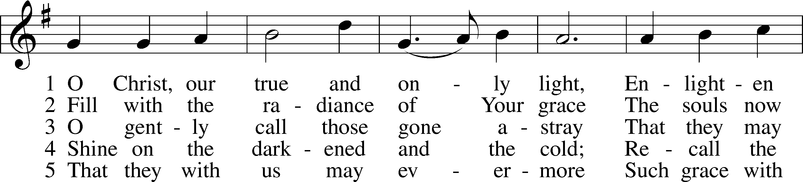
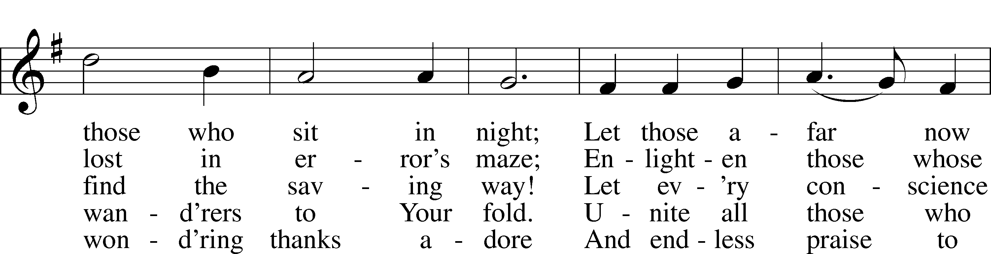
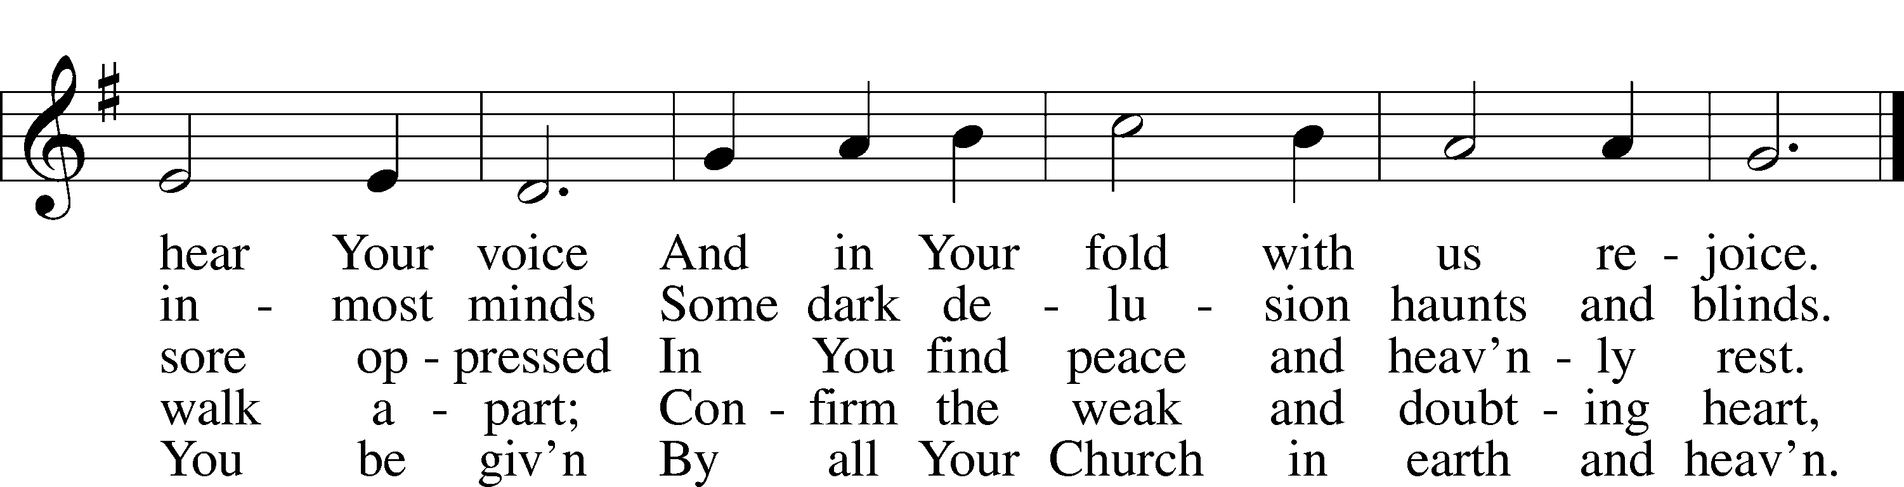
Text: Johann Heermann, 1585–1647; tr. Catherine Winkworth, 1827–78, alt.
Tune: Andächtige Haus-Kirche, 1676, Nürnberg
Text and tune: Public domain

Sermon

Votum
P The peace of God, which passes all understanding, keep your hearts and minds in Christ Jesus.
C Amen.

Stand

Offertory Psalm 51:10–12
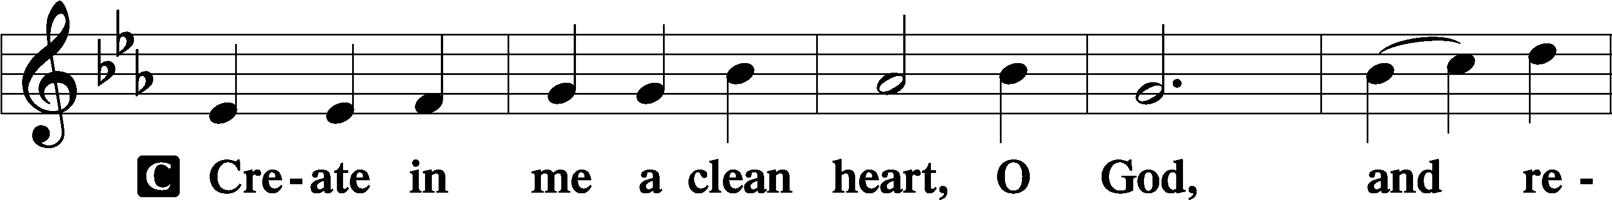
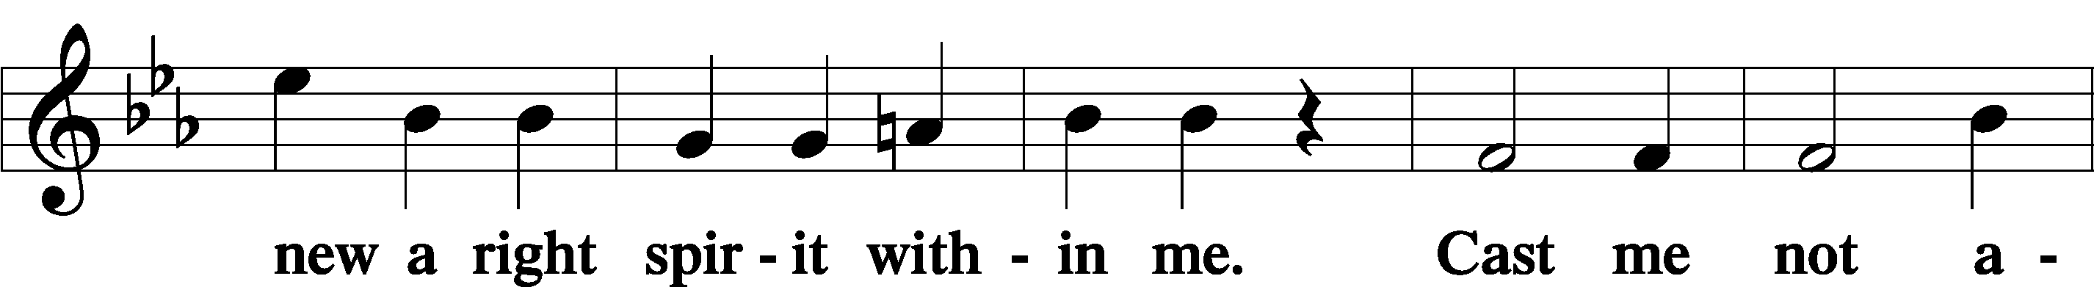
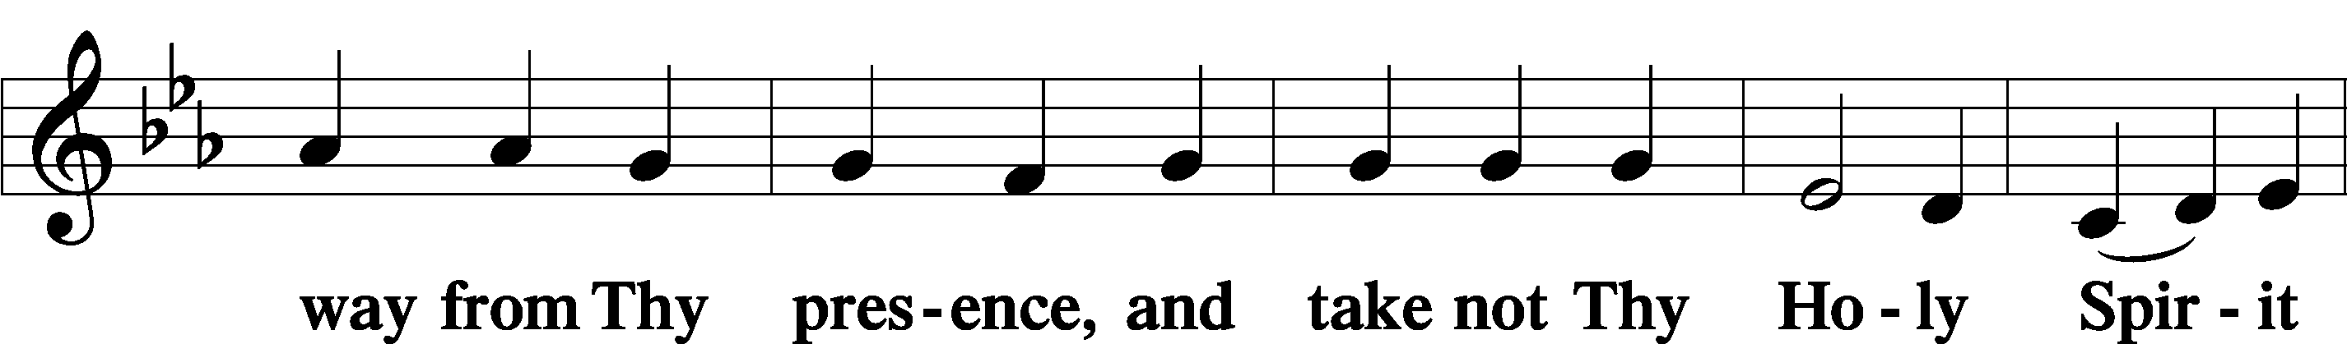
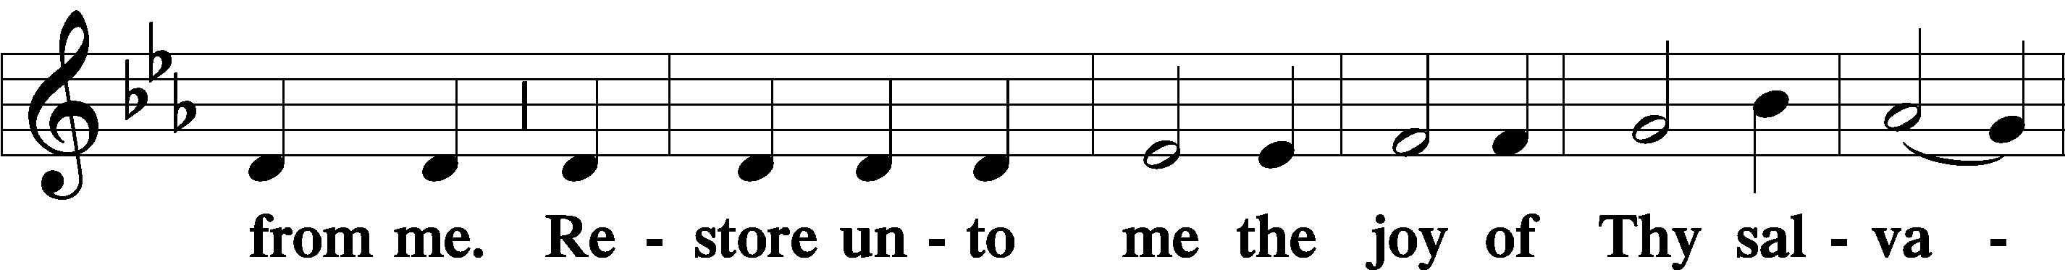
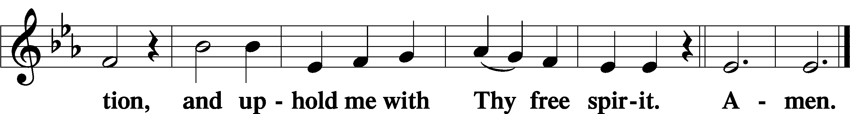

Offering

Prayer of the Church

Lord’s Prayer Matthew 6:9–13
P Lord, remember us in Your kingdom and teach us to pray:
C Our Father who art in heaven,
hallowed be Thy name,
Thy kingdom come,
Thy will be done on earth
as it is in heaven;
give us this day our daily bread;
and forgive us our trespasses
as we forgive those
who trespass against us;
and lead us not into temptation,
but deliver us from evil.
For Thine is the kingdom
and the power and the glory
forever and ever. Amen.

Collect for the Word
Blessed Lord, You have caused all Holy Scriptures to be written for our learning.
Grant that we may so hear them, read, mark, learn, and inwardly digest them that, by the patience and comfort of Your holy Word, we may embrace and ever hold fast the blessed hope of everlasting life; which you have given us in our Savior Jesus Christ, your Son, our Lord, who lives and reigns with You and the Holy Spirit, one God, now and forever.

Post-Communion Collect
A Let us pray.

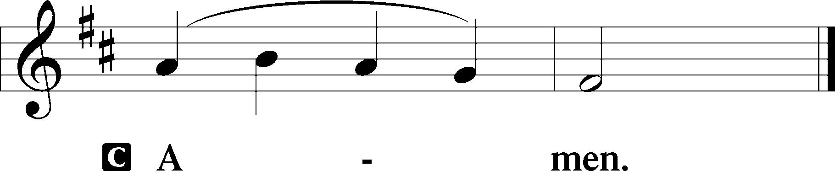

644 The Church’s One Foundation sts. 1–5
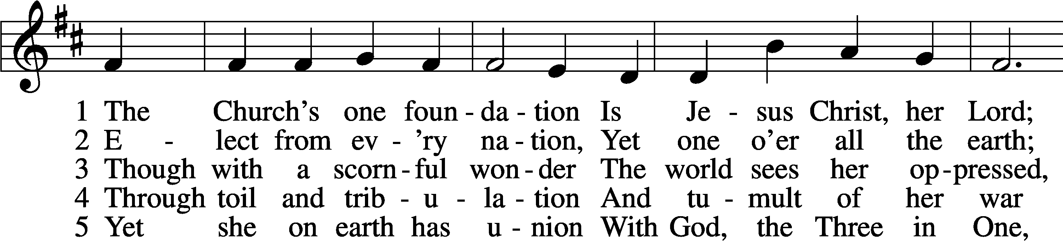
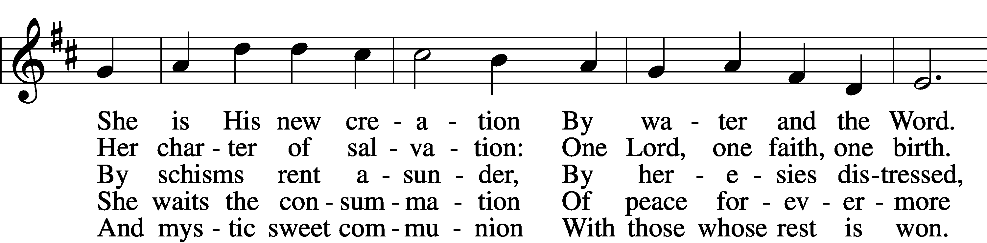
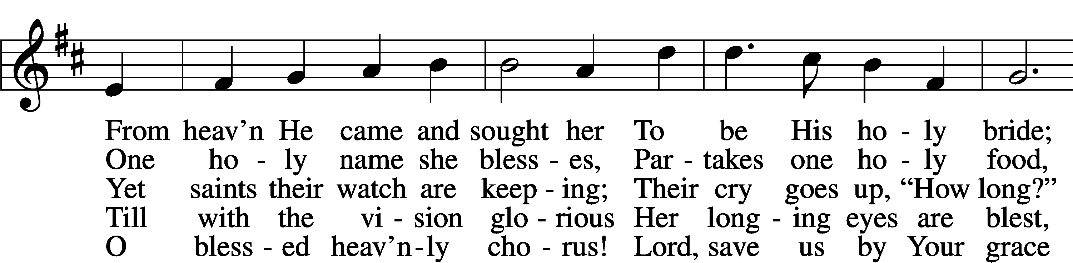
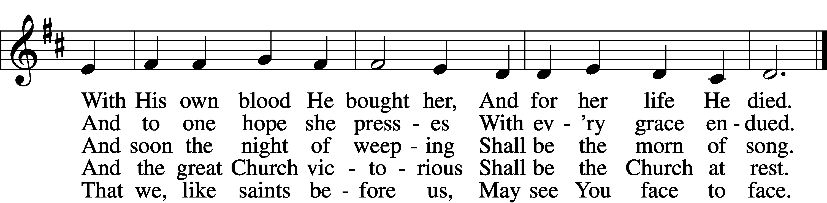
Text: Samuel J. Stone, 1839–1900, alt.
Tune: Samuel S. Wesley, 1810–76
Text and tune: Public domain

Acknowledgments
Unless otherwise indicated, Scripture quotations are from the ESV® Bible (The Holy Bible, English Standard Version®), copyright © 2001 by Crossway, a publishing ministry of Good News Publishers. Used by permission. All rights reserved.
Created by Lutheran Service Builder © 2023 Concordia Publishing House.

