TLH 16 Blessed Jesus, at Your Word
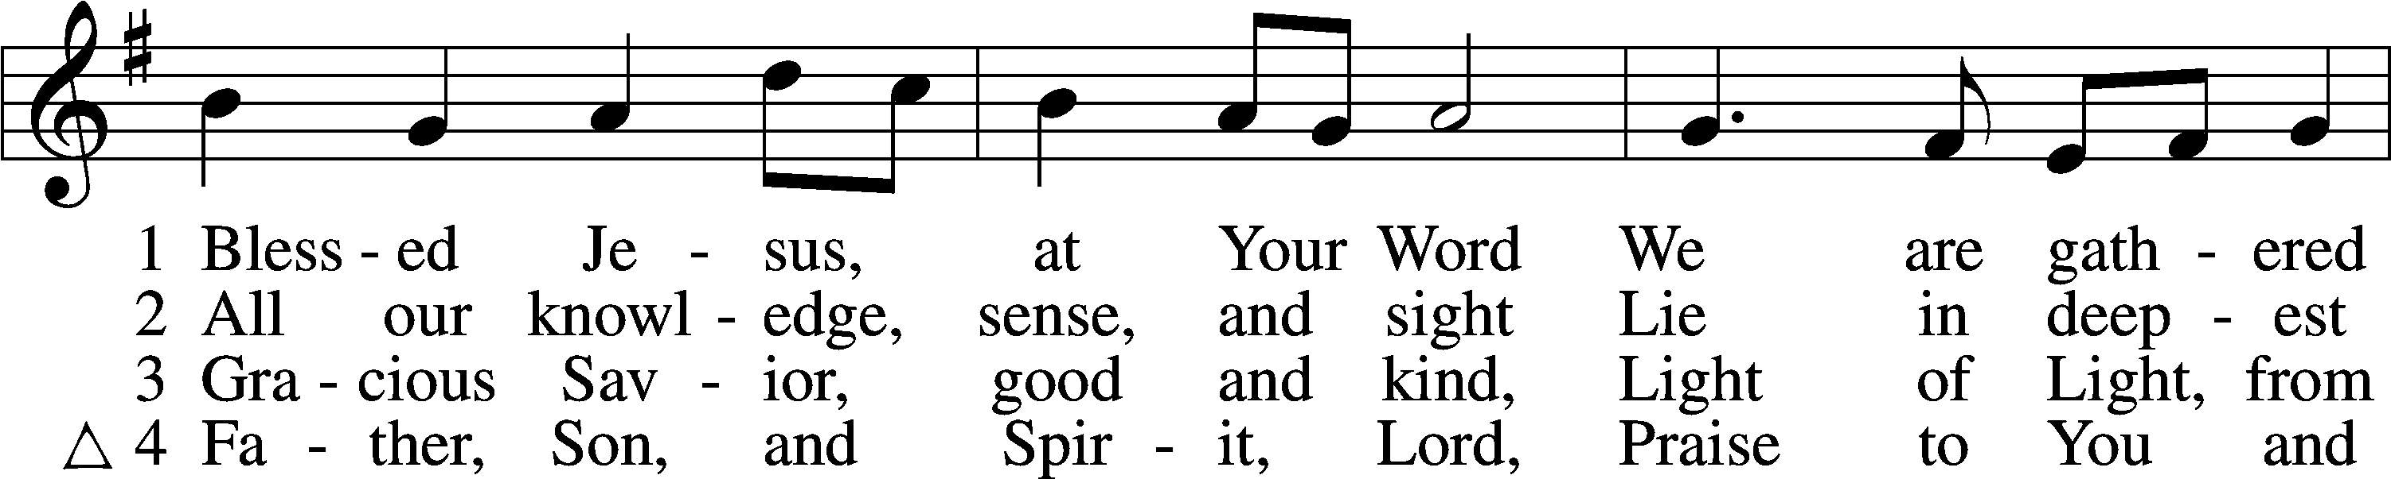
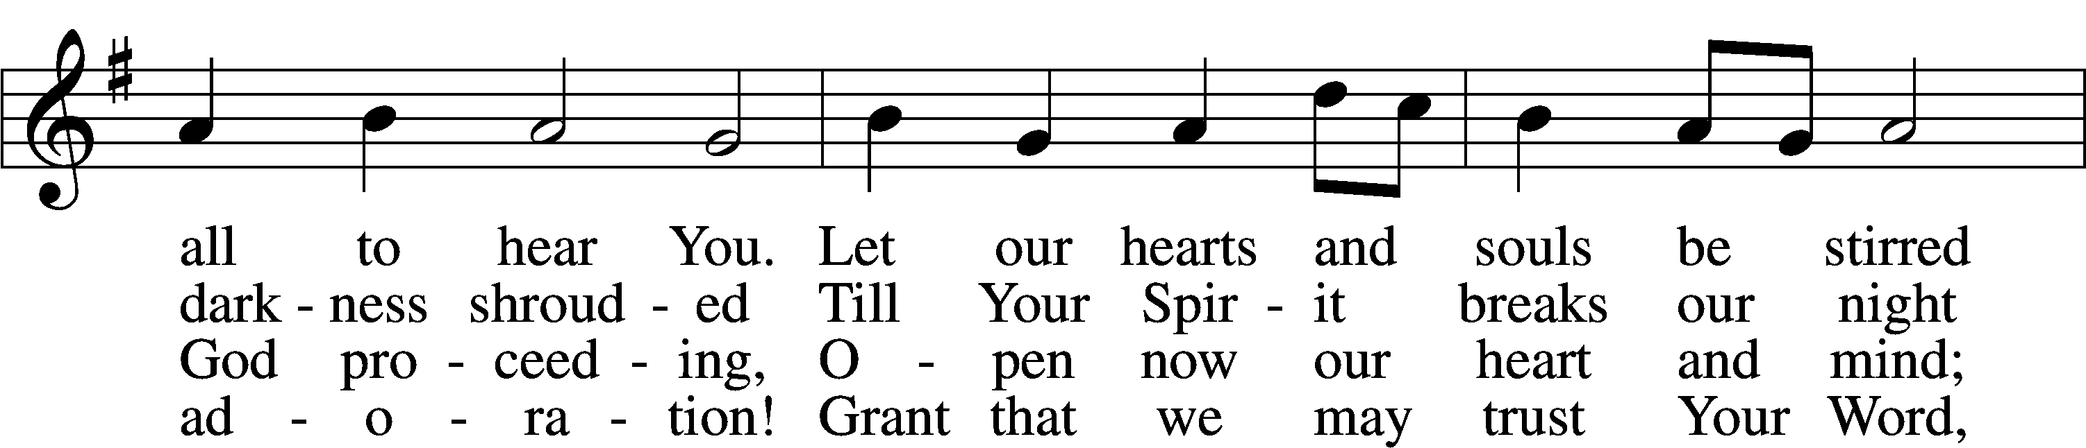
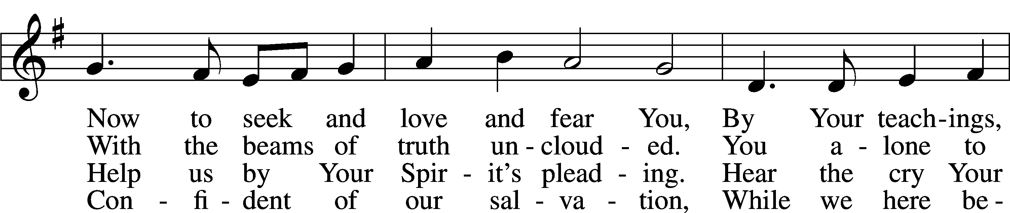
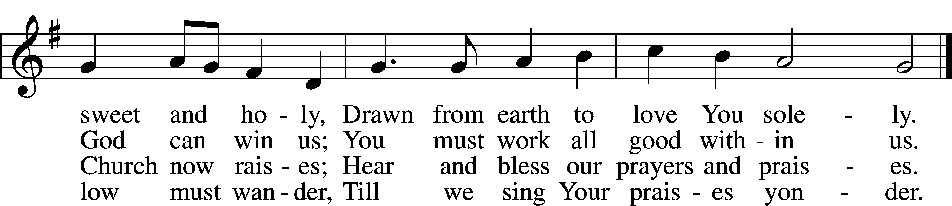
Text (sts. 1–3): Tobias Clausnitzer, 1619–84; (sts. 1–3): tr. Catherine Winkworth, 1827–78, alt.; (st. 4): Geistreiches Gesang-Büchlein, 1707, Berlin; (st. 4): tr. unknown, alt.
Tune: Johann Rudolph Ahle, 1625–73, alt.
Text and tune: Public domain

Confession and Absolution

Stand

The sign of the cross may be made by all in remembrance of their Baptism.

Invocation Matthew 28:19b; 18:20
P In the name of the Father and of the T Son and of the Holy Spirit.
C Amen.

Exhortation Hebrews 10:22; Psalm 124:8; Psalm 32:5
P Beloved in the Lord! Let us draw near with a true heart and confess our sins unto God our Father, beseeching Him in the name of our Lord Jesus Christ to grant us forgiveness.

P Our help is in the name of the Lord,
C who made heaven and earth.
P I said, I will confess my transgressions unto the Lord,
C and You forgave the iniquity of my sin.

Kneel/Stand

Silence for reflection on God’s Word and for self-examination.

Confession of Sins
P O almighty God, merciful Father,
C I, a poor, miserable sinner, confess unto You all my sins and iniquities with which I have ever offended You and justly deserved Your temporal and eternal punishment. But I am heartily sorry for them and sincerely repent of them, and I pray You of Your boundless mercy and for the sake of the holy, innocent, bitter sufferings and death of Your beloved Son, Jesus Christ, to be gracious and merciful to me, a poor, sinful being.

Absolution [John 20:19–23]
P Upon this your confession, I, by virtue of my office, as a called and ordained servant of the Word, announce the grace of God unto all of you, and in the stead and by the command of my Lord Jesus Christ I forgive you all your sins in the name of the Father and of the T Son and of the Holy Spirit.
C Amen.

Stand

Service of the Word

Introit Psalm 1:1–5; antiphon: v. 6
For the Lord knows the way of the righteous,
but the way of the wicked will perish.
Blessèd is the man who walks not in the counsel of the wicked,
nor stands in the way of sinners, nor sits in the seat of scoffers;
but his delight is in the law of the Lord,
and on his law he meditates day and night.
He is like a tree planted by streams of water that yields its fruit in its season, and its leaf does not wither.
In all that he does, he prospers.
The wicked are not so,
but are like chaff that the wind drives away.
Therefore the wicked will not stand in the judgment,
nor sinners in the congregation of the righteous.

Gloria Patri
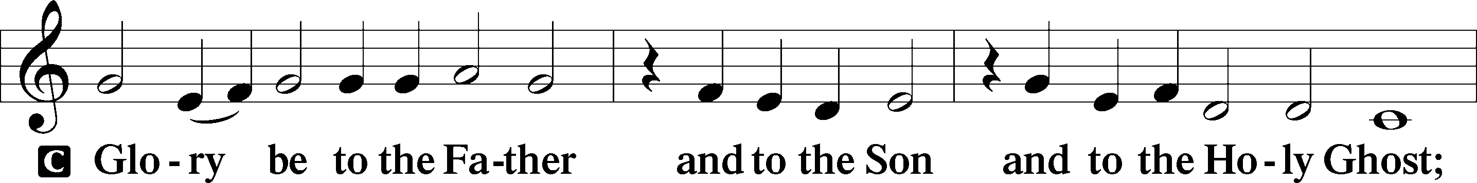
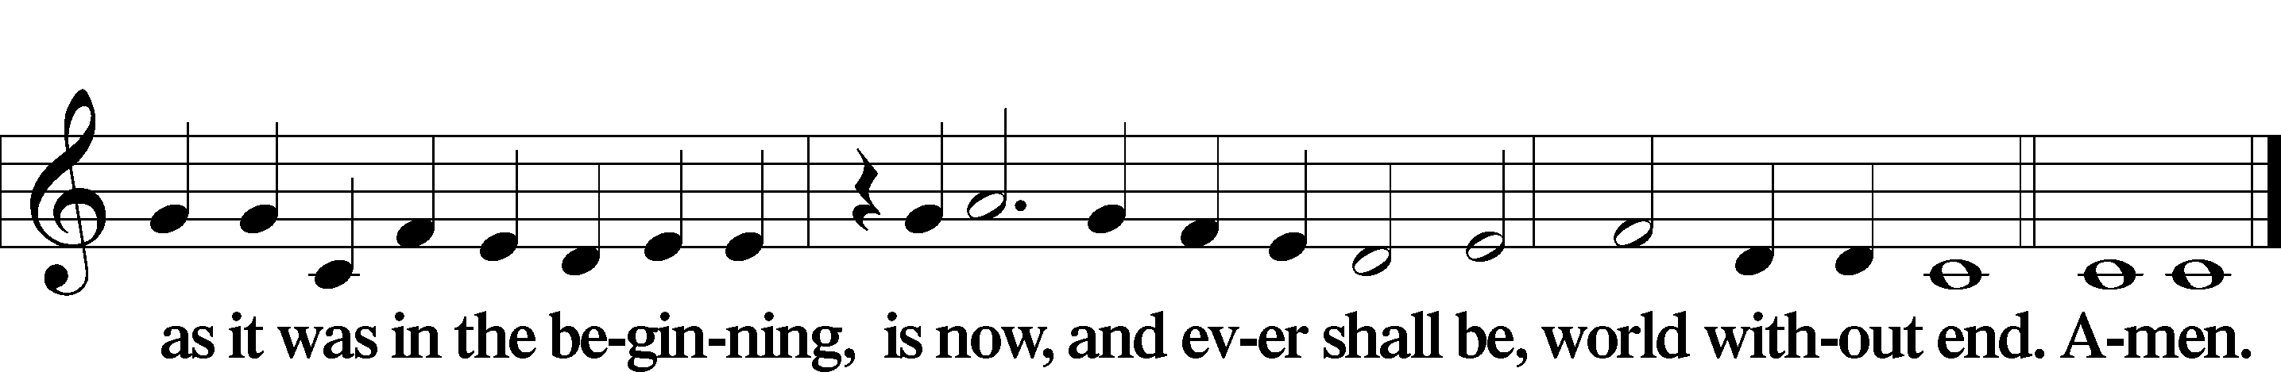

Kyrie Mark 10:47
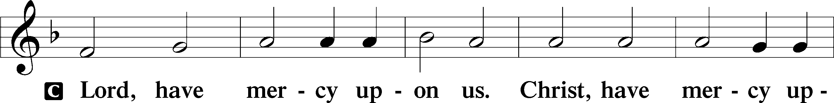
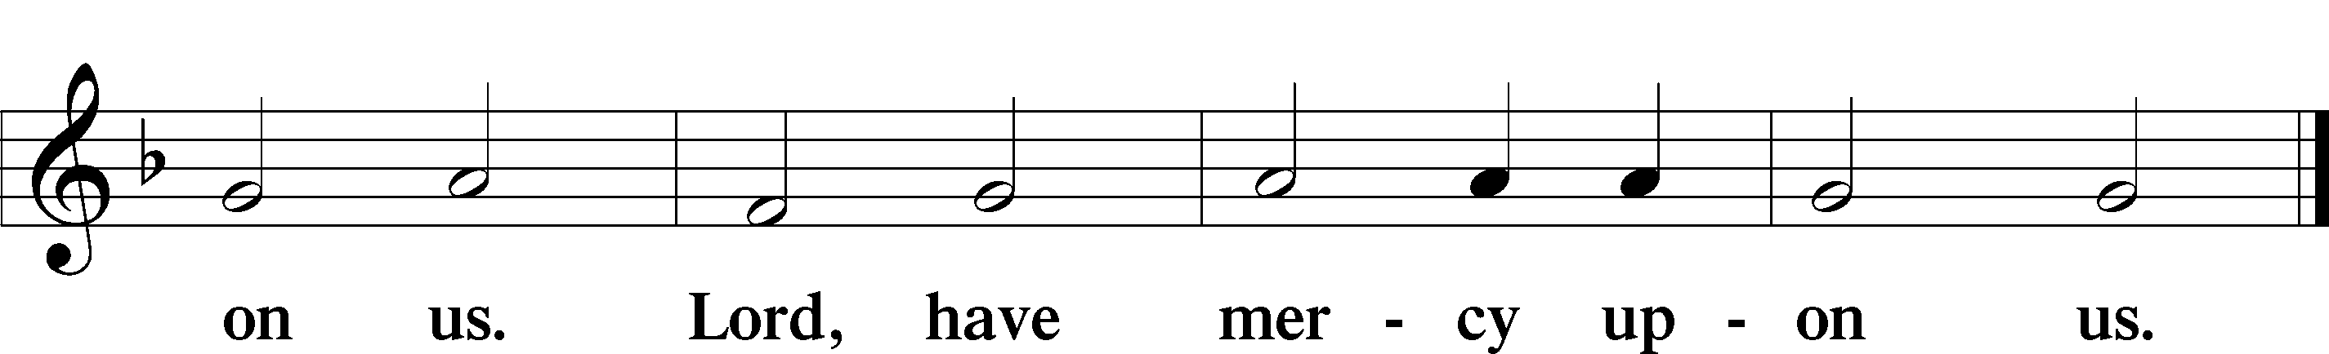

Gloria in Excelsis Luke 2:14; John 1:29
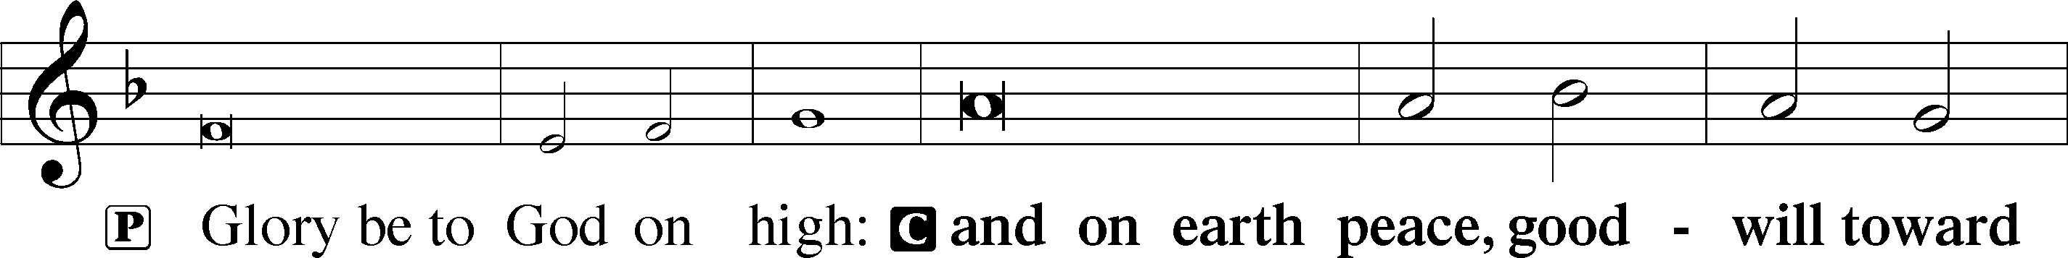
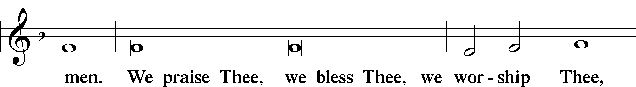
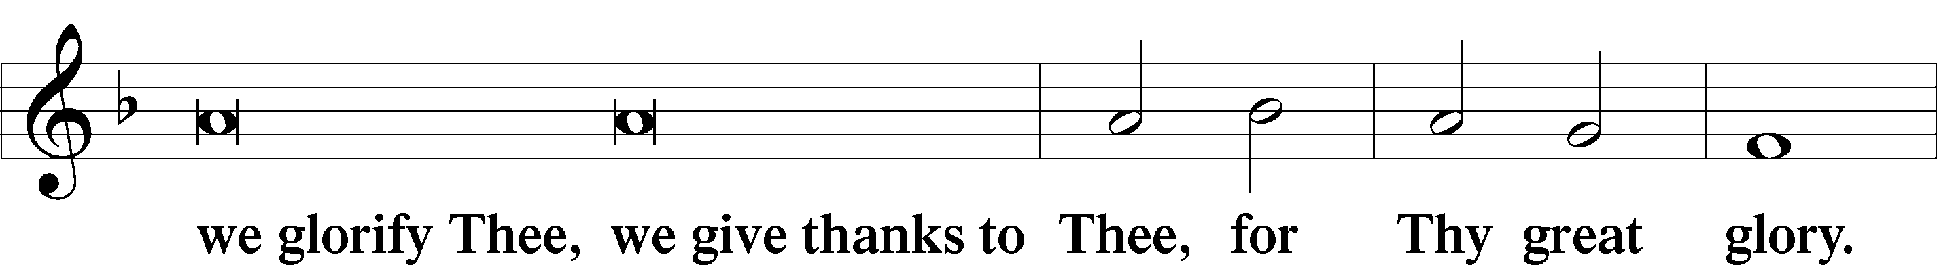
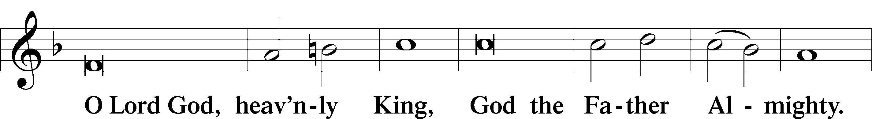
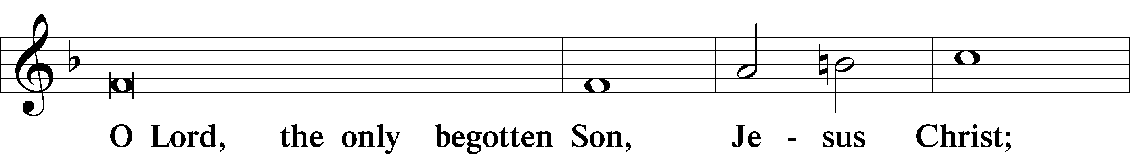
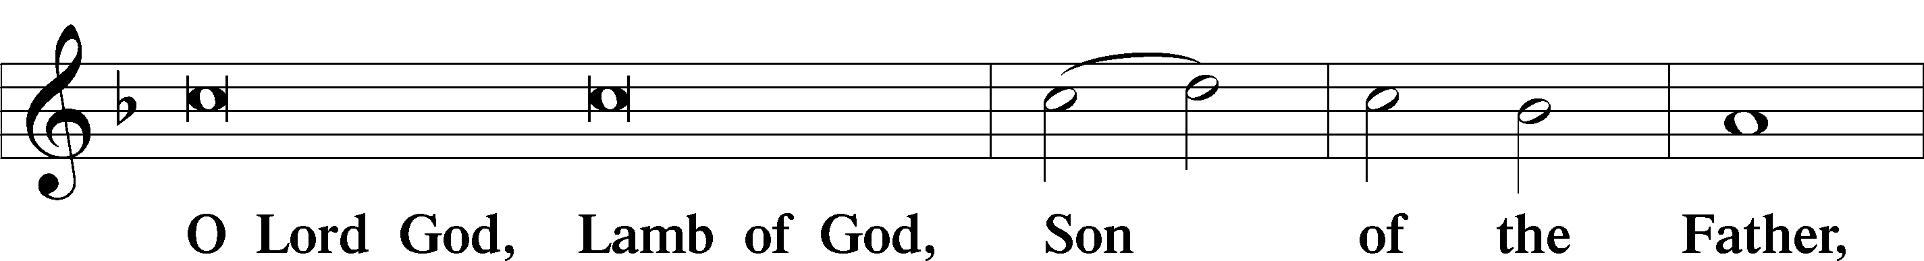
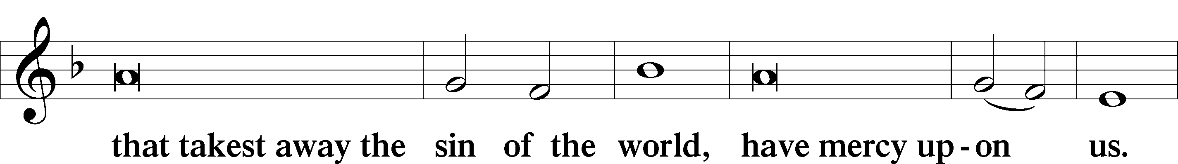
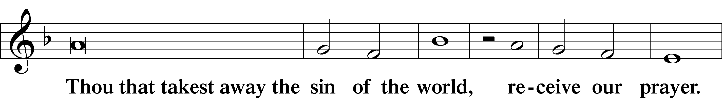
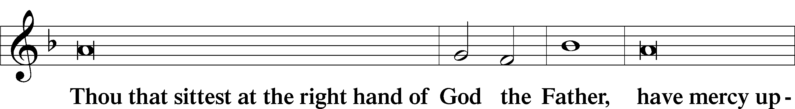
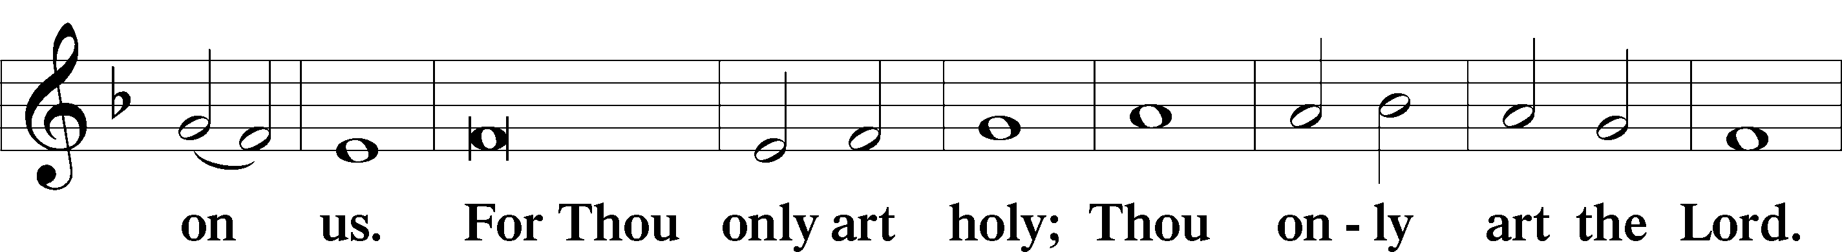
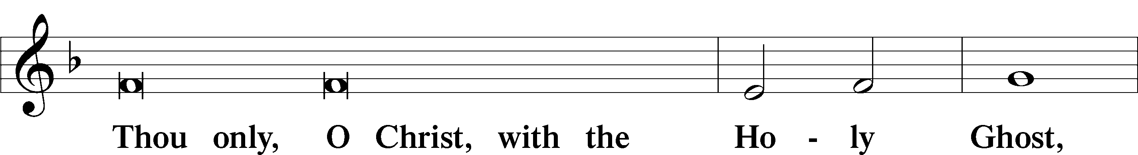
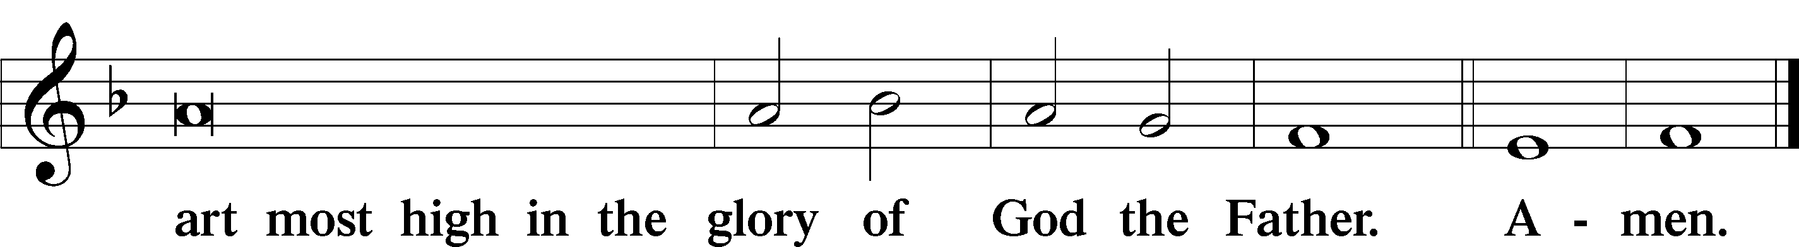

Salutation and Collect of the Day
P The Lord be with you.
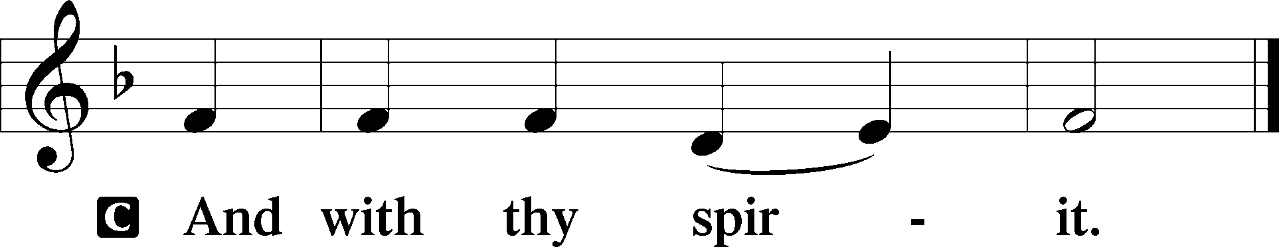

P Let us pray.
Almighty God, You know we live in the midst of so many dangers that in our frailty we cannot stand upright. Grant strength and protection to support us in all dangers and carry us through all temptations; through Jesus Christ, Your Son, our Lord, who lives and reigns with You and the Holy Spirit, one God, now and forever.

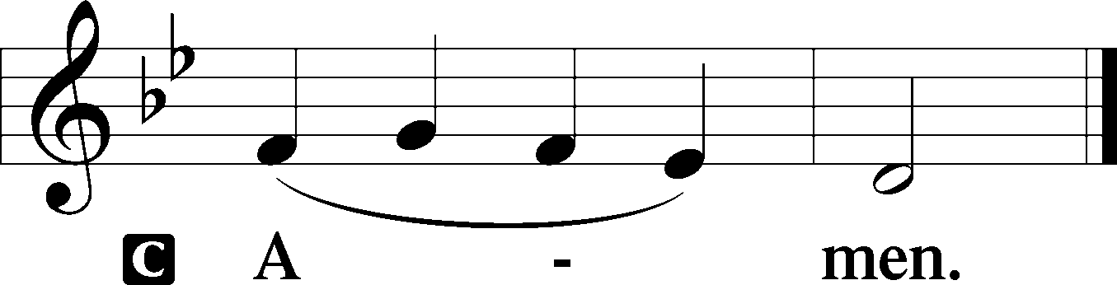

Sit

Old Testament Reading Micah 6:1–8
The Indictment of the Lord
1Hear what the Lord says:
Arise, plead your case before the mountains,
and let the hills hear your voice.
2Hear, you mountains, the indictment of the Lord,
and you enduring foundations of the earth,
for the Lord has an indictment against his people,
and he will contend with Israel.
3“O my people, what have I done to you?
How have I wearied you? Answer me!
4For I brought you up from the land of Egypt
and redeemed you from the house of slavery,
and I sent before you Moses,
Aaron, and Miriam.
5O my people, remember what Balak king of Moab devised,
and what Balaam the son of Beor answered him,
and what happened from Shittim to Gilgal,
that you may know the saving acts of the Lord.”
What Does the Lord Require?
6“With what shall I come before the Lord,
and bow myself before God on high?
Shall I come before him with burnt offerings,
with calves a year old?
7Will the Lord be pleased with thousands of rams,
with ten thousands of rivers of oil?
Shall I give my firstborn for my transgression,
the fruit of my body for the sin of my soul?”
8He has told you, O man, what is good;
and what does the Lord require of you
but to do justice, and to love kindness,
and to walk humbly with your God?

A This is the Word of the Lord.
C Thanks be to God.

Gradual Psalm 117:1–2a; 96:8
Praise the Lord, all nations!
Extol him, all peoples!
For great is his steadfast love toward us,
and the faithfulness of the Lord endures forever.
Ascribe to the Lord the glory due his name;
bring an offering, and come into his courts!

Epistle 1 Corinthians 1:18–31
Christ the Wisdom and Power of God
18The word of the cross is folly to those who are perishing, but to us who are being saved it is the power of God. 19For it is written,
“I will destroy the wisdom of the wise,
and the discernment of the discerning I will thwart.”
20Where is the one who is wise? Where is the scribe? Where is the debater of this age? Has not God made foolish the wisdom of the world? 21For since, in the wisdom of God, the world did not know God through wisdom, it pleased God through the folly of what we preach to save those who believe. 22For Jews demand signs and Greeks seek wisdom, 23but we preach Christ crucified, a stumbling block to Jews and folly to Gentiles, 24but to those who are called, both Jews and Greeks, Christ the power of God and the wisdom of God. 25For the foolishness of God is wiser than men, and the weakness of God is stronger than men.
26For consider your calling, brothers: not many of you were wise according to worldly standards, not many were powerful, not many were of noble birth. 27But God chose what is foolish in the world to shame the wise; God chose what is weak in the world to shame the strong; 28God chose what is low and despised in the world, even things that are not, to bring to nothing things that are, 29so that no human being might boast in the presence of God. 30He is the source of your life in Christ Jesus, whom God made our wisdom and our righteousness and sanctification and redemption. 31Therefore, as it is written, “Let the one who boasts, boast in the Lord.”

A This is the Word of the Lord.
C Thanks be to God.

Stand

Alleluia
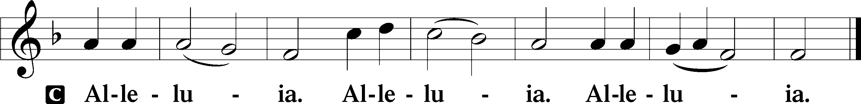

Holy Gospel Matthew 5:1–12
P The Holy Gospel according to St. Matthew, the fifth chapter.

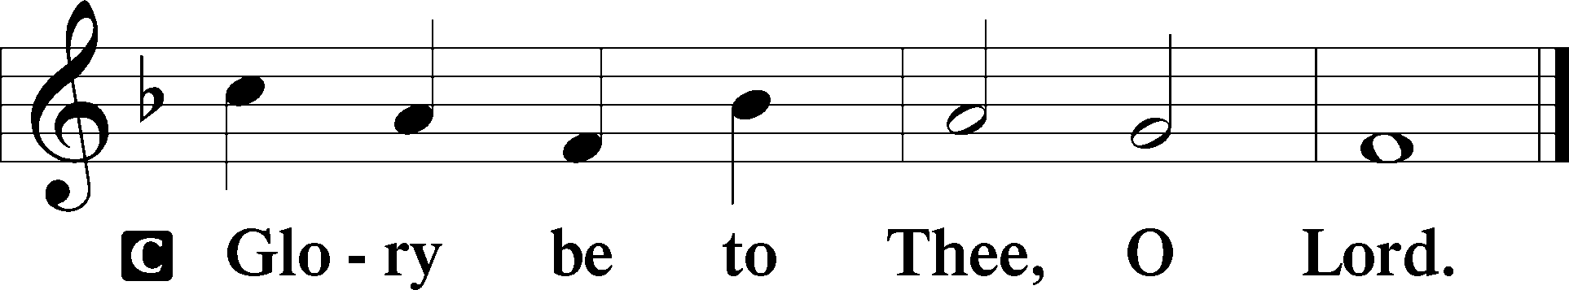

The Sermon on the Mount
1Seeing the crowds, [Jesus] went up on the mountain, and when he sat down, his disciples came to him.
The Beatitudes
2And he opened his mouth and taught them, saying:
3“Blessed are the poor in spirit, for theirs is the kingdom of heaven.
4“Blessed are those who mourn, for they shall be comforted.
5“Blessed are the meek, for they shall inherit the earth.
6“Blessed are those who hunger and thirst for righteousness, for they shall be satisfied.
7“Blessed are the merciful, for they shall receive mercy.
8“Blessed are the pure in heart, for they shall see God.
9“Blessed are the peacemakers, for they shall be called sons of God.
10“Blessed are those who are persecuted for righteousness’ sake, for theirs is the kingdom of heaven.
11“Blessed are you when others revile you and persecute you and utter all kinds of evil against you falsely on my account. 12Rejoice and be glad, for your reward is great in heaven, for so they persecuted the prophets who were before you.”

P This is the Gospel of the Lord.

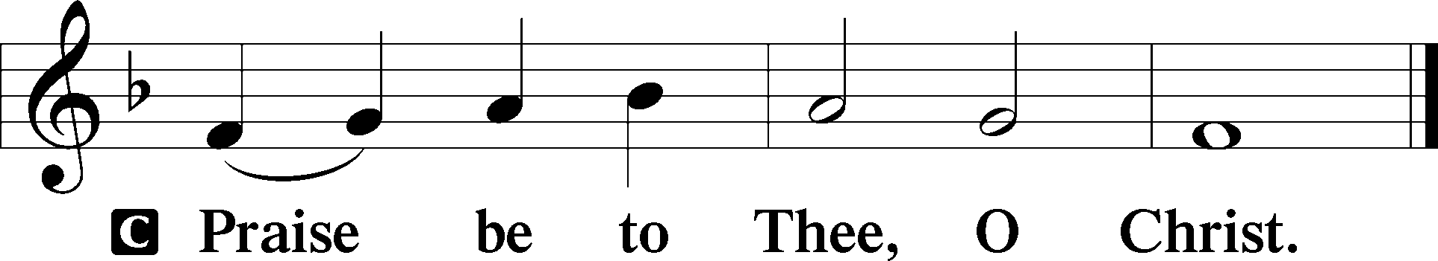

Nicene Creed
C I believe in one God,
the Father Almighty,
maker of heaven and earth
and of all things visible and invisible.

And in one Lord Jesus Christ,
the only-begotten Son of God,
begotten of His Father before all worlds,
God of God, Light of Light,
very God of very God,
begotten, not made,
being of one substance with the Father,
by whom all things were made;
who for us men and for our salvation came down from heaven
and was incarnate by the Holy Spirit of the virgin Mary
and was made man;
and was crucified also for us under Pontius Pilate.
He suffered and was buried.
And the third day He rose again according to the Scriptures
and ascended into heaven
and sits at the right hand of the Father.
And He will come again with glory to judge both the living and the dead,
whose kingdom will have no end.

And I believe in the Holy Spirit,
the Lord and giver of life,
who proceeds from the Father and the Son,
who with the Father and the Son together is worshiped and glorified,
who spoke by the prophets.
And I believe in one holy Christian and apostolic Church,
I acknowledge one Baptism for the remission of sins,
and I look for the resurrection of the dead
and the life T of the world to come. Amen.

Children's Message

592 Dearest Jesus, We Are Here
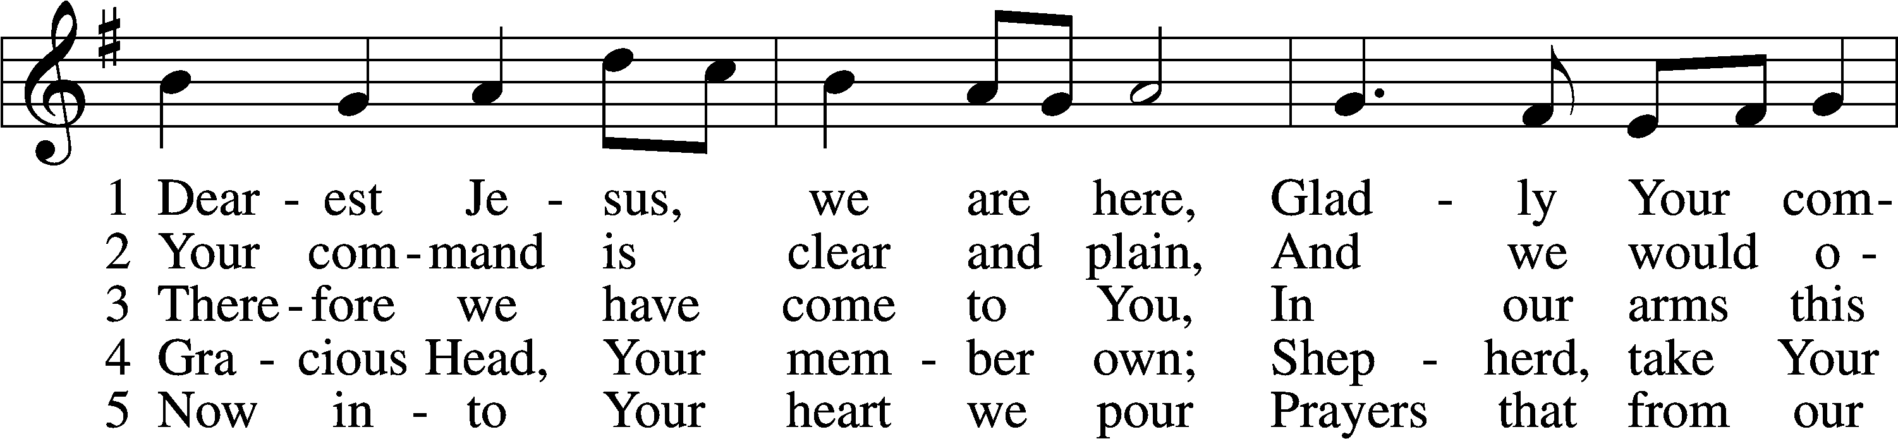
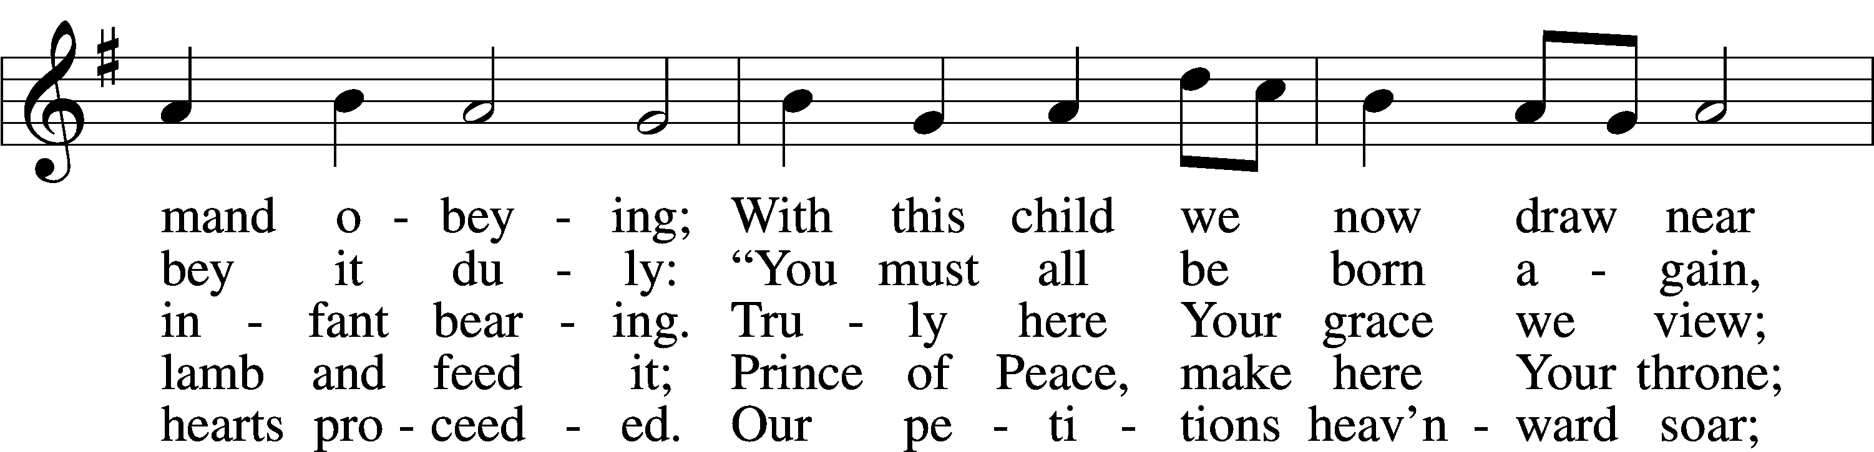
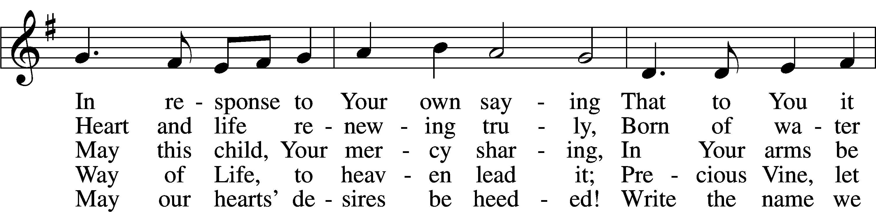
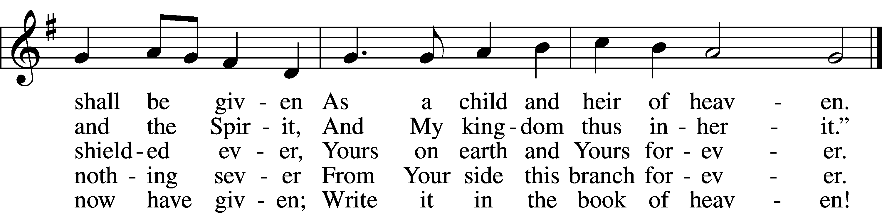
Text: Benjamin Schmolck, 1672–1737; tr. Catherine Winkworth, 1827–78, alt.
Tune: Johann Rudolph Ahle, 1625–73, alt.
Text and tune: Public domain

Sermon

Votum
P The peace of God, which passes all understanding, keep your hearts and minds in Christ Jesus.
C Amen.

Stand

Offertory Psalm 51:10–12
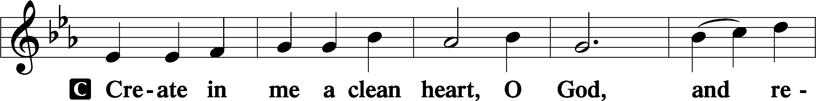
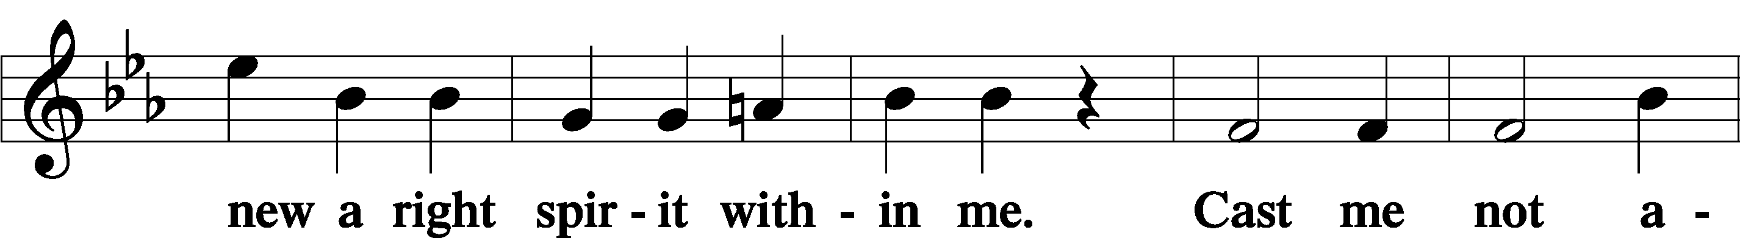
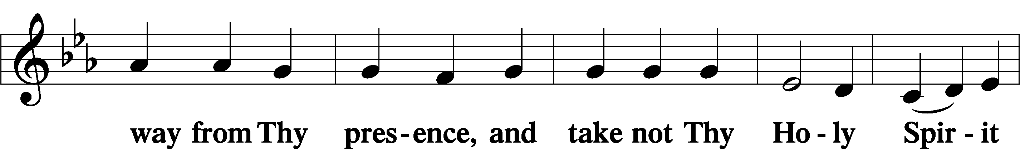
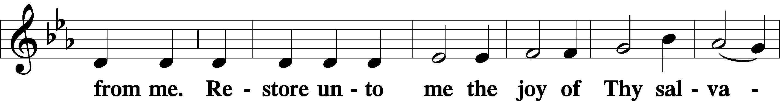
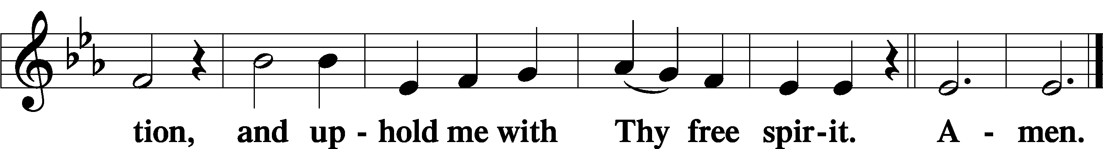

Sit

Offering

805 Praise God, from Whom All Blessings Flow
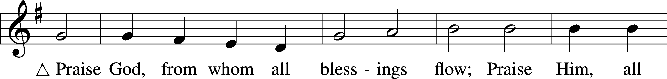
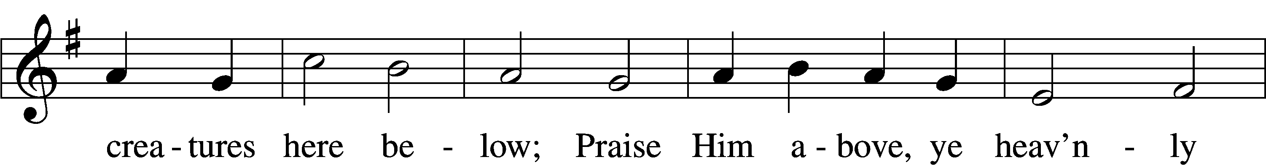
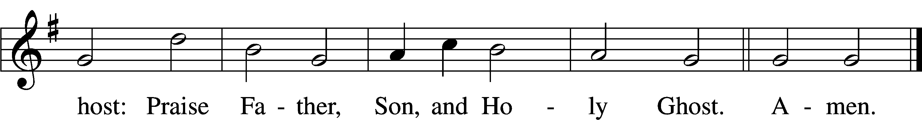
Text: Thomas Ken, 1637–1711
Tune: Trente quatre Pseaumes de David, 1551, Geneva, ed. Louis Bourgeois
Text and tune: Public domain

Stand

Prayer of the Church

Service of the Sacrament

Preface 2 Timothy 4:22; [Colossians 3:1]; [Psalm 136]
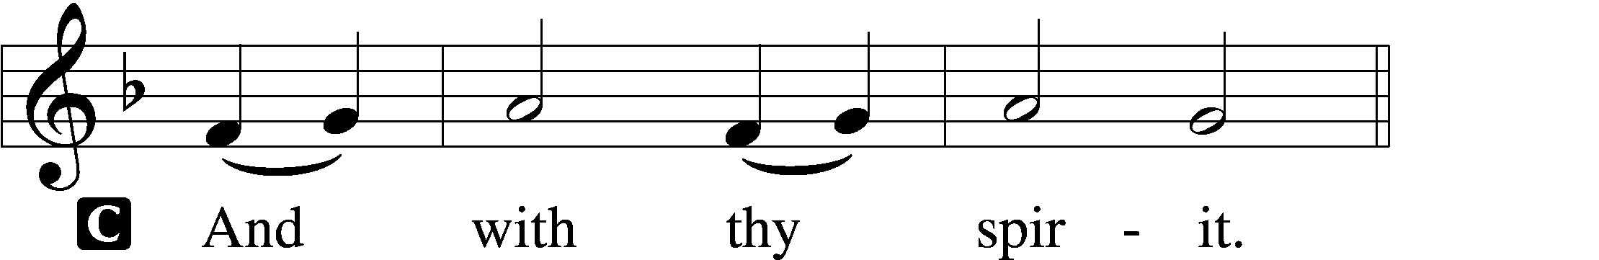

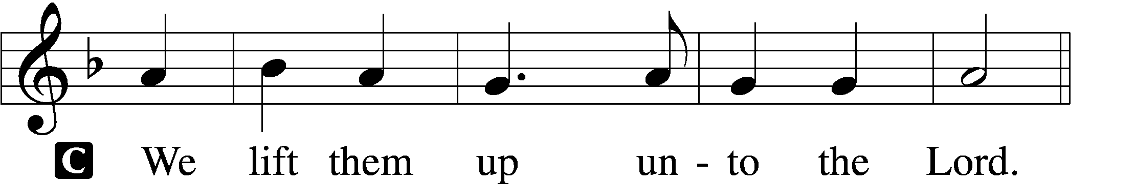

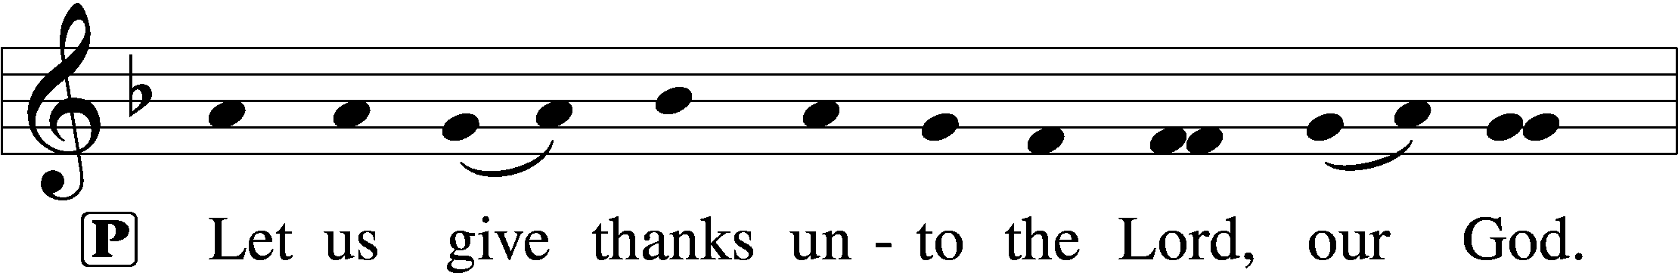
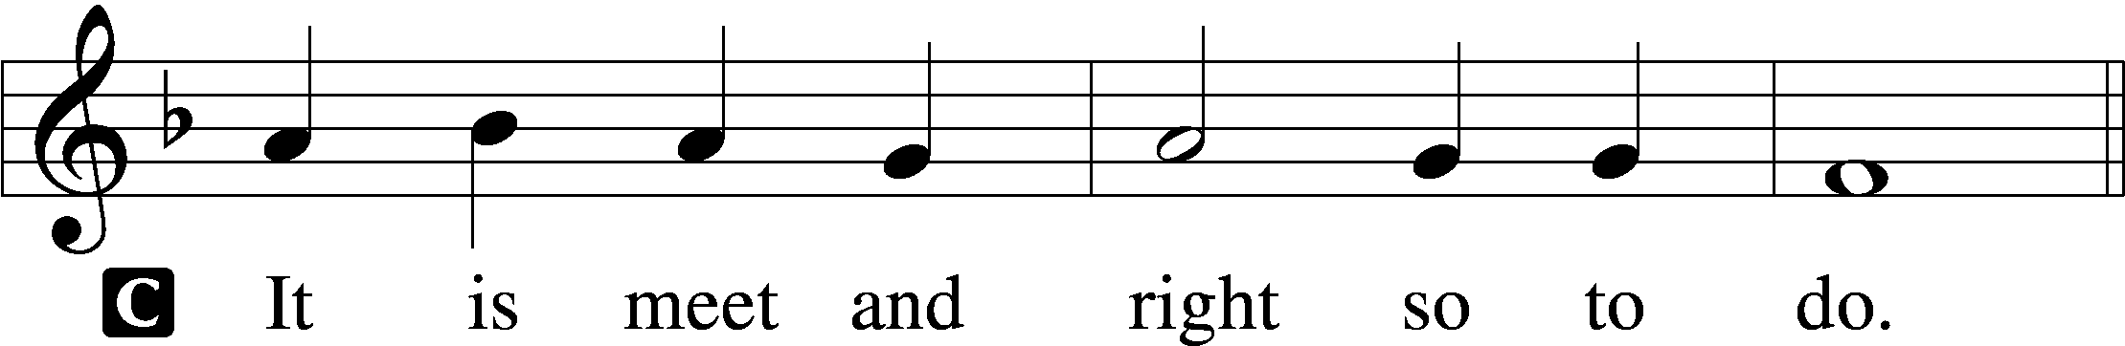

Proper Preface (Full)
P It is truly meet, right, and salutary that we should at all times and in all places give thanks to You, holy Lord, almighty Father, everlasting God, through Jesus Christ, our Lord; for what had been hidden from before the foundation of the world You have made known to the nations in Your Son. In Him, being found in the substance of our mortal nature, You have manifested the fullness of Your glory. Therefore with angels and archangels and with all the company of heaven we laud and magnify Your glorious name, evermore praising You and saying:

Sanctus Isaiah 6:3; Matthew 21:9
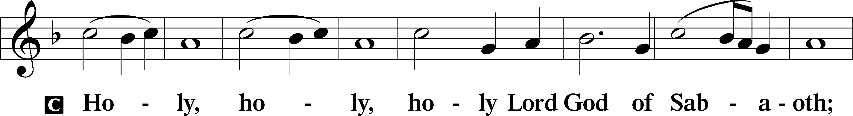
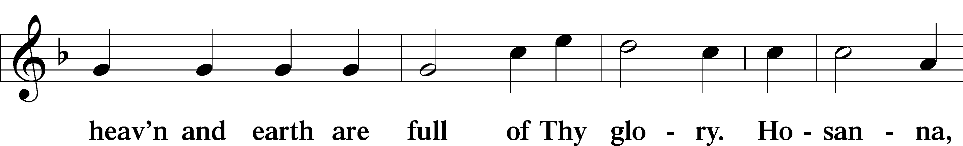
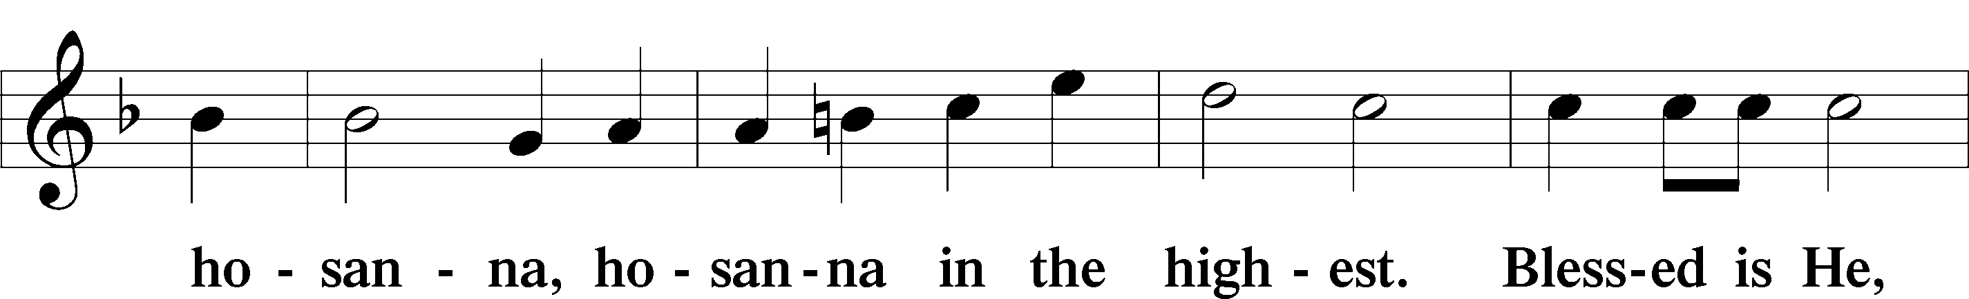
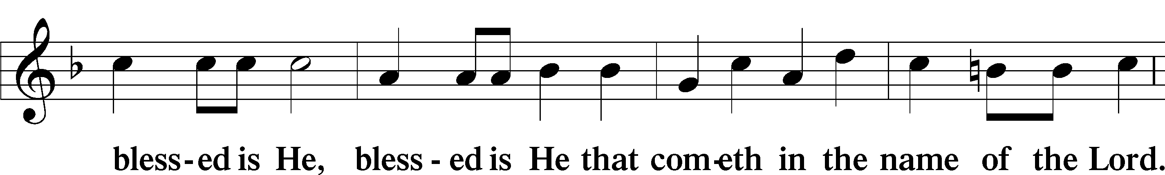
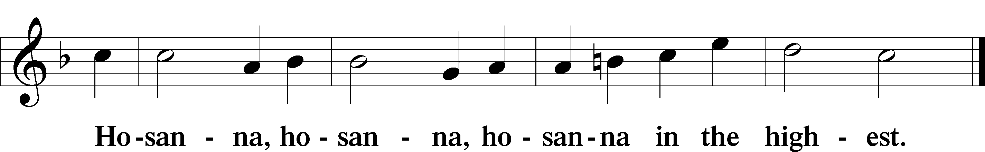

Lord’s Prayer Matthew 6:9–13
P Our Father who art in heaven,
hallowed be Thy name,
Thy kingdom come,
Thy will be done on earth as it is in heaven;
give us this day our daily bread;
and forgive us our trespasses as we forgive those who trespass against us;
and lead us not into temptation,
but deliver us from evil.
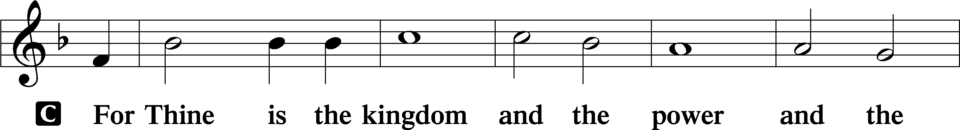
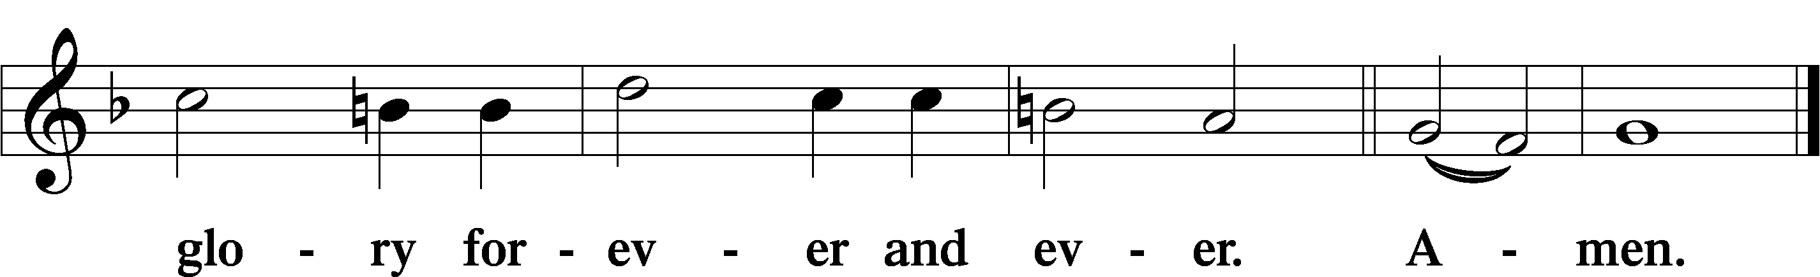

The Words of Our Lord Matthew 26:26–28; Mark 14:22–24; Luke 22:19–20; 1 Corinthians 11:23–25
P Our Lord Jesus Christ, on the night when He was betrayed, took bread, and when He had given thanks, He broke it and gave it to the disciples and said: “Take, eat; this is My T body, which is given for you. This do in remembrance of Me.”

In the same way also He took the cup after supper, and when He had given thanks, He gave it to them, saying: “Drink of it, all of you; this cup is the new testament in My T blood, which is shed for you for the forgiveness of sins. This do, as often as you drink it, in remembrance of Me.”

Pax Domini John 20:19
P The peace of the Lord be with you always.

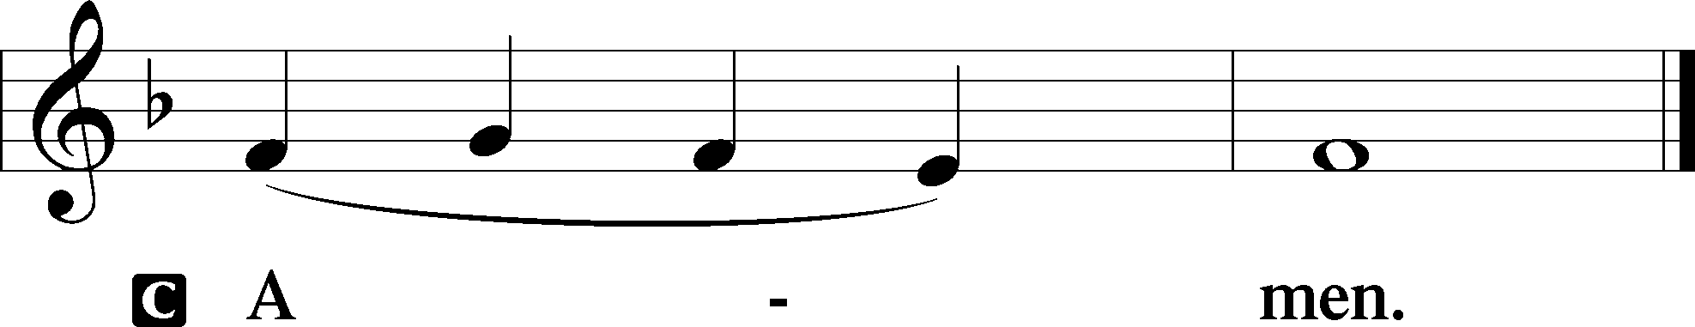

Agnus Dei John 1:29
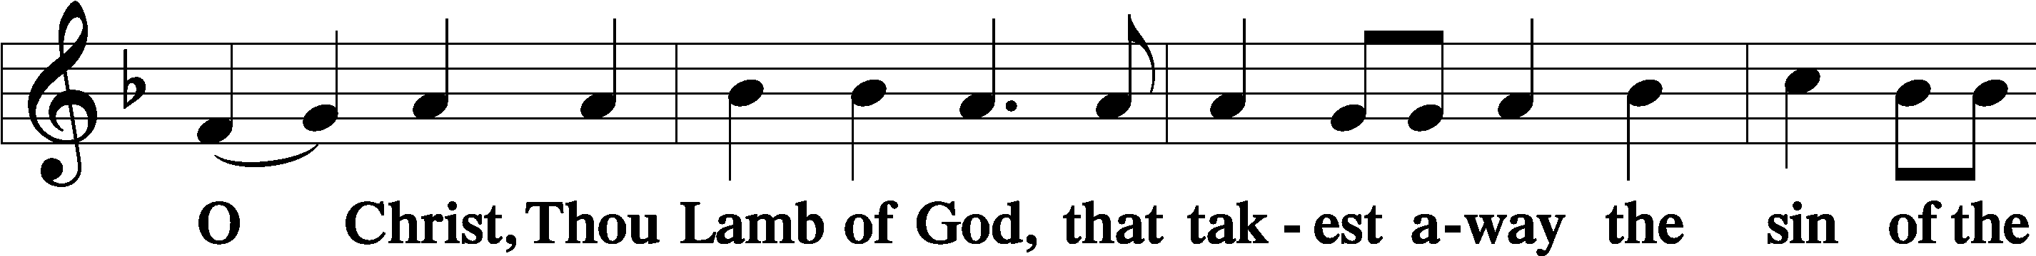
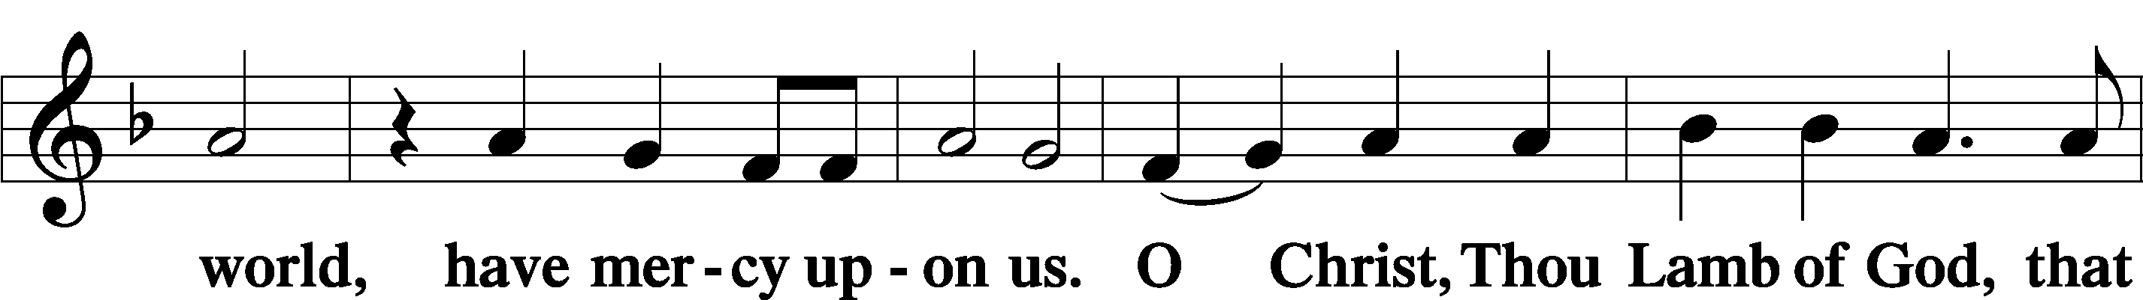
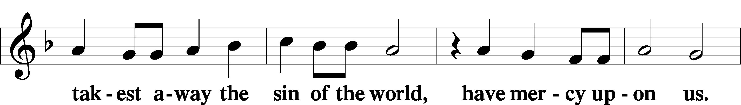
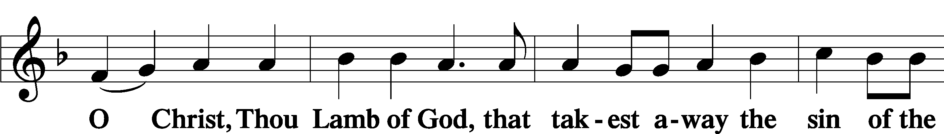
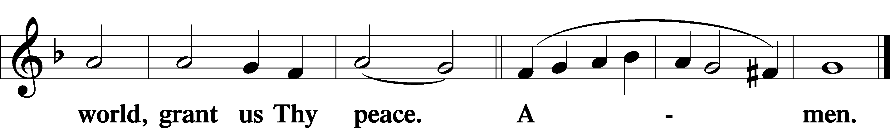

Sit

Distribution

575 My Hope Is Built on Nothing Less
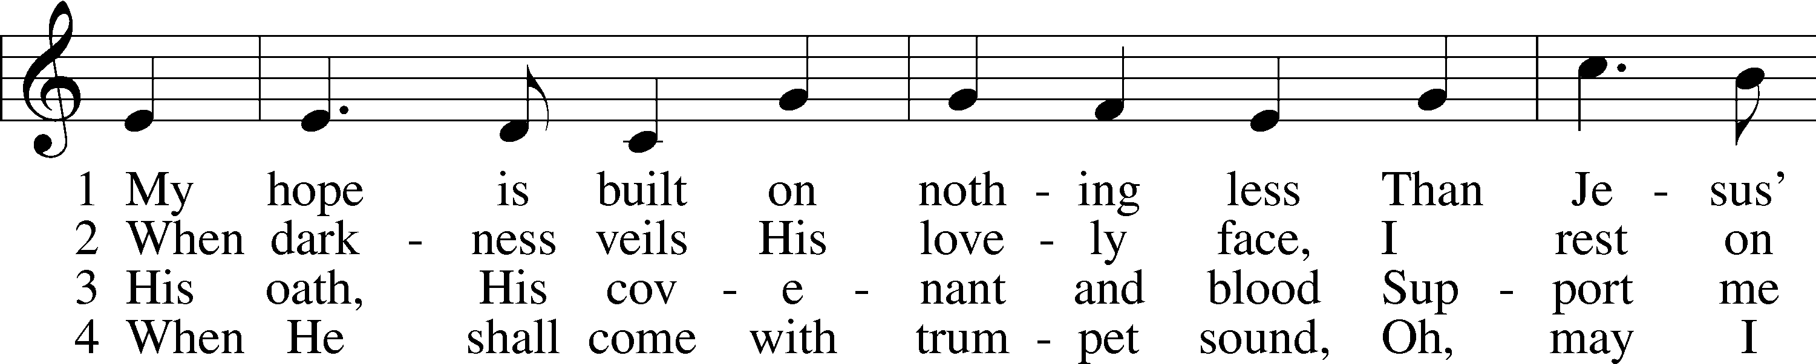
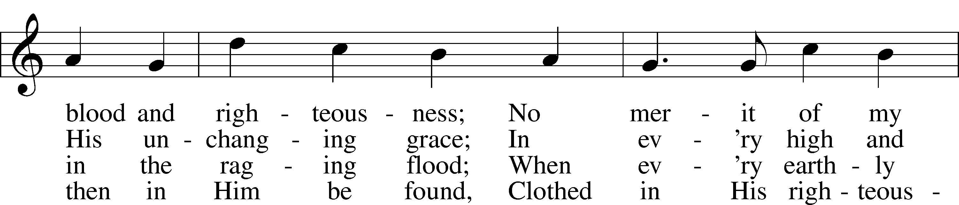
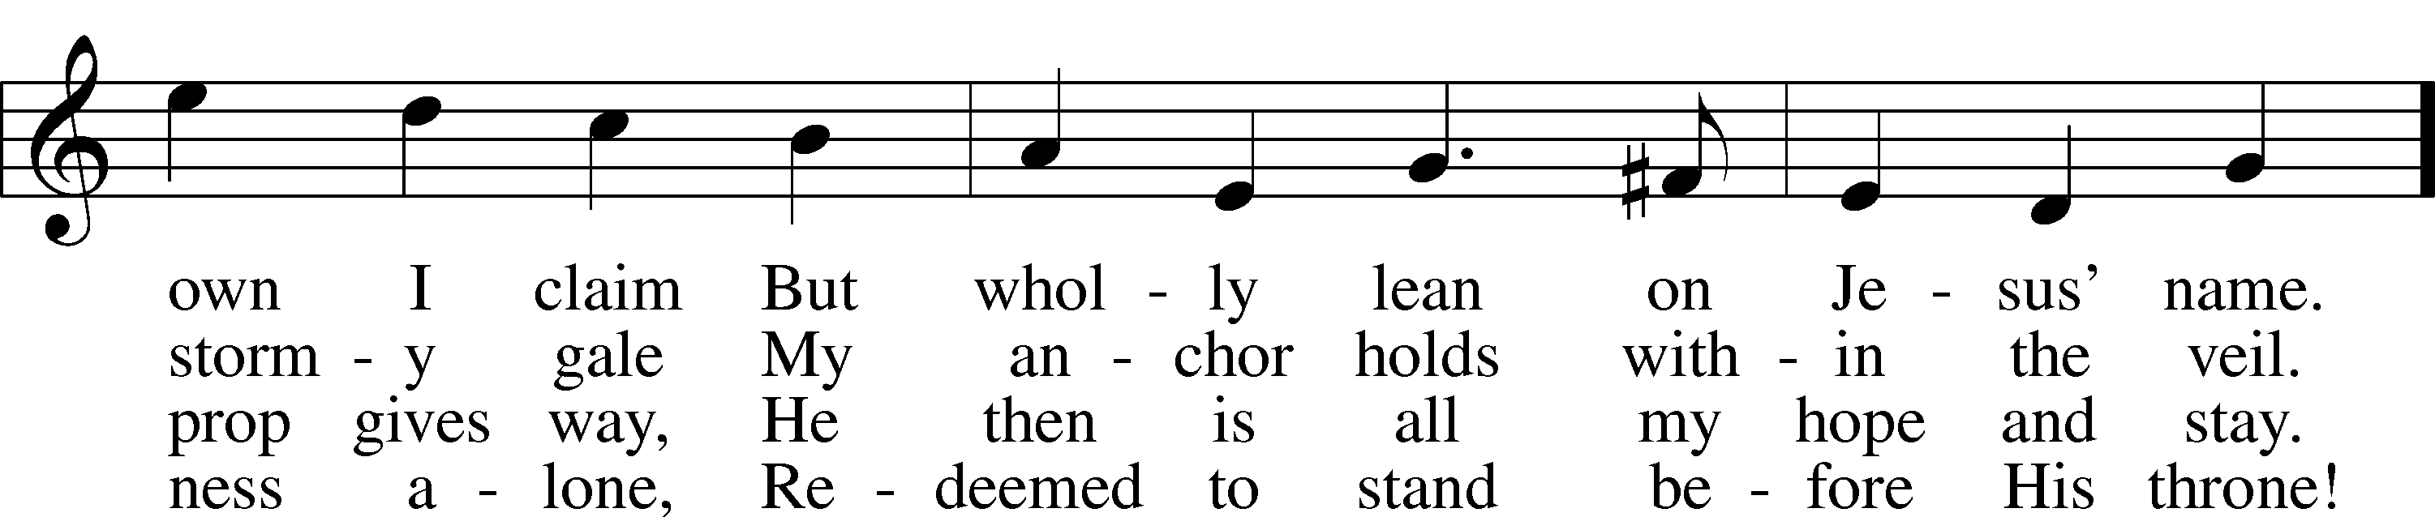
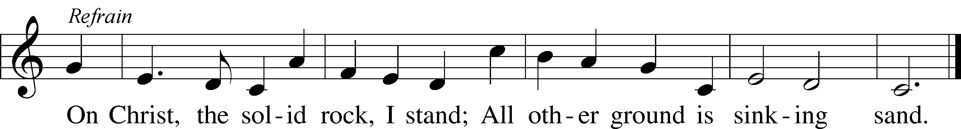
Text: Edward Mote, 1797–1874, alt.
Tune: John Stainer, 1840–1901
Text and tune: Public domain

783 Take My Life and Let It Be
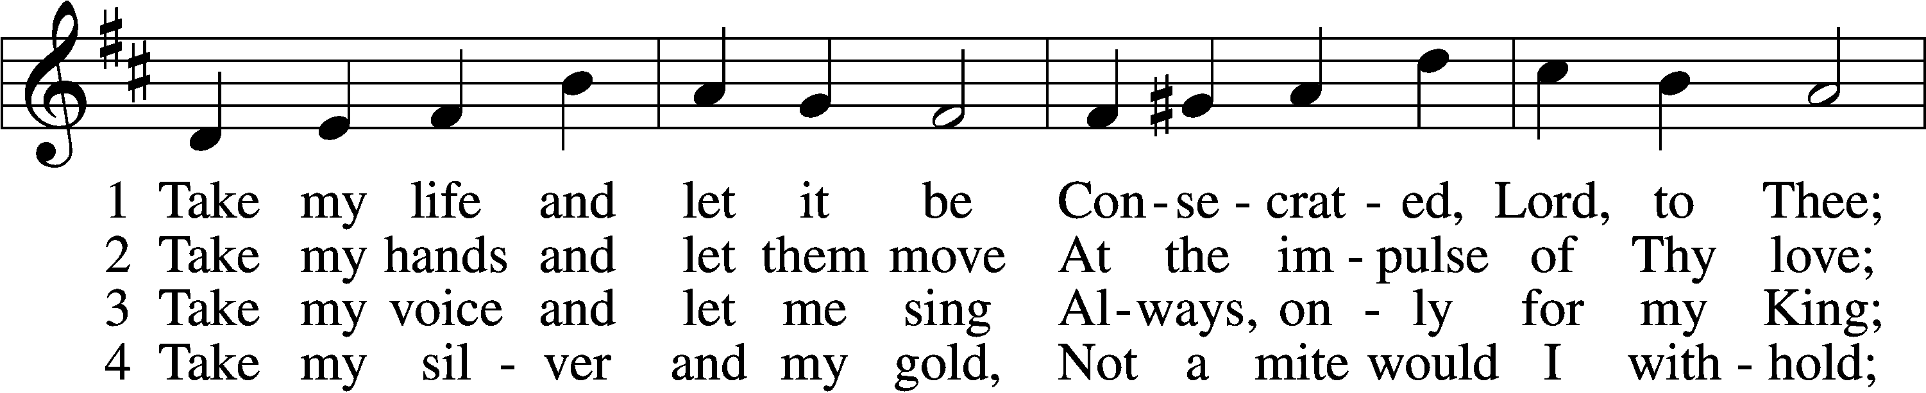
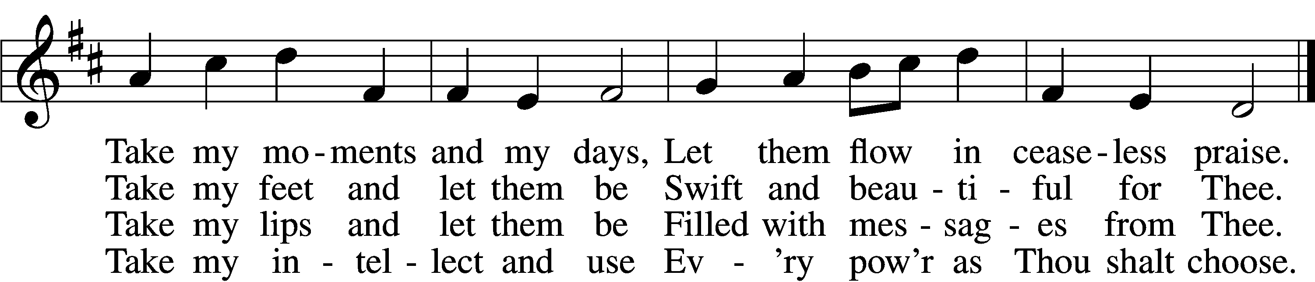

5 Take my will and make it Thine,
It shall be no longer mine;
Take my heart, it is Thine own,
It shall be Thy royal throne.

6 Take my love, my Lord, I pour
At Thy feet its treasure store;
Take myself, and I will be
Ever, only, all for Thee.
Text: Frances R. Havergal, 1836–79
Tune: William H. Havergal, 1793–1870
Text and tune: Public domain

781 We Give Thee But Thine Own
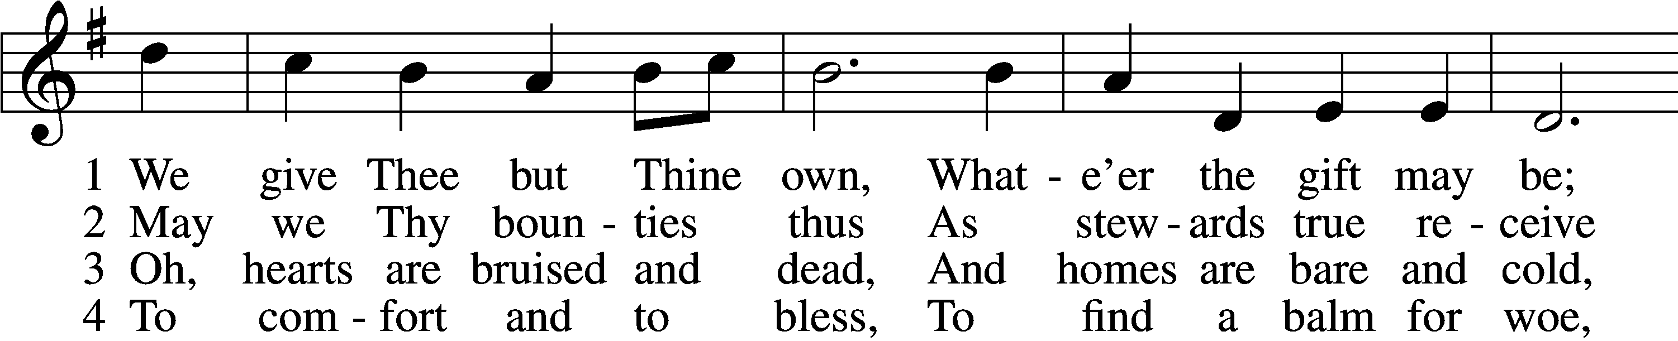
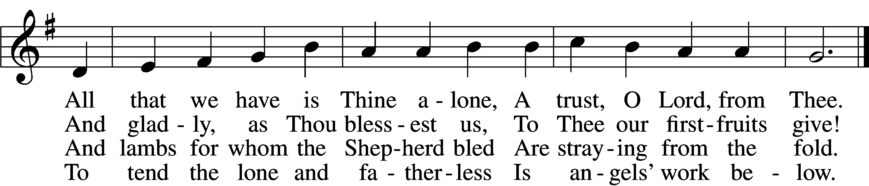

5 The captive to release,
To God the lost to bring,
To teach the way of life and peace,
It is a Christ-like thing.

6 And we believe Thy Word,
Though dim our faith may be:
Whate’er for Thine we do, O Lord,
We do it unto Thee.
Text: William W. How, 1823–97
Tune: William H. Monk, 1823–89
Text and tune: Public domain

707 Oh, That the Lord Would Guide My Ways
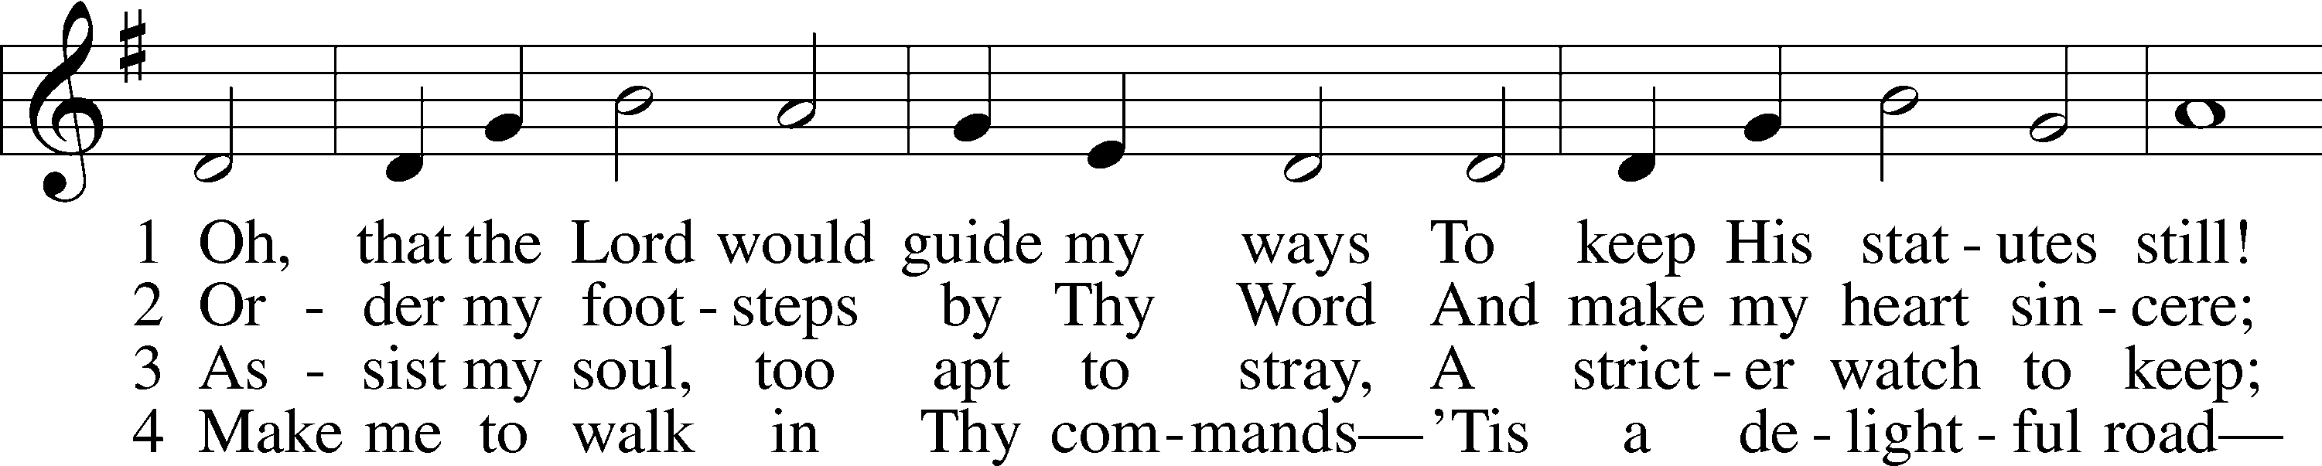
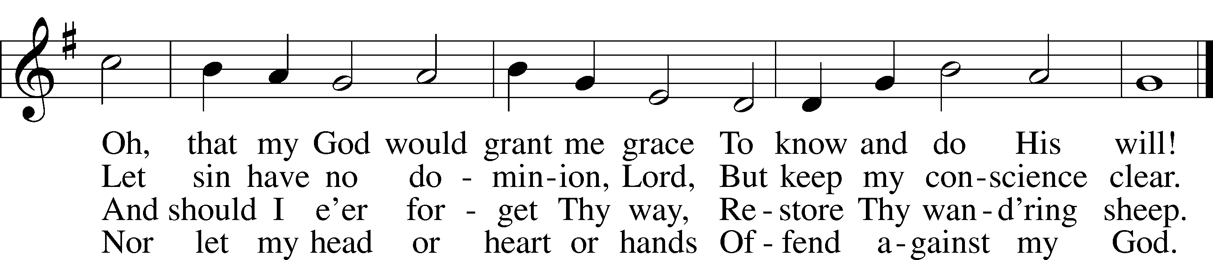
Text: Isaac Watts, 1674–1748, alt.
Tune: William H. Havergal, 1793–1870
Text and tune: Public domain

Stand

The Dismissal
P The body and blood of our Lord Jesus Christ strengthen and preserve you in body and soul to life everlasting. Depart T in peace.
C Amen.

Nunc Dimittis Luke 2:29–32
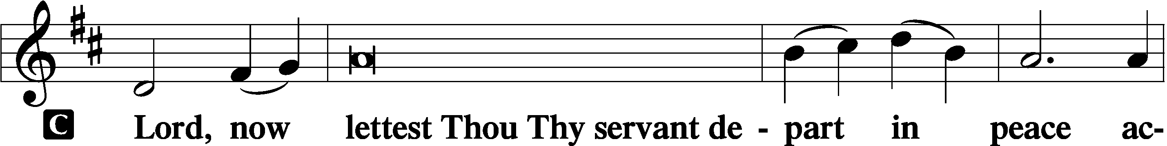

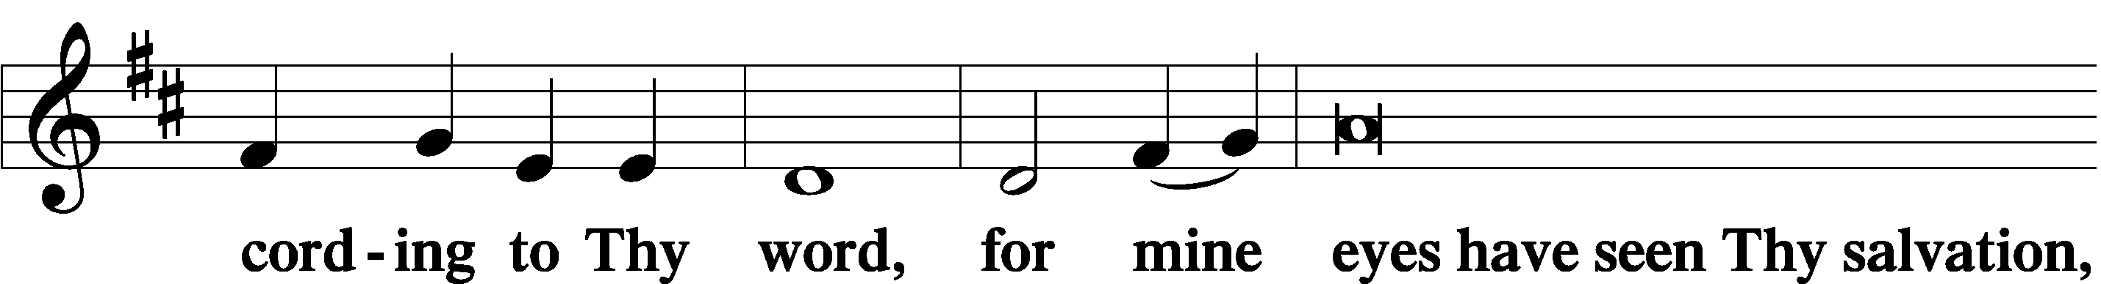

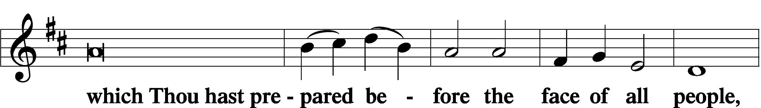

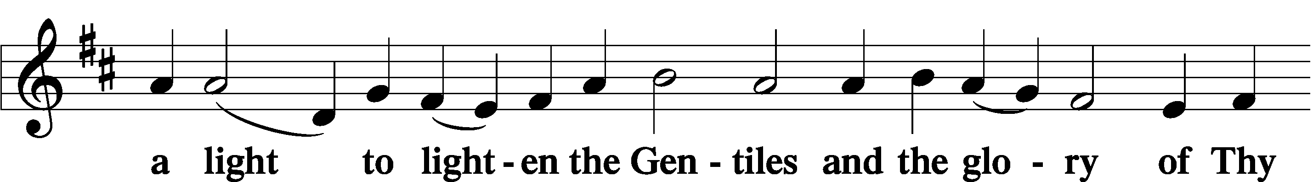

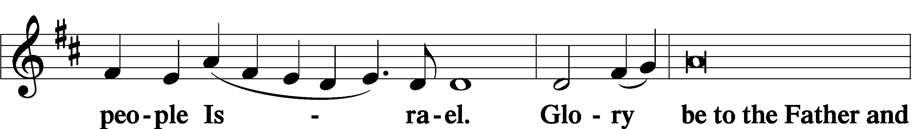

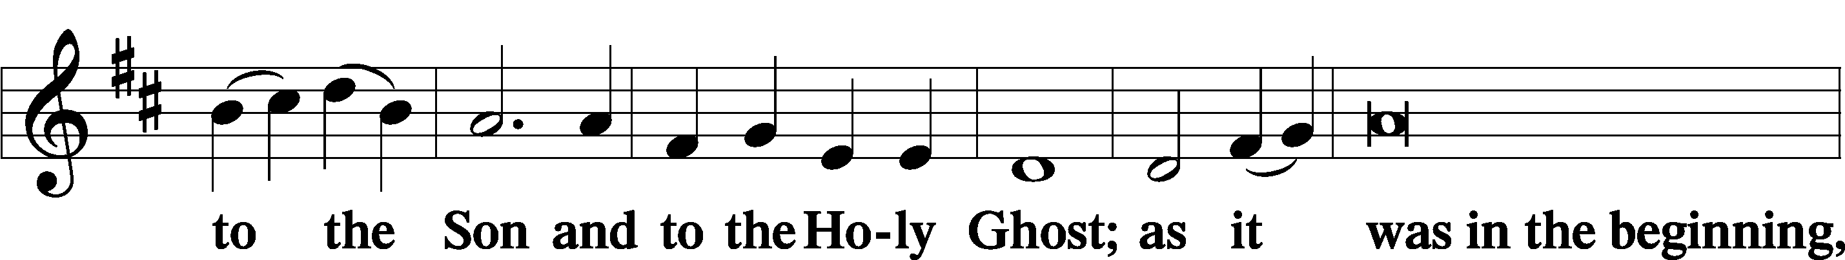

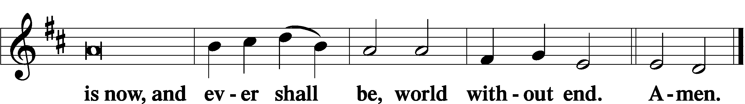

Thanksgiving Psalm 107:1
A O give thanks unto the Lord, for He is good,

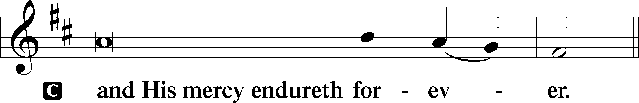

Post-Communion Collect
A Let us pray.
We give thanks to You, almighty God, that You have refreshed us through this salutary gift, and we implore You that of Your mercy You would strengthen us through the same in faith toward You and in fervent love toward one another; through Jesus Christ, Your Son, our Lord, who lives and reigns with You and the Holy Spirit, one God, now and forever.

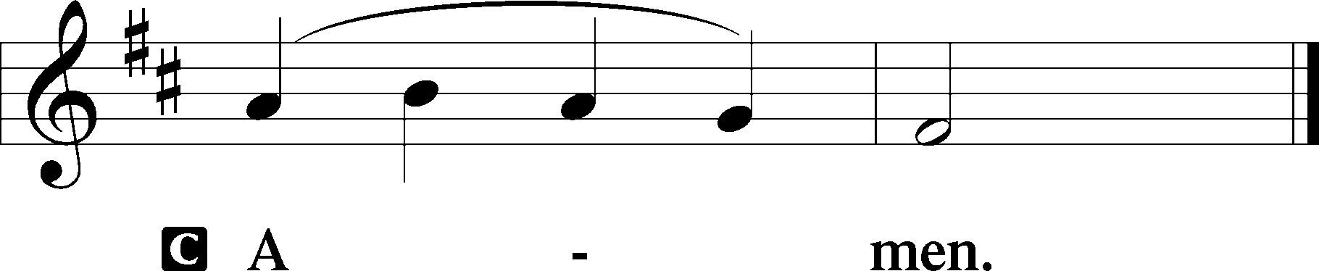

Salutation 2 Timothy 4:22
P The Lord be with you.

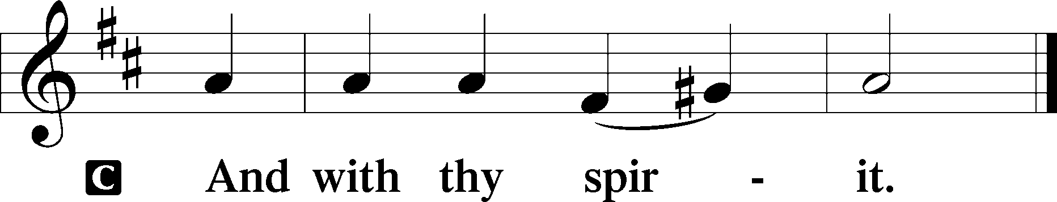

Benedicamus Psalm 103:1
A Bless we the Lord.

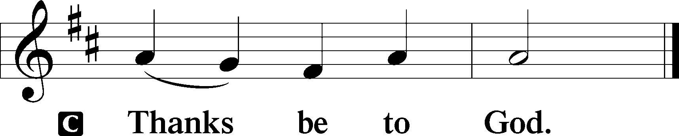

Benediction Numbers 6:24–26
P The Lord bless you and keep you.
The Lord make His face shine upon you and be gracious unto you.
The Lord lift up His countenance upon you and T give you peace.
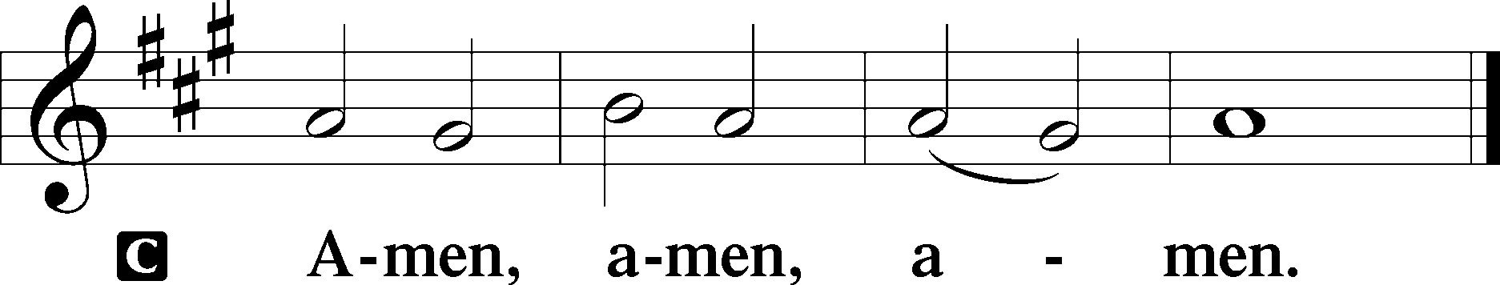

427 In the Cross of Christ I Glory
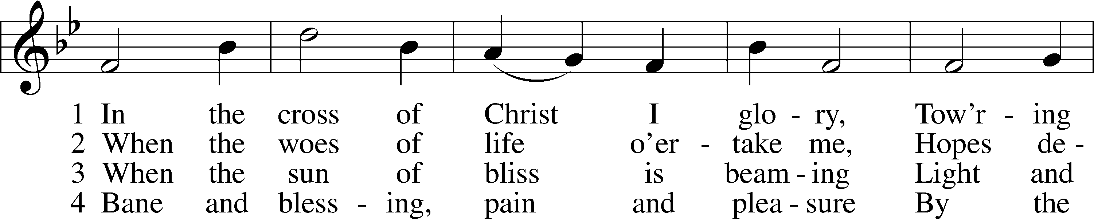
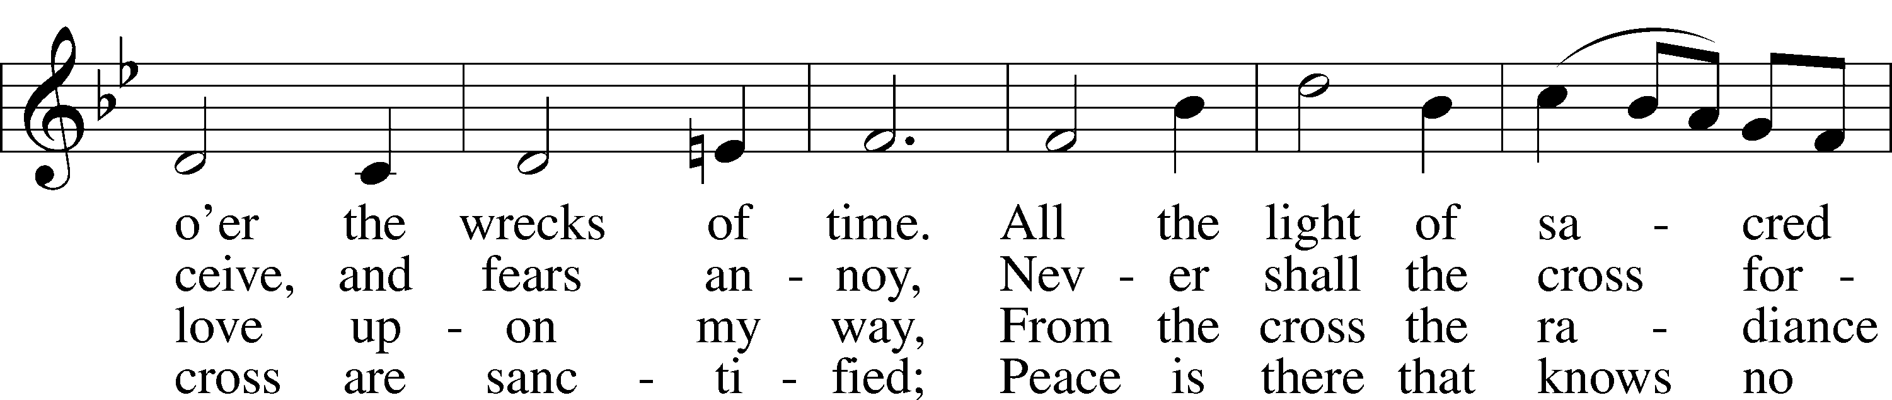
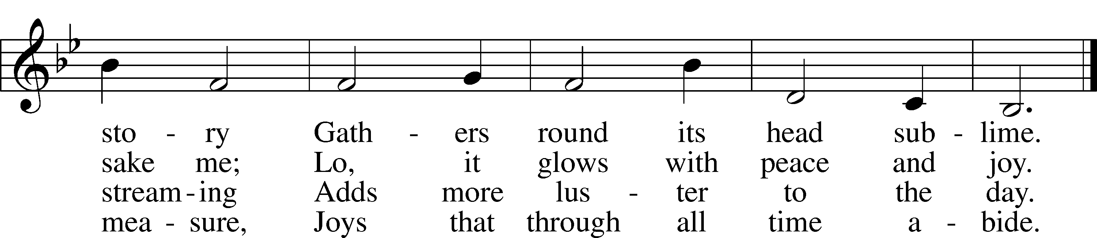
Text: John Bowring, 1792–1872
Tune: Ithamar Conkey, 1815–67
Text and tune: Public domain

Acknowledgments
Divine Service, Setting Three from Lutheran Service Book
Unless otherwise indicated, Scripture quotations are from the ESV® Bible (The Holy Bible, English Standard Version®), copyright © 2001 by Crossway, a publishing ministry of Good News Publishers. Used by permission. All rights reserved.
Created by Lutheran Service Builder © 2023 Concordia Publishing House.

