583 God Has Spoken by His Prophets
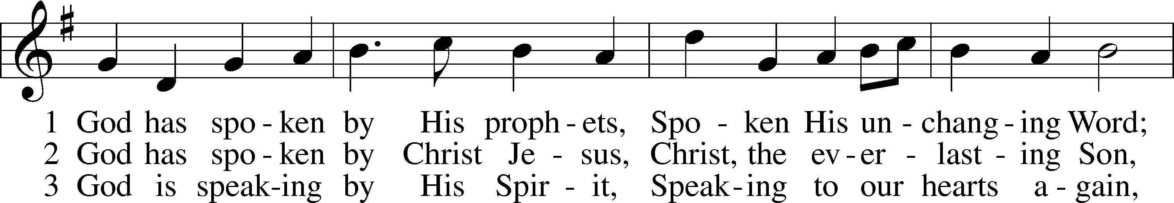
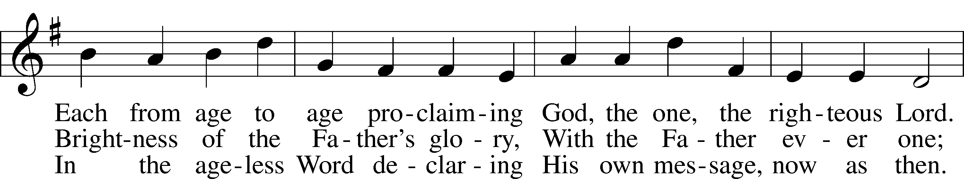
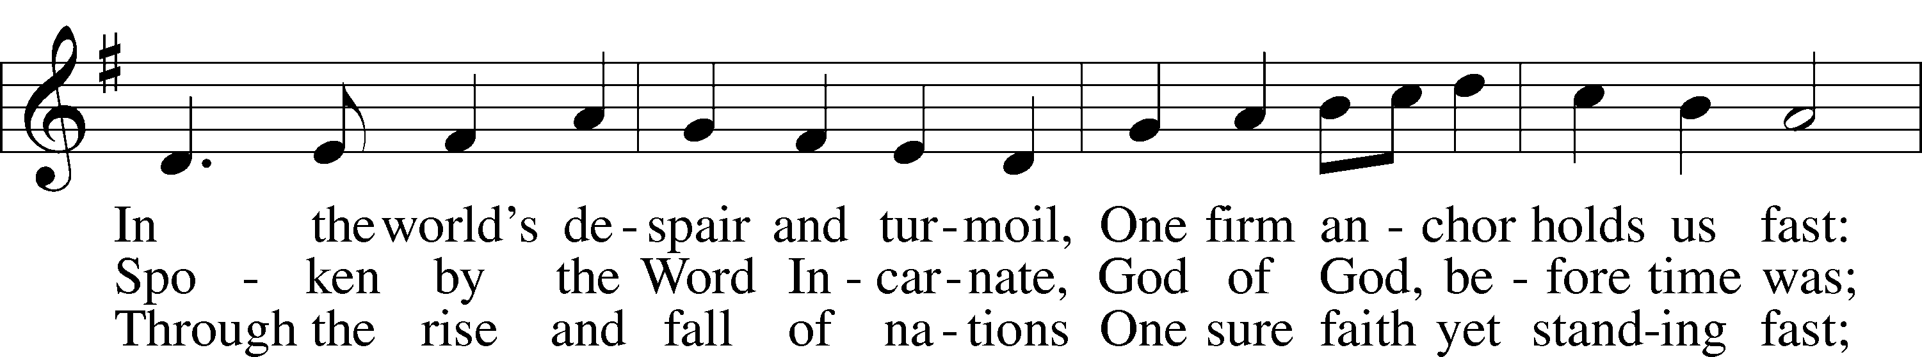
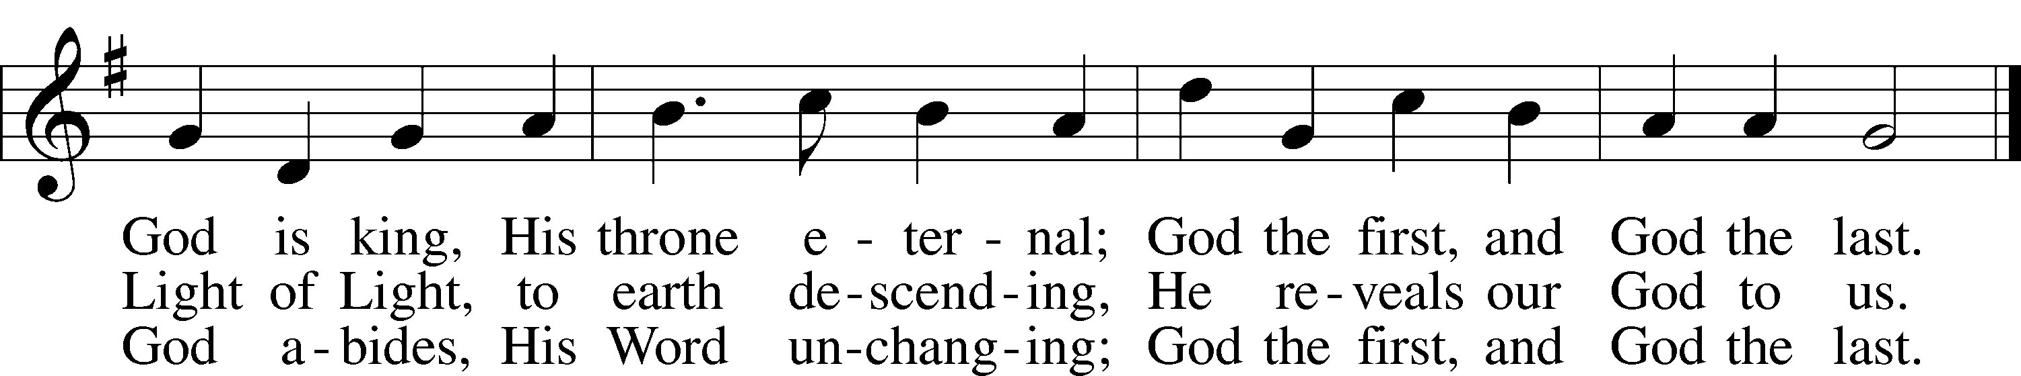
Text: George W. Briggs, 1875–1959, alt.
Tune: Henry T. Smart, 1813–79
Text: © 1953, renewed 1981 The Hymn Society, admin. Hope Publishing Co. Used by permission: LSB Hymn License no. 110005011
Tune: Public domain

Confession and Absolution

Stand

The sign of the cross may be made by all in remembrance of their Baptism.

Invocation Matthew 28:19b; 18:20
P In the name of the Father and of the T Son and of the Holy Spirit.
C Amen.

Exhortation Hebrews 10:22; Psalm 124:8; Psalm 32:5
P Beloved in the Lord! Let us draw near with a true heart and confess our sins unto God our Father, beseeching Him in the name of our Lord Jesus Christ to grant us forgiveness.

P Our help is in the name of the Lord,
C who made heaven and earth.
P I said, I will confess my transgressions unto the Lord,
C and You forgave the iniquity of my sin.

Kneel/Stand

Silence for reflection on God’s Word and for self-examination.

Confession of Sins
P O almighty God, merciful Father,
C I, a poor, miserable sinner, confess unto You all my sins and iniquities with which I have ever offended You and justly deserved Your temporal and eternal punishment. But I am heartily sorry for them and sincerely repent of them, and I pray You of Your boundless mercy and for the sake of the holy, innocent, bitter sufferings and death of Your beloved Son, Jesus Christ, to be gracious and merciful to me, a poor, sinful being.

Absolution [John 20:19–23]
P Upon this your confession, I, by virtue of my office, as a called and ordained servant of the Word, announce the grace of God unto all of you, and in the stead and by the command of my Lord Jesus Christ I forgive you all your sins in the name of the Father and of the T Son and of the Holy Spirit.
C Amen.

Stand

Service of the Word

Introit Psalm 119:9–16; antiphon: v. 12
Blessèd are you, O Lord;
teach me your statutes!
How can a young man keep his way pure?
By guarding it according to your word.
With my whole heart I | seek you;
let me not wander from your commandments!
I have stored up your word | in my heart,
that I might not sin against you.
Blessèd are you, O Lord;
teach me your statutes!
With my lips I declare
all the just decrees of your mouth.
In the way of your testimonies I delight
as much as in all riches.
I will meditate on your precepts
and fix my eyes on your ways.
I will delight in your |statutes;
I will not forget your word.

Gloria Patri
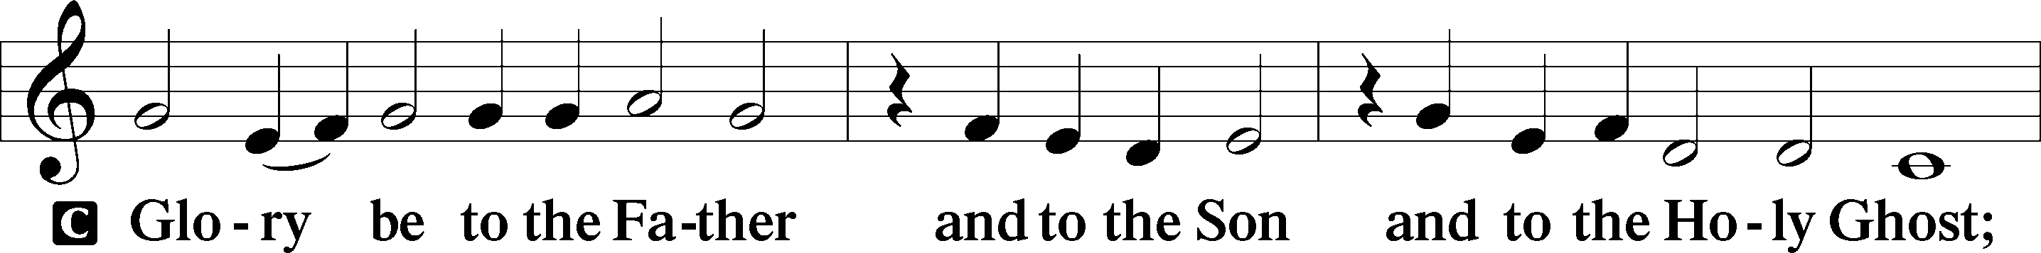
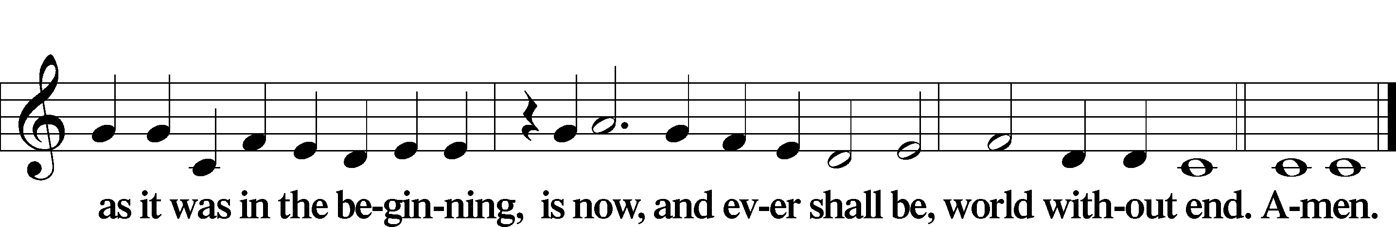

Kyrie Mark 10:47
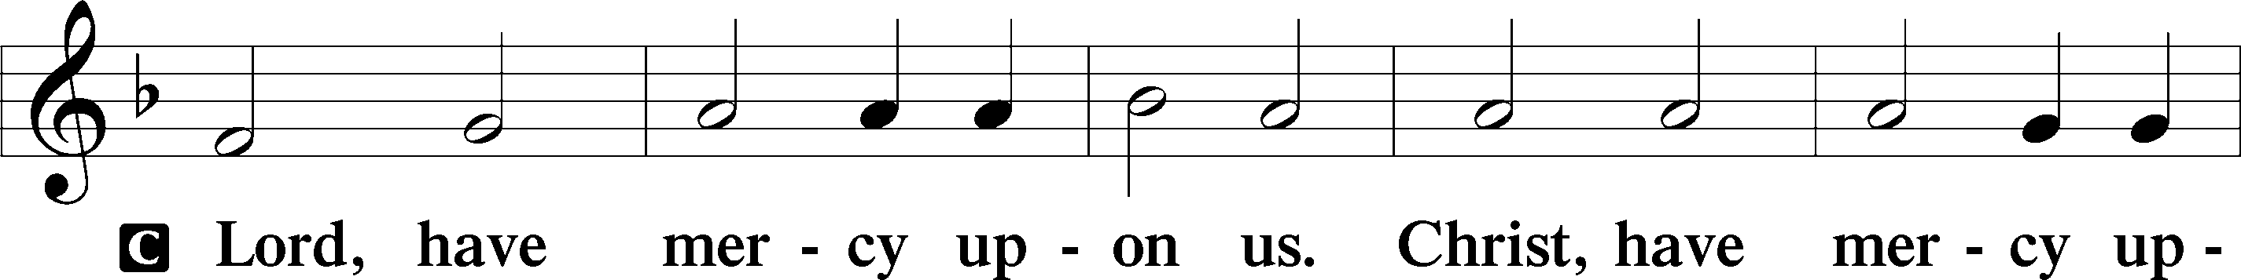
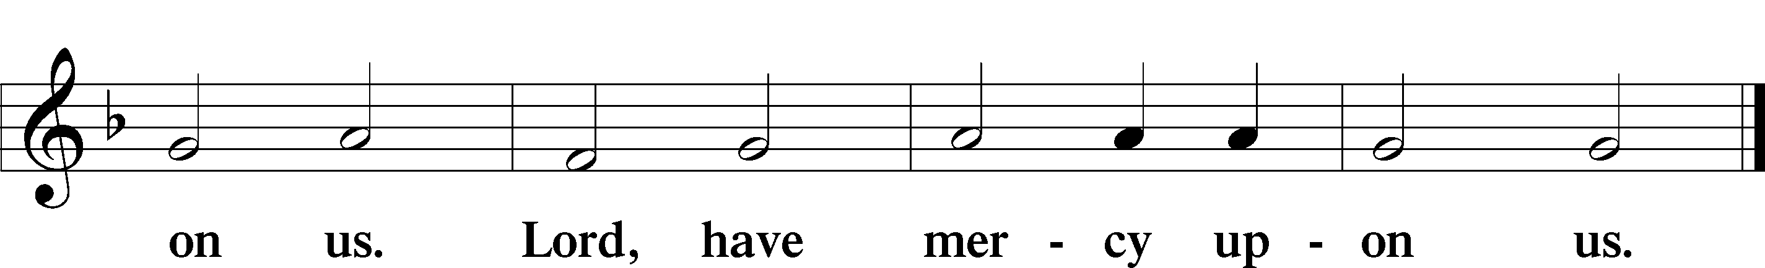

Gloria in Excelsis Luke 2:14; John 1:29
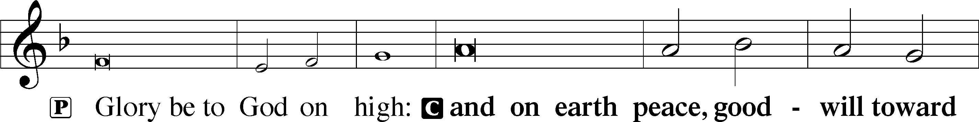
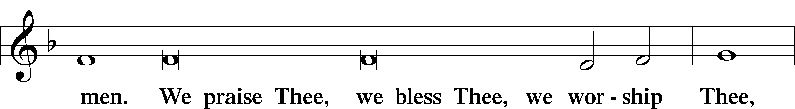
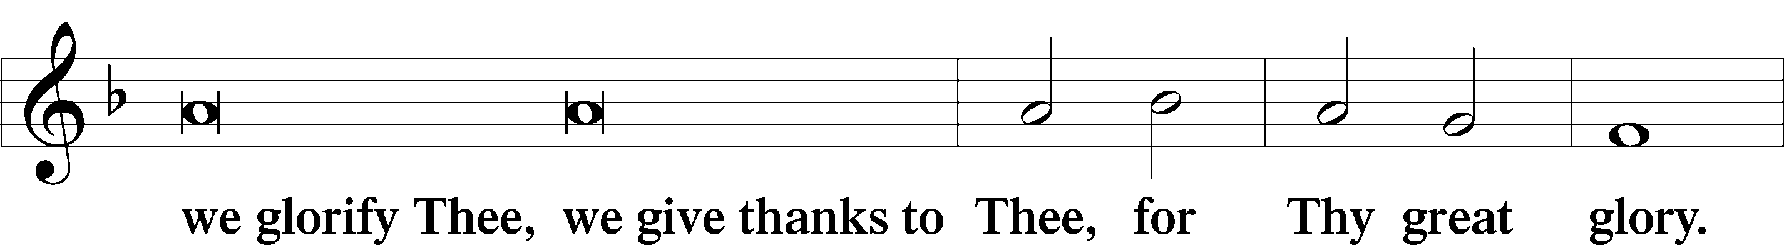
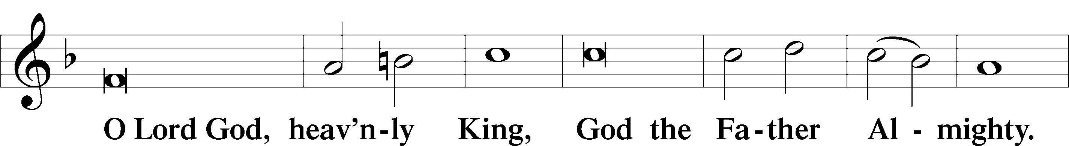
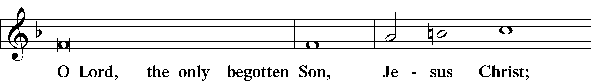
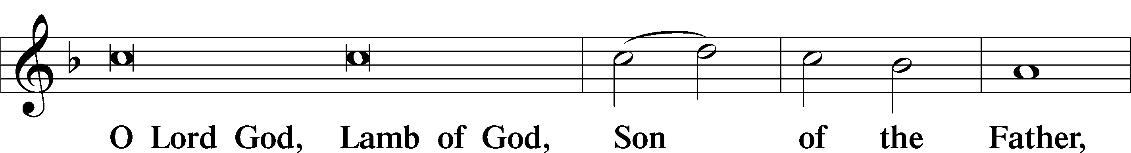
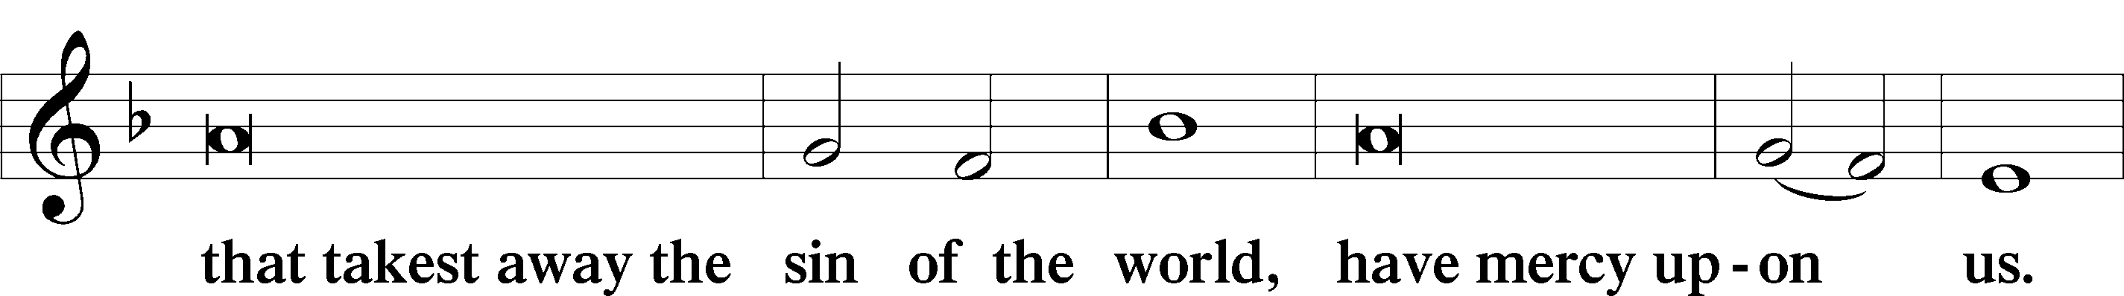
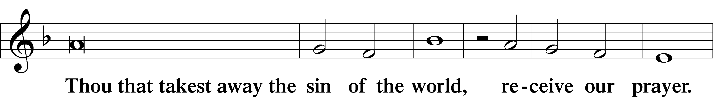
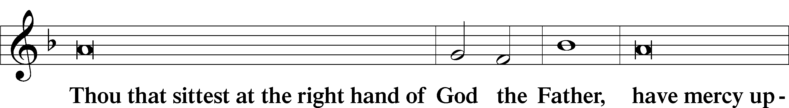
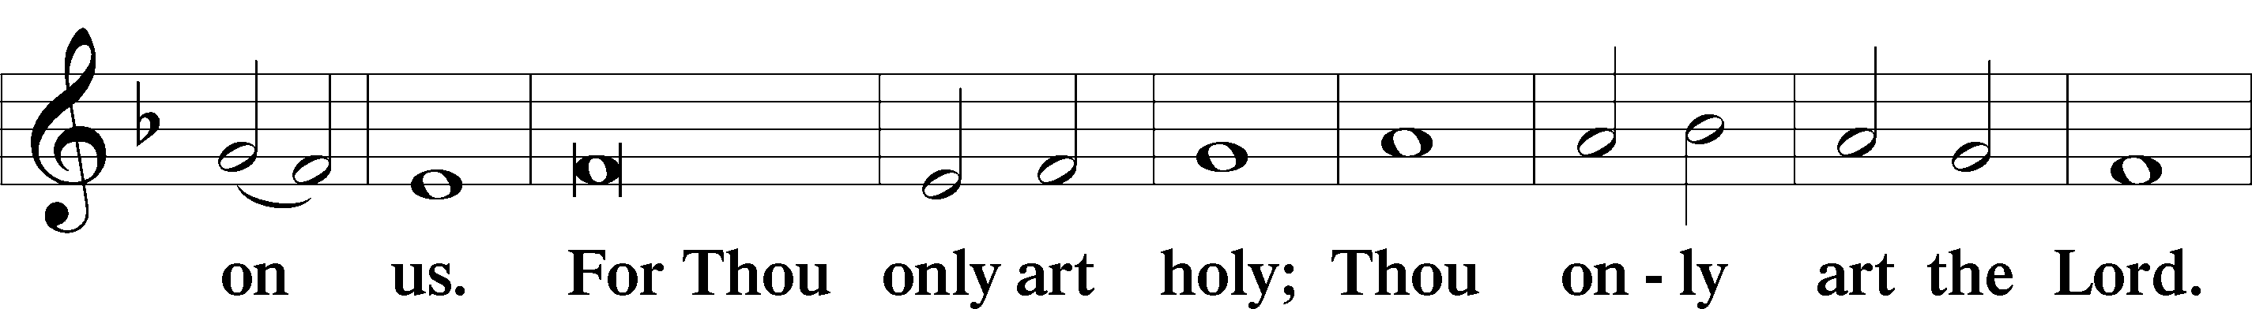
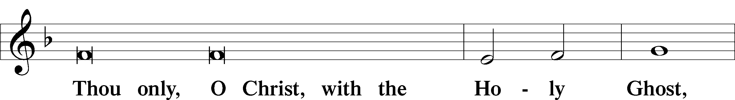
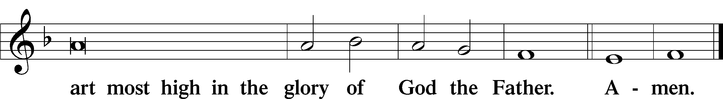

Salutation and Collect of the Day
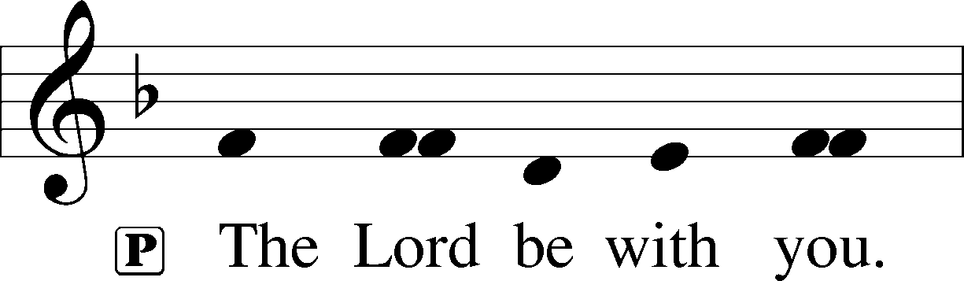
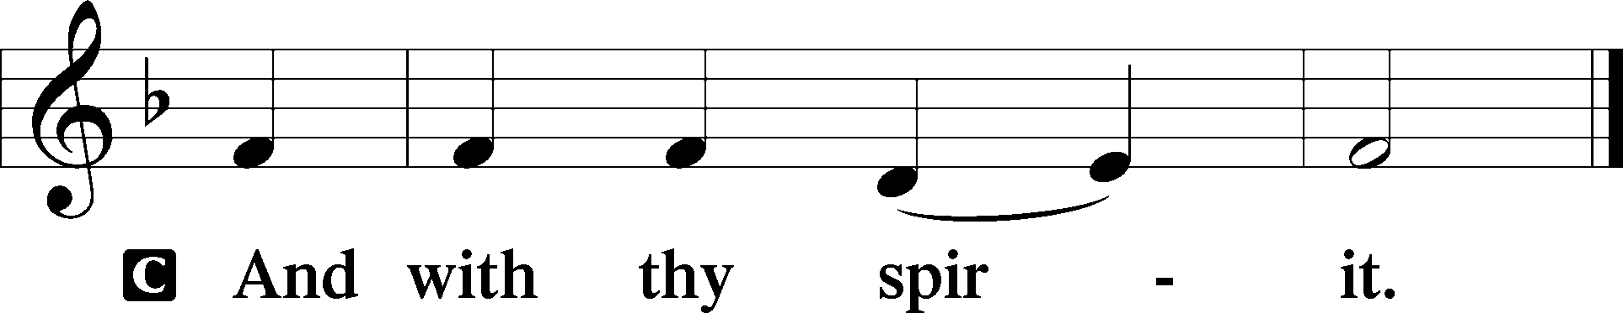

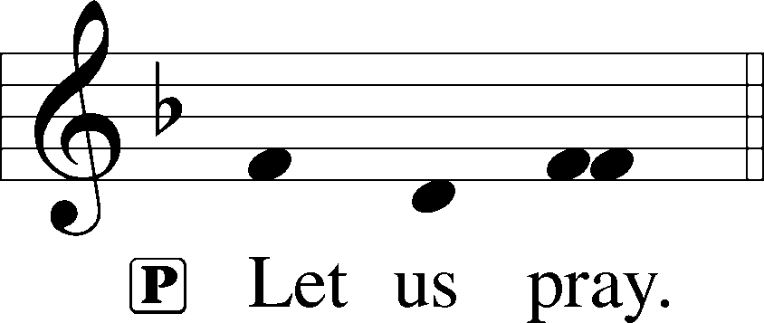

P O Lord, keep Your family the Church continually in the true faith that, relying on the hope of Your heavenly grace, we may ever be defended by Your mighty power; through Jesus Christ, Your Son, our Lord, who lives and reigns with You and the Holy Spirit, one God, now and forever.

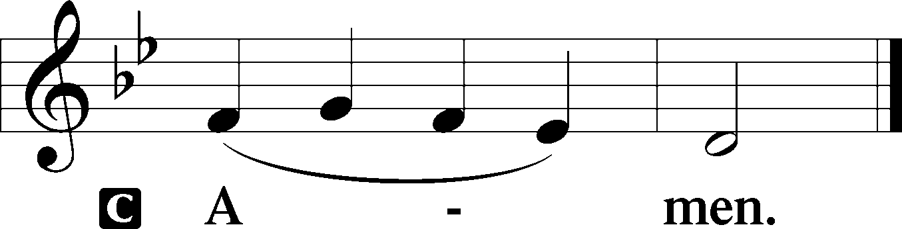

Sit

Old Testament Reading Isaiah 58:3–9a
3“‘Why have we fasted, and you see it not?
Why have we humbled ourselves, and you take no knowledge of it?’
Behold, in the day of your fast you seek your own pleasure,
and oppress all your workers.
4Behold, you fast only to quarrel and to fight
and to hit with a wicked fist.
Fasting like yours this day
will not make your voice to be heard on high.
5Is such the fast that I choose,
a day for a person to humble himself?
Is it to bow down his head like a reed,
and to spread sackcloth and ashes under him?
Will you call this a fast,
and a day acceptable to the Lord?
6“Is not this the fast that I choose:
to loose the bonds of wickedness,
to undo the straps of the yoke,
to let the oppressed go free,
and to break every yoke?
7Is it not to share your bread with the hungry
and bring the homeless poor into your house;
when you see the naked, to cover him,
and not to hide yourself from your own flesh?
8Then shall your light break forth like the dawn,
and your healing shall spring up speedily;
your righteousness shall go before you;
the glory of the Lord shall be your rear guard.
9Then you shall call, and the Lord will answer;
you shall cry, and he will say, ‘Here I am.’”

A This is the Word of the Lord.
C Thanks be to God.

Gradual Psalm 117:1–2a; 96:8
Praise the Lord, all nations!
Extol him, all peoples!
For great is his steadfast love toward us,
and the faithfulness of the Lord endures forever.
Ascribe to the Lord the glory due his name;
bring an offering, and come into his courts!

Epistle 1 Corinthians 2:1–16
Proclaiming Christ Crucified
1And I, when I came to you, brothers, did not come proclaiming to you the testimony of God with lofty speech or wisdom. 2For I decided to know nothing among you except Jesus Christ and him crucified. 3And I was with you in weakness and in fear and much trembling, 4and my speech and my message were not in plausible words of wisdom, but in demonstration of the Spirit and of power, 5that your faith might not rest in the wisdom of men but in the power of God.
Wisdom from the Spirit
6Yet among the mature we do impart wisdom, although it is not a wisdom of this age or of the rulers of this age, who are doomed to pass away. 7But we impart a secret and hidden wisdom of God, which God decreed before the ages for our glory. 8None of the rulers of this age understood this, for if they had, they would not have crucified the Lord of glory. 9But, as it is written,
“What no eye has seen, nor ear heard,
nor the heart of man imagined,
what God has prepared for those who love him”—
10these things God has revealed to us through the Spirit. For the Spirit searches everything, even the depths of God. 11For who knows a person’s thoughts except the spirit of that person, which is in him? So also no one comprehends the thoughts of God except the Spirit of God. 12Now we have received not the spirit of the world, but the Spirit who is from God, that we might understand the things freely given us by God. 13And we impart this in words not taught by human wisdom but taught by the Spirit, interpreting spiritual truths to those who are spiritual.
14The natural person does not accept the things of the Spirit of God, for they are folly to him, and he is not able to understand them because they are spiritually discerned. 15The spiritual person judges all things, but is himself to be judged by no one. 16“For who has understood the mind of the Lord so as to instruct him?” But we have the mind of Christ.

A This is the Word of the Lord.
C Thanks be to God.

Stand

Alleluia
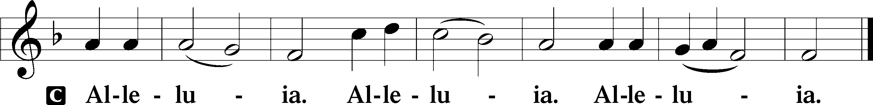

Holy Gospel Matthew 5:13–20
P The Holy Gospel according to St. Matthew, the fifth chapter.

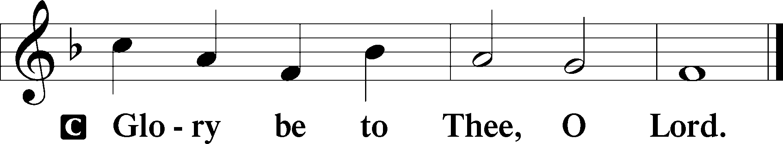

Salt and Light
13[Jesus said:] “You are the salt of the earth, but if salt has lost its taste, how shall its saltiness be restored? It is no longer good for anything except to be thrown out and trampled under people’s feet.
14“You are the light of the world. A city set on a hill cannot be hidden. 15Nor do people light a lamp and put it under a basket, but on a stand, and it gives light to all in the house. 16In the same way, let your light shine before others, so that they may see your good works and give glory to your Father who is in heaven.
Christ Came to Fulfill the Law
17“Do not think that I have come to abolish the Law or the Prophets; I have not come to abolish them but to fulfill them. 18For truly, I say to you, until heaven and earth pass away, not an iota, not a dot, will pass from the Law until all is accomplished. 19Therefore whoever relaxes one of the least of these commandments and teaches others to do the same will be called least in the kingdom of heaven, but whoever does them and teaches them will be called great in the kingdom of heaven. 20For I tell you, unless your righteousness exceeds that of the scribes and Pharisees, you will never enter the kingdom of heaven.”

P This is the Gospel of the Lord.

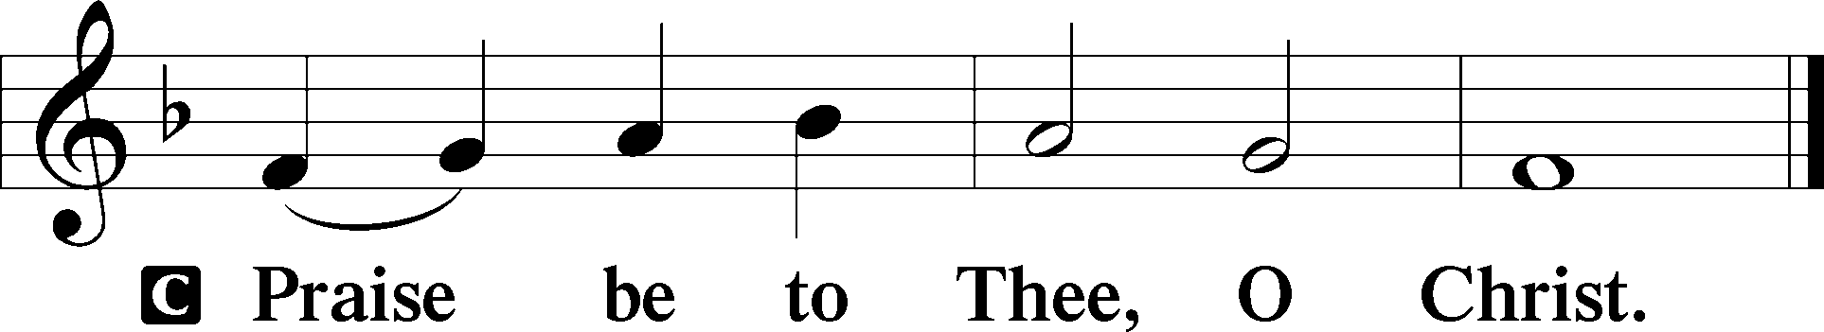

Nicene Creed
C I believe in one God,
the Father Almighty,
maker of heaven and earth
and of all things visible and invisible.

And in one Lord Jesus Christ,
the only-begotten Son of God,
begotten of His Father before all worlds,
God of God, Light of Light,
very God of very God,
begotten, not made,
being of one substance with the Father,
by whom all things were made;
who for us men and for our salvation came down from heaven
and was incarnate by the Holy Spirit of the virgin Mary
and was made man;
and was crucified also for us under Pontius Pilate.
He suffered and was buried.
And the third day He rose again according to the Scriptures
and ascended into heaven
and sits at the right hand of the Father.
And He will come again with glory to judge both the living and the dead,
whose kingdom will have no end.

And I believe in the Holy Spirit,
the Lord and giver of life,
who proceeds from the Father and the Son,
who with the Father and the Son together is worshiped and glorified,
who spoke by the prophets.
And I believe in one holy Christian and apostolic Church,
I acknowledge one Baptism for the remission of sins,
and I look for the resurrection of the dead
and the life T of the world to come. Amen.

Children's Message

578 Thy Strong Word
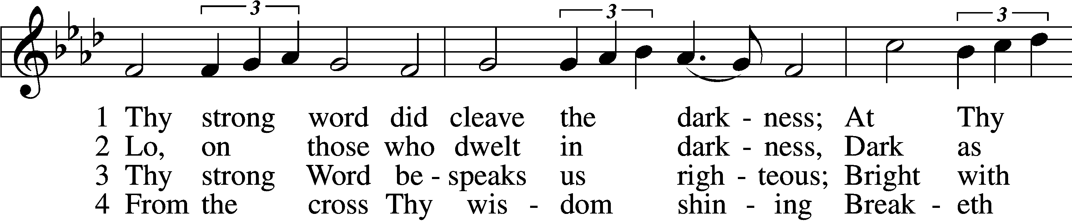
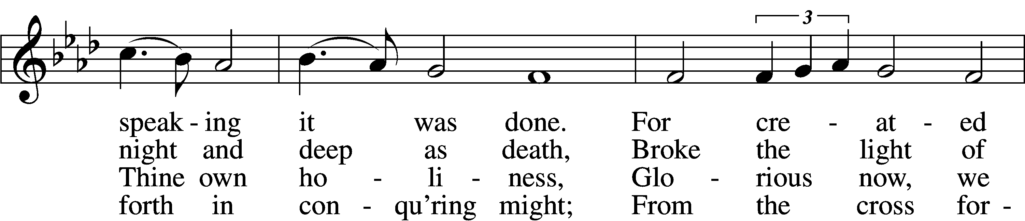
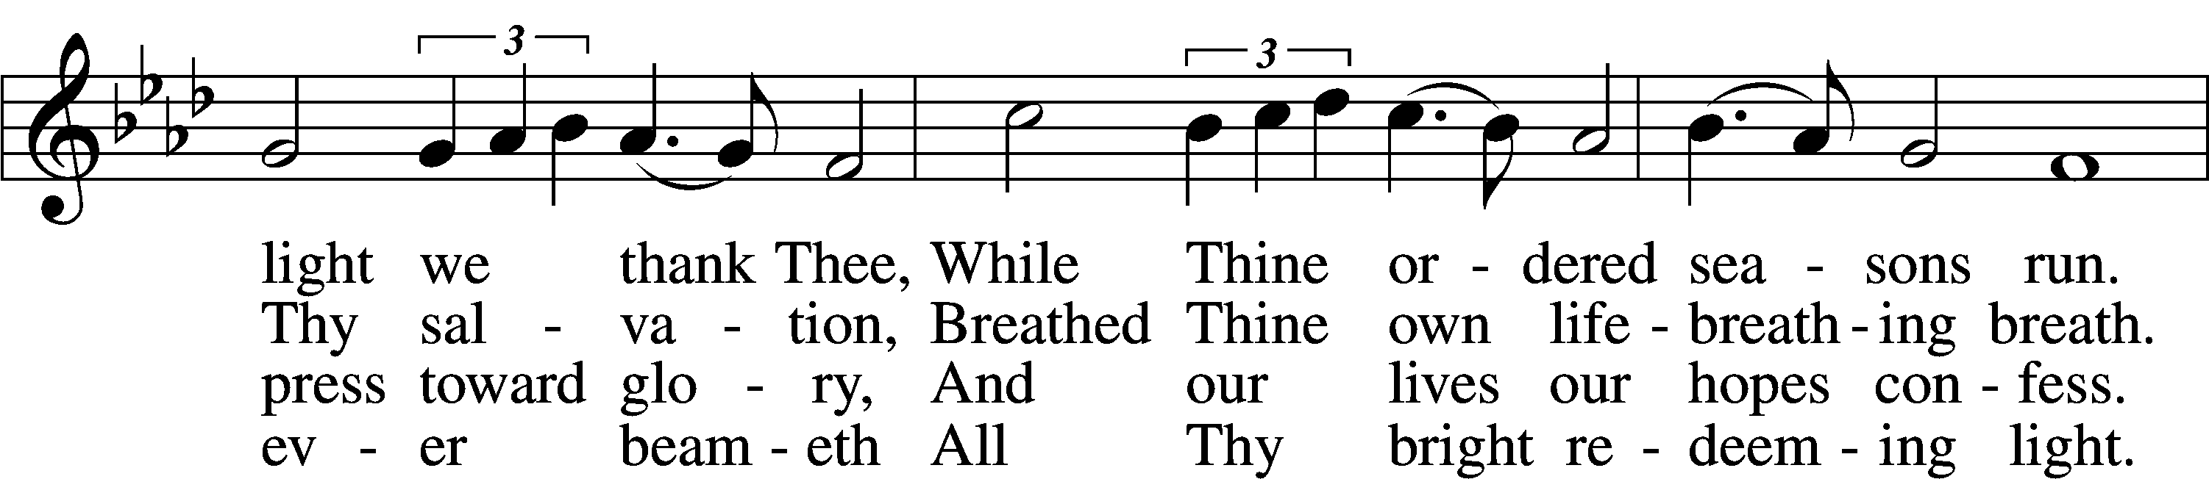
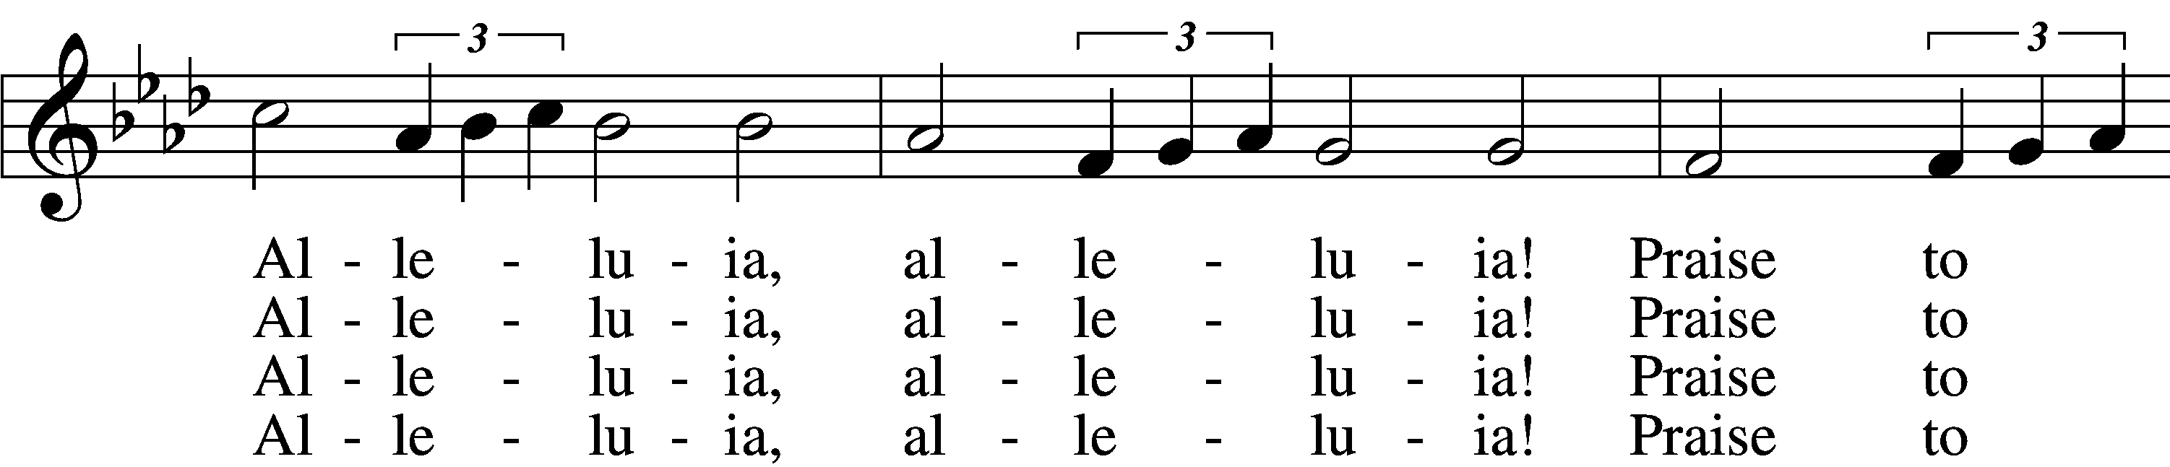
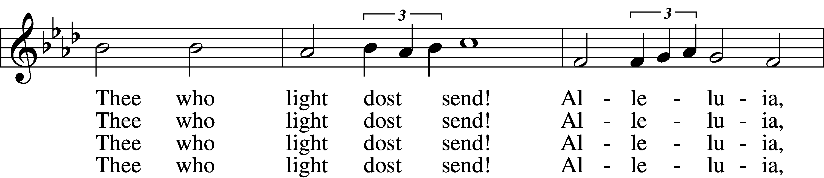
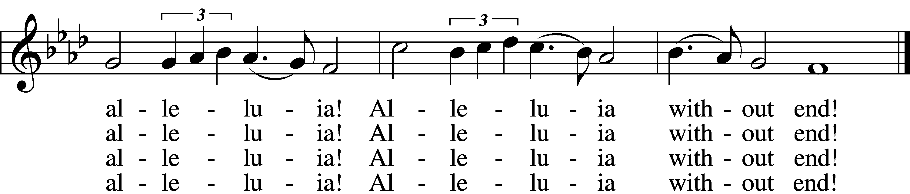

5 Give us lips to sing Thy glory,
Tongues Thy mercy to proclaim,
Throats that shout the hope that fills us,
Mouths to speak Thy holy name.
Alleluia, alleluia!
May the light which Thou dost send
Fill our songs with alleluias,
Alleluias without end!

D 6 God the Father, light-creator,
To Thee laud and honor be.
To Thee, Light of Light begotten,
Praise be sung eternally.
Holy Spirit, light-revealer,
Glory, glory be to Thee.
Mortals, angels, now and ever
Praise the holy Trinity!
Text: Martin H. Franzmann, 1907–76
Tune: Thomas J. Williams, 1869–1944
Text: © 1969 Concordia Publishing House. Used by permission: LSB Hymn License no. 110005011
Tune: Public domain

Sermon

Votum
P The peace of God, which passes all understanding, keep your hearts and minds in Christ Jesus.
C Amen.

Stand

Offertory Psalm 51:10–12
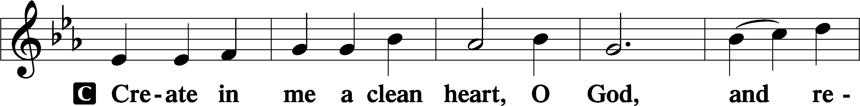
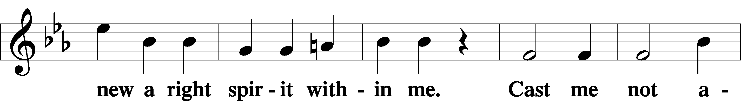
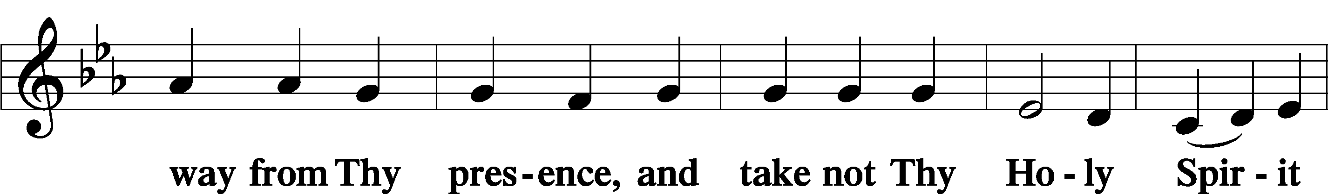
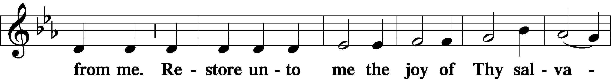
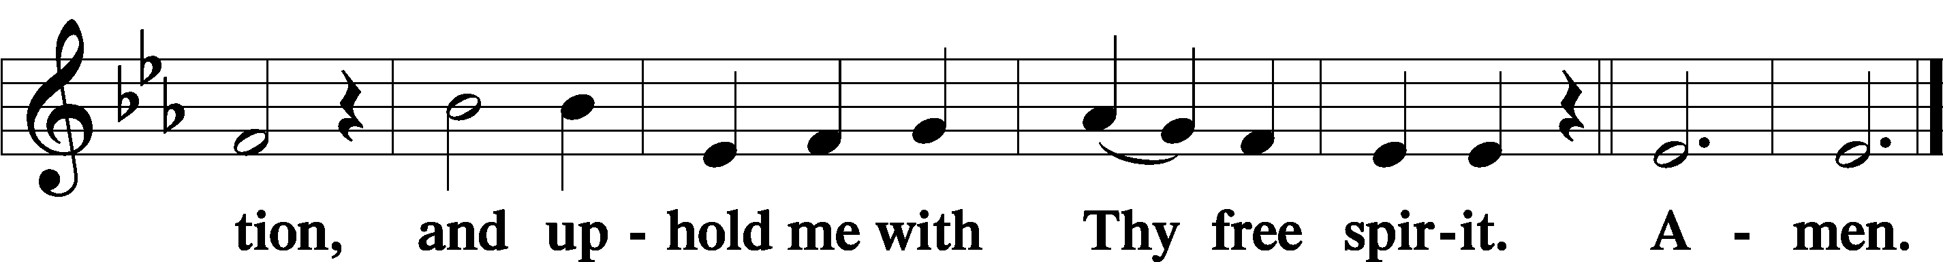

Sit

Offering

805 Praise God, from Whom All Blessings Flow
D 1 Praise God, from whom all blessings flow;
Praise Him, all creatures here below;
Praise Him above, ye heav’nly host:
Praise Father, Son, and Holy Ghost.
Amen.
Text: Thomas Ken, 1637–1711
Text: Public domain

Stand

Prayer of the Church

Service of the Sacrament

Preface 2 Timothy 4:22; [Colossians 3:1]; [Psalm 136]
P The Lord be with you.
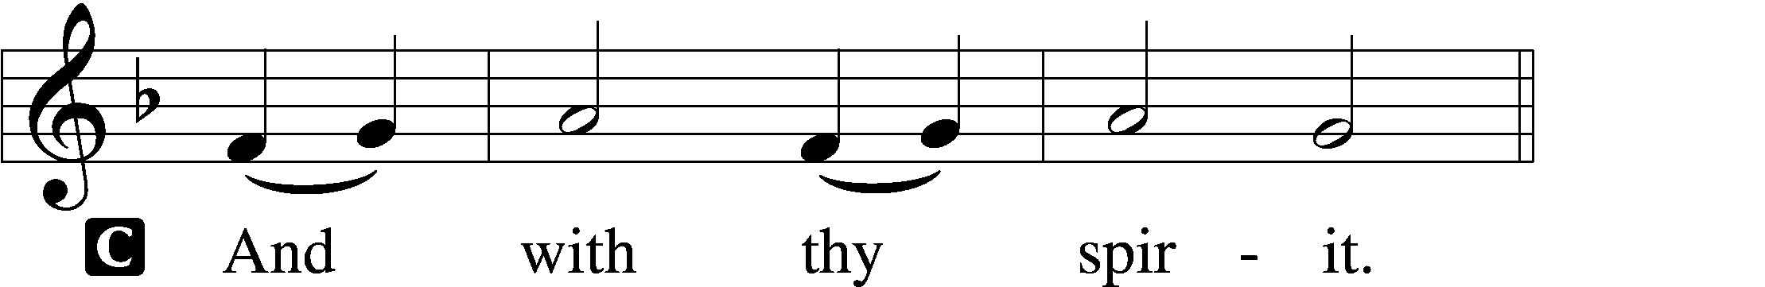

P Lift up your hearts.
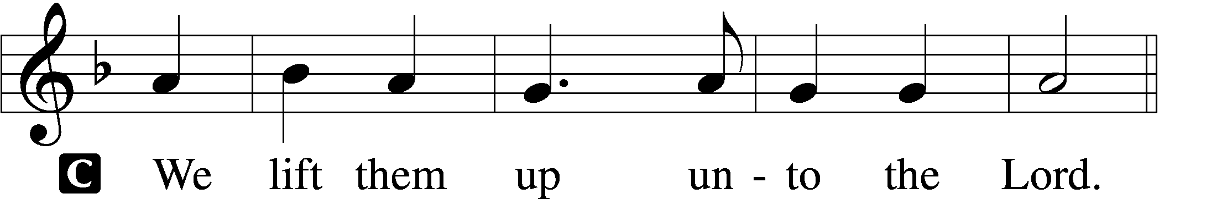

P Let us give thanks unto the Lord, our God.
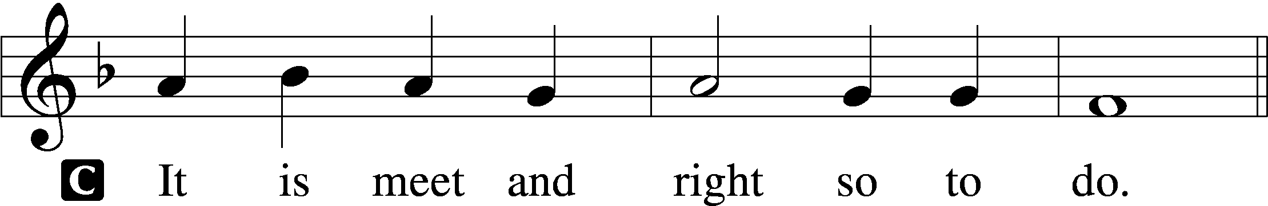

Proper Preface (Full)
P It is truly meet, right, and salutary that we should at all times and in all places give thanks to You, holy Lord, almighty Father, everlasting God, through Jesus Christ, our Lord; for what had been hidden from before the foundation of the world You have made known to the nations in Your Son. In Him, being found in the substance of our mortal nature, You have manifested the fullness of Your glory. Therefore with angels and archangels and with all the company of heaven we laud and magnify Your glorious name, evermore praising You and saying:

Sanctus Isaiah 6:3; Matthew 21:9
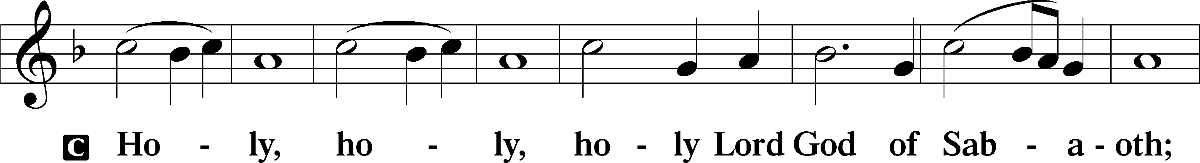
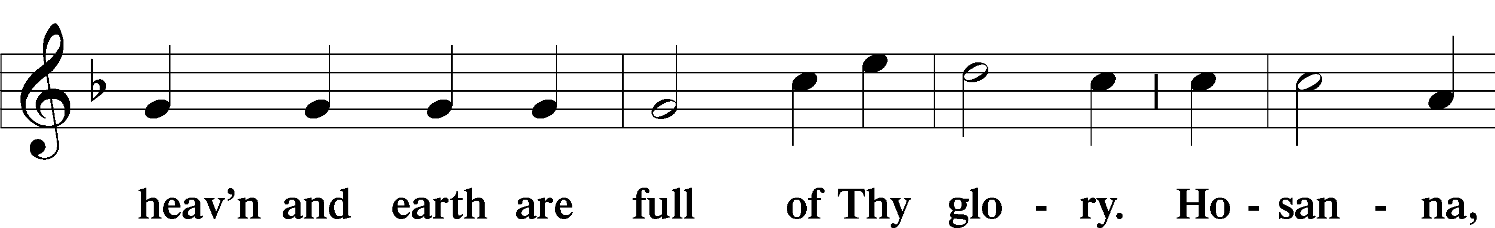
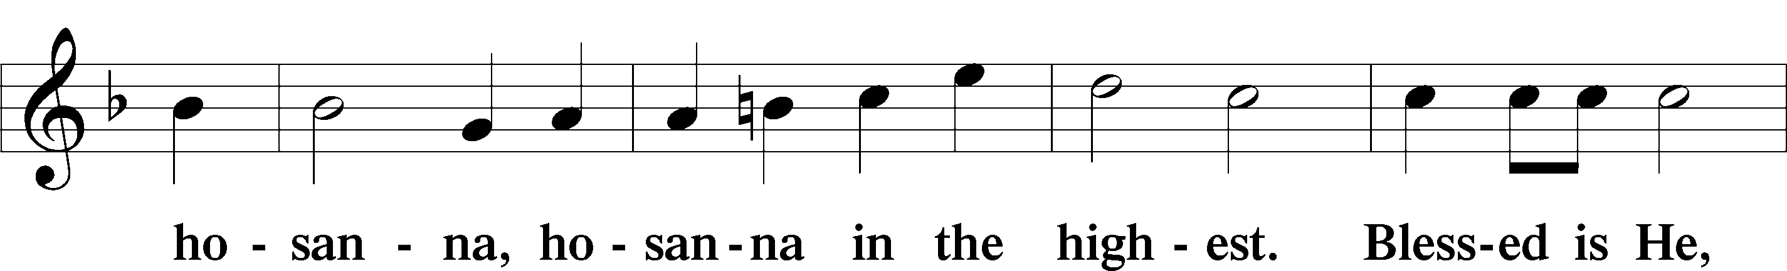
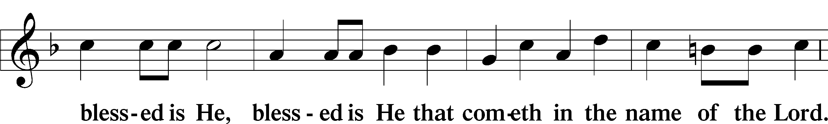
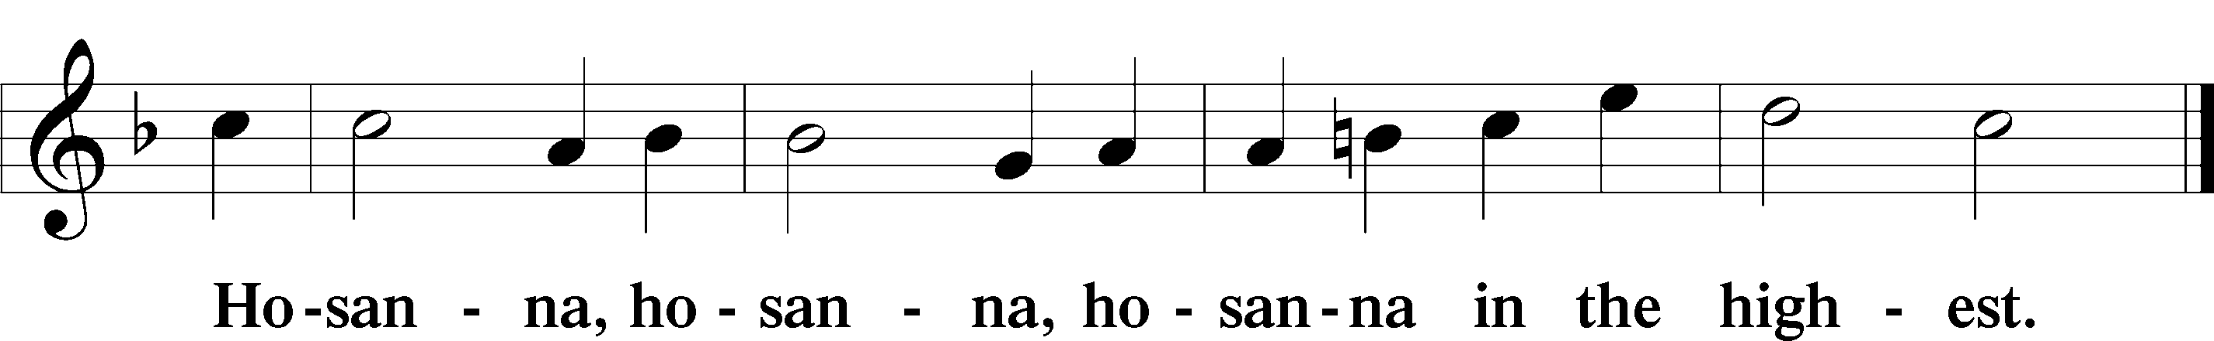

Lord’s Prayer Matthew 6:9–13

Our Father who art in heaven,
hallowed be Thy name,
Thy kingdom come,
Thy will be done on earth
as it is in heaven;
give us this day our daily bread;
and forgive us our trespasses
as we forgive those
who trespass against us;
and lead us not into temptation,
but deliver us from ✠ evil.

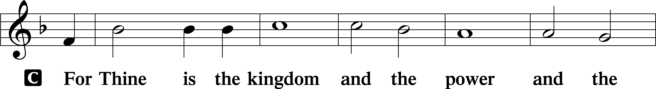
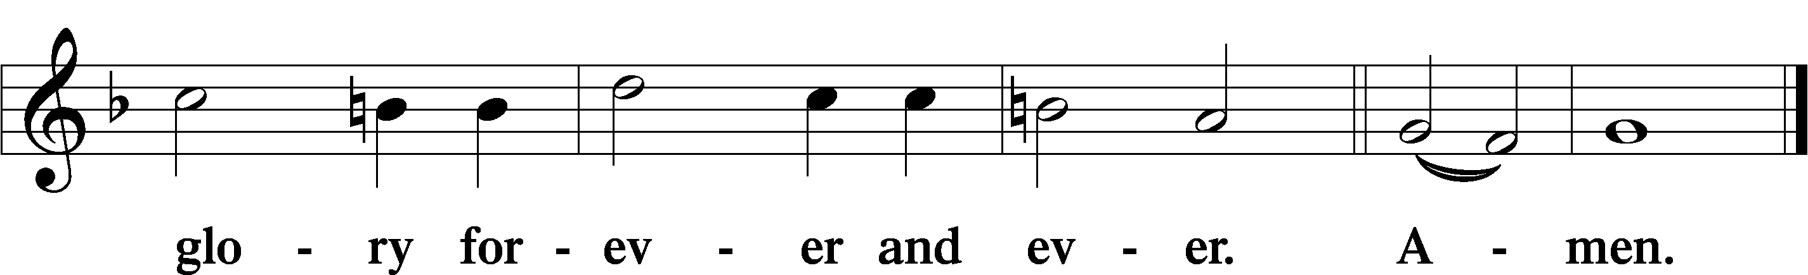

The Words of Our Lord Matthew 26:26–28; Mark 14:22–24; Luke 22:19–20; 1 Corinthians 11:23–25
P Our Lord Jesus Christ, on the night when He was betrayed, took bread, and when He had given thanks, He broke it and gave it to the disciples and said: “Take, eat; this is My T body, which is given for you. This do in remembrance of Me.”

In the same way also He took the cup after supper, and when He had given thanks, He gave it to them, saying: “Drink of it, all of you; this cup is the new testament in My T blood, which is shed for you for the forgiveness of sins. This do, as often as you drink it, in remembrance of Me.”

Pax Domini John 20:19
P The peace of the Lord be with you always.
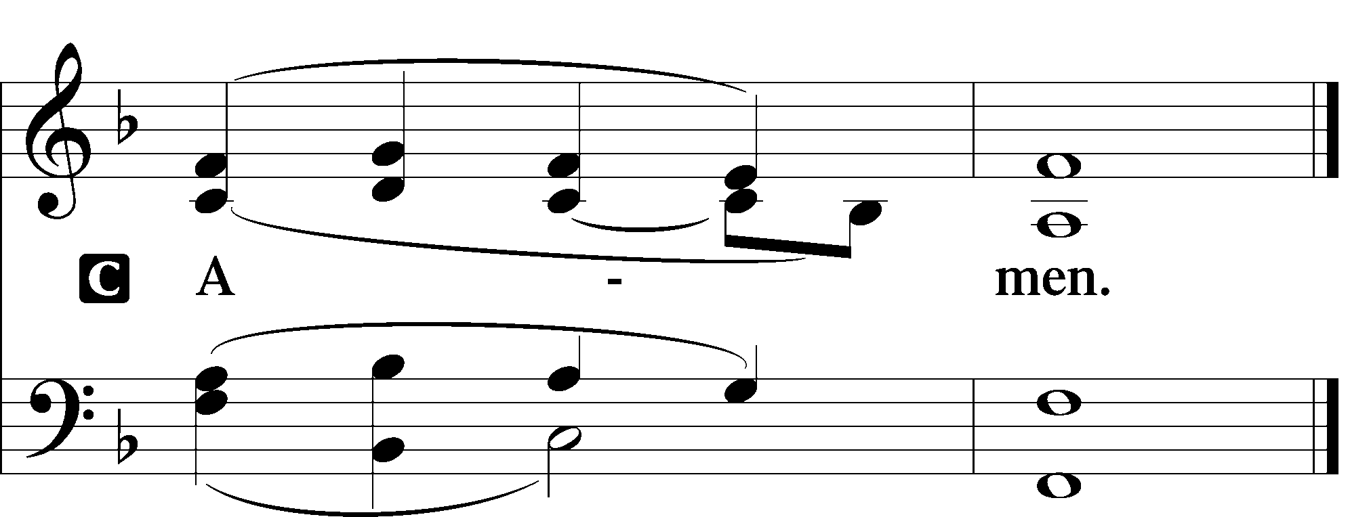

Agnus Dei John 1:29
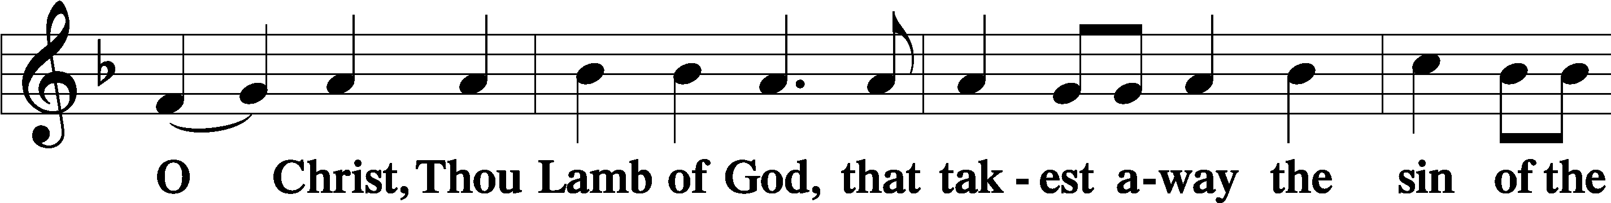
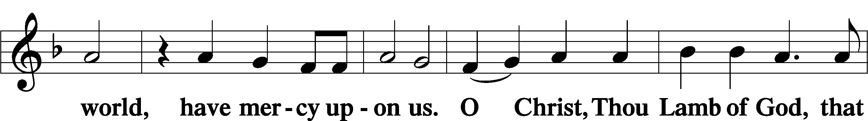
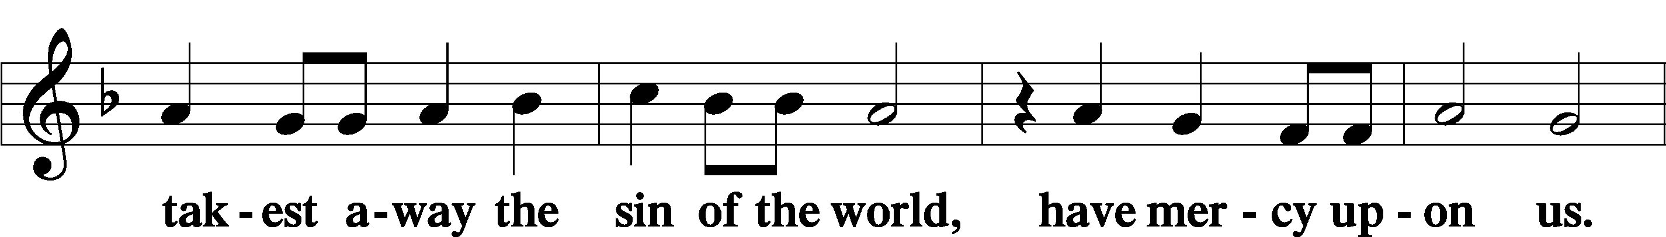
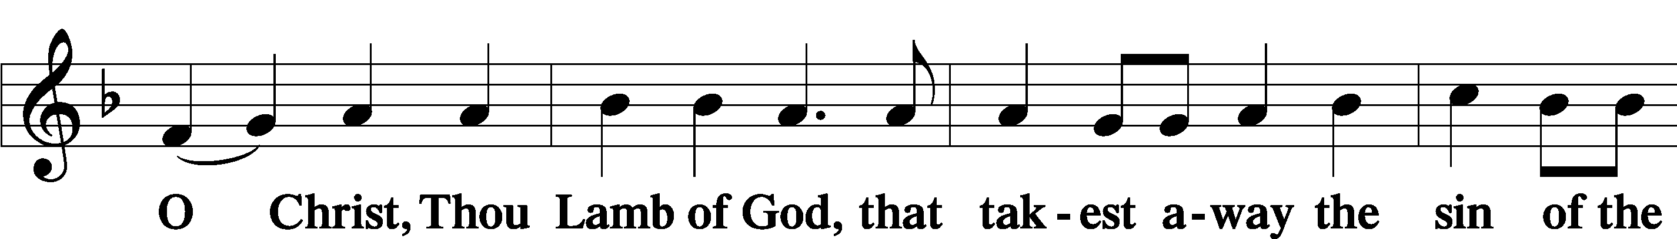
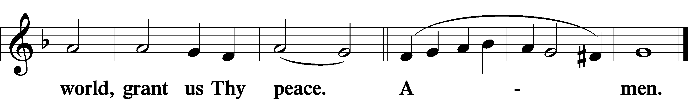

Sit

Distribution

171 This Is the Feast
This is the feast of victory for our God. Alleluia.
Worthy is Christ, the Lamb who was slain, whose blood set us free to be people of God.
Power and riches and wisdom and strength and honor and blessing and glory are His.
This is the feast of victory for our God. Alleluia.
Sing with all the people of God, and join in the hymn of all creation:
Blessing and honor and glory and might be to God and the Lamb forever. Amen.
This is the feast of victory for our God, for the Lamb who was slain has begun His reign .Alleluia, alleluia

633 At the Lamb’s High Feast We Sing
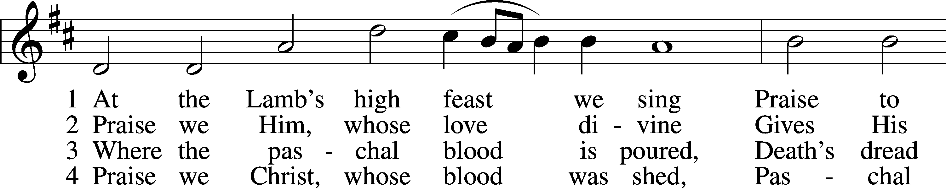
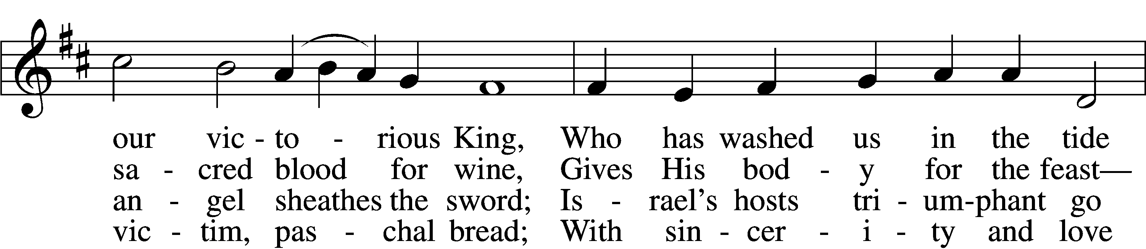
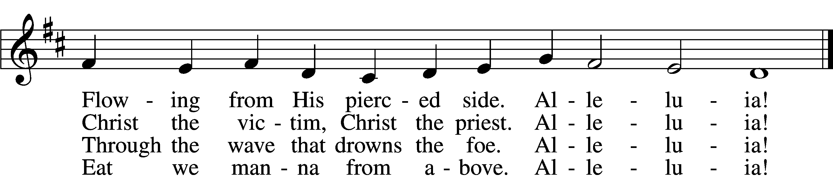

5 Mighty Victim from the sky,
Hell’s fierce pow’rs beneath You lie;
You have conquered in the fight,
You have brought us life and light.
Alleluia!

6 Now no more can death appall,
Now no more the grave enthrall;
You have opened paradise,
And Your saints in You shall rise.
Alleluia!

7 Easter triumph, Easter joy!
This alone can sin destroy;
From sin’s pow’r, Lord, set us free,
Newborn souls in You to be.
Alleluia!

D 8 Father, who the crown shall give,
Savior, by whose death we live,
Spirit, guide through all our days:
Three in One, Your name we praise.
Alleluia!
Text: Latin, c. 5th–10th cent.; tr. Robert Campbell, 1814–68, alt.
Tune: Kirchengeseng, 1566, Ivancice
Text and tune: Public domain

801 How Great Thou Art
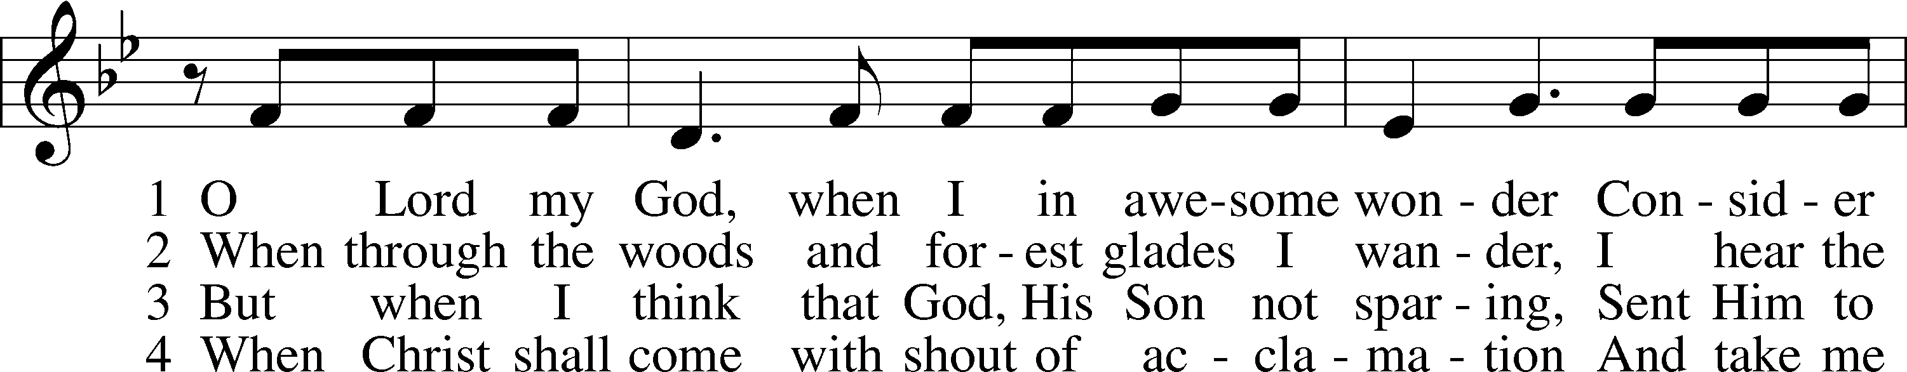
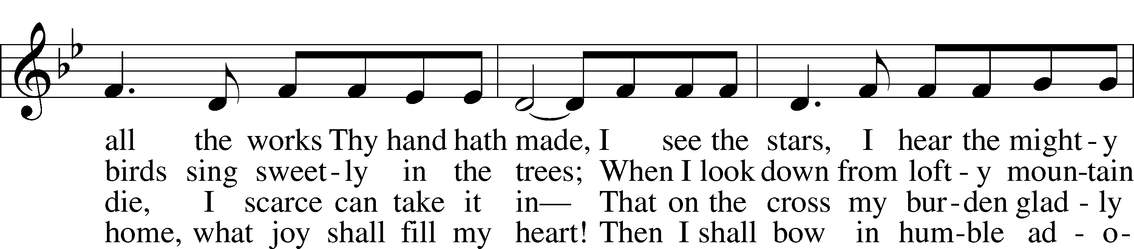
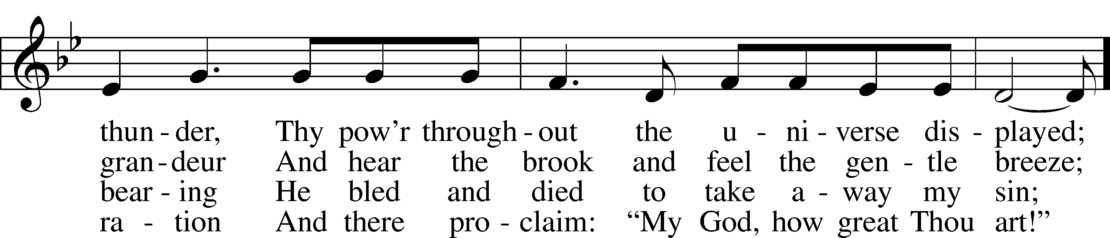
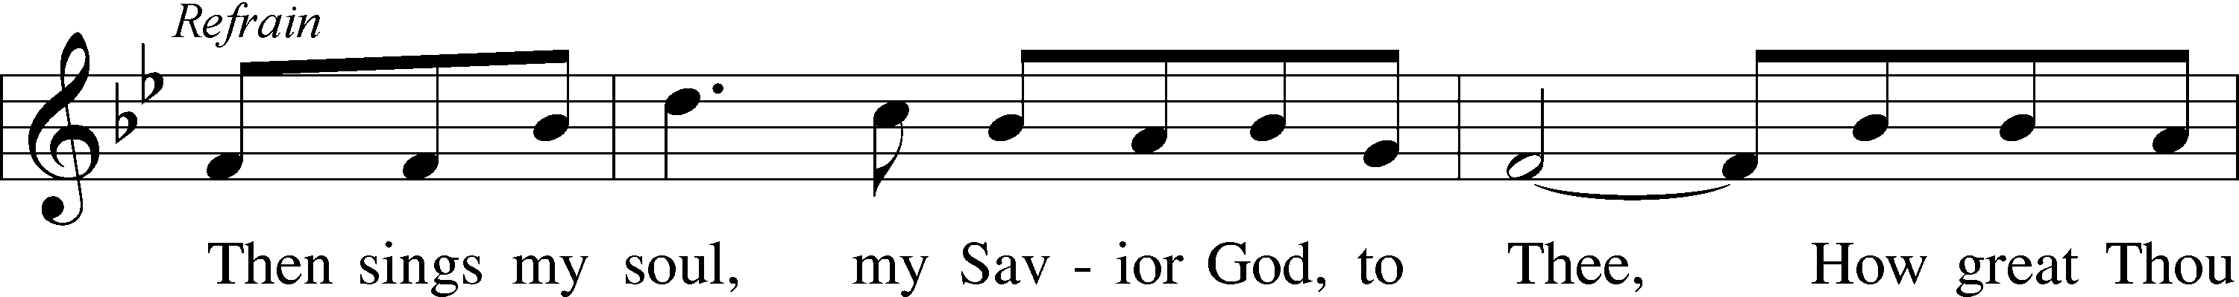
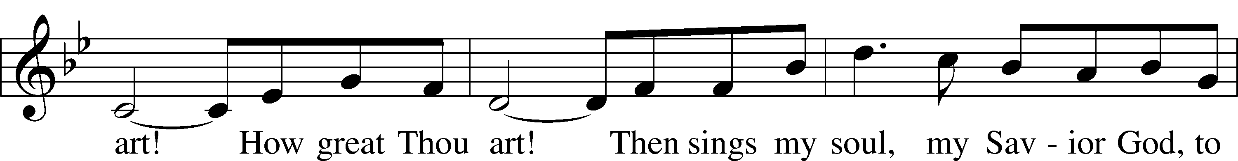
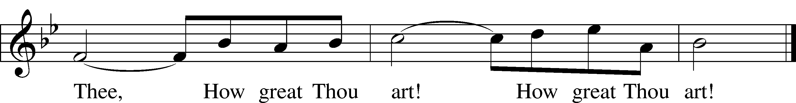
Text: Carl Gustaf Boberg, 1859–1940; tr. Stuart W. K. Hine, 1899–1989
Tune: Swedish; arr. Stuart W. K. Hine, 1899–1989
Text and tune: © 1949, 1953 The Stuart Hine Trust, admin. EMI CMG and Hope Publishing Co. Used by permission: LSB Hymn License no. 110005011

Stand

650 Holy Spirit, Ever Dwelling
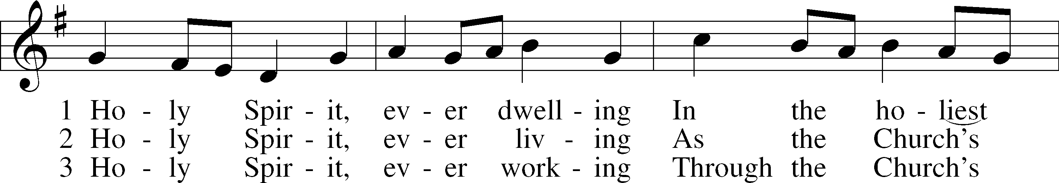
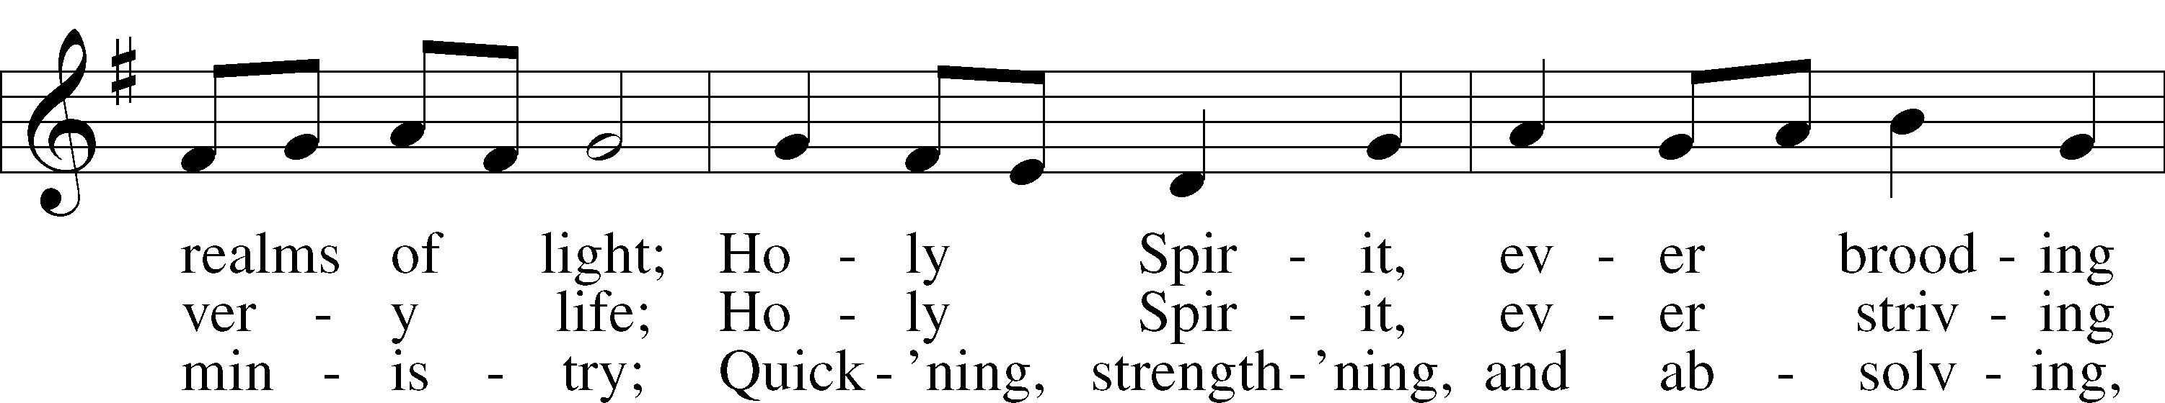
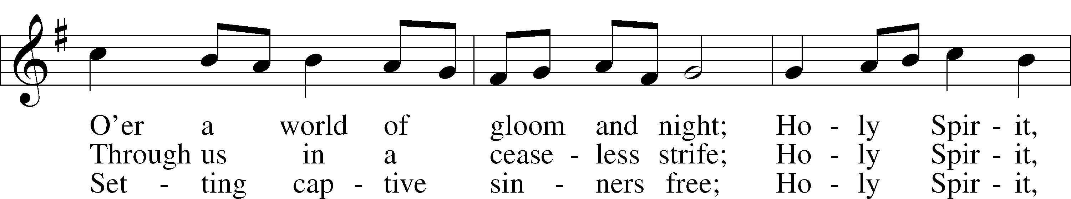
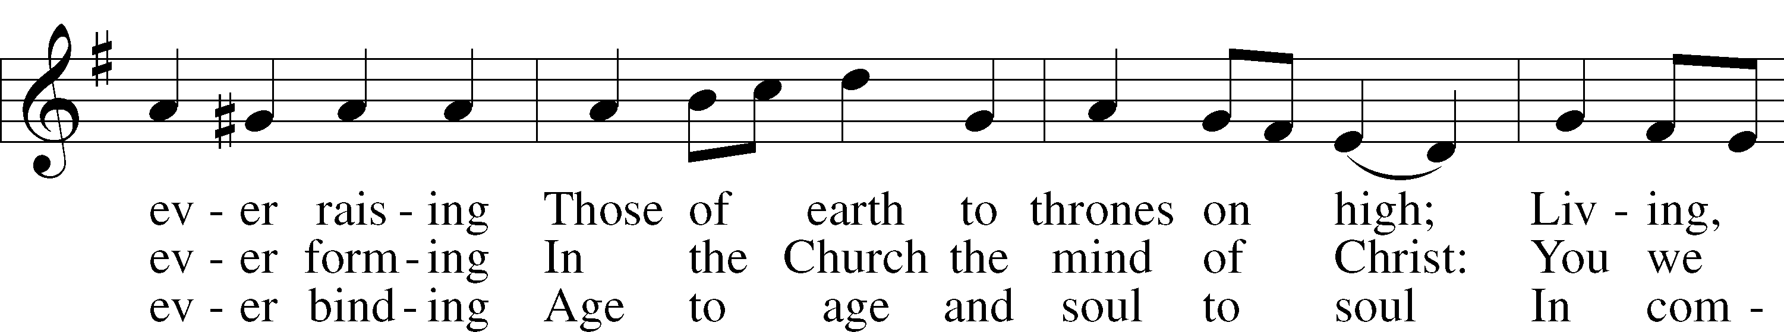
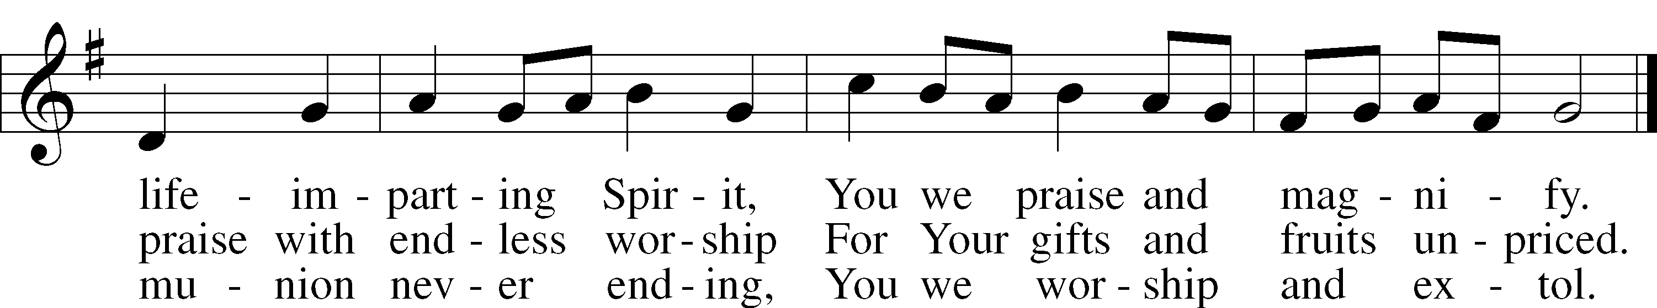
Text: Timothy Rees, 1874–1939, alt.
Tune: Oude en Nieuwe Hollantse . . . Contradanseu, c. 1710, Amsterdam
Text and tune: Public domain

The Dismissal
P The body and blood of our Lord Jesus Christ strengthen and preserve you in body and soul to life everlasting. Depart T in peace.
C Amen.

Nunc Dimittis Luke 2:29–32
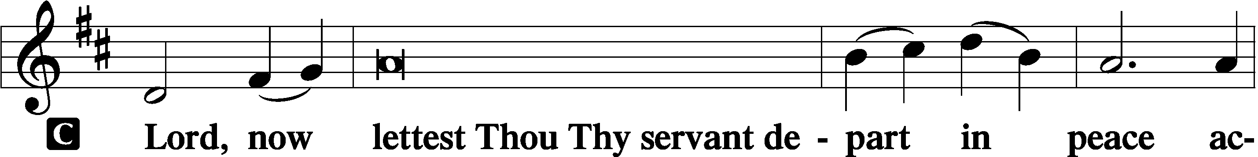

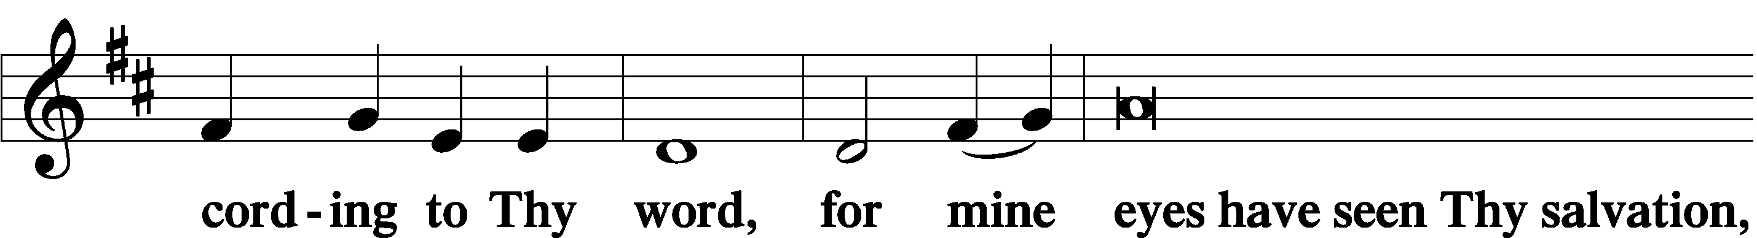

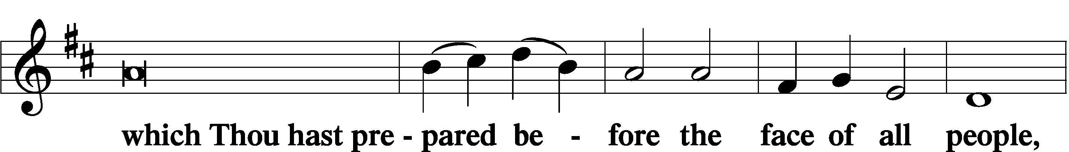

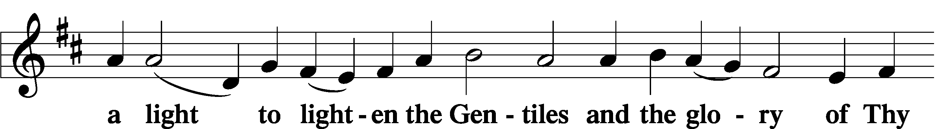

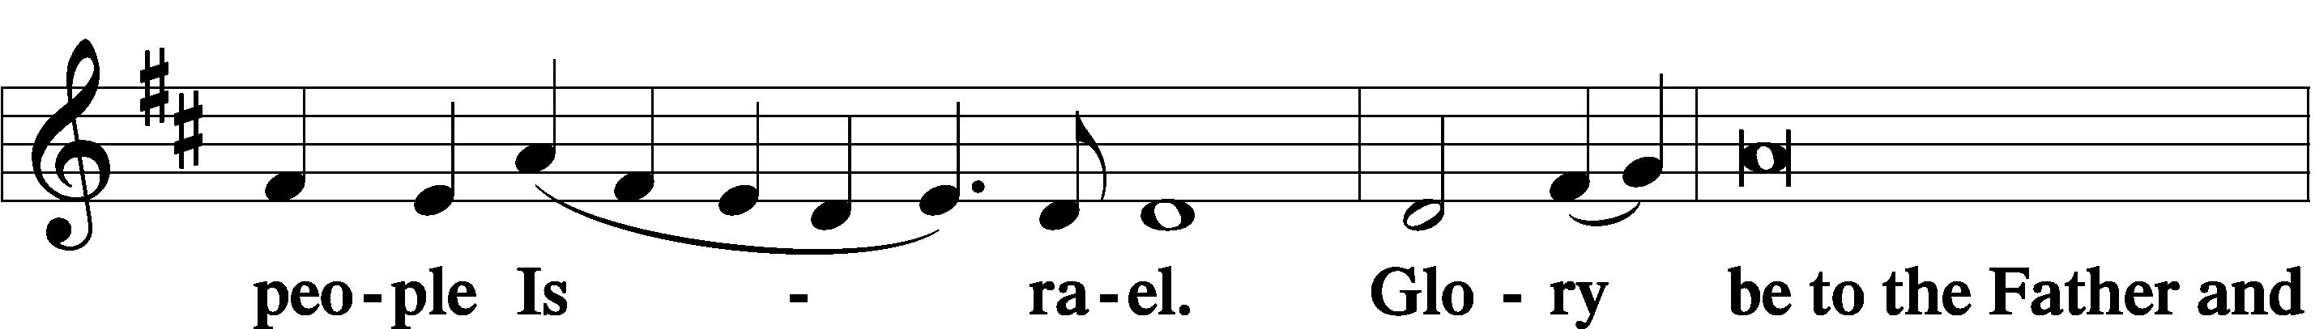

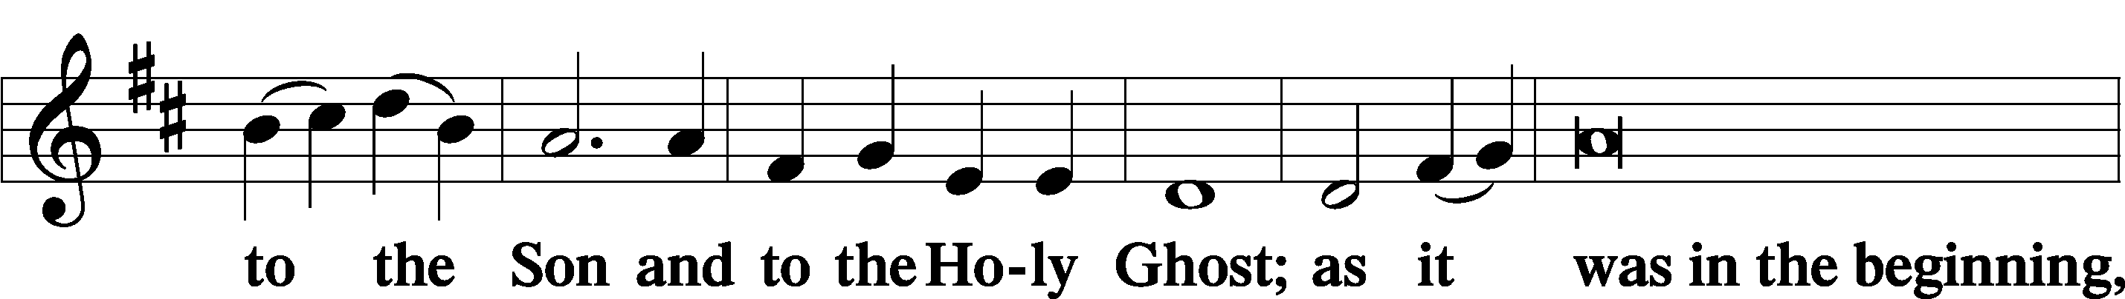

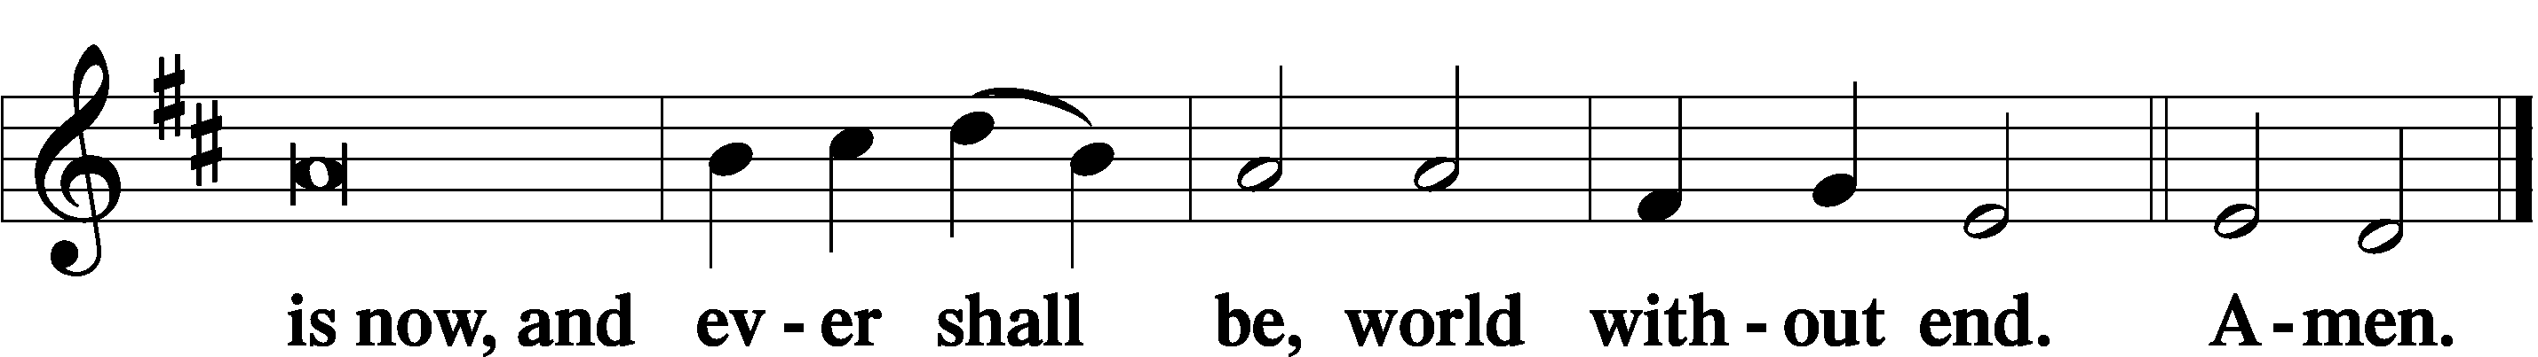

Thanksgiving Psalm 107:1
A O give thanks unto the Lord, for He is good,

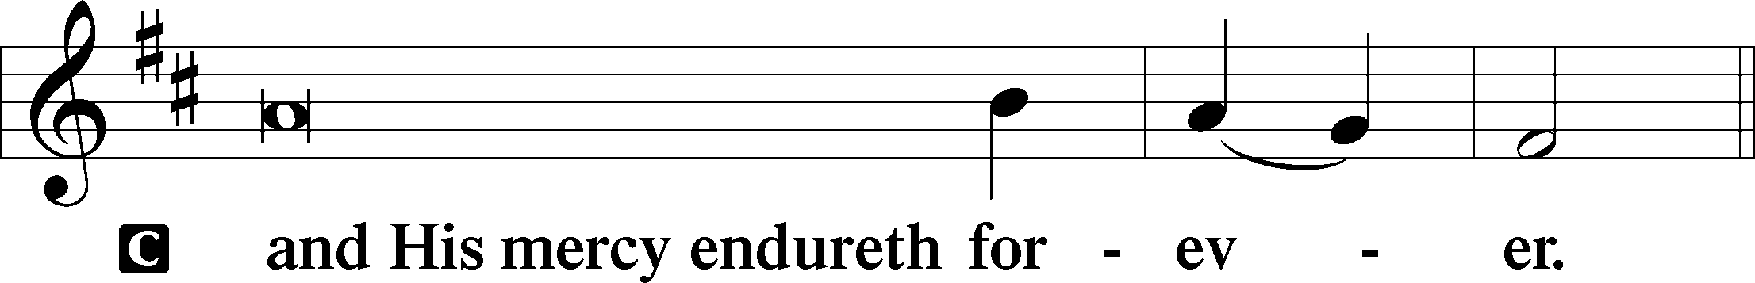

Post-Communion Collect
A Let us pray.
We give thanks to You, almighty God, that You have refreshed us through this salutary gift, and we implore You that of Your mercy You would strengthen us through the same in faith toward You and in fervent love toward one another; through Jesus Christ, Your Son, our Lord, who lives and reigns with You and the Holy Spirit, one God, now and forever.

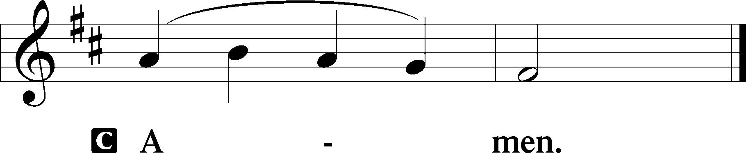

Salutation 2 Timothy 4:22
P The Lord be with you.

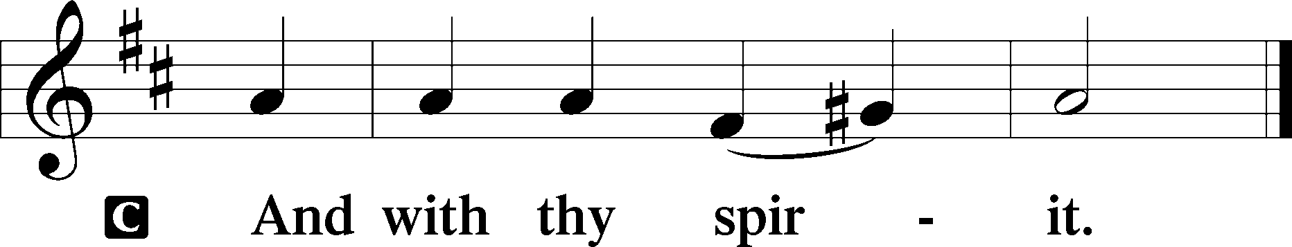

Benedicamus Psalm 103:1
A Bless we the Lord.

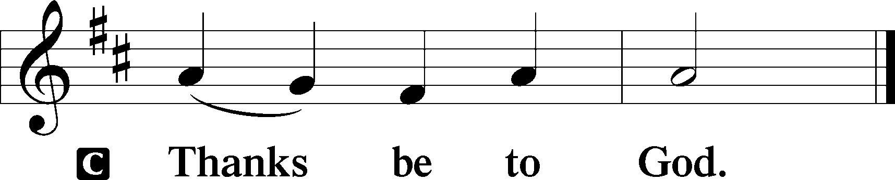

Benediction Numbers 6:24–26
P The Lord bless you and keep you.
The Lord make His face shine upon you and be gracious unto you.
The Lord lift up His countenance upon you and T give you peace.
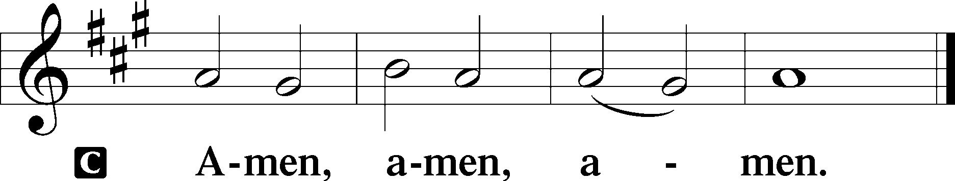

936 Sing Praise to the God of Israel
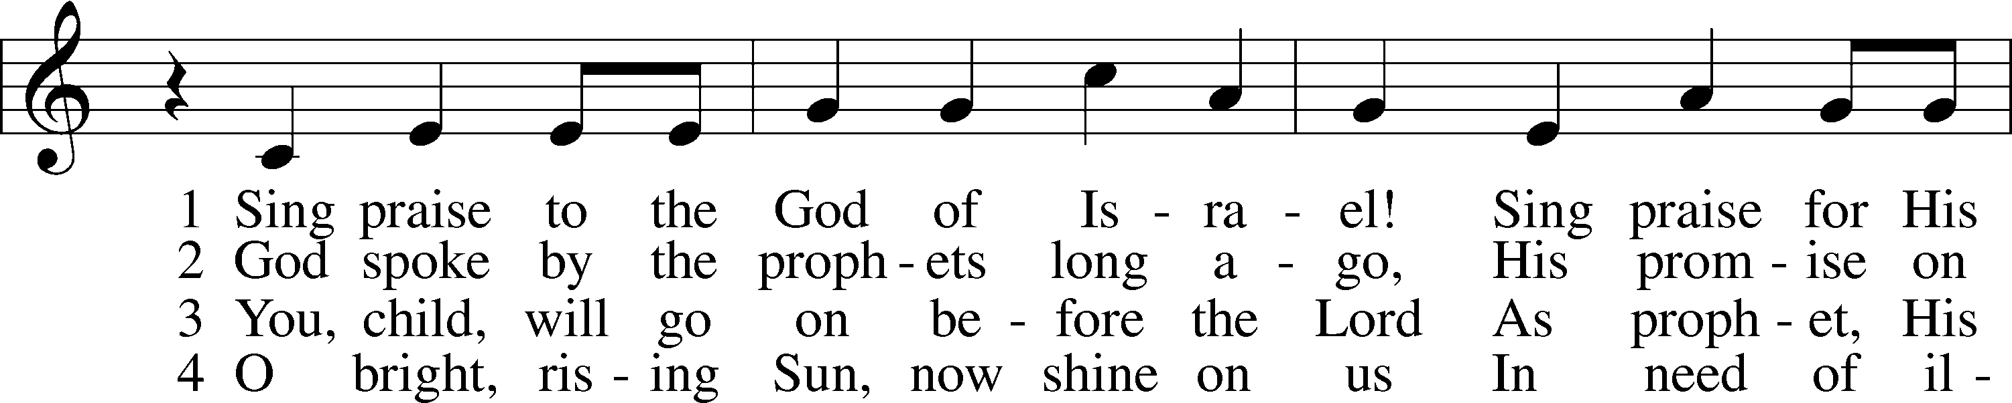
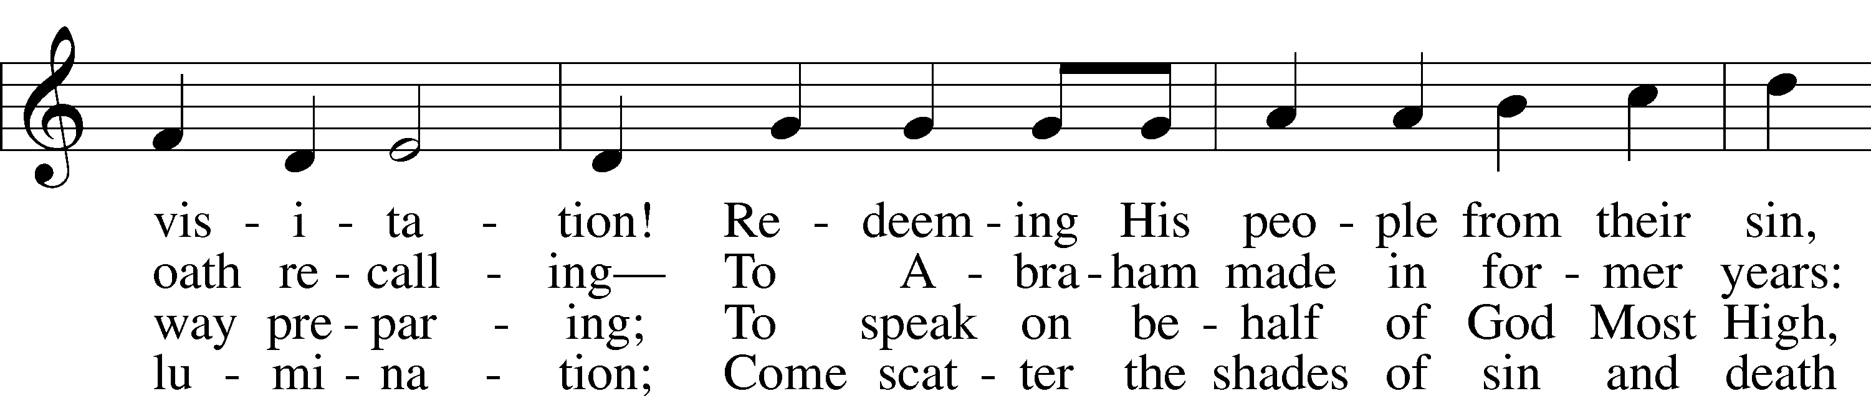
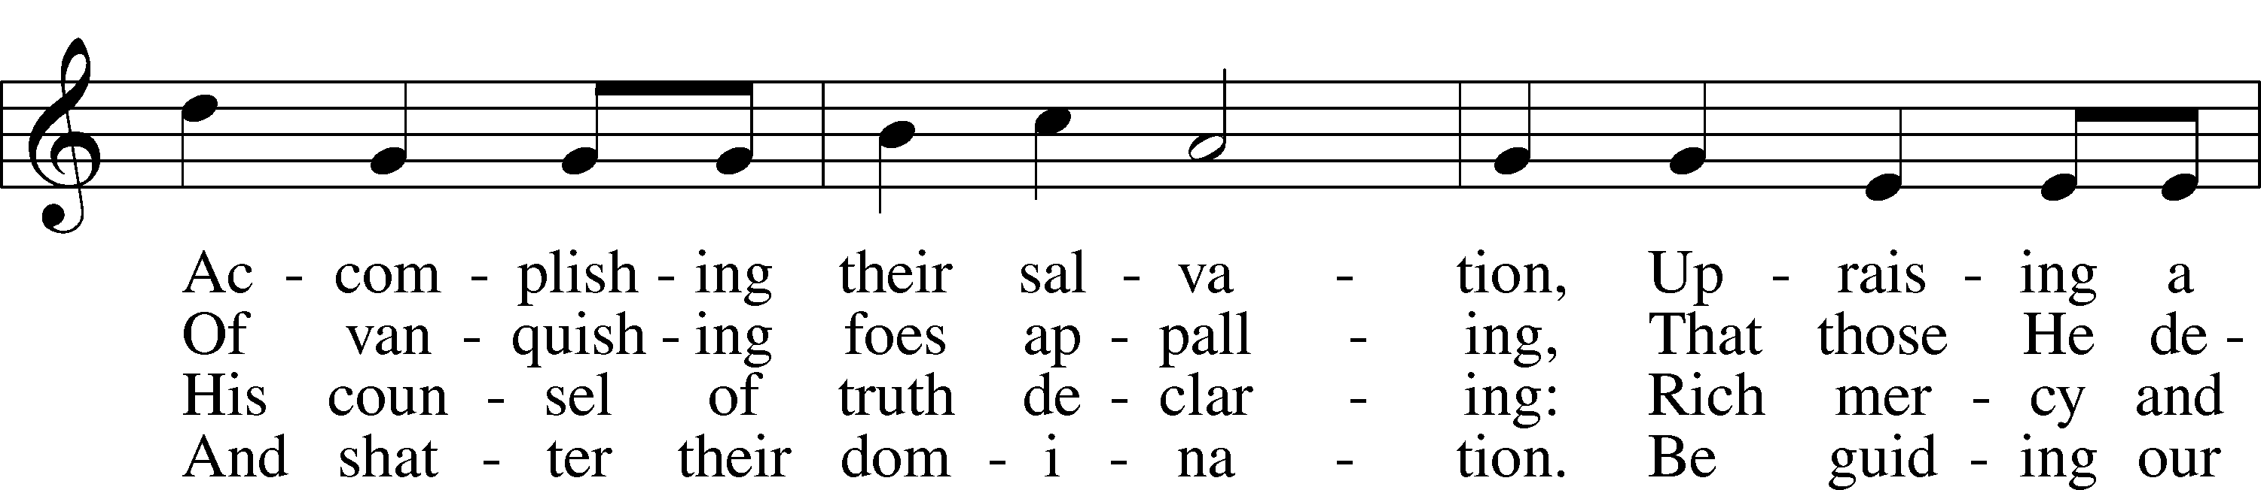
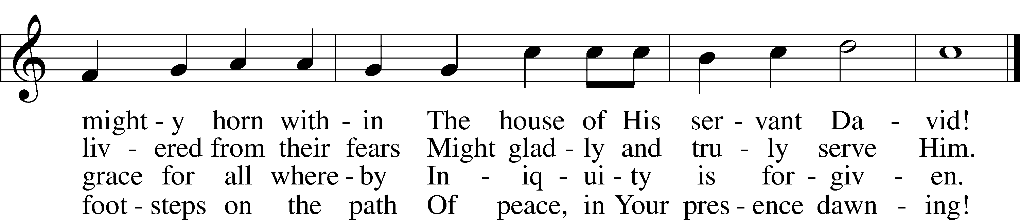
Text: Stephen P. Starke, 1955
Tune: Christoph E. F. Weyse, 1774–1842
Text: © 1992 Stephen P. Starke, admin. Concordia Publishing House. Used by permission: LSB Hymn License no. 110005011
Tune: Public domain

Acknowledgments
Divine Service, Setting Three from Lutheran Service Book
Unless otherwise indicated, Scripture quotations are from the ESV® Bible (The Holy Bible, English Standard Version®), copyright © 2001 by Crossway, a publishing ministry of Good News Publishers. Used by permission. All rights reserved.
Created by Lutheran Service Builder © 2023 Concordia Publishing House.

