698 May We Thy Precepts, Lord, Fulfill

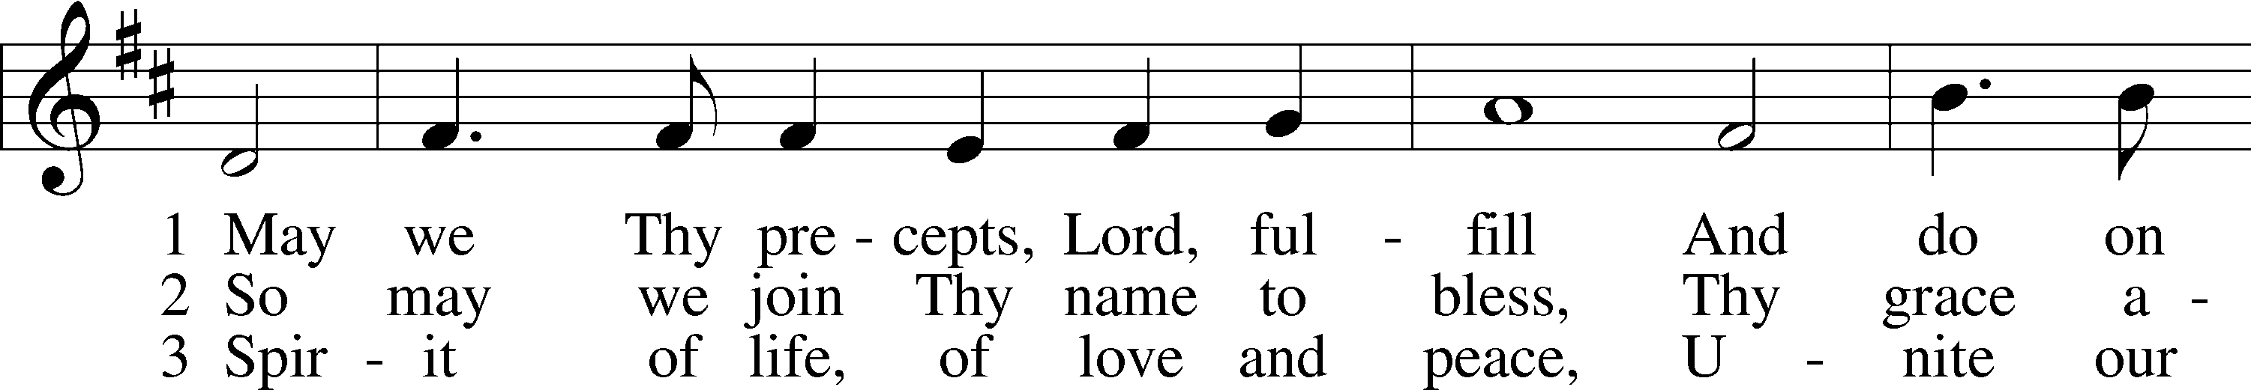

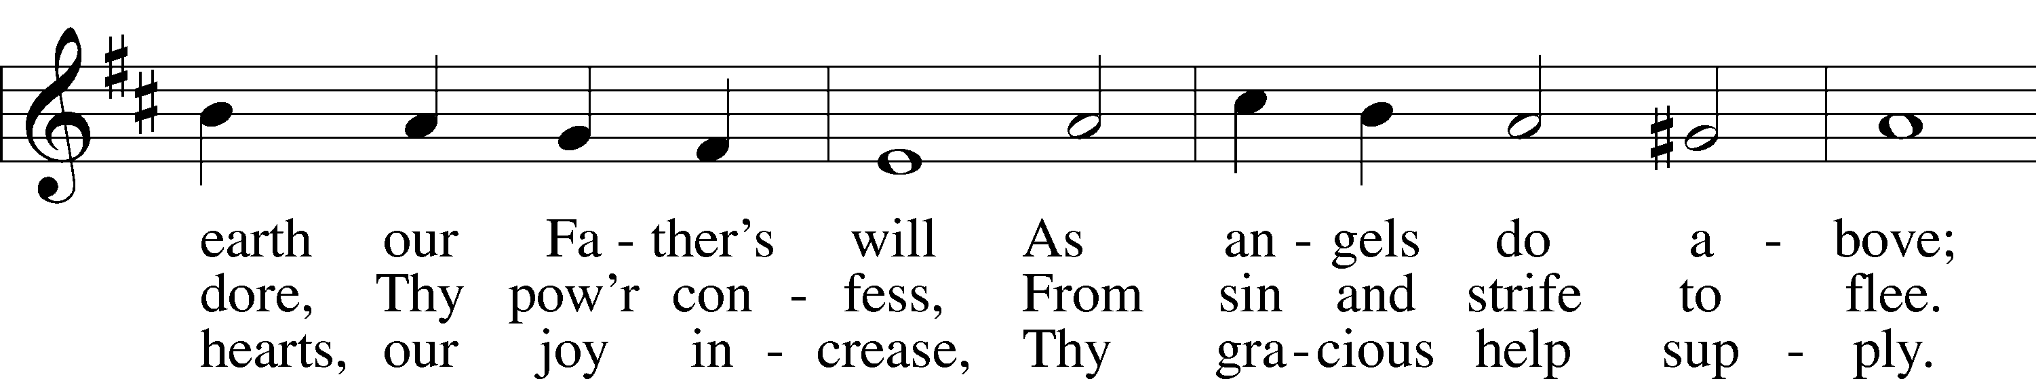

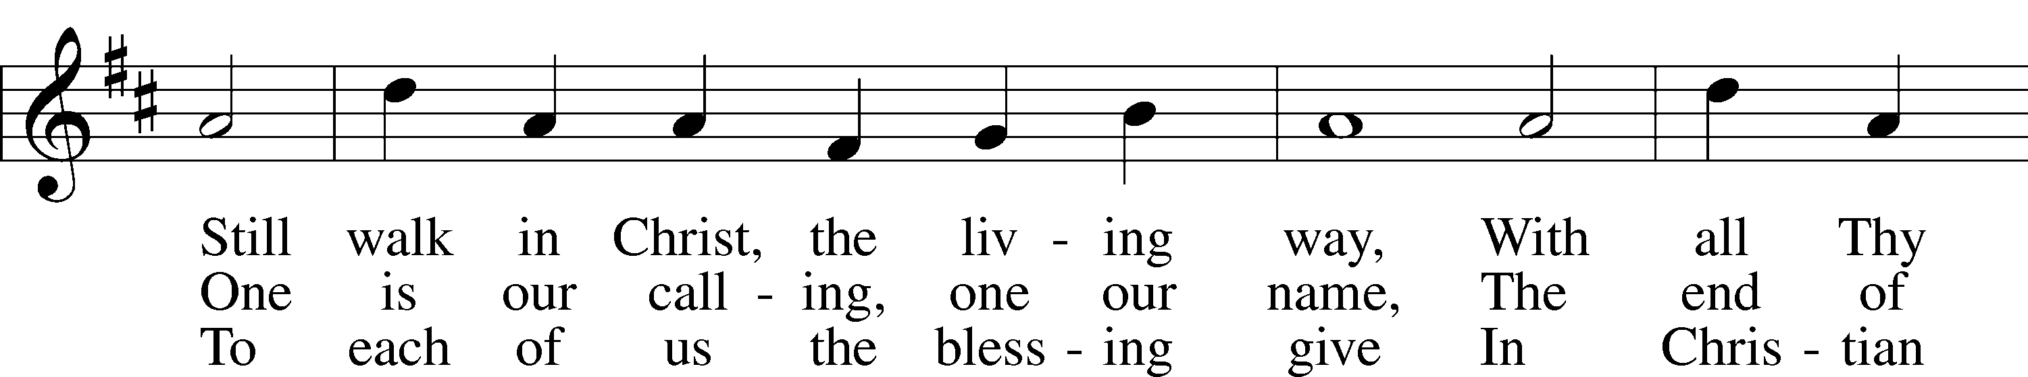

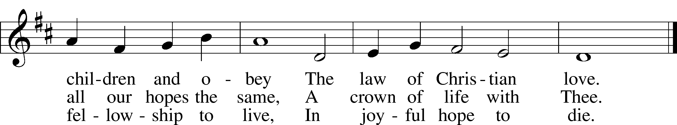

Text: Edward Osler, 1798–1863, alt.  
Tune: Lowell Mason, 1792–1872  
Text and tune: Public domain

# Confession and Absolution

The sign of the cross may be made by all in remembrance of their Baptism.

Invocation Matthew 28:19b; 18:20

P In the name of the Father and of the T Son and of the Holy Spirit.

C **Amen.**

Exhortation Hebrews 10:22; Psalm 124:8; Psalm 32:5

P Beloved in the Lord! Let us draw near with a true heart and confess our sins unto God our Father, beseeching Him in the name of our Lord Jesus Christ to grant us forgiveness.

P Our help is in the name of the Lord,

C **who made heaven and earth.**

P I said, I will confess my transgressions unto the Lord,

C **and You forgave the iniquity of my sin.**

Silence for reflection on God’s Word and for self-examination.

Confession of Sins

P Almighty God, our maker and redeemer, we poor sinners confess unto You that we are by nature sinful and unclean and that we have sinned against You by thought, word, and deed. Wherefore we flee for refuge to Your infinite mercy, seeking and imploring Your grace for the sake of our Lord Jesus Christ.

C **O most merciful God, who has given Your only-begotten Son to die for us, have mercy upon us and for His sake grant us remission of all our sins; and by Your Holy Spirit increase in us true knowledge of You and of Your will and true obedience to Your Word, to the end that by Your grace we may come to everlasting life; through Jesus Christ, our Lord. Amen.**

Declaration of Grace Mark 16:16; John 1:12

P Almighty God, our heavenly Father, has had mercy upon us and has given His only Son to die for us and for His sake forgives us all our sins. To those who believe on His name He gives power to become the children of God and has promised them His Holy Spirit. He that believes and is baptized shall be saved.  
  
Grant this, Lord, unto us all.

C **Amen.**

# Service of the Word

Introit Psalm 98:7–9; antiphon: v. 2

The Lord has made known his salvation;  
 he has revealed his righteousness in the sight of the nations.  
**Let the sea roar, and all that fills it;**  
 **the world and those who dwell in it!**  
Let the rivers clap their hands; let the hills sing for joy together before the Lord,  
 for he comes to judge the earth.  
**He will judge the world with righteousness,  
 and the peoples with equity.**

Gloria Patri

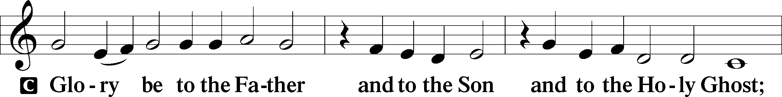

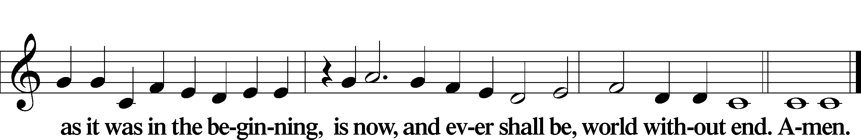

Kyrie Mark 10:47

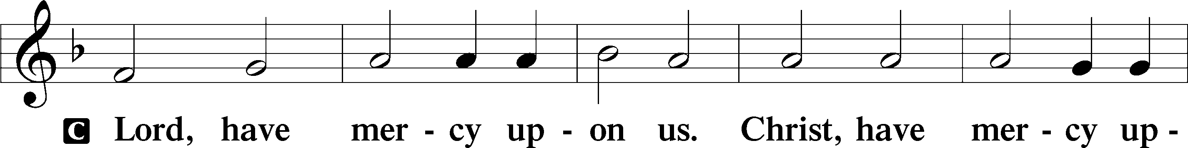

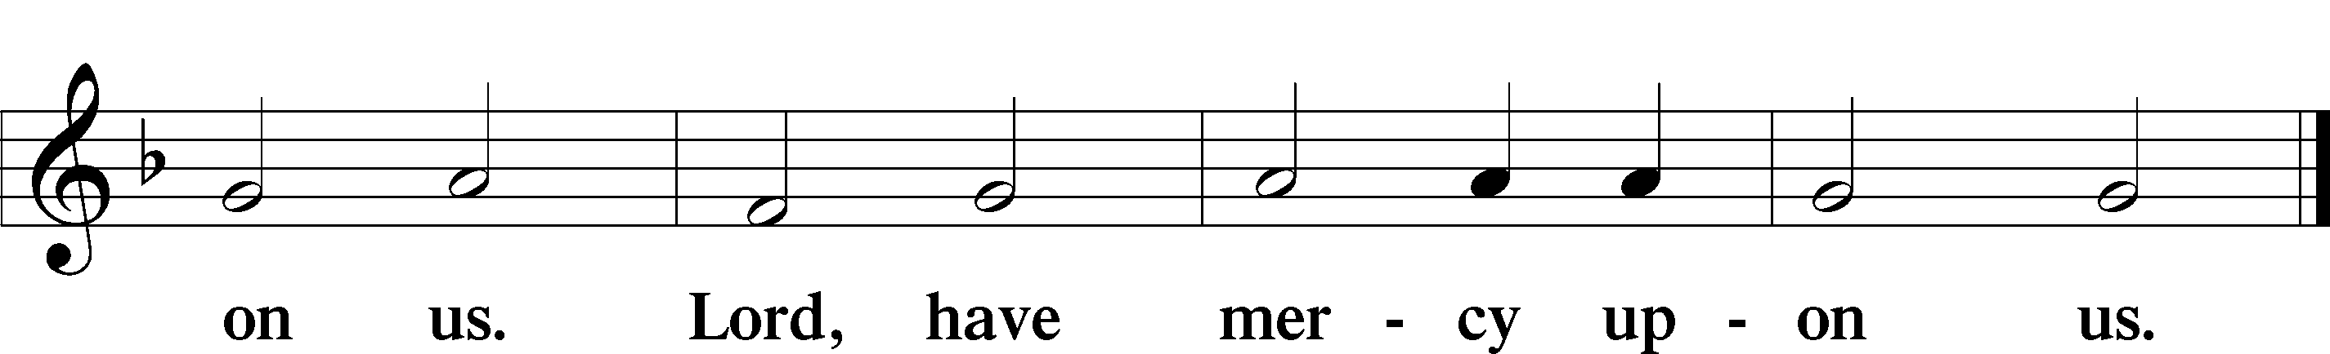

Gloria in Excelsis Luke 2:14; John 1:29

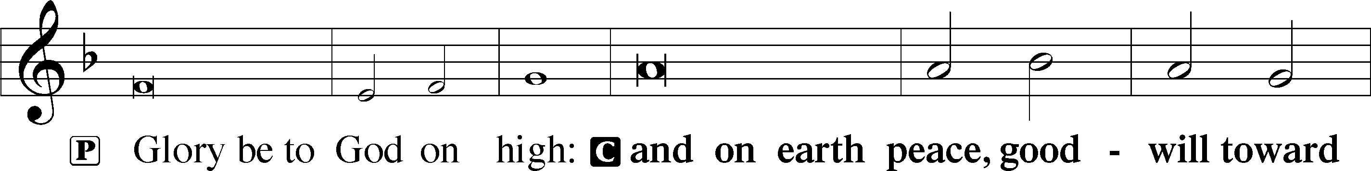

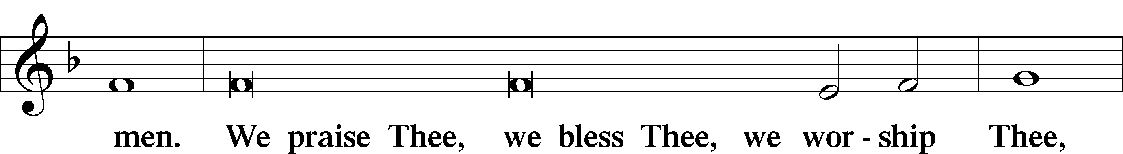

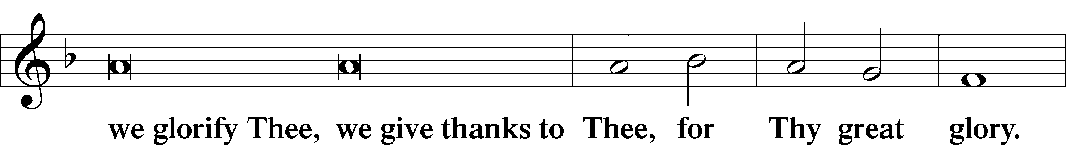

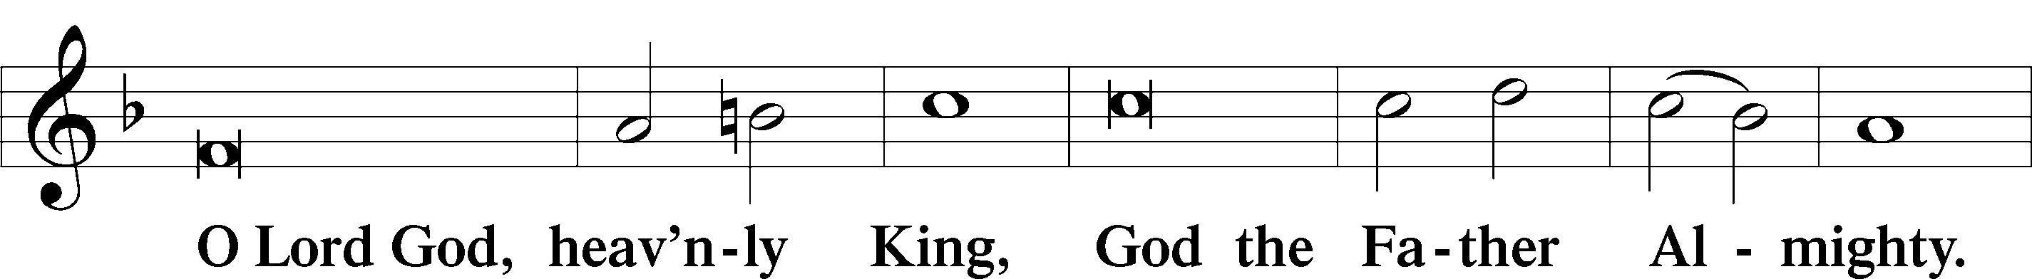

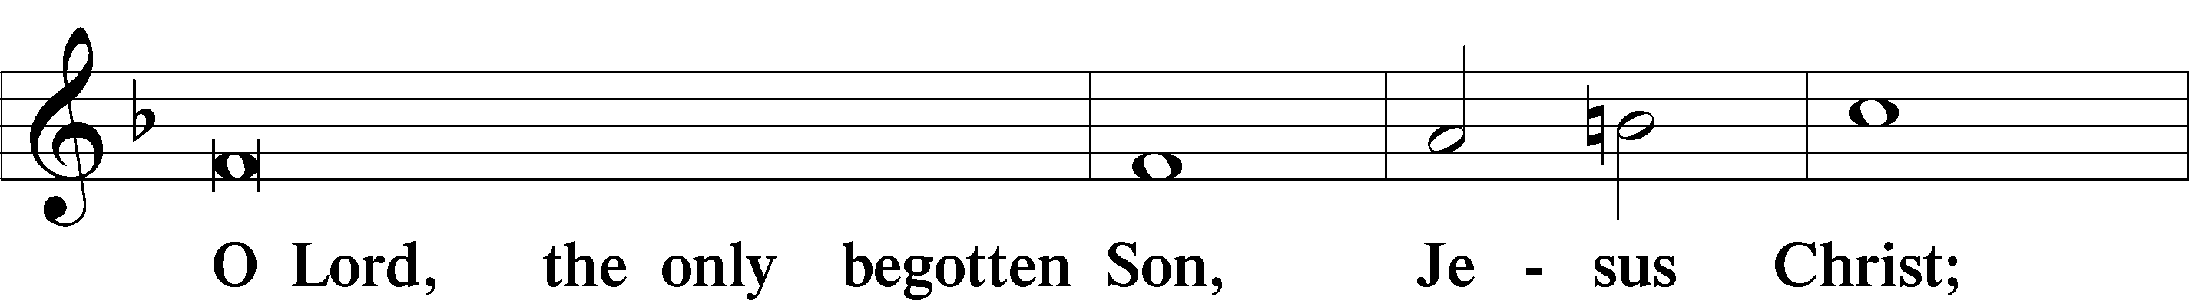

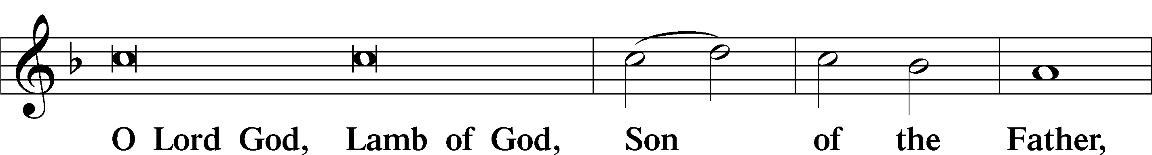

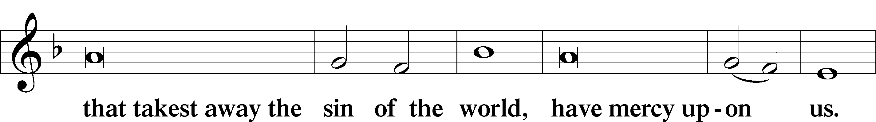

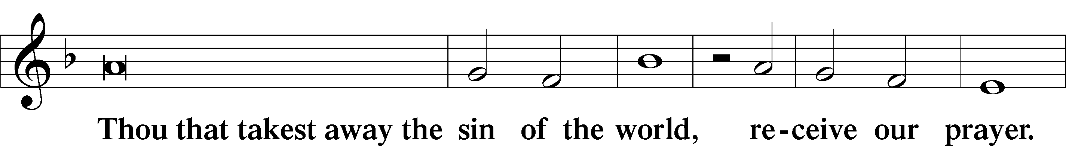

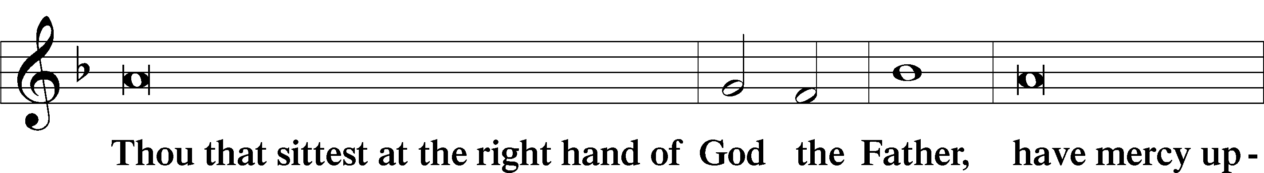

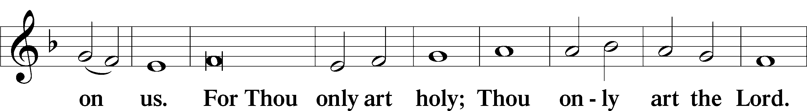

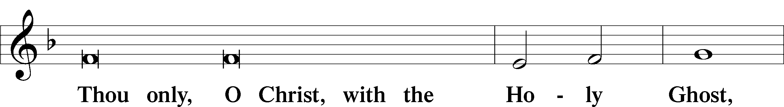

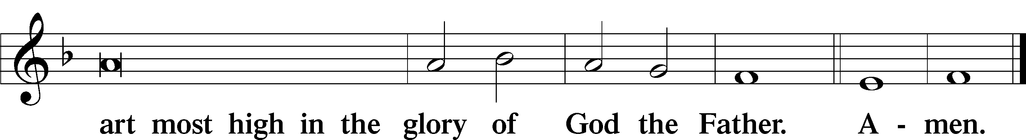

Salutation and Collect of the Day

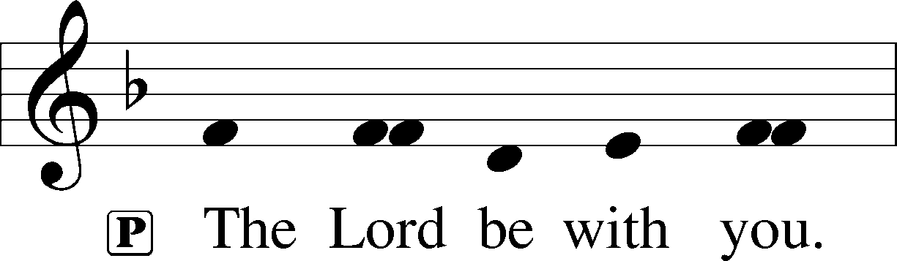

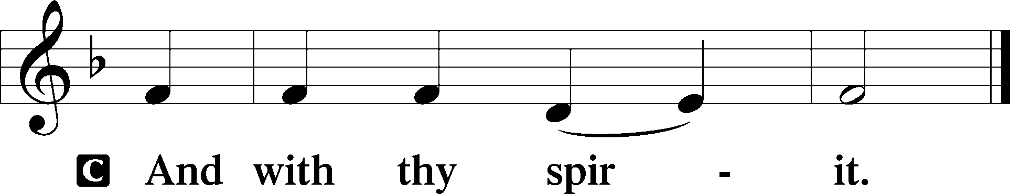

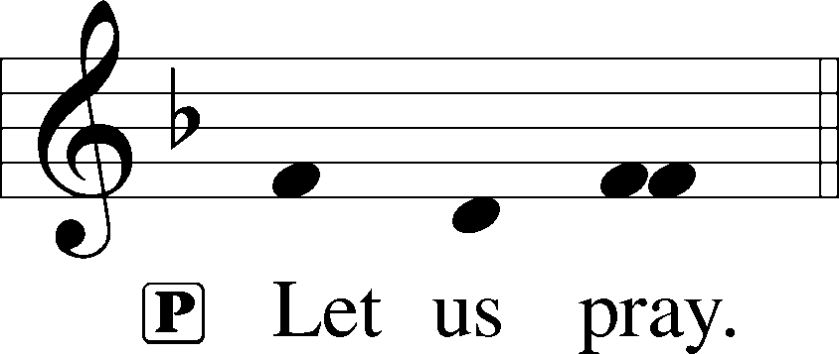

P O Lord, graciously hear the prayers of Your people that we who justly suffer the consequence of our sin may be mercifully delivered by Your goodness to the glory of Your name; through Jesus Christ, Your Son, our Lord, who lives and reigns with You and the Holy Spirit, one God, now and forever.

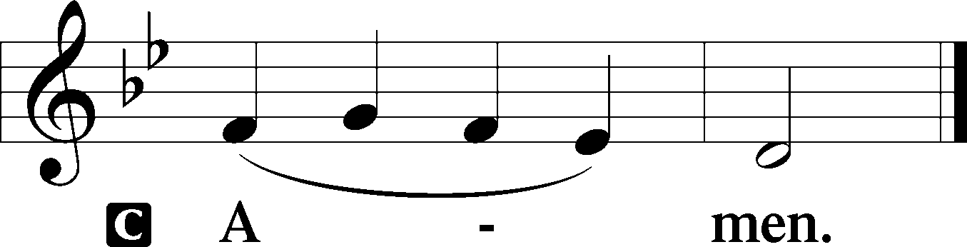

Sit

Old Testament Reading Deuteronomy 30:15–20

15“See, I have set before you today life and good, death and evil. 16If you obey the commandments of the Lord your God that I command you today, by loving the Lord your God, by walking in his ways, and by keeping his commandments and his statutes and his rules, then you shall live and multiply, and the Lord your God will bless you in the land that you are entering to take possession of it. 17But if your heart turns away, and you will not hear, but are drawn away to worship other gods and serve them, 18I declare to you today, that you shall surely perish. You shall not live long in the land that you are going over the Jordan to enter and possess. 19I call heaven and earth to witness against you today, that I have set before you life and death, blessing and curse. Therefore choose life, that you and your offspring may live, 20loving the Lord your God, obeying his voice and holding fast to him, for he is your life and length of days, that you may dwell in the land that the Lord swore to your fathers, to Abraham, to Isaac, and to Jacob, to give them.”

A This is the Word of the Lord.

C **Thanks be to God.**

Gradual Psalm 117:1–2a; 96:8

Praise the Lord, all nations!  
 Extol him, all peoples!  
**For great is his steadfast love toward us,  
 and the faithfulness of the Lord endures forever.**  
Ascribe to the Lord the glory due his name;  
 bring an offering, and come into his courts!

Reading Romans 5:6–15

6For while we were still weak, at the right time Christ died for the ungodly. 7For one will scarcely die for a righteous person—though perhaps for a good person one would dare even to die— 8but God shows his love for us in that while we were still sinners, Christ died for us. 9Since, therefore, we have now been justified by his blood, much more shall we be saved by him from the wrath of God. 10For if while we were enemies we were reconciled to God by the death of his Son, much more, now that we are reconciled, shall we be saved by his life. 11More than that, we also rejoice in God through our Lord Jesus Christ, through whom we have now received reconciliation.

Death in Adam, Life in Christ

12Therefore, just as sin came into the world through one man, and death through sin, and so death spread to all men because all sinned— 13for sin indeed was in the world before the law was given, but sin is not counted where there is no law. 14Yet death reigned from Adam to Moses, even over those whose sinning was not like the transgression of Adam, who was a type of the one who was to come.

15But the free gift is not like the trespass. For if many died through one man’s trespass, much more have the grace of God and the free gift by the grace of that one man Jesus Christ abounded for many.

Stand

Alleluia

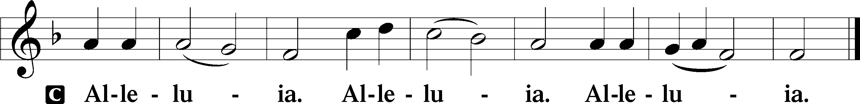

Holy Gospel Matthew 5:21–37

P The Holy Gospel according to St. Matthew, the fifth chapter.

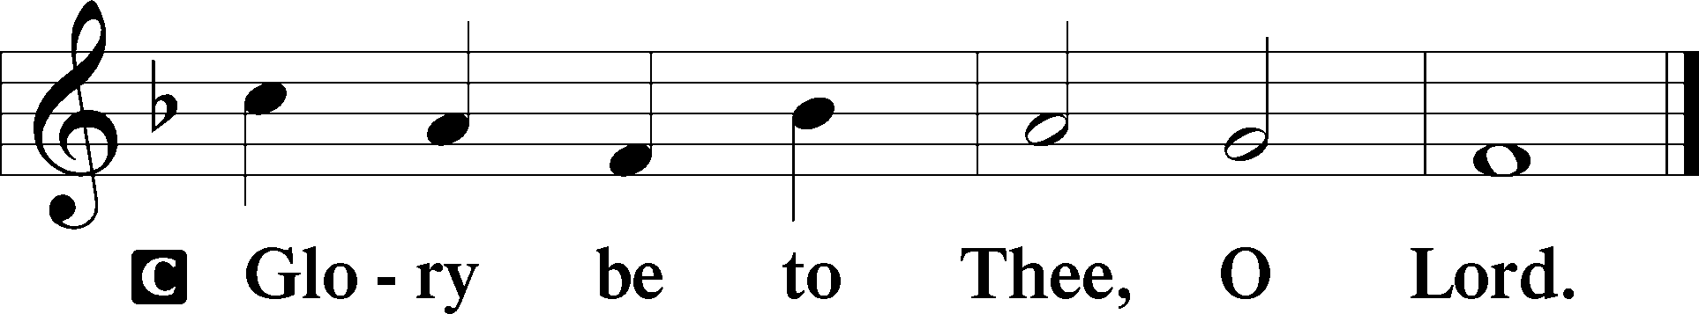

Anger

21[Jesus said:] “You have heard that it was said to those of old, ‘You shall not murder; and whoever murders will be liable to judgment.’ 22But I say to you that everyone who is angry with his brother will be liable to judgment; whoever insults his brother will be liable to the council; and whoever says, ‘You fool!’ will be liable to the hell of fire. 23So if you are offering your gift at the altar and there remember that your brother has something against you, 24leave your gift there before the altar and go. First be reconciled to your brother, and then come and offer your gift. 25Come to terms quickly with your accuser while you are going with him to court, lest your accuser hand you over to the judge, and the judge to the guard, and you be put in prison. 26Truly, I say to you, you will never get out until you have paid the last penny.

Lust

27“You have heard that it was said, ‘You shall not commit adultery.’ 28But I say to you that everyone who looks at a woman with lustful intent has already committed adultery with her in his heart. 29If your right eye causes you to sin, tear it out and throw it away. For it is better that you lose one of your members than that your whole body be thrown into hell. 30And if your right hand causes you to sin, cut it off and throw it away. For it is better that you lose one of your members than that your whole body go into hell.

Divorce

31“It was also said, ‘Whoever divorces his wife, let him give her a certificate of divorce.’ 32But I say to you that everyone who divorces his wife, except on the ground of sexual immorality, makes her commit adultery. And whoever marries a divorced woman commits adultery.

Oaths

33“Again you have heard that it was said to those of old, ‘You shall not swear falsely, but shall perform to the Lord what you have sworn.’ 34But I say to you, Do not take an oath at all, either by heaven, for it is the throne of God, 35or by the earth, for it is his footstool, or by Jerusalem, for it is the city of the great King. 36And do not take an oath by your head, for you cannot make one hair white or black. 37Let what you say be simply ‘Yes’ or ‘No’; anything more than this comes from evil.”

P This is the Gospel of the Lord.

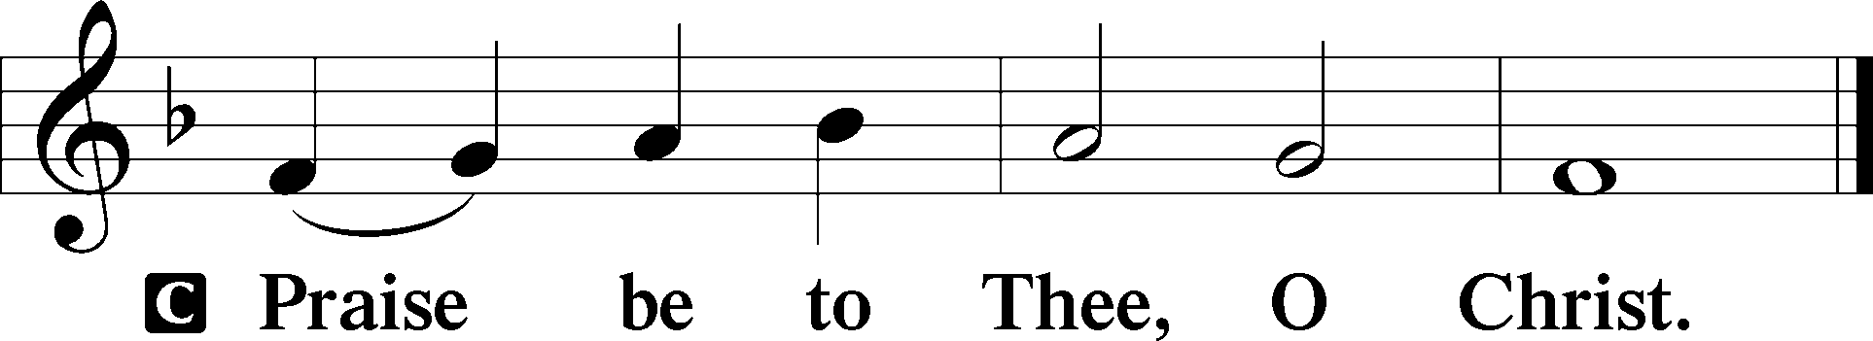

Apostles’ Creed

C **I believe in God, the Father Almighty,**

**maker of heaven and earth.**

**And in Jesus Christ, His only Son, our Lord,**

**who was conceived by the Holy Spirit,**

**born of the virgin Mary,**

**suffered under Pontius Pilate,**

**was crucified, died and was buried.**

**He descended into hell.**

**The third day He rose again from the dead.**

**He ascended into heaven**

**and sits at the right hand of God the Father Almighty.**

**From thence He will come to judge the living and the dead.**

**I believe in the Holy Spirit,**

**the holy Christian Church,**

**the communion of saints,**

**the forgiveness of sins,**

**the resurrection of the body,**

**and the life** T **everlasting. Amen.**

**Children's Message**

394 Songs of Thankfulness and Praise

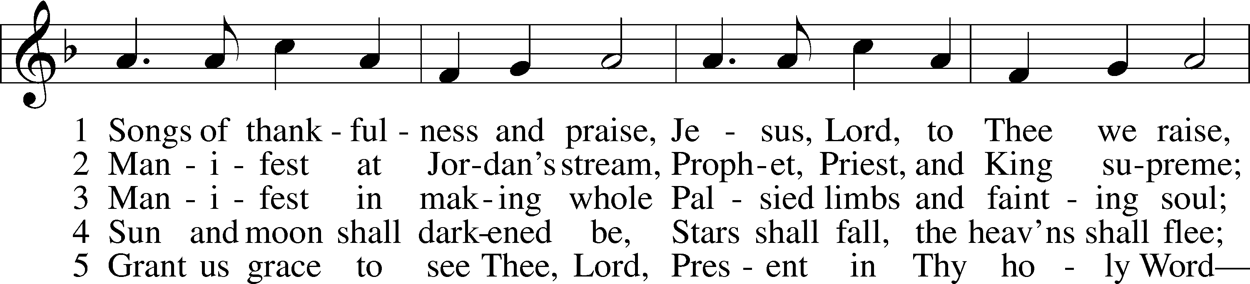

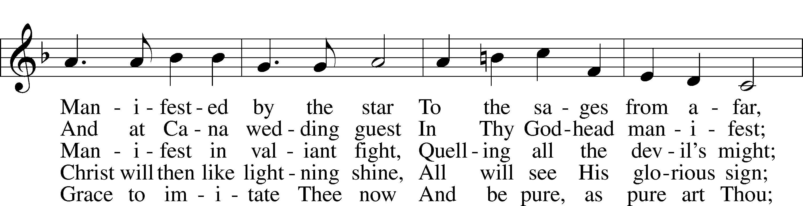

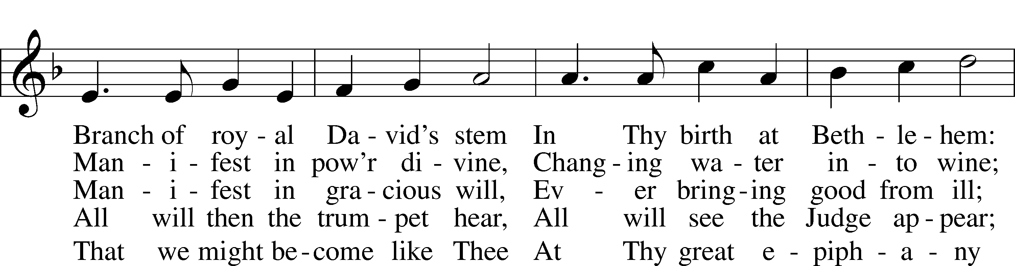

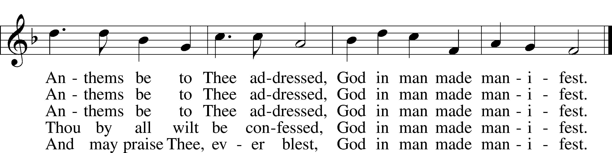

Text: Christopher Wordsworth, 1807–85, alt.  
Tune: George J. Elvey, 1816–93  
Text and tune: Public domain

Sermon

Votum

P The peace of God, which passes all understanding, keep your hearts and minds in Christ Jesus.

C **Amen.**

Stand

Offertory Psalm 51:10–12

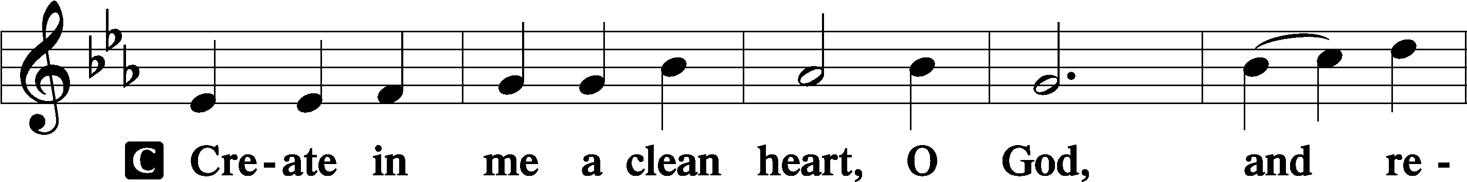

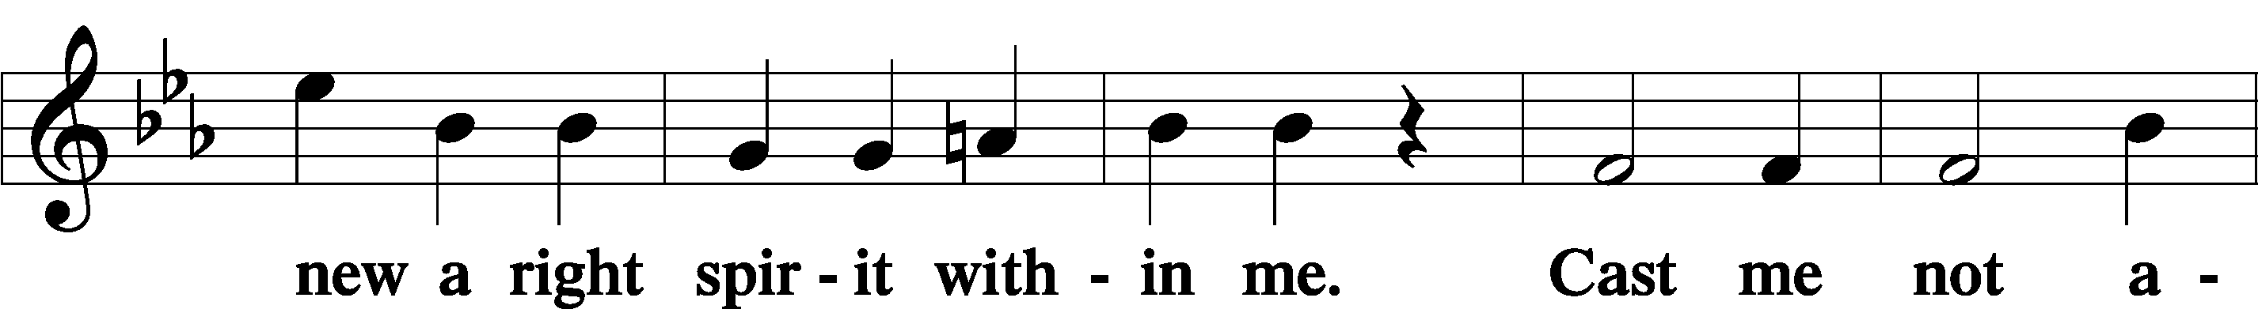

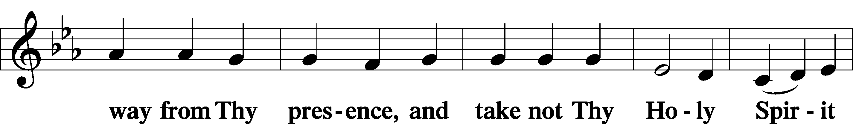

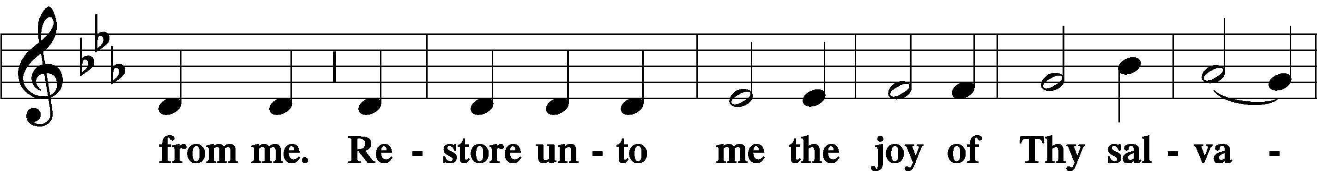

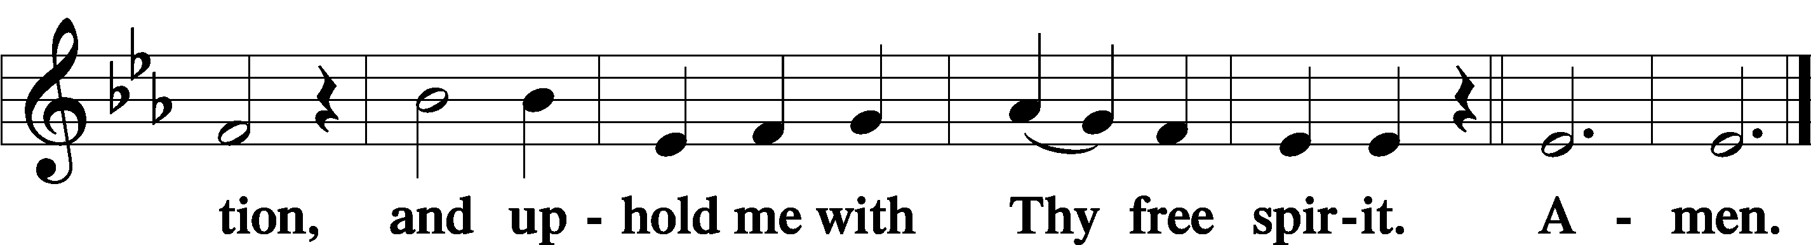

Offering

805 Praise God, from Whom All Blessings Flow

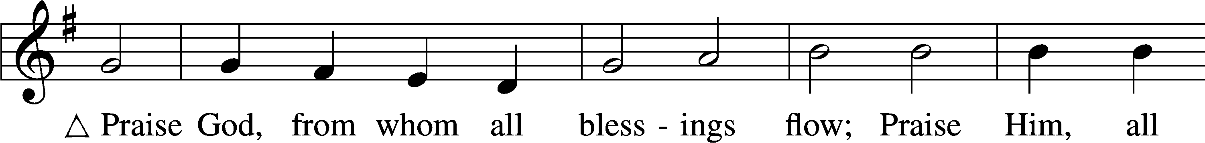

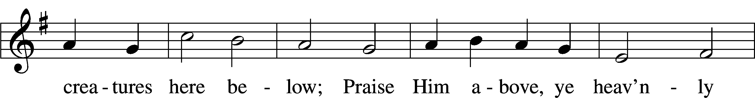

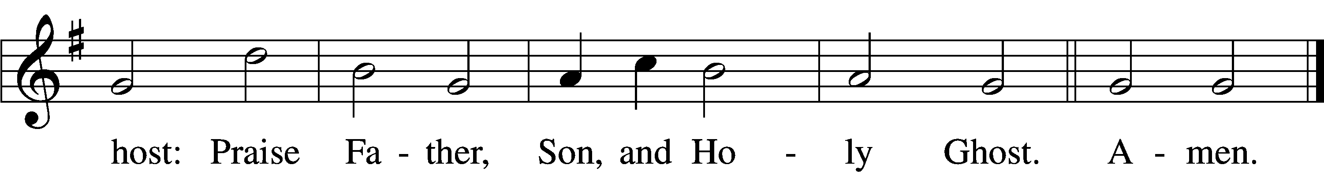

Text: Thomas Ken, 1637–1711  
Tune: Trente quatre Pseaumes de David, 1551, Geneva, ed. Louis Bourgeois  
Text and tune: Public domain

Prayer of the Church

Lord’s Prayer Matthew 6:9–13

P Lord, remember us in Your kingdom and teach us to pray:

C **Our Father who art in heaven,**

**hallowed be Thy name,**

**Thy kingdom come,**

**Thy will be done on earth**

**as it is in heaven;**

**give us this day our daily bread;**

**and forgive us our trespasses**

**as we forgive those**

**who trespass against us;**

**and lead us not into temptation,**

**but deliver us from evil.**

**For Thine is the kingdom**

**and the power and the glory**

**forever and ever. Amen.**

Collect for the Word

Blessed Lord, You have caused all Holy Scriptures to be written for our learning.

Grant that we may so hear them, read, mark, learn, and inwardly digest them that, by the patience and comfort of Your holy Word, we may embrace and ever hold fast the blessed hope of everlasting life; which you have given us in our Savior Jesus Christ, Your Son, our Lord, who lives and reigns with You and the Holy Spirit, one God, now and forever.

Post-Communion Collect

A Let us pray.

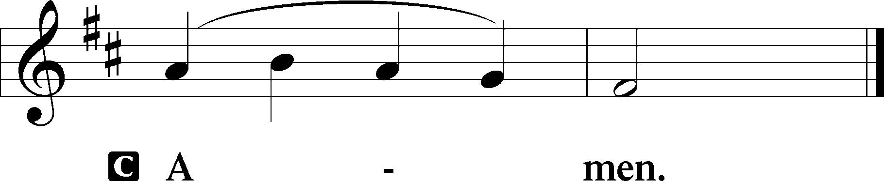

Hymn to Depart

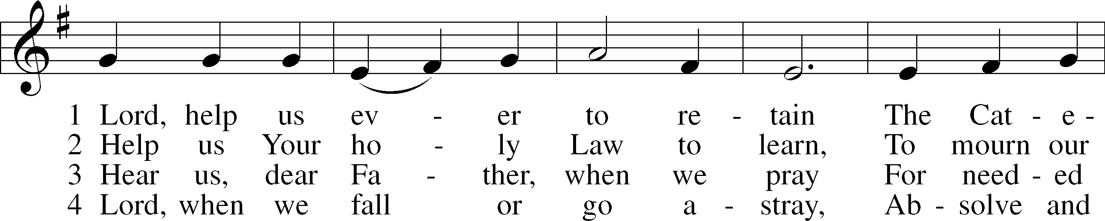

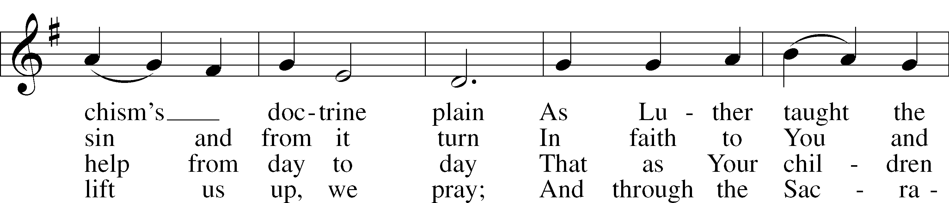

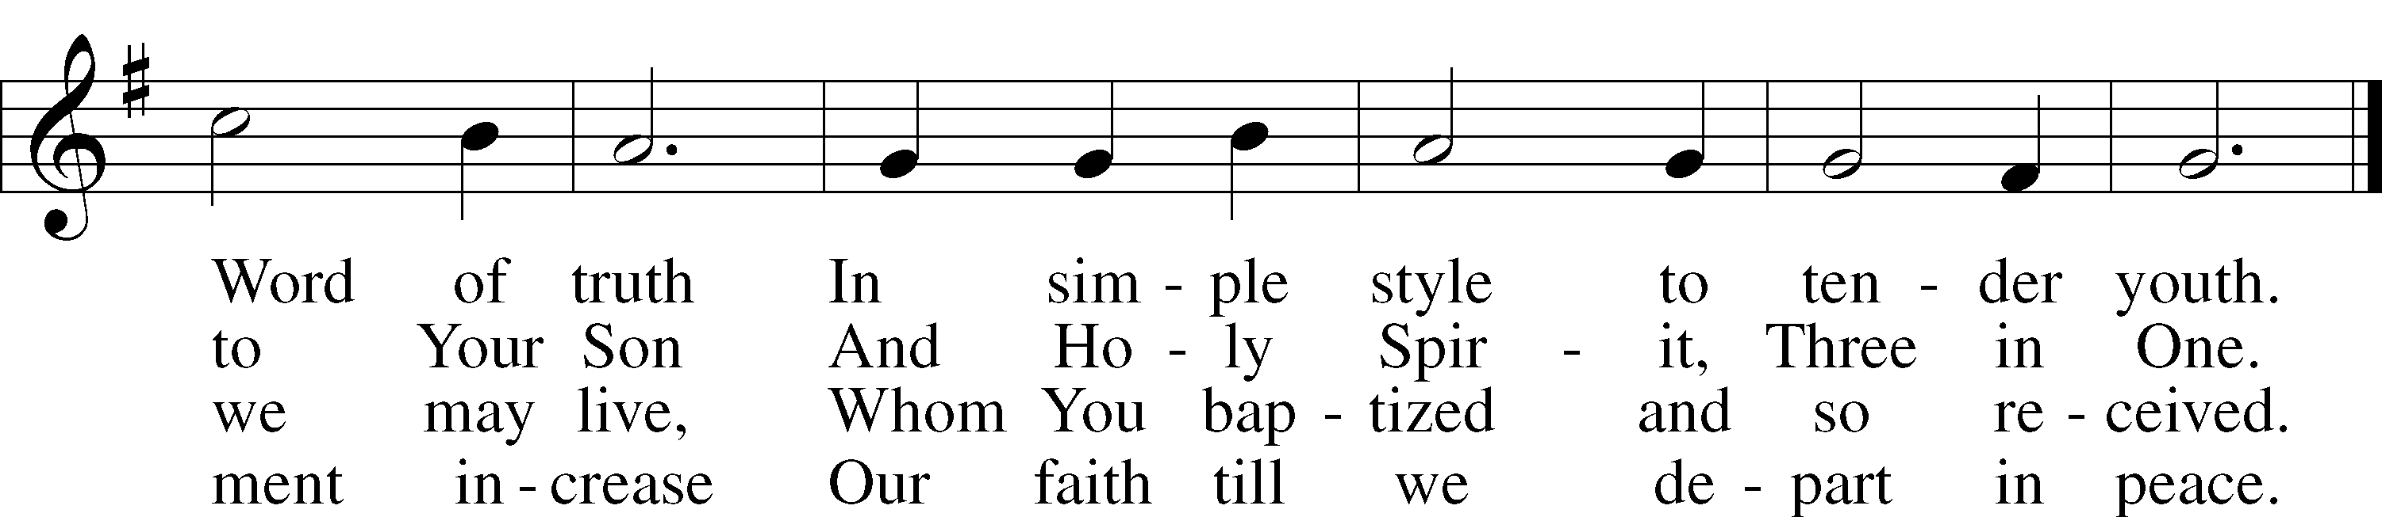

Text: Ludwig Helmbold, 1532–98; tr. Matthias Loy, 1828–1915, alt.  
Tune: As hymnodus sacer, 1625, Leipzig  
Text and tune: Public domain

Acknowledgments

Unless otherwise indicated, Scripture quotations are from the ESV® Bible (The Holy Bible, English Standard Version®), copyright © 2001 by Crossway, a publishing ministry of Good News Publishers. Used by permission. All rights reserved.

Created by Lutheran Service Builder © 2023 Concordia Publishing House.