# Confession and Absolution

414 ’Tis Good, Lord, to Be Here

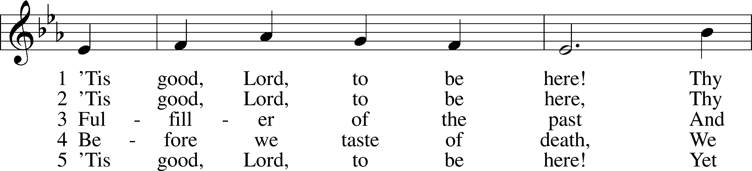

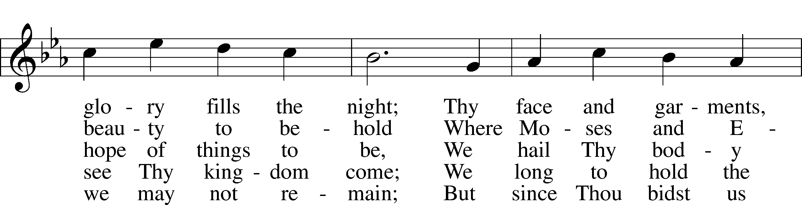

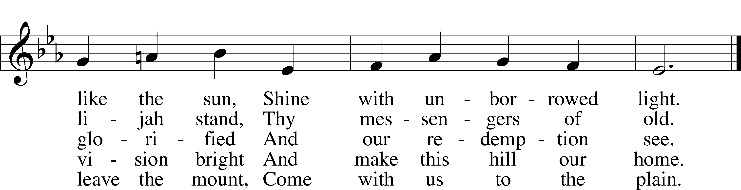

Text: Joseph A. Robinson, 1858–1933, alt.  
Tune: Johann Sebastian Bach, 1685–1750, adapt.  
Text and tune: Public domain

Stand

The sign of the cross may be made by all in remembrance of their Baptism.

Invocation Matthew 28:19b; 18:20

P In the name of the Father and of the T Son and of the Holy Spirit.

C **Amen.**

Exhortation Psalm 124:8; Psalm 130:3–4; Luke 18:13

P Our help is in the name of the Lord,

C **who made heaven and earth.**

P If You, O Lord, kept a record of sins, O Lord, who could stand?

C **But with You there is forgiveness; therefore You are feared.**

P Since we are gathered to hear God’s Word, call upon Him in prayer and praise, and receive the body and blood of our Lord Jesus Christ in the fellowship of this altar, let us first consider our unworthiness and confess before God and one another that we have sinned in thought, word, and deed, and that we cannot free ourselves from our sinful condition. Together as His people let us take refuge in the infinite mercy of God, our heavenly Father, seeking His grace for the sake of Christ, and saying: God, be merciful to me, a sinner.

Kneel/Stand

Confession of Sins

C **Almighty God, have mercy upon us, forgive us our sins, and lead us to everlasting life. Amen.**

Prayer for Forgiveness

P Almighty God, merciful Father, in Holy Baptism You declared us to be Your children and gathered us into Your one, holy Church, in which You daily and richly forgive us our sins and grant us new life through Your Spirit. Be in our midst, enliven our faith, and graciously receive our prayer and praise; through Your Son, Jesus Christ, our Lord.

C **Amen.**

Stand

# Service of the Word

Introit Psalm 99:1–5; antiphon: v. 9

Exalt the Lord our God, and worship at his holy mountain;  
 for the Lord our God is holy!  
The Lord reigns; let the peoples tremble!  
 He sits enthroned upon the cherubim; let the earth quake!  
The Lord is great in Zion;  
 he is exalted over all the peoples.  
Let them praise your great and awesome name!  
 Holy is he!  
The King in his might loves justice.  
 You have established equity; you have executed justice and righteousness in Jacob.  
Exalt the Lord our God; worship at his footstool!  
 Holy is he!  
**Glory be to the Father and to the Son and to the Holy Spirit; as it was in the beginning, is now, and will be forever. Amen.**

Exalt the Lord our God, and worship at his holy mountain;  
 for the Lord our God is holy!

Kyrie Mark 10:47

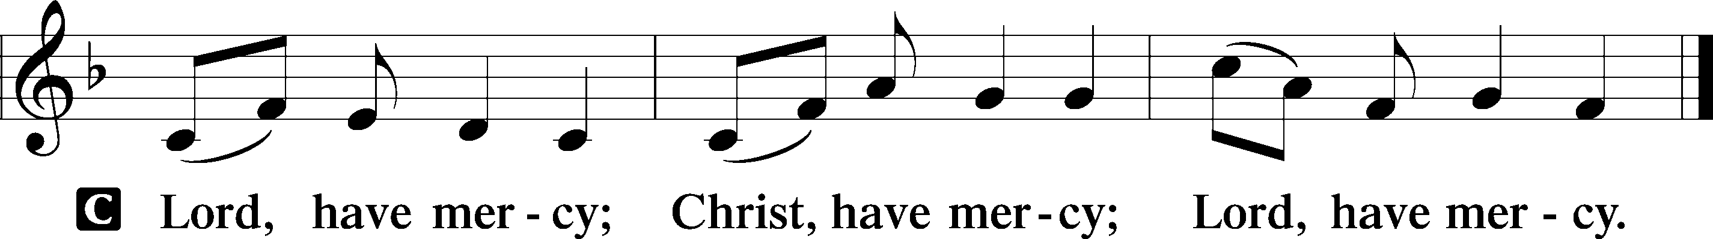

Gloria in Excelsis Luke 2:14; John 1:29

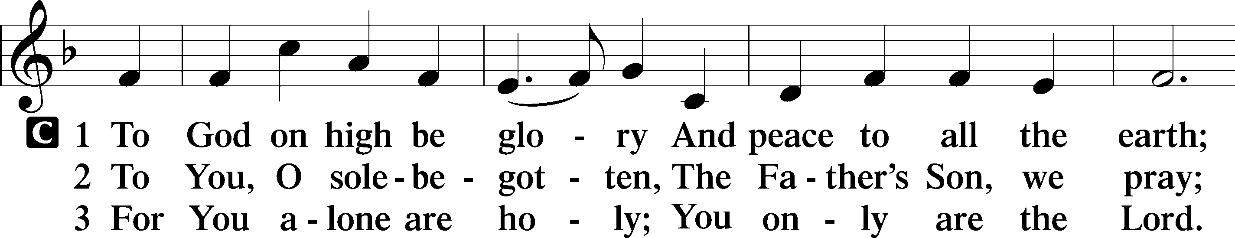

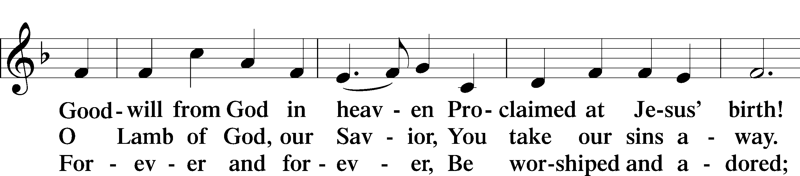

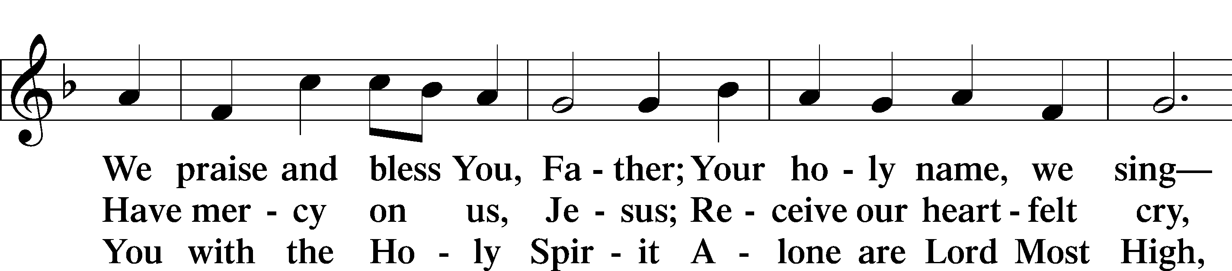

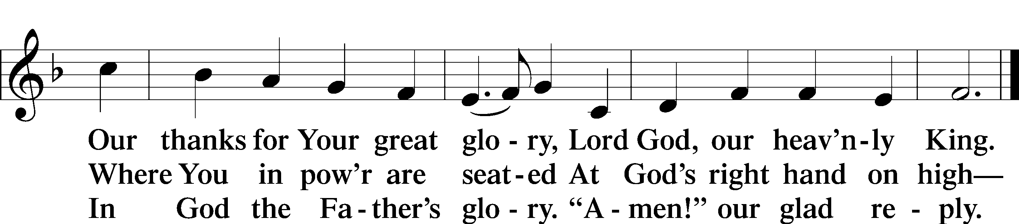

Text: Stephen P. Starke

Salutation and Collect of the Day

P The Lord be with you.

C **And also with you.**

P Let us pray.

O God, in the glorious transfiguration of Your beloved Son You confirmed the mysteries of the faith by the testimony of Moses and Elijah. In the voice that came from the bright cloud You wonderfully foreshowed our adoption by grace. Mercifully make us co-heirs with the King in His glory and bring us to the fullness of our inheritance in heaven; through the same Jesus Christ, our Lord, who lives and reigns with You and the Holy Spirit, one God, now and forever.

C **Amen.**

Sit

Old Testament Reading Exodus 24:8–18

8And Moses took the blood and threw it on the people and said, “Behold the blood of the covenant that the Lord has made with you in accordance with all these words.”

9Then Moses and Aaron, Nadab, and Abihu, and seventy of the elders of Israel went up, 10and they saw the God of Israel. There was under his feet as it were a pavement of sapphire stone, like the very heaven for clearness. 11And he did not lay his hand on the chief men of the people of Israel; they beheld God, and ate and drank.

12The Lord said to Moses, “Come up to me on the mountain and wait there, that I may give you the tablets of stone, with the law and the commandment, which I have written for their instruction.” 13So Moses rose with his assistant Joshua, and Moses went up into the mountain of God. 14And he said to the elders, “Wait here for us until we return to you. And behold, Aaron and Hur are with you. Whoever has a dispute, let him go to them.”

15Then Moses went up on the mountain, and the cloud covered the mountain. 16The glory of the Lord dwelt on Mount Sinai, and the cloud covered it six days. And on the seventh day he called to Moses out of the midst of the cloud. 17Now the appearance of the glory of the Lord was like a devouring fire on the top of the mountain in the sight of the people of Israel. 18Moses entered the cloud and went up on the mountain. And Moses was on the mountain forty days and forty nights.

A This is the Word of the Lord.

C **Thanks be to God.**

Gradual Psalm 117:1–2a; 96:8

Praise the Lord, all nations!  
 Extol him, all peoples!  
For great is his steadfast love toward us,  
 and the faithfulness of the Lord endures forever.  
Ascribe to the Lord the glory due his name;  
 bring an offering, and come into his courts!

Epistle 2 Peter 1:16–21

Christ’s Glory and the Prophetic Word

16For we did not follow cleverly devised myths when we made known to you the power and coming of our Lord Jesus Christ, but we were eyewitnesses of his majesty. 17For when he received honor and glory from God the Father, and the voice was borne to him by the Majestic Glory, “This is my beloved Son, with whom I am well pleased,” 18we ourselves heard this very voice borne from heaven, for we were with him on the holy mountain. 19And we have something more sure, the prophetic word, to which you will do well to pay attention as to a lamp shining in a dark place, until the day dawns and the morning star rises in your hearts, 20knowing this first of all, that no prophecy of Scripture comes from someone’s own interpretation. 21For no prophecy was ever produced by the will of man, but men spoke from God as they were carried along by the Holy Spirit.

A This is the Word of the Lord.

C **Thanks be to God.**

Stand

Alleluia and Verse

Alleluia

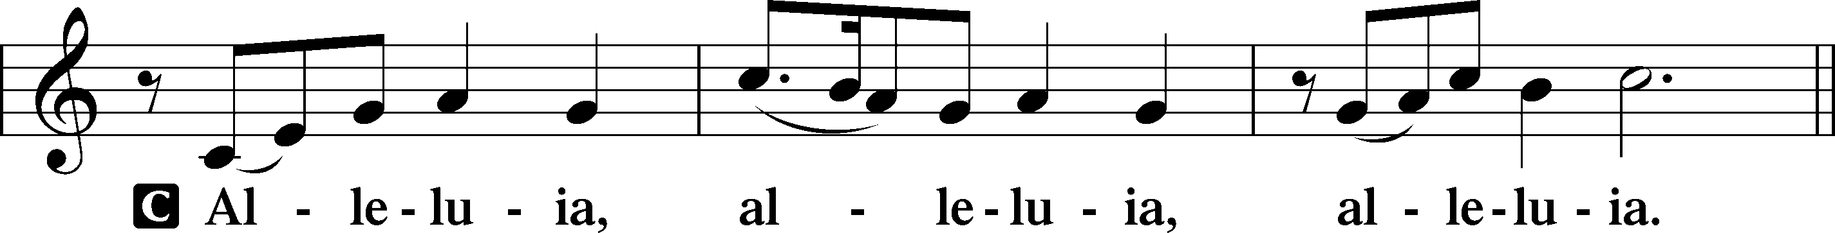

Verse John 20:31

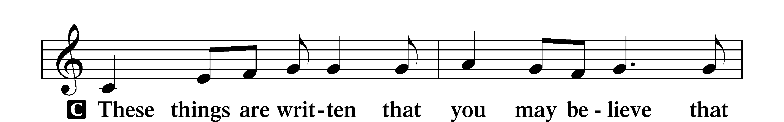

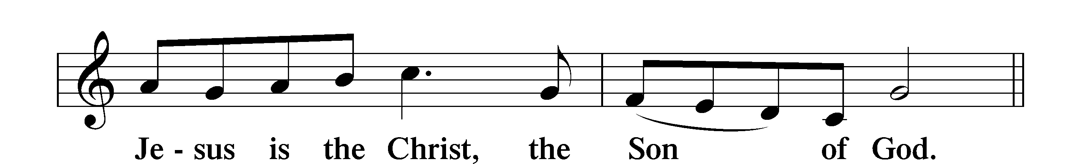

Alleluia

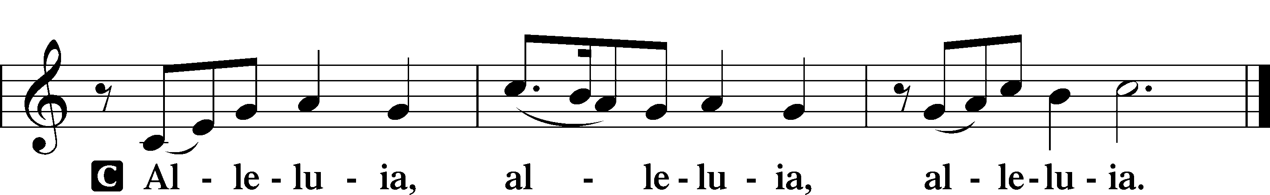

Holy Gospel Matthew 17:1–9

P The Holy Gospel according to St. Matthew, the seventeenth chapter.

C **Glory to You, O Lord.**

The Transfiguration

1After six days Jesus took with him Peter and James, and John his brother, and led them up a high mountain by themselves. 2And he was transfigured before them, and his face shone like the sun, and his clothes became white as light. 3And behold, there appeared to them Moses and Elijah, talking with him. 4And Peter said to Jesus, “Lord, it is good that we are here. If you wish, I will make three tents here, one for you and one for Moses and one for Elijah.” 5He was still speaking when, behold, a bright cloud overshadowed them, and a voice from the cloud said, “This is my beloved Son, with whom I am well pleased; listen to him.” 6When the disciples heard this, they fell on their faces and were terrified. 7But Jesus came and touched them, saying, “Rise, and have no fear.” 8And when they lifted up their eyes, they saw no one but Jesus only.

9And as they were coming down the mountain, Jesus commanded them, “Tell no one the vision, until the Son of Man is raised from the dead.”

P This is the Gospel of the Lord.

C **Praise to You, O Christ.**

Nicene Creed

C **I believe in one God,**

**the Father Almighty,**

**maker of heaven and earth**

**and of all things visible and invisible.**

**And in one Lord Jesus Christ,**

**the only-begotten Son of God,**

**begotten of His Father before all worlds,**

**God of God, Light of Light,**

**very God of very God,**

**begotten, not made,**

**being of one substance with the Father,**

**by whom all things were made;**

**who for us men and for our salvation came down from heaven**

**and was incarnate by the Holy Spirit of the virgin Mary**

**and was made man;**

**and was crucified also for us under Pontius Pilate.**

**He suffered and was buried.**

**And the third day He rose again according to the Scriptures**

**and ascended into heaven**

**and sits at the right hand of the Father.**

**And He will come again with glory to judge both the living and the dead,**

**whose kingdom will have no end.**

**And I believe in the Holy Spirit,**

**the Lord and giver of life,**

**who proceeds from the Father and the Son,**

**who with the Father and the Son together is worshiped and glorified,**

**who spoke by the prophets.**

**And I believe in one holy Christian and apostolic Church,**

**I acknowledge one Baptism for the remission of sins,**

**and I look for the resurrection of the dead**

**and the life** T **of the world to come. Amen.**

Sit

**Children's Message**

435 Come to Calvary’s Holy Mountain

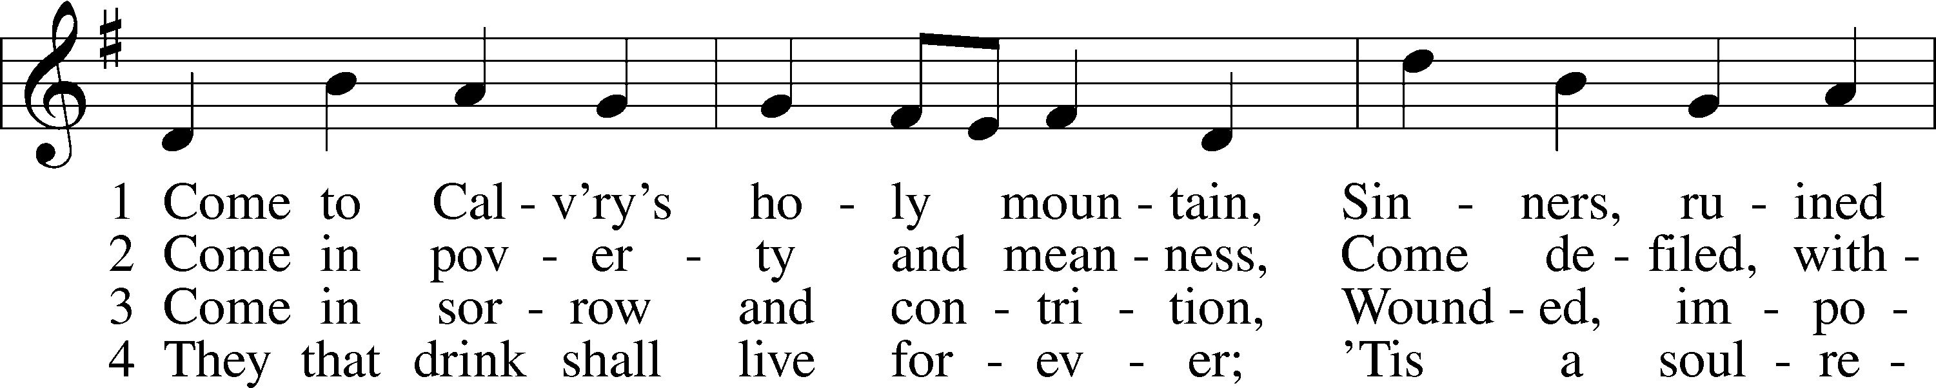

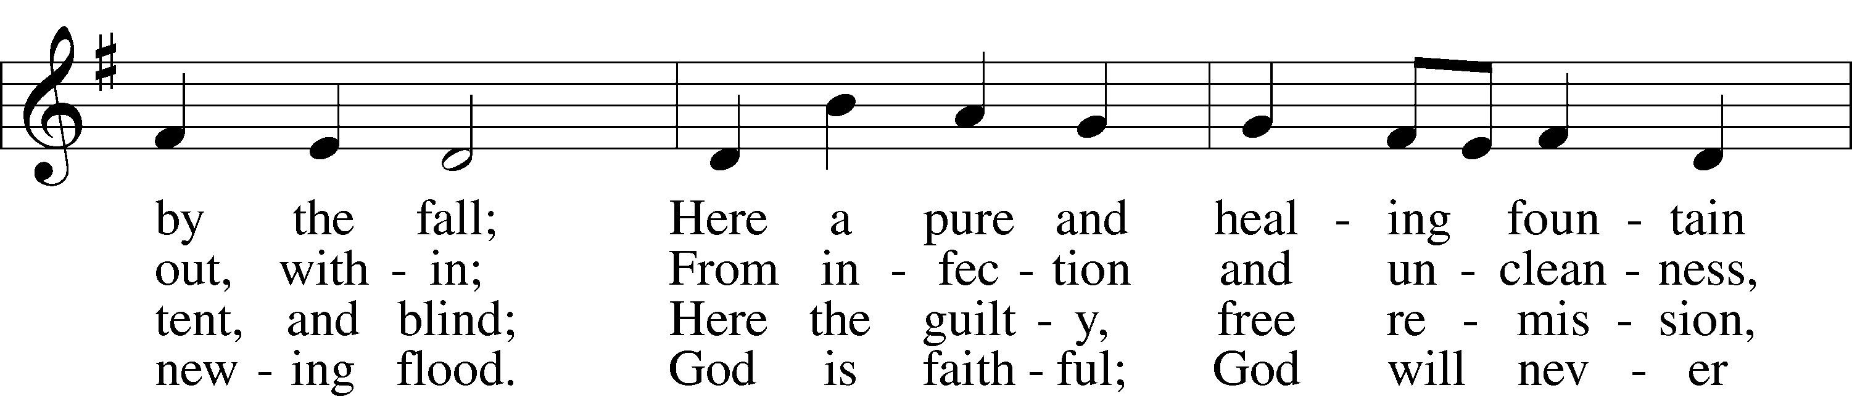

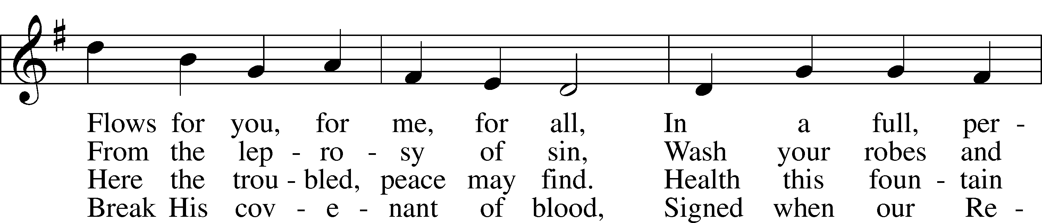

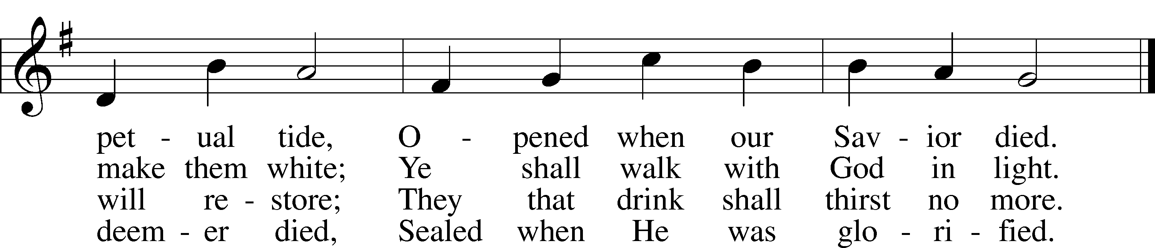

Text: James Montgomery, 1771–1854, alt.  
Tune: Ludvig M. Lindeman, 1812–87  
Text and tune: Public domain

Sermon

Stand

Prayer of the Church

Sit

Offering

805 Praise God, from Whom All Blessings Flow

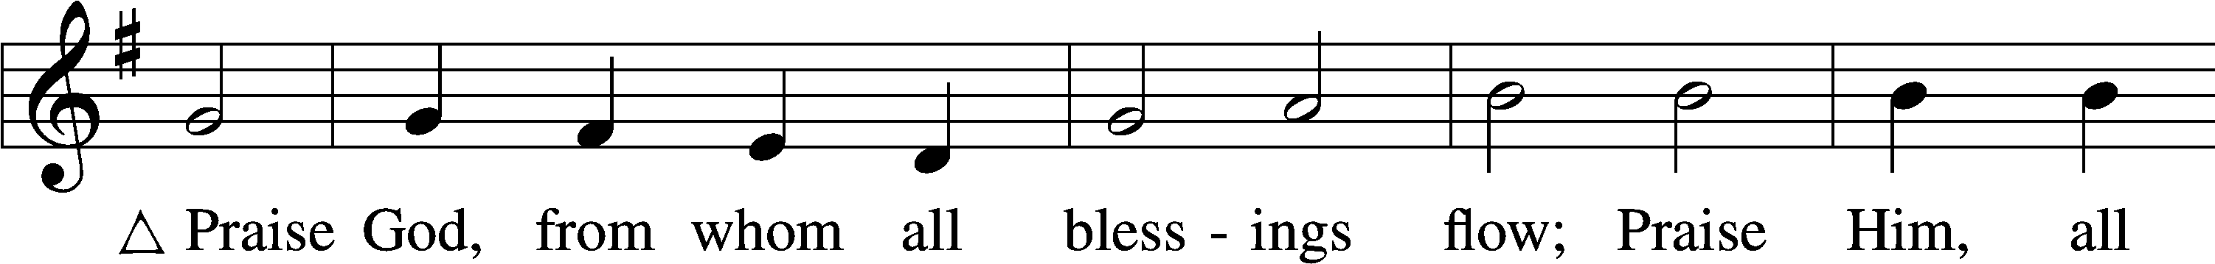

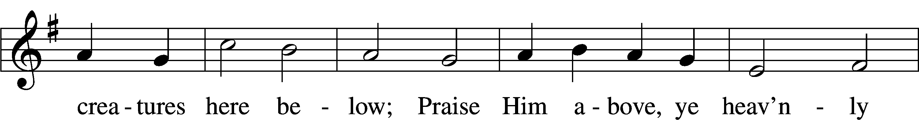

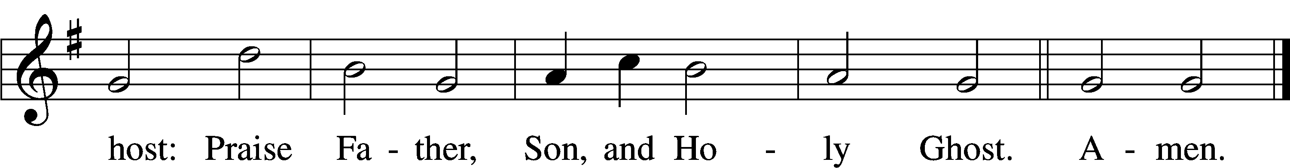

Text: Thomas Ken, 1637–1711  
Tune: Trente quatre Pseaumes de David, 1551, Geneva, ed. Louis Bourgeois  
Text and tune: Public domain

# Service of the Sacrament

Stand

Preface 2 Timothy 4:22; [Colossians 3:1]; [Psalm 136]

P The Lord be with you.

C **And also with you.**

P Lift up your hearts.

C **We lift them to the Lord.**

P Let us give thanks to the Lord our God.

C **It is right to give Him thanks and praise.**

P It is truly good, right, and salutary that we should at all times and in all places give thanks to You, O Lord, holy Father, almighty and everlasting God, for the countless blessings You so freely bestow on us and all creation. Above all, we give thanks for Your boundless love shown to us when You sent Your only-begotten Son, Jesus Christ, into our flesh and laid on Him our sin, giving Him into death that we might not die eternally. Because He is now risen from the dead and lives and reigns to all eternity, all who believe in Him will overcome sin and death and will rise again to new life. Therefore with angels and archangels and with all the company of heaven we laud and magnify Your glorious name, evermore praising You and saying:

Sanctus Isaiah 6:3; Matthew 21:9

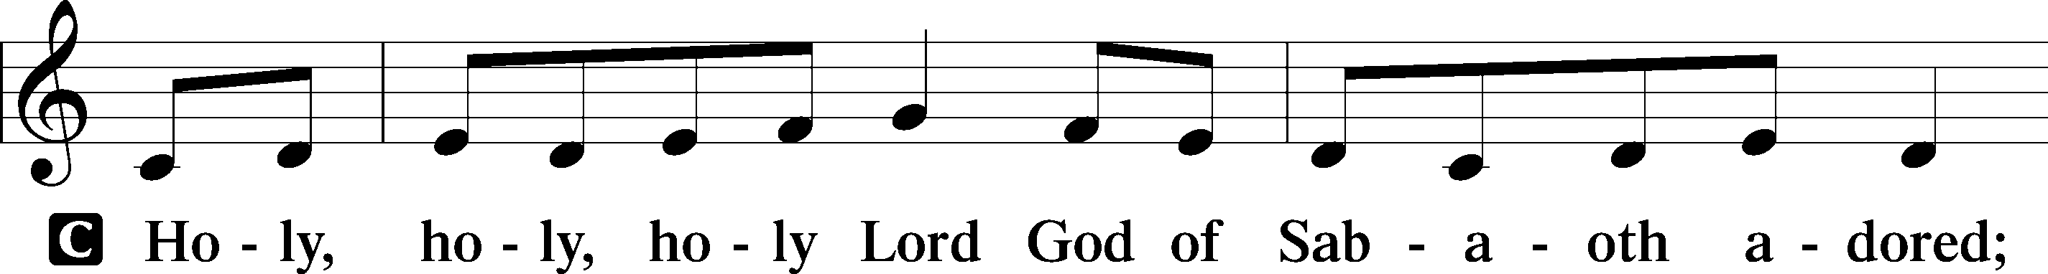

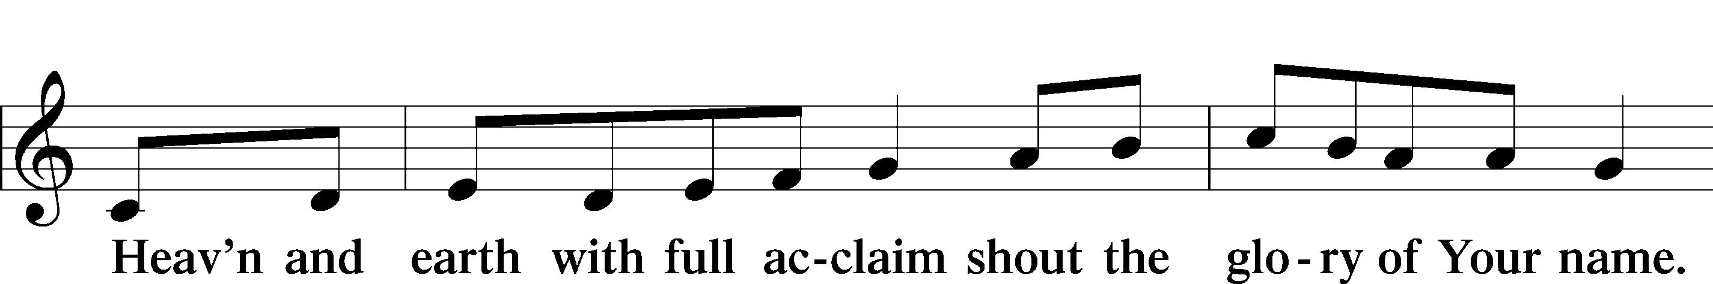

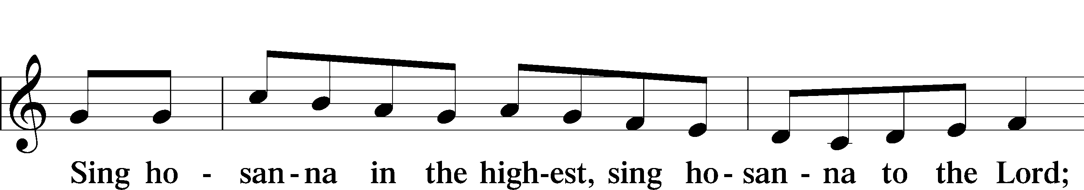

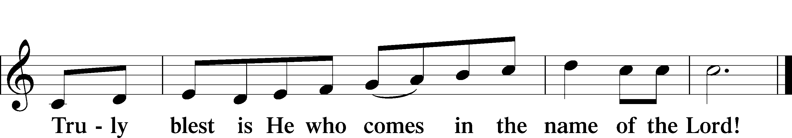

Text: Stephen P. Starke

Prayer of Thanksgiving

P Blessed are You, O Lord our God, king of all creation, for You have had mercy on us and given Your only-begotten Son that whoever believes in Him should not perish but have eternal life.

As the glory of Your presence once filled Your ancient temple, so in the incarnation of Your Son, Jesus Christ, You manifested the fullness of Your glory in human flesh.

We give You thanks that in His most Holy Supper You reveal Your glory to us. Grant us faithfully to eat His body and drink His blood so that we may one day behold Your glory face to face.

Hear us as we pray in His name and as He has taught us:

Lord’s Prayer

C **Our Father who art in heaven,**

**hallowed be Thy name,**

**Thy kingdom come,**

**Thy will be done on earth**

**as it is in heaven;**

**give us this day our daily bread;**

**and forgive us our trespasses**

**as we forgive those**

**who trespass against us;**

**and lead us not into temptation,**

**but deliver us from evil.**

**For Thine is the kingdom**

**and the power and the glory**

**forever and ever. Amen.**

The Words of Our Lord

P Our Lord Jesus Christ, on the night when He was betrayed, took bread, and when He had given thanks, He broke it and gave it to the disciples and said: “Take, eat; this is My T body, which is given for you. This do in remembrance of Me.”

In the same way also He took the cup after supper, and when He had given thanks, He gave it to them, saying: “Drink of it, all of you; this cup is the new testament in My T blood, which is shed for you for the forgiveness of sins. This do, as often as you drink it, in remembrance of Me.”

Pax Domini

P The peace of the Lord be with you always.

C **Amen.**

Agnus Dei John 1:29

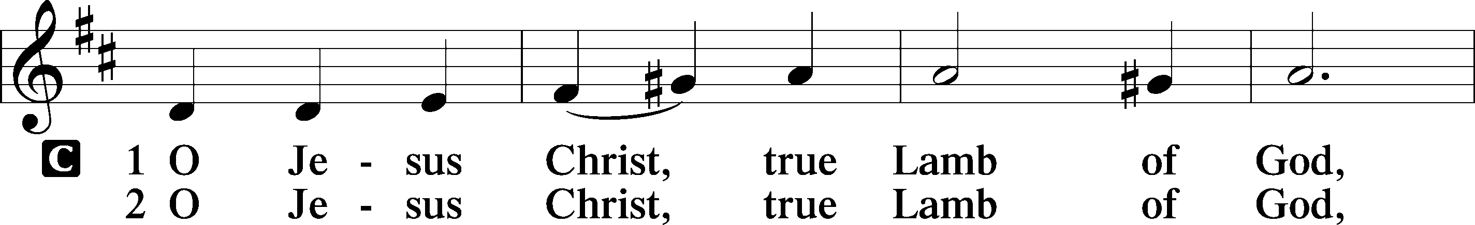

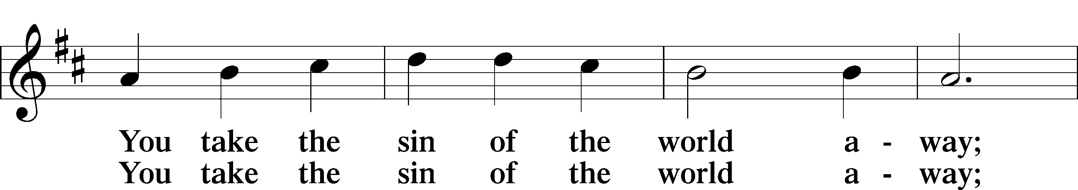

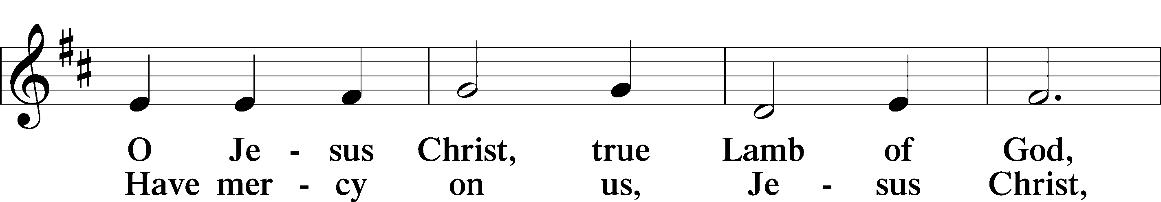

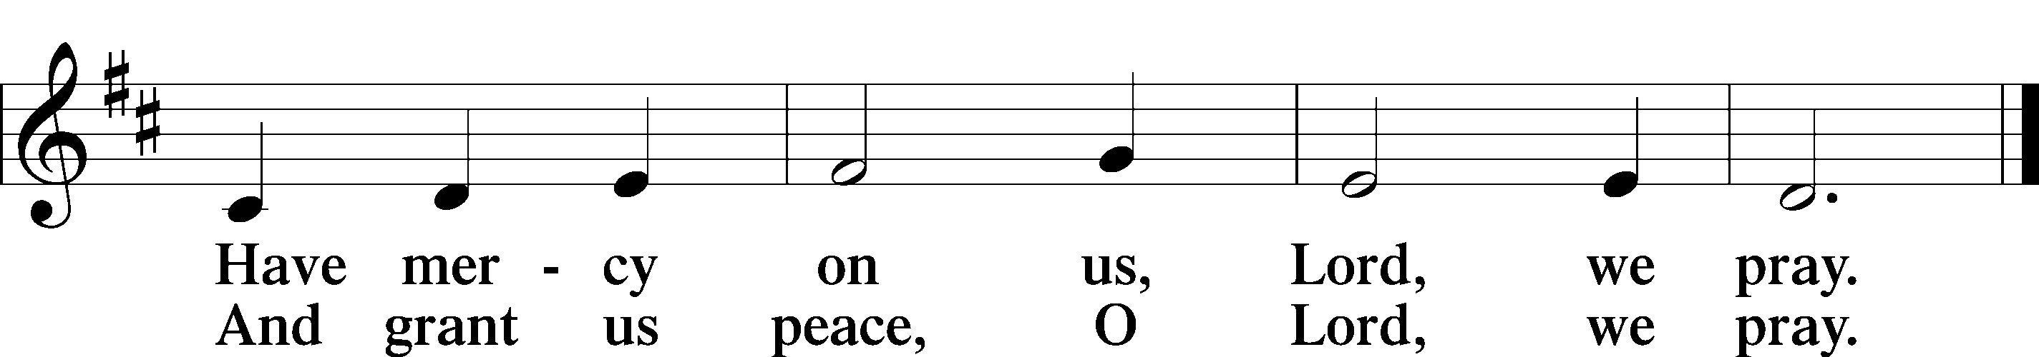

Text: Stephen P. Starke

Sit

Distribution

The Dismissal

P The body and blood of our Lord Jesus Christ strengthen and preserve you in body and soul to life everlasting. Depart T in peace.

C **Amen.**

628 Your Table I Approach

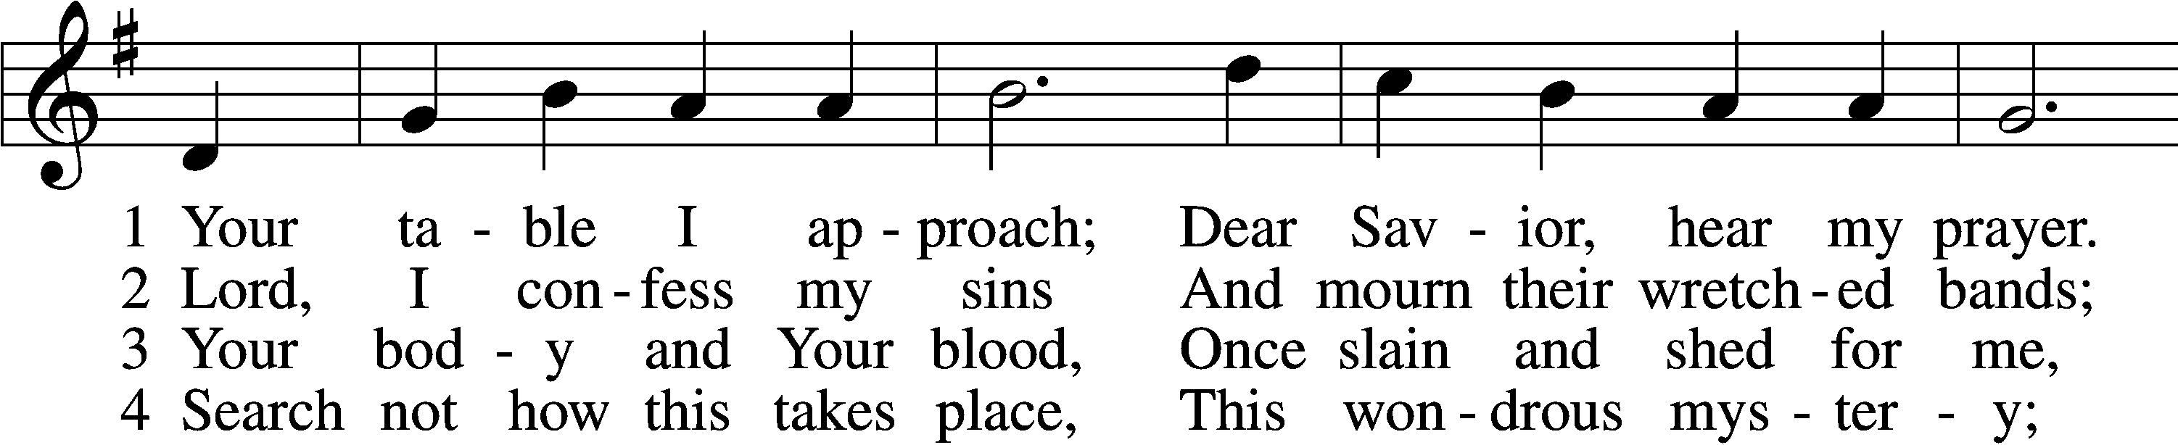

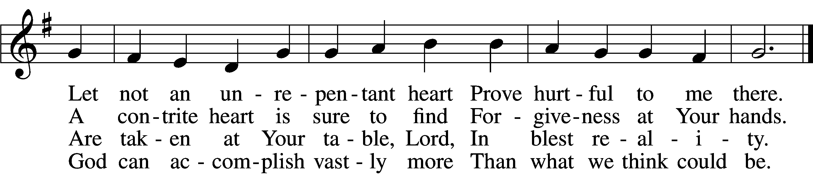

5 O grant, most blessèd Lord,  
 That earth and hell combined  
May not about this sacrament  
 Raise doubt within my mind.

6 Oh, may I never fail  
 To thank You day and night  
For Your true body and true blood,  
 O God, my peace and light.

Text: Gerhard Wolter Molanus, 1633–1722; tr. Matthias Loy, 1828–1915, alt.  
Tune: Trente quatre Pseaumes de David, 1551, Geneva, ed. Louis Bourgeois  
Text and tune: Public domain

620 Jesus Comes Today with Healing

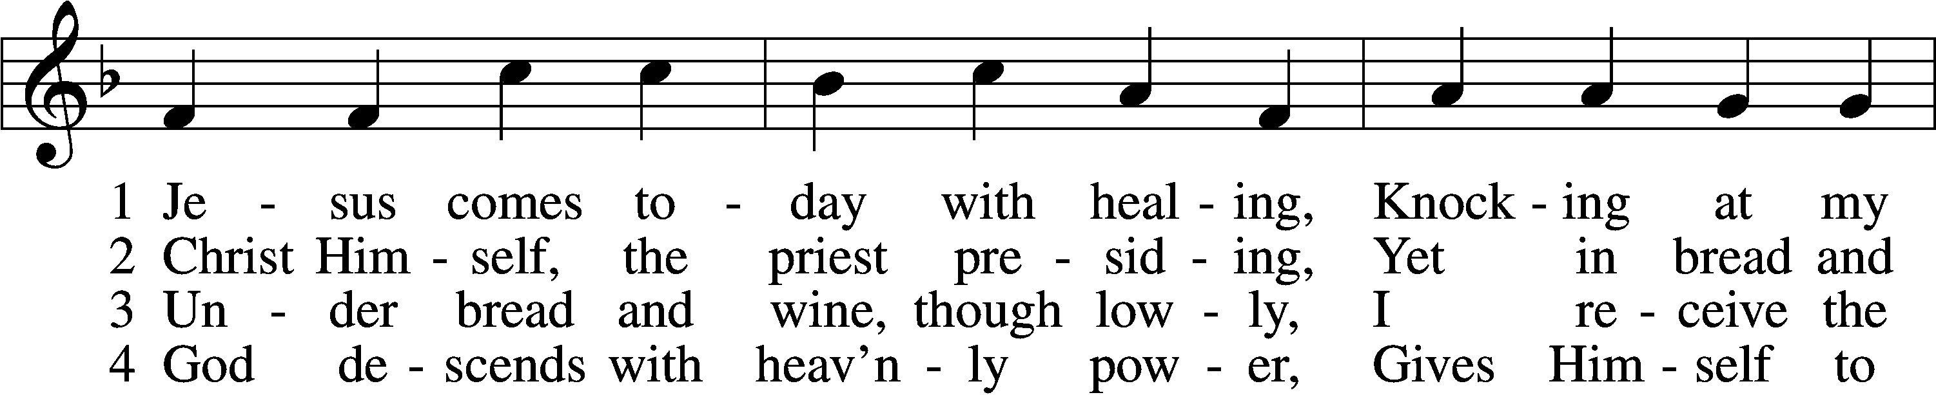

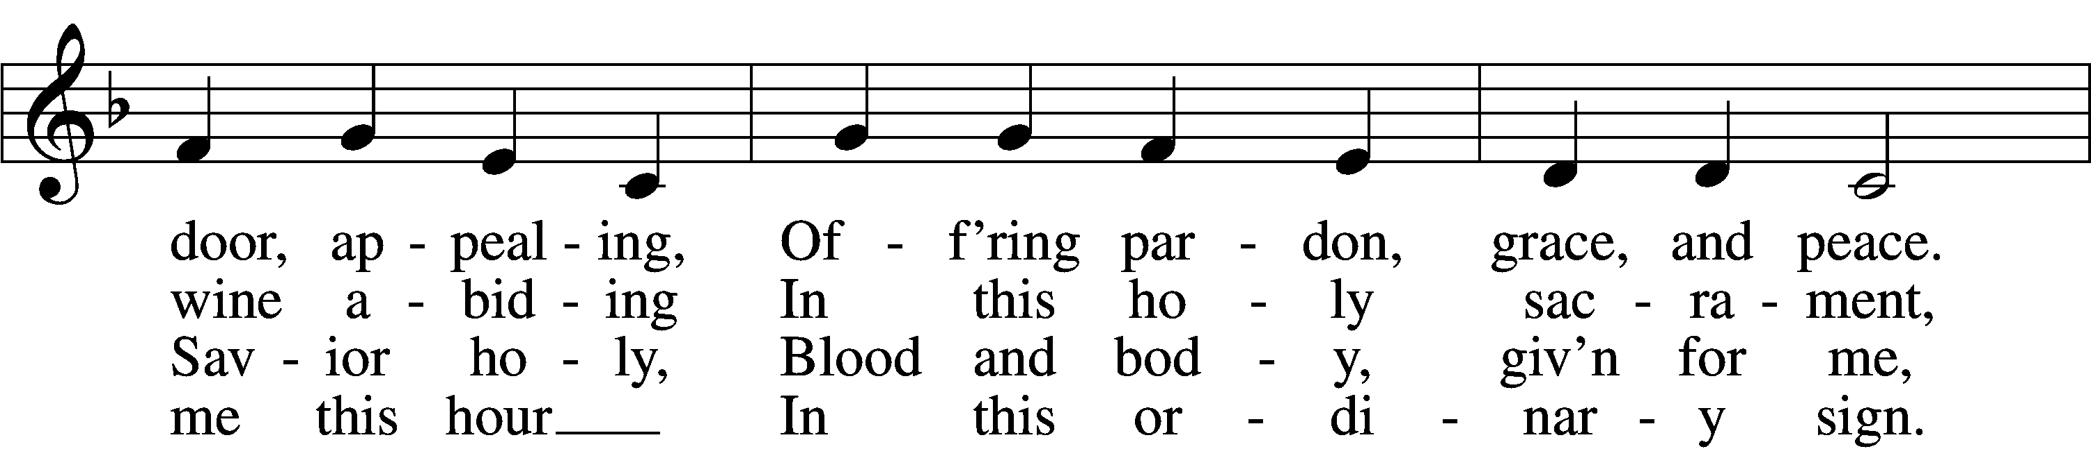

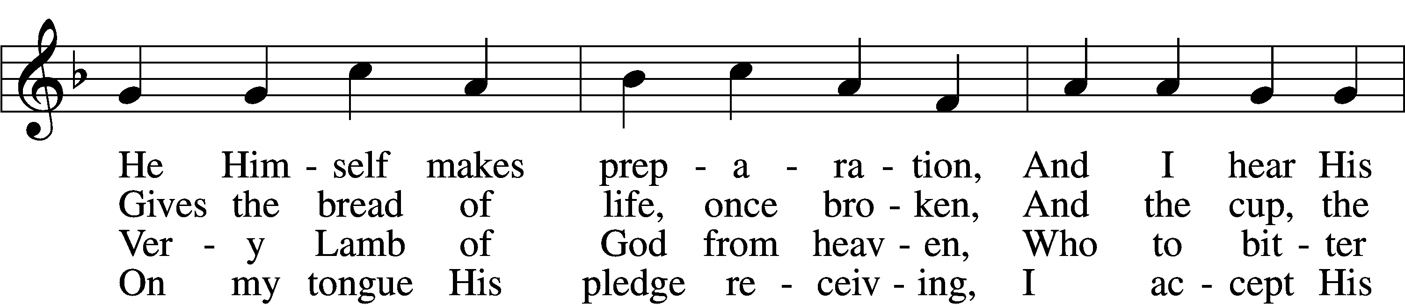

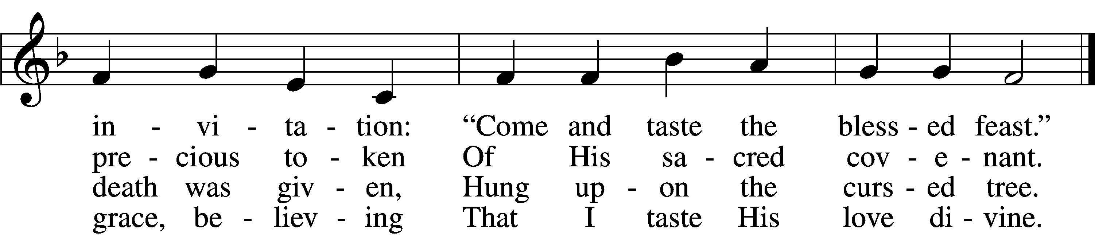

5 Let me praise God’s boundless favor,  
Whose own feast of love I savor,  
 Bidden by His gracious call.  
Wedding garments He provides me,  
With a robe of white He hides me,  
 Fits me for the royal hall.

6 Now have I found consolation,  
Comfort in my tribulation,  
 Balm to heal the troubled soul.  
God, my shield from ev’ry terror,  
Cleanses me from sin and error,  
 Makes my wounded spirit whole.

Text: Heinrich Puchta, 1808–58; tr. David W. Rogner, 1960  
Tune: Johann Löhner, 1645–1705; adapt. Johann Balthasar König, 1691–1758  
Text: © David W. Rogner. Used by permission: LSB Hymn License no. 110005011  
Tune: Public domain

680 Thine the Amen, Thine the Praise

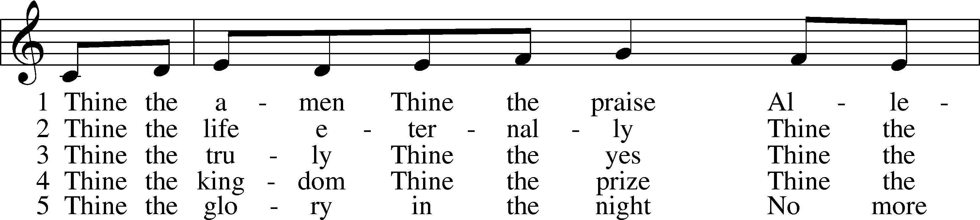

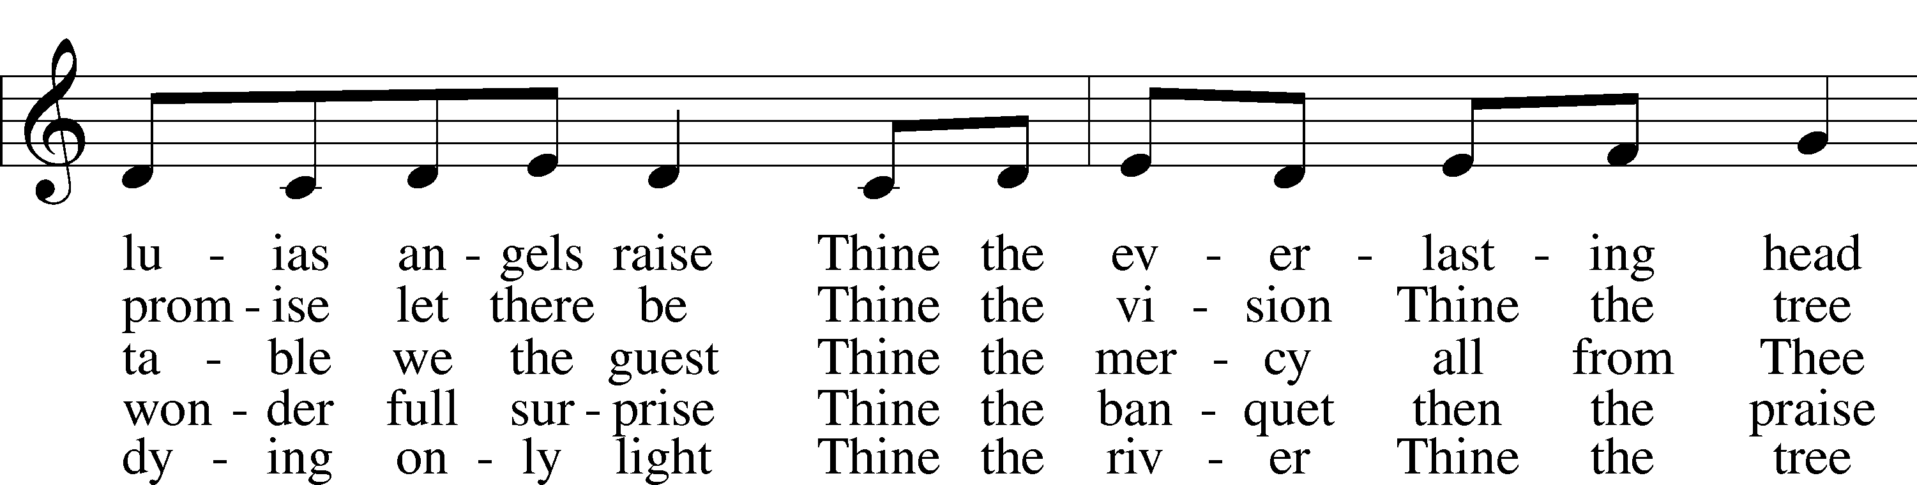

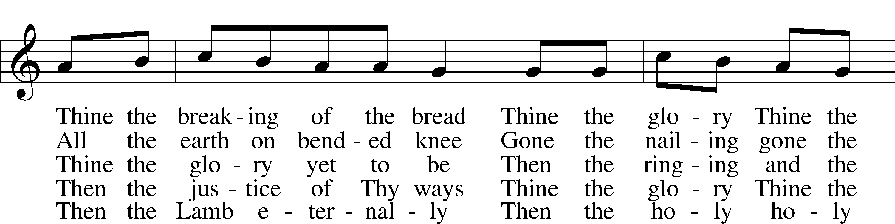

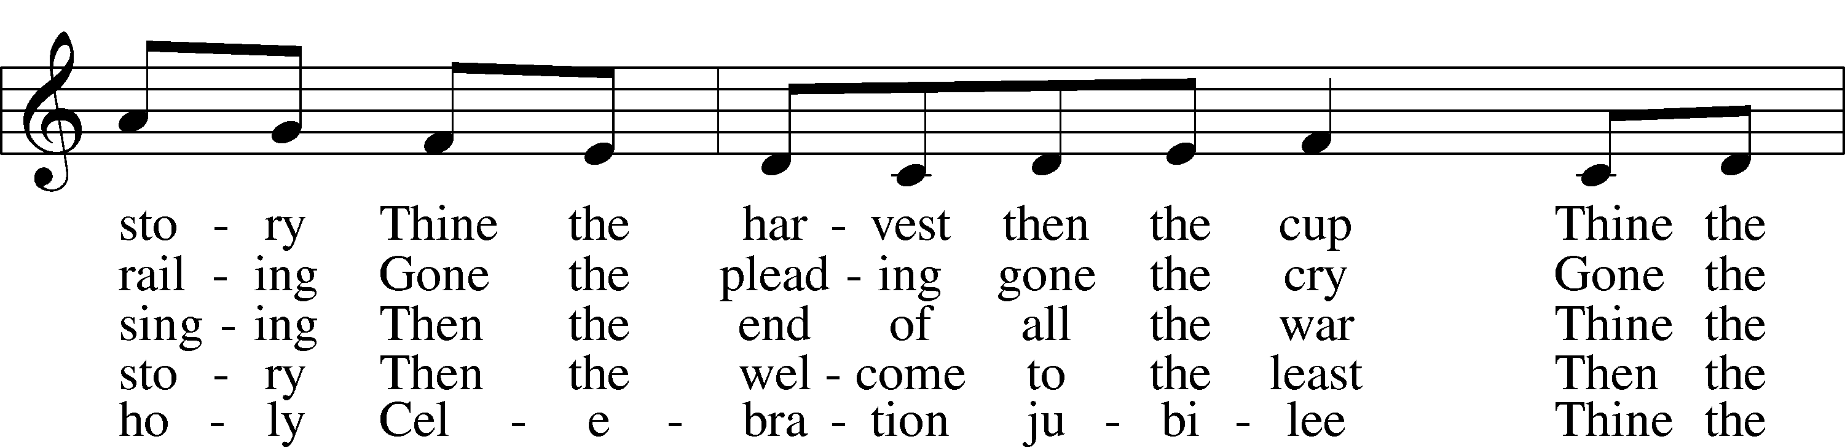

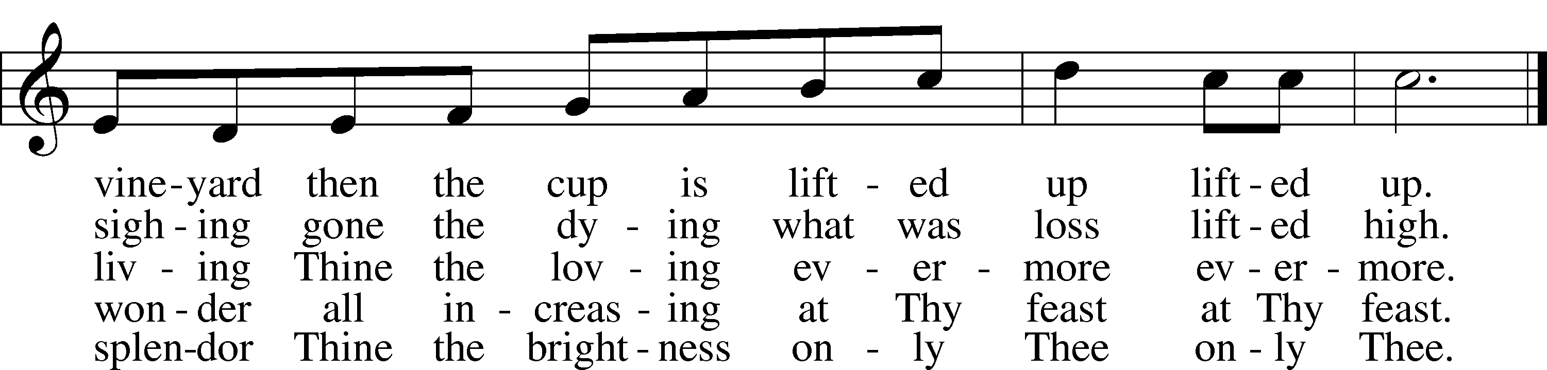

Text: Herbert F. Brokering, 1926–2009  
Tune: Carl F. Schalk, 1929  
Text and tune: © 1983 Augsburg Publishing House. Used by permission: LSB Hymn License no. 110005011

523 O Word of God Incarnate

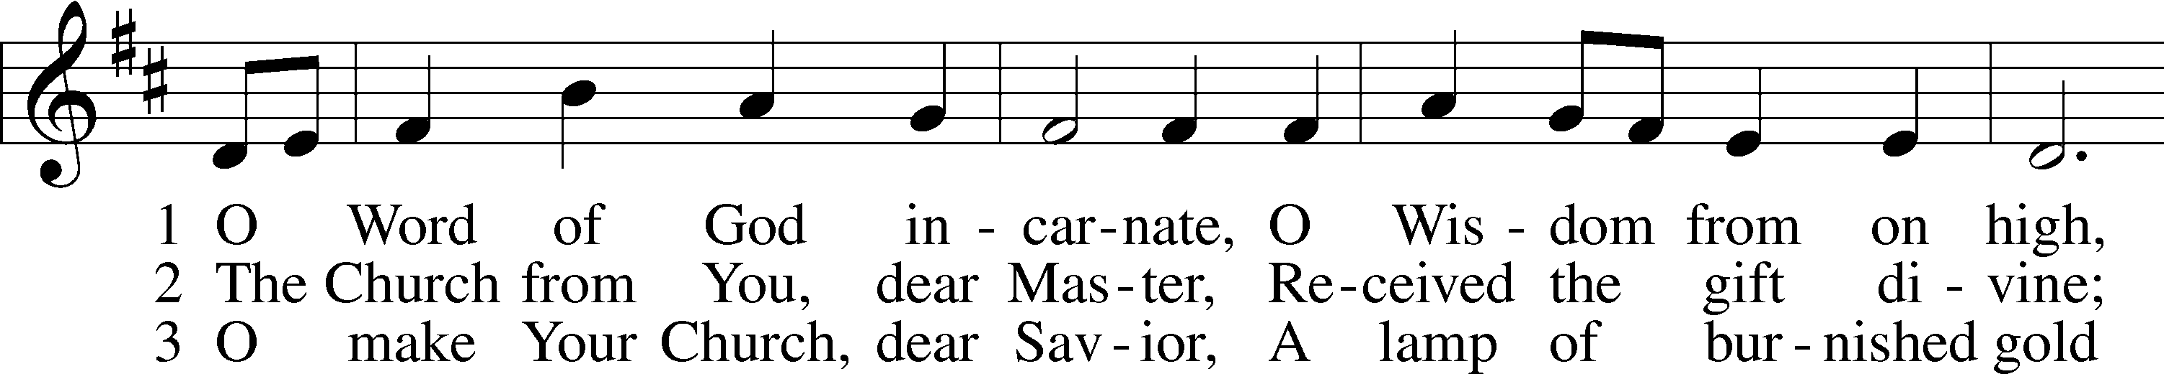

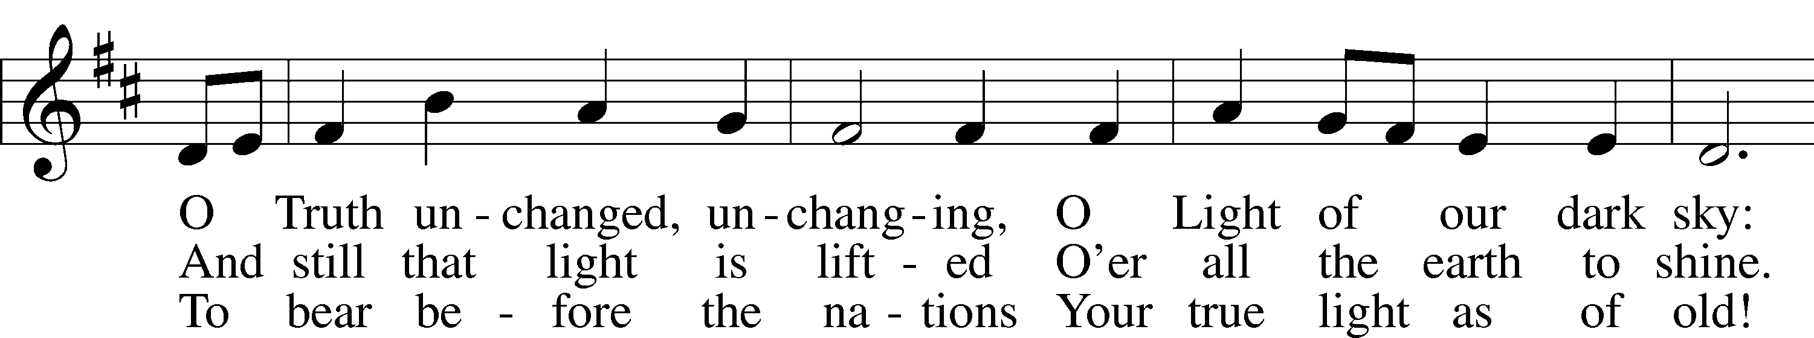

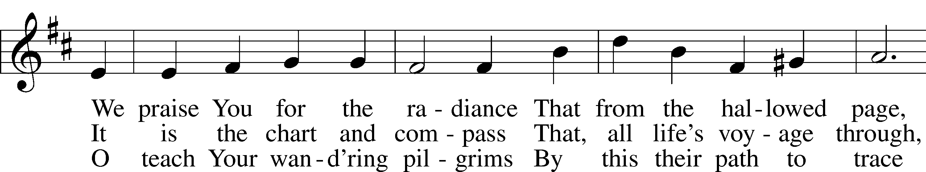

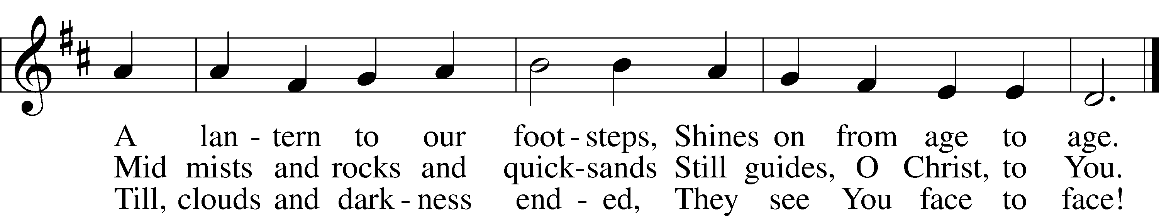

Text: William W. How, 1823–97, alt.  
Tune: Neu-vermehrtes . . . Gesangbuch, 1693, 3rd ed., Meiningen  
Text and tune: Public domain

The Dismissal

P The body and blood of our Lord Jesus Christ strengthen and preserve you in body and soul to life everlasting. Depart T in peace.

C **Amen.**

Stand

Nunc Dimittis Luke 2:29–32

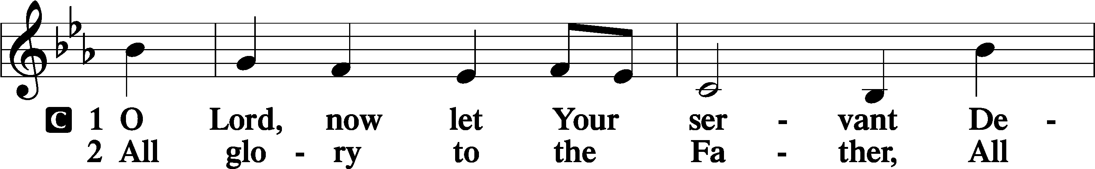

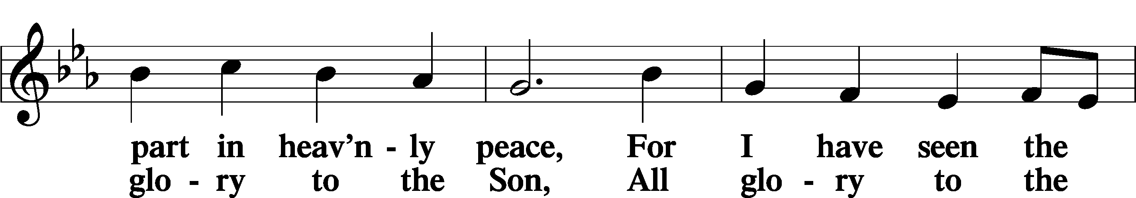

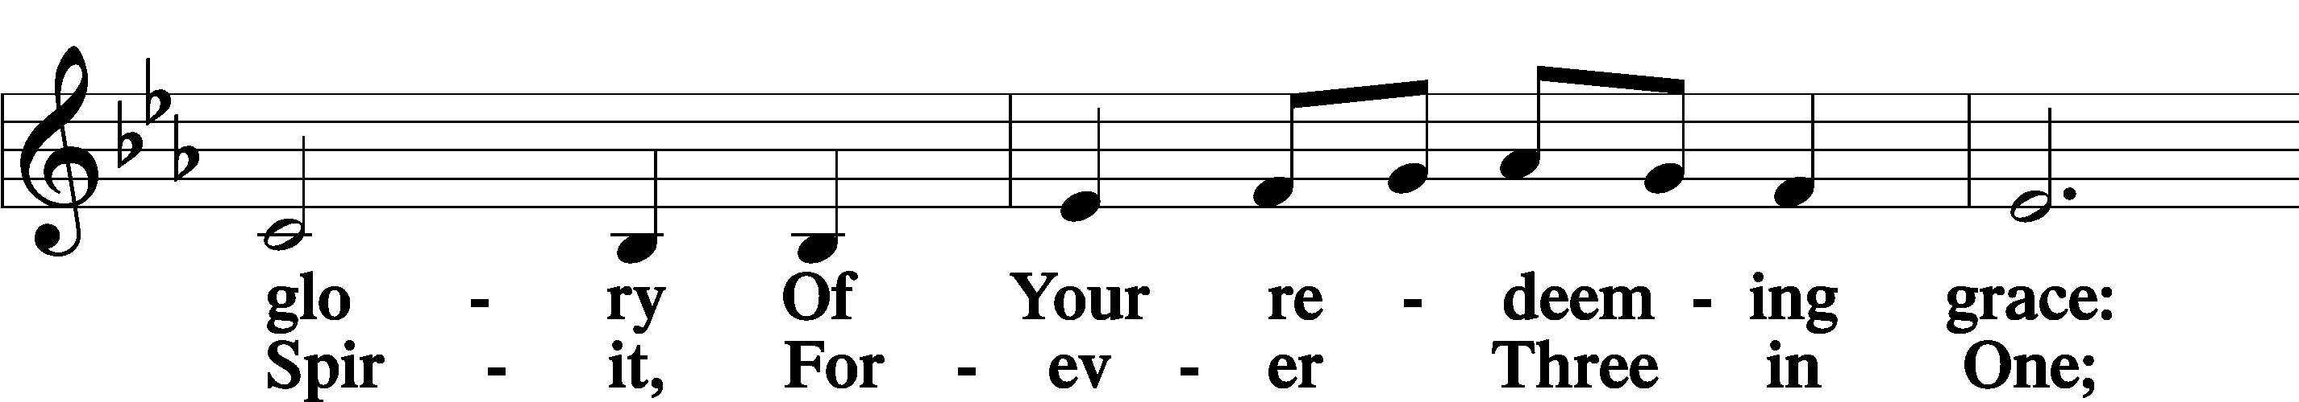

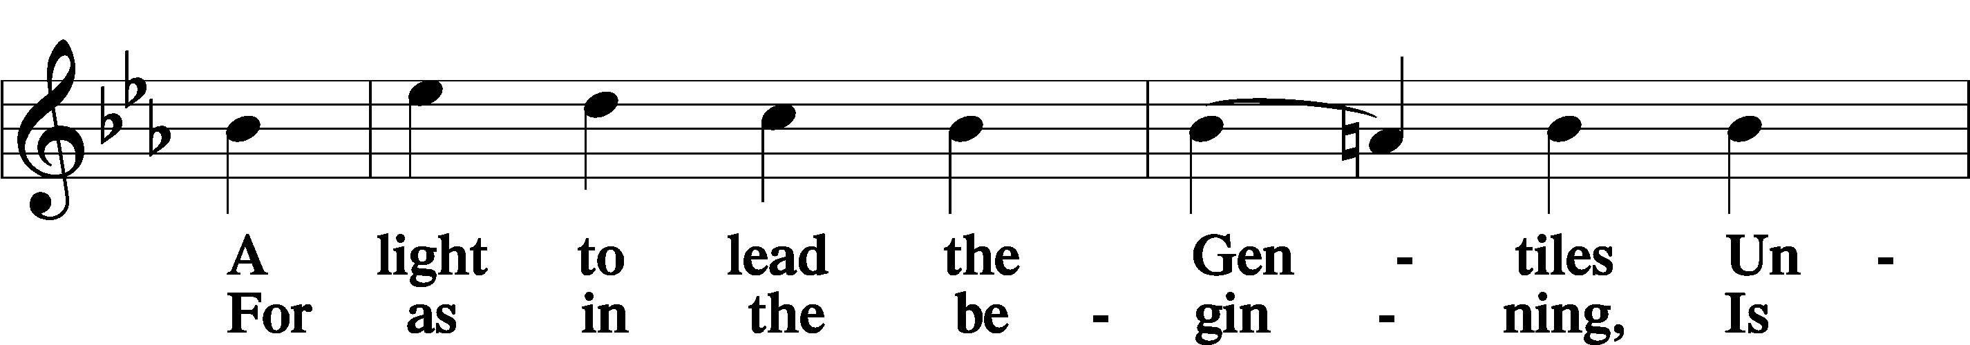

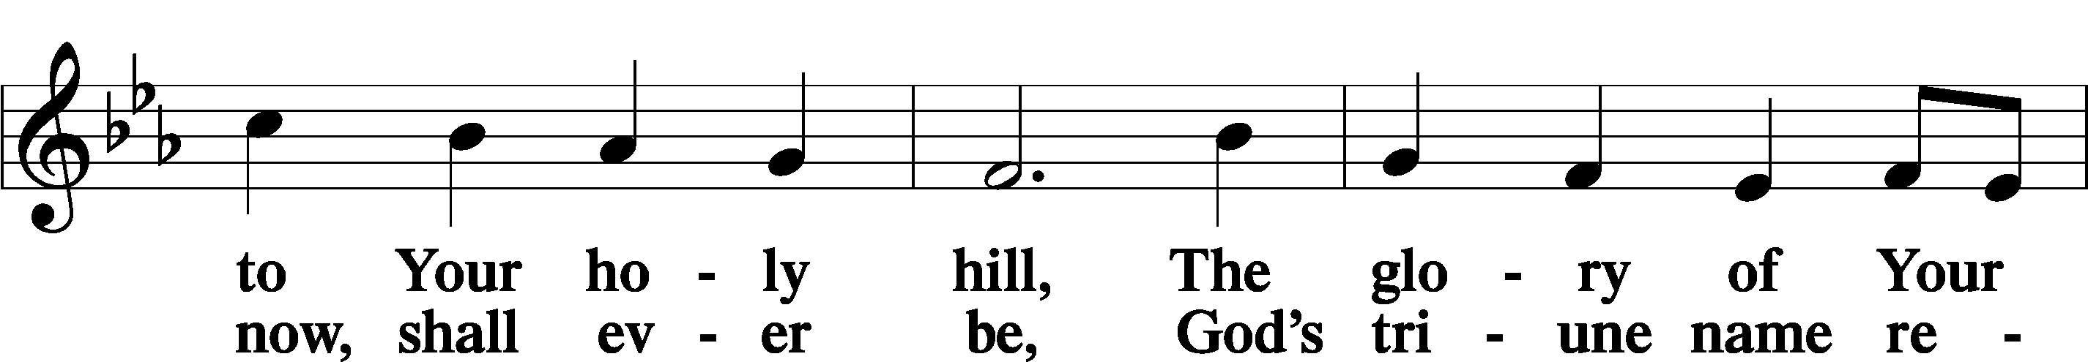

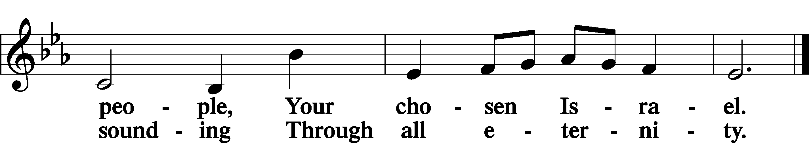

Post-Communion Collect

A Let us pray.

We give thanks to You, almighty God, that You have refreshed us through this salutary gift, and we implore You that of Your mercy You would strengthen us through the same in faith toward You and in fervent love toward one another; through Jesus Christ, Your Son, our Lord, who lives and reigns with You and the Holy Spirit, one God, now and forever.

C **Amen.**

Benedicamus Psalm 103:1

A Let us bless the Lord.

C **Thanks be to God.**

Benediction

P The Lord bless you and keep you.

The Lord make His face shine on you and be gracious to you.

The Lord look upon you with favor and T give you peace.

C **Amen.**

400 Brightest and Best of the Stars of the Morning

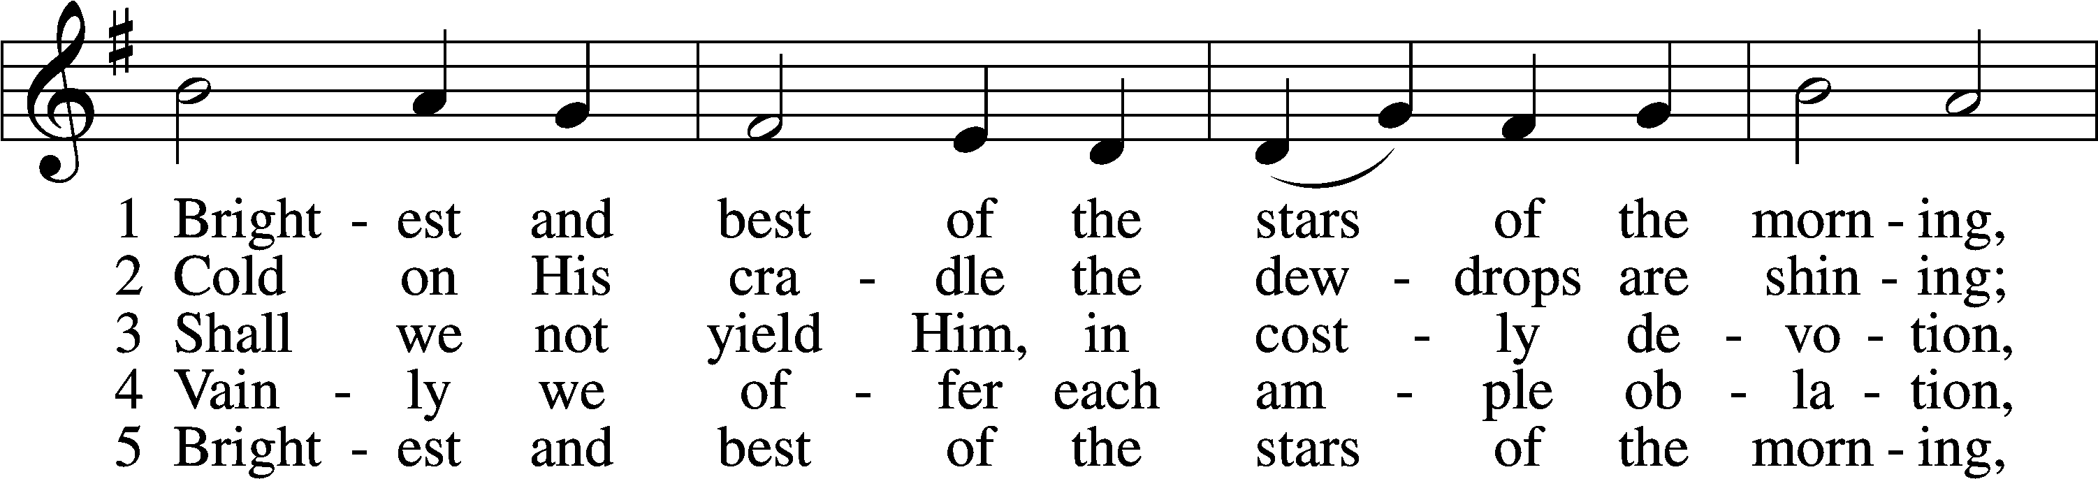

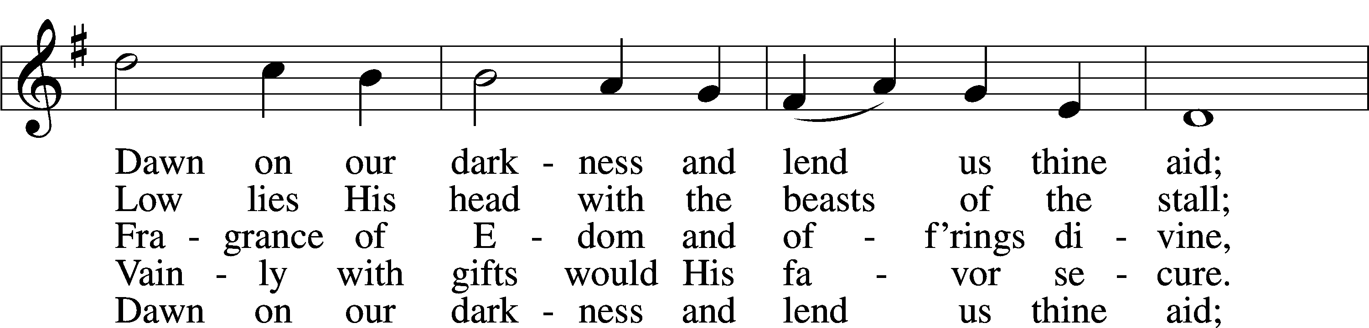

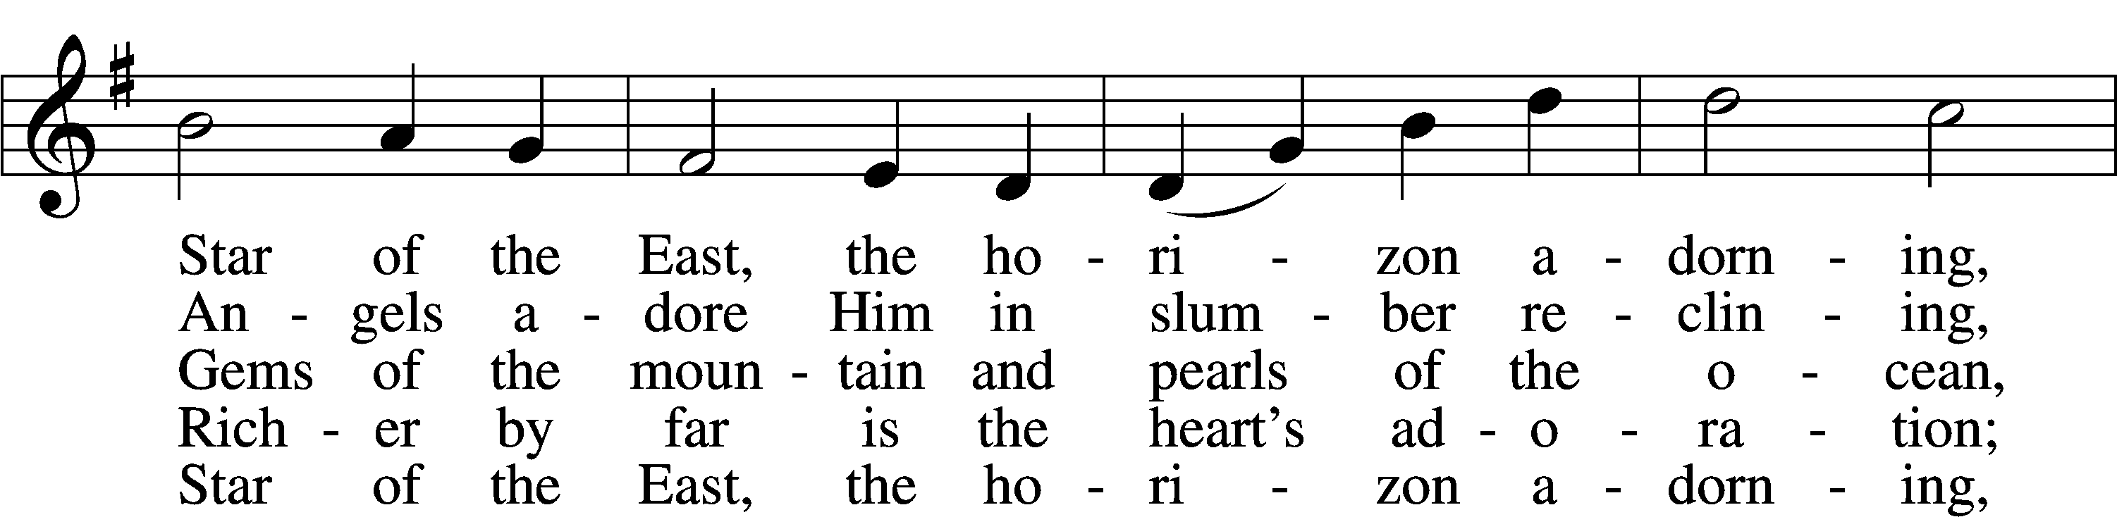

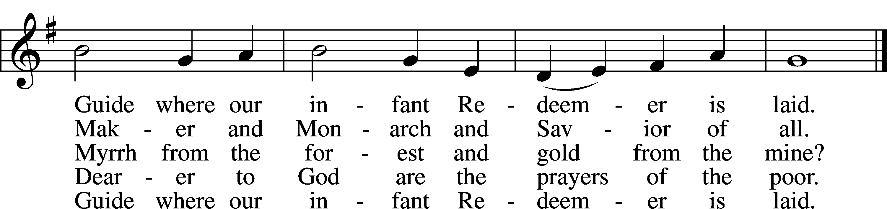

Text: Reginald Heber, 1783–1826, alt.  
Tune: James P. Harding, 1850–1911, adapt.  
Text and tune: Public domain

Acknowledgments

Divine Service, Setting Four from Lutheran Service Book

Unless otherwise indicated, Scripture quotations are from the ESV® Bible (The Holy Bible, English Standard Version®), copyright © 2001 by Crossway, a publishing ministry of Good News Publishers. Used by permission. All rights reserved.

Created by Lutheran Service Builder © 2023 Concordia Publishing House.