562 All Mankind Fell in Adam’s Fall

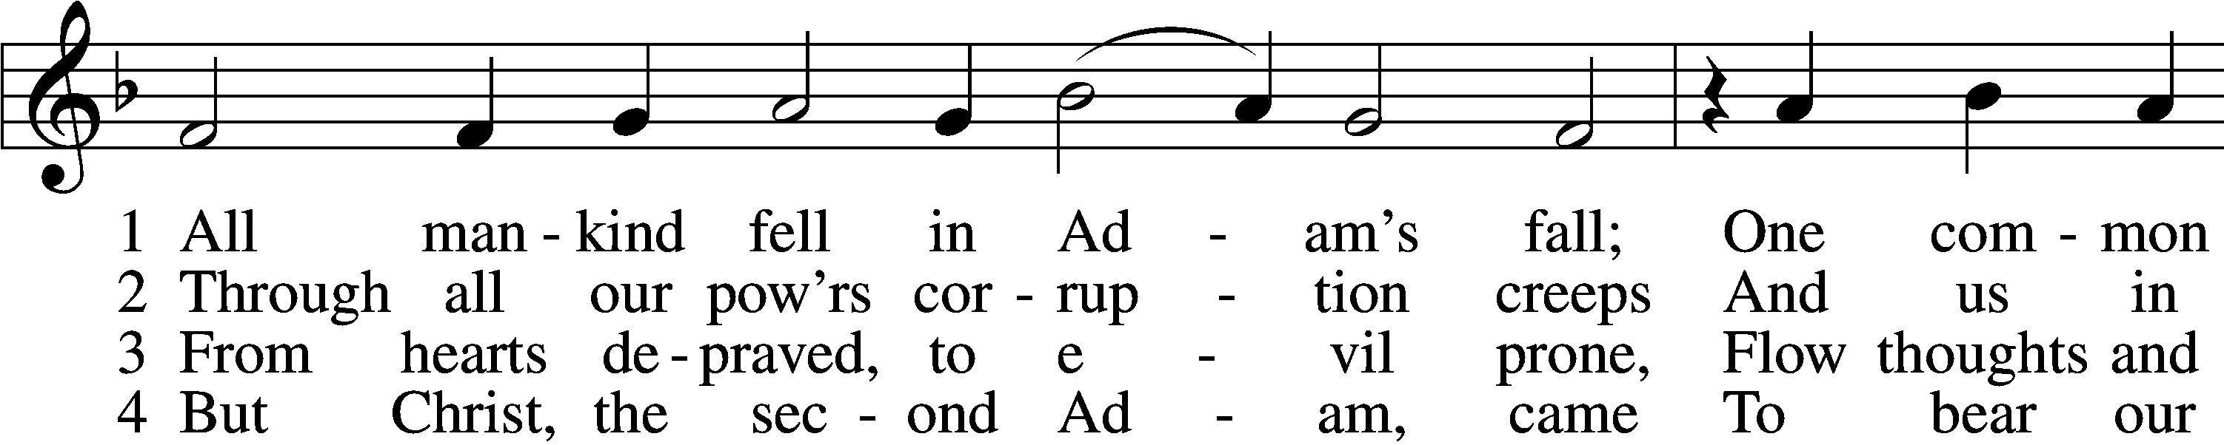

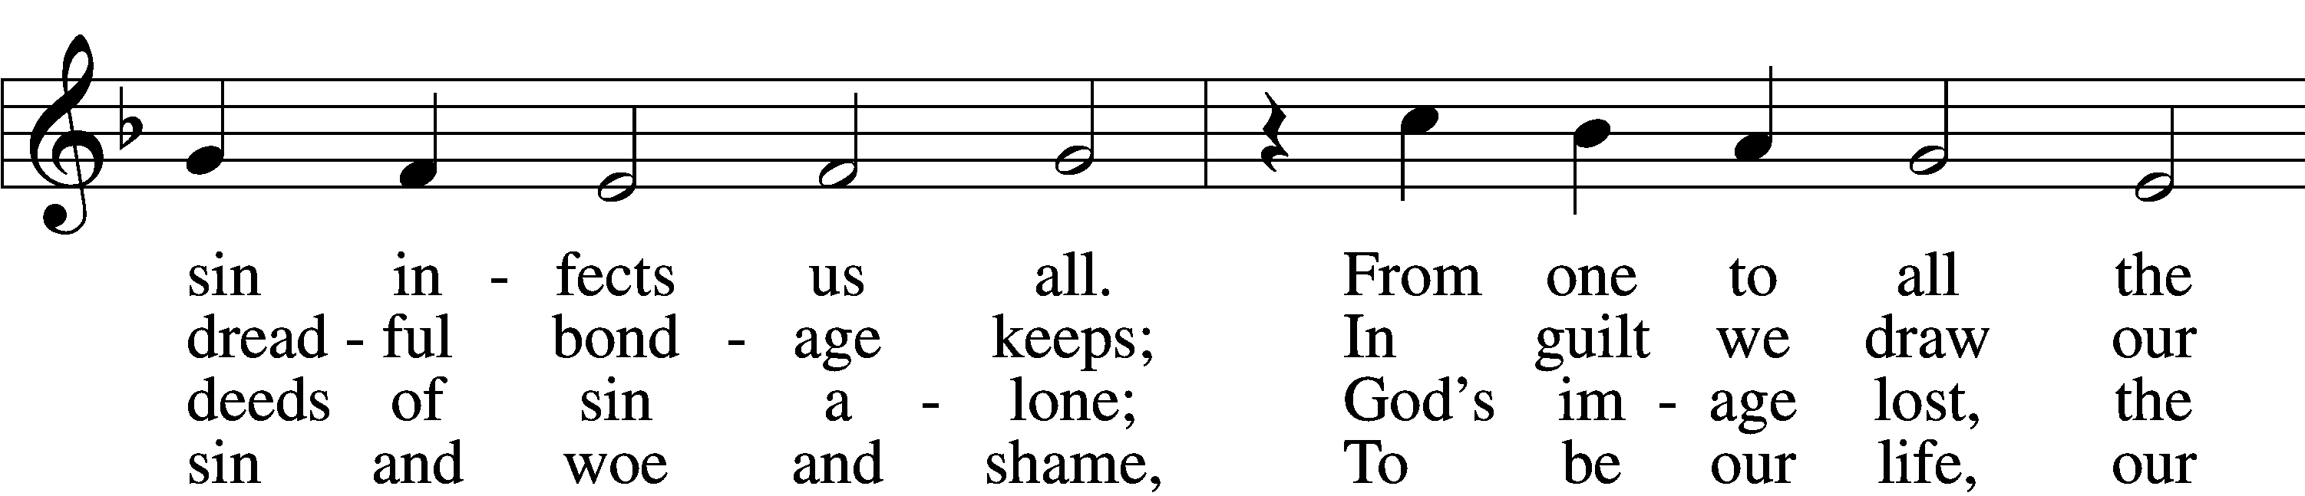

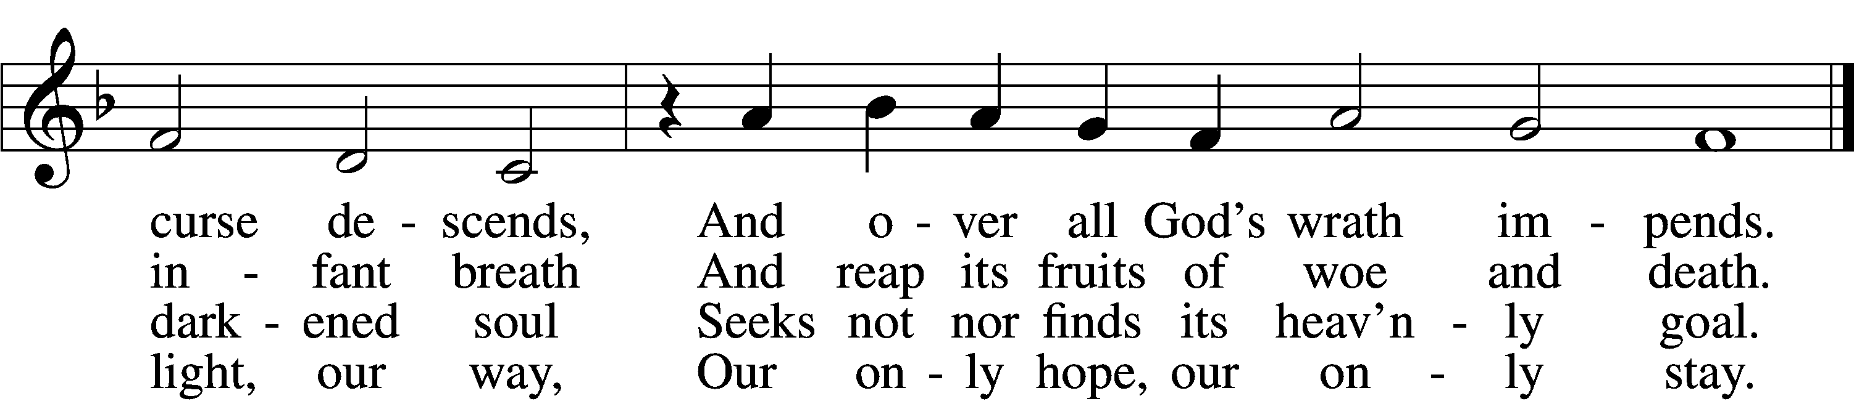

5 As by one man all mankind fell  
And, born in sin, was doomed to hell,  
So by one Man, who took our place,  
We all were justified by grace.

6 We thank You, Christ; new life is ours,  
New light, new hope, new strength, new pow’rs.  
This grace our ev’ry way attend  
Until we reach our journey’s end.

Text: Lazarus Spengler, 1479–1534; tr. Matthias Loy, 1828–1915, alt.  
Tune: Louis Bourgeois, c. 1510–61  
Text and tune: Public domain

# Confession and Absolution

The sign of the cross may be made by all in remembrance of their Baptism.

Invocation Matthew 28:19b; 18:20

P In the name of the Father and of the T Son and of the Holy Spirit.

C **Amen.**

Exhortation Hebrews 10:22; Psalm 124:8; Psalm 32:5

P Beloved in the Lord! Let us draw near with a true heart and confess our sins unto God our Father, beseeching Him in the name of our Lord Jesus Christ to grant us forgiveness.

P Our help is in the name of the Lord,

C **who made heaven and earth.**

P I said, I will confess my transgressions unto the Lord,

C **and You forgave the iniquity of my sin.**

Silence for reflection on God’s Word and for self-examination.

Confession of Sins

P Almighty God, our maker and redeemer, we poor sinners confess unto You that we are by nature sinful and unclean and that we have sinned against You by thought, word, and deed. Wherefore we flee for refuge to Your infinite mercy, seeking and imploring Your grace for the sake of our Lord Jesus Christ.

C **O most merciful God, who has given Your only-begotten Son to die for us, have mercy upon us and for His sake grant us remission of all our sins; and by Your Holy Spirit increase in us true knowledge of You and of Your will and true obedience to Your Word, to the end that by Your grace we may come to everlasting life; through Jesus Christ, our Lord. Amen.**

Declaration of Grace Mark 16:16; John 1:12

P Almighty God, our heavenly Father, has had mercy upon us and has given His only Son to die for us and for His sake forgives us all our sins. To those who believe on His name He gives power to become the children of God and has promised them His Holy Spirit. He that believes and is baptized shall be saved.  
  
Grant this, Lord, unto us all.

C **Amen.**

# Service of the Word

Introit Psalm 91:9–13; antiphon: vv. 15–16

When he calls to me, I will answer him; I will be with him in trouble;  
 I will rescue him and honor him.  
With long life I will satisfy him  
 and show him my salvation.  
Because you have made the Lord your dwelling place—  
 the Most High, who is my refuge—  
no evil shall be allowed to befall you,  
 no plague come near your tent.  
For he will command his angels concerning you  
 to guard you in all your ways.  
On their hands they will bear you up,  
 lest you strike your foot against a stone.  
You will tread on the lion and the adder;  
 the young lion and the serpent you will trample underfoot.

Gloria Patri

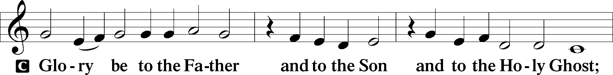

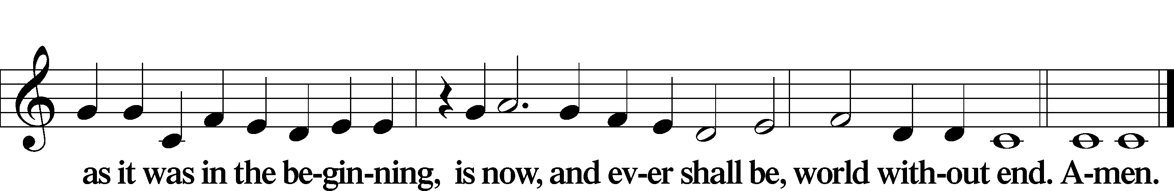

Kyrie Mark 10:47

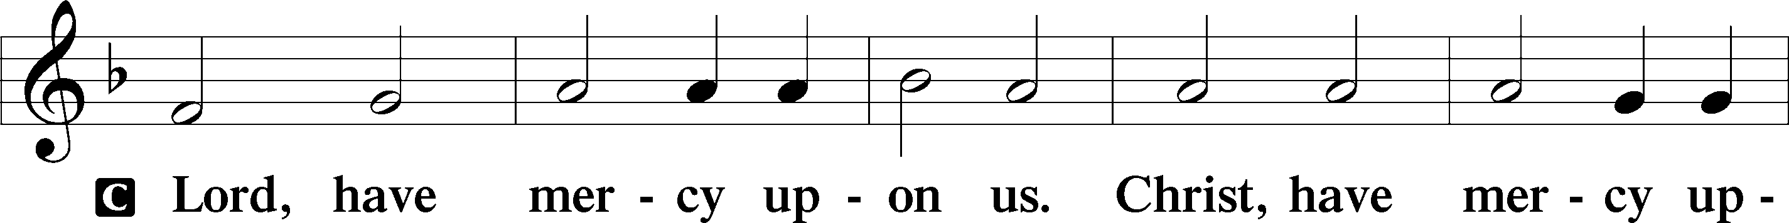

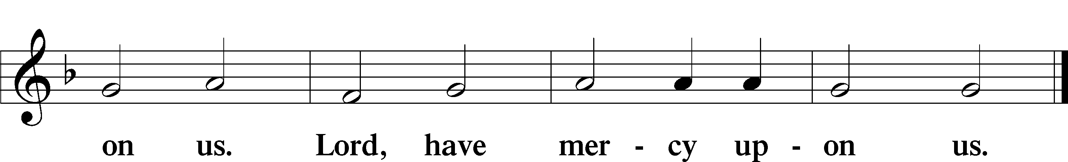

Salutation and Collect of the Day

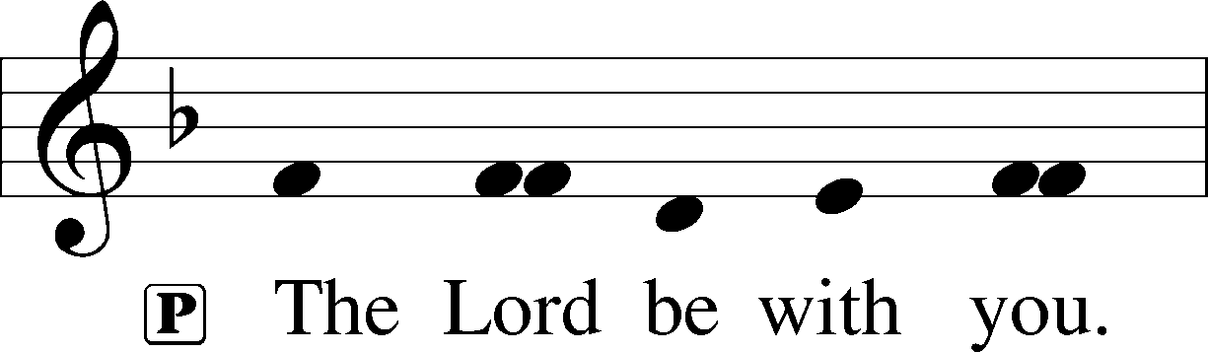

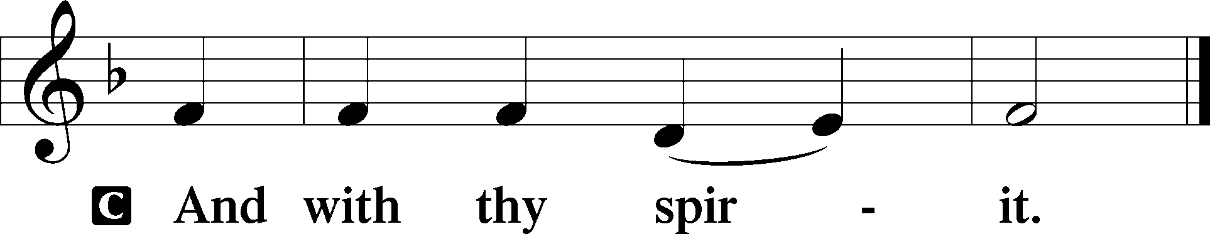

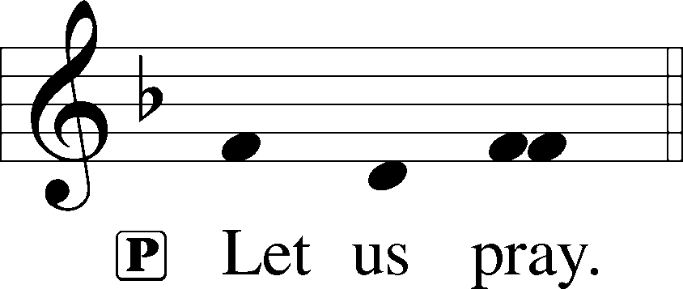

P O Lord God, You led Your ancient people through the wilderness and brought them to the promised land. Guide the people of Your Church that following our Savior we may walk through the wilderness of this world toward the glory of the world to come; through Jesus Christ, Your Son, our Lord, who lives and reigns with You and the Holy Spirit, one God, now and forever.

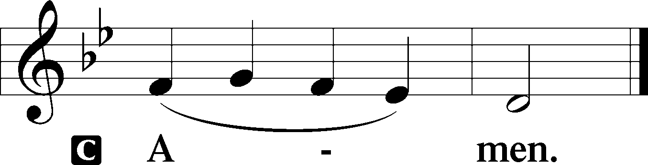

Sit

Old Testament Reading Genesis 3:1–21

The Fall

1Now the serpent was more crafty than any other beast of the field that the Lord God had made.

He said to the woman, “Did God actually say, ‘You shall not eat of any tree in the garden’?” 2And the woman said to the serpent, “We may eat of the fruit of the trees in the garden, 3but God said, ‘You shall not eat of the fruit of the tree that is in the midst of the garden, neither shall you touch it, lest you die.’” 4But the serpent said to the woman, “You will not surely die. 5For God knows that when you eat of it your eyes will be opened, and you will be like God, knowing good and evil.” 6So when the woman saw that the tree was good for food, and that it was a delight to the eyes, and that the tree was to be desired to make one wise, she took of its fruit and ate, and she also gave some to her husband who was with her, and he ate. 7Then the eyes of both were opened, and they knew that they were naked. And they sewed fig leaves together and made themselves loincloths.

8And they heard the sound of the Lord God walking in the garden in the cool of the day, and the man and his wife hid themselves from the presence of the Lord God among the trees of the garden. 9But the Lord God called to the man and said to him, “Where are you?” 10And he said, “I heard the sound of you in the garden, and I was afraid, because I was naked, and I hid myself.” 11He said, “Who told you that you were naked? Have you eaten of the tree of which I commanded you not to eat?” 12The man said, “The woman whom you gave to be with me, she gave me fruit of the tree, and I ate.” 13Then the Lord God said to the woman, “What is this that you have done?” The woman said, “The serpent deceived me, and I ate.”

14The Lord God said to the serpent,

“Because you have done this,  
 cursed are you above all livestock  
 and above all beasts of the field;  
on your belly you shall go,  
 and dust you shall eat  
 all the days of your life.  
15I will put enmity between you and the woman,  
 and between your offspring and her offspring;  
he shall bruise your head,  
 and you shall bruise his heel.”

16To the woman he said,

“I will surely multiply your pain in childbearing;  
 in pain you shall bring forth children.  
Your desire shall be for your husband,  
 and he shall rule over you.”

17And to Adam he said,

“Because you have listened to the voice of your wife  
 and have eaten of the tree  
of which I commanded you,  
 ‘You shall not eat of it,’  
cursed is the ground because of you;  
 in pain you shall eat of it all the days of your life;  
18thorns and thistles it shall bring forth for you;  
 and you shall eat the plants of the field.  
19By the sweat of your face  
 you shall eat bread,  
till you return to the ground,  
 for out of it you were taken;  
for you are dust,  
 and to dust you shall return.”

20The man called his wife’s name Eve, because she was the mother of all living. 21And the Lord God made for Adam and for his wife garments of skins and clothed them.

A This is the Word of the Lord.

C **Thanks be to God.**

Gradual Hebrews 12:2

[O come, let us fix our eyes on] Jesus,  
 the founder and perfecter of our faith,  
who for the joy that was set before him endured the cross, despising the shame,  
 and is seated at the right hand of the throne of God.

Reading Romans 5:6–15

6For while we were still weak, at the right time Christ died for the ungodly. 7For one will scarcely die for a righteous person—though perhaps for a good person one would dare even to die— 8but God shows his love for us in that while we were still sinners, Christ died for us. 9Since, therefore, we have now been justified by his blood, much more shall we be saved by him from the wrath of God. 10For if while we were enemies we were reconciled to God by the death of his Son, much more, now that we are reconciled, shall we be saved by his life. 11More than that, we also rejoice in God through our Lord Jesus Christ, through whom we have now received reconciliation.

Death in Adam, Life in Christ

12Therefore, just as sin came into the world through one man, and death through sin, and so death spread to all men because all sinned— 13for sin indeed was in the world before the law was given, but sin is not counted where there is no law. 14Yet death reigned from Adam to Moses, even over those whose sinning was not like the transgression of Adam, who was a type of the one who was to come.

15But the free gift is not like the trespass. For if many died through one man’s trespass, much more have the grace of God and the free gift by the grace of that one man Jesus Christ abounded for many.

Stand

Verse Joel 2:13b

**Return to the Lord, your God, for he is gracious and merciful, slow to anger, and abounding in steadfast love.**

Holy Gospel Matthew 4:1–11

P The Holy Gospel according to St. Matthew, the fourth chapter.

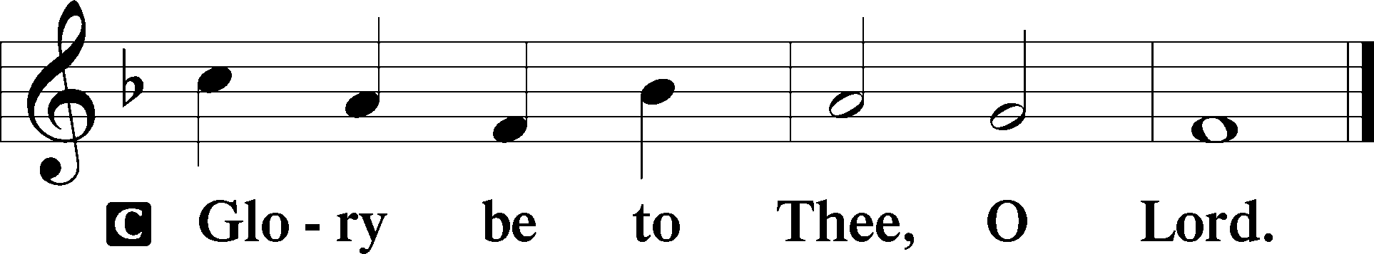

The Temptation of Jesus

1Then Jesus was led up by the Spirit into the wilderness to be tempted by the devil. 2And after fasting forty days and forty nights, he was hungry. 3And the tempter came and said to him, “If you are the Son of God, command these stones to become loaves of bread.” 4But he answered, “It is written,

“‘Man shall not live by bread alone,  
 but by every word that comes from the mouth of God.’”

5Then the devil took him to the holy city and set him on the pinnacle of the temple 6and said to him, “If you are the Son of God, throw yourself down, for it is written,

“‘He will command his angels concerning you,’

and

“‘On their hands they will bear you up,  
 lest you strike your foot against a stone.’”

7Jesus said to him, “Again it is written, ‘You shall not put the Lord your God to the test.’” 8Again, the devil took him to a very high mountain and showed him all the kingdoms of the world and their glory. 9And he said to him, “All these I will give you, if you will fall down and worship me.” 10Then Jesus said to him, “Be gone, Satan! For it is written,

“‘You shall worship the Lord your God  
 and him only shall you serve.’”

11Then the devil left him, and behold, angels came and were ministering to him.

P This is the Gospel of the Lord.

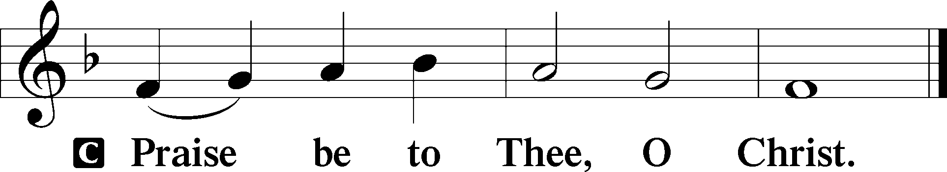

Apostles’ Creed

C **I believe in God, the Father Almighty,**

**maker of heaven and earth.**

**And in Jesus Christ, His only Son, our Lord,**

**who was conceived by the Holy Spirit,**

**born of the virgin Mary,**

**suffered under Pontius Pilate,**

**was crucified, died and was buried.**

**He descended into hell.**

**The third day He rose again from the dead.**

**He ascended into heaven**

**and sits at the right hand of God the Father Almighty.**

**From thence He will come to judge the living and the dead.**

**I believe in the Holy Spirit,**

**the holy Christian Church,**

**the communion of saints,**

**the forgiveness of sins,**

**the resurrection of the body,**

**and the life** T **everlasting. Amen.**

Sit

**Children's Message**

418 O Lord, throughout These Forty Days

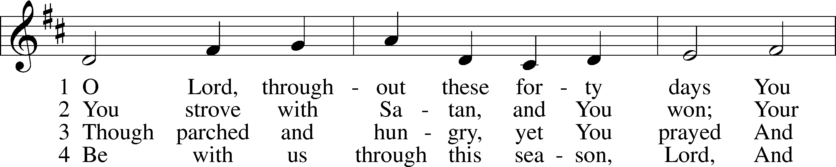

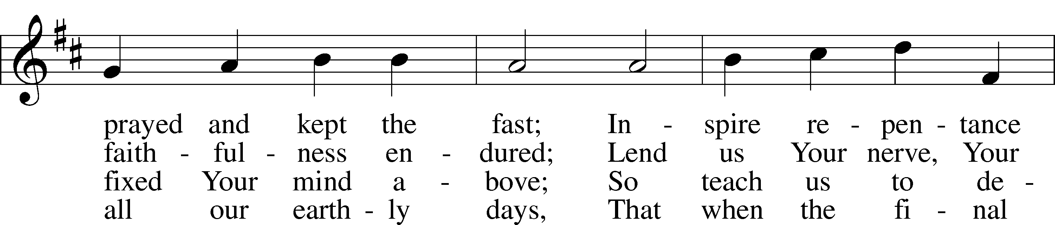

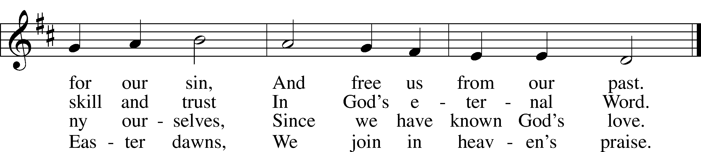

Text: based on Claudia F. Hernaman, 1838–98; para. Gilbert E. Doan, 1930  
Tune: The Psalmes of David in Prose and Meeter, 1635, Edinburgh  
Text: © 1978 Lutheran Book of Worship. Used by permission: LSB Hymn License no. 110005011  
Tune: Public domain

Sermon

Votum

P The peace of God, which passes all understanding, keep your hearts and minds in Christ Jesus.

C **Amen.**

Stand

Offertory Psalm 51:10–12

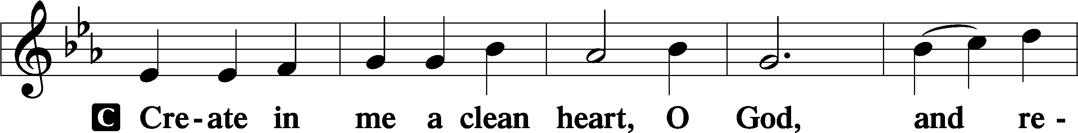

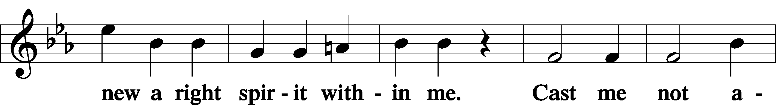

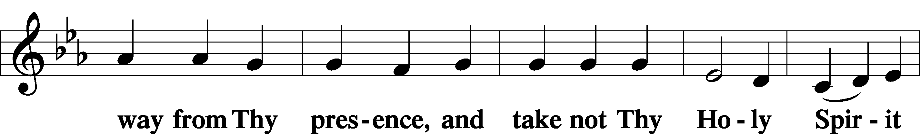

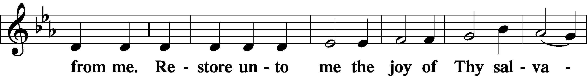

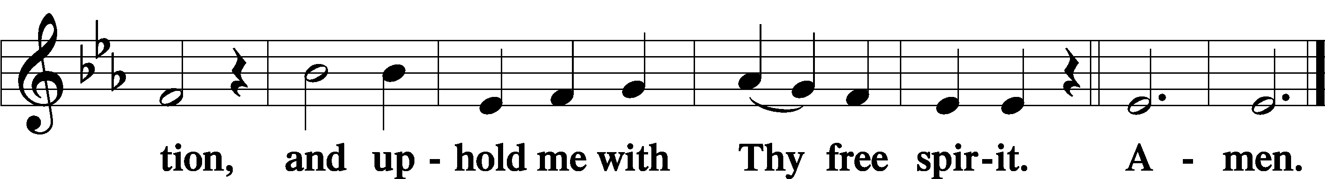

Offering

805 Praise God, from Whom All Blessings Flow

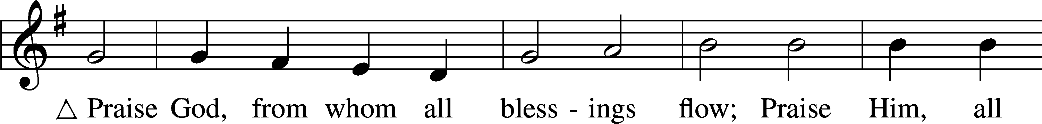

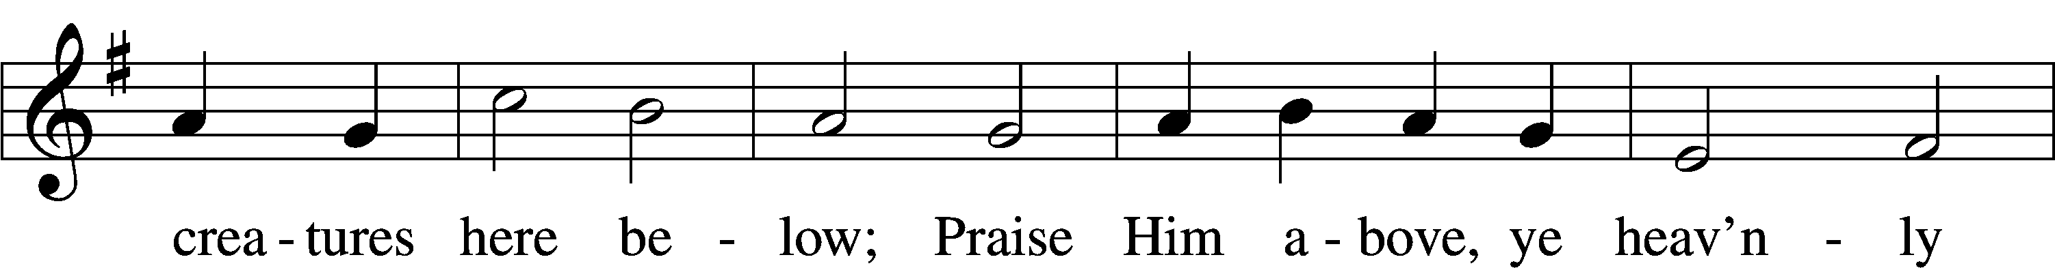

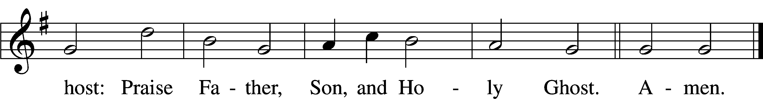

Text: Thomas Ken, 1637–1711  
Tune: Trente quatre Pseaumes de David, 1551, Geneva, ed. Louis Bourgeois  
Text and tune: Public domain

Prayer of the Church

Lord’s Prayer Matthew 6:9–13

P Lord, remember us in Your kingdom and teach us to pray:

C **Our Father who art in heaven,**

**hallowed be Thy name,**

**Thy kingdom come,**

**Thy will be done on earth**

**as it is in heaven;**

**give us this day our daily bread;**

**and forgive us our trespasses**

**as we forgive those**

**who trespass against us;**

**and lead us not into temptation,**

**but deliver us from evil.**

**For Thine is the kingdom**

**and the power and the glory**

**forever and ever. Amen.**

Collect for the Word

Blessed Lord, You have caused all holy Scriptures to be written for our learning.

Grant that we may so hear them, read, mark, learn, and inwardly digest them that, by the patience and comfort of Your holy Word, we may embrace and ever hold fast the blessed hope of everlasting life; which you have given us in our Savior Jesus Christ, Your Son, our Lord, who lives and reigns with You and the Holy Spirit, one God, now and forever.

Post-Communion Collect

A Let us pray.

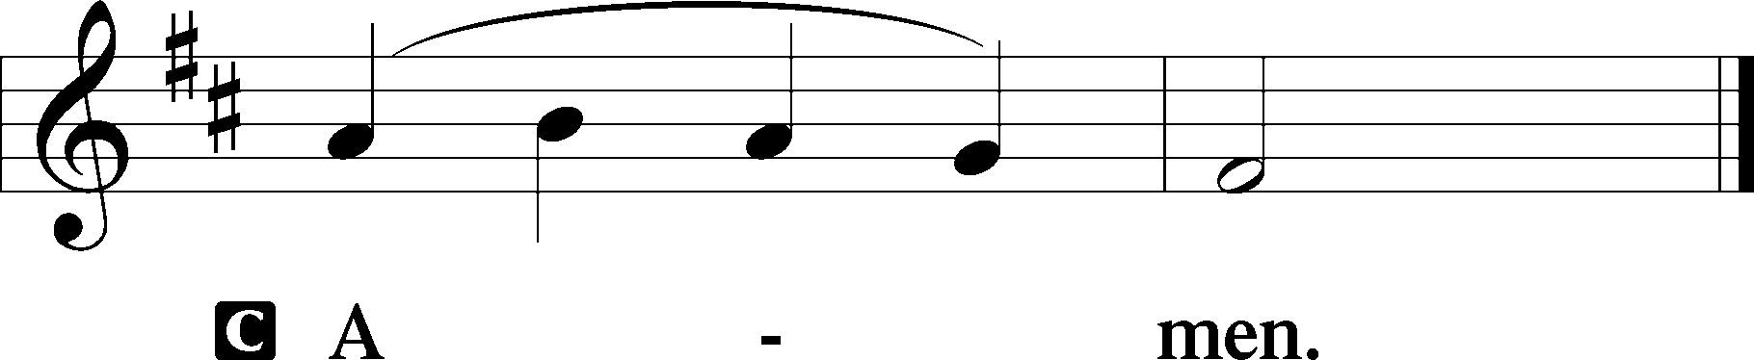

655 Lord, Keep Us Steadfast in Your Word

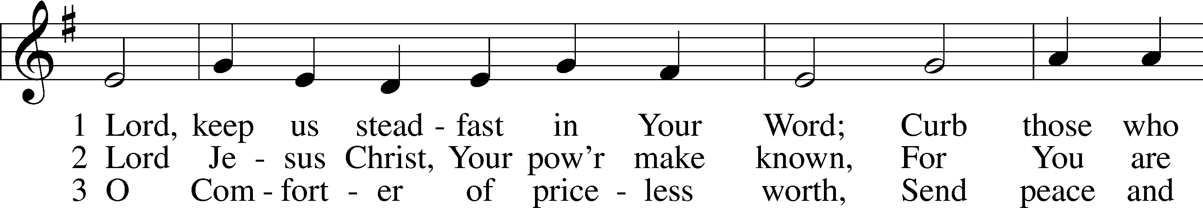

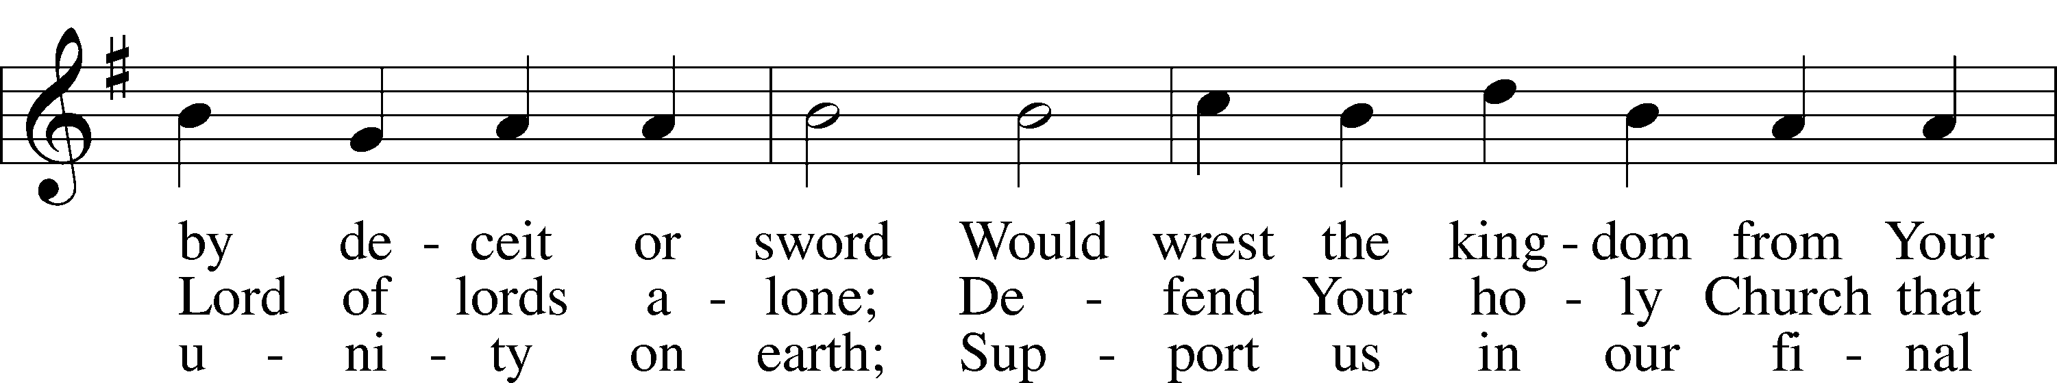

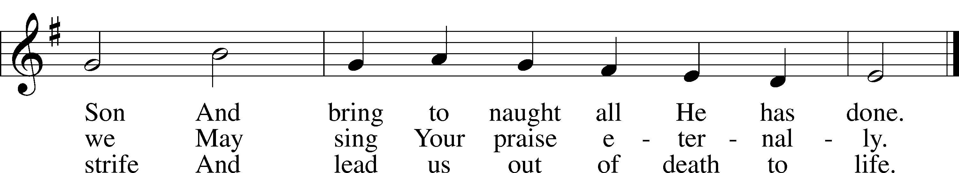

Text: Martin Luther, 1483–1546; tr. Catherine Winkworth, 1827–78, alt.  
Tune: Geistliche Lieder auffs new gebessert, 1543, Wittenberg, ed. Joseph Klug  
Text and tune: Public domain

Acknowledgments

Unless otherwise indicated, Scripture quotations are from the ESV® Bible (The Holy Bible, English Standard Version®), copyright © 2001 by Crossway, a publishing ministry of Good News Publishers. Used by permission. All rights reserved.

Created by Lutheran Service Builder © 2023 Concordia Publishing House.