571 God Loved the World So That He Gave
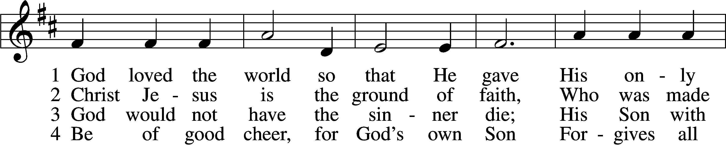
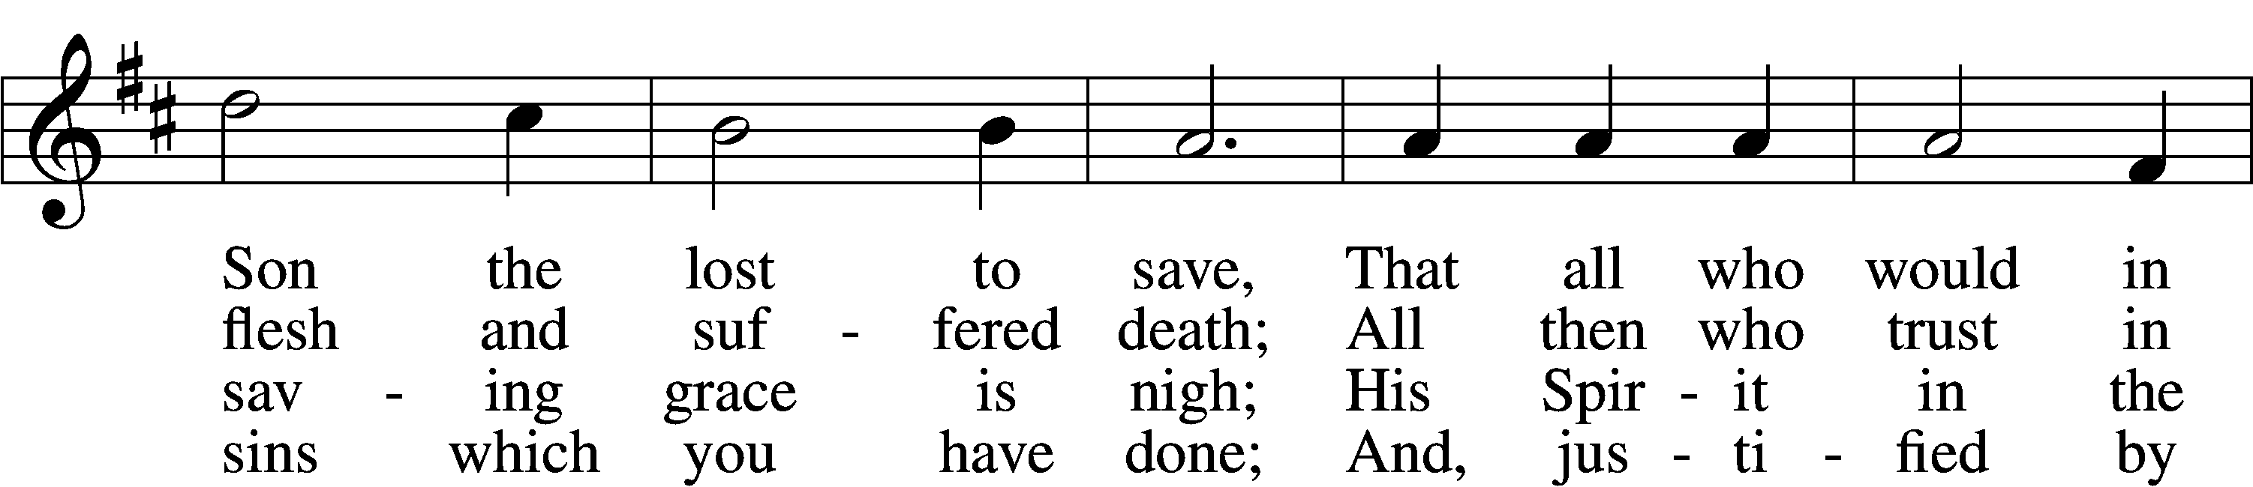
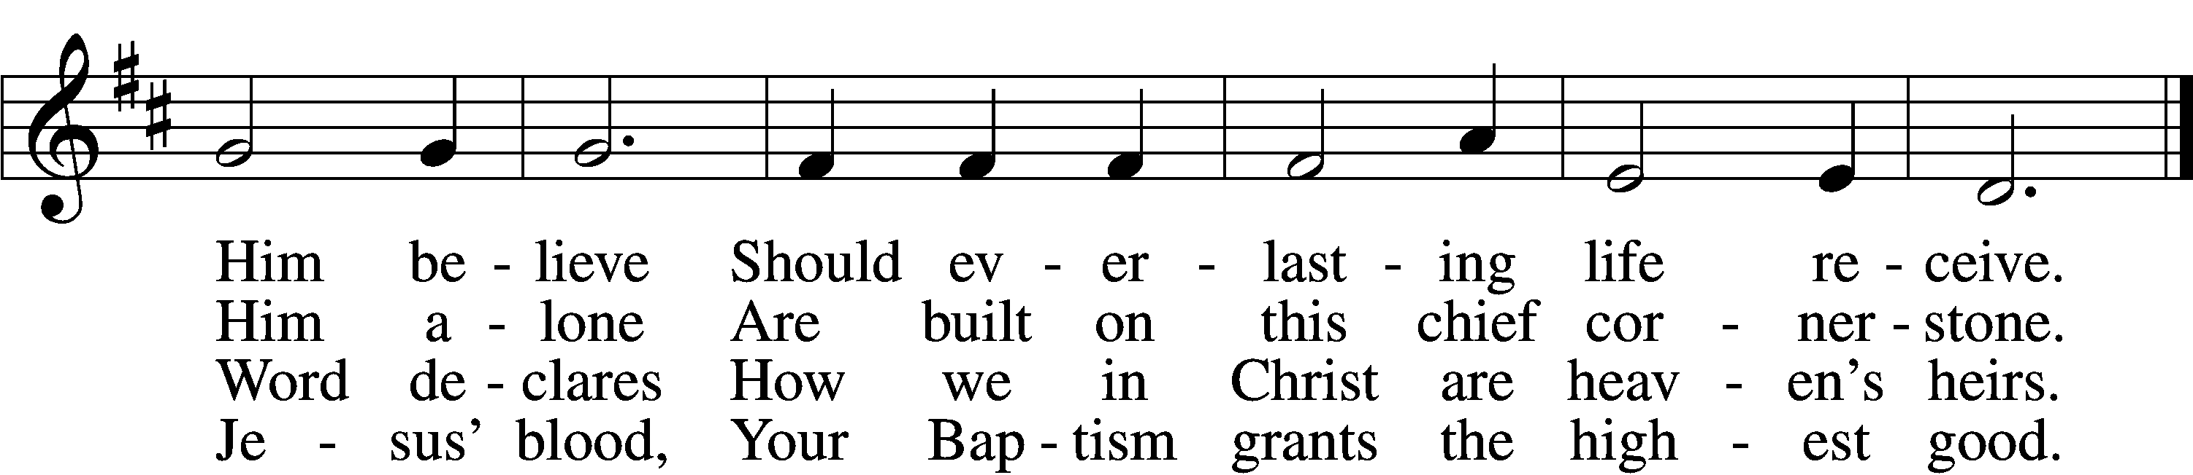

5 If you are sick, if death is near,
This truth your troubled heart can cheer:
Christ Jesus saves your soul from death;
That is the firmest ground of faith.

D 6 Glory to God the Father, Son,
And Holy Spirit, Three in One!
To You, O blessèd Trinity,
Be praise now and eternally!
Text: Heiliges Lippen- und Hertzens-Opffer, c. 1778, Stettin; tr. August Crull, 1845–1923, alt.
Tune: George J. Elvey, 1816–93
Text and tune: Public domain
Confession and Absolution

Stand

The sign of the cross may be made by all in remembrance of their Baptism.

Invocation Matthew 28:19b; 18:20
P In the name of the Father and of the T Son and of the Holy Spirit.
C Amen.

Exhortation Hebrews 10:22; Psalm 124:8; Psalm 32:5
P Beloved in the Lord! Let us draw near with a true heart and confess our sins unto God our Father, beseeching Him in the name of our Lord Jesus Christ to grant us forgiveness.

P Our help is in the name of the Lord,
C who made heaven and earth.
P I said, I will confess my transgressions unto the Lord,
C and You forgave the iniquity of my sin.

Kneel/Stand

Silence for reflection on God’s Word and for self-examination.

Confession of Sins
P O almighty God, merciful Father,
C I, a poor, miserable sinner, confess unto You all my sins and iniquities with which I have ever offended You and justly deserved Your temporal and eternal punishment. But I am heartily sorry for them and sincerely repent of them, and I pray You of Your boundless mercy and for the sake of the holy, innocent, bitter sufferings and death of Your beloved Son, Jesus Christ, to be gracious and merciful to me, a poor, sinful being.

Absolution [John 20:19–23]
P Upon this your confession, I, by virtue of my office, as a called and ordained servant of the Word, announce the grace of God unto all of you, and in the stead and by the command of my Lord Jesus Christ I forgive you all your sins in the name of the Father and of the T Son and of the Holy Spirit.
C Amen.

Stand

Service of the Word

Introit Psalm 105:4–7; antiphon: v. 8
He remembers his covenant forever,
the word that he commanded, for a thousand gener- ations.
Seek the Lord and his strength;
seek his presence continually!
Remember the wondrous works that he has done,
his miracles, and the judgments he uttered,
O offspring of Abraham, his servant,
children of Jacob, his chosen ones!
He is the Lord our God;
his judgments are in all the earth.

Gloria Patri
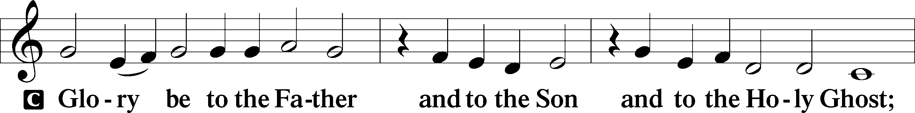
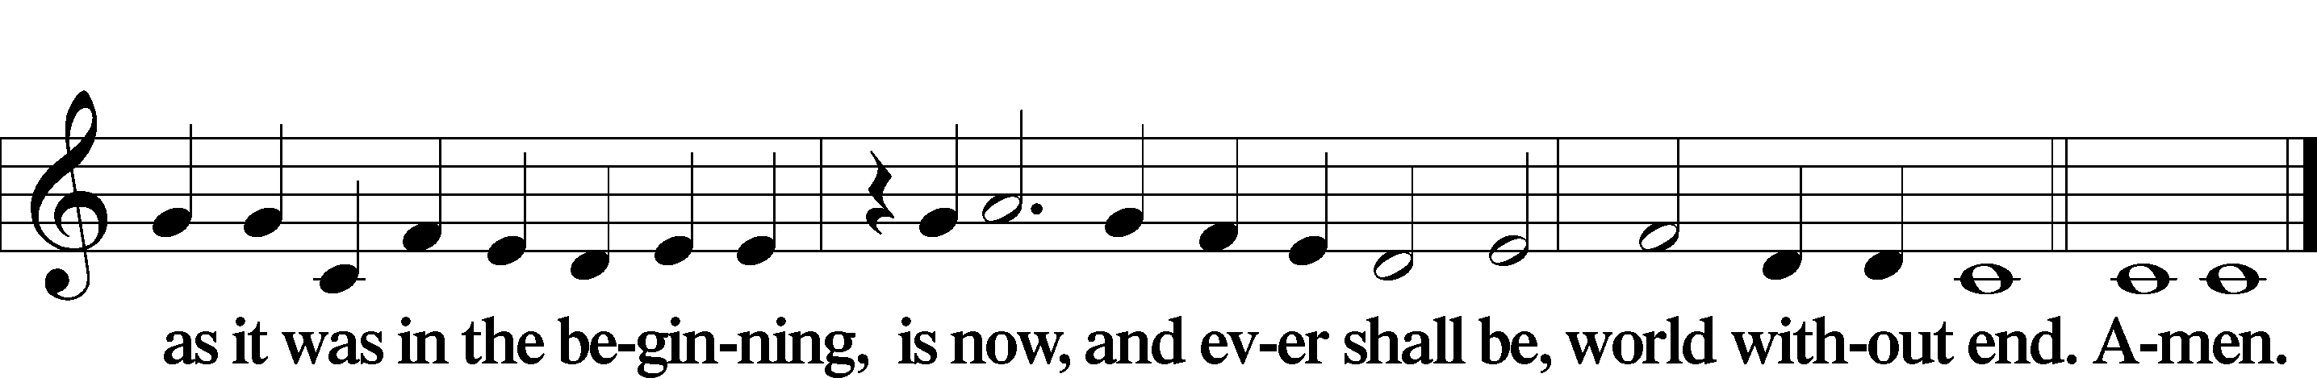

Kyrie Mark 10:47
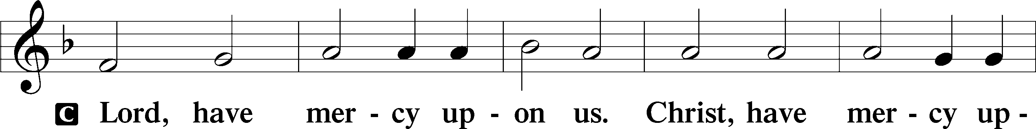
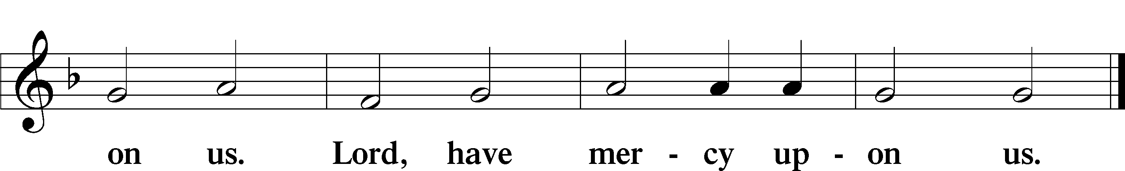

Salutation and Collect of the Day
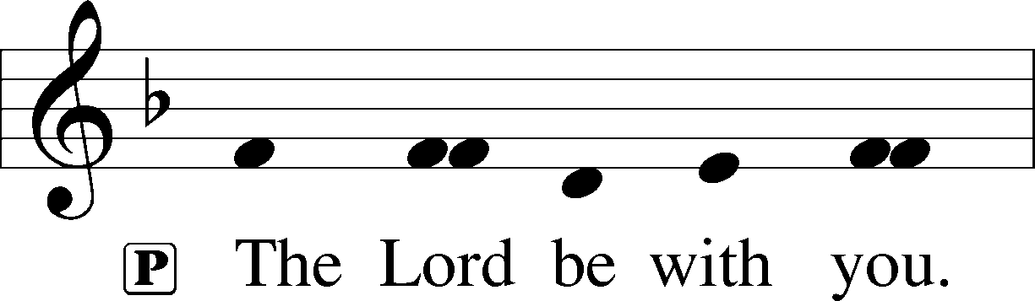
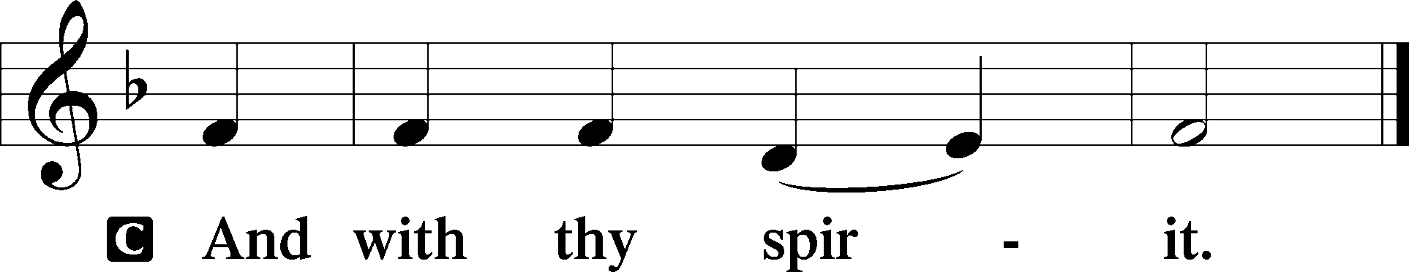

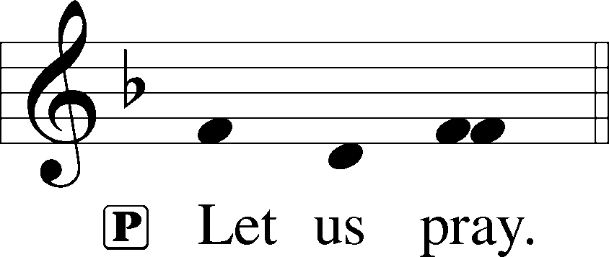

P O God, You see that of ourselves we have no strength. By Your mighty power defend us from all adversities that may happen to the body and from all evil thoughts that may assault and hurt the soul; through Jesus Christ, Your Son, our Lord, who lives and reigns with You and the Holy Spirit, one God, now and forever.

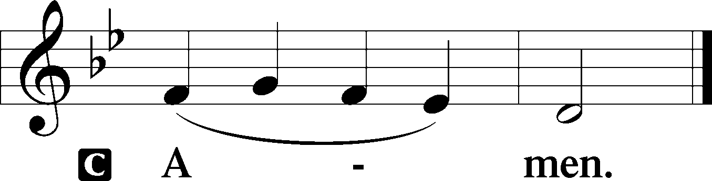

Sit

Old Testament Reading Genesis 12:1–9
The Call of Abram
1The Lord said to Abram, “Go from your country and your kindred and your father’s house to the land that I will show you. 2And I will make of you a great nation, and I will bless you and make your name great, so that you will be a blessing. 3I will bless those who bless you, and him who dishonors you I will curse, and in you all the families of the earth shall be blessed.”
4So Abram went, as the Lord had told him, and Lot went with him. Abram was seventy-five years old when he departed from Haran. 5And Abram took Sarai his wife, and Lot his brother’s son, and all their possessions that they had gathered, and the people that they had acquired in Haran, and they set out to go to the land of Canaan. When they came to the land of Canaan, 6Abram passed through the land to the place at Shechem, to the oak of Moreh. At that time the Canaanites were in the land. 7Then the Lord appeared to Abram and said, “To your offspring I will give this land.” So he built there an altar to the Lord, who had appeared to him. 8From there he moved to the hill country on the east of Bethel and pitched his tent, with Bethel on the west and Ai on the east. And there he built an altar to the Lord and called upon the name of the Lord. 9And Abram journeyed on, still going toward the Negeb.

A This is the Word of the Lord.
C Thanks be to God.

Gradual Hebrews 12:2
[O come, let us fix our eyes on] Jesus,
the founder and perfecter of our faith,
who for the joy that was set before him endured the cross, despising the shame,
and is seated at the right hand of the throne of God.

Epistle Romans 4:1–8, 13–17
Abraham Justified by Faith
1What then shall we say was gained by Abraham, our forefather according to the flesh? 2For if Abraham was justified by works, he has something to boast about, but not before God. 3For what does the Scripture say? “Abraham believed God, and it was counted to him as righteousness.” 4Now to the one who works, his wages are not counted as a gift but as his due. 5And to the one who does not work but trusts him who justifies the ungodly, his faith is counted as righteousness, 6just as David also speaks of the blessing of the one to whom God counts righteousness apart from works:
7“Blessed are those whose lawless deeds are forgiven,
and whose sins are covered;
8blessed is the man against whom the Lord will not count his sin.” . . .
The Promise Realized Through Faith
13For the promise to Abraham and his offspring that he would be heir of the world did not come through the law but through the righteousness of faith. 14For if it is the adherents of the law who are to be the heirs, faith is null and the promise is void. 15For the law brings wrath, but where there is no law there is no transgression.
16That is why it depends on faith, in order that the promise may rest on grace and be guaranteed to all his offspring—not only to the adherent of the law but also to the one who shares the faith of Abraham, who is the father of us all, 17as it is written, “I have made you the father of many nations”—in the presence of the God in whom he believed, who gives life to the dead and calls into existence the things that do not exist.

A This is the Word of the Lord.
C Thanks be to God.

Stand

Holy Gospel John 3:1–17
P The Holy Gospel according to St. John, the third chapter.

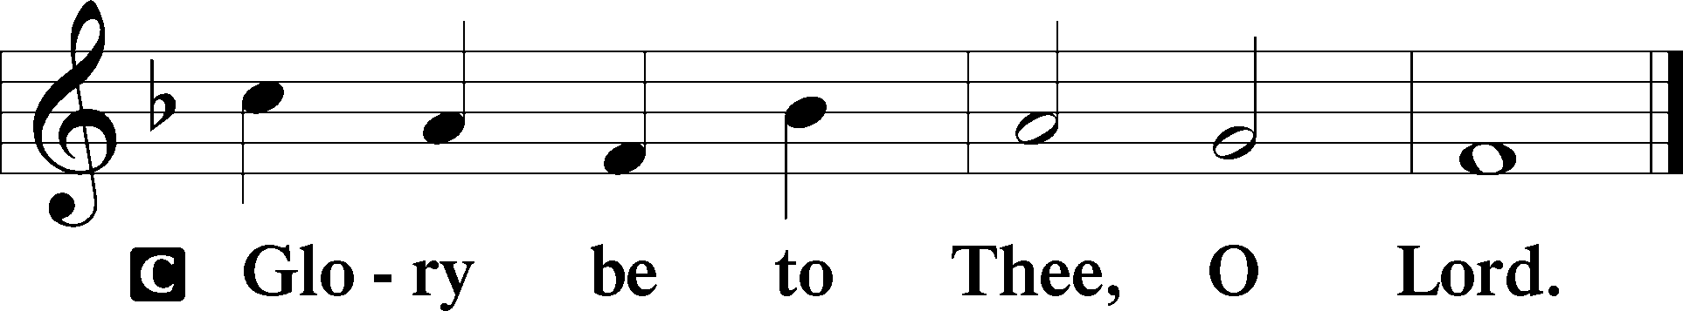

You Must Be Born Again
1Now there was a man of the Pharisees named Nicodemus, a ruler of the Jews. 2This man came to Jesus by night and said to him, “Rabbi, we know that you are a teacher come from God, for no one can do these signs that you do unless God is with him.” 3Jesus answered him, “Truly, truly, I say to you, unless one is born again he cannot see the kingdom of God.” 4Nicodemus said to him, “How can a man be born when he is old? Can he enter a second time into his mother’s womb and be born?” 5Jesus answered, “Truly, truly, I say to you, unless one is born of water and the Spirit, he cannot enter the kingdom of God. 6That which is born of the flesh is flesh, and that which is born of the Spirit is spirit. 7Do not marvel that I said to you, ‘You must be born again.’ 8The wind blows where it wishes, and you hear its sound, but you do not know where it comes from or where it goes. So it is with everyone who is born of the Spirit.”
9Nicodemus said to him, “How can these things be?” 10Jesus answered him, “Are you the teacher of Israel and yet you do not understand these things? 11Truly, truly, I say to you, we speak of what we know, and bear witness to what we have seen, but you do not receive our testimony. 12If I have told you earthly things and you do not believe, how can you believe if I tell you heavenly things? 13No one has ascended into heaven except he who descended from heaven, the Son of Man. 14And as Moses lifted up the serpent in the wilderness, so must the Son of Man be lifted up, 15that whoever believes in him may have eternal life.
For God So Loved the World
16“For God so loved the world, that he gave his only Son, that whoever believes in him should not perish but have eternal life. 17For God did not send his Son into the world to condemn the world, but in order that the world might be saved through him.”

P This is the Gospel of the Lord.

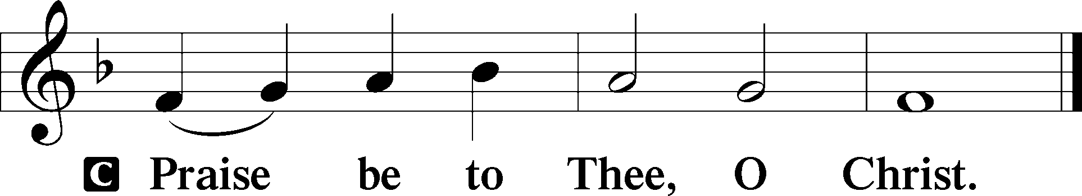

Nicene Creed
C I believe in one God,
the Father Almighty,
maker of heaven and earth
and of all things visible and invisible.

And in one Lord Jesus Christ,
the only-begotten Son of God,
begotten of His Father before all worlds,
God of God, Light of Light,
very God of very God,
begotten, not made,
being of one substance with the Father,
by whom all things were made;
who for us men and for our salvation came down from heaven
and was incarnate by the Holy Spirit of the virgin Mary
and was made man;
and was crucified also for us under Pontius Pilate.
He suffered and was buried.
And the third day He rose again according to the Scriptures
and ascended into heaven
and sits at the right hand of the Father.
And He will come again with glory to judge both the living and the dead,
whose kingdom will have no end.

And I believe in the Holy Spirit,
the Lord and giver of life,
who proceeds from the Father and the Son,
who with the Father and the Son together is worshiped and glorified,
who spoke by the prophets.
And I believe in one holy Christian and apostolic Church,
I acknowledge one Baptism for the remission of sins,
and I look for the resurrection of the dead
and the life T of the world to come. Amen.

Sit

Children's Message

708 Lord, Thee I Love with All My Heart
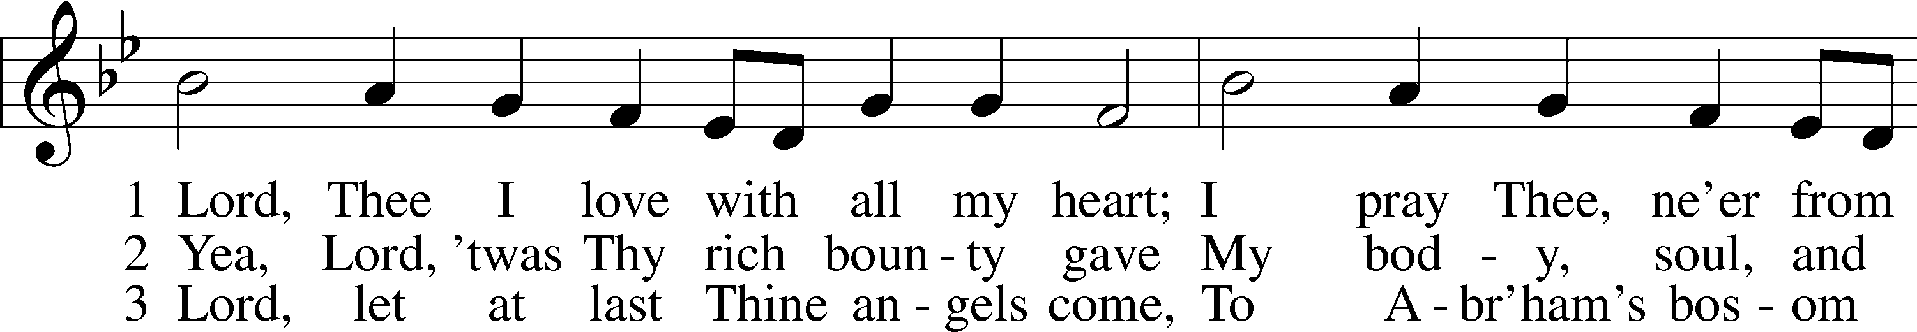
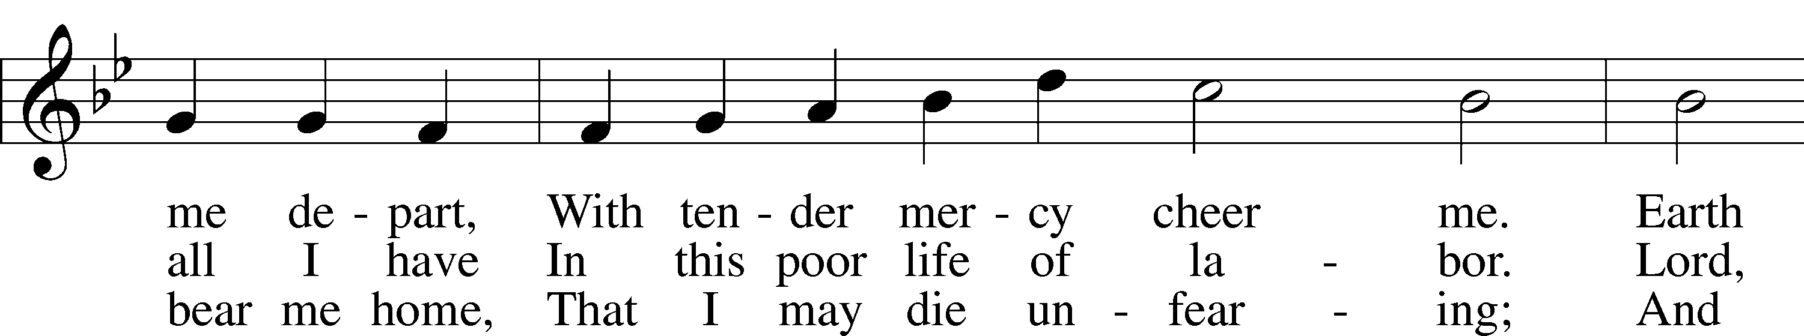
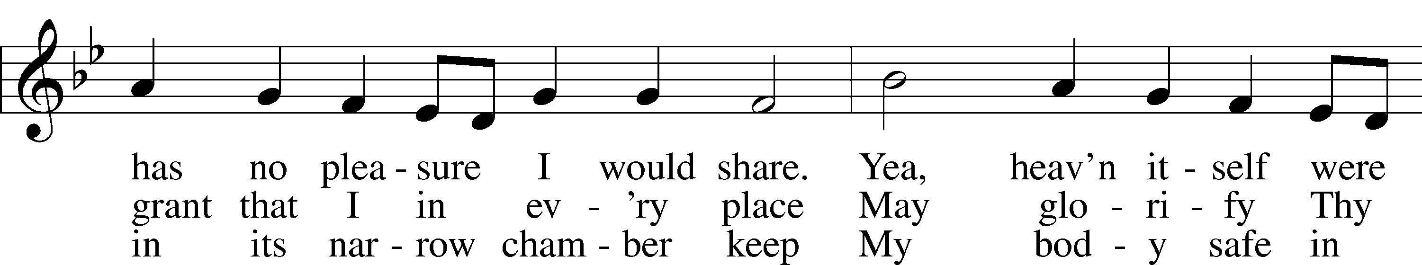
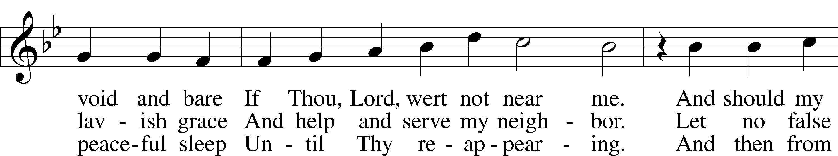
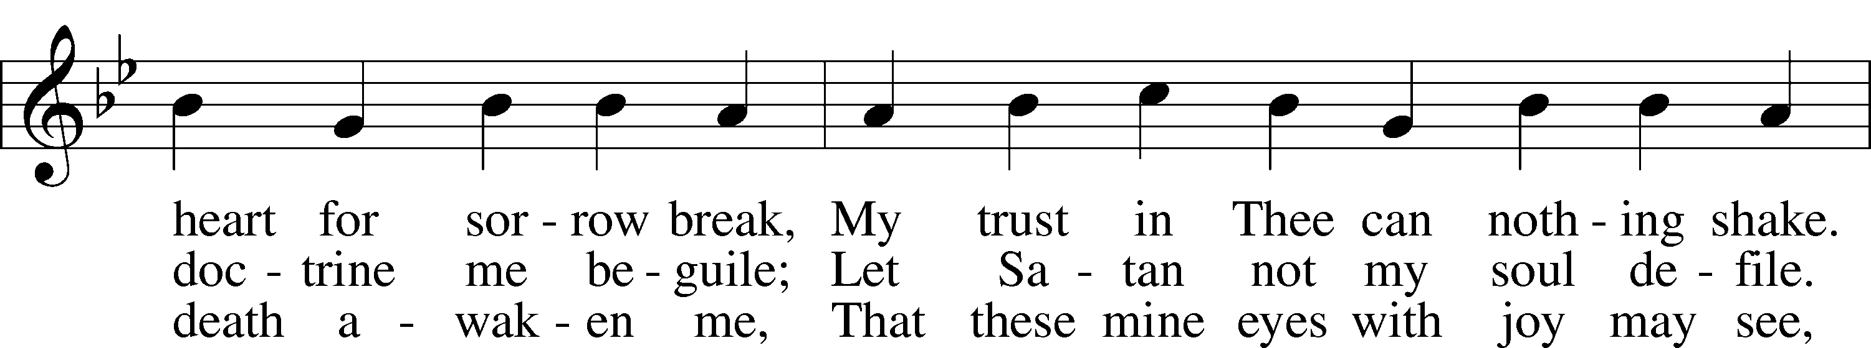
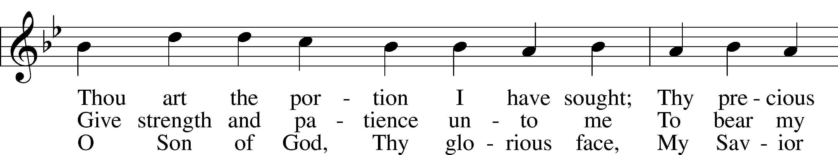
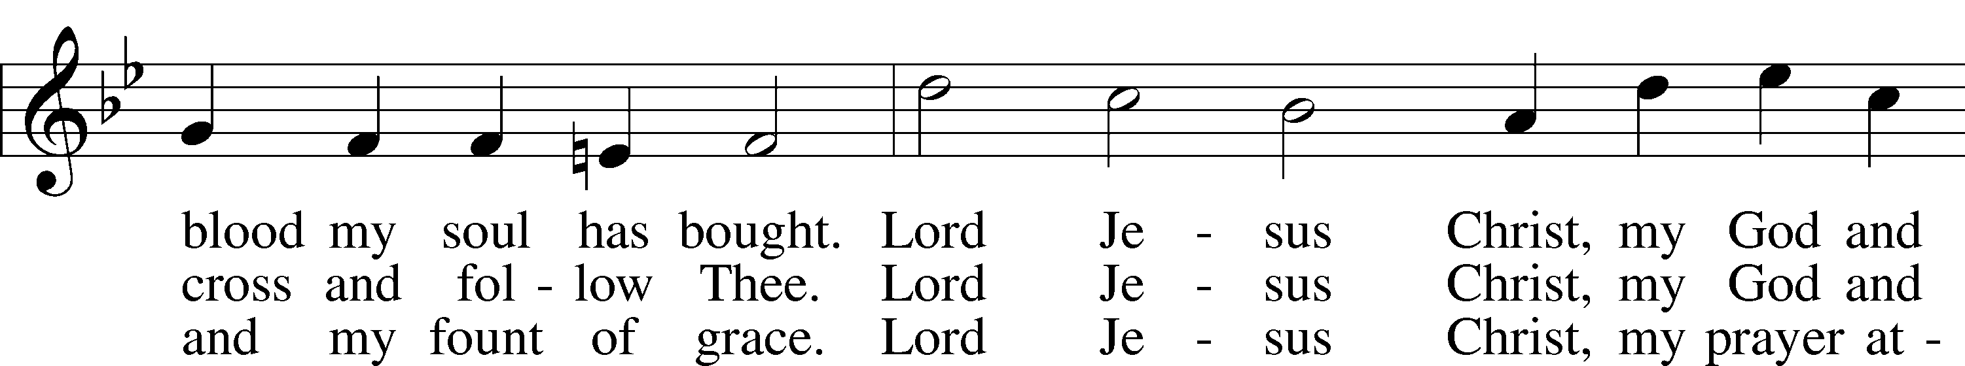
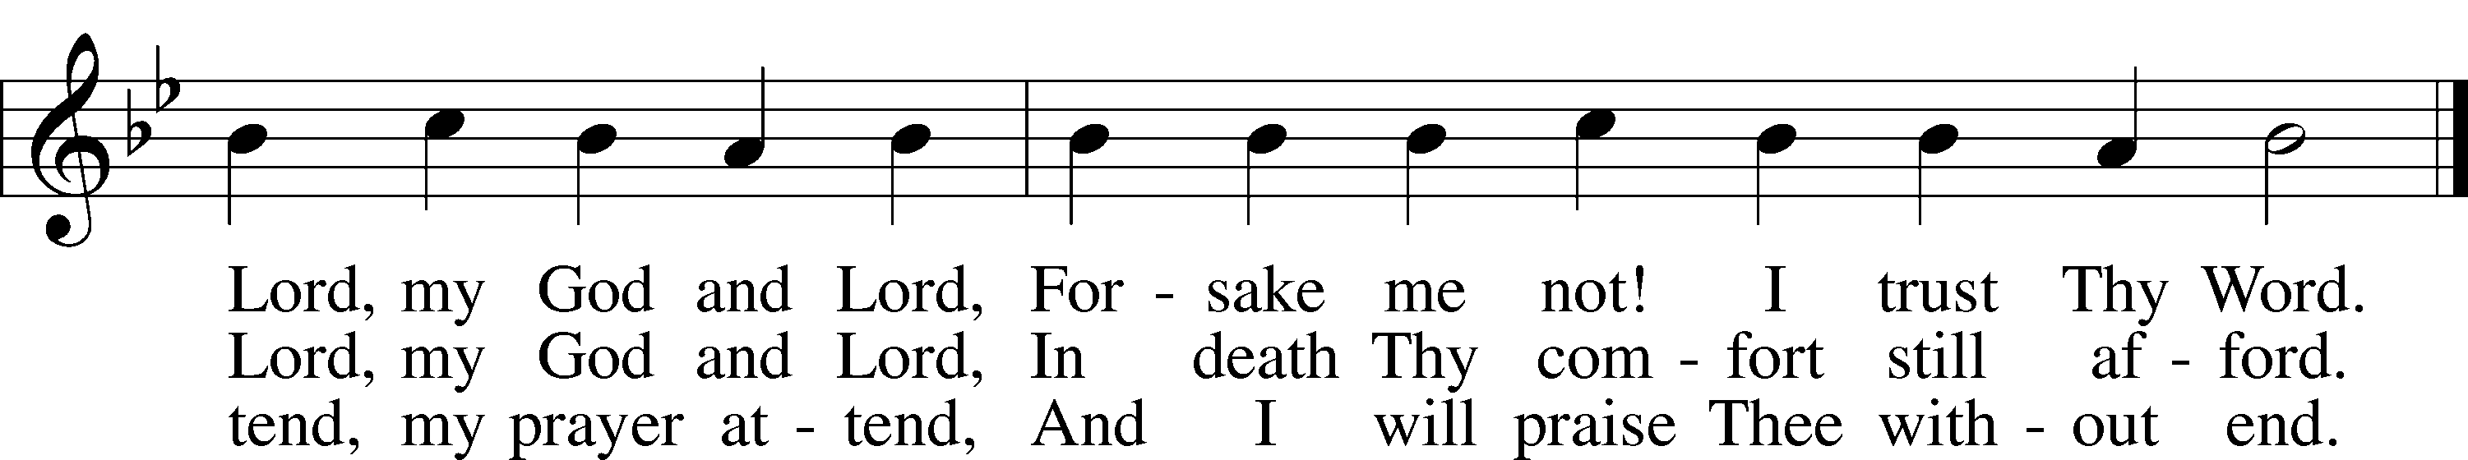
Text: Martin Schalling, 1532–1608; tr. Catherine Winkworth, 1827–78, alt.
Tune: Zwey Bücher . . . Tabulatur, 1577, Strassburg
Text and tune: Public domain

Sermon

Votum
P The peace of God, which passes all understanding, keep your hearts and minds in Christ Jesus.
C Amen.

Stand

Offertory Psalm 51:10–12
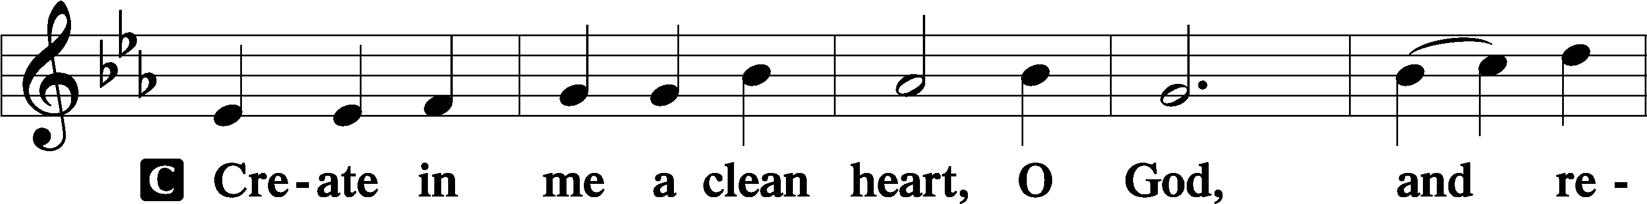
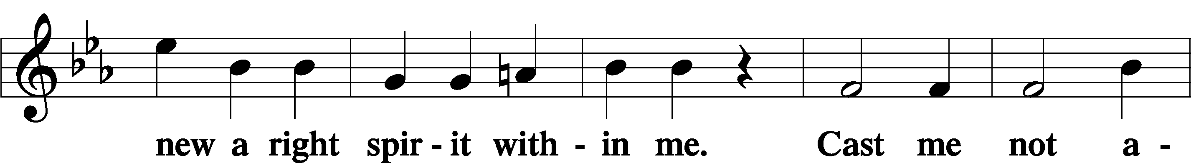
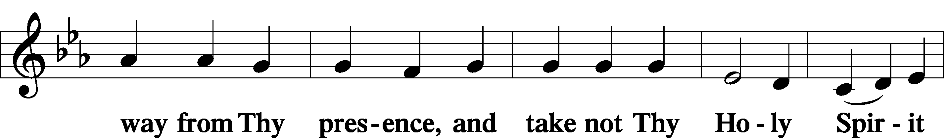
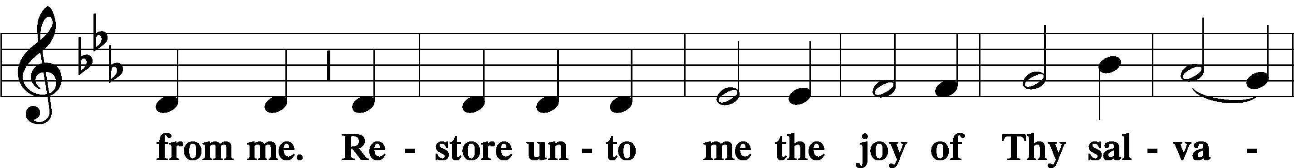
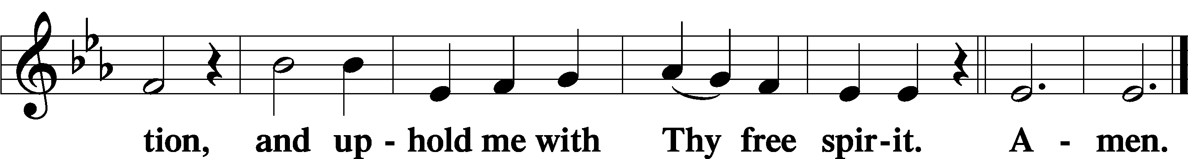

Sit

Offering

Stand

Prayer of the Church

Service of the Sacrament

Preface 2 Timothy 4:22; [Colossians 3:1]; [Psalm 136]
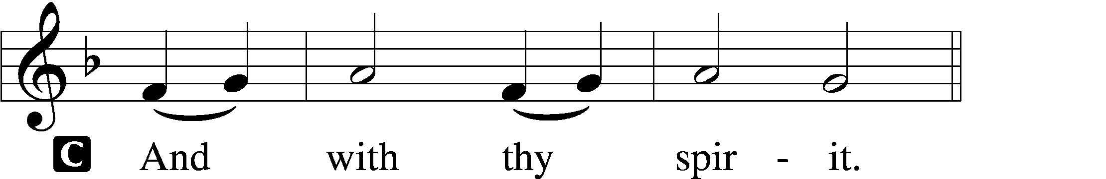

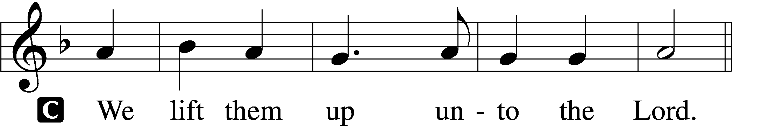

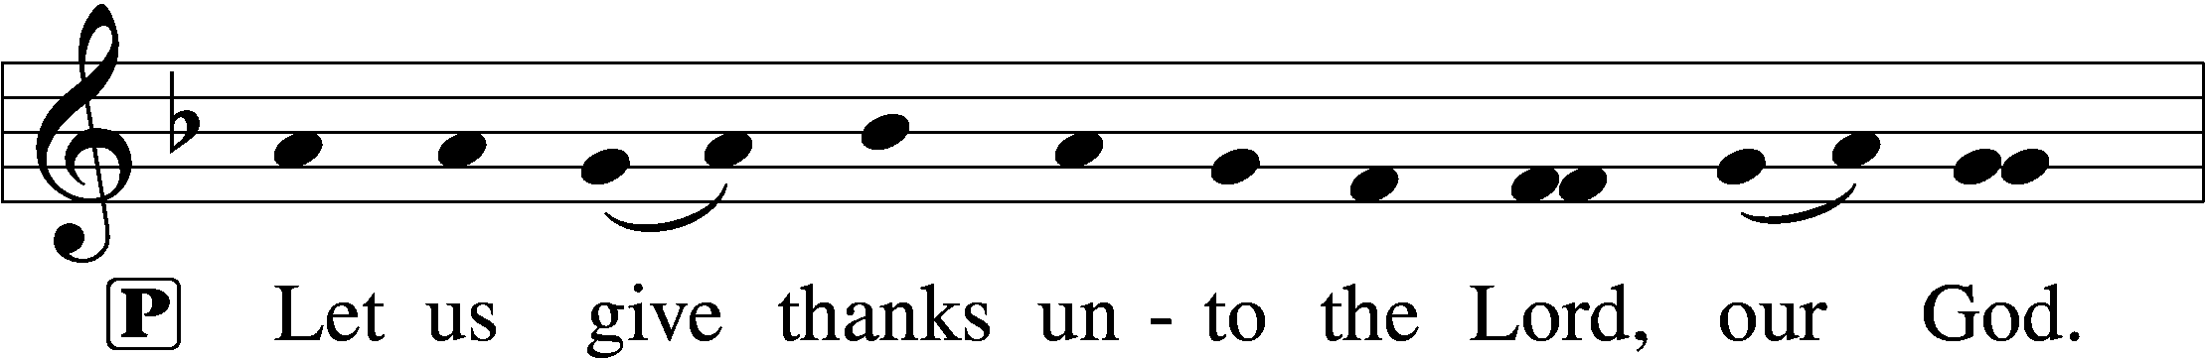
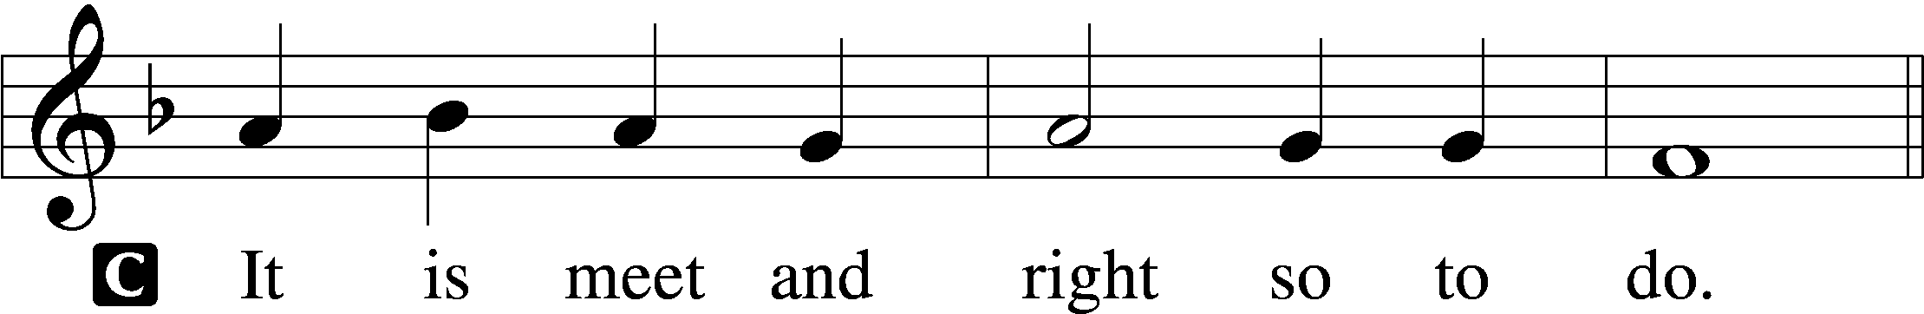

Proper Preface (Full)
P It is truly meet, right, and salutary that we should at all times and in all places give thanks to You, holy Lord, almighty Father, everlasting God, through Jesus Christ, our Lord, who overcame the assaults of the devil and gave His life as a ransom for many that with cleansed hearts we might be prepared joyfully to celebrate the paschal feast in sincerity and truth. Therefore with angels and archangels and with all the company of heaven we laud and magnify Your glorious name, evermore praising You and saying:

Sanctus Isaiah 6:3; Matthew 21:9
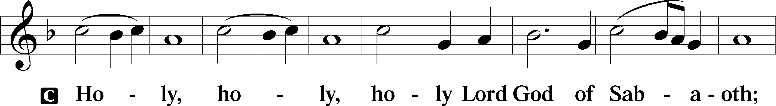
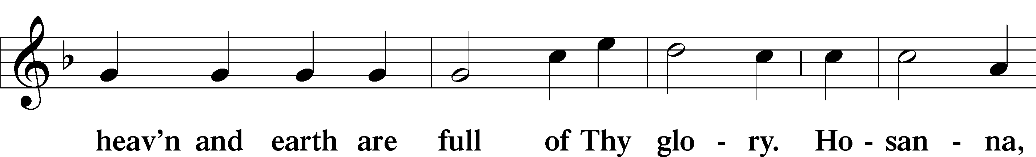
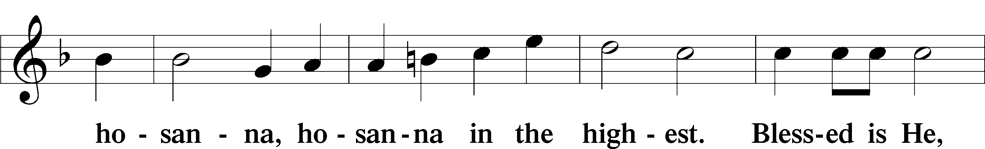
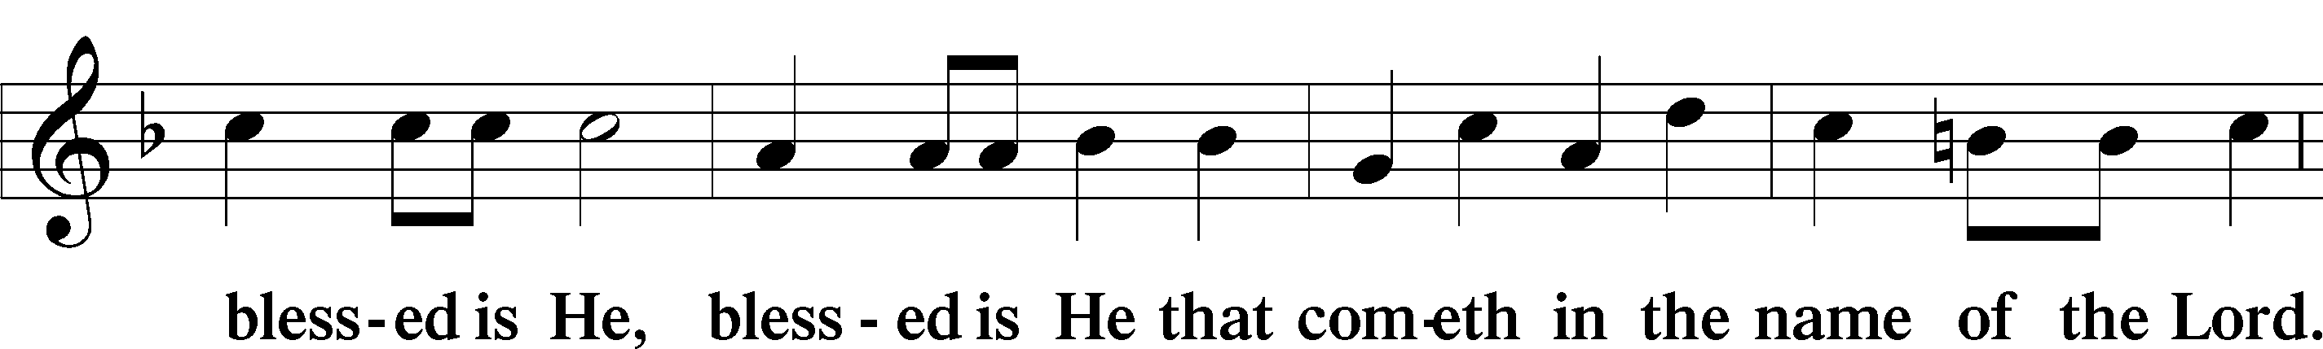
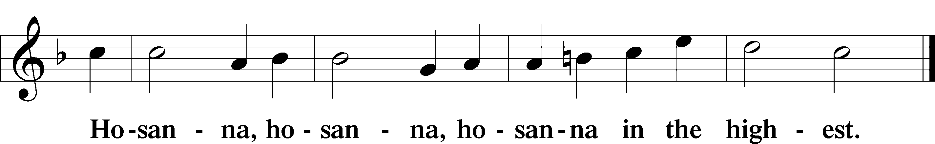

Lord’s Prayer Matthew 6:9–13
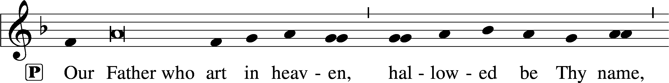
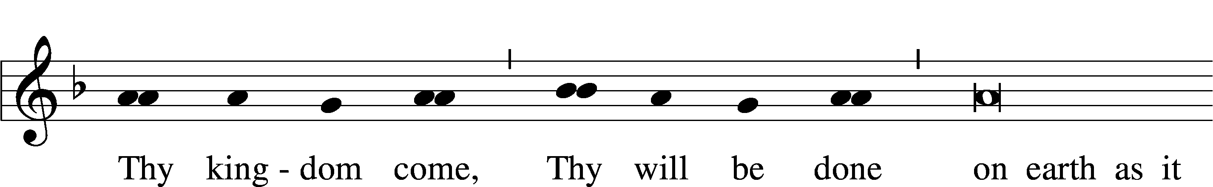
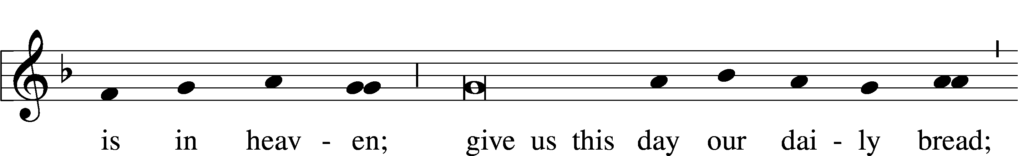
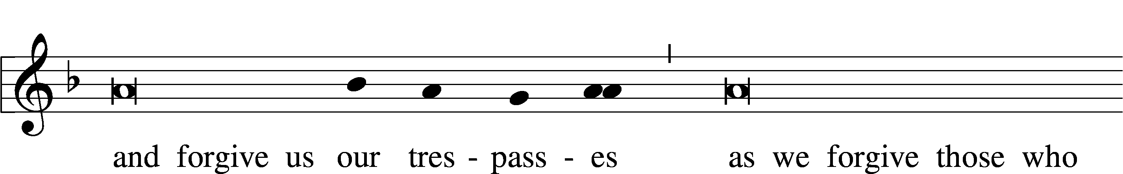
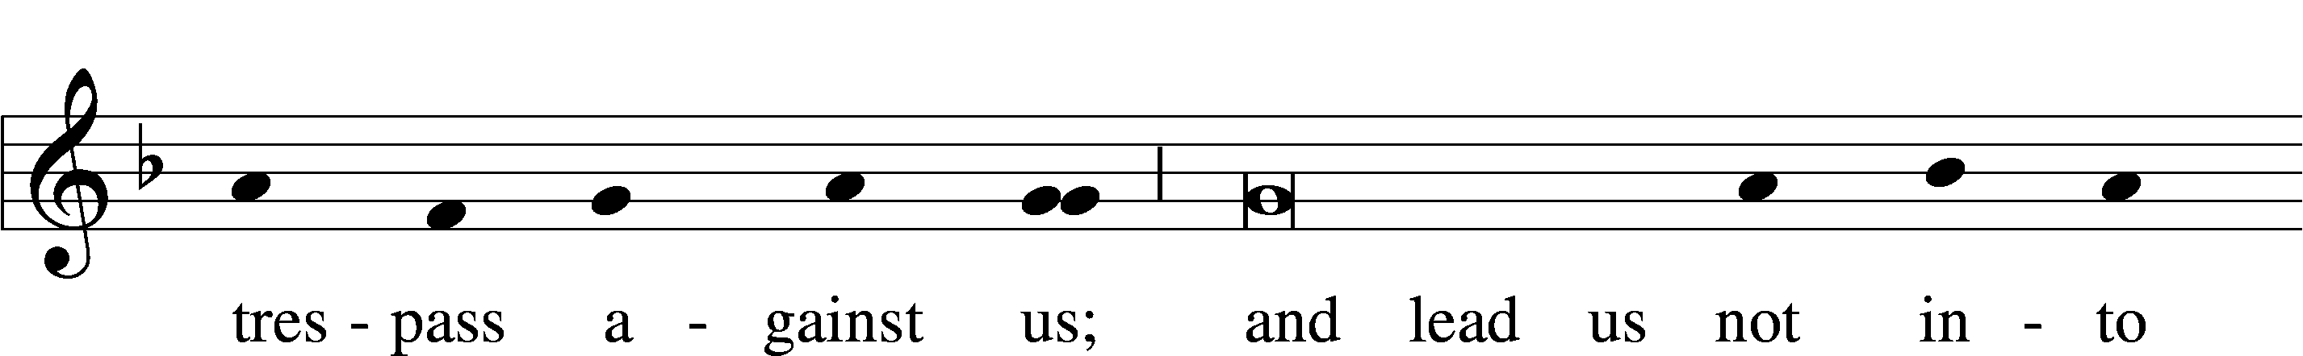
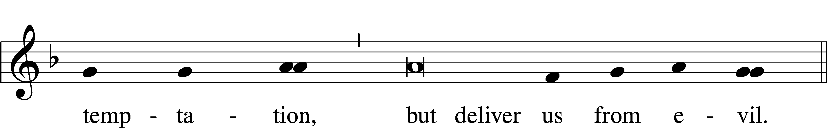

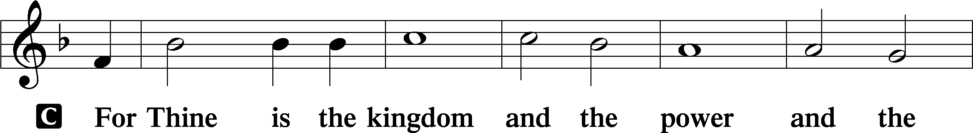
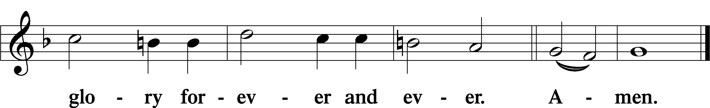

The Words of Our Lord Matthew 26:26–28; Mark 14:22–24; Luke 22:19–20; 1 Corinthians 11:23–25
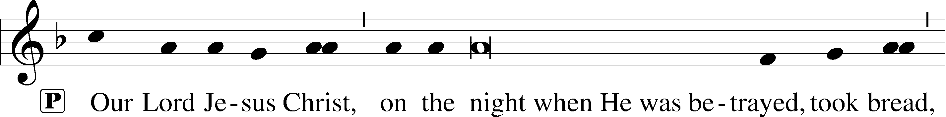
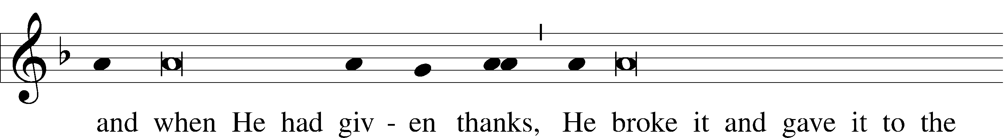
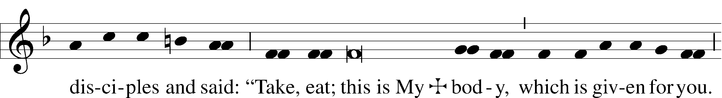
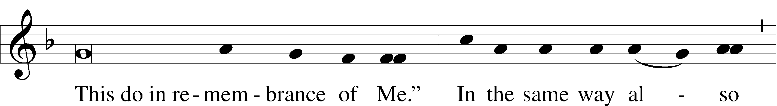
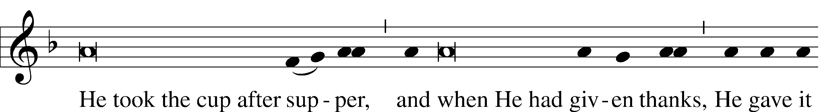
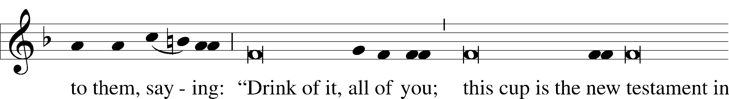
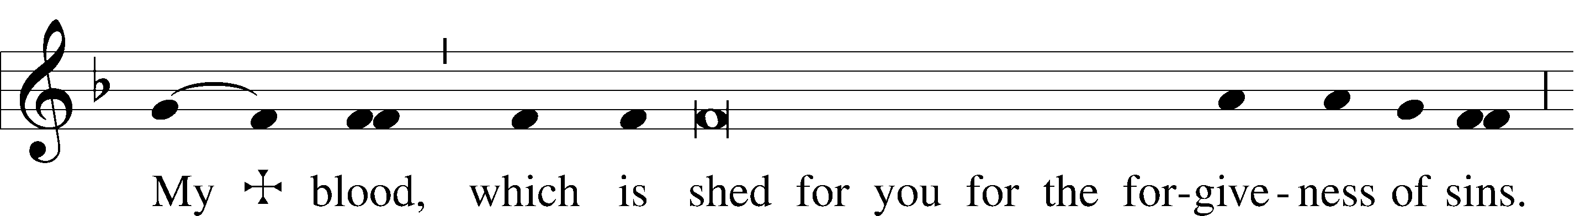
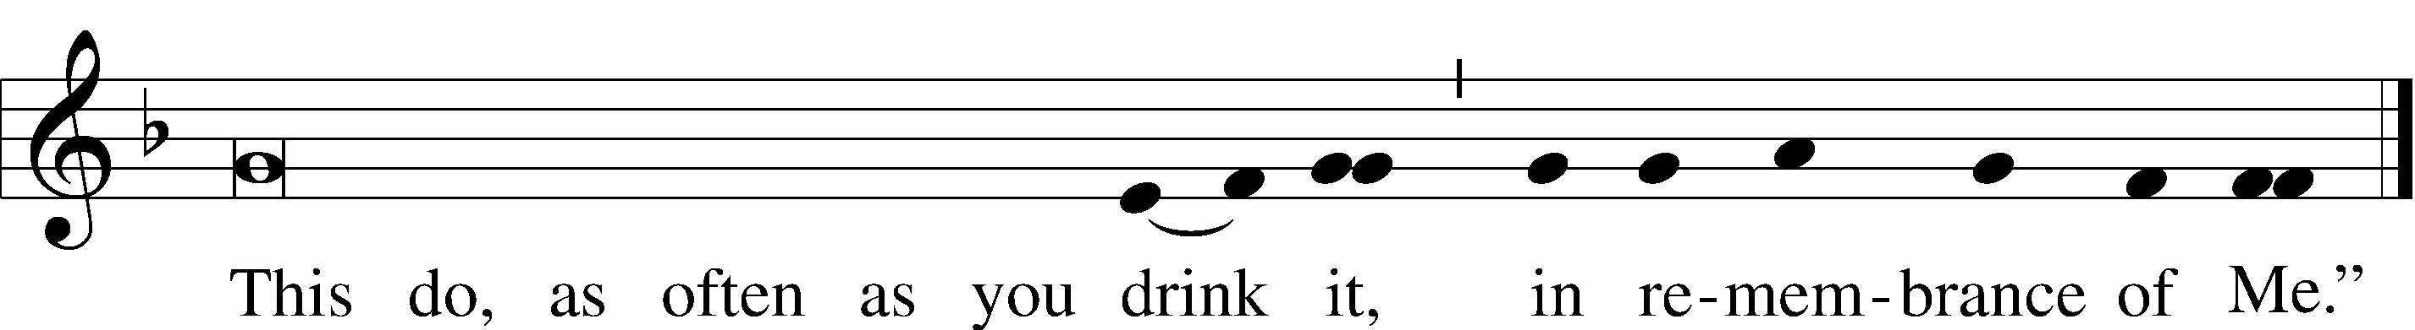

Pax Domini John 20:19
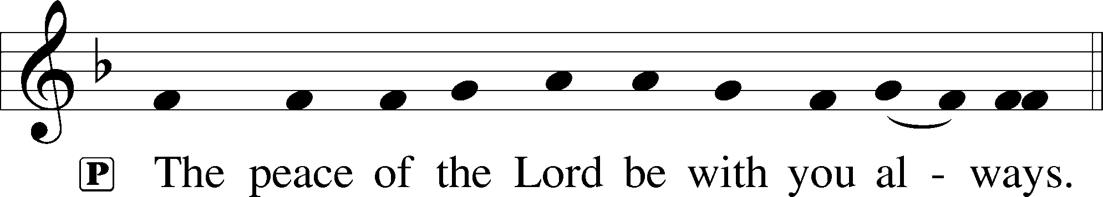

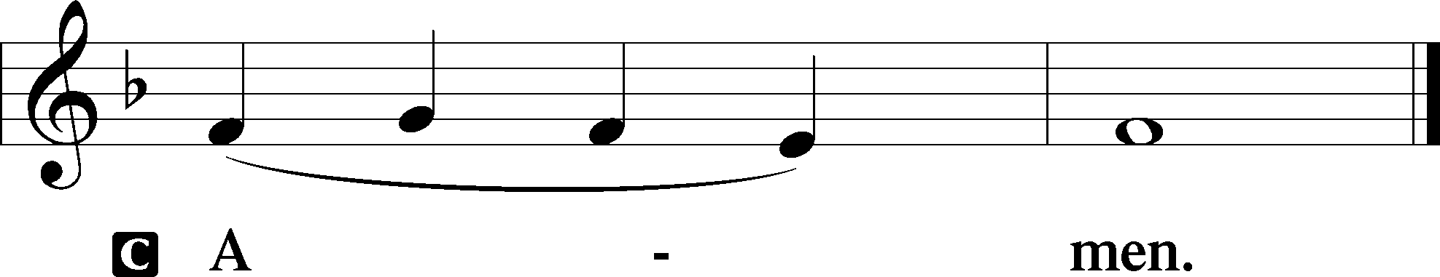

Agnus Dei John 1:29
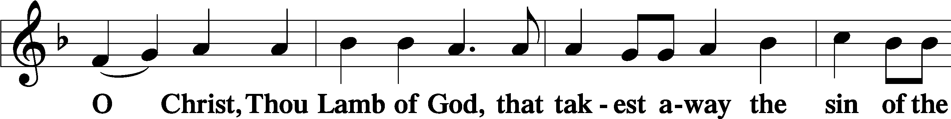
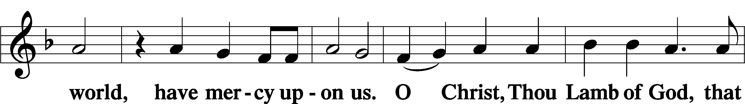
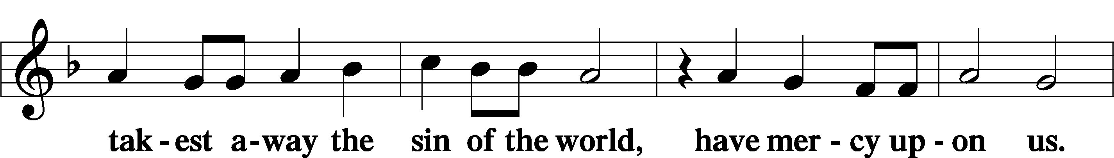
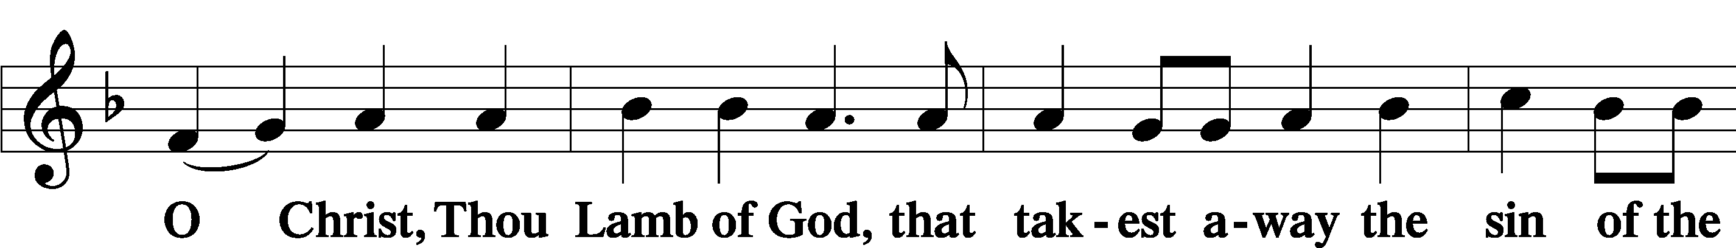
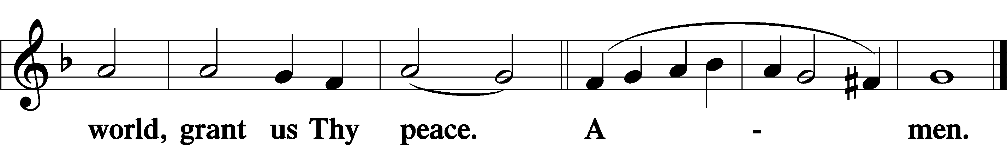

Sit

Distribution

619 Thy Body, Given for Me, O Savior
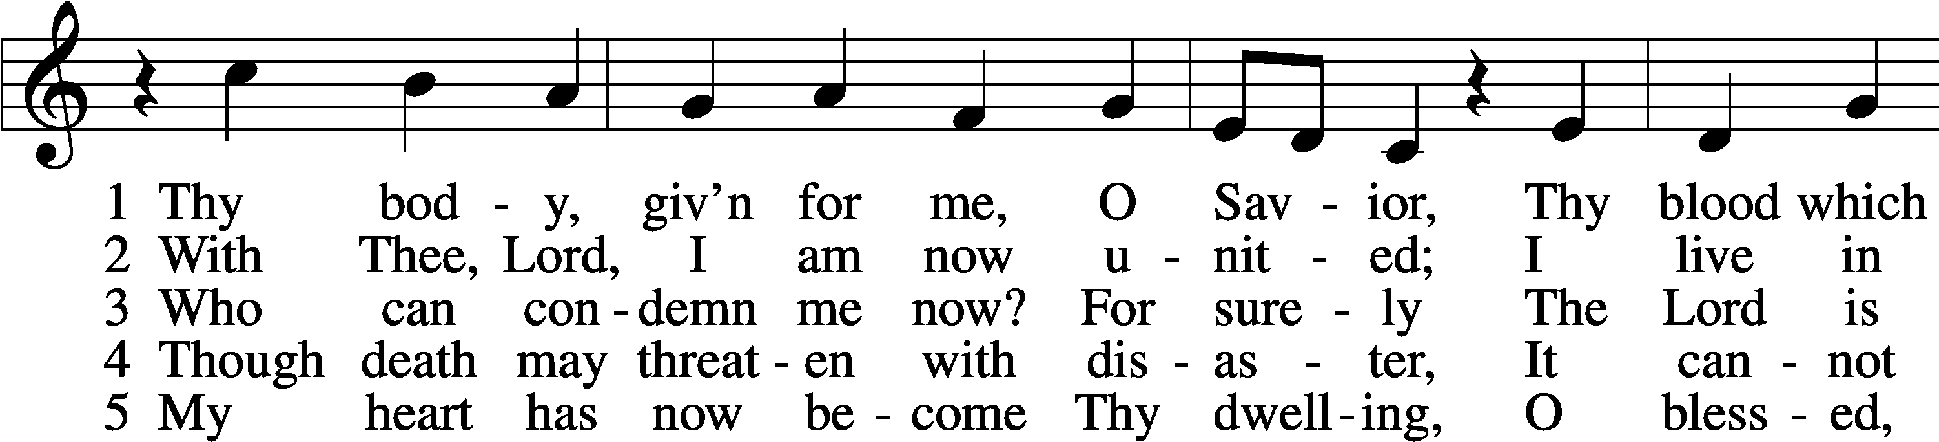
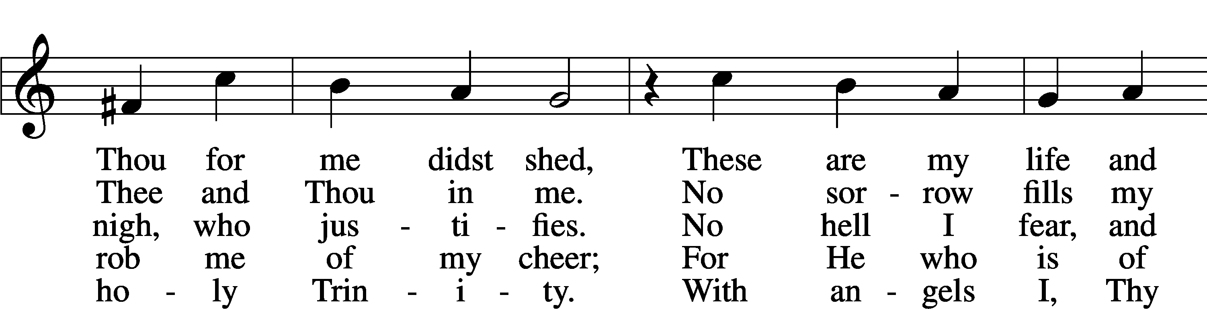
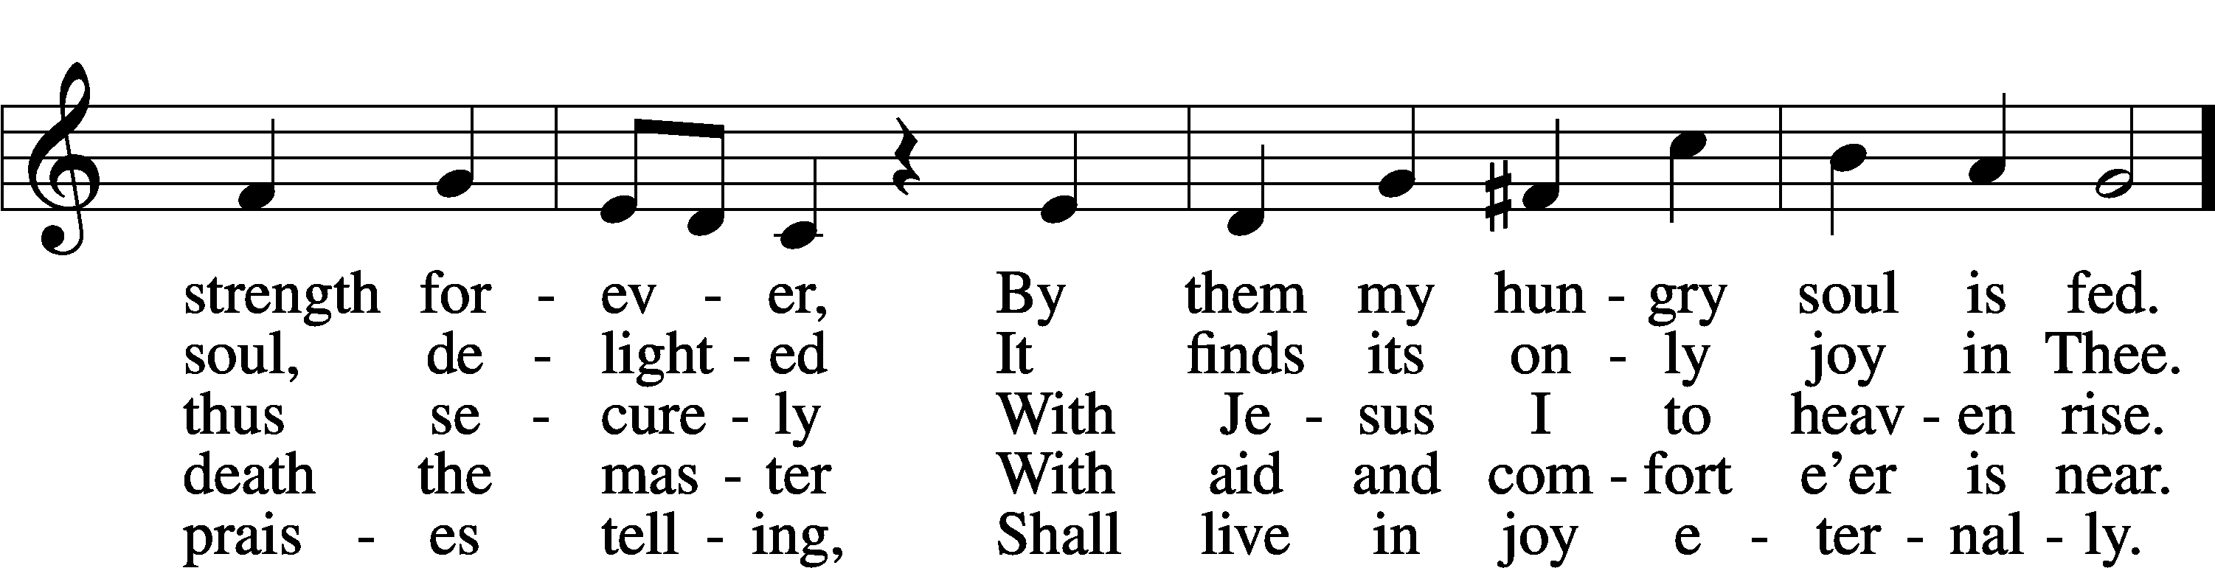
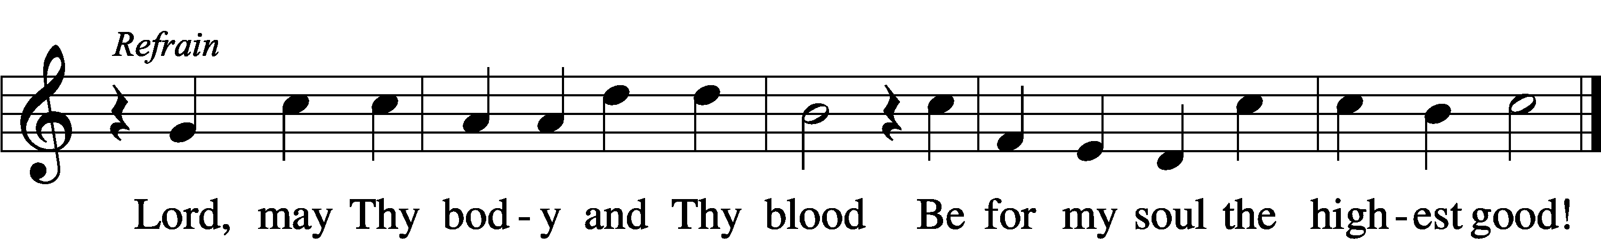
Text: Friedrich Christian Heyder, 1677–1754; tr. The Lutheran Hymnal, 1941, abr.
Tune: Emskirchner Choral-Buch, 1756, Leipzig
Text: © 1941 Concordia Publishing House. Used by permission: LSB Hymn License no. 110005011
Tune: Public domain

425 When I Survey the Wondrous Cross
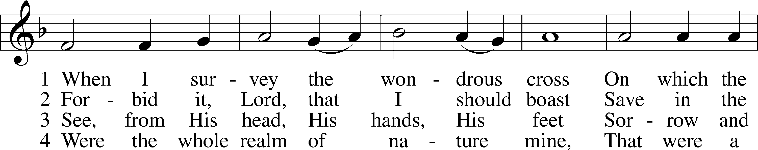
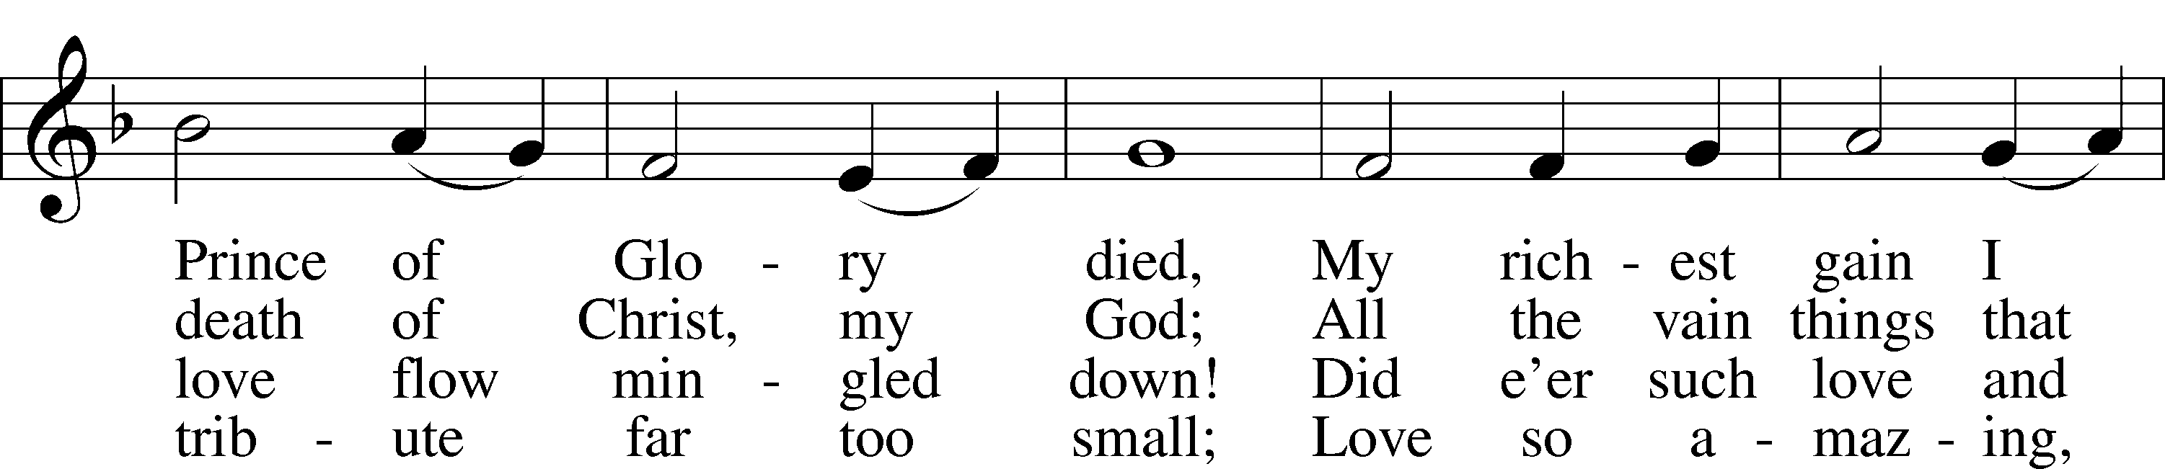
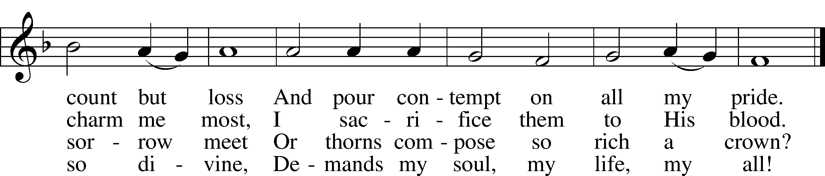
Text: Isaac Watts, 1674–1748
Tune: Lowell Mason, 1792–1872
Text and tune: Public domain

421 Jesus, Grant That Balm and Healing
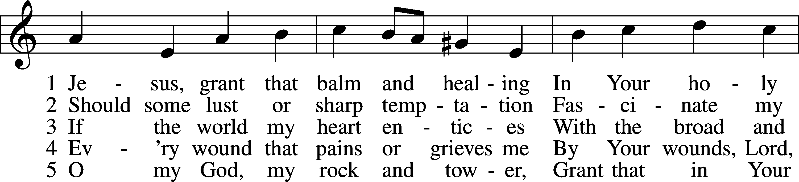
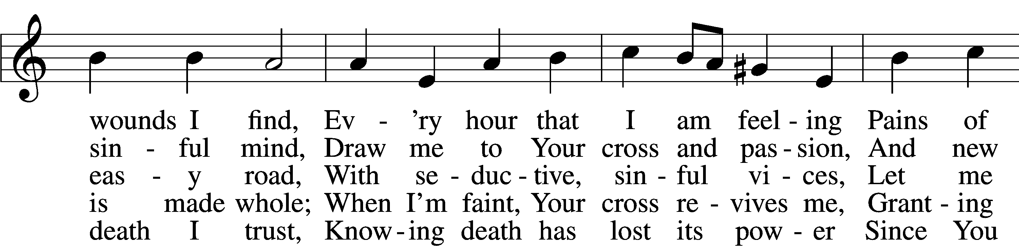
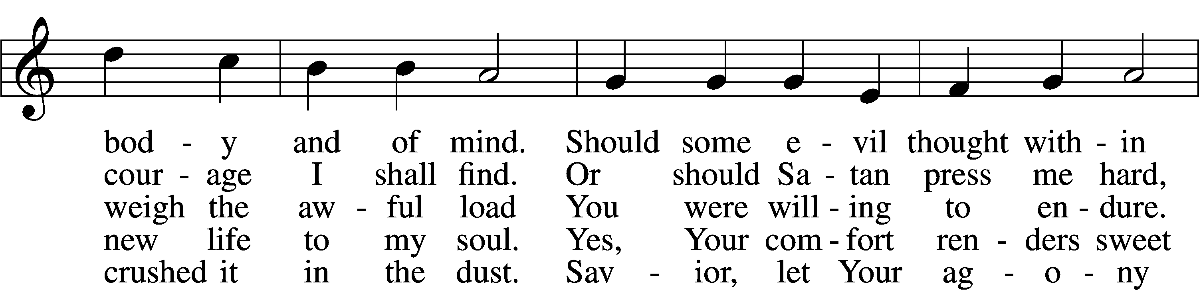
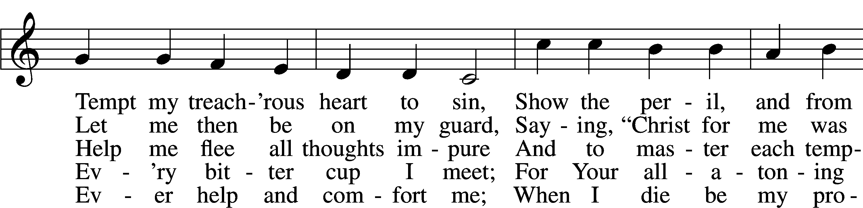
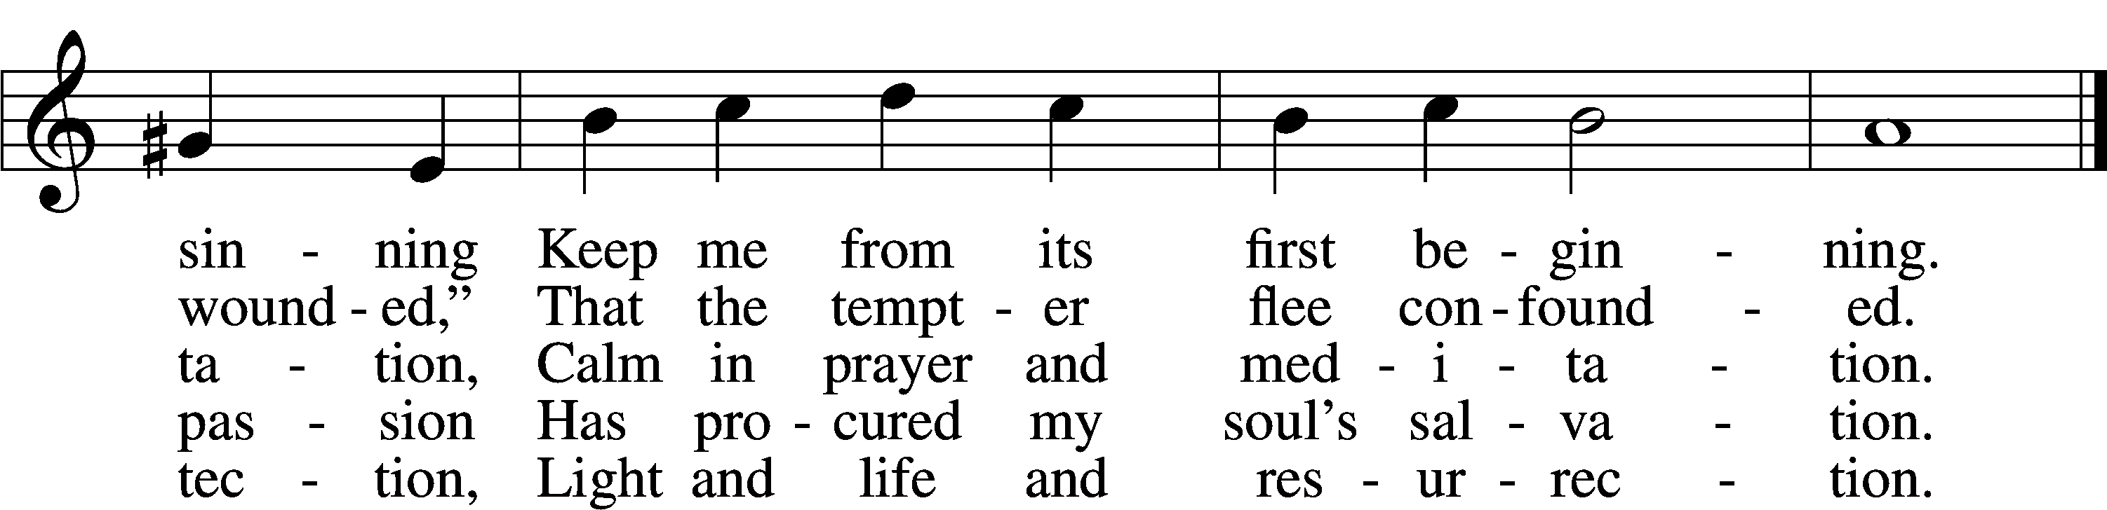
Text: Johann Heermann, 1585–1647; tr. composite, alt.
Tune: Johann Balthasar König, 1691–1758
Text and tune: Public domain

637 Draw Near and Take the Body of the Lord
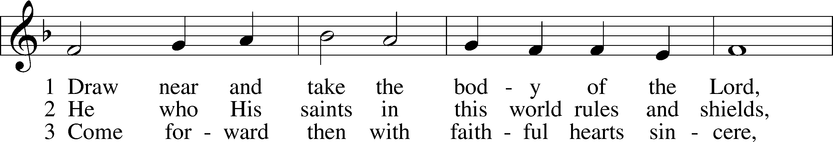
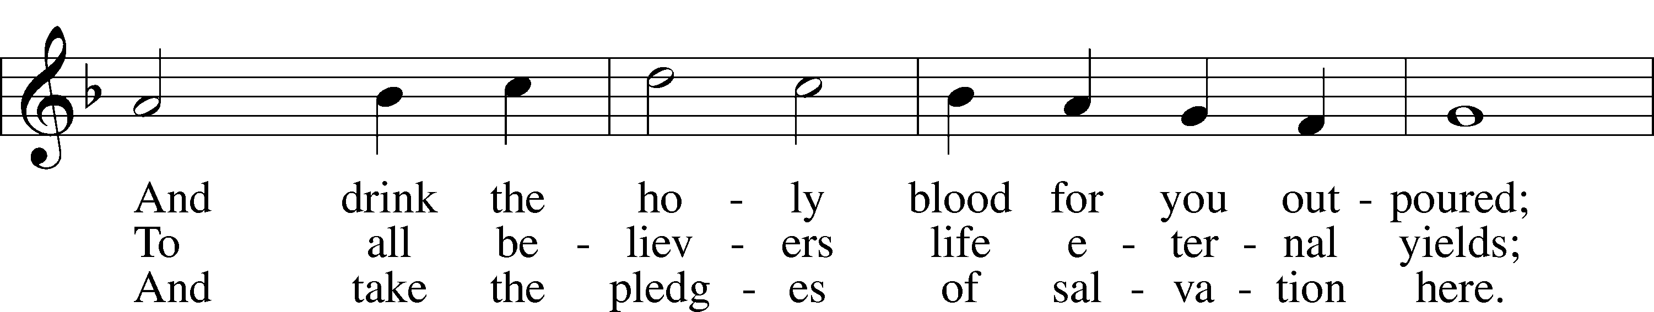
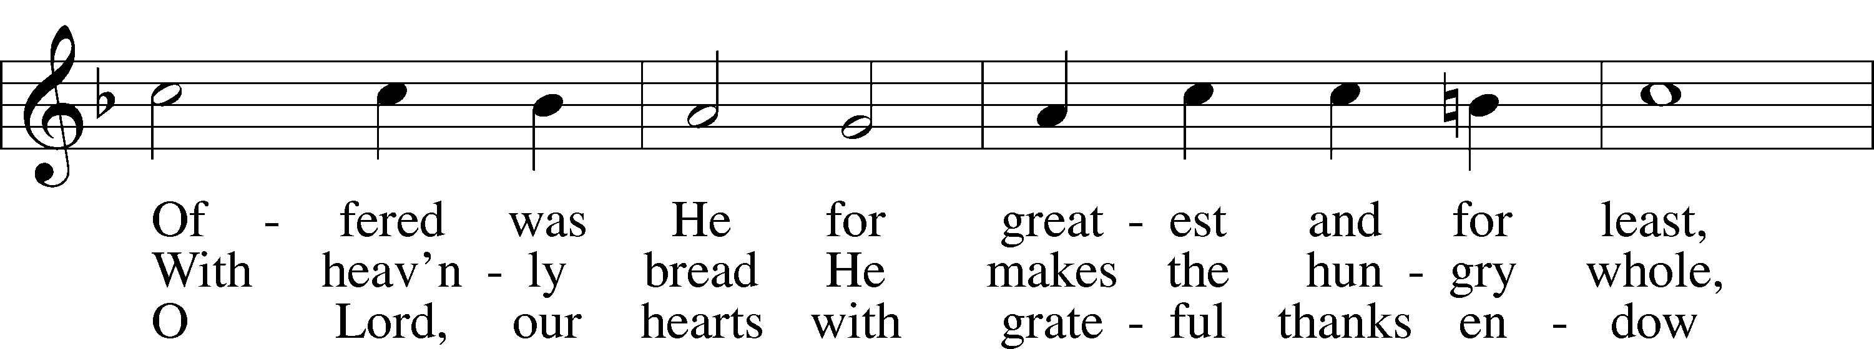
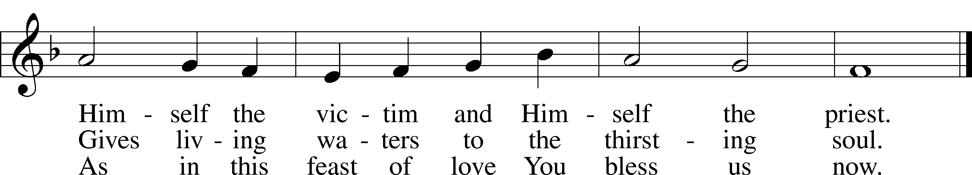
Text: Latin, 7th cent.; tr. John Mason Neale, 1818–66, alt.
Tune: Trente quatre Pseaumes de David, 1551, Geneva, ed. Louis Bourgeois
Text and tune: Public domain

The Dismissal
P The body and blood of our Lord Jesus Christ strengthen and preserve you in body and soul to life everlasting. Depart T in peace.
C Amen.

Stand

Nunc Dimittis Luke 2:29–32
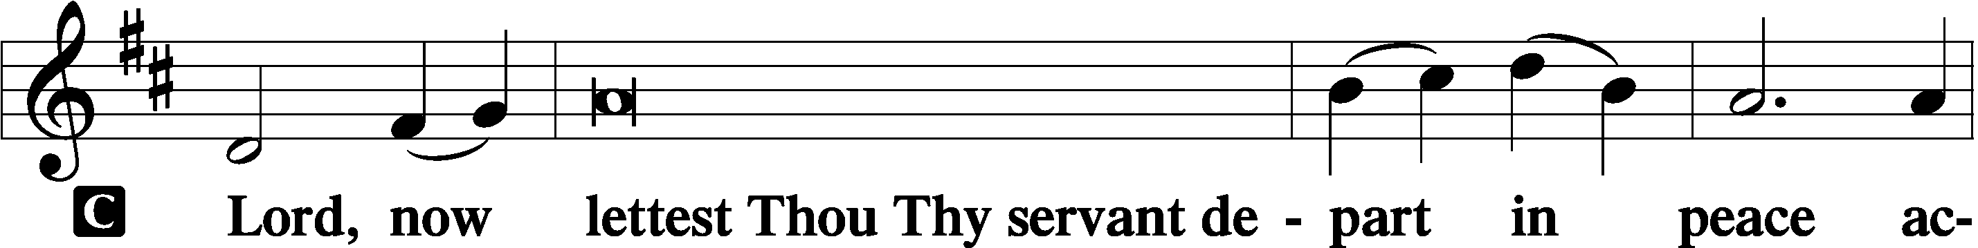

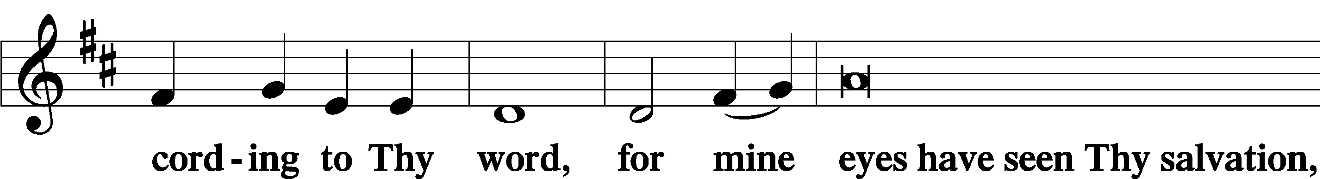

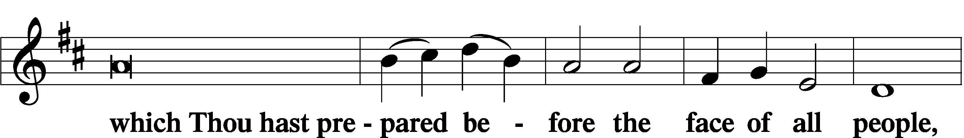

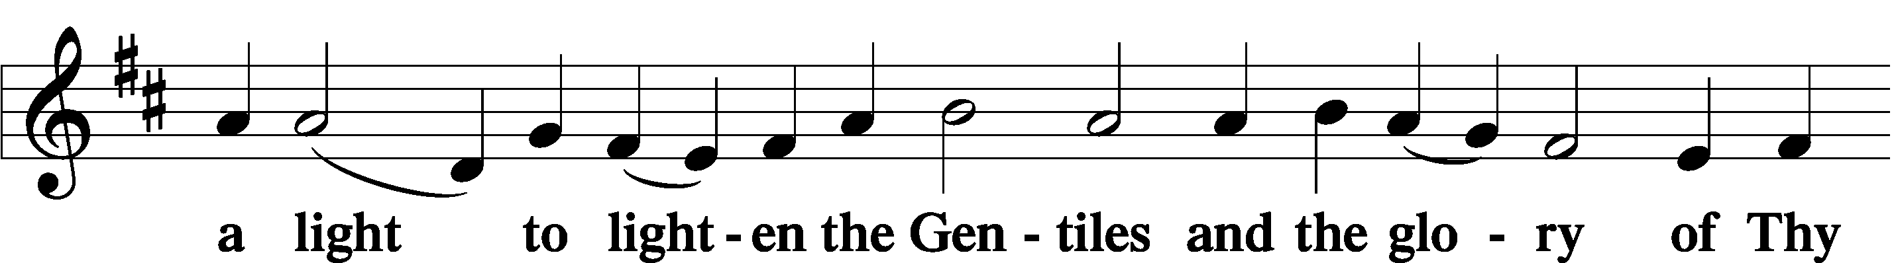

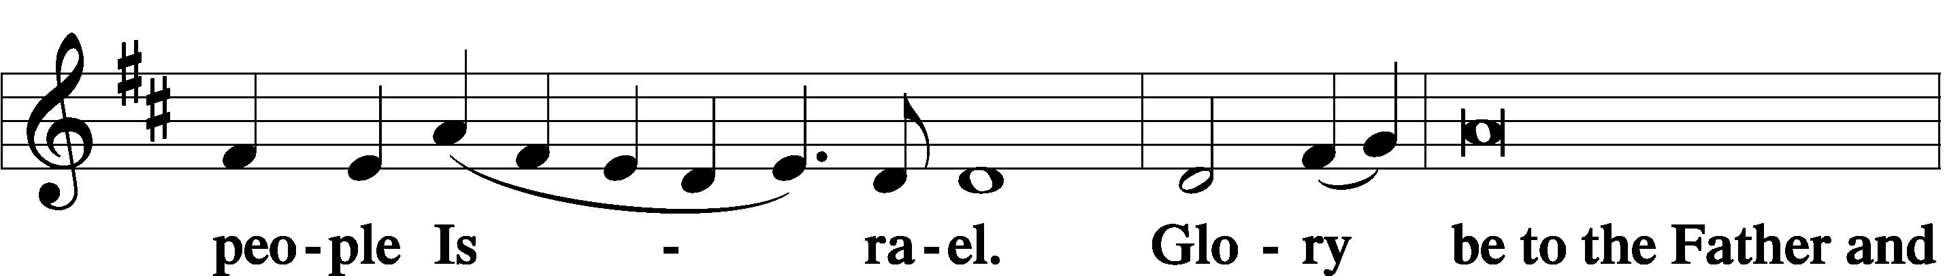

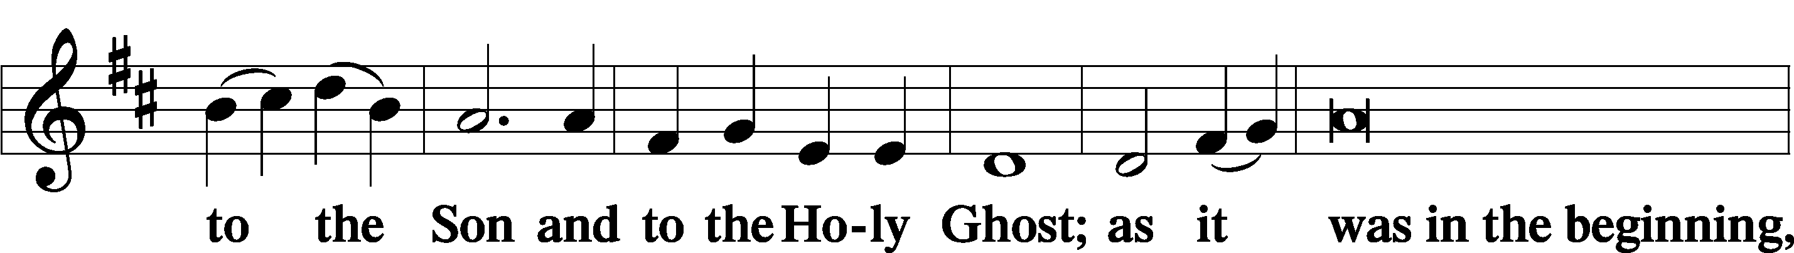

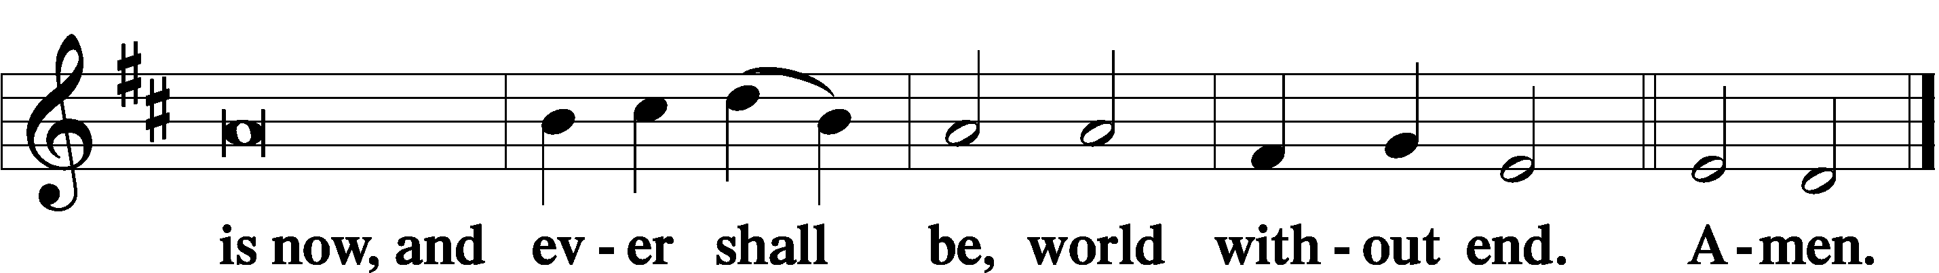

Thanksgiving Psalm 107:1
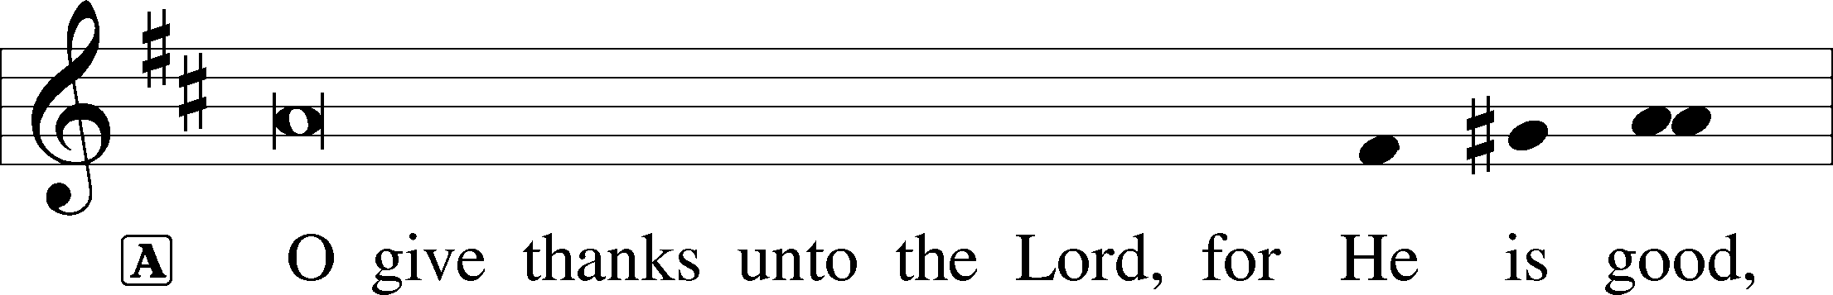

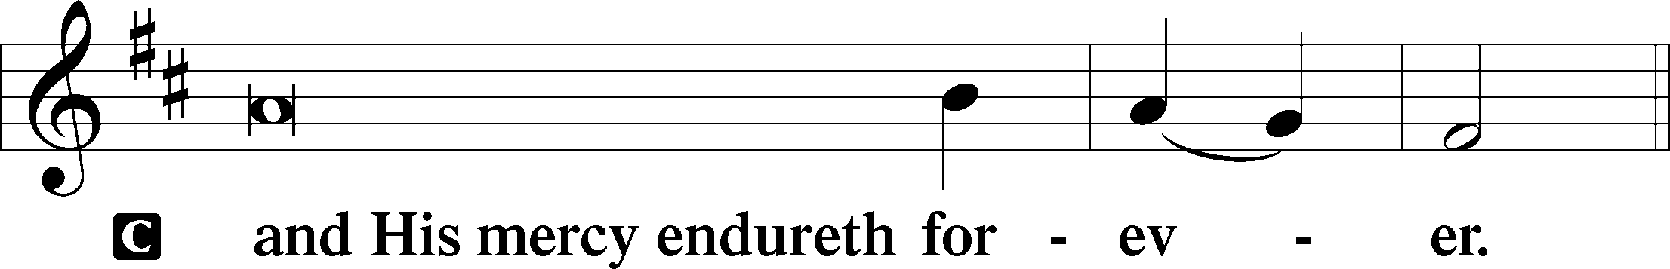

Post-Communion Collect
A Let us pray.
We give thanks to You, almighty God, that You have refreshed us through this salutary gift, and we implore You that of Your mercy You would strengthen us through the same in faith toward You and in fervent love toward one another; through Jesus Christ, Your Son, our Lord, who lives and reigns with You and the Holy Spirit, one God, now and forever.

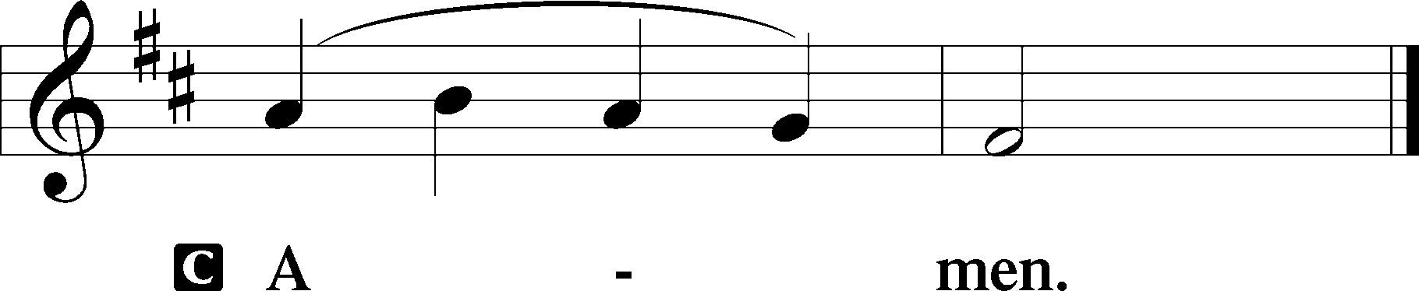

Salutation 2 Timothy 4:22
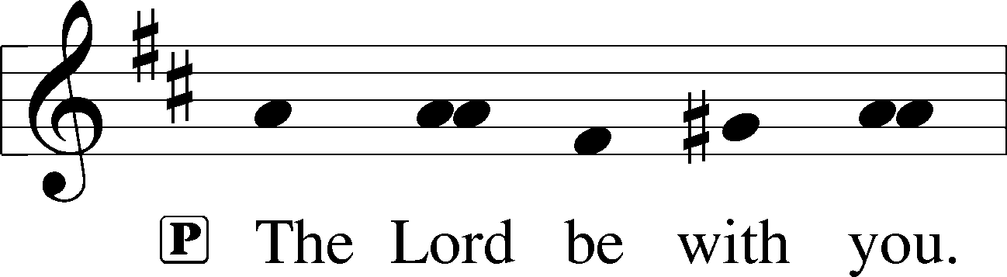

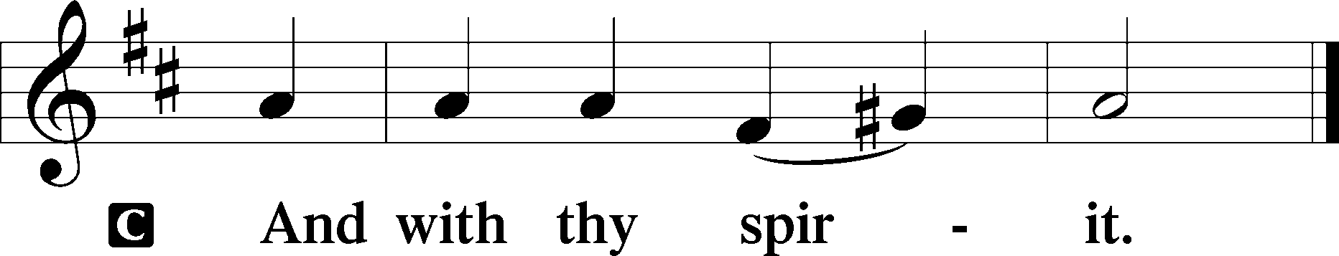

Benedicamus Psalm 103:1
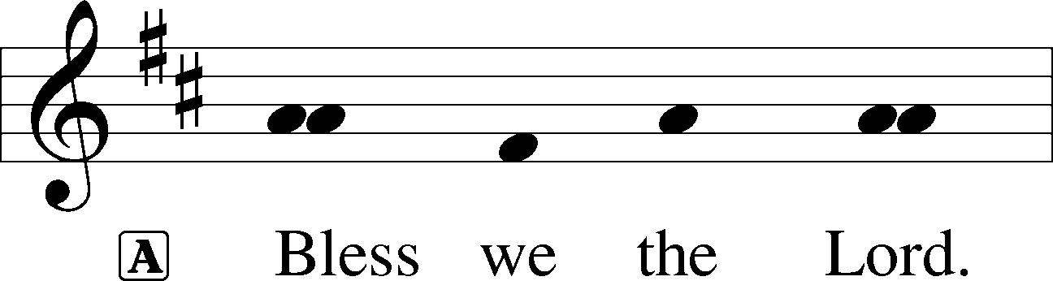

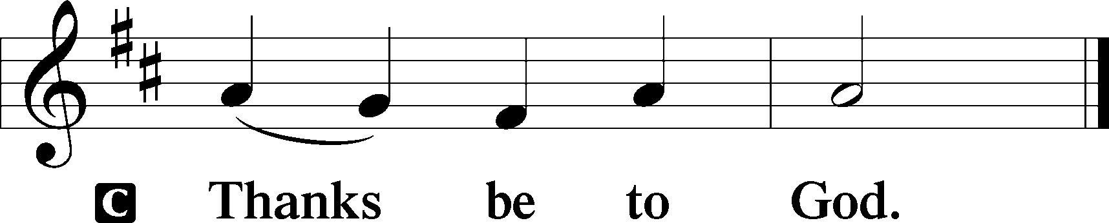

Benediction Numbers 6:24–26
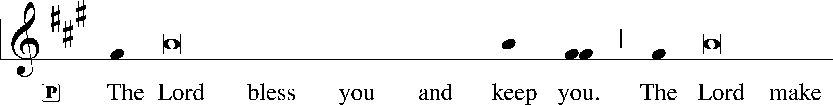
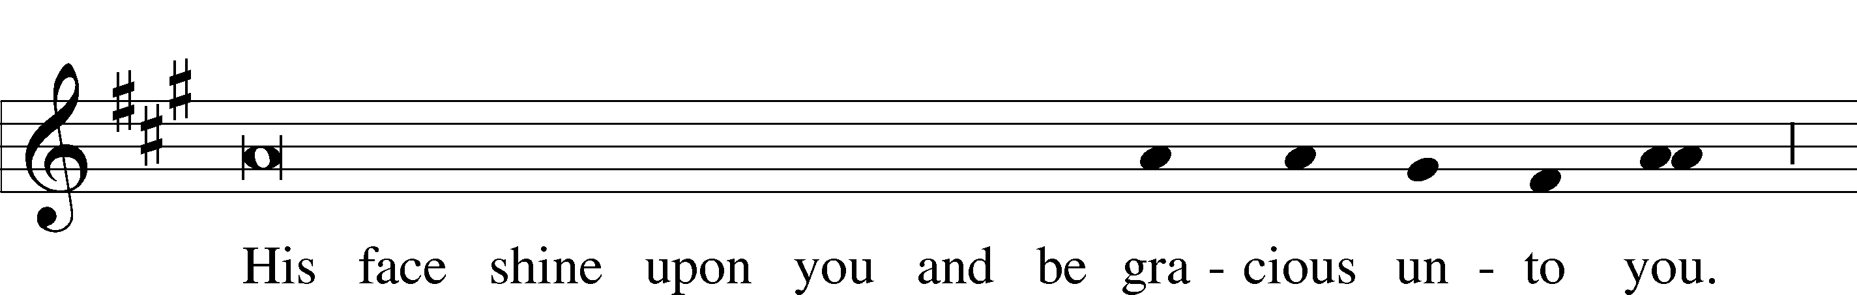
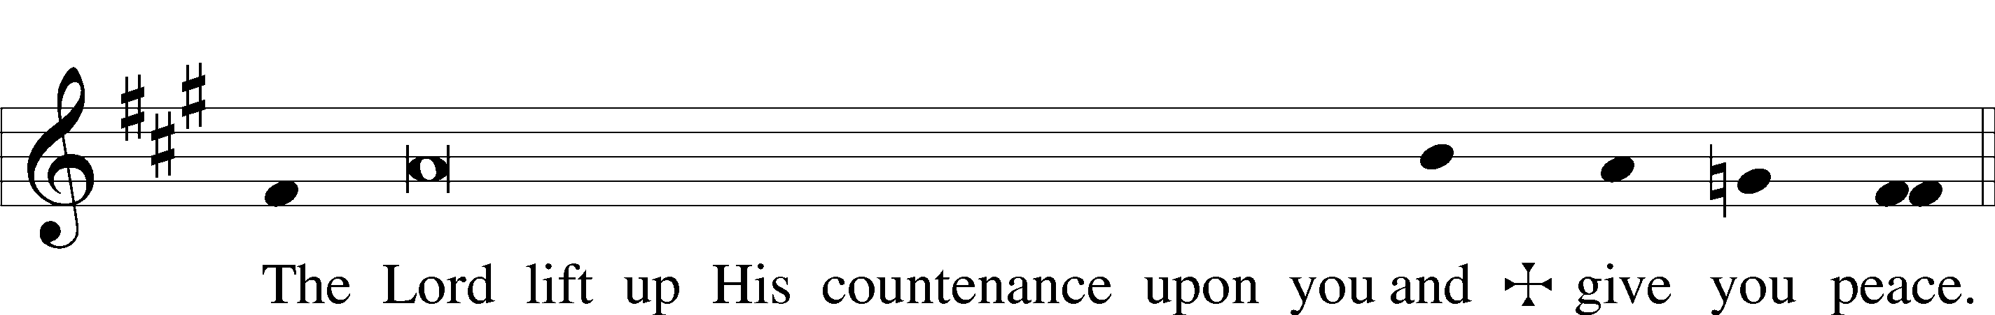

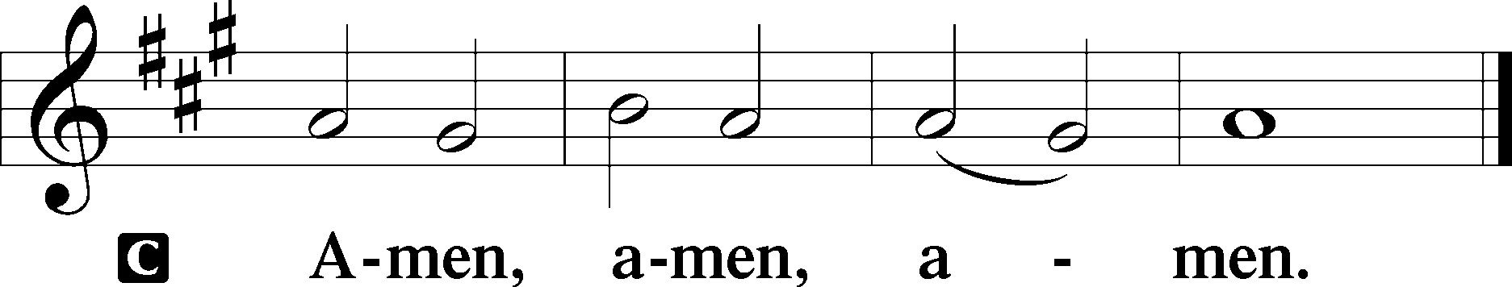

596 All Christians Who Have Been Baptized
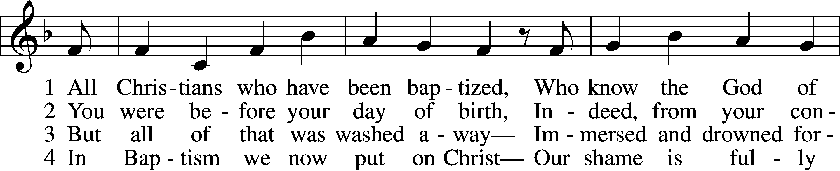
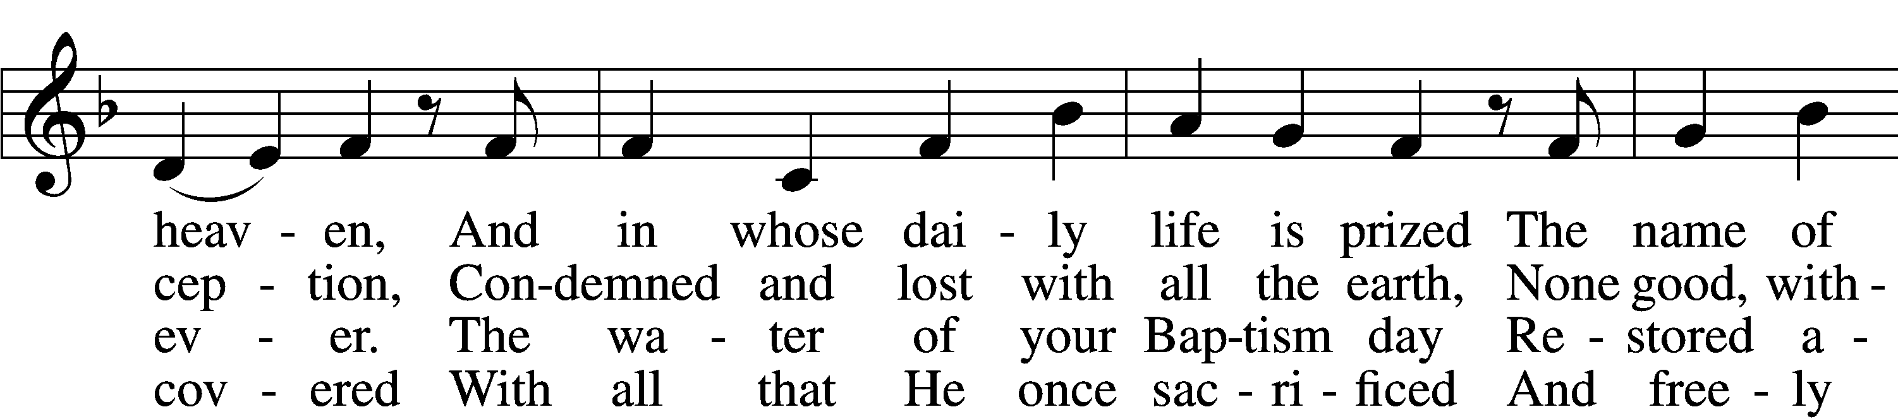
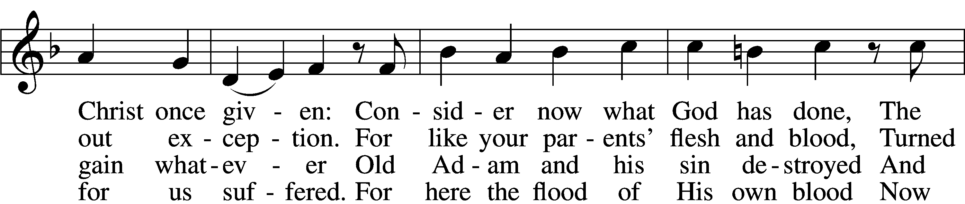
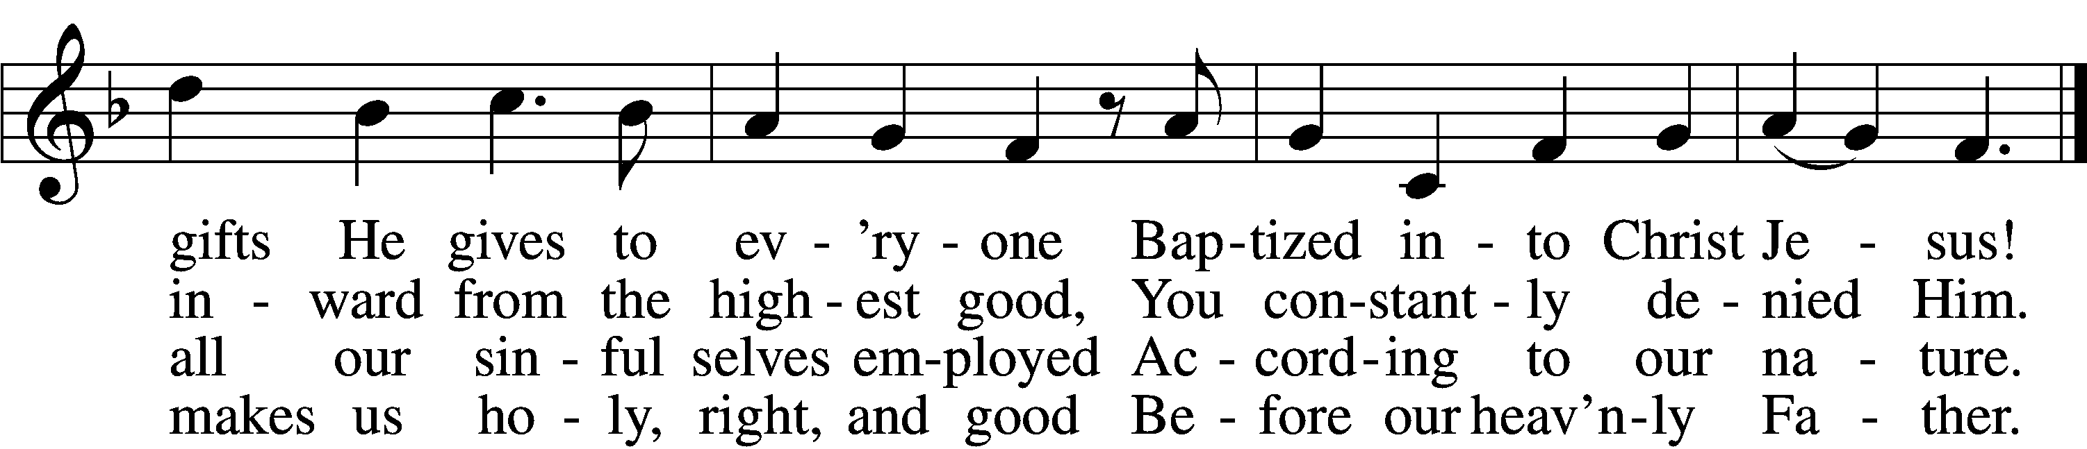

5 O Christian, firmly hold this gift
And give God thanks forever!
It gives the power to uplift
In all that you endeavor.
When nothing else revives your soul,
Your Baptism stands and makes you whole
And then in death completes you.

6 So use it well! You are made new—
In Christ a new creation!
As faithful Christians, live and do
Within your own vocation,
Until that day when you possess
His glorious robe of righteousness
Bestowed on you forever!
Text: Paul Gerhardt, 1607–76; tr. Jon D. Vieker, 1961
Tune: Etlich Cristlich lider, 1524, Wittenberg
Text: © 2004 Concordia Publishing House. Used by permission: LSB Hymn License no. 110005011
Tune: Public domain

Acknowledgments
Divine Service, Setting Three from Lutheran Service Book
Unless otherwise indicated, Scripture quotations are from the ESV® Bible (The Holy Bible, English Standard Version®), copyright © 2001 by Crossway, a publishing ministry of Good News Publishers. Used by permission. All rights reserved.
Created by Lutheran Service Builder © 2023 Concordia Publishing House.

