LSB 616 Baptismal Waters Cover Me

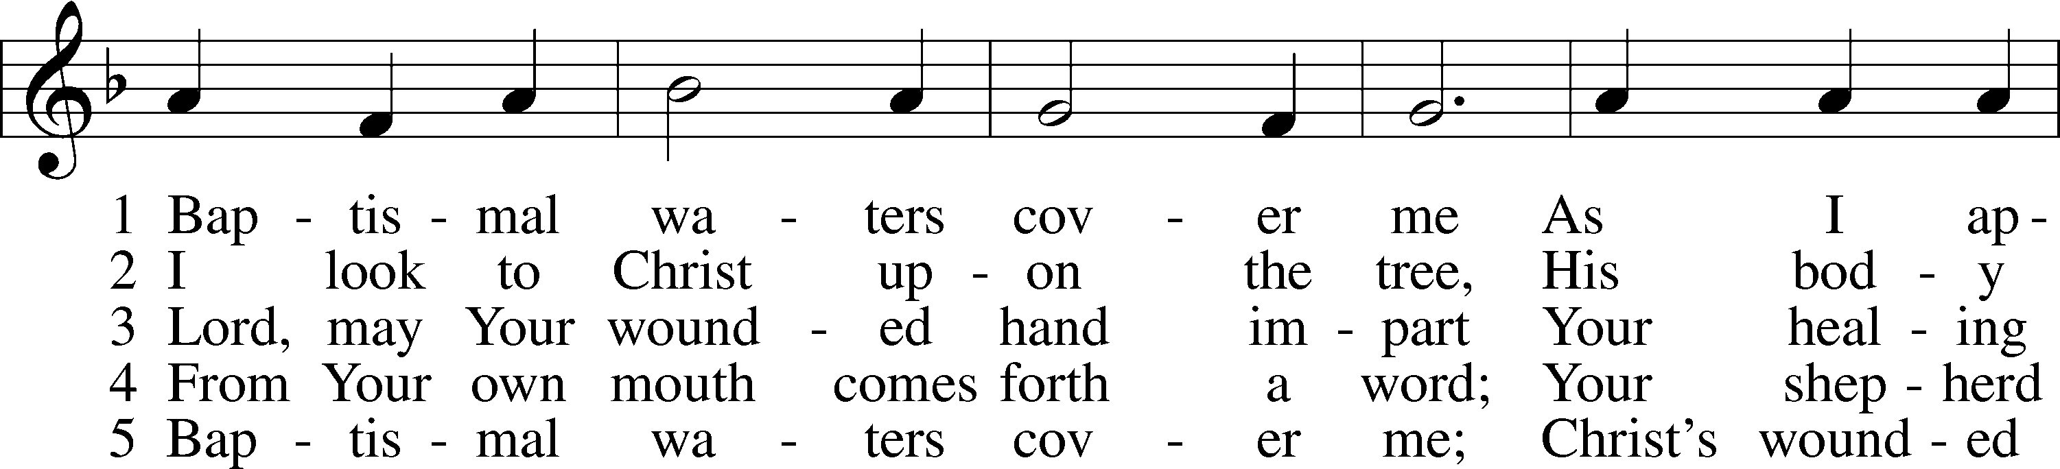

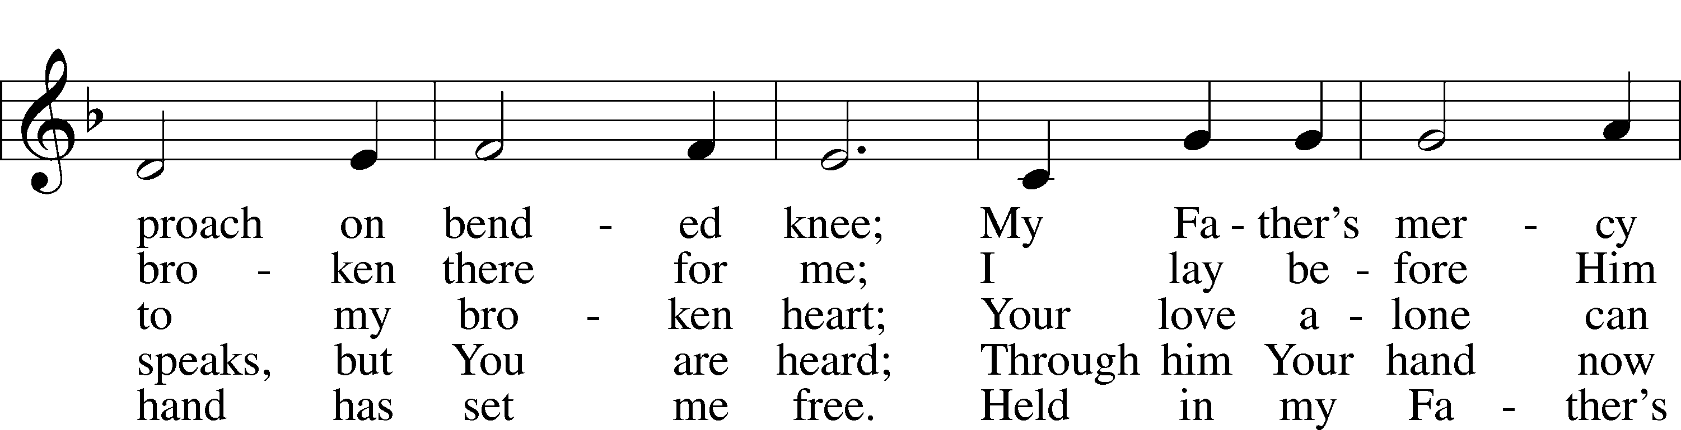

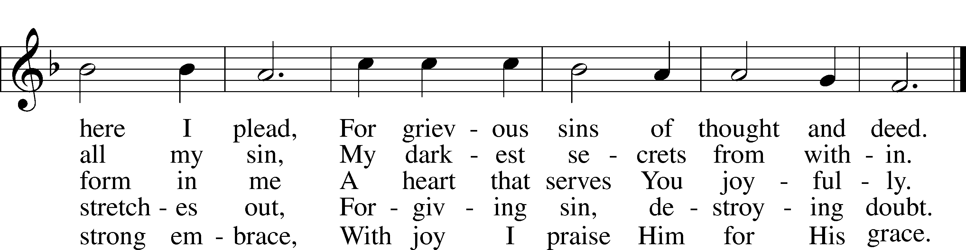

Text: Kurt E. Reinhardt, 1969  
Tune: Sammlung alter und neuer . . . Melodien, 1742  
Text: © 2003 Kurt E. Reinhardt. Used by permission: LSB Hymn License no. 110005011  
Tune: Public domain

# Confession and Absolution

The sign of the cross may be made by all in remembrance of their Baptism.

Invocation Matthew 28:19b; 18:20

P In the name of the Father and of the T Son and of the Holy Spirit.

C **Amen.**

Exhortation Hebrews 10:22; Psalm 124:8; Psalm 32:5

P Beloved in the Lord! Let us draw near with a true heart and confess our sins unto God our Father, beseeching Him in the name of our Lord Jesus Christ to grant us forgiveness.

P Our help is in the name of the Lord,

C **who made heaven and earth.**

P I said, I will confess my transgressions unto the Lord,

C **and You forgave the iniquity of my sin.**

Silence for reflection on God’s Word and for self-examination.

Confession of Sins

P Almighty God, our maker and redeemer, we poor sinners confess unto You that we are by nature sinful and unclean and that we have sinned against You by thought, word, and deed. Wherefore we flee for refuge to Your infinite mercy, seeking and imploring Your grace for the sake of our Lord Jesus Christ.

C **O most merciful God, who has given Your only-begotten Son to die for us, have mercy upon us and for His sake grant us remission of all our sins; and by Your Holy Spirit increase in us true knowledge of You and of Your will and true obedience to Your Word, to the end that by Your grace we may come to everlasting life; through Jesus Christ, our Lord. Amen.**

Declaration of Grace Mark 16:16; John 1:12

P Almighty God, our heavenly Father, has had mercy upon us and has given His only Son to die for us and for His sake forgives us all our sins. To those who believe on His name He gives power to become the children of God and has promised them His Holy Spirit. He that believes and is baptized shall be saved.  
  
Grant this, Lord, unto us all.

C **Amen.**

# Service of the Word

Introit Psalm 84:1–4; antiphon: v. 5

Blessèd are those whose strength is in you,  
 in whose heart are the highways to Zion.  
**How lovely is your dwelling place,** **O Lord of hosts!**  
My soul longs, yes, faints for the courts of the Lord;  
 my heart and flesh sing for joy to the living God.  
**Even the sparrow finds a home, and the swallow a nest for herself, where she may lay her young,  
 at your altars, O Lord of hosts, my King and my God**.  
Blessèd are those who dwell in your house,  
 ever singing your praise!  
**Glory be to the Father and to the Son**  
 **and to the Holy Spirit;**  
**as it was in the beginning**  
 **is now, and will be forever. Amen.**  
Blessèd are those whose strength is in you,  
 in whose heart are the highways to Zion.

Kyrie Mark 10:47

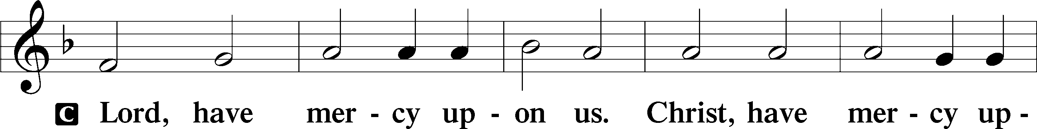

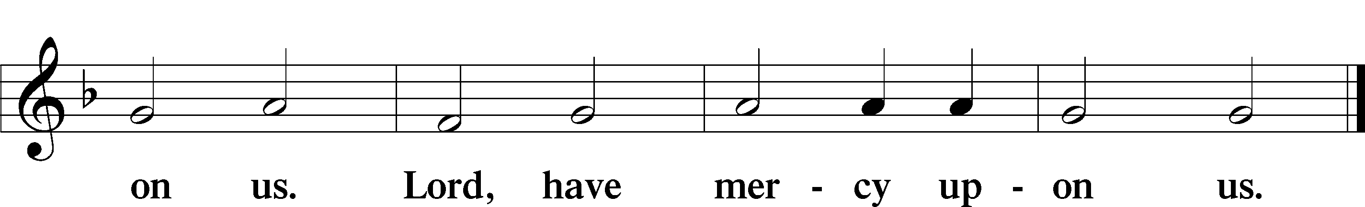

Salutation and Collect of the Day

P The Lord be with you.

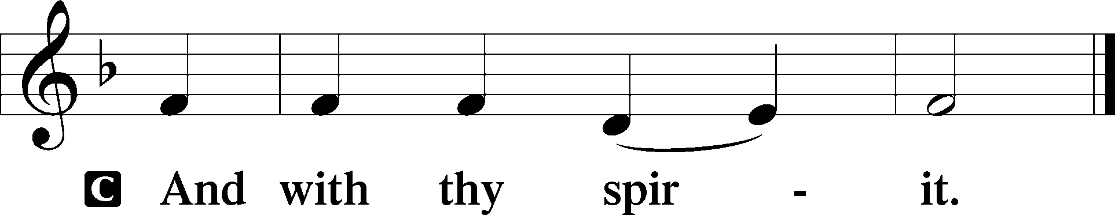

P Let us pray.

O God, whose glory it is always to have mercy, be gracious to all who have gone astray from Your ways and bring them again with penitent hearts and steadfast faith to embrace and hold fast the unchangeable truth of Your Word; through Jesus Christ, Your Son, our Lord, who lives and reigns with You and the Holy Spirit, one God, now and forever.

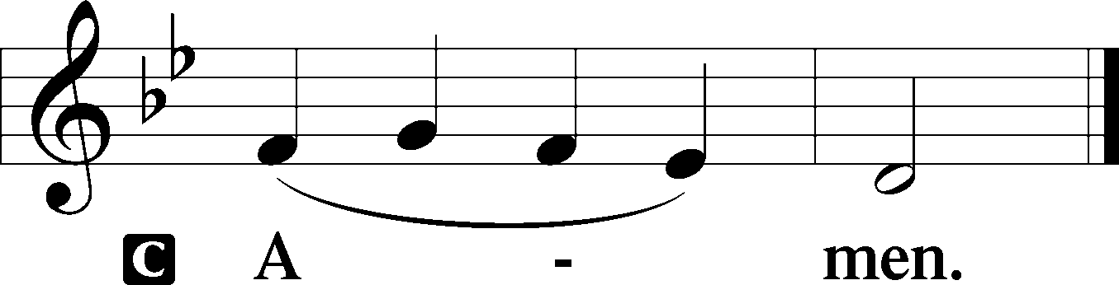

Sit

Old Testament Reading Exodus 17:1–7

Water from the Rock

1All the congregation of the people of Israel moved on from the wilderness of Sin by stages, according to the commandment of the Lord, and camped at Rephidim, but there was no water for the people to drink. 2Therefore the people quarreled with Moses and said, “Give us water to drink.” And Moses said to them, “Why do you quarrel with me? Why do you test the Lord?” 3But the people thirsted there for water, and the people grumbled against Moses and said, “Why did you bring us up out of Egypt, to kill us and our children and our livestock with thirst?” 4So Moses cried to the Lord, “What shall I do with this people? They are almost ready to stone me.” 5And the Lord said to Moses, “Pass on before the people, taking with you some of the elders of Israel, and take in your hand the staff with which you struck the Nile, and go. 6Behold, I will stand before you there on the rock at Horeb, and you shall strike the rock, and water shall come out of it, and the people will drink.” And Moses did so, in the sight of the elders of Israel. 7And he called the name of the place Massah and Meribah, because of the quarreling of the people of Israel, and because they tested the Lord by saying, “Is the Lord among us or not?”

A This is the Word of the Lord.

C **Thanks be to God.**

Gradual Hebrews 12:2

[O come, let us fix our eyes on] |Jesus,  
 the founder and perfecter of our faith,  
**who for the joy that was set before him endured the** cross, despising the shame,  
 and is seated at the right hand of the throne of God.

Reading Romans 5:6–15

6For while we were still weak, at the right time Christ died for the ungodly. 7For one will scarcely die for a righteous person—though perhaps for a good person one would dare even to die— 8but God shows his love for us in that while we were still sinners, Christ died for us. 9Since, therefore, we have now been justified by his blood, much more shall we be saved by him from the wrath of God. 10For if while we were enemies we were reconciled to God by the death of his Son, much more, now that we are reconciled, shall we be saved by his life. 11More than that, we also rejoice in God through our Lord Jesus Christ, through whom we have now received reconciliation.

Death in Adam, Life in Christ

12Therefore, just as sin came into the world through one man, and death through sin, and so death spread to all men because all sinned— 13for sin indeed was in the world before the law was given, but sin is not counted where there is no law. 14Yet death reigned from Adam to Moses, even over those whose sinning was not like the transgression of Adam, who was a type of the one who was to come.

15But the free gift is not like the trespass. For if many died through one man’s trespass, much more have the grace of God and the free gift by the grace of that one man Jesus Christ abounded for many.

Stand

Holy Gospel John 4:5–26

P The Holy Gospel according to St. John, the fourth chapter.

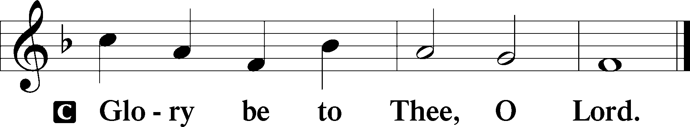

5[Jesus] came to a town of Samaria called Sychar, near the field that Jacob had given to his son Joseph. 6Jacob’s well was there; so Jesus, wearied as he was from his journey, was sitting beside the well. It was about the sixth hour.

7There came a woman of Samaria to draw water. Jesus said to her, “Give me a drink.” 8(For his disciples had gone away into the city to buy food.) 9The Samaritan woman said to him, “How is it that you, a Jew, ask for a drink from me, a woman of Samaria?” (For Jews have no dealings with Samaritans.) 10Jesus answered her, “If you knew the gift of God, and who it is that is saying to you, ‘Give me a drink,’ you would have asked him, and he would have given you living water.” 11The woman said to him, “Sir, you have nothing to draw water with, and the well is deep. Where do you get that living water? 12Are you greater than our father Jacob? He gave us the well and drank from it himself, as did his sons and his livestock.” 13Jesus said to her, “Everyone who drinks of this water will be thirsty again, 14but whoever drinks of the water that I will give him will never be thirsty forever. The water that I will give him will become in him a spring of water welling up to eternal life.” 15The woman said to him, “Sir, give me this water, so that I will not be thirsty or have to come here to draw water.”

16Jesus said to her, “Go, call your husband, and come here.” 17The woman answered him, “I have no husband.” Jesus said to her, “You are right in saying, ‘I have no husband’; 18for you have had five husbands, and the one you now have is not your husband. What you have said is true.” 19The woman said to him, “Sir, I perceive that you are a prophet. 20Our fathers worshiped on this mountain, but you say that in Jerusalem is the place where people ought to worship.” 21Jesus said to her, “Woman, believe me, the hour is coming when neither on this mountain nor in Jerusalem will you worship the Father. 22You worship what you do not know; we worship what we know, for salvation is from the Jews. 23But the hour is coming, and is now here, when the true worshipers will worship the Father in spirit and truth, for the Father is seeking such people to worship him. 24God is spirit, and those who worship him must worship in spirit and truth.” 25The woman said to him, “I know that Messiah is coming (he who is called Christ). When he comes, he will tell us all things.” 26Jesus said to her, “I who speak to you am he.”

P This is the Gospel of the Lord.

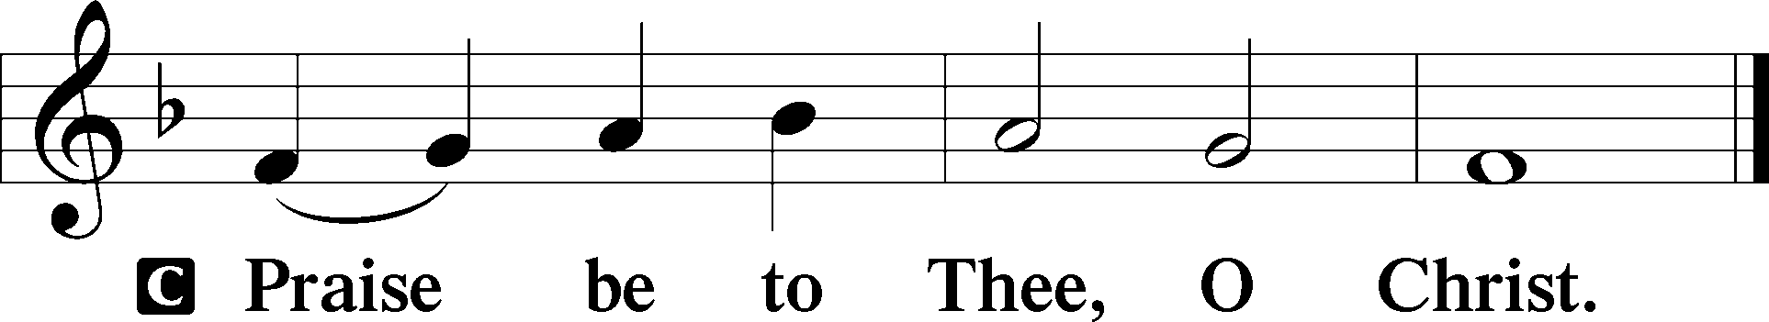

Children’s Message

Apostles’ Creed

C **I believe in God, the Father Almighty,**

**maker of heaven and earth.**

**And in Jesus Christ, His only Son, our Lord,**

**who was conceived by the Holy Spirit,**

**born of the virgin Mary,**

**suffered under Pontius Pilate,**

**was crucified, died and was buried.**

**He descended into hell.**

**The third day He rose again from the dead.**

**He ascended into heaven**

**and sits at the right hand of God the Father Almighty.**

**From thence He will come to judge the living and the dead.**

**I believe in the Holy Spirit,**

**the holy Christian Church,**

**the communion of saints,**

**the forgiveness of sins,**

**the resurrection of the body,**

**and the life** T **everlasting. Amen.**

Sit

423 Jesus, Refuge of the Weary

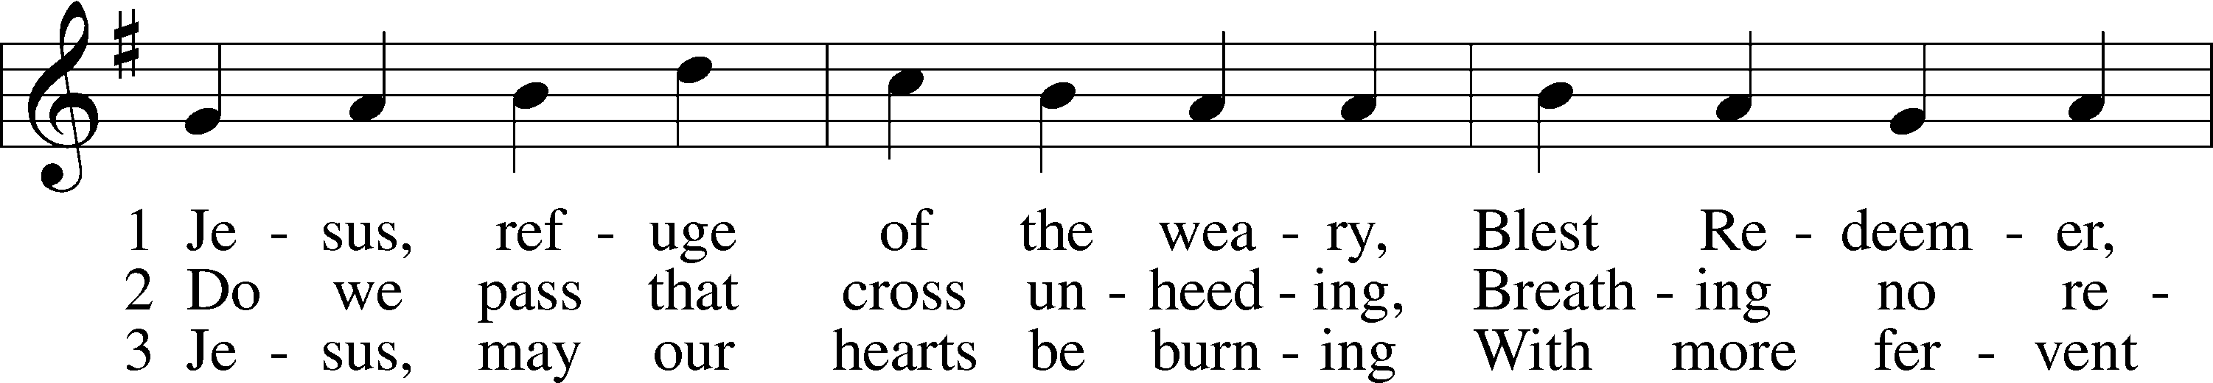

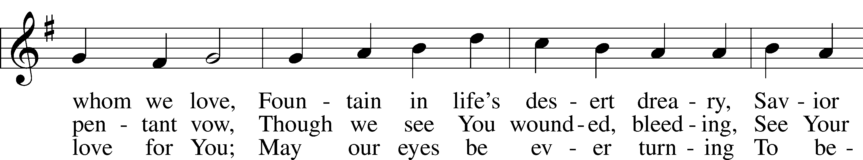

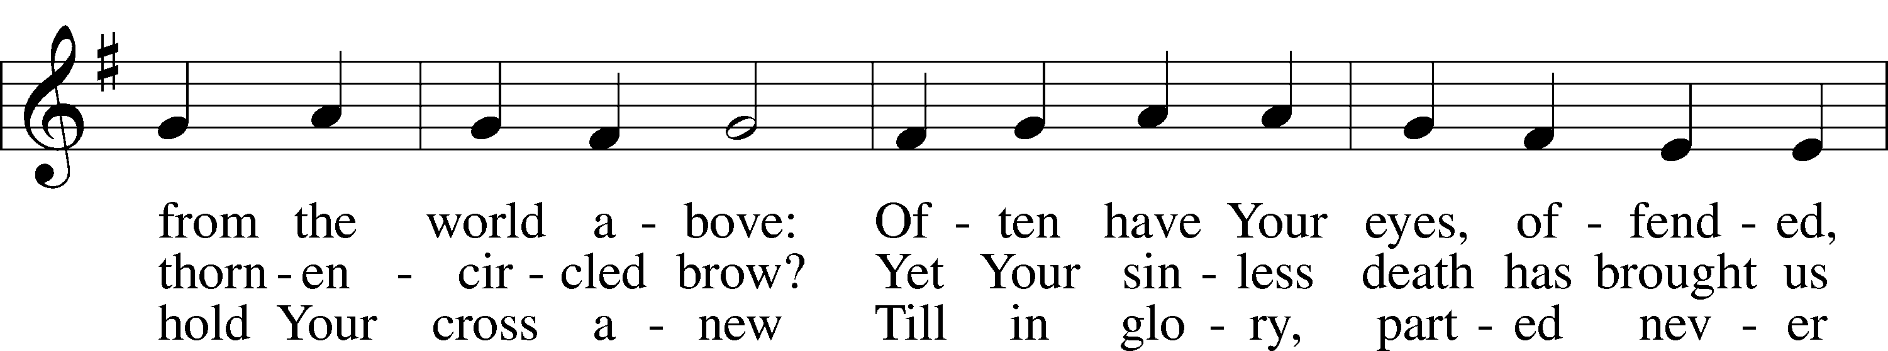

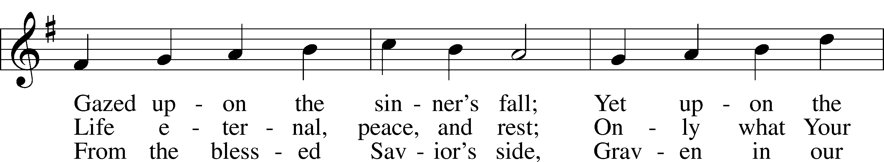

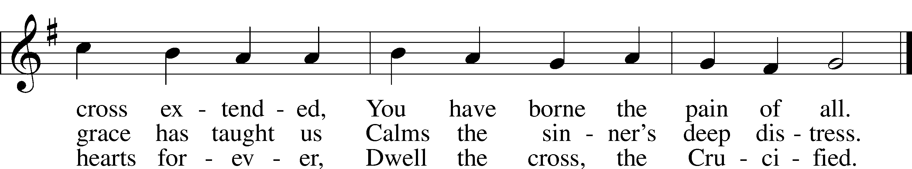

Text: Girolamo Savonarola, 1452–98; tr. Jane F. Wilde, 1826–96, alt.  
Tune: Erbaulicher Musicalischer Christen-Schatz, 1745, Basel  
Text and tune: Public domain

Sermon

Votum

P The peace of God, which passes all understanding, keep your hearts and minds in Christ Jesus.

C **Amen.**

Stand

Offertory Psalm 51:10–12

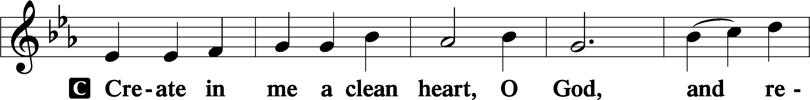

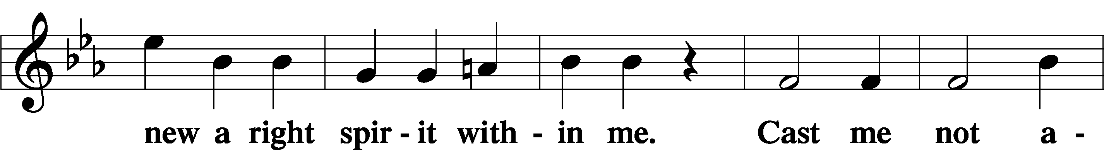

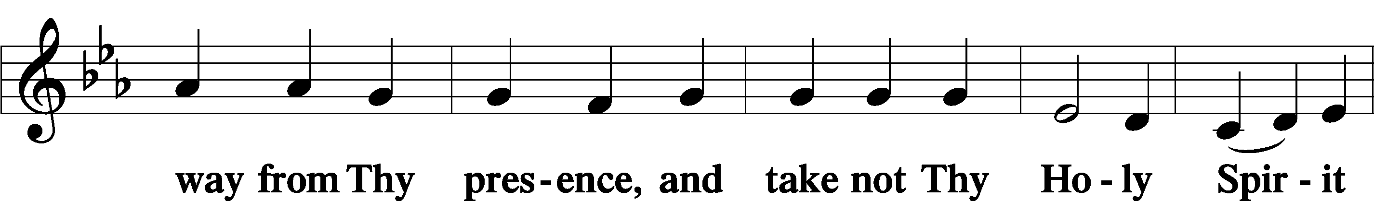

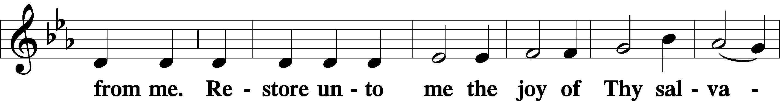

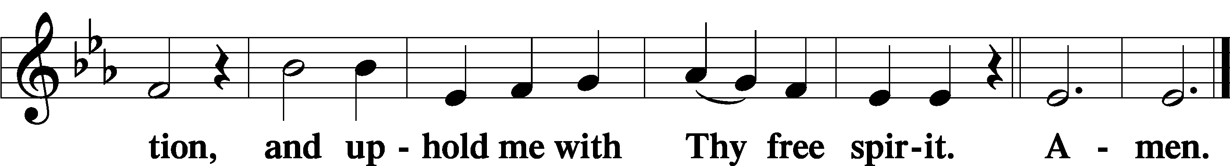

Offering

805 Praise God, from Whom All Blessings Flow

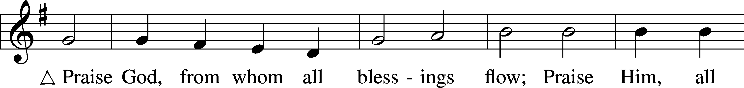

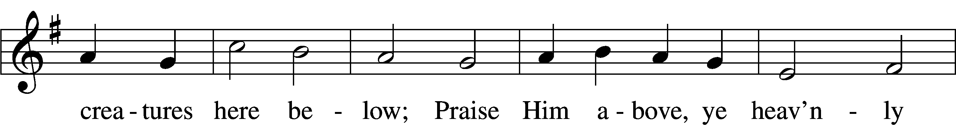

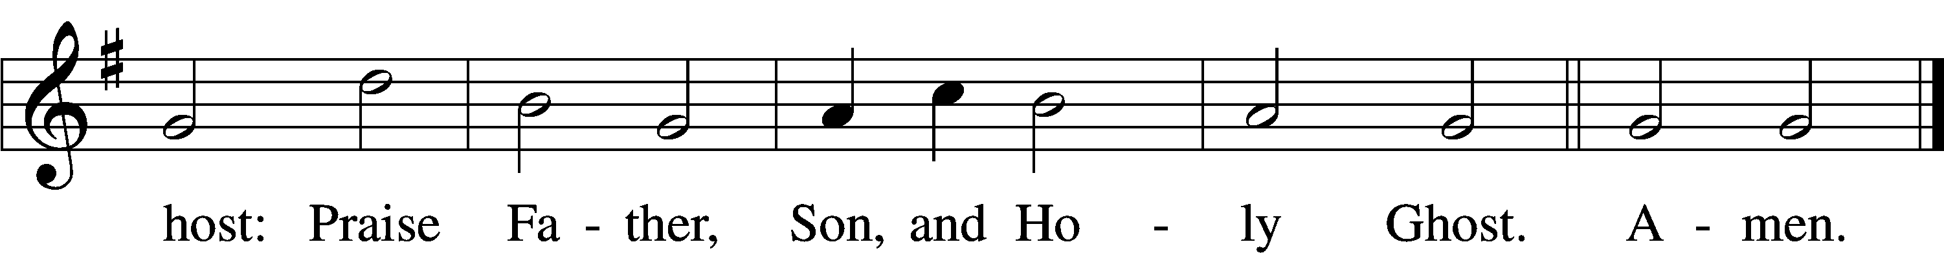

Text: Thomas Ken, 1637–1711  
Tune: Trente quatre Pseaumes de David, 1551, Geneva, ed. Louis Bourgeois  
Text and tune: Public domain

Prayer of the Church

Lord’s Prayer Matthew 6:9–13

P Lord, remember us in Your kingdom and teach us to pray:

C **Our Father who art in heaven,**

**hallowed be Thy name,**

**Thy kingdom come,**

**Thy will be done on earth**

**as it is in heaven;**

**give us this day our daily bread;**

**and forgive us our trespasses**

**as we forgive those**

**who trespass against us;**

**and lead us not into temptation,**

**but deliver us from evil.**

**For Thine is the kingdom**

**and the power and the glory**

**forever and ever. Amen.**

Collect for the Mission of the Church

P Blessed Lord, You have caused all Holy Scriptures to be written for our learning.

Grant that we may so hear them, rea, mark, and inwardly digest them that, by the patience and comfort of Your holy Word, we may embrace and ever hold fast the blesses hope of everlasting life; which You have given us in our Savior Jesus Christ, Your Son, , our Lord who lives and reigns with You and the Holy Spirit, One God, now and forever.

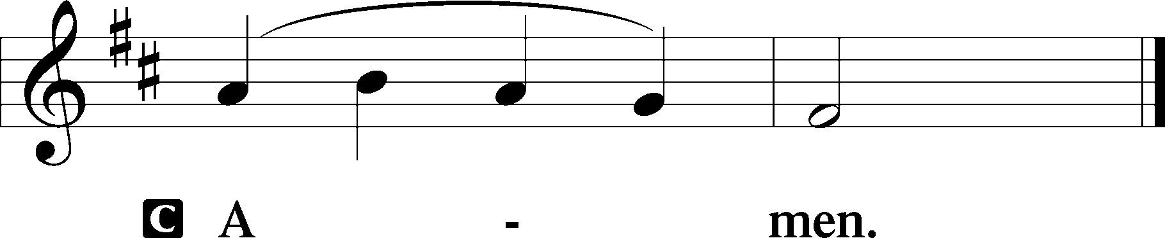

435 Come to Calvary’s Holy Mountain

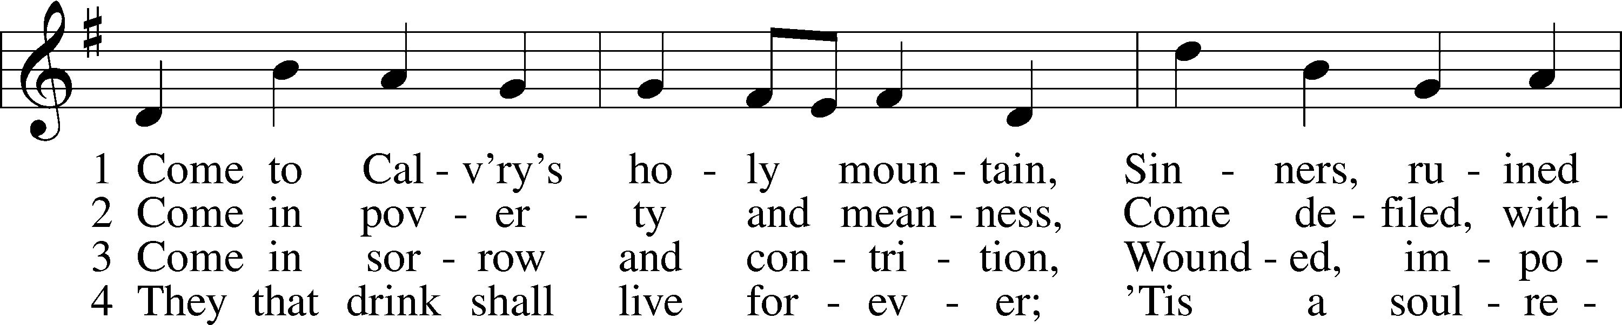

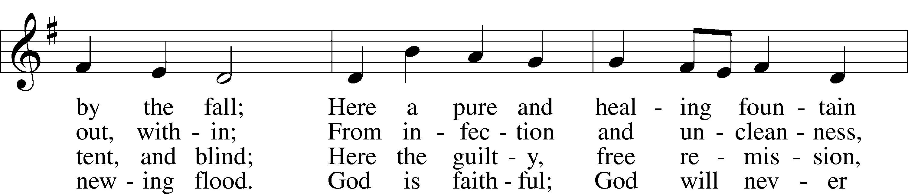

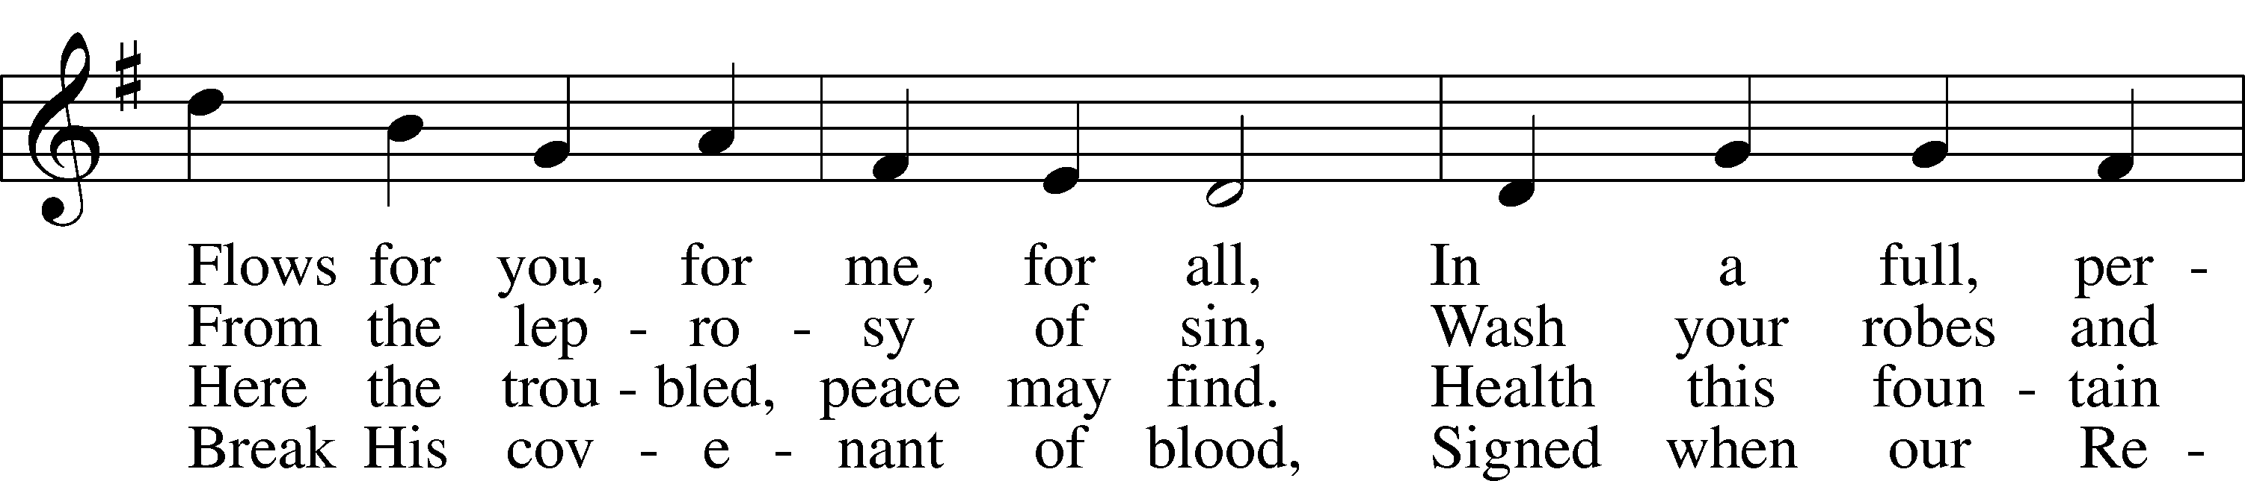

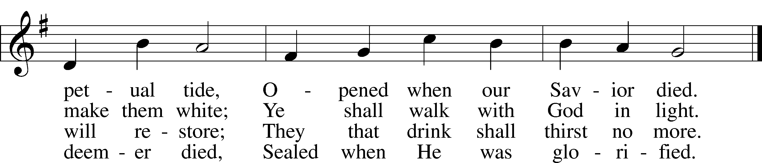

Text: James Montgomery, 1771–1854, alt.  
Tune: Ludvig M. Lindeman, 1812–87  
Text and tune: Public domain

Acknowledgments

Unless otherwise indicated, Scripture quotations are from the ESV® Bible (The Holy Bible, English Standard Version®), copyright © 2001 by Crossway, a publishing ministry of Good News Publishers. Used by permission. All rights reserved.

Created by Lutheran Service Builder © 2023 Concordia Publishing House.