543 What Wondrous Love Is This

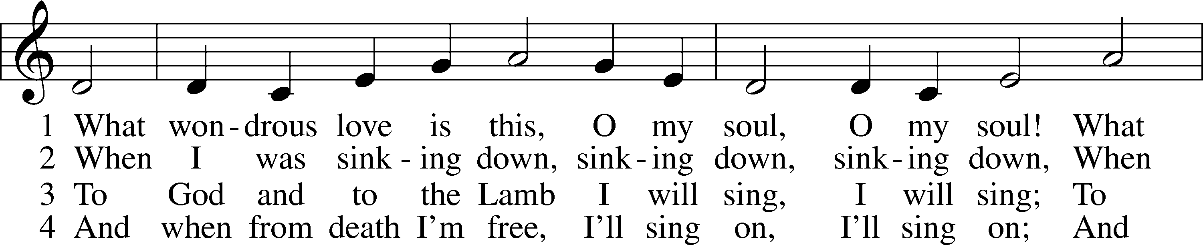

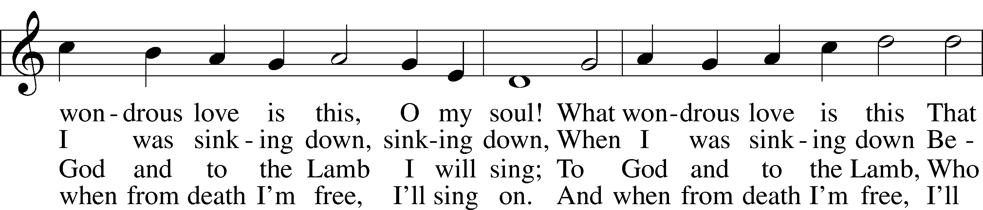

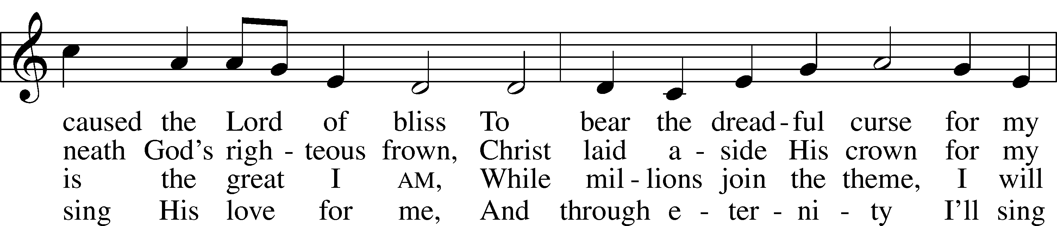

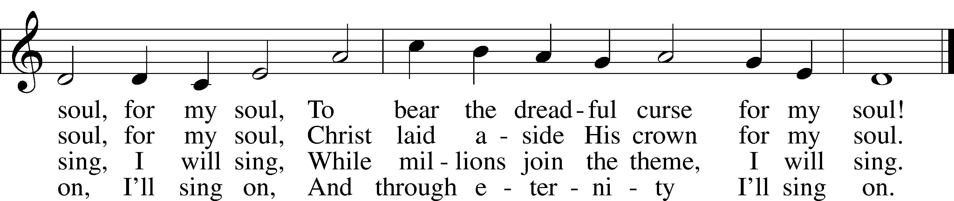

Text: A General Selection of . . . Hymns and Spiritual Songs, 1811, Lynchburg, alt.  
Tune: Southern Harmony, 1835, New Haven  
Text and tune: Public domain

# Confession and Absolution

The sign of the cross may be made by all in remembrance of their Baptism.

Invocation Matthew 28:19b; 18:20

P In the name of the Father and of the T Son and of the Holy Spirit.

C **Amen.**

Exhortation Hebrews 10:22; Psalm 124:8; Psalm 32:5

P Beloved in the Lord! Let us draw near with a true heart and confess our sins unto God our Father, beseeching Him in the name of our Lord Jesus Christ to grant us forgiveness.

P Our help is in the name of the Lord,

C **who made heaven and earth.**

P I said, I will confess my transgressions unto the Lord,

C **and You forgave the iniquity of my sin.**

Silence for reflection on God’s Word and for self-examination.

Confession of Sins

P Almighty God, our maker and redeemer, we poor sinners confess unto You that we are by nature sinful and unclean and that we have sinned against You by thought, word, and deed. Wherefore we flee for refuge to Your infinite mercy, seeking and imploring Your grace for the sake of our Lord Jesus Christ.

C **O most merciful God, who has given Your only-begotten Son to die for us, have mercy upon us and for His sake grant us remission of all our sins; and by Your Holy Spirit increase in us true knowledge of You and of Your will and true obedience to Your Word, to the end that by Your grace we may come to everlasting life; through Jesus Christ, our Lord. Amen.**

Declaration of Grace Mark 16:16; John 1:12

P Almighty God, our heavenly Father, has had mercy upon us and has given His only Son to die for us and for His sake forgives us all our sins. To those who believe on His name He gives power to become the children of God and has promised them His Holy Spirit. He that believes and is baptized shall be saved.  
  
Grant this, Lord, unto us all.

C **Amen.**

# Service of the Word

Introit Psalm 116:1–4, 8; antiphon: v. 15

Precious in the sight of the Lord  
 is the death of his saints.  
**I love the Lord, because he has heard  
 my voice and my pleas for mercy.**  
Because he inclined his ear to me,  
 therefore I will call on him as long as I live.  
**The snares of death encompassed me; the pangs of Sheol laid hold on me;**  
 **I suffered distress and anguish.**  
Then I called on the name of the Lord:  
 “O Lord, I pray, deliver my soul!”  
**For you have delivered my soul from death,  
 my eyes from tears, my feet from stumbling.**

Gloria Patri

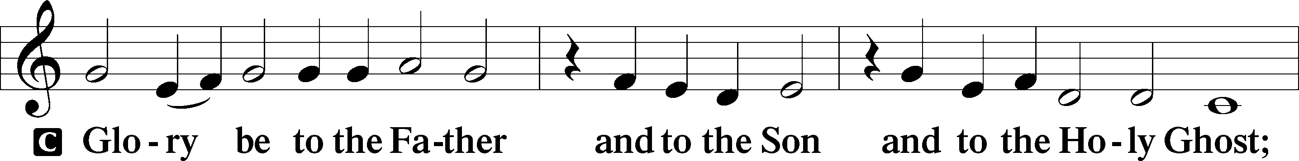

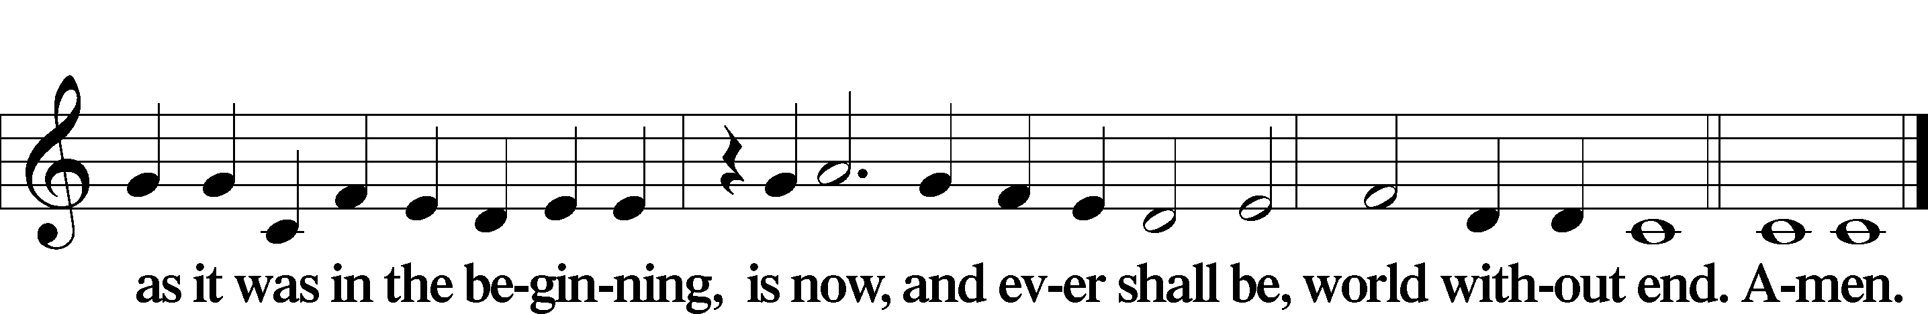

Kyrie Mark 10:47

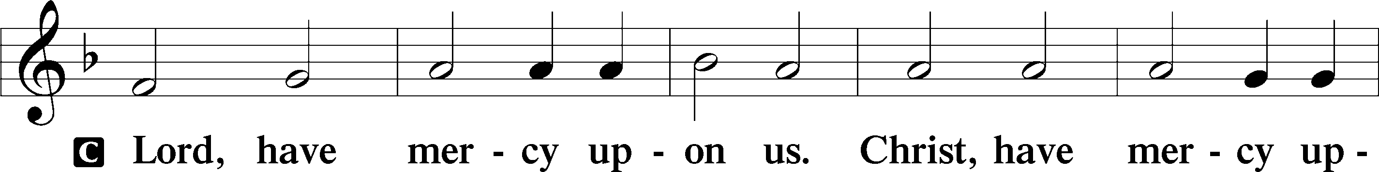

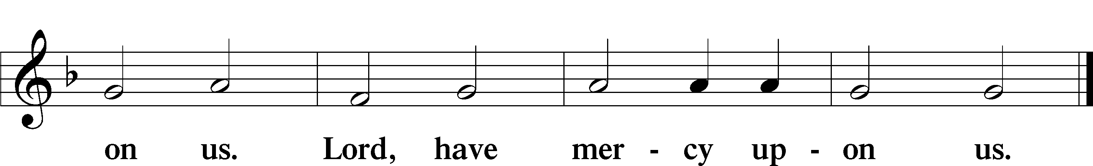

Salutation and Collect of the Day

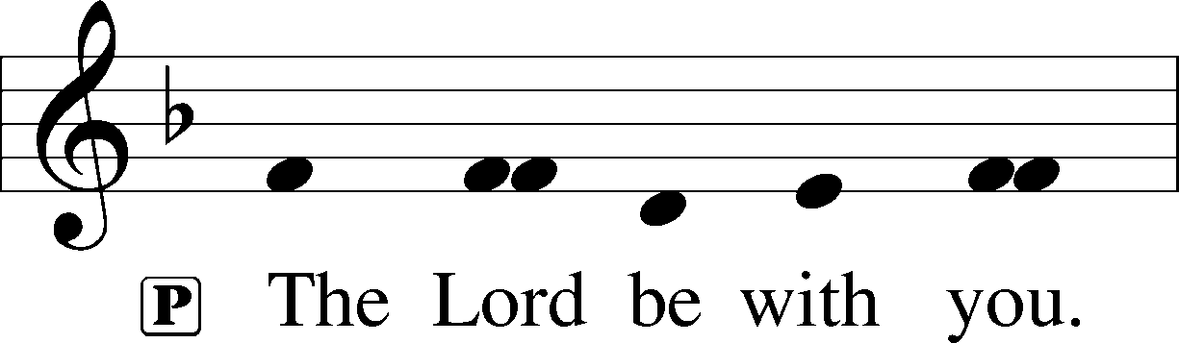

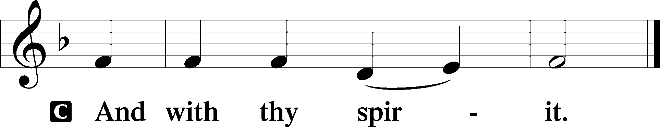

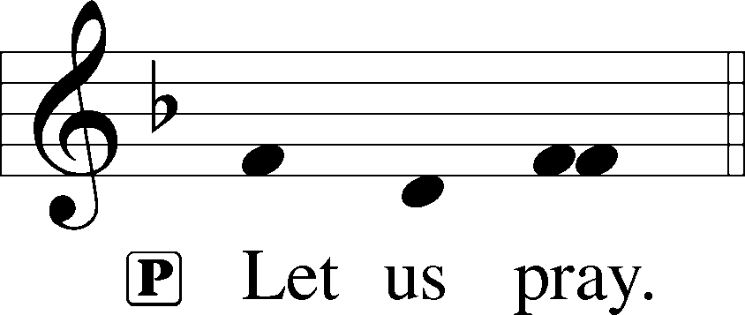

P Almighty God, by Your great goodness mercifully look upon Your people that we may be governed and preserved evermore in body and soul; through Jesus Christ, Your Son, our Lord, who lives and reigns with You and the Holy Spirit, one God, now and forever.

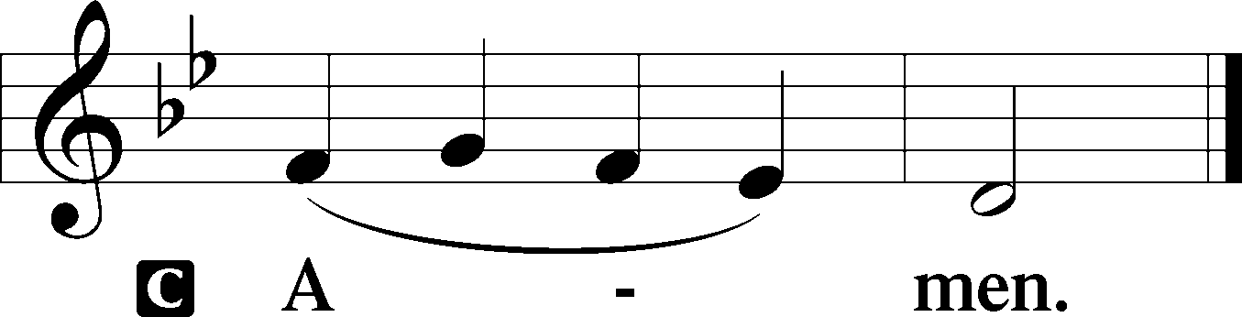

Sit

Old Testament Reading Ezekiel 37:1–14

The Valley of Dry Bones

1The hand of the Lord was upon me, and he brought me out in the Spirit of the Lord and set me down in the middle of the valley; it was full of bones. 2And he led me around among them, and behold, there were very many on the surface of the valley, and behold, they were very dry. 3And he said to me, “Son of man, can these bones live?” And I answered, “O Lord God, you know.” 4Then he said to me, “Prophesy over these bones, and say to them, O dry bones, hear the word of the Lord. 5Thus says the Lord God to these bones: Behold, I will cause breath to enter you, and you shall live. 6And I will lay sinews upon you, and will cause flesh to come upon you, and cover you with skin, and put breath in you, and you shall live, and you shall know that I am the Lord.”

7So I prophesied as I was commanded. And as I prophesied, there was a sound, and behold, a rattling, and the bones came together, bone to its bone. 8And I looked, and behold, there were sinews on them, and flesh had come upon them, and skin had covered them. But there was no breath in them. 9Then he said to me, “Prophesy to the breath; prophesy, son of man, and say to the breath, Thus says the Lord God: Come from the four winds, O breath, and breathe on these slain, that they may live.” 10So I prophesied as he commanded me, and the breath came into them, and they lived and stood on their feet, an exceedingly great army.

11Then he said to me, “Son of man, these bones are the whole house of Israel. Behold, they say, ‘Our bones are dried up, and our hope is lost; we are clean cut off.’ 12Therefore prophesy, and say to them, Thus says the Lord God: Behold, I will open your graves and raise you from your graves, O my people. And I will bring you into the land of Israel. 13And you shall know that I am the Lord, when I open your graves, and raise you from your graves, O my people. 14And I will put my Spirit within you, and you shall live, and I will place you in your own land. Then you shall know that I am the Lord; I have spoken, and I will do it, declares the Lord.”

A This is the Word of the Lord.

C **Thanks be to God.**

Gradual Hebrews 12:2

[O come, let us fix our eyes on] Jesus,  
 the founder and perfecter of our faith,  
**who for the joy that was set before him endured the cross, despising the shame,  
 and is seated at the right hand of the throne of God.**

Reading Romans 5:6–15

6For while we were still weak, at the right time Christ died for the ungodly. 7For one will scarcely die for a righteous person—though perhaps for a good person one would dare even to die— 8but God shows his love for us in that while we were still sinners, Christ died for us. 9Since, therefore, we have now been justified by his blood, much more shall we be saved by him from the wrath of God. 10For if while we were enemies we were reconciled to God by the death of his Son, much more, now that we are reconciled, shall we be saved by his life. 11More than that, we also rejoice in God through our Lord Jesus Christ, through whom we have now received reconciliation.

Death in Adam, Life in Christ

12Therefore, just as sin came into the world through one man, and death through sin, and so death spread to all men because all sinned— 13for sin indeed was in the world before the law was given, but sin is not counted where there is no law. 14Yet death reigned from Adam to Moses, even over those whose sinning was not like the transgression of Adam, who was a type of the one who was to come.

15But the free gift is not like the trespass. For if many died through one man’s trespass, much more have the grace of God and the free gift by the grace of that one man Jesus Christ abounded for many.

Stand

**Gospel Proclamation**

**Return to the Lord, your God, for He is gracious and merciful, slow to anger, and abounding in steadfast love.**

Holy Gospel John 11:1–45

P The Holy Gospel according to St. John, the eleventh chapter.

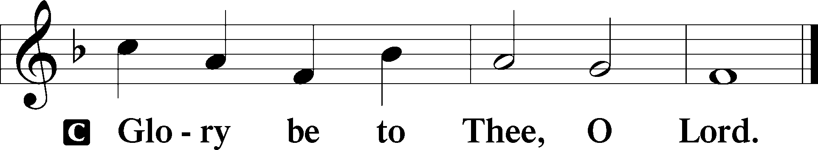

The Death of Lazarus

1Now a certain man was ill, Lazarus of Bethany, the village of Mary and her sister Martha. 2It was Mary who anointed the Lord with ointment and wiped his feet with her hair, whose brother Lazarus was ill. 3So the sisters sent to him, saying, “Lord, he whom you love is ill.” 4But when Jesus heard it he said, “This illness does not lead to death. It is for the glory of God, so that the Son of God may be glorified through it.”

5Now Jesus loved Martha and her sister and Lazarus. 6So, when he heard that Lazarus was ill, he stayed two days longer in the place where he was. 7Then after this he said to the disciples, “Let us go to Judea again.” 8The disciples said to him, “Rabbi, the Jews were just now seeking to stone you, and are you going there again?” 9Jesus answered, “Are there not twelve hours in the day? If anyone walks in the day, he does not stumble, because he sees the light of this world. 10But if anyone walks in the night, he stumbles, because the light is not in him.” 11After saying these things, he said to them, “Our friend Lazarus has fallen asleep, but I go to awaken him.” 12The disciples said to him, “Lord, if he has fallen asleep, he will recover.” 13Now Jesus had spoken of his death, but they thought that he meant taking rest in sleep. 14Then Jesus told them plainly, “Lazarus has died, 15and for your sake I am glad that I was not there, so that you may believe. But let us go to him.” 16So Thomas, called the Twin, said to his fellow disciples, “Let us also go, that we may die with him.”

I Am the Resurrection and the Life

17Now when Jesus came, he found that Lazarus had already been in the tomb four days. 18Bethany was near Jerusalem, about two miles off, 19and many of the Jews had come to Martha and Mary to console them concerning their brother. 20So when Martha heard that Jesus was coming, she went and met him, but Mary remained seated in the house. 21Martha said to Jesus, “Lord, if you had been here, my brother would not have died. 22But even now I know that whatever you ask from God, God will give you.” 23Jesus said to her, “Your brother will rise again.” 24Martha said to him, “I know that he will rise again in the resurrection on the last day.” 25Jesus said to her, “I am the resurrection and the life. Whoever believes in me, though he die, yet shall he live, 26and everyone who lives and believes in me shall never die. Do you believe this?” 27She said to him, “Yes, Lord; I believe that you are the Christ, the Son of God, who is coming into the world.”

Jesus Wept

28When she had said this, she went and called her sister Mary, saying in private, “The Teacher is here and is calling for you.” 29And when she heard it, she rose quickly and went to him. 30Now Jesus had not yet come into the village, but was still in the place where Martha had met him. 31When the Jews who were with her in the house, consoling her, saw Mary rise quickly and go out, they followed her, supposing that she was going to the tomb to weep there. 32Now when Mary came to where Jesus was and saw him, she fell at his feet, saying to him, “Lord, if you had been here, my brother would not have died.” 33When Jesus saw her weeping, and the Jews who had come with her also weeping, he was deeply moved in his spirit and greatly troubled. 34And he said, “Where have you laid him?” They said to him, “Lord, come and see.” 35Jesus wept. 36So the Jews said, “See how he loved him!” 37But some of them said, “Could not he who opened the eyes of the blind man also have kept this man from dying?”

Jesus Raises Lazarus

38Then Jesus, deeply moved again, came to the tomb. It was a cave, and a stone lay against it. 39Jesus said, “Take away the stone.” Martha, the sister of the dead man, said to him, “Lord, by this time there will be an odor, for he has been dead four days.” 40Jesus said to her, “Did I not tell you that if you believed you would see the glory of God?” 41So they took away the stone. And Jesus lifted up his eyes and said, “Father, I thank you that you have heard me. 42I knew that you always hear me, but I said this on account of the people standing around, that they may believe that you sent me.” 43When he had said these things, he cried out with a loud voice, “Lazarus, come out.” 44The man who had died came out, his hands and feet bound with linen strips, and his face wrapped with a cloth. Jesus said to them, “Unbind him, and let him go.”

The Plot to Kill Jesus

45Many of the Jews therefore, who had come with Mary and had seen what he did, believed in him.

P This is the Gospel of the Lord.

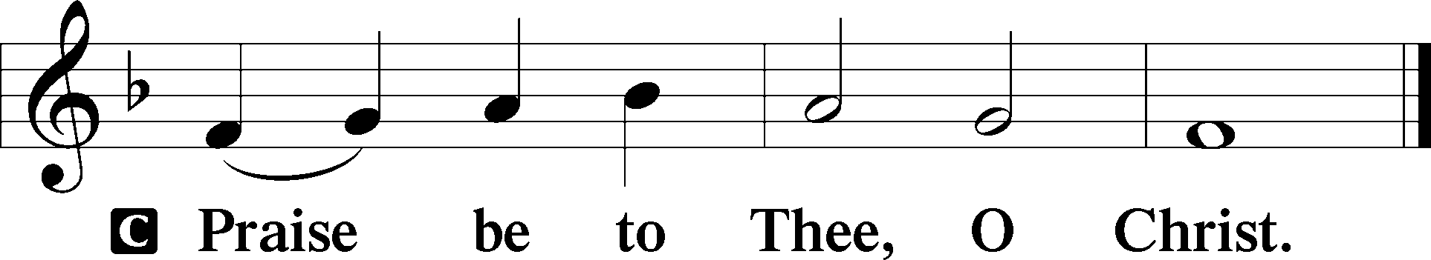

Apostles’ Creed

C **I believe in God, the Father Almighty,**

**maker of heaven and earth.**

**And in Jesus Christ, His only Son, our Lord,**

**who was conceived by the Holy Spirit,**

**born of the virgin Mary,**

**suffered under Pontius Pilate,**

**was crucified, died and was buried.**

**He descended into hell.**

**The third day He rose again from the dead.**

**He ascended into heaven**

**and sits at the right hand of God the Father Almighty.**

**From thence He will come to judge the living and the dead.**

**I believe in the Holy Spirit,**

**the holy Christian Church,**

**the communion of saints,**

**the forgiveness of sins,**

**the resurrection of the body,**

**and the life** T **everlasting. Amen.**

Sit

**Children’s Message**

430 My Song Is Love Unknown

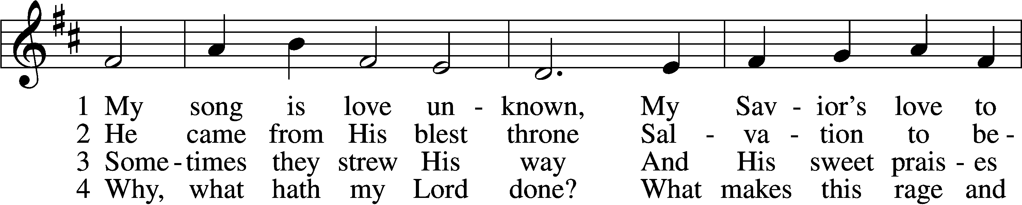

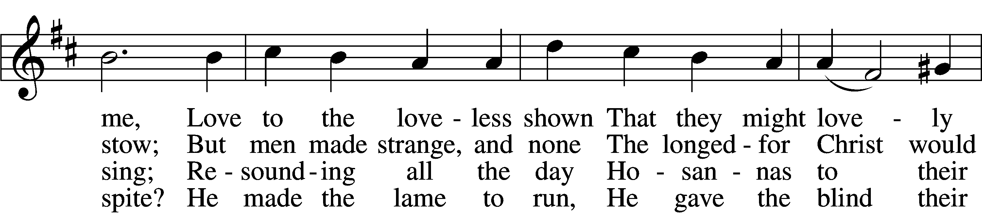

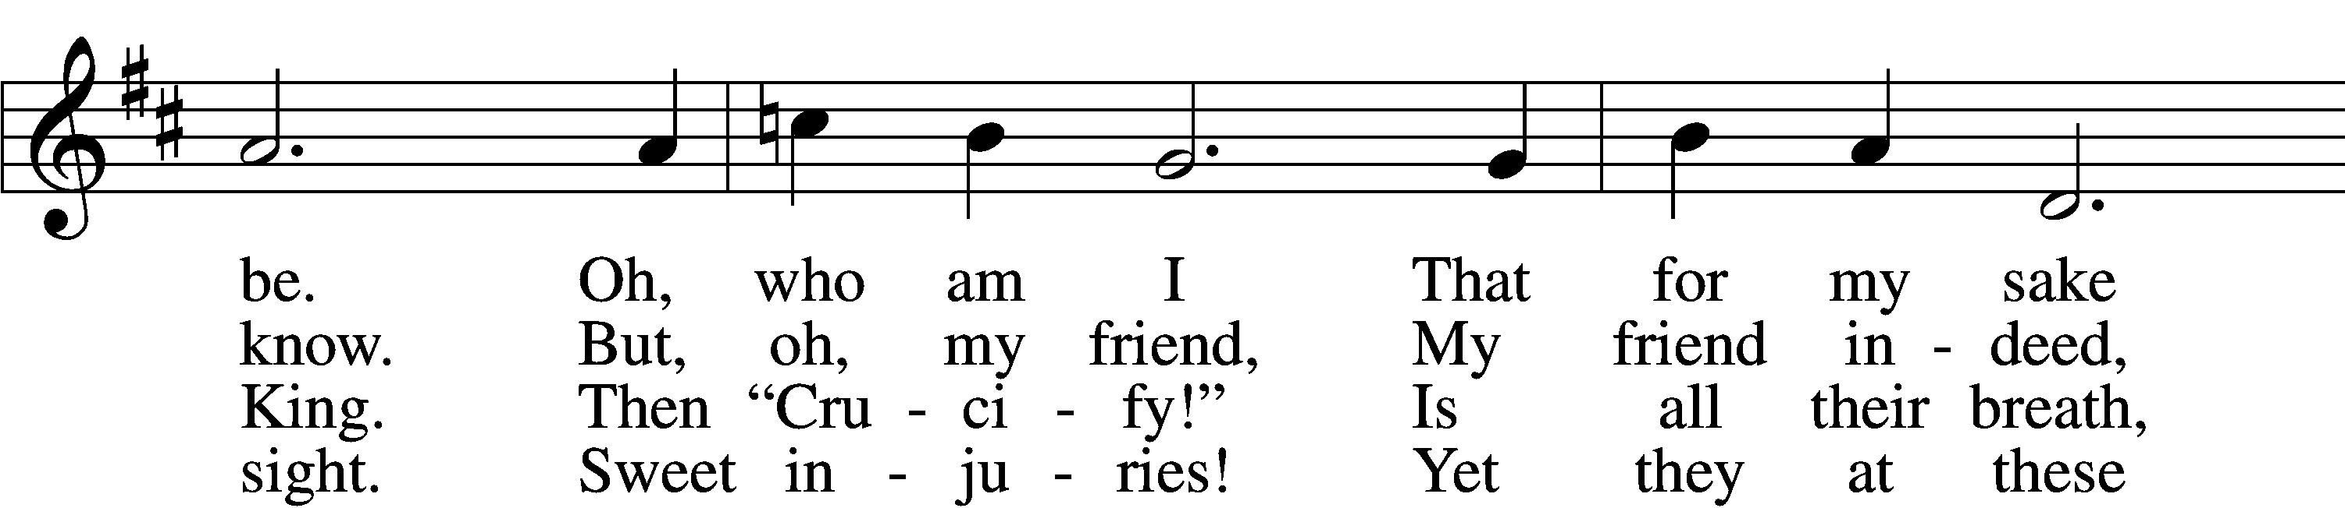

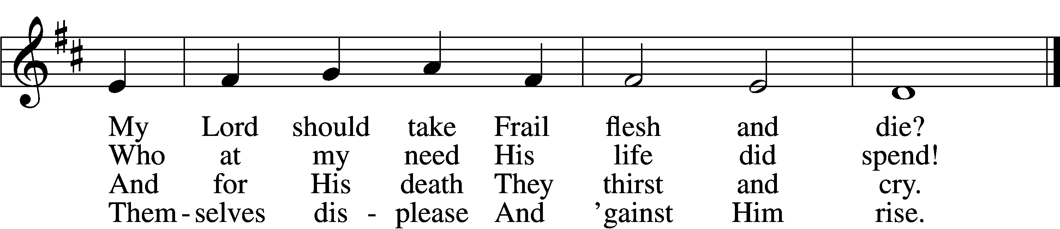

5 They rise and needs will have  
 My dear Lord made away;  
A murderer they save,  
 The Prince of Life they slay.  
Yet cheerful He  
 To suff’ring goes  
 That He His foes  
From thence might free.

6 In life no house, no home  
 My Lord on earth might have;  
In death no friendly tomb  
 But what a stranger gave.  
What may I say?  
 Heav’n was His home  
 But mine the tomb  
Wherein He lay.

7 Here might I stay and sing,  
 No story so divine!  
Never was love, dear King,  
 Never was grief like Thine.  
This is my friend,  
 In whose sweet praise  
 I all my days  
Could gladly spend!

Text: Samuel Crossman, c. 1624–1683  
Tune: John N. Ireland, 1879–1962  
Text: Public domain  
Tune: © John Ireland Trust. Used by permission: LSB Hymn License no. 110005011

Sermon

Votum

P The peace of God, which passes all understanding, keep your hearts and minds in Christ Jesus.

C **Amen.**

Stand

Offertory Psalm 51:10–12

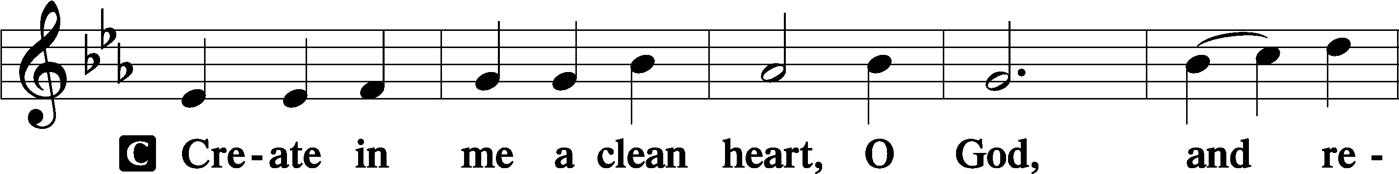

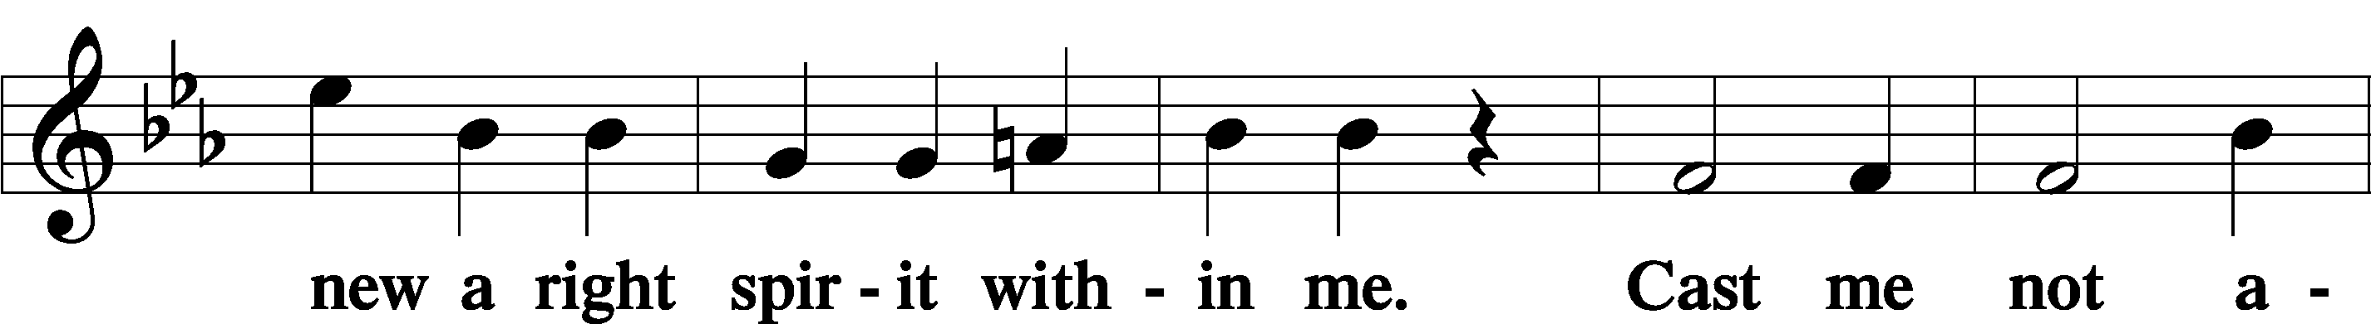

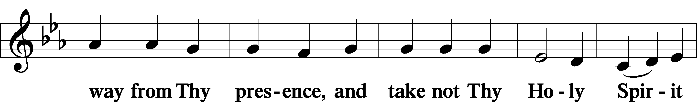

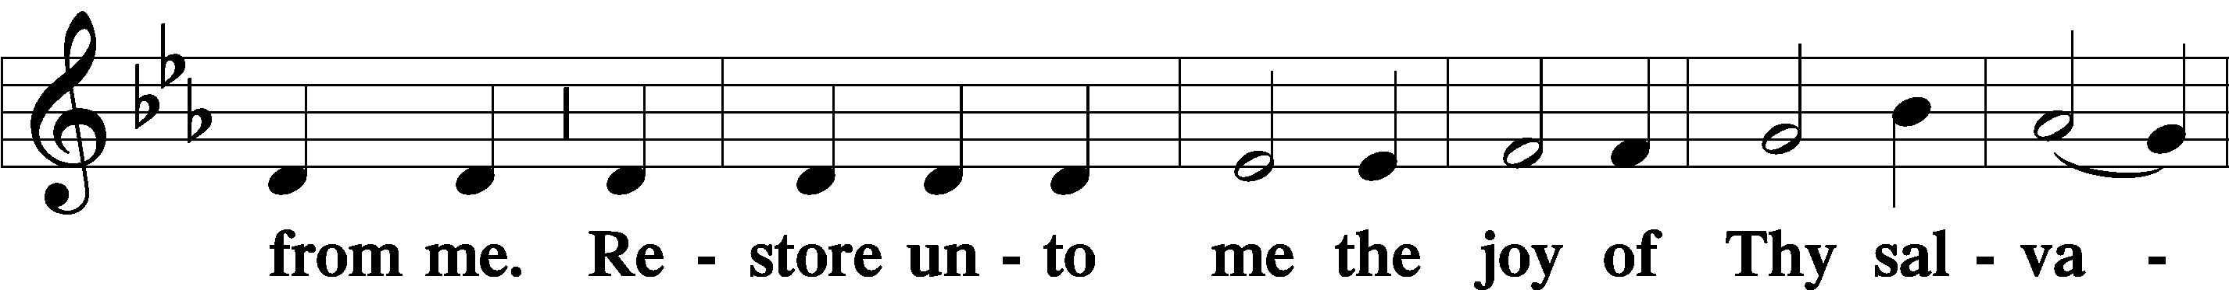

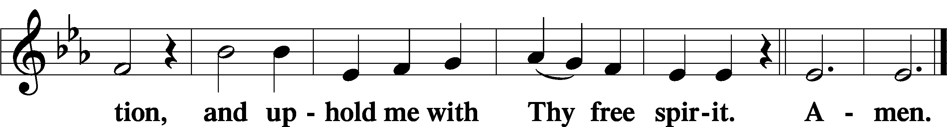

Offering

805 Praise God, from Whom All Blessings Flow

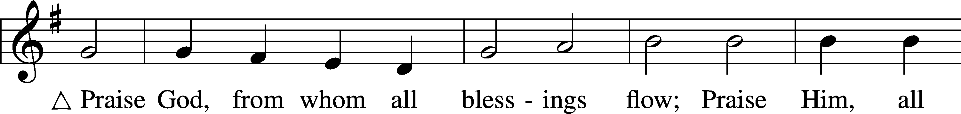

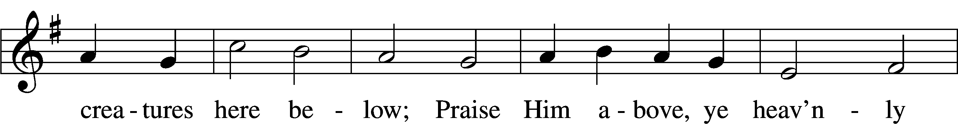

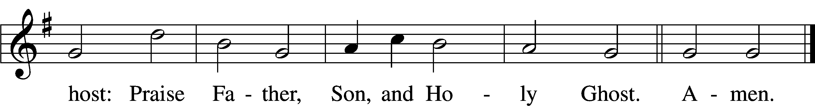

Text: Thomas Ken, 1637–1711  
Tune: Trente quatre Pseaumes de David, 1551, Geneva, ed. Louis Bourgeois  
Text and tune: Public domain

Prayer of the Church

Lord’s Prayer Matthew 6:9–13

P Lord, remember us in Your kingdom and teach us to pray:

C **Our Father who art in heaven,**

**hallowed be Thy name,**

**Thy kingdom come,**

**Thy will be done on earth**

**as it is in heaven;**

**give us this day our daily bread;**

**and forgive us our trespasses**

**as we forgive those**

**who trespass against us;**

**and lead us not into temptation,**

**but deliver us from evil.**

**For Thine is the kingdom**

**and the power and the glory**

**forever and ever. Amen.**

Collect for the Word

Blessed Lord, You have caused all Holy Scriptures to be written for our learning.

Grant that we may so hear them, read, mark, learn, and inwardly digest them that, by the patience and comfort of Your holy Word, we may embrace and ever holdfast the blessed hope of everlasting life; which you have given us in our Savior Jesus Christ, Your Son, our Lord, who lives and reigns with You and the Holy Spirit, one God, now and forever.

Post-Communion Collect

A Let us pray.

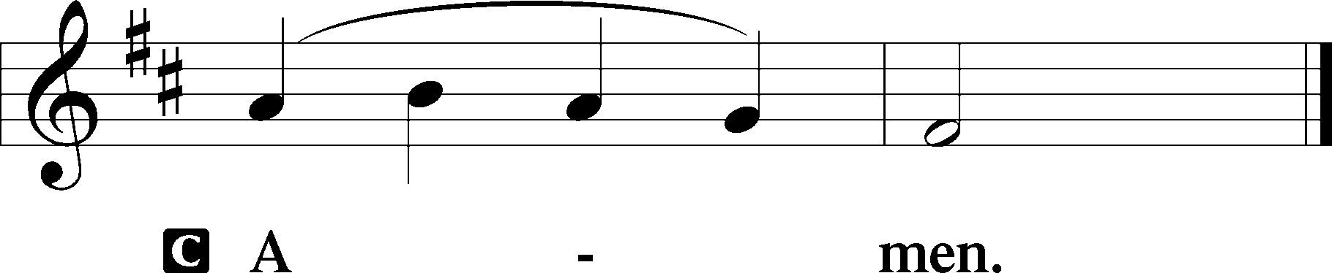

741 Jesus Christ, My Sure Defense

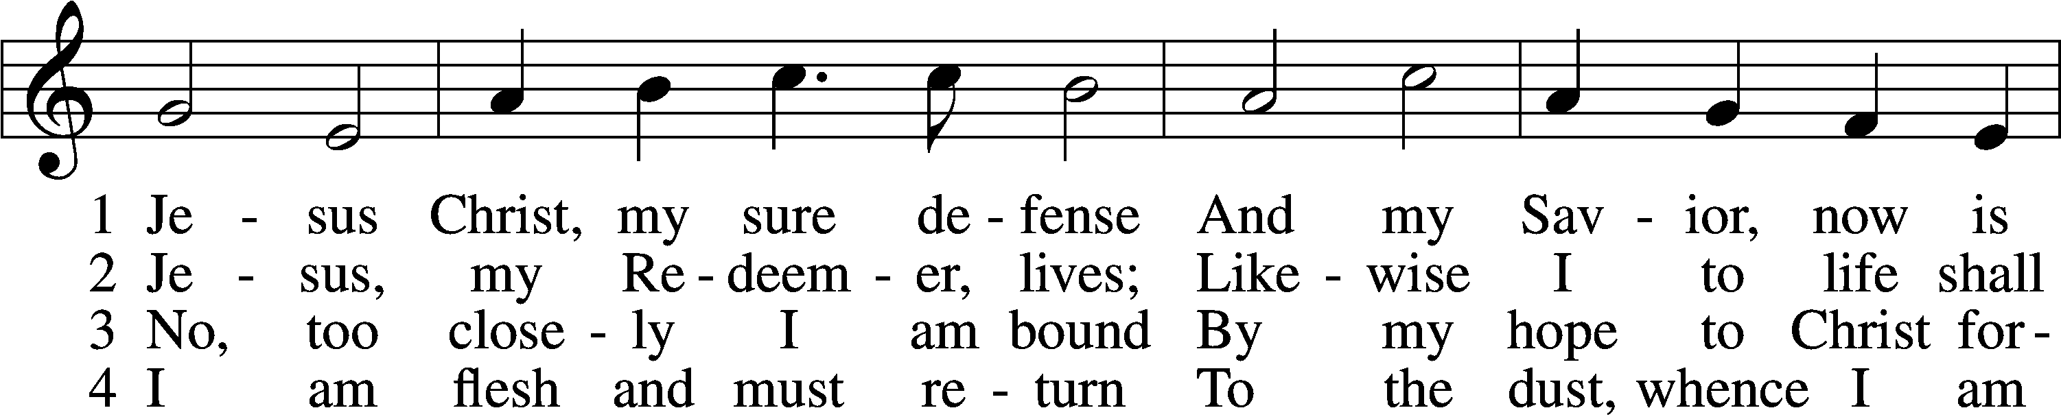

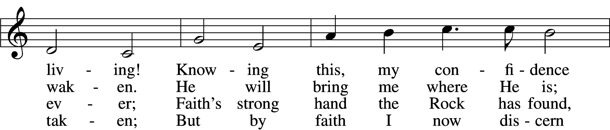

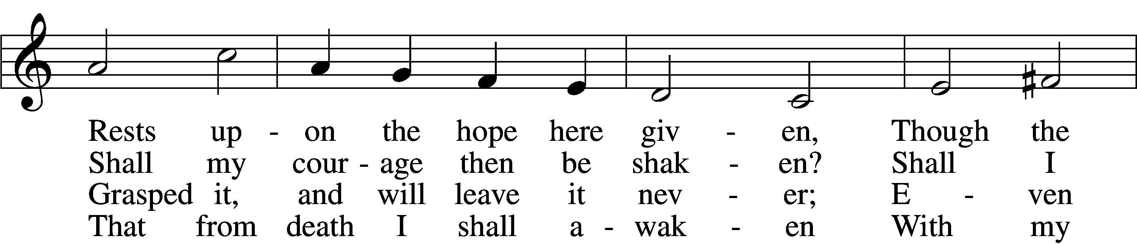

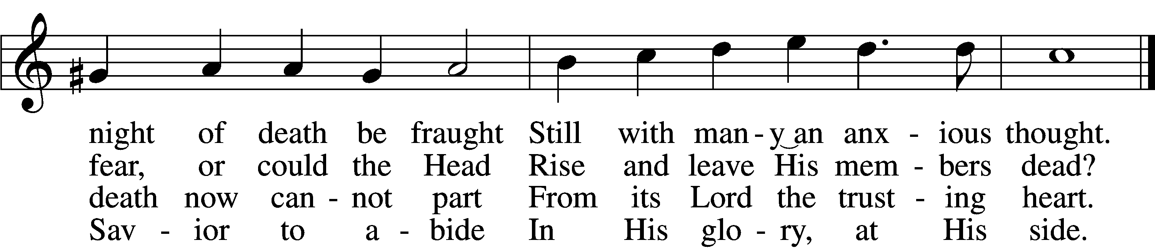

5 Glorified, I shall anew  
 With this flesh then be enshrouded;  
In this body I shall view  
 God, my Lord, with eyes unclouded;  
In this flesh I then shall see  
Jesus Christ eternally.

6 Then take comfort and rejoice,  
 For His members Christ will cherish.  
Fear not, they will hear His voice;  
 Dying, they will never perish;  
For the very grave is stirred  
When the trumpet’s blast is heard.

7 Laugh to scorn the gloomy grave  
 And at death no longer tremble;  
He, the Lord, who came to save  
 Will at last His own assemble.  
They will go their Lord to meet,  
Treading death beneath their feet.

8 O, then, draw away your hearts  
 From all pleasures base and hollow;  
Strive to share what He imparts  
 While you here His footsteps follow.  
As you now still wait to rise,  
Fix your hearts beyond the skies!

Text: Otto von Schwerin, 1616–79; tr. Catherine Winkworth, 1827–78, alt.  
Tune: Johann Crüger, 1598–1662  
Text and tune: Public domain

Acknowledgments

Unless otherwise indicated, Scripture quotations are from the ESV® Bible (The Holy Bible, English Standard Version®), copyright © 2001 by Crossway, a publishing ministry of Good News Publishers. Used by permission. All rights reserved.

Created by Lutheran Service Builder © 2023 Concordia Publishing House.