469 Christ the Lord Is Risen Today

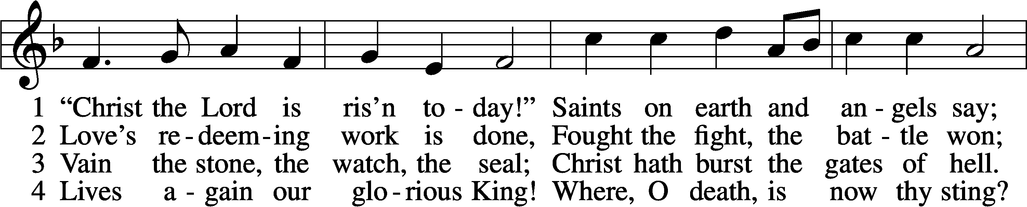

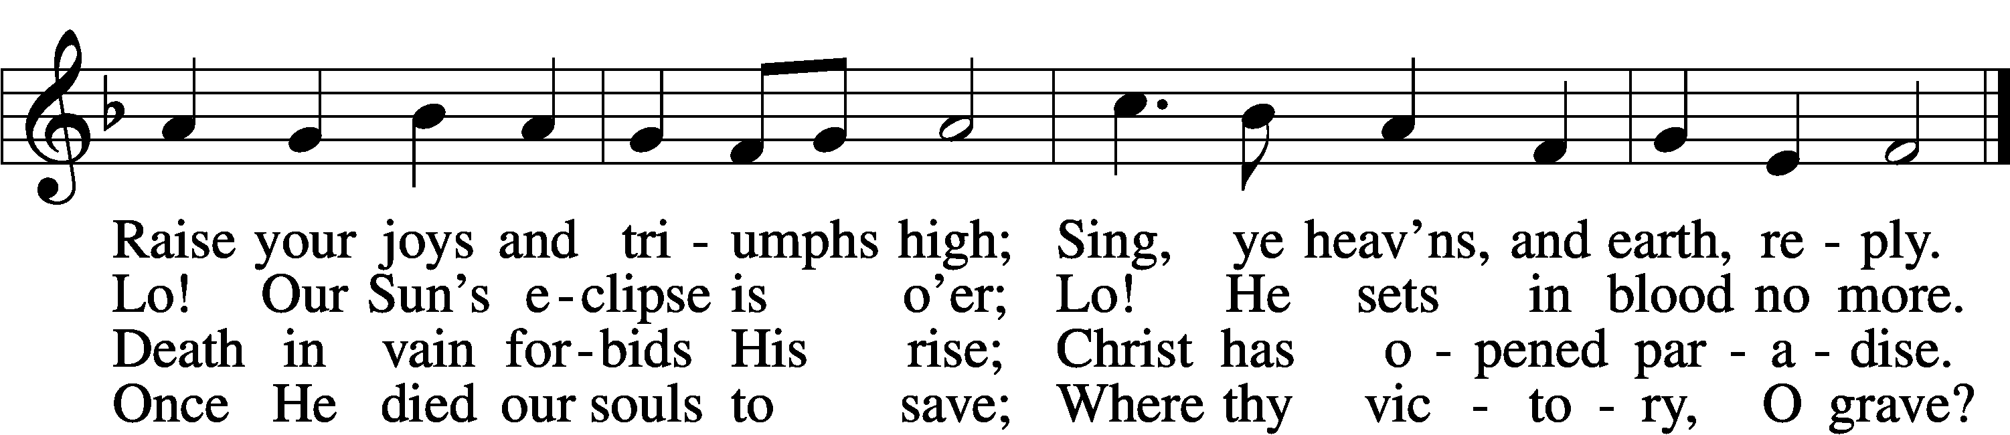

5 Soar we now where Christ has led;  
Foll’wing our exalted Head.  
Made like Him, like Him we rise;  
Ours the cross, the grave, the skies.

6 Hail the Lord of earth and heav’n!  
Praise to Thee by both be giv’n!  
Thee we greet triumphant now:  
Hail, the resurrection, Thou!

Text: Charles Wesley, 1707–88, alt.  
Tune: French, 13th cent.  
Text and tune: Public domain

# Confession and Absolution

Stand

The sign of the cross may be made by all in remembrance of their Baptism.

Invocation Matthew 28:19b; 18:20

P In the name of the Father and of the T Son and of the Holy Spirit.

C **Amen.**

Exhortation Hebrews 10:22; Psalm 124:8; Psalm 32:5

P Beloved in the Lord! Let us draw near with a true heart and confess our sins unto God our Father, beseeching Him in the name of our Lord Jesus Christ to grant us forgiveness.

P Our help is in the name of the Lord,

C **who made heaven and earth.**

P I said, I will confess my transgressions unto the Lord,

C **and You forgave the iniquity of my sin.**

Kneel/Stand

Silence for reflection on God’s Word and for self-examination.

Confession of Sins

P O almighty God, merciful Father,

C **I, a poor, miserable sinner, confess unto You all my sins and iniquities with which I have ever offended You and justly deserved Your temporal and eternal punishment. But I am heartily sorry for them and sincerely repent of them, and I pray You of Your boundless mercy and for the sake of the holy, innocent, bitter sufferings and death of Your beloved Son, Jesus Christ, to be gracious and merciful to me, a poor, sinful being.**

Absolution [John 20:19–23]

P Upon this your confession, I, by virtue of my office, as a called and ordained servant of the Word, announce the grace of God unto all of you, and in the stead and by the command of my Lord Jesus Christ I forgive you all your sins in the name of the Father and of the T Son and of the Holy Spirit.

C **Amen.**

Stand

# Service of the Word

Introit Exodus 15:2a, 6, 13, 17–18; antiphon: v. 1b

I will sing to the Lord, for he has triumphed gloriously;  
 the horse and his rider he has thrown into the sea.  
**The Lord is my strength and my song,  
 and he has become my salvation.**Your right hand, O Lord, glorious n power,  
 your right hand, O Lord, shatters the enemy.  
**You have led in your steadfast love the people whom you have redeemed;  
 you have guided them by your strength to your holy abode.**You will bring them in and plant them on your own mountain,  
 the place, O Lord, which you have made for your abode,  
**the sanctuary, O Lord, which your hands have established.  
 The Lord will reign forever and ever.**

Gloria Patri

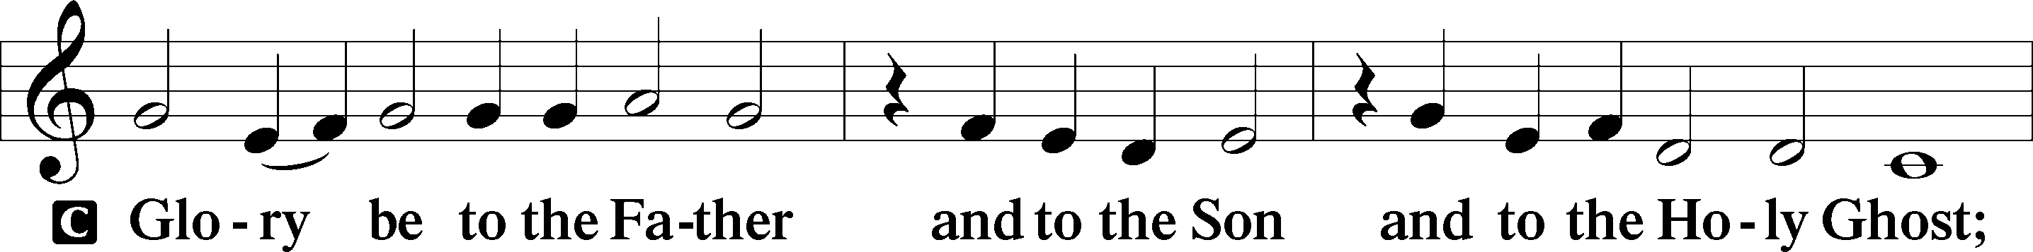

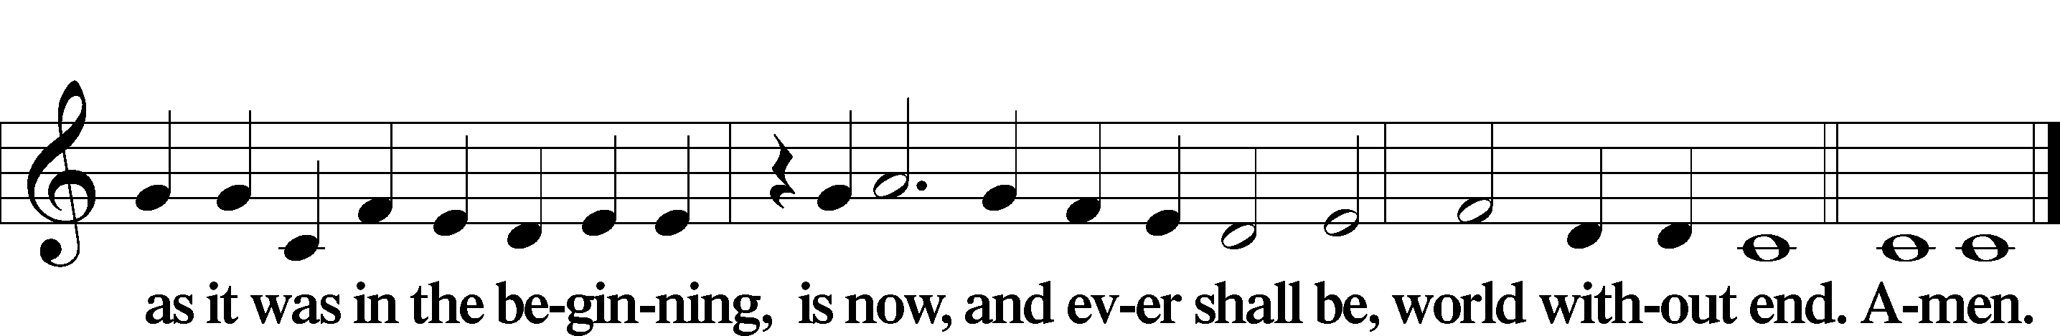

Kyrie Mark 10:47

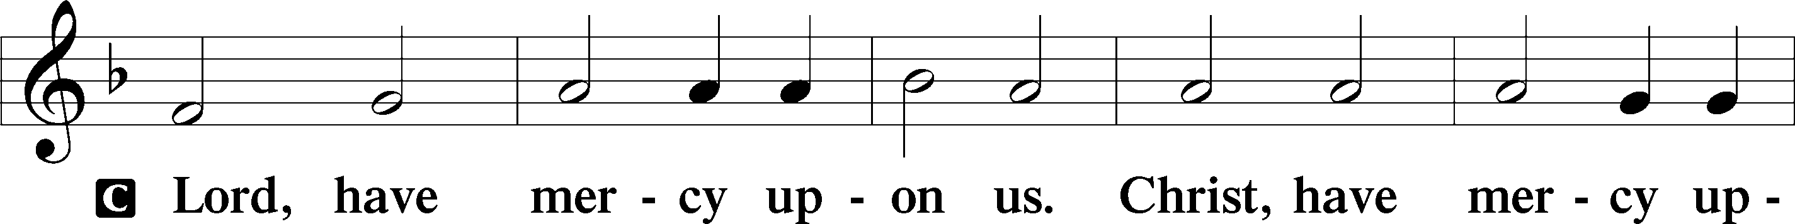

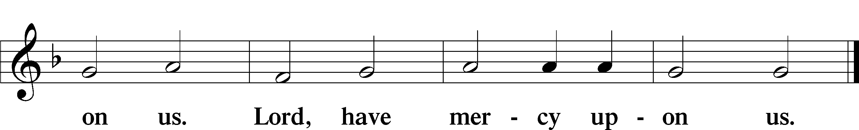

Gloria in Excelsis Luke 2:14; John 1:29

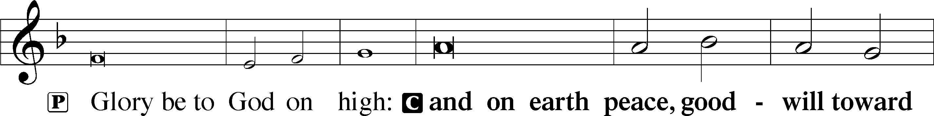

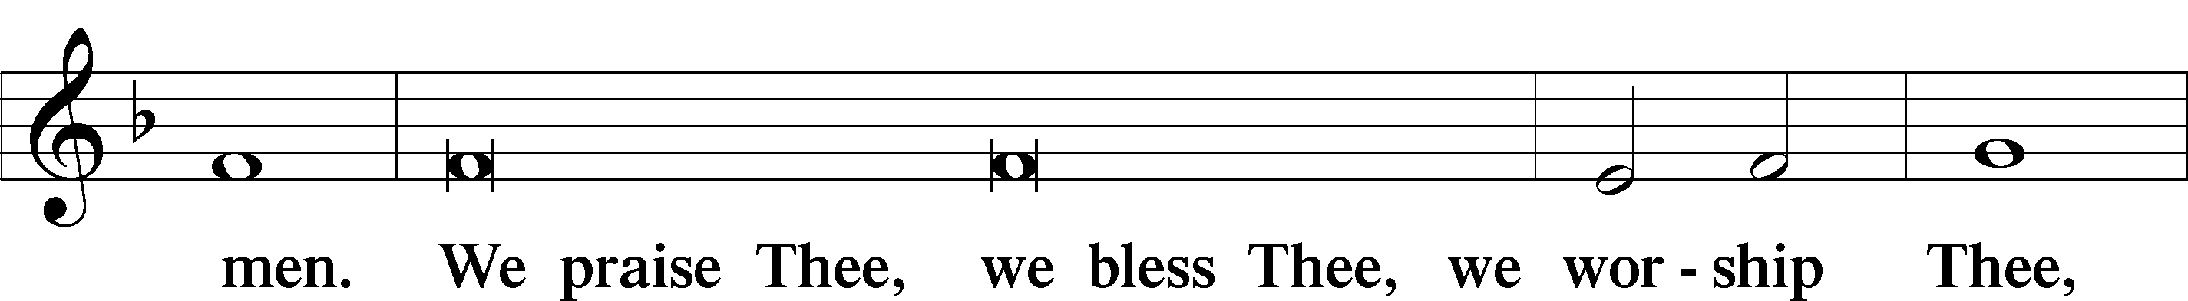

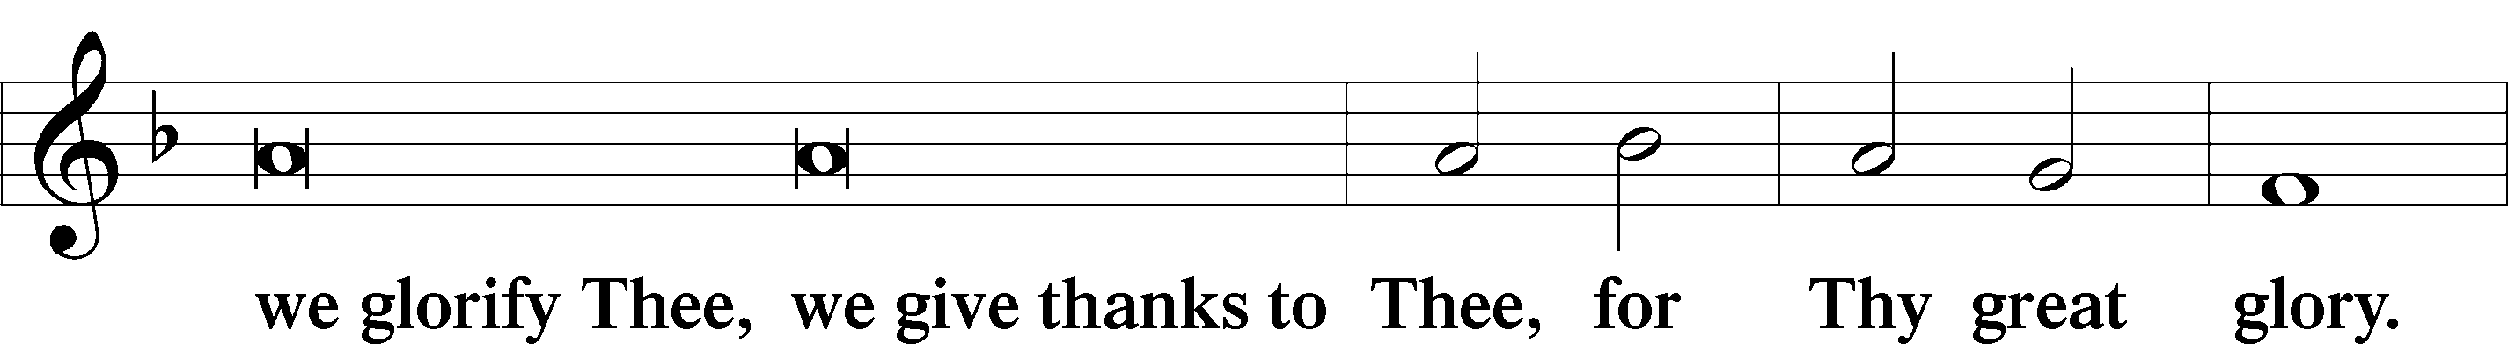

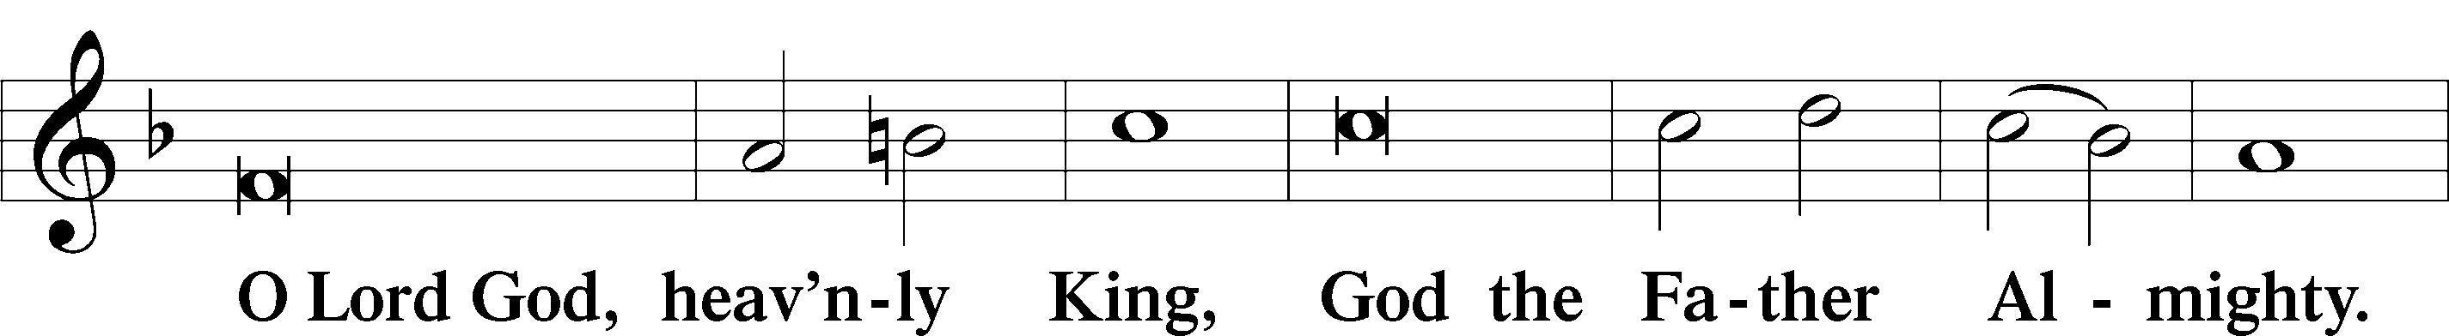

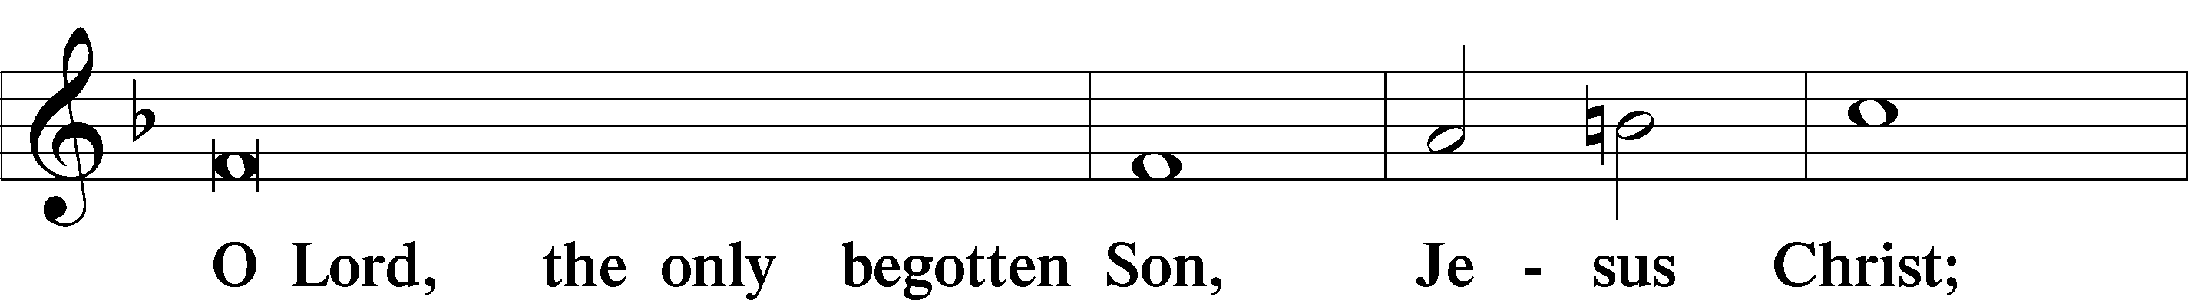

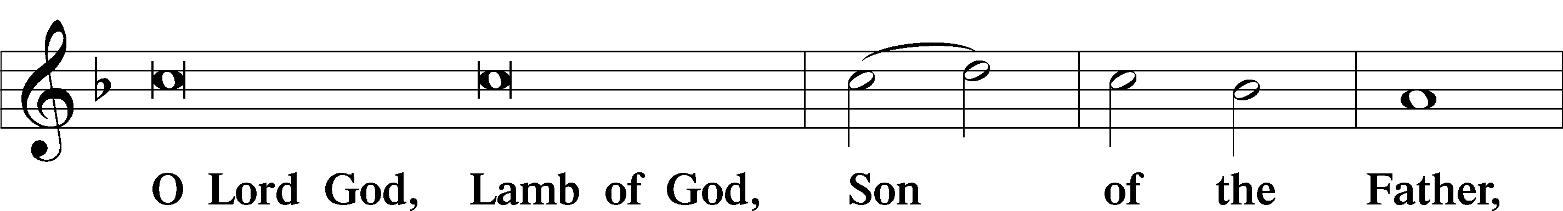

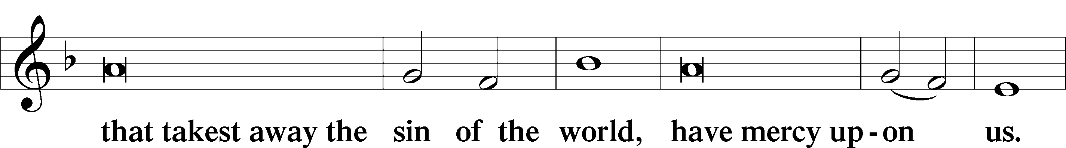

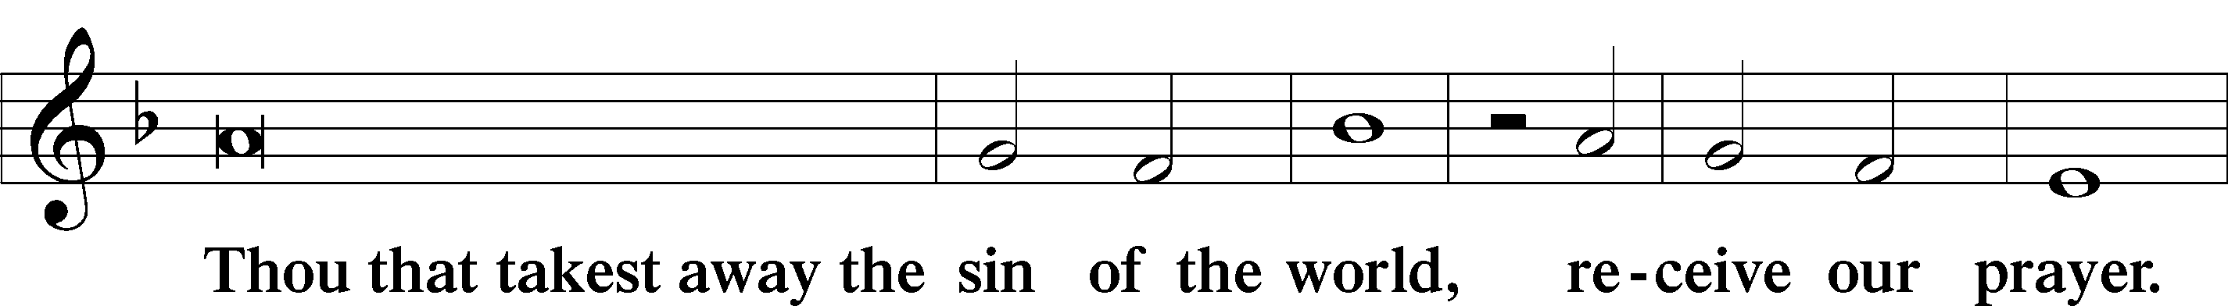

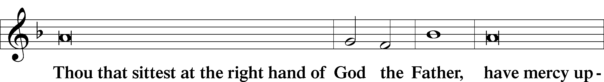

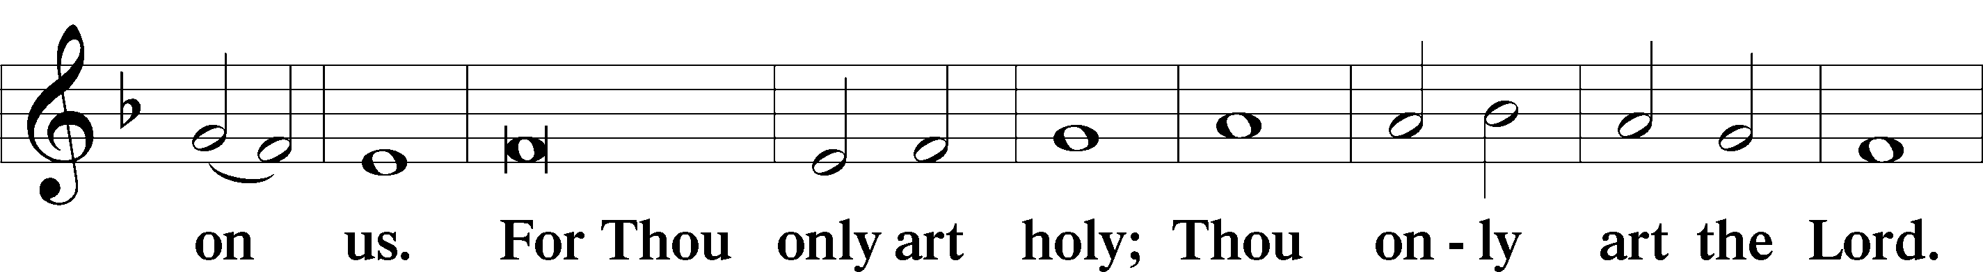

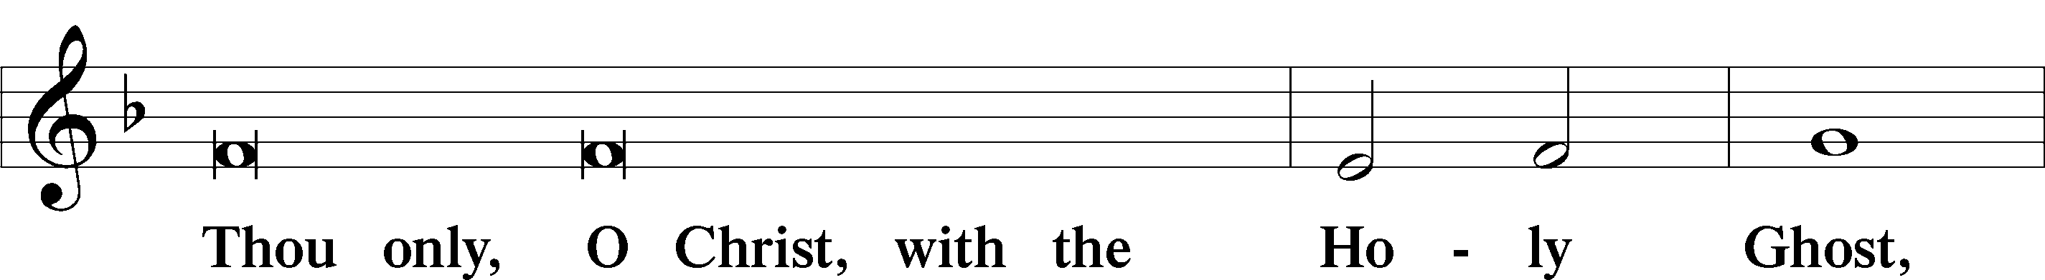

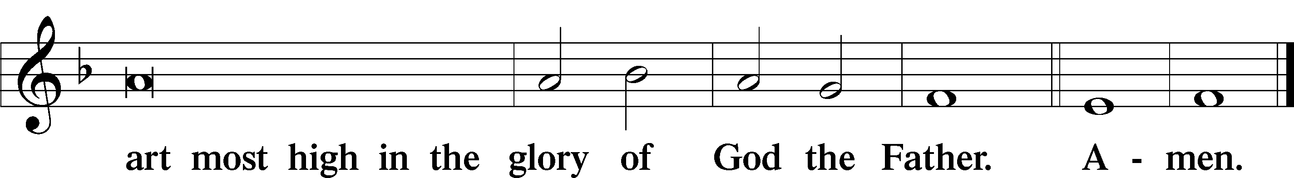

Salutation and Collect of the Day

P The Lord be with you.

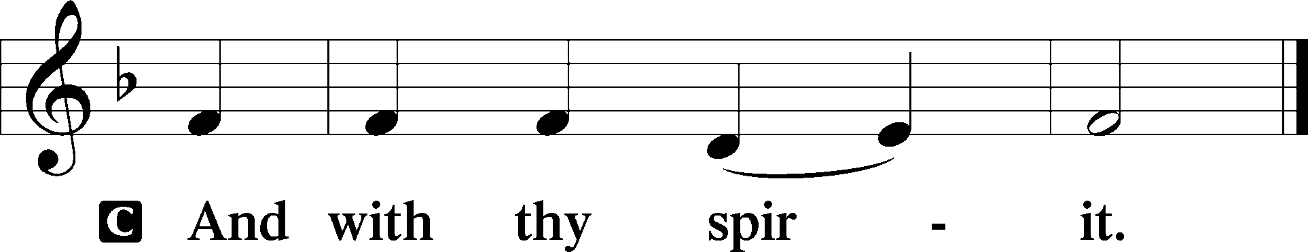

P Let us pray.

Almighty God the Father, through Your only-begotten Son, Jesus Christ, You have overcome death and opened the gate of everlasting life to us. Grant that we, who celebrate with joy the day of our Lord’s resurrection, may be raised from the death of sin by Your life-giving Spirit; through Jesus Christ, our Lord, who lives and reigns with You and the Holy Spirit, one God, now and forever.

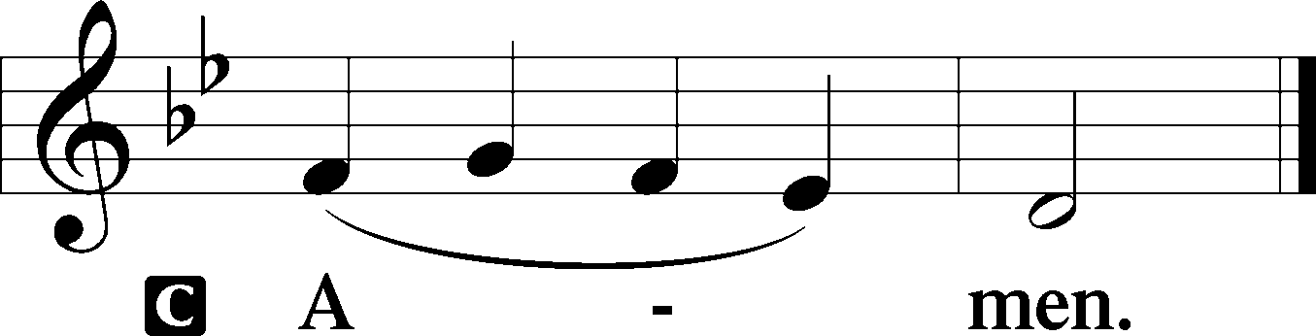

Sit

Old Testament Reading Jeremiah 31:1–6

The Lord Will Turn Mourning to Joy

1“At that time, declares the Lord, I will be the God of all the clans of Israel, and they shall be my people.”

2Thus says the Lord:  
“The people who survived the sword  
 found grace in the wilderness;  
when Israel sought for rest,  
 3the Lord appeared to him from far away.  
I have loved you with an everlasting love;  
 therefore I have continued my faithfulness to you.  
4Again I will build you, and you shall be built,  
 O virgin Israel!  
Again you shall adorn yourself with tambourines  
 and shall go forth in the dance of the merrymakers.  
5Again you shall plant vineyards  
 on the mountains of Samaria;  
the planters shall plant  
 and shall enjoy the fruit.  
6For there shall be a day when watchmen will call  
 in the hill country of Ephraim:  
‘Arise, and let us go up to Zion,  
 to the Lord our God.’”

A This is the Word of the Lord.

C **Thanks be to God.**

Proper adapt. from Matthew 28:7; Hebrews 2:7; Psalm 8:6

Christ has risen from the dead.  
 [God the Father] has crowned him with glory and honor.  
**He has given him dominion over the works of his hands;  
 he has put all things under his feet.**

Epistle Colossians 3:1–4

Put on the New Self

1If then you have been raised with Christ, seek the things that are above, where Christ is, seated at the right hand of God. 2Set your minds on things that are above, not on things that are on earth. 3For you have died, and your life is hidden with Christ in God. 4When Christ who is your life appears, then you also will appear with him in glory.

A This is the Word of the Lord.

C **Thanks be to God.**

Stand

Alleluia

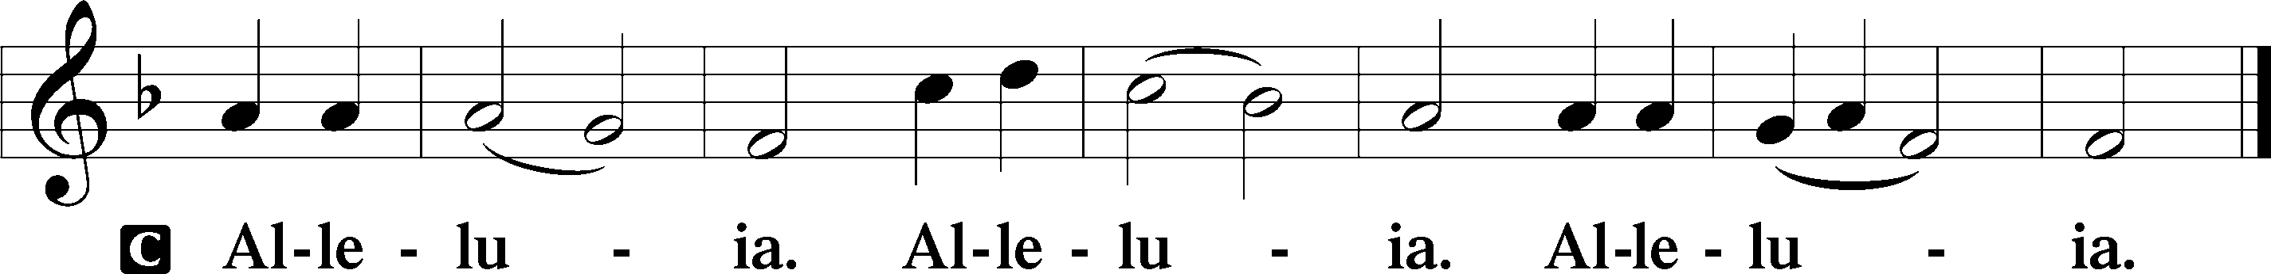

Holy Gospel Matthew 28:1–10

P The Holy Gospel according to St. Matthew, the twenty-eighth chapter.

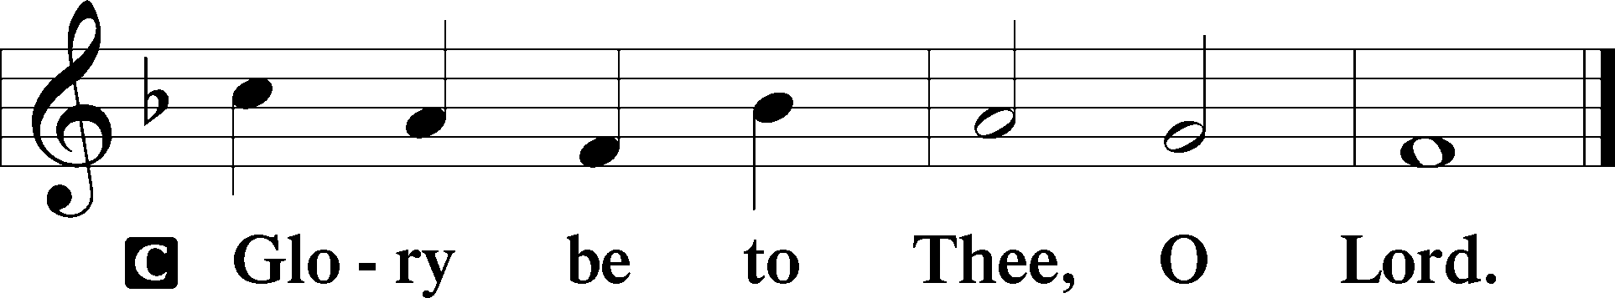

The Resurrection

1Now after the Sabbath, toward the dawn of the first day of the week, Mary Magdalene and the other Mary went to see the tomb. 2And behold, there was a great earthquake, for an angel of the Lord descended from heaven and came and rolled back the stone and sat on it. 3His appearance was like lightning, and his clothing white as snow. 4And for fear of him the guards trembled and became like dead men. 5But the angel said to the women, “Do not be afraid, for I know that you seek Jesus who was crucified. 6He is not here, for he has risen, as he said. Come, see the place where he lay. 7Then go quickly and tell his disciples that he has risen from the dead, and behold, he is going before you to Galilee; there you will see him. See, I have told you.” 8So they departed quickly from the tomb with fear and great joy, and ran to tell his disciples. 9And behold, Jesus met them and said, “Greetings!” And they came up and took hold of his feet and worshiped him. 10Then Jesus said to them, “Do not be afraid; go and tell my brothers to go to Galilee, and there they will see me.”

P This is the Gospel of the Lord.

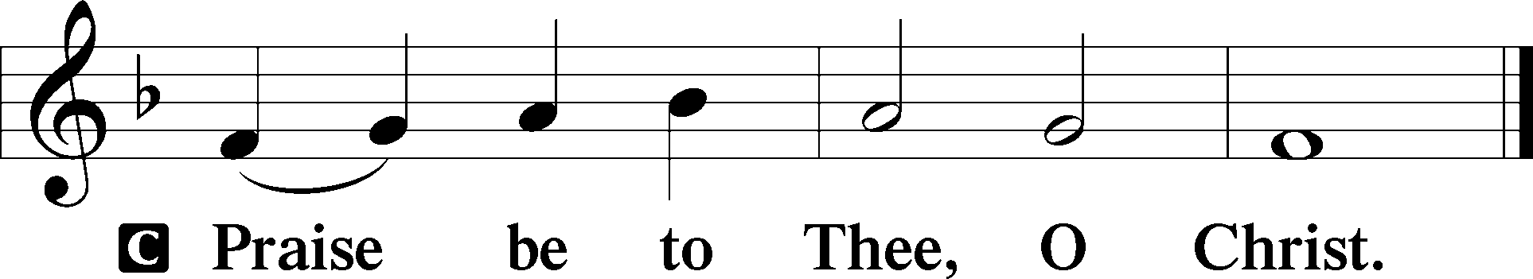

Nicene Creed

C **I believe in one God,**

**the Father Almighty,**

**maker of heaven and earth**

**and of all things visible and invisible.**

**And in one Lord Jesus Christ,**

**the only-begotten Son of God,**

**begotten of His Father before all worlds,**

**God of God, Light of Light,**

**very God of very God,**

**begotten, not made,**

**being of one substance with the Father,**

**by whom all things were made;**

**who for us men and for our salvation came down from heaven**

**and was incarnate by the Holy Spirit of the virgin Mary**

**and was made man;**

**and was crucified also for us under Pontius Pilate.**

**He suffered and was buried.**

**And the third day He rose again according to the Scriptures**

**and ascended into heaven**

**and sits at the right hand of the Father.**

**And He will come again with glory to judge both the living and the dead,**

**whose kingdom will have no end.**

**And I believe in the Holy Spirit,**

**the Lord and giver of life,**

**who proceeds from the Father and the Son,**

**who with the Father and the Son together is worshiped and glorified,**

**who spoke by the prophets.**

**And I believe in one holy Christian and apostolic Church,**

**I acknowledge one Baptism for the remission of sins,**

**and I look for the resurrection of the dead**

**and the life** T **of the world to come. Amen.**

Sit

Children's Message

467 Awake, My Heart, with Gladness

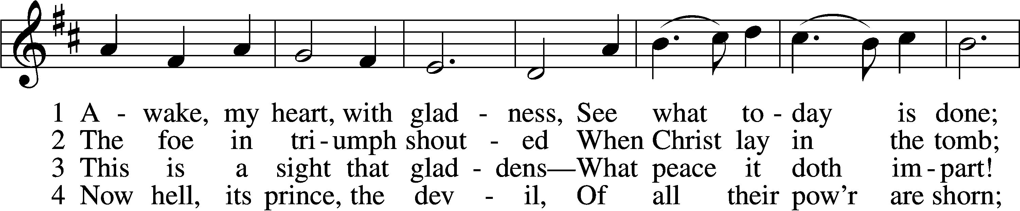

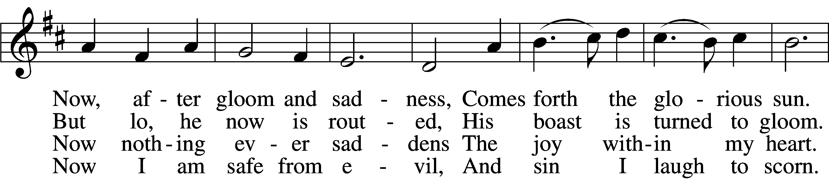

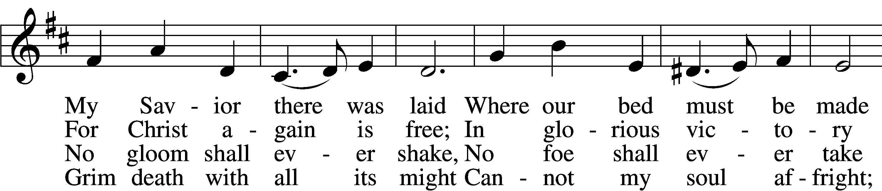

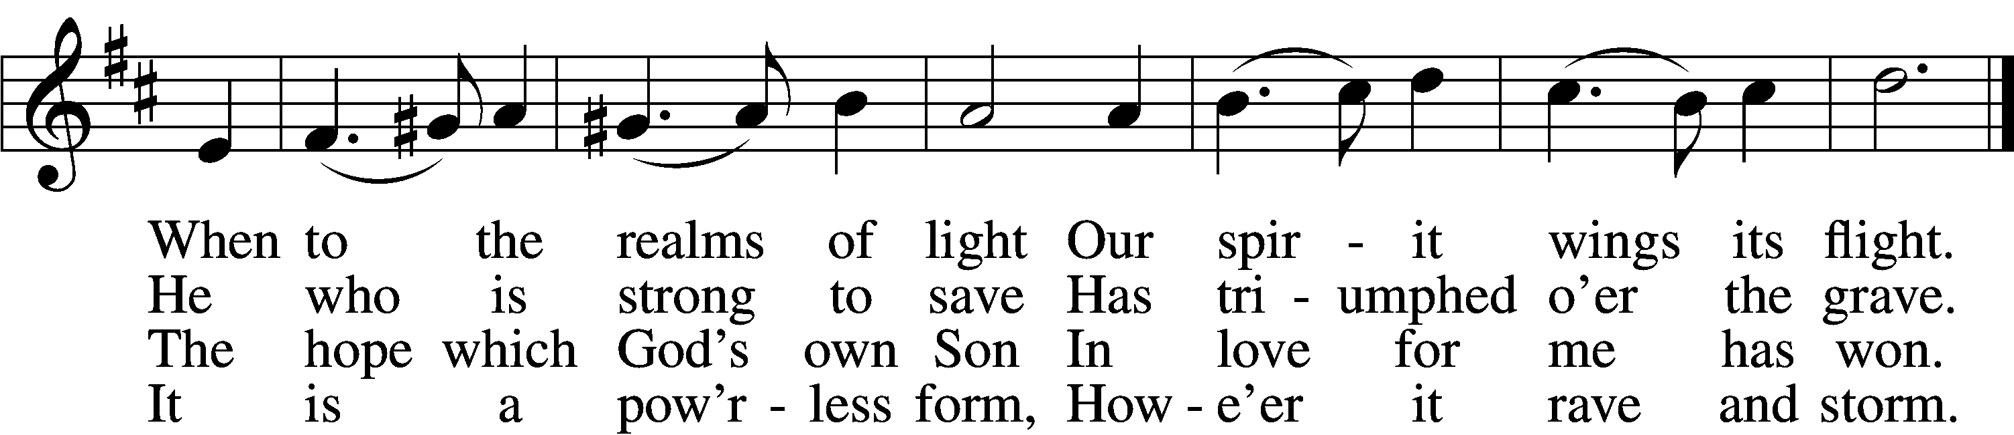

5 The world against me rages,  
 Its fury I disdain;  
Though bitter war it wages,  
 Its work is all in vain.  
My heart from care is free,  
No trouble troubles me.  
 Misfortune now is play,  
 And night is bright as day.

6 Now I will cling forever  
 To Christ, my Savior true;  
My Lord will leave me never,  
 Whate’er He passes through.  
He rends death’s iron chain;  
He breaks through sin and pain;  
 He shatters hell’s grim thrall;  
 I follow Him through all.

7 He brings me to the portal  
 That leads to bliss untold,  
Whereon this rhyme immortal  
 Is found in script of gold:  
“Who there My cross has shared  
Finds here a crown prepared;  
 Who there with Me has died  
 Shall here be glorified.”

Text: Paul Gerhardt, 1607–76; tr. John Kelly, 1833–90, alt.  
Tune: Johann Crüger, 1598–1662  
Text and tune: Public domain

Sermon

Votum

P The peace of God, which passes all understanding, keep your hearts and minds in Christ Jesus.

C **Amen.**

Stand

Offertory Psalm 51:10–12

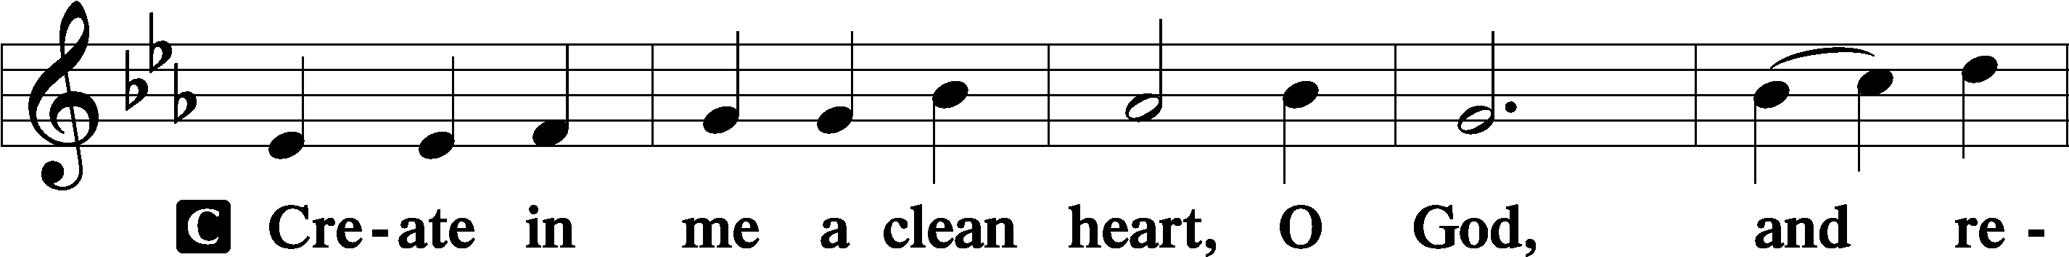

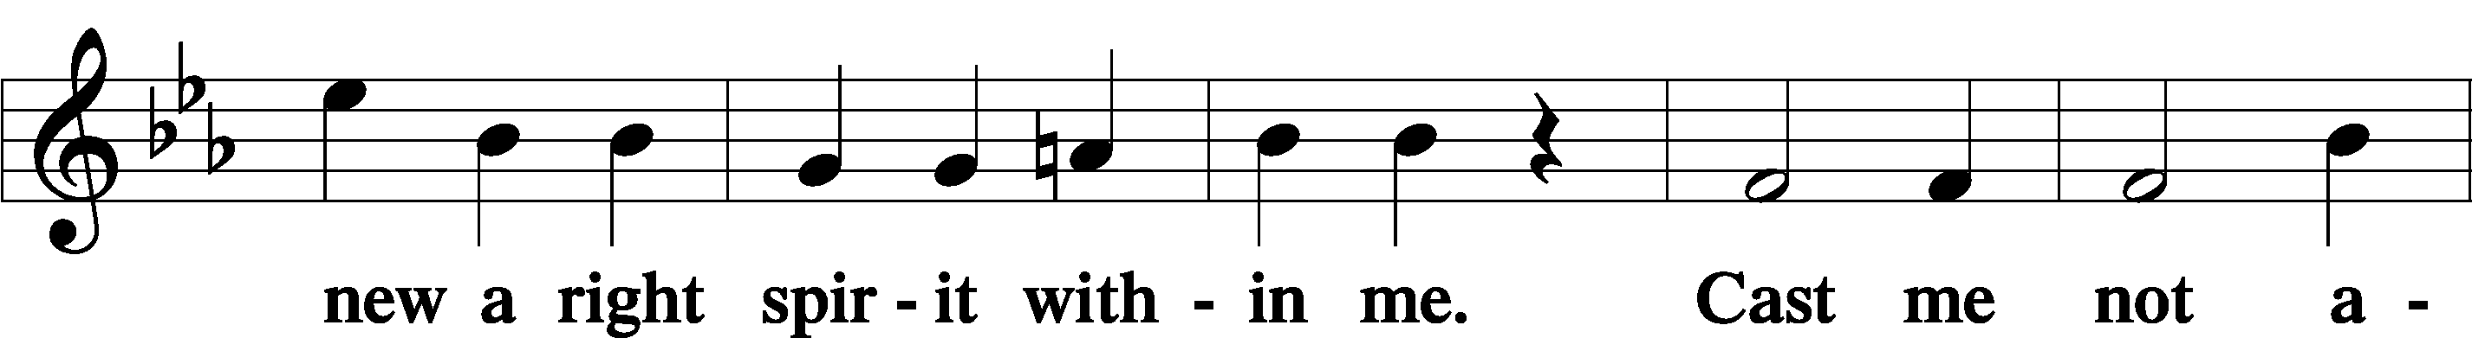

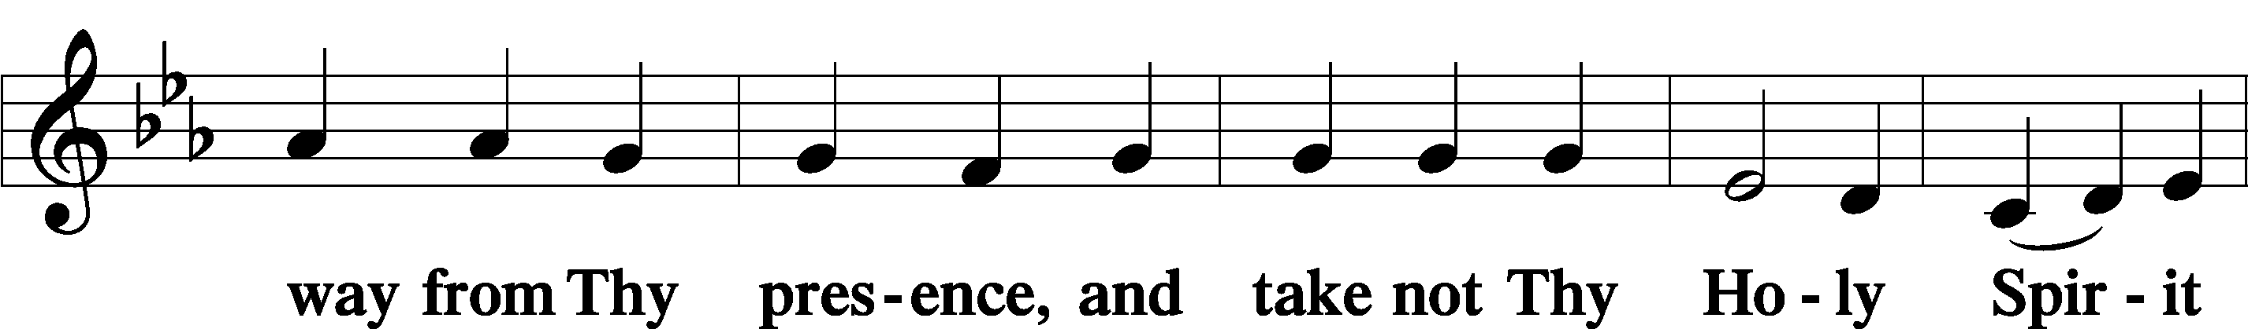

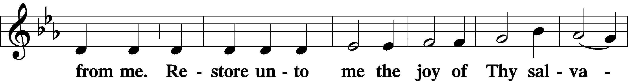

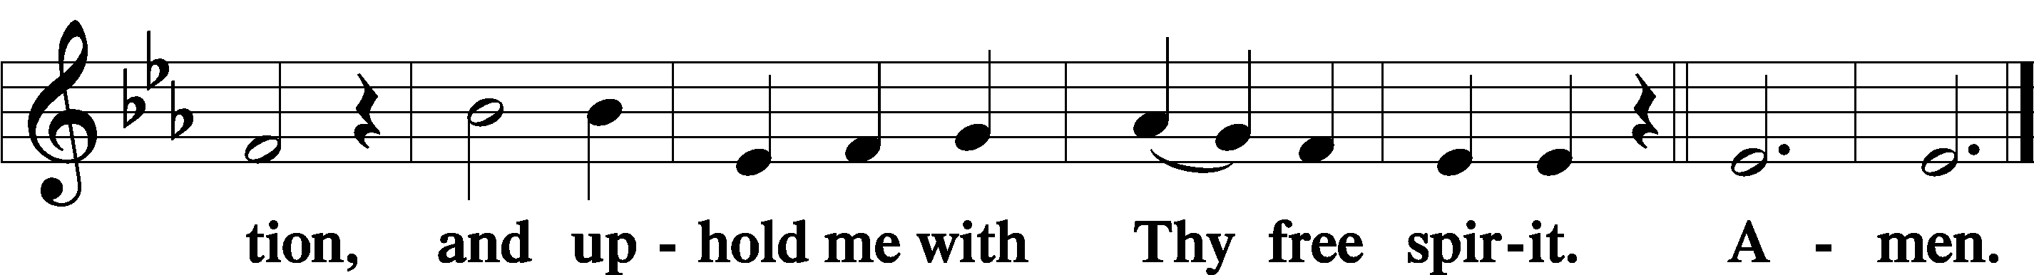

Sit

Offering

Stand

805 Praise God, from Whom All Blessings Flow

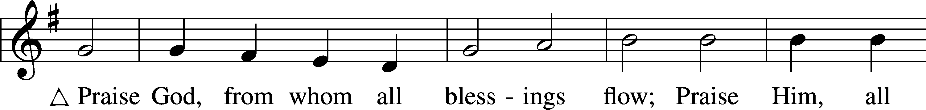

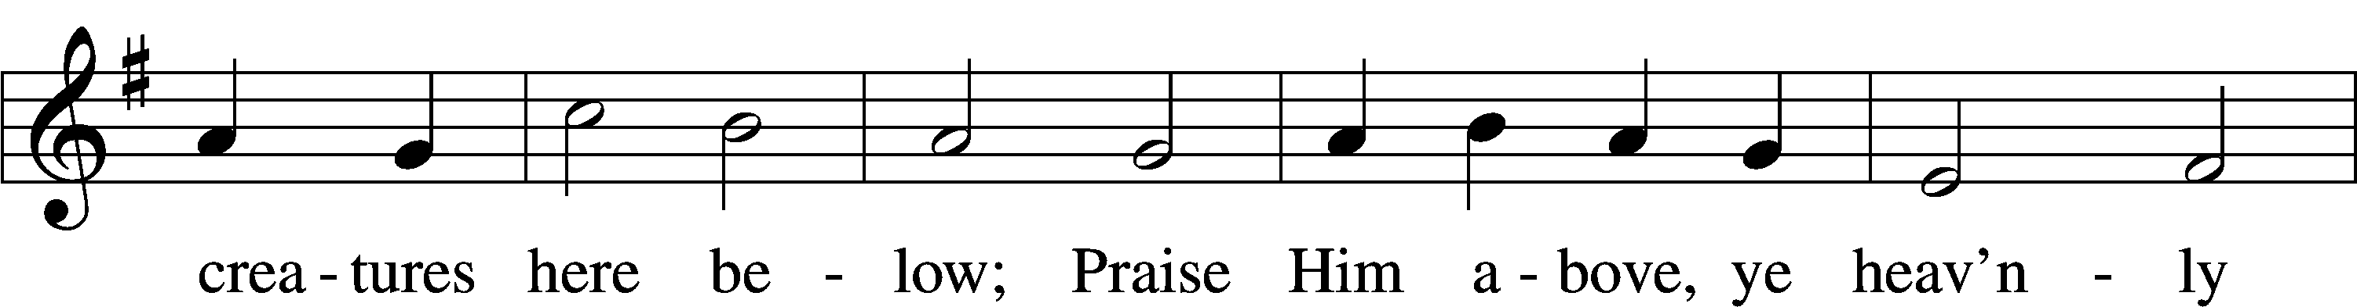

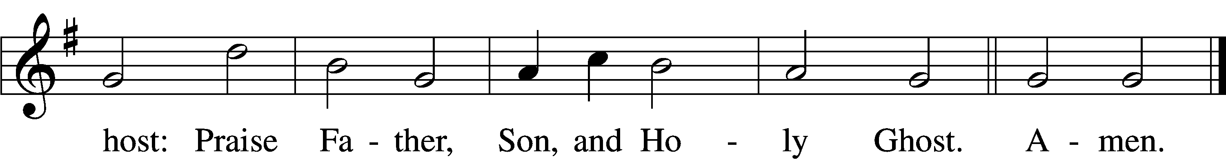

Text: Thomas Ken, 1637–1711  
Tune: Trente quatre Pseaumes de David, 1551, Geneva, ed. Louis Bourgeois  
Text and tune: Public domain

Prayer of the Church

# Service of the Sacrament

Preface 2 Timothy 4:22; [Colossians 3:1]; [Psalm 136]

P The Lord be with you.

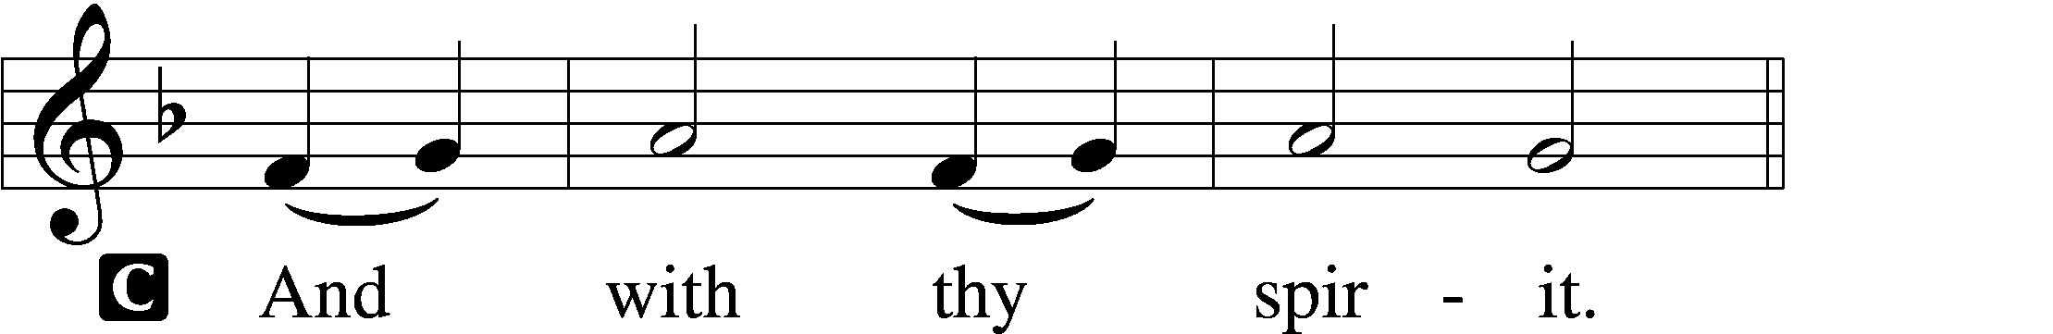

P Lift up your hearts.

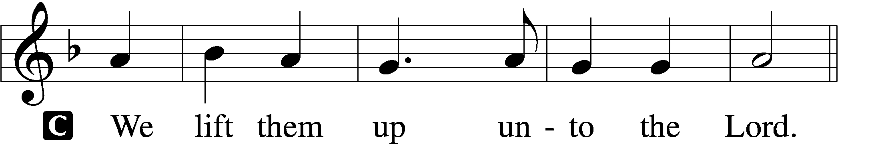

P Let us give thanks unto the Lord, our God.

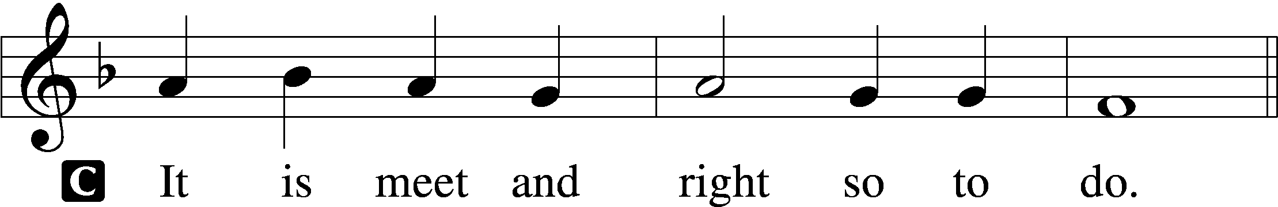

Proper Preface (Full)

P It is truly meet, right, and salutary that we should at all times and in all places give thanks to You, holy Lord, almighty Father, everlasting God. And most especially are we bound to praise You on this day for the glorious resurrection of Your Son, Jesus Christ, the very Paschal Lamb, who was sacrificed for us and bore the sins of the world. By His dying He has destroyed death, and by His rising again He has restored to us everlasting life. Therefore with Mary Magdalene, Peter and John, and with all the witnesses of the resurrection, with angels and archangels, and with all the company of heaven we laud and magnify Your glorious name, evermore praising You and saying:

Sanctus Isaiah 6:3; Matthew 21:9

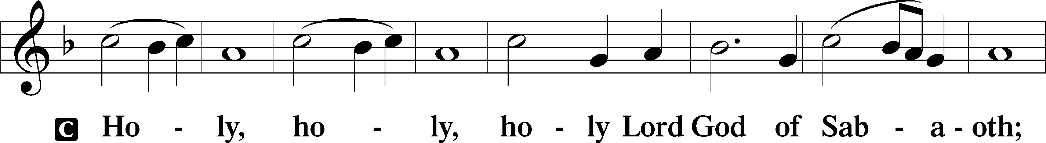

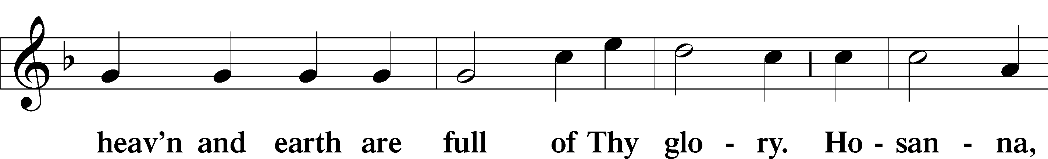

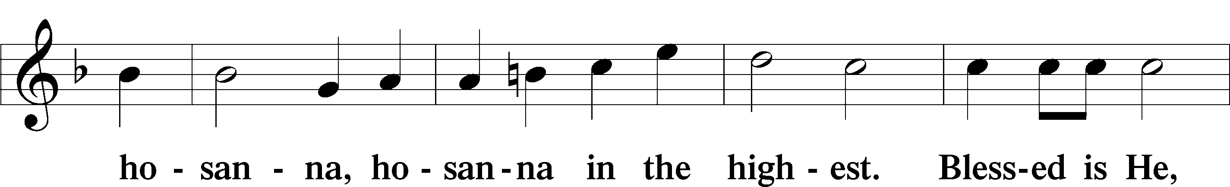

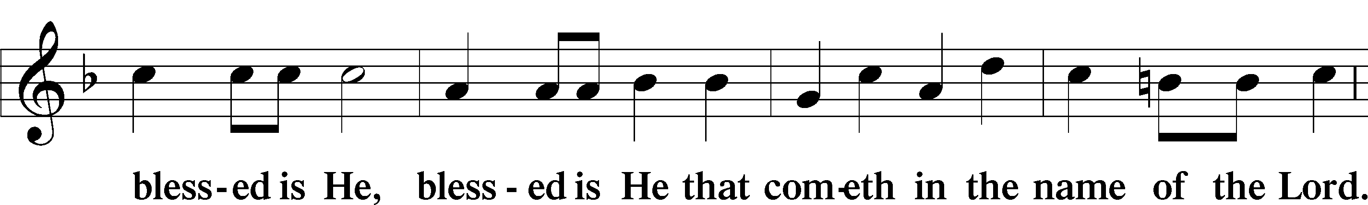

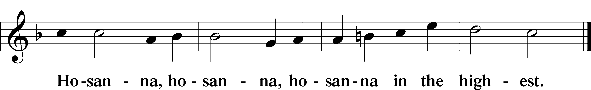

Lord’s Prayer Matthew 6:9–13

P Our Father who art in heaven,

hallowed be Thy name,

Thy kingdom come,

Thy will be done on earth as it is in heaven;

give us this day our daily bread;

and forgive us our trespasses as we forgive those who trespass against us;

and lead us not into temptation,

but deliver us from evil.

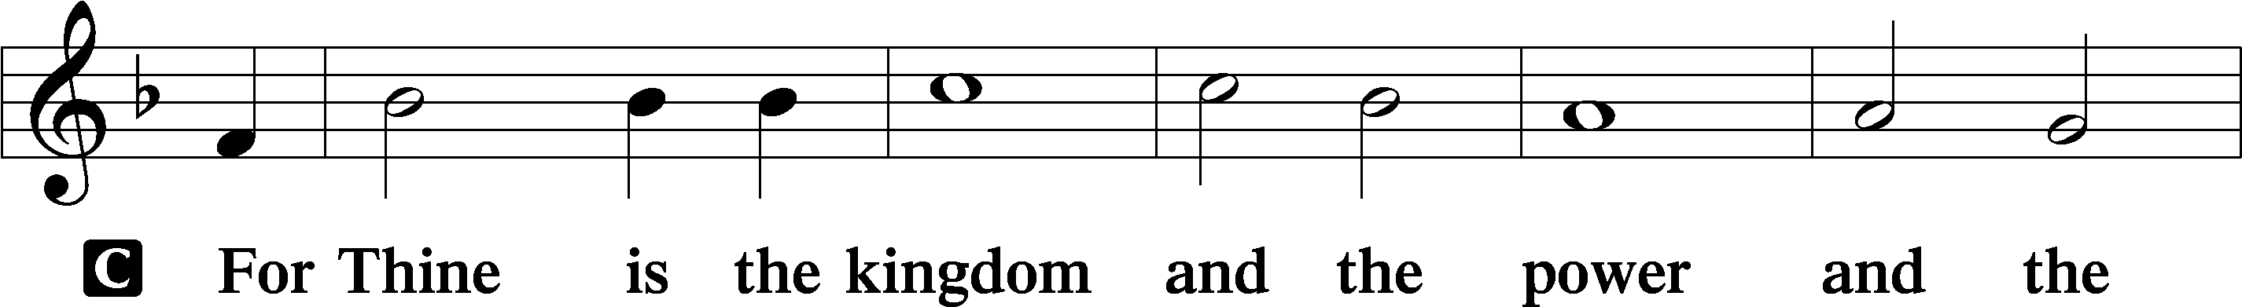

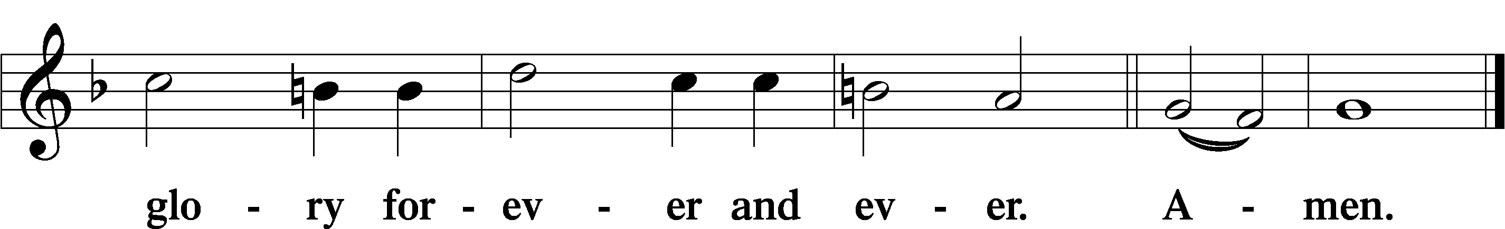

The Words of Our Lord Matthew 26:26–28; Mark 14:22–24; Luke 22:19–20; 1 Corinthians 11:23–25

P Our Lord Jesus Christ, on the night when He was betrayed, took bread, and when He had given thanks, He broke it and gave it to the disciples and said: “Take, eat; this is My T body, which is given for you. This do in remembrance of Me.”

In the same way also He took the cup after supper, and when He had given thanks, He gave it to them, saying: “Drink of it, all of you; this cup is the new testament in My T blood, which is shed for you for the forgiveness of sins. This do, as often as you drink it, in remembrance of Me.”

Pax Domini John 20:19

P The peace of the Lord be with you always.

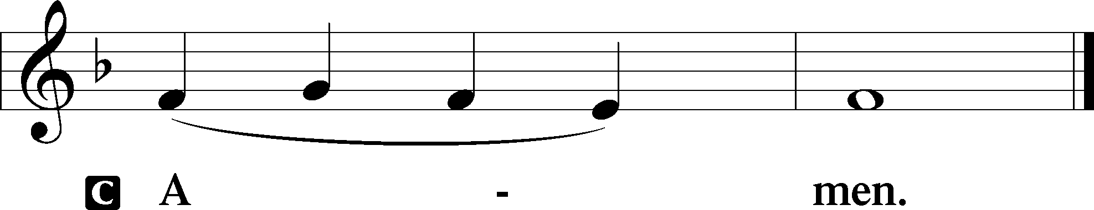

Agnus Dei John 1:29

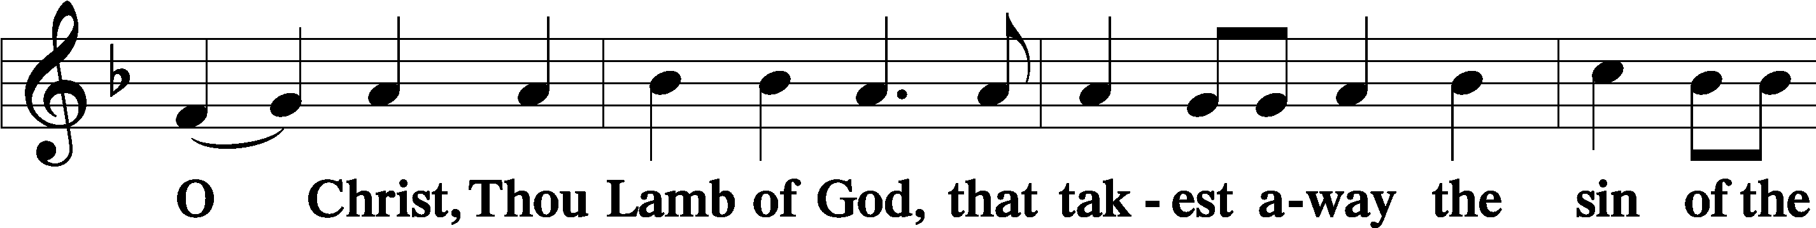

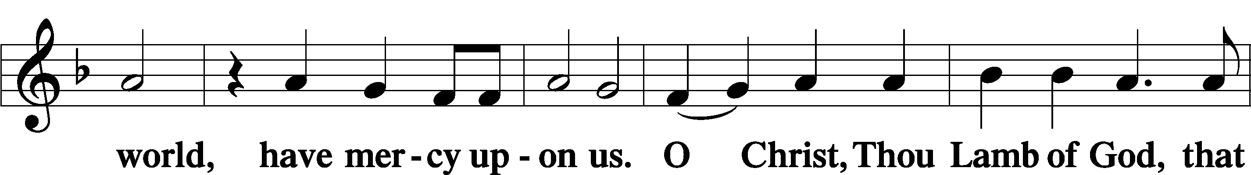

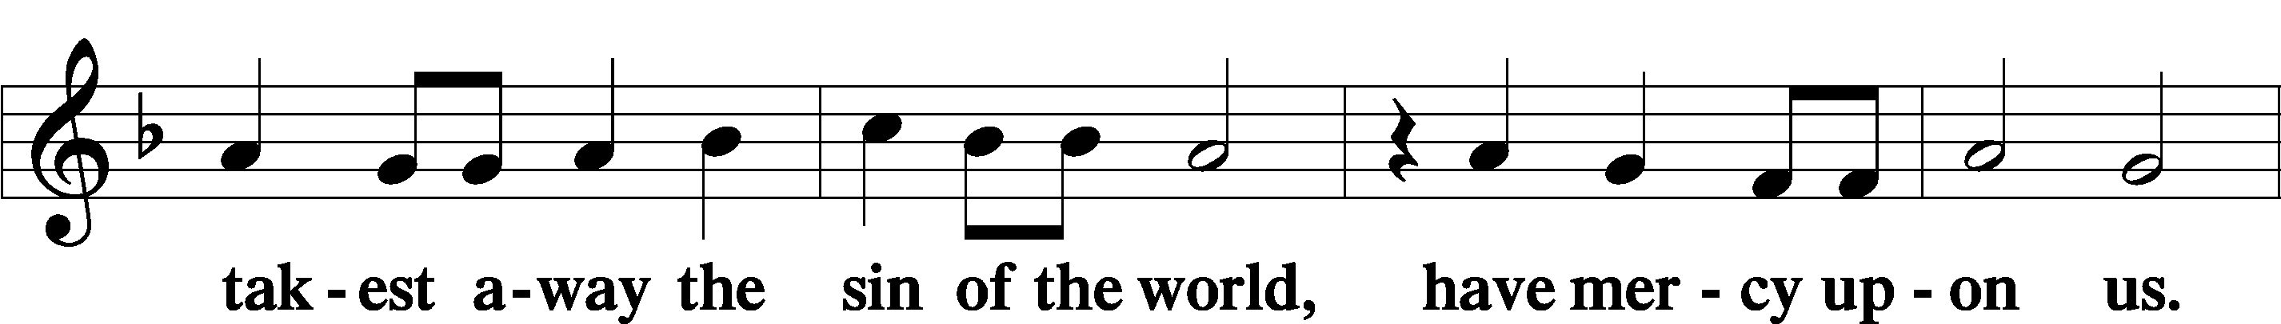

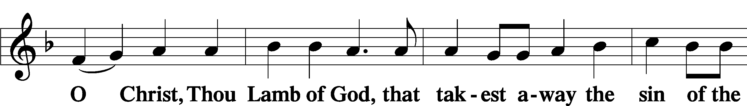

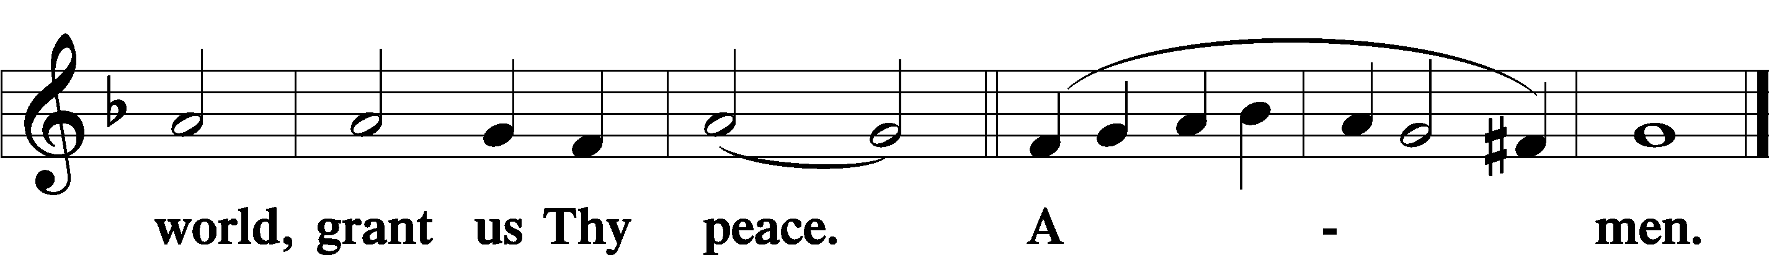

Sit

Distribution

633 At the Lamb’s High Feast We Sing

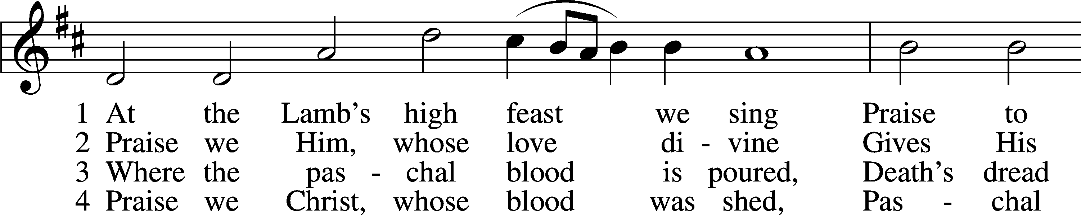

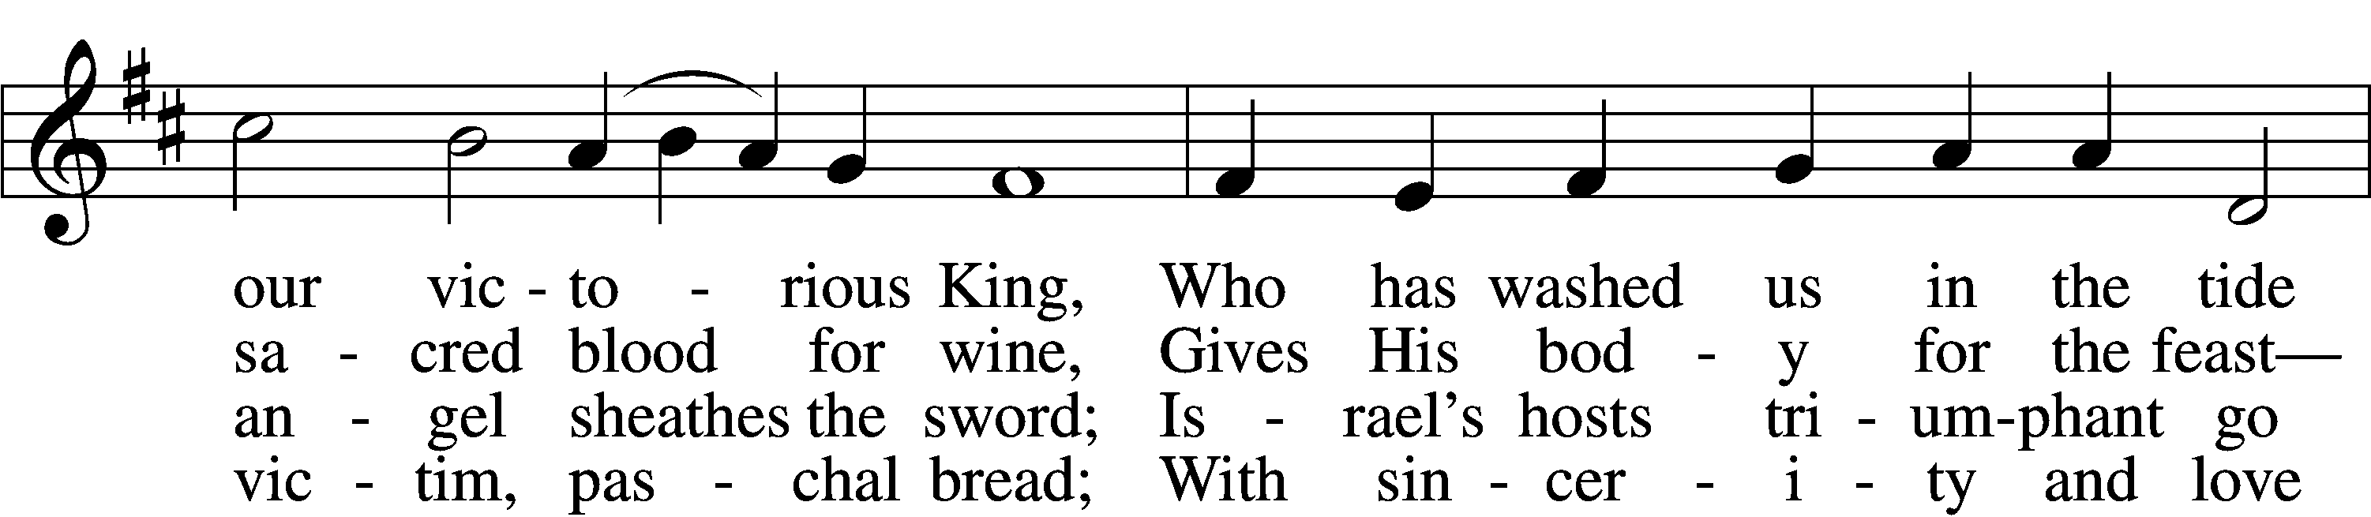

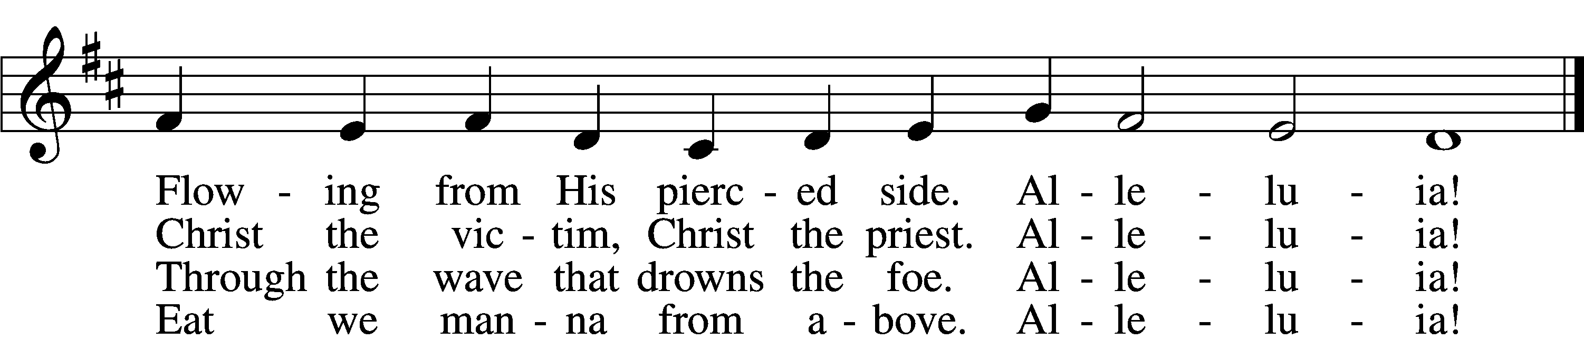

5 Mighty Victim from the sky,  
Hell’s fierce pow’rs beneath You lie;  
You have conquered in the fight,  
You have brought us life and light.  
 Alleluia!

6 Now no more can death appall,  
Now no more the grave enthrall;  
You have opened paradise,  
And Your saints in You shall rise.  
 Alleluia!

7 Easter triumph, Easter joy!  
This alone can sin destroy;  
From sin’s pow’r, Lord, set us free,  
Newborn souls in You to be.  
 Alleluia!

D 8 Father, who the crown shall give,  
Savior, by whose death we live,  
Spirit, guide through all our days:  
Three in One, Your name we praise.  
 Alleluia!

Text: Latin, c. 5th–10th cent.; tr. Robert Campbell, 1814–68, alt.  
Tune: Kirchengeseng, 1566, Ivancice  
Text and tune: Public domain

461 I Know That My Redeemer Lives

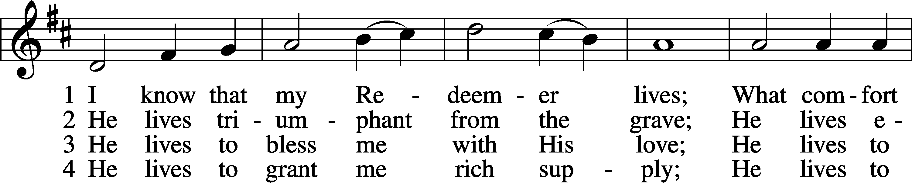

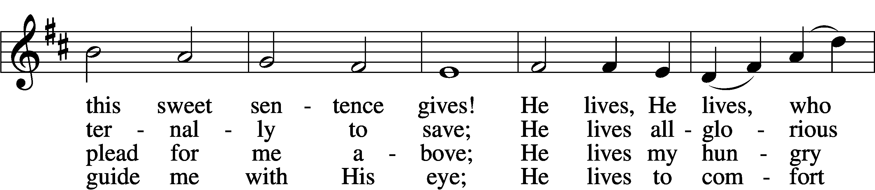

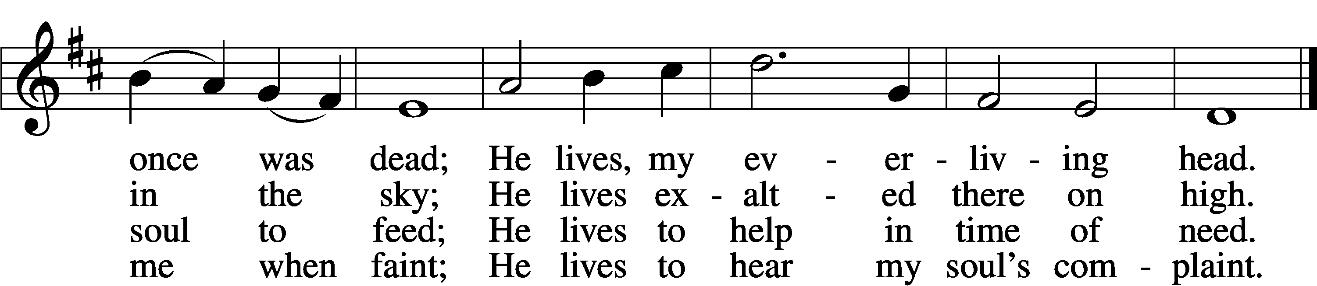

5 He lives to silence all my fears;  
He lives to wipe away my tears;  
He lives to calm my troubled heart;  
He lives all blessings to impart.

6 He lives, my kind, wise, heav’nly friend;  
He lives and loves me to the end;  
He lives, and while He lives, I’ll sing;  
He lives, my Prophet, Priest, and King.

7 He lives and grants me daily breath;  
He lives, and I shall conquer death;  
He lives my mansion to prepare;  
He lives to bring me safely there.

8 He lives, all glory to His name!  
He lives, my Jesus, still the same;  
Oh, the sweet joy this sentence gives:  
I know that my Redeemer lives!

Text: Samuel Medley, 1738–99, abr.  
Tune: attr. John C. Hatton, d. 1793  
Text and tune: Public domain

477 Alleluia, Alleluia! Hearts to Heaven

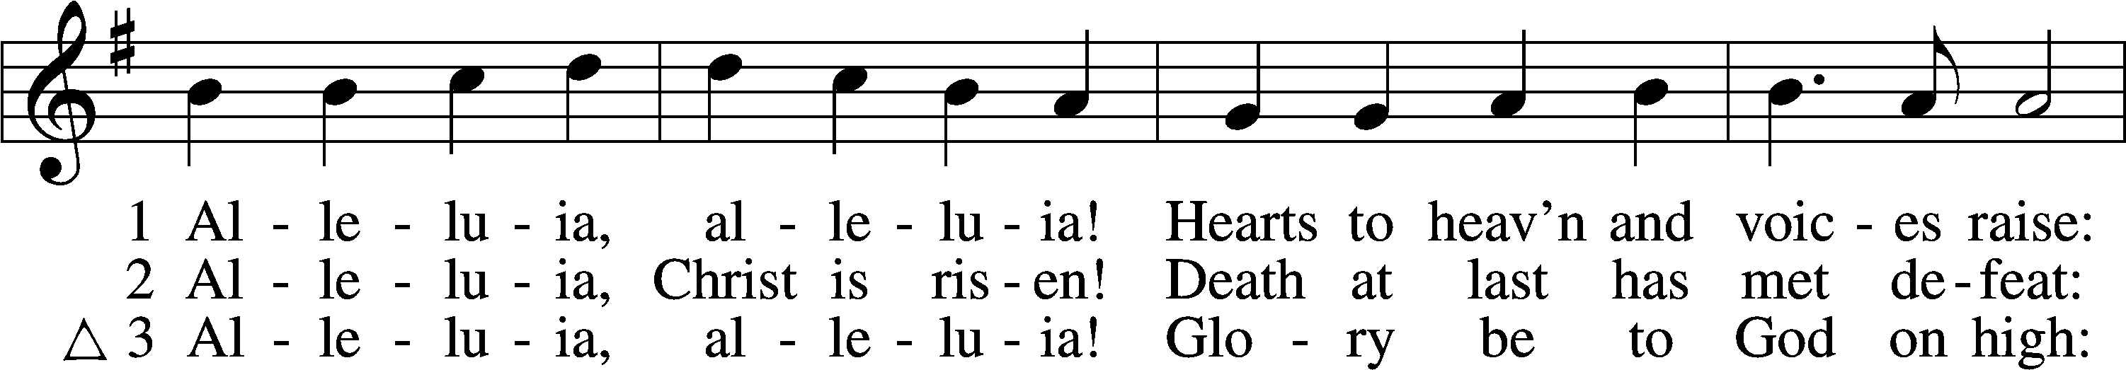

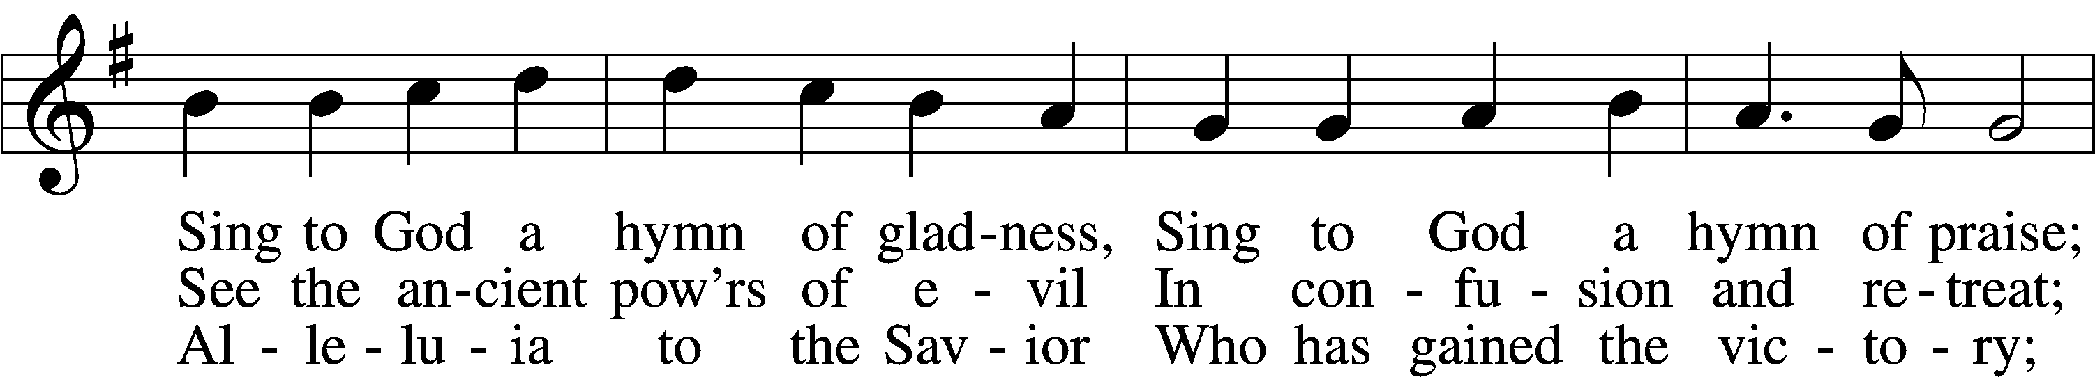

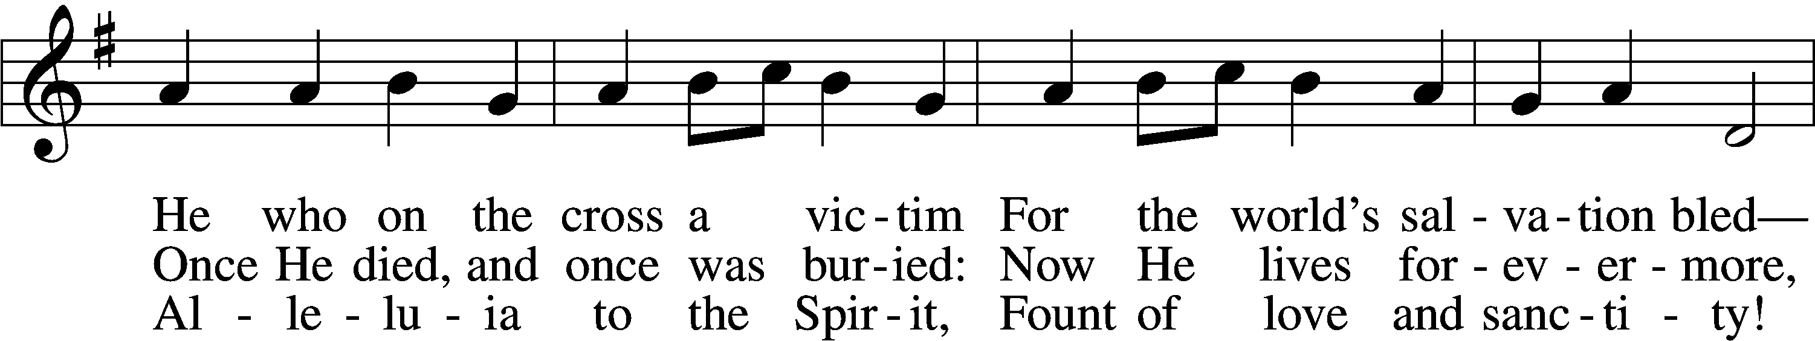

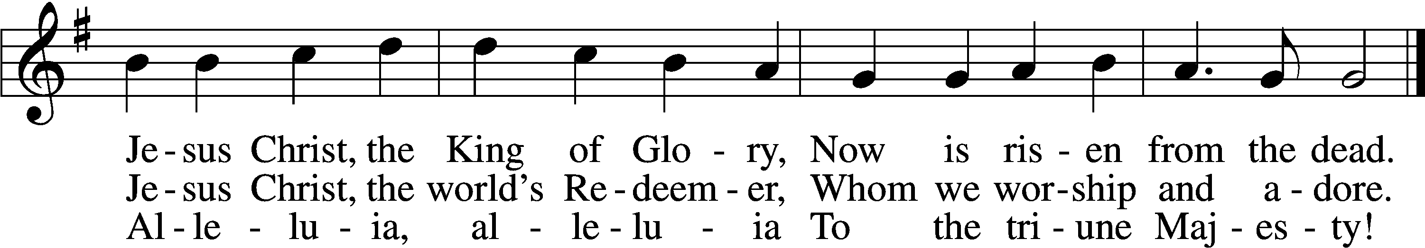

Text (sts. 1, 3): Christopher Wordsworth, 1807–85; (st. 2): rev. The Jubilate Group  
Tune: Ludwig van Beethoven, 1770–1827; adapt. Edward Hodges, 1796–1867  
Text (st. 2): © 1982 The Jubilate Group, admin. Hope Publishing Co. Used by permission: LSB Hymn License no. 110005011  
Text (sts. 1, 3) and tune: Public domain

478 The Day of Resurrection

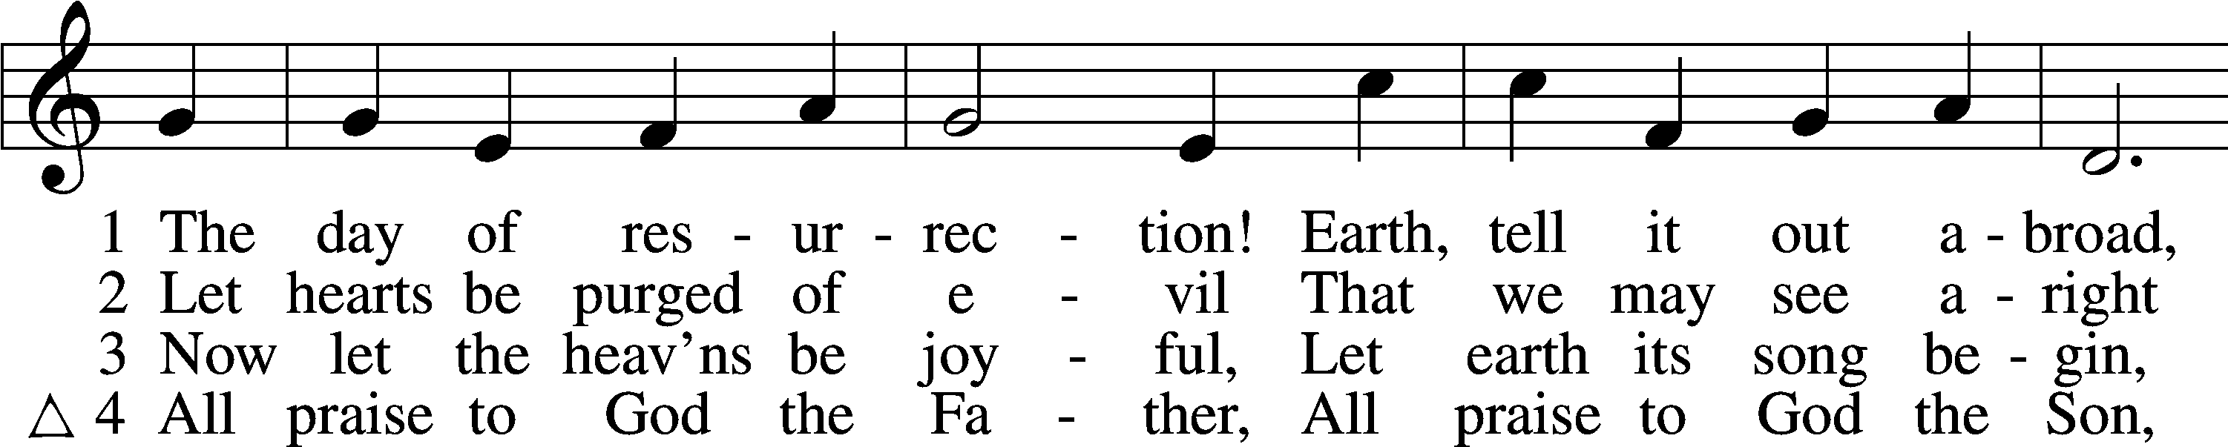

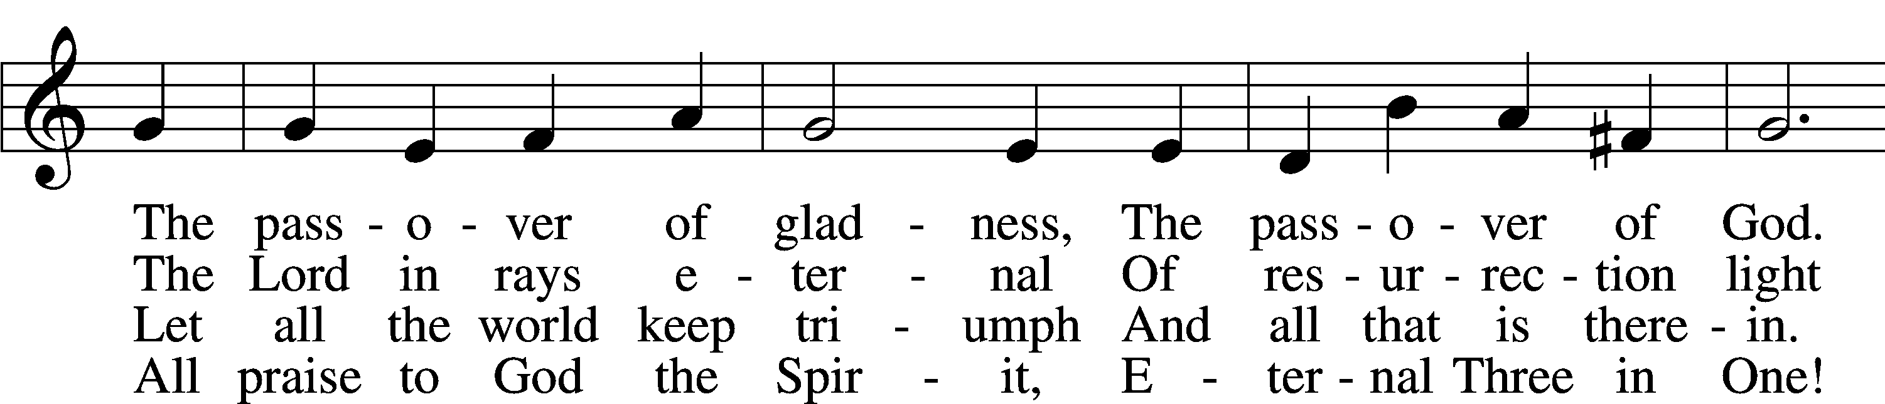

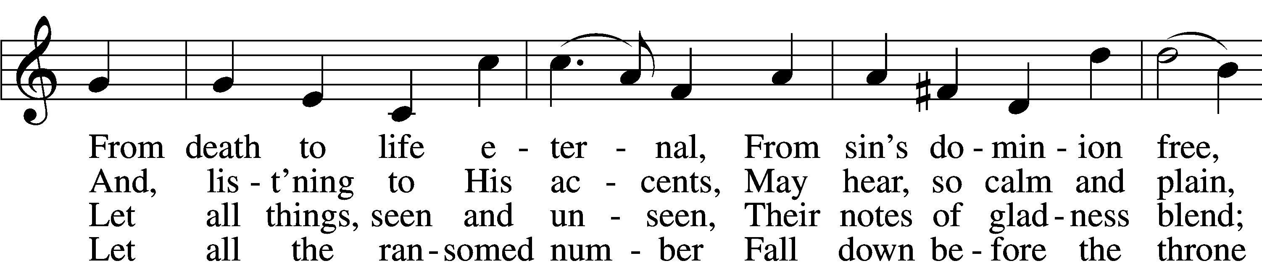

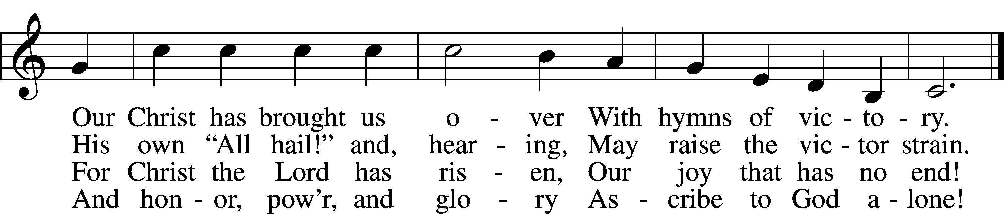

Text: John of Damascus, c. 696–c. 754; tr. John Mason Neale, 1818–66, alt.  
Tune: Henry T. Smart, 1813–79  
Text and tune: Public domain

The Dismissal

P The body and blood of our Lord Jesus Christ strengthen and preserve you in body and soul to life everlasting. Depart T in peace.

C **Amen.**

Stand

Nunc Dimittis Luke 2:29–32

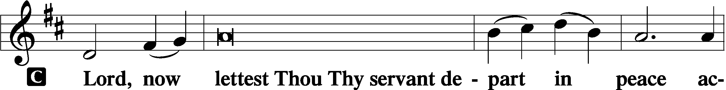

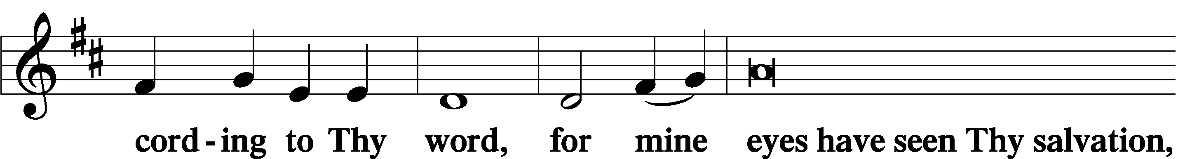

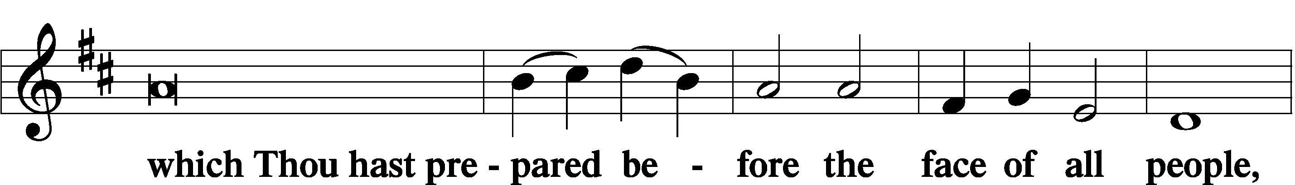

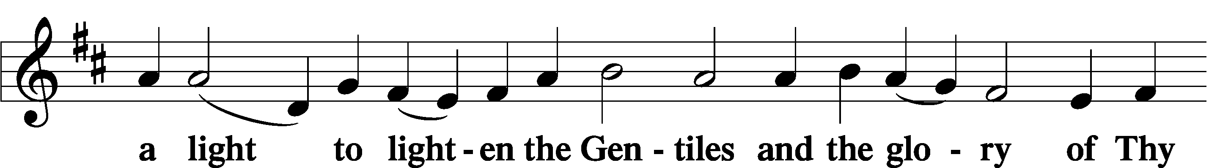

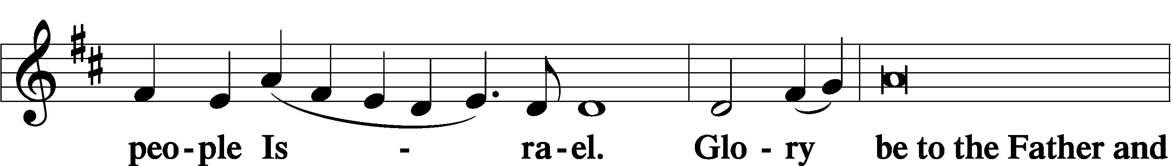

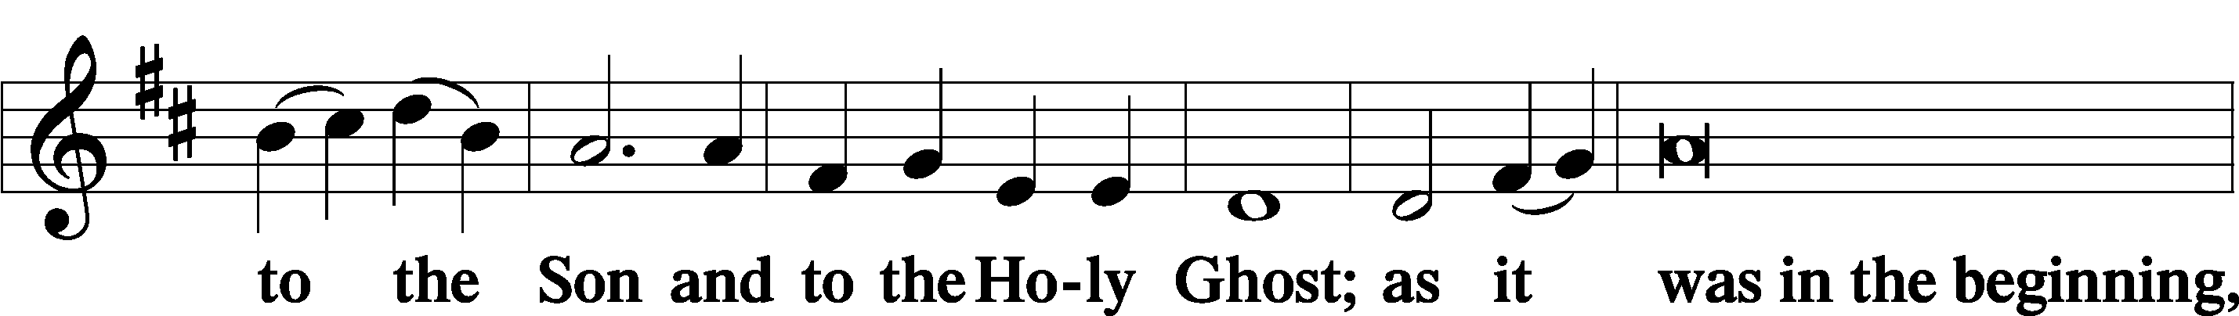

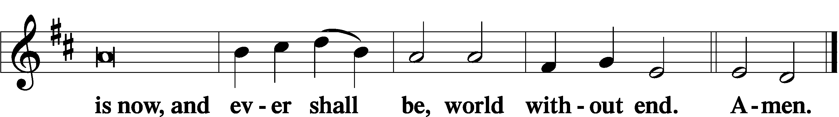

Thanksgiving Psalm 107:1

A O give thanks unto the Lord, for He is good,

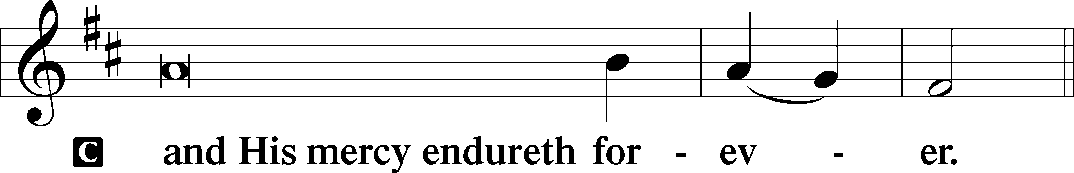

Post-Communion Collect

A Let us pray.

We give thanks to You, almighty God, that You have refreshed us through this salutary gift, and we implore You that of Your mercy You would strengthen us through the same in faith toward You and in fervent love toward one another; through Jesus Christ, Your Son, our Lord, who lives and reigns with You and the Holy Spirit, one God, now and forever.

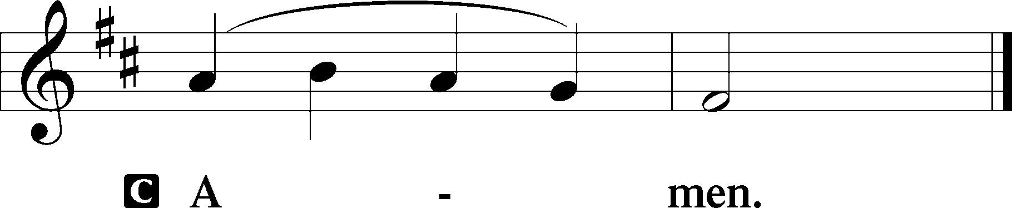

Salutation 2 Timothy 4:22

P The Lord be with you.

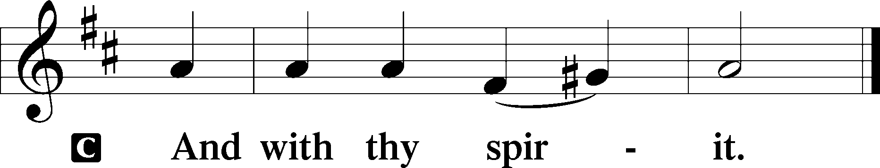

Benedicamus Psalm 103:1

A Bless we the Lord.

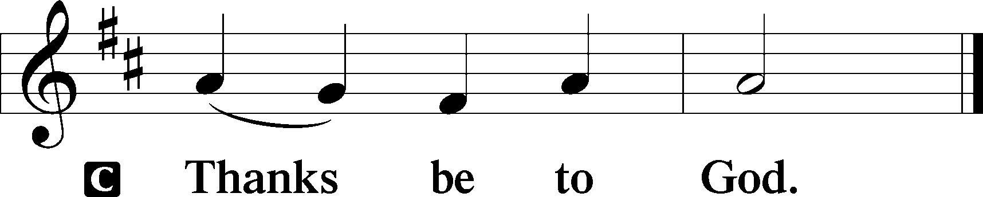

Benediction Numbers 6:24–26

P The Lord bless you and keep you.

The Lord make His face shine upon you and be gracious unto you.

The Lord lift up His countenance upon you and T give you peace.

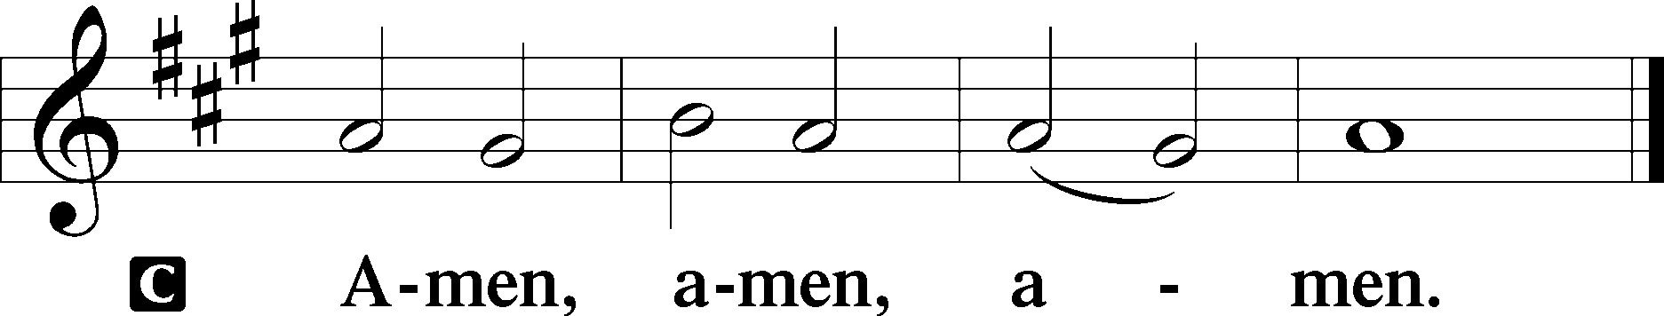

457 Jesus Christ Is Risen Today

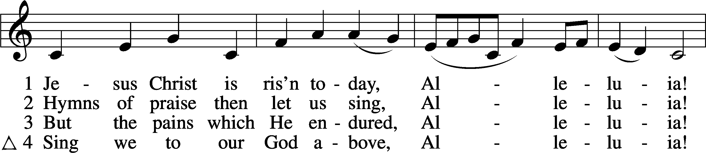

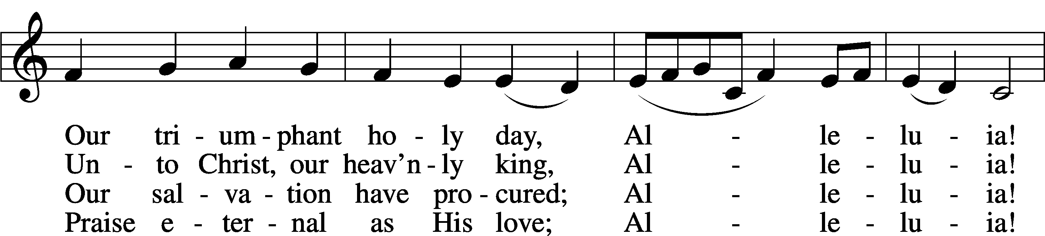

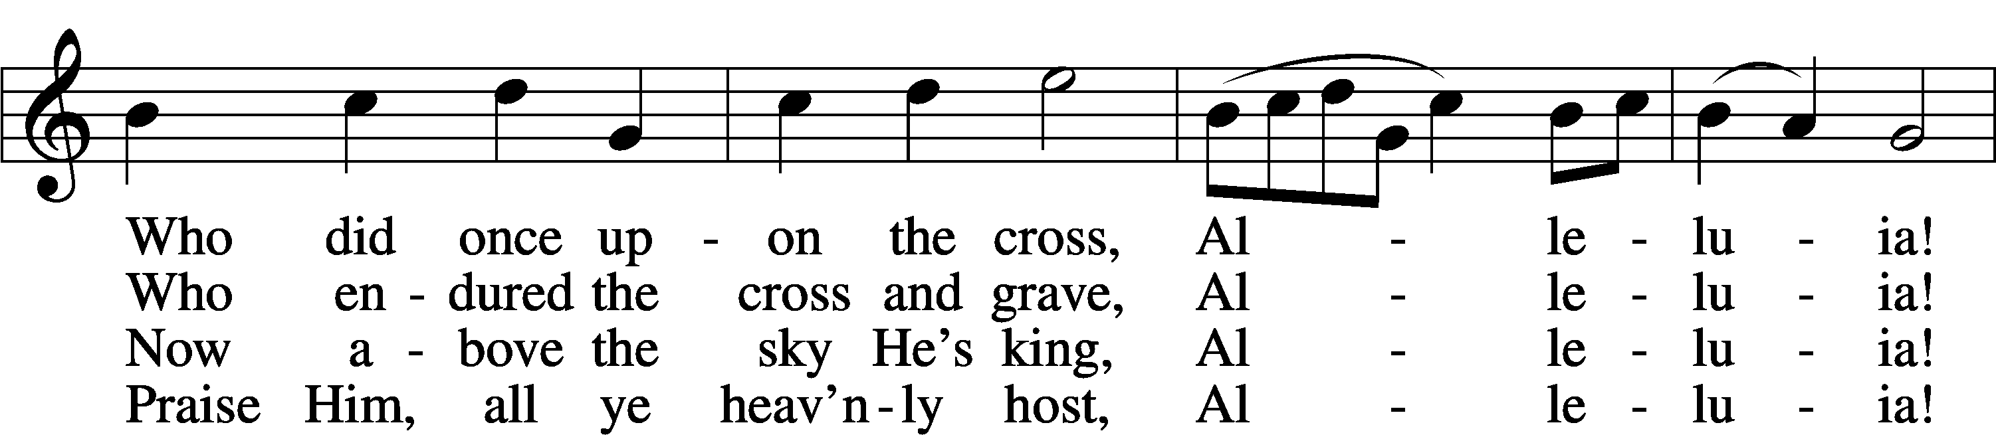

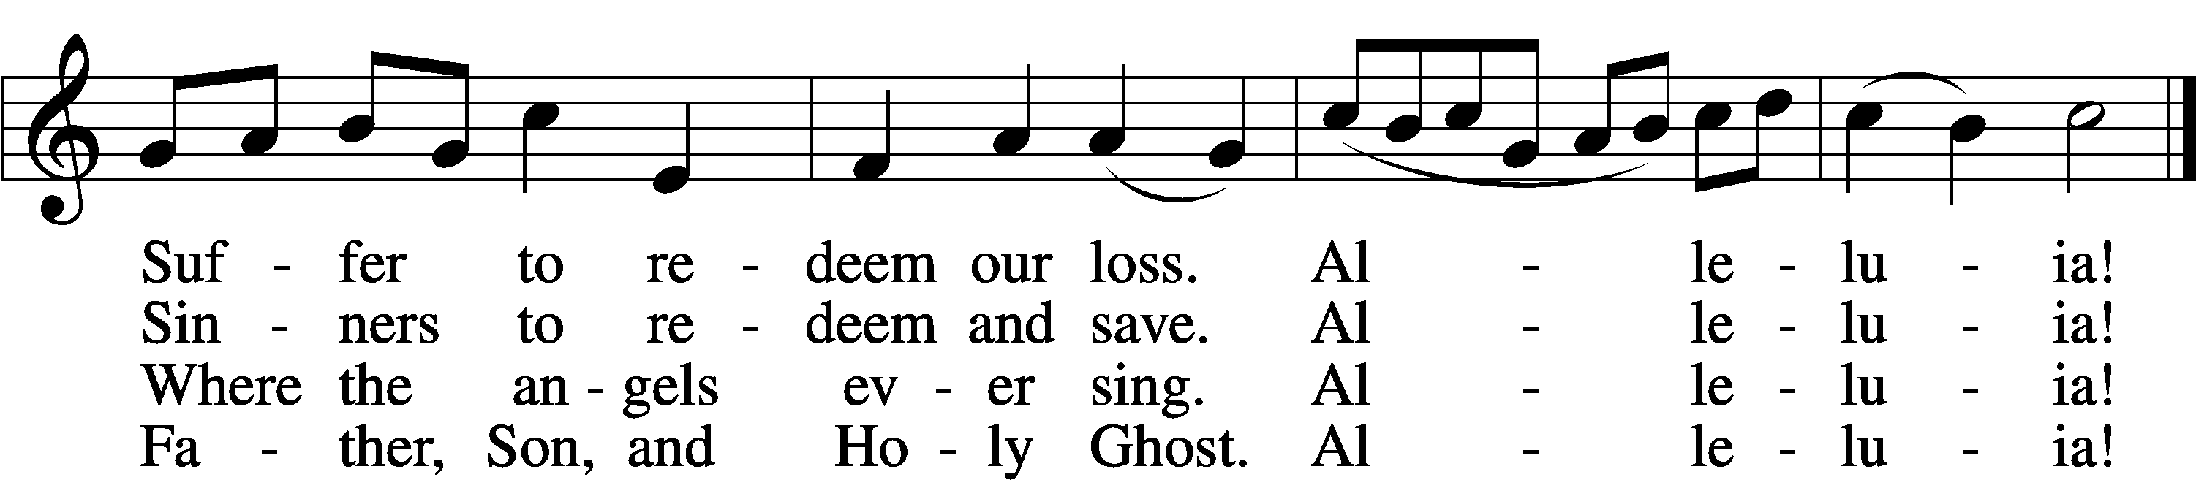

Text: tr. Lyra Davidica, 1708, London, alt.; (sts. 1–3): Latin, 14th cent.; (st. 4): Charles Wesley, 1707–88  
Tune: Lyra Davidica, 1708, London  
Text and tune: Public domain

Acknowledgments

Divine Service, Setting Three from Lutheran Service Book

Unless otherwise indicated, Scripture quotations are from the ESV® Bible (The Holy Bible, English Standard Version®), copyright © 2001 by Crossway, a publishing ministry of Good News Publishers. Used by permission. All rights reserved. Created by Lutheran Service Builder © 2023 Concordia Publishing House.

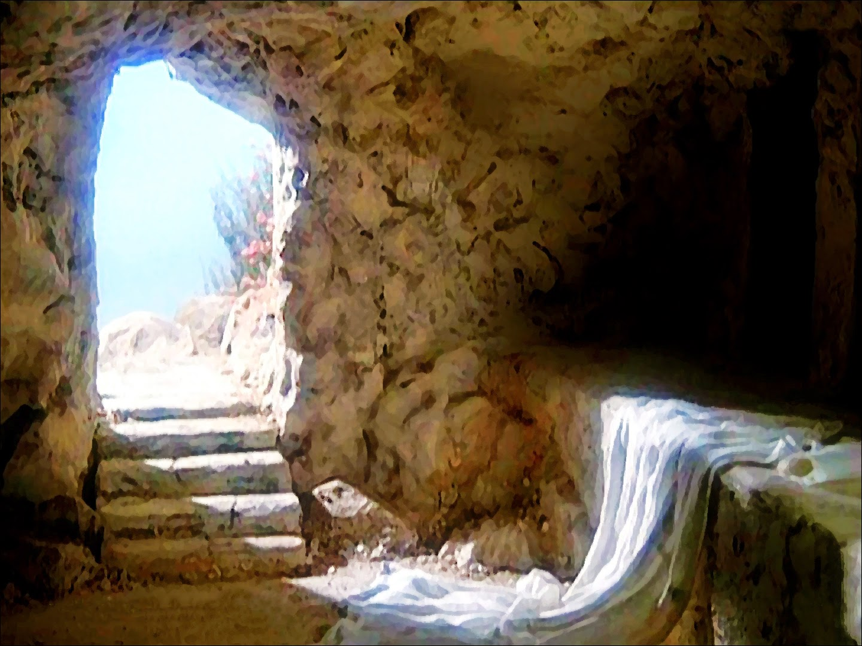

. *He Is Risen*