464 The Strife Is O’er, the Battle Done
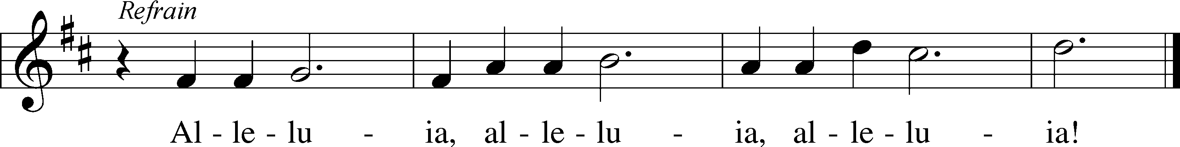
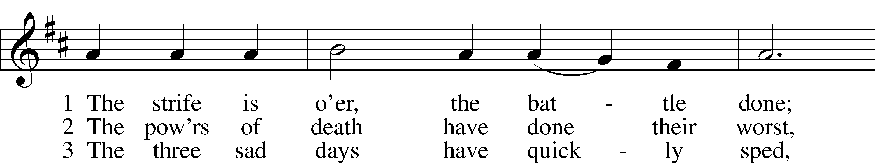
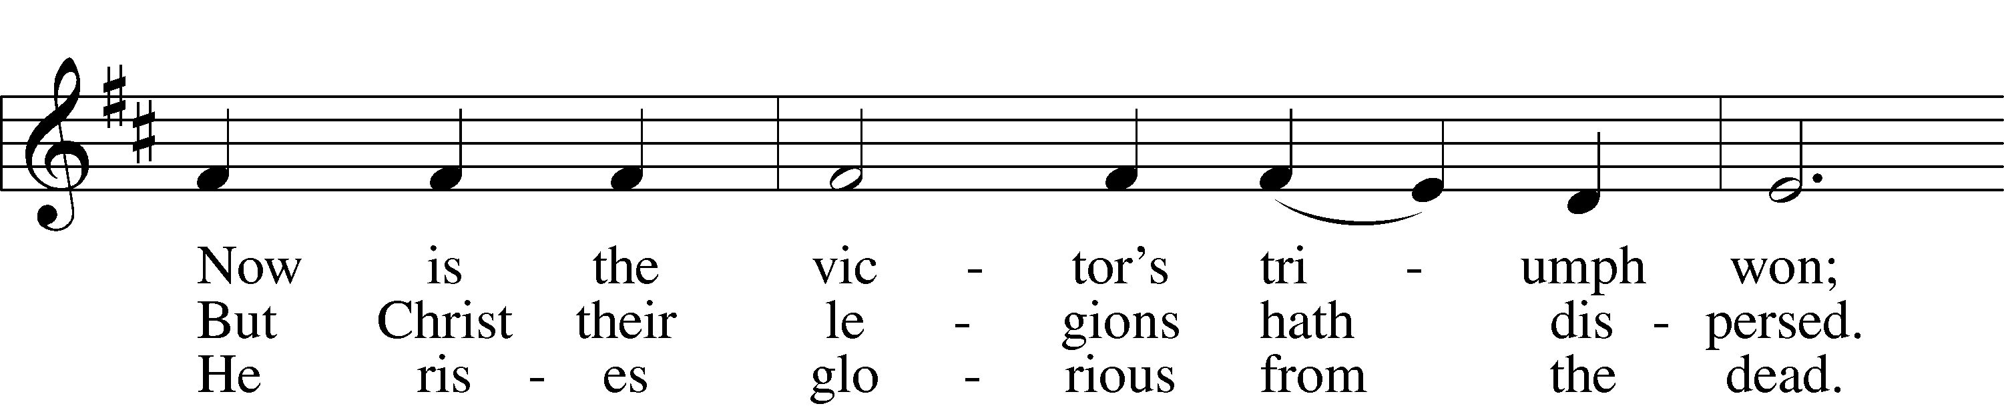
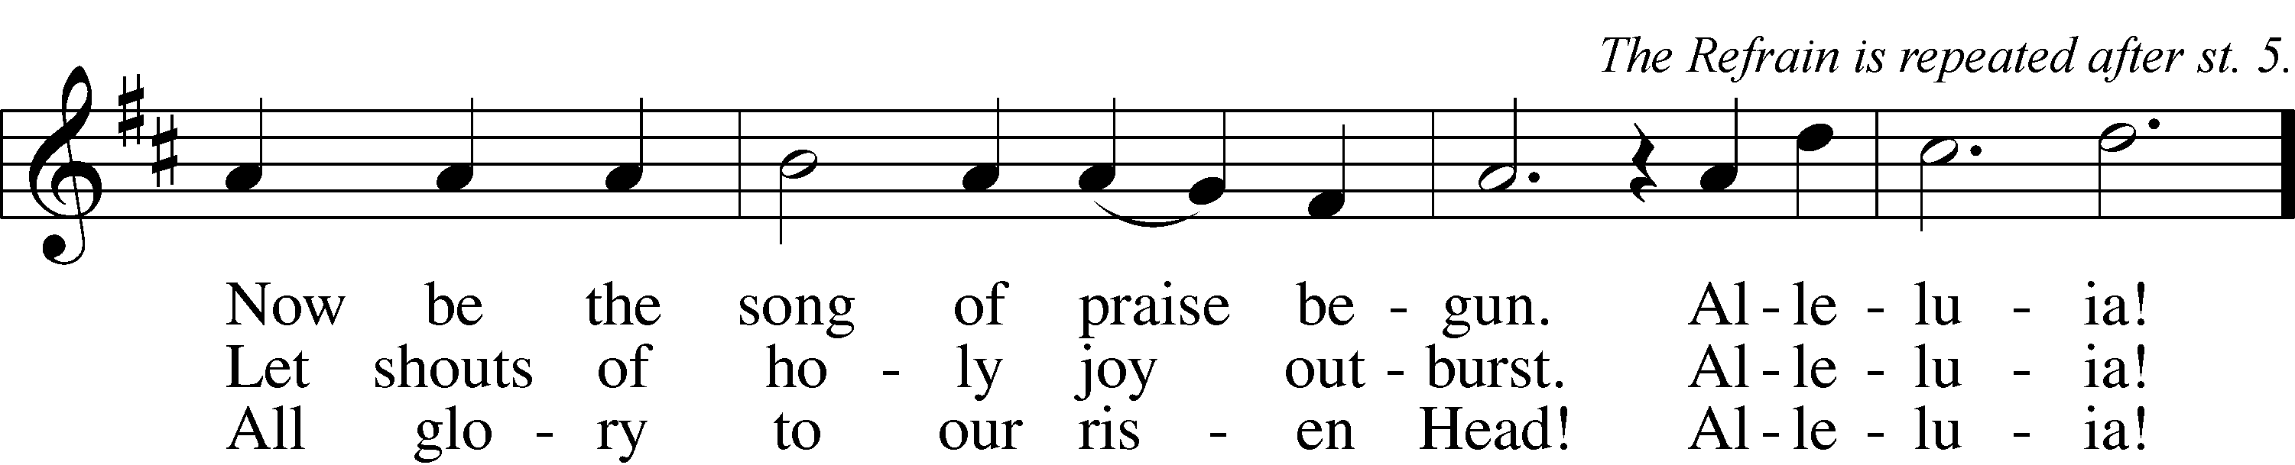

4 He broke the age-bound chains of hell;
The bars from heav’n’s high portals fell.
Let hymns of praise His triumph tell.
Alleluia!

5 Lord, by the stripes which wounded Thee,
From death’s dread sting Thy servants free
That we may live and sing to Thee.
Alleluia! Refrain
Text: Symphonia Sirenum Selectarum, 1695, Köln; tr. Francis Pott, 1832–1909, alt.
Tune: Giovanni P. da Palestrina, c. 1525–1594, adapt.
Text and tune: Public domain

Confession and Absolution

Stand

The sign of the cross may be made by all in remembrance of their Baptism.

Invocation Matthew 28:19b; 18:20
P In the name of the Father and of the T Son and of the Holy Spirit.
C Amen.

Exhortation Psalm 124:8; Psalm 130:3–4; Luke 18:13
P Our help is in the name of the Lord,
C who made heaven and earth.

P If You, O Lord, kept a record of sins, O Lord, who could stand?
C But with You there is forgiveness; therefore You are feared.

P Since we are gathered to hear God’s Word, call upon Him in prayer and praise, and receive the body and blood of our Lord Jesus Christ in the fellowship of this altar, let us first consider our unworthiness and confess before God and one another that we have sinned in thought, word, and deed, and that we cannot free ourselves from our sinful condition. Together as His people let us take refuge in the infinite mercy of God, our heavenly Father, seeking His grace for the sake of Christ, and saying: God, be merciful to me, a sinner.

Kneel/Stand

Confession of Sins
C Almighty God, have mercy upon us, forgive us our sins, and lead us to everlasting life. Amen.

Prayer for Forgiveness
P Almighty God, merciful Father, in Holy Baptism You declared us to be Your children and gathered us into Your one, holy Church, in which You daily and richly forgive us our sins and grant us new life through Your Spirit. Be in our midst, enliven our faith, and graciously receive our prayer and praise; through Your Son, Jesus Christ, our Lord.
C Amen.

Stand

Service of the Word

Introit Psalm 105:1–5, 8; antiphon: 1 Peter 2:2–3
Like newborn infants, long for the pure spiritual milk, that by it you may grow up to salvation—
if indeed you have tasted that the Lord is good.
Oh give thanks to the Lord; call upon his name;
make known his deeds among the peoples!
Sing to him, sing praises to him;
tell of all his wondrous works!
Glory in his holy name;
let the hearts of those who seek the Lord rejoice!
Seek the Lord and his strength;
seek his presence continually!
Remember the wondrous works that he has done,
his miracles, and the judgments he uttered.
He remembers his covenant forever,
the word that he commanded, for a thousand generations.

Kyrie Mark 10:47
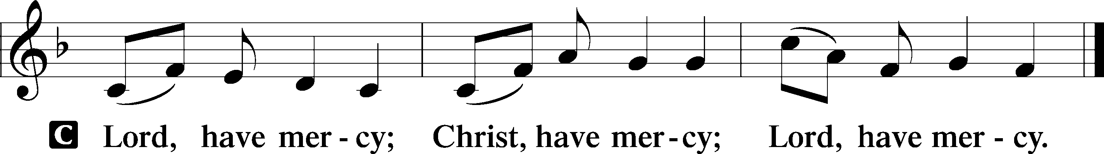

Gloria in Excelsis Luke 2:14; John 1:29
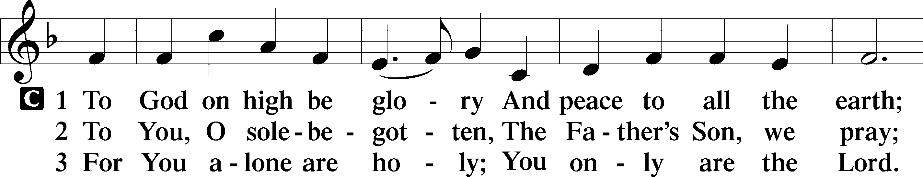
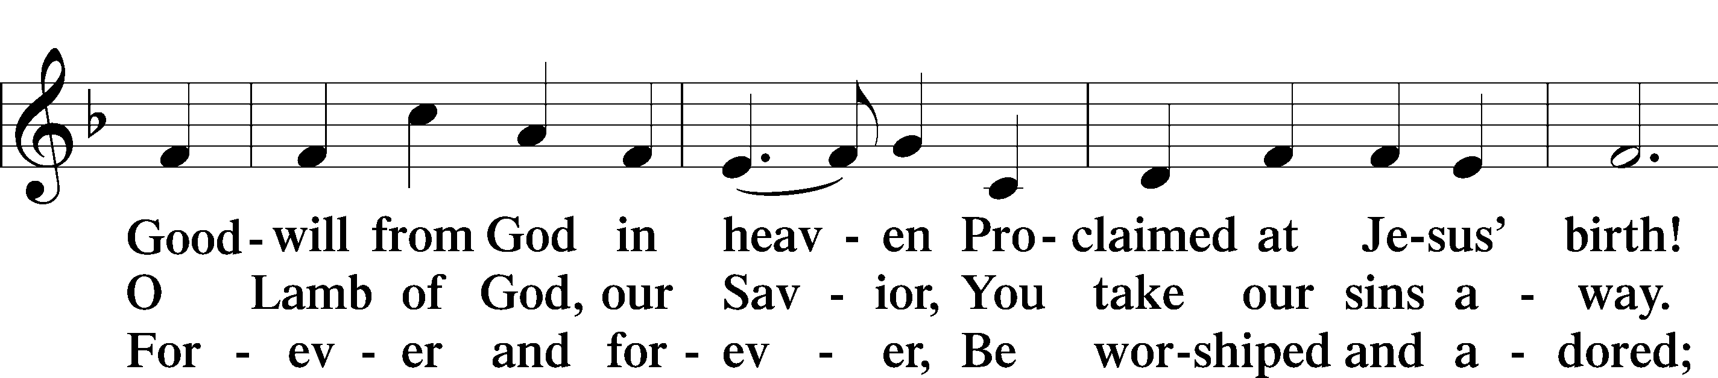
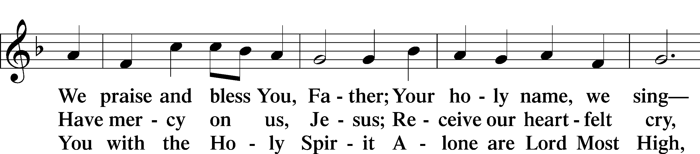
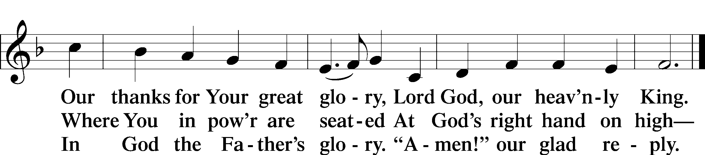
Text: Stephen P. Starke

Salutation and Collect of the Day
P The Lord be with you.
C And also with you.

P Let us pray.
Almighty God, grant that we who have celebrated the Lord’s resurrection may by Your grace confess in our life and conversation that Jesus is Lord and God; through the same Jesus Christ, Your Son, who lives and reigns with You and the Holy Spirit, one God, now and forever.

C Amen.

Sit

First Reading Acts 5:29–42
29But Peter and the apostles answered, “We must obey God rather than men. 30The God of our fathers raised Jesus, whom you killed by hanging him on a tree. 31God exalted him at his right hand as Leader and Savior, to give repentance to Israel and forgiveness of sins. 32And we are witnesses to these things, and so is the Holy Spirit, whom God has given to those who obey him.”
33When they heard this, they were enraged and wanted to kill them. 34But a Pharisee in the council named Gamaliel, a teacher of the law held in honor by all the people, stood up and gave orders to put the men outside for a little while. 35And he said to them, “Men of Israel, take care what you are about to do with these men. 36For before these days Theudas rose up, claiming to be somebody, and a number of men, about four hundred, joined him. He was killed, and all who followed him were dispersed and came to nothing. 37After him Judas the Galilean rose up in the days of the census and drew away some of the people after him. He too perished, and all who followed him were scattered. 38So in the present case I tell you, keep away from these men and let them alone, for if this plan or this undertaking is of man, it will fail; 39but if it is of God, you will not be able to overthrow them. You might even be found opposing God!” So they took his advice, 40and when they had called in the apostles, they beat them and charged them not to speak in the name of Jesus, and let them go. 41Then they left the presence of the council, rejoicing that they were counted worthy to suffer dishonor for the name. 42And every day, in the temple and from house to house, they did not cease teaching and preaching Jesus as the Christ.

A This is the Word of the Lord.
C Thanks be to God.

Gradual adapt. from Matthew 28:7; Hebrews 2:7; Psalm 8:6
Christ has risen from the dead.
[God the Father] has crowned him with glory and honor.
He has given him dominion over the works of his hands;
he has put all things under his feet.

Epistle 1 Peter 1:3–9
Born Again to a Living Hope
3Blessed be the God and Father of our Lord Jesus Christ! According to his great mercy, he has caused us to be born again to a living hope through the resurrection of Jesus Christ from the dead, 4to an inheritance that is imperishable, undefiled, and unfading, kept in heaven for you, 5who by God’s power are being guarded through faith for a salvation ready to be revealed in the last time. 6In this you rejoice, though now for a little while, if necessary, you have been grieved by various trials, 7so that the tested genuineness of your faith—more precious than gold that perishes though it is tested by fire—may be found to result in praise and glory and honor at the revelation of Jesus Christ. 8Though you have not seen him, you love him. Though you do not now see him, you believe in him and rejoice with joy that is inexpressible and filled with glory, 9obtaining the outcome of your faith, the salvation of your souls.

A This is the Word of the Lord.
C Thanks be to God.

Stand

Alleluia and Verse

Alleluia
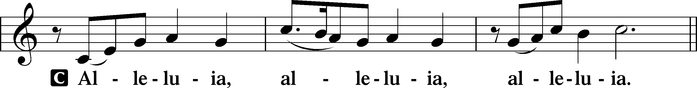

Verse John 20:31
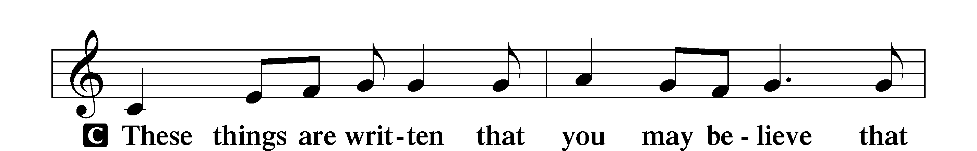
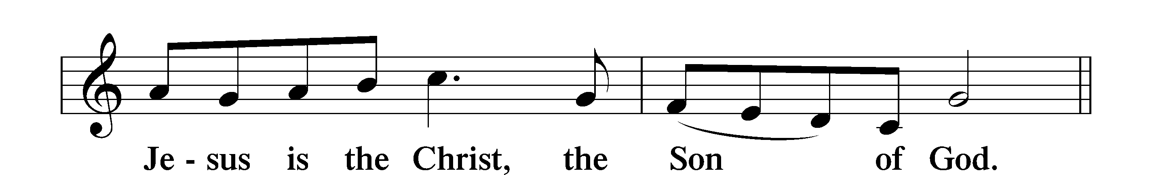

Alleluia
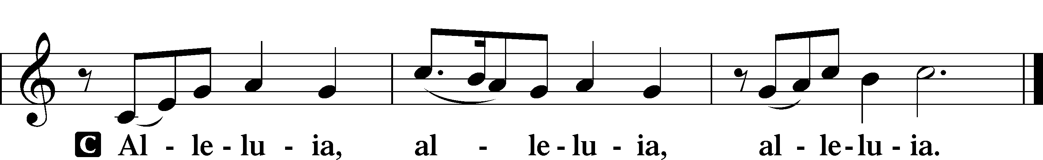

Holy Gospel John 20:19–31
P The Holy Gospel according to St. John, the twentieth chapter.
C Glory to You, O Lord.

Jesus Appears to the Disciples
19On the evening of that day, the first day of the week, the doors being locked where the disciples were for fear of the Jews, Jesus came and stood among them and said to them, “Peace be with you.” 20When he had said this, he showed them his hands and his side. Then the disciples were glad when they saw the Lord. 21Jesus said to them again, “Peace be with you. As the Father has sent me, even so I am sending you.” 22And when he had said this, he breathed on them and said to them, “Receive the Holy Spirit. 23If you forgive the sins of anyone, they are forgiven; if you withhold forgiveness from anyone, it is withheld.”
Jesus and Thomas
24Now Thomas, one of the Twelve, called the Twin, was not with them when Jesus came. 25So the other disciples told him, “We have seen the Lord.” But he said to them, “Unless I see in his hands the mark of the nails, and place my finger into the mark of the nails, and place my hand into his side, I will never believe.”
26Eight days later, his disciples were inside again, and Thomas was with them. Although the doors were locked, Jesus came and stood among them and said, “Peace be with you.” 27Then he said to Thomas, “Put your finger here, and see my hands; and put out your hand, and place it in my side. Do not disbelieve, but believe.” 28Thomas answered him, “My Lord and my God!” 29Jesus said to him, “Have you believed because you have seen me? Blessed are those who have not seen and yet have believed.”
The Purpose of This Book
30Now Jesus did many other signs in the presence of the disciples, which are not written in this book; 31but these are written so that you may believe that Jesus is the Christ, the Son of God, and that by believing you may have life in his name.

P This is the Gospel of the Lord.
C Praise to You, O Christ.

Nicene Creed
C I believe in one God,
the Father Almighty,
maker of heaven and earth
and of all things visible and invisible.

And in one Lord Jesus Christ,
the only-begotten Son of God,
begotten of His Father before all worlds,
God of God, Light of Light,
very God of very God,
begotten, not made,
being of one substance with the Father,
by whom all things were made;
who for us men and for our salvation came down from heaven
and was incarnate by the Holy Spirit of the virgin Mary
and was made man;
and was crucified also for us under Pontius Pilate.
He suffered and was buried.
And the third day He rose again according to the Scriptures
and ascended into heaven
and sits at the right hand of the Father.
And He will come again with glory to judge both the living and the dead,
whose kingdom will have no end.

And I believe in the Holy Spirit,
the Lord and giver of life,
who proceeds from the Father and the Son,
who with the Father and the Son together is worshiped and glorified,
who spoke by the prophets.
And I believe in one holy Christian and apostolic Church,
I acknowledge one Baptism for the remission of sins,
and I look for the resurrection of the dead
and the life T of the world to come. Amen.

Sit

Children's Message

470 O Sons and Daughters of the King sts. 1–5
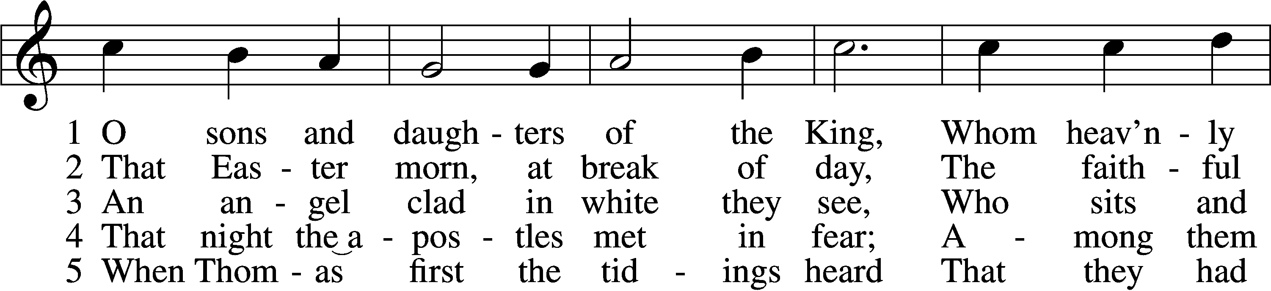
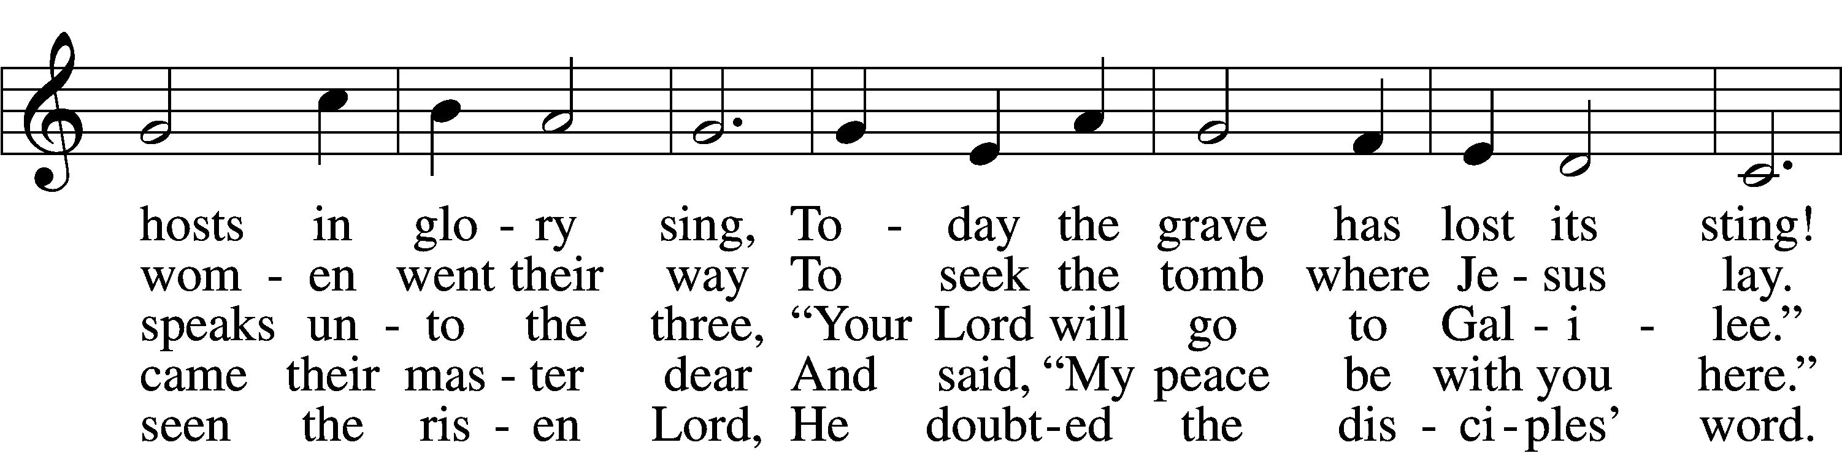
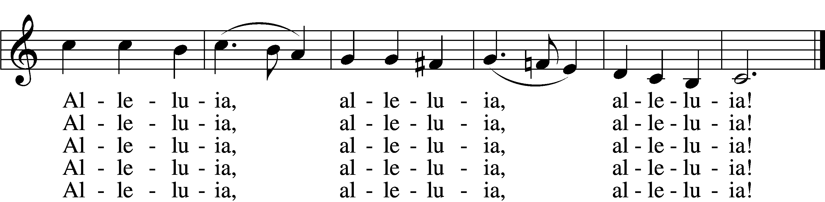
Text: attr. Jean Tisserand, d. 1494; tr. John Mason Neale, 1818–66, alt.
Tune: Melchior Vulpius, c. 1570–1615
Text and tune: Public domain

Sermon

470 O Sons and Daughters of the King sts. 6–9
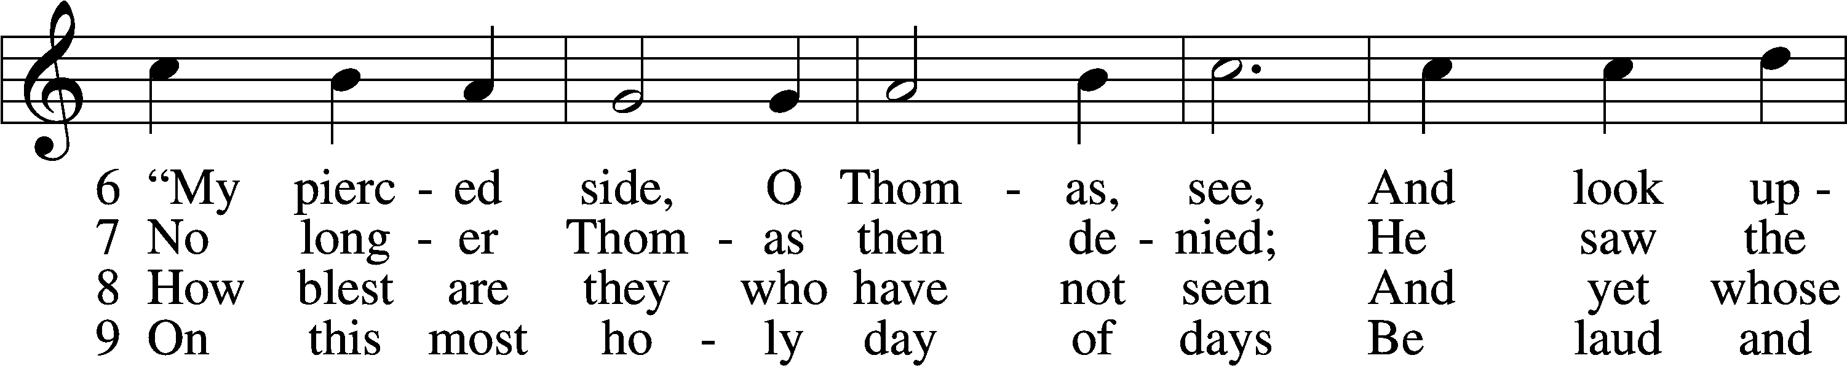
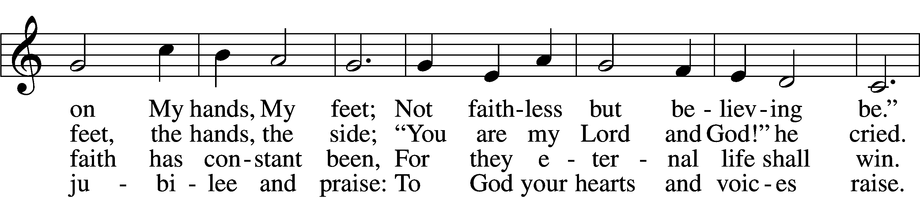
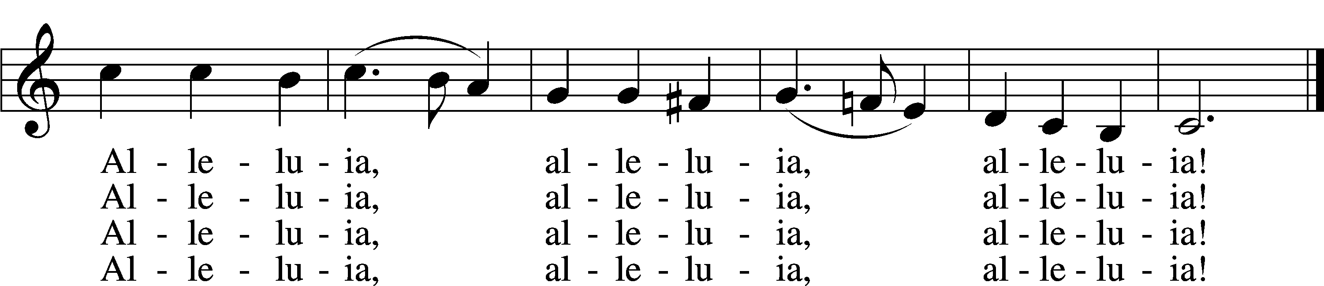
Text: attr. Jean Tisserand, d. 1494; tr. John Mason Neale, 1818–66, alt.
Tune: Melchior Vulpius, c. 1570–1615
Text and tune: Public domain

Stand

Prayer of the Church

Sit

Offering

805 Praise God, from Whom All Blessings Flow
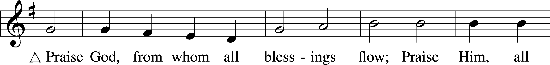
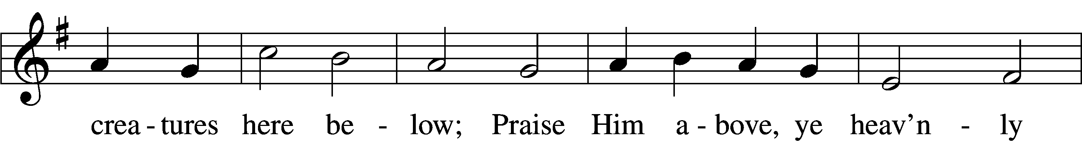
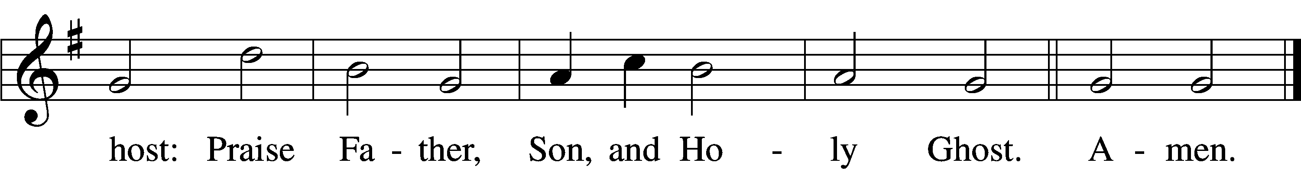
Text: Thomas Ken, 1637–1711
Tune: Trente quatre Pseaumes de David, 1551, Geneva, ed. Louis Bourgeois
Text and tune: Public domain

Service of the Sacrament

Stand

Preface 2 Timothy 4:22; [Colossians 3:1]; [Psalm 136]
P The Lord be with you.
C And also with you.

P Lift up your hearts.
C We lift them to the Lord.

P Let us give thanks to the Lord our God.
C It is right to give Him thanks and praise.

P It is truly good, right, and salutary that we should at all times and in all places give thanks to You, O Lord, holy Father, almighty and everlasting God, for the countless blessings You so freely bestow on us and all creation. Above all, we give thanks for Your boundless love shown to us when You sent Your only-begotten Son, Jesus Christ, into our flesh and laid on Him our sin, giving Him into death that we might not die eternally. Because He is now risen from the dead and lives and reigns to all eternity, all who believe in Him will overcome sin and death and will rise again to new life. Therefore with angels and archangels and with all the company of heaven we laud and magnify Your glorious name, evermore praising You and saying:

Sanctus Isaiah 6:3; Matthew 21:9
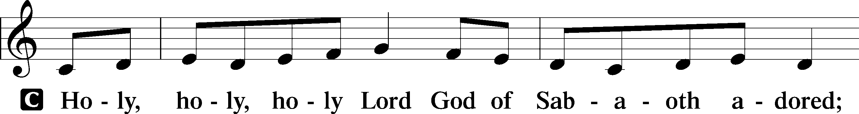
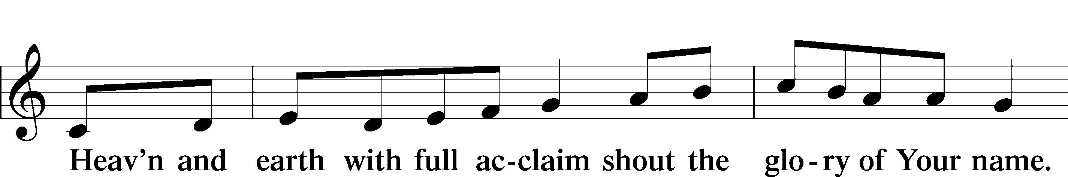
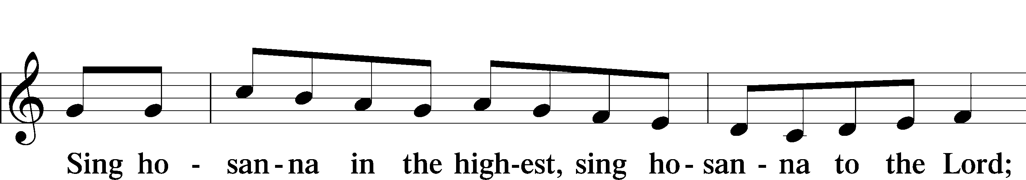
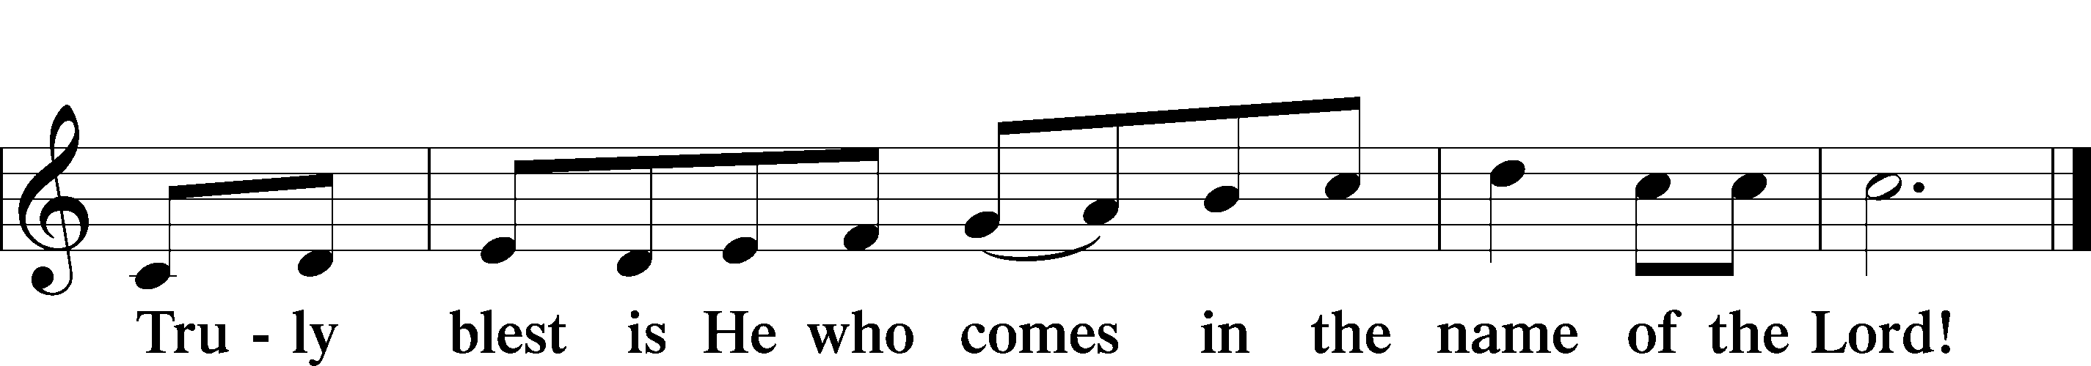
Text: Stephen P. Starke

Prayer of Thanksgiving
P Blessed are You, O Lord our God, king of all creation, for You have had mercy on us and given Your only-begotten Son that whoever believes in Him should not perish but have eternal life.

For Christ, our Passover Lamb, has been sacrificed. By His death, He has redeemed us from bondage to sin and death, and by His resurrection, He has delivered us into new life in Him.

Grant us to keep the Feast in sincerity and truth, faithfully eating His body given into death and drinking His life’s blood poured out for our salvation until we pass through death to the promised land of life eternal.

Hear us as we pray in His name and as He has taught us:

Lord’s Prayer
C Our Father who art in heaven,
hallowed be Thy name,
Thy kingdom come,
Thy will be done on earth
as it is in heaven;
give us this day our daily bread;
and forgive us our trespasses
as we forgive those
who trespass against us;
and lead us not into temptation,
but deliver us from evil.
For Thine is the kingdom
and the power and the glory
forever and ever. Amen.

The Words of Our Lord
P Our Lord Jesus Christ, on the night when He was betrayed, took bread, and when He had given thanks, He broke it and gave it to the disciples and said: “Take, eat; this is My T body, which is given for you. This do in remembrance of Me.”

In the same way also He took the cup after supper, and when He had given thanks, He gave it to them, saying: “Drink of it, all of you; this cup is the new testament in My T blood, which is shed for you for the forgiveness of sins. This do, as often as you drink it, in remembrance of Me.”

Pax Domini
P The peace of the Lord be with you always.
C Amen.

Agnus Dei John 1:29
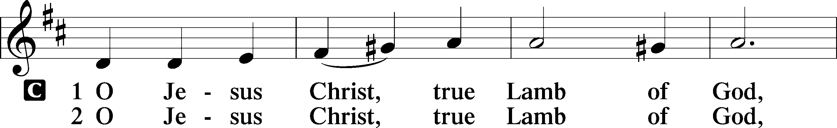
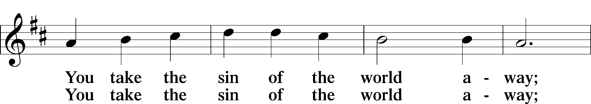
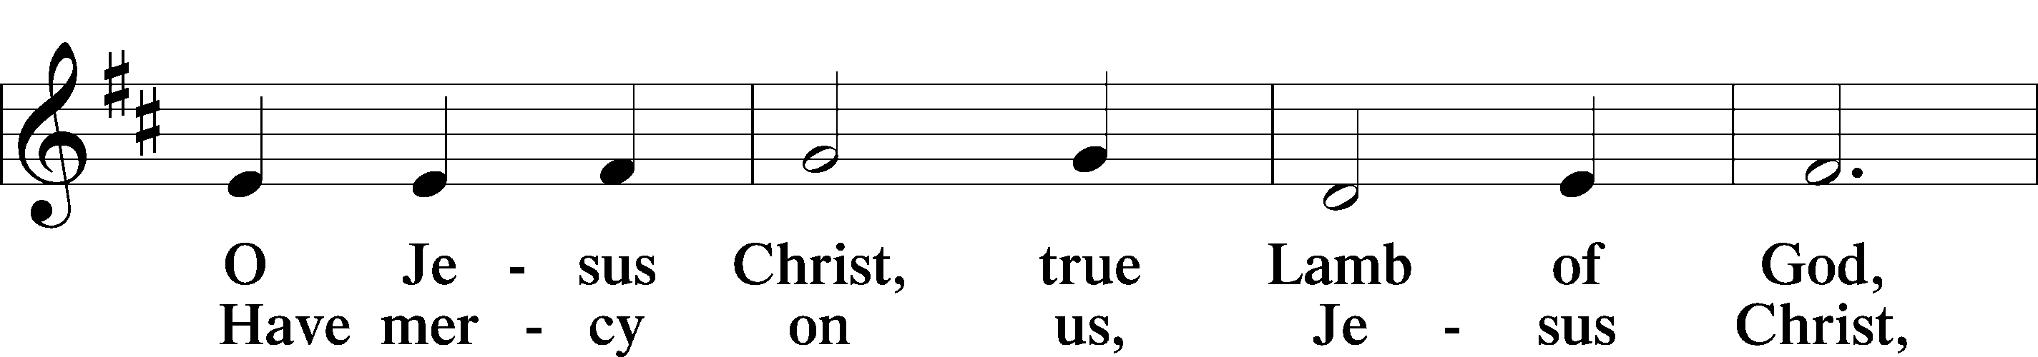
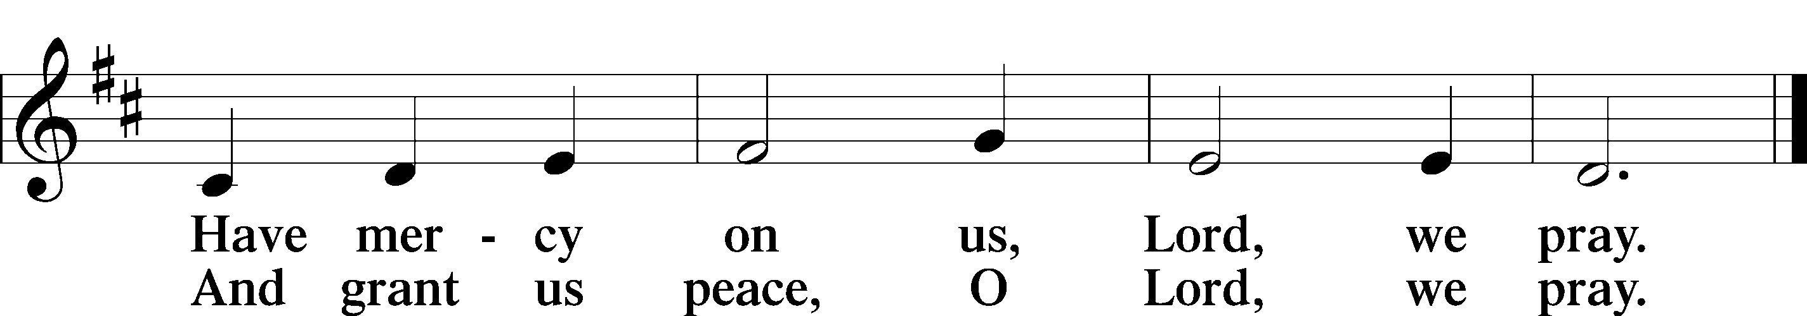
Text: Stephen P. Starke

Sit

Distribution

474 Alleluia! Jesus Is Risen
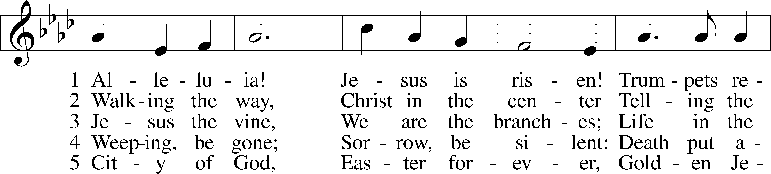
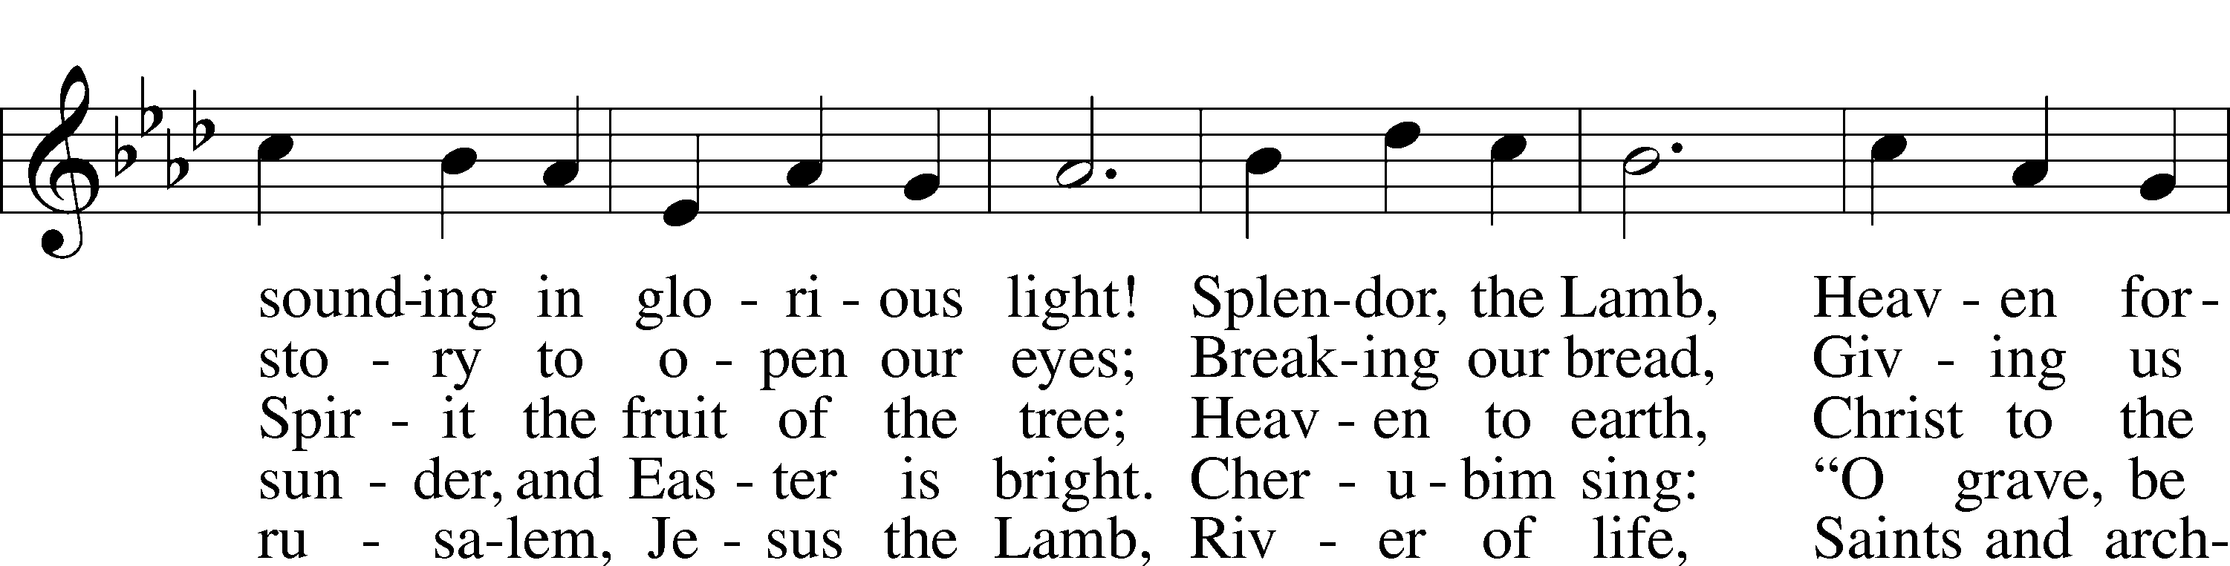
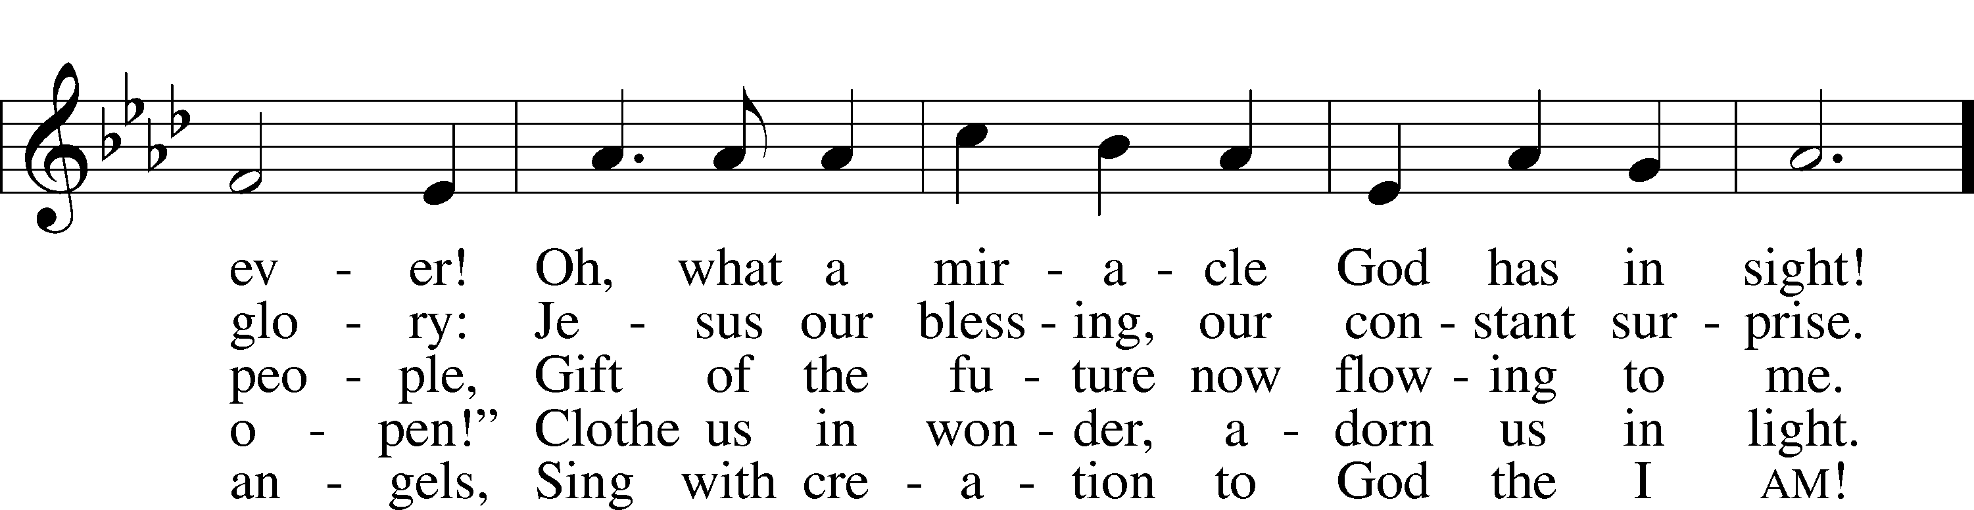
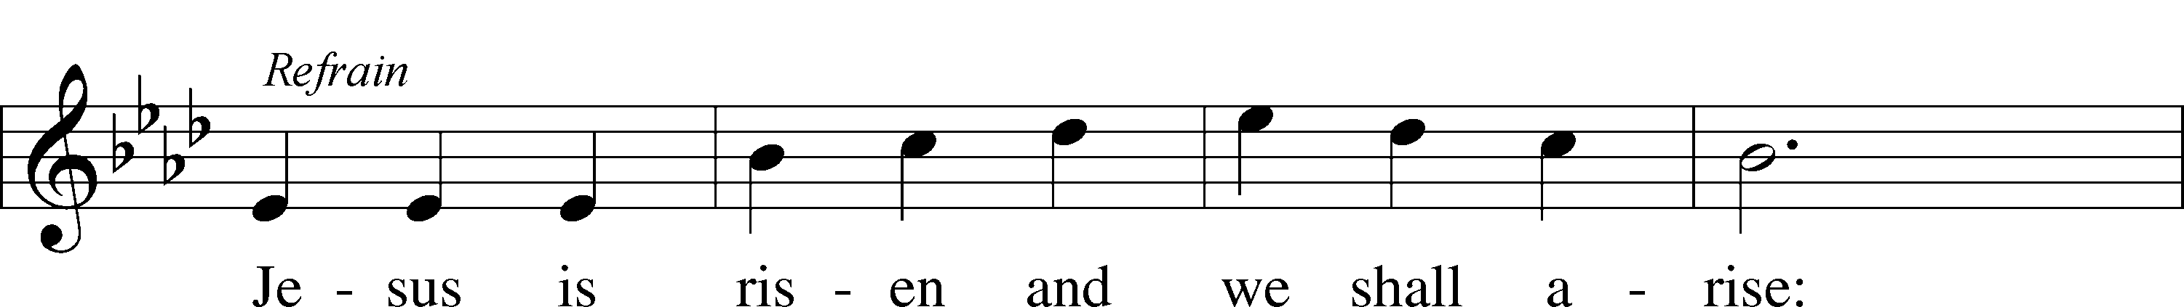
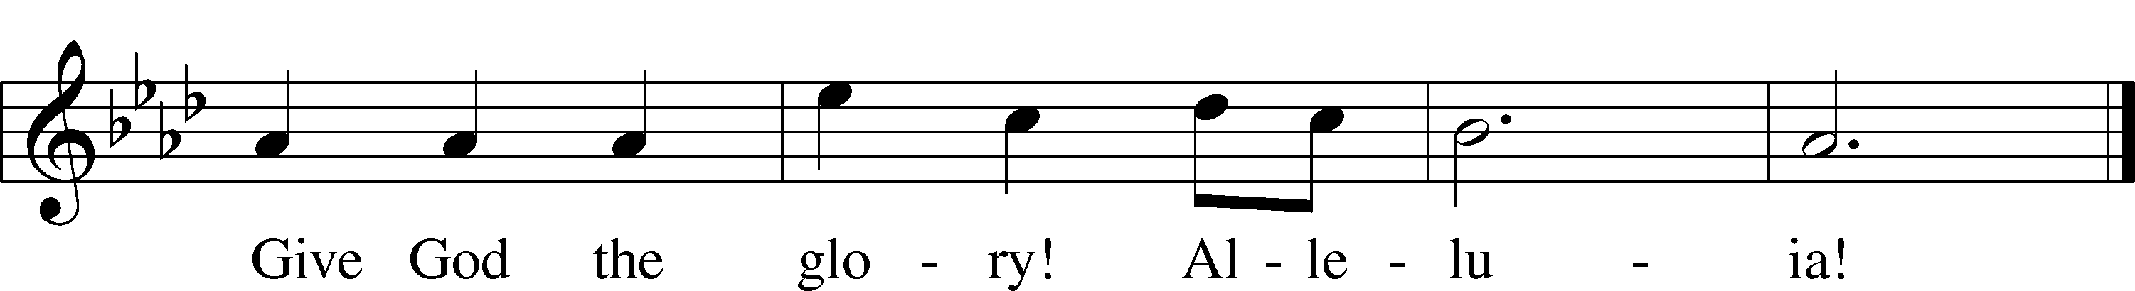
Text: Herbert F. Brokering, 1926–2009
Tune: David N. Johnson, 1922–87
Text: © 1995 Augsburg Fortress. Used by permission: LSB Hymn License no. 110005011
Tune: © 1968 Augsburg Publishing House. Used by permission: LSB Hymn License no. 110005011

525 Crown Him with Many Crowns
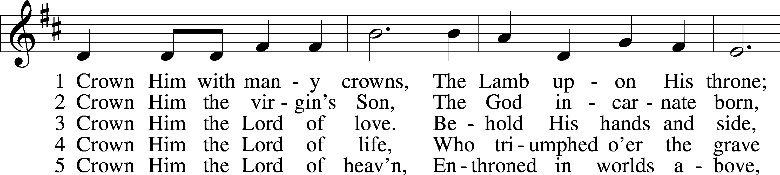
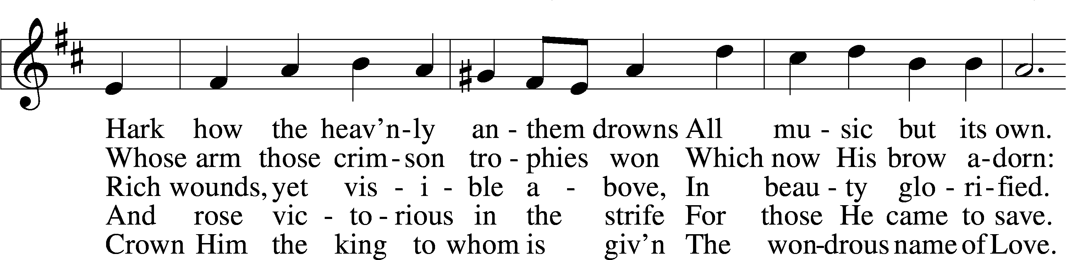
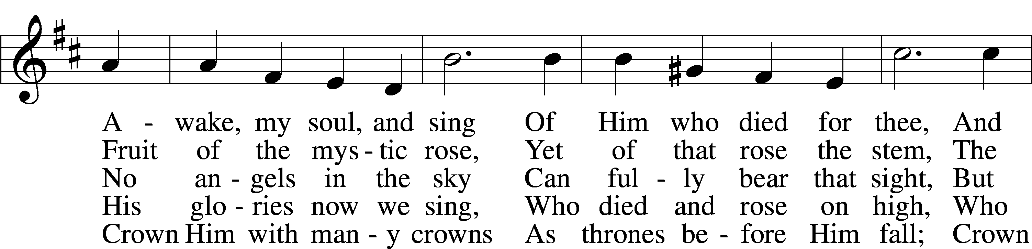
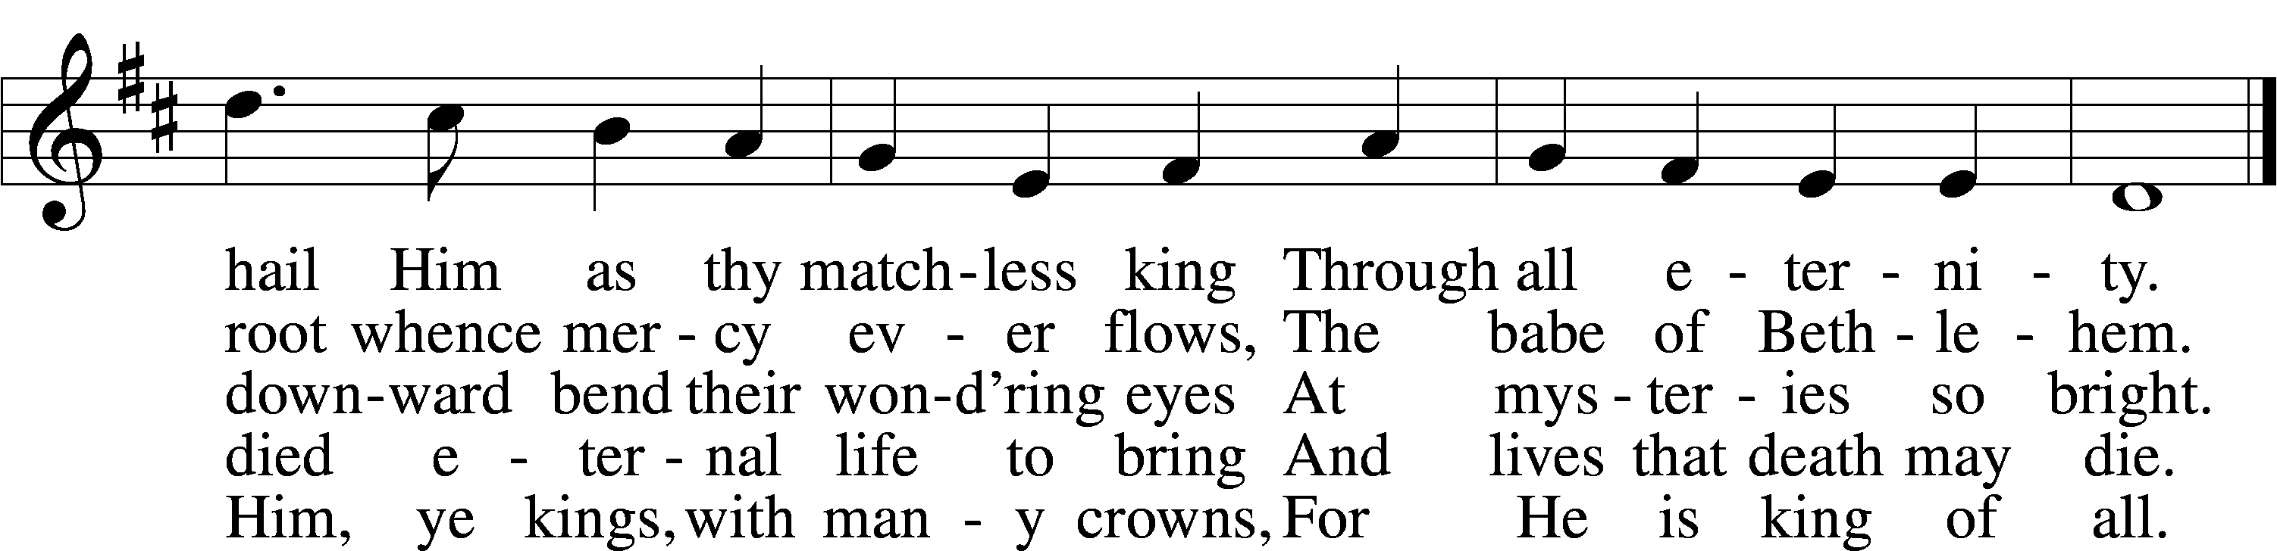
Text (sts. 1–3, 5): Matthew Bridges, 1800–94, alt.; (st. 4): Godfrey Thring, 1823–1903
Tune: George J. Elvey, 1816–93
Text and tune: Public domain

537 Beautiful Savior
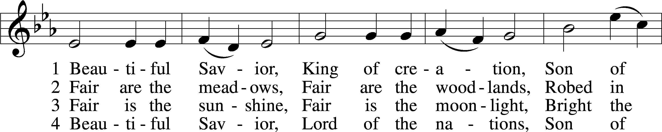
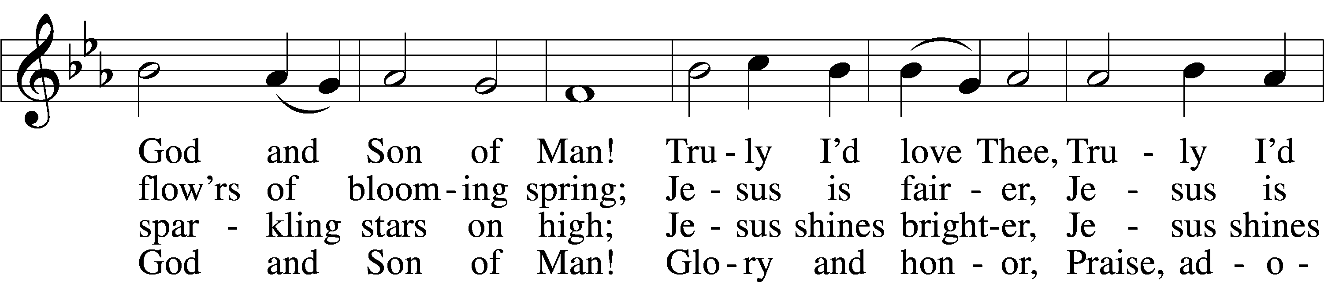
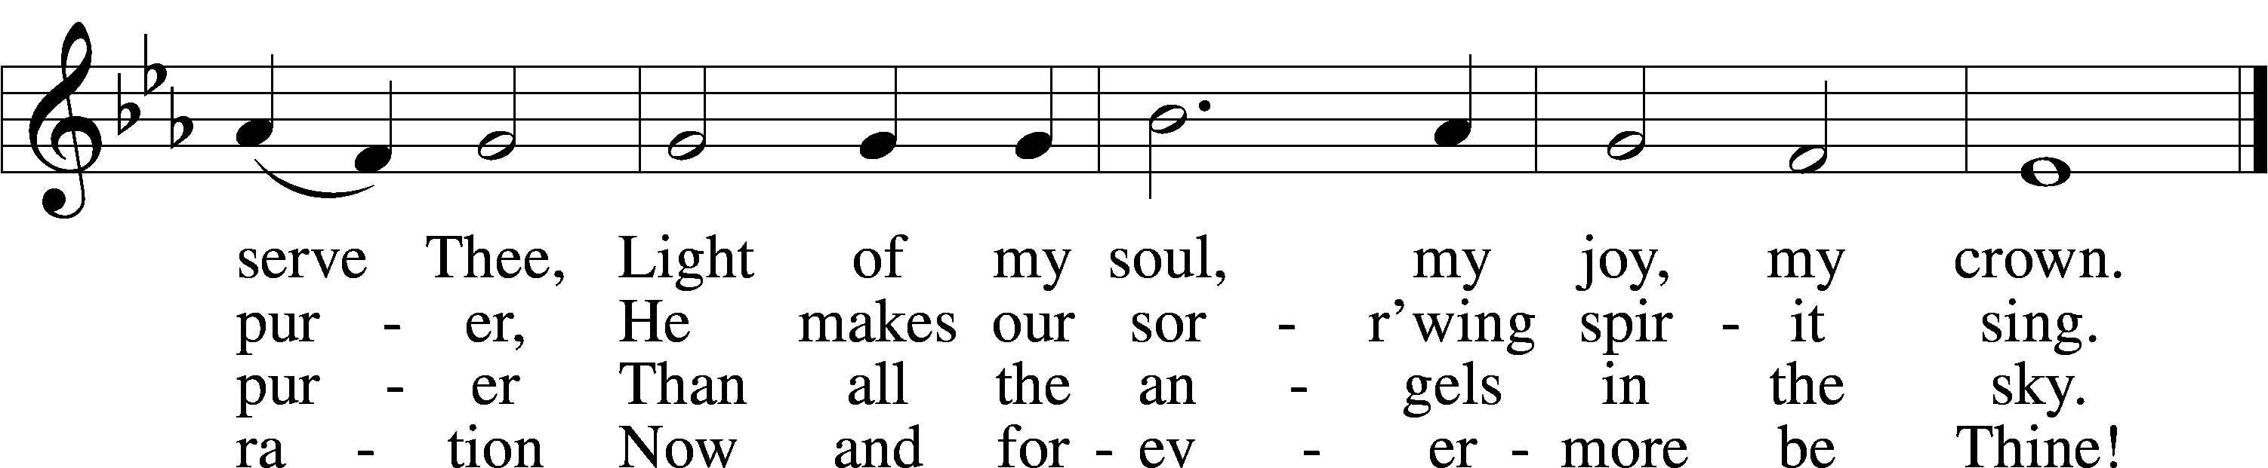
Text: Münsterisch Gesangbuch, 1677, Münster; tr. Joseph A. Seiss, 1823–1904
Tune: Silesian, 19th cent.
Text and tune: Public domain

475 Good Christian Friends, Rejoice and Sing
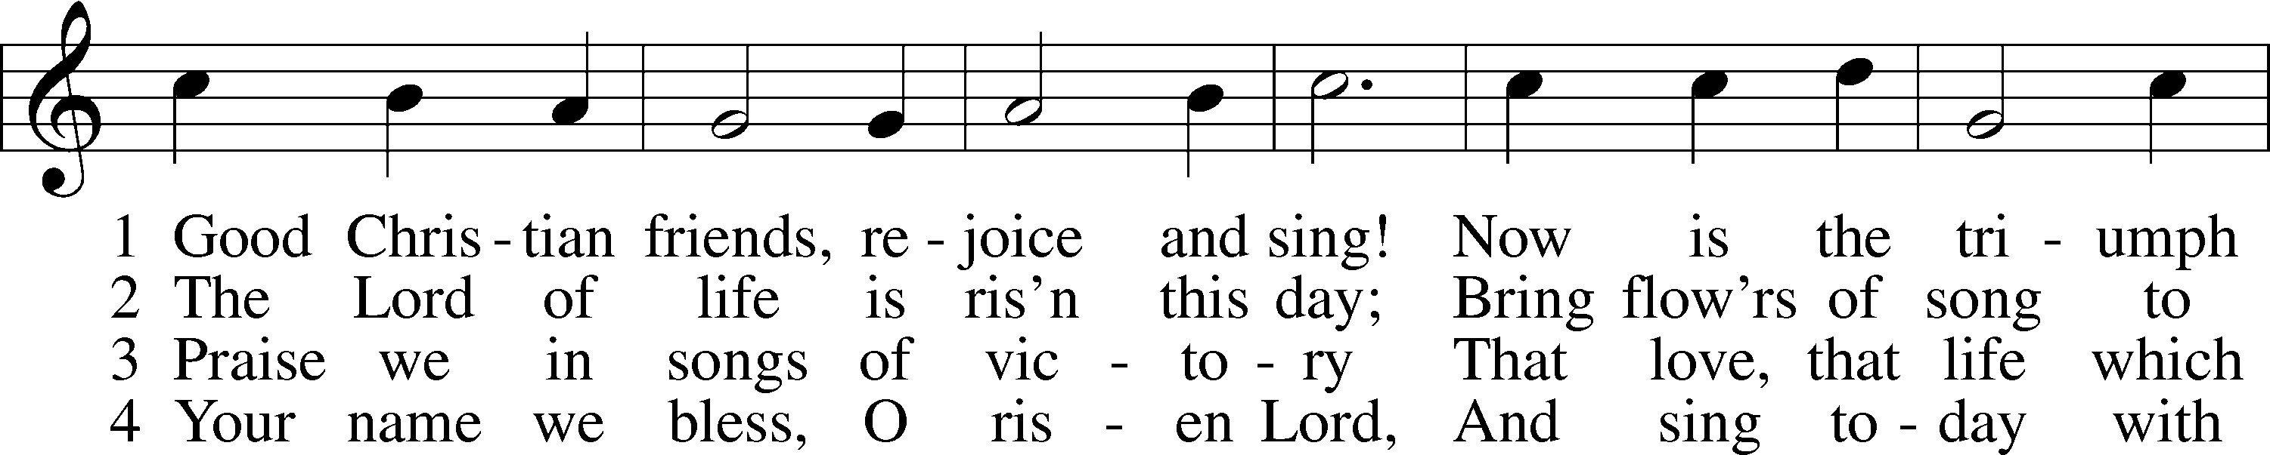
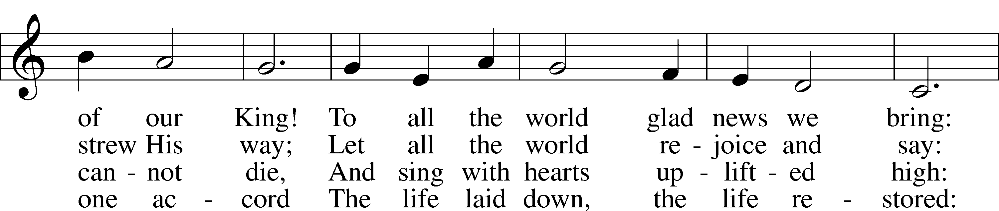
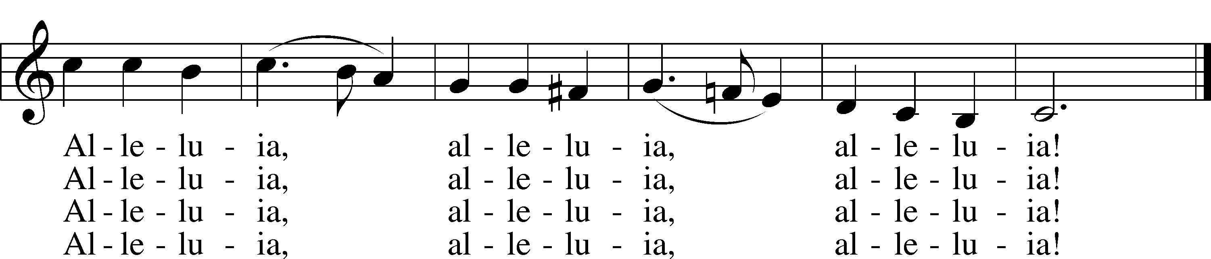
Text: Cyril A. Alington, 1872–1955, alt.
Tune: Melchior Vulpius, c. 1570–1615
Text: © 1958, renewed 1986 Hymns Ancient and Modern Ltd., admin. Hope Publishing Co. Used by permission: LSB Hymn License no. 110005011
Tune: Public domain

Stand

The Dismissal
P The body and blood of our Lord Jesus Christ strengthen and preserve you in body and soul to life everlasting. Depart T in peace.
C Amen.

Nunc Dimittis Luke 2:29–32
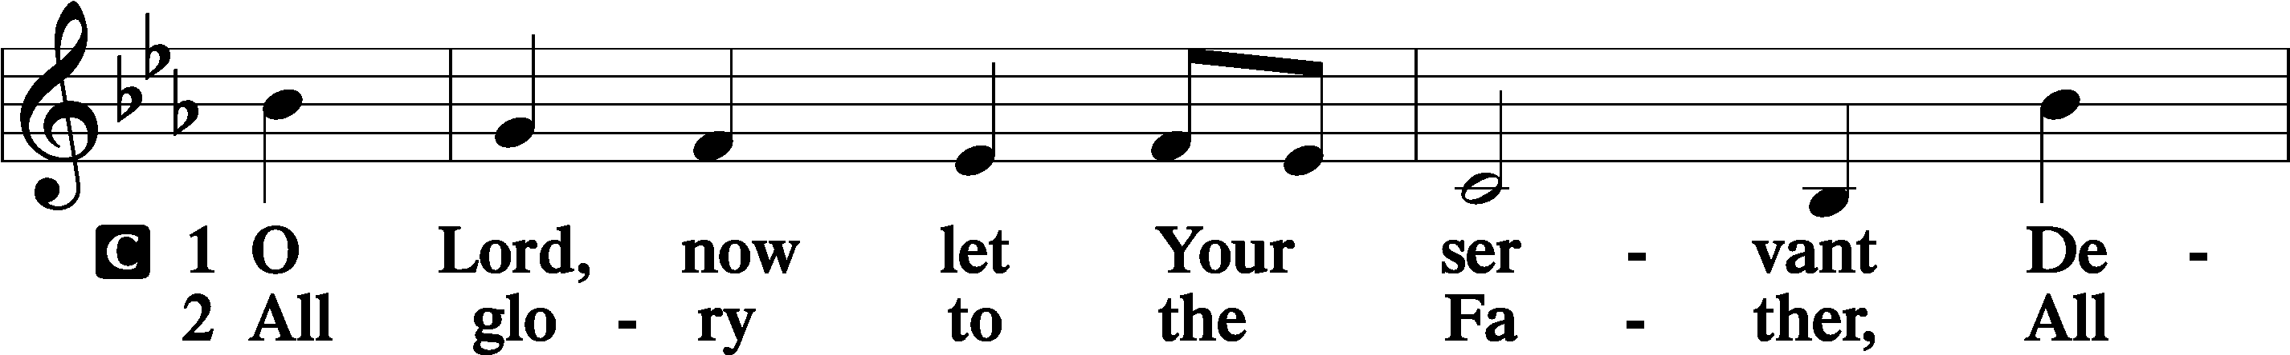
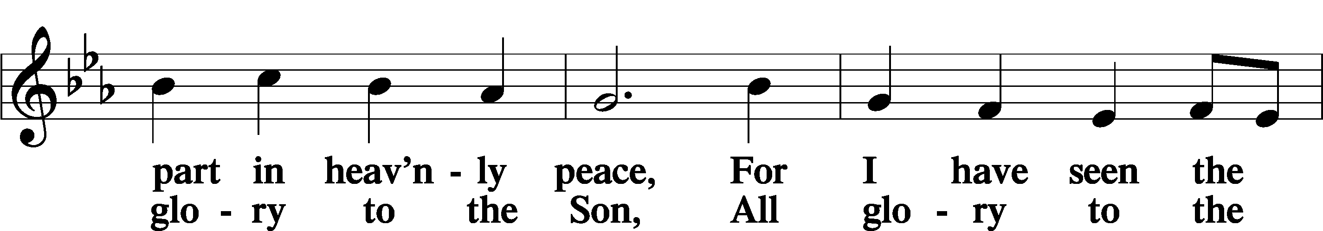
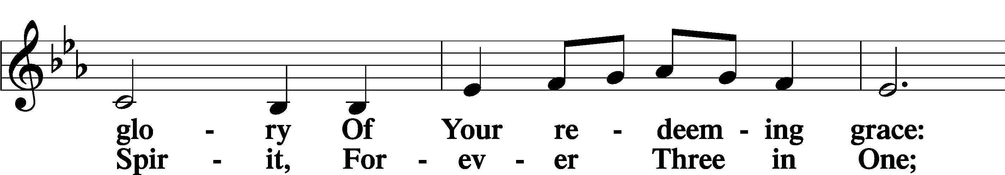
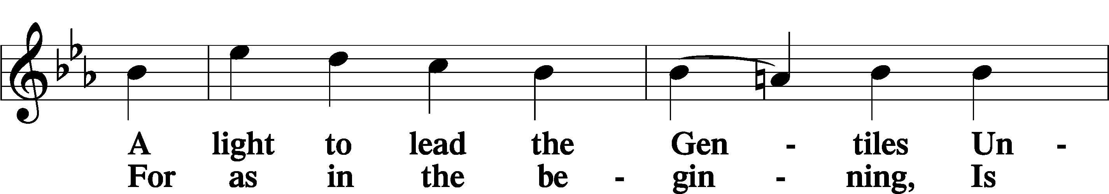
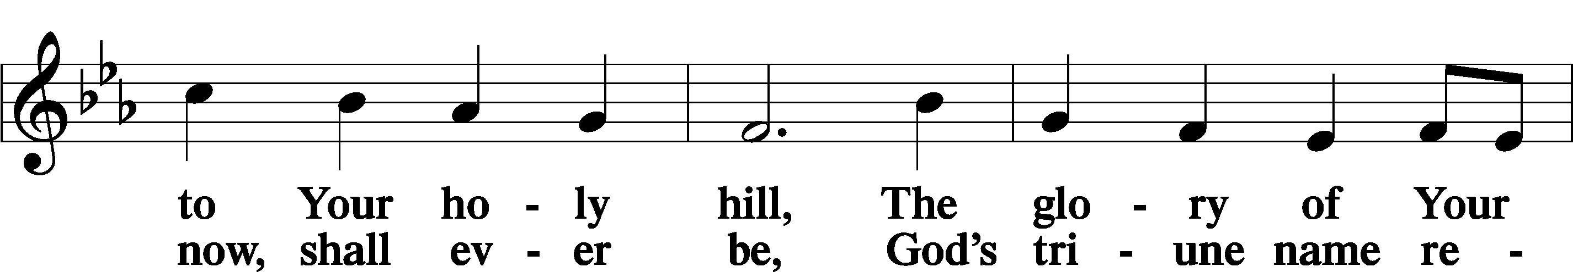
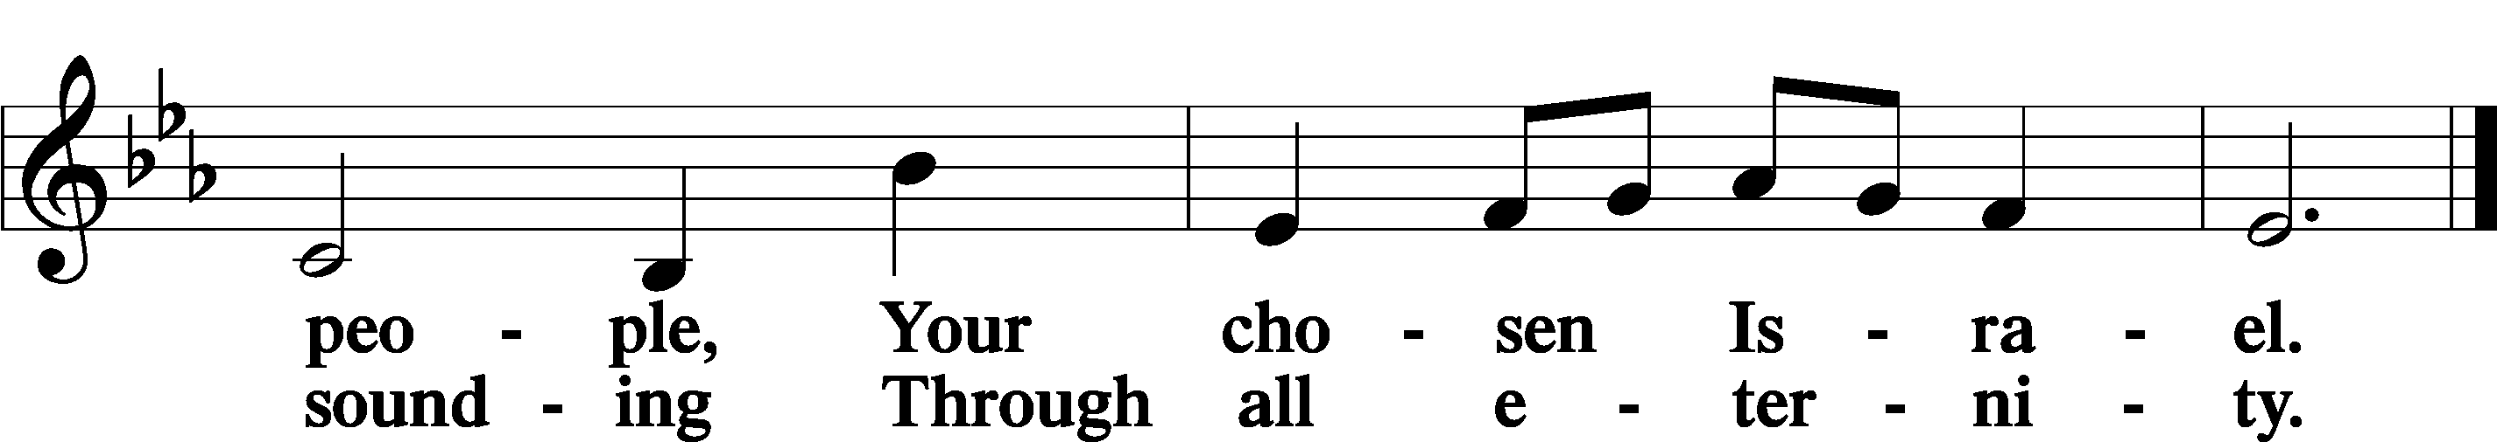

Post-Communion Collect
A Let us pray.
We give thanks to You, almighty God, that You have refreshed us through this salutary gift, and we implore You that of Your mercy You would strengthen us through the same in faith toward You and in fervent love toward one another; through Jesus Christ, Your Son, our Lord, who lives and reigns with You and the Holy Spirit, one God, now and forever.
C Amen.

Benedicamus Psalm 103:1
A Let us bless the Lord.
C Thanks be to God.

Benediction
P The Lord bless you and keep you.
The Lord make His face shine on you and be gracious to you.
The Lord look upon you with favor and T give you peace.
C Amen.

480 He’s Risen, He’s Risen
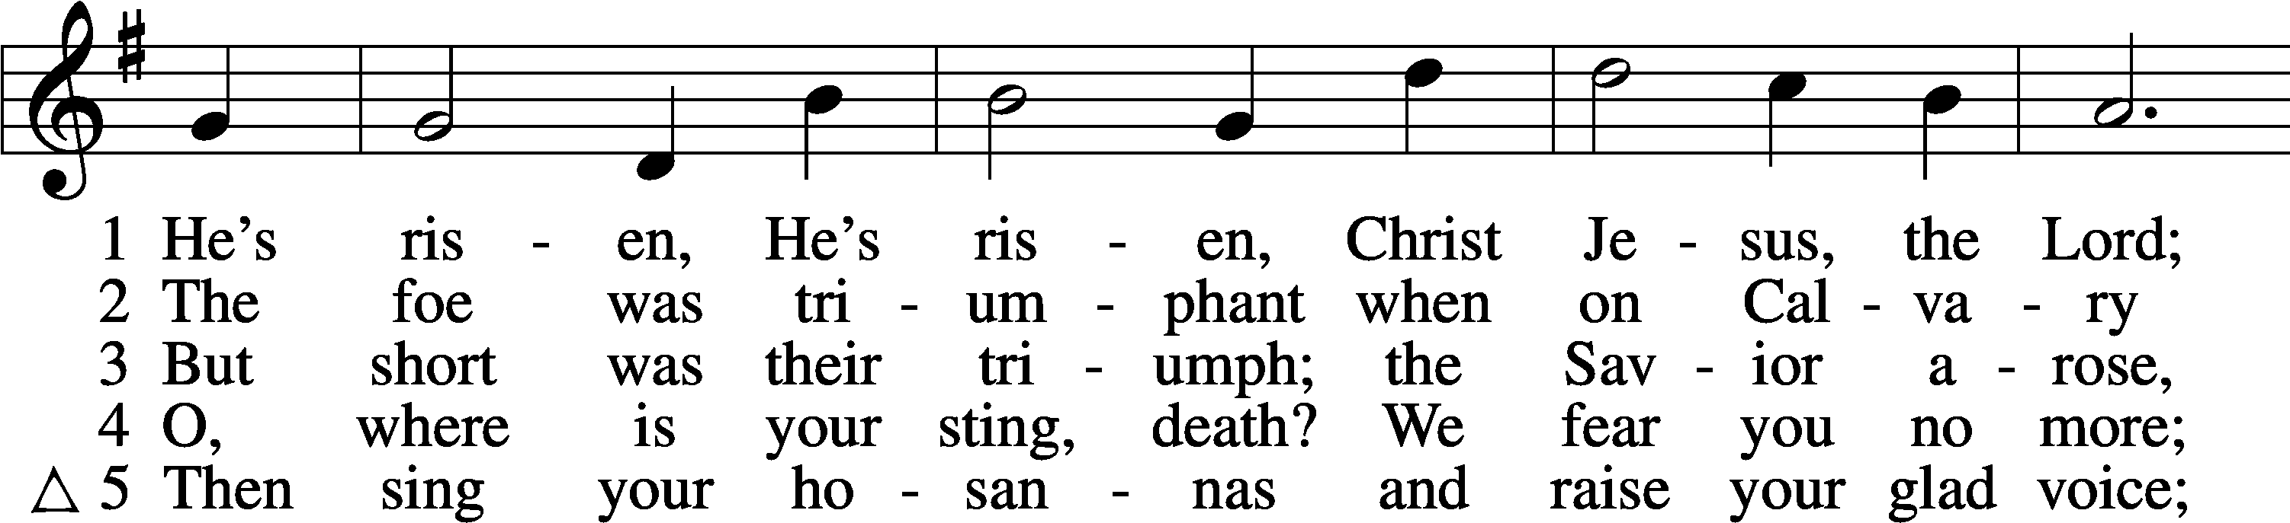
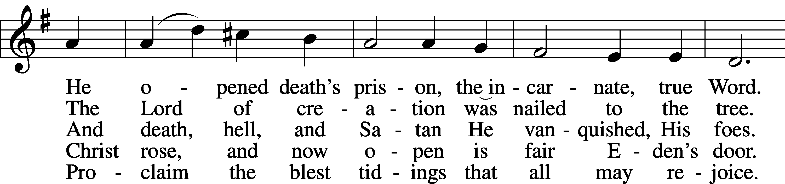
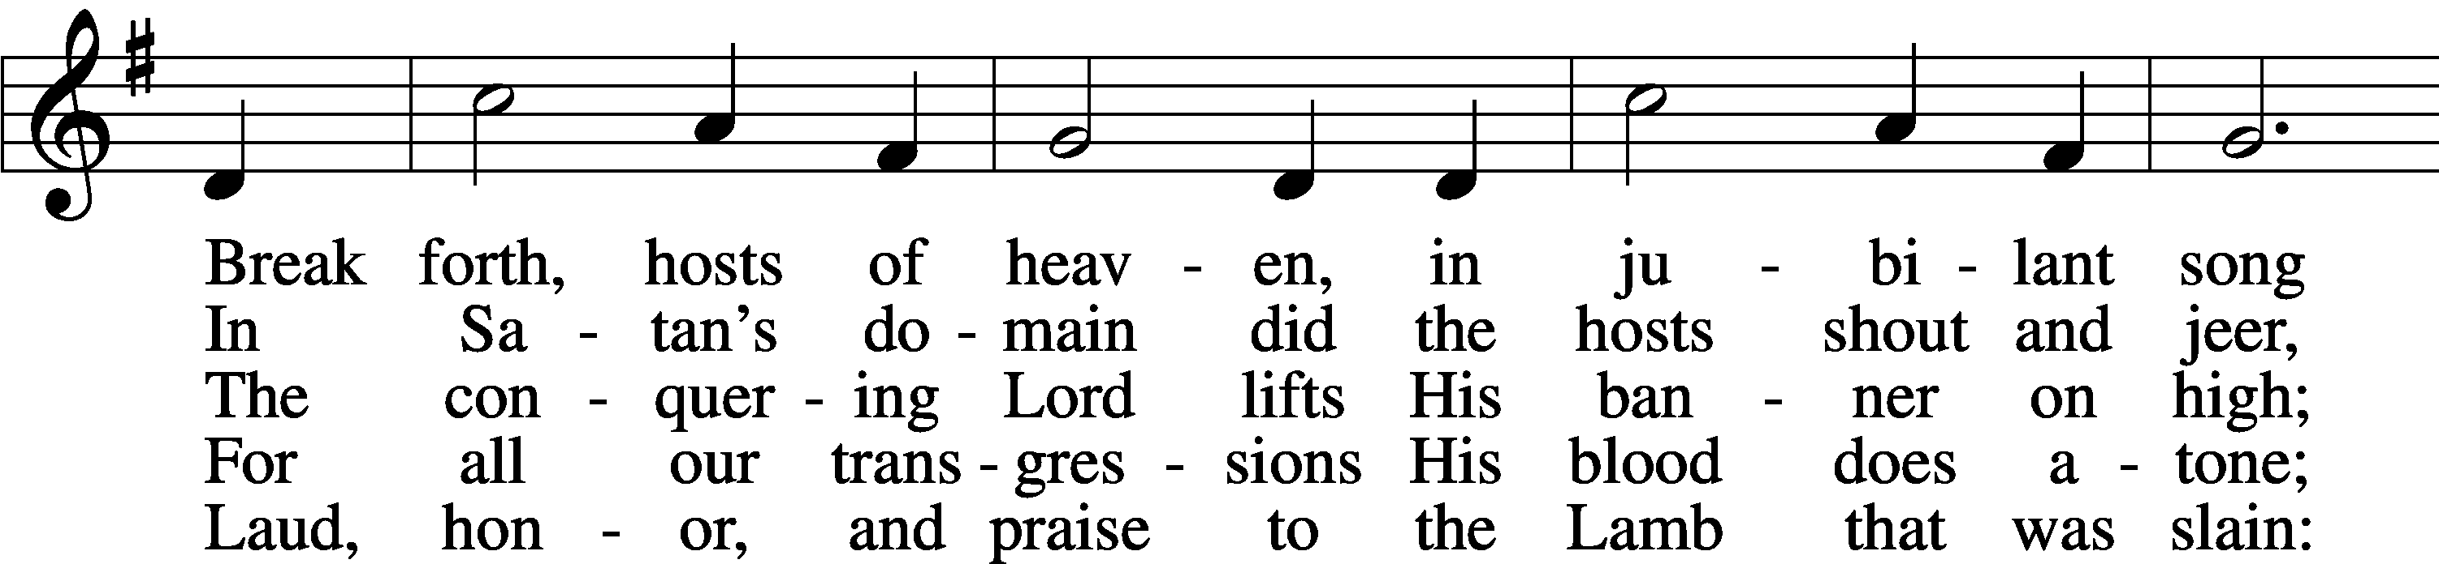
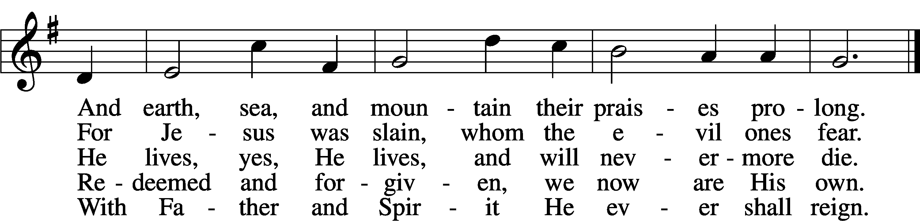
Text: C. F. W. Walther, 1811–87, abr.; tr. Anna M. Meyer, 1867–1941, alt.
Tune: C. F. W. Walther, 1811–87
Text: © 1941 Concordia Publishing House. Used by permission: LSB Hymn License no. 110005011
Tune: Public domain

Acknowledgments
Divine Service, Setting Four from Lutheran Service Book
Unless otherwise indicated, Scripture quotations are from the ESV® Bible (The Holy Bible, English Standard Version®), copyright © 2001 by Crossway, a publishing ministry of Good News Publishers. Used by permission. All rights reserved.
Created by Lutheran Service Builder © 2023 Concordia Publishing House.

