878 Abide with Me

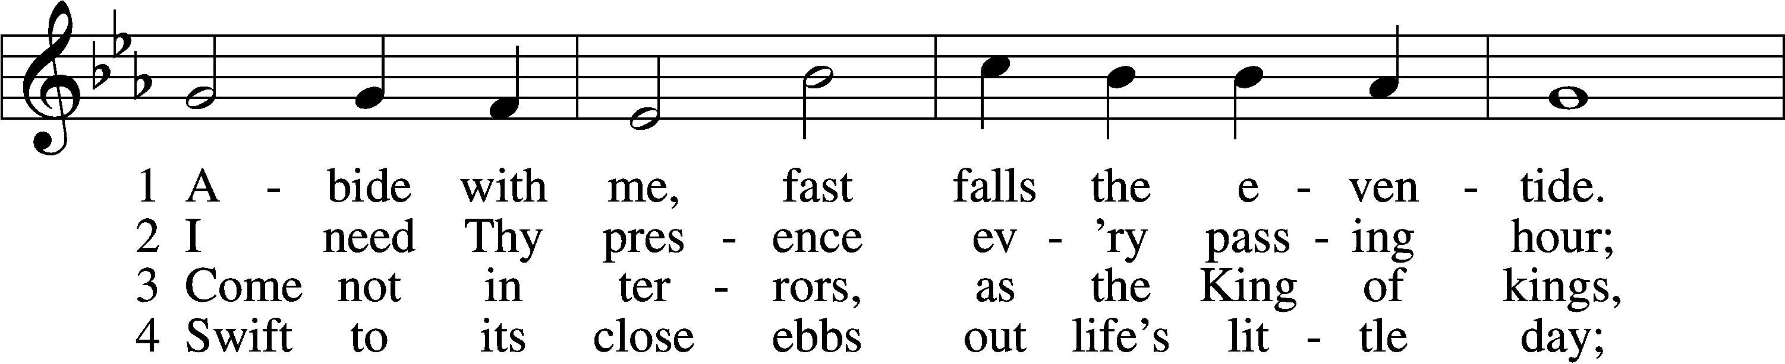

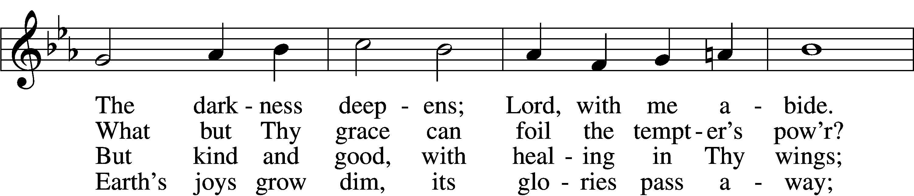

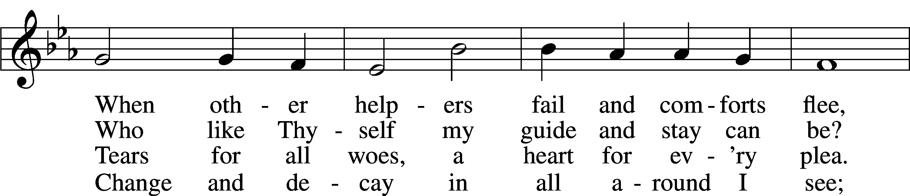

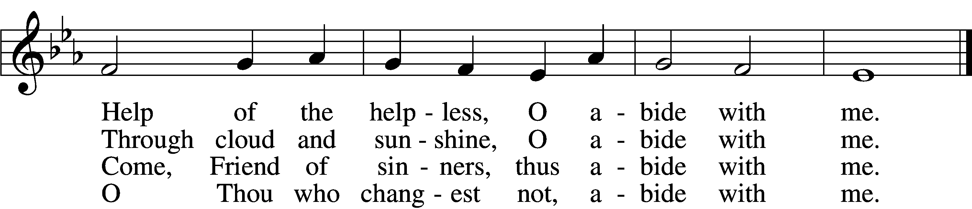

5 I fear no foe with Thee at hand to bless;  
Ills have no weight and tears no bitterness.  
Where is death’s sting? Where, grave, thy victory?  
I triumph still if Thou abide with me!

6 Hold Thou Thy cross before my closing eyes;  
Shine through the gloom, and point me to the skies.  
Heav’n’s morning breaks, and earth’s vain shadows flee;  
In life, in death, O Lord, abide with me.

Text: Henry F. Lyte, 1793–1847, alt.  
Tune: William H. Monk, 1823–89  
Text and tune: Public domain

# Confession and Absolution

The sign of the cross may be made by all in remembrance of their Baptism.

Invocation Matthew 28:19b; 18:20

P In the name of the Father and of the T Son and of the Holy Spirit.

C **Amen.**

Exhortation Hebrews 10:22; Psalm 124:8; Psalm 32:5

P Beloved in the Lord! Let us draw near with a true heart and confess our sins unto God our Father, beseeching Him in the name of our Lord Jesus Christ to grant us forgiveness.

P Our help is in the name of the Lord,

C **who made heaven and earth.**

P I said, I will confess my transgressions unto the Lord,

C **and You forgave the iniquity of my sin.**

Silence for reflection on God’s Word and for self-examination.

Confession of Sins

P Almighty God, our maker and redeemer, we poor sinners confess unto You that we are by nature sinful and unclean and that we have sinned against You by thought, word, and deed. Wherefore we flee for refuge to Your infinite mercy, seeking and imploring Your grace for the sake of our Lord Jesus Christ.

C **O most merciful God, who has given Your only-begotten Son to die for us, have mercy upon us and for His sake grant us remission of all our sins; and by Your Holy Spirit increase in us true knowledge of You and of Your will and true obedience to Your Word, to the end that by Your grace we may come to everlasting life; through Jesus Christ, our Lord. Amen.**

Declaration of Grace Mark 16:16; John 1:12

P Almighty God, our heavenly Father, has had mercy upon us and has given His only Son to die for us and for His sake forgives us all our sins. To those who believe on His name He gives power to become the children of God and has promised them His Holy Spirit. He that believes and is baptized shall be saved.  
  
Grant this, Lord, unto us all.

C **Amen.**

# Service of the Word

Introit Psalm 133; antiphon: v. 1

Behold, how good and pleasant it is  
 when brothers dwell in unity!  
**It is like the precious oil on the head, running down on the beard, on the beard of Aaron,  
 running down on the collar of his robes!**It is like the dew of Hermon, which falls on the mountains of Zion!  
 For there the Lord has commanded the blessing, life for- evermore.

Gloria Patri

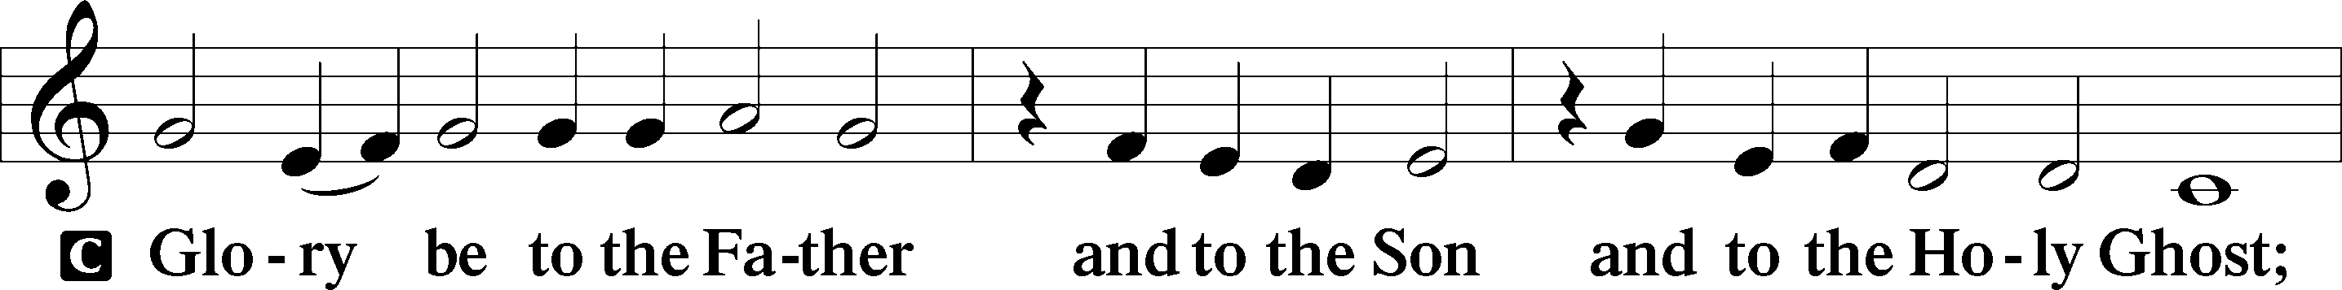

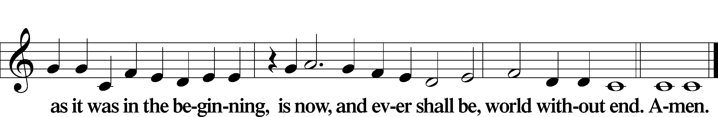

Kyrie Mark 10:47

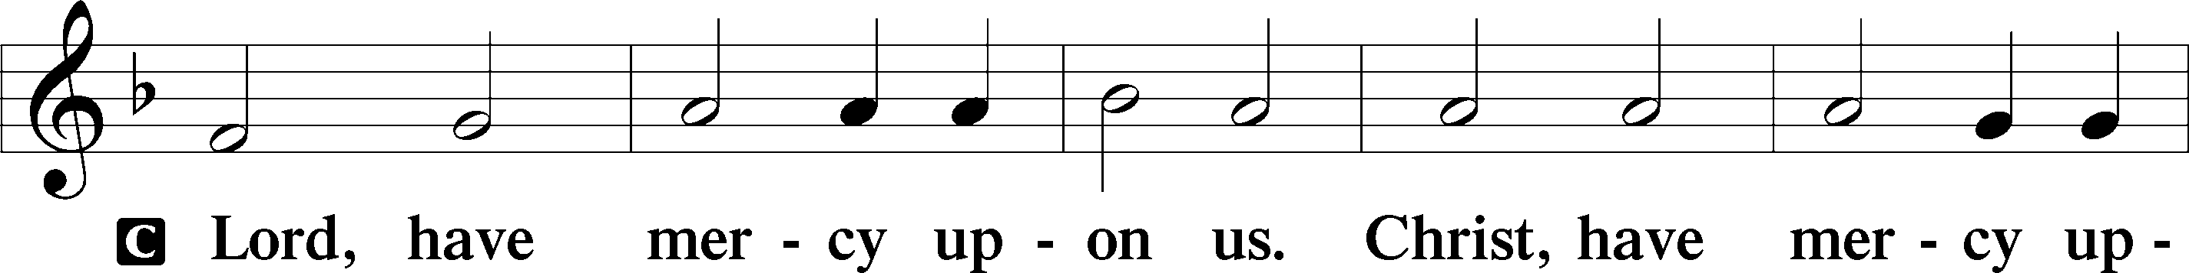

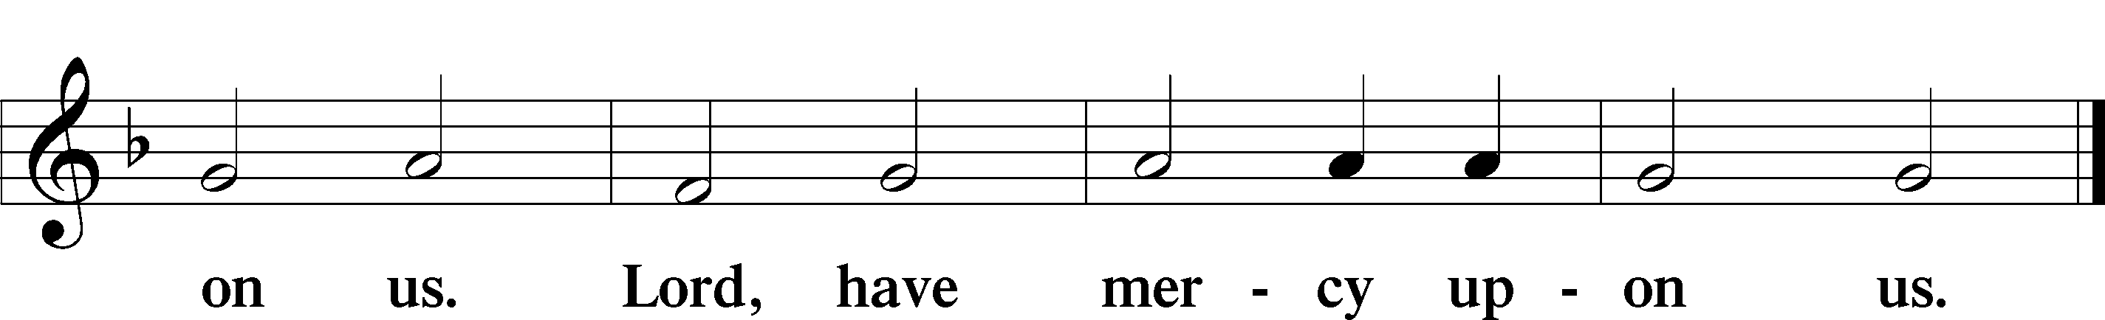

Gloria in Excelsis Luke 2:14; John 1:29

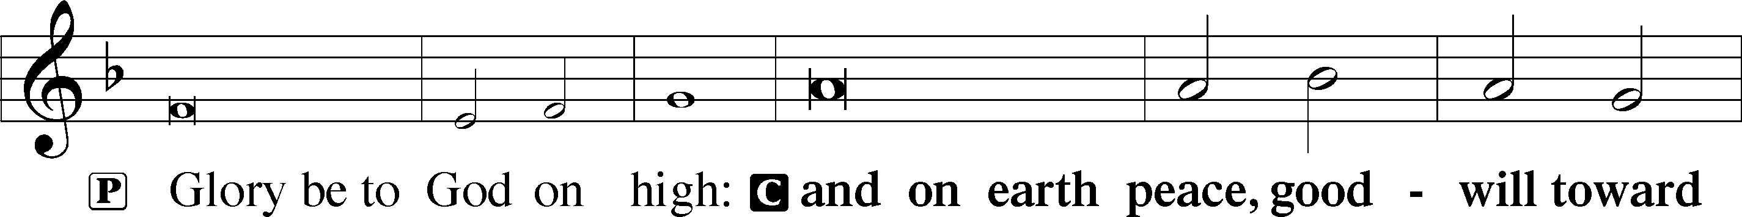

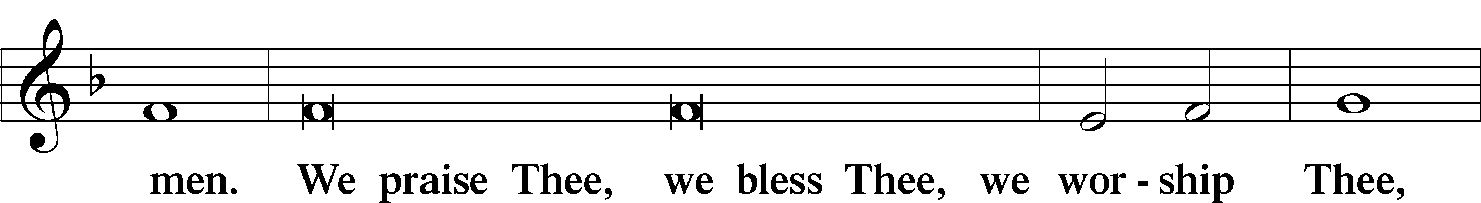

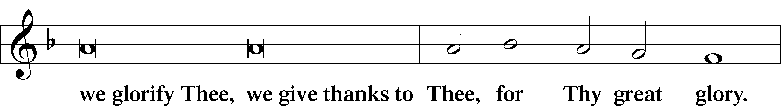

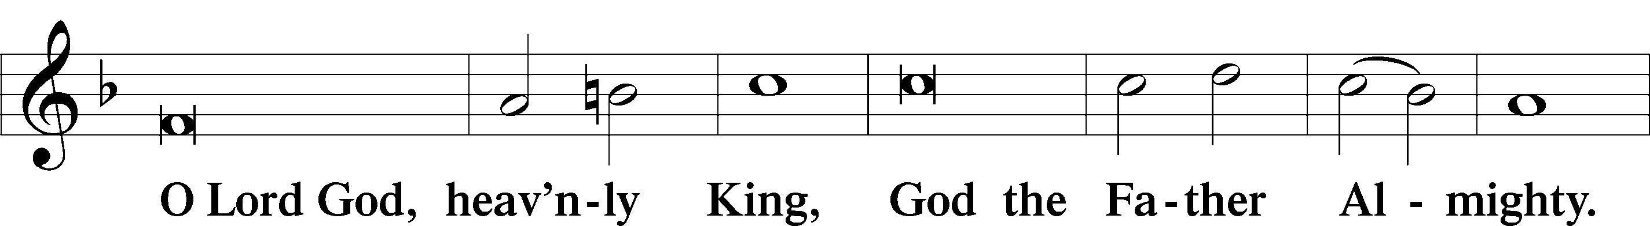

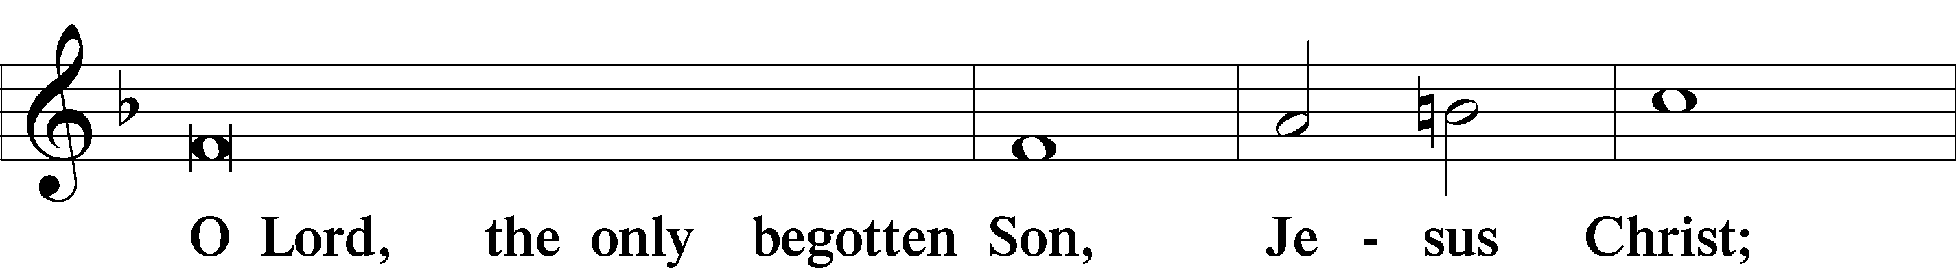

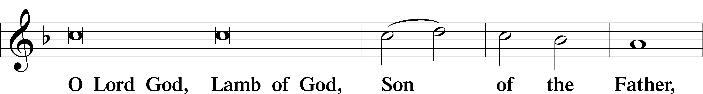

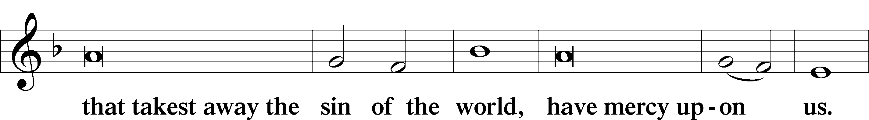

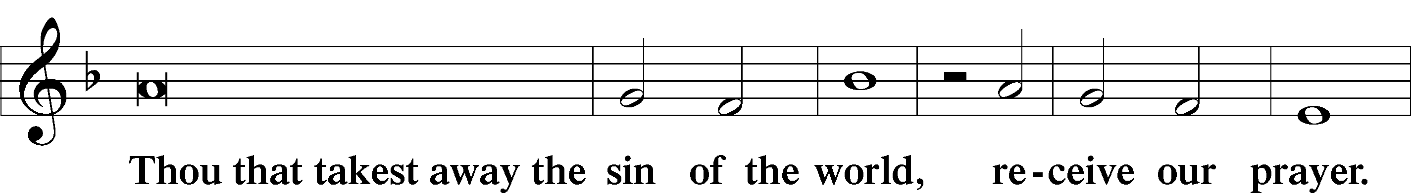

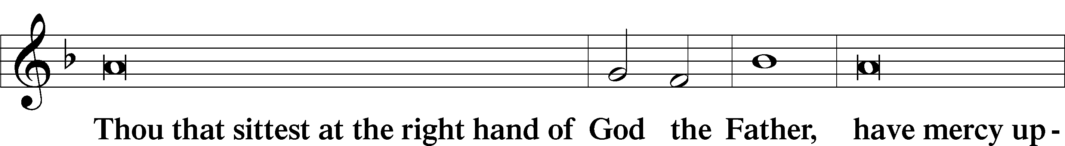

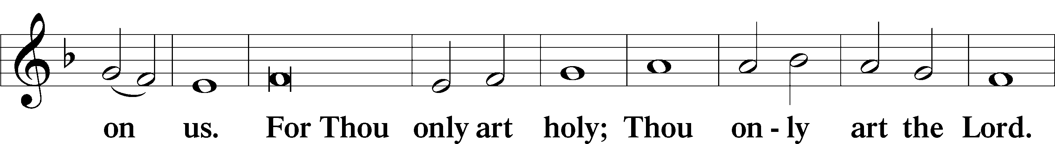

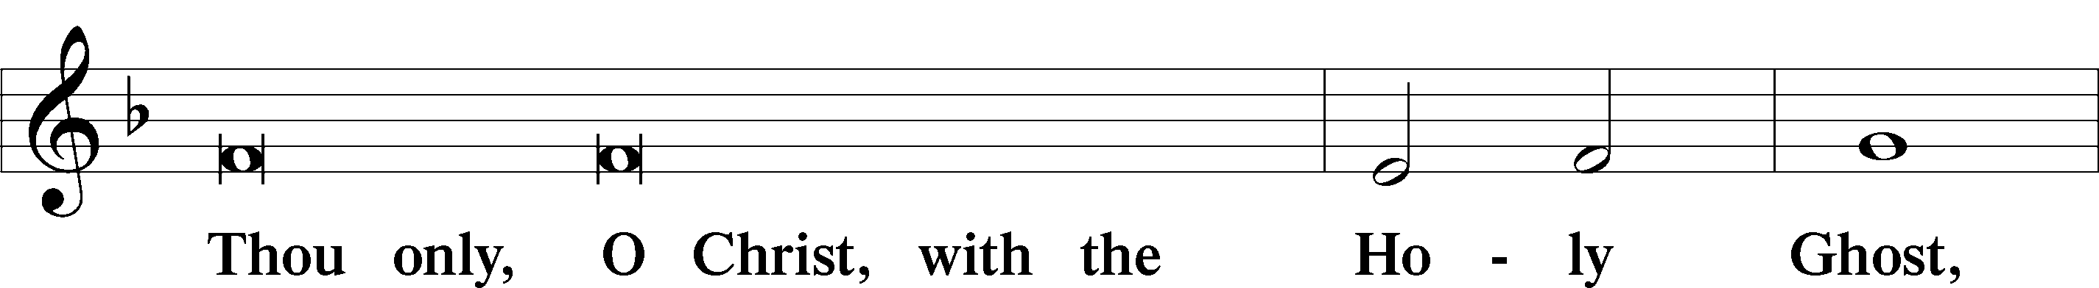

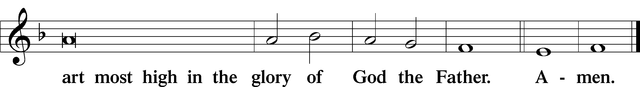

Salutation and Collect of the Day

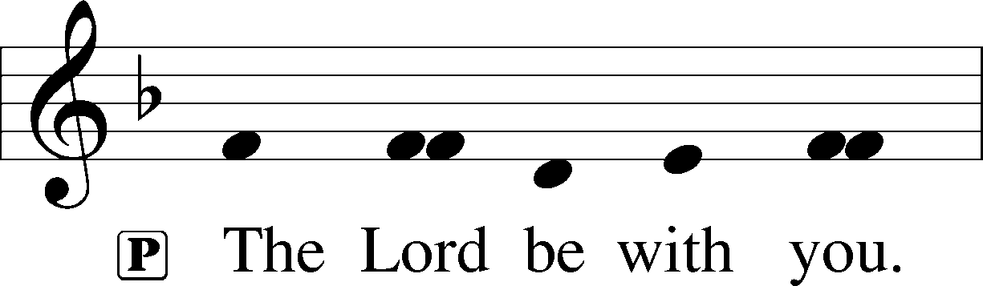

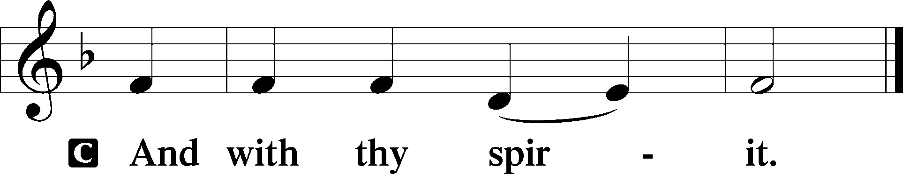

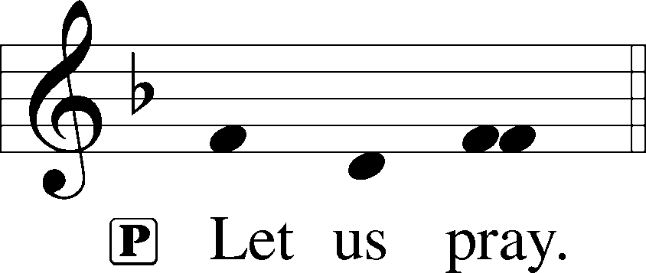

P O God, through the humiliation of Your Son You raised up the fallen world. Grant to Your faithful people, rescued from the peril of everlasting death, perpetual gladness and eternal joys; through Jesus Christ, our Lord, who lives and reigns with You and the Holy Spirit, one God, now and forever.

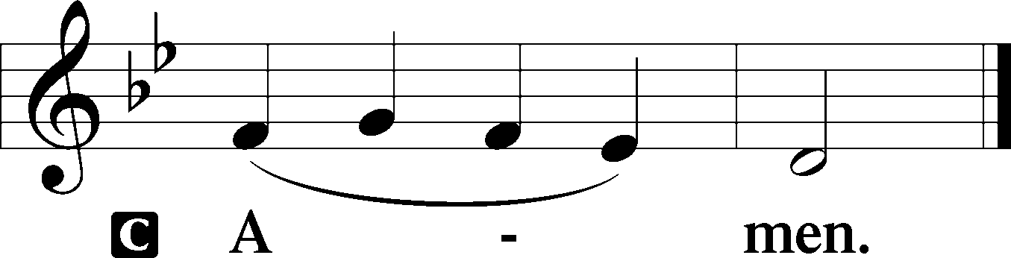

Sit

First Reading Acts 2:14a, 36–41

Peter’s Sermon at Pentecost

14Peter, standing with the eleven, lifted up his voice and addressed them, . . .

36Let all the house of Israel therefore know for certain that God has made him both Lord and Christ, this Jesus whom you crucified.”

37Now when they heard this they were cut to the heart, and said to Peter and the rest of the apostles, “Brothers, what shall we do?” 38And Peter said to them, “Repent and be baptized every one of you in the name of Jesus Christ for the forgiveness of your sins, and you will receive the gift of the Holy Spirit. 39For the promise is for you and for your children and for all who are far off, everyone whom the Lord our God calls to himself.” 40And with many other words he bore witness and continued to exhort them, saying, “Save yourselves from this crooked generation.” 41So those who received his word were baptized, and there were added that day about three thousand souls.

A This is the Word of the Lord.

C **Thanks be to God.**

Gradual adapt. from Matthew 28:7; Hebrews 2:7; Psalm 8:6

Christ has risen from the dead.  
 [God the Father] has crowned him with glory and honor.  
**He has given him dominion over the works of his hands;  
 he has put all things under his feet.**

Reading Romans 5:6–15

6For while we were still weak, at the right time Christ died for the ungodly. 7For one will scarcely die for a righteous person—though perhaps for a good person one would dare even to die— 8but God shows his love for us in that while we were still sinners, Christ died for us. 9Since, therefore, we have now been justified by his blood, much more shall we be saved by him from the wrath of God. 10For if while we were enemies we were reconciled to God by the death of his Son, much more, now that we are reconciled, shall we be saved by his life. 11More than that, we also rejoice in God through our Lord Jesus Christ, through whom we have now received reconciliation.

Death in Adam, Life in Christ

12Therefore, just as sin came into the world through one man, and death through sin, and so death spread to all men because all sinned— 13for sin indeed was in the world before the law was given, but sin is not counted where there is no law. 14Yet death reigned from Adam to Moses, even over those whose sinning was not like the transgression of Adam, who was a type of the one who was to come.

15But the free gift is not like the trespass. For if many died through one man’s trespass, much more have the grace of God and the free gift by the grace of that one man Jesus Christ abounded for many.

Stand

Alleluia

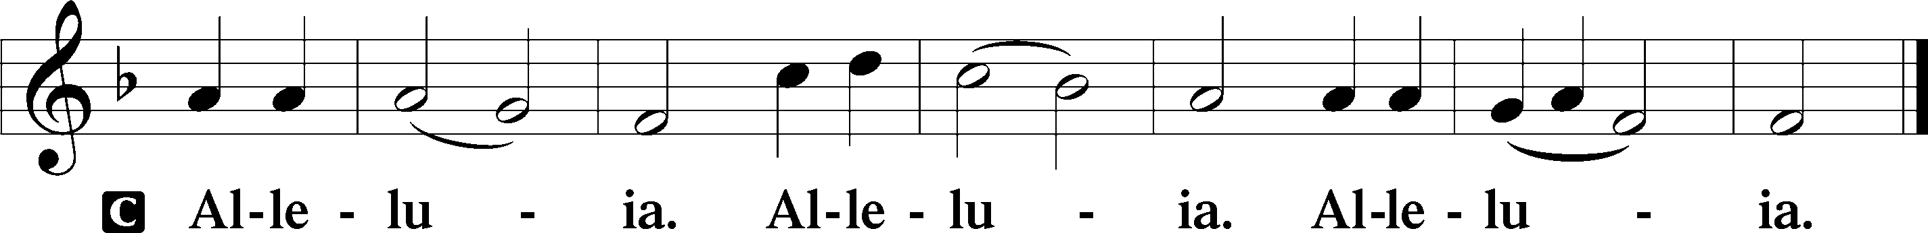

Holy Gospel Luke 24:13–35

P The Holy Gospel according to St. Luke, the twenty-fourth chapter.

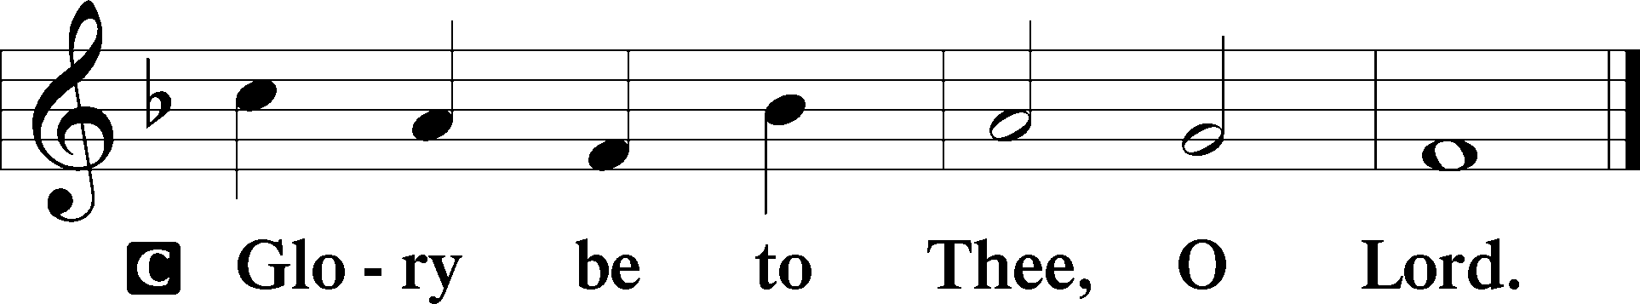

On the Road to Emmaus

13That very day two of them were going to a village named Emmaus, about seven miles from Jerusalem, 14and they were talking with each other about all these things that had happened. 15While they were talking and discussing together, Jesus himself drew near and went with them. 16But their eyes were kept from recognizing him. 17And he said to them, “What is this conversation that you are holding with each other as you walk?” And they stood still, looking sad. 18Then one of them, named Cleopas, answered him, “Are you the only visitor to Jerusalem who does not know the things that have happened there in these days?” 19And he said to them, “What things?” And they said to him, “Concerning Jesus of Nazareth, a man who was a prophet mighty in deed and word before God and all the people, 20and how our chief priests and rulers delivered him up to be condemned to death, and crucified him. 21But we had hoped that he was the one to redeem Israel. Yes, and besides all this, it is now the third day since these things happened. 22Moreover, some women of our company amazed us. They were at the tomb early in the morning, 23and when they did not find his body, they came back saying that they had even seen a vision of angels, who said that he was alive. 24Some of those who were with us went to the tomb and found it just as the women had said, but him they did not see.” 25And he said to them, “O foolish ones, and slow of heart to believe all that the prophets have spoken! 26Was it not necessary that the Christ should suffer these things and enter into his glory?” 27And beginning with Moses and all the Prophets, he interpreted to them in all the Scriptures the things concerning himself.

28So they drew near to the village to which they were going. He acted as if he were going farther, 29but they urged him strongly, saying, “Stay with us, for it is toward evening and the day is now far spent.” So he went in to stay with them. 30When he was at table with them, he took the bread and blessed and broke it and gave it to them. 31And their eyes were opened, and they recognized him. And he vanished from their sight. 32They said to each other, “Did not our hearts burn within us while he talked to us on the road, while he opened to us the Scriptures?” 33And they rose that same hour and returned to Jerusalem. And they found the eleven and those who were with them gathered together, 34saying, “The Lord has risen indeed, and has appeared to Simon!” 35Then they told what had happened on the road, and how he was known to them in the breaking of the bread.

P This is the Gospel of the Lord.

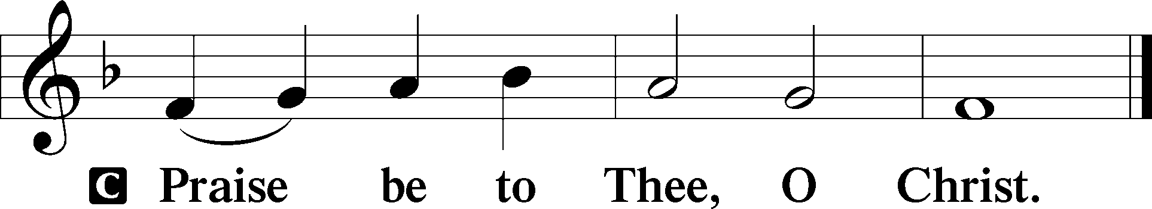

Apostles’ Creed

C **I believe in God, the Father Almighty,**

**maker of heaven and earth.**

**And in Jesus Christ, His only Son, our Lord,**

**who was conceived by the Holy Spirit,**

**born of the virgin Mary,**

**suffered under Pontius Pilate,**

**was crucified, died and was buried.**

**He descended into hell.**

**The third day He rose again from the dead.**

**He ascended into heaven**

**and sits at the right hand of God the Father Almighty.**

**From thence He will come to judge the living and the dead.**

**I believe in the Holy Spirit,**

**the holy Christian Church,**

**the communion of saints,**

**the forgiveness of sins,**

**the resurrection of the body,**

**and the life** T **everlasting. Amen.**

Children's Message

Sit

585 Lord Jesus Christ, with Us Abide

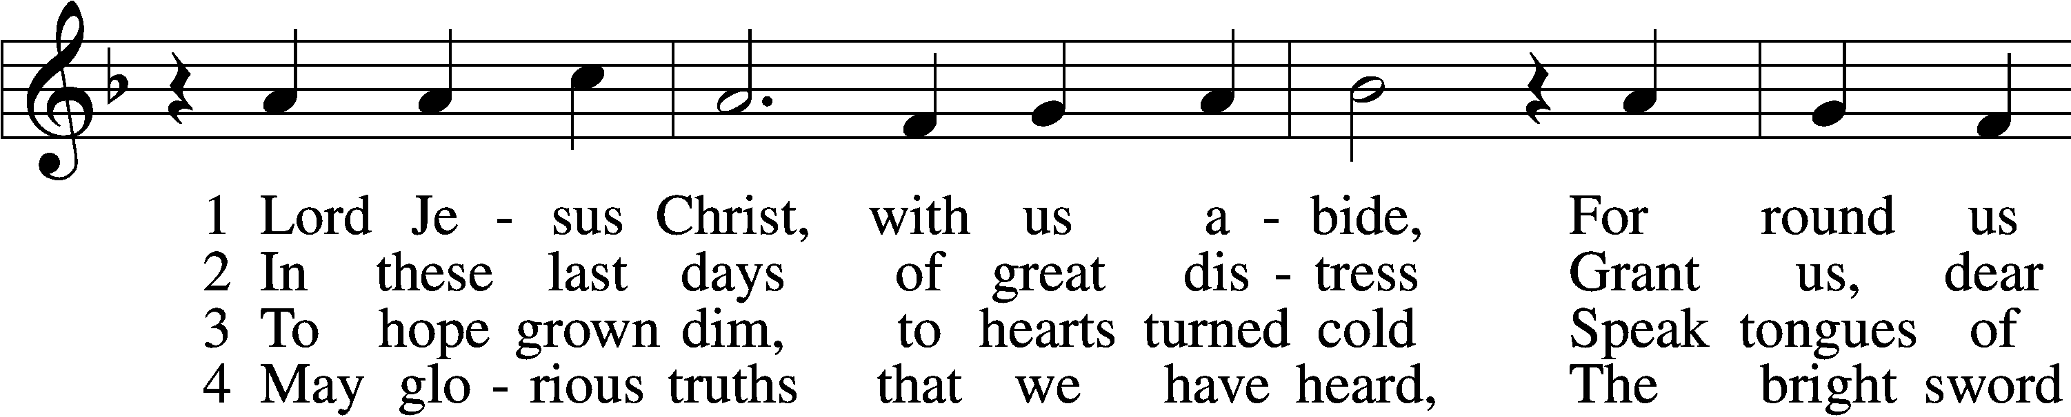

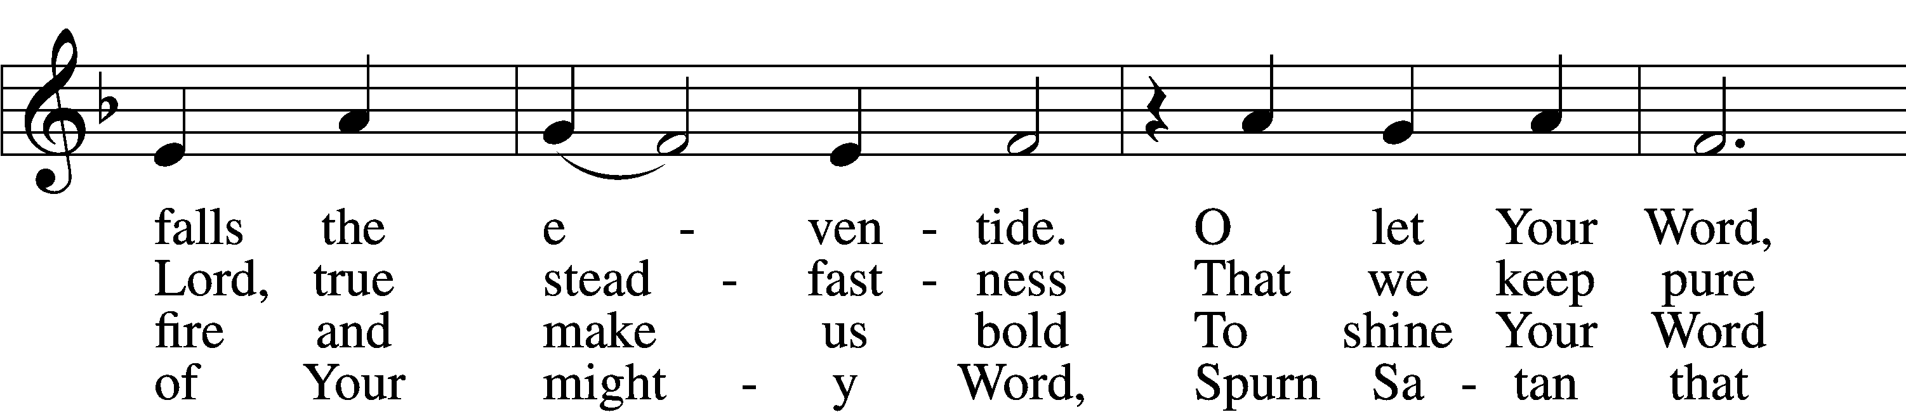

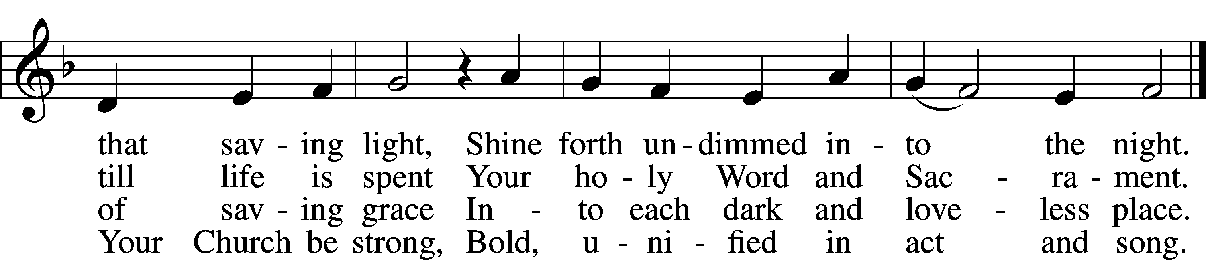

5 Restrain, O Lord, the human pride  
That seeks to thrust Your truth aside  
Or with some man-made thoughts or things  
Would dim the words Your Spirit sings.

6 Stay with us, Lord, and keep us true;  
Preserve our faith our whole life through—  
Your Word alone our heart’s defense,  
The Church’s glorious confidence.

Text: tr. F. Samuel Janzow, 1913–2001, alt.; (st. 1): Philipp Melanchthon, 1497–1560; (st. 1): German version Geistliche Psalmen, 1611, Nuremberg; (sts. 2–6): Nicolaus Selnecker, 1532–92  
Tune: Geistliche Lieder D. Martini Lutheri, 1589, Leipzig  
Text: © 1982 Concordia Publishing House. Used by permission: LSB Hymn License no. 110005011  
Tune: Public domain

Sermon

Votum

P The peace of God, which passes all understanding, keep your hearts and minds in Christ Jesus.

C **Amen.**

Stand

Offertory Psalm 51:10–12

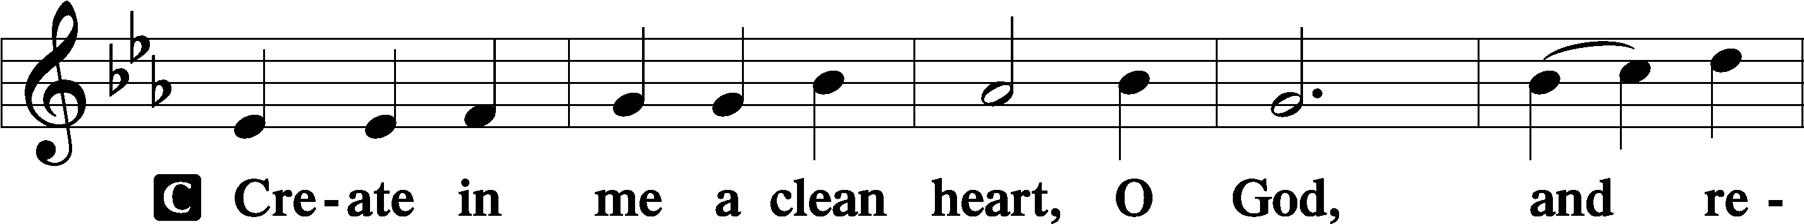

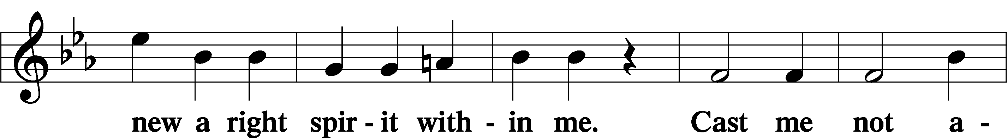

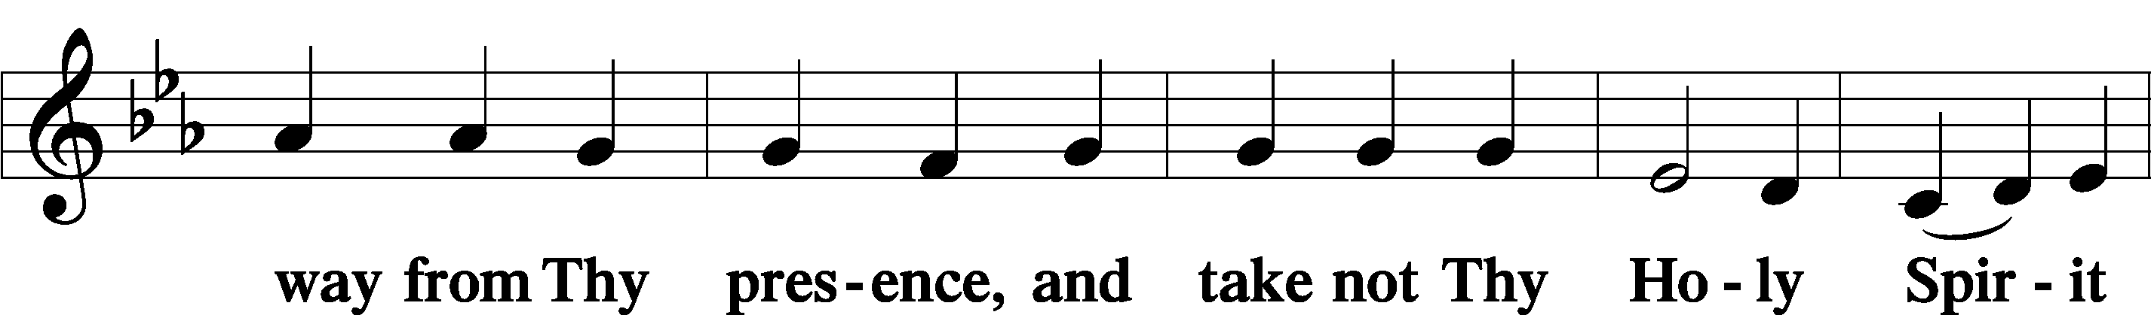

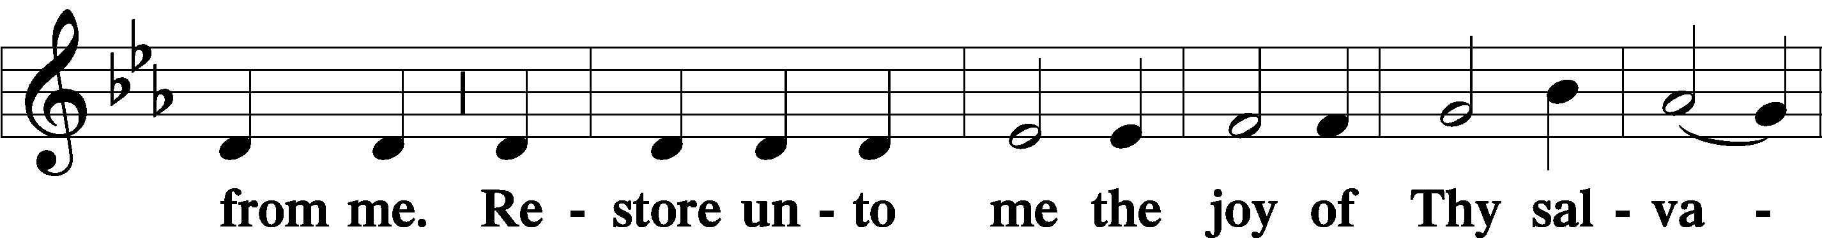

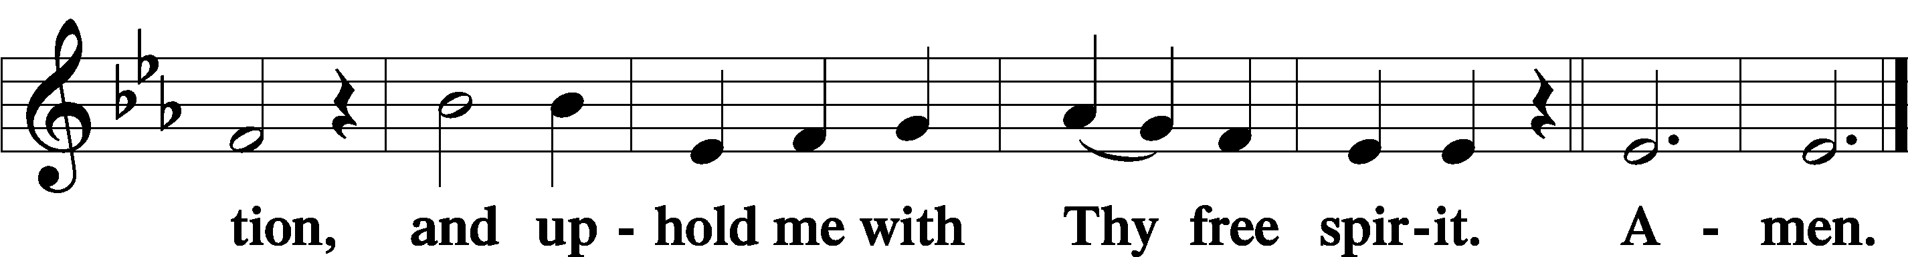

Offering

805 Praise God, from Whom All Blessings Flow

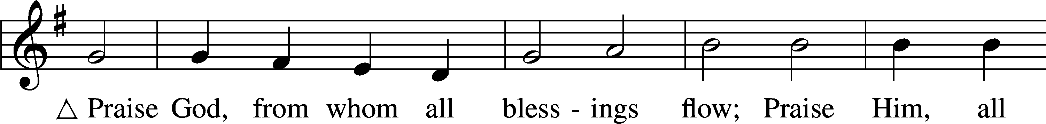

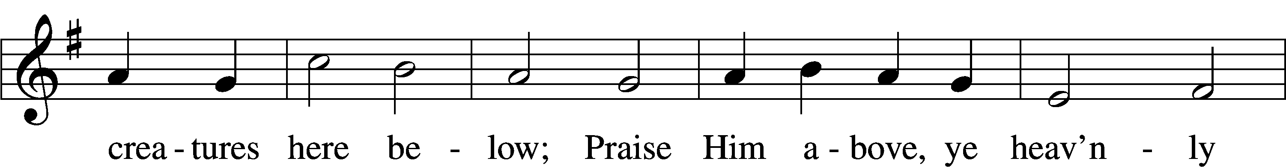

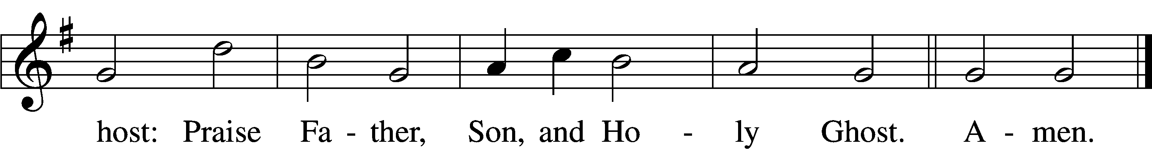

Text: Thomas Ken, 1637–1711  
Tune: Trente quatre Pseaumes de David, 1551, Geneva, ed. Louis Bourgeois  
Text and tune: Public domain

Prayer of the Church

Lord’s Prayer Matthew 6:9–13

P Lord, remember us in Your kingdom and teach us to pray:

C **Our Father who art in heaven,**

**hallowed be Thy name,**

**Thy kingdom come,**

**Thy will be done on earth**

**as it is in heaven;**

**give us this day our daily bread;**

**and forgive us our trespasses**

**as we forgive those**

**who trespass against us;**

**and lead us not into temptation,**

**but deliver us from evil.**

**For Thine is the kingdom**

**and the power and the glory**

**forever and ever. Amen.**

Collect for the Word

Blessed Lord, You have caused all Holy Scriptures to be written for our learning.

Grant that we may so hear them, read, mark, learn, and inwardly digest them that, by the patience and comfort of Your holy Word, we may embrace and ever hold fast the blessed hope of everlasting life; which you have given us in our Savior Jesus Christ, Your Son, our Lord, who lives and reigns with You and the Holy Spirit, one God, now and forever.

Post-Communion Collect

A Let us pray.

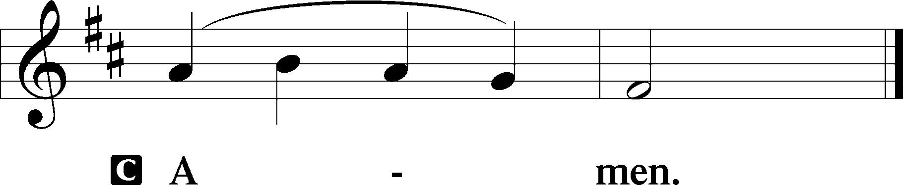

923 Almighty Father, Bless the Word

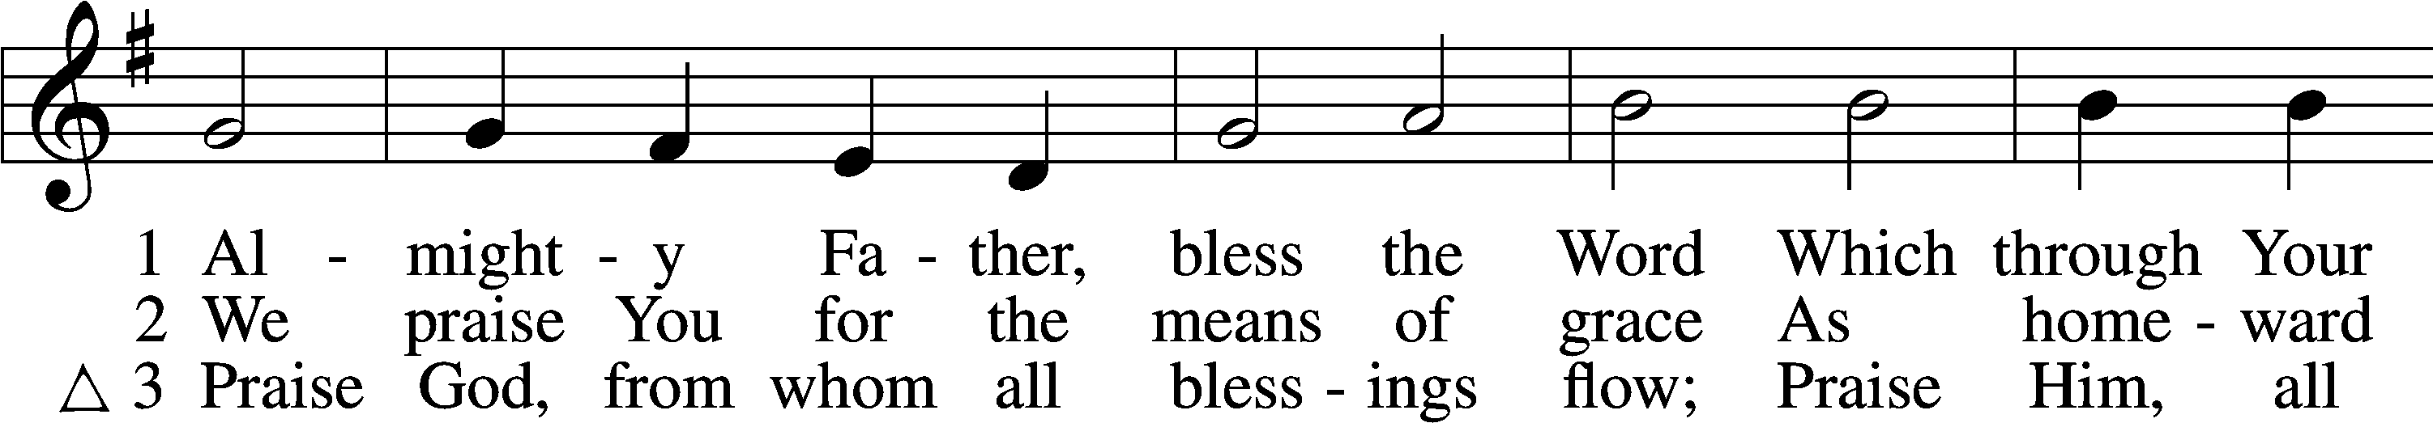

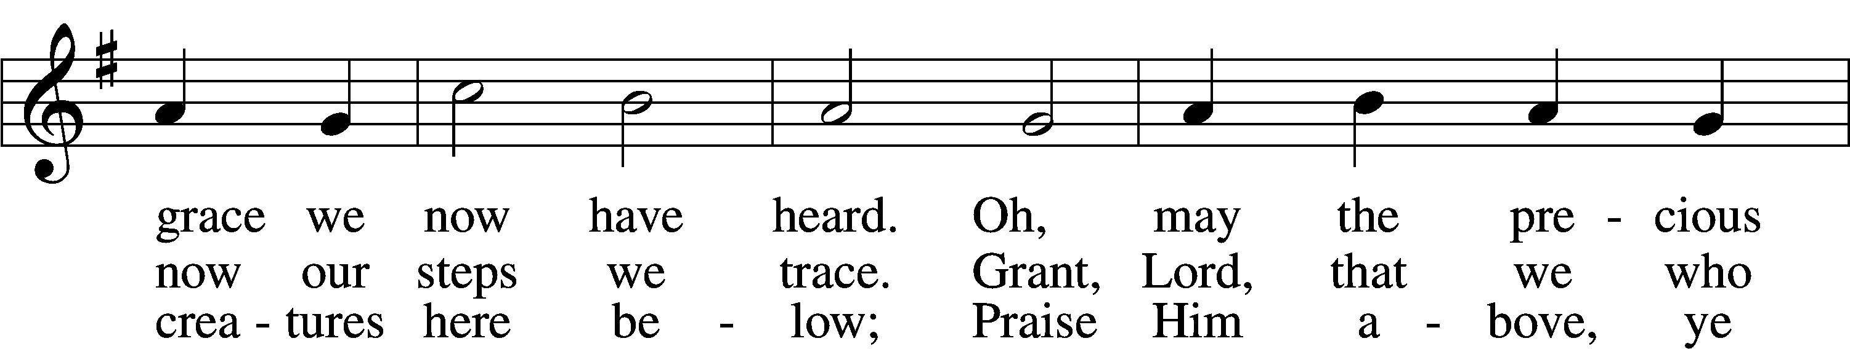

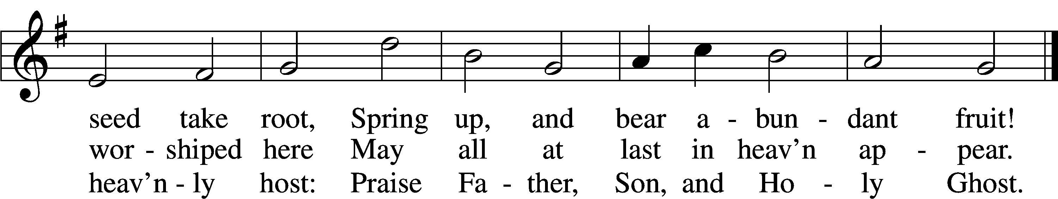

Text (sts. 1–2): Church Poetry, 1823, Philadelphia, alt.; (st. 3): Thomas Ken, 1637–1711  
Tune: Trente quatre Pseaumes de David, 1551, Geneva, ed. Louis Bourgeois  
Text and tune: Public domain

Acknowledgments

Unless otherwise indicated, Scripture quotations are from the ESV® Bible (The Holy Bible, English Standard Version®), copyright © 2001 by Crossway, a publishing ministry of Good News Publishers. Used by permission. All rights reserved.

Created by Lutheran Service Builder © 2023 Concordia Publishing House.