TLH 246 Holy, Holy, Holy sts. 1–4

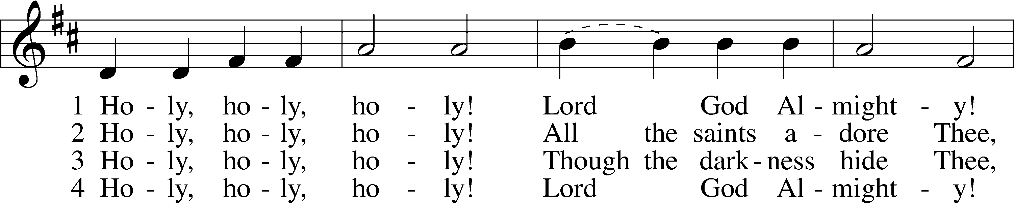

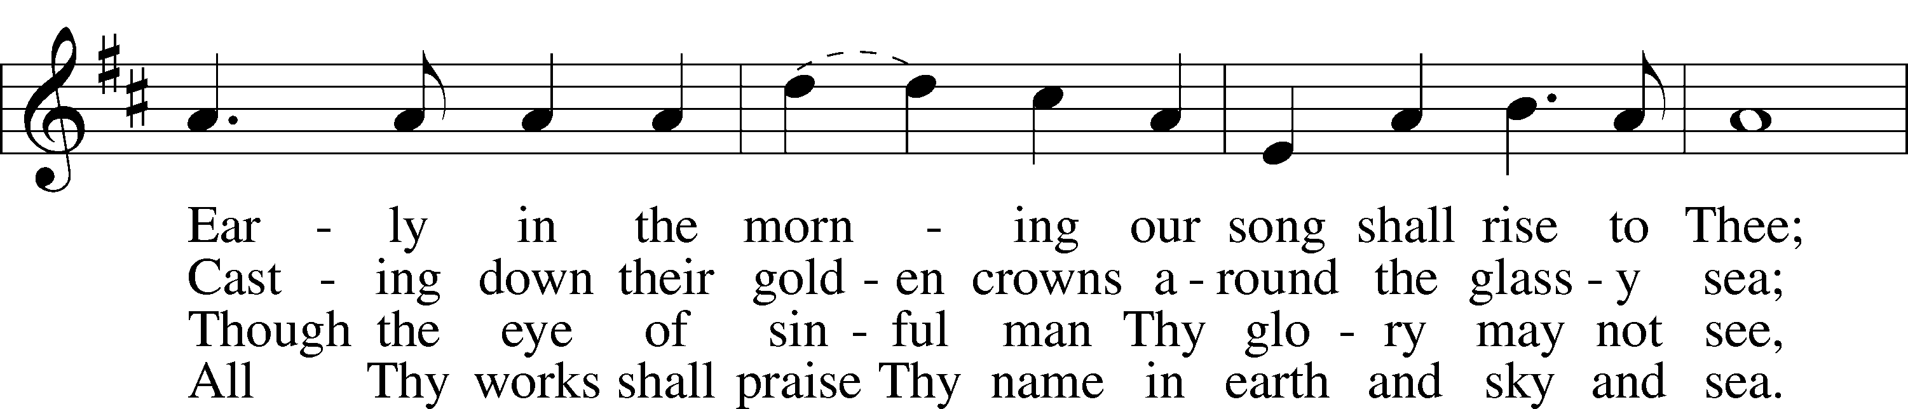

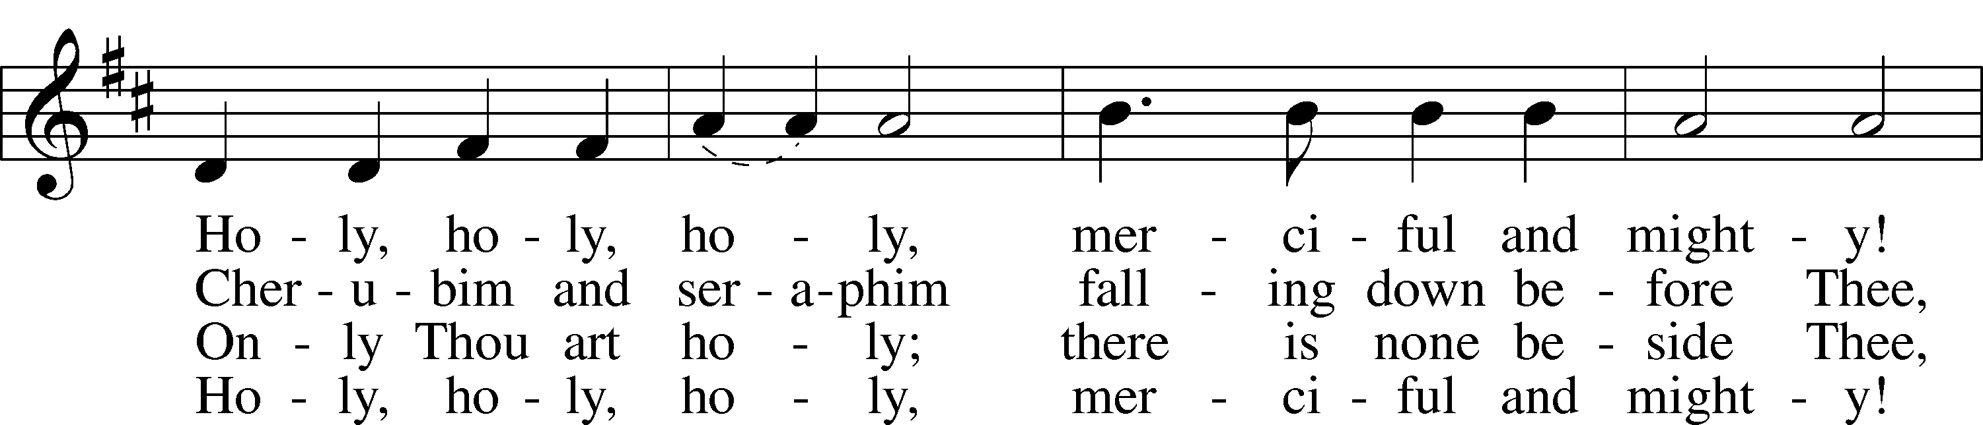

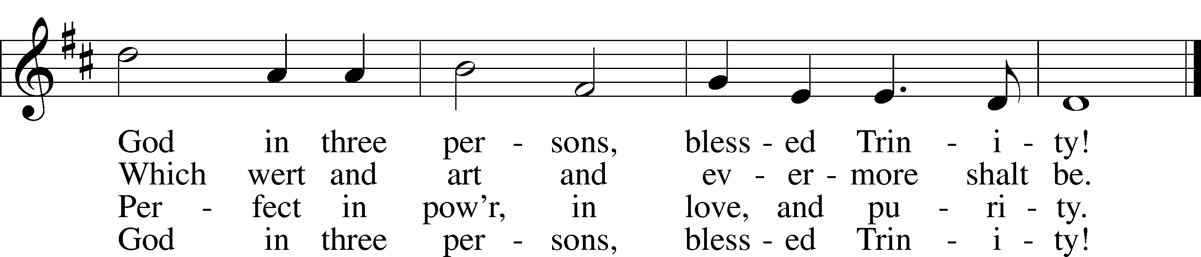

Text: Reginald Heber, 1783–1826  
Tune: John B. Dykes, 1823–76  
Text and tune: Public domain

# Confession and Absolution

Stand

The sign of the cross may be made by all in remembrance of their Baptism.

Invocation Matthew 28:19b; 18:20

P In the name of the Father and of the T Son and of the Holy Spirit.

C **Amen.**

Kneel/Stand

Silence for reflection on God’s Word and for self-examination.

Confession of Sins

P O almighty God, merciful Father,

C **I, a poor, miserable sinner, confess unto You all my sins and iniquities with which I have ever offended You and justly deserved Your temporal and eternal punishment. But I am heartily sorry for them and sincerely repent of them, and I pray You of Your boundless mercy and for the sake of the holy, innocent, bitter sufferings and death of Your beloved Son, Jesus Christ, to be gracious and merciful to me, a poor, sinful being.**

Absolution [John 20:19–23]

P Upon this your confession, I, by virtue of my office, as a called and ordained servant of the Word, announce the grace of God unto all of you, and in the stead and by the command of my Lord Jesus Christ I forgive you all your sins in the name of the Father and of the T Son and of the Holy Spirit.

C **Amen.**

Stand

# Service of the Word

Introit Psalm 95:1–3, 6–7a; antiphon: John 10:14, 15b

I am the good shepherd.  
 I know my own and my own know me, and I lay down my life for the sheep.  
**Oh come, let us sing to the Lord;  
 let us make a joyful noise to the rock of our salvation!**Let us come into his presence with thanksgiving;  
 let us make a joyful noise to him with songs of praise!  
**For the Lord is a great God,  
 and a great King above all gods**.  
Oh come, let us worship and bow down  
 let us kneel before the Lord, our Maker!  
For he is our God,  
 and we are the people of his pasture, and the sheep of his hand.

Gloria Patri

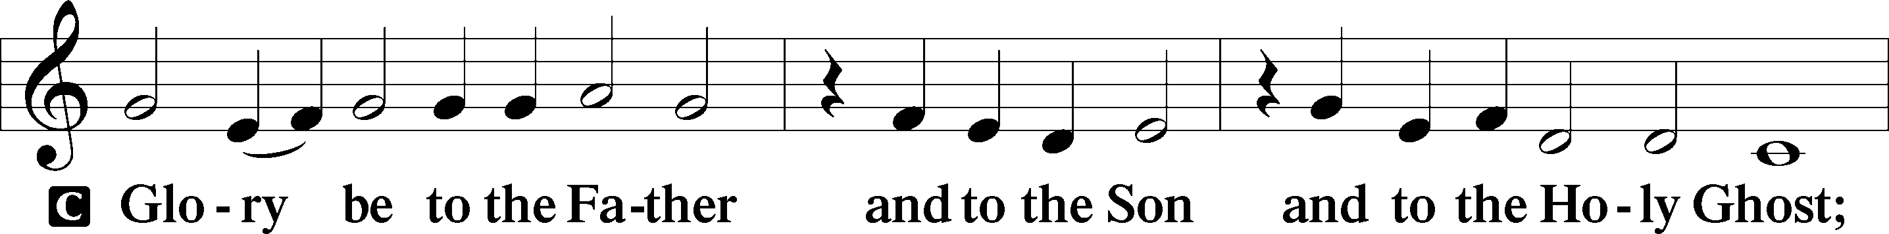

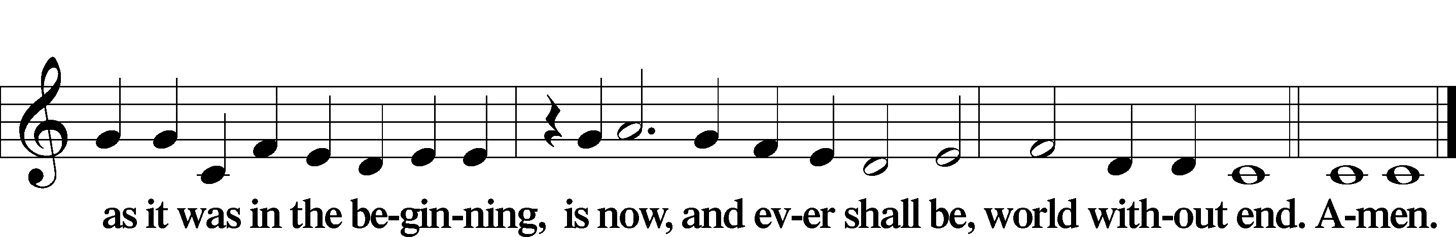

Kyrie Mark 10:47

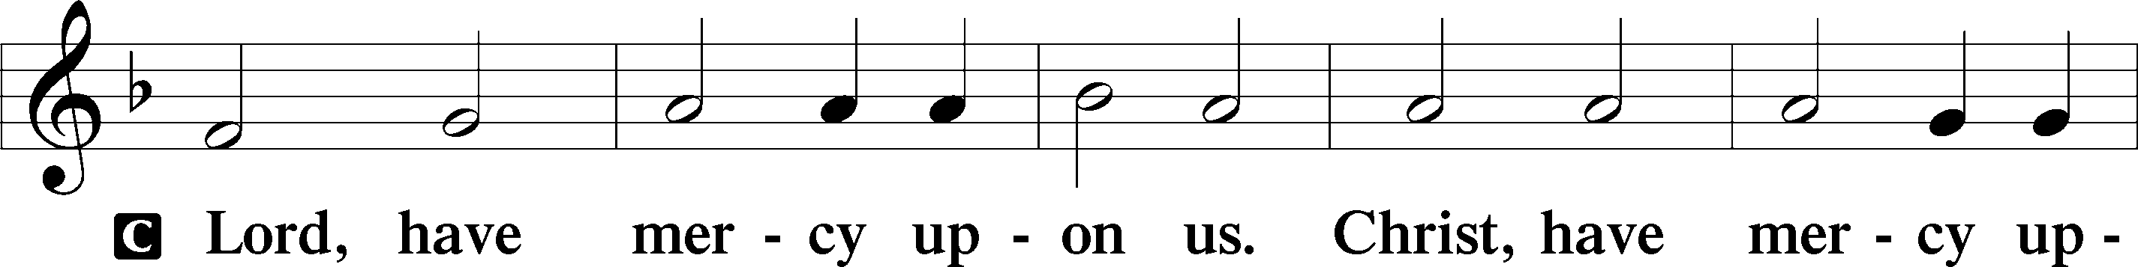

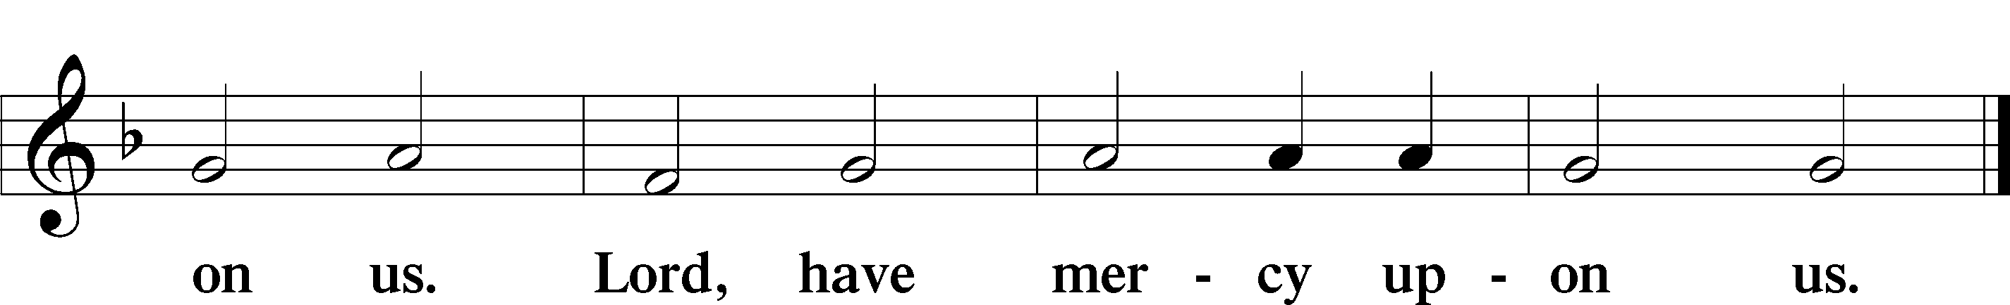

Gloria in Excelsis Luke 2:14; John 1:29

P Glory be to God on high:

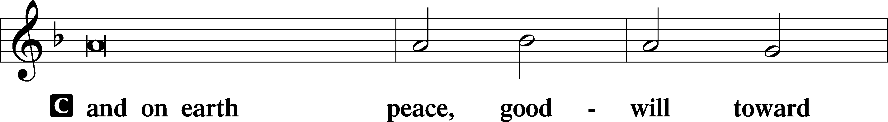

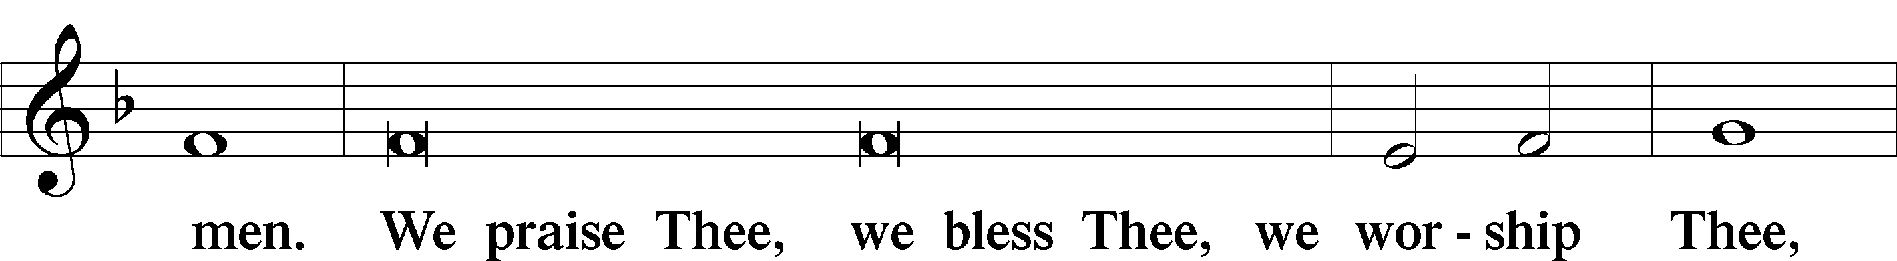

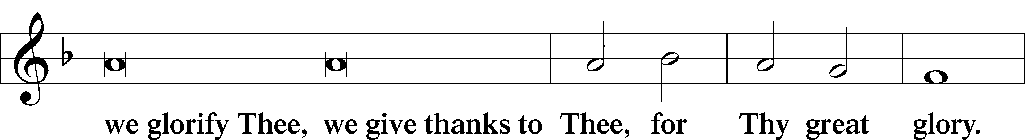

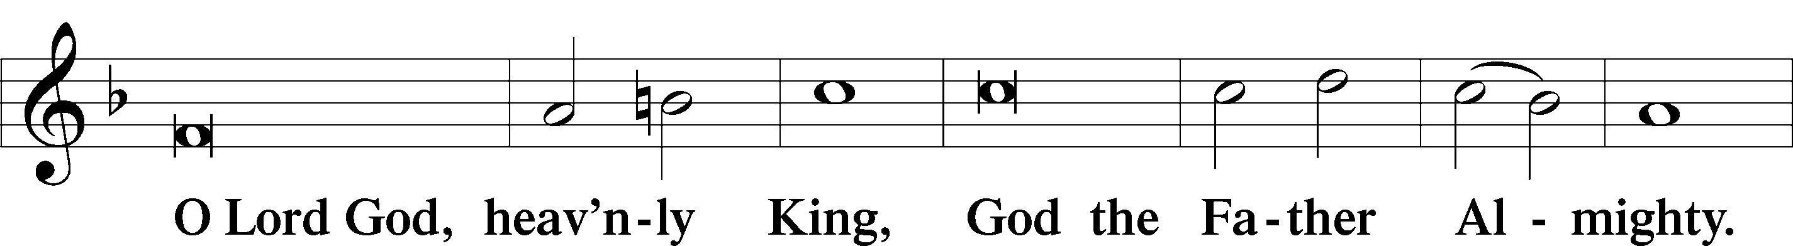

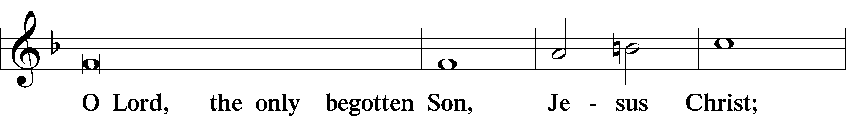

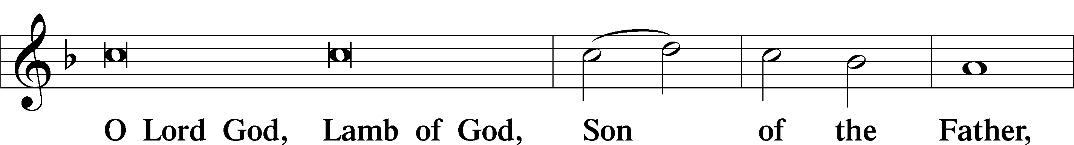

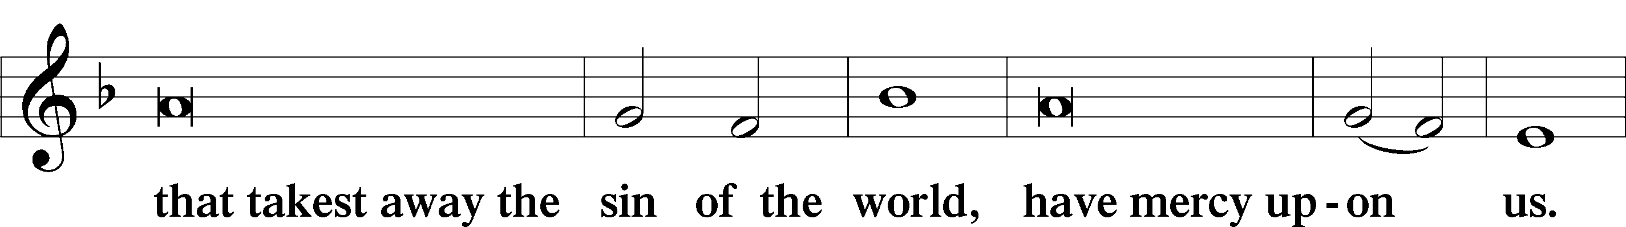

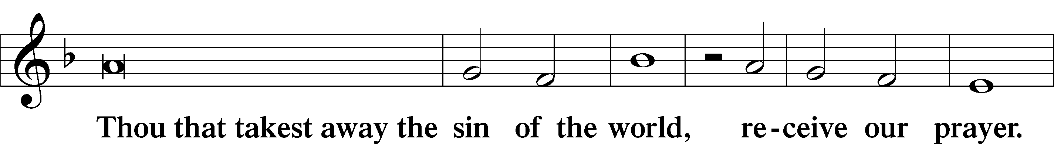

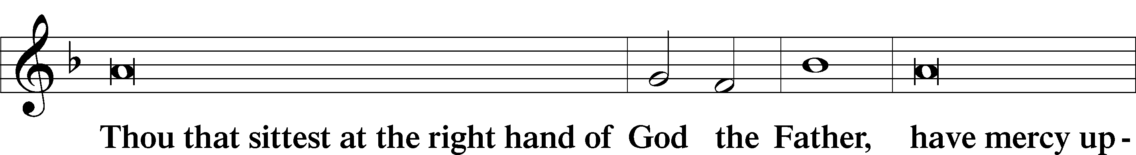

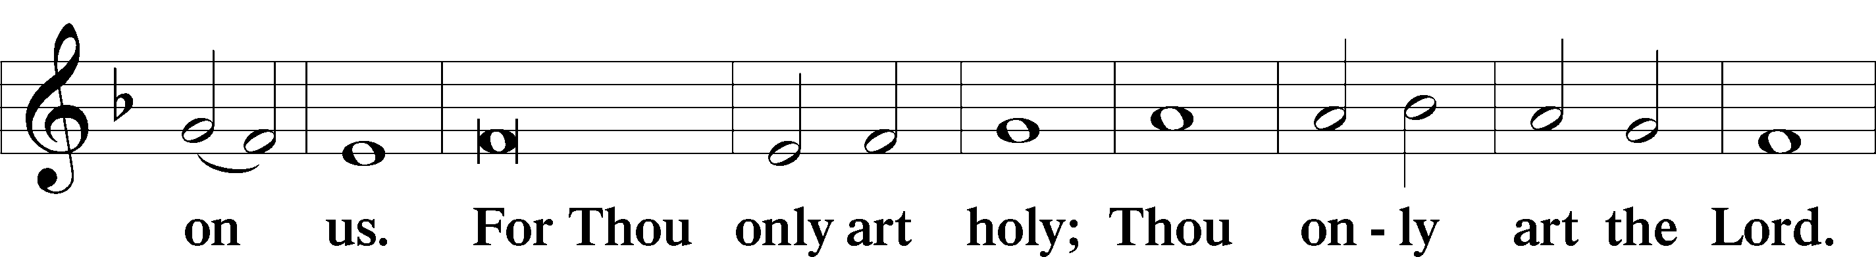

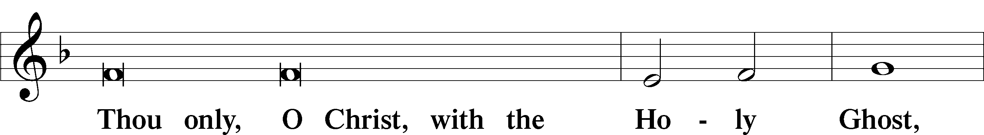

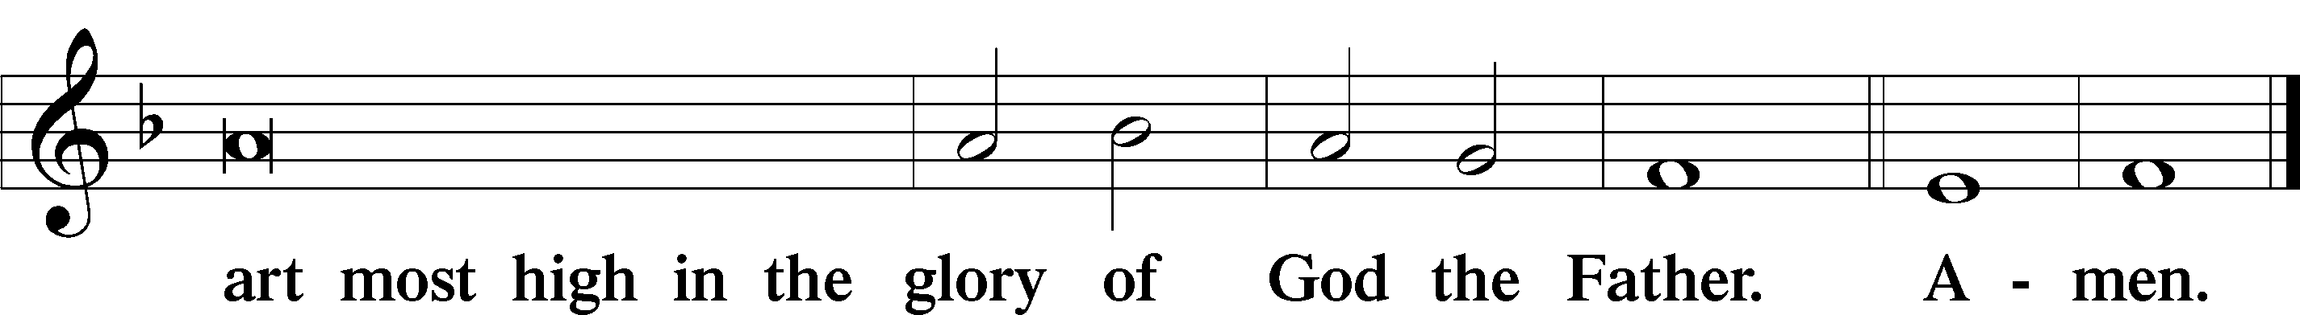

Salutation and Collect of the Day

P The Lord be with you.

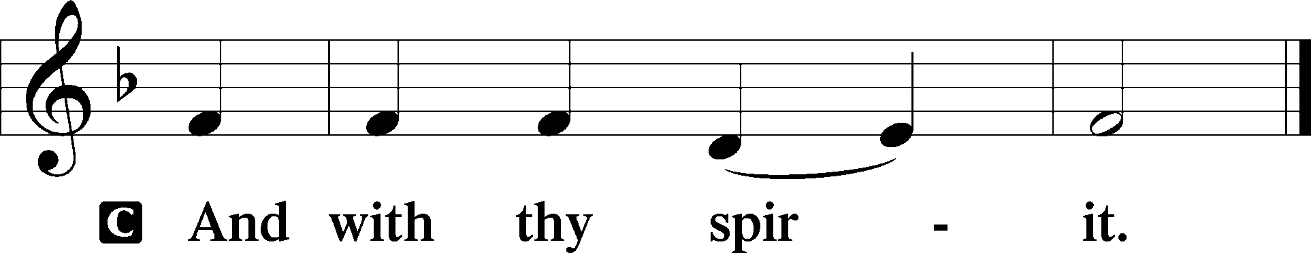

P Let us pray.

Almighty God, merciful Father, since You have wakened from death the Shepherd of Your sheep, grant us Your Holy Spirit that when we hear the voice of our Shepherd we may know Him who calls us each by name and follow where He leads; through the same Jesus Christ, Your Son, our Lord, who lives and reigns with You and the Holy Spirit, one God, now and forever.

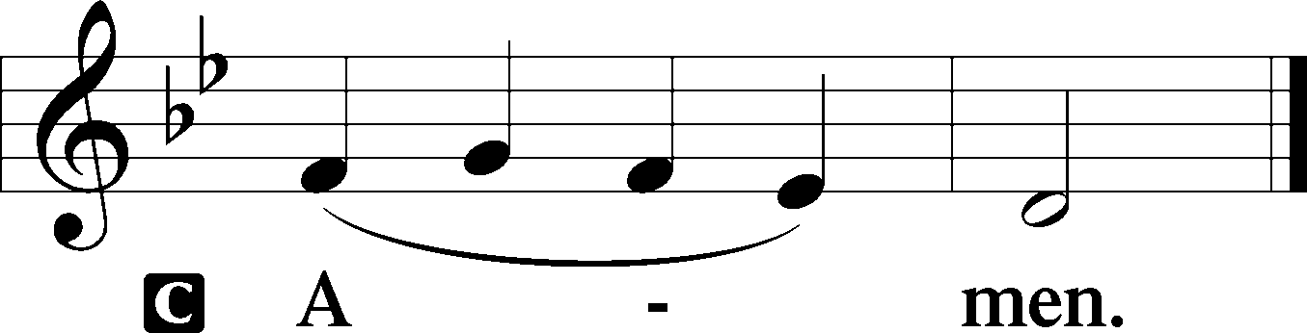

Sit

First Reading Acts 2:42–47

The Fellowship of the Believers

42They devoted themselves to the apostles’ teaching and fellowship, to the breaking of bread and the prayers. 43And awe came upon every soul, and many wonders and signs were being done through the apostles. 44And all who believed were together and had all things in common. 45And they were selling their possessions and belongings and distributing the proceeds to all, as any had need. 46And day by day, attending the temple together and breaking bread in their homes, they received their food with glad and generous hearts, 47praising God and having favor with all the people. And the Lord added to their number day by day those who were being saved.

A This is the Word of the Lord.

C **Thanks be to God.**

Epistle 1 Peter 2:19–25

19This is a gracious thing, when, mindful of God, one endures sorrows while suffering unjustly. 20For what credit is it if, when you sin and are beaten for it, you endure? But if when you do good and suffer for it you endure, this is a gracious thing in the sight of God. 21For to this you have been called, because Christ also suffered for you, leaving you an example, so that you might follow in his steps. 22He committed no sin, neither was deceit found in his mouth. 23When he was reviled, he did not revile in return; when he suffered, he did not threaten, but continued entrusting himself to him who judges justly. 24He himself bore our sins in his body on the tree, that we might die to sin and live to righteousness. By his wounds you have been healed. 25For you were straying like sheep, but have now returned to the Shepherd and Overseer of your souls.

A This is the Word of the Lord.

C **Thanks be to God.**

Stand

Alleluia

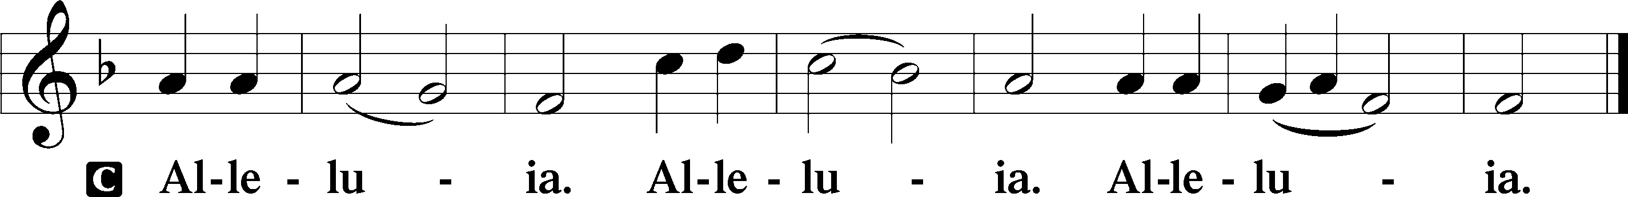

Holy Gospel John 10:1–10

P The Holy Gospel according to St. John, the tenth chapter.

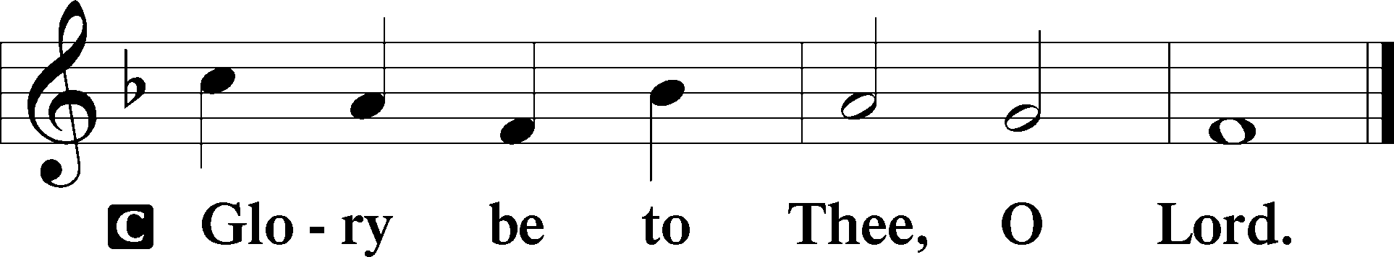

I Am the Good Shepherd

1[Jesus said:] “Truly, truly, I say to you, he who does not enter the sheepfold by the door but climbs in by another way, that man is a thief and a robber. 2But he who enters by the door is the shepherd of the sheep. 3To him the gatekeeper opens. The sheep hear his voice, and he calls his own sheep by name and leads them out. 4When he has brought out all his own, he goes before them, and the sheep follow him, for they know his voice. 5A stranger they will not follow, but they will flee from him, for they do not know the voice of strangers.” 6This figure of speech Jesus used with them, but they did not understand what he was saying to them.

7So Jesus again said to them, “Truly, truly, I say to you, I am the door of the sheep. 8All who came before me are thieves and robbers, but the sheep did not listen to them. 9I am the door. If anyone enters by me, he will be saved and will go in and out and find pasture. 10The thief comes only to steal and kill and destroy. I came that they may have life and have it abundantly.”

P This is the Gospel of the Lord.

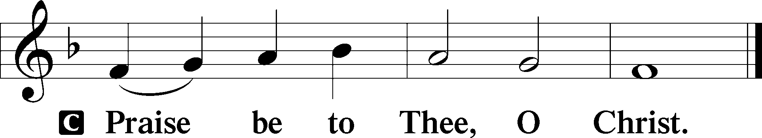

Nicene Creed

C **I believe in one God,**

**the Father Almighty,**

**maker of heaven and earth**

**and of all things visible and invisible.**

**And in one Lord Jesus Christ,**

**the only-begotten Son of God,**

**begotten of His Father before all worlds,**

**God of God, Light of Light,**

**very God of very God,**

**begotten, not made,**

**being of one substance with the Father,**

**by whom all things were made;**

**who for us men and for our salvation came down from heaven**

**and was incarnate by the Holy Spirit of the virgin Mary**

**and was made man;**

**and was crucified also for us under Pontius Pilate.**

**He suffered and was buried.**

**And the third day He rose again according to the Scriptures**

**and ascended into heaven**

**and sits at the right hand of the Father.**

**And He will come again with glory to judge both the living and the dead,**

**whose kingdom will have no end.**

**And I believe in the Holy Spirit,**

**the Lord and giver of life,**

**who proceeds from the Father and the Son,**

**who with the Father and the Son together is worshiped and glorified,**

**who spoke by the prophets.**

**And I believe in one holy Christian and apostolic Church,**

**I acknowledge one Baptism for the remission of sins,**

**and I look for the resurrection of the dead**

**and the life** T **of the world to come. Amen.**

Sit

TLH 342 Chief of Sinners Though I Be

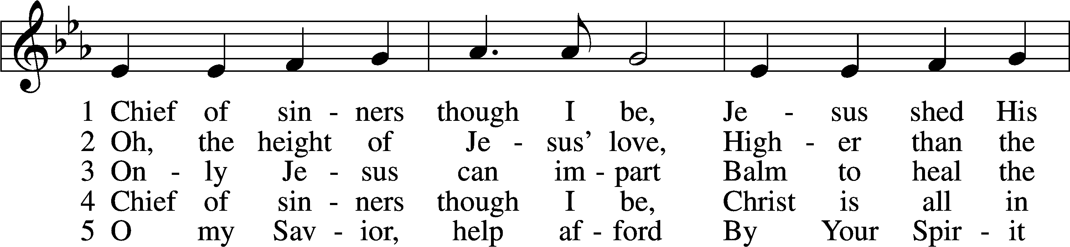

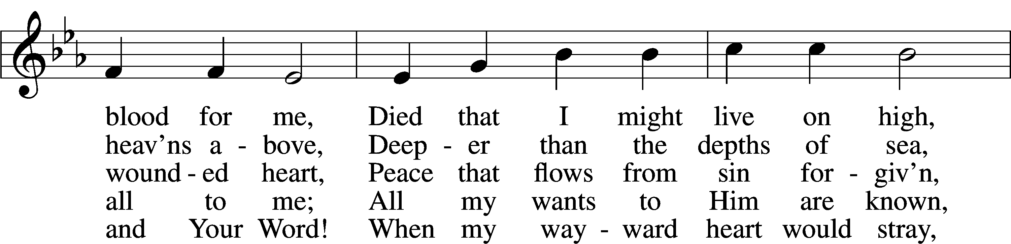

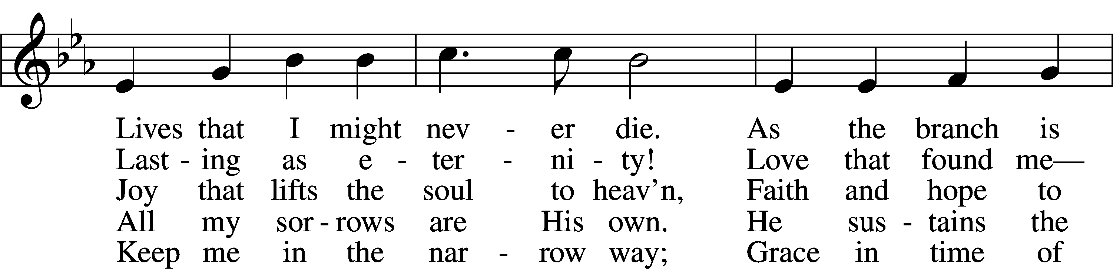

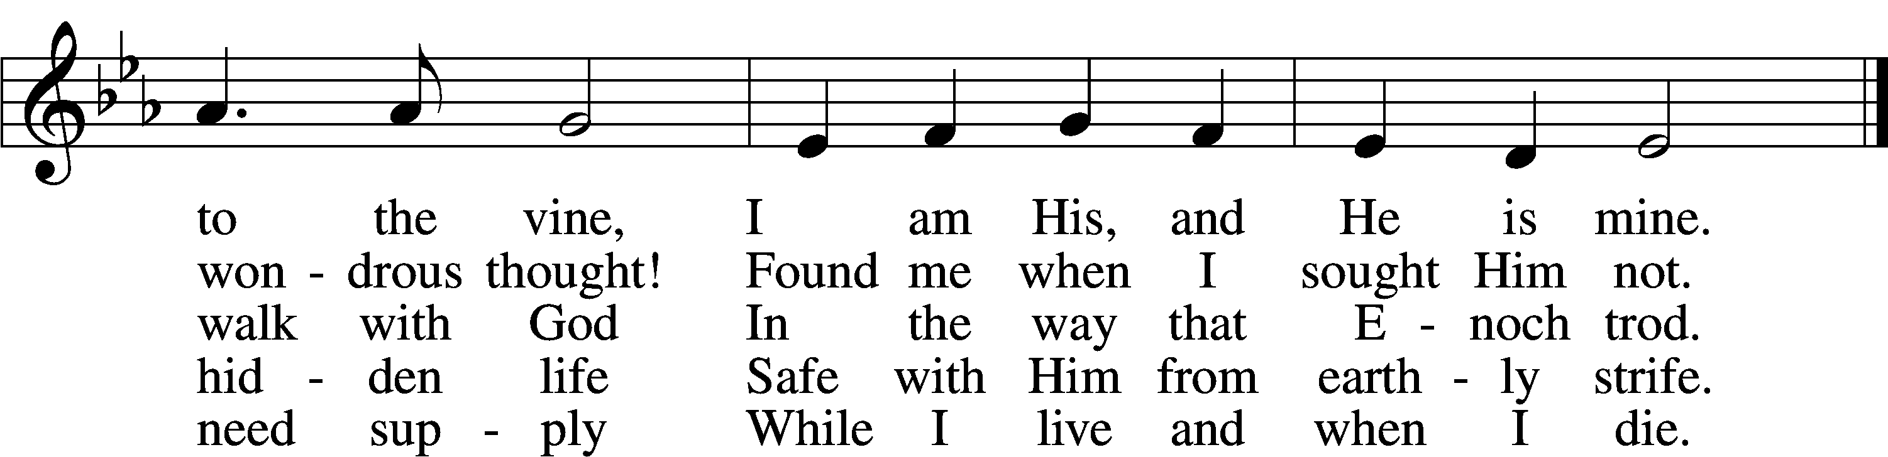

Text: William McComb, 1793–1873, alt.  
Tune: Richard Redhead, 1820–1901  
Text and tune: Public domain

Sermon

Votum

P The peace of God, which passes all understanding, keep your hearts and minds in Christ Jesus.

C **Amen.**

Stand

Offertory Psalm 51:10–12

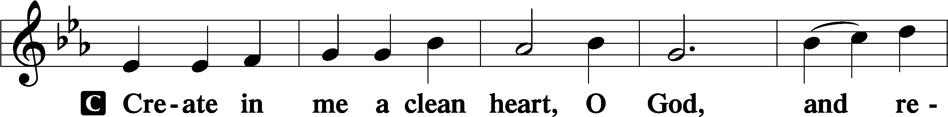

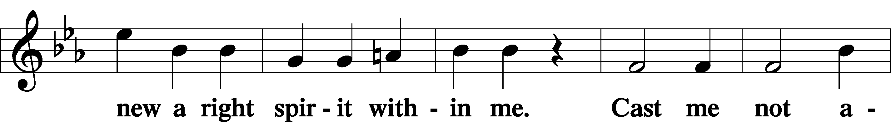

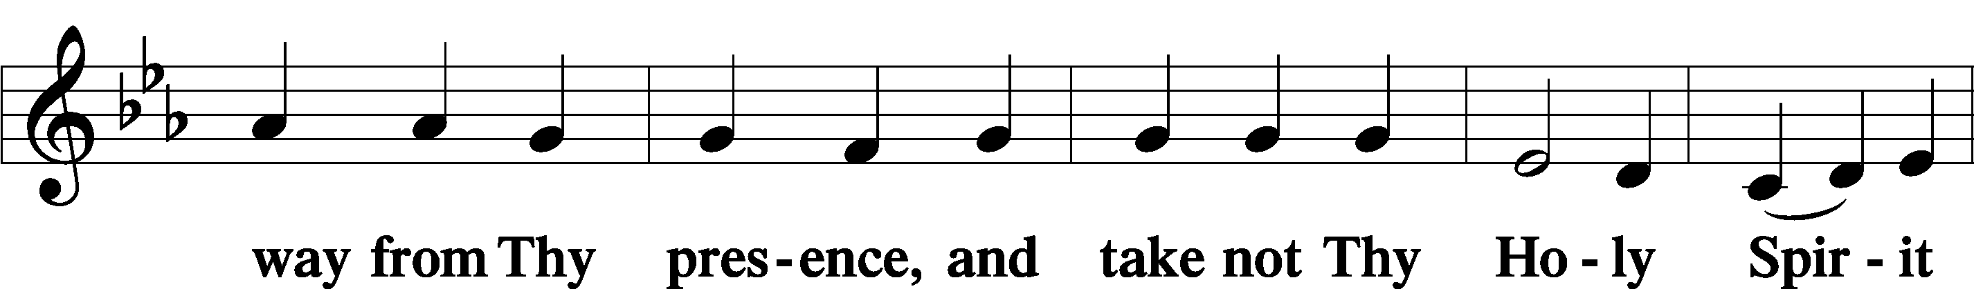

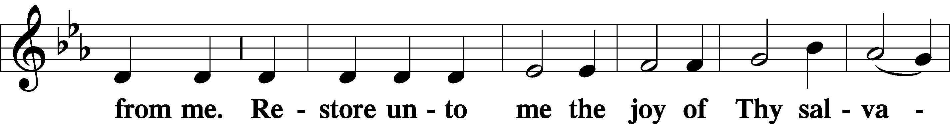

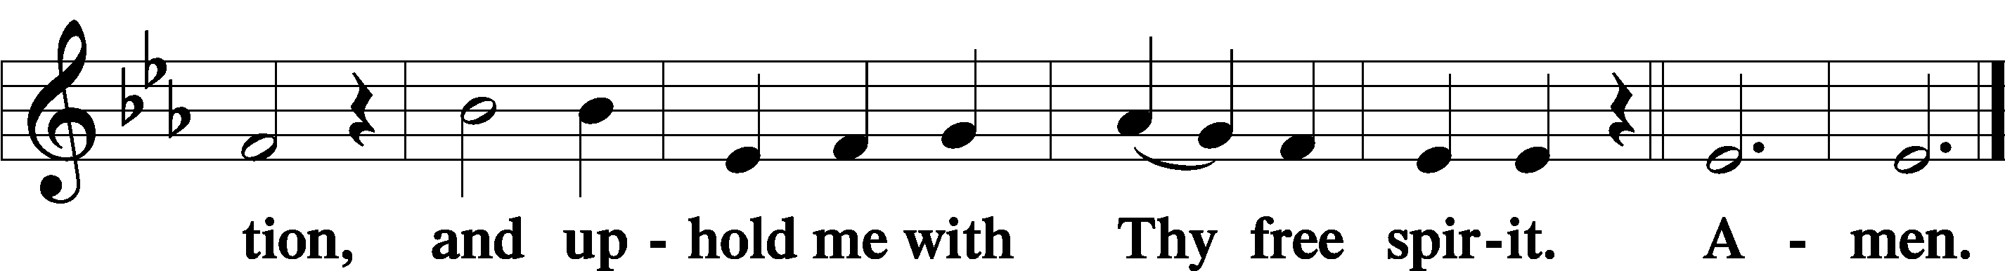

Offering

805 Praise God, from Whom All Blessings Flow

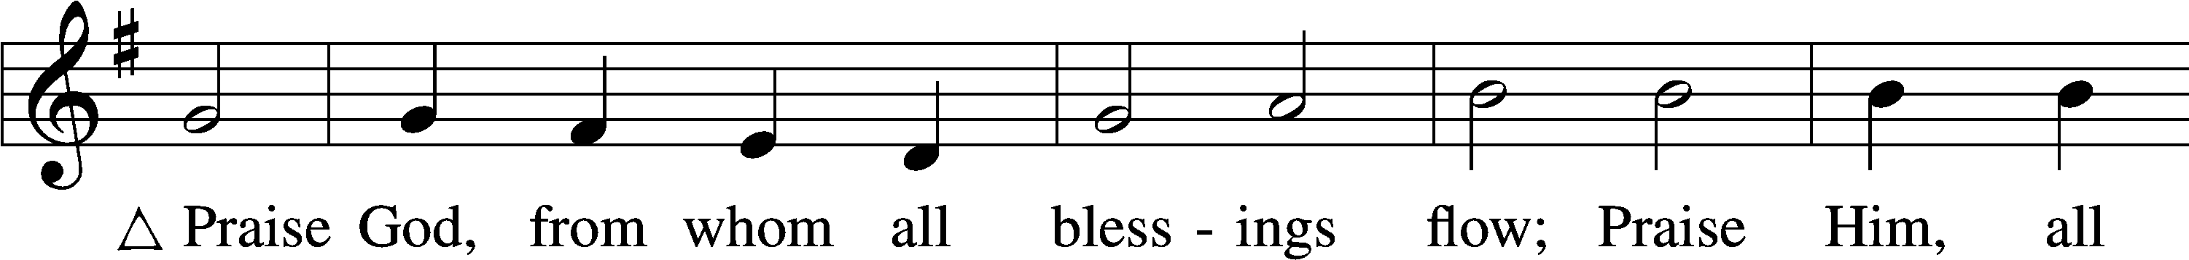

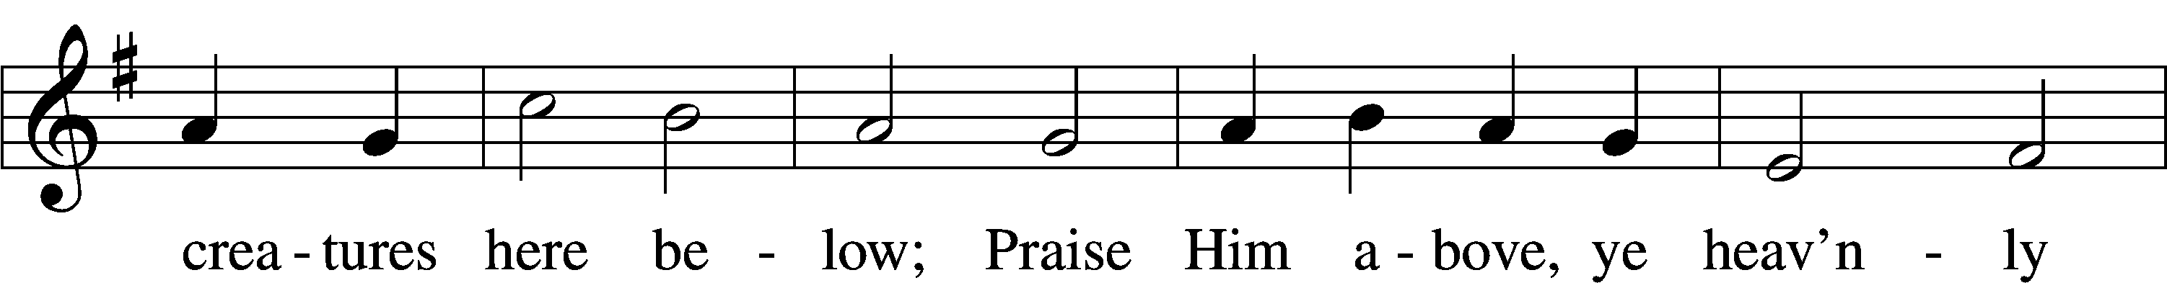

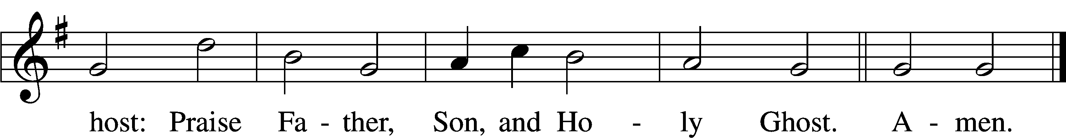

Text: Thomas Ken, 1637–1711  
Tune: Trente quatre Pseaumes de David, 1551, Geneva, ed. Louis Bourgeois  
Text and tune: Public domain

Stand

Prayer of the Church

# Service of the Sacrament

Preface 2 Timothy 4:22; [Colossians 3:1]; [Psalm 136]

P The Lord be with you.

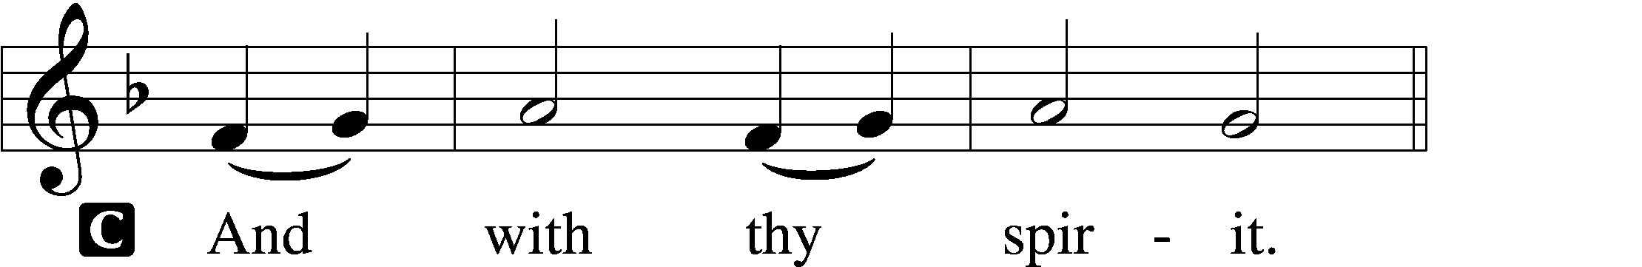

P Lift up your hearts.

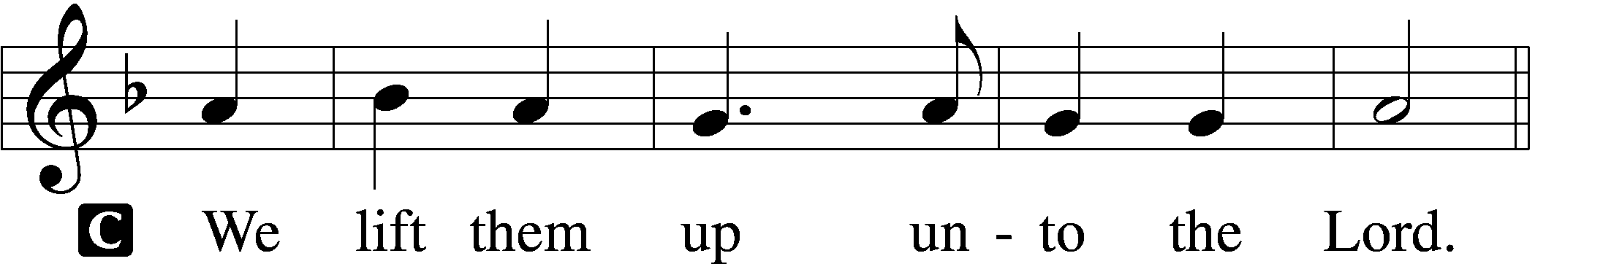

P Let us give thanks unto the Lord, our God.

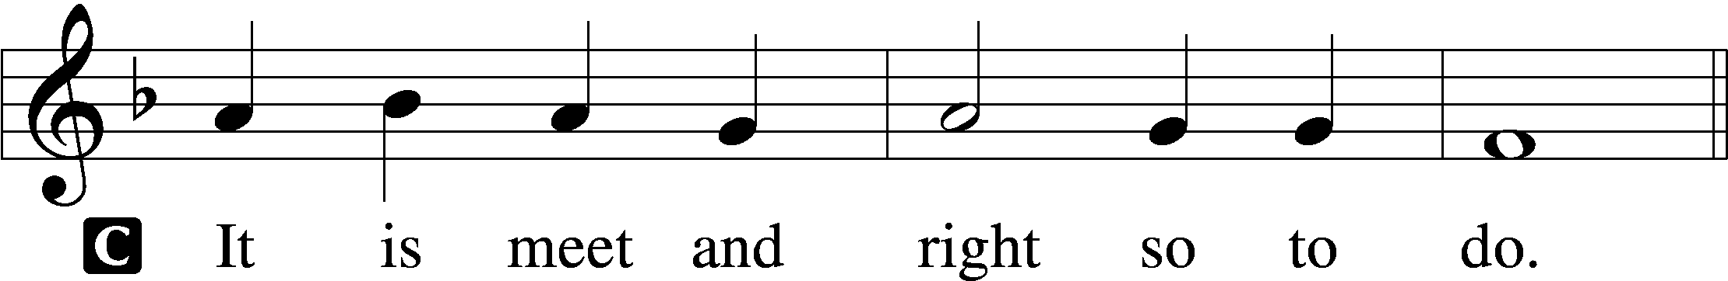

Proper Preface (Full)

P It is truly meet, right, and salutary that we should at all times and in all places give thanks to You, holy Lord, almighty Father, everlasting God. And most especially are we bound to praise You on this day for the glorious resurrection of Your Son, Jesus Christ, the very Paschal Lamb, who was sacrificed for us and bore the sins of the world. By His dying He has destroyed death, and by His rising again He has restored to us everlasting life. Therefore with Mary Magdalene, Peter and John, and with all the witnesses of the resurrection, with angels and archangels, and with all the company of heaven we laud and magnify Your glorious name, evermore praising You and saying:

Sanctus Isaiah 6:3; Matthew 21:9

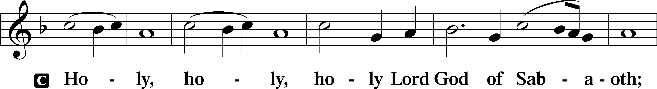

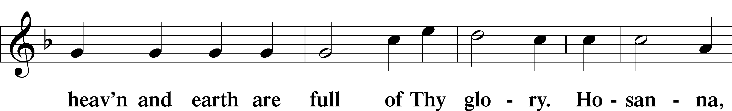

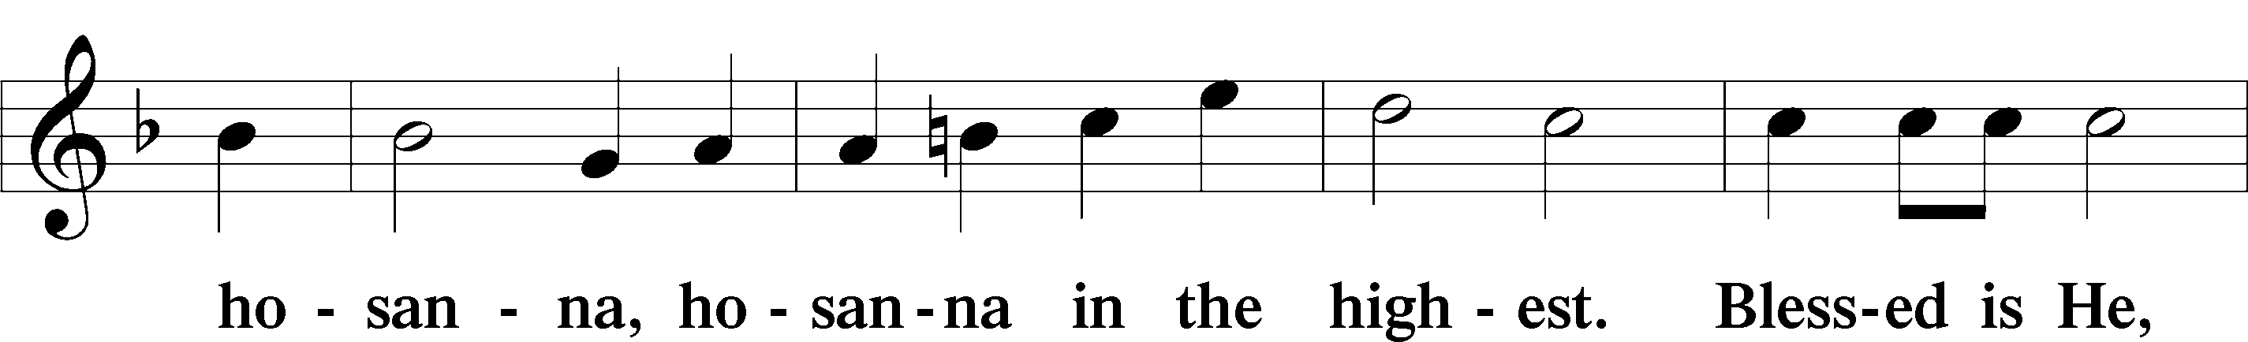

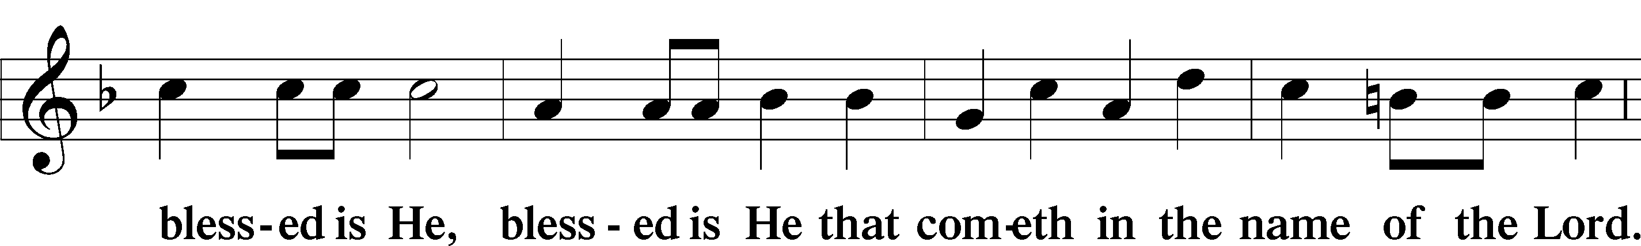

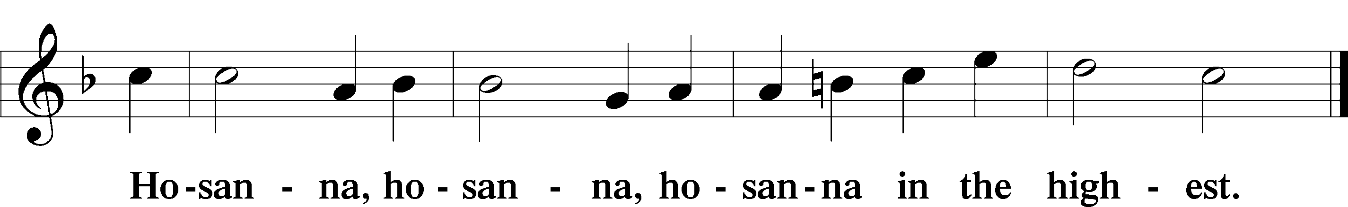

Lord’s Prayer Matthew 6:9–13

P Our Father who art in heaven,

hallowed be Thy name,

Thy kingdom come,

Thy will be done on earth as it is in heaven;

give us this day our daily bread;

and forgive us our trespasses as we forgive those who trespass against us;

and lead us not into temptation,

but deliver us from evil.

C **For Thine is the kingdom and the power and the glory forever and ever. Amen.**

The Words of Our Lord Matthew 26:26–28; Mark 14:22–24; Luke 22:19–20; 1 Corinthians 11:23–25

P Our Lord Jesus Christ, on the night when He was betrayed, took bread, and when He had given thanks, He broke it and gave it to the disciples and said: “Take, eat; this is My T body, which is given for you. This do in remembrance of Me.”

In the same way also He took the cup after supper, and when He had given thanks, He gave it to them, saying: “Drink of it, all of you; this cup is the new testament in My T blood, which is shed for you for the forgiveness of sins. This do, as often as you drink it, in remembrance of Me.”

Pax Domini John 20:19

P The peace of the Lord be with you always.

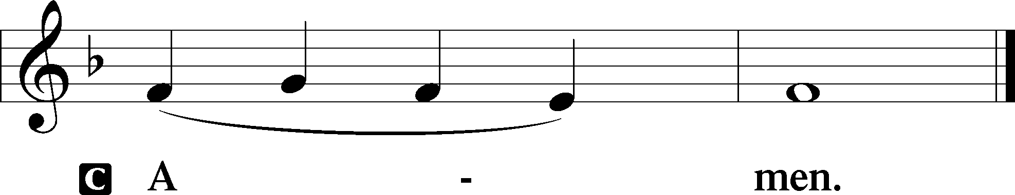

Agnus Dei John 1:29

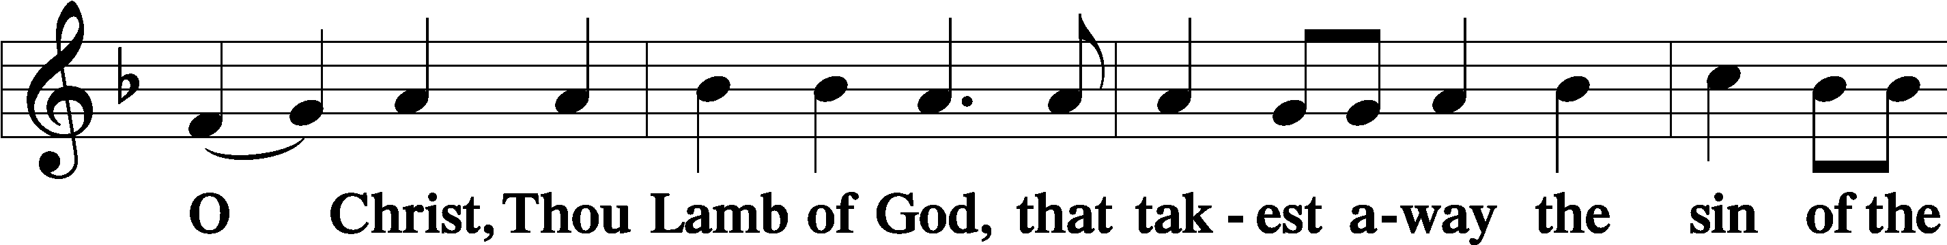

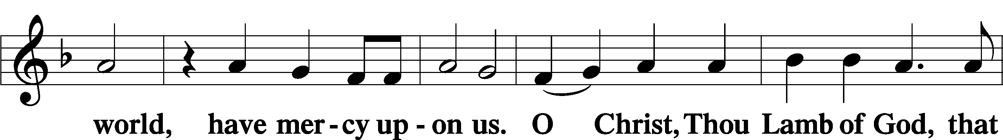

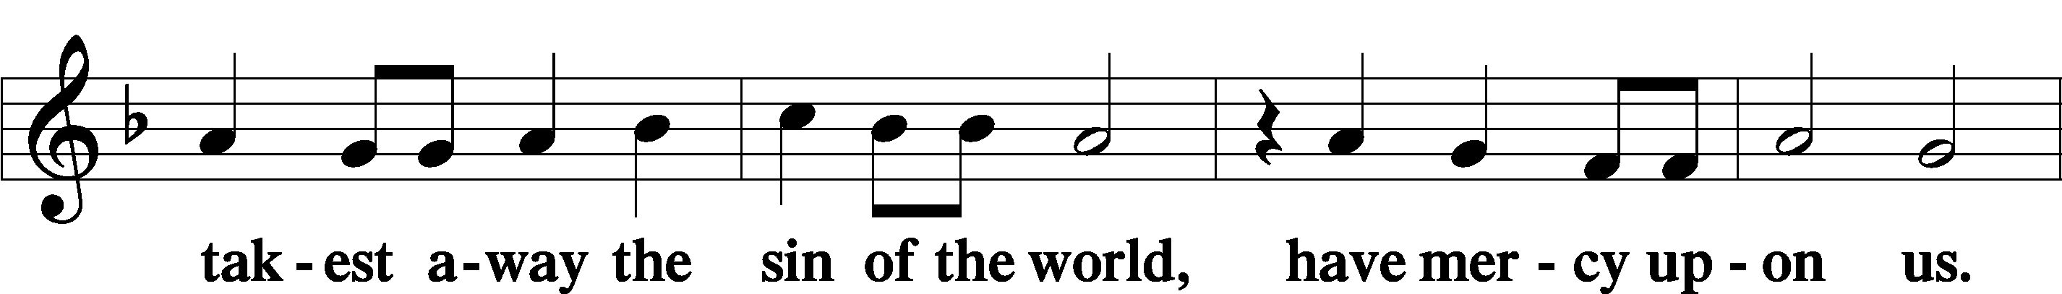

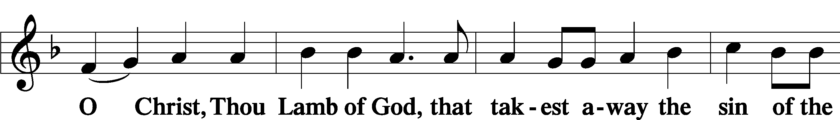

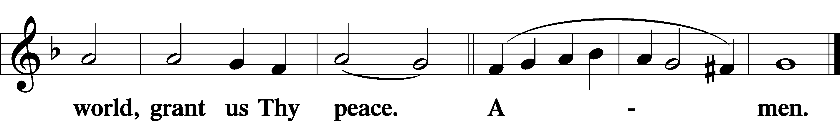

Sit

Distribution

TLH 162 Ride On, Ride On in Majesty

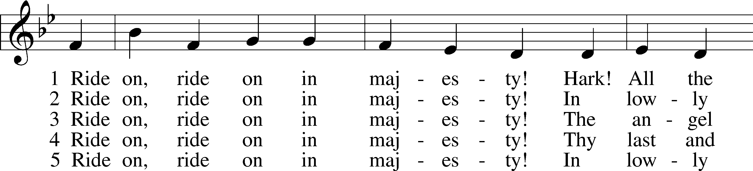

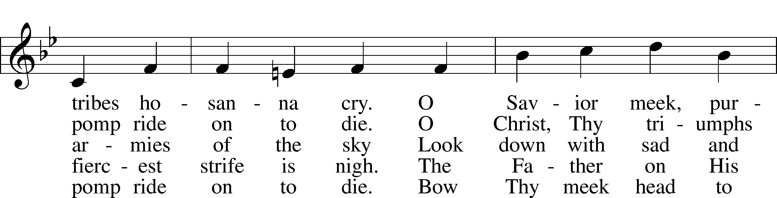

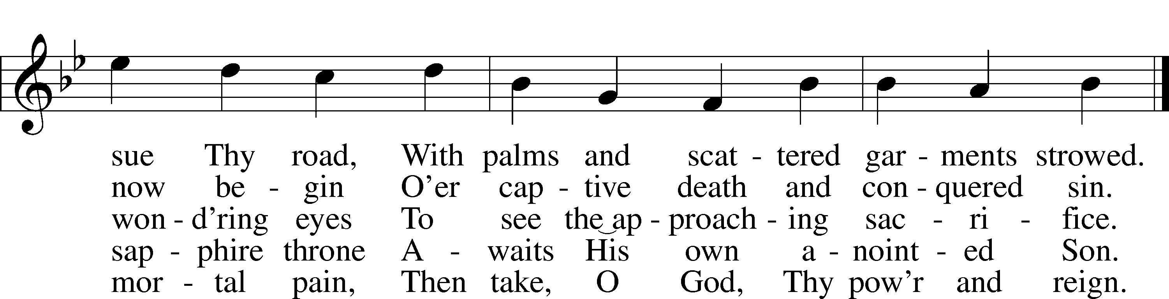

Text: Henry H. Milman, 1791–1868, alt.  
Tune: Musicalisch Hand-Buch der Geistlichen Melodien, 1690, Hamburg, alt.  
Text and tune: Public domain

TLH 201Jesus Lives! The Victory’s Won

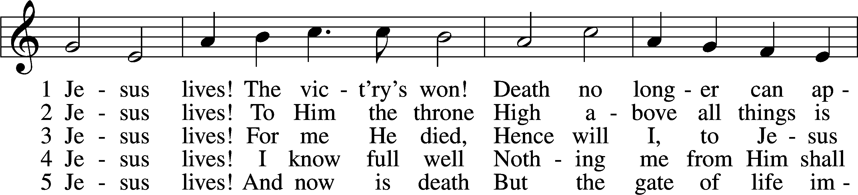

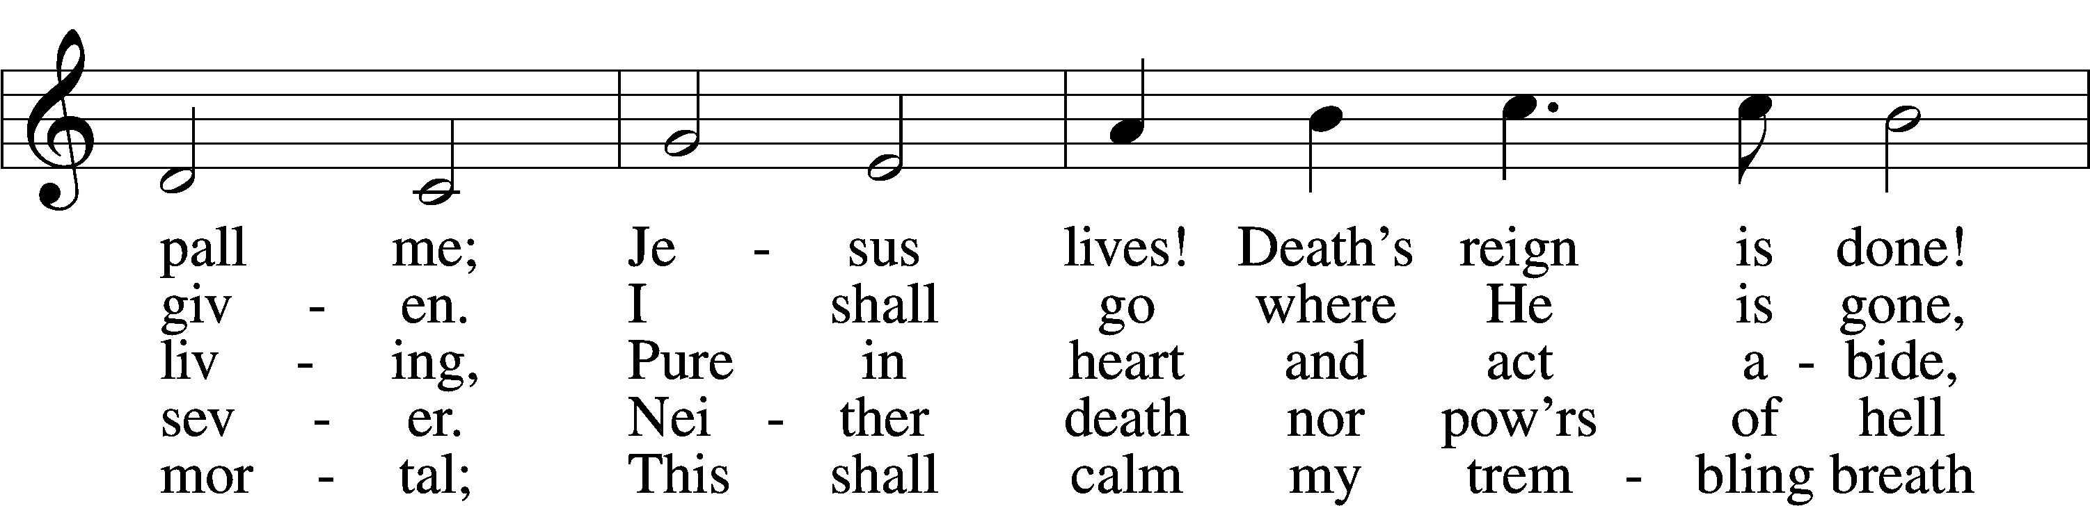

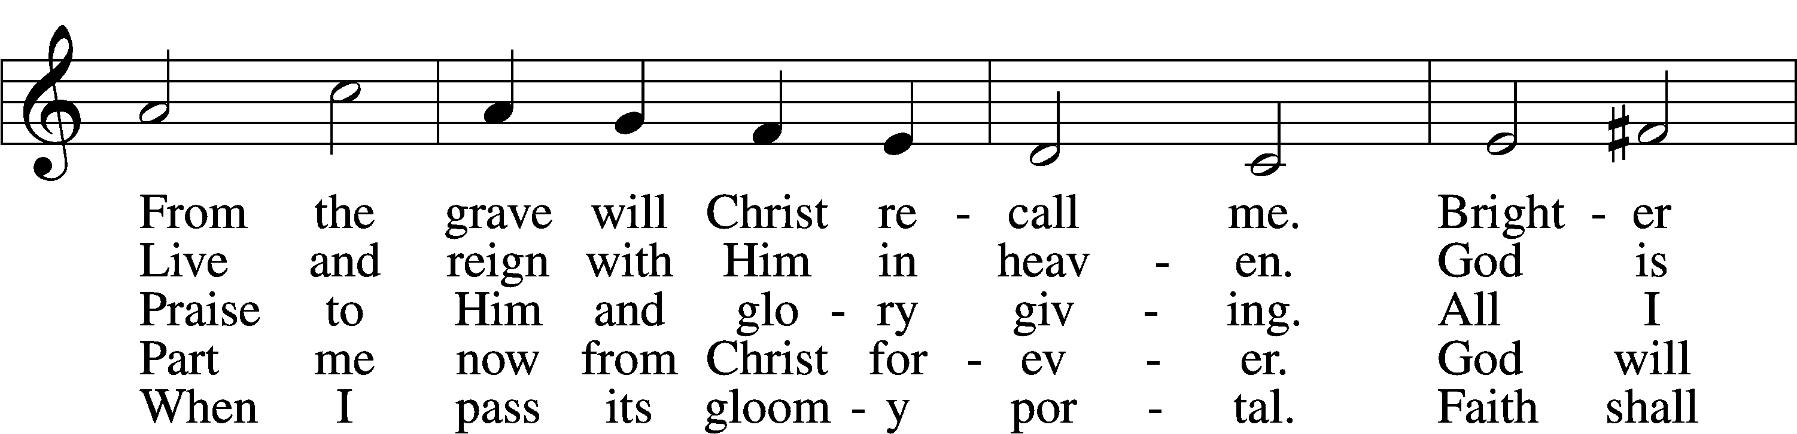

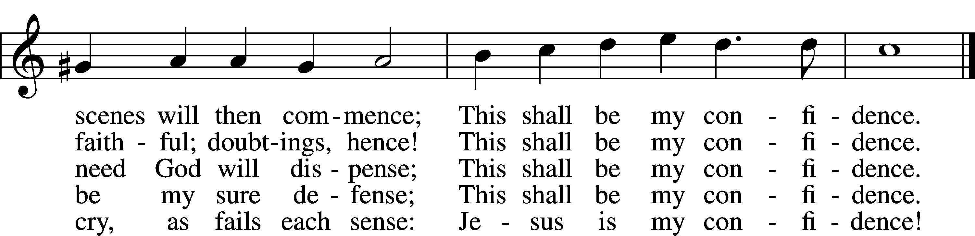

Text: Christian Fürchtegott Gellert, 1715–69; tr. Frances E. Cox, 1812–97, alt.  
Tune: Johann Crüger, 1598–1662  
Text and tune: Public domain

610 Lord Jesus, Think on Me

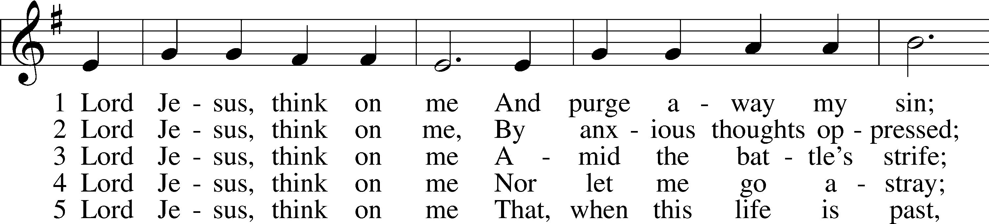

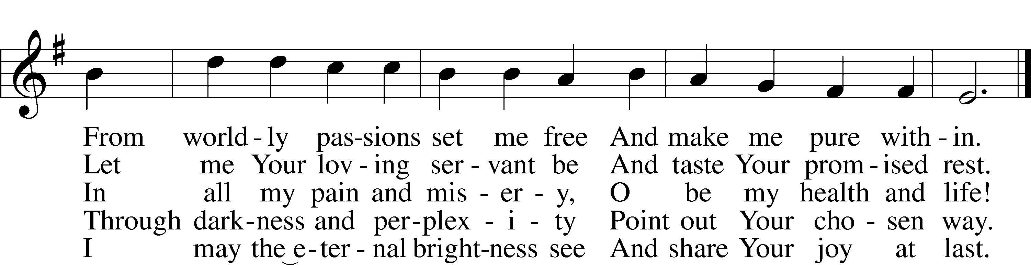

6 Lord Jesus think on me 7. Lord Jesus think on me

That when the flood is past That I may a sing above

I may th’eternal brightness see To Father Spirit and to Thee

And share the joy at last. The strains of praise and love

6\\Text: Synesius of Cyrene, c. 365–c. 414; tr. Allen W. Chatfield, 1808–96, alt.  
Tune: William Daman, c. 1540–1591  
Text and tune: Public domain

707 Oh, That the Lord Would Guide My Ways

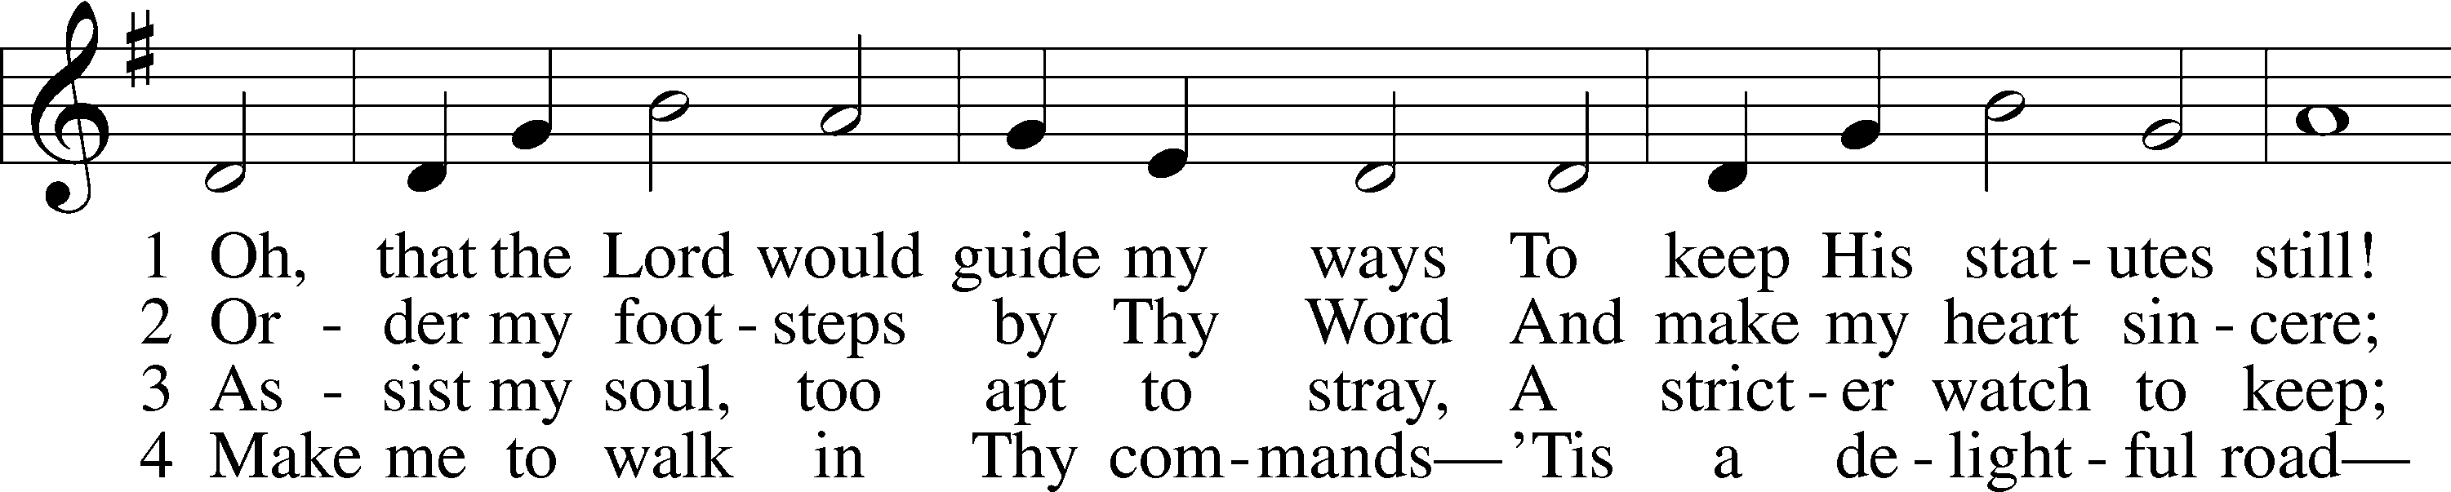

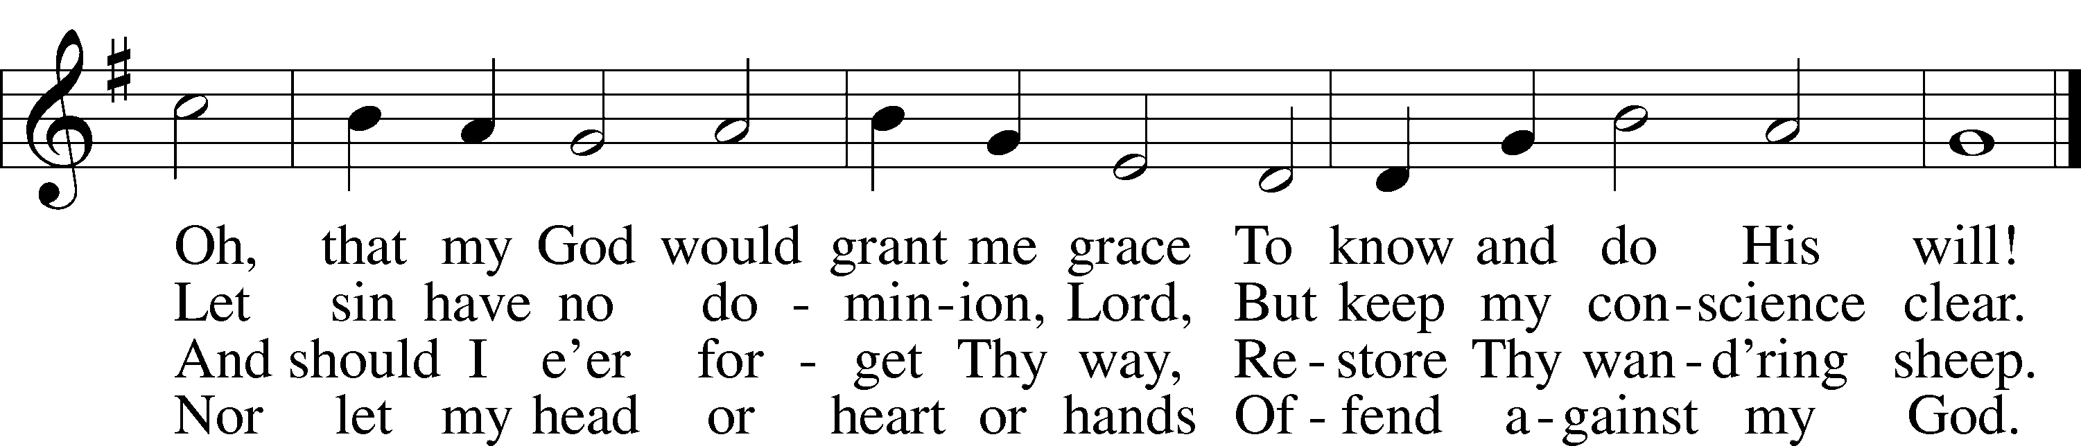

Text: Isaac Watts, 1674–1748, alt.  
Tune: William H. Havergal, 1793–1870  
Text and tune: Public domain

Stand

The Dismissal

P The body and blood of our Lord Jesus Christ strengthen and preserve you in body and soul to life everlasting. Depart T in peace.

C **Amen.**

Nunc Dimittis Luke 2:29–32

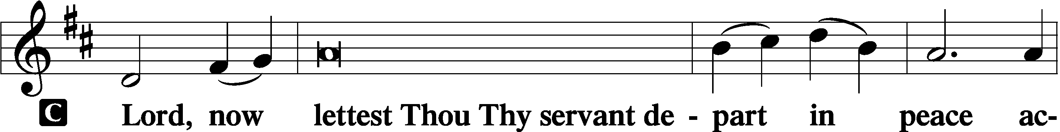

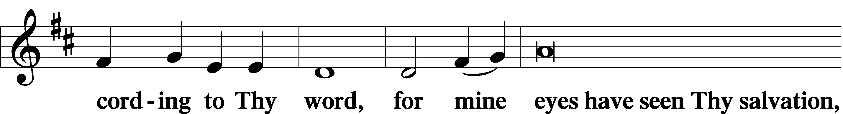

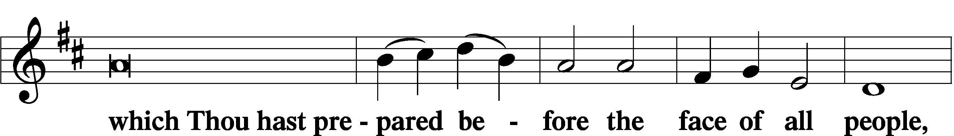

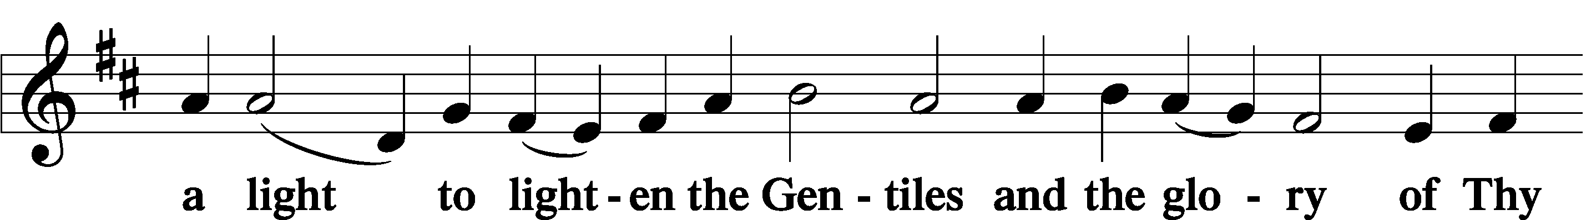

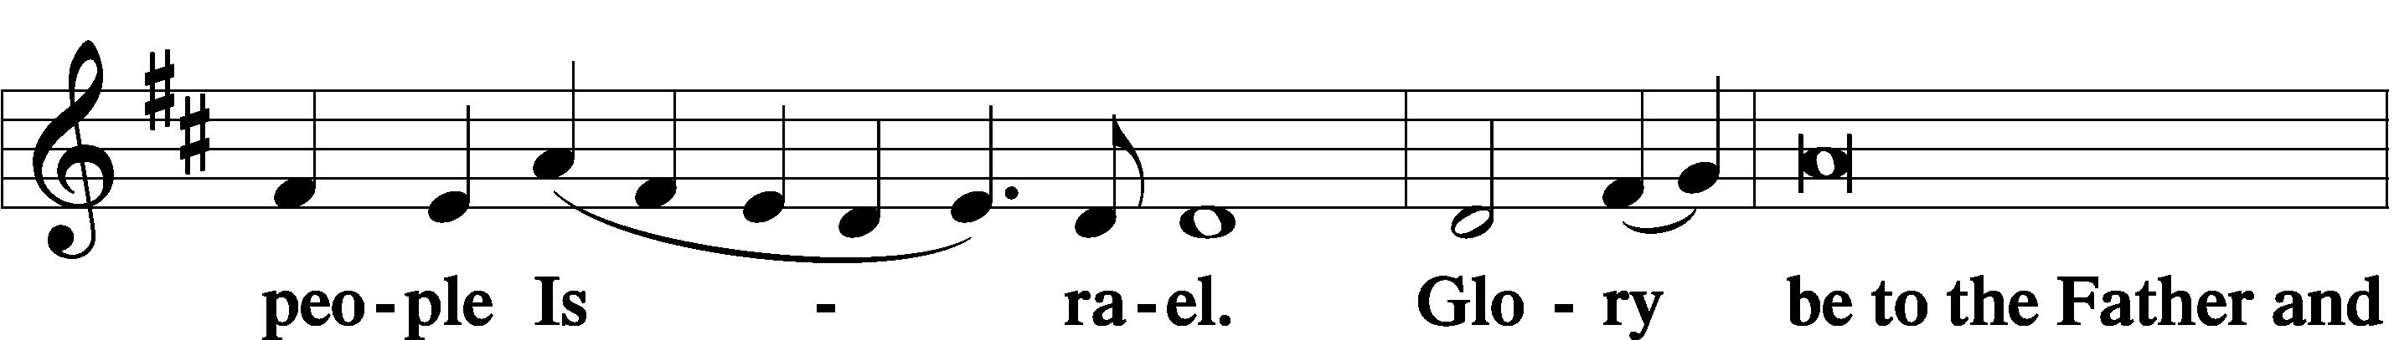

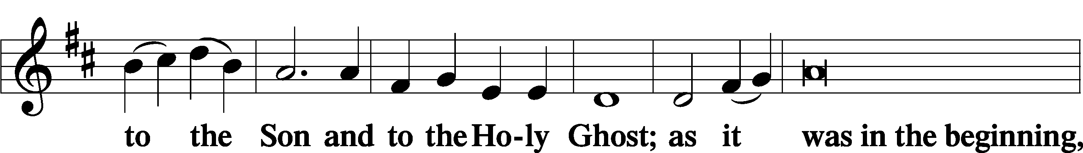

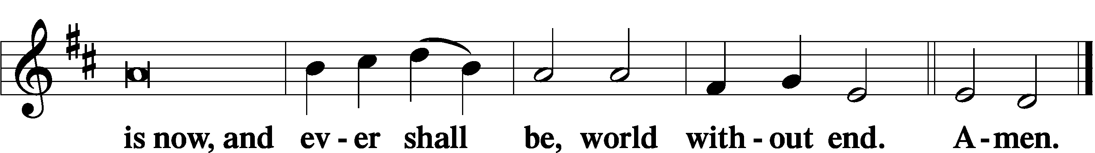

Thanksgiving Psalm 107:1

A O give thanks unto the Lord, for He is good,

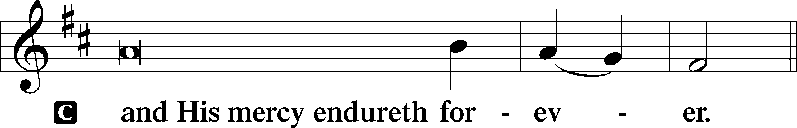

Post-Communion Collect

A Let us pray.

We give thanks to You, almighty God, that You have refreshed us through this salutary gift, and we implore You that of Your mercy You would strengthen us through the same in faith toward You and in fervent love toward one another; through Jesus Christ, Your Son, our Lord, who lives and reigns with You and the Holy Spirit, one God, now and forever.

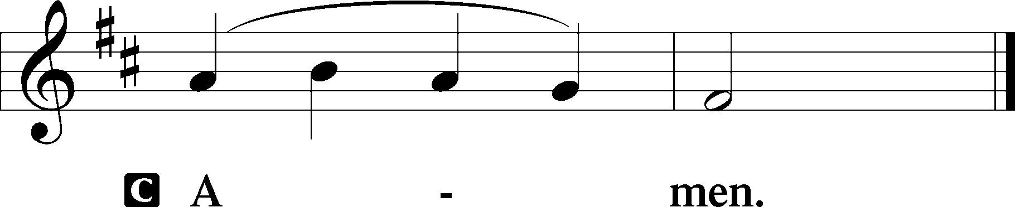

Salutation 2 Timothy 4:22

P The Lord be with you.

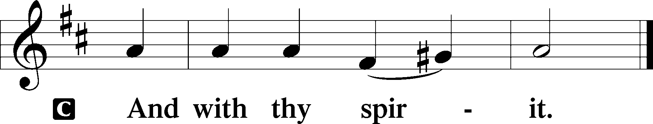

Benedicamus Psalm 103:1

A Bless we the Lord.

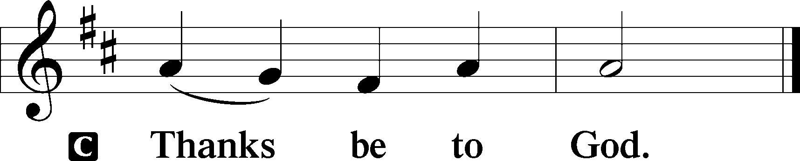

Benediction Numbers 6:24–26

P The Lord bless you and keep you.

The Lord make His face shine upon you and be gracious unto you.

The Lord lift up His countenance upon you and T give you peace.

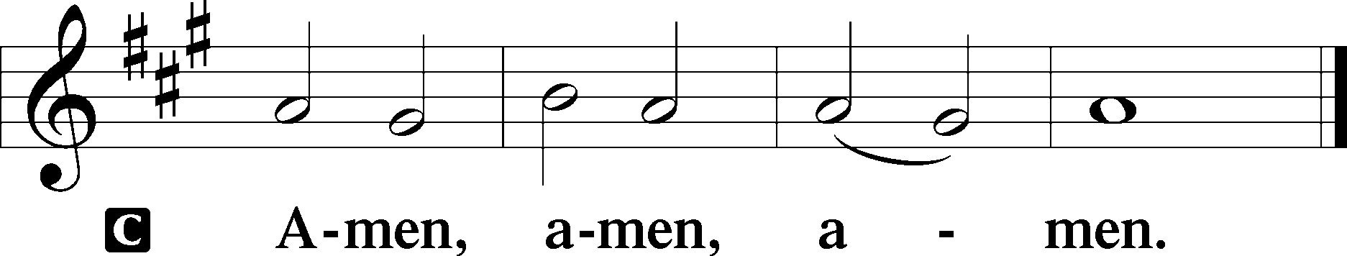

790 Praise to the Lord, the Almighty

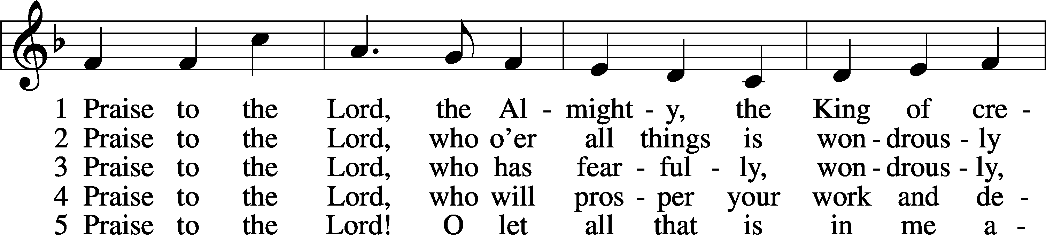

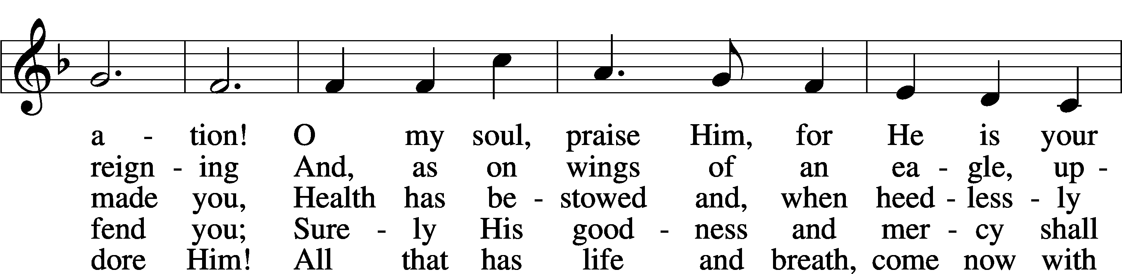

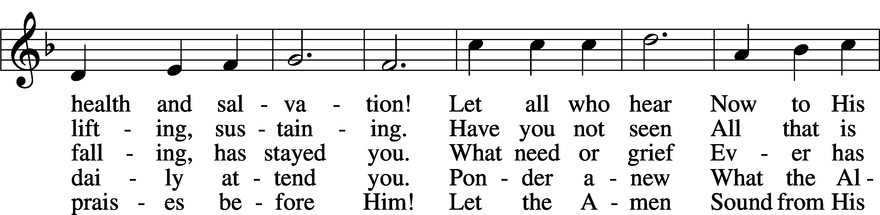

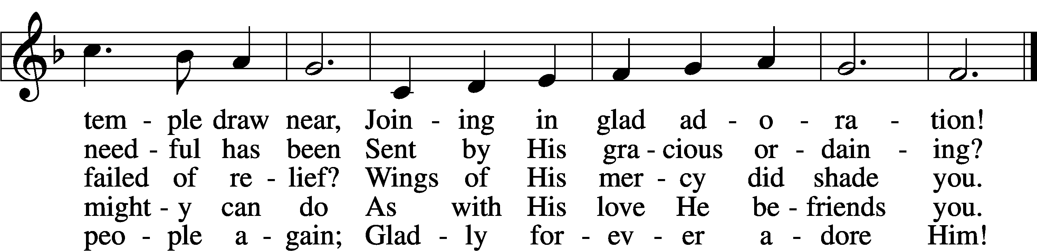

Text: Joachim Neander, 1650–80; tr. Catherine Winkworth, 1827–78, altTune: Ander Theil Des Erneuerten Gesang-Buchs, 1665, StralsundText and tune: Public domain

Acknowledgments

Divine Service, Setting Three from Lutheran Service Book

Unless otherwise indicated, Scripture quotations are from the ESV® Bible (The Holy Bible, English Standard Version®), copyright © 2001 by Crossway, a publishing ministry of Good News Publishers. Used by permission. All rights reserved.

Created by Lutheran Service Builder © 2023 Concordia Publishing House.