726 Evening and Morning

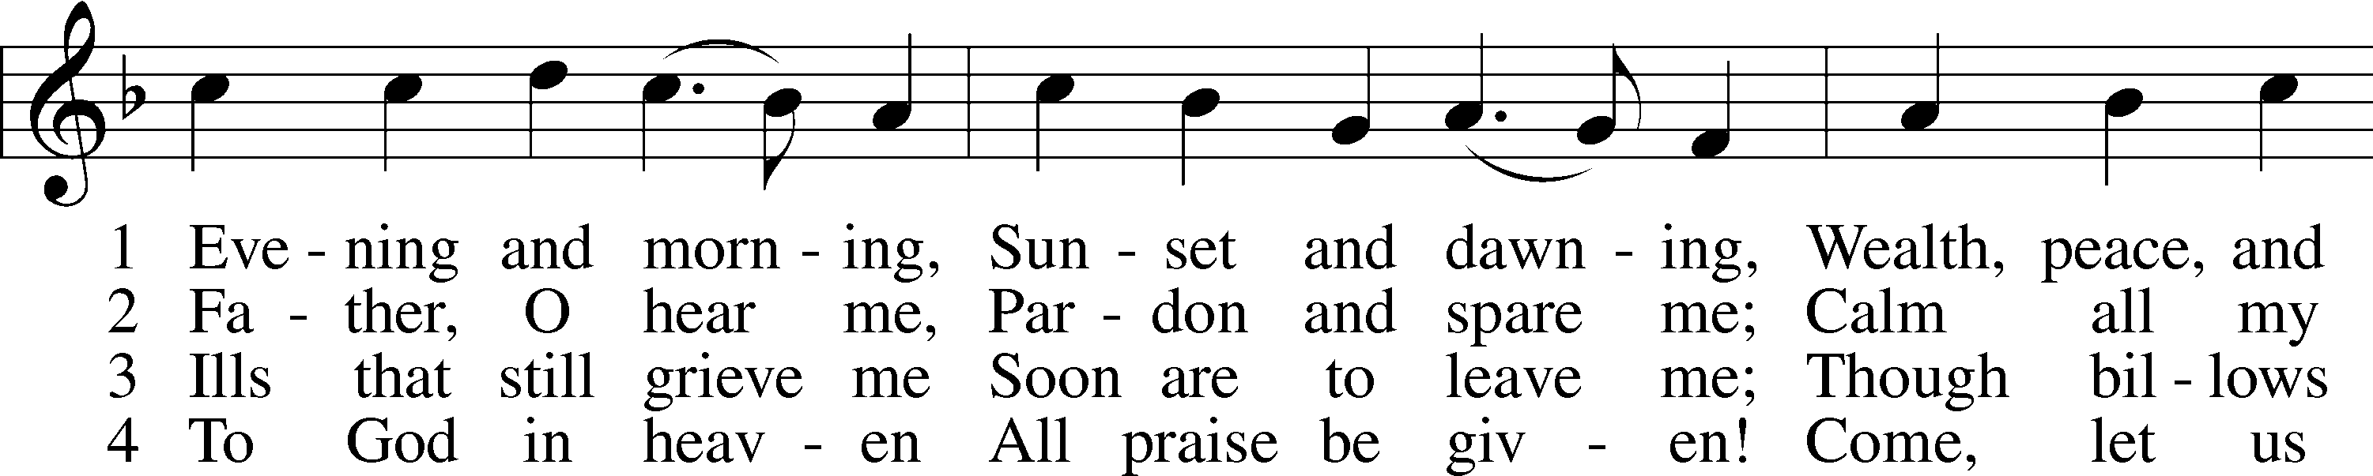

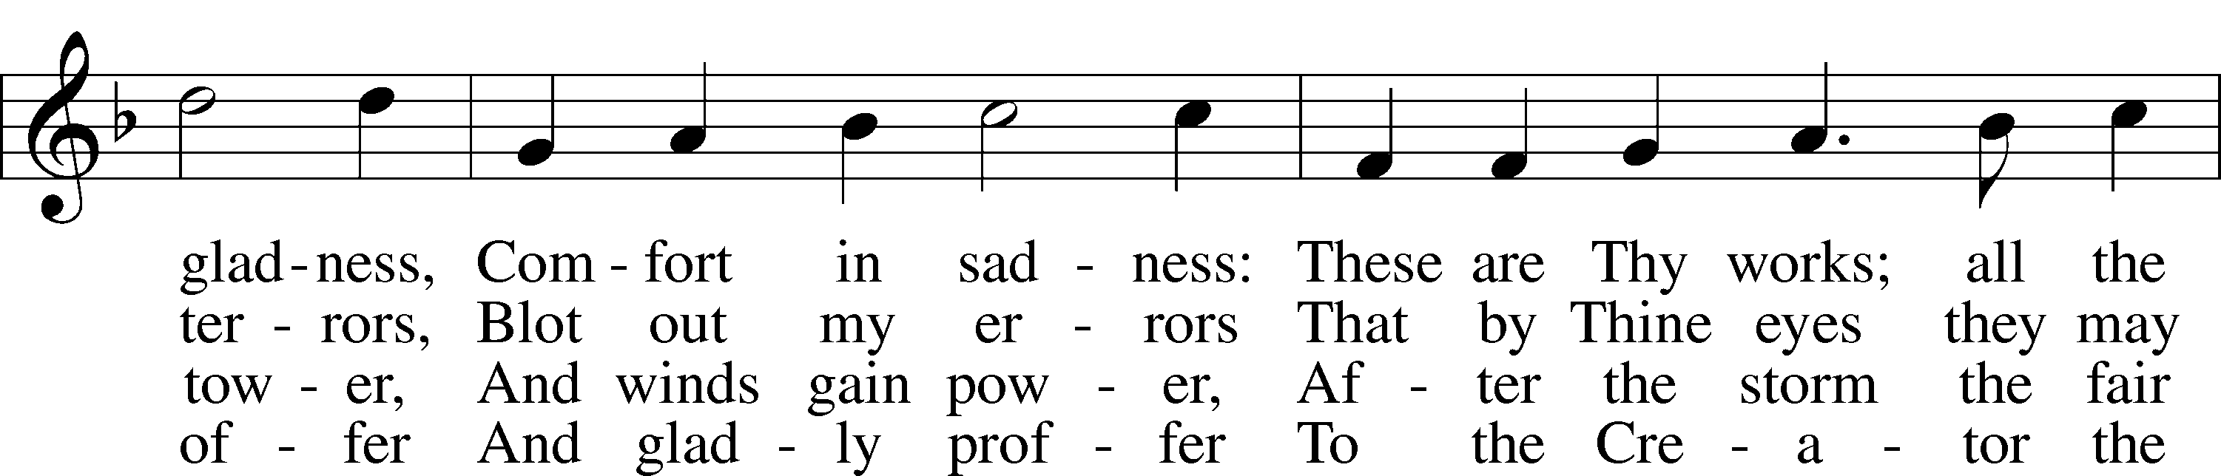

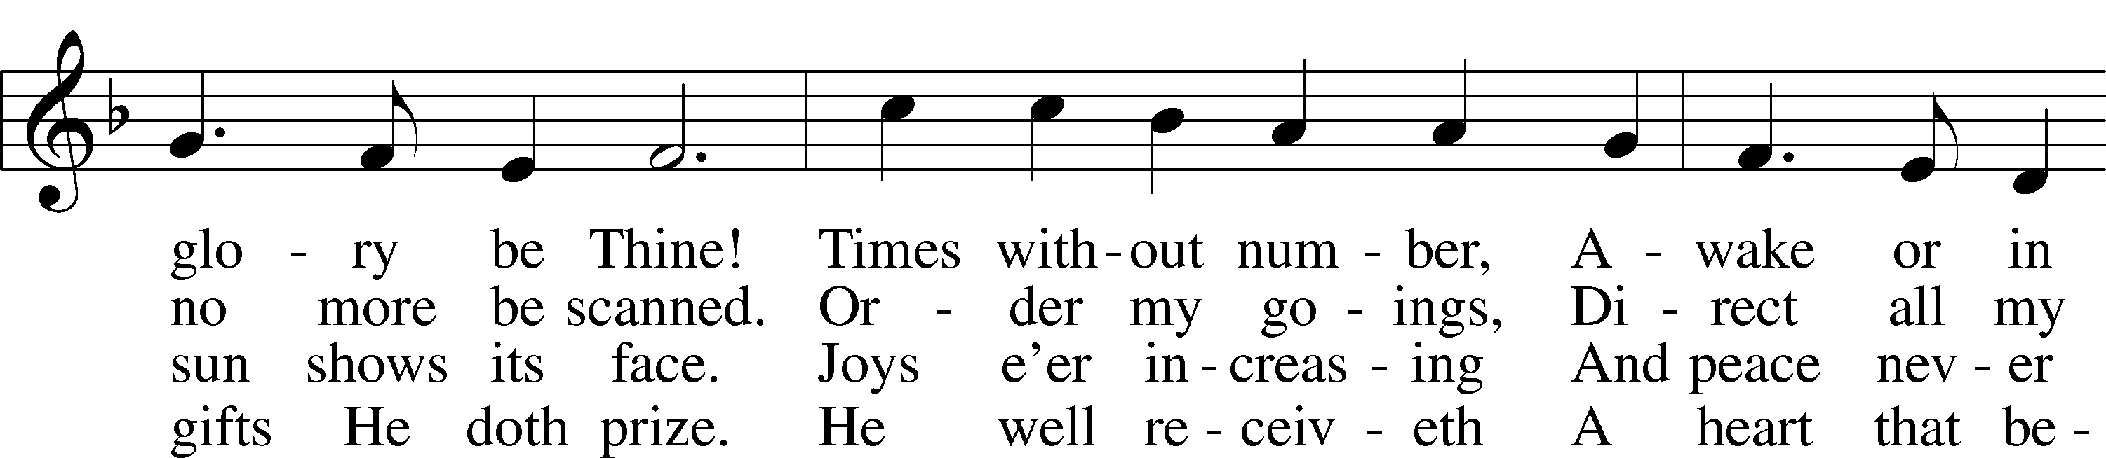

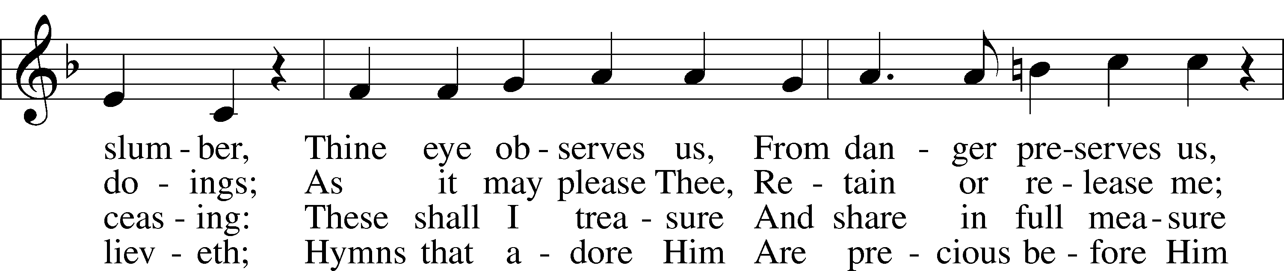

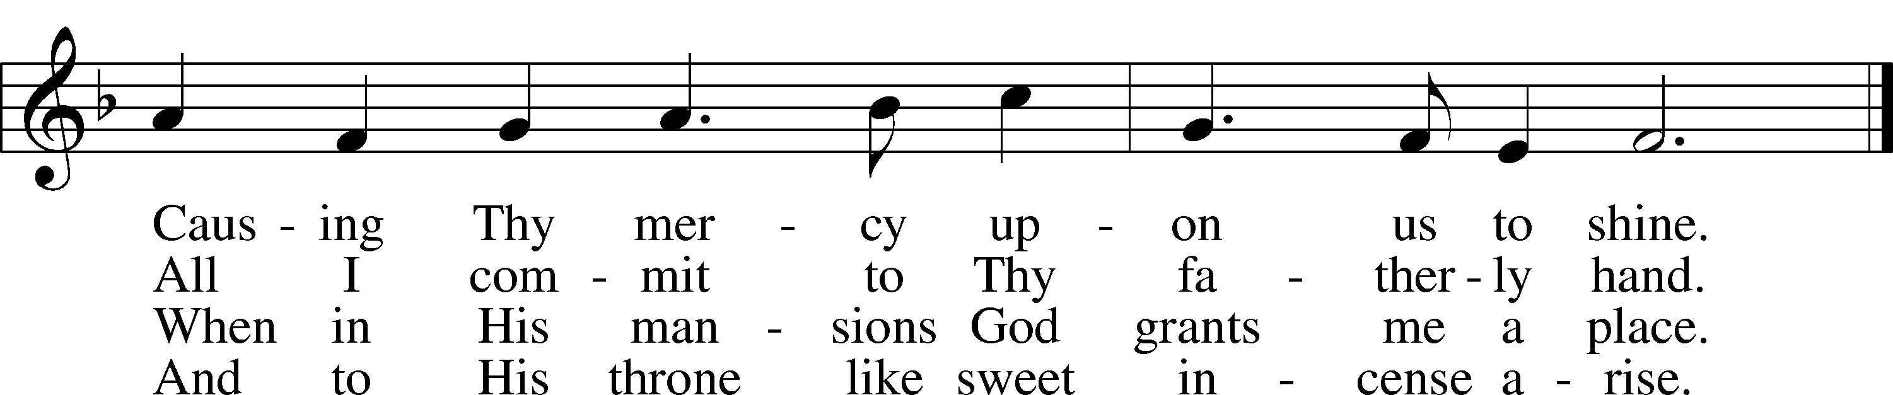

Text: Paul Gerhardt, 1607–76; (sts. 1–2): tr. Richard Massie, 1800–87, alt.; (sts. 3–4): tr. Hermann H. M. Brueckner, 1866–1942, alt.  
Tune: Johann G. Ebeling, 1637–76  
Text (sts. 1–2): Public domain  
Text (sts. 3–4): © 1930 Augsburg Publishing House. Used by permission: LSB Hymn License no. 110005011  
Tune: Public domain

# Confession and Absolution

Stand

The sign of the cross may be made by all in remembrance of their Baptism.

Invocation Matthew 28:19b; 18:20

P In the name of the Father and of the T Son and of the Holy Spirit.

C **Amen.**

Exhortation Hebrews 10:22; Psalm 124:8; Psalm 32:5

P Beloved in the Lord! Let us draw near with a true heart and confess our sins unto God our Father, beseeching Him in the name of our Lord Jesus Christ to grant us forgiveness.

P Our help is in the name of the Lord,

C **who made heaven and earth.**

P I said, I will confess my transgressions unto the Lord,

C **and You forgave the iniquity of my sin.**

Kneel/Stand

Silence for reflection on God’s Word and for self-examination.

Confession of Sins

P O almighty God, merciful Father,

C **I, a poor, miserable sinner, confess unto You all my sins and iniquities with which I have ever offended You and justly deserved Your temporal and eternal punishment. But I am heartily sorry for them and sincerely repent of them, and I pray You of Your boundless mercy and for the sake of the holy, innocent, bitter sufferings and death of Your beloved Son, Jesus Christ, to be gracious and merciful to me, a poor, sinful being.**

Absolution [John 20:19–23]

P Upon this your confession, I, by virtue of my office, as a called and ordained servant of the Word, announce the grace of God unto all of you, and in the stead and by the command of my Lord Jesus Christ I forgive you all your sins in the name of the Father and of the T Son and of the Holy Spirit.

C **Amen.**

Stand

# Service of the Word

Introit Psalm 30:1–5; antiphon: Psalm 149:1

Praise the Lord! Sing to the Lord a new song,  
 his praise in the assembly of the godly!  
**I will extol you, O Lord, for you have drawn me up  
 and have not let my foes rejoice over me.**  
O Lord my God, I cried to you for help,  
 and you have healed me.  
**O Lord, you have brought up my soul from Sheol;  
 you restored me to life from among those who go down to the pit.**  
Sing praises to the Lord, O you his saints,  
 and give thanks to his holy name.  
**For his anger is but for a moment, and his favor is for a lifetime.  
 Weeping may tarry for the night, but joy comes with the morning.**

Gloria Patri

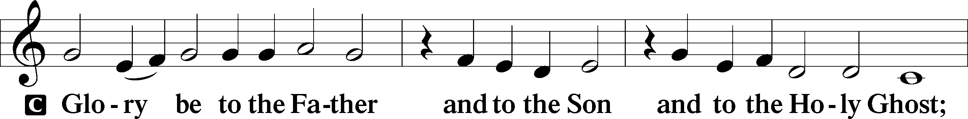

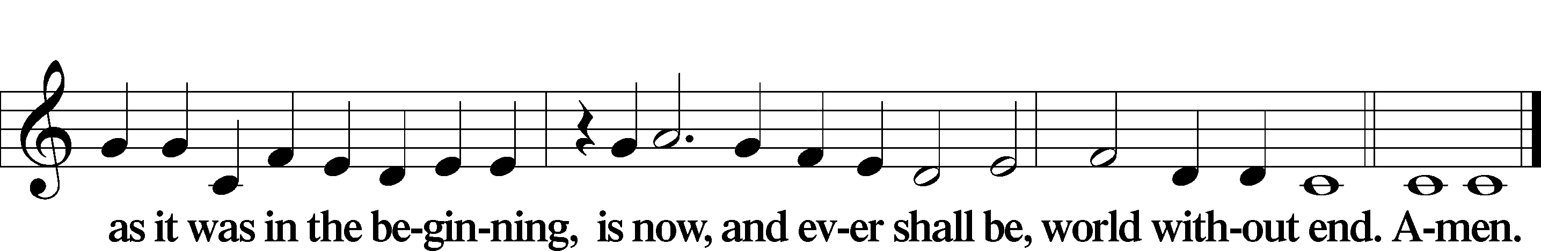

Kyrie Mark 10:47

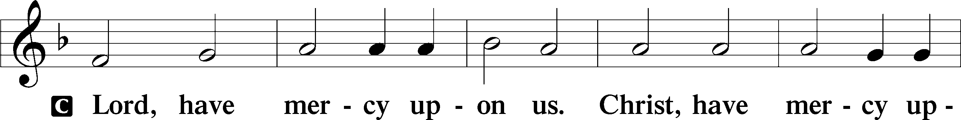

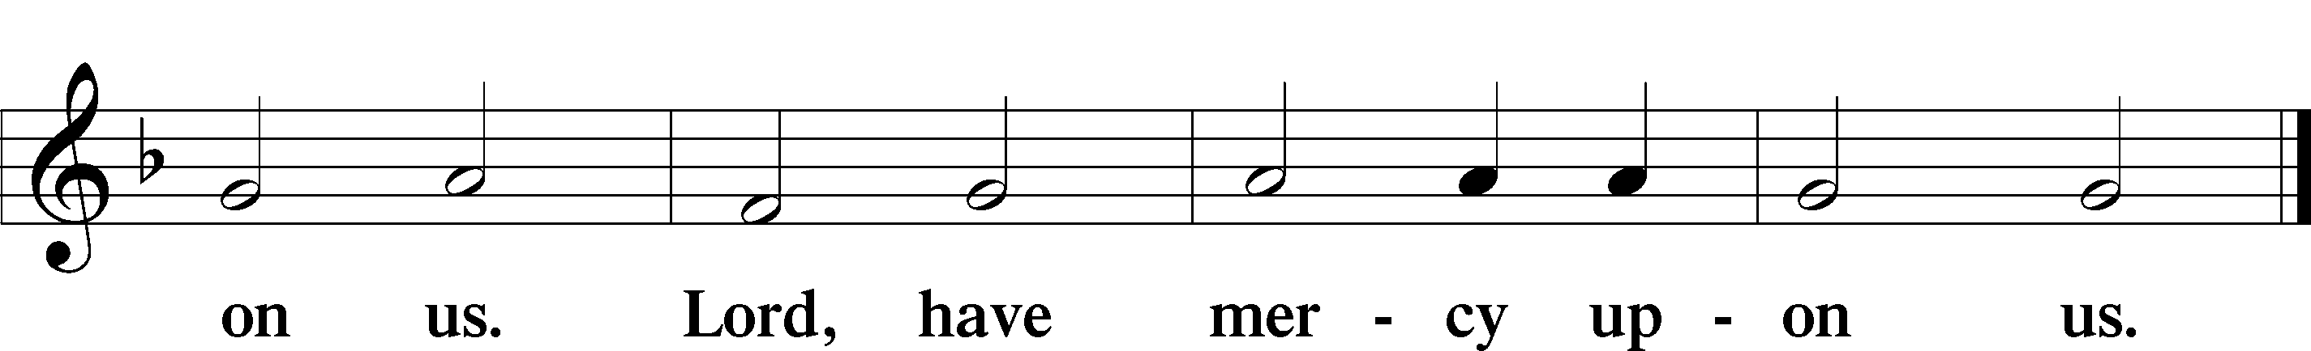

Gloria in Excelsis Luke 2:14; John 1:29

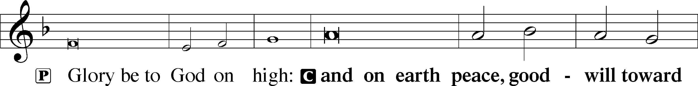

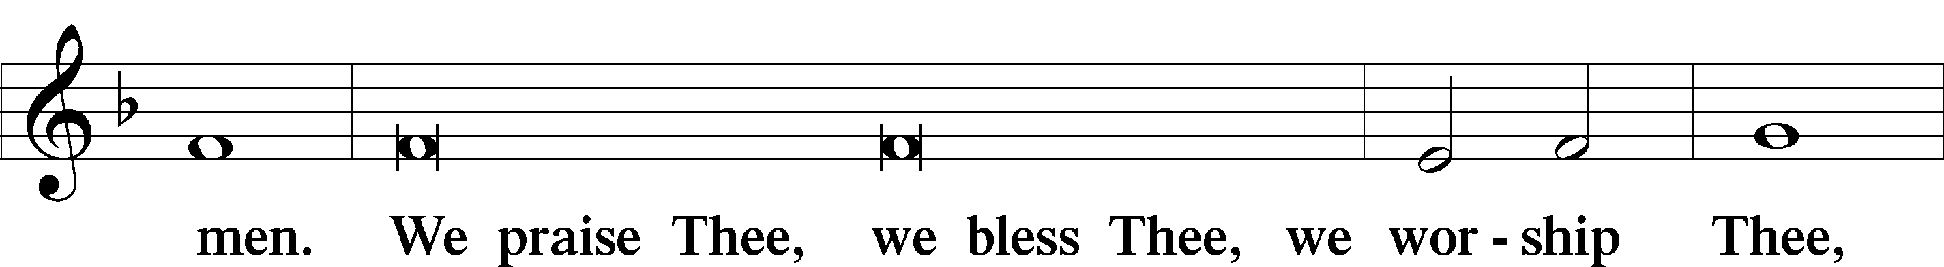

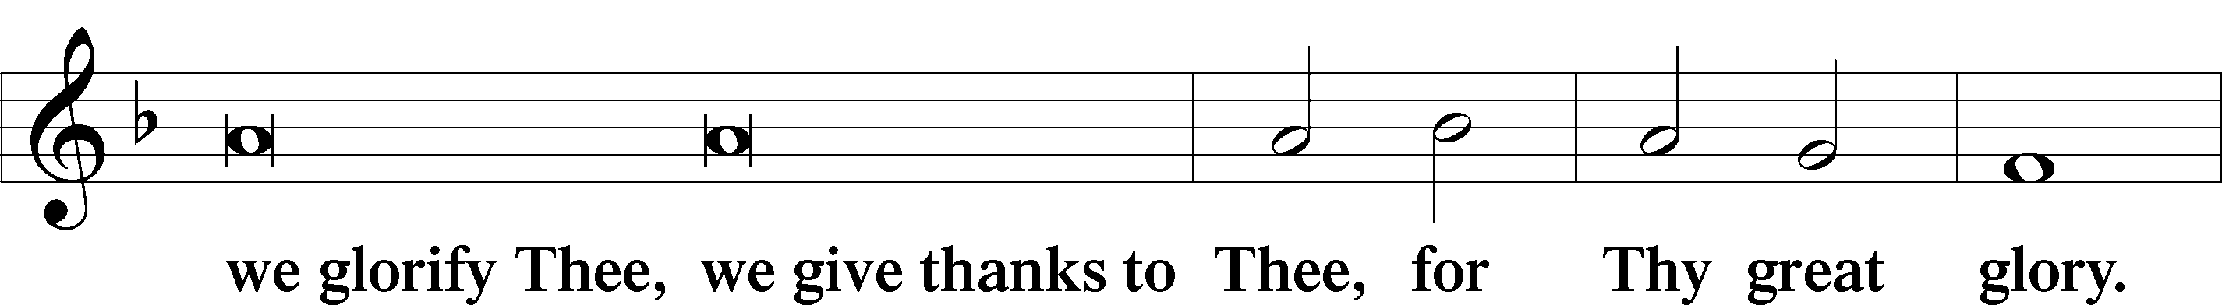

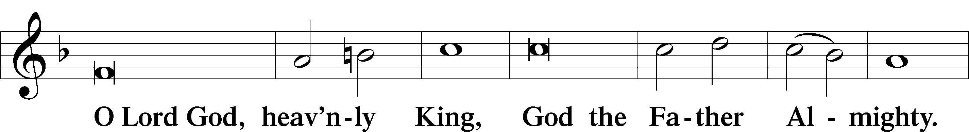

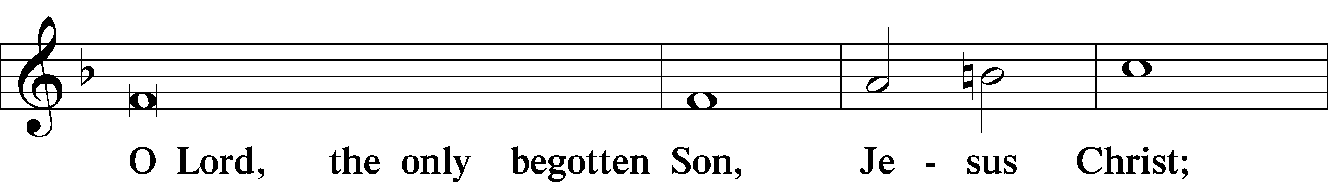

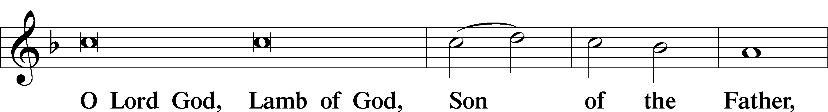

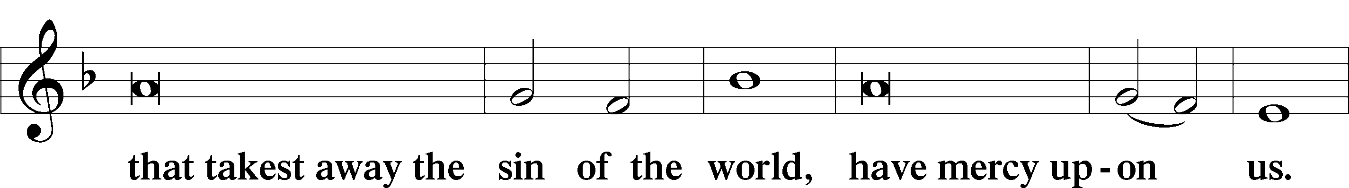

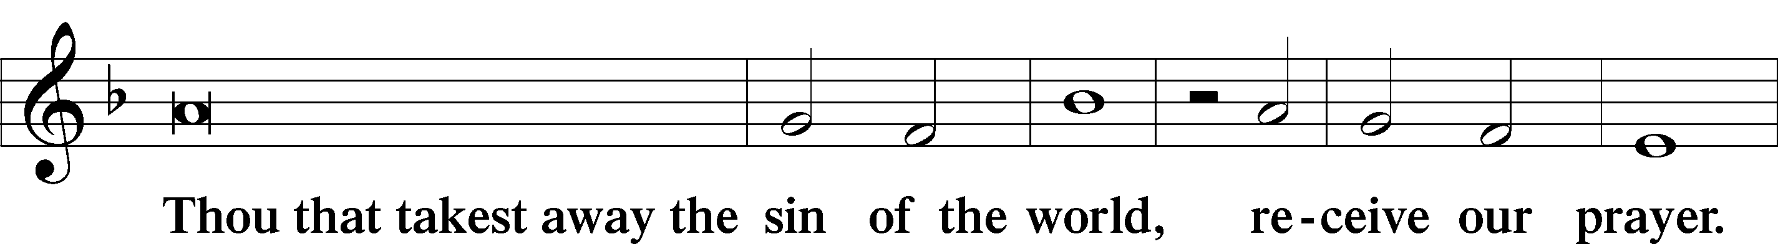

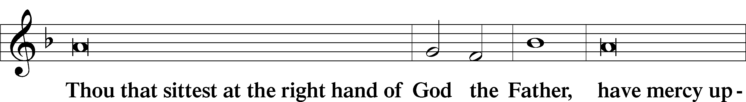

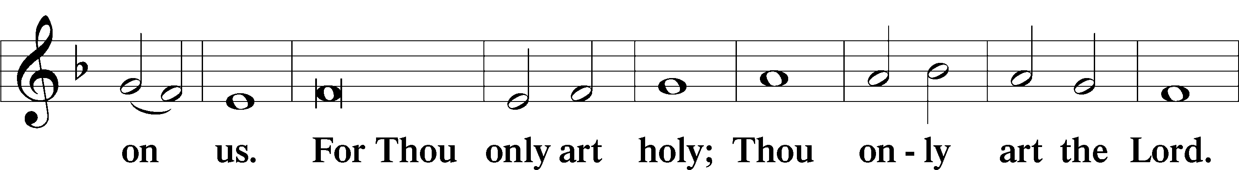

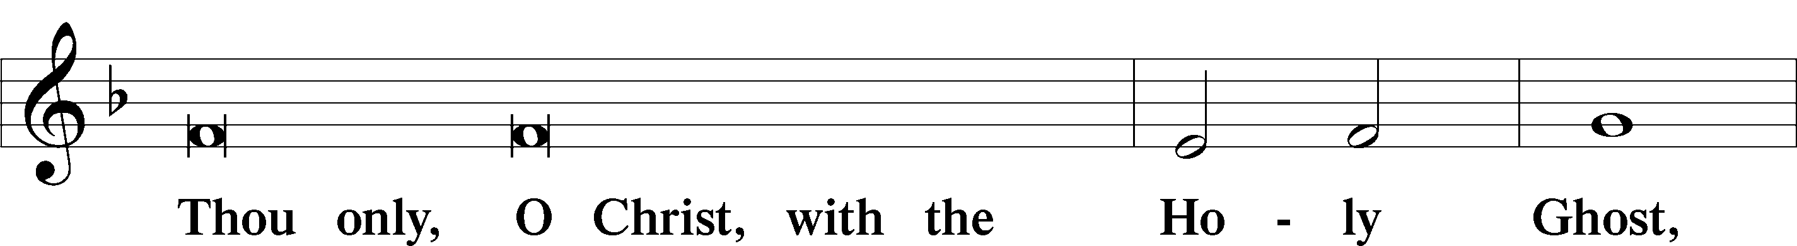

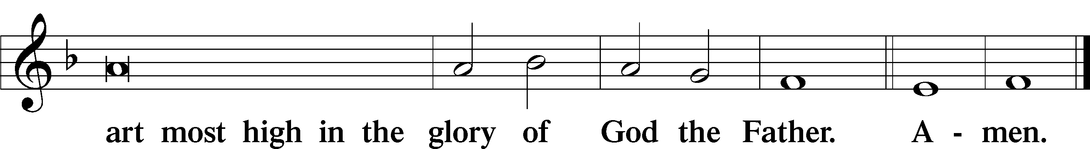

Salutation and Collect of the Day

P The Lord be with you.

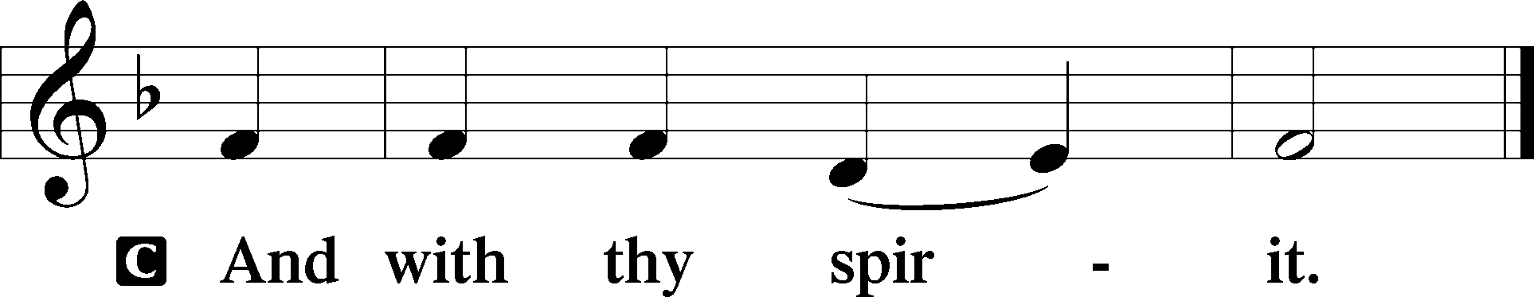

P Let us pray.

O God, You make the minds of Your faithful to be of one will. Grant that we may love what You have commanded and desire what You promise, that among the many changes of this world our hearts may be fixed where true joys are found; through Jesus Christ, Your Son, our Lord, who lives and reigns with You and the Holy Spirit, one God, now and forever.

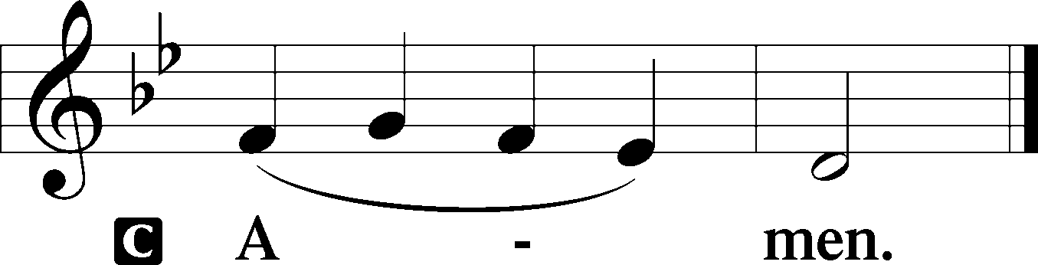

Sit

First Reading Acts 6:1–9; 7:2a, 51–60

Seven Chosen to Serve

1Now in these days when the disciples were increasing in number, a complaint by the Hellenists arose against the Hebrews because their widows were being neglected in the daily distribution. 2And the twelve summoned the full number of the disciples and said, “It is not right that we should give up preaching the word of God to serve tables. 3Therefore, brothers, pick out from among you seven men of good repute, full of the Spirit and of wisdom, whom we will appoint to this duty. 4But we will devote ourselves to prayer and to the ministry of the word.” 5And what they said pleased the whole gathering, and they chose Stephen, a man full of faith and of the Holy Spirit, and Philip, and Prochorus, and Nicanor, and Timon, and Parmenas, and Nicolaus, a proselyte of Antioch. 6These they set before the apostles, and they prayed and laid their hands on them.

7And the word of God continued to increase, and the number of the disciples multiplied greatly in Jerusalem, and a great many of the priests became obedient to the faith.

Stephen Is Seized

8And Stephen, full of grace and power, was doing great wonders and signs among the people. 9Then some of those who belonged to the synagogue of the Freedmen (as it was called), and of the Cyrenians, and of the Alexandrians, and of those from Cilicia and Asia, rose up and disputed with Stephen. . . .

2And Stephen said:

“Brothers and fathers, hear me. . . .

51You stiff-necked people, uncircumcised in heart and ears, you always resist the Holy Spirit. As your fathers did, so do you. 52Which of the prophets did not your fathers persecute? And they killed those who announced beforehand the coming of the Righteous One, whom you have now betrayed and murdered, 53you who received the law as delivered by angels and did not keep it.”

The Stoning of Stephen

54Now when they heard these things they were enraged, and they ground their teeth at him. 55But he, full of the Holy Spirit, gazed into heaven and saw the glory of God, and Jesus standing at the right hand of God. 56And he said, “Behold, I see the heavens opened, and the Son of Man standing at the right hand of God.” 57But they cried out with a loud voice and stopped their ears and rushed together at him. 58Then they cast him out of the city and stoned him. And the witnesses laid down their garments at the feet of a young man named Saul. 59And as they were stoning Stephen, he called out, “Lord Jesus, receive my spirit.” 60And falling to his knees he cried out with a loud voice, “Lord, do not hold this sin against them.” And when he had said this, he fell asleep.

A This is the Word of the Lord.

C **Thanks be to God.**

Gradual adapt. from Matthew 28:7; Hebrews 2:7; Psalm 8:6

Christ has risen from the dead.  
 [God the Father] has crowned him with glory and honor.  
**He has given him dominion over the works of his hands;  
 he has put all things under his feet.**

Epistle 1 Peter 2:2–10

2Like newborn infants, long for the pure spiritual milk, that by it you may grow up to salvation— 3if indeed you have tasted that the Lord is good.

4As you come to him, a living stone rejected by men but in the sight of God chosen and precious, 5you yourselves like living stones are being built up as a spiritual house, to be a holy priesthood, to offer spiritual sacrifices acceptable to God through Jesus Christ. 6For it stands in Scripture:

“Behold, I am laying in Zion a stone,  
 a cornerstone chosen and precious,  
and whoever believes in him will not be put to shame.”

7So the honor is for you who believe, but for those who do not believe,

“The stone that the builders rejected  
 has become the cornerstone,”

8and

“A stone of stumbling,  
 and a rock of offense.”

They stumble because they disobey the word, as they were destined to do.

9But you are a chosen race, a royal priesthood, a holy nation, a people for his own possession, that you may proclaim the excellencies of him who called you out of darkness into his marvelous light. 10Once you were not a people, but now you are God’s people; once you had not received mercy, but now you have received mercy.

A This is the Word of the Lord.

C **Thanks be to God.**

Stand

Alleluia

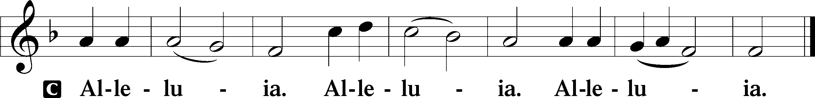

Holy Gospel John 14:1–14

P The Holy Gospel according to St. John, the fourteenth chapter.

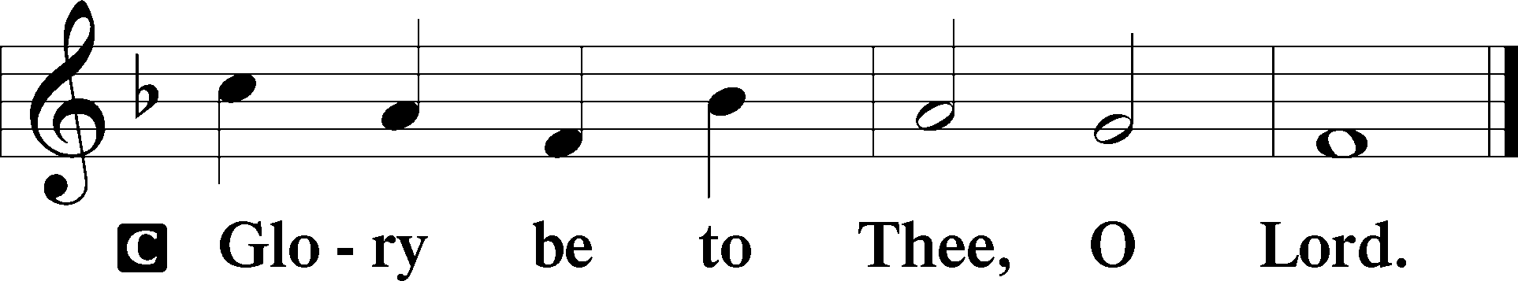

I Am the Way, and the Truth, and the Life

1[Jesus said:] “Let not your hearts be troubled. Believe in God; believe also in me. 2In my Father’s house are many rooms. If it were not so, would I have told you that I go to prepare a place for you? 3And if I go and prepare a place for you, I will come again and will take you to myself, that where I am you may be also. 4And you know the way to where I am going.” 5Thomas said to him, “Lord, we do not know where you are going. How can we know the way?” 6Jesus said to him, “I am the way, and the truth, and the life. No one comes to the Father except through me. 7If you had known me, you would have known my Father also. From now on you do know him and have seen him.”

8Philip said to him, “Lord, show us the Father, and it is enough for us.” 9Jesus said to him, “Have I been with you so long, and you still do not know me, Philip? Whoever has seen me has seen the Father. How can you say, ‘Show us the Father’? 10Do you not believe that I am in the Father and the Father is in me? The words that I say to you I do not speak on my own authority, but the Father who dwells in me does his works. 11Believe me that I am in the Father and the Father is in me, or else believe on account of the works themselves.

12“Truly, truly, I say to you, whoever believes in me will also do the works that I do; and greater works than these will he do, because I am going to the Father. 13Whatever you ask in my name, this I will do, that the Father may be glorified in the Son. 14If you ask me anything in my name, I will do it.”

P This is the Gospel of the Lord.

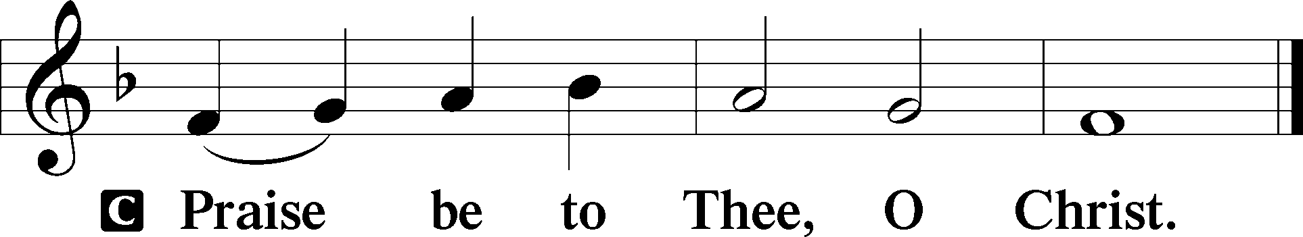

Nicene Creed

C **I believe in one God,**

**the Father Almighty,**

**maker of heaven and earth**

**and of all things visible and invisible.**

**And in one Lord Jesus Christ,**

**the only-begotten Son of God,**

**begotten of His Father before all worlds,**

**God of God, Light of Light,**

**very God of very God,**

**begotten, not made,**

**being of one substance with the Father,**

**by whom all things were made;**

**who for us men and for our salvation came down from heaven**

**and was incarnate by the Holy Spirit of the virgin Mary**

**and was made man;**

**and was crucified also for us under Pontius Pilate.**

**He suffered and was buried.**

**And the third day He rose again according to the Scriptures**

**and ascended into heaven**

**and sits at the right hand of the Father.**

**And He will come again with glory to judge both the living and the dead,**

**whose kingdom will have no end.**

**And I believe in the Holy Spirit,**

**the Lord and giver of life,**

**who proceeds from the Father and the Son,**

**who with the Father and the Son together is worshiped and glorified,**

**who spoke by the prophets.**

**And I believe in one holy Christian and apostolic Church,**

**I acknowledge one Baptism for the remission of sins,**

**and I look for the resurrection of the dead**

**and the life** T **of the world to come. Amen.**

Sit

Children's Message

633 At the Lamb’s High Feast We Sing

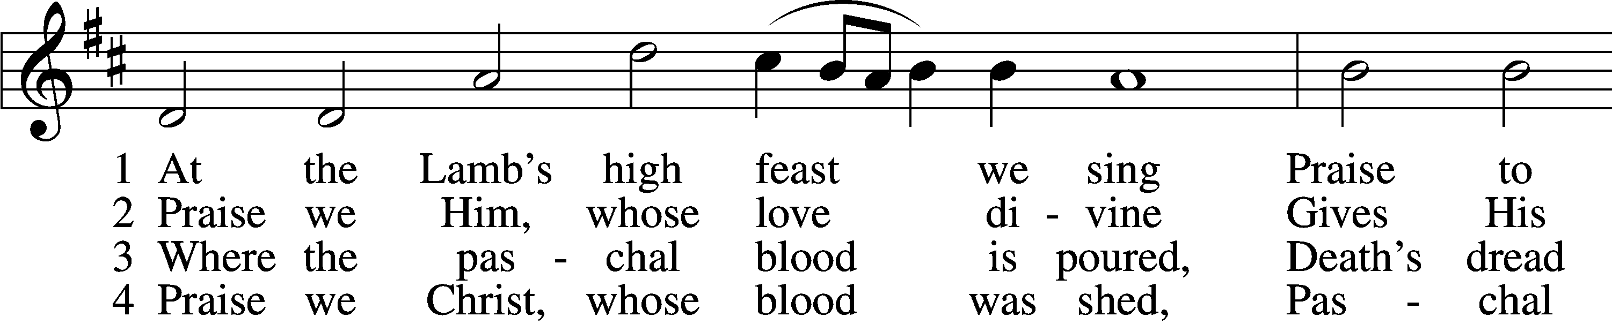

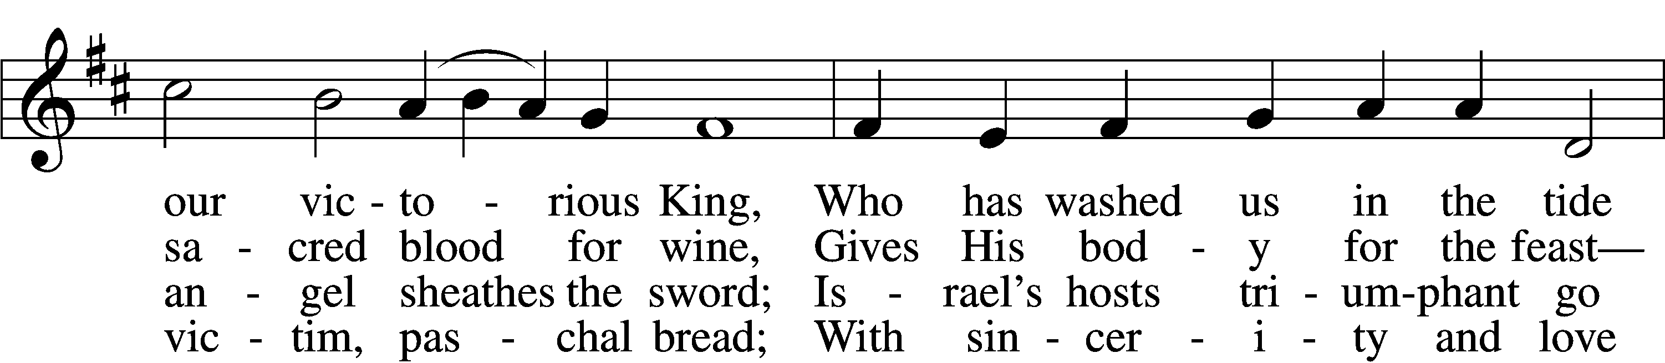

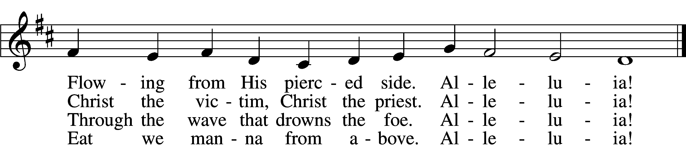

5 Mighty Victim from the sky,  
Hell’s fierce pow’rs beneath You lie;  
You have conquered in the fight,  
You have brought us life and light.  
 Alleluia!

6 Now no more can death appall,  
Now no more the grave enthrall;  
You have opened paradise,  
And Your saints in You shall rise.  
 Alleluia!

7 Easter triumph, Easter joy!  
This alone can sin destroy;  
From sin’s pow’r, Lord, set us free,  
Newborn souls in You to be.  
 Alleluia!

D 8 Father, who the crown shall give,  
Savior, by whose death we live,  
Spirit, guide through all our days:  
Three in One, Your name we praise.  
 Alleluia!

Text: Latin, c. 5th–10th cent.; tr. Robert Campbell, 1814–68, alt.  
Tune: Kirchengeseng, 1566, Ivancice  
Text and tune: Public domain

Sermon

Votum

P The peace of God, which passes all understanding, keep your hearts and minds in Christ Jesus.

C **Amen.**

Stand

Offertory Psalm 51:10–12

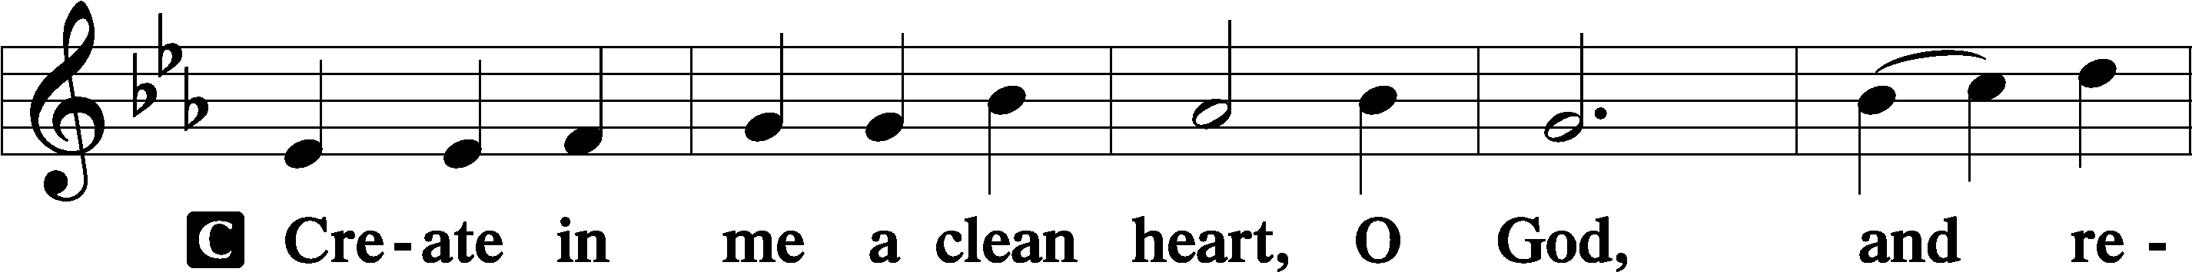

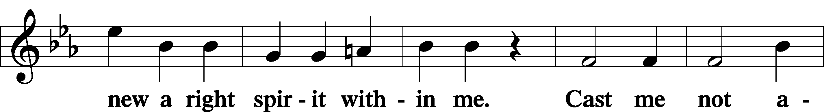

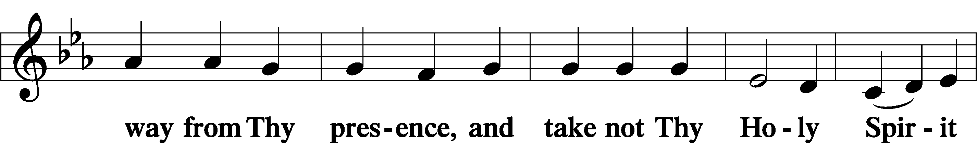

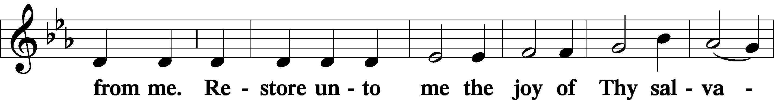

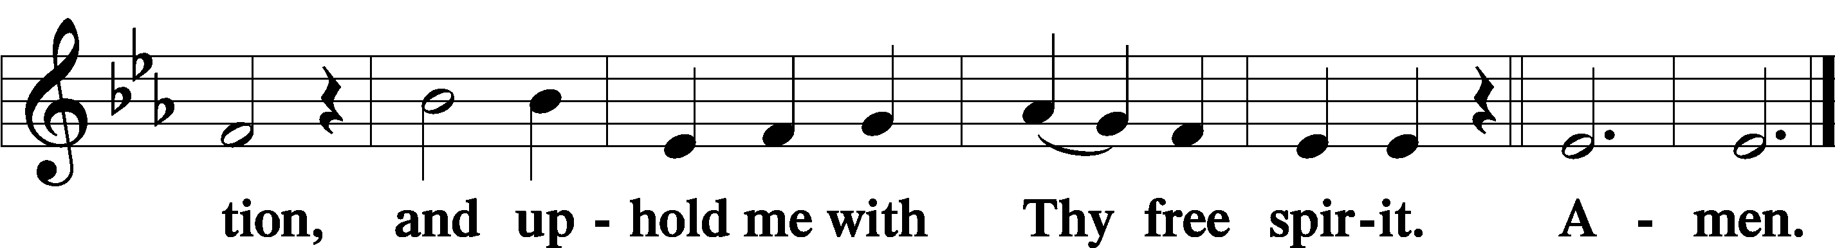

Sit

Offering

Stand

Prayer of the Church

# Service of the Sacrament

Preface 2 Timothy 4:22; [Colossians 3:1]; [Psalm 136]

P The Lord be with you.

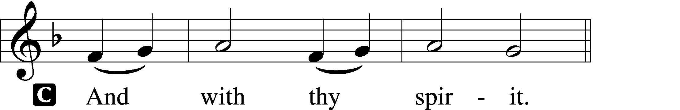

P Lift up your hearts.

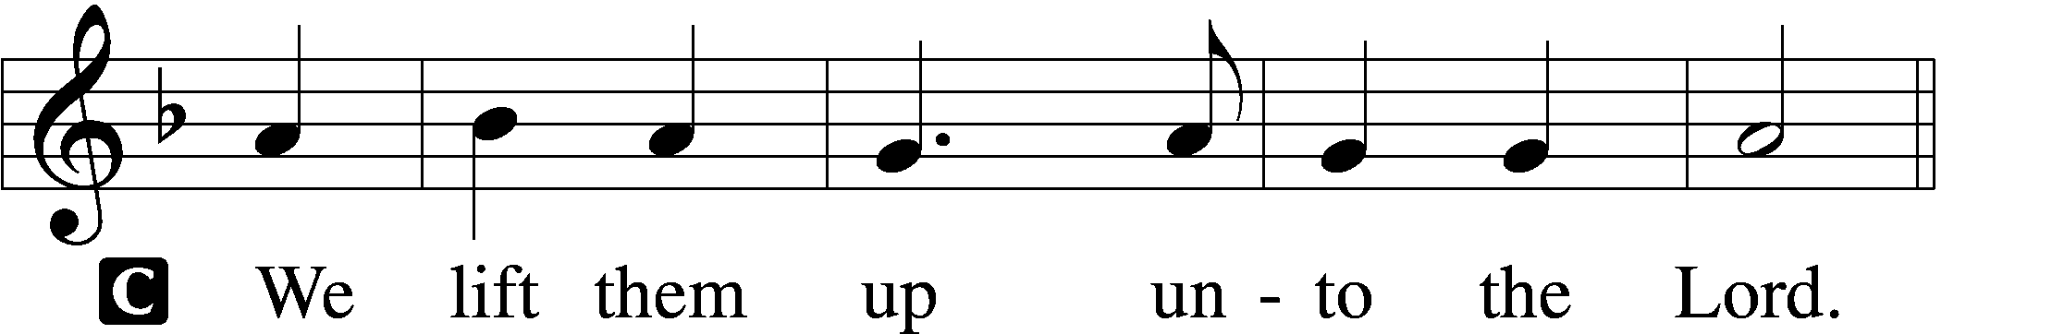

P Let us give thanks unto the Lord, our God.

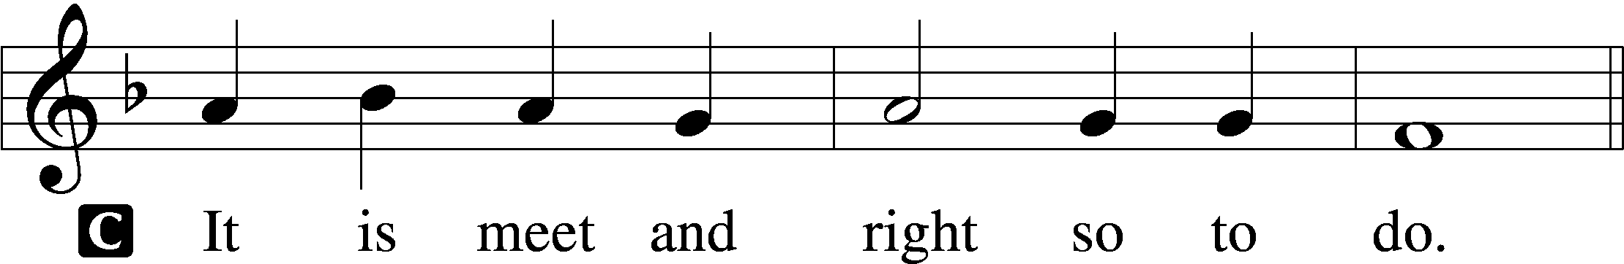

Proper Preface (Full)

P It is truly meet, right, and salutary that we should at all times and in all places give thanks to You, holy Lord, almighty Father, everlasting God. And most especially are we bound to praise You on this day for the glorious resurrection of Your Son, Jesus Christ, the very Paschal Lamb, who was sacrificed for us and bore the sins of the world. By His dying He has destroyed death, and by His rising again He has restored to us everlasting life. Therefore with Mary Magdalene, Peter and John, and with all the witnesses of the resurrection, with angels and archangels, and with all the company of heaven we laud and magnify Your glorious name, evermore praising You and saying:

Sanctus Isaiah 6:3; Matthew 21:9

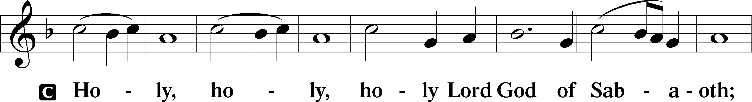

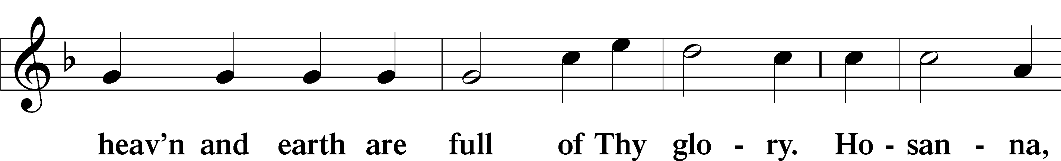

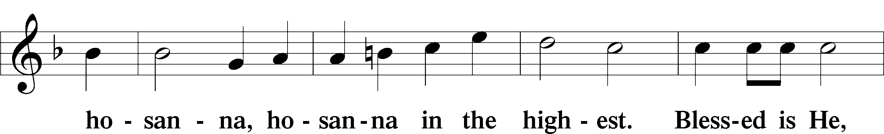

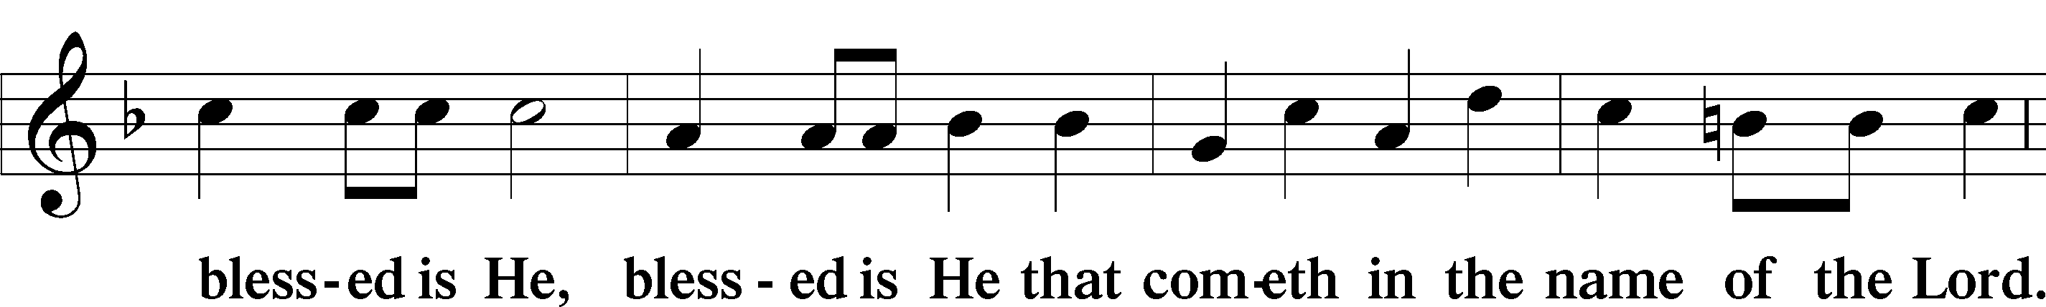

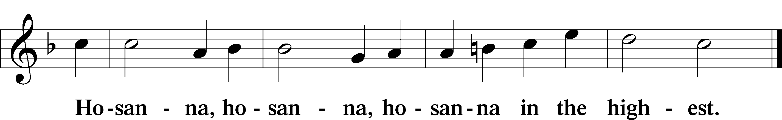

Lord’s Prayer Matthew 6:9–13

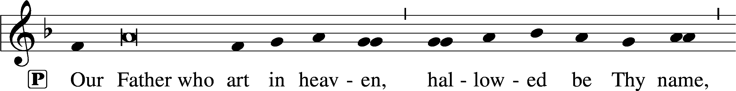

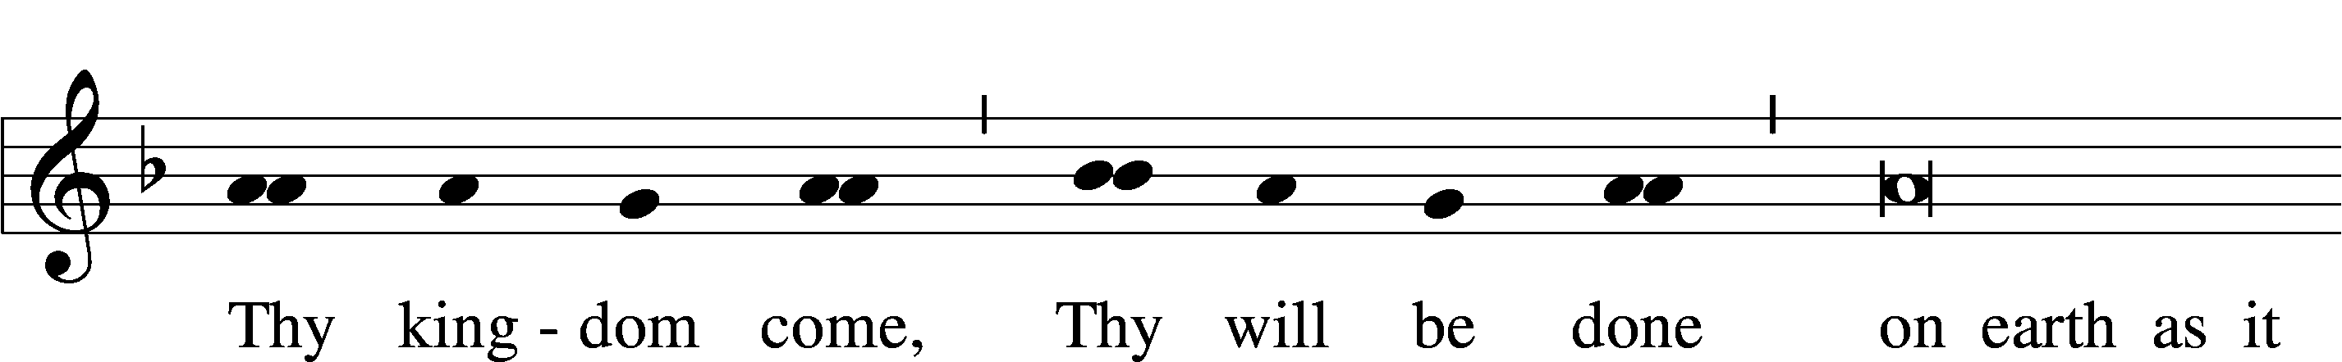

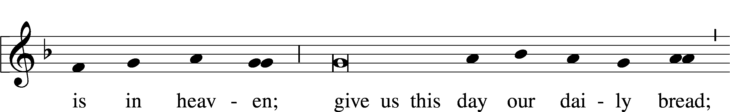

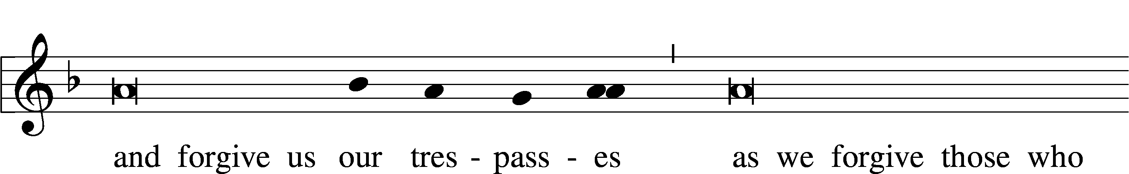

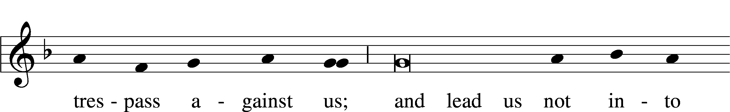

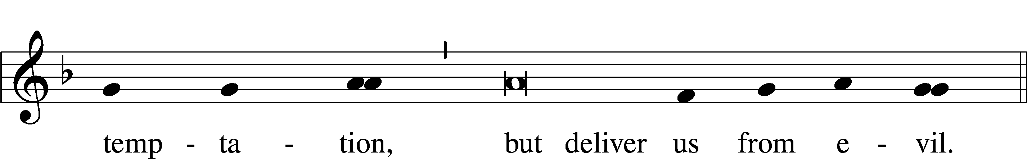

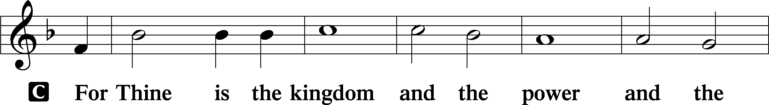

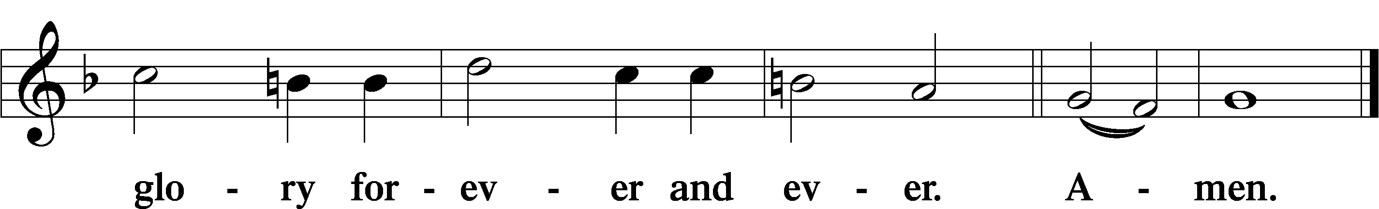

The Words of Our Lord Matthew 26:26–28; Mark 14:22–24; Luke 22:19–20; 1 Corinthians 11:23–25

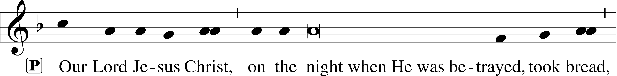

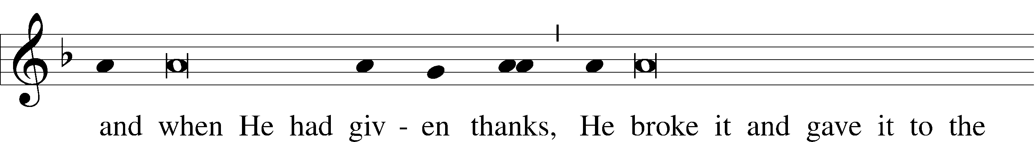

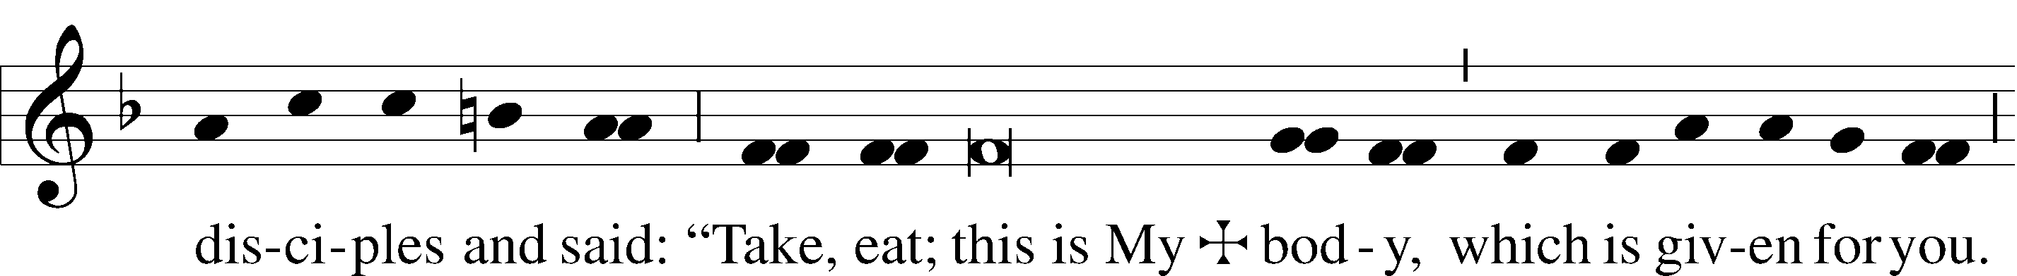

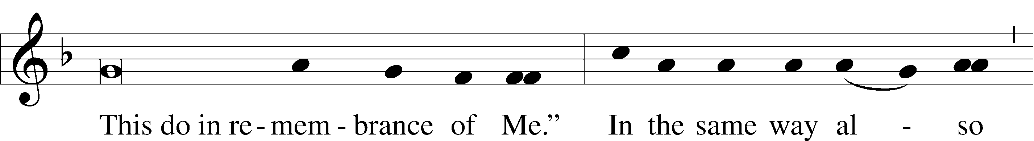

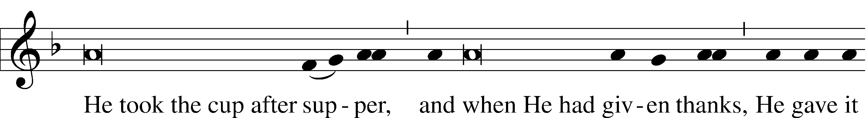

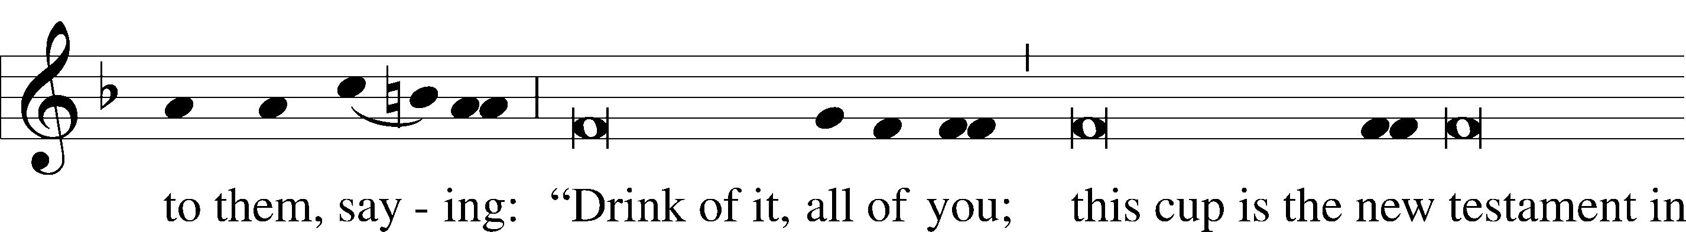

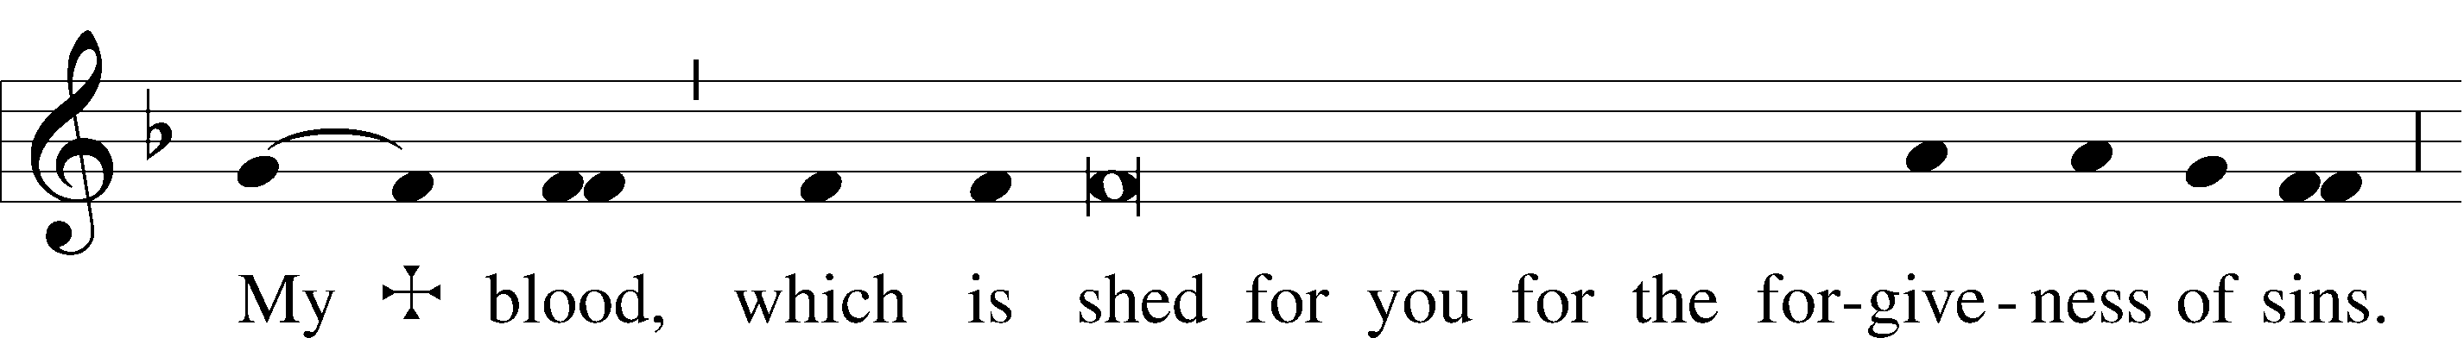

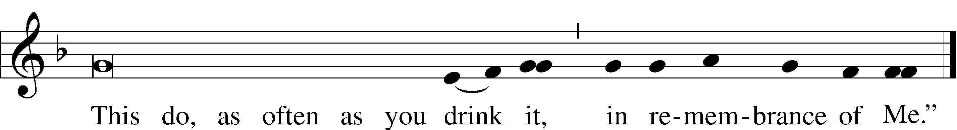

Pax Domini John 20:19

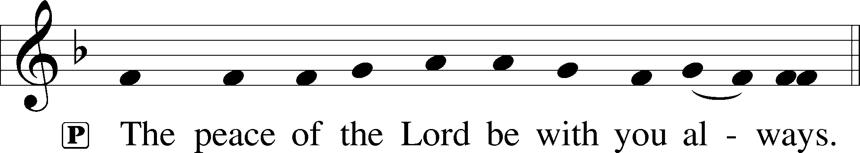

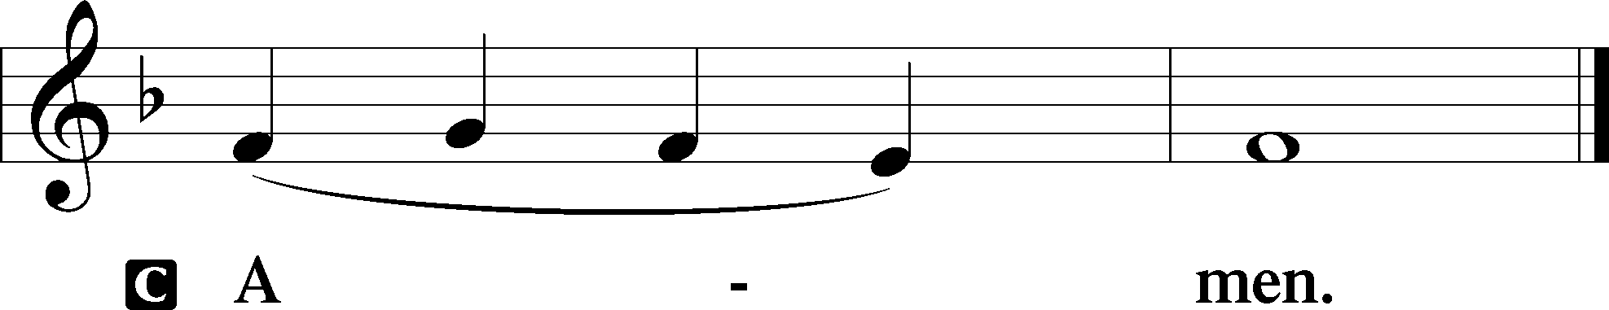

Agnus Dei John 1:29

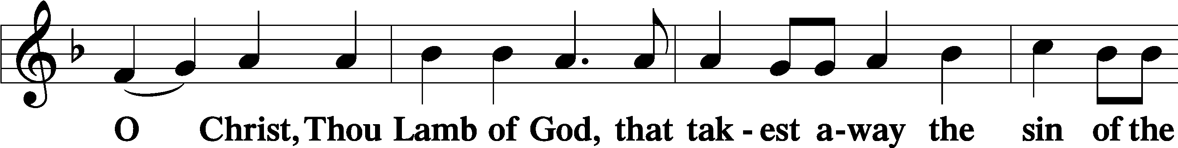

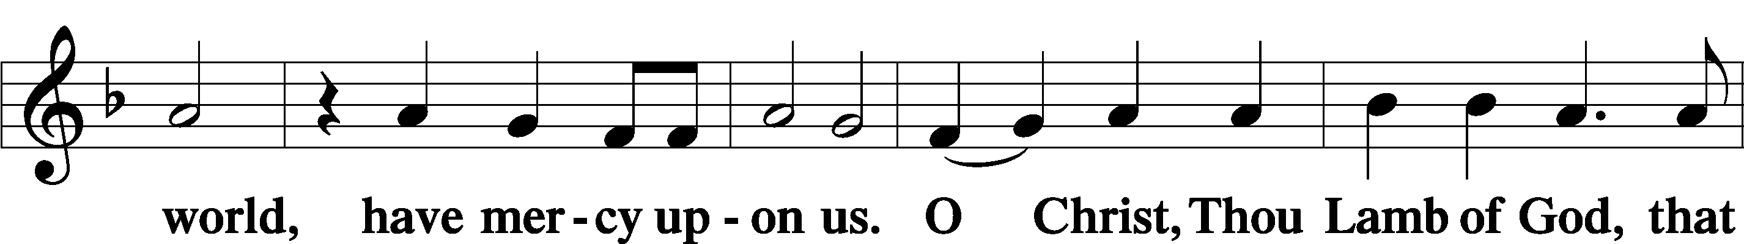

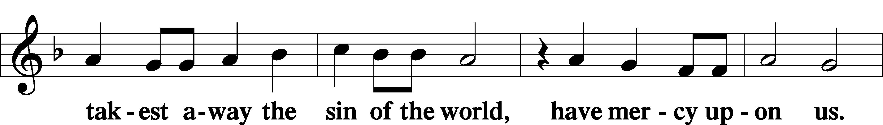

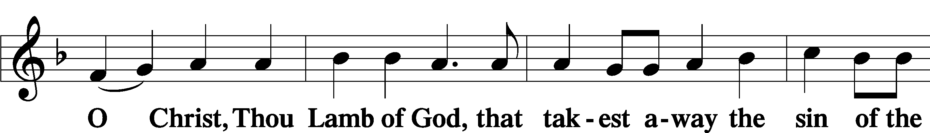

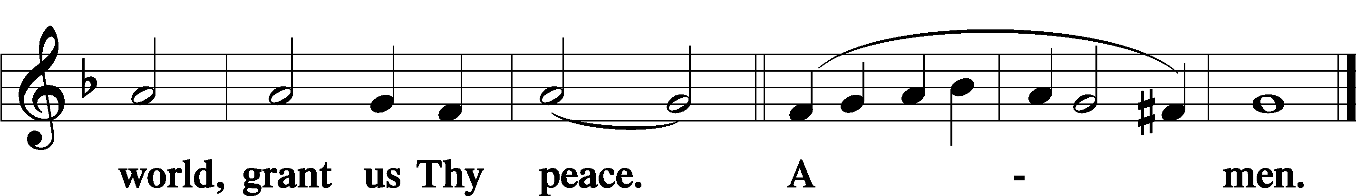

Sit

Distribution

618 I Come, O Savior, to Thy Table

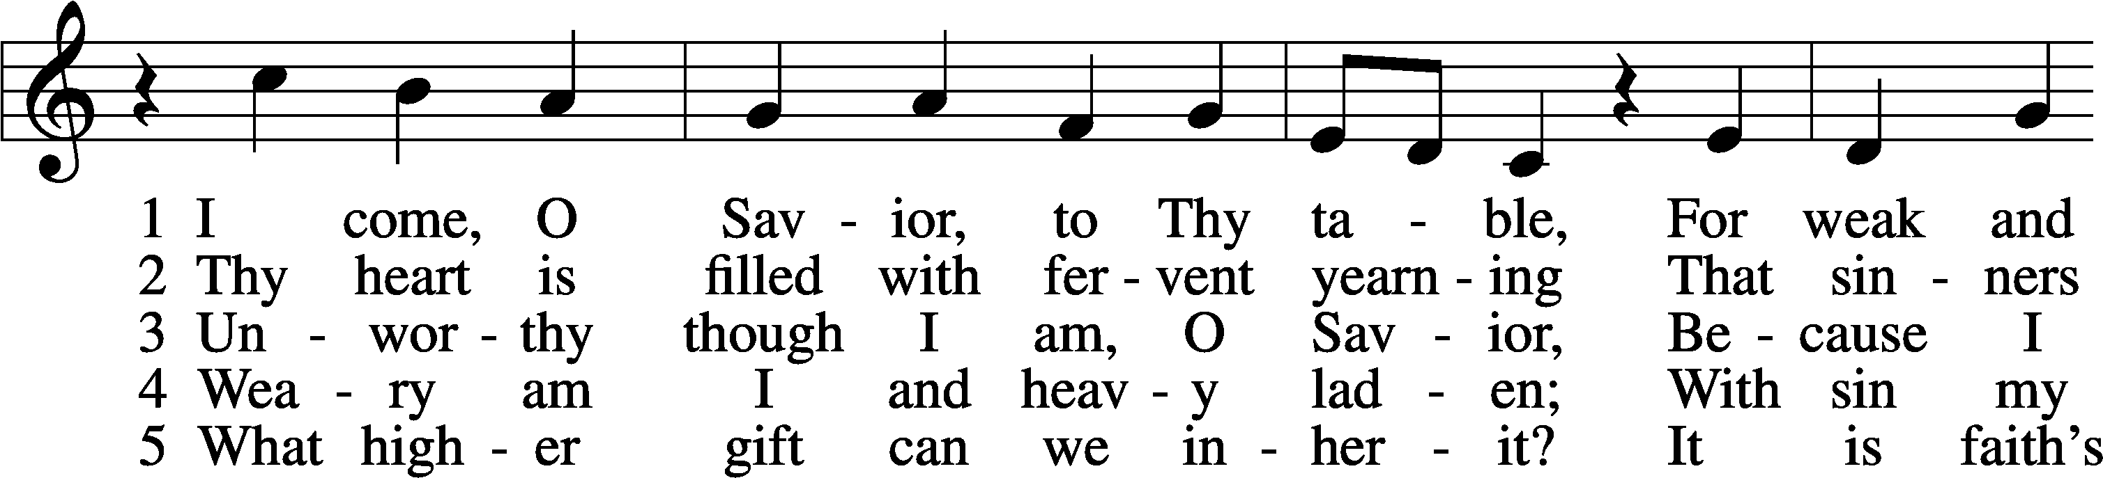

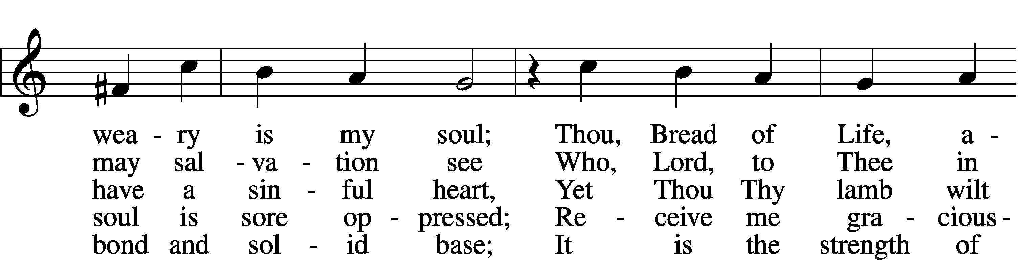

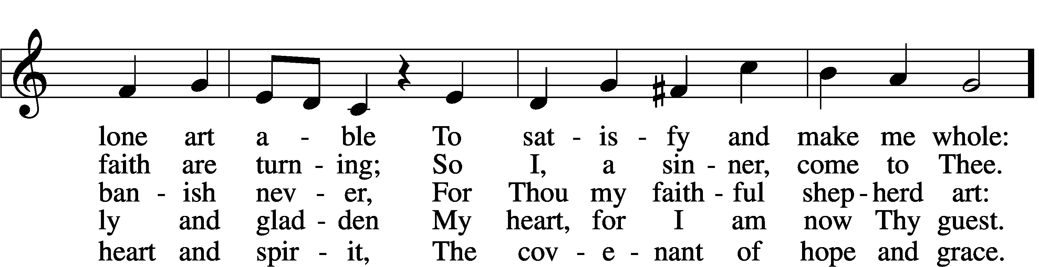

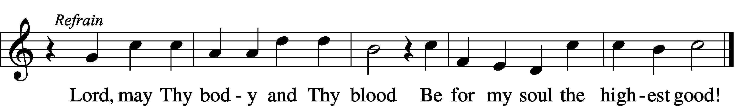

Text: Friedrich Christian Heyder, 1677–1754; tr. The Lutheran Hymnal, 1941, abr.  
Tune: Emskirchner Choral-Buch, 1756, Leipzig  
Text: © 1941 Concordia Publishing House. Used by permission: LSB Hymn License no. 110005011  
Tune: Public domain

616 Baptismal Waters Cover Me

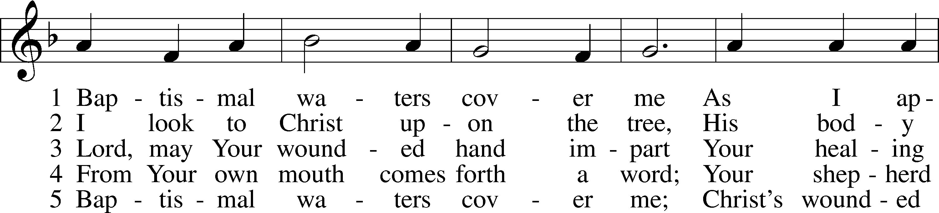

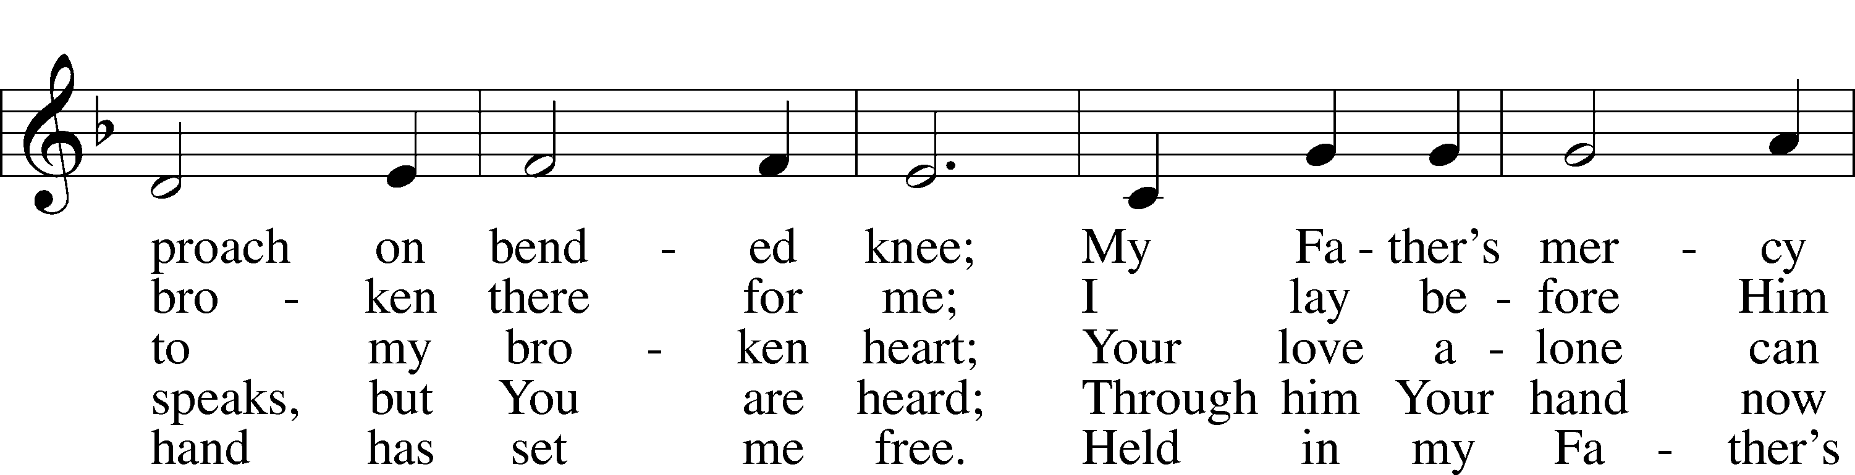

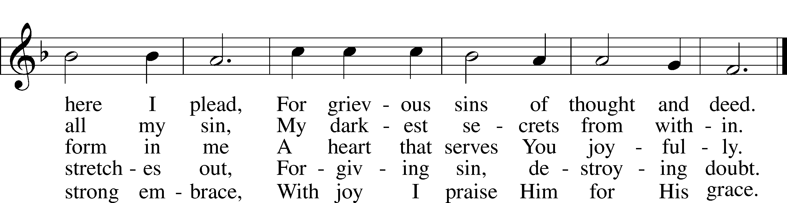

Text: Kurt E. Reinhardt, 1969  
Tune: Sammlung alter und neuer . . . Melodien, 1742  
Text: © 2003 Kurt E. Reinhardt. Used by permission: LSB Hymn License no. 110005011  
Tune: Public domain

623 Lord Jesus Christ, We Humbly Pray

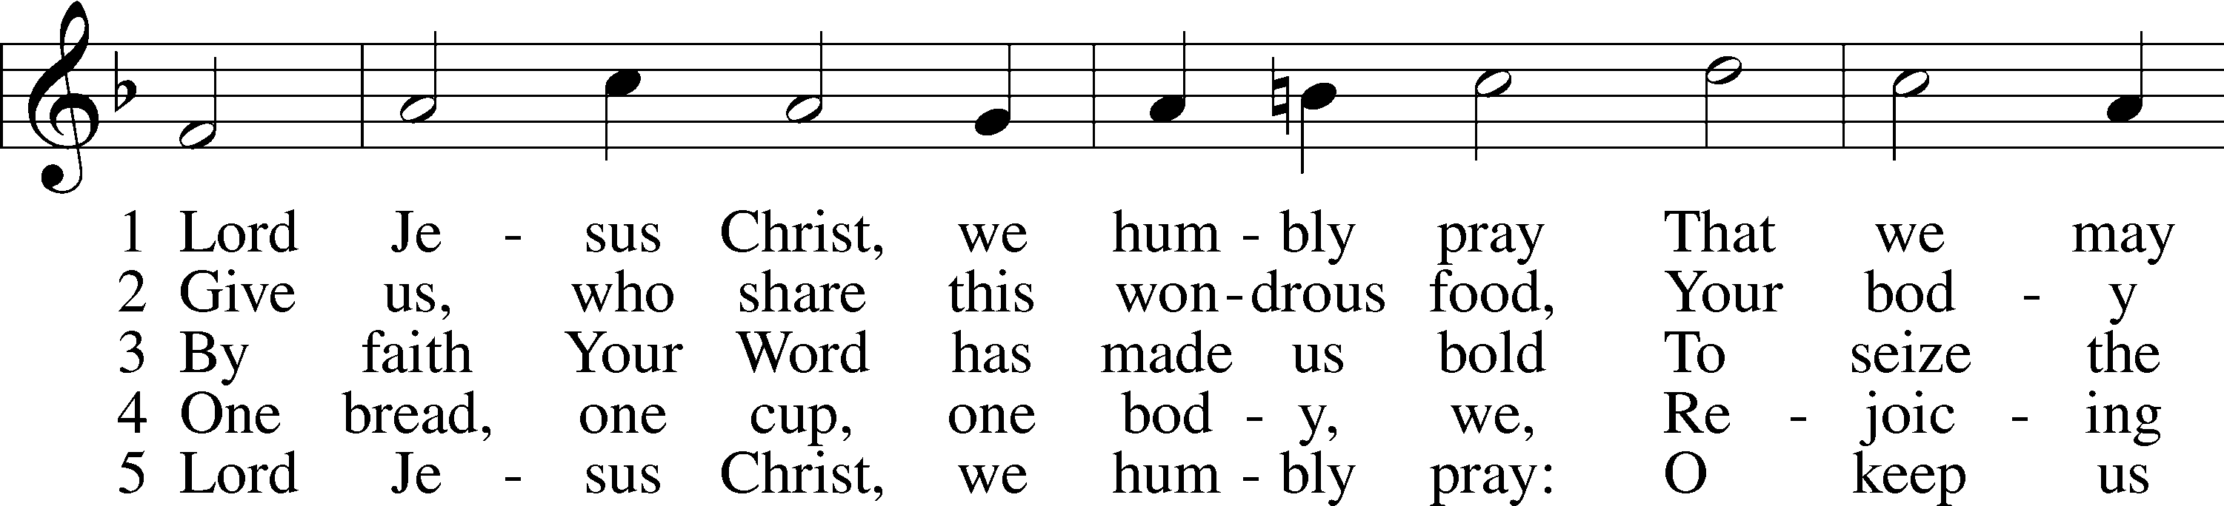

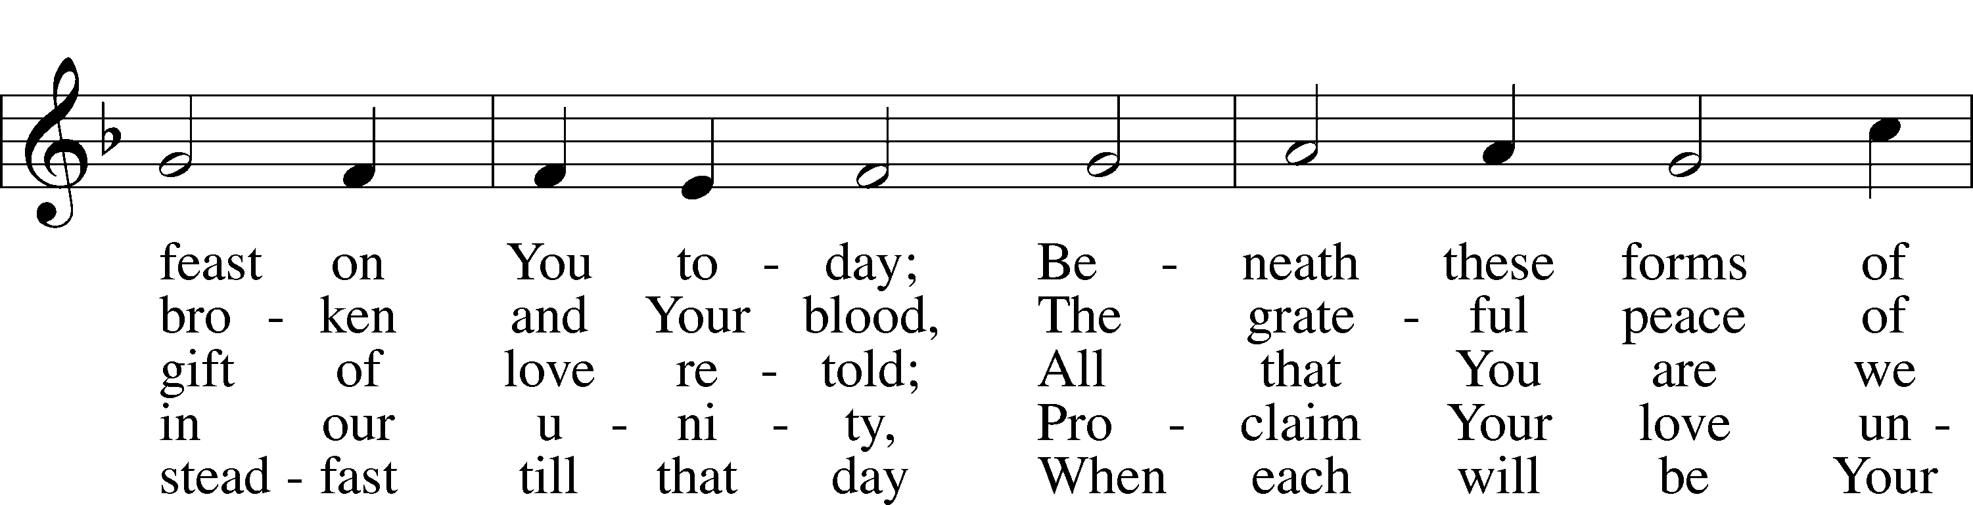

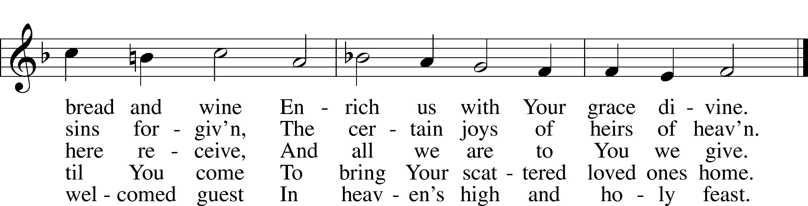

Text: Henry E. Jacobs, 1844–1932, alt.  
Tune: Cantionale Germanicum, 1628, Gochsheim  
Text and tune: Public domain

461 I Know That My Redeemer Lives

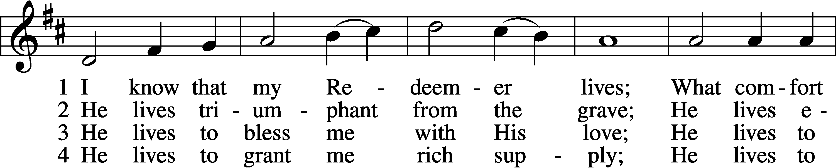

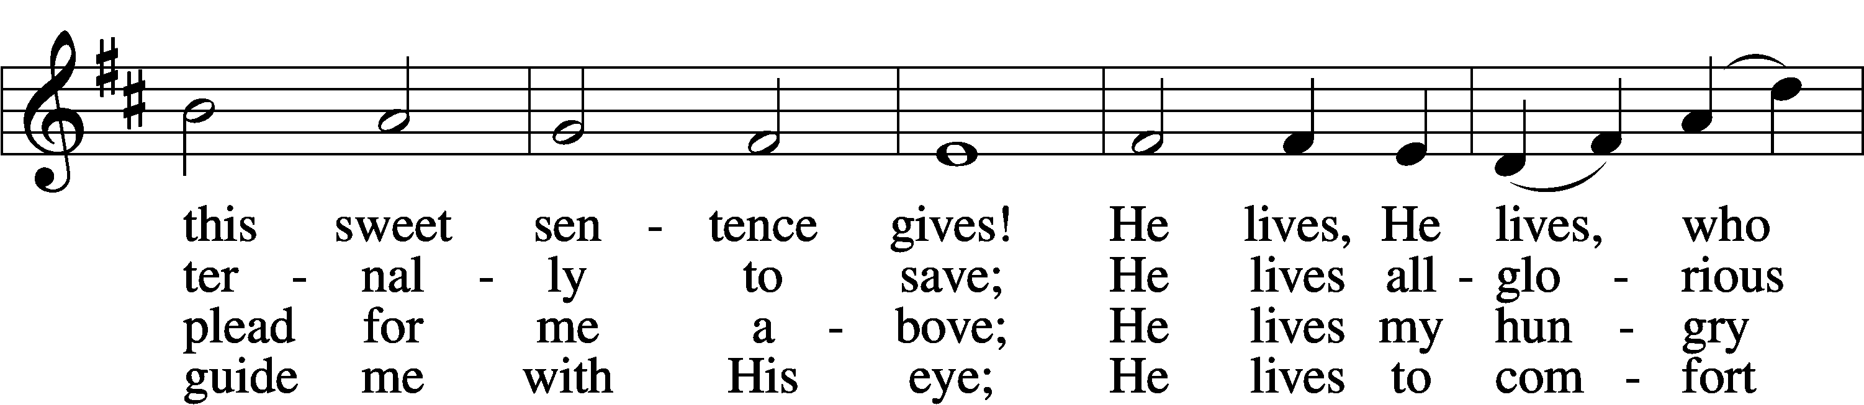

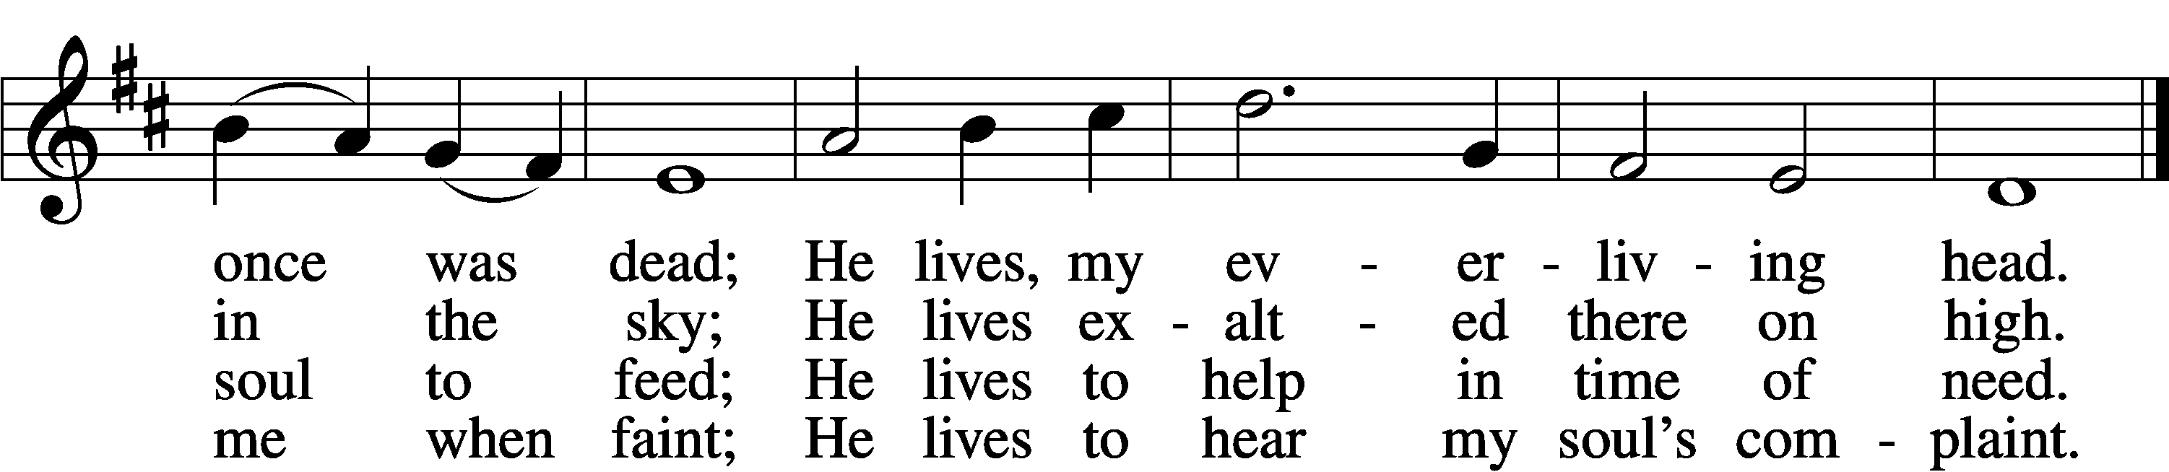

5 He lives to silence all my fears;  
He lives to wipe away my tears;  
He lives to calm my troubled heart;  
He lives all blessings to impart.

6 He lives, my kind, wise, heav’nly friend;  
He lives and loves me to the end;  
He lives, and while He lives, I’ll sing;  
He lives, my Prophet, Priest, and King.

7 He lives and grants me daily breath;  
He lives, and I shall conquer death;  
He lives my mansion to prepare;  
He lives to bring me safely there.

8 He lives, all glory to His name!  
He lives, my Jesus, still the same;  
Oh, the sweet joy this sentence gives:  
I know that my Redeemer lives!

Text: Samuel Medley, 1738–99, abr.  
Tune: attr. John C. Hatton, d. 1793  
Text and tune: Public domain

Stand

The Dismissal

P The body and blood of our Lord Jesus Christ strengthen and preserve you in body and soul to life everlasting. Depart T in peace.

C **Amen.**

Nunc Dimittis Luke 2:29–32

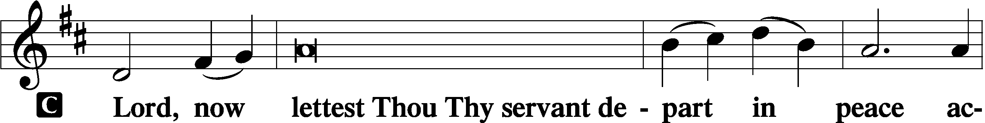

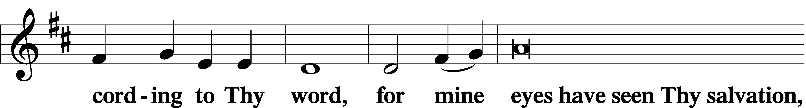

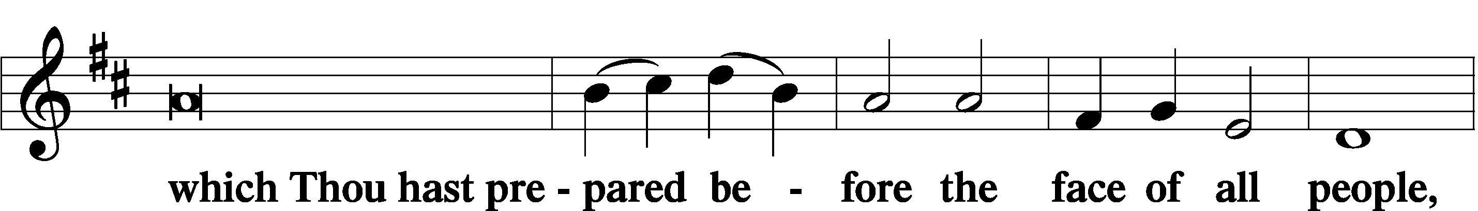

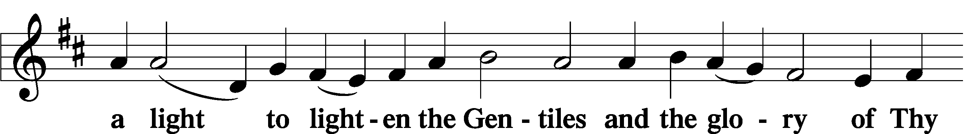

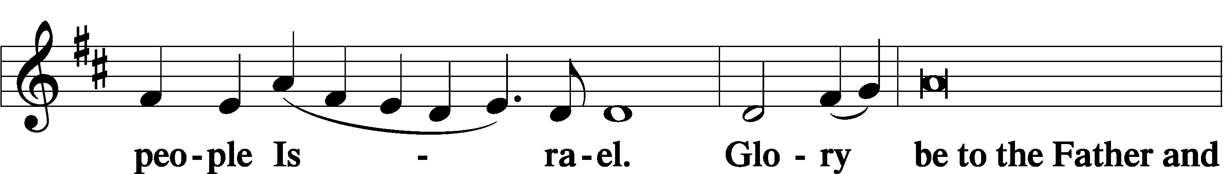

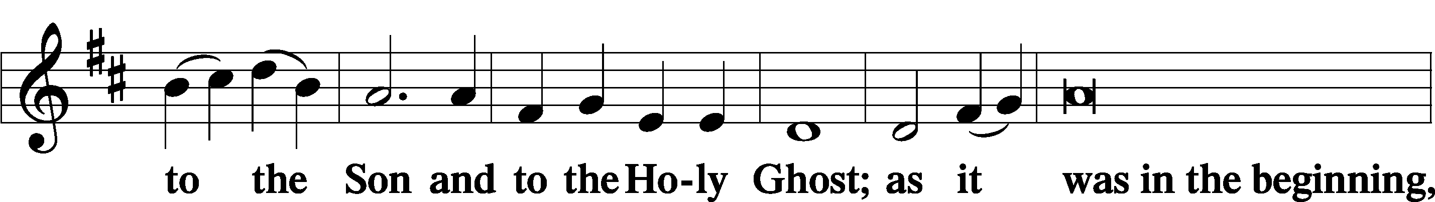

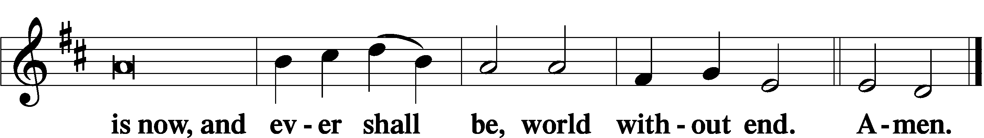

Thanksgiving Psalm 107:1

A O give thanks unto the Lord, for He is good,

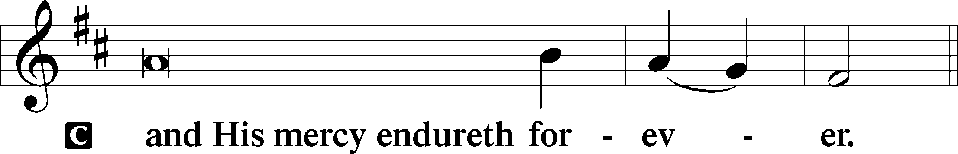

Post-Communion Collect

A Let us pray.

We give thanks to You, almighty God, that You have refreshed us through this salutary gift, and we implore You that of Your mercy You would strengthen us through the same in faith toward You and in fervent love toward one another; through Jesus Christ, Your Son, our Lord, who lives and reigns with You and the Holy Spirit, one God, now and forever.

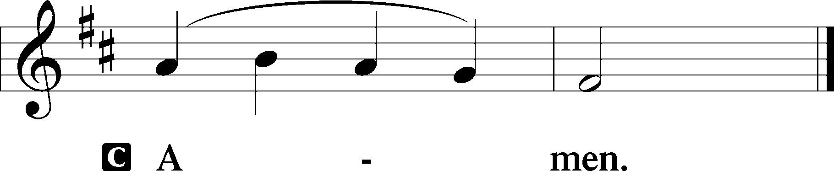

Salutation 2 Timothy 4:22

P The Lord be with you.

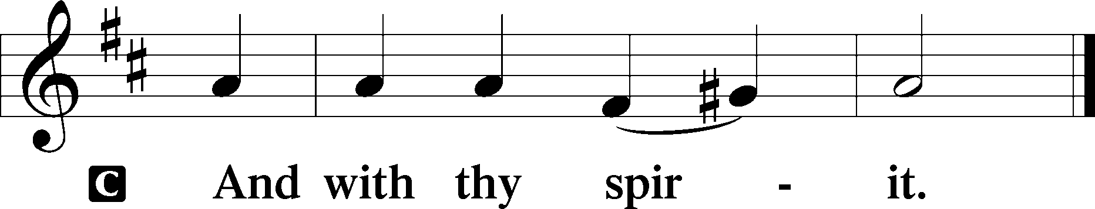

Benedicamus Psalm 103:1

A Bless we the Lord.

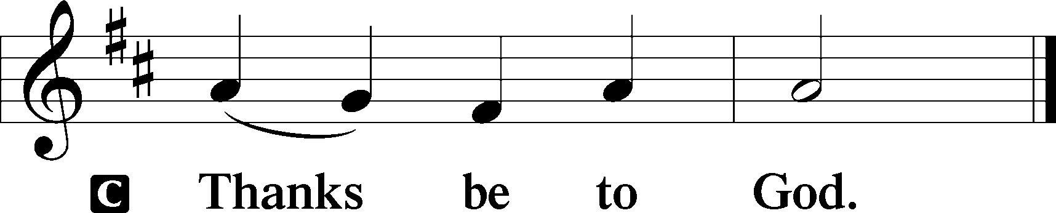

Benediction Numbers 6:24–26

P The Lord bless you and keep you.

The Lord make His face shine upon you and be gracious unto you.

The Lord lift up His countenance upon you and T give you peace.

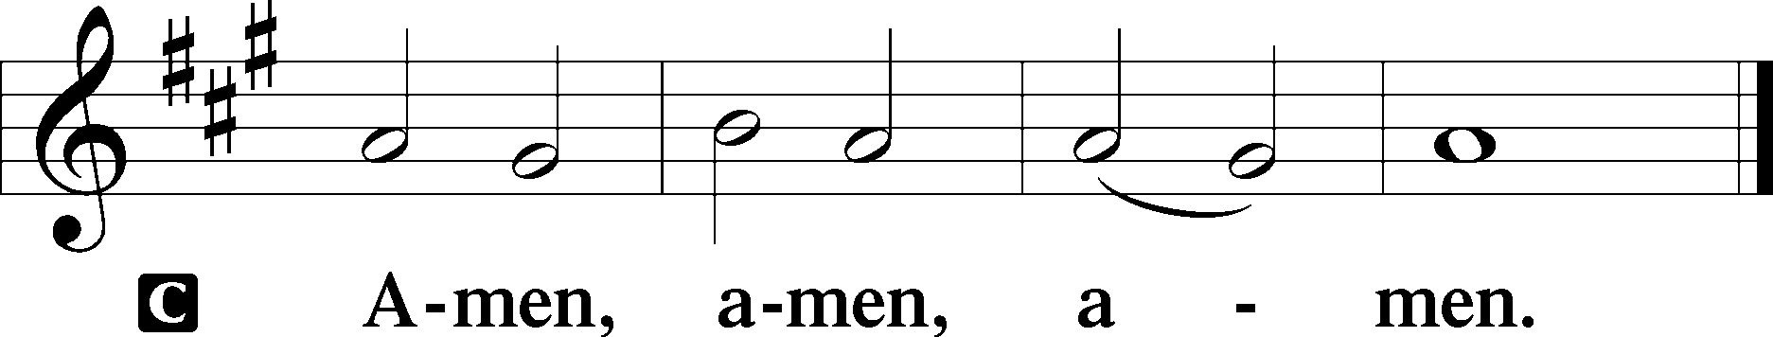

861 Christ Be My Leader

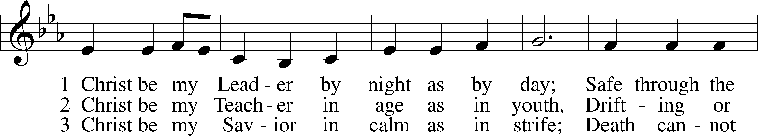

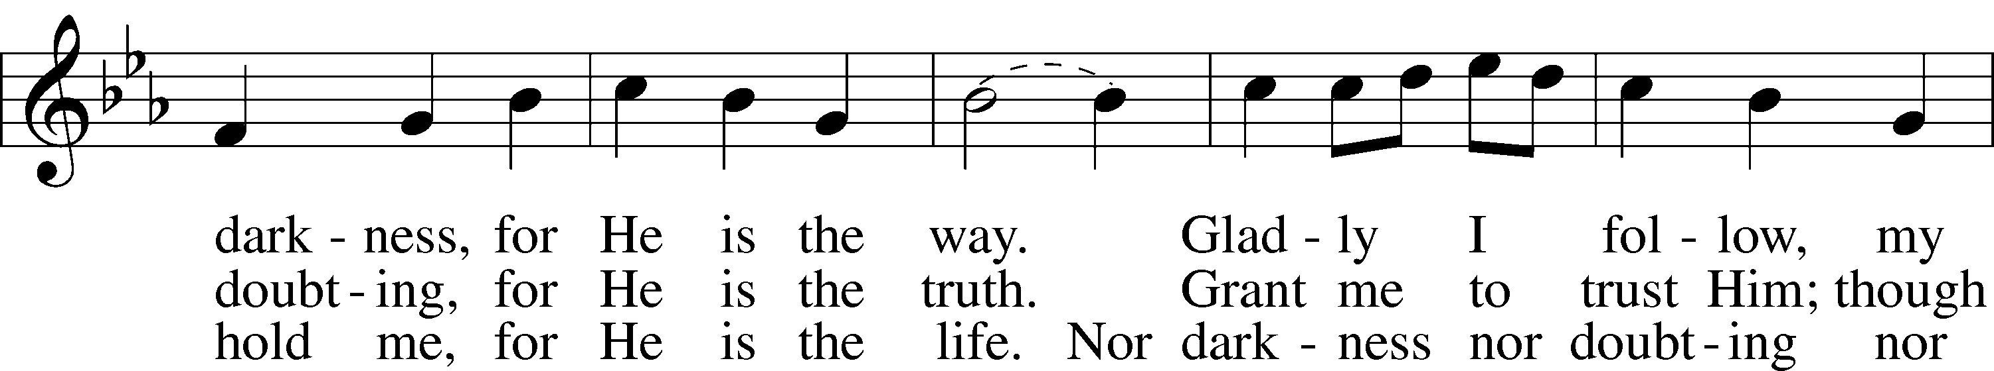

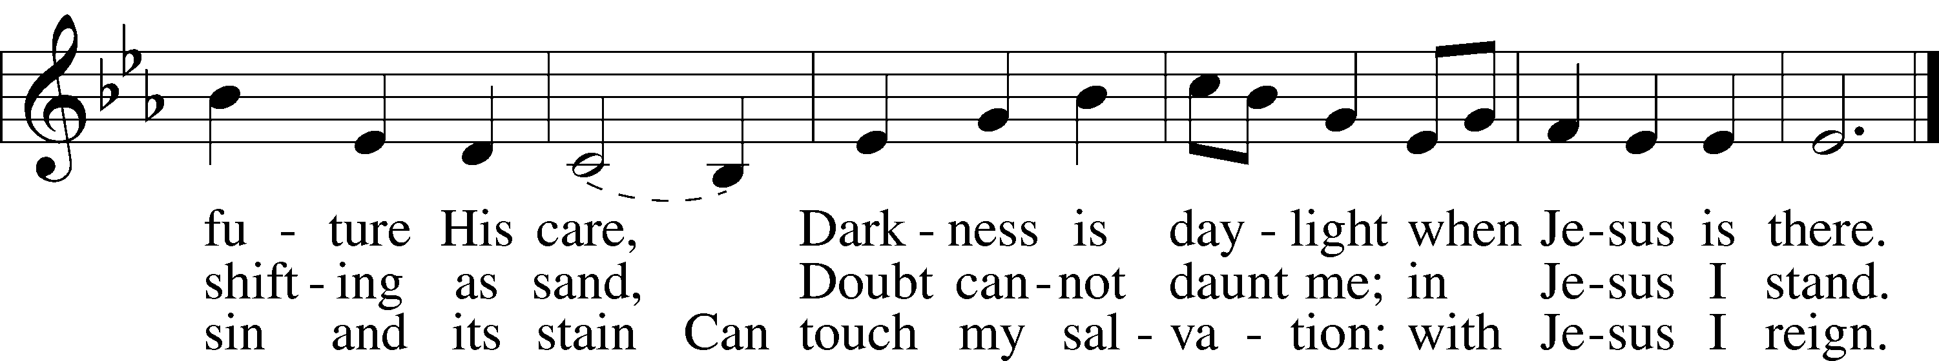

Text: Timothy Dudley-Smith, 1926  
Tune: Irish  
Text: © 1964, renewed 1992 Hope Publishing Co. Used by permission: LSB Hymn License no. 110005011  
Tune: Public domain

Acknowledgments

Divine Service, Setting Three from Lutheran Service Book

Unless otherwise indicated, Scripture quotations are from the ESV® Bible (The Holy Bible, English Standard Version®), copyright © 2001 by Crossway, a publishing ministry of Good News Publishers. Used by permission. All rights reserved.

Created by Lutheran Service Builder © 2023 Concordia Publishing House.