844 Lord of All Nations, Grant Me Grace

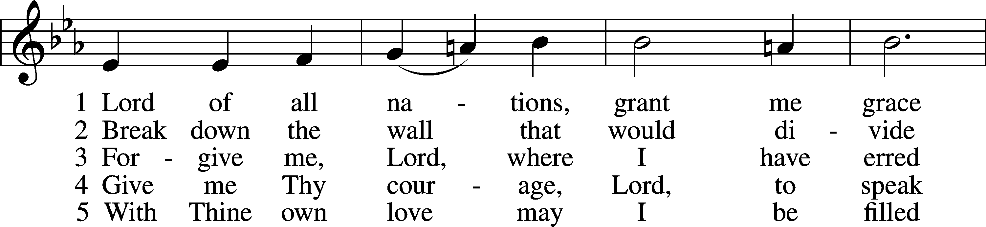

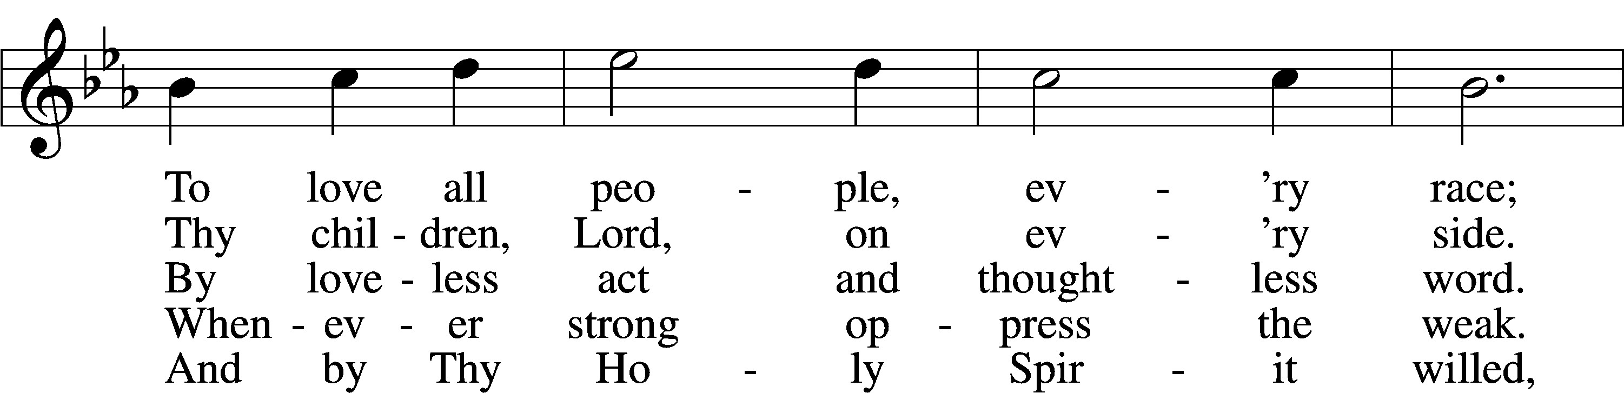

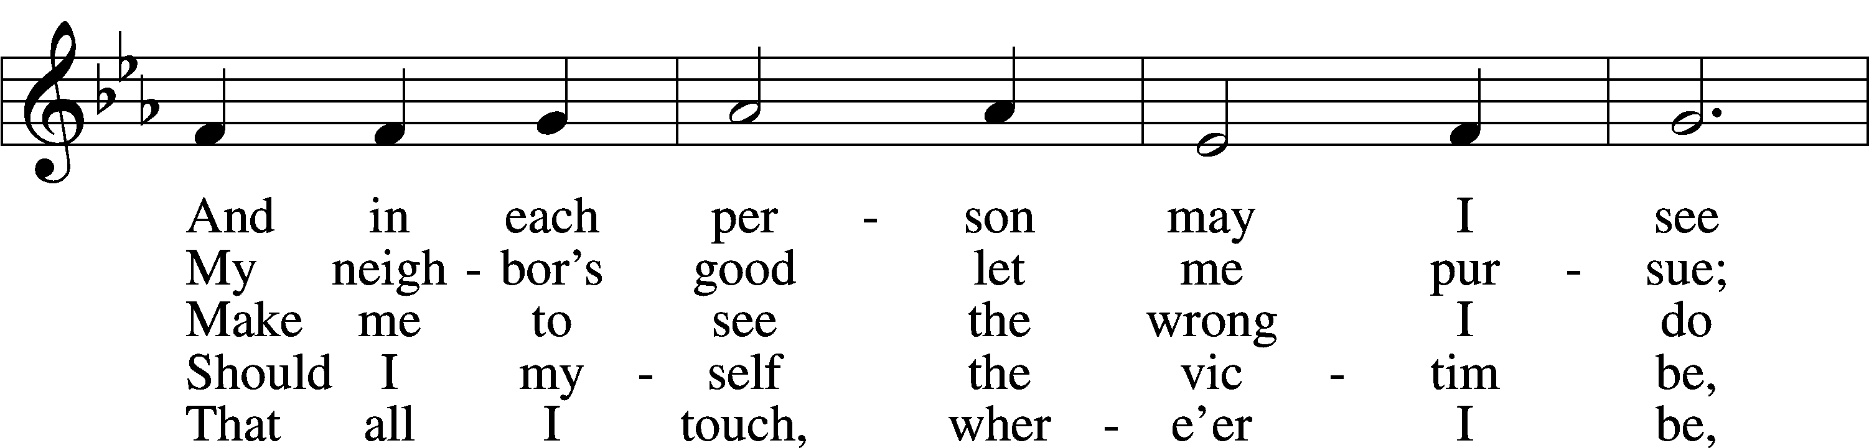

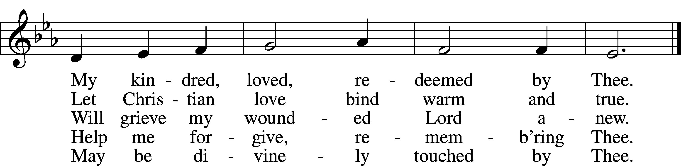

Text: Olive Wise Spannaus, 1916–2018, alt.  
Tune: Georg Joseph, 17th cent., adapt.  
Text: © 1969 Concordia Publishing House. Used by permission: LSB Hymn License no. 110005011  
Tune: Public domain

# Confession and Absolution

The sign of the cross may be made by all in remembrance of their Baptism.

Invocation Matthew 28:19b; 18:20

P In the name of the Father and of the T Son and of the Holy Spirit.

C **Amen.**

Exhortation Hebrews 10:22; Psalm 124:8; Psalm 32:5

P Beloved in the Lord! Let us draw near with a true heart and confess our sins unto God our Father, beseeching Him in the name of our Lord Jesus Christ to grant us forgiveness.

P Our help is in the name of the Lord,

C **who made heaven and earth.**

P I said, I will confess my transgressions unto the Lord,

C **and You forgave the iniquity of my sin.**

Silence for reflection on God’s Word and for self-examination.

Confession of Sins

P Almighty God, our maker and redeemer, we poor sinners confess unto You that we are by nature sinful and unclean and that we have sinned against You by thought, word, and deed. Wherefore we flee for refuge to Your infinite mercy, seeking and imploring Your grace for the sake of our Lord Jesus Christ.

C **O most merciful God, who has given Your only-begotten Son to die for us, have mercy upon us and for His sake grant us remission of all our sins; and by Your Holy Spirit increase in us true knowledge of You and of Your will and true obedience to Your Word, to the end that by Your grace we may come to everlasting life; through Jesus Christ, our Lord. Amen.**

Declaration of Grace Mark 16:16; John 1:12

P Almighty God, our heavenly Father, has had mercy upon us and has given His only Son to die for us and for His sake forgives us all our sins. To those who believe on His name He gives power to become the children of God and has promised them His Holy Spirit. He that believes and is baptized shall be saved.  
  
Grant this, Lord, unto us all.

C **Amen.**

# Service of the Word

Introit Psalm 119:89–93; antiphon: v. 105

Your word is a lamp to my feet  
 and a light to my path.  
**Forever, O Lord, your word  
 is firmly fixed in the heavens.**  
Your faithfulness endures to all generations;  
 you have established the earth, and it stands fast.  
**By your appointment they stand this day,  
 for all things are your servants.**  
If your law had not been my delight,  
 I would have perished in my affliction.  
**I will never forget your precepts,  
 for by them you have given me life.**

Gloria Patri

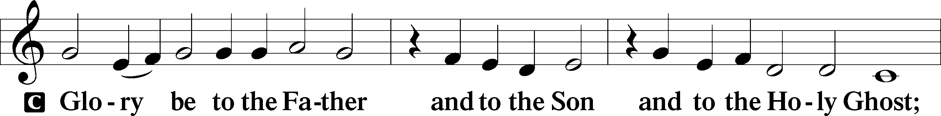

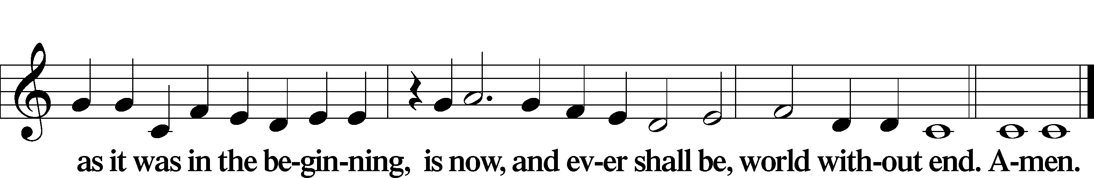

Kyrie Mark 10:47

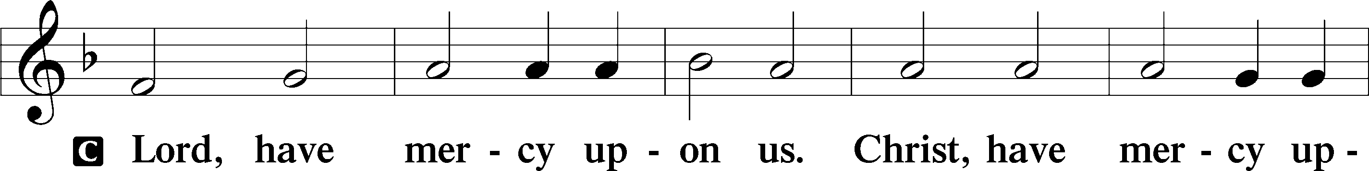

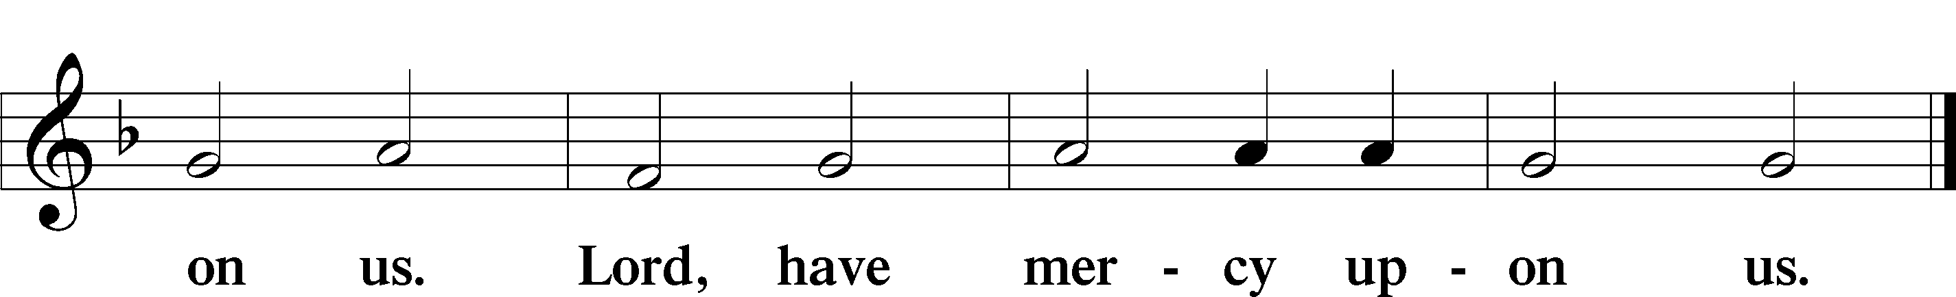

Gloria in Excelsis Luke 2:14; John 1:29

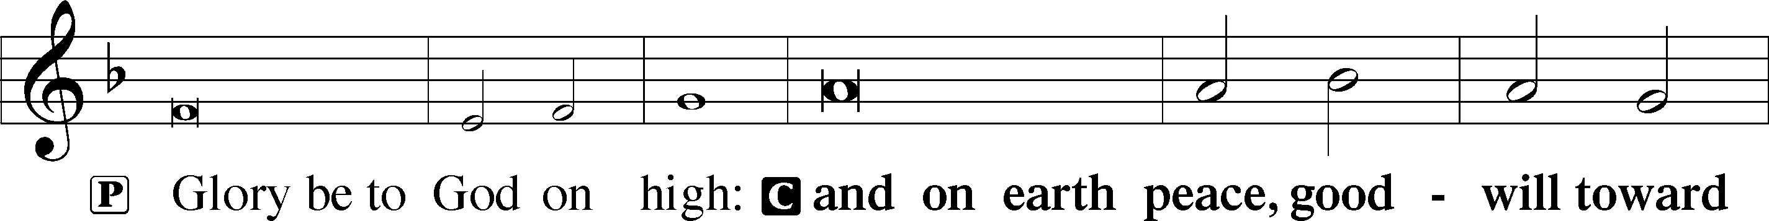

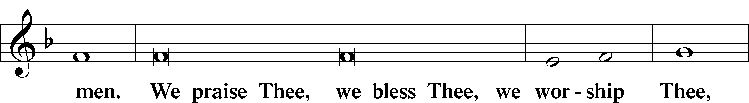

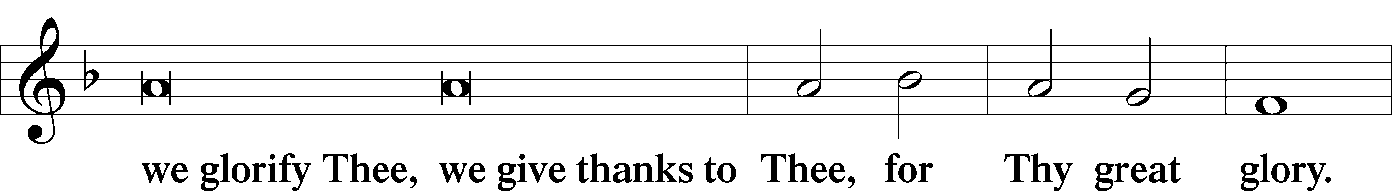

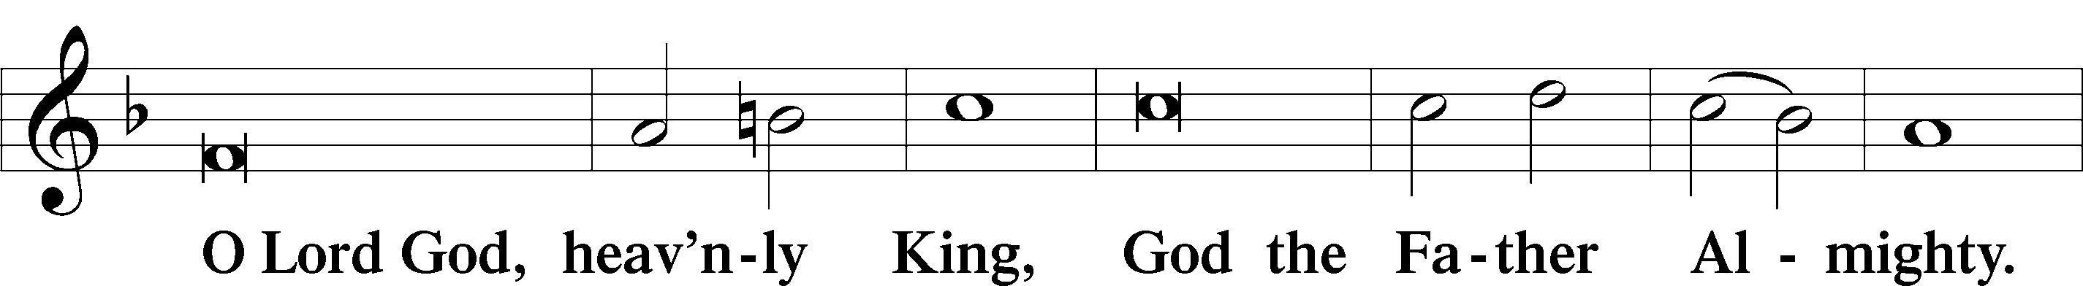

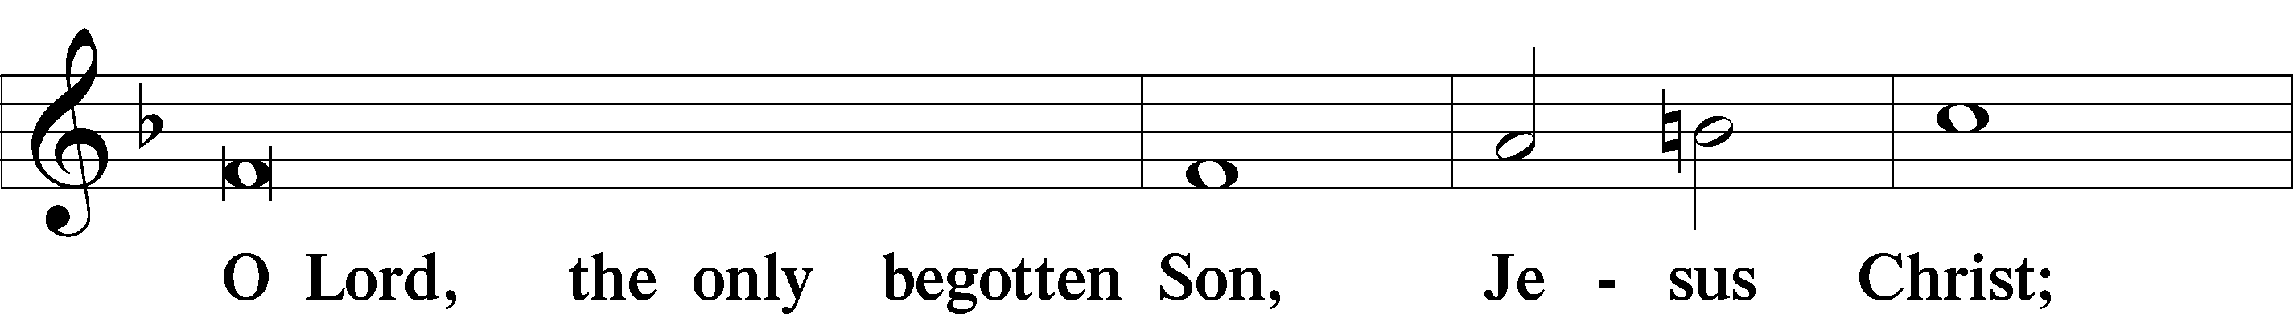

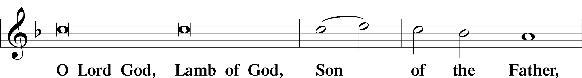

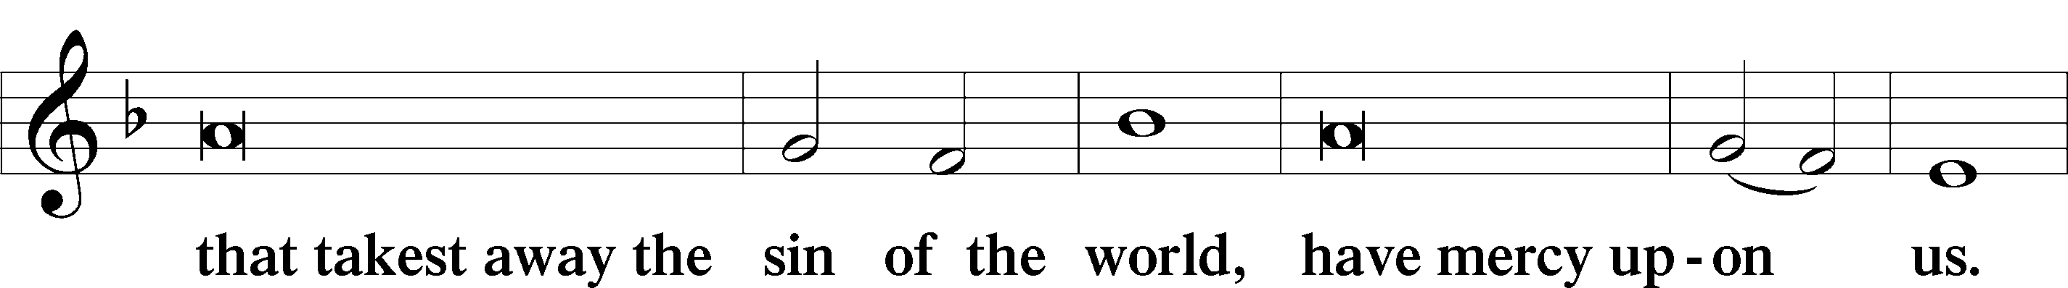

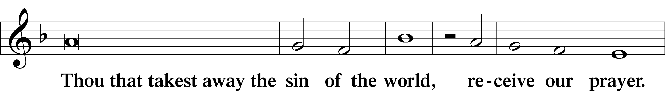

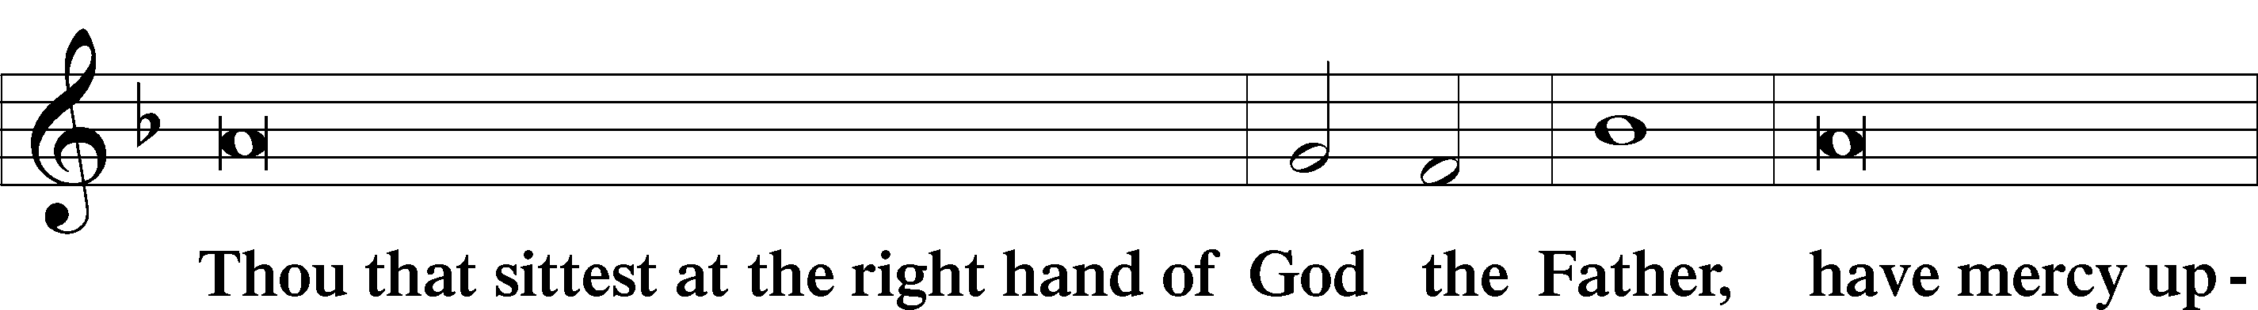

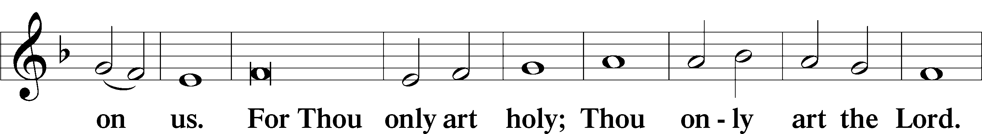

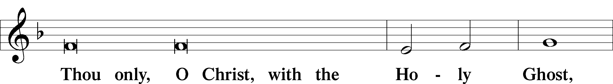

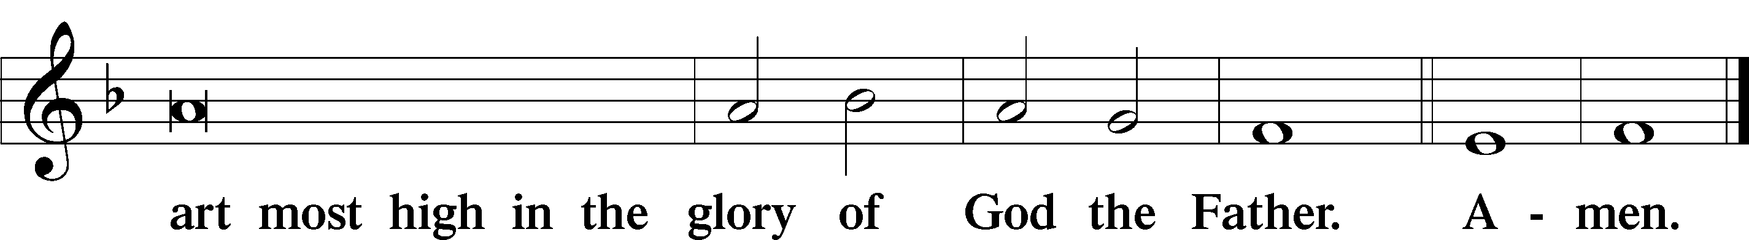

Salutation and Collect of the Day

P The Lord be with you.

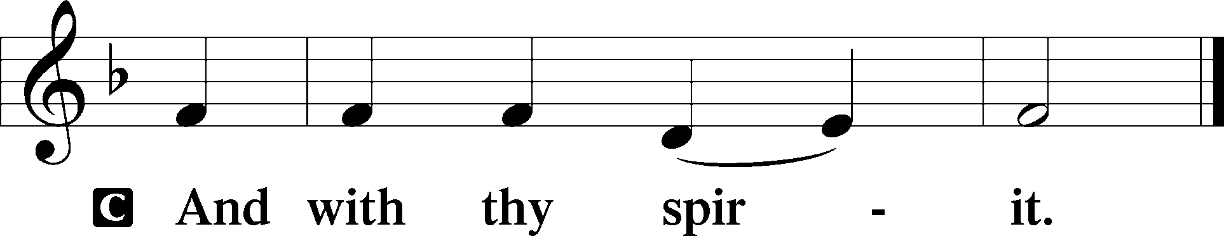

P Let us pray.

O God, the giver of all that is good, by Your holy inspiration grant that we may think those things that are right and by Your merciful guiding accomplish them; through Jesus Christ, Your Son, our Lord, who lives and reigns with You and the Holy Spirit, one God, now and forever.

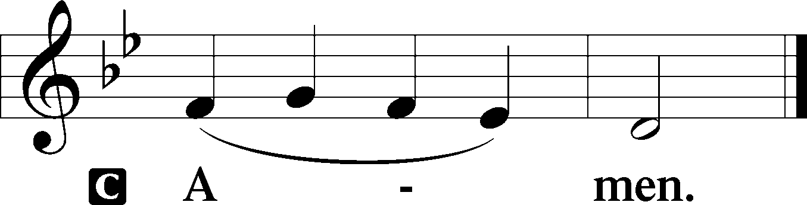

Sit

First Reading Acts 17:16–31

Paul in Athens

16While Paul was waiting for them at Athens, his spirit was provoked within him as he saw that the city was full of idols. 17So he reasoned in the synagogue with the Jews and the devout persons, and in the marketplace every day with those who happened to be there. 18Some of the Epicurean and Stoic philosophers also conversed with him. And some said, “What does this babbler wish to say?” Others said, “He seems to be a preacher of foreign divinities”—because he was preaching Jesus and the resurrection. 19And they took hold of him and brought him to the Areopagus, saying, “May we know what this new teaching is that you are presenting? 20For you bring some strange things to our ears. We wish to know therefore what these things mean.” 21Now all the Athenians and the foreigners who lived there would spend their time in nothing except telling or hearing something new.

Paul Addresses the Areopagus

22So Paul, standing in the midst of the Areopagus, said: “Men of Athens, I perceive that in every way you are very religious. 23For as I passed along and observed the objects of your worship, I found also an altar with this inscription, ‘To the unknown god.’ What therefore you worship as unknown, this I proclaim to you. 24The God who made the world and everything in it, being Lord of heaven and earth, does not live in temples made by man, 25nor is he served by human hands, as though he needed anything, since he himself gives to all mankind life and breath and everything. 26And he made from one man every nation of mankind to live on all the face of the earth, having determined allotted periods and the boundaries of their dwelling place, 27that they should seek God, in the hope that they might feel their way toward him and find him. Yet he is actually not far from each one of us, 28for

“‘In him we live and move and have our being’;

as even some of your own poets have said,

“‘For we are indeed his offspring.’

29Being then God’s offspring, we ought not to think that the divine being is like gold or silver or stone, an image formed by the art and imagination of man. 30The times of ignorance God overlooked, but now he commands all people everywhere to repent, 31because he has fixed a day on which he will judge the world in righteousness by a man whom he has appointed; and of this he has given assurance to all by raising him from the dead.”

A This is the Word of the Lord.

C **Thanks be to God.**

Gradual adapt. from Matthew 28:7; Hebrews 2:7; Psalm 8:6

Christ has risen from the dead.  
 [God the Father] has crowned him with glory and honor.  
**He has given him dominion over the works of his hands;  
 he has put all things under his feet.**

Reading 1 Peter 3:13–22

13Now who is there to harm you if you are zealous for what is good? 14But even if you should suffer for righteousness’ sake, you will be blessed. Have no fear of them, nor be troubled, 15but in your hearts regard Christ the Lord as holy, always being prepared to make a defense to anyone who asks you for a reason for the hope that is in you; 16yet do it with gentleness and respect, having a good conscience, so that, when you are slandered, those who revile your good behavior in Christ may be put to shame. 17For it is better to suffer for doing good, if that should be God’s will, than for doing evil.

18For Christ also suffered once for sins, the righteous for the unrighteous, that he might bring us to God, being put to death in the flesh but made alive in the spirit, 19in which he went and proclaimed to the spirits in prison, 20because they formerly did not obey, when God’s patience waited in the days of Noah, while the ark was being prepared, in which a few, that is, eight persons, were brought safely through water. 21Baptism, which corresponds to this, now saves you, not as a removal of dirt from the body but as an appeal to God for a good conscience, through the resurrection of Jesus Christ, 22who has gone into heaven and is at the right hand of God, with angels, authorities, and powers having been subjected to him.

Stand

Alleluia

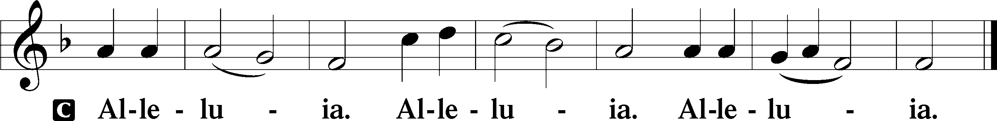

Holy Gospel John 14:15–21

P The Holy Gospel according to St. John, the fourteenth chapter.

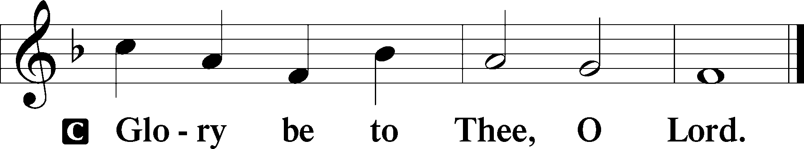

Jesus Promises the Holy Spirit

15[Jesus said:] “If you love me, you will keep my commandments. 16And I will ask the Father, and he will give you another Helper, to be with you forever, 17even the Spirit of truth, whom the world cannot receive, because it neither sees him nor knows him. You know him, for he dwells with you and will be in you.

18“I will not leave you as orphans; I will come to you. 19Yet a little while and the world will see me no more, but you will see me. Because I live, you also will live. 20In that day you will know that I am in my Father, and you in me, and I in you. 21Whoever has my commandments and keeps them, he it is who loves me. And he who loves me will be loved by my Father, and I will love him and manifest myself to him.”

P This is the Gospel of the Lord.

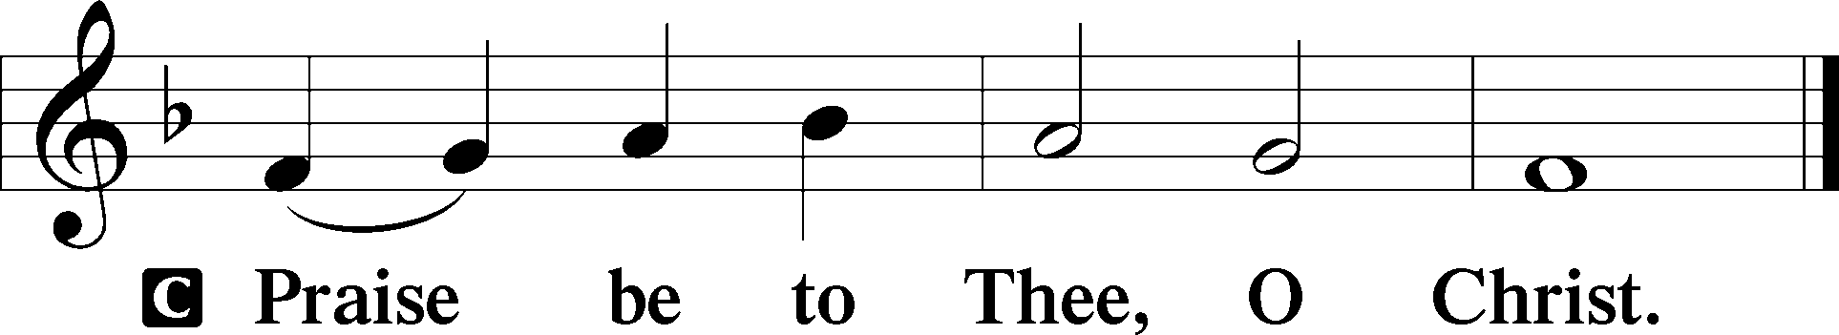

Apostles’ Creed

C **I believe in God, the Father Almighty,**

**maker of heaven and earth.**

**And in Jesus Christ, His only Son, our Lord,**

**who was conceived by the Holy Spirit,**

**born of the virgin Mary,**

**suffered under Pontius Pilate,**

**was crucified, died and was buried.**

**He descended into hell.**

**The third day He rose again from the dead.**

**He ascended into heaven**

**and sits at the right hand of God the Father Almighty.**

**From thence He will come to judge the living and the dead.**

**I believe in the Holy Spirit,**

**the holy Christian Church,**

**the communion of saints,**

**the forgiveness of sins,**

**the resurrection of the body,**

**and the life** T **everlasting. Amen.**

Sit

Children's Message

556 Dear Christians, One and All, Rejoice sts. 1–5

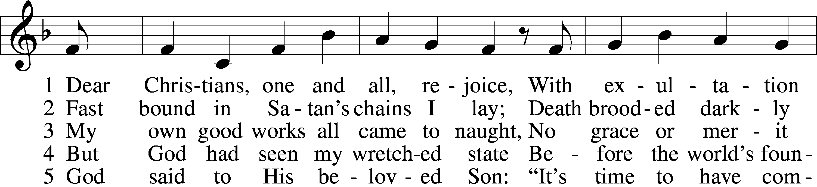

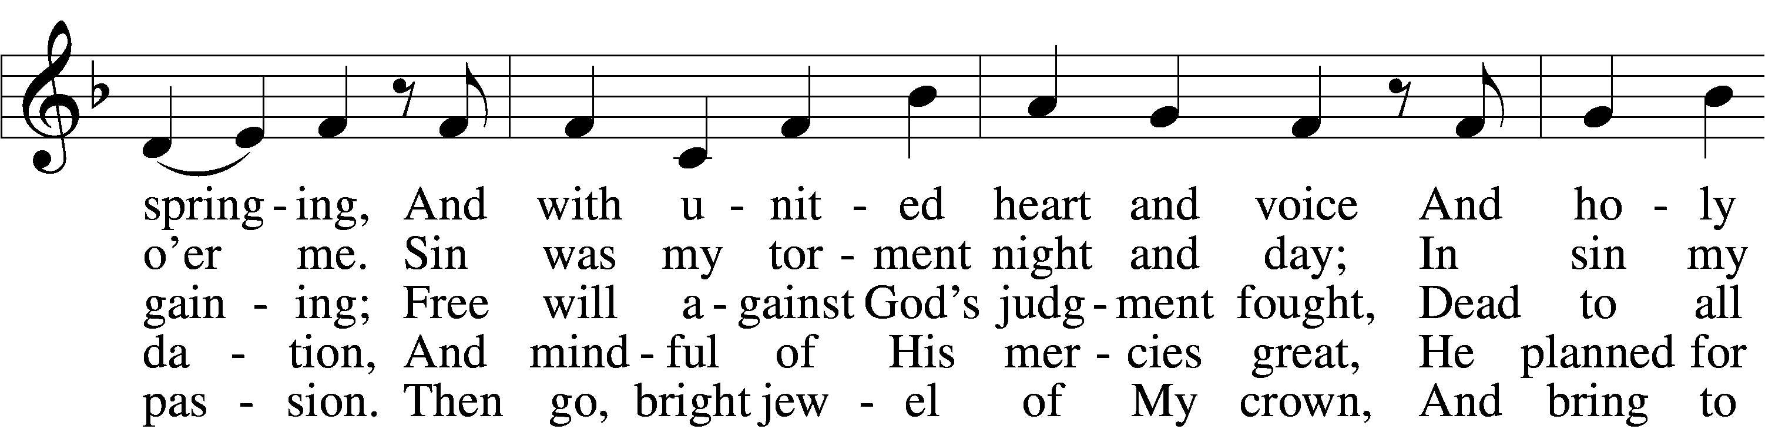

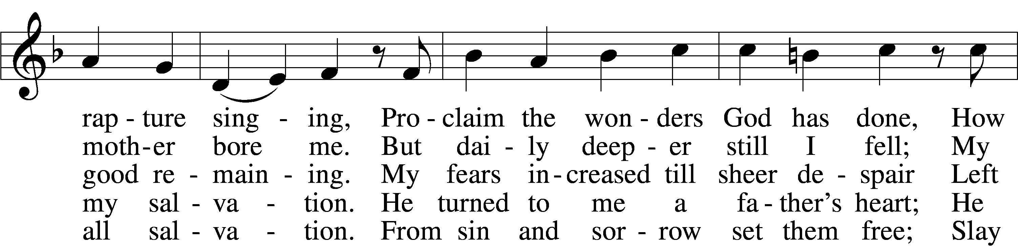

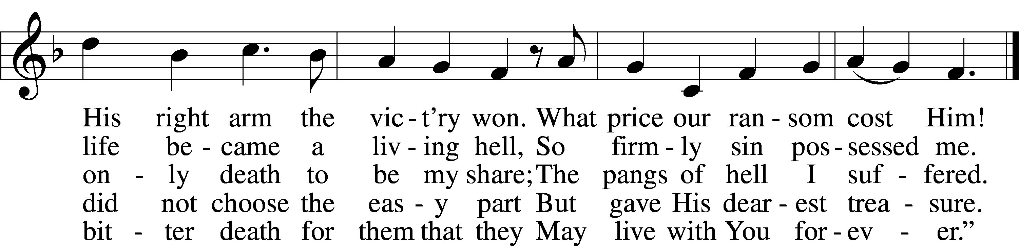

Text: Martin Luther, 1483–1546; tr. Richard Massie, 1800–87, alt.  
Tune: Etlich Cristlich lider, 1524, Wittenberg  
Text and tune: Public domain

Sermon

556 Dear Christians, One and All, Rejoice sts. 6–10

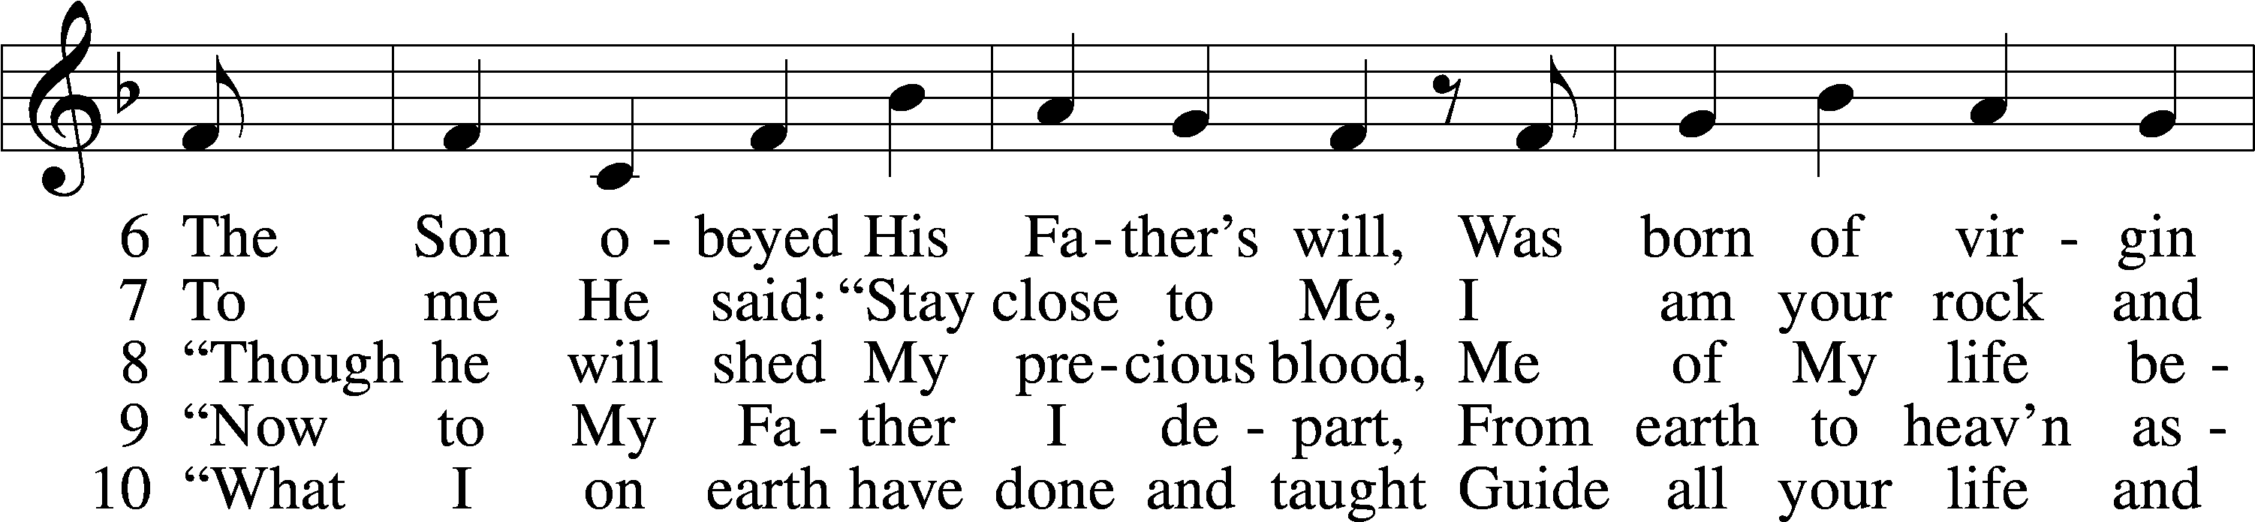

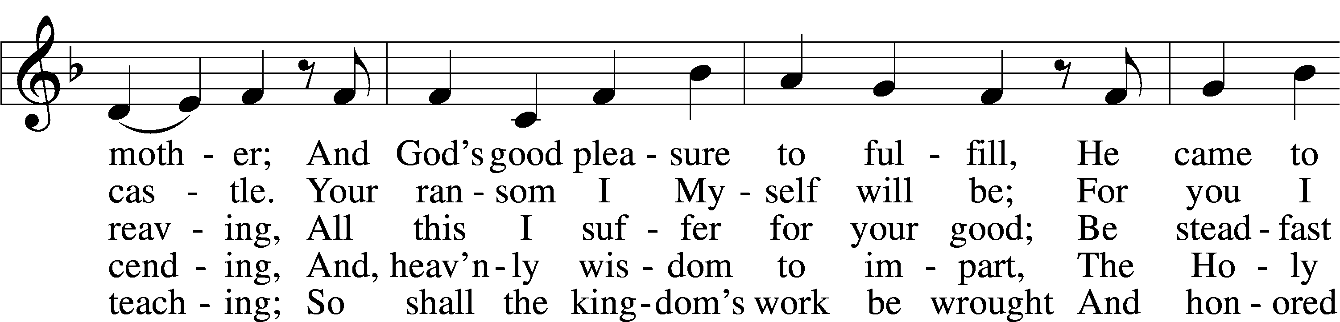

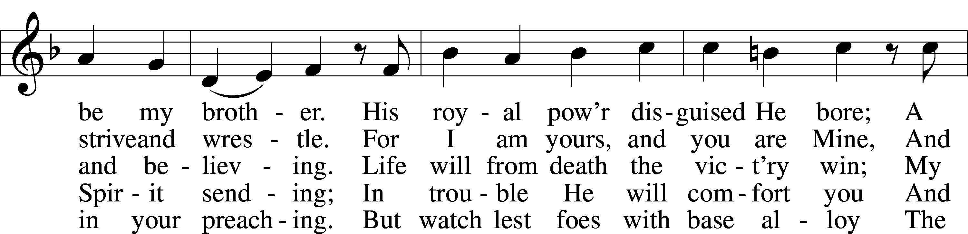

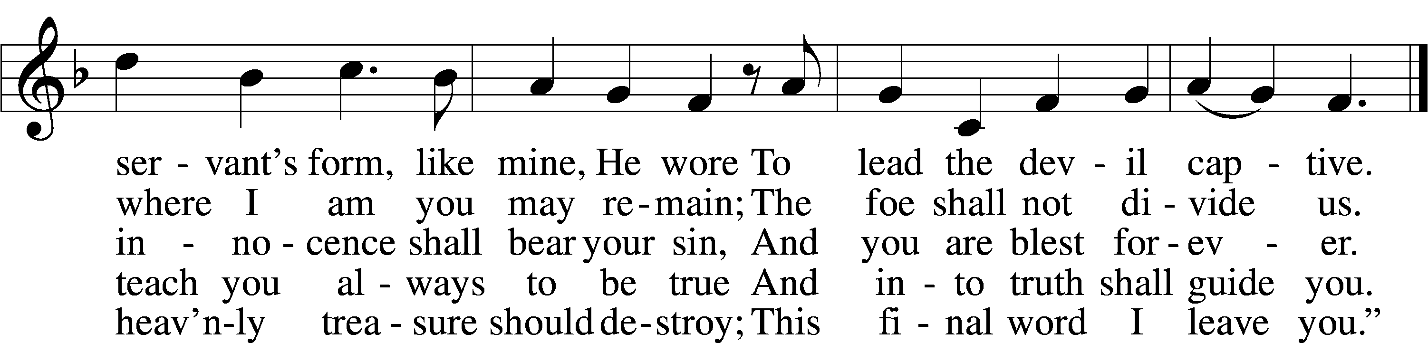

Text: Martin Luther, 1483–1546; tr. Richard Massie, 1800–87, alt.  
Tune: Etlich Cristlich lider, 1524, Wittenberg  
Text and tune: Public domain

Votum

P The peace of God, which passes all understanding, keep your hearts and minds in Christ Jesus.

C **Amen.**

Stand

Offertory Psalm 51:10–12

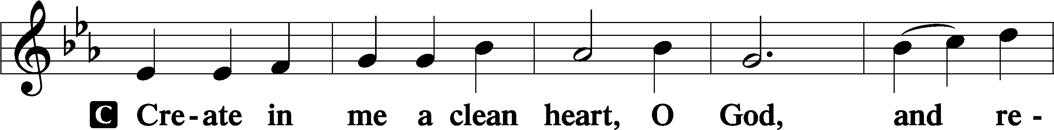

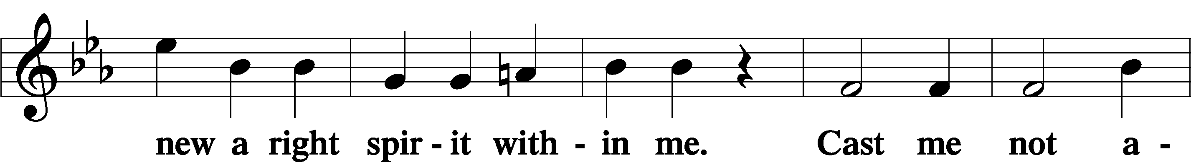

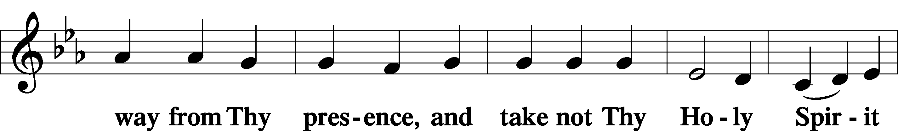

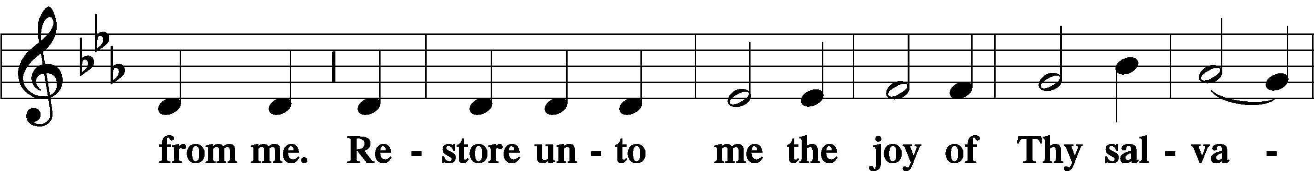

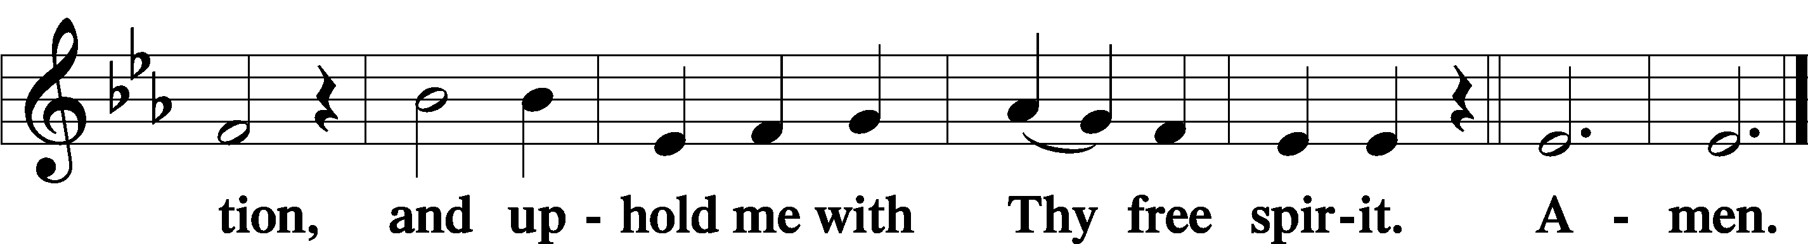

Offering

805 Praise God, from Whom All Blessings Flow

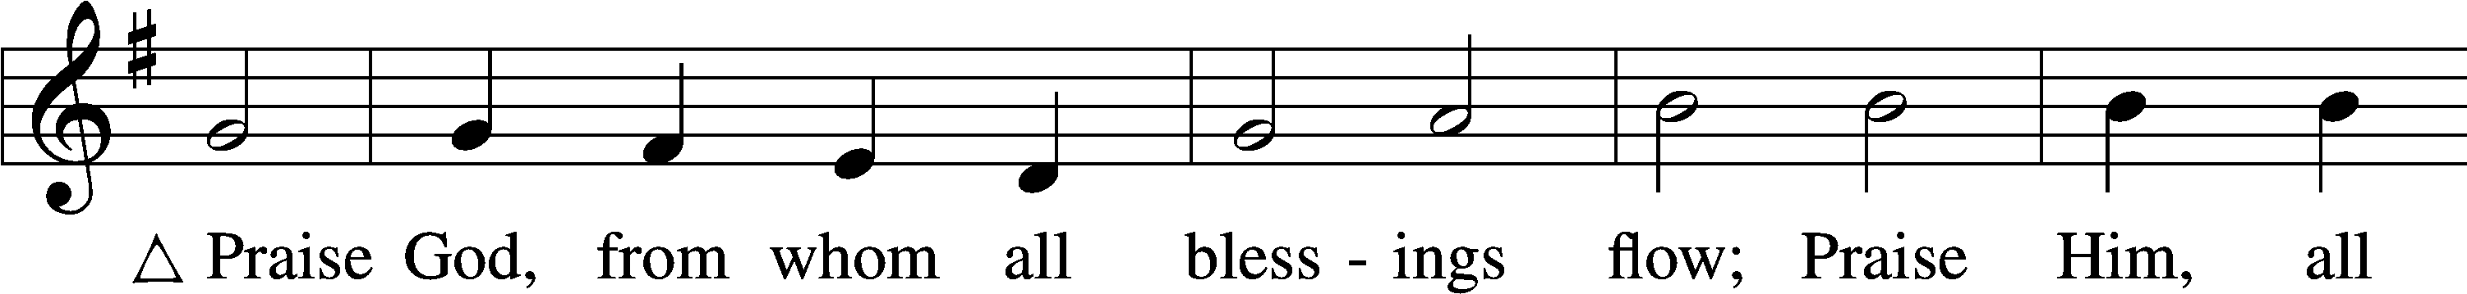

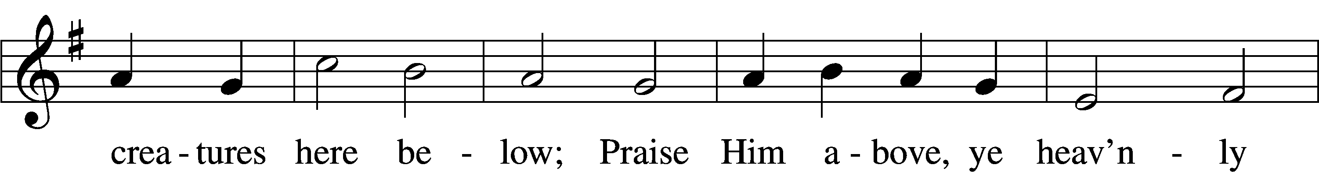

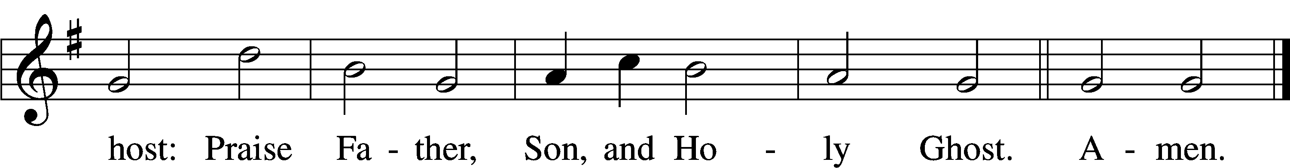

Text: Thomas Ken, 1637–1711  
Tune: Trente quatre Pseaumes de David, 1551, Geneva, ed. Louis Bourgeois  
Text and tune: Public domain

Prayer of the Church

Lord’s Prayer Matthew 6:9–13

P Lord, remember us in Your kingdom and teach us to pray:

C **Our Father who art in heaven,**

**hallowed be Thy name,**

**Thy kingdom come,**

**Thy will be done on earth**

**as it is in heaven;**

**give us this day our daily bread;**

**and forgive us our trespasses**

**as we forgive those**

**who trespass against us;**

**and lead us not into temptation,**

**but deliver us from evil.**

**For Thine is the kingdom**

**and the power and the glory**

**forever and ever. Amen.**

Collect for the Word

Blessed Lord, You have caused all Holy Scriptures to be written for our learning.

Grant that we may so hear them, read, mark, learn, and inwardly digest them that, by the patience and comfort of Your holy Word, we may embrace and ever hold fast the blessed hope of everlasting life; which you have given us in our Savior Jesus Christ, Your son, our Lord, who lives and reigns with You and the Holy Spirit, one God, now and forever.

Post-Communion Collect

A Let us pray.

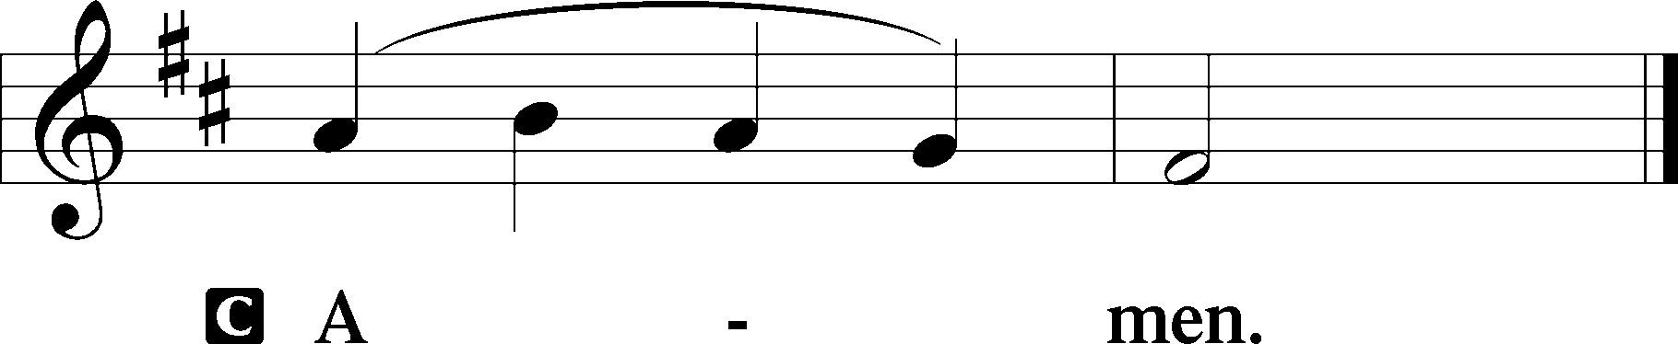

816 From All That Dwell Below the Skies

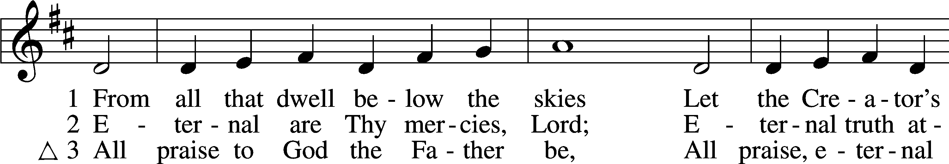

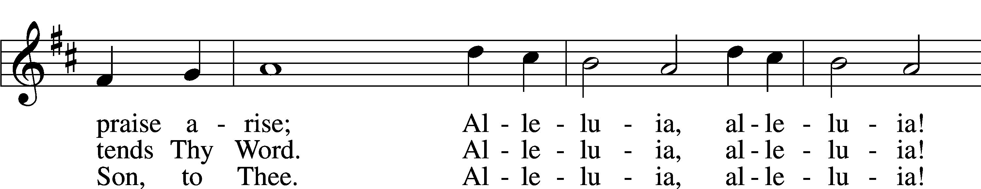

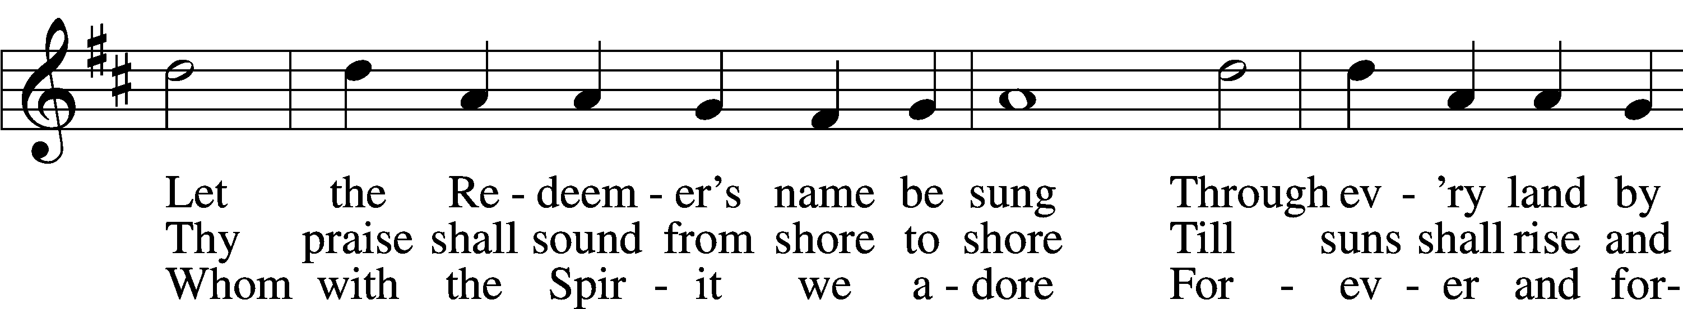

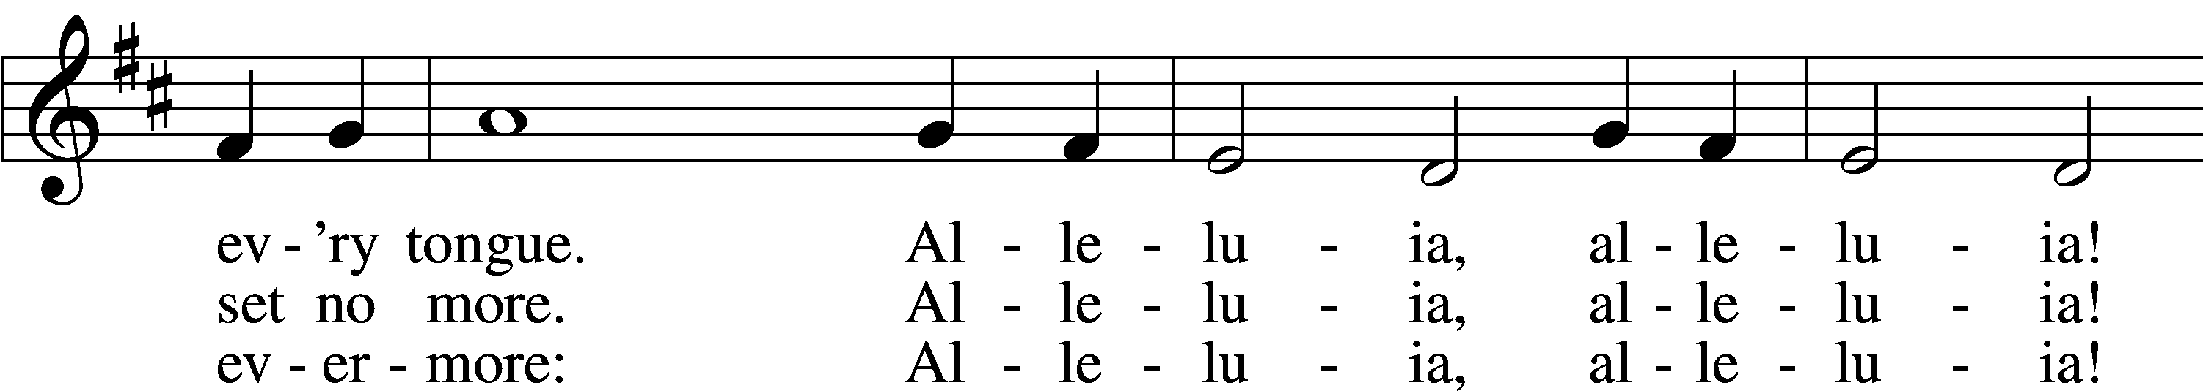

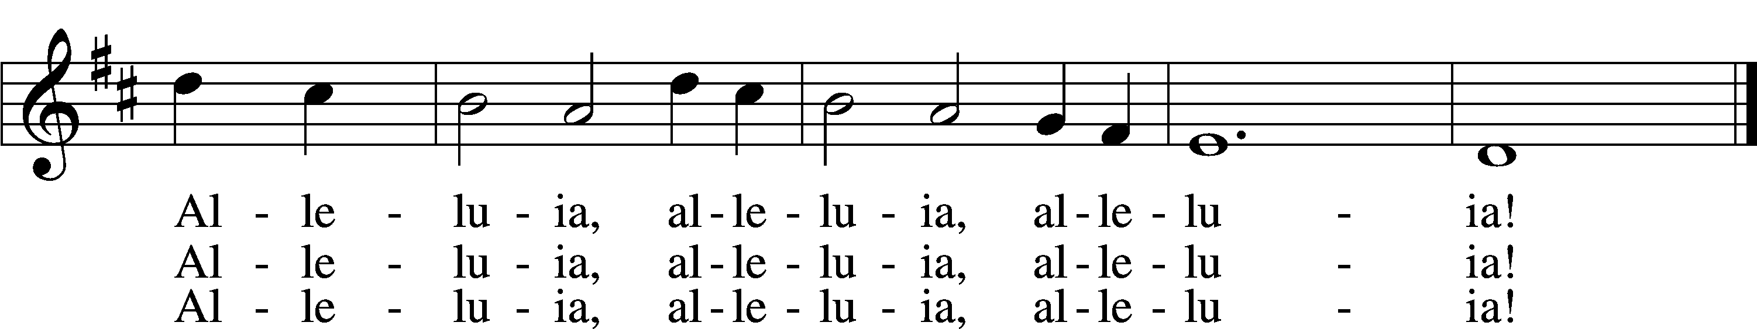

Text (sts. 1–2): Isaac Watts, 1674–1748; (st. 3): William W. How, 1823–97  
Tune: Geistliche Kirchengesäng, 1623, Köln  
Text and tune: Public domain

Acknowledgments

Unless otherwise indicated, Scripture quotations are from the ESV® Bible (The Holy Bible, English Standard Version®), copyright © 2001 by Crossway, a publishing ministry of Good News Publishers. Used by permission. All rights reserved.

Created by Lutheran Service Builder © 2023 Concordia Publishing House.