730 What Is the World to Me
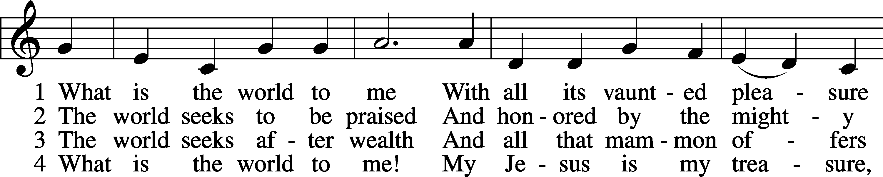
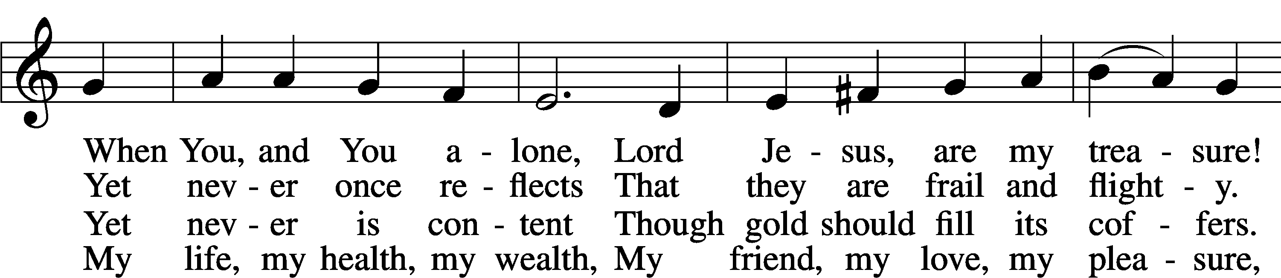
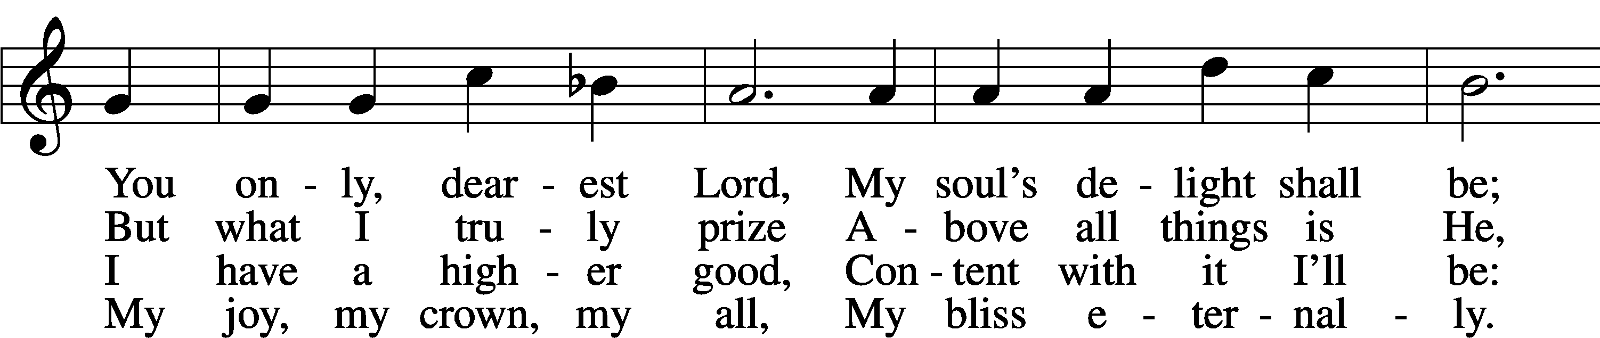
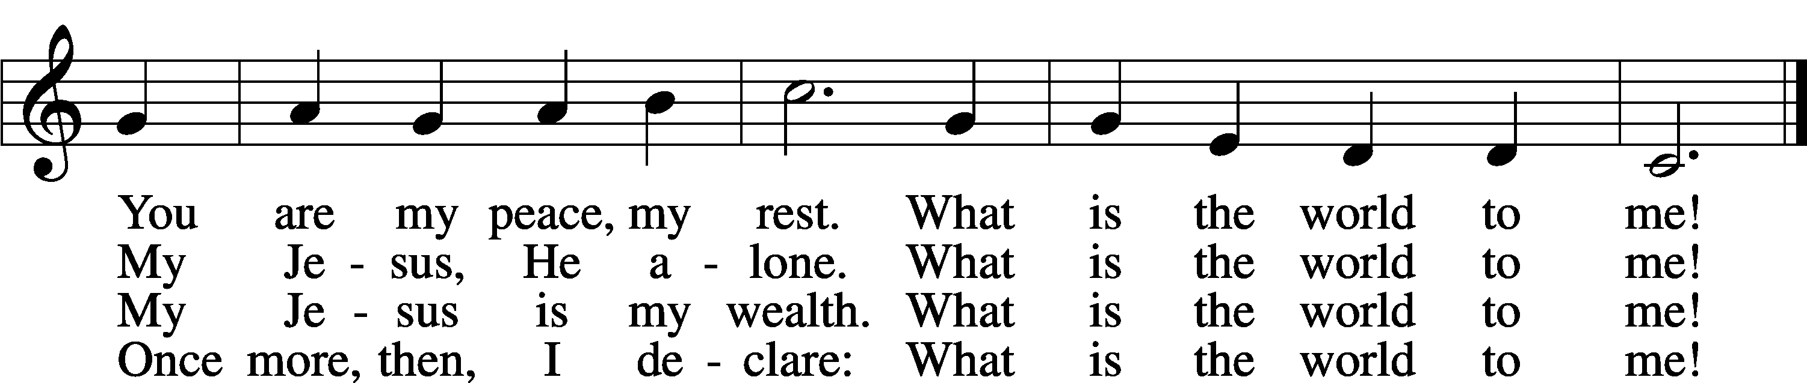
Text: Georg Michael Pfefferkorn, 1645–1732; tr. August Crull, 1845–1923, alt.
Tune: Ahasverus Fritsch, 1629–1701
Text and tune: Public domain

Confession and Absolution

Stand

The sign of the cross may be made by all in remembrance of their Baptism.

Invocation Matthew 28:19b; 18:20
P In the name of the Father and of the T Son and of the Holy Spirit.
C Amen.

Exhortation Psalm 124:8; Psalm 130:3–4; Luke 18:13
P Our help is in the name of the Lord,
C who made heaven and earth.

P If You, O Lord, kept a record of sins, O Lord, who could stand?
C But with You there is forgiveness; therefore You are feared.

P Since we are gathered to hear God’s Word, call upon Him in prayer and praise, and receive the body and blood of our Lord Jesus Christ in the fellowship of this altar, let us first consider our unworthiness and confess before God and one another that we have sinned in thought, word, and deed, and that we cannot free ourselves from our sinful condition. Together as His people let us take refuge in the infinite mercy of God, our heavenly Father, seeking His grace for the sake of Christ, and saying: God, be merciful to me, a sinner.

Kneel/Stand

Confession of Sins
C Almighty God, have mercy upon us, forgive us our sins, and lead us to everlasting life. Amen.

Prayer for Forgiveness
P Almighty God, merciful Father, in Holy Baptism You declared us to be Your children and gathered us into Your one, holy Church, in which You daily and richly forgive us our sins and grant us new life through Your Spirit. Be in our midst, enliven our faith, and graciously receive our prayer and praise; through Your Son, Jesus Christ, our Lord.
C Amen.

Stand

Service of the Word

Introit Psalm 100; antiphon: Psalm 101:1
I will sing of steadfast love and justice;
to you, O Lord, I will make music.
Make a joyful noise to the Lord, all the earth!
Serve the Lord with gladness! Come into his presence with singing!
Know that the Lord, he is God!
It is he who made us, and we are his; we are his people, and the sheep of his pasture.
Enter his gates with thanksgiving, and his courts with praise!
Give thanks to him; bless his name!
For the Lord is good; his steadfast love endures forever,
and his faithfulness to all generations.
Kyrie Mark 10:47
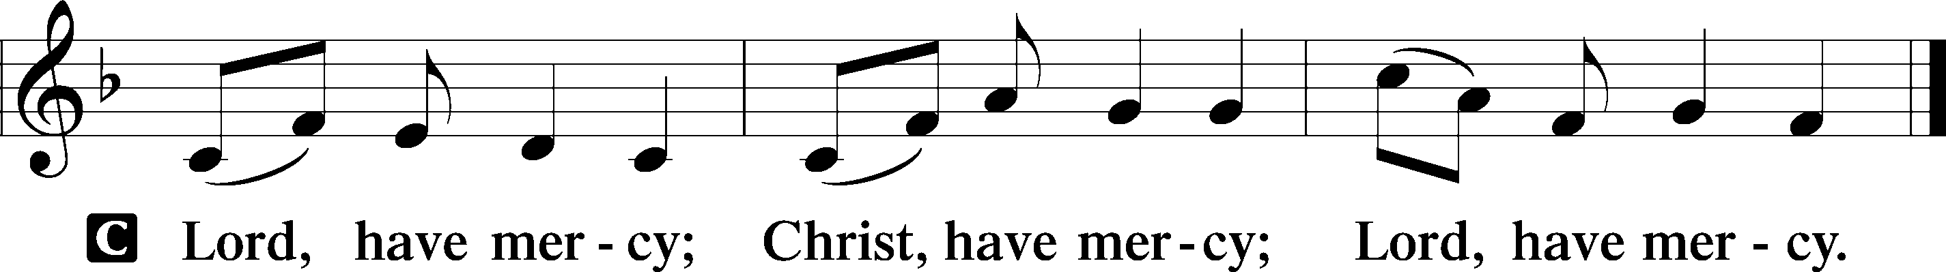

Gloria in Excelsis Luke 2:14; John 1:29
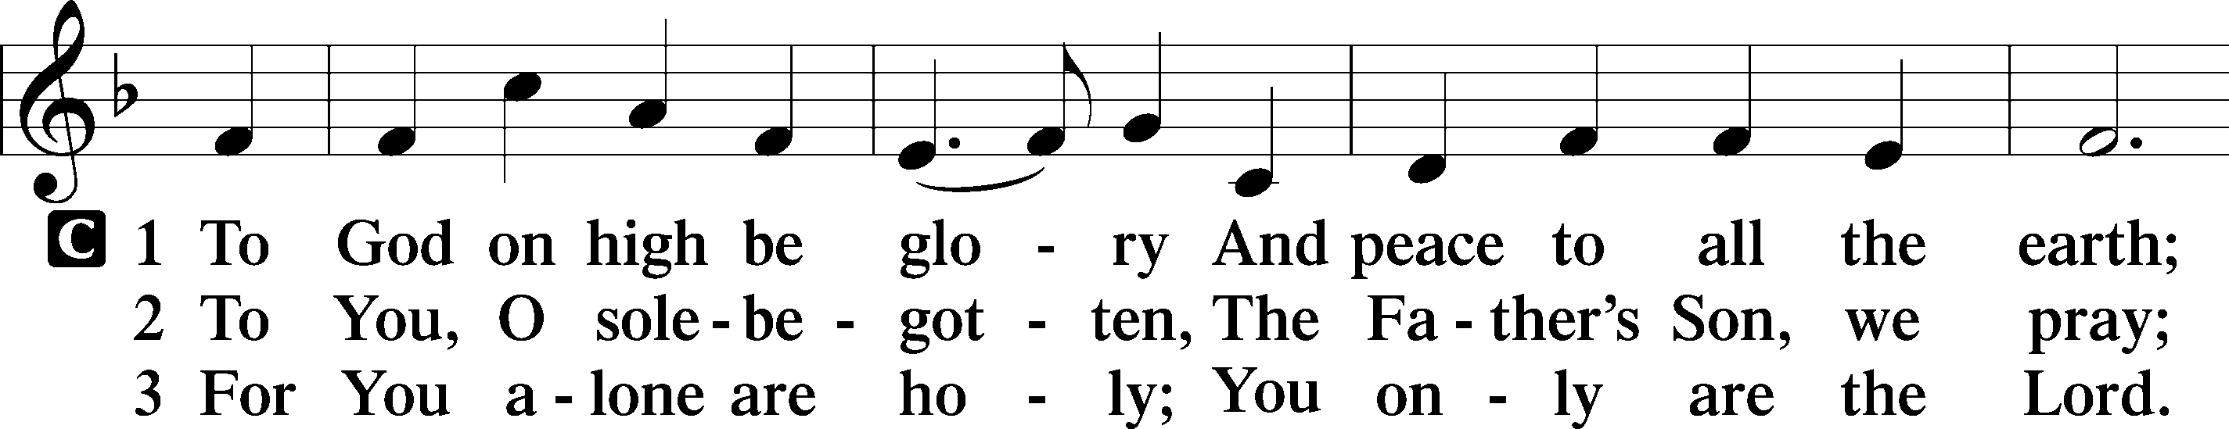
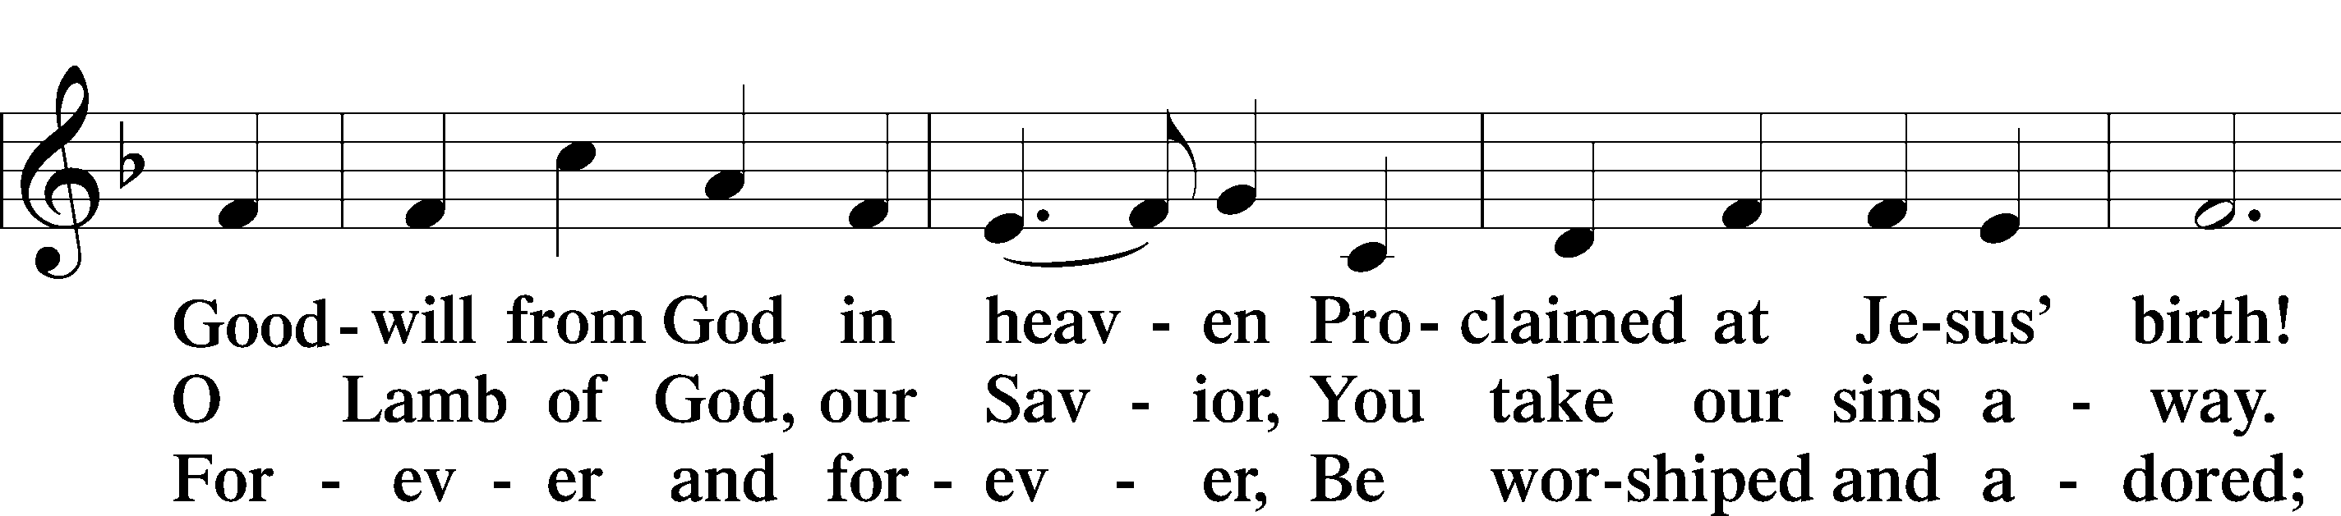
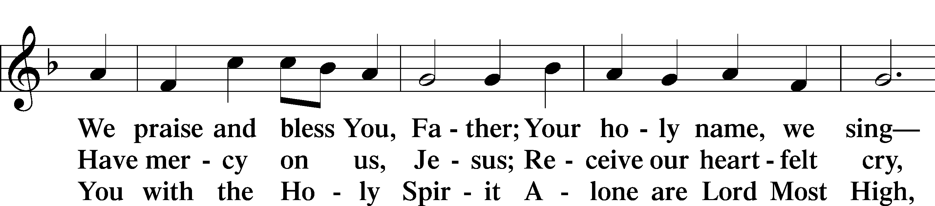
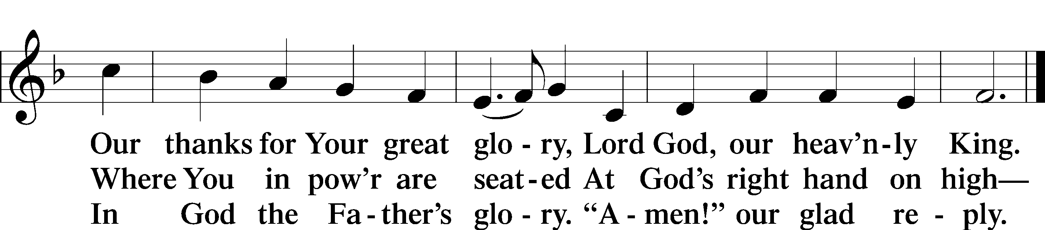
Text: Stephen P. Starke

Salutation and Collect of the Day
P The Lord be with you.
C And also with you.

P Let us pray.
O King of glory, Lord of hosts, uplifted in triumph far above all heavens, leave us not without consolation but send us the Spirit of truth whom You promised from the Father; for You live and reign with Him and the Holy Spirit, one God, now and forever.

C Amen.

Sit

First Reading Acts 1:12–26
Matthias Chosen to Replace Judas
12Then [the apostles] returned to Jerusalem from the mount called Olivet, which is near Jerusalem, a Sabbath day’s journey away. 13And when they had entered, they went up to the upper room, where they were staying, Peter and John and James and Andrew, Philip and Thomas, Bartholomew and Matthew, James the son of Alphaeus and Simon the Zealot and Judas the son of James. 14All these with one accord were devoting themselves to prayer, together with the women and Mary the mother of Jesus, and his brothers.
15In those days Peter stood up among the brothers (the company of persons was in all about 120) and said, 16“Brothers, the Scripture had to be fulfilled, which the Holy Spirit spoke beforehand by the mouth of David concerning Judas, who became a guide to those who arrested Jesus. 17For he was numbered among us and was allotted his share in this ministry.” 18(Now this man bought a field with the reward of his wickedness, and falling headlong he burst open in the middle and all his bowels gushed out. 19And it became known to all the inhabitants of Jerusalem, so that the field was called in their own language Akeldama, that is, Field of Blood.) 20“For it is written in the Book of Psalms,
“‘May his camp become desolate,
and let there be no one to dwell in it’;
and
“‘Let another take his office.’
21So one of the men who have accompanied us during all the time that the Lord Jesus went in and out among us, 22beginning from the baptism of John until the day when he was taken up from us—one of these men must become with us a witness to his resurrection.” 23And they put forward two, Joseph called Barsabbas, who was also called Justus, and Matthias. 24And they prayed and said, “You, Lord, who know the hearts of all, show which one of these two you have chosen 25to take the place in this ministry and apostleship from which Judas turned aside to go to his own place.” 26And they cast lots for them, and the lot fell on Matthias, and he was numbered with the eleven apostles.

A This is the Word of the Lord.
C Thanks be to God.

Gradual adapt. from Matthew 28:7; Hebrews 2:7; Psalm 8:6
Christ has risen from the dead.
[God the Father] has crowned him with glory and honor.
He has given him dominion over the works of his hands;
he has put all things under his feet.

Epistle 1 Peter 4:12–19; 5:6–11
Suffering As a Christian
12Beloved, do not be surprised at the fiery trial when it comes upon you to test you, as though something strange were happening to you. 13But rejoice insofar as you share Christ’s sufferings, that you may also rejoice and be glad when his glory is revealed. 14If you are insulted for the name of Christ, you are blessed, because the Spirit of glory and of God rests upon you. 15But let none of you suffer as a murderer or a thief or an evildoer or as a meddler. 16Yet if anyone suffers as a Christian, let him not be ashamed, but let him glorify God in that name. 17For it is time for judgment to begin at the household of God; and if it begins with us, what will be the outcome for those who do not obey the gospel of God? 18And
“If the righteous is scarcely saved,
what will become of the ungodly and the sinner?”
19Therefore let those who suffer according to God’s will entrust their souls to a faithful Creator while doing good. . . .
6Humble yourselves, therefore, under the mighty hand of God so that at the proper time he may exalt you, 7casting all your anxieties on him, because he cares for you. 8Be sober-minded; be watchful. Your adversary the devil prowls around like a roaring lion, seeking someone to devour. 9Resist him, firm in your faith, knowing that the same kinds of suffering are being experienced by your brotherhood throughout the world. 10And after you have suffered a little while, the God of all grace, who has called you to his eternal glory in Christ, will himself restore, confirm, strengthen, and establish you. 11To him be the dominion forever and ever. Amen.

A This is the Word of the Lord.
C Thanks be to God.

Stand

Alleluia and Verse

Alleluia
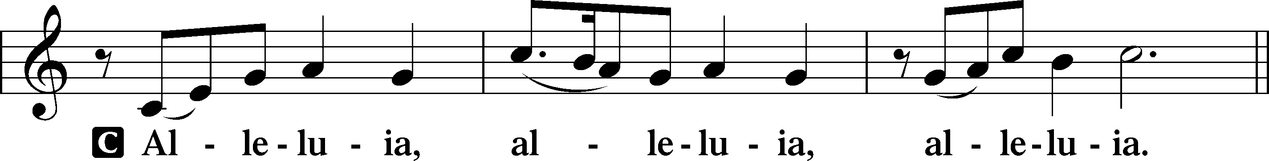

Verse John 20:31
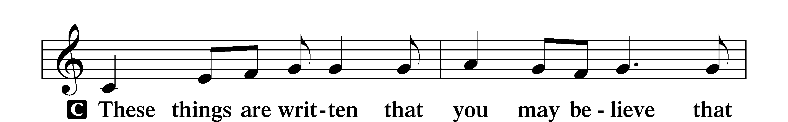
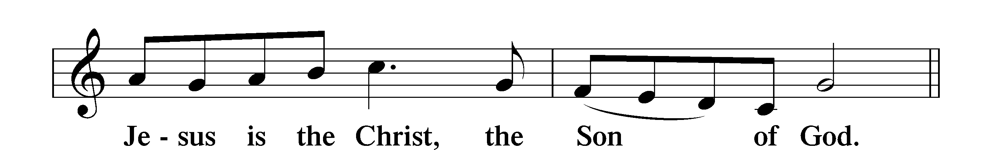

Alleluia
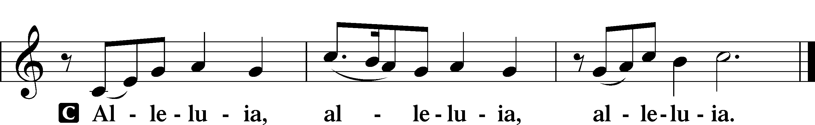

Holy Gospel John 17:1–11
P The Holy Gospel according to St. John, the seventeenth chapter.
C Glory to You, O Lord.

The High Priestly Prayer
1When Jesus had spoken these words, he lifted up his eyes to heaven, and said, “Father, the hour has come; glorify your Son that the Son may glorify you, 2since you have given him authority over all flesh, to give eternal life to all whom you have given him. 3And this is eternal life, that they know you the only true God, and Jesus Christ whom you have sent. 4I glorified you on earth, having accomplished the work that you gave me to do. 5And now, Father, glorify me in your own presence with the glory that I had with you before the world existed.
6“I have manifested your name to the people whom you gave me out of the world. Yours they were, and you gave them to me, and they have kept your word. 7Now they know that everything that you have given me is from you. 8For I have given them the words that you gave me, and they have received them and have come to know in truth that I came from you; and they have believed that you sent me. 9I am praying for them. I am not praying for the world but for those whom you have given me, for they are yours. 10All mine are yours, and yours are mine, and I am glorified in them. 11And I am no longer in the world, but they are in the world, and I am coming to you. Holy Father, keep them in your name, which you have given me, that they may be one, even as we are one.”

P This is the Gospel of the Lord.
C Praise to You, O Christ.

Nicene Creed
C I believe in one God,
the Father Almighty,
maker of heaven and earth
and of all things visible and invisible.

And in one Lord Jesus Christ,
the only-begotten Son of God,
begotten of His Father before all worlds,
God of God, Light of Light,
very God of very God,
begotten, not made,
being of one substance with the Father,
by whom all things were made;
who for us men and for our salvation came down from heaven
and was incarnate by the Holy Spirit of the virgin Mary
and was made man;
and was crucified also for us under Pontius Pilate.
He suffered and was buried.
And the third day He rose again according to the Scriptures
and ascended into heaven
and sits at the right hand of the Father.
And He will come again with glory to judge both the living and the dead,
whose kingdom will have no end.

And I believe in the Holy Spirit,
the Lord and giver of life,
who proceeds from the Father and the Son,
who with the Father and the Son together is worshiped and glorified,
who spoke by the prophets.
And I believe in one holy Christian and apostolic Church,
I acknowledge one Baptism for the remission of sins,
and I look for the resurrection of the dead
and the life T of the world to come. Amen.
Sit

Children’s Message

664 Fight the Good Fight
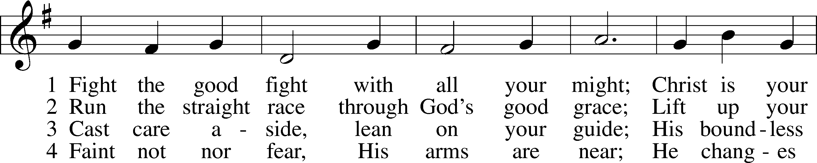
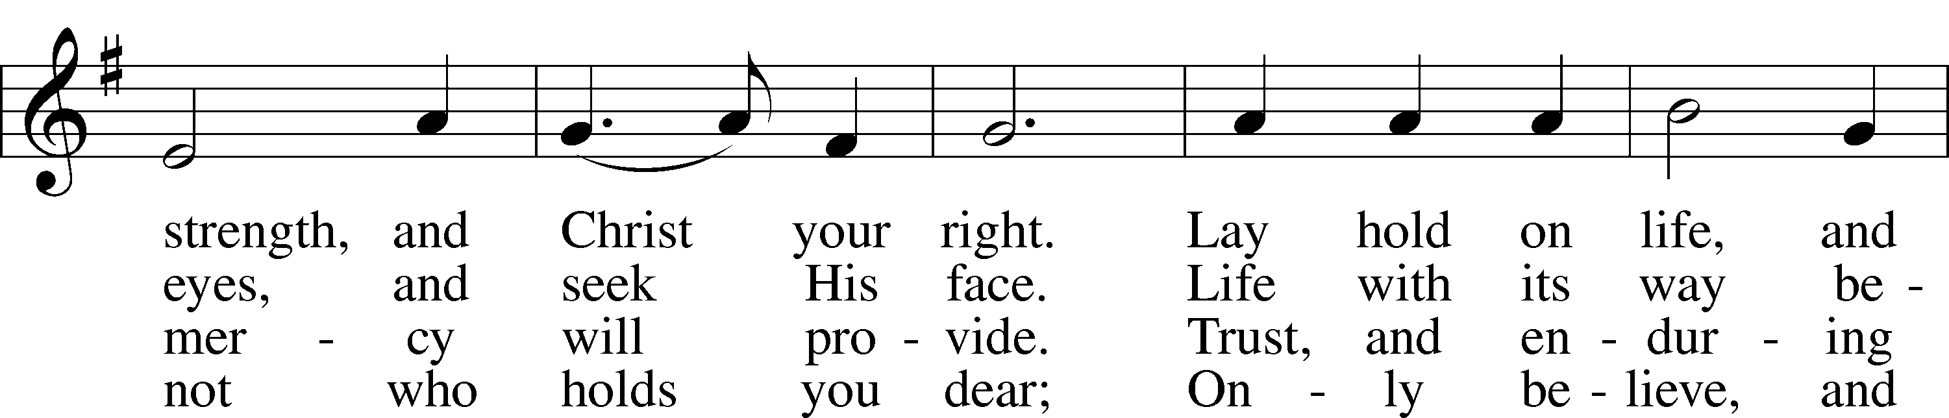
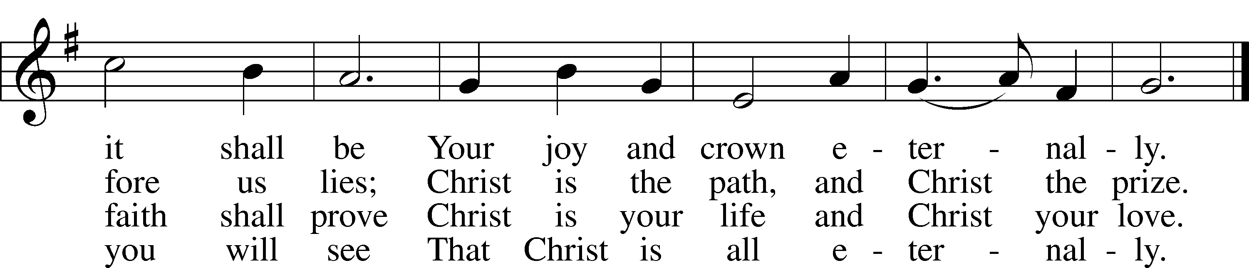
Text: John S. B. Monsell, 1811–75, alt.
Tune: The Methodist Harmonist, 1821, New York
Text and tune: Public domain

Sermon

Confirmation Pg. 272

Prayer of the Church

Offering

Service of the Sacrament

Stand

Preface 2 Timothy 4:22; [Colossians 3:1]; [Psalm 136]
P The Lord be with you.
C And also with you.

P Lift up your hearts.
C We lift them to the Lord.

P Let us give thanks to the Lord our God.
C It is right to give Him thanks and praise.

P It is truly good, right, and salutary that we should at all times and in all places give thanks to You, O Lord, holy Father, almighty and everlasting God, for the countless blessings You so freely bestow on us and all creation. Above all, we give thanks for Your boundless love shown to us when You sent Your only-begotten Son, Jesus Christ, into our flesh and laid on Him our sin, giving Him into death that we might not die eternally. Because He is now risen from the dead and lives and reigns to all eternity, all who believe in Him will overcome sin and death and will rise again to new life. Therefore with angels and archangels and with all the company of heaven we laud and magnify Your glorious name, evermore praising You and saying:

Sanctus Isaiah 6:3; Matthew 21:9
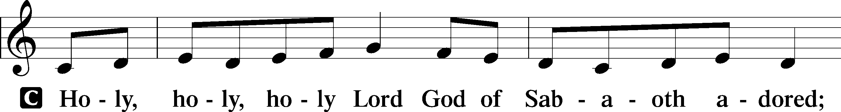
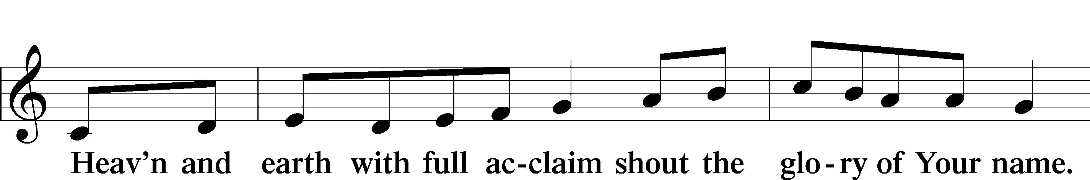
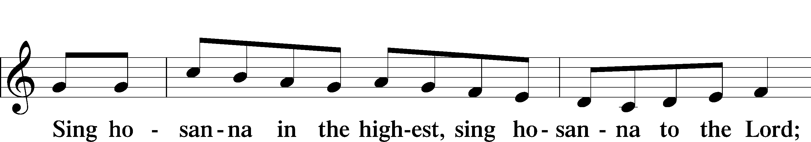
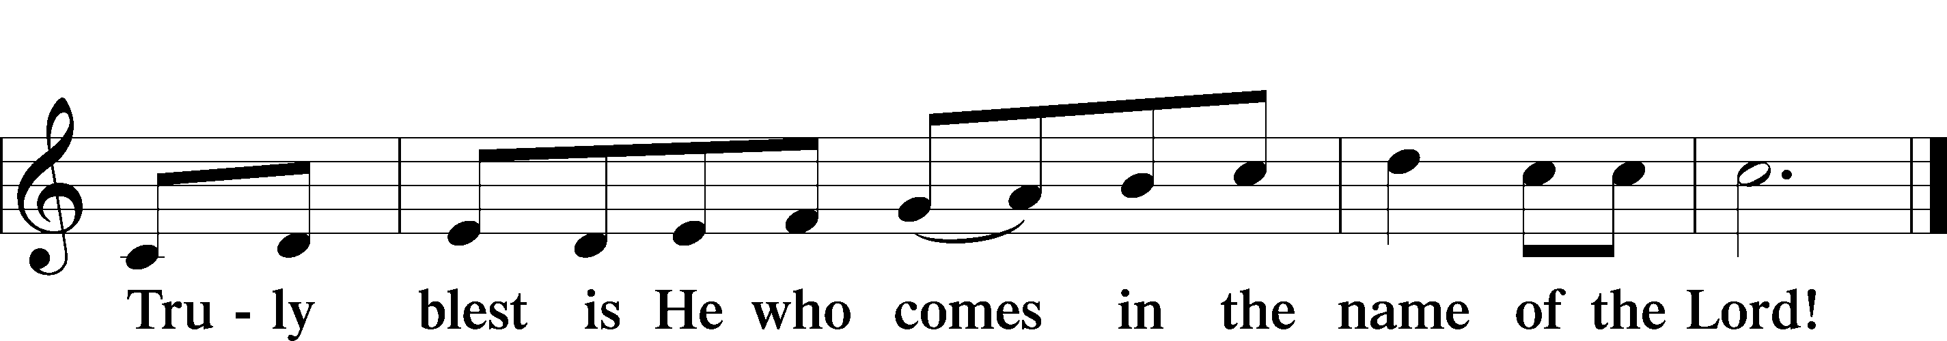
Text: Stephen P. Starke

Prayer of Thanksgiving
P Blessed are You, O Lord our God, king of all creation, for You have had mercy on us and given Your only-begotten Son that whoever believes in Him should not perish but have eternal life.

Having revealed Your glory in the face of Your only-begotten Son, who suffered, died, and rose for our salvation, You have exalted Him to the highest majesty at Your right hand, that He might graciously fill all things.

Grant us faithfully to eat and drink this Holy Supper, trusting our reigning Savior Jesus, who, though unseen in His ascended glory, is here present to save by His body and blood.

Hear us as we pray in His name and as He has taught us:

Lord’s Prayer
C Our Father who art in heaven,
hallowed be Thy name,
Thy kingdom come,
Thy will be done on earth
as it is in heaven;
give us this day our daily bread;
and forgive us our trespasses
as we forgive those
who trespass against us;
and lead us not into temptation,
but deliver us from evil.
For Thine is the kingdom
and the power and the glory
forever and ever. Amen.

The Words of Our Lord
P Our Lord Jesus Christ, on the night when He was betrayed, took bread, and when He had given thanks, He broke it and gave it to the disciples and said: “Take, eat; this is My T body, which is given for you. This do in remembrance of Me.”

In the same way also He took the cup after supper, and when He had given thanks, He gave it to them, saying: “Drink of it, all of you; this cup is the new testament in My T blood, which is shed for you for the forgiveness of sins. This do, as often as you drink it, in remembrance of Me.”

Pax Domini
P The peace of the Lord be with you always.
C Amen.

Agnus Dei John 1:29
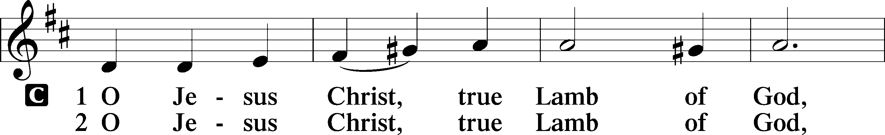
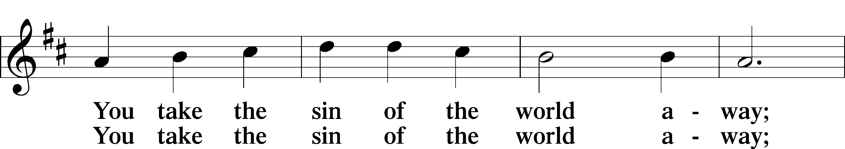
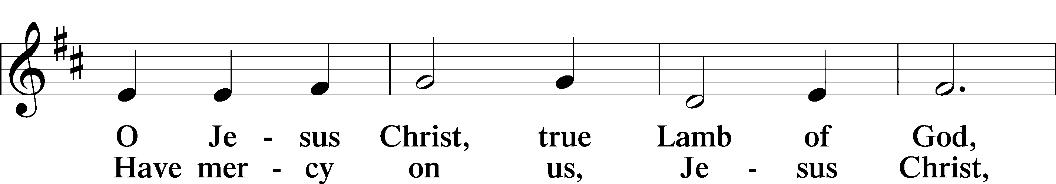
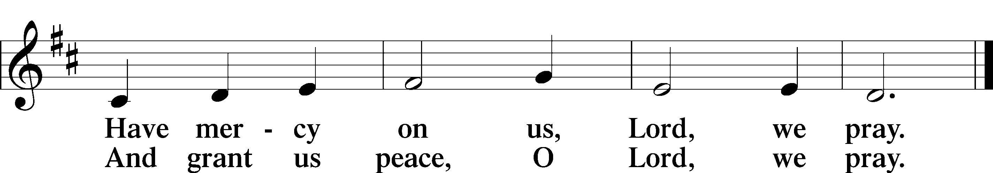
Text: Stephen P. Starke

Sit

Distribution

618 I Come, O Savior, to Thy Table
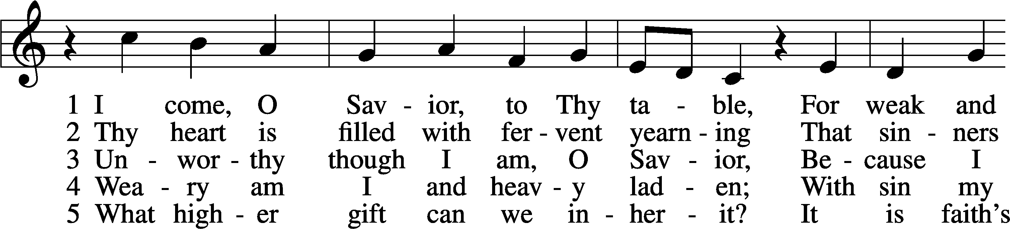
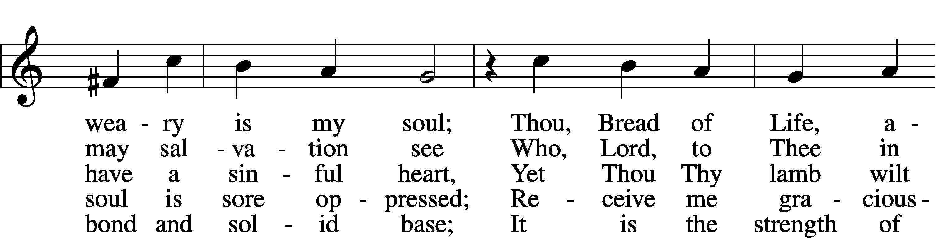
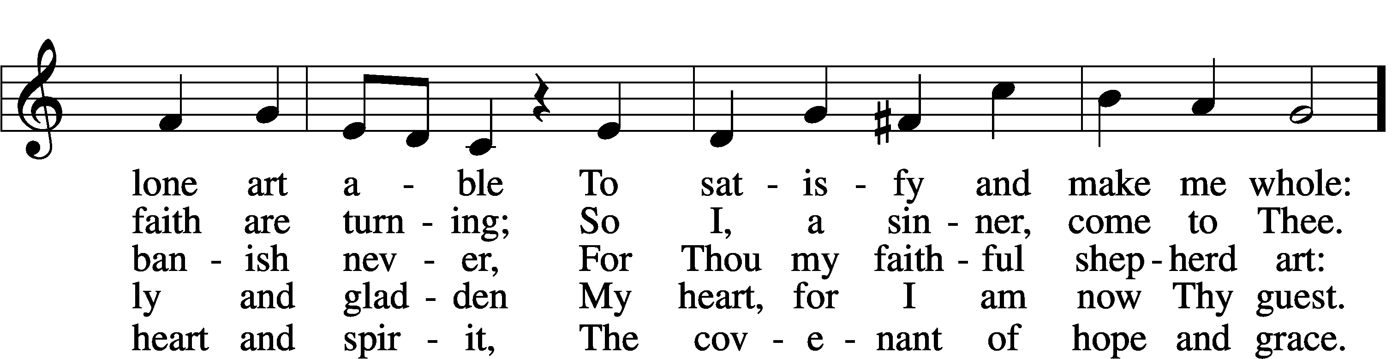
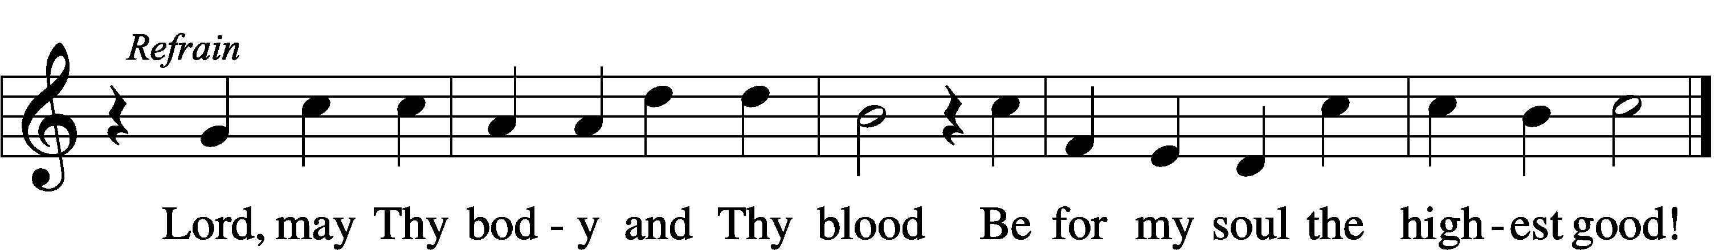
Text: Friedrich Christian Heyder, 1677–1754; tr. The Lutheran Hymnal, 1941, abr.
Tune: Emskirchner Choral-Buch, 1756, Leipzig
Text: © 1941 Concordia Publishing House. Used by permission: LSB Hymn License no. 110005011
Tune: Public domain

493 A Hymn of Glory Let Us Sing
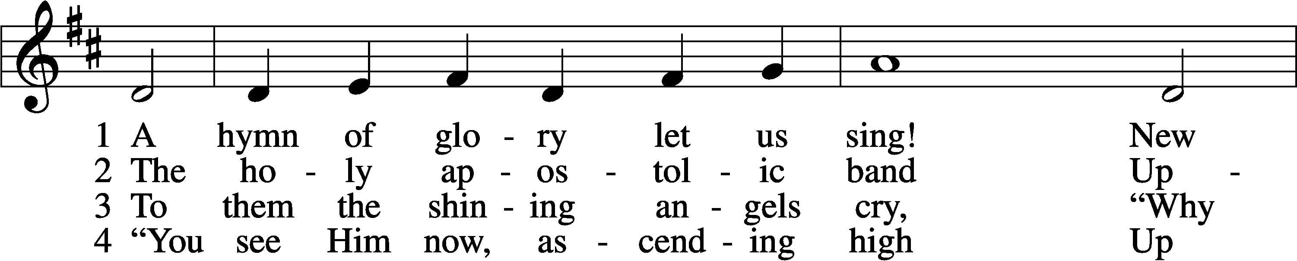
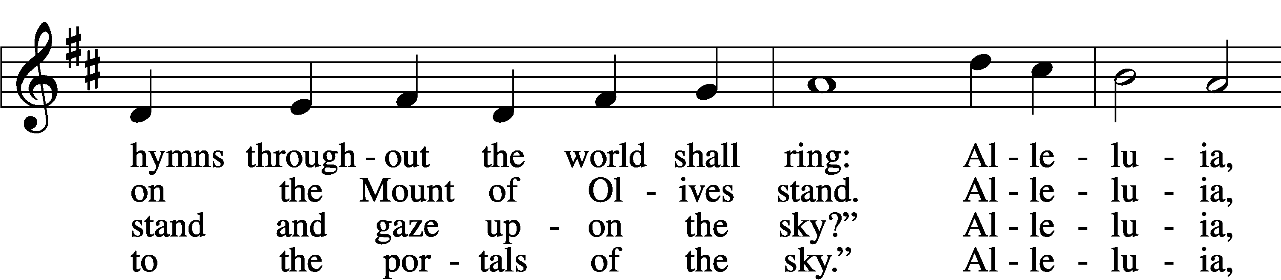
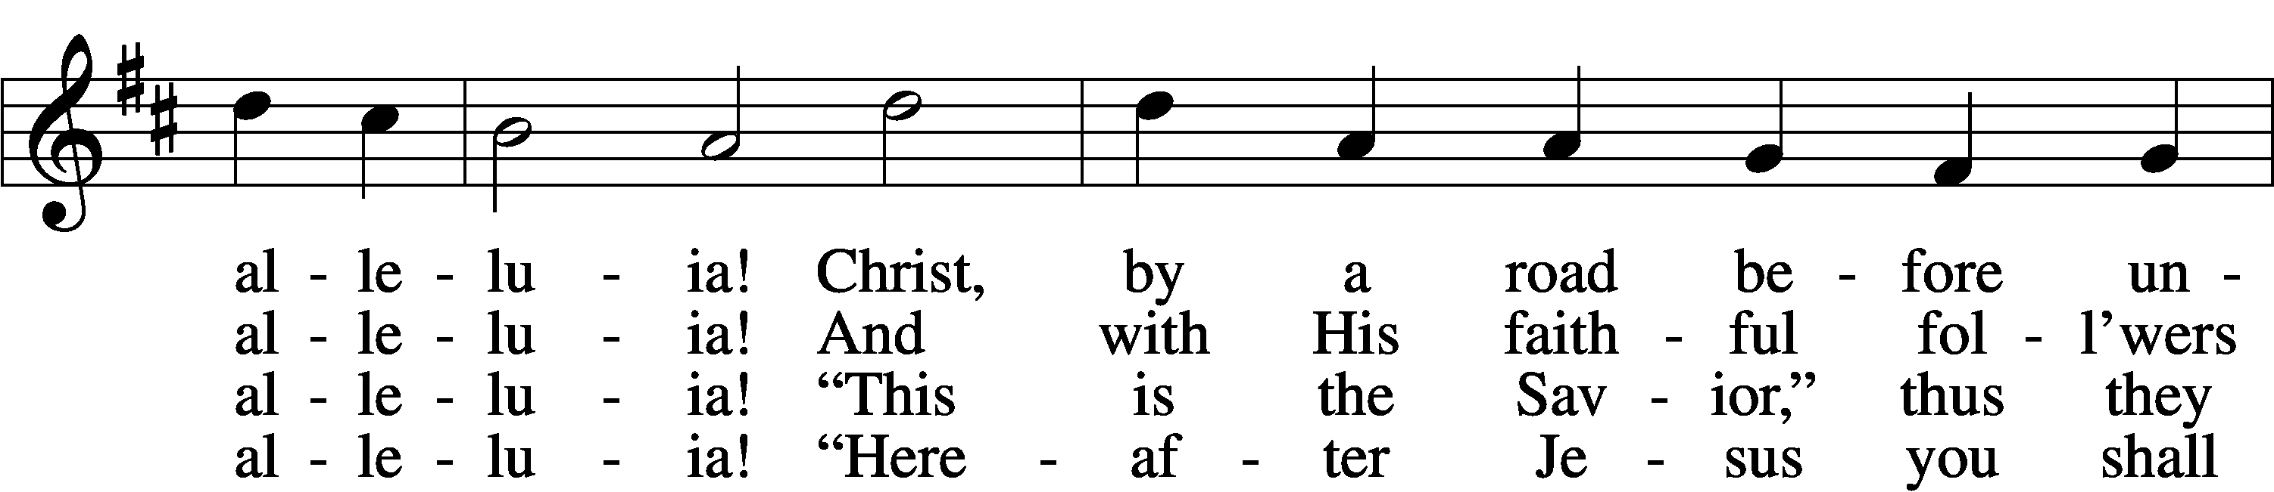
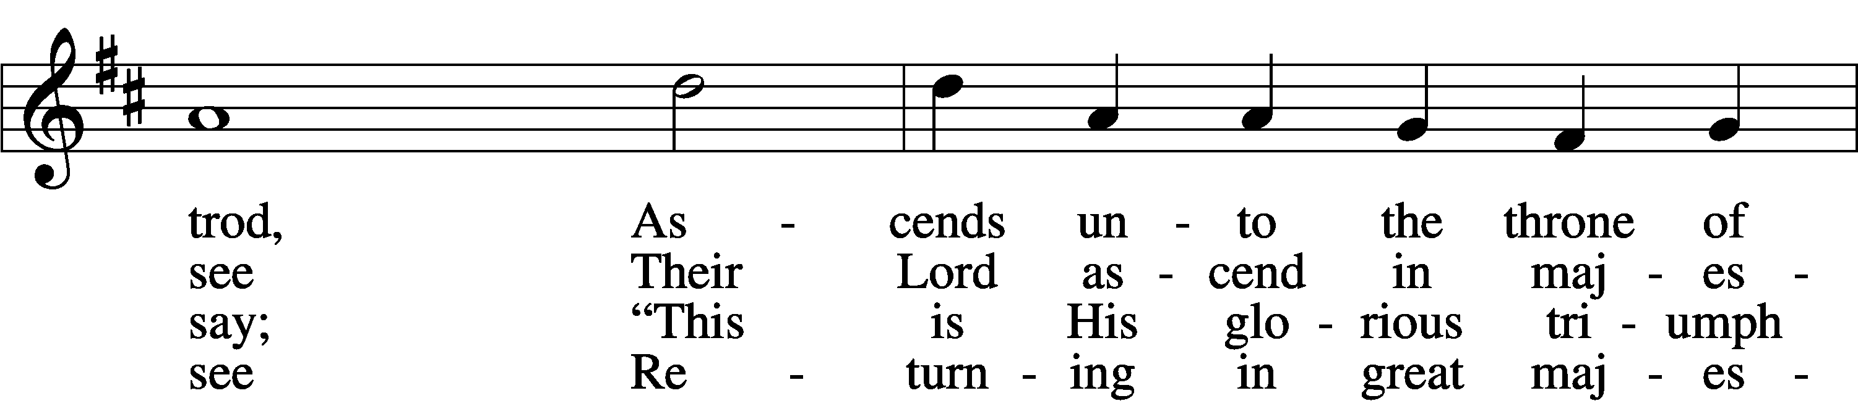
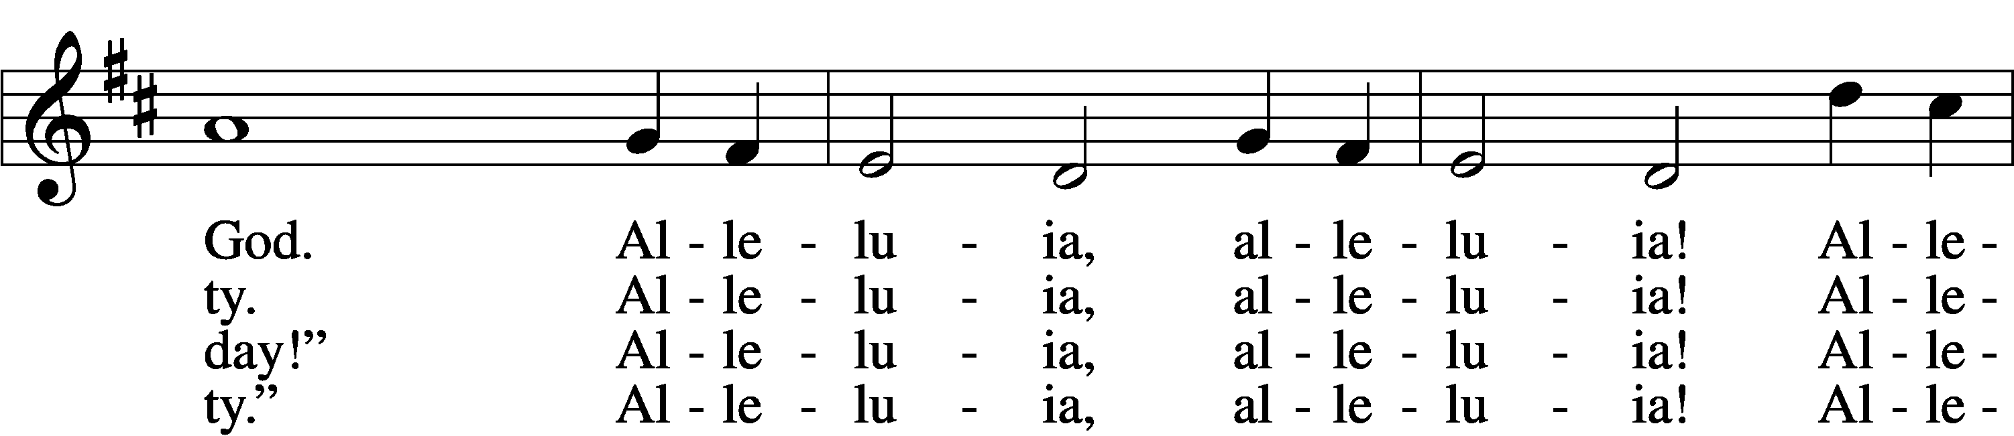
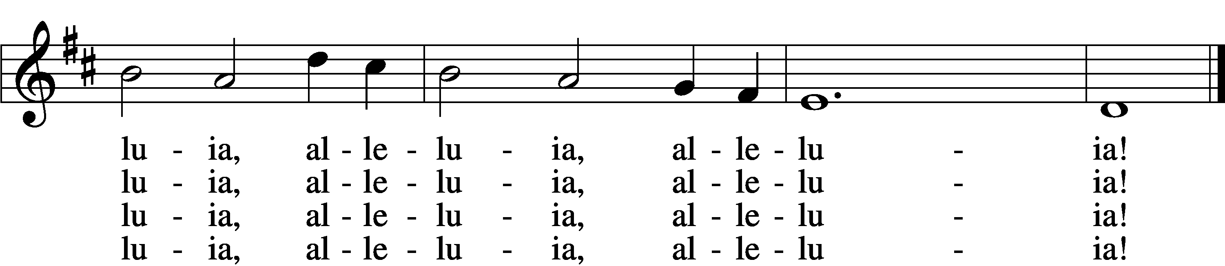

5 Be now our joy on earth, O Lord,
And be our future great reward.
Alleluia, alleluia!
Then, throned with You forever, we
Shall praise Your name eternally.
Alleluia, alleluia!
Alleluia, alleluia, alleluia!

D 6 O risen Christ, ascended Lord,
All praise to You let earth accord:
Alleluia, alleluia!
You are, while endless ages run,
With Father and with Spirit one.
Alleluia, alleluia!
Alleluia, alleluia, alleluia!
Text: Bede, 673–735; tr. Lutheran Book of Worship, 1978, alt.
Tune: Geistliche Kirchengesäng, 1623, Köln
Text: © 1978 Lutheran Book of Worship. Used by permission: LSB Hymn License no. 110005011
Tune: Public domain

528 Oh, for a Thousand Tongues to Sing
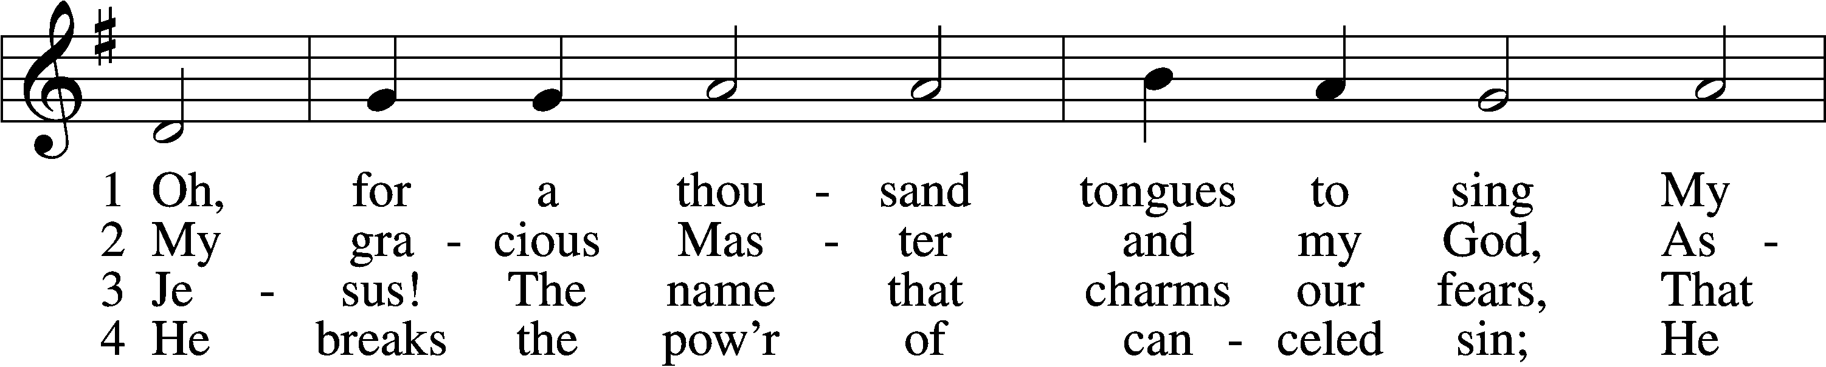
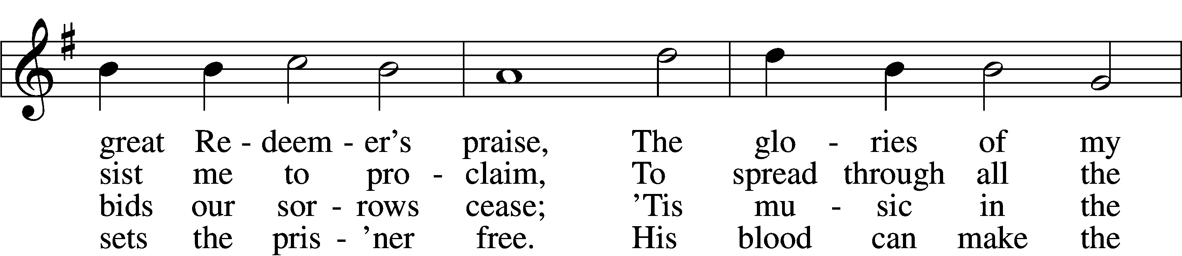
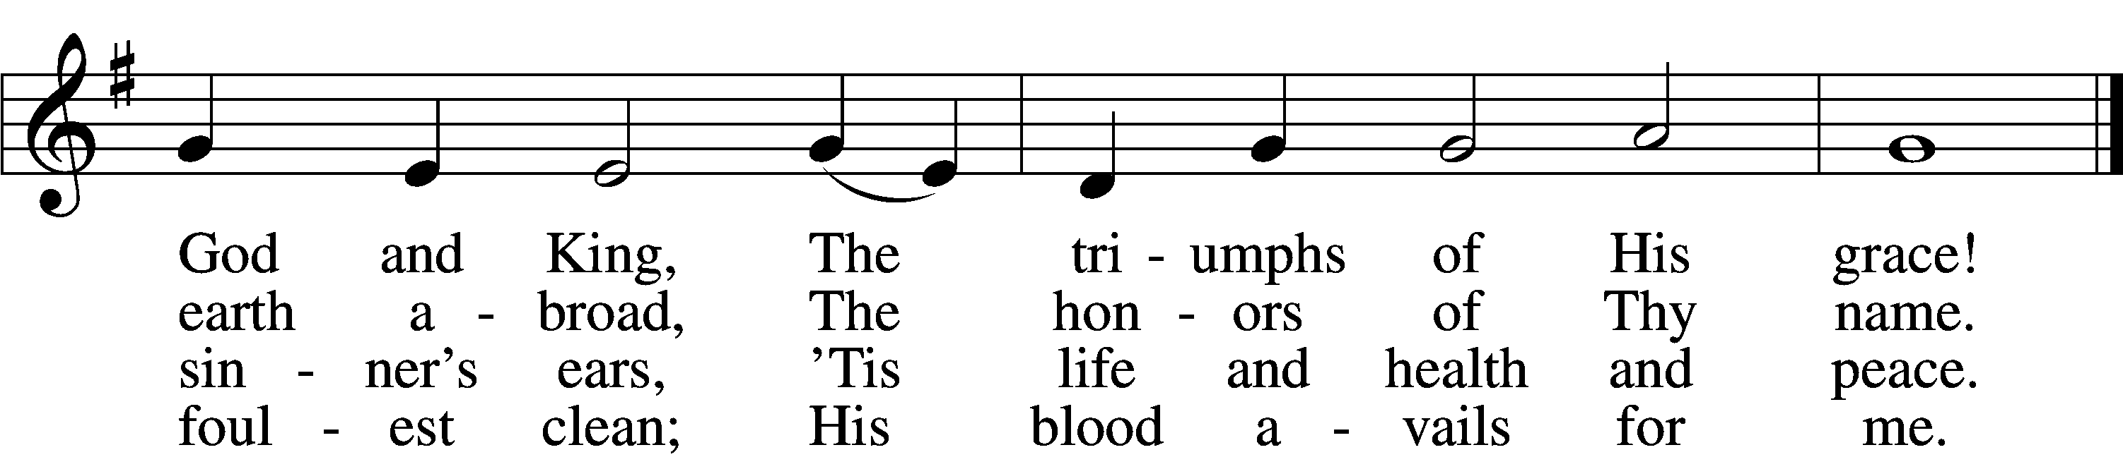

5 Look unto Him, ye nations; own
Your God, ye fallen race.
Look and be saved through faith alone,
Be justified by grace.

6 See all your sins on Jesus laid;
The Lamb of God was slain.
His soul was once an off’ring made
For ev’ry soul of man.

7 To God all glory, praise, and love
Be now and ever giv’n
By saints below and saints above,
The Church in earth and heav’n.
Text: Charles Wesley, 1707–88, alt.
Tune: Carl G. Gläser, 1784–1829
Text and tune: Public domain

563 Jesus, Thy Blood and Righteousness
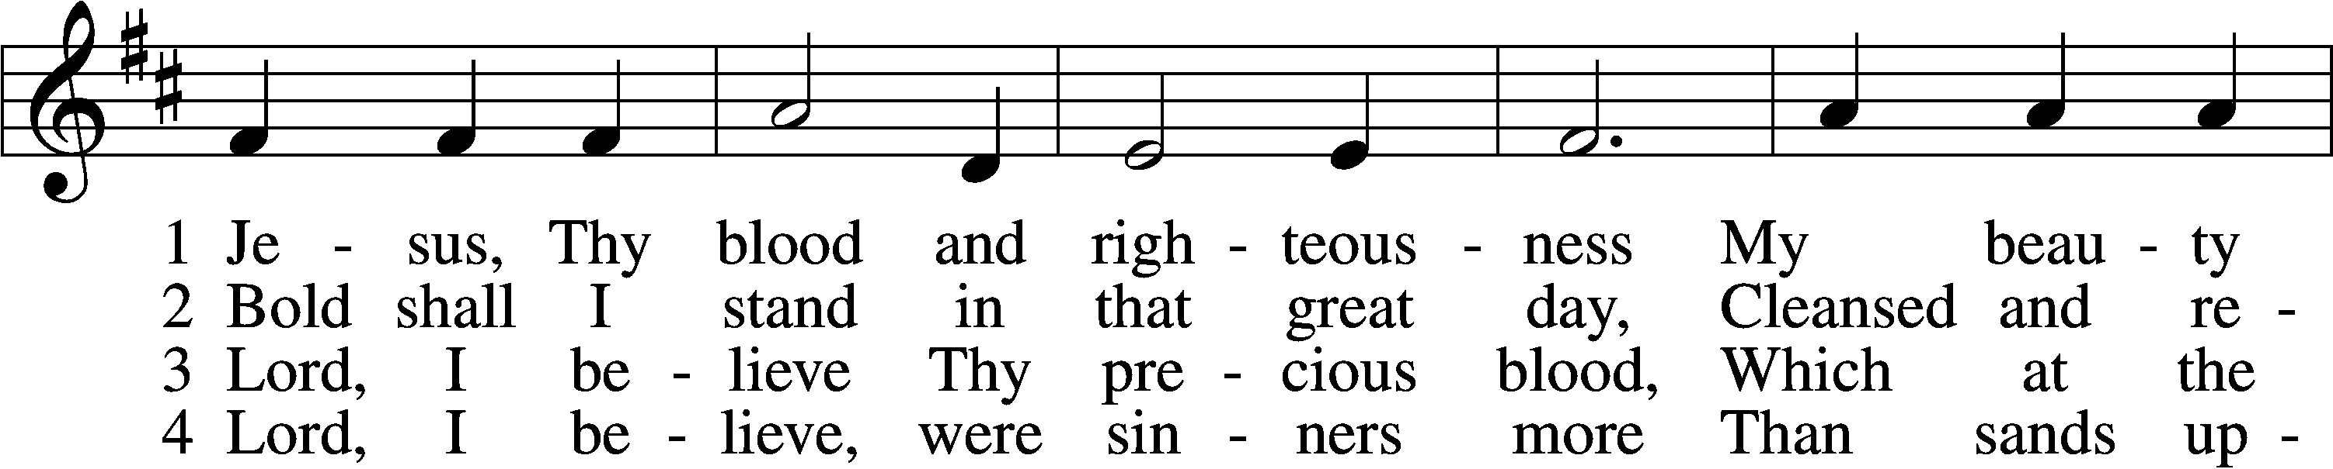
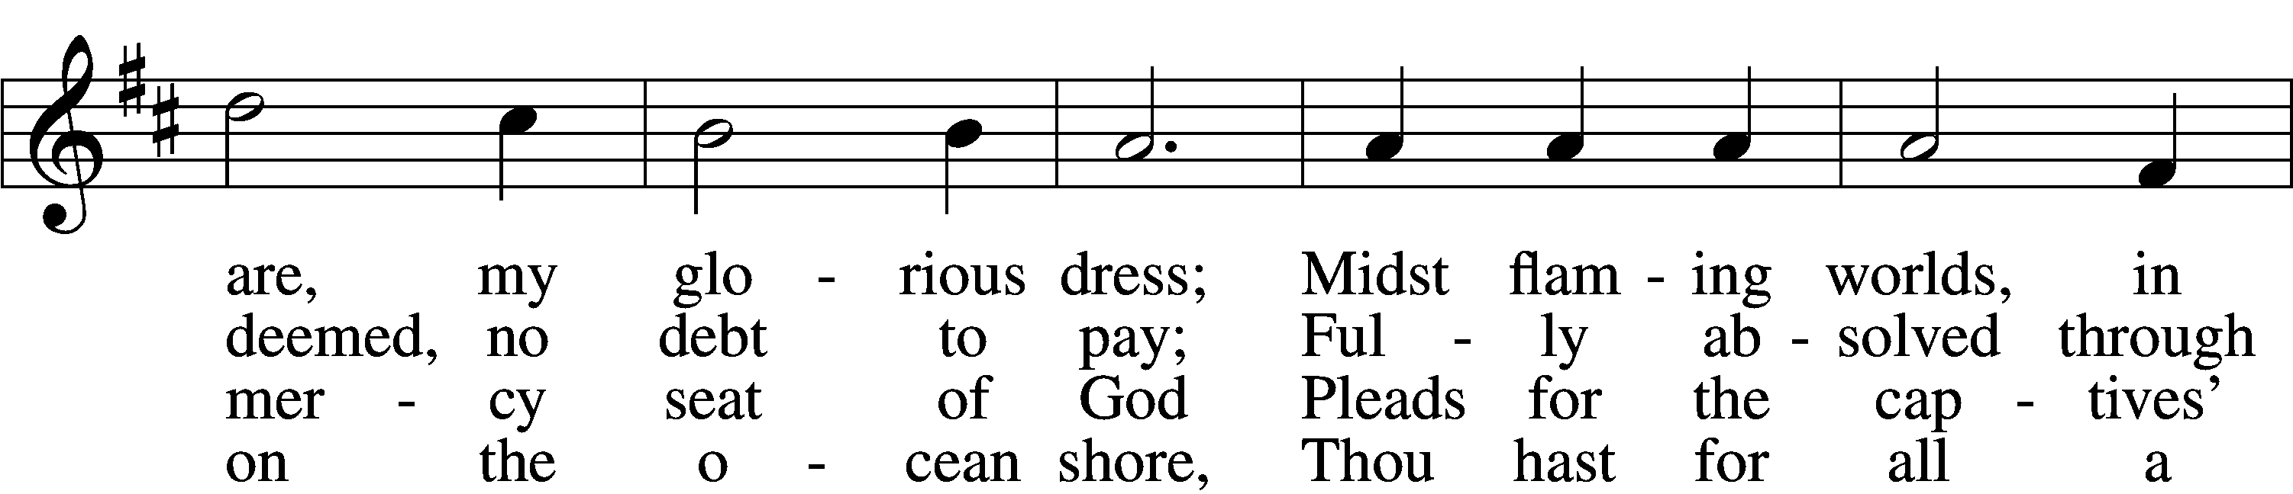
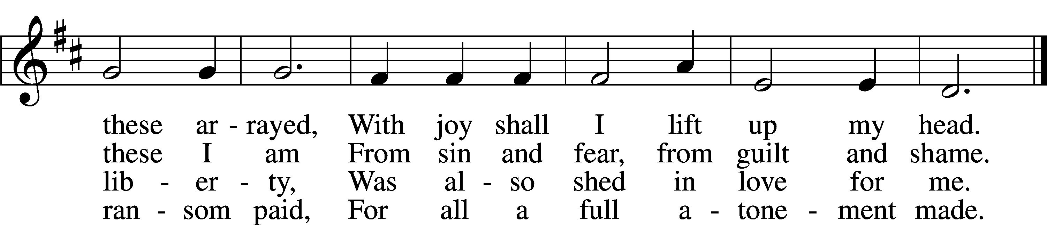

5 When from the dust of death I rise
To claim my mansion in the skies,
This then shall be my only plea:
Jesus hath lived and died for me.

6 Jesus, be endless praise to Thee,
Whose boundless mercy hath for me,
For me, and all Thy hands have made,
An everlasting ransom paid.
Text: Nicolaus Ludwig von Zinzendorf, 1700–60; tr. John B. Wesley, 1703–91, alt.
Tune: George J. Elvey, 1816–93
Text and tune: Public domain

The Dismissal
P The body and blood of our Lord Jesus Christ strengthen and preserve you in body and soul to life everlasting. Depart T in peace.
C Amen.

Stand

Nunc Dimittis Luke 2:29–32
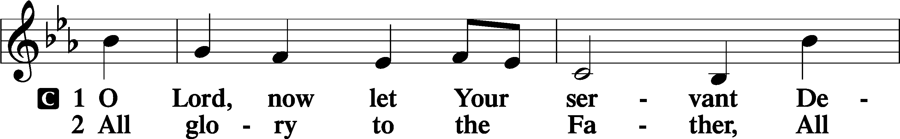
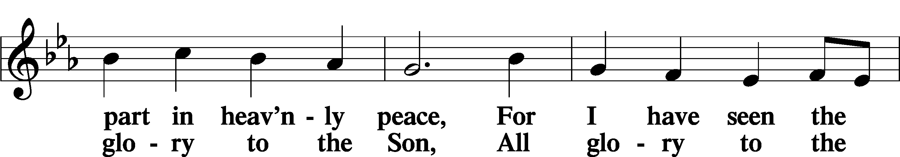
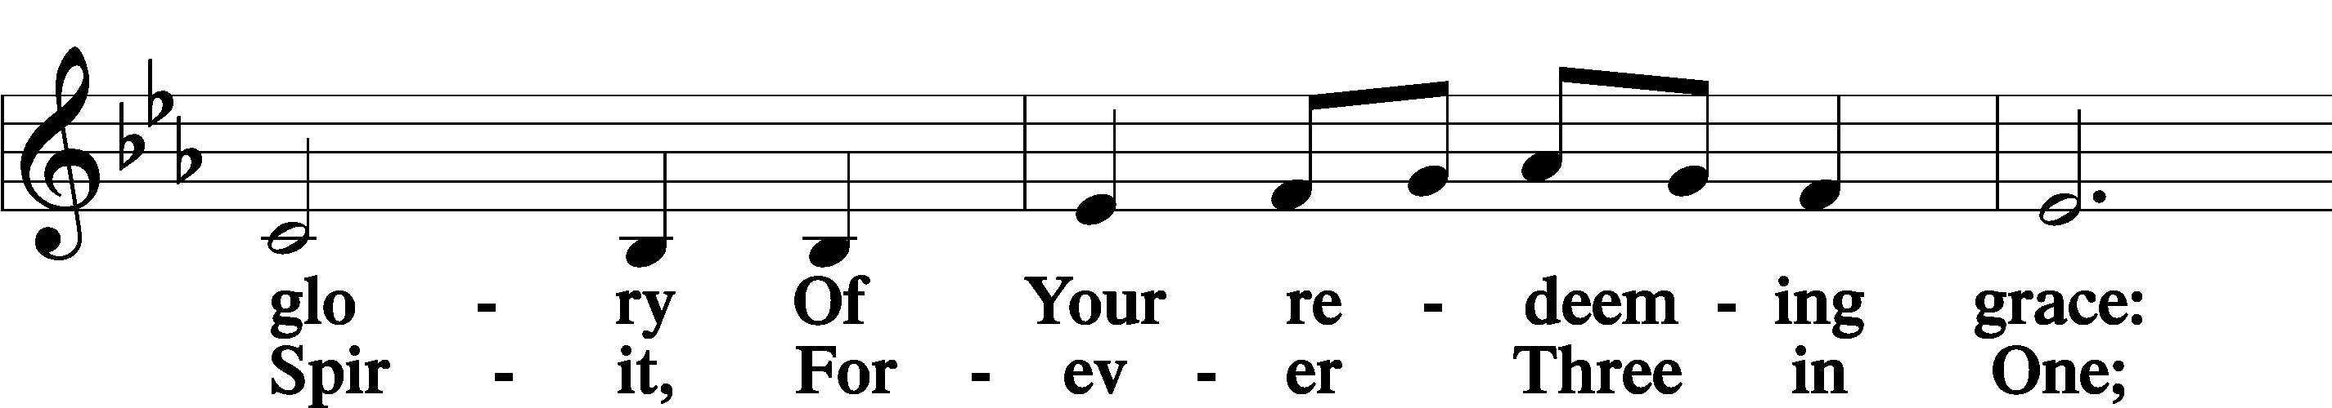
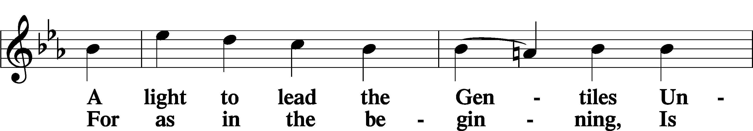
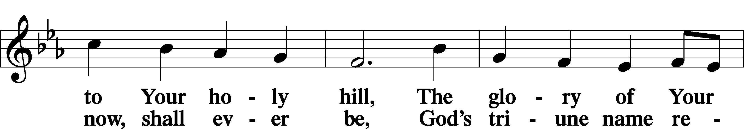
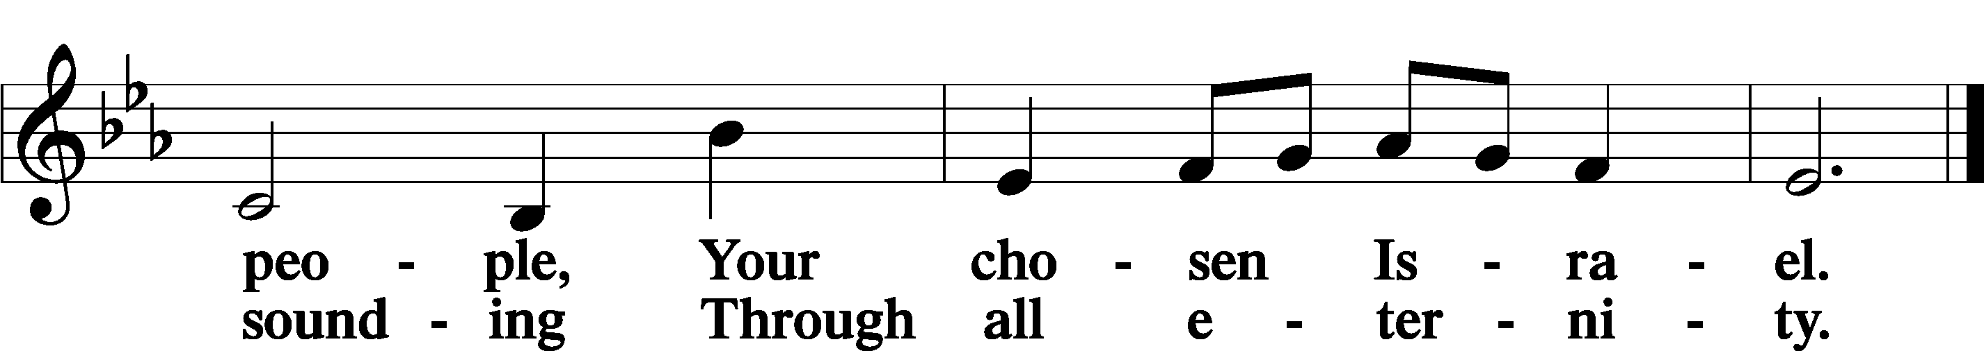

Post-Communion Collect
A Let us pray.
We give thanks to You, almighty God, that You have refreshed us through this salutary gift, and we implore You that of Your mercy You would strengthen us through the same in faith toward You and in fervent love toward one another; through Jesus Christ, Your Son, our Lord, who lives and reigns with You and the Holy Spirit, one God, now and forever.
C Amen.

Benedicamus Psalm 103:1
A Let us bless the Lord.
C Thanks be to God.

Benediction
P The Lord bless you and keep you.
The Lord make His face shine on you and be gracious to you.
The Lord look upon you with favor and T give you peace.
C Amen.

821 Alleluia! Sing to Jesus
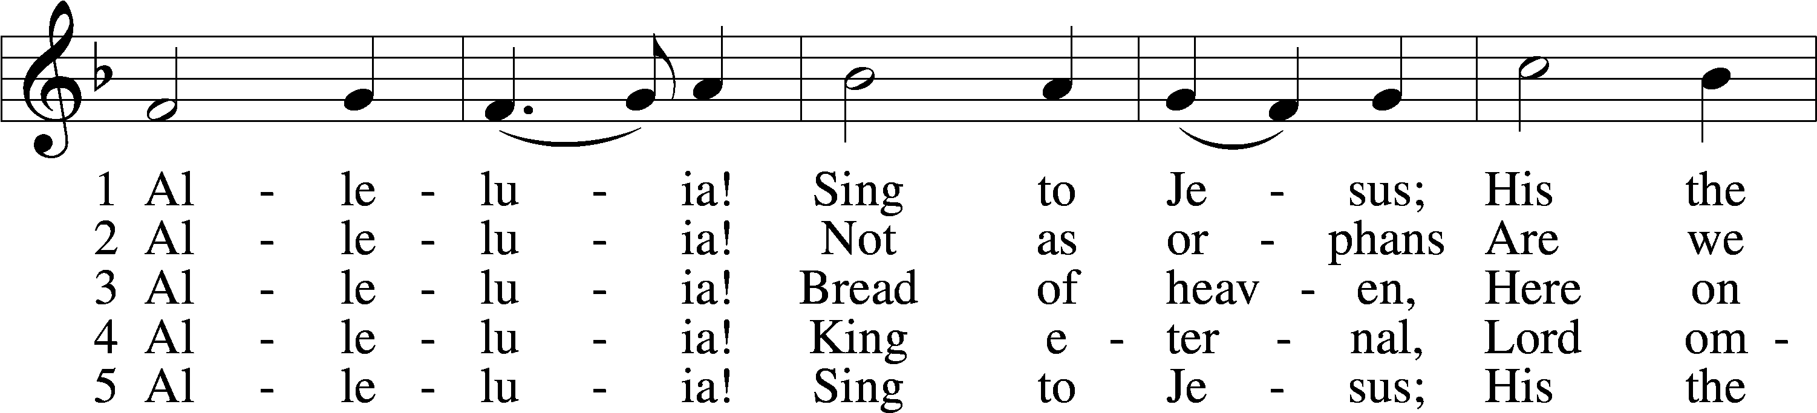
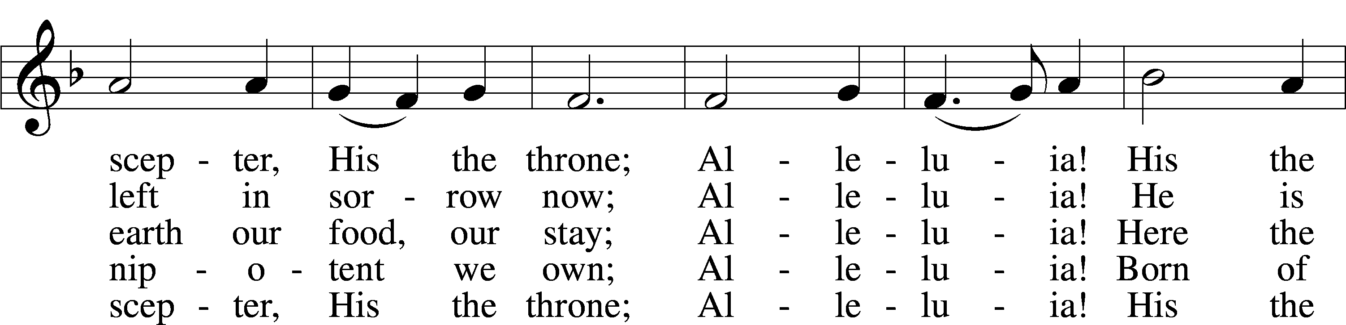
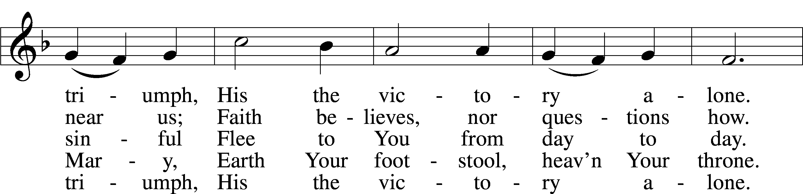
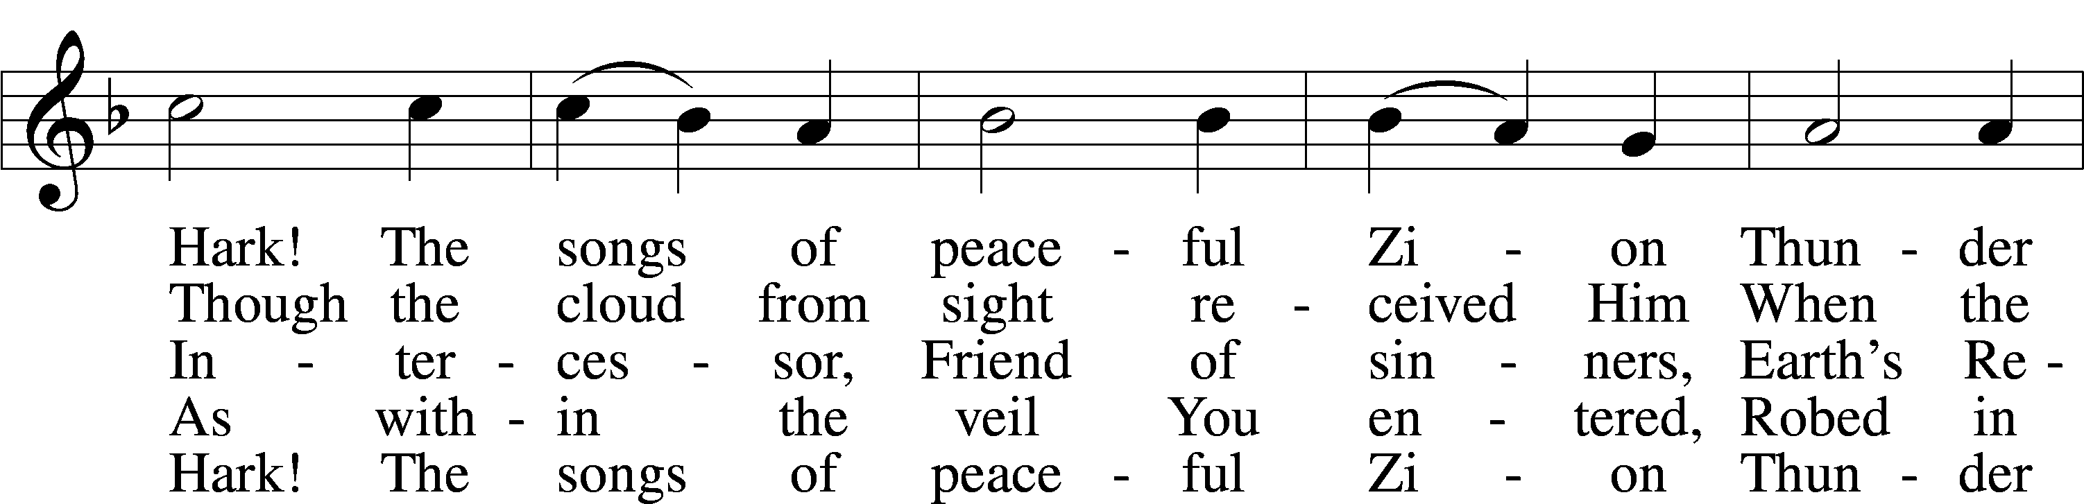
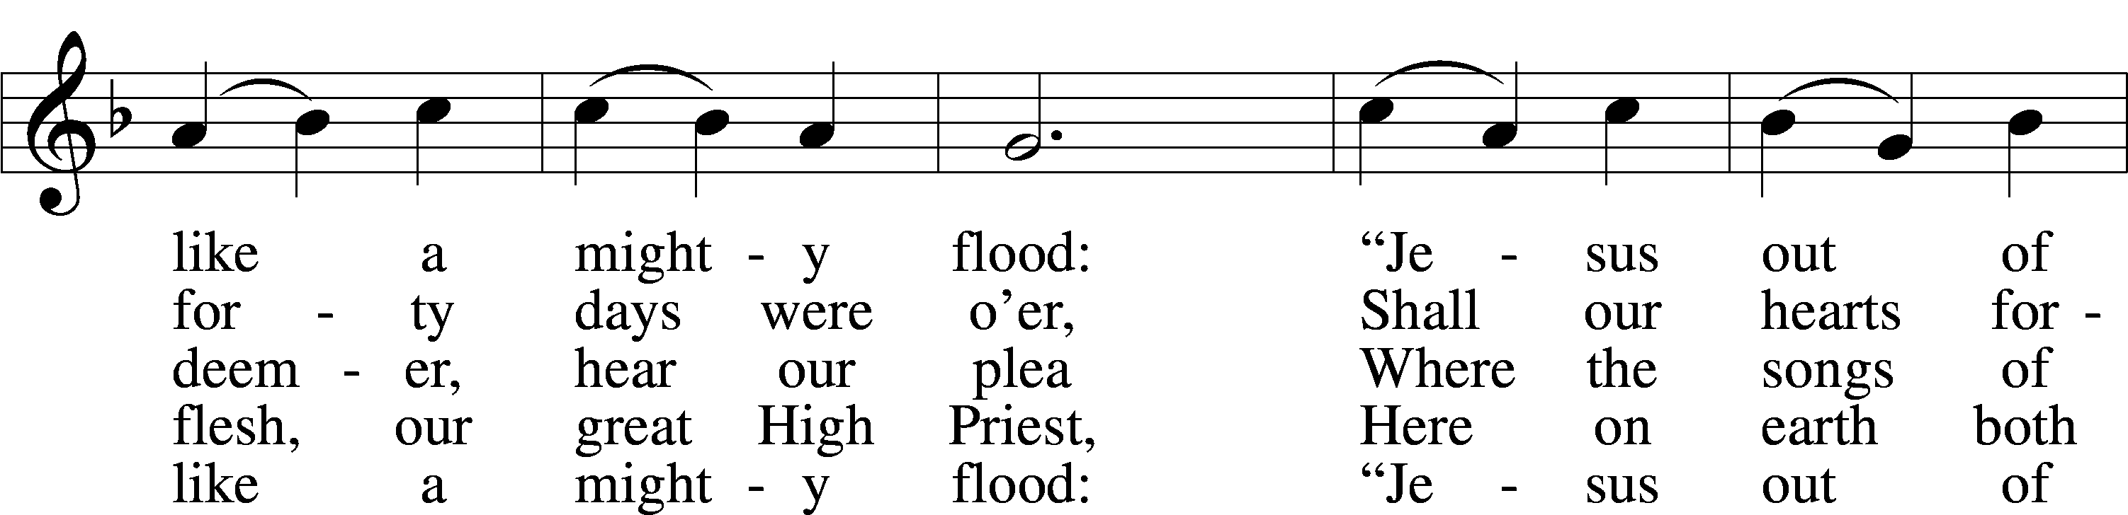
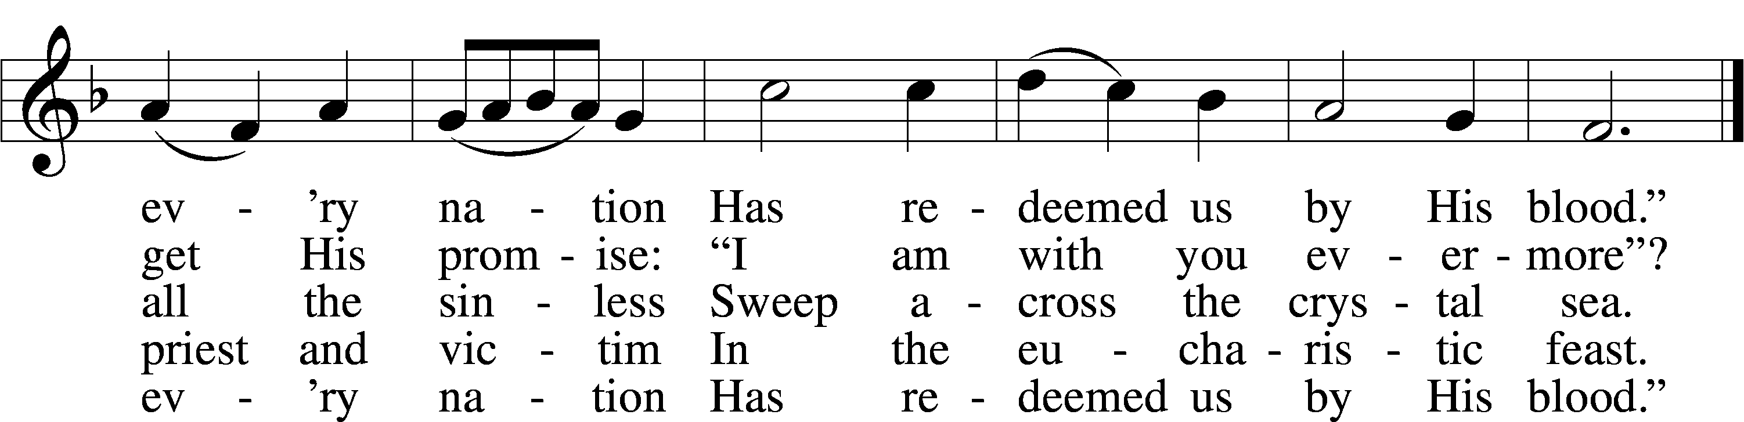
Text: William C. Dix, 1837–98, alt.
Tune: Rowland H. Prichard, 1811–87
Text and tune: Public domain

Acknowledgments
Divine Service, Setting Four from Lutheran Service Book
Unless otherwise indicated, Scripture quotations are from the ESV® Bible (The Holy Bible, English Standard Version®), copyright © 2001 by Crossway, a publishing ministry of Good News Publishers. Used by permission. All rights reserved.
Created by Lutheran Service Builder © 2023 Concordia Publishing House.

