688 “Come, Follow Me,” the Savior Spake

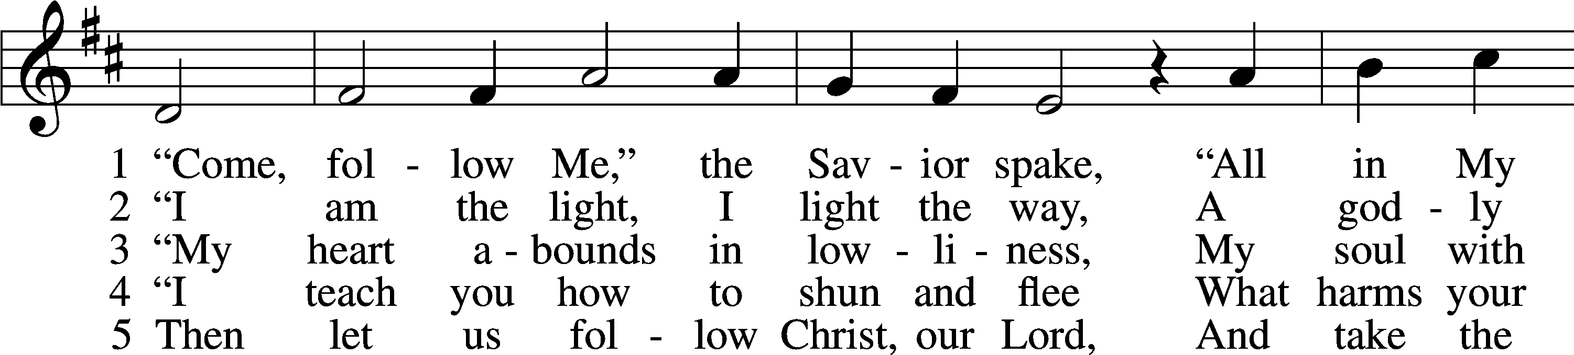

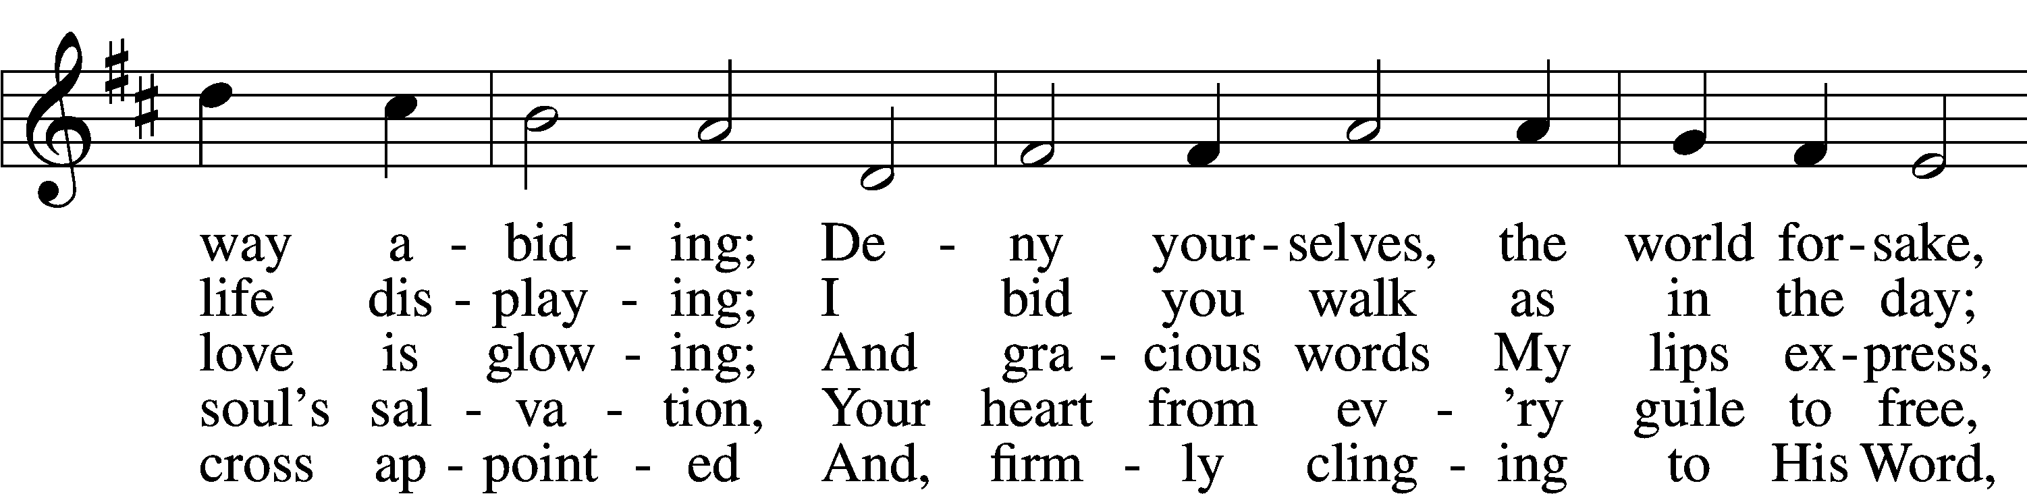

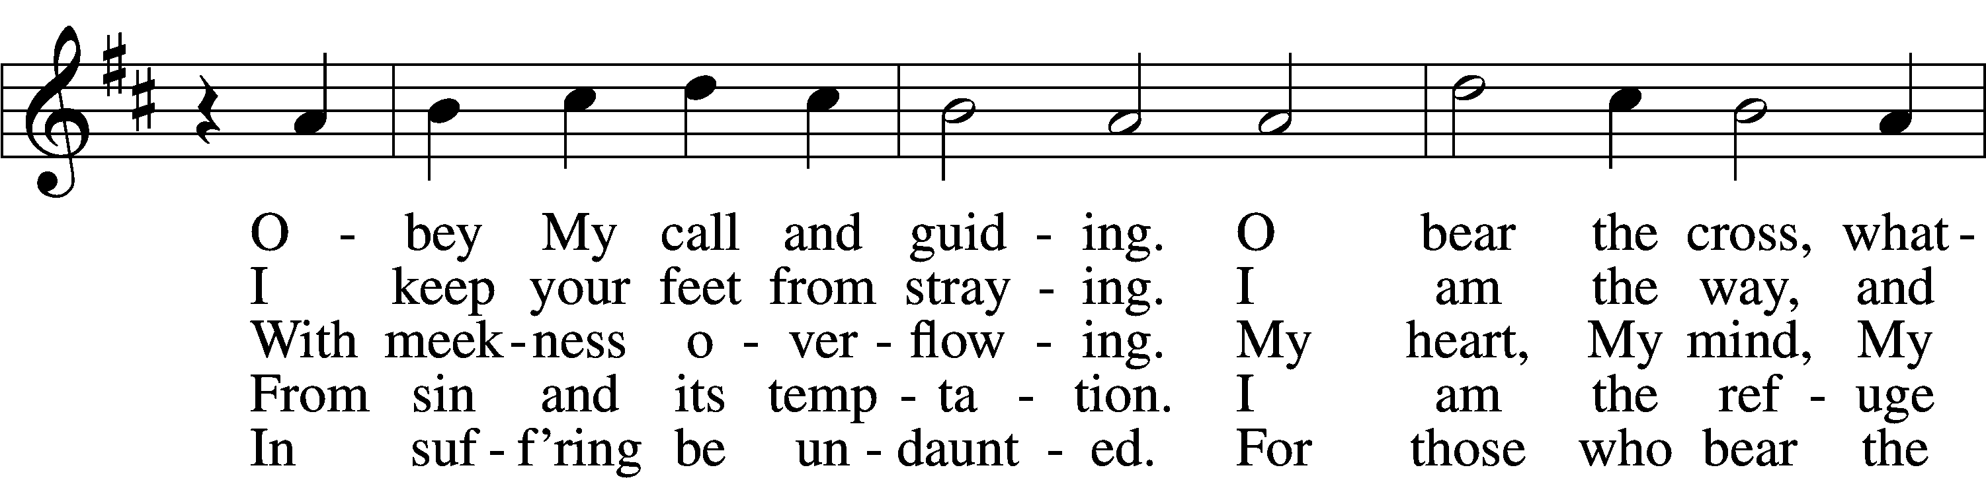

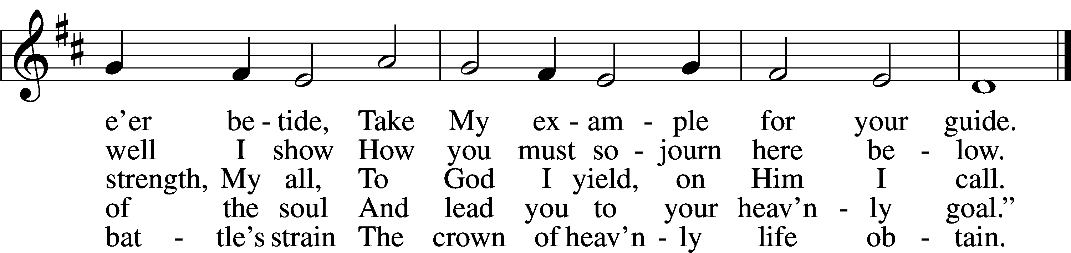

Text: tr. Charles W. Schaeffer, 1813–96; (sts. 1–3, 5): Johann Scheffler, 1624–77; (st. 4): Geistliche Lieder und Lobgesänge, 1695  
Tune: Bartholomäus Gesius, c. 1555–1613, adapt.  
Text and tune: Public domain

# Confession and Absolution

The sign of the cross may be made by all in remembrance of their Baptism.

Invocation Matthew 28:19b; 18:20

P In the name of the Father and of the T Son and of the Holy Spirit.

C **Amen.**

Exhortation Hebrews 10:22; Psalm 124:8; Psalm 32:5

P Beloved in the Lord! Let us draw near with a true heart and confess our sins unto God our Father, beseeching Him in the name of our Lord Jesus Christ to grant us forgiveness.

P Our help is in the name of the Lord,

C **who made heaven and earth.**

P I said, I will confess my transgressions unto the Lord,

C **and You forgave the iniquity of my sin.**

Silence for reflection on God’s Word and for self-examination.

Confession of Sins

P Almighty God, our maker and redeemer, we poor sinners confess unto You that we are by nature sinful and unclean and that we have sinned against You by thought, word, and deed. Wherefore we flee for refuge to Your infinite mercy, seeking and imploring Your grace for the sake of our Lord Jesus Christ.

C **O most merciful God, who has given Your only-begotten Son to die for us, have mercy upon us and for His sake grant us remission of all our sins; and by Your Holy Spirit increase in us true knowledge of You and of Your will and true obedience to Your Word, to the end that by Your grace we may come to everlasting life; through Jesus Christ, our Lord. Amen.**

Declaration of Grace Mark 16:16; John 1:12

P Almighty God, our heavenly Father, has had mercy upon us and has given His only Son to die for us and for His sake forgives us all our sins. To those who believe on His name He gives power to become the children of God and has promised them His Holy Spirit. He that believes and is baptized shall be saved.  
  
Grant this, Lord, unto us all.

C **Amen.**

# Service of the Word

Introit Psalm 50:7–10; antiphon: v. 1

The Mighty One, God the Lord, speaks and summons the earth  
 from the rising of the sun to its setting.  
**Hear, O my people, and I will speak; O Israel, I will testify against you.  
 I am God, your God.**  
Not for your sacrifices do I rebuke you;  
 your burnt offerings are continually before me.  
**I will not accept a bull from your house  
 or goats from your folds.**  
For every beast of the forest is mine,  
 the cattle on a thousand hills.

Gloria Patri

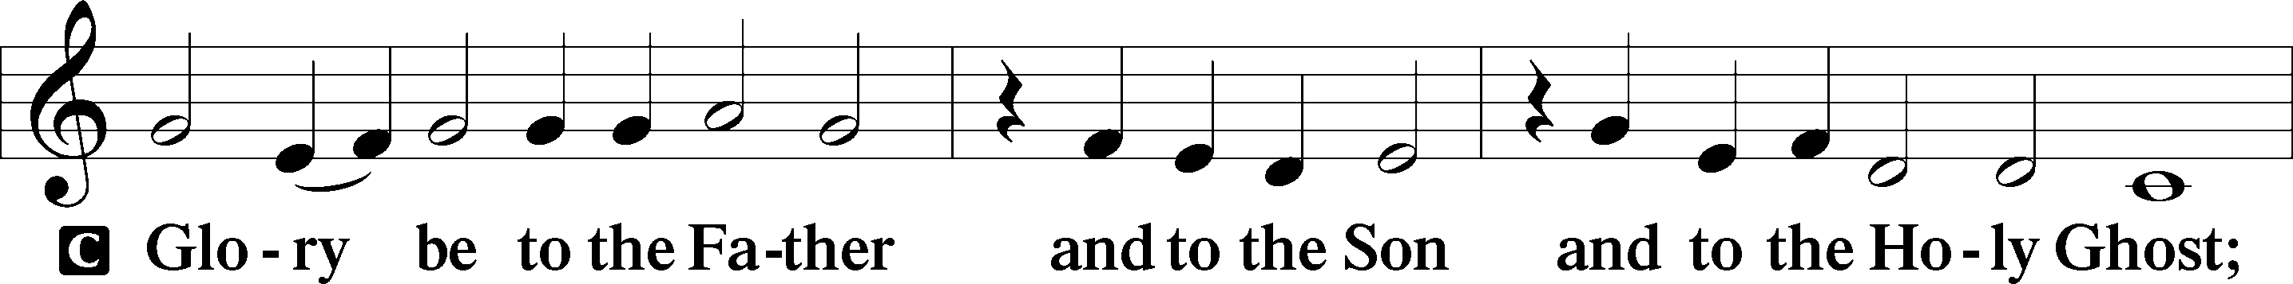

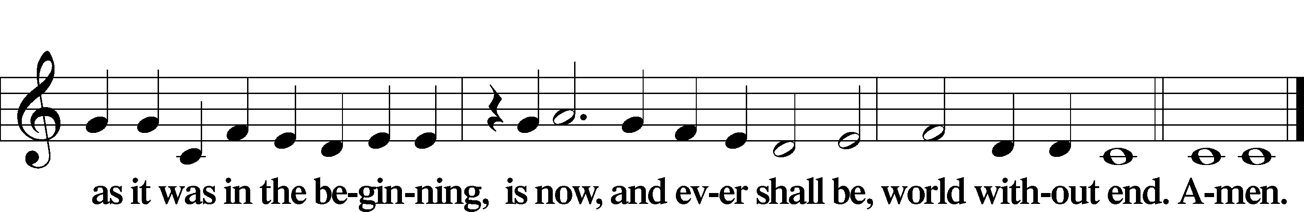

Kyrie Mark 10:47

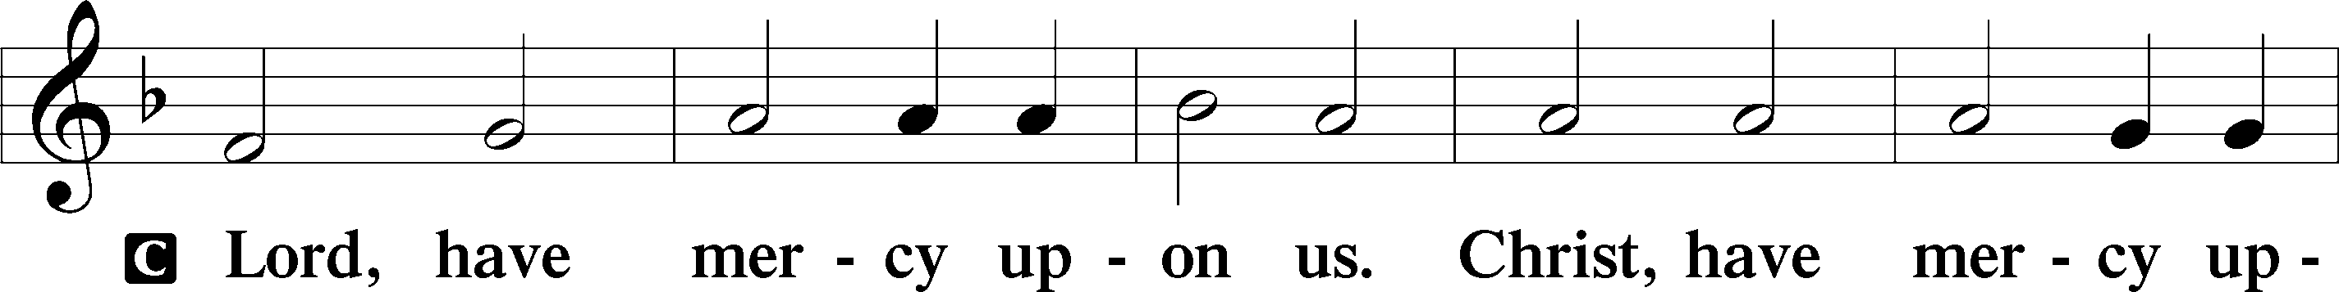

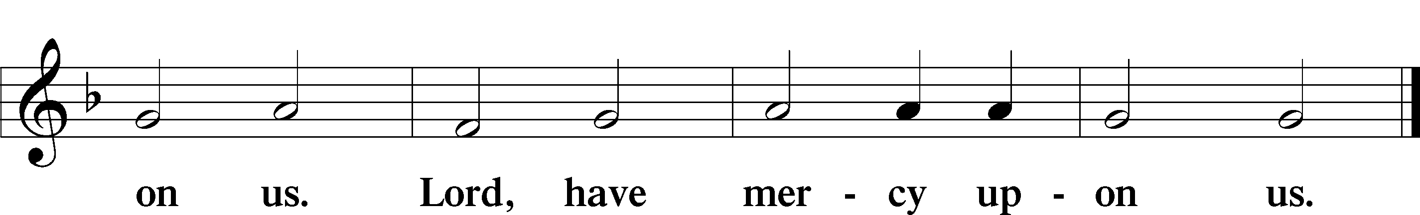

Gloria in Excelsis Luke 2:14; John 1:29

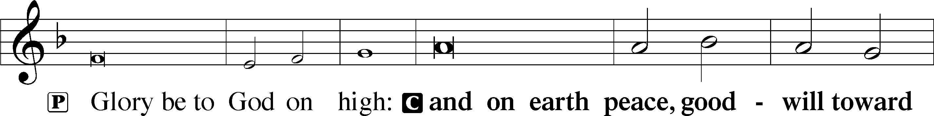

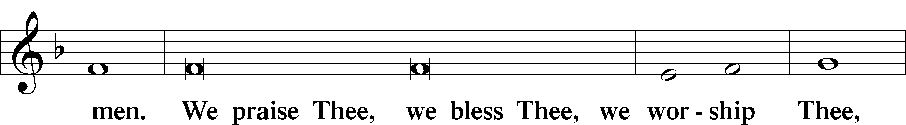

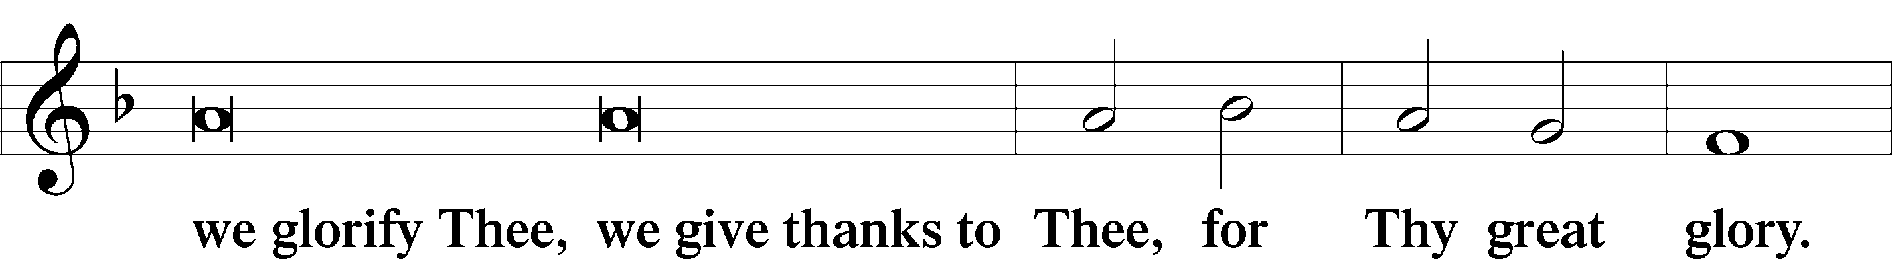

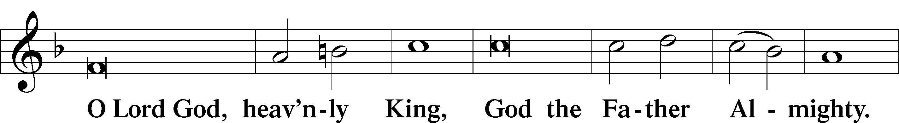

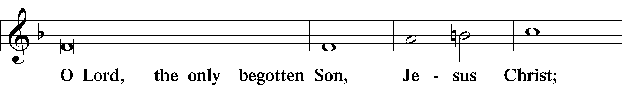

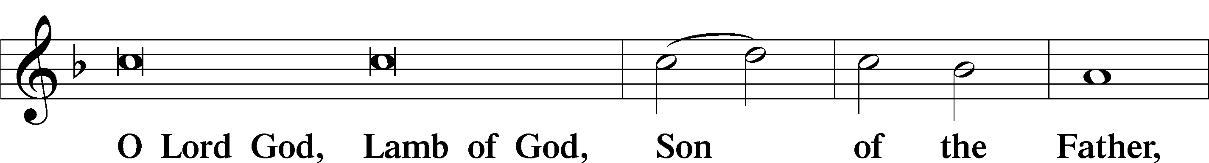

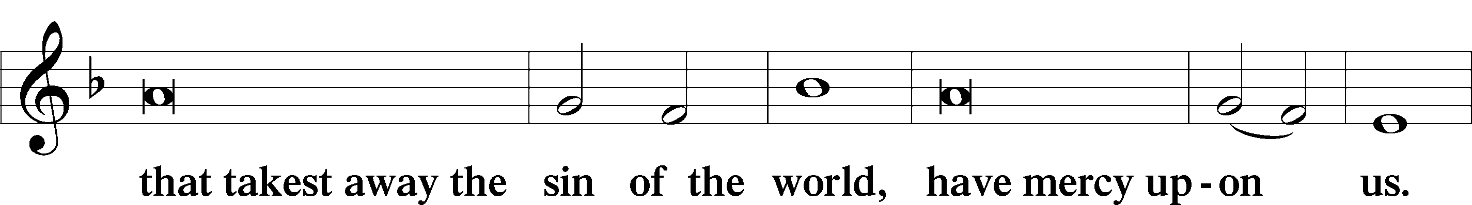

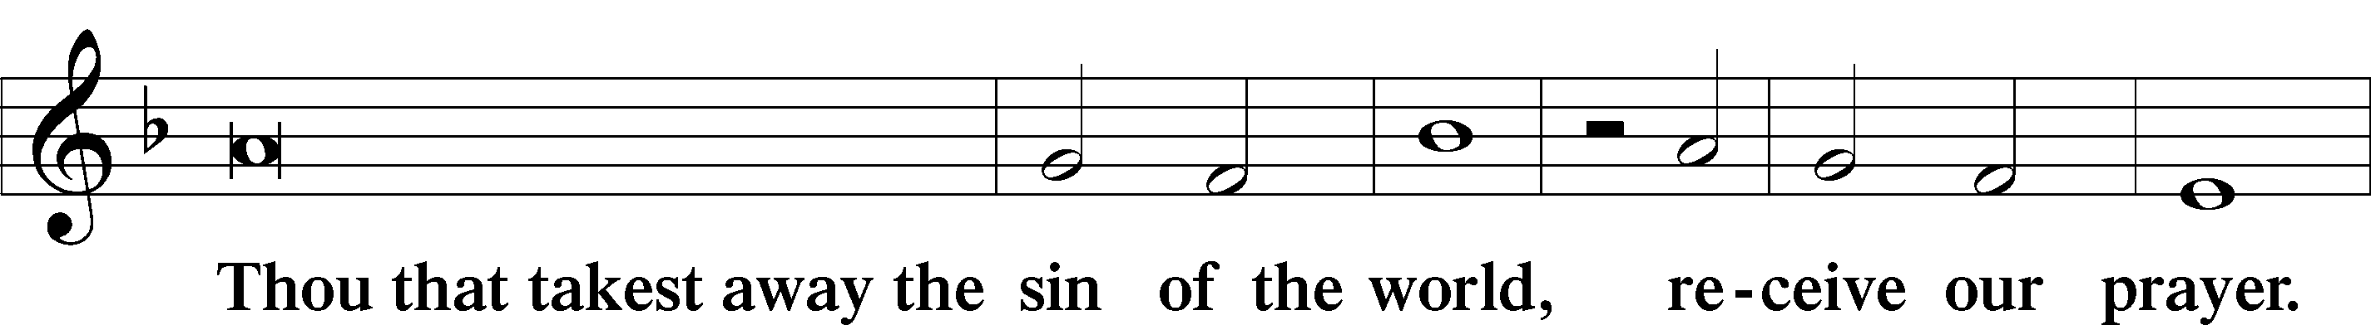

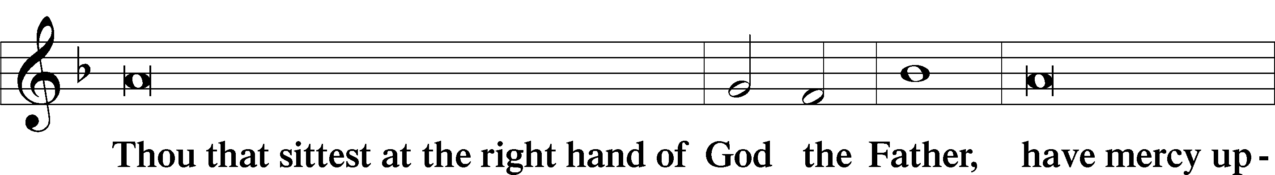

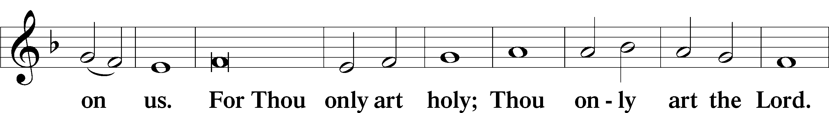

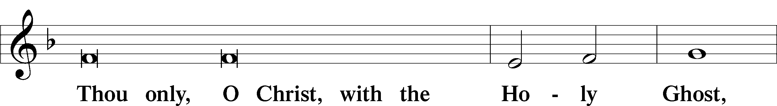

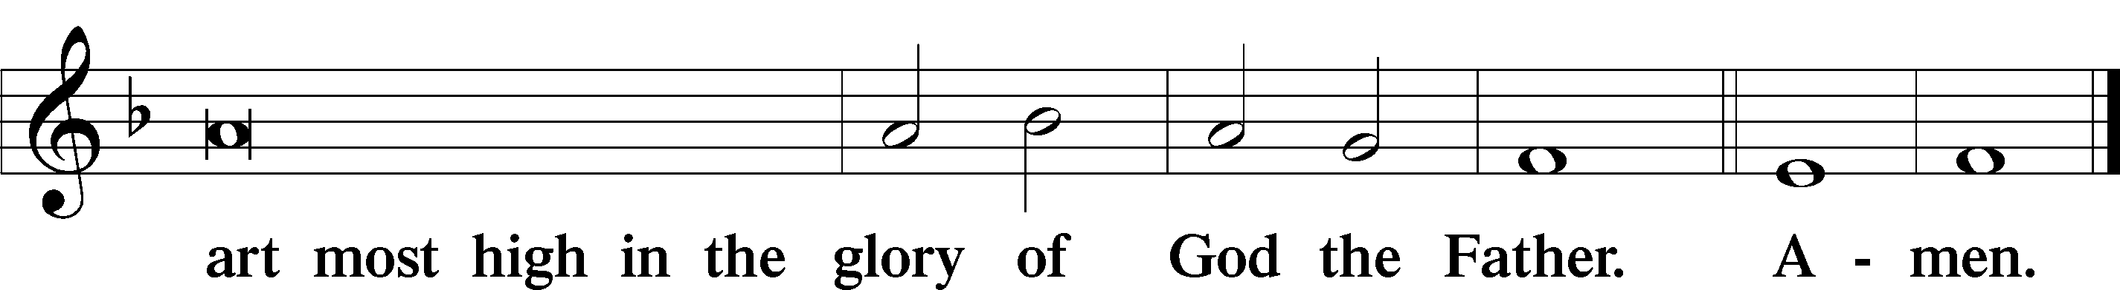

Salutation and Collect of the Day

P The Lord be with you.

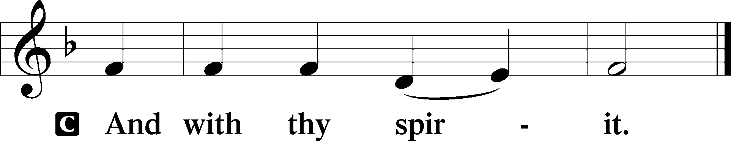

P Let us pray.

Almighty and most merciful God, You sent Your Son, Jesus Christ, to seek and to save the lost. Graciously open our ears and our hearts to hear His call and to follow Him by faith that we may feast with Him forever in His kingdom; through the same Jesus Christ, our Lord, who lives and reigns with You and the Holy Spirit, one God, now and forever.

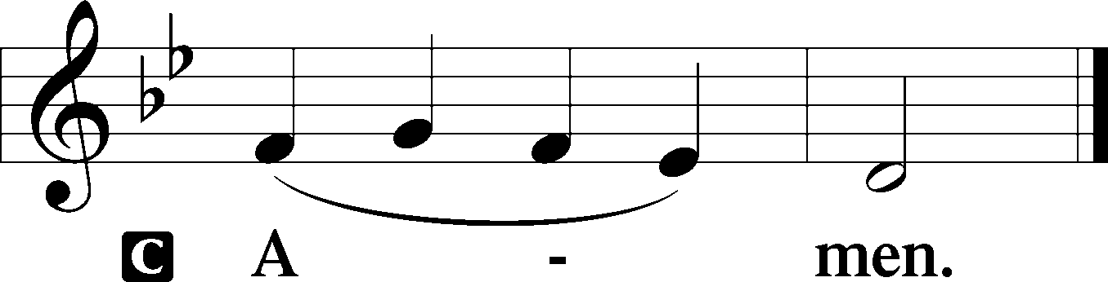

Sit

Old Testament Reading Hosea 5:15—6:6

15I will return again to my place,  
 until they acknowledge their guilt and seek my face,  
 and in their distress earnestly seek me.

Israel and Judah Are Unrepentant

1“Come, let us return to the Lord;  
 for he has torn us, that he may heal us;  
 he has struck us down, and he will bind us up.  
2After two days he will revive us;  
 on the third day he will raise us up,  
 that we may live before him.  
3Let us know; let us press on to know the Lord;  
 his going out is sure as the dawn;  
he will come to us as the showers,  
 as the spring rains that water the earth.”  
4What shall I do with you, O Ephraim?  
 What shall I do with you, O Judah?  
Your love is like a morning cloud,  
 like the dew that goes early away.  
5Therefore I have hewn them by the prophets;  
 I have slain them by the words of my mouth,  
 and my judgment goes forth as the light.  
6For I desire steadfast love and not sacrifice,  
 the knowledge of God rather than burnt offerings.

A This is the Word of the Lord.

C **Thanks be to God.**

Gradual Psalm 145:3, 5b, 6b

Great is the Lord, and greatly to be praised,  
 and his greatness is unsearchable.  
**On your wondrous works, I will meditate,  
 and I will declare your greatness.**

Reading Romans 5:6–15

6For while we were still weak, at the right time Christ died for the ungodly. 7For one will scarcely die for a righteous person—though perhaps for a good person one would dare even to die— 8but God shows his love for us in that while we were still sinners, Christ died for us. 9Since, therefore, we have now been justified by his blood, much more shall we be saved by him from the wrath of God. 10For if while we were enemies we were reconciled to God by the death of his Son, much more, now that we are reconciled, shall we be saved by his life. 11More than that, we also rejoice in God through our Lord Jesus Christ, through whom we have now received reconciliation.

Death in Adam, Life in Christ

12Therefore, just as sin came into the world through one man, and death through sin, and so death spread to all men because all sinned— 13for sin indeed was in the world before the law was given, but sin is not counted where there is no law. 14Yet death reigned from Adam to Moses, even over those whose sinning was not like the transgression of Adam, who was a type of the one who was to come.

15But the free gift is not like the trespass. For if many died through one man’s trespass, much more have the grace of God and the free gift by the grace of that one man Jesus Christ abounded for many.

Stand

Alleluia

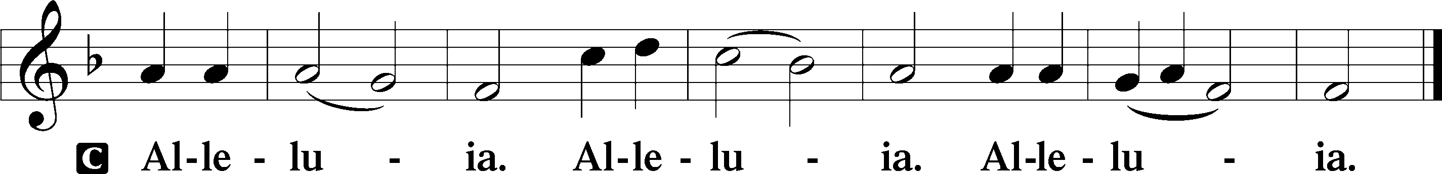

Holy Gospel Matthew 9:9–13

P The Holy Gospel according to St. Matthew, the ninth chapter.

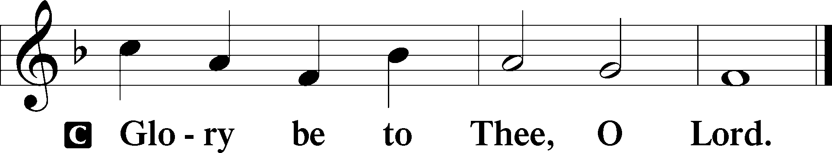

Jesus Calls Matthew

9As Jesus passed on from there, he saw a man called Matthew sitting at the tax booth, and he said to him, “Follow me.” And he rose and followed him.

10And as Jesus reclined at table in the house, behold, many tax collectors and sinners came and were reclining with Jesus and his disciples. 11And when the Pharisees saw this, they said to his disciples, “Why does your teacher eat with tax collectors and sinners?” 12But when he heard it, he said, “Those who are well have no need of a physician, but those who are sick. 13Go and learn what this means, ‘I desire mercy, and not sacrifice.’ For I came not to call the righteous, but sinners.”

P This is the Gospel of the Lord.

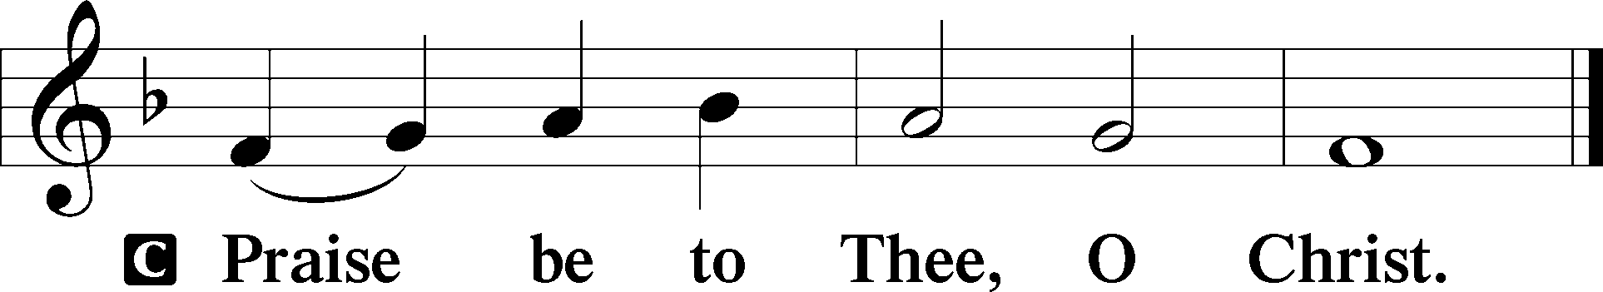

Apostles’ Creed

C **I believe in God, the Father Almighty,**

**maker of heaven and earth.**

**And in Jesus Christ, His only Son, our Lord,**

**who was conceived by the Holy Spirit,**

**born of the virgin Mary,**

**suffered under Pontius Pilate,**

**was crucified, died and was buried.**

**He descended into hell.**

**The third day He rose again from the dead.**

**He ascended into heaven**

**and sits at the right hand of God the Father Almighty.**

**From thence He will come to judge the living and the dead.**

**I believe in the Holy Spirit,**

**the holy Christian Church,**

**the communion of saints,**

**the forgiveness of sins,**

**the resurrection of the body,**

**and the life** T **everlasting. Amen.**

Sit

Children's Message

578 Thy Strong Word

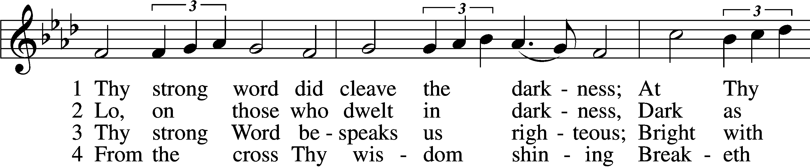

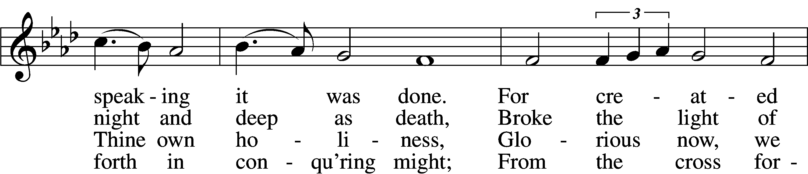

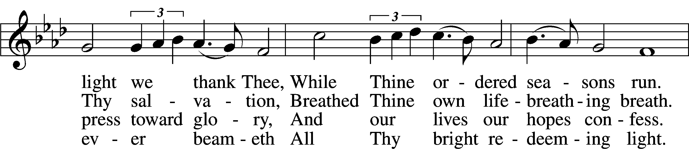

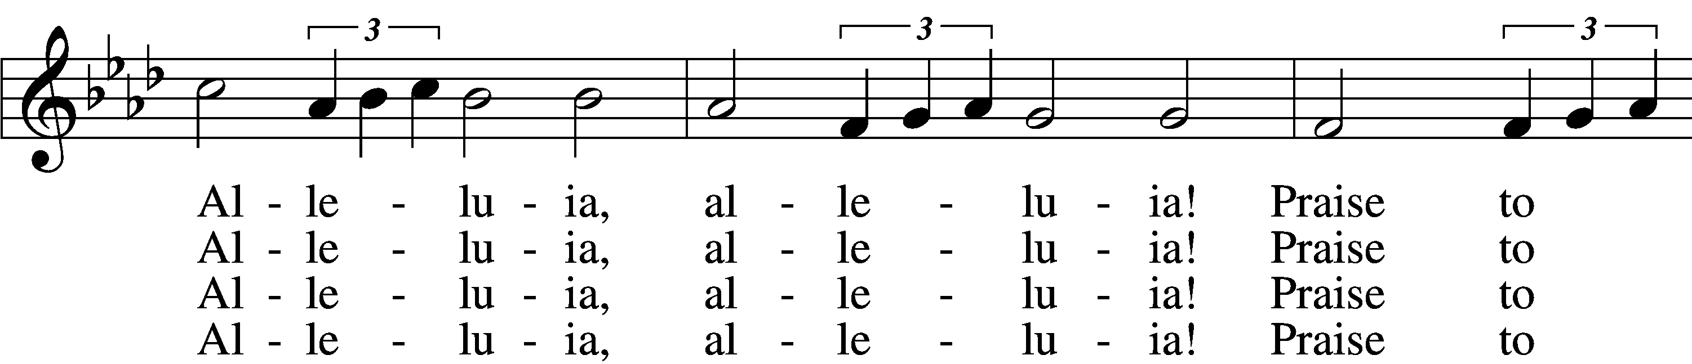

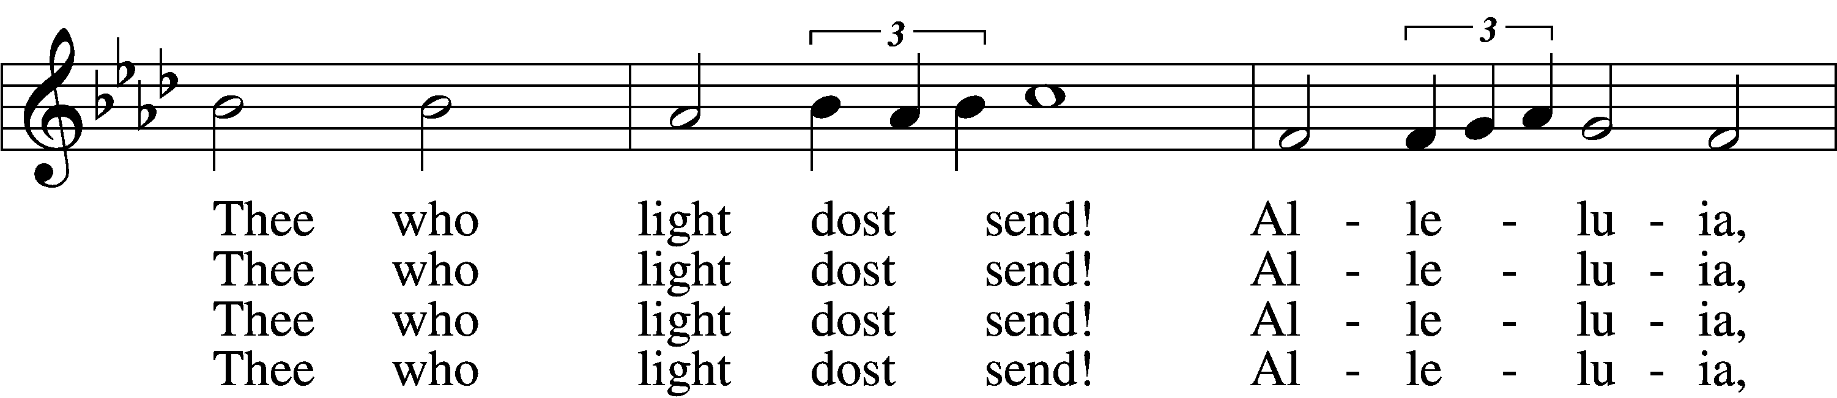

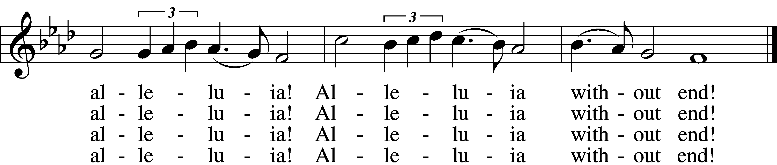

5 Give us lips to sing Thy glory,  
 Tongues Thy mercy to proclaim,  
Throats that shout the hope that fills us,  
 Mouths to speak Thy holy name.  
Alleluia, alleluia!  
 May the light which Thou dost send  
Fill our songs with alleluias,  
 Alleluias without end!

D 6 God the Father, light-creator,  
 To Thee laud and honor be.  
To Thee, Light of Light begotten,  
 Praise be sung eternally.  
Holy Spirit, light-revealer,  
 Glory, glory be to Thee.  
Mortals, angels, now and ever  
 Praise the holy Trinity!

Text: Martin H. Franzmann, 1907–76  
Tune: Thomas J. Williams, 1869–1944  
Text: © 1969 Concordia Publishing House. Used by permission: LSB Hymn License no. 110005011  
Tune: Public domain

Sermon

Votum

P The peace of God, which passes all understanding, keep your hearts and minds in Christ Jesus.

C **Amen.**

Stand

Offertory Psalm 51:10–12

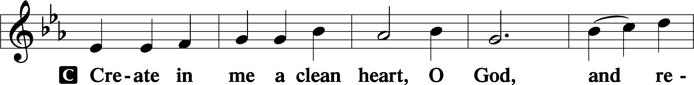

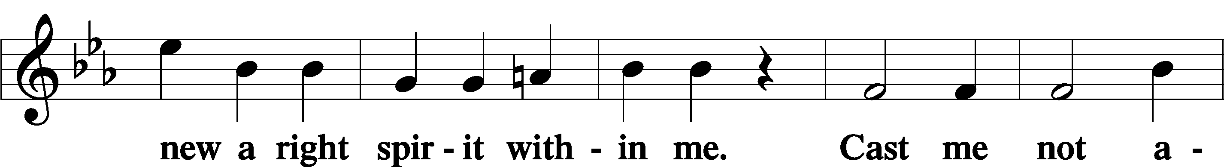

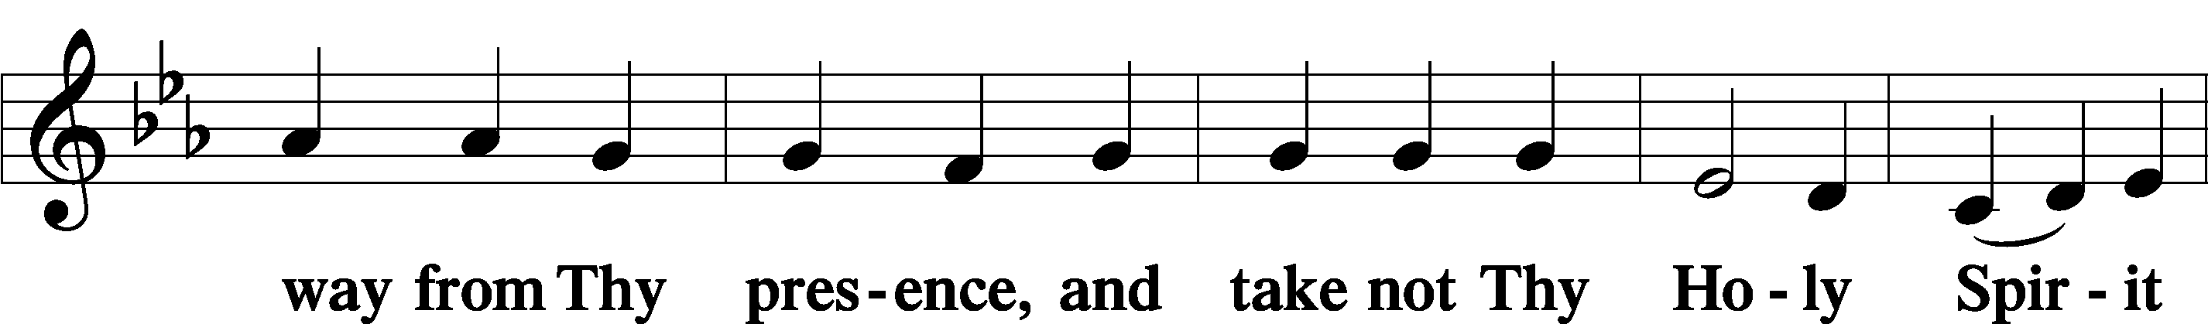

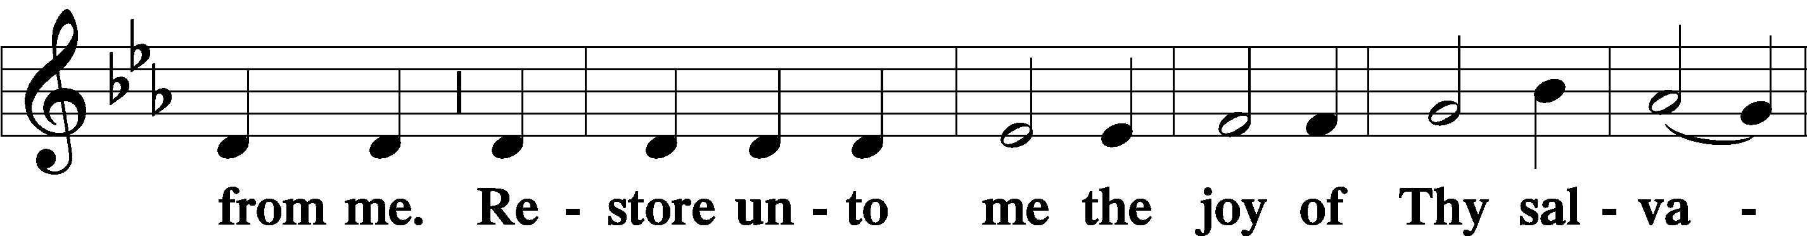

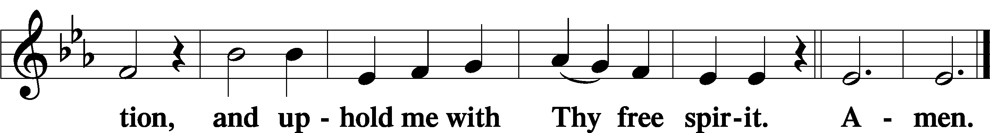

Offering

805 Praise God, from Whom All Blessings Flow

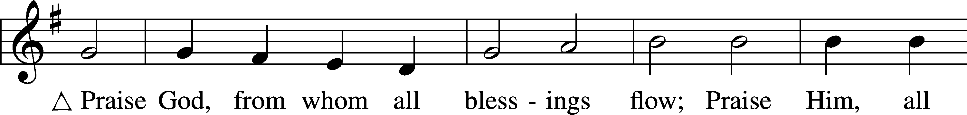

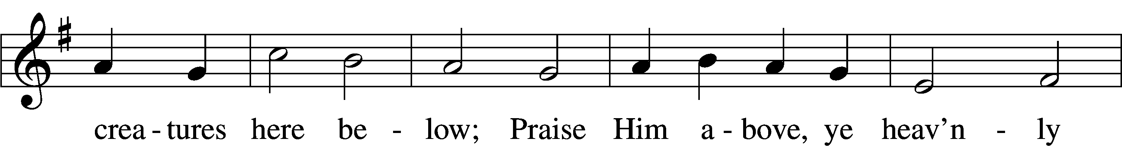

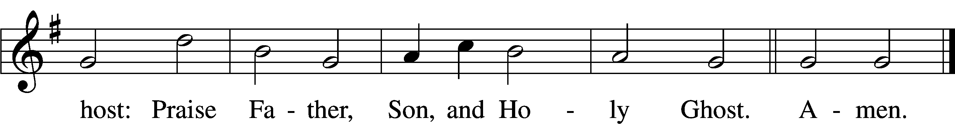

Text: Thomas Ken, 1637–1711  
Tune: Trente quatre Pseaumes de David, 1551, Geneva, ed. Louis Bourgeois  
Text and tune: Public domain

Prayer of the Church

Lord’s Prayer Matthew 6:9–13

P Lord, remember us in Your kingdom and teach us to pray:

C **Our Father who art in heaven,**

**hallowed be Thy name,**

**Thy kingdom come,**

**Thy will be done on earth**

**as it is in heaven;**

**give us this day our daily bread;**

**and forgive us our trespasses**

**as we forgive those**

**who trespass against us;**

**and lead us not into temptation,**

**but deliver us from evil.**

**For Thine is the kingdom**

**and the power and the glory**

**forever and ever. Amen.**

Collect for the Word

Blessed Lord, You have caused all Holy Scriptures to be written for our learning.

Grant that we may so hear them, read, mark, learn, and inwardly digest them that, by the patience and comfort of Your holy Word, we may embrace and ever hold fast the blessed hope of everlasting life; which you have given us in our Savior Jesus Christ, Your son, our Lord, who lives and reigns with You and the Holy Spirit, one god, now and forever.

Post-Communion Collect

A Let us pray.

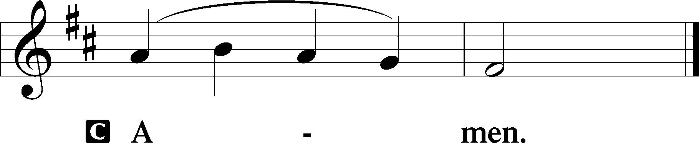

690 Hope of the World

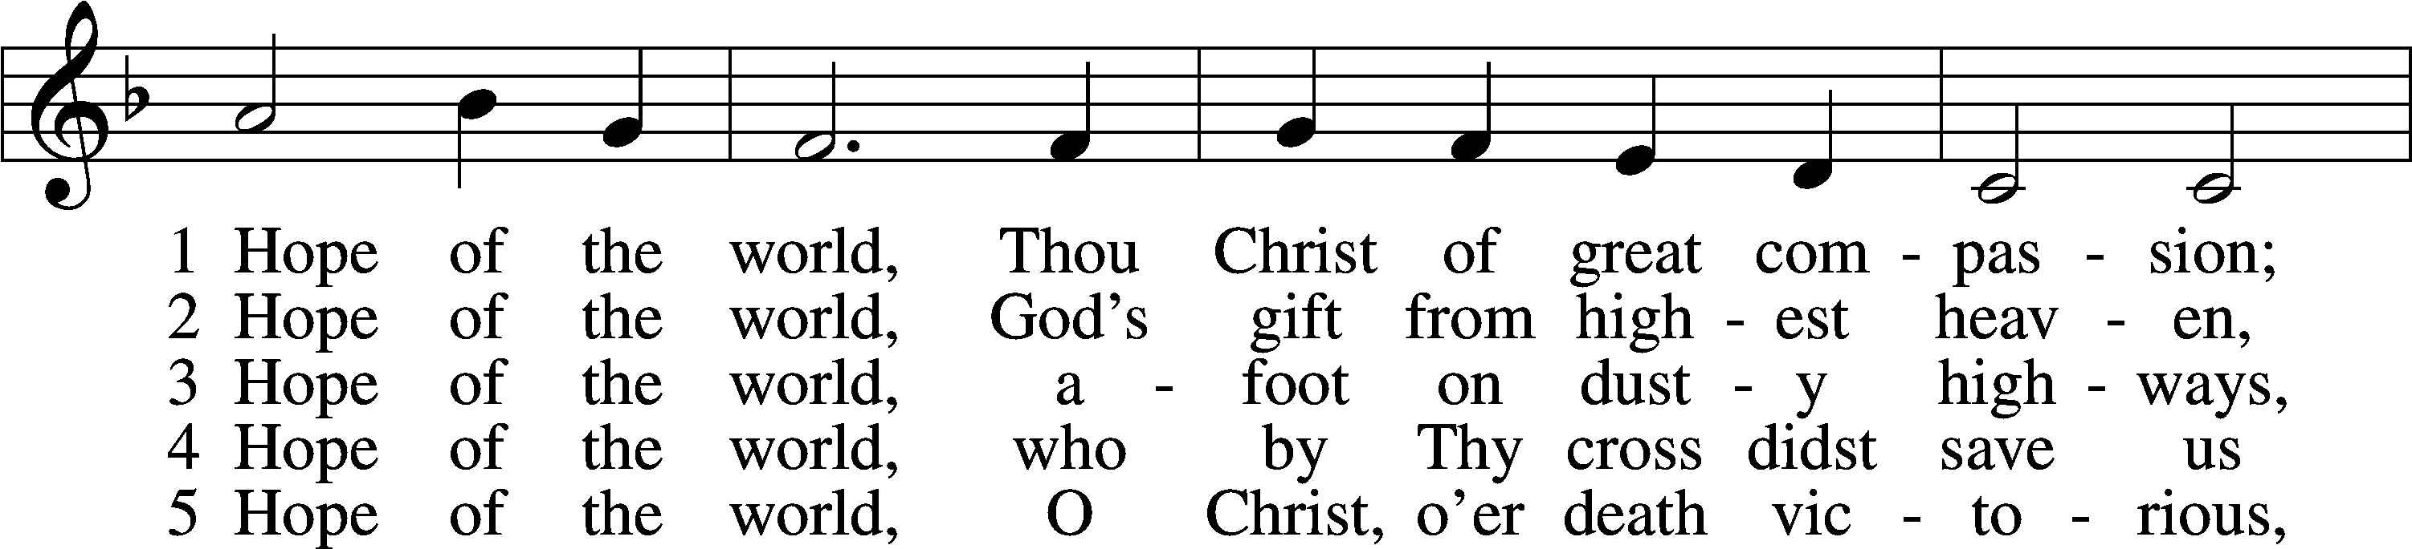

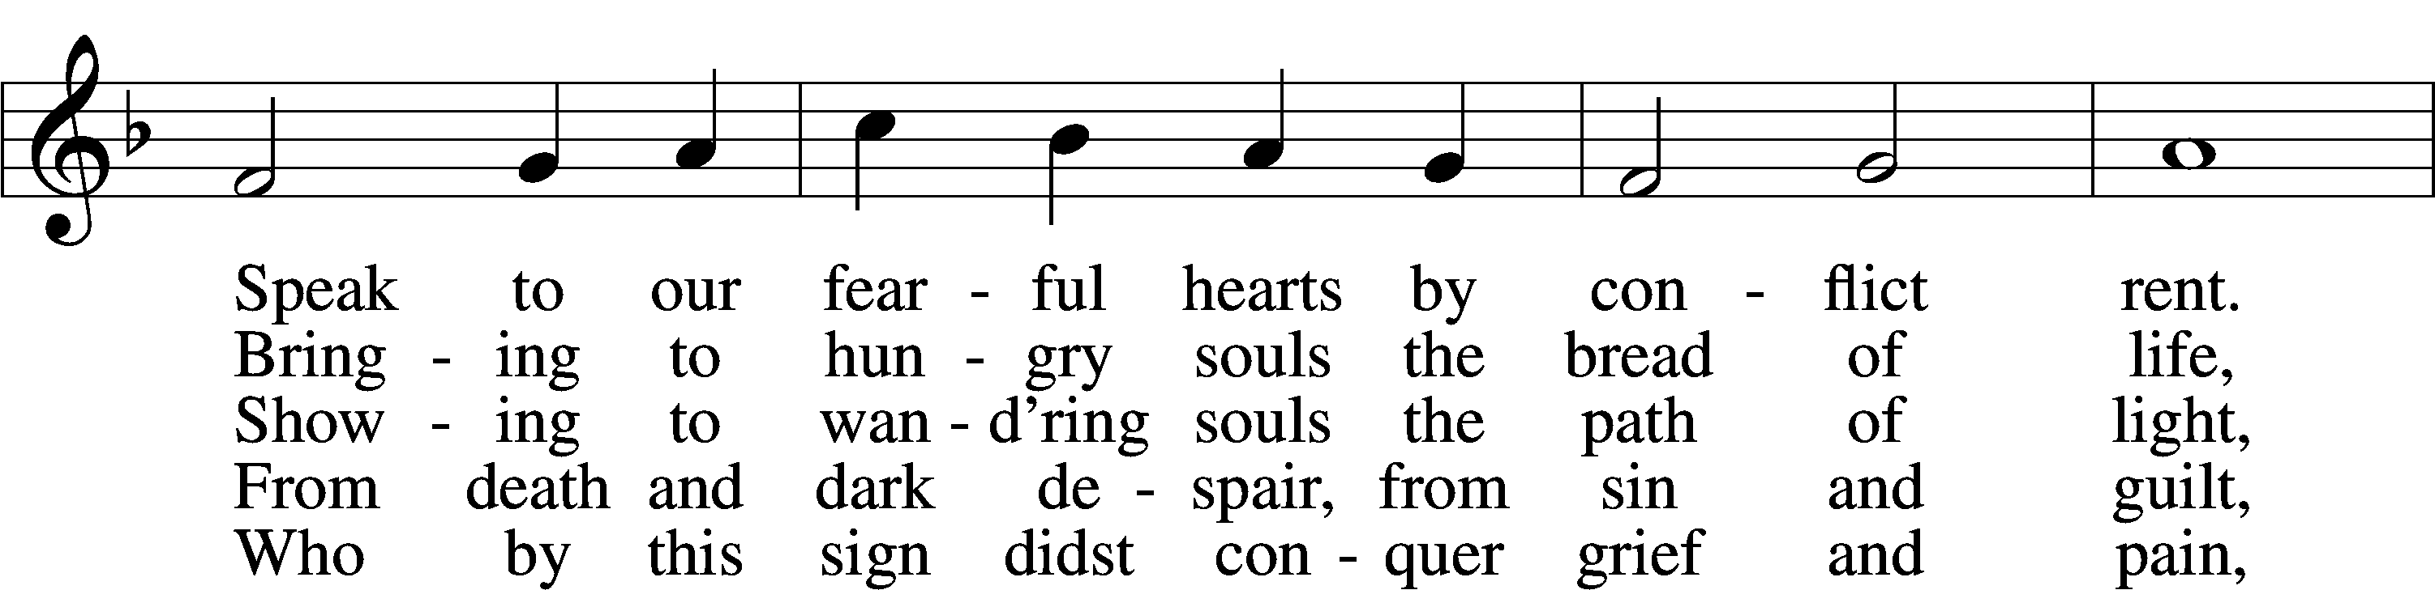

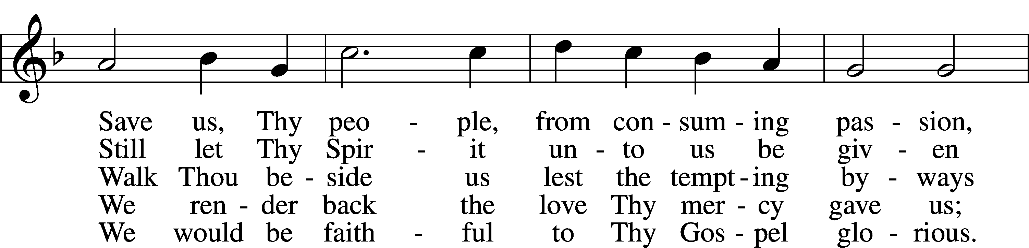

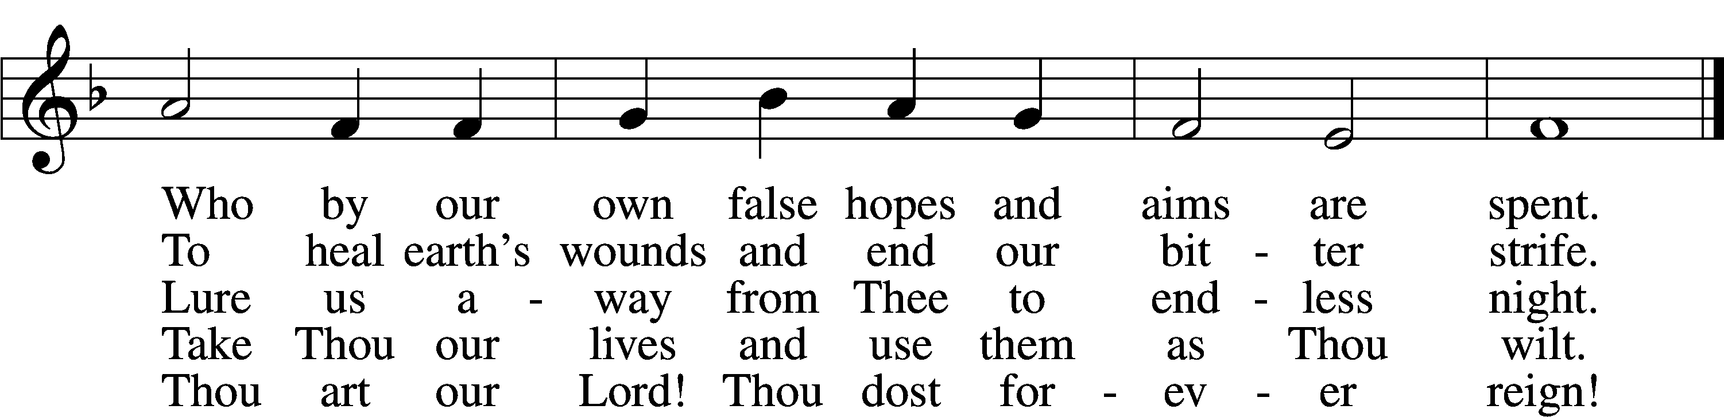

Text: Georgia Harkness, 1891–1974  
Tune: Frances R. Havergal, 1836–79  
Text: © 1954, renewed 1982 The Hymn Society, admin. Hope Publishing Co. Used by permission: LSB Hymn License no. 110005011  
Tune: Public domain

Acknowledgments

Unless otherwise indicated, Scripture quotations are from the ESV® Bible (The Holy Bible, English Standard Version®), copyright © 2001 by Crossway, a publishing ministry of Good News Publishers. Used by permission. All rights reserved.

Created by Lutheran Service Builder © 2023 Concordia Publishing House.