579 The Law of God Is Good and Wise

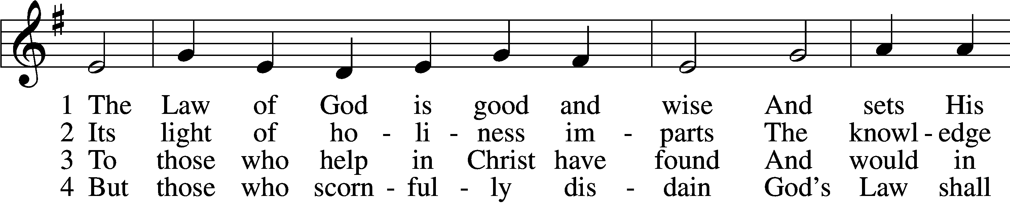

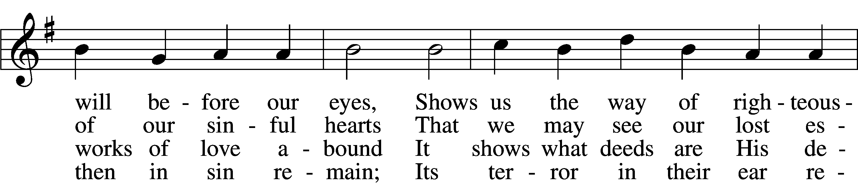

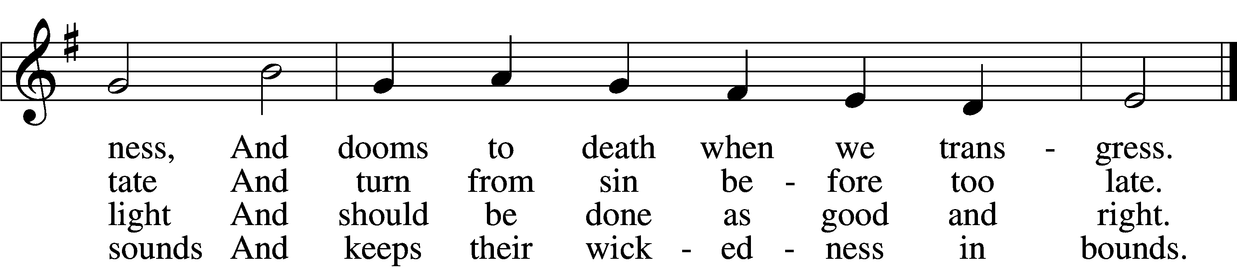

5 The Law is good; but since the fall  
Its holiness condemns us all;  
It dooms us for our sin to die  
And has no pow’r to justify.

6 To Jesus we for refuge flee,  
Who from the curse has set us free,  
And humbly worship at His throne,  
Saved by His grace through faith alone.

Text: Matthias Loy, 1828–1915, alt.  
Tune: Geistliche Lieder auffs new gebessert, 1543, Wittenberg, ed. Joseph Klug  
Text and tune: Public domain

# Confession and Absolution

Stand

The sign of the cross may be made by all in remembrance of their Baptism.

Invocation Matthew 28:19b; 18:20

P In the name of the Father and of the T Son and of the Holy Spirit.

C **Amen.**

Exhortation Hebrews 10:22; Psalm 124:8; Psalm 32:5

P Beloved in the Lord! Let us draw near with a true heart and confess our sins unto God our Father, beseeching Him in the name of our Lord Jesus Christ to grant us forgiveness.

P Our help is in the name of the Lord,

C **who made heaven and earth.**

P I said, I will confess my transgressions unto the Lord,

C **and You forgave the iniquity of my sin.**

Kneel/Stand

Silence for reflection on God’s Word and for self-examination.

Confession of Sins

P O almighty God, merciful Father,

C **I, a poor, miserable sinner, confess unto You all my sins and iniquities with which I have ever offended You and justly deserved Your temporal and eternal punishment. But I am heartily sorry for them and sincerely repent of them, and I pray You of Your boundless mercy and for the sake of the holy, innocent, bitter sufferings and death of Your beloved Son, Jesus Christ, to be gracious and merciful to me, a poor, sinful being.**

Absolution [John 20:19–23]

P Upon this your confession, I, by virtue of my office, as a called and ordained servant of the Word, announce the grace of God unto all of you, and in the stead and by the command of my Lord Jesus Christ I forgive you all your sins in the name of the Father and of the T Son and of the Holy Spirit.

C **Amen.**

Stand

# Service of the Word

Introit Psalm 89:15–18; antiphon: v. 1

I will sing of the steadfast love of the Lord, forever;  
 with my mouth I will make known your faithfulness to all generations.  
**Blessèd are the people who know the festal shout,  
 who walk, O Lord, in the light of your face,**  
who exult in your name all the day  
 and in your righteousness are exalted.  
**For you are the glory of their strength;  
 by your favor our horn is exalted.**  
For our shield belongs to the Lord,  
 our king to the Holy One of Israel.

Gloria Patri

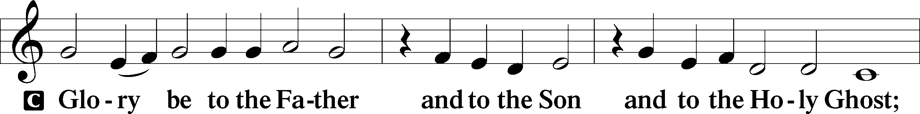

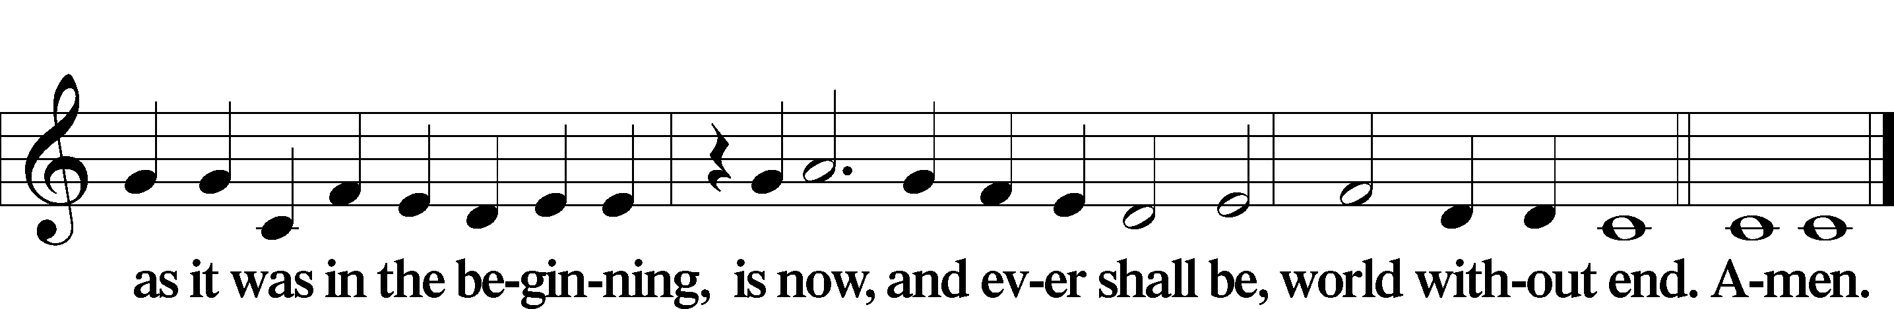

Kyrie Mark 10:47

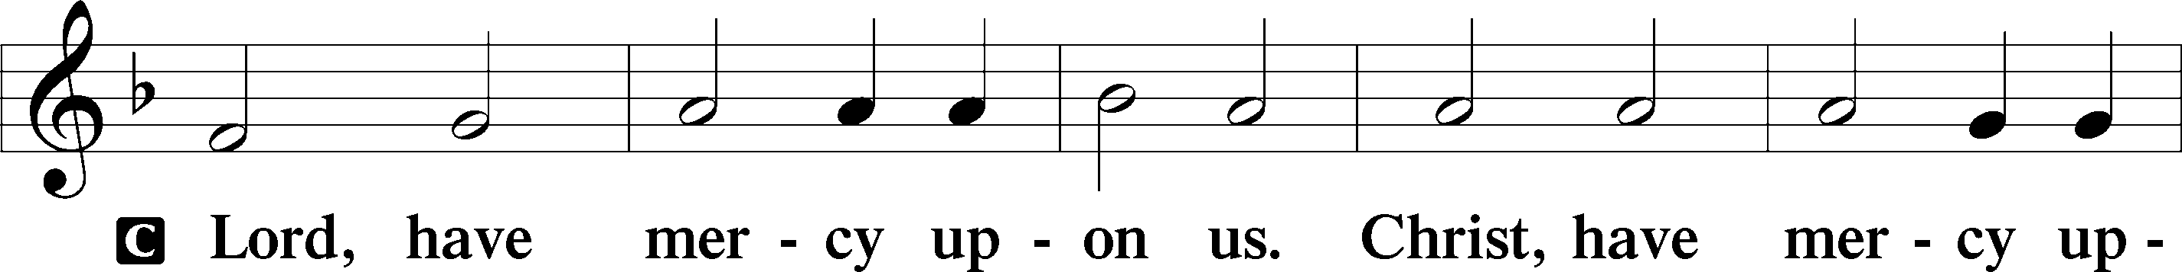

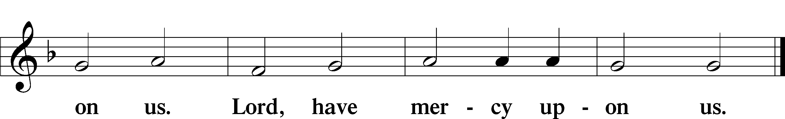

Gloria in Excelsis Luke 2:14; John 1:29

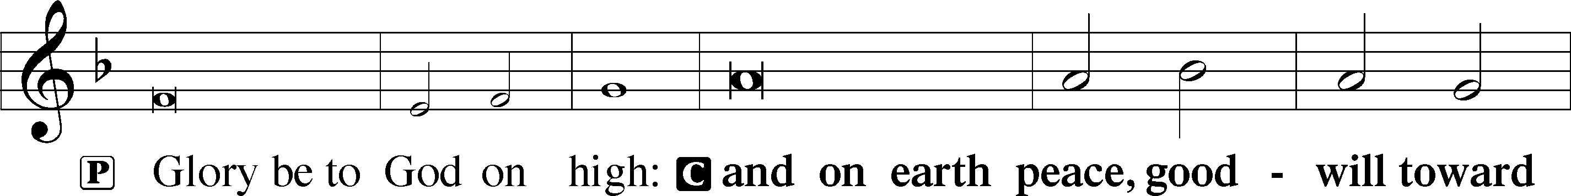

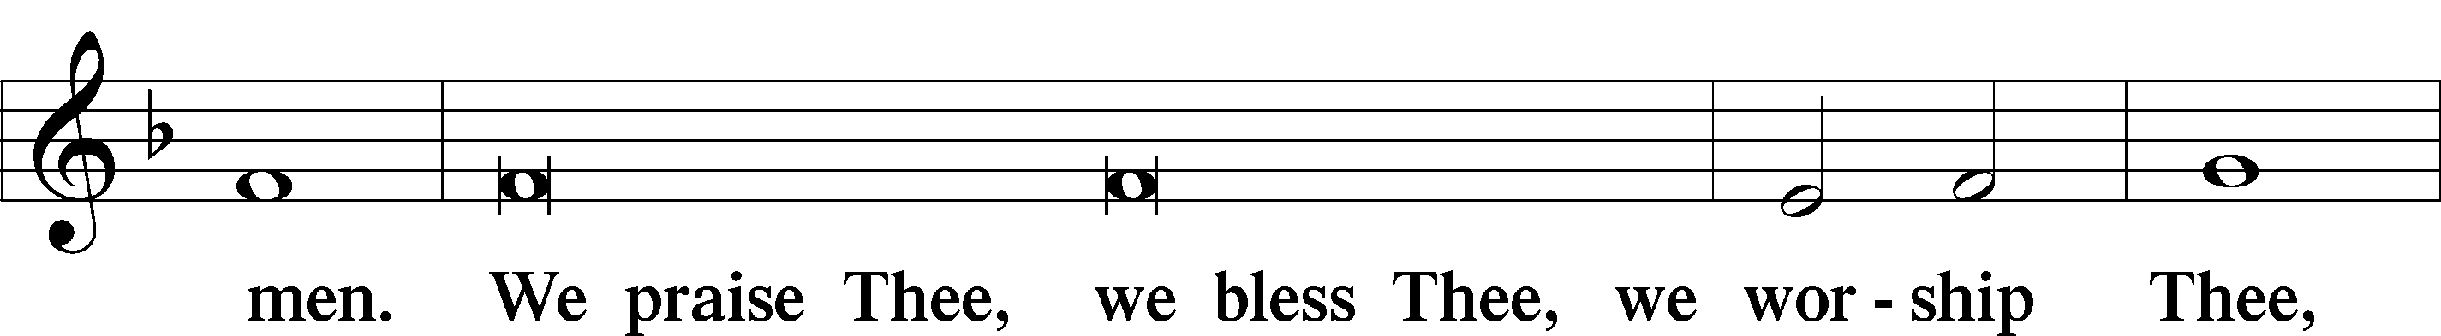

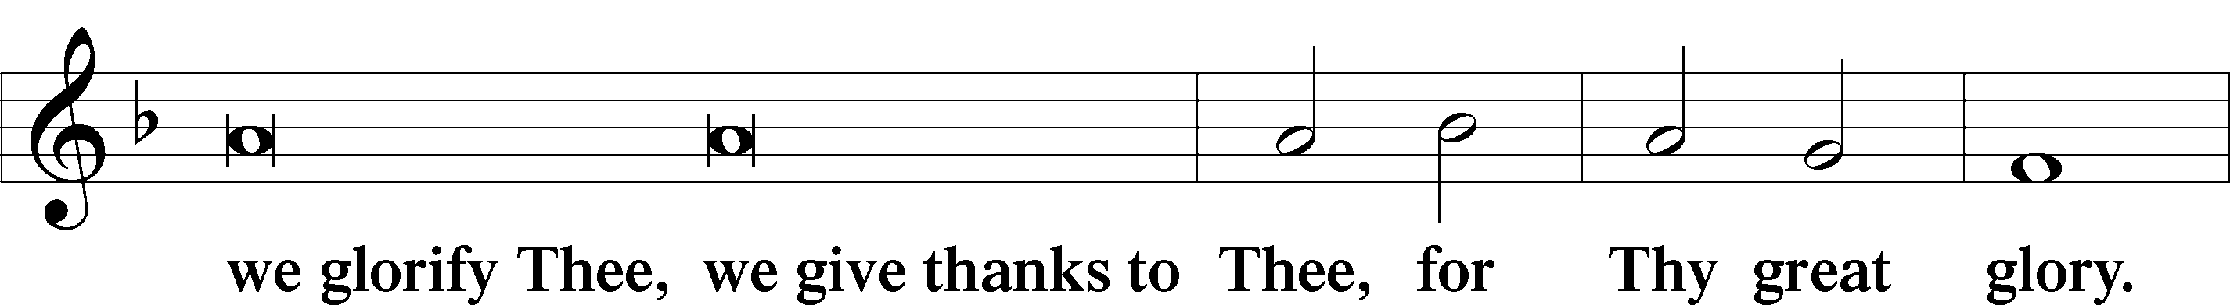

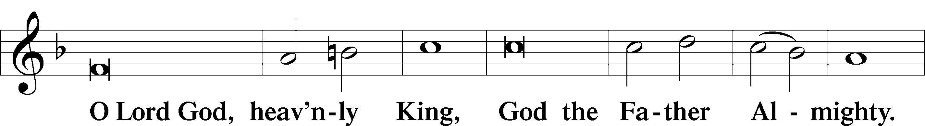

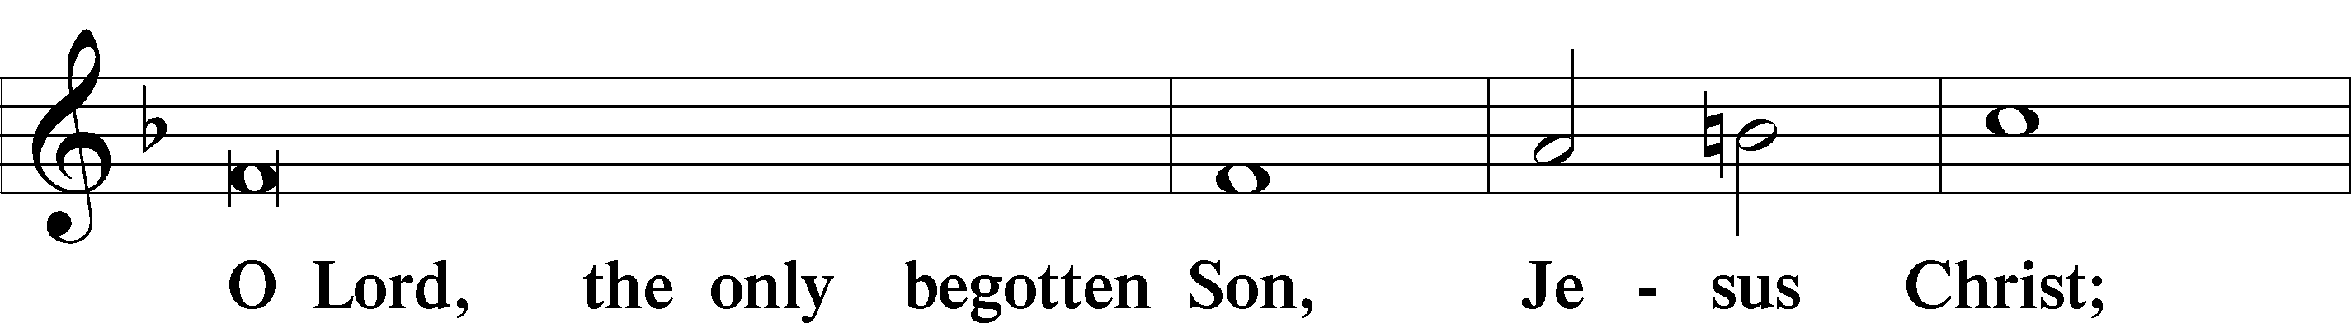

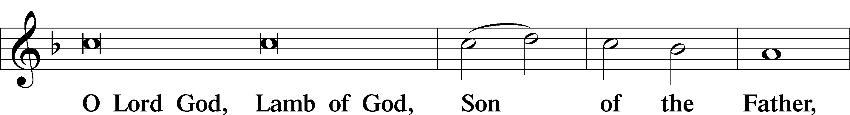

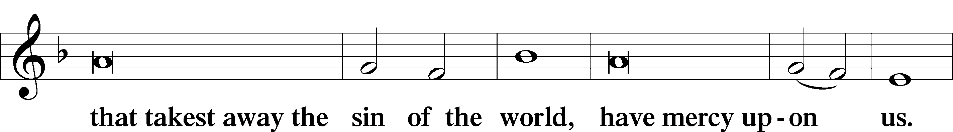

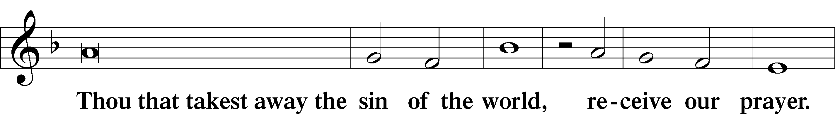

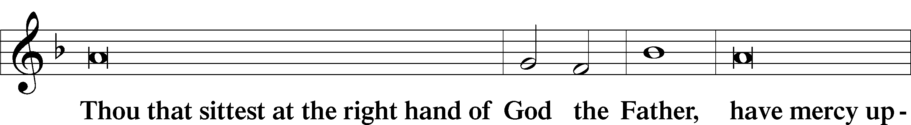

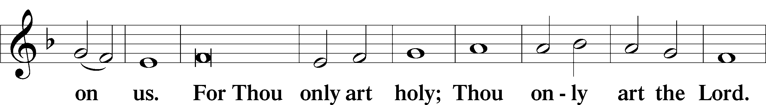

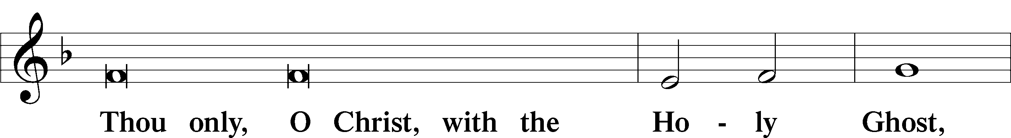

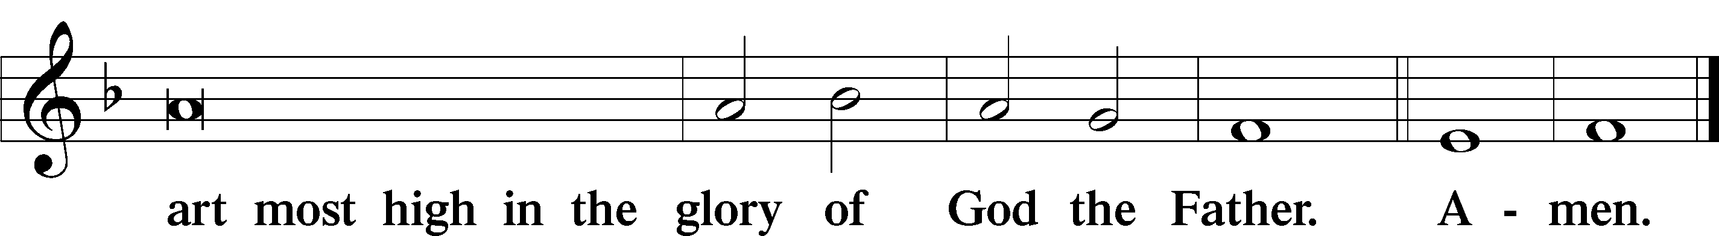

Salutation and Collect of the Day

P The Lord be with you.

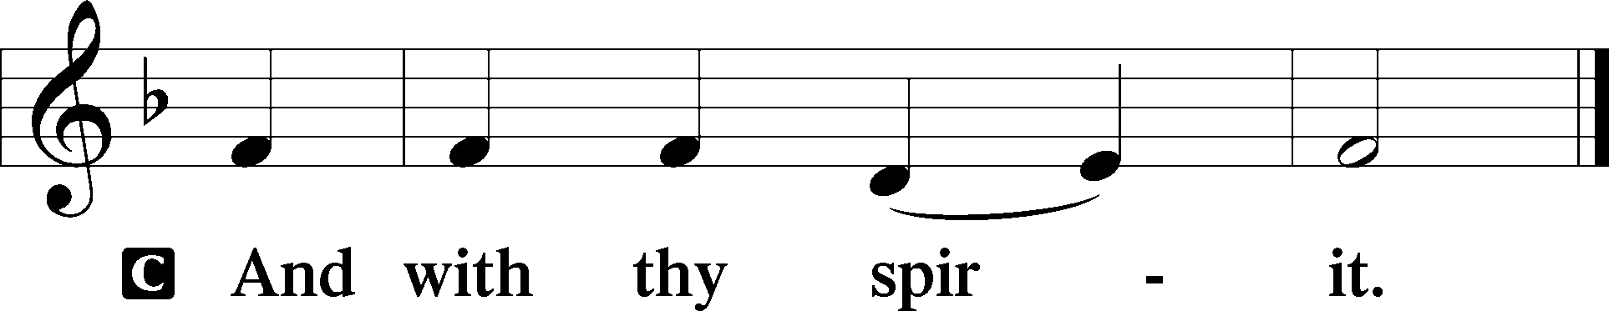

P Let us pray.

Almighty God, by the working of Your Holy Spirit, grant that we may gladly hear Your Word proclaimed among us and follow its directing; through Jesus Christ, Your Son, our Lord, who lives and reigns with You and the Holy Spirit, one God, now and forever.

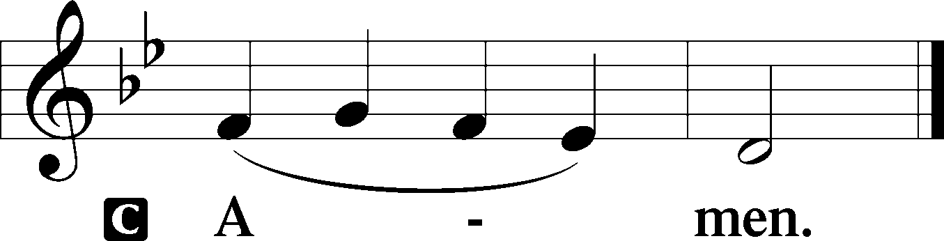

Sit

Old Testament Reading Jeremiah 28:5–9

5Then the prophet Jeremiah spoke to Hananiah the prophet in the presence of the priests and all the people who were standing in the house of the Lord, 6and the prophet Jeremiah said, “Amen! May the Lord do so; may the Lord make the words that you have prophesied come true, and bring back to this place from Babylon the vessels of the house of the Lord, and all the exiles. 7Yet hear now this word that I speak in your hearing and in the hearing of all the people. 8The prophets who preceded you and me from ancient times prophesied war, famine, and pestilence against many countries and great kingdoms. 9As for the prophet who prophesies peace, when the word of that prophet comes to pass, then it will be known that the Lord has truly sent the prophet.”

A This is the Word of the Lord.

C **Thanks be to God.**

Gradual Romans 11:33, 36

Oh, the depth of the riches and wisdom and knowledge of God!  
 How unsearchable are his judgments and how inscrutable his ways!  
**For from him and through him and to him are all things.  
 To him be glory forever. Amen.**

Epistle Romans 7:1–13

Released from the Law

1Or do you not know, brothers—for I am speaking to those who know the law—that the law is binding on a person only as long as he lives? 2Thus a married woman is bound by law to her husband while he lives, but if her husband dies she is released from the law of marriage. 3Accordingly, she will be called an adulteress if she lives with another man while her husband is alive. But if her husband dies, she is free from that law, and if she marries another man she is not an adulteress.

4Likewise, my brothers, you also have died to the law through the body of Christ, so that you may belong to another, to him who has been raised from the dead, in order that we may bear fruit for God. 5For while we were living in the flesh, our sinful passions, aroused by the law, were at work in our members to bear fruit for death. 6But now we are released from the law, having died to that which held us captive, so that we serve not under the old written code but in the new life of the Spirit.

The Law and Sin

7What then shall we say? That the law is sin? By no means! Yet if it had not been for the law, I would not have known sin. I would not have known what it is to covet if the law had not said, “You shall not covet.” 8But sin, seizing an opportunity through the commandment, produced in me all kinds of covetousness. Apart from the law, sin lies dead. 9I was once alive apart from the law, but when the commandment came, sin came alive and I died. 10The very commandment that promised life proved to be death to me. 11For sin, seizing an opportunity through the commandment, deceived me and through it killed me. 12So the law is holy, and the commandment is holy and righteous and good.

13Did that which is good, then, bring death to me? By no means! It was sin, producing death in me through what is good, in order that sin might be shown to be sin, and through the commandment might become sinful beyond measure.

A This is the Word of the Lord.

C **Thanks be to God.**

Stand

Alleluia

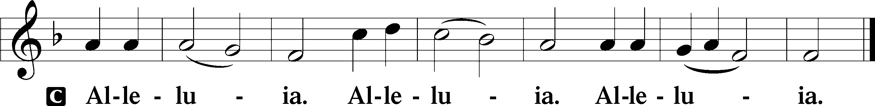

Holy Gospel Matthew 10:34–42

P The Holy Gospel according to St. Matthew, the tenth chapter.

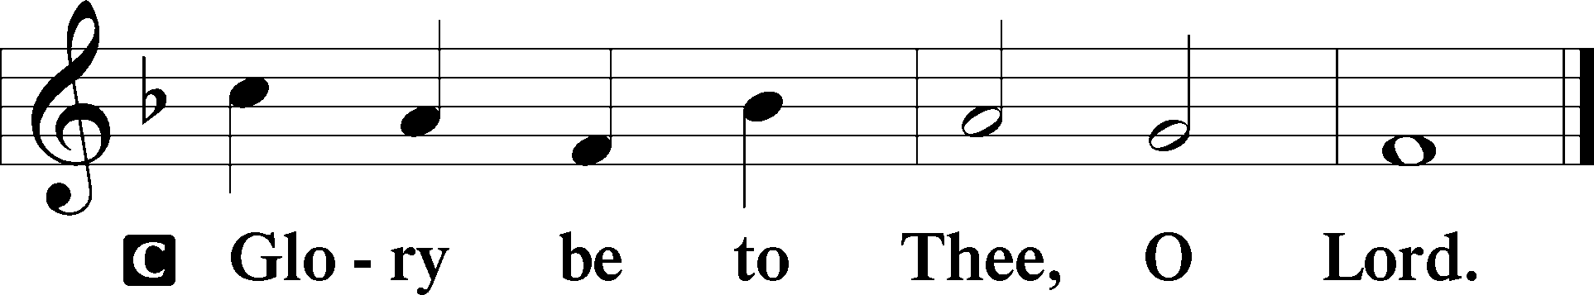

Not Peace, but a Sword

34[Jesus said:] “Do not think that I have come to bring peace to the earth. I have not come to bring peace, but a sword. 35For I have come to set a man against his father, and a daughter against her mother, and a daughter-in-law against her mother-in-law. 36And a person’s enemies will be those of his own household. 37Whoever loves father or mother more than me is not worthy of me, and whoever loves son or daughter more than me is not worthy of me. 38And whoever does not take his cross and follow me is not worthy of me. 39Whoever finds his life will lose it, and whoever loses his life for my sake will find it.

Rewards

40“Whoever receives you receives me, and whoever receives me receives him who sent me. 41The one who receives a prophet because he is a prophet will receive a prophet’s reward, and the one who receives a righteous person because he is a righteous person will receive a righteous person’s reward. 42And whoever gives one of these little ones even a cup of cold water because he is a disciple, truly, I say to you, he will by no means lose his reward.”

P This is the Gospel of the Lord.

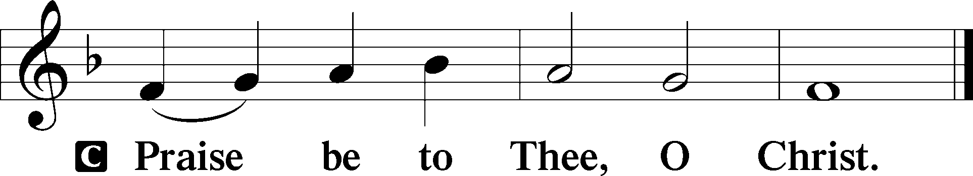

Nicene Creed

C **I believe in one God,**

**the Father Almighty,**

**maker of heaven and earth**

**and of all things visible and invisible.**

**And in one Lord Jesus Christ,**

**the only-begotten Son of God,**

**begotten of His Father before all worlds,**

**God of God, Light of Light,**

**very God of very God,**

**begotten, not made,**

**being of one substance with the Father,**

**by whom all things were made;**

**who for us men and for our salvation came down from heaven**

**and was incarnate by the Holy Spirit of the virgin Mary**

**and was made man;**

**and was crucified also for us under Pontius Pilate.**

**He suffered and was buried.**

**And the third day He rose again according to the Scriptures**

**and ascended into heaven**

**and sits at the right hand of the Father.**

**And He will come again with glory to judge both the living and the dead,**

**whose kingdom will have no end.**

**And I believe in the Holy Spirit,**

**the Lord and giver of life,**

**who proceeds from the Father and the Son,**

**who with the Father and the Son together is worshiped and glorified,**

**who spoke by the prophets.**

**And I believe in one holy Christian and apostolic Church,**

**I acknowledge one Baptism for the remission of sins,**

**and I look for the resurrection of the dead**

**and the life** T **of the world to come. Amen.**

Sit

Children's Message

685 Let Us Ever Walk with Jesus

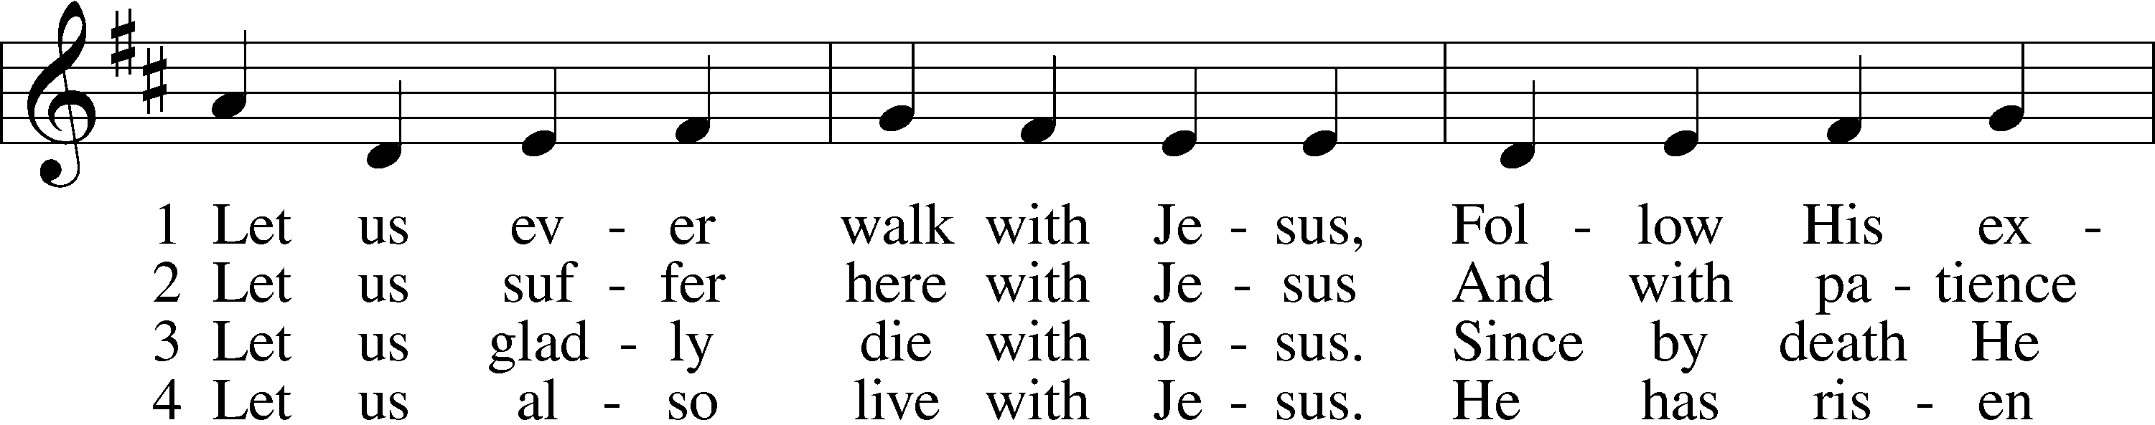

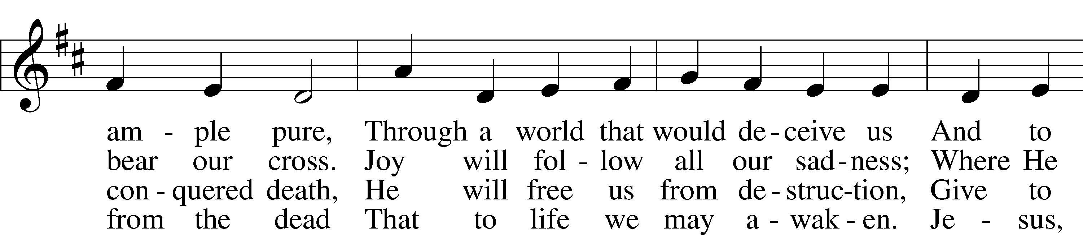

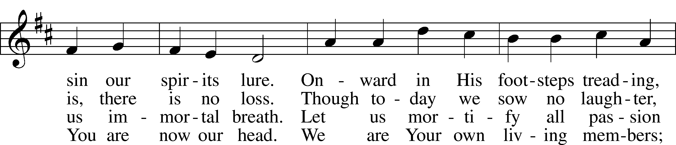

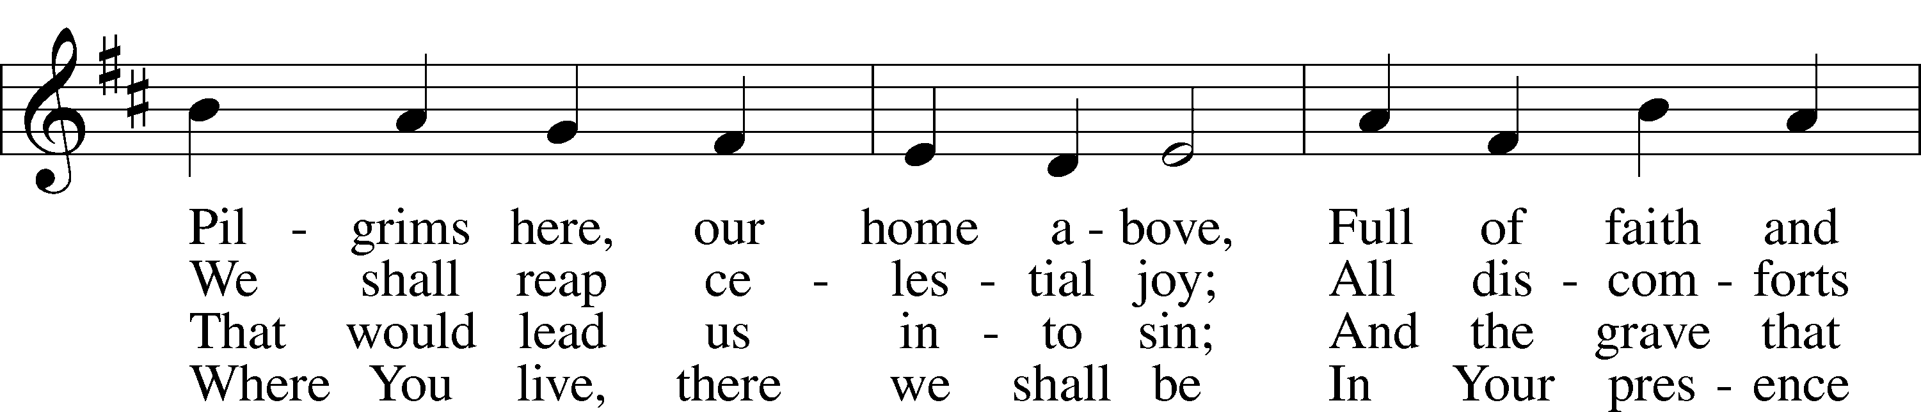

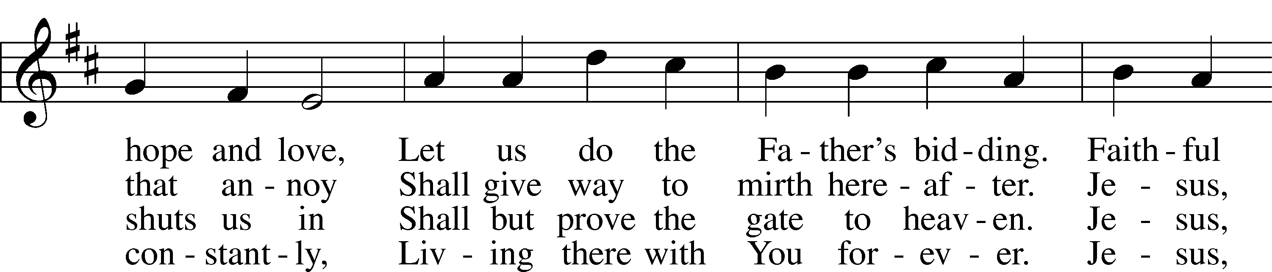

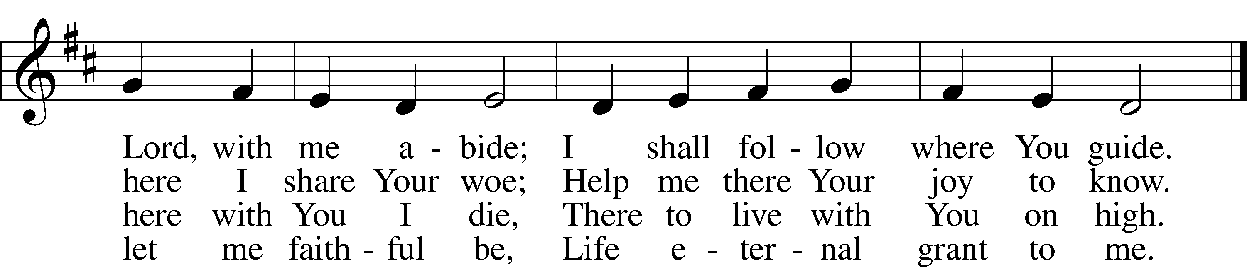

Text: Sigismund von Birken, 1626–81; tr. Lutheran Book of Worship, 1978, alt.  
Tune: Georg G. Boltze, 18th cent.  
Text: © 1978 Lutheran Book of Worship. Used by permission: LSB Hymn License no. 110005011  
Tune: Public domain

Sermon

Votum

P The peace of God, which passes all understanding, keep your hearts and minds in Christ Jesus.

C **Amen.**

Stand

Offertory Psalm 51:10–12

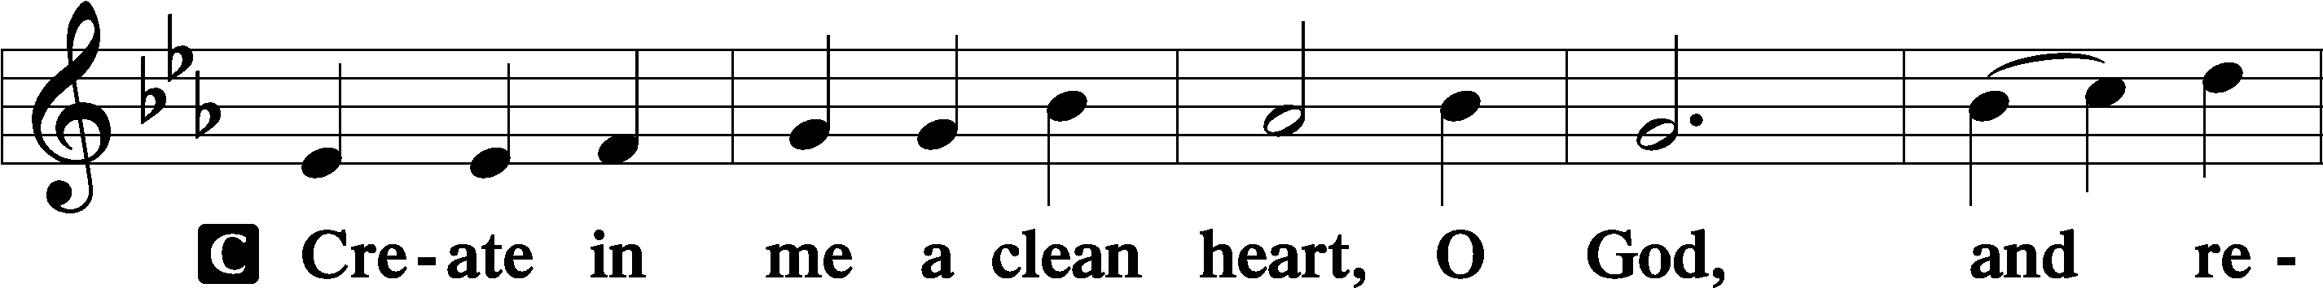

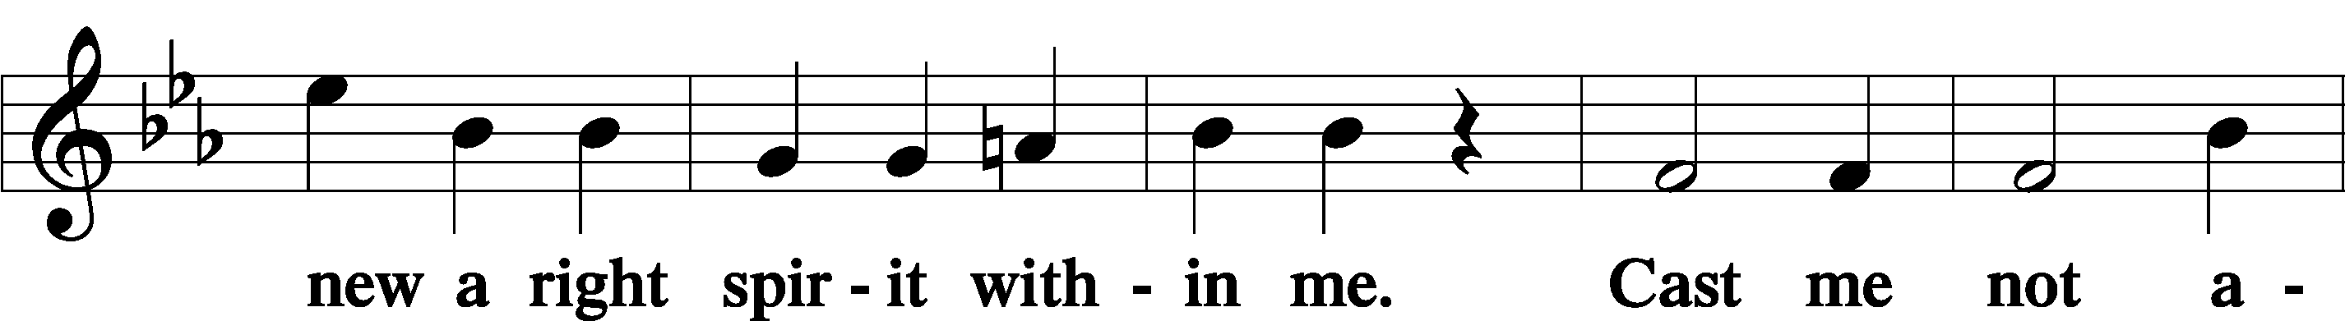

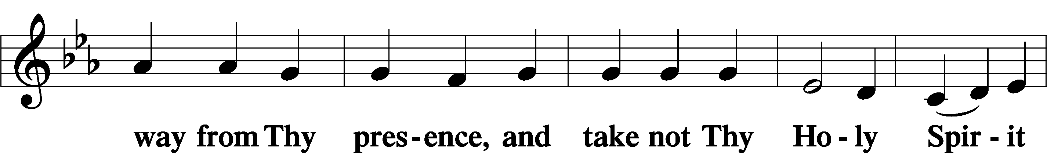

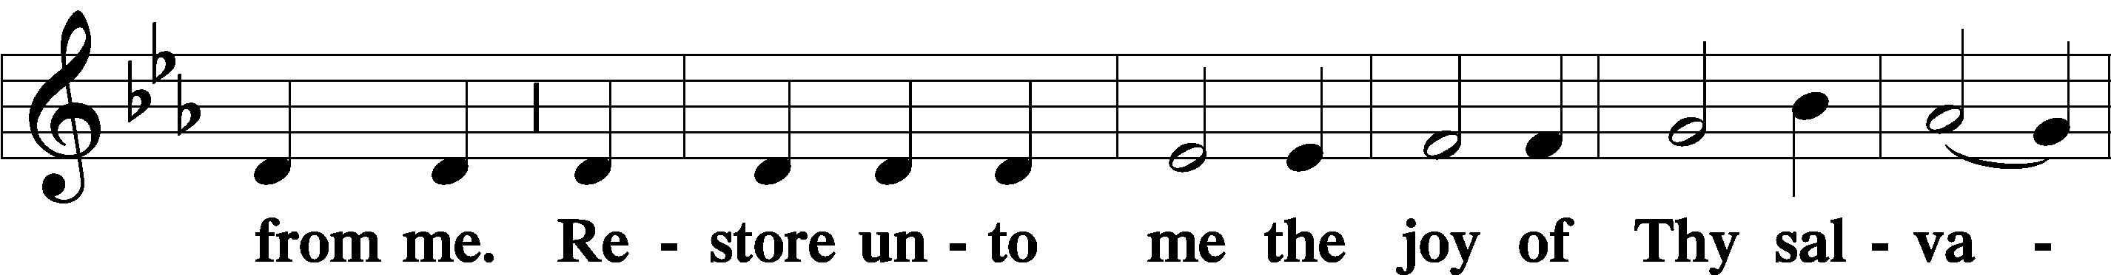

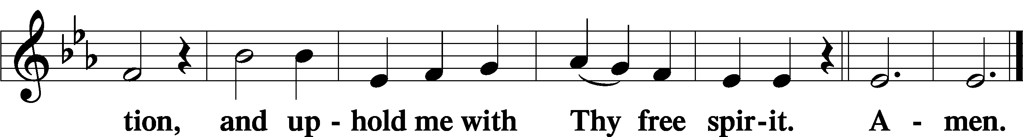

Sit

Offering

805 Praise God, from Whom All Blessings Flow

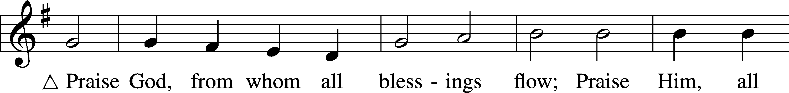

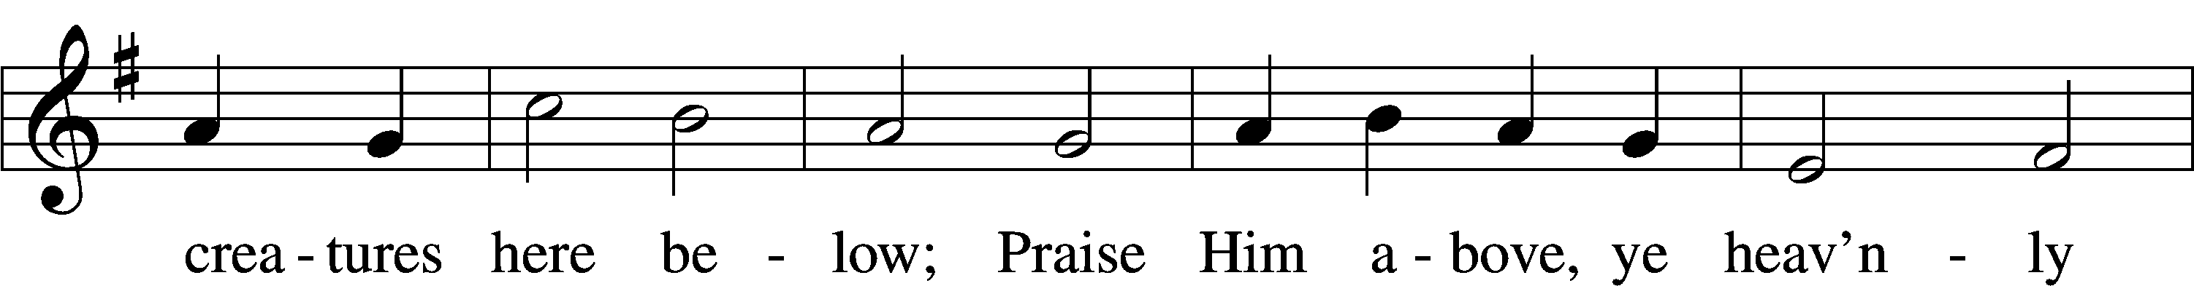

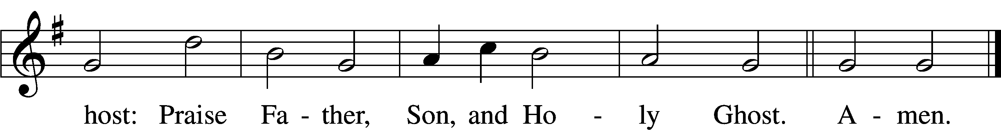

Text: Thomas Ken, 1637–1711  
Tune: Trente quatre Pseaumes de David, 1551, Geneva, ed. Louis Bourgeois  
Text and tune: Public domain

Stand

Prayer of the Church

# Service of the Sacrament

Preface 2 Timothy 4:22; [Colossians 3:1]; [Psalm 136]

P The Lord be with you.

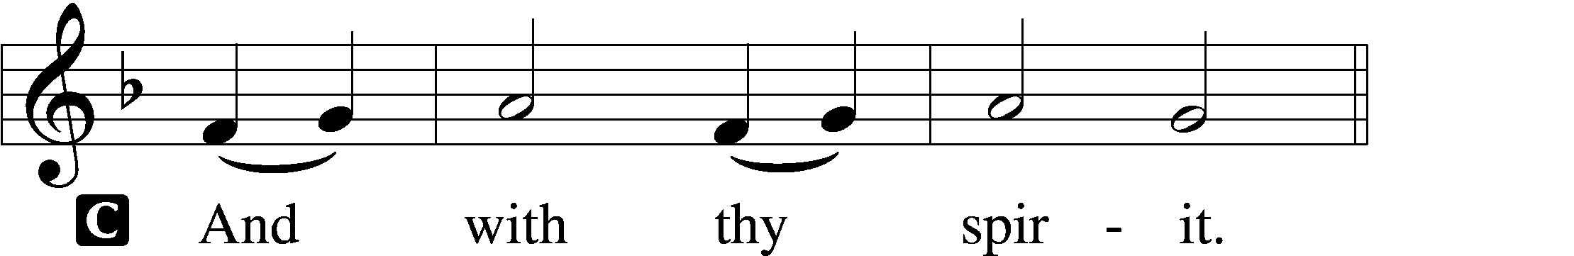

P Lift up your hearts.

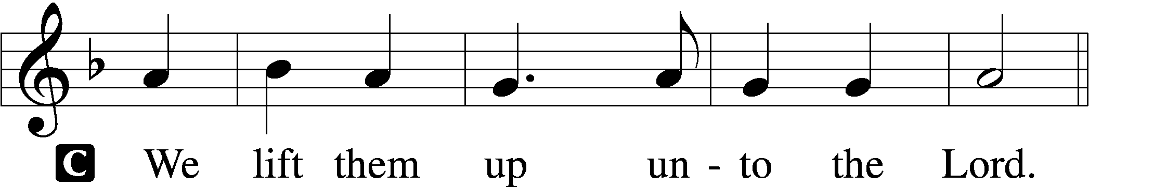

P Let us give thanks unto the Lord, our God.

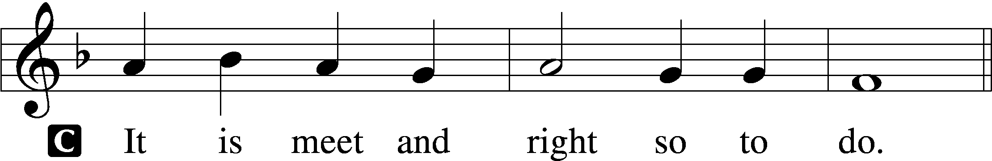

Proper Preface (Full)

P It is truly meet, right, and salutary that we should at all times and in all places give thanks to You, holy Lord, almighty Father, everlasting God, through Jesus Christ, our Lord, who, out of love for His fallen creation, humbled Himself by taking on the form of a servant, becoming obedient unto death, even death upon a cross. Risen from the dead, He has freed us from eternal death and given us life everlasting. Therefore with angels and archangels and with all the company of heaven we laud and magnify Your glorious name, evermore praising You and saying:

Sanctus Isaiah 6:3; Matthew 21:9

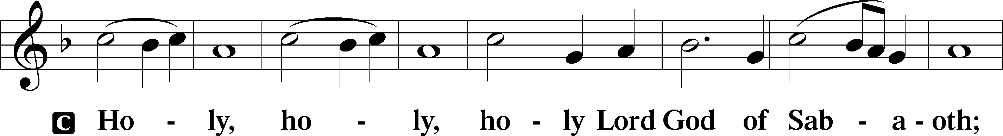

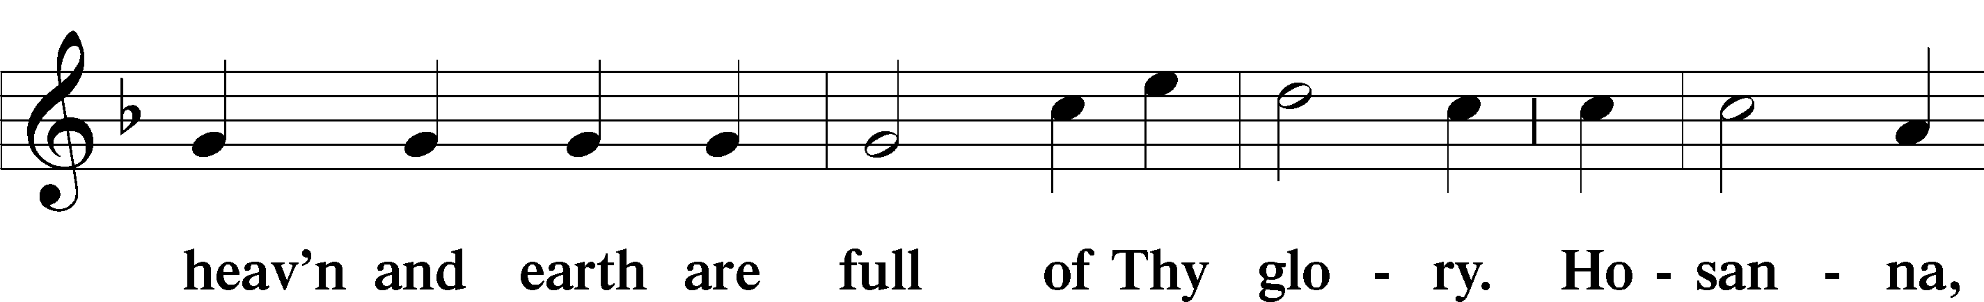

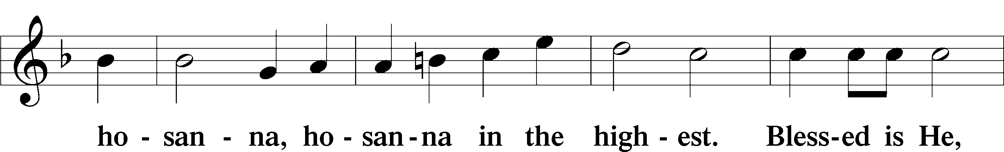

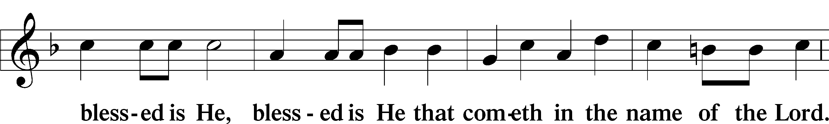

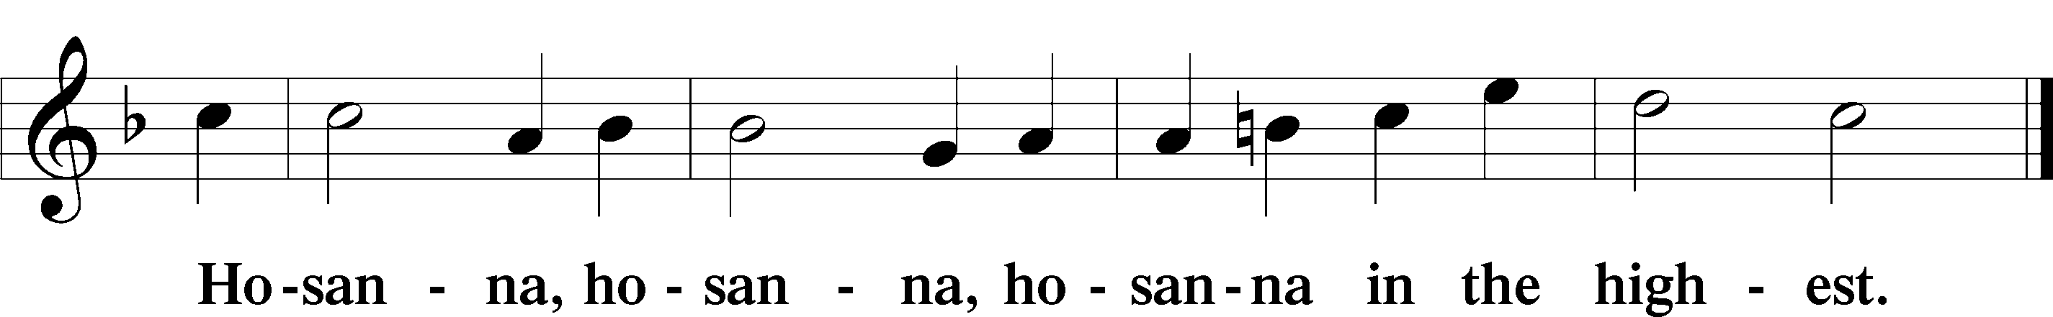

Lord’s Prayer Matthew 6:9–13

P Our Father who art in heaven,

hallowed be Thy name,

Thy kingdom come,

Thy will be done on earth as it is in heaven;

give us this day our daily bread;

and forgive us our trespasses as we forgive those who trespass against us;

and lead us not into temptation,

but deliver us from evil.

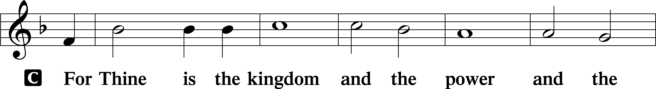

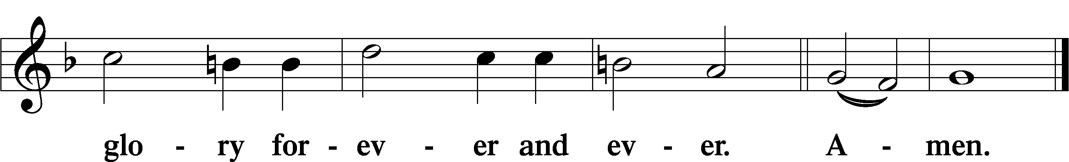

The Words of Our Lord Matthew 26:26–28; Mark 14:22–24; Luke 22:19–20; 1 Corinthians 11:23–25

P Our Lord Jesus Christ, on the night when He was betrayed, took bread, and when He had given thanks, He broke it and gave it to the disciples and said: “Take, eat; this is My T body, which is given for you. This do in remembrance of Me.”

In the same way also He took the cup after supper, and when He had given thanks, He gave it to them, saying: “Drink of it, all of you; this cup is the new testament in My T blood, which is shed for you for the forgiveness of sins. This do, as often as you drink it, in remembrance of Me.”

Pax Domini John 20:19

P The peace of the Lord be with you always.

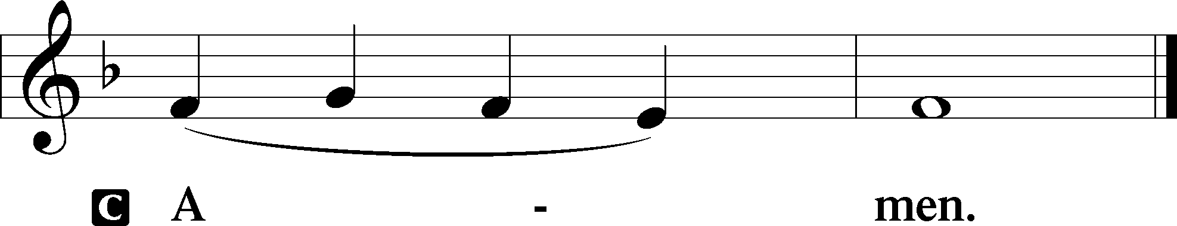

Agnus Dei John 1:29

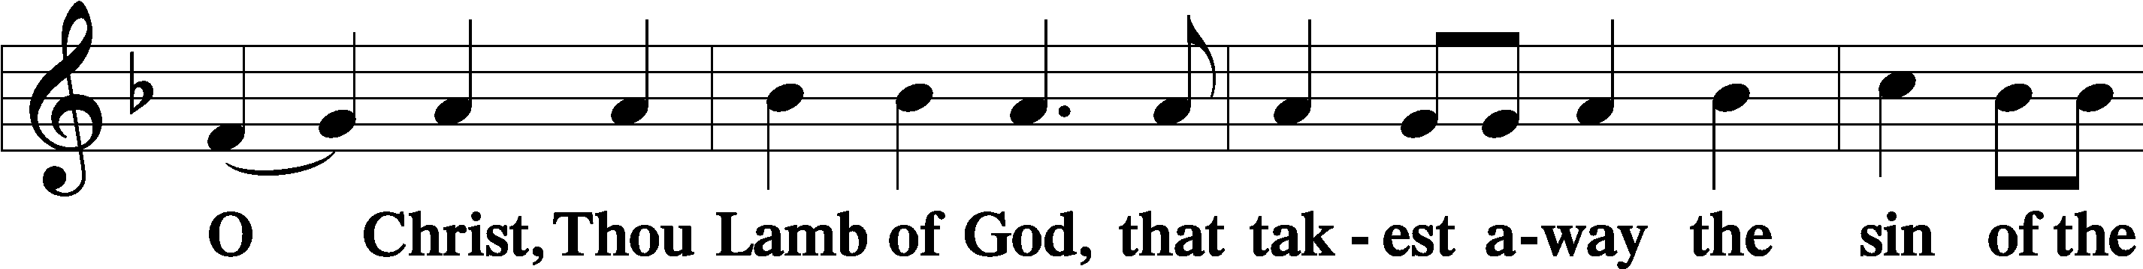

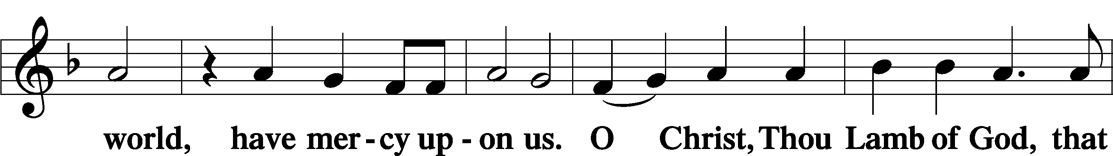

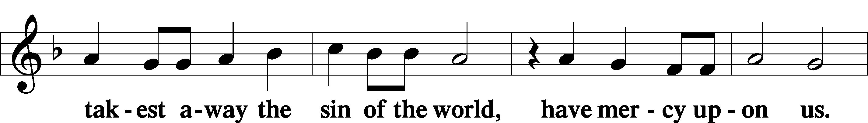

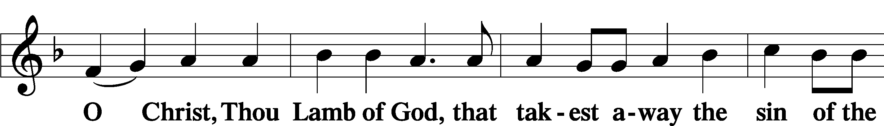

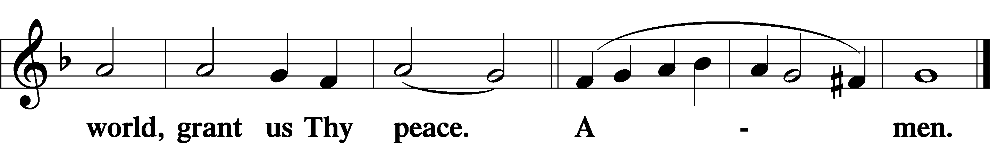

Sit

Distribution

628 Your Table I Approach

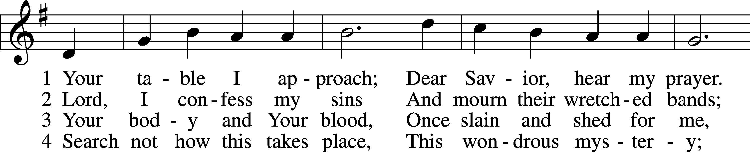

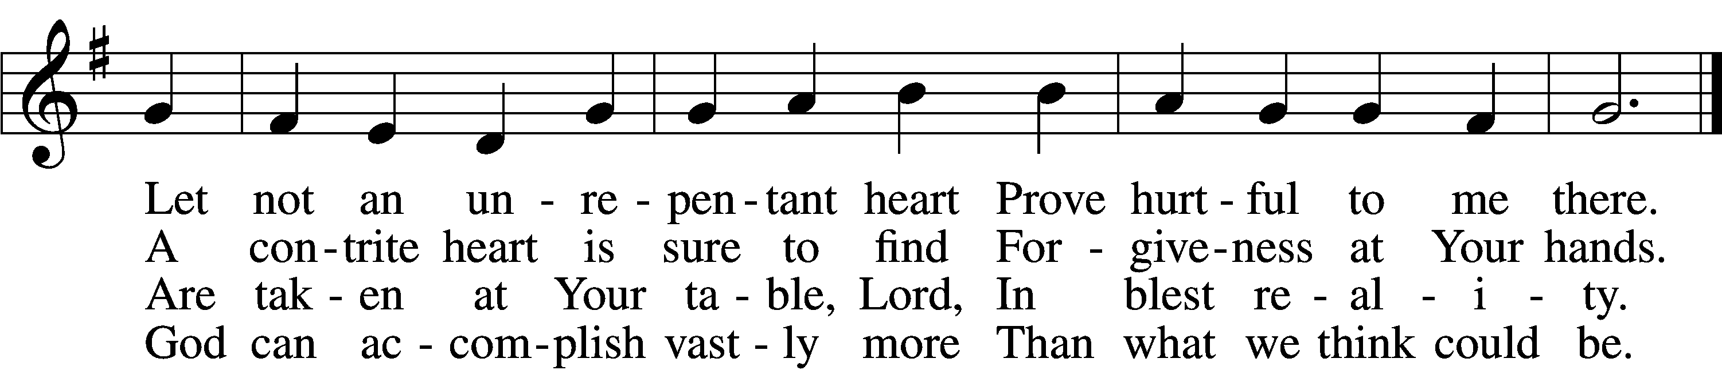

5 O grant, most blessèd Lord,  
 That earth and hell combined  
May not about this sacrament  
 Raise doubt within my mind.

6 Oh, may I never fail  
 To thank You day and night  
For Your true body and true blood,  
 O God, my peace and light.

Text: Gerhard Wolter Molanus, 1633–1722; tr. Matthias Loy, 1828–1915, alt.  
Tune: Trente quatre Pseaumes de David, 1551, Geneva, ed. Louis Bourgeois  
Text and tune: Public domain

620 Jesus Comes Today with Healing

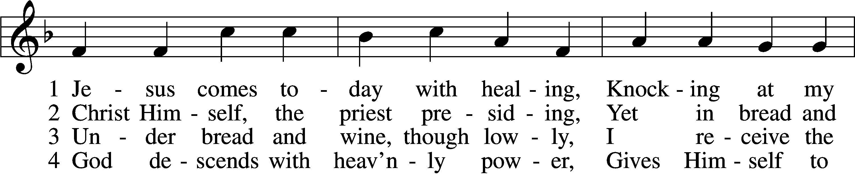

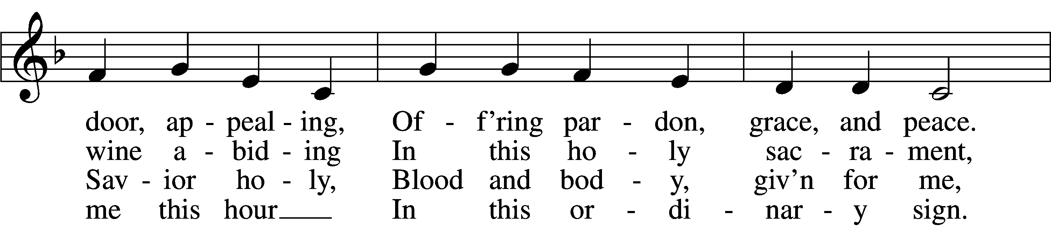

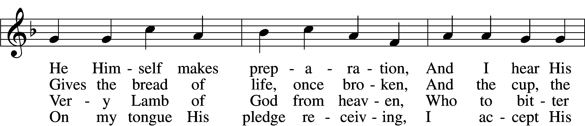

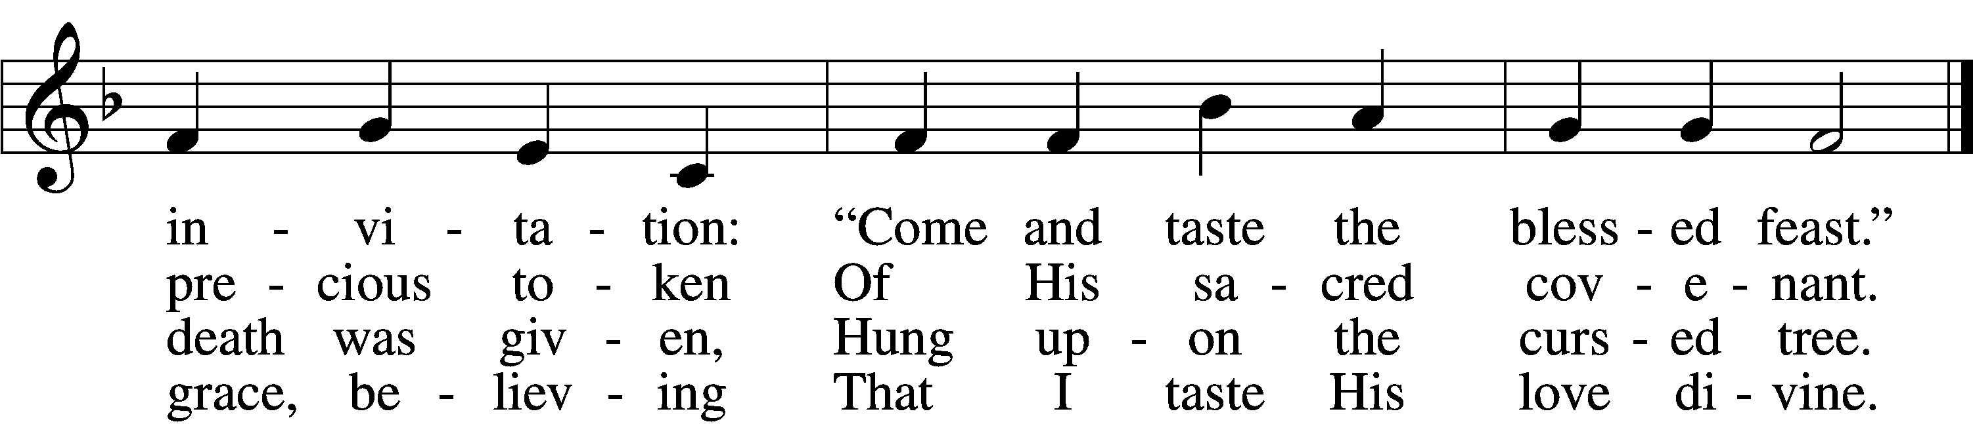

5 Let me praise God’s boundless favor,  
Whose own feast of love I savor,  
 Bidden by His gracious call.  
Wedding garments He provides me,  
With a robe of white He hides me,  
 Fits me for the royal hall.

6 Now have I found consolation,  
Comfort in my tribulation,  
 Balm to heal the troubled soul.  
God, my shield from ev’ry terror,  
Cleanses me from sin and error,  
 Makes my wounded spirit whole.

Text: Heinrich Puchta, 1808–58; tr. David W. Rogner, 1960  
Tune: Johann Löhner, 1645–1705; adapt. Johann Balthasar König, 1691–1758  
Text: © David W. Rogner. Used by permission: LSB Hymn License no. 110005011  
Tune: Public domain

940 Holy God, We Praise Thy Name sts. 1–5

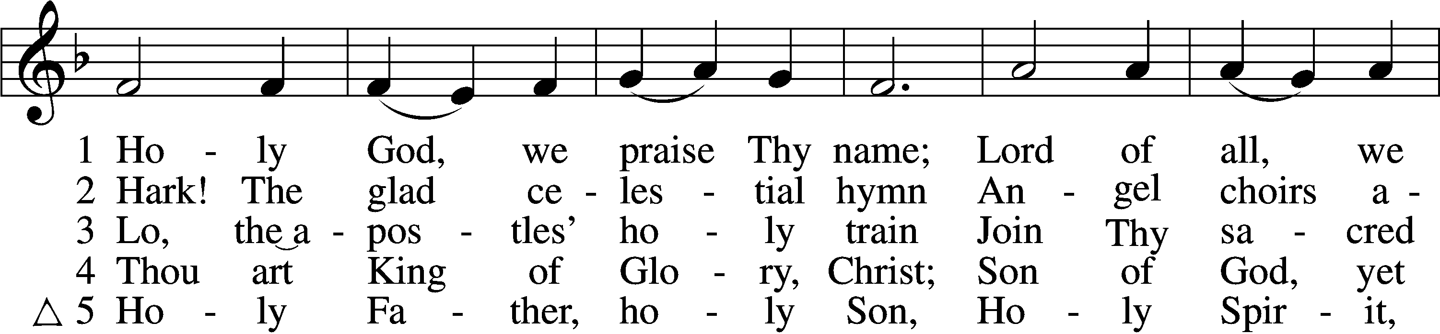

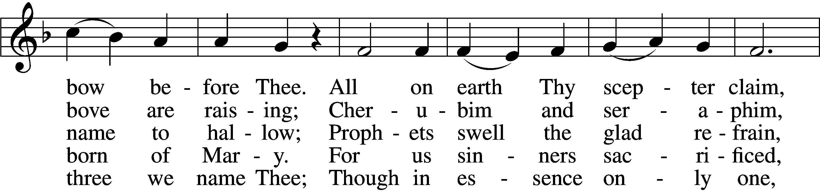

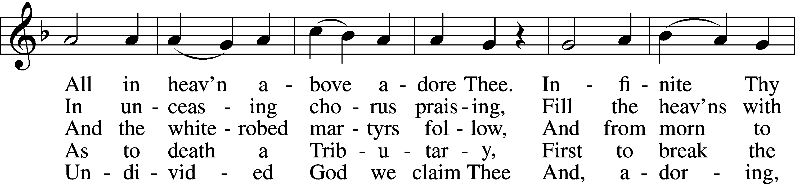

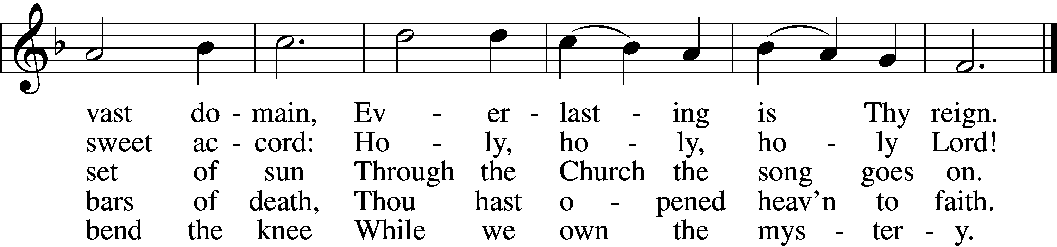

Text: Latin, c. 4th cent.; German version Katholisches Gesangbuch, 1774, Vienna; tr. Clarence A. Walworth, 1820–1900, alt.  
Tune: Katholisches Gesangbuch, 1774, Vienna  
Text and tune: Public domain

933 My Soul Rejoices

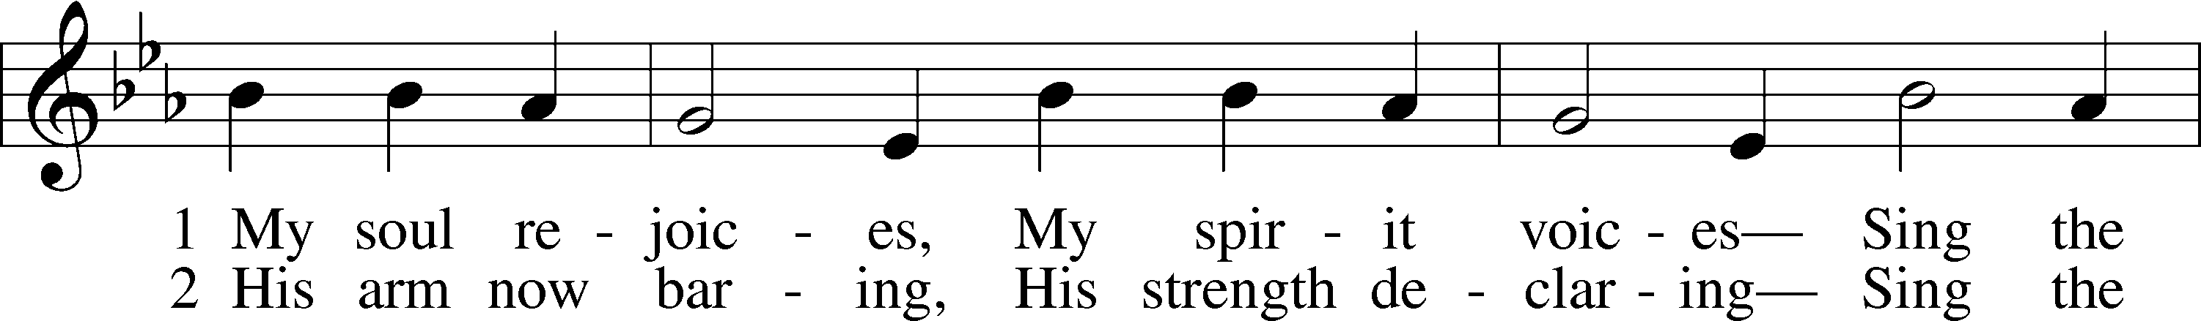

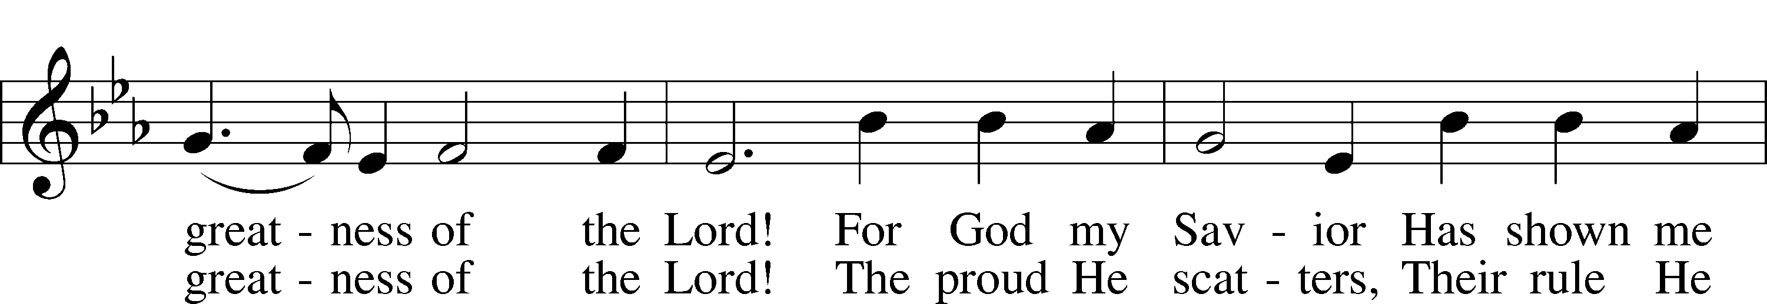

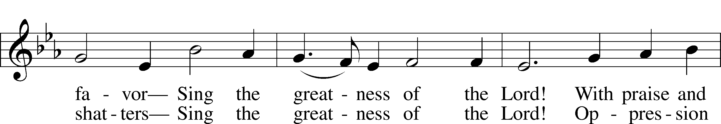

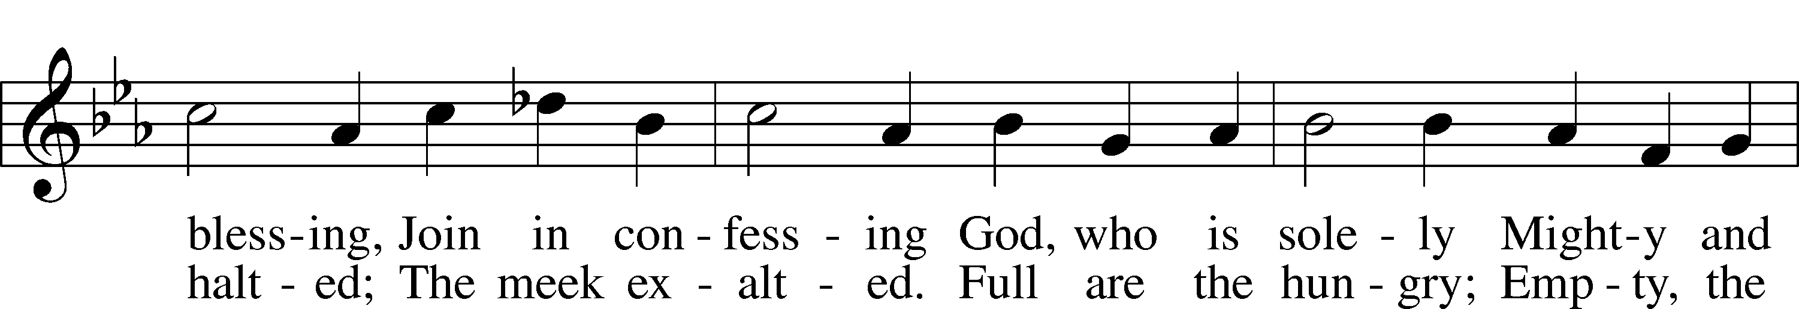

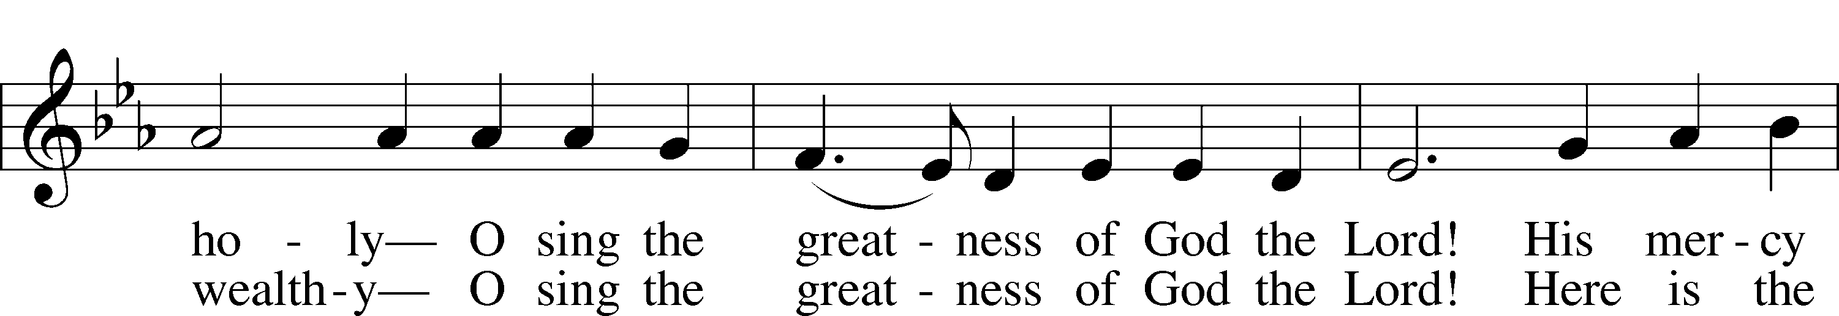

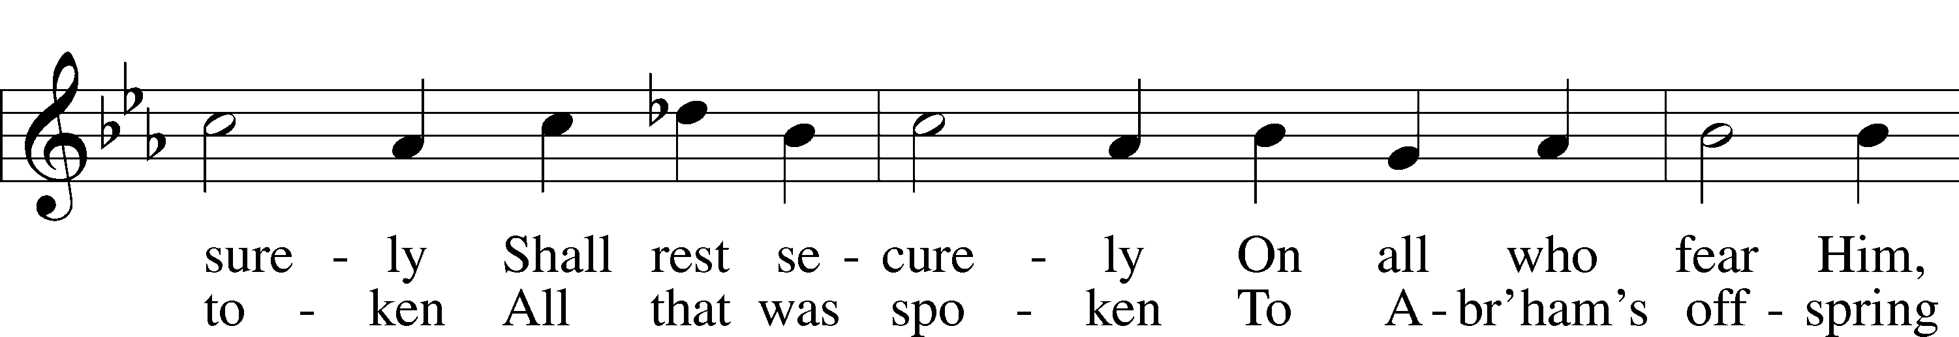

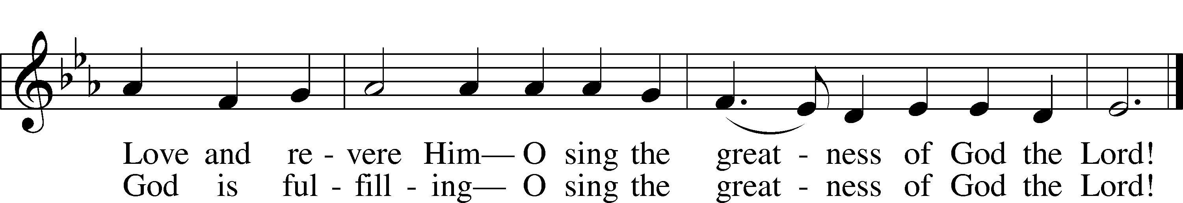

Text: Stephen P. Starke, 1955  
Tune: Giovanni Giacomo Gastoldi, c. 1556–c. 1622  
Text: © 1991 Stephen P. Starke, admin. Concordia Publishing House. Used by permission: LSB Hymn License no. 110005011  
Tune: Public domain

Stand

The Dismissal

P The body and blood of our Lord Jesus Christ strengthen and preserve you in body and soul to life everlasting. Depart T in peace.

C **Amen.**

Nunc Dimittis Luke 2:29–32

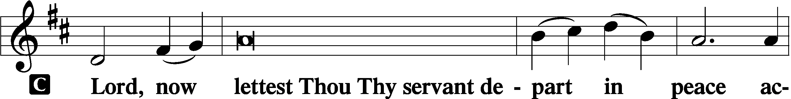

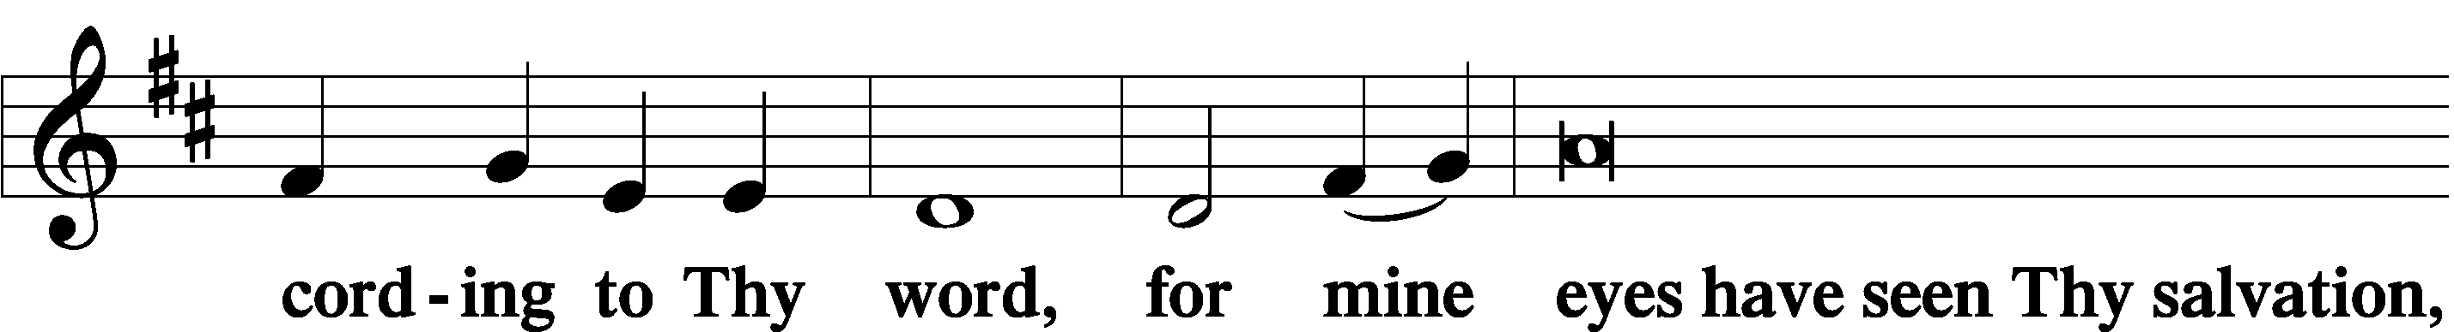

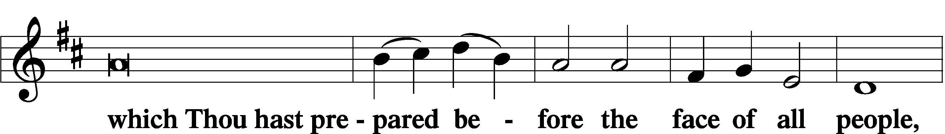

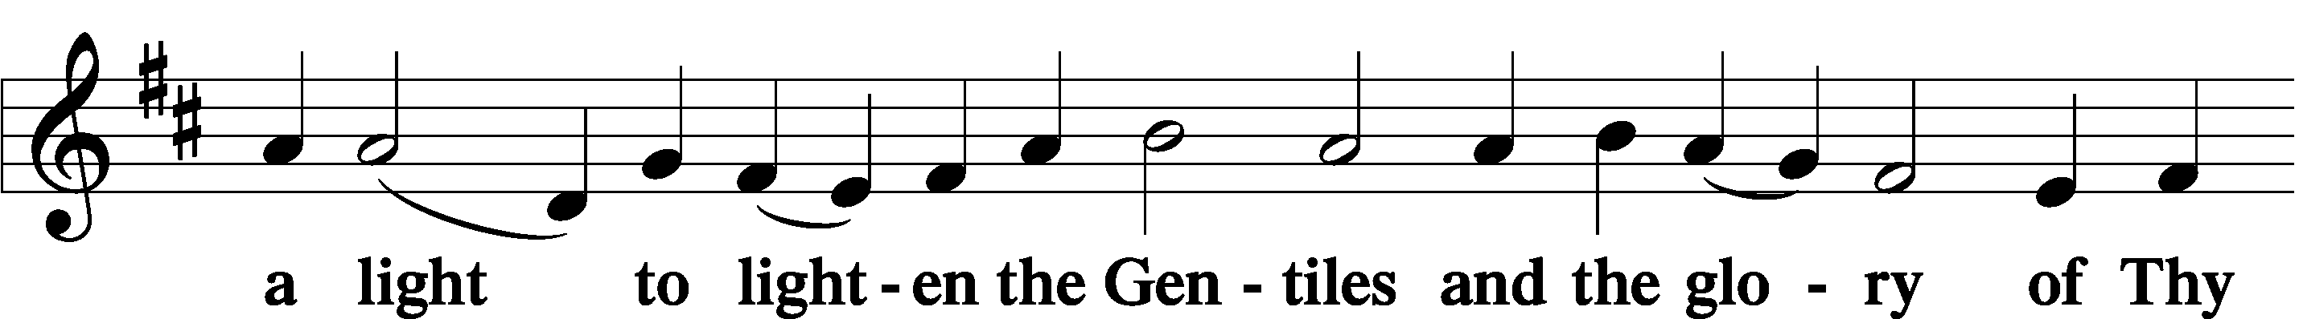

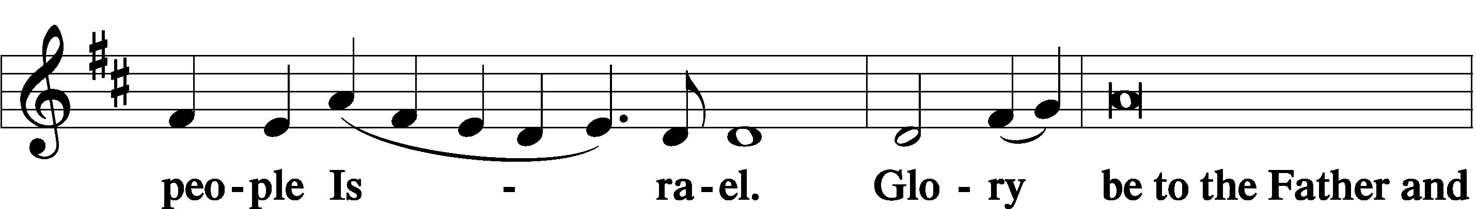

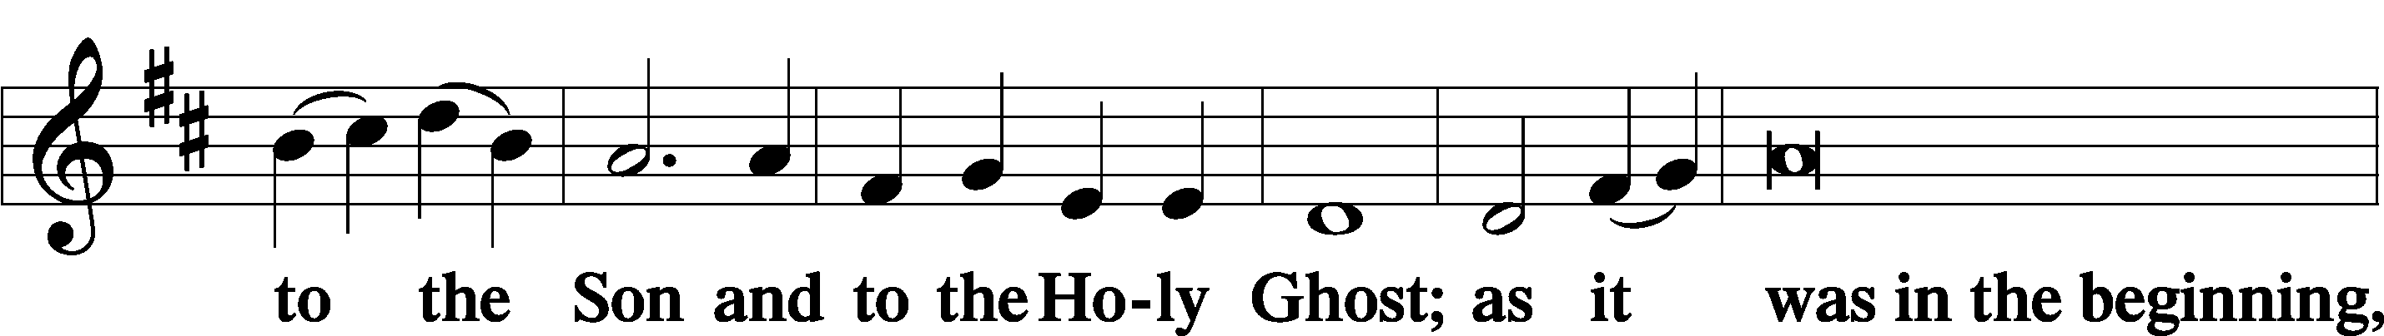

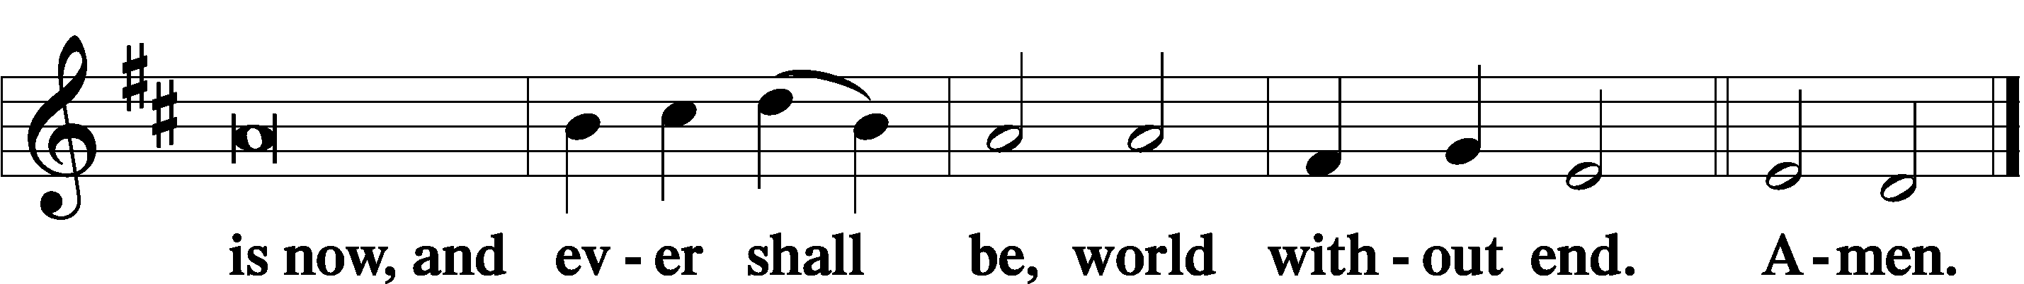

Thanksgiving Psalm 107:1

A O give thanks unto the Lord, for He is good,

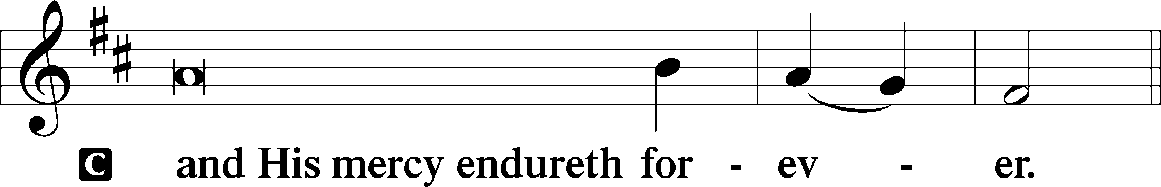

Post-Communion Collect

A Let us pray.

We give thanks to You, almighty God, that You have refreshed us through this salutary gift, and we implore You that of Your mercy You would strengthen us through the same in faith toward You and in fervent love toward one another; through Jesus Christ, Your Son, our Lord, who lives and reigns with You and the Holy Spirit, one God, now and forever.

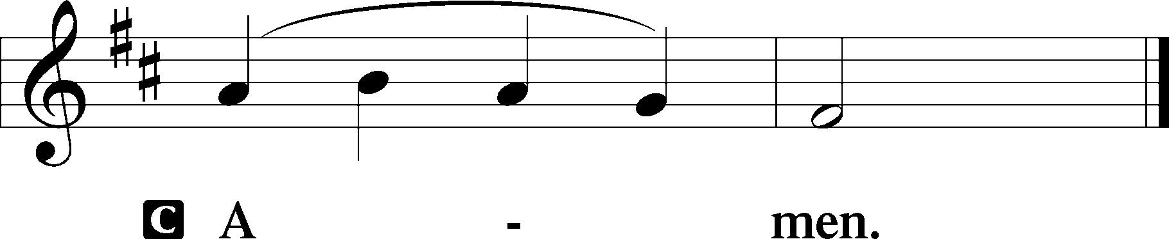

Salutation 2 Timothy 4:22

P The Lord be with you.

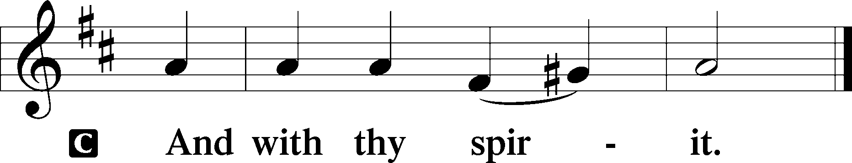

Benedicamus Psalm 103:1

A Bless we the Lord.

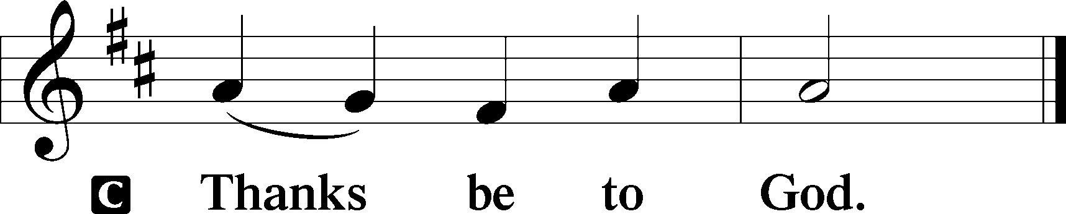

Benediction Numbers 6:24–26

P The Lord bless you and keep you.

The Lord make His face shine upon you and be gracious unto you.

The Lord lift up His countenance upon you and T give you peace.

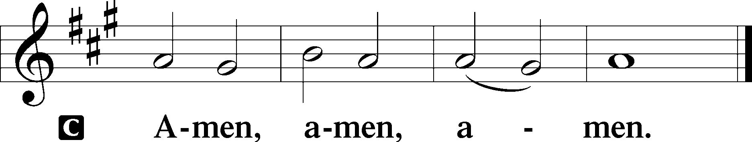

863 Our Father, by Whose Name

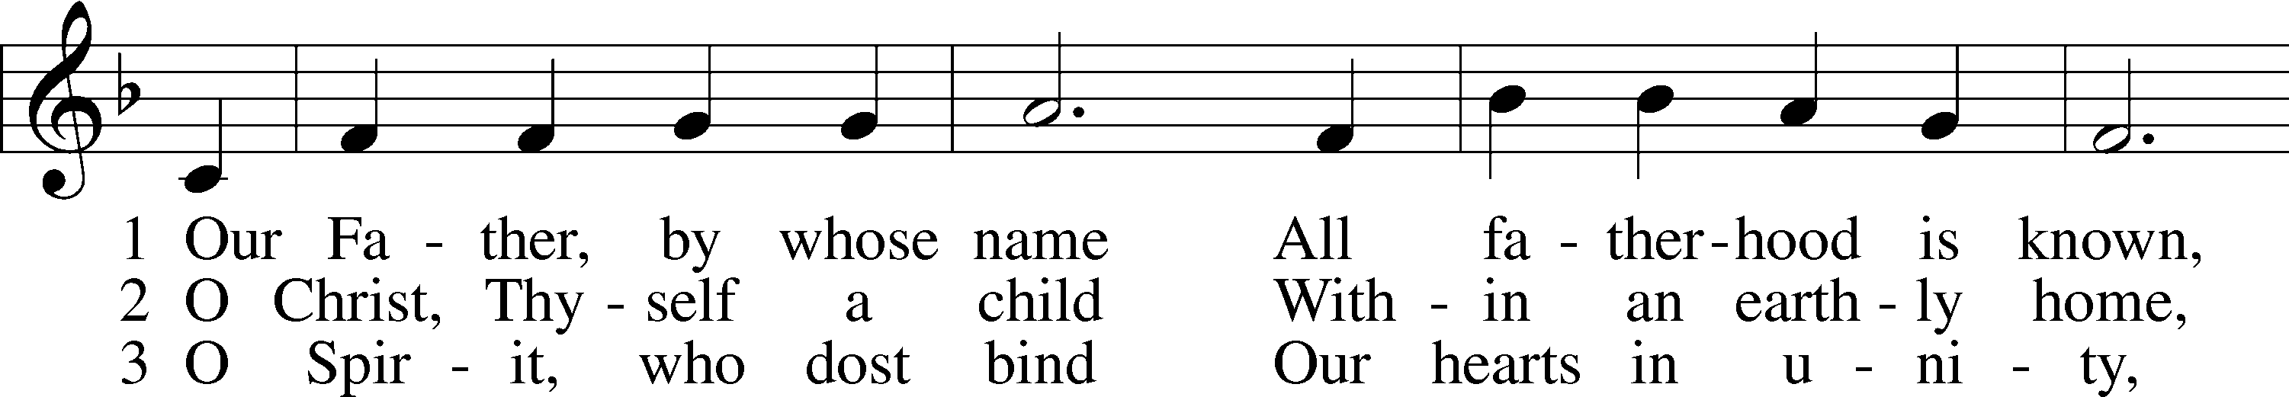

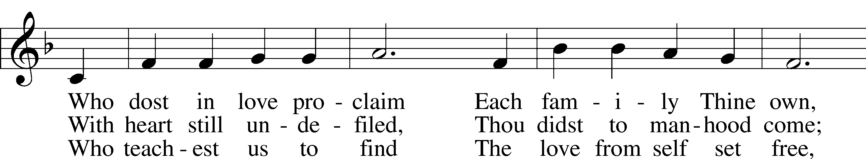

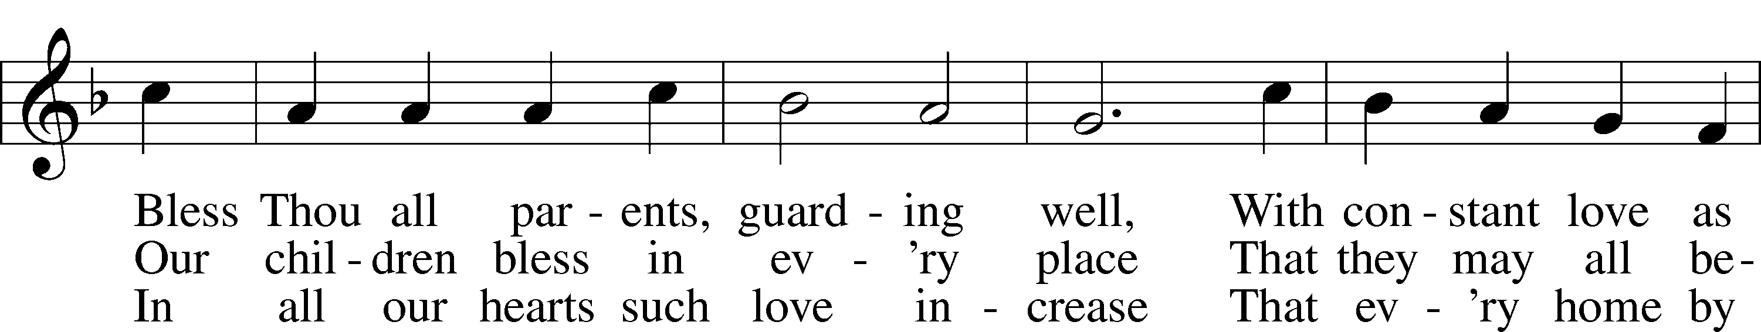

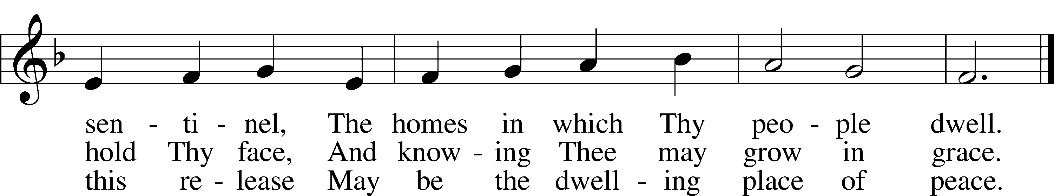

Text: F. Bland Tucker, 1895–1984  
Tune: John D. Edwards, 1805–85  
Text: © The Church Pension Fund. Used by permission: LSB Hymn License no. 110005011  
Tune: Public domain

Acknowledgments

Divine Service, Setting Three from Lutheran Service Book

Unless otherwise indicated, Scripture quotations are from the ESV® Bible (The Holy Bible, English Standard Version®), copyright © 2001 by Crossway, a publishing ministry of Good News Publishers. Used by permission. All rights reserved.

Created by Lutheran Service Builder © 2023 Concordia Publishing House.