# Confession and Absolution

907 God Himself Is Present

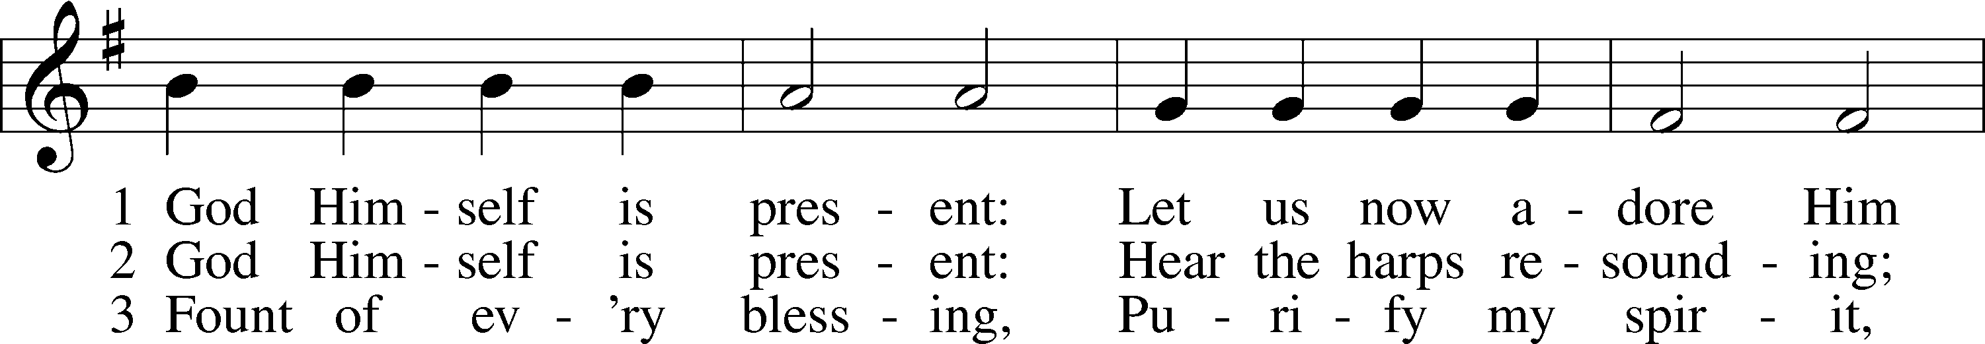

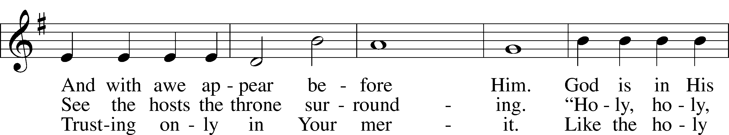

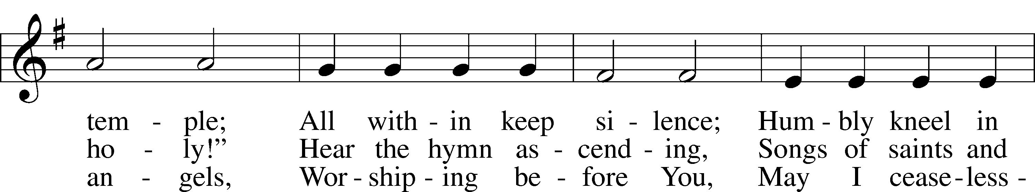

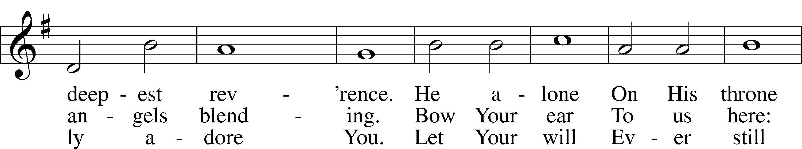

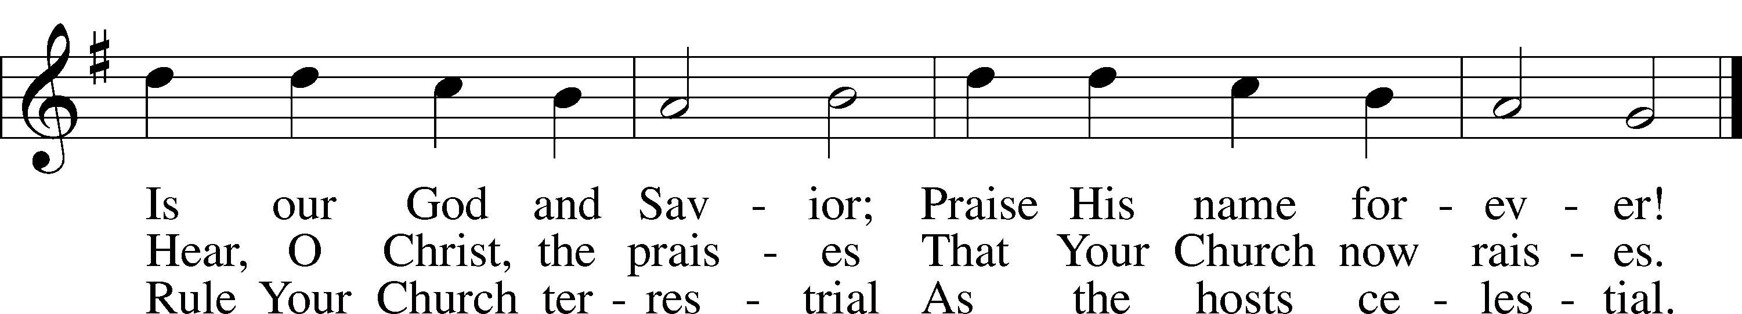

Text: Gerhard Tersteegen, 1697–1769, abr.; tr. Frederick W. Foster, 1760–1835, alt.; tr. John Miller, 1756–90, alt.  
Tune: Joachim Neander, 1650–80  
Text and tune: Public domain

Stand

The sign of the cross may be made by all in remembrance of their Baptism.

Invocation Matthew 28:19b; 18:20

P In the name of the Father and of the T Son and of the Holy Spirit.

C **Amen.**

Exhortation Hebrews 10:22; Psalm 124:8; Psalm 32:5

P Beloved in the Lord! Let us draw near with a true heart and confess our sins unto God our Father, beseeching Him in the name of our Lord Jesus Christ to grant us forgiveness.

P Our help is in the name of the Lord,

C **who made heaven and earth.**

P I said, I will confess my transgressions unto the Lord,

C **and You forgave the iniquity of my sin.**

Kneel/Stand

Silence for reflection on God’s Word and for self-examination.

Confession of Sins

P O almighty God, merciful Father,

C **I, a poor, miserable sinner, confess unto You all my sins and iniquities with which I have ever offended You and justly deserved Your temporal and eternal punishment. But I am heartily sorry for them and sincerely repent of them, and I pray You of Your boundless mercy and for the sake of the holy, innocent, bitter sufferings and death of Your beloved Son, Jesus Christ, to be gracious and merciful to me, a poor, sinful being.**

Absolution [John 20:19–23]

P Upon this your confession, I, by virtue of my office, as a called and ordained servant of the Word, announce the grace of God unto all of you, and in the stead and by the command of my Lord Jesus Christ I forgive you all your sins in the name of the Father and of the T Son and of the Holy Spirit.

C **Amen.**

Stand

# Service of the Word

Introit Psalm 105:2–6; antiphon: v. 1

Oh give thanks to the Lord; call up on his name;  
 make known his deeds among the peoples!  
Sing to him, sing praises to him;  
 tell of all his wondrous works!  
Glory in his holy name;  
 let the hearts of those who seek the Lord rejoice!  
Seek the Lord and his strength;  
 seek his presence continually!  
Remember the wondrous works that he has done,  
 his miracles, and the judgments he uttered,  
O offspring of Abraham, his servant,  
 children of Jacob, his chosen ones!

Gloria Patri

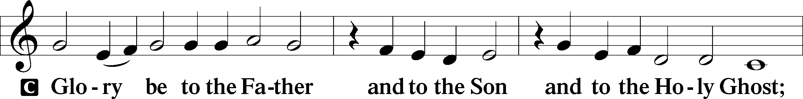

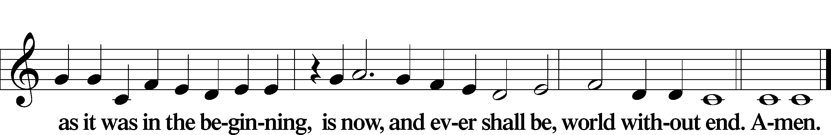

Kyrie Mark 10:47

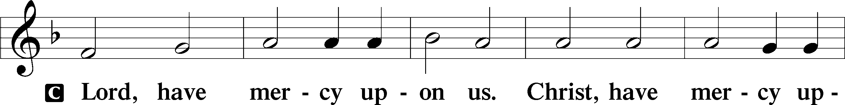

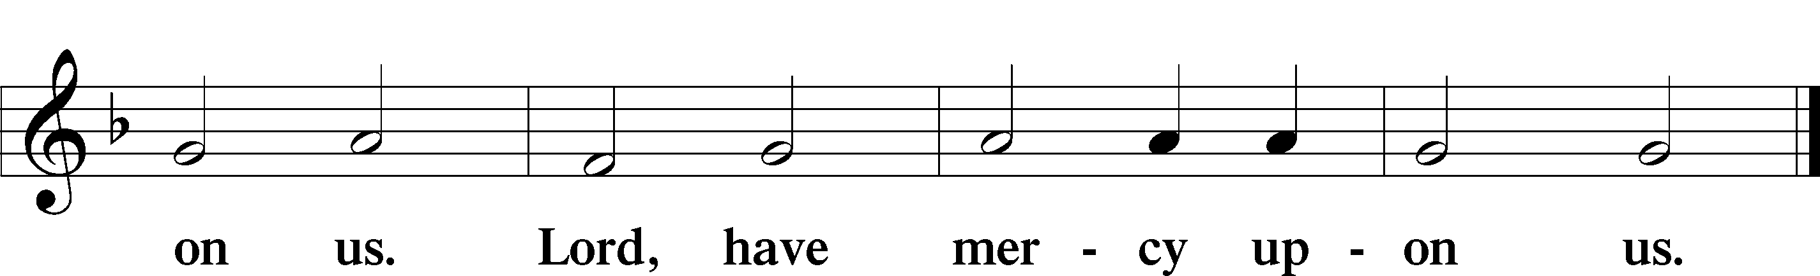

Gloria in Excelsis Luke 2:14; John 1:29

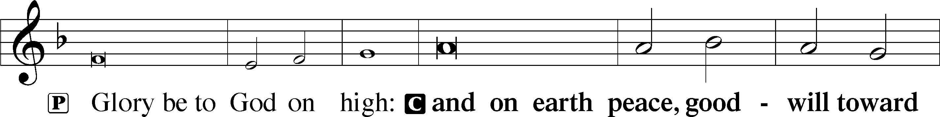

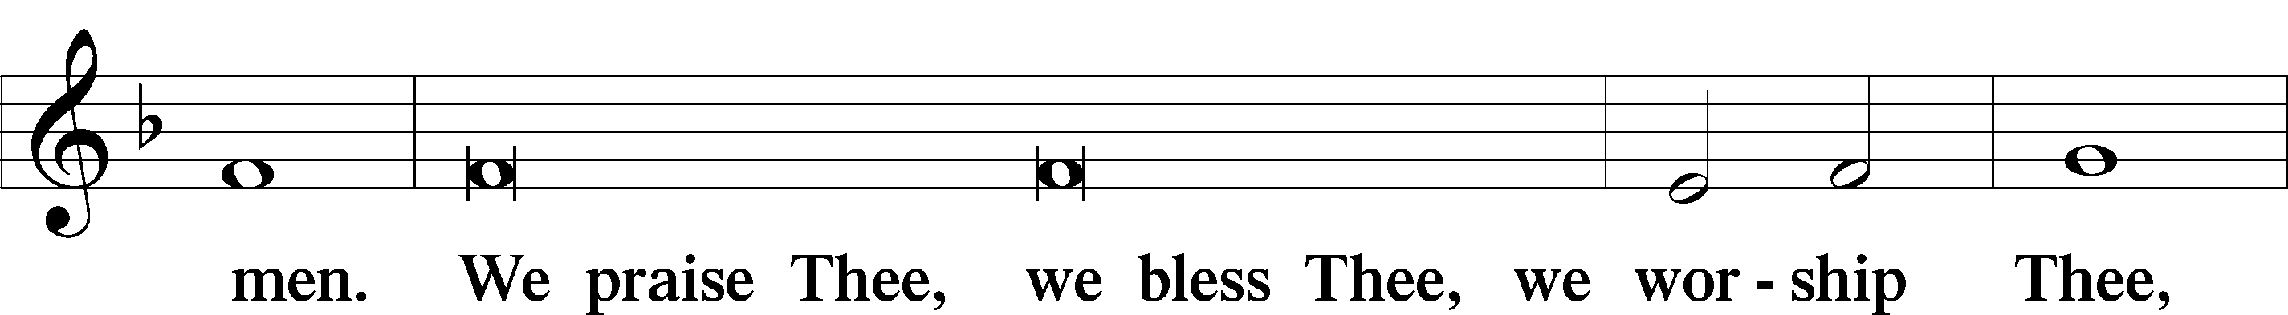

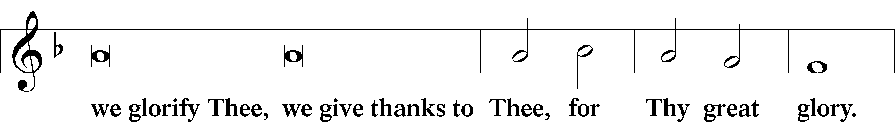

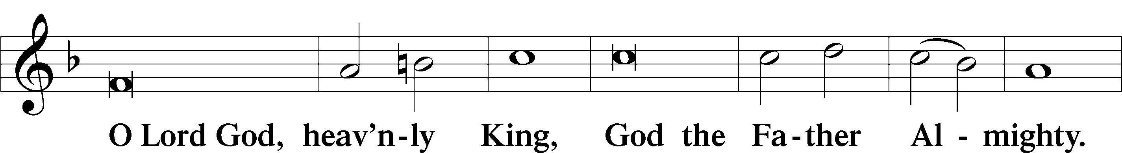

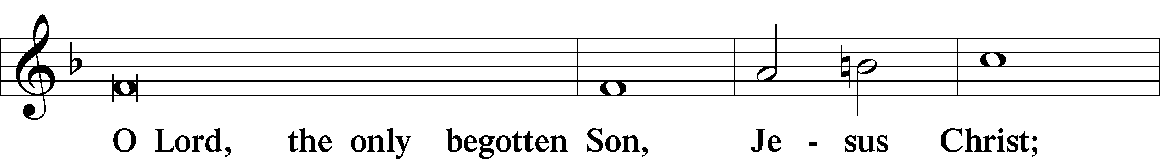

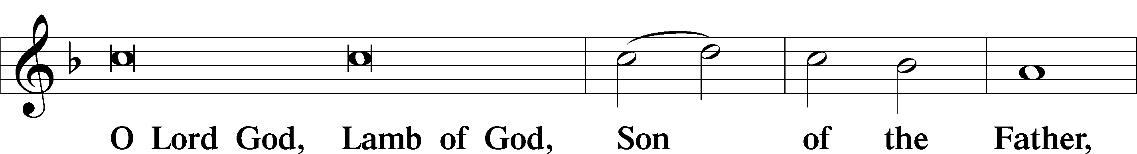

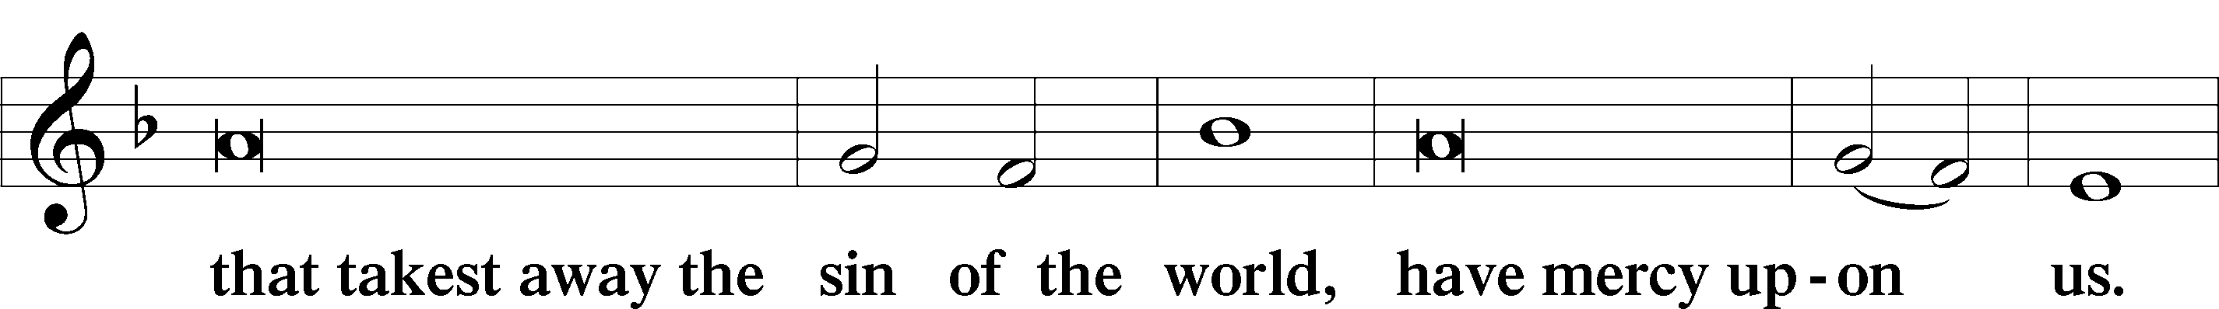

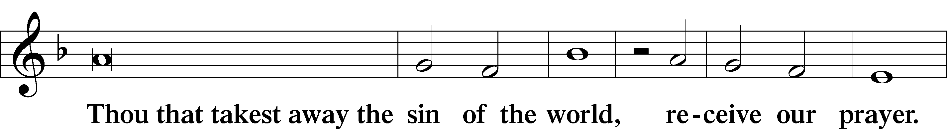

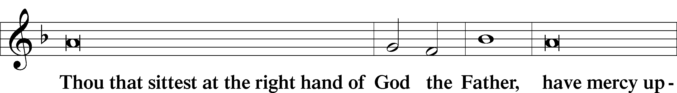

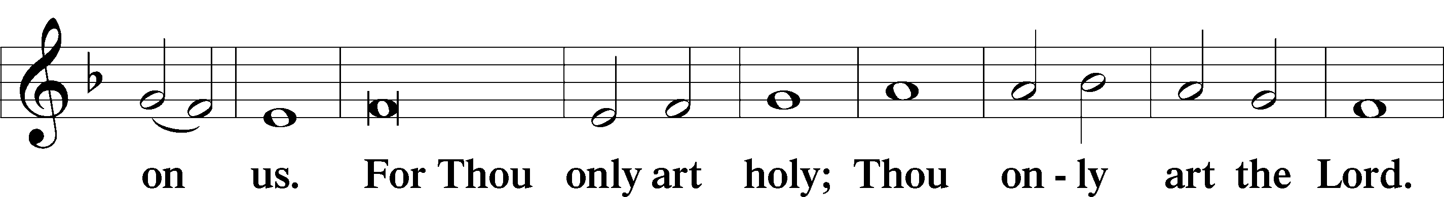

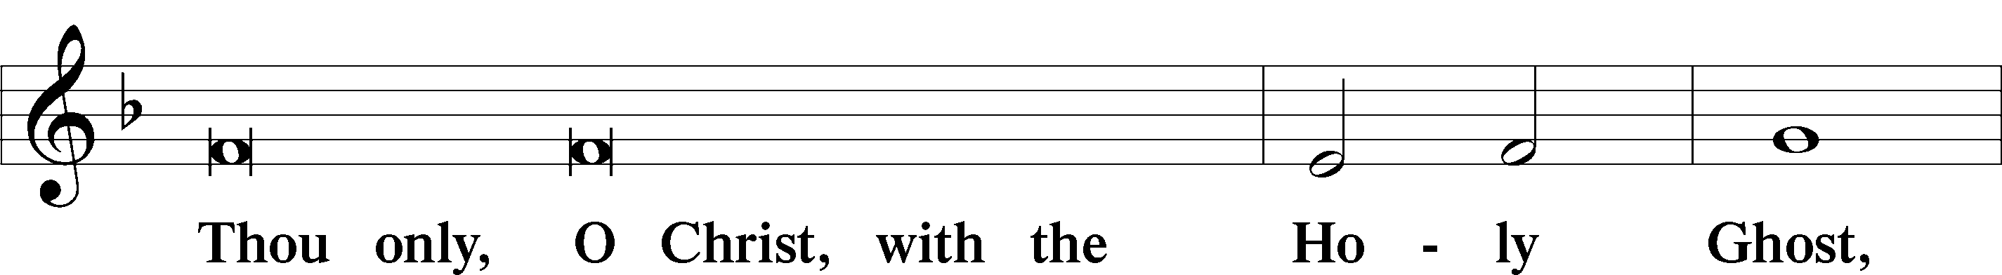

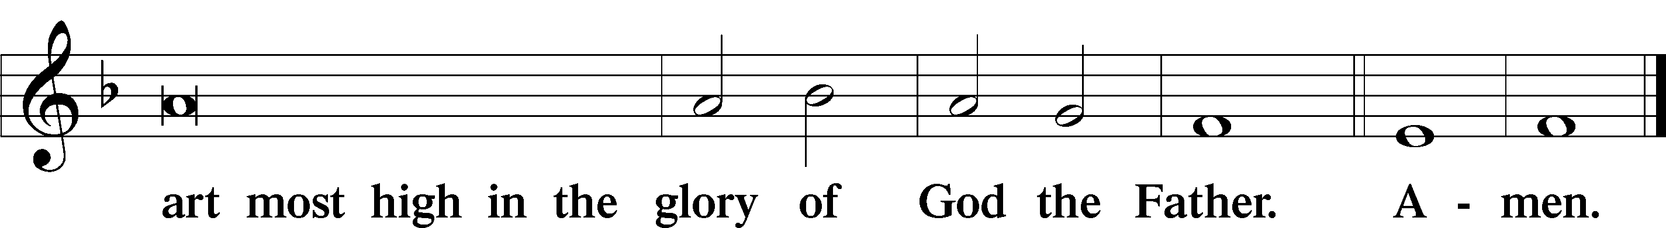

Salutation and Collect of the Day

P The Lord be with you.

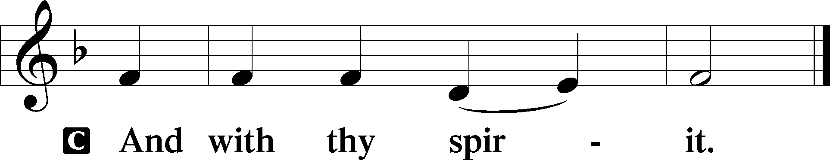

P Let us pray.

Almighty and everlasting God, give us an increase of faith, hope, and love, that, receiving what You have promised, we may love what You have commanded; through Jesus Christ, Your Son, our Lord, who lives and reigns with You and the Holy Spirit, one God, now and forever.

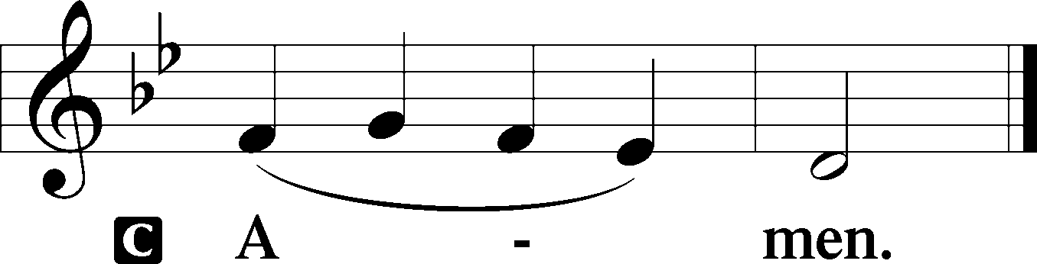

Sit

Old Testament Reading Deuteronomy 7:6–9

6“You are a people holy to the Lord your God. The Lord your God has chosen you to be a people for his treasured possession, out of all the peoples who are on the face of the earth. 7It was not because you were more in number than any other people that the Lord set his love on you and chose you, for you were the fewest of all peoples, 8but it is because the Lord loves you and is keeping the oath that he swore to your fathers, that the Lord has brought you out with a mighty hand and redeemed you from the house of slavery, from the hand of Pharaoh king of Egypt. 9Know therefore that the Lord your God is God, the faithful God who keeps covenant and steadfast love with those who love him and keep his commandments, to a thousand generations.”

A This is the Word of the Lord.

C **Thanks be to God.**

Psalm Psalm 125; antiphon: v. 2

The Lord Surrounds His People

1Those who trust in the Lord are like Mount Zion,  
 which cannot be moved, but abides forever.  
2As the mountains surround Jerusalem,  
 so the Lord surrounds his people,  
 from this time forth and forevermore.  
3For the scepter of wickedness shall not rest  
 on the land allotted to the righteous,  
lest the righteous stretch out  
 their hands to do wrong  
4Do good, O Lord, to those who are good,  
 and to those who are upright in their hearts!  
5But those who turn aside to their crooked ways  
 the Lord will lead away with evildoers!  
 Peace be upon Israel!

Epistle Romans 8:28–39

28We know that for those who love God all things work together for good, for those who are called according to his purpose. 29For those whom he foreknew he also predestined to be conformed to the image of his Son, in order that he might be the firstborn among many brothers. 30And those whom he predestined he also called, and those whom he called he also justified, and those whom he justified he also glorified.

God’s Everlasting Love

31What then shall we say to these things? If God is for us, who can be against us? 32He who did not spare his own Son but gave him up for us all, how will he not also with him graciously give us all things? 33Who shall bring any charge against God’s elect? It is God who justifies. 34Who is to condemn? Christ Jesus is the one who died—more than that, who was raised—who is at the right hand of God, who indeed is interceding for us. 35Who shall separate us from the love of Christ? Shall tribulation, or distress, or persecution, or famine, or nakedness, or danger, or sword? 36As it is written,

“For your sake we are being killed all the day long;  
 we are regarded as sheep to be slaughtered.”

37No, in all these things we are more than conquerors through him who loved us. 38For I am sure that neither death nor life, nor angels nor rulers, nor things present nor things to come, nor powers, 39nor height nor depth, nor anything else in all creation, will be able to separate us from the love of God in Christ Jesus our Lord.

A This is the Word of the Lord.

C **Thanks be to God.**

Stand

Alleluia

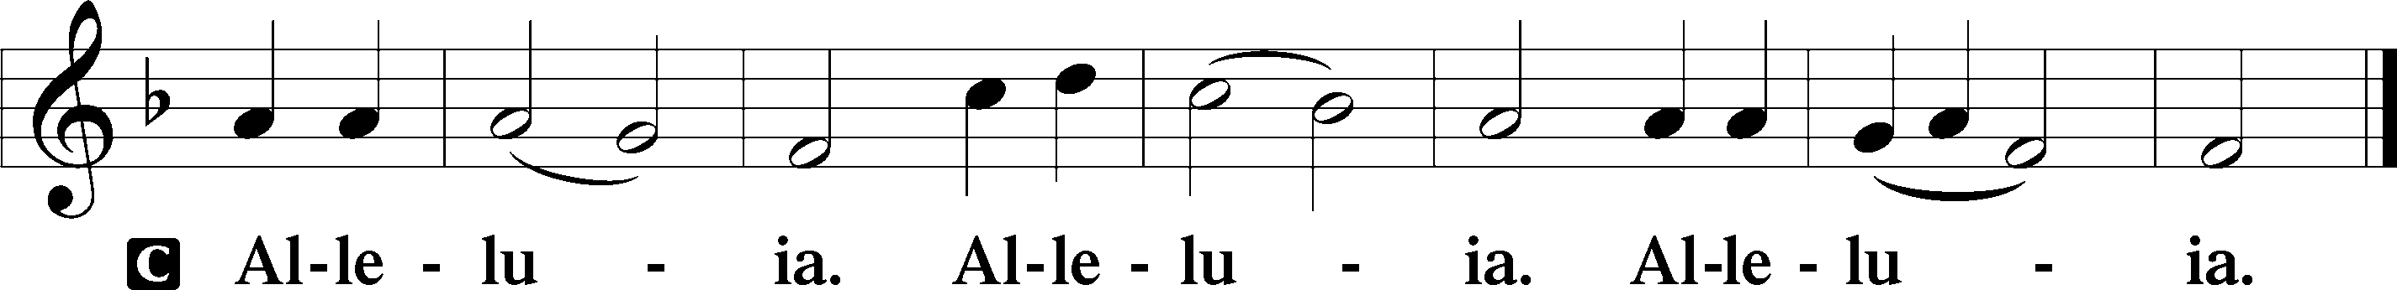

Holy Gospel Matthew 13:44–52

P The Holy Gospel according to St. Matthew, the thirteenth chapter.

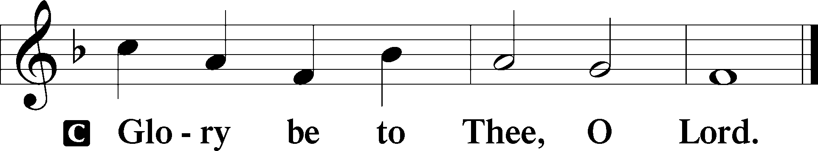

The Parable of the Hidden Treasure

44[Jesus said:] “The kingdom of heaven is like treasure hidden in a field, which a man found and covered up. Then in his joy he goes and sells all that he has and buys that field.

The Parable of the Pearl of Great Value

45“Again, the kingdom of heaven is like a merchant in search of fine pearls, 46who, on finding one pearl of great value, went and sold all that he had and bought it.

The Parable of the Net

47“Again, the kingdom of heaven is like a net that was thrown into the sea and gathered fish of every kind. 48When it was full, men drew it ashore and sat down and sorted the good into containers but threw away the bad. 49So it will be at the close of the age. The angels will come out and separate the evil from the righteous 50and throw them into the fiery furnace. In that place there will be weeping and gnashing of teeth.

New and Old Treasures

51“Have you understood all these things?” They said to him, “Yes.” 52And he said to them, “Therefore every scribe who has been trained for the kingdom of heaven is like a master of a house, who brings out of his treasure what is new and what is old.”

P This is the Gospel of the Lord.

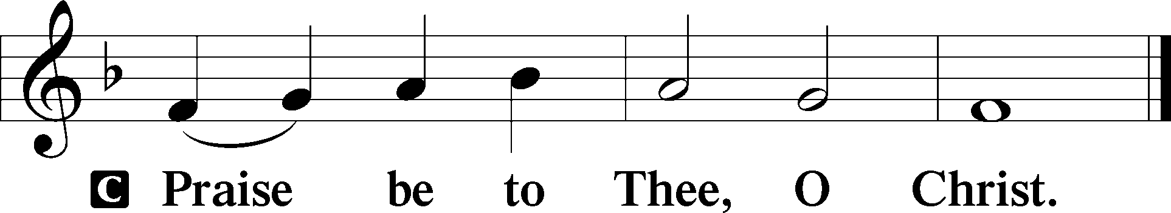

Nicene Creed

C **I believe in one God,**

**the Father Almighty,**

**maker of heaven and earth**

**and of all things visible and invisible.**

**And in one Lord Jesus Christ,**

**the only-begotten Son of God,**

**begotten of His Father before all worlds,**

**God of God, Light of Light,**

**very God of very God,**

**begotten, not made,**

**being of one substance with the Father,**

**by whom all things were made;**

**who for us men and for our salvation came down from heaven**

**and was incarnate by the Holy Spirit of the virgin Mary**

**and was made man;**

**and was crucified also for us under Pontius Pilate.**

**He suffered and was buried.**

**And the third day He rose again according to the Scriptures**

**and ascended into heaven**

**and sits at the right hand of the Father.**

**And He will come again with glory to judge both the living and the dead,**

**whose kingdom will have no end.**

**And I believe in the Holy Spirit,**

**the Lord and giver of life,**

**who proceeds from the Father and the Son,**

**who with the Father and the Son together is worshiped and glorified,**

**who spoke by the prophets.**

**And I believe in one holy Christian and apostolic Church,**

**I acknowledge one Baptism for the remission of sins,**

**and I look for the resurrection of the dead**

**and the life** T **of the world to come. Amen.**

Sit

Children's Message

760 What God Ordains Is Always Good

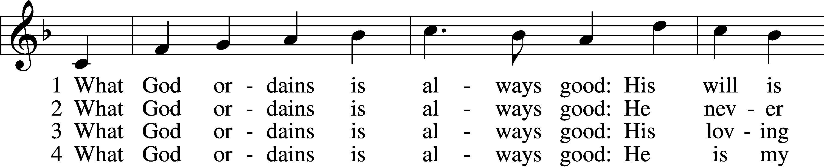

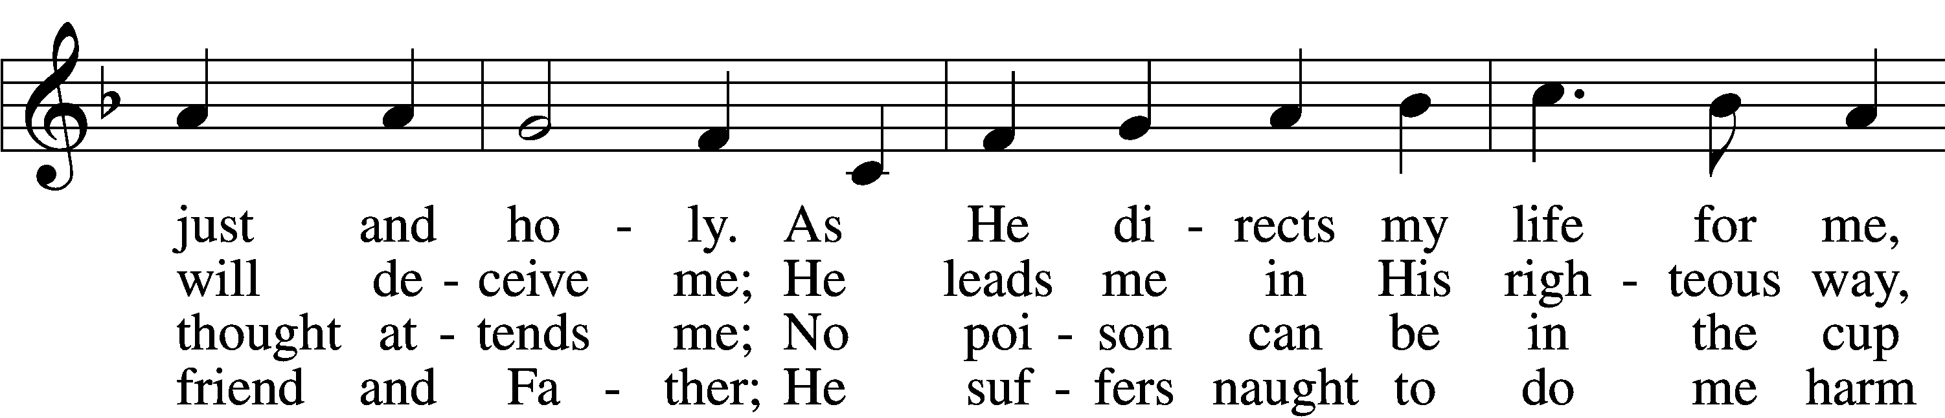

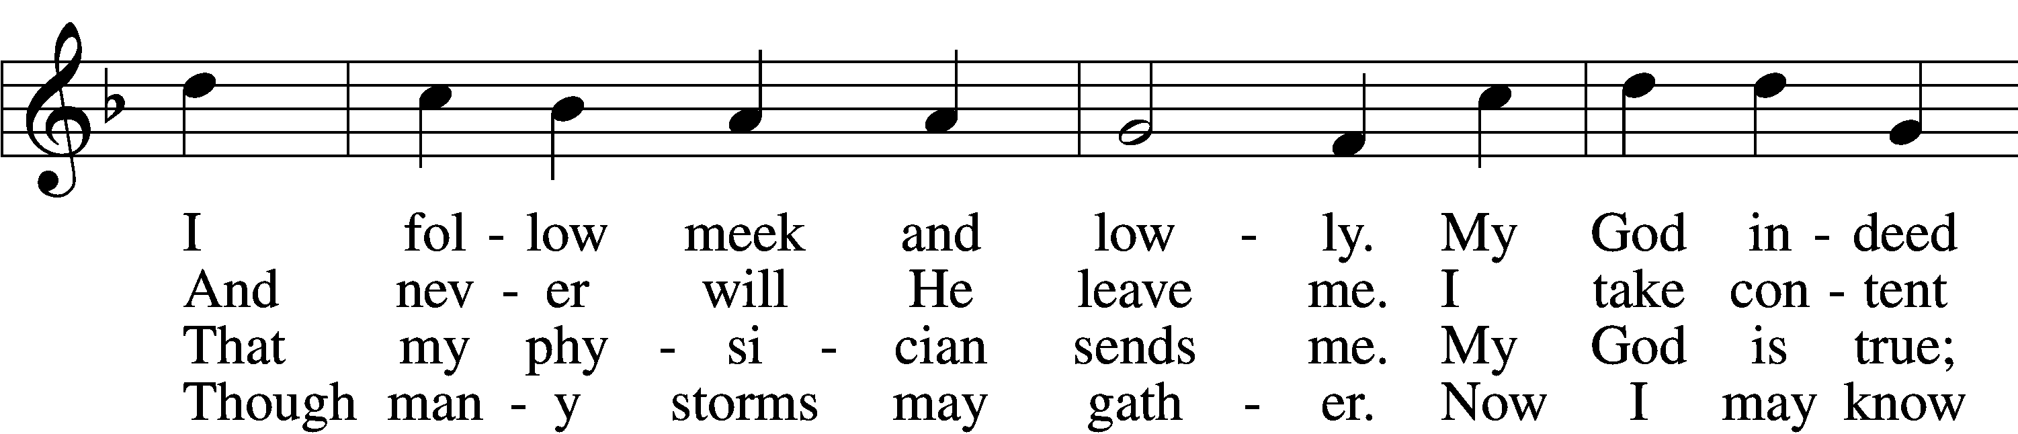

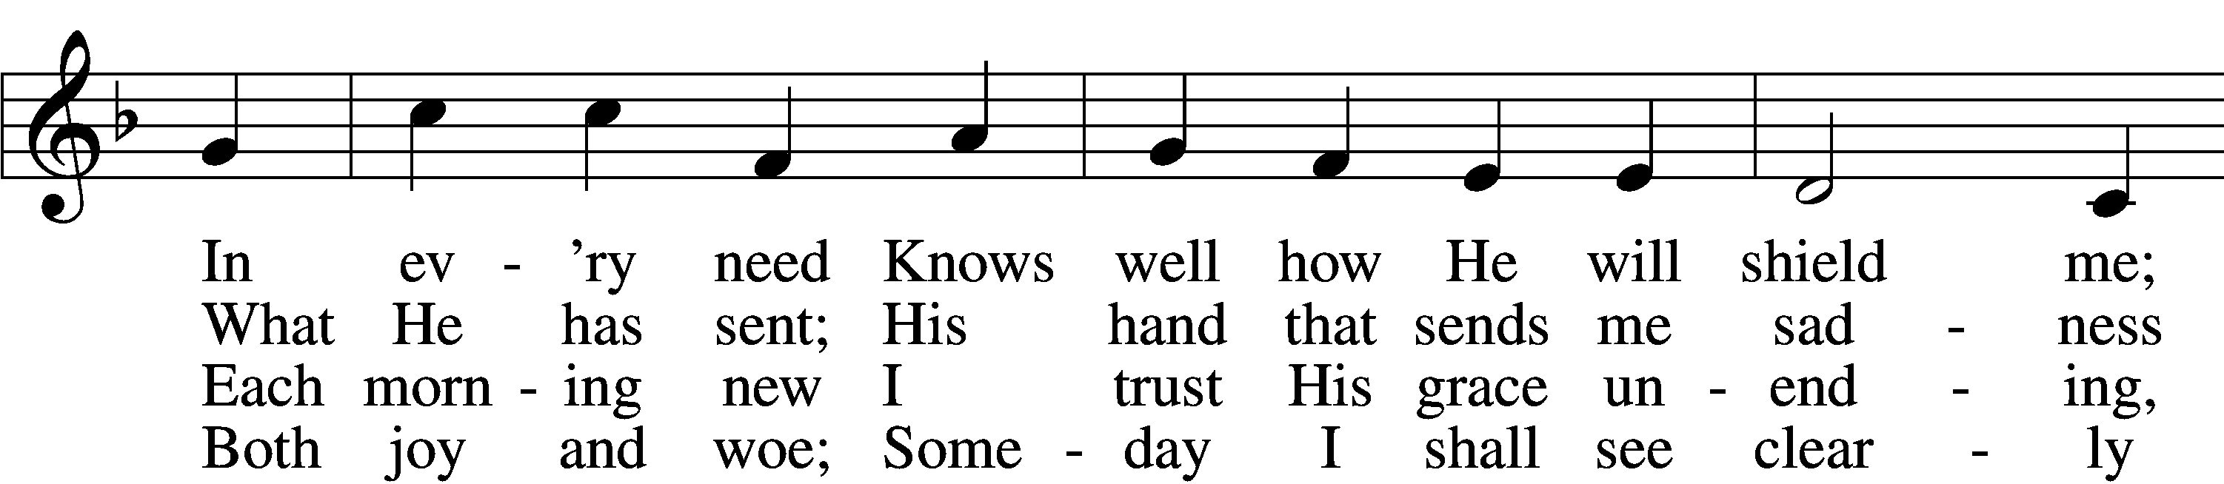

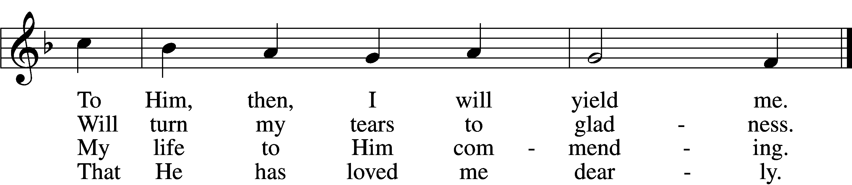

5 What God ordains is always good:  
 Though I the cup am drinking  
Which savors now of bitterness,  
 I take it without shrinking.  
 For after grief  
 God gives relief,  
My heart with comfort filling  
And all my sorrow stilling.

6 What God ordains is always good:  
 This truth remains unshaken.  
Though sorrow, need, or death be mine,  
 I shall not be forsaken.  
 I fear no harm,  
 For with His arm  
He shall embrace and shield me;  
So to my God I yield me.

Text: Samuel Rodigast, 1649–1708; tr. The Lutheran Hymnal, 1941, alt.  
Tune: Severus Gastorius, 1646–82, alt.  
Text and tune: Public domain

Sermon

Votum

P The peace of God, which passes all understanding, keep your hearts and minds in Christ Jesus.

C **Amen.**

Stand

Offertory Psalm 51:10–12

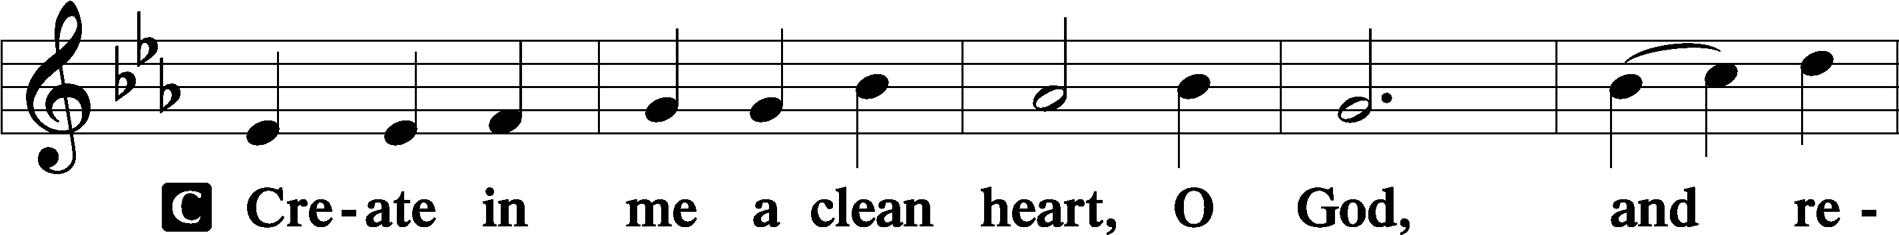

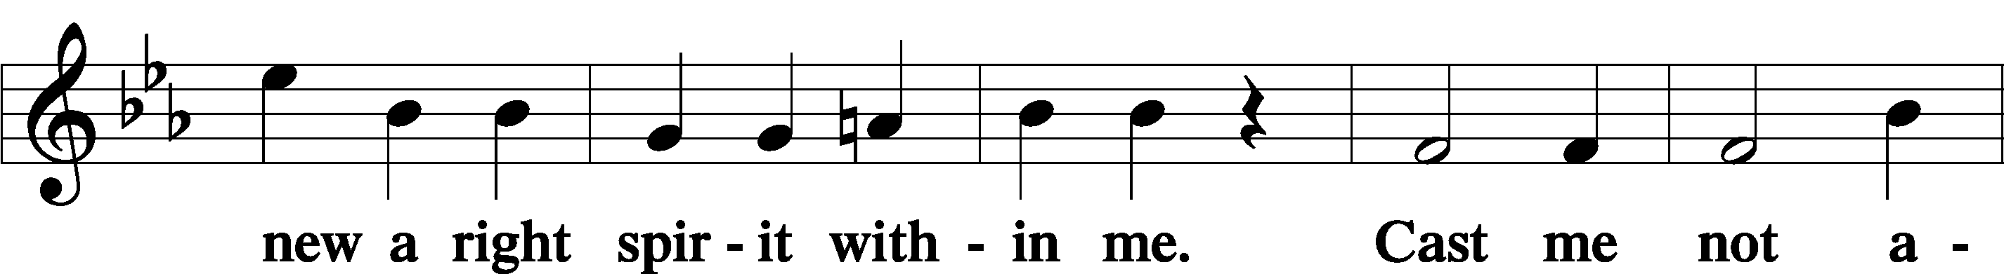

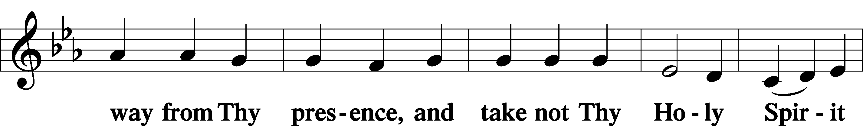

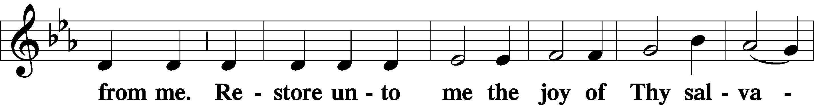

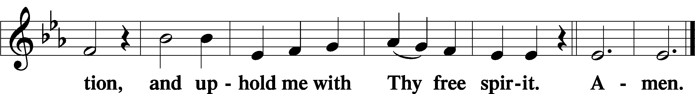

805 Praise God, from Whom All Blessings Flow

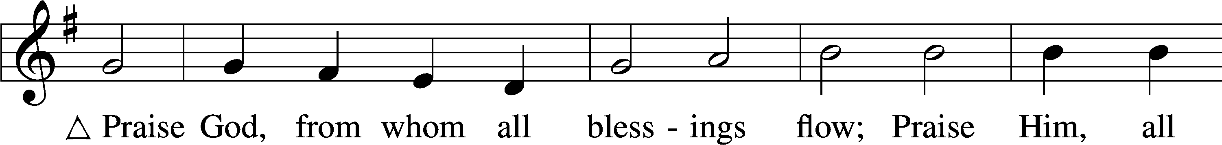

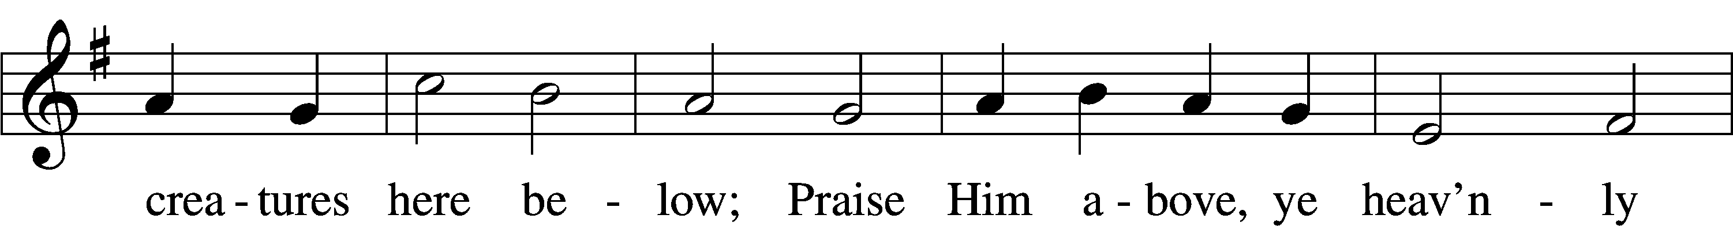

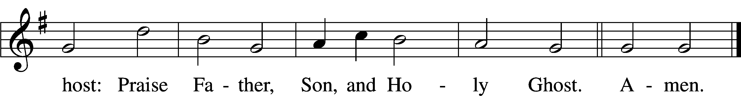

Text: Thomas Ken, 1637–1711  
Tune: Trente quatre Pseaumes de David, 1551, Geneva, ed. Louis Bourgeois  
Text and tune: Public domain

Sit

Offering

Stand

Prayer of the Church

# Service of the Sacrament

Preface 2 Timothy 4:22; [Colossians 3:1]; [Psalm 136]

P The Lord be with you.

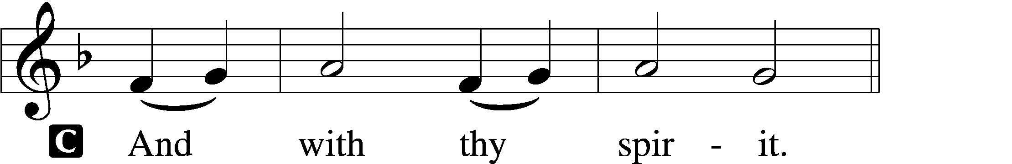

P Lift up your hearts.

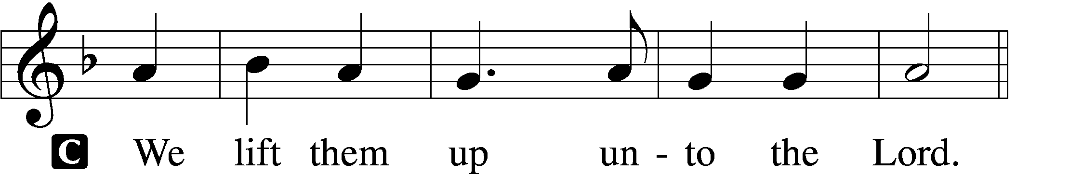

P Let us give thanks unto the Lord, our God.

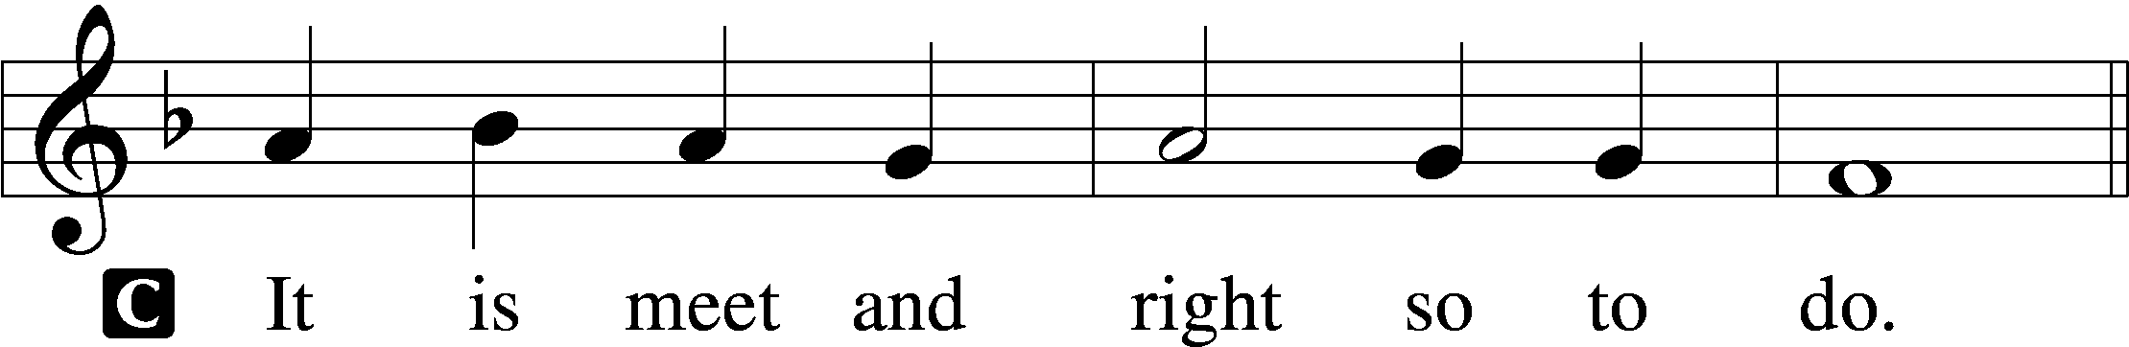

Proper Preface (Full)

P It is truly meet, right, and salutary that we should at all times and in all places give thanks to You, holy Lord, almighty Father, everlasting God, through Jesus Christ, our Lord, who, having created all things, took on human flesh and was born of the virgin Mary. For our sake He died on the cross and rose from the dead to put an end to death, thus fulfilling Your will and gaining for You a holy people. Therefore with angels and archangels and with all the company of heaven we laud and magnify Your glorious name, evermore praising You and saying:

Sanctus Isaiah 6:3; Matthew 21:9

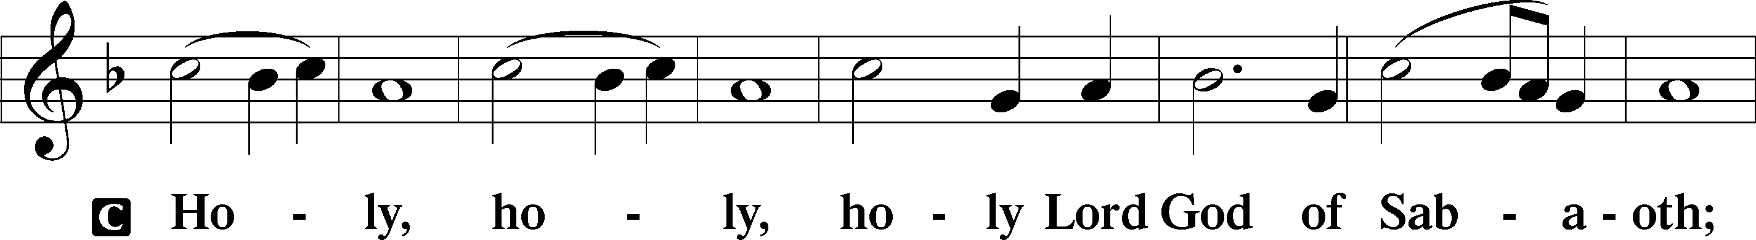

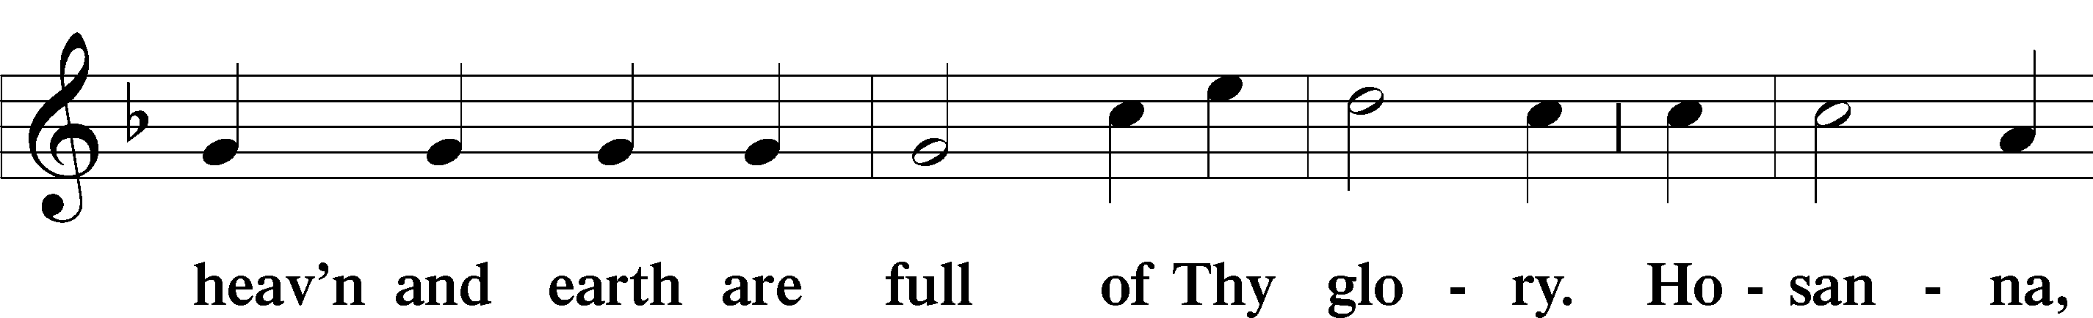

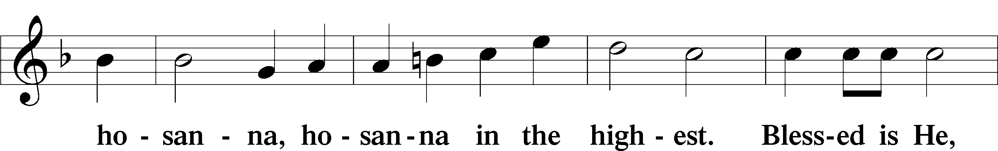

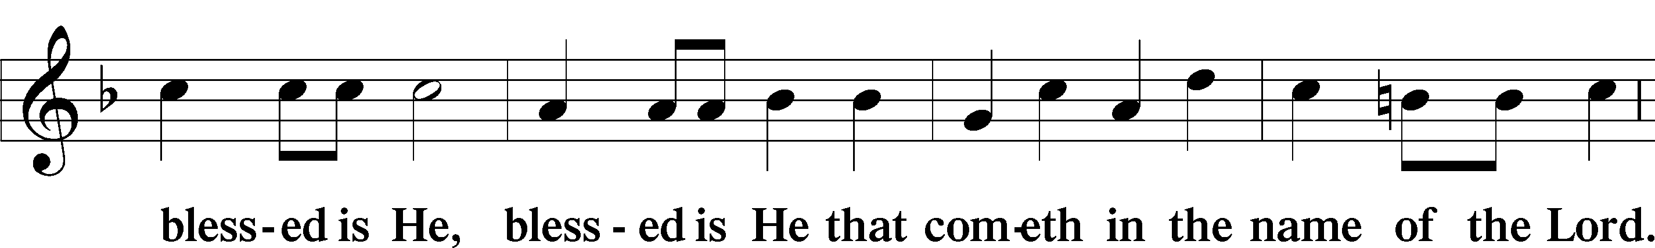

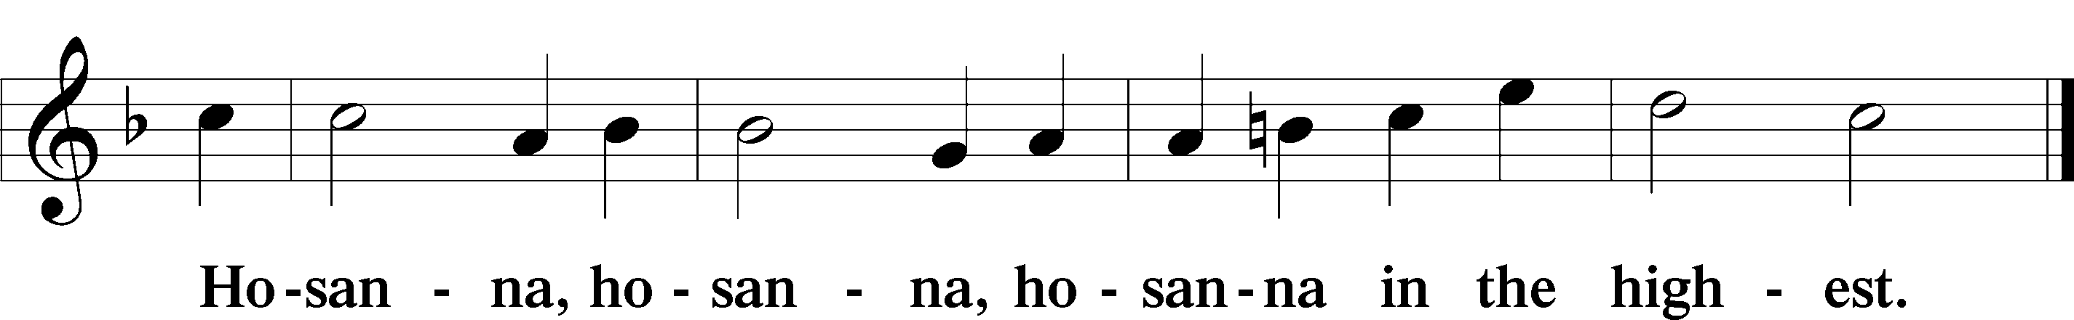

Lord’s Prayer Matthew 6:9–13

P Our Father who art in heaven,

hallowed be Thy name,

Thy kingdom come,

Thy will be done on earth as it is in heaven;

give us this day our daily bread;

and forgive us our trespasses as we forgive those who trespass against us;

and lead us not into temptation,

but deliver us from evil.

C **For Thine is the kingdom and the power and the glory forever and ever. Amen.**

The Words of Our Lord Matthew 26:26–28; Mark 14:22–24; Luke 22:19–20; 1 Corinthians 11:23–25

P Our Lord Jesus Christ, on the night when He was betrayed, took bread, and when He had given thanks, He broke it and gave it to the disciples and said: “Take, eat; this is My T body, which is given for you. This do in remembrance of Me.”

In the same way also He took the cup after supper, and when He had given thanks, He gave it to them, saying: “Drink of it, all of you; this cup is the new testament in My T blood, which is shed for you for the forgiveness of sins. This do, as often as you drink it, in remembrance of Me.”

Pax Domini John 20:19

P The peace of the Lord be with you always.

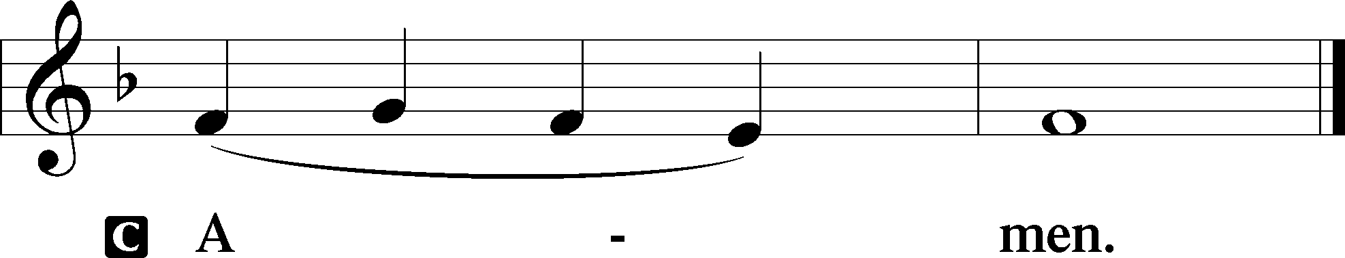

Agnus Dei John 1:29

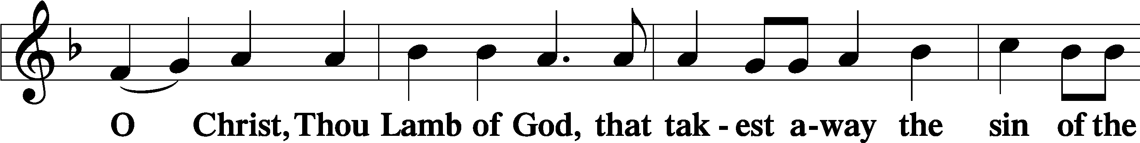

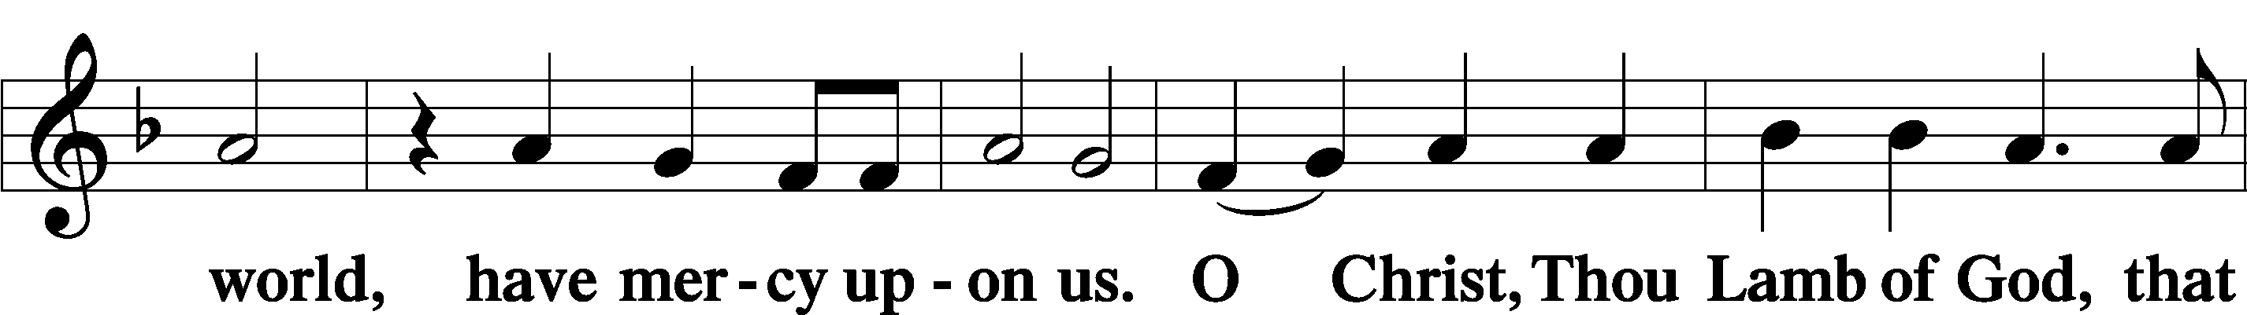

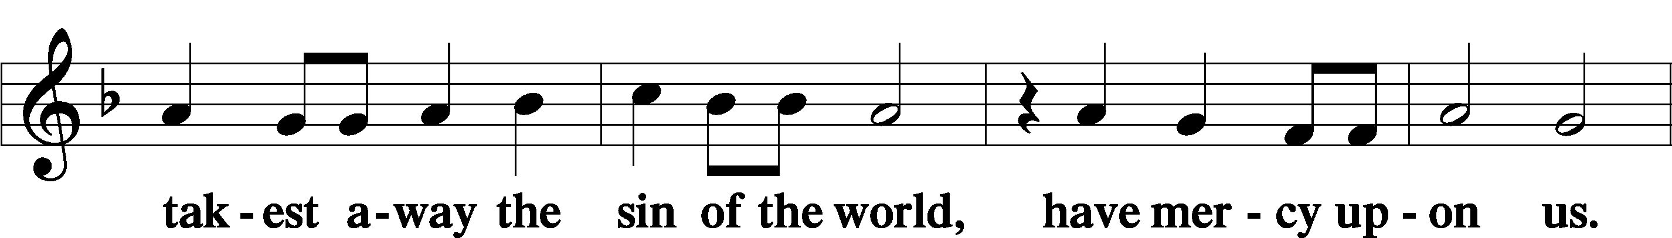

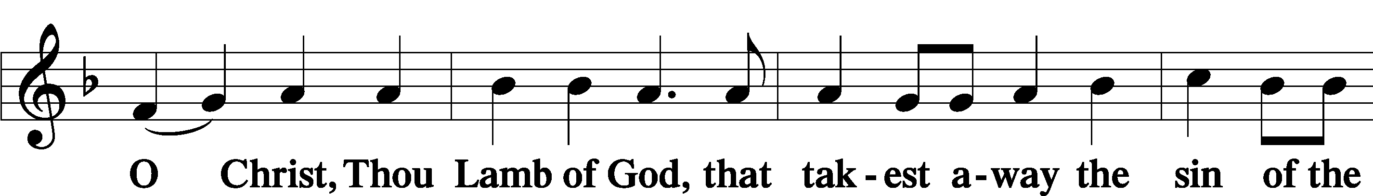

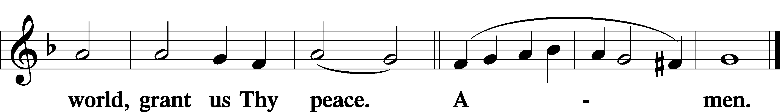

Sit

Distribution

619 Thy Body, Given for Me, O Savior

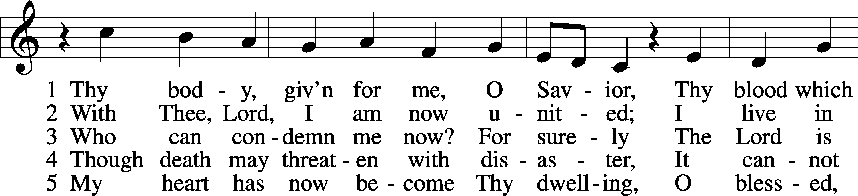

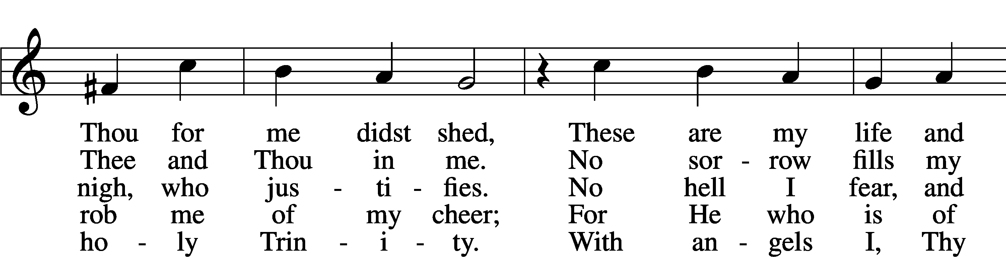

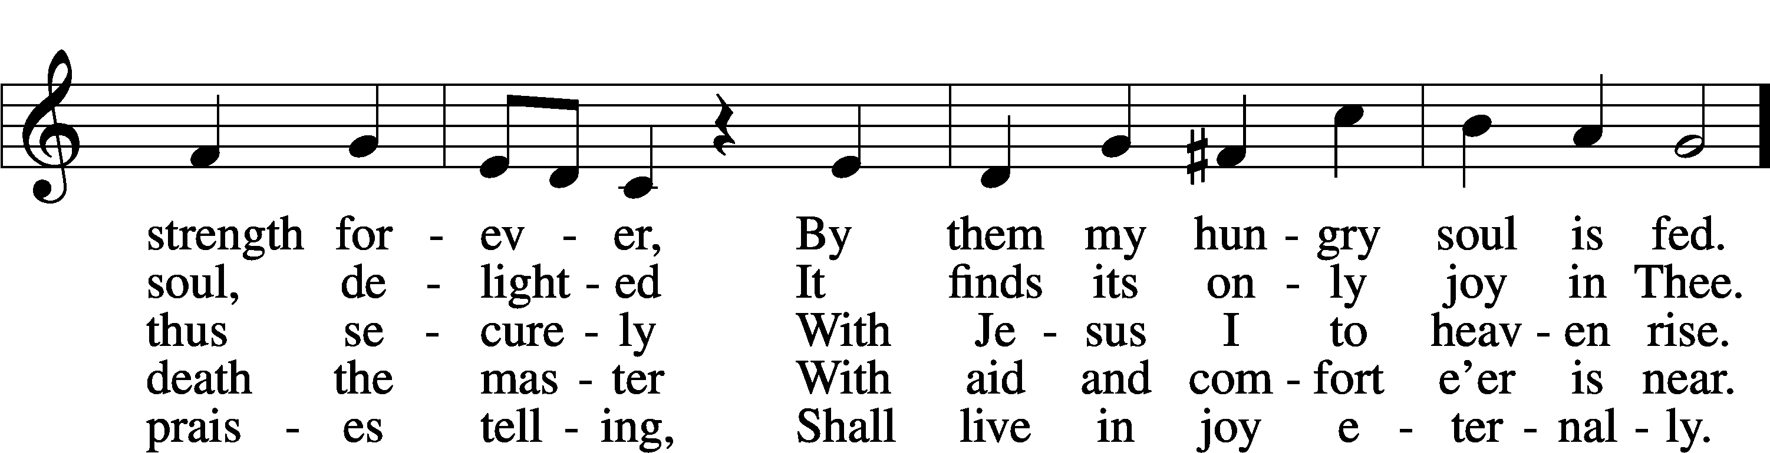

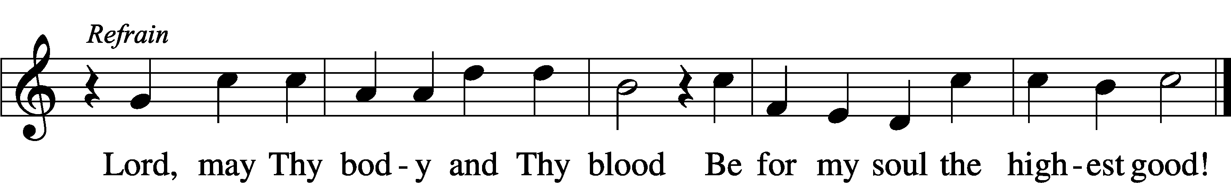

Text: Friedrich Christian Heyder, 1677–1754; tr. The Lutheran Hymnal, 1941, abr.  
Tune: Emskirchner Choral-Buch, 1756, Leipzig  
Text: © 1941 Concordia Publishing House. Used by permission: LSB Hymn License no. 110005011  
Tune: Public domain

575 My Hope Is Built on Nothing Less

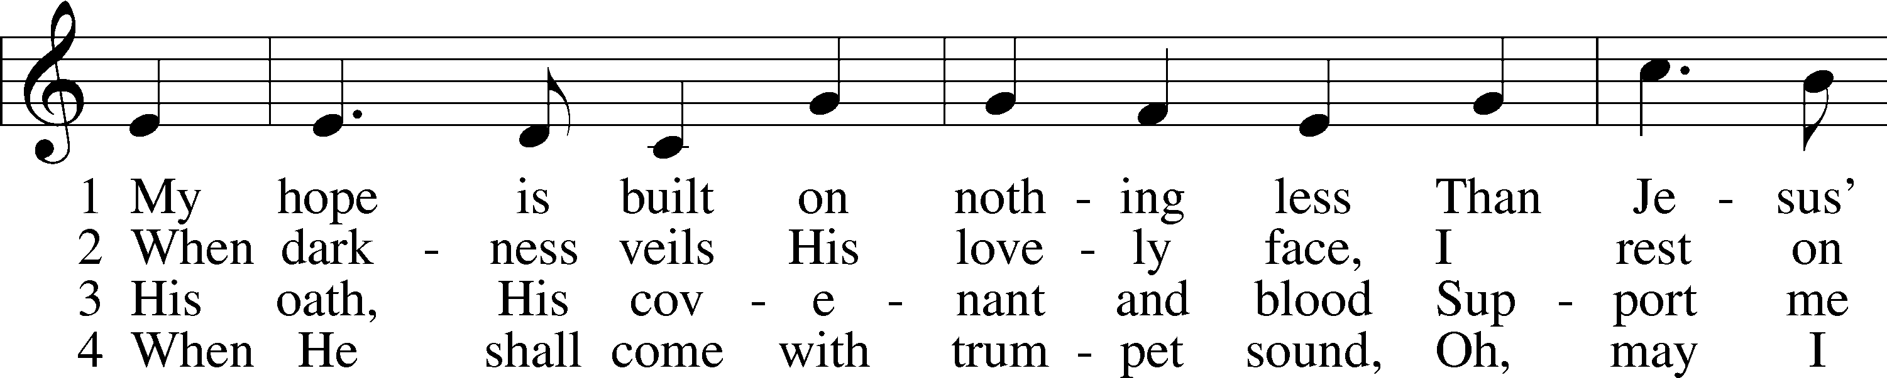

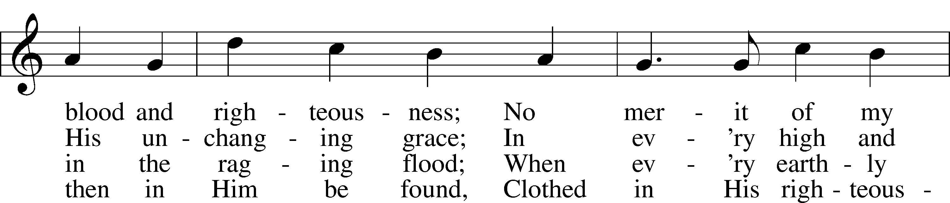

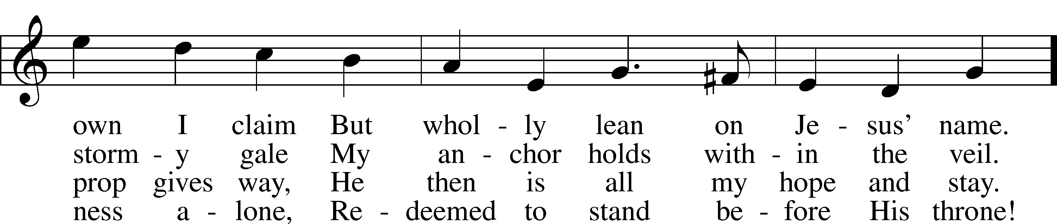

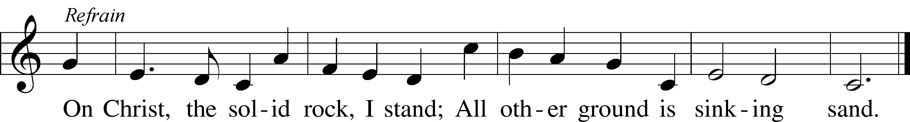

Text: Edward Mote, 1797–1874, alt.  
Tune: John Stainer, 1840–1901  
Text and tune: Public domain

643 Sent Forth by God’s Blessing

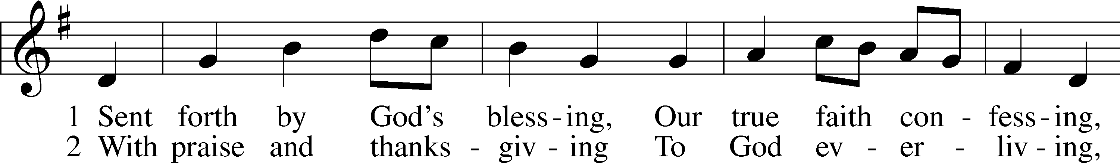

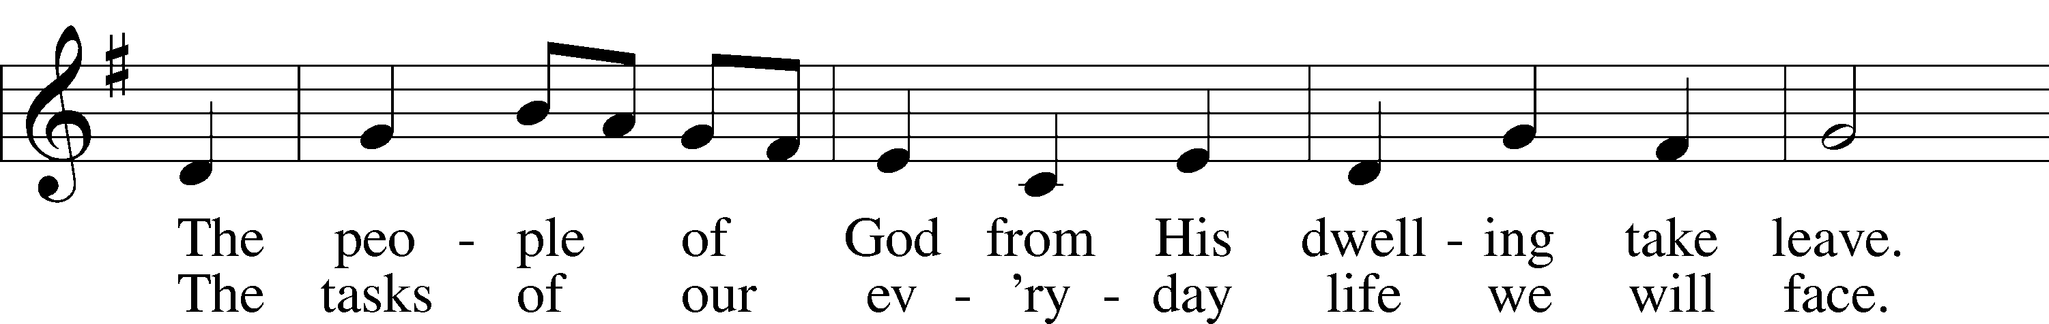

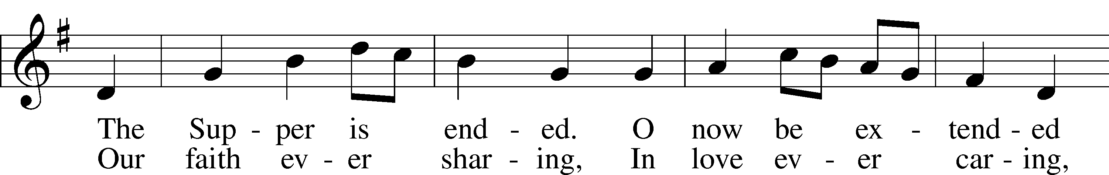

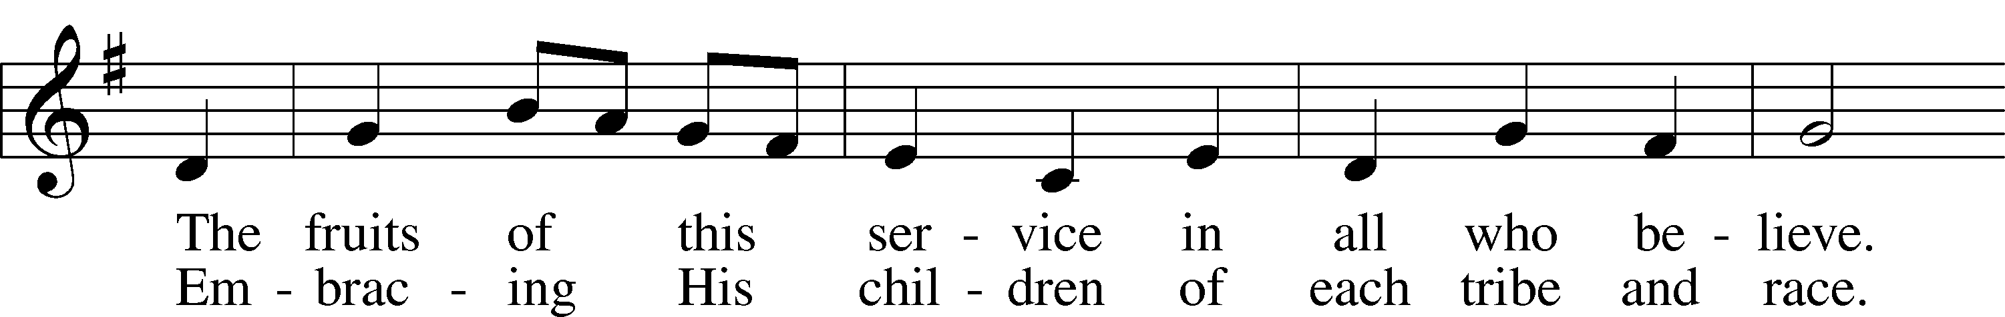

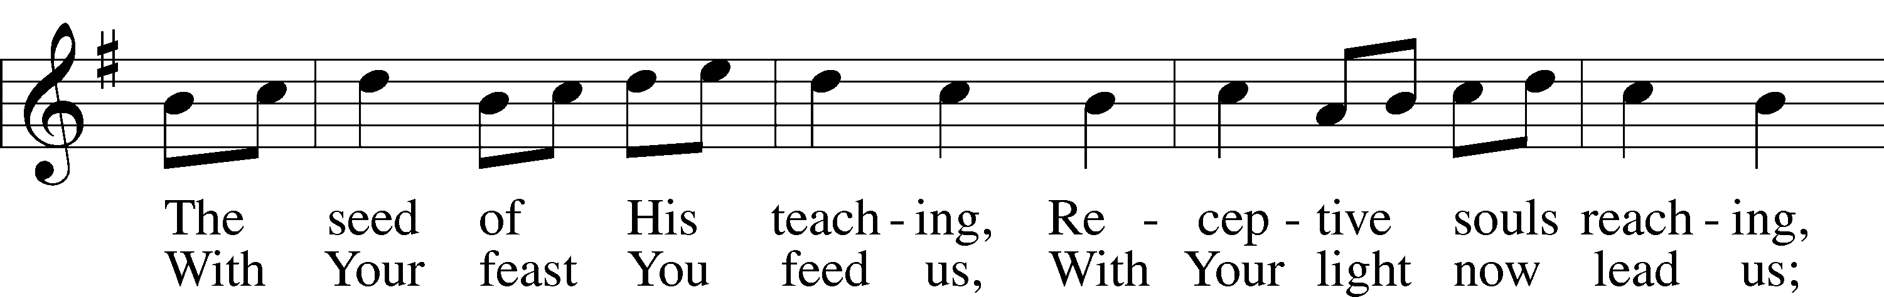

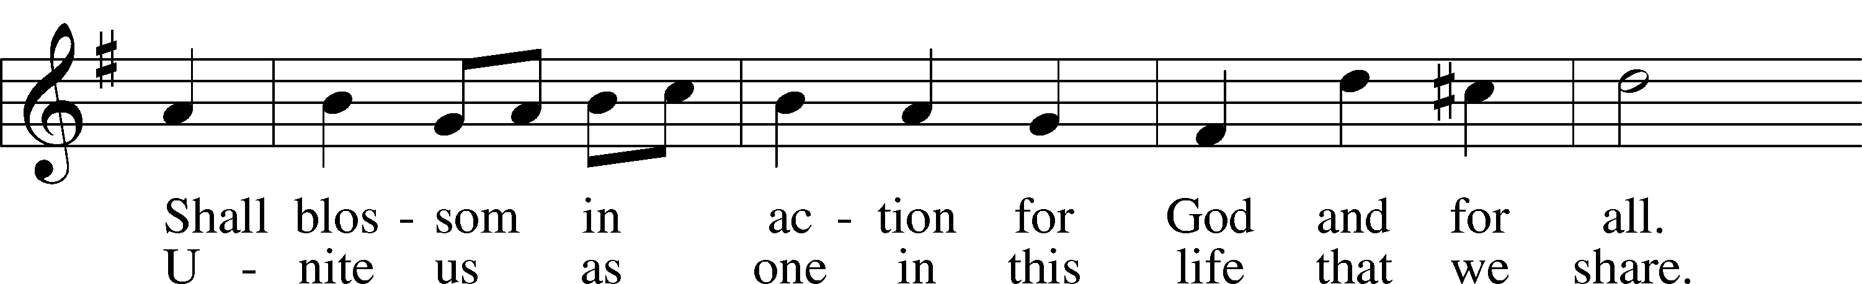

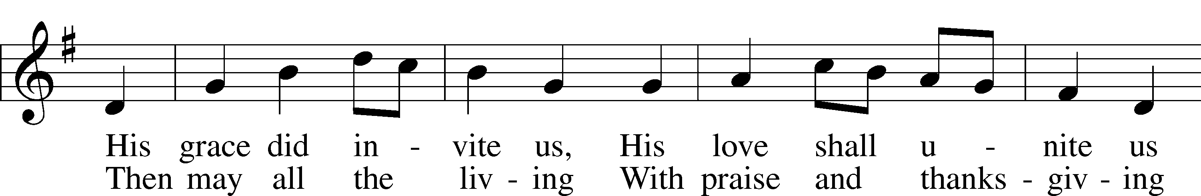

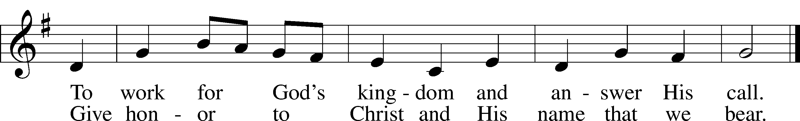

Text: Omer E. Westendorf, 1916–97, alt.  
Tune: Welsh  
Text: © 1964 World Library Publications. Used by permission: LSB Hymn License no. 110005011  
Tune: Public domain

617 O Lord, We Praise Thee

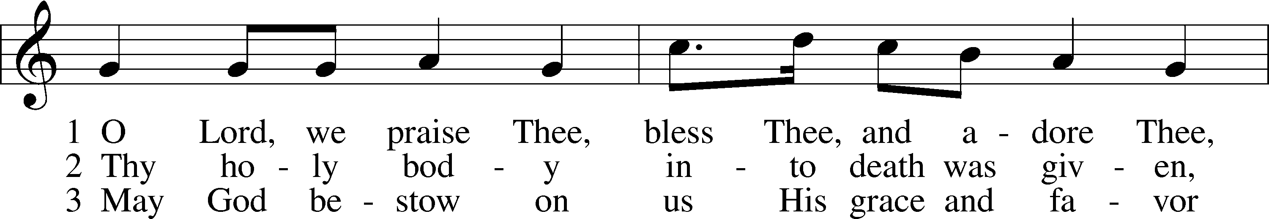

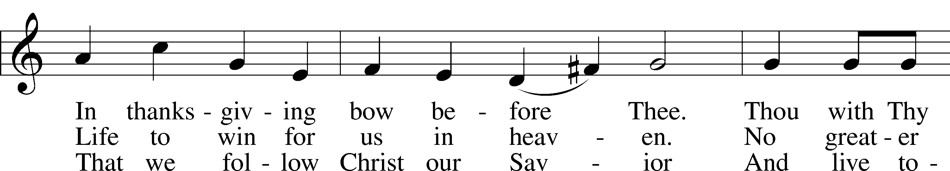

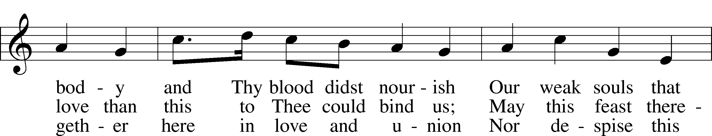

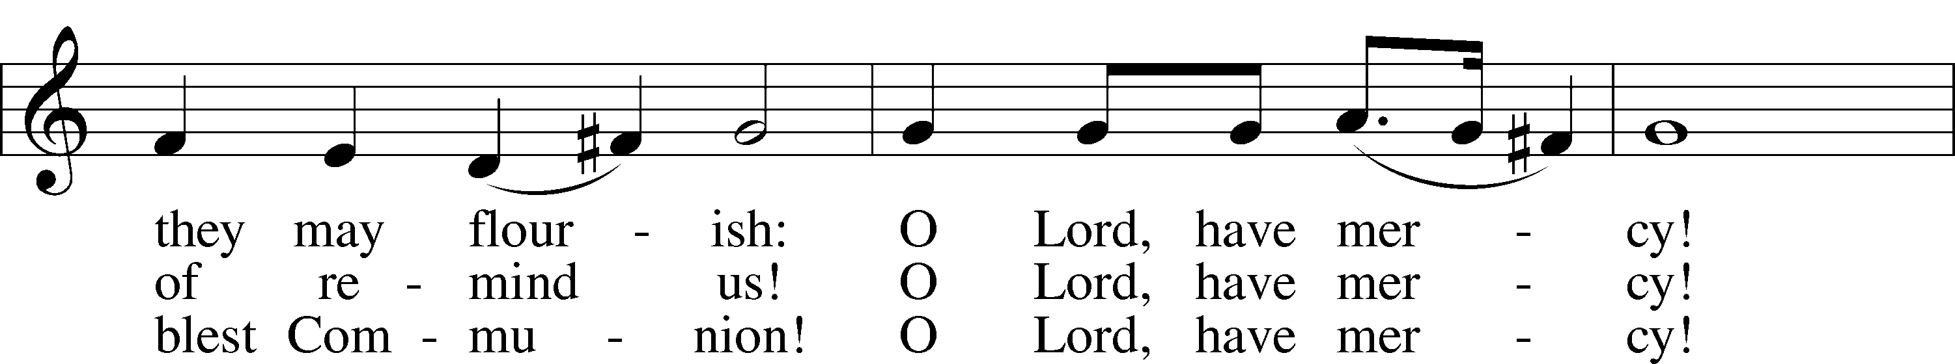

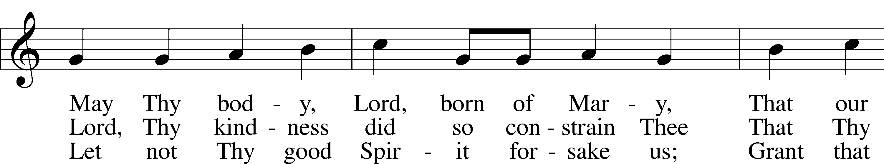

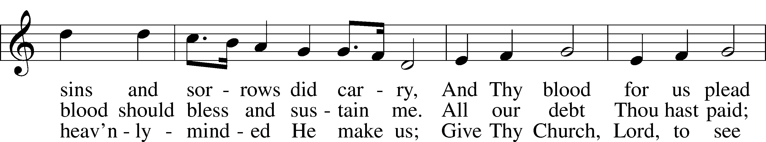

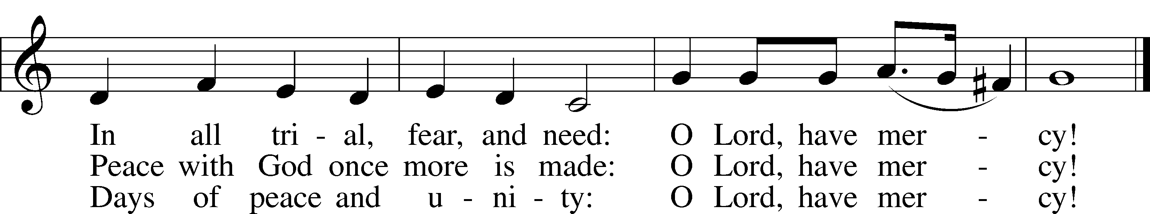

Text: tr. The Lutheran Hymnal, 1941, alt.; (st. 1): German, 14th cent.; (sts. 2–3): Martin Luther, 1483–1546  
Tune: Geystliche gesangk Buchleyn, 1524, Wittenberg, ed. Johann Walter  
Text: © 1941 Concordia Publishing House. Used by permission: LSB Hymn License no. 110005011  
Tune: Public domain

Stand

In dismissing the communicants, the following is said:

The Dismissal

P The body and blood of our Lord Jesus Christ strengthen and preserve you in body and soul to life everlasting. Depart T in peace.

C **Amen.**

Nunc Dimittis Luke 2:29–32

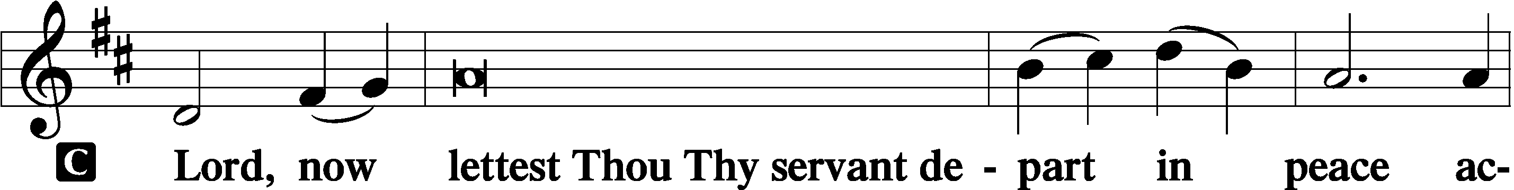

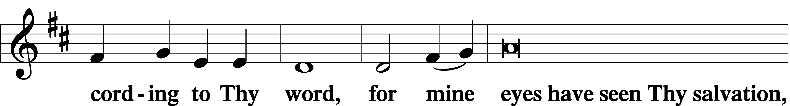

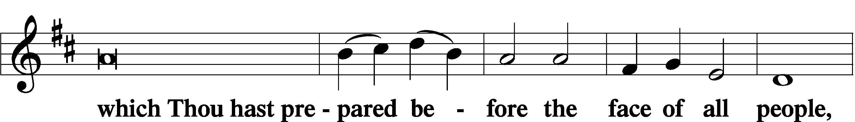

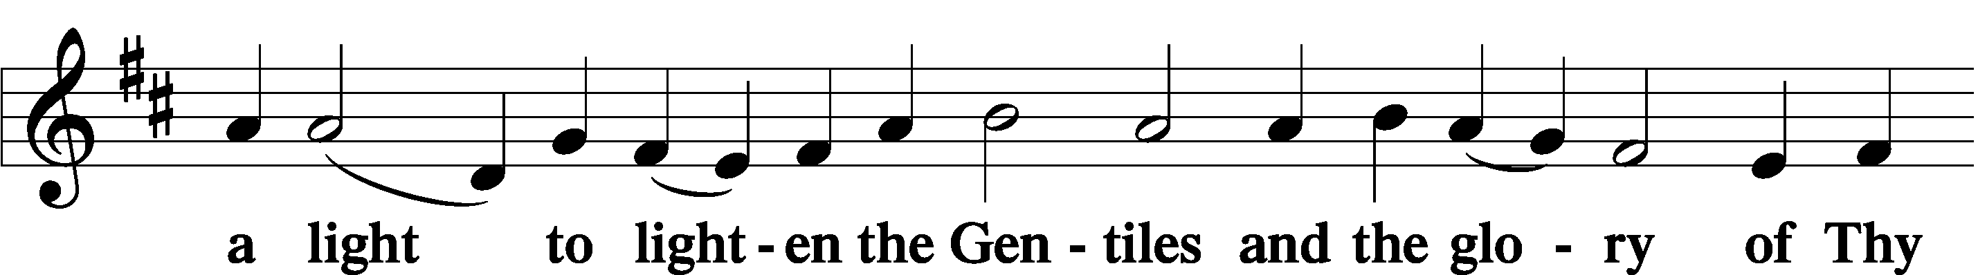

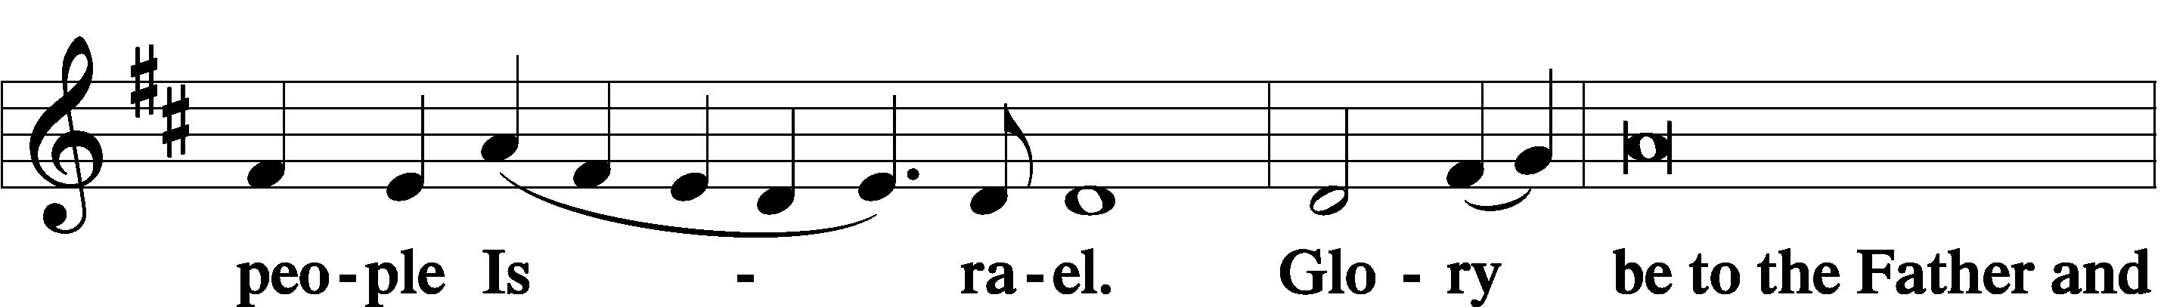

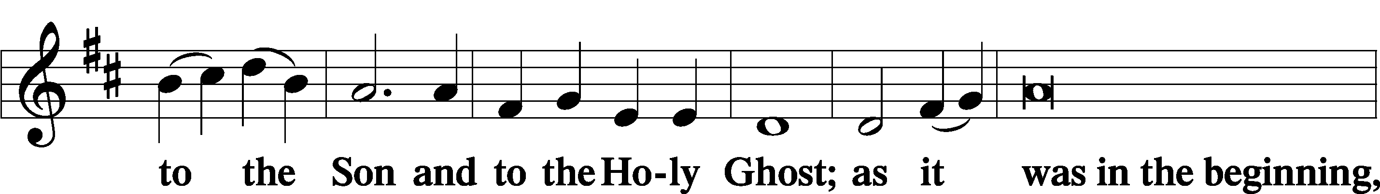

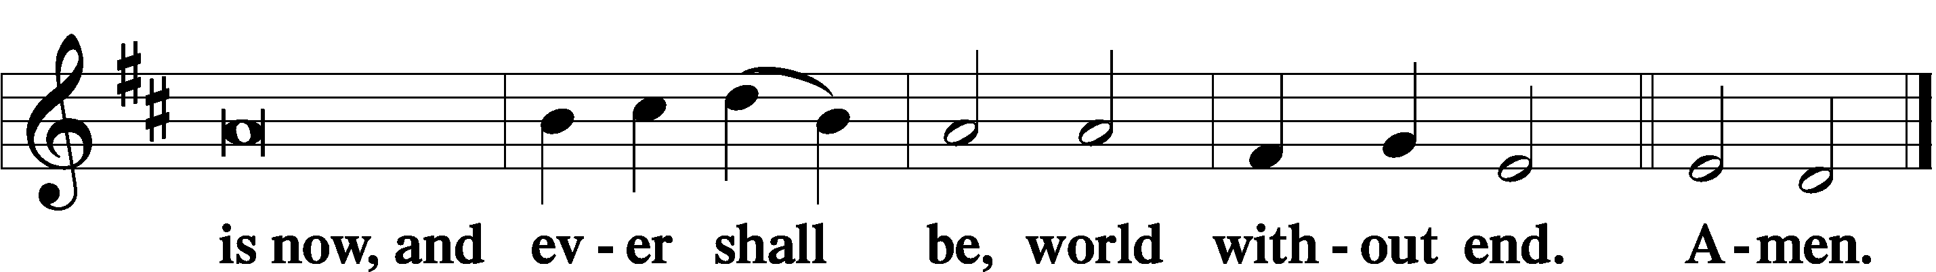

Thanksgiving Psalm 107:1

A O give thanks unto the Lord, for He is good,

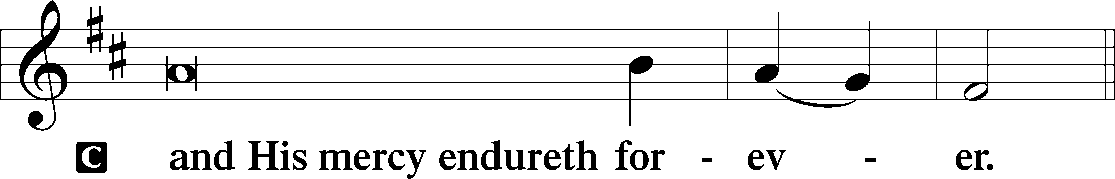

Post-Communion Collect

A Let us pray.

We give thanks to You, almighty God, that You have refreshed us through this salutary gift, and we implore You that of Your mercy You would strengthen us through the same in faith toward You and in fervent love toward one another; through Jesus Christ, Your Son, our Lord, who lives and reigns with You and the Holy Spirit, one God, now and forever.

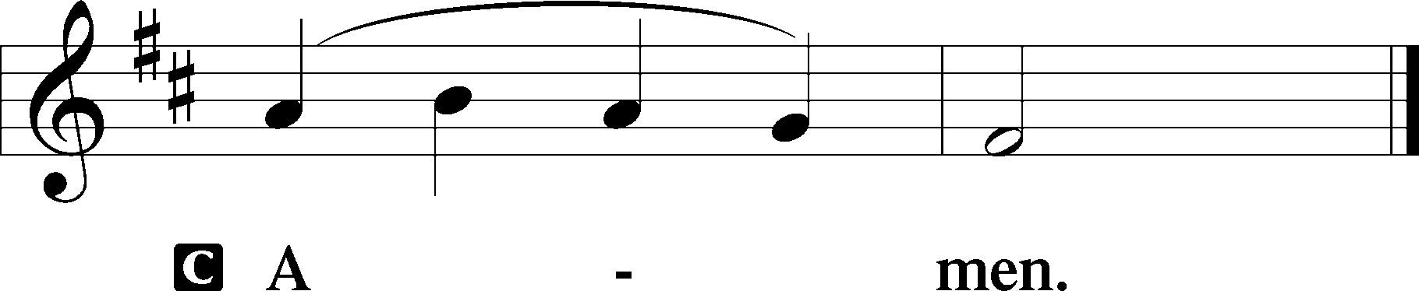

Salutation 2 Timothy 4:22

P The Lord be with you.

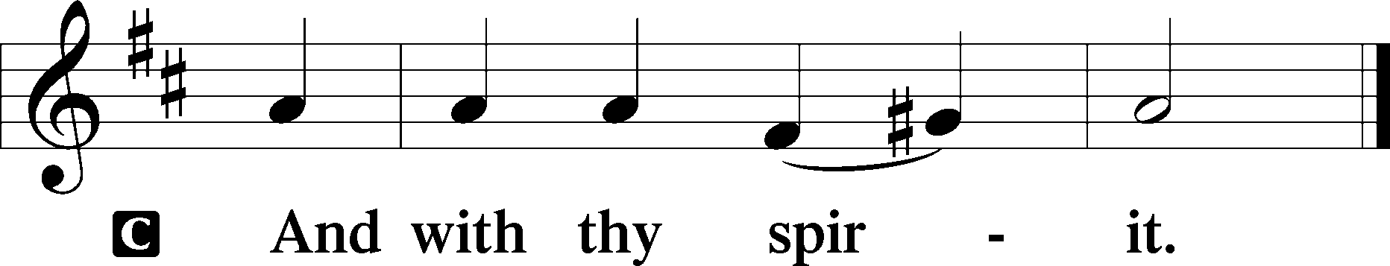

Benedicamus Psalm 103:1

A Bless we the Lord.

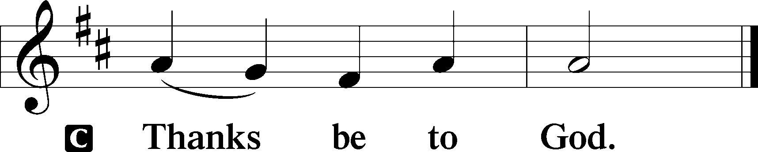

Benediction Numbers 6:24–26

P The Lord bless you and keep you.

The Lord make His face shine upon you and be gracious unto you.

The Lord lift up His countenance upon you and T give you peace.

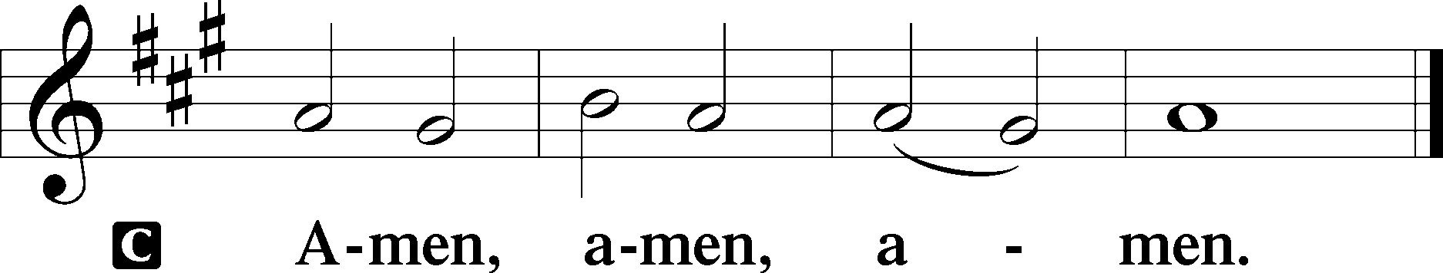

738 Lord of All Hopefulness

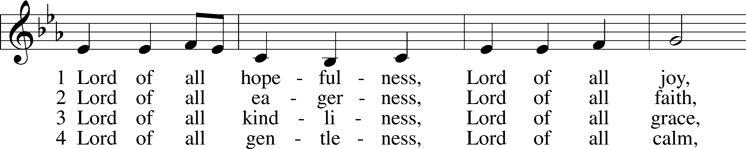

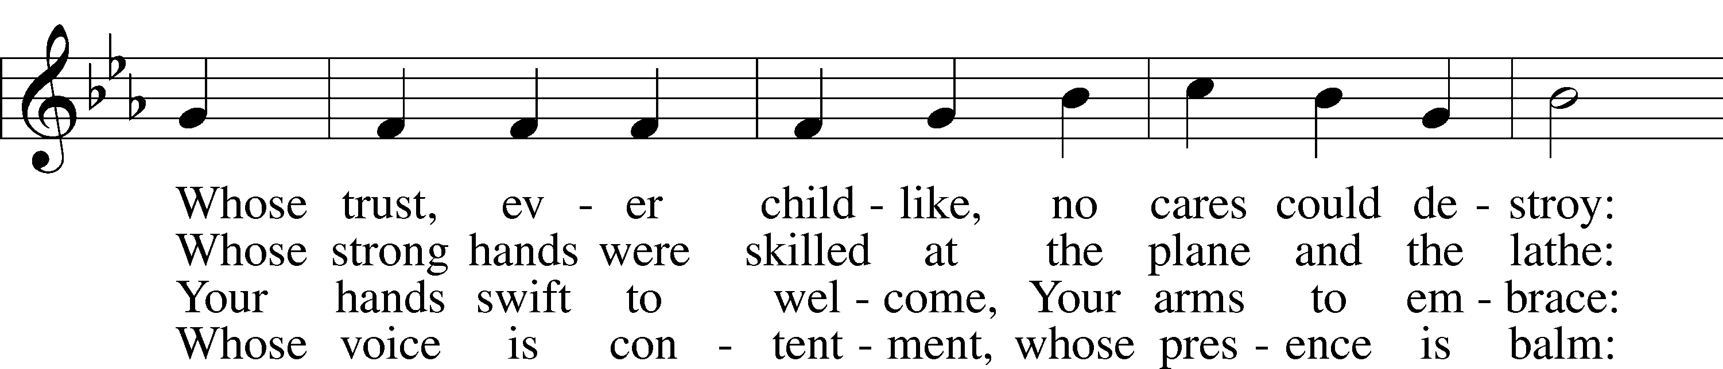

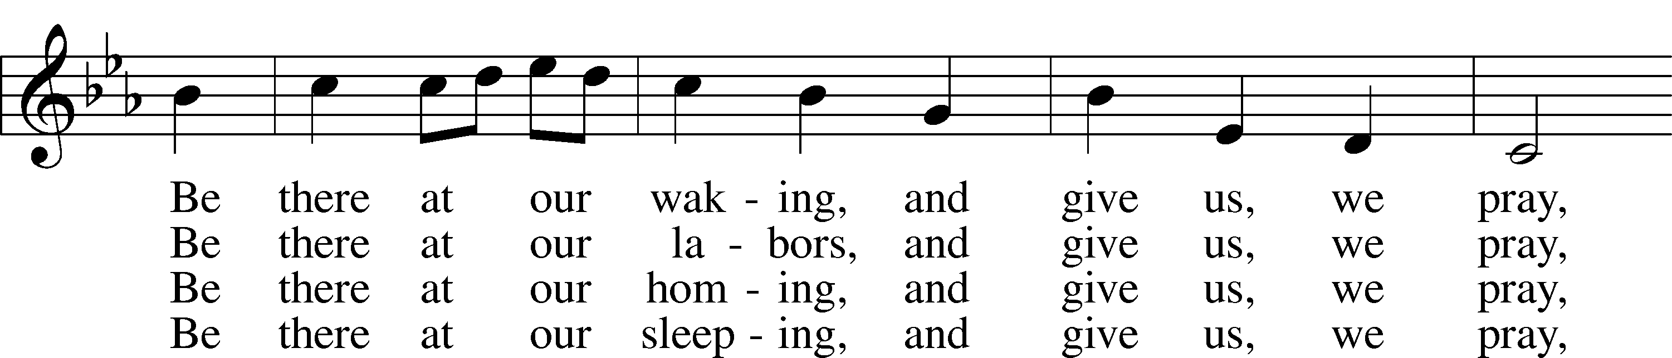

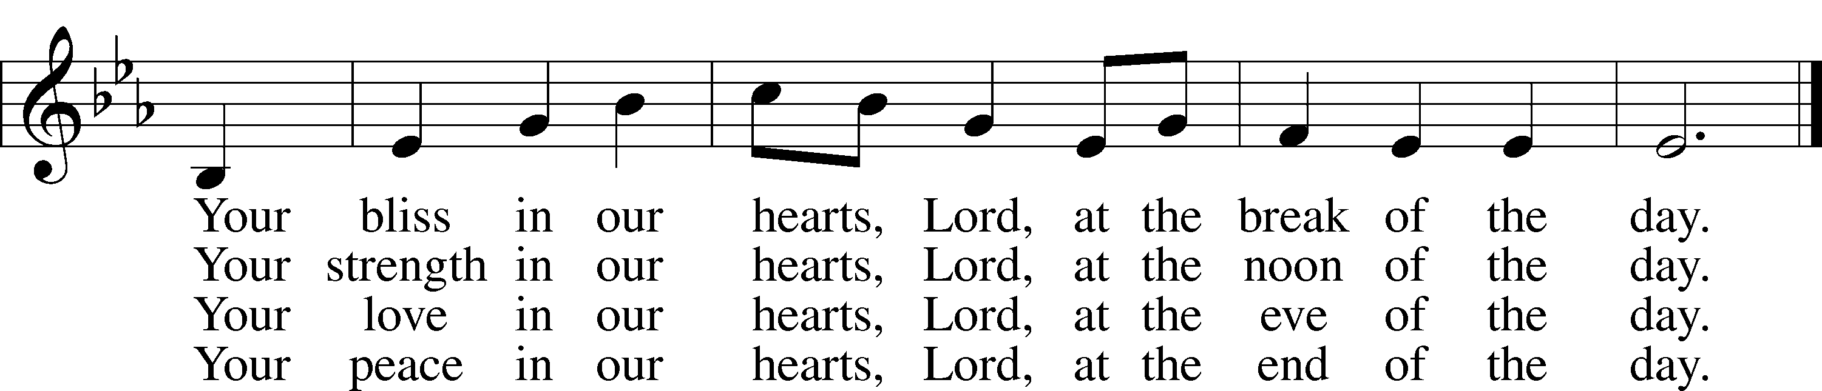

Text: Jan Struther, 1901–53  
Tune: Irish  
Text: © Oxford University Press. Used by permission: LSB Hymn License no. 110005011  
Tune: Public domain

Acknowledgments

Divine Service, Setting Three from Lutheran Service Book

Unless otherwise indicated, Scripture quotations are from the ESV® Bible (The Holy Bible, English Standard Version®), copyright © 2001 by Crossway, a publishing ministry of Good News Publishers. Used by permission. All rights reserved.

Created by Lutheran Service Builder © 2023 Concordia Publishing House.