On entering the church

P Lord, I love the habitation of Your house and the place

where Your glory dwells. In the multitude of Your tender

mercies prepare my heart that I may enter Your house to

worship and confess Your holy name; through Jesus Christ,

my God and Lord.

Before worship

C O Lord, our creator, redeemer, and comforter, as we come

together to worship You in spirit and in truth, we humbly

pray that You would open our hearts to the preaching of

Your Word so that we may repent of our sins, believe in

Jesus Christ as our only Savior, and grow in grace and

holiness. Hear us for His sake.

807 When Morning Gilds the Skies

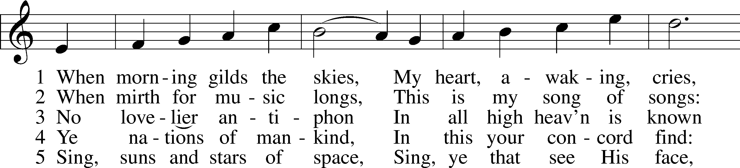

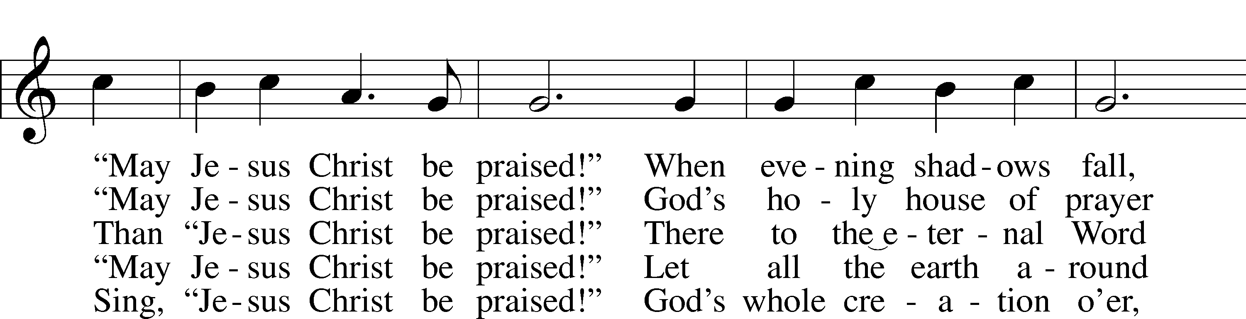

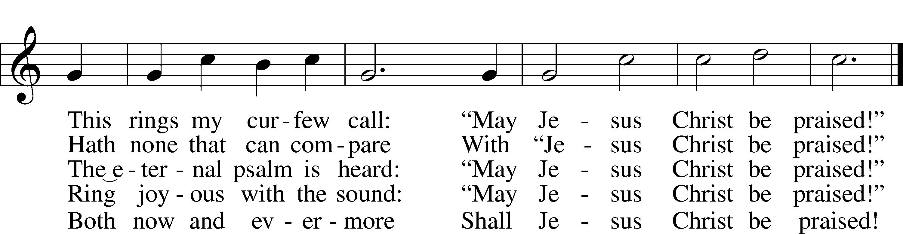

Text: Katholisches Gesangbuch, 1828, Würzburg; tr. Robert S. Bridges, 1844–1930, alt.  
Tune: Joseph Barnby, 1838–96  
Text and tune: Public domain

# Confession and Absolution

Stand

The sign of the cross may be made by all in remembrance of their Baptism.

Invocation Matthew 28:19b; 18:20

P In the name of the Father and of the T Son and of the Holy Spirit.

C **Amen.**

Exhortation Psalm 124:8; Psalm 130:3–4; Luke 18:13

P Our help is in the name of the Lord,

C **who made heaven and earth.**

P If You, O Lord, kept a record of sins, O Lord, who could stand?

C **But with You there is forgiveness; therefore You are feared.**

P Since we are gathered to hear God’s Word, call upon Him in prayer and praise, and receive the body and blood of our Lord Jesus Christ in the fellowship of this altar, let us first consider our unworthiness and confess before God and one another that we have sinned in thought, word, and deed, and that we cannot free ourselves from our sinful condition. Together as His people let us take refuge in the infinite mercy of God, our heavenly Father, seeking His grace for the sake of Christ, and saying: God, be merciful to me, a sinner.

Kneel/Stand

Confession of Sins

C **Almighty God, have mercy upon us, forgive us our sins, and lead us to everlasting life. Amen.**

Absolution [John 20:19–23]

P Almighty God in His mercy has given His Son to die for you and for His sake forgives you all your sins. As a called and ordained servant of Christ, and by His authority, I therefore forgive you all your sins in the name of the Father and of the T Son and of the Holy Spirit.

C **Amen.**

Stand

# Service of the Word

Introit Psalm 111:1–5, 9; antiphon: v. 10

The fear of the Lord is the beginning of wisdom; all those who practice it have a good understanding.  
 His praise endures forever!  
**Praise the Lord! I will give thanks to the Lord with my whole heart,**  
 **in the company of the upright, in the congregation**.  
Great are the works of the Lord,  
 studied by all who delight in them.  
**Full of splendor and majesty is his work,  
 and his righteousness endures forever.**He has caused his wondrous works to be remembered;  
 the Lord is gracious and merciful.  
**He provides food for those who fear him;  
 he remembers his covenant forever.**He sent redemption to his people; he has commanded his covenant forever.  
 Holy and awesome is his name!  
**Glory be to the Father and to the Son**  
 **and to the Holy Spirit;**  
**as it was in the beginning,**  
 **is now, and will be forever. Amen.**  
The fear of the Lord is the beginning of wisdom; all those who practice it have a good understanding.  
 His praise endures forever!

Kyrie Mark 10:47

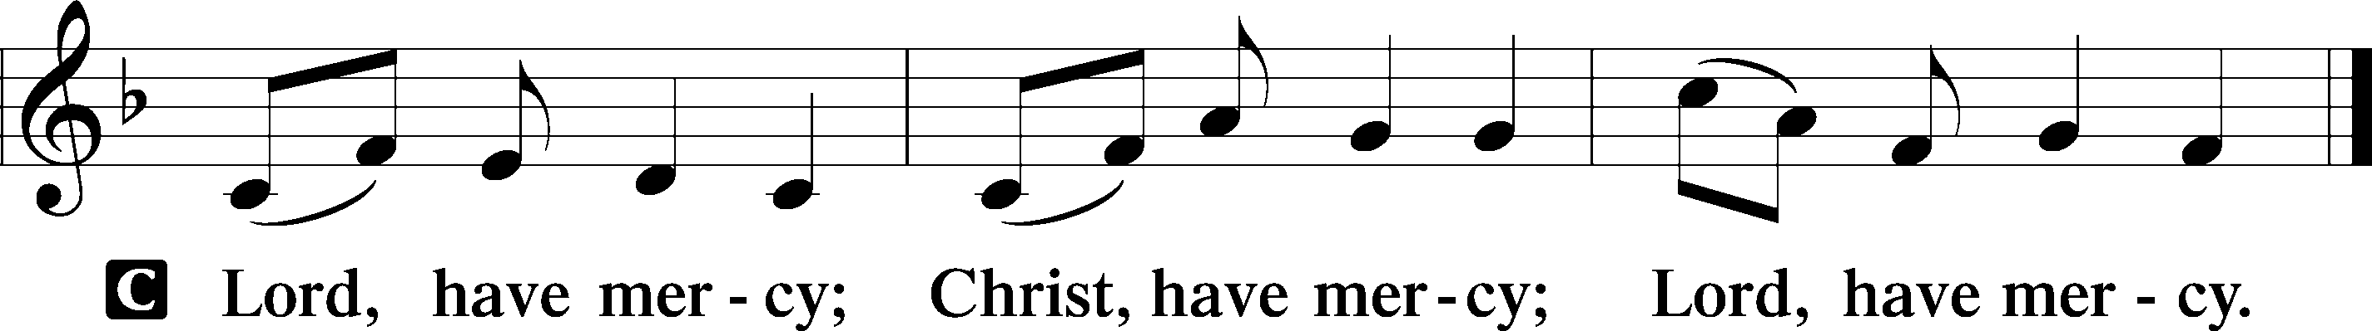

Gloria in Excelsis Luke 2:14; John 1:29

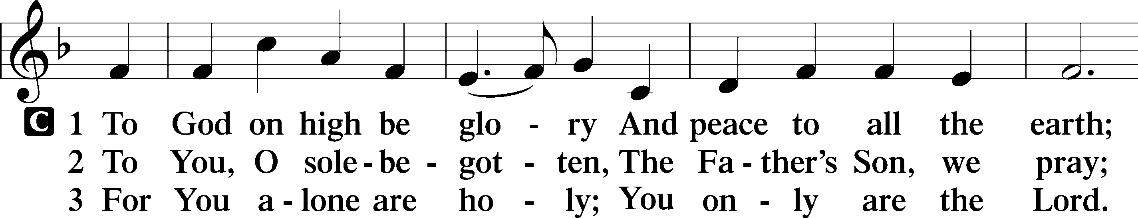

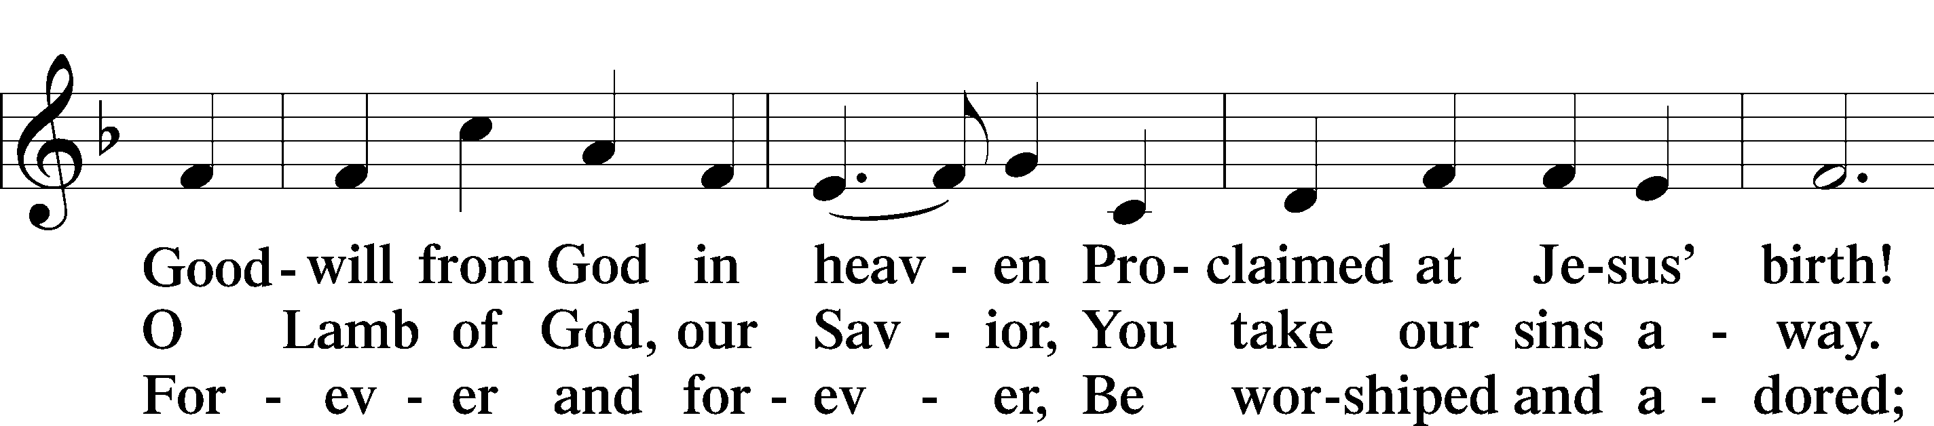

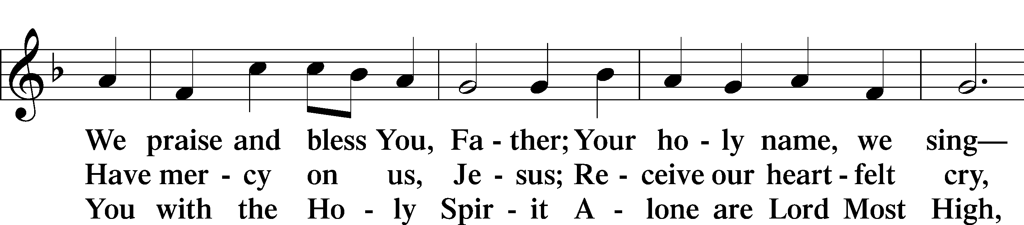

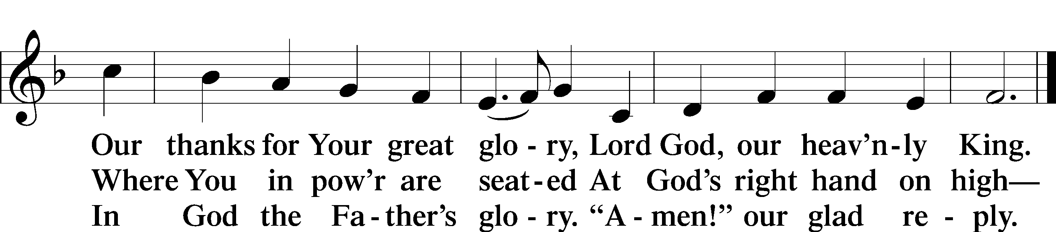

Text: Stephen P. Starke

Salutation and Collect of the Day

P The Lord be with you.

C **And also with you.**

P Let us pray.

Almighty God, whom to know is everlasting life, grant us to know Your Son, Jesus, to be the way, the truth, and the life, that we may steadfastly follow His steps in the way that leads to life eternal; through Jesus Christ, our Lord, who lives and reigns with You and the Holy Spirit, one God, now and forever.

C **Amen.**

Sit

Old Testament Reading Proverbs 9:1–10

1Wisdom has built her house;  
 she has hewn her seven pillars.  
2She has slaughtered her beasts; she has mixed her wine;  
 she has also set her table.  
3She has sent out her young women to call  
 from the highest places in the town,  
4“Whoever is simple, let him turn in here!”  
 To him who lacks sense she says,  
5“Come, eat of my bread  
 and drink of the wine I have mixed.  
6Leave your simple ways, and live,  
 and walk in the way of insight.”  
7Whoever corrects a scoffer gets himself abuse,  
 and he who reproves a wicked man incurs injury.  
8Do not reprove a scoffer, or he will hate you;  
 reprove a wise man, and he will love you.  
9Give instruction to a wise man, and he will be still wiser;  
 teach a righteous man, and he will increase in learning.  
10The fear of the Lord is the beginning of wisdom,  
 and the knowledge of the Holy One is insight.

A This is the Word of the Lord.

C **Thanks be to God.**

Gradual Psalm 34:9, 19, alt.

Fear the Lord, you his saints,  
 for those who fear him lack nothing!  
**Many are the afflictions of the righteous,  
 but the Lord delivers him out of them all.**

Epistle Ephesians 5:6–21

6Let no one deceive you with empty words, for because of these things the wrath of God comes upon the sons of disobedience. 7Therefore do not associate with them; 8for at one time you were darkness, but now you are light in the Lord. Walk as children of light 9(for the fruit of light is found in all that is good and right and true), 10and try to discern what is pleasing to the Lord. 11Take no part in the unfruitful works of darkness, but instead expose them. 12For it is shameful even to speak of the things that they do in secret. 13But when anything is exposed by the light, it becomes visible, 14for anything that becomes visible is light. Therefore it says,

“Awake, O sleeper,  
 and arise from the dead,  
and Christ will shine on you.”

15Look carefully then how you walk, not as unwise but as wise, 16making the best use of the time, because the days are evil. 17Therefore do not be foolish, but understand what the will of the Lord is. 18And do not get drunk with wine, for that is debauchery, but be filled with the Spirit, 19addressing one another in psalms and hymns and spiritual songs, singing and making melody to the Lord with all your heart, 20giving thanks always and for everything to God the Father in the name of our Lord Jesus Christ, 21submitting to one another out of reverence for Christ.

A This is the Word of the Lord.

C **Thanks be to God.**

Stand

Alleluia and Verse

Alleluia

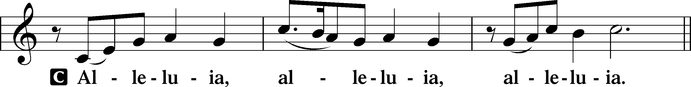

Verse John 20:31

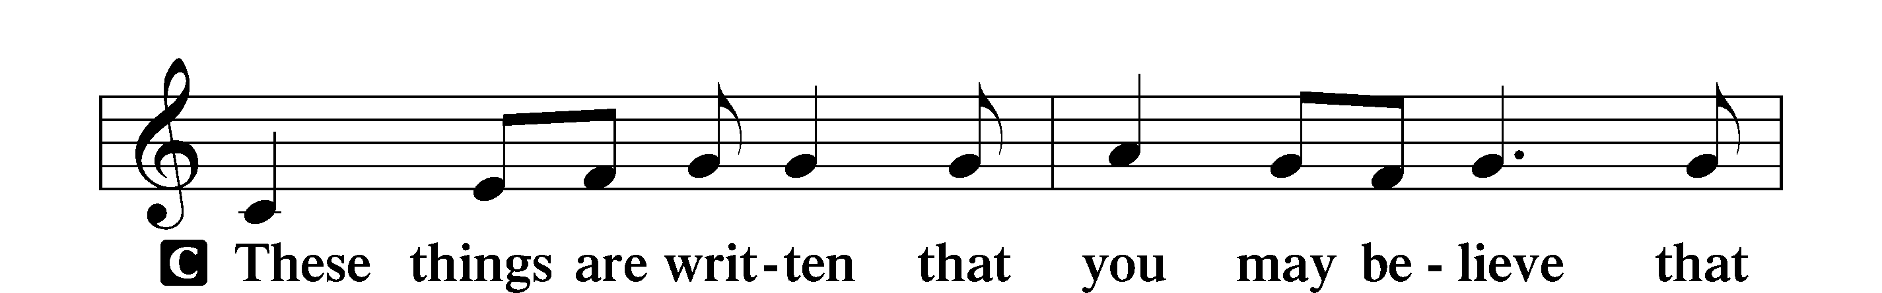

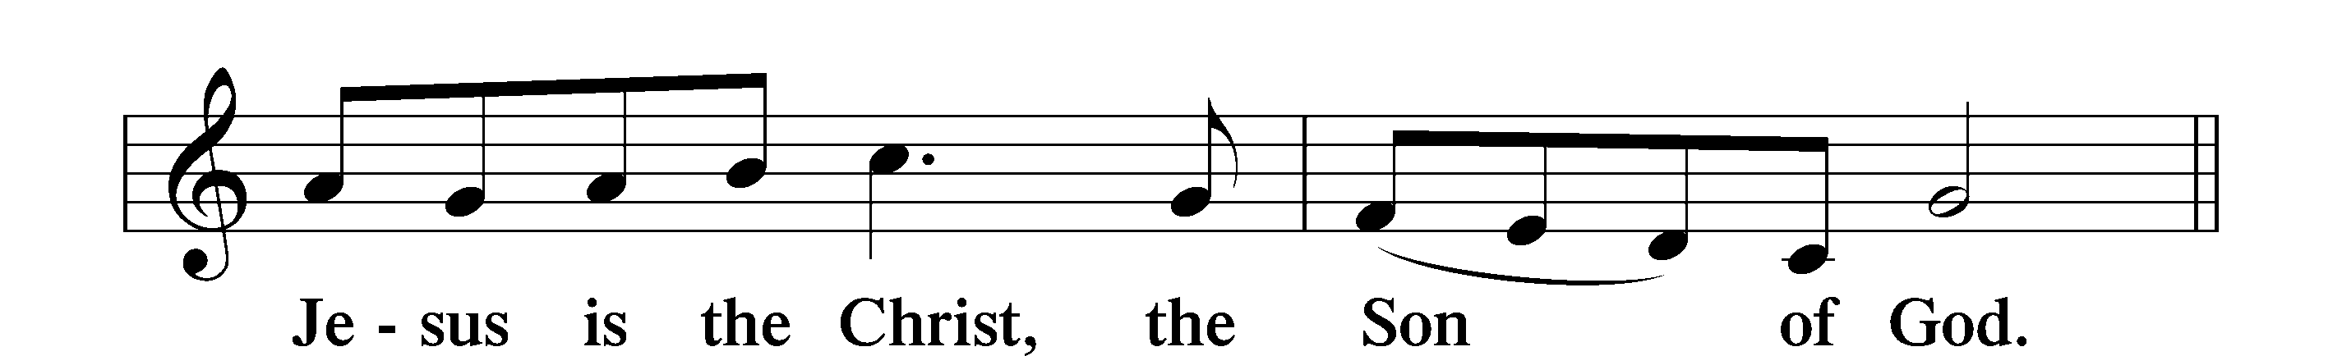

Alleluia

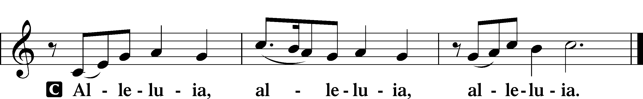

Holy Gospel John 6:51–69

P The Holy Gospel according to St. John, the sixth chapter.

C **Glory to You, O Lord.**

51[Jesus said:] “I am the living bread that came down from heaven. If anyone eats of this bread, he will live forever. And the bread that I will give for the life of the world is my flesh.”

52The Jews then disputed among themselves, saying, “How can this man give us his flesh to eat?” 53So Jesus said to them, “Truly, truly, I say to you, unless you eat the flesh of the Son of Man and drink his blood, you have no life in you. 54Whoever feeds on my flesh and drinks my blood has eternal life, and I will raise him up on the last day. 55For my flesh is true food, and my blood is true drink. 56Whoever feeds on my flesh and drinks my blood abides in me, and I in him. 57As the living Father sent me, and I live because of the Father, so whoever feeds on me, he also will live because of me. 58This is the bread that came down from heaven, not as the fathers ate and died. Whoever feeds on this bread will live forever.” 59Jesus said these things in the synagogue, as he taught at Capernaum.

The Words of Eternal Life

60When many of his disciples heard it, they said, “This is a hard saying; who can listen to it?” 61But Jesus, knowing in himself that his disciples were grumbling about this, said to them, “Do you take offense at this? 62Then what if you were to see the Son of Man ascending to where he was before? 63It is the Spirit who gives life; the flesh is of no avail. The words that I have spoken to you are spirit and life. 64But there are some of you who do not believe.” (For Jesus knew from the beginning who those were who did not believe, and who it was who would betray him.) 65And he said, “This is why I told you that no one can come to me unless it is granted him by the Father.”

66After this many of his disciples turned back and no longer walked with him. 67So Jesus said to the Twelve, “Do you want to go away as well?” 68Simon Peter answered him, “Lord, to whom shall we go? You have the words of eternal life, 69and we have believed, and have come to know, that you are the Holy One of God.”

P This is the Gospel of the Lord.

C **Praise to You, O Christ.**

Nicene Creed

C **I believe in one God,**

**the Father Almighty,**

**maker of heaven and earth**

**and of all things visible and invisible.**

**And in one Lord Jesus Christ,**

**the only-begotten Son of God,**

**begotten of His Father before all worlds,**

**God of God, Light of Light,**

**very God of very God,**

**begotten, not made,**

**being of one substance with the Father,**

**by whom all things were made;**

**who for us men and for our salvation came down from heaven**

**and was incarnate by the Holy Spirit of the virgin Mary**

**and was made man;**

**and was crucified also for us under Pontius Pilate.**

**He suffered and was buried.**

**And the third day He rose again according to the Scriptures**

**and ascended into heaven**

**and sits at the right hand of the Father.**

**And He will come again with glory to judge both the living and the dead,**

**whose kingdom will have no end.**

**And I believe in the Holy Spirit,**

**the Lord and giver of life,**

**who proceeds from the Father and the Son,**

**who with the Father and the Son together is worshiped and glorified,**

**who spoke by the prophets.**

**And I believe in one holy Christian and apostolic Church,**

**I acknowledge one Baptism for the remission of sins,**

**and I look for the resurrection of the dead**

**and the life** T **of the world to come. Amen.**

Sit

Children's Sermon

696 O God, My Faithful God

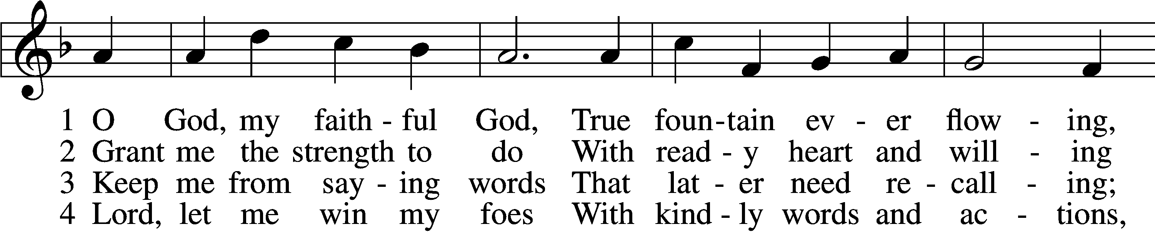

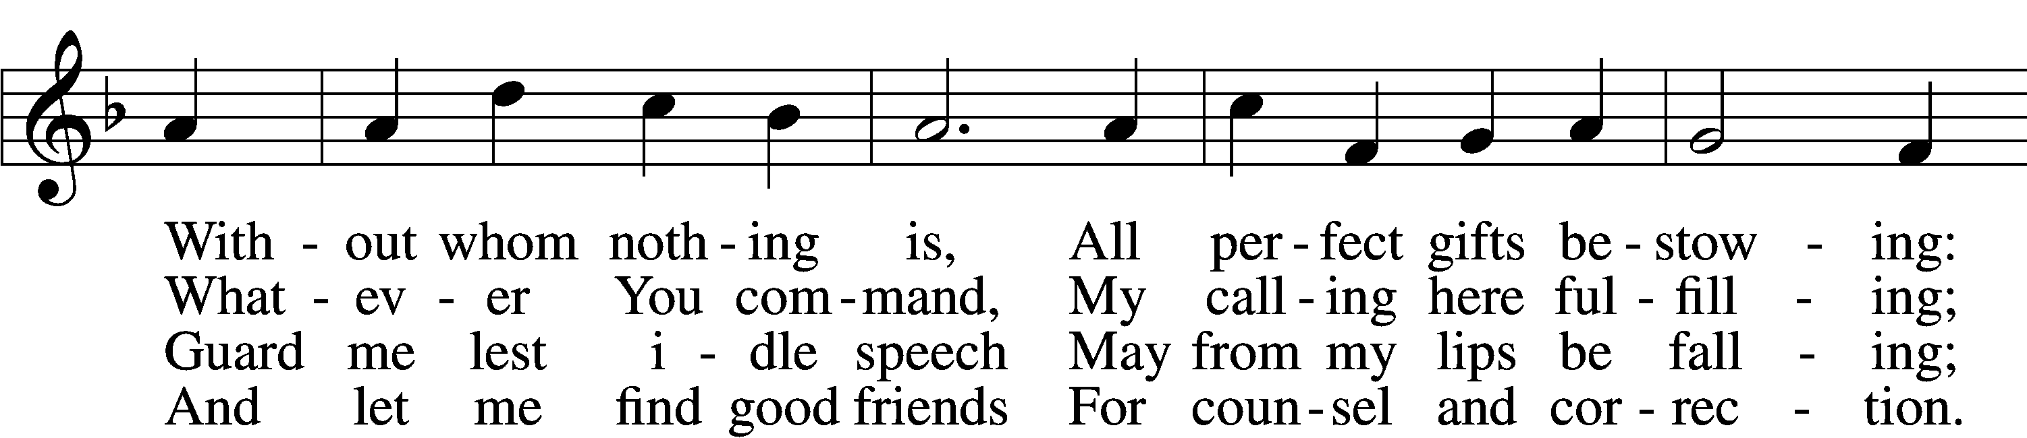

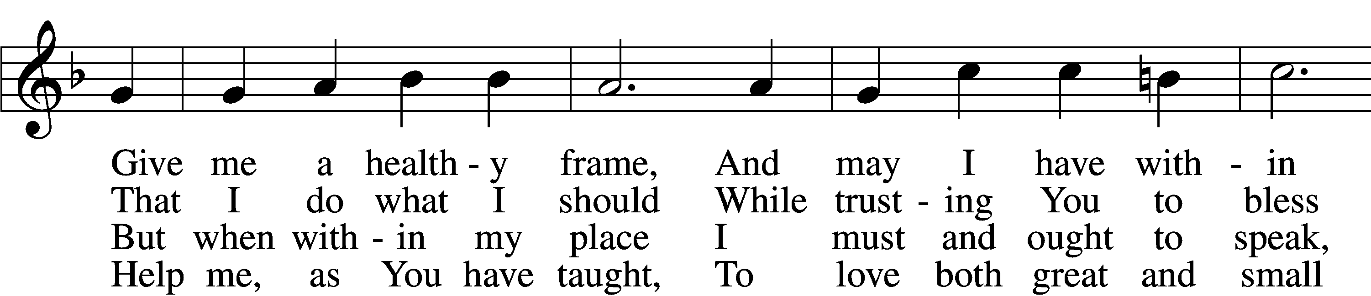

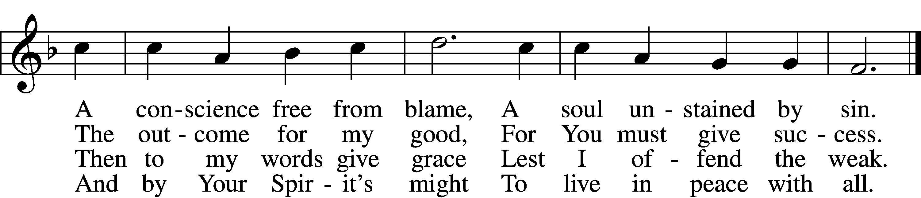

5 Let me depart this life  
 Confiding in my Savior;  
By grace receive my soul  
 That it may live forever;  
And let my body have  
 A quiet resting place  
Within a Christian grave;  
 And let it sleep in peace.

6 And on that final day  
 When all the dead are waking,  
Stretch out Your mighty hand,  
 My deathly slumber breaking.  
Then let me hear Your voice,  
 Redeem this earthly frame,  
And bid me to rejoice  
 With those who love Your name.

Text: Johann Heermann, 1585–1647; tr. Catherine Winkworth, 1827–78, alt.  
Tune: Neu-vermehrtes . . . Gesangbuch, 1693, 3rd ed., Meiningen  
Text and tune: Public domain

Sermon

Stand

Prayer of the Church

Following the prayers, the people may greet one another in the name of the Lord, saying, “Peace be with you,” as a sign of reconciliation and of the unity of the Spirit in the bond of peace (Matt. 5:22–24; Eph. 4:1–3).

Sit

Offering

Hymn

# Service of the Sacrament

Stand

Preface 2 Timothy 4:22; [Colossians 3:1]; [Psalm 136]

P The Lord be with you.

C **And also with you.**

P Lift up your hearts.

C **We lift them to the Lord.**

P Let us give thanks to the Lord our God.

C **It is right to give Him thanks and praise.**

P It is truly good, right, and salutary that we should at all times and in all places give thanks to You, O Lord, holy Father, almighty and everlasting God, for the countless blessings You so freely bestow on us and all creation. Above all, we give thanks for Your boundless love shown to us when You sent Your only-begotten Son, Jesus Christ, into our flesh and laid on Him our sin, giving Him into death that we might not die eternally. Because He is now risen from the dead and lives and reigns to all eternity, all who believe in Him will overcome sin and death and will rise again to new life. Therefore with angels and archangels and with all the company of heaven we laud and magnify Your glorious name, evermore praising You and saying:

Sanctus Isaiah 6:3; Matthew 21:9

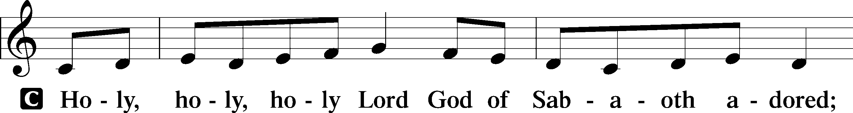

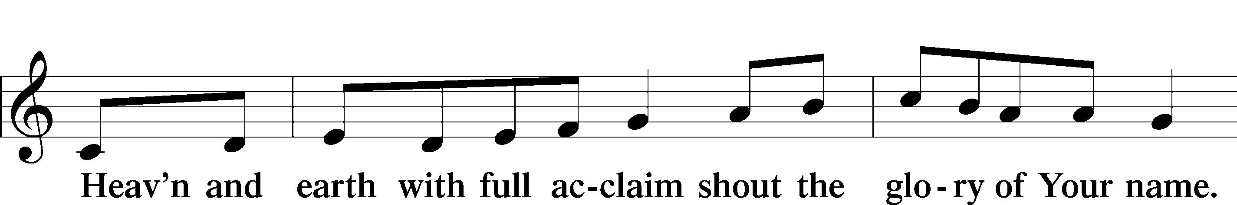

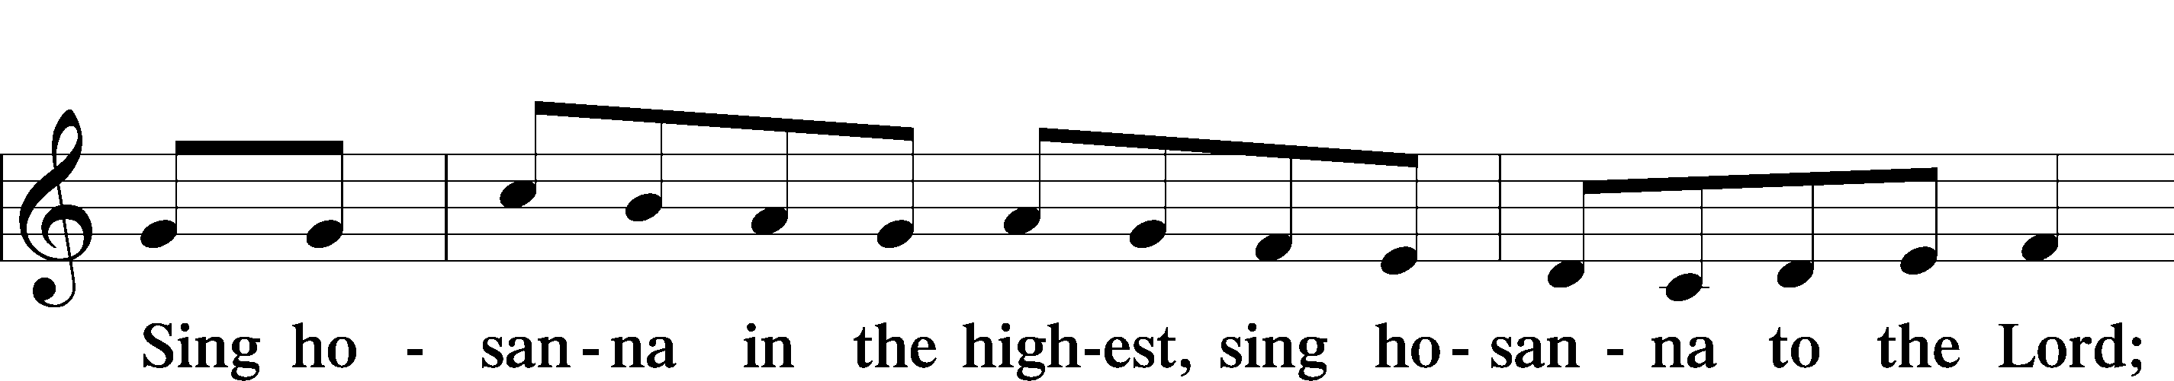

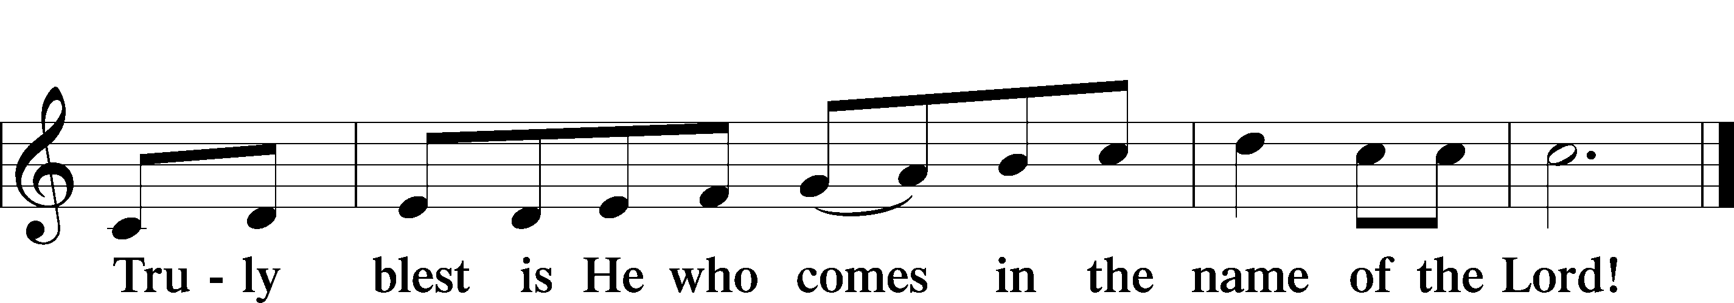

Text: Stephen P. Starke

Prayer of Thanksgiving

P Blessed are You, O Lord our God, king of all creation, for You have had mercy on us and given Your only-begotten Son that whoever believes in Him should not perish but have eternal life.

In Your righteous judgment You condemned the sin of Adam and Eve, who ate the forbidden fruit, and You justly barred them and all their children from the tree of life. Yet, in Your great mercy, You promised salvation by a second Adam, Your Son, Jesus Christ, our Lord, and made His cross a life-giving tree for all who trust in Him.

We give You thanks for the redemption You have prepared for us through Jesus Christ. Grant us Your Holy Spirit that we may faithfully eat and drink of the fruits of His cross and receive the blessings of forgiveness, life, and salvation that come to us in His body and blood.

Hear us as we pray in His name and as He has taught us:

Lord’s Prayer

C **Our Father who art in heaven,**

**hallowed be Thy name,**

**Thy kingdom come,**

**Thy will be done on earth**

**as it is in heaven;**

**give us this day our daily bread;**

**and forgive us our trespasses**

**as we forgive those**

**who trespass against us;**

**and lead us not into temptation,**

**but deliver us from evil.**

**For Thine is the kingdom**

**and the power and the glory**

**forever and ever. Amen.**

The Words of Our Lord

P Our Lord Jesus Christ, on the night when He was betrayed, took bread, and when He had given thanks, He broke it and gave it to the disciples and said: “Take, eat; this is My T body, which is given for you. This do in remembrance of Me.”

In the same way also He took the cup after supper, and when He had given thanks, He gave it to them, saying: “Drink of it, all of you; this cup is the new testament in My T blood, which is shed for you for the forgiveness of sins. This do, as often as you drink it, in remembrance of Me.”

Pax Domini

P The peace of the Lord be with you always.

C **Amen.**

Agnus Dei John 1:29

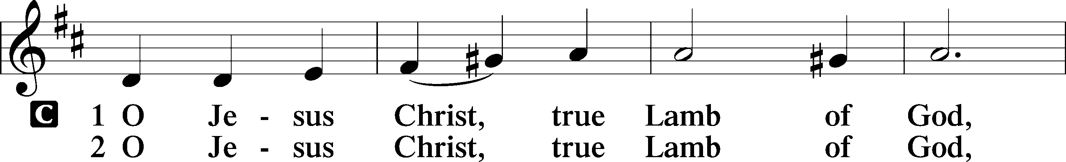

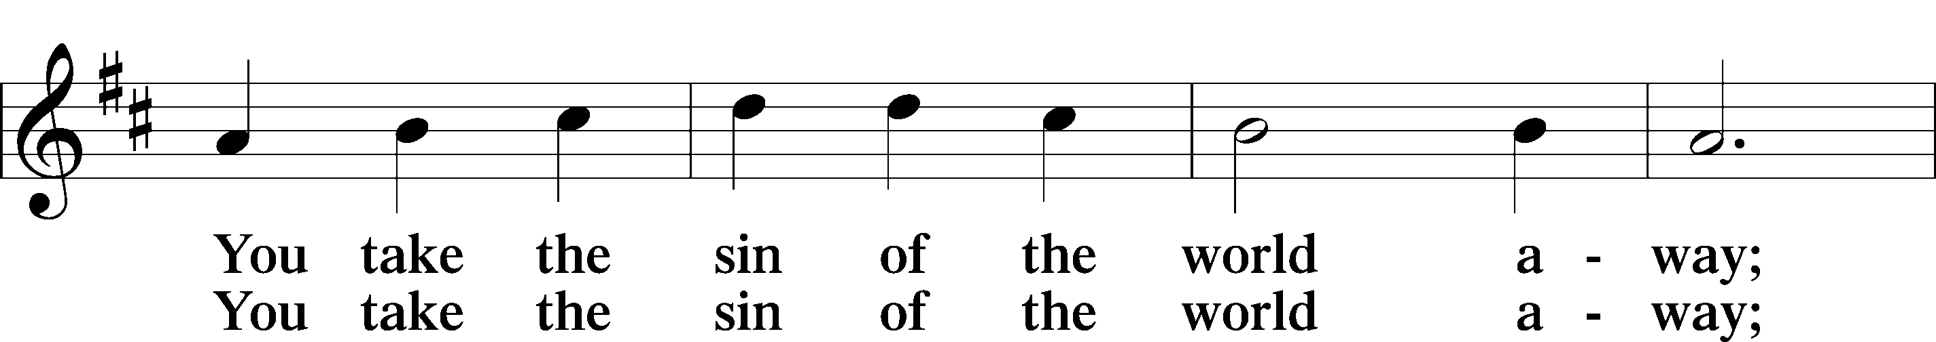

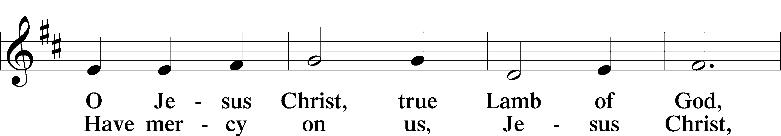

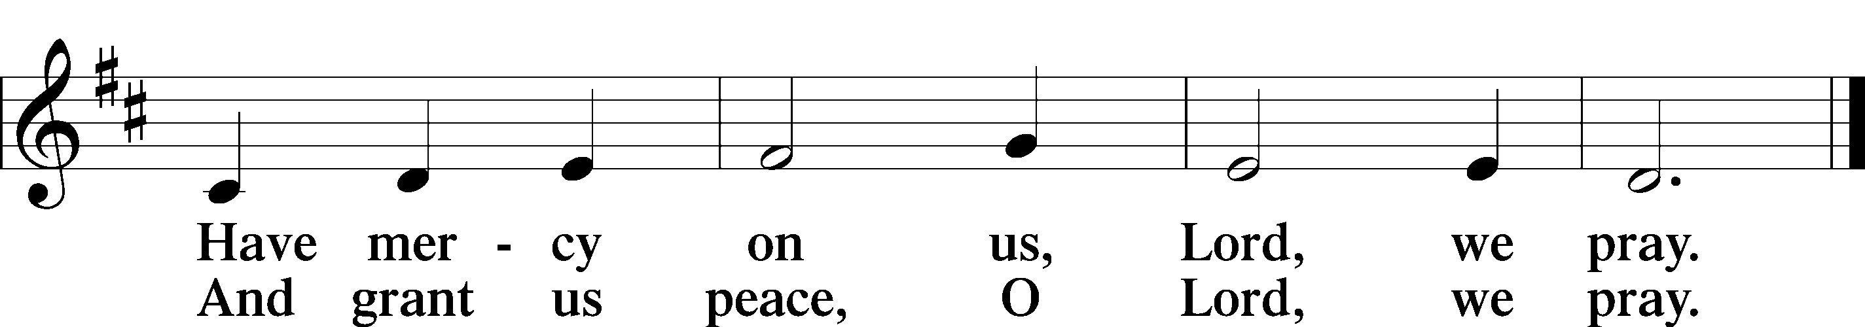

Text: Stephen P. Starke

Sit

Distribution

The pastor and those who assist him receive the body and blood of Christ first and then distribute them to those who come to receive, saying:

Take, eat; this is the true body of our Lord and Savior Jesus Christ, given into death for your sins.

**Amen.**

Take, drink; this is the true blood of our Lord and Savior Jesus Christ, shed for the forgiveness of your sins.

**Amen.**

In dismissing the communicants, the following is said:

The Dismissal

P The body and blood of our Lord Jesus Christ strengthen and preserve you in body and soul to life everlasting. Depart T in peace.

C **Amen.**

680 Thine the Amen, Thine the Praise

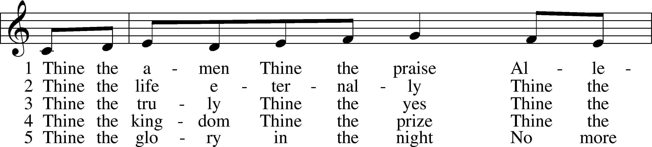

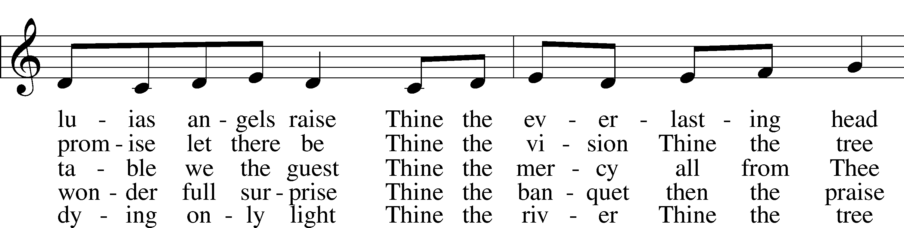

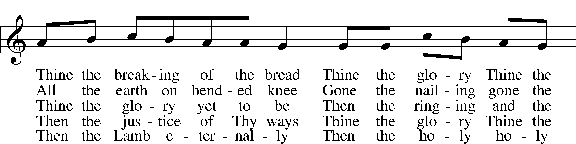

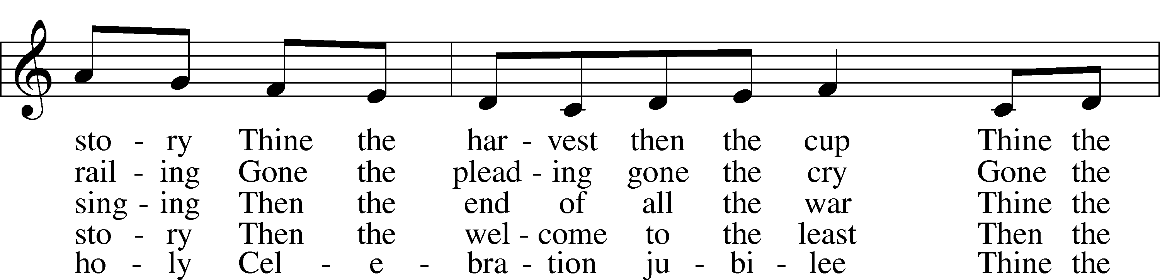

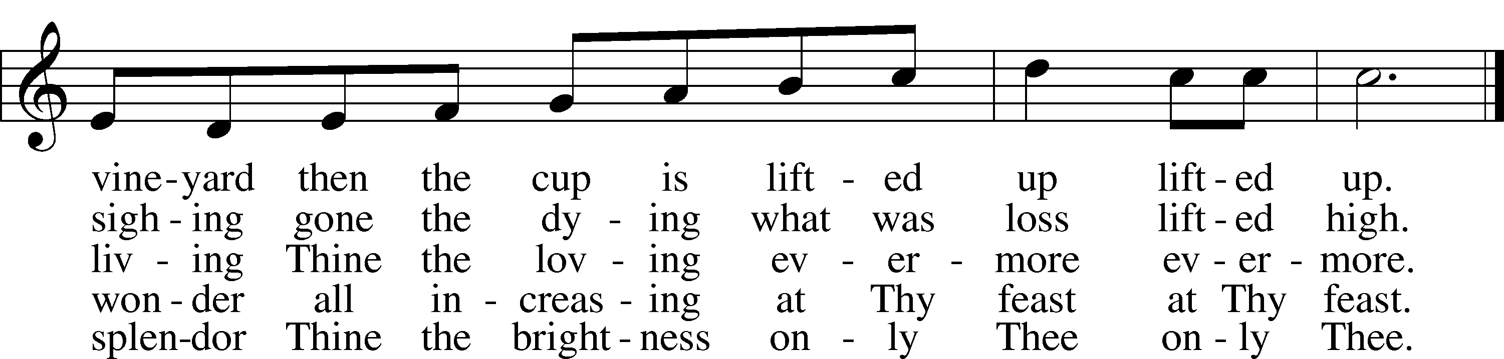

Text: Herbert F. Brokering, 1926–2009  
Tune: Carl F. Schalk, 1929  
Text and tune: © 1983 Augsburg Publishing House. Used by permission: LSB Hymn License no. 110005011

914 Light of Light, O Sole-Begotten

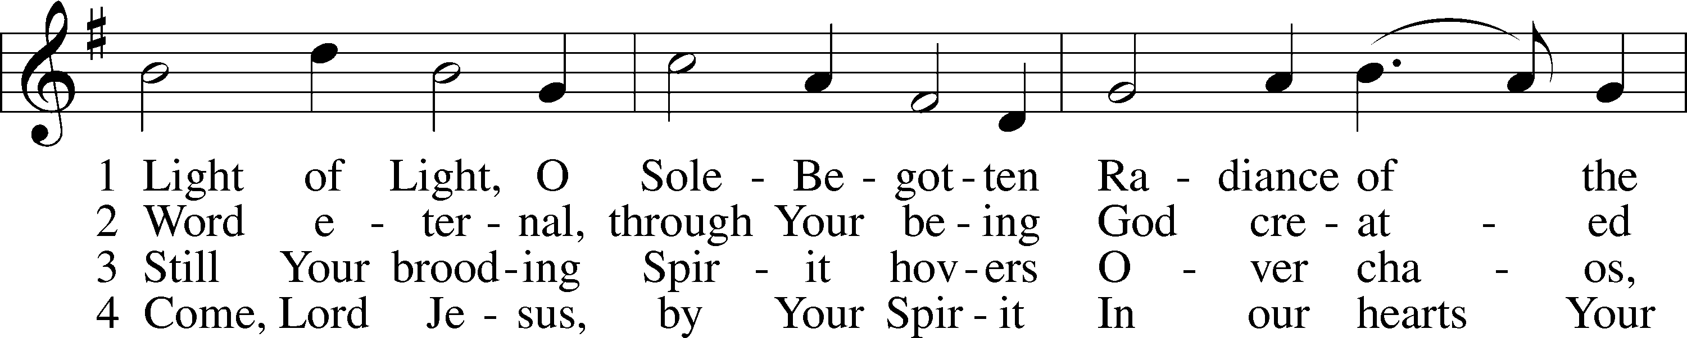

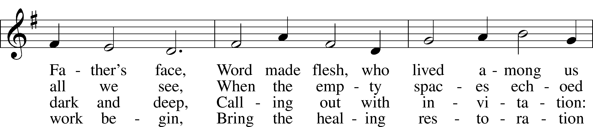

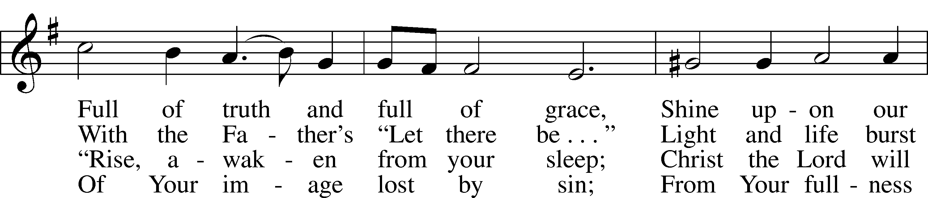

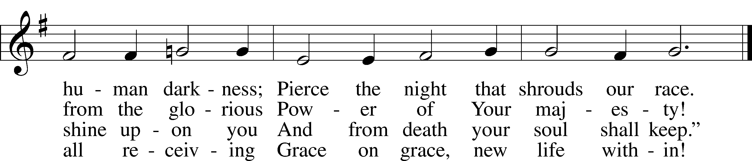

Text: Stephen P. Starke, 1955  
Tune: Henry Purcell, 1659–95, adapt.  
Text: © 1992 Stephen P. Starke, admin. Concordia Publishing House. Used by permission: LSB Hymn License no. 110005011  
Tune: Public domain

625 Lord Jesus Christ, Life-Giving Bread

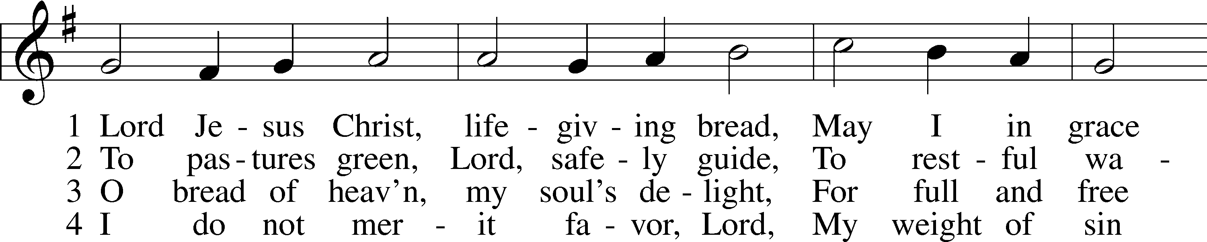

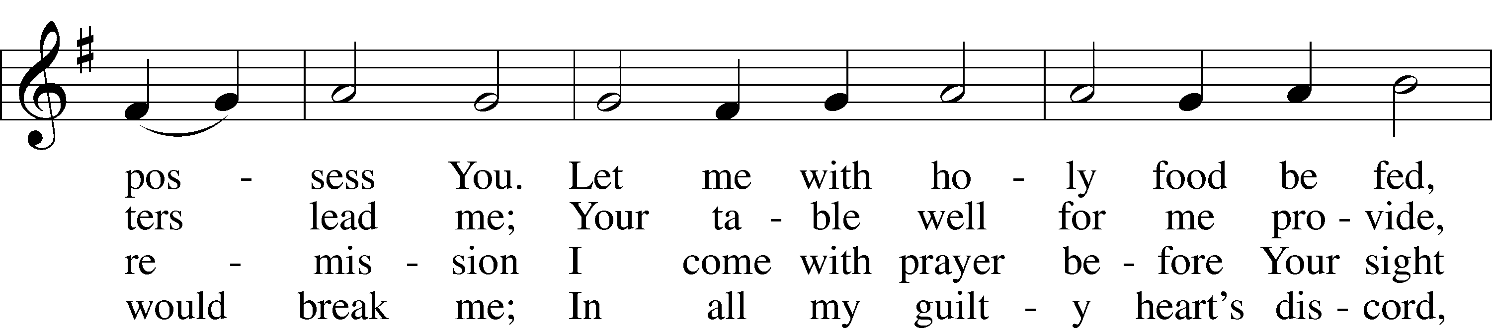

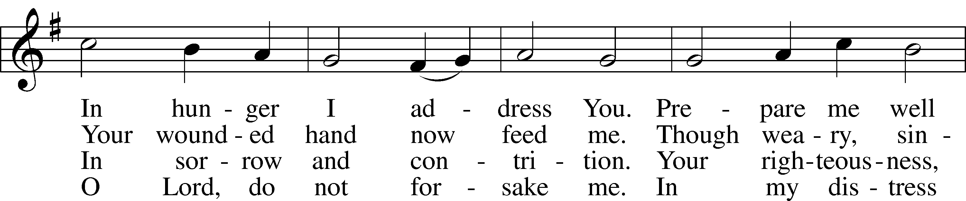

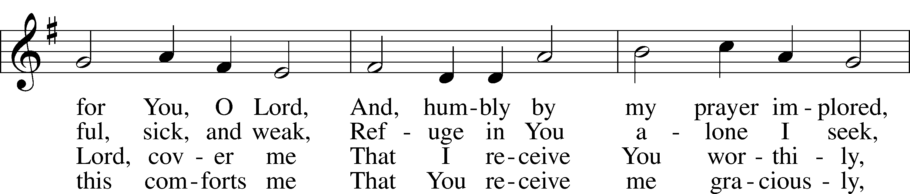

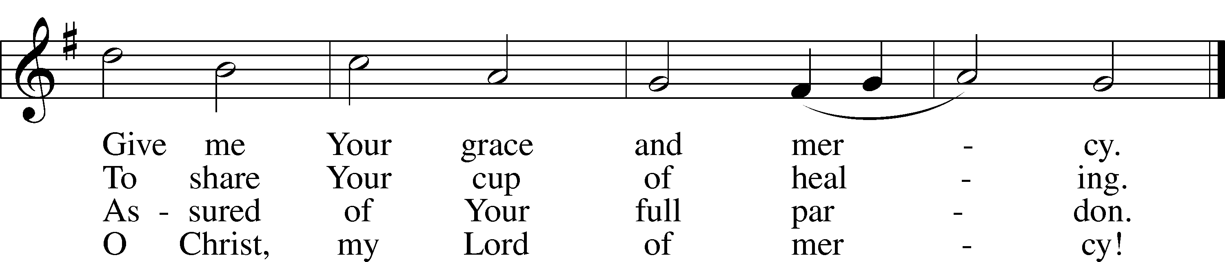

Text: Johann Rist, 1607–67; tr. Arthur T. Russell, 1806–74, alt.  
Tune: Theütsch kirchen ampt, 1525, Strassburg  
Text and tune: Public domain

643 Sent Forth by God’s Blessing

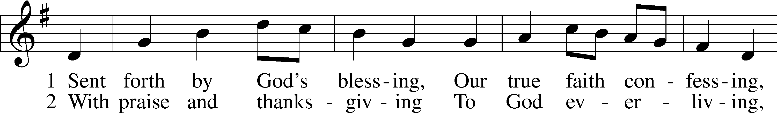

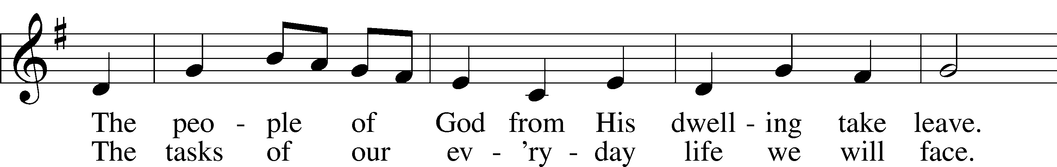

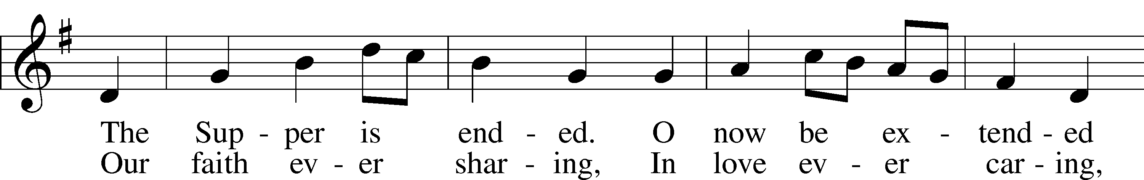

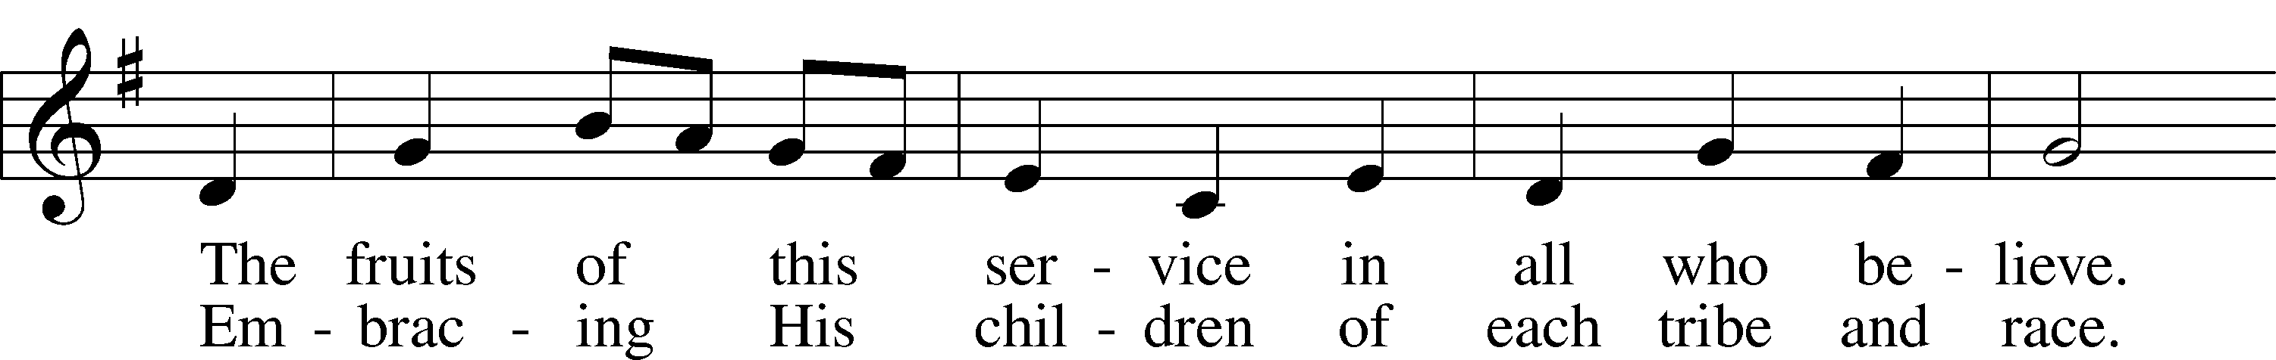

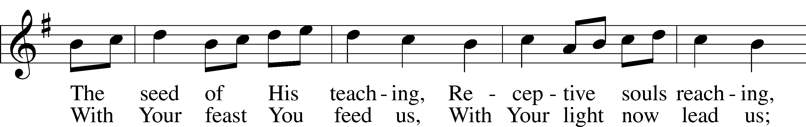

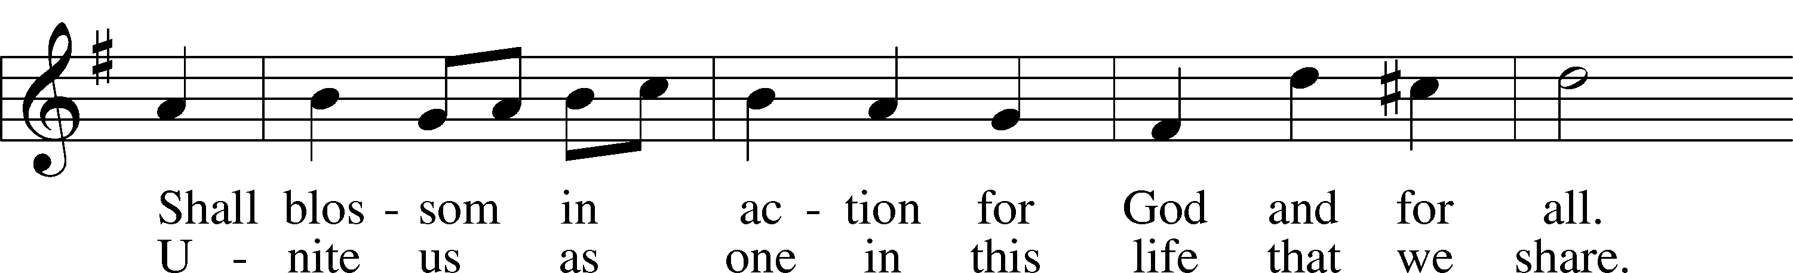

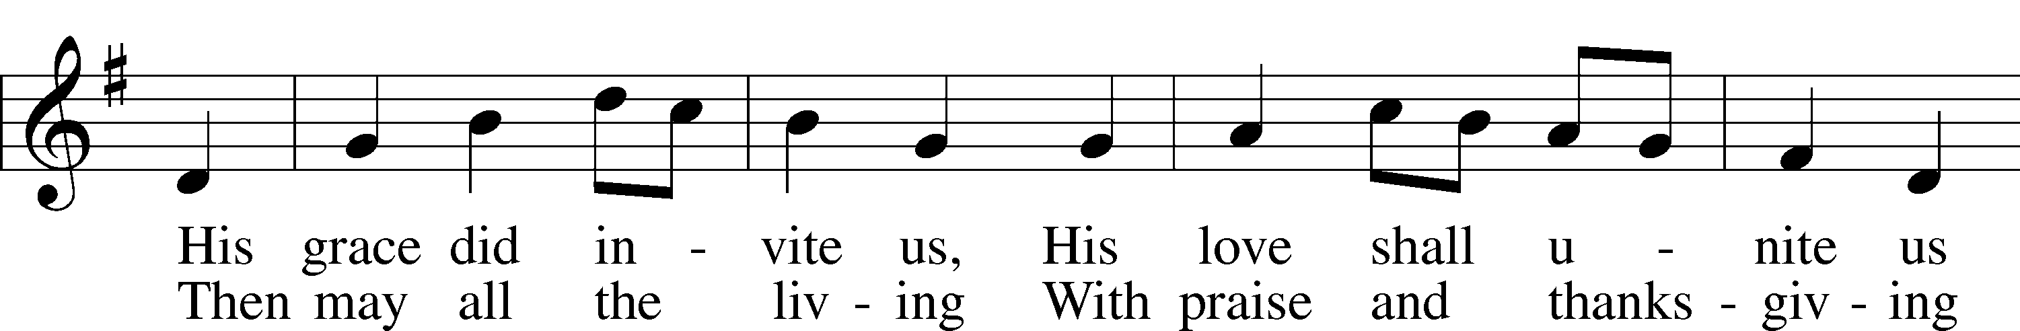

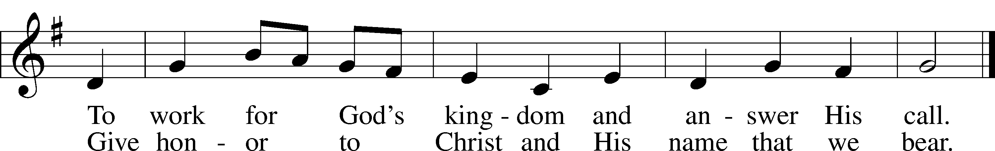

Text: Omer E. Westendorf, 1916–97, alt.  
Tune: Welsh  
Text: © 1964 World Library Publications. Used by permission: LSB Hymn License no. 110005011  
Tune: Public domain

Stand

Nunc Dimittis Luke 2:29–32

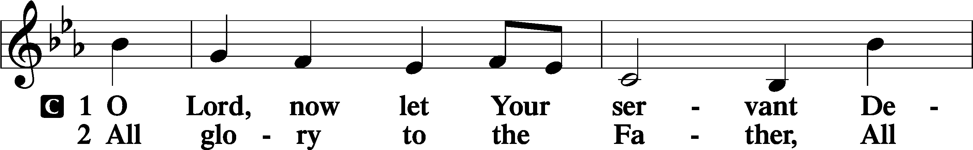

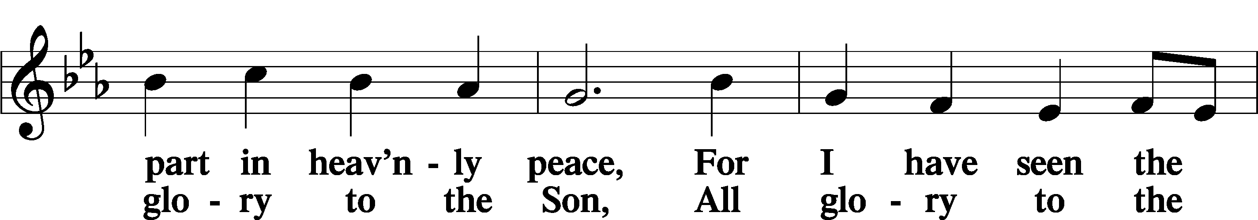

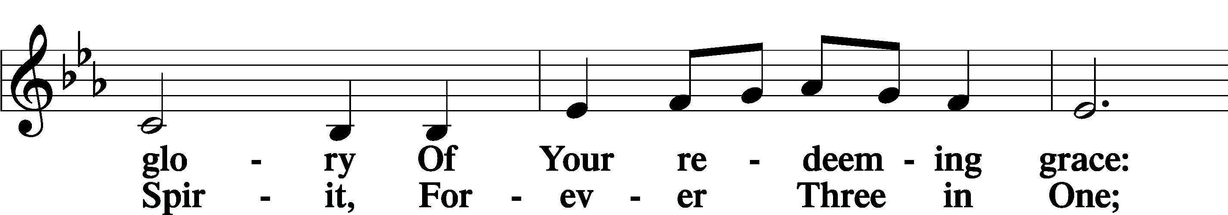

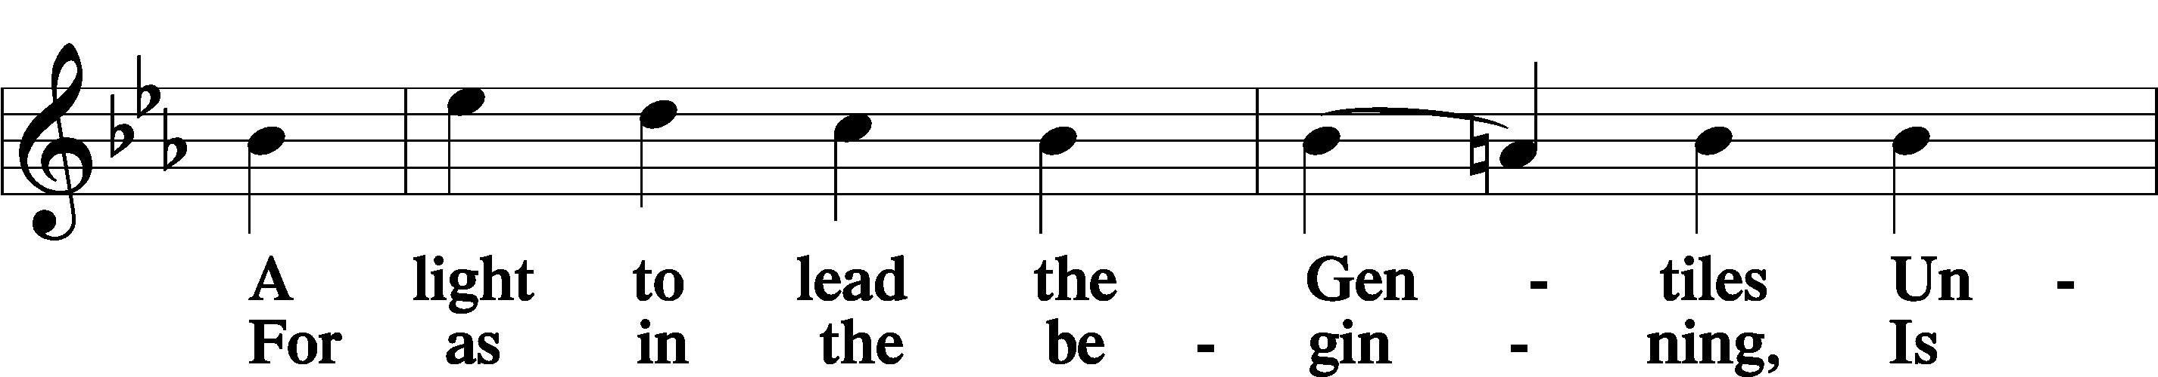

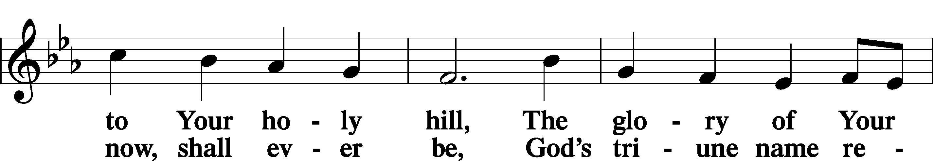

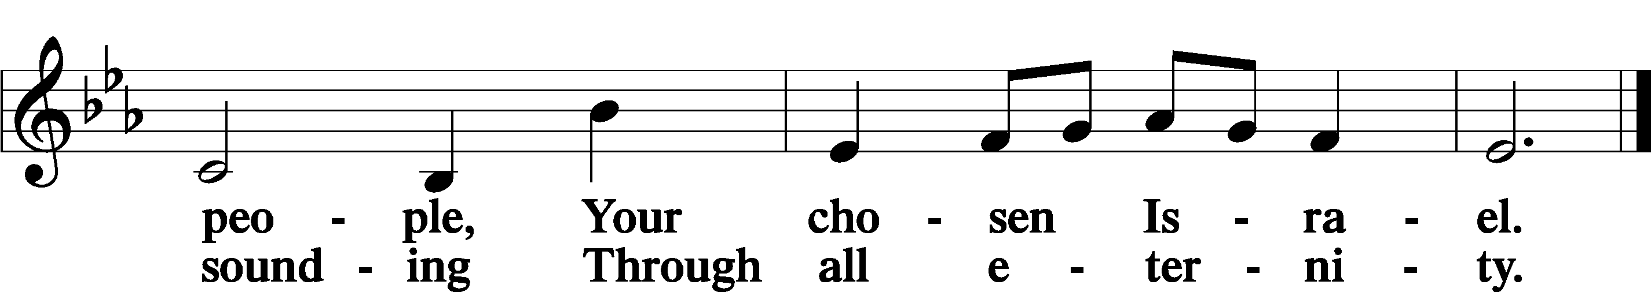

Post-Communion Collect

A Let us pray.

We give thanks to You, almighty God, that You have refreshed us through this salutary gift, and we implore You that of Your mercy You would strengthen us through the same in faith toward You and in fervent love toward one another; through Jesus Christ, Your Son, our Lord, who lives and reigns with You and the Holy Spirit, one God, now and forever.

C **Amen.**

Benedicamus Psalm 103:1

A Let us bless the Lord.

C **Thanks be to God.**

Benediction

P The Lord bless you and keep you.

The Lord make His face shine on you and be gracious to you.

The Lord look upon you with favor and T give you peace.

C **Amen.**

655 Lord, Keep Us Steadfast in Your Word

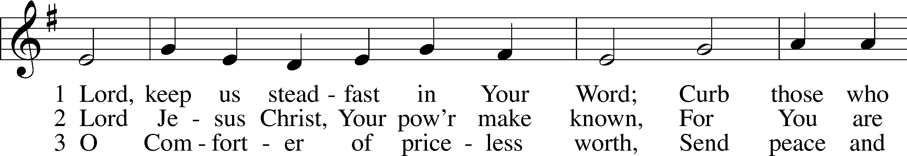

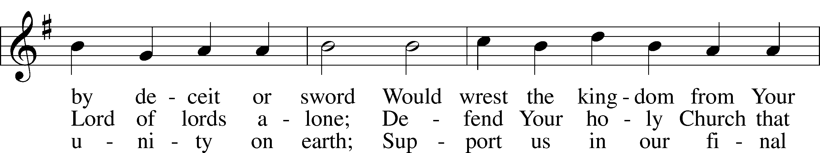

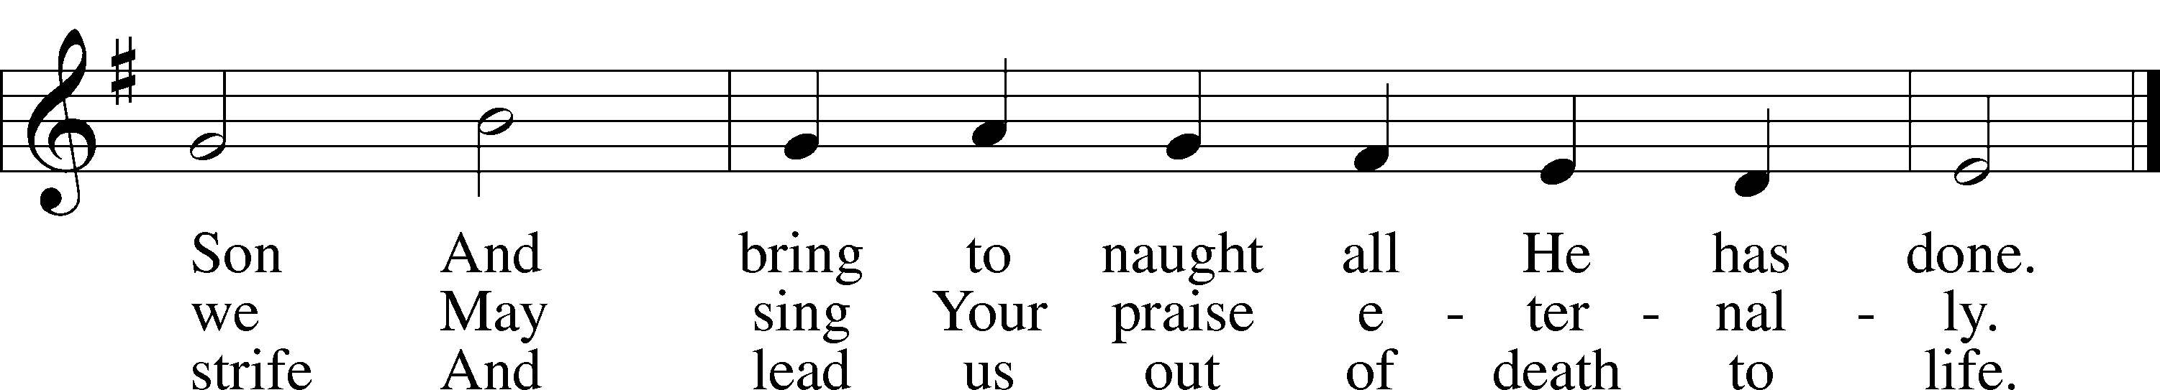

Text: Martin Luther, 1483–1546; tr. Catherine Winkworth, 1827–78, alt.  
Tune: Geistliche Lieder auffs new gebessert, 1543, Wittenberg, ed. Joseph Klug  
Text and tune: Public domain

Acknowledgments

Divine Service, Setting Four from Lutheran Service Book

Unless otherwise indicated, Scripture quotations are from the ESV® Bible (The Holy Bible, English Standard Version®), copyright © 2001 by Crossway, a publishing ministry of Good News Publishers. Used by permission. All rights reserved.

Created by Lutheran Service Builder © 2024 Concordia Publishing House.