
















Celebrate June’s Baptism Birthdays
& their years as heirs of God’s kingdom!

Date | Name | Years
1st | Terry Henry | 45
 | Chanda Lee | 43
 | Jack Morgan | 87
3rd | Tonda Rice | 43
5th | Ailey Pickett | 15
6th | Brad Hammer | 33
9th | Jo Kleinhans | 80
 | Glenda Roth | 74
10th | Art Noack | 93
14th | Cade Roth | 28
 | Emily Roth | 28
 | Grant Roth | 28
17th | Nealee Allen | 14
 | Chance Gilmore | 36
 | Camerin Dyson | 36
20th | Lee Allen | 45
25th | Lark Shaw | 9
26th | Debbie Herriage | 34
30th | Maleisa Belcher | 48

Serving in God’s House this month

Elder of the Month | David Geis
Counters | Lee Hughes / David Geis
Altar Guild | Lisa Lawson / Rebecca Horton
Altar Care | Maleisa Belcher / Becky Geis
Guest Monitor | Kelly Roth

Week | Acolytes | Reader
June 07 | Molly Grace Gilmore & Max Gilmore | Arn Anderson
June 14 | Parker Lawson & Annallee Osbon | Bryan Roth
June 21 | Avery Henry & Karlee Hughes | William Pickett
June 28 | Emily Keyes & Parker Lawson | Lee Hughes

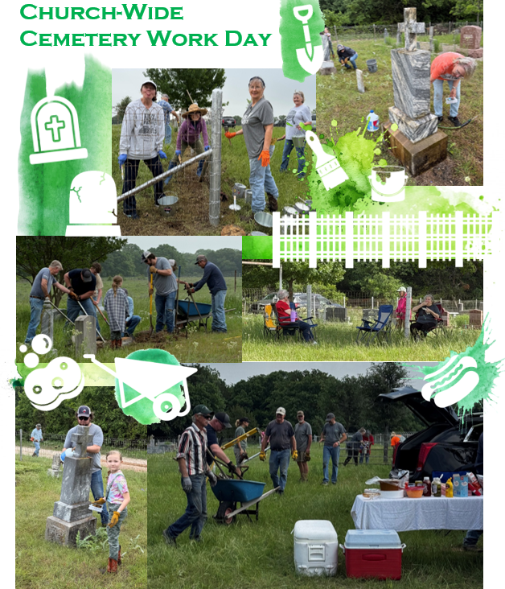





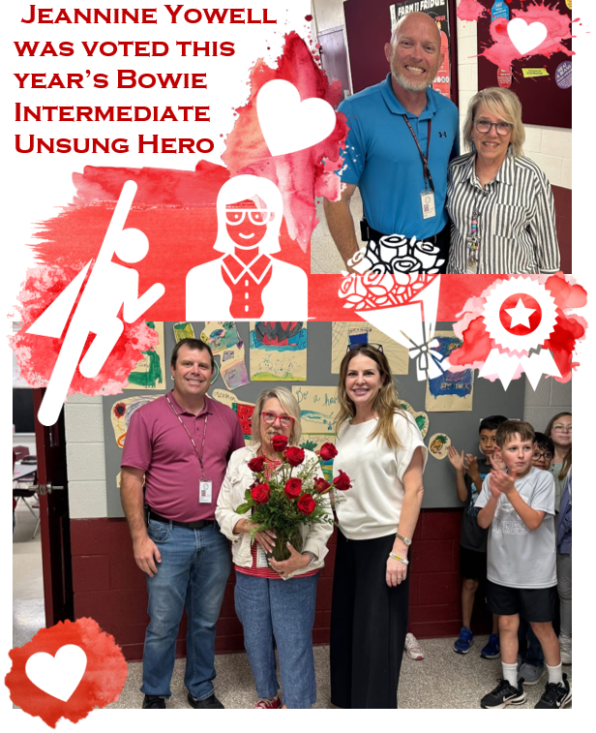

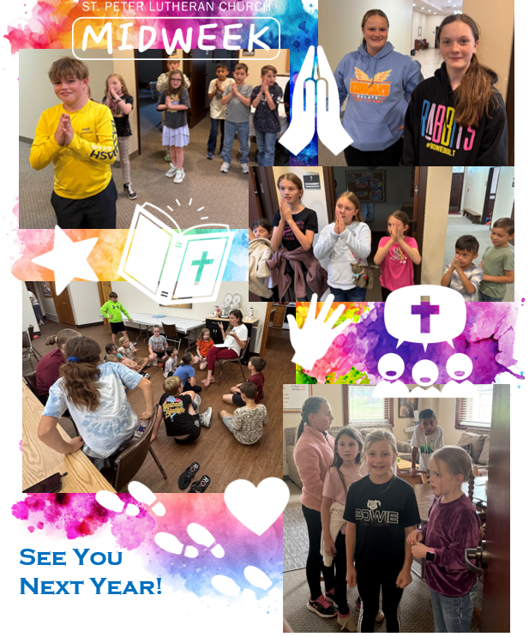







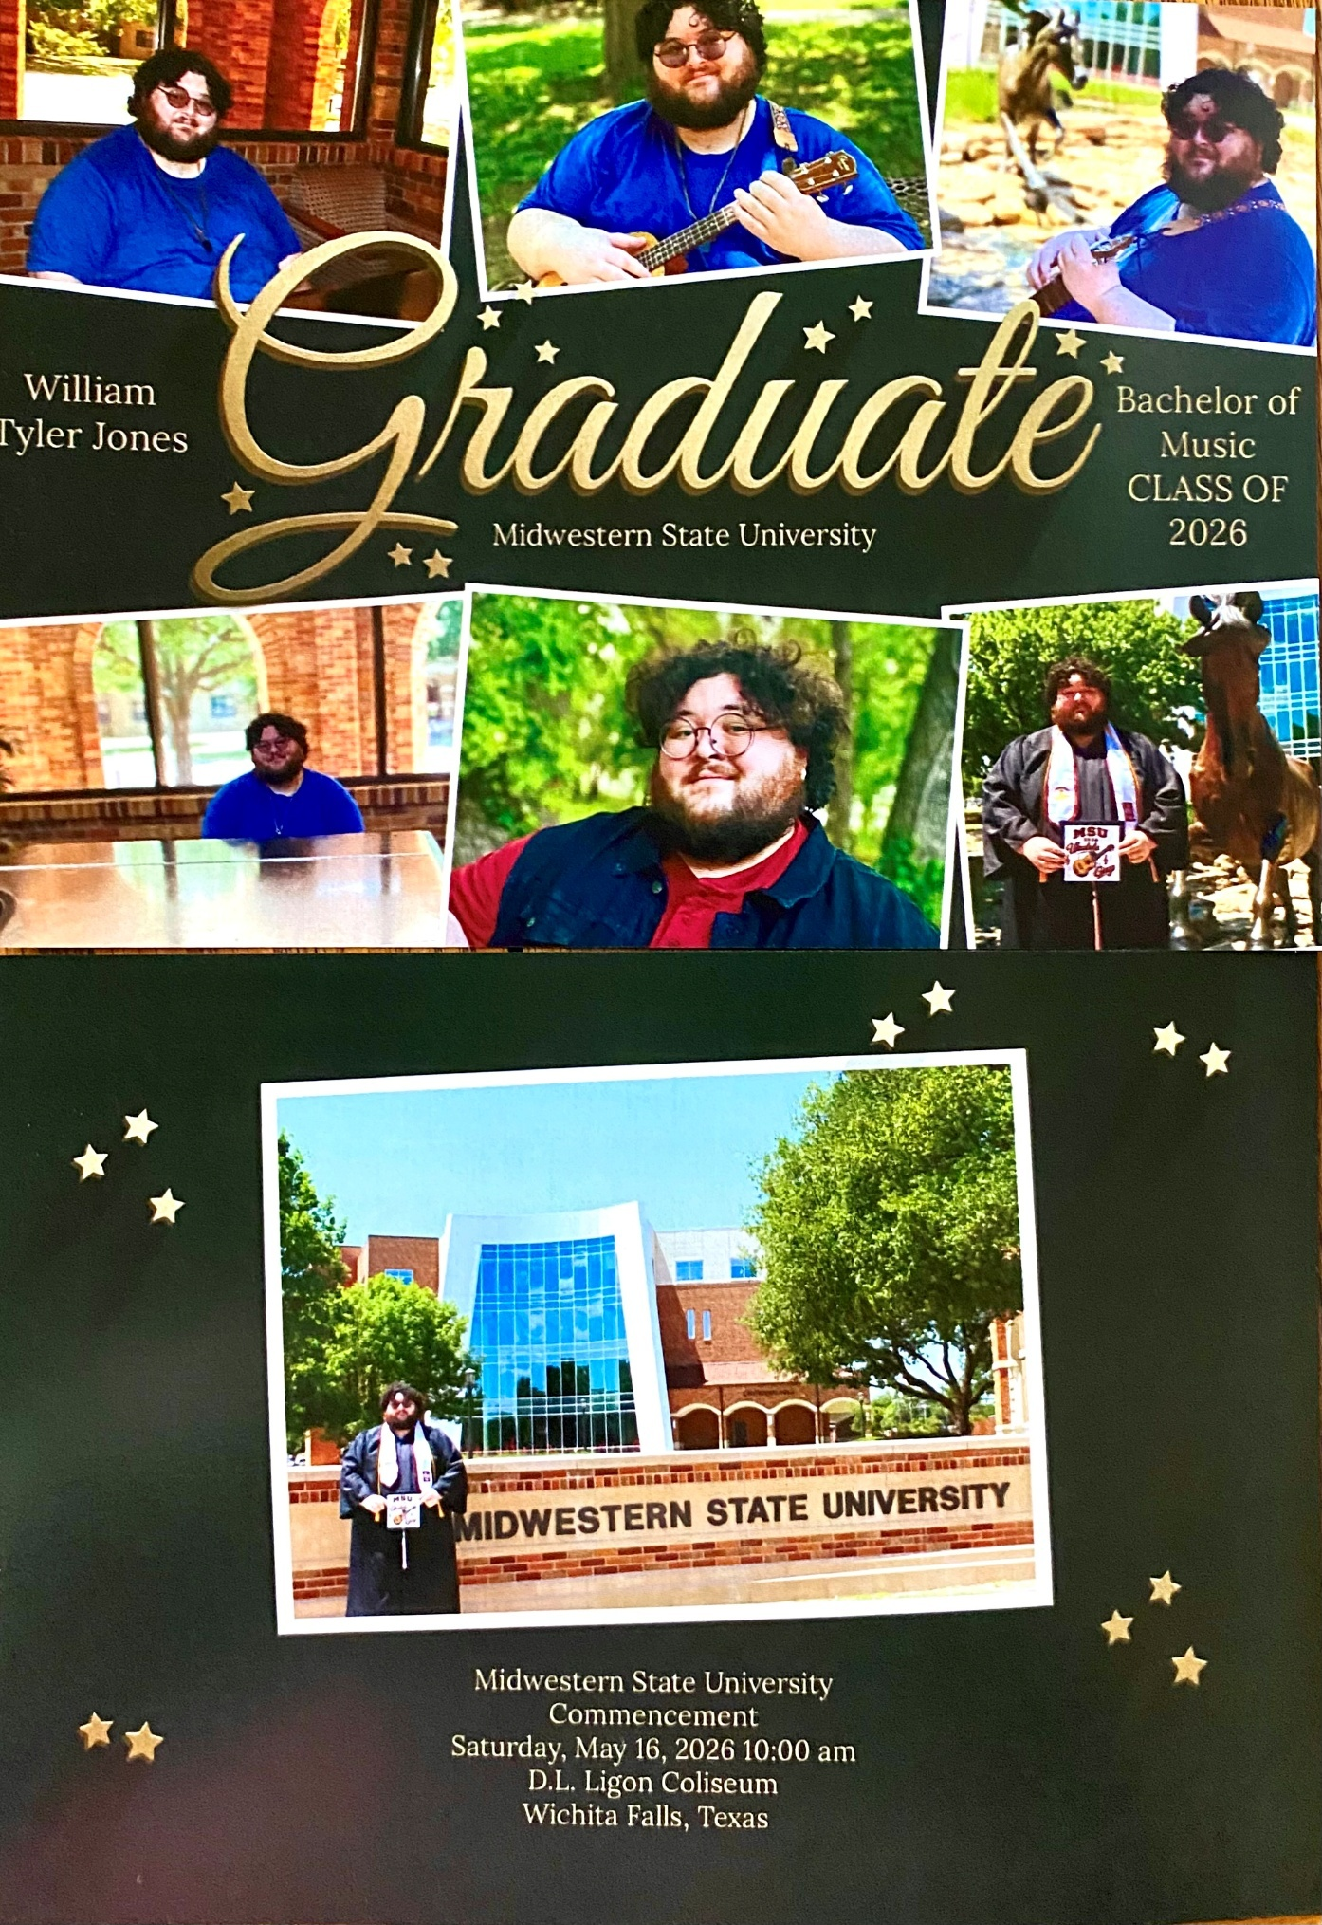



Did you know we have a Facebook & Instagram?

You can find the links to our socials on our website at: www.stpetertex.com

Follow us for important updates, verse-of-the-week posts, and more!
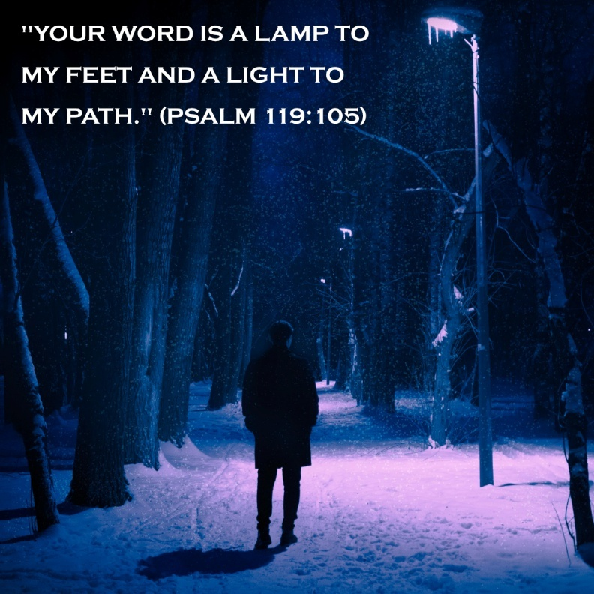
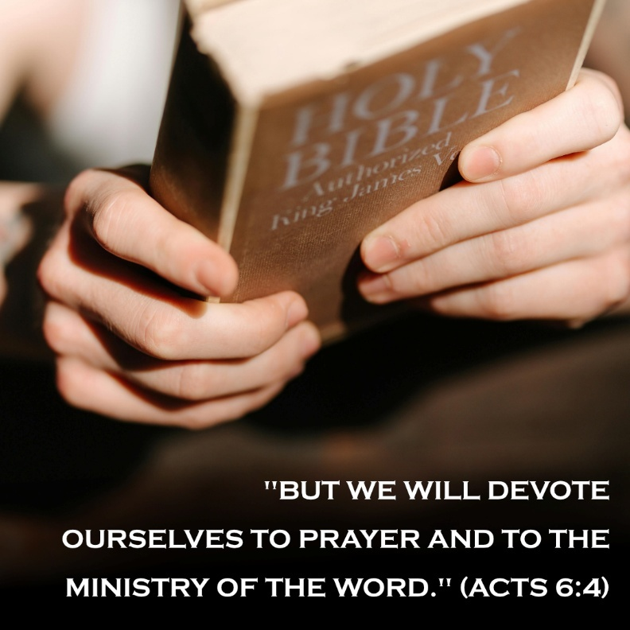
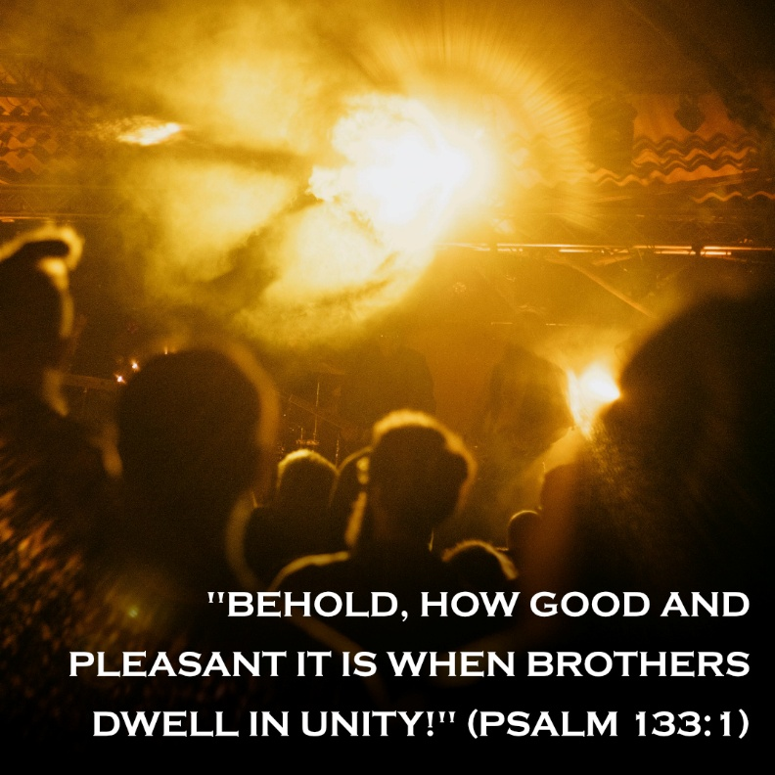
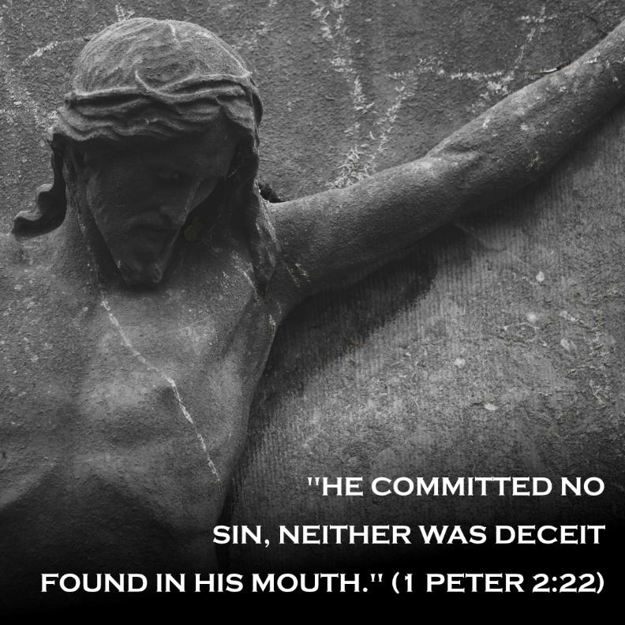
In case you missed last month’s weekly verse posts:

