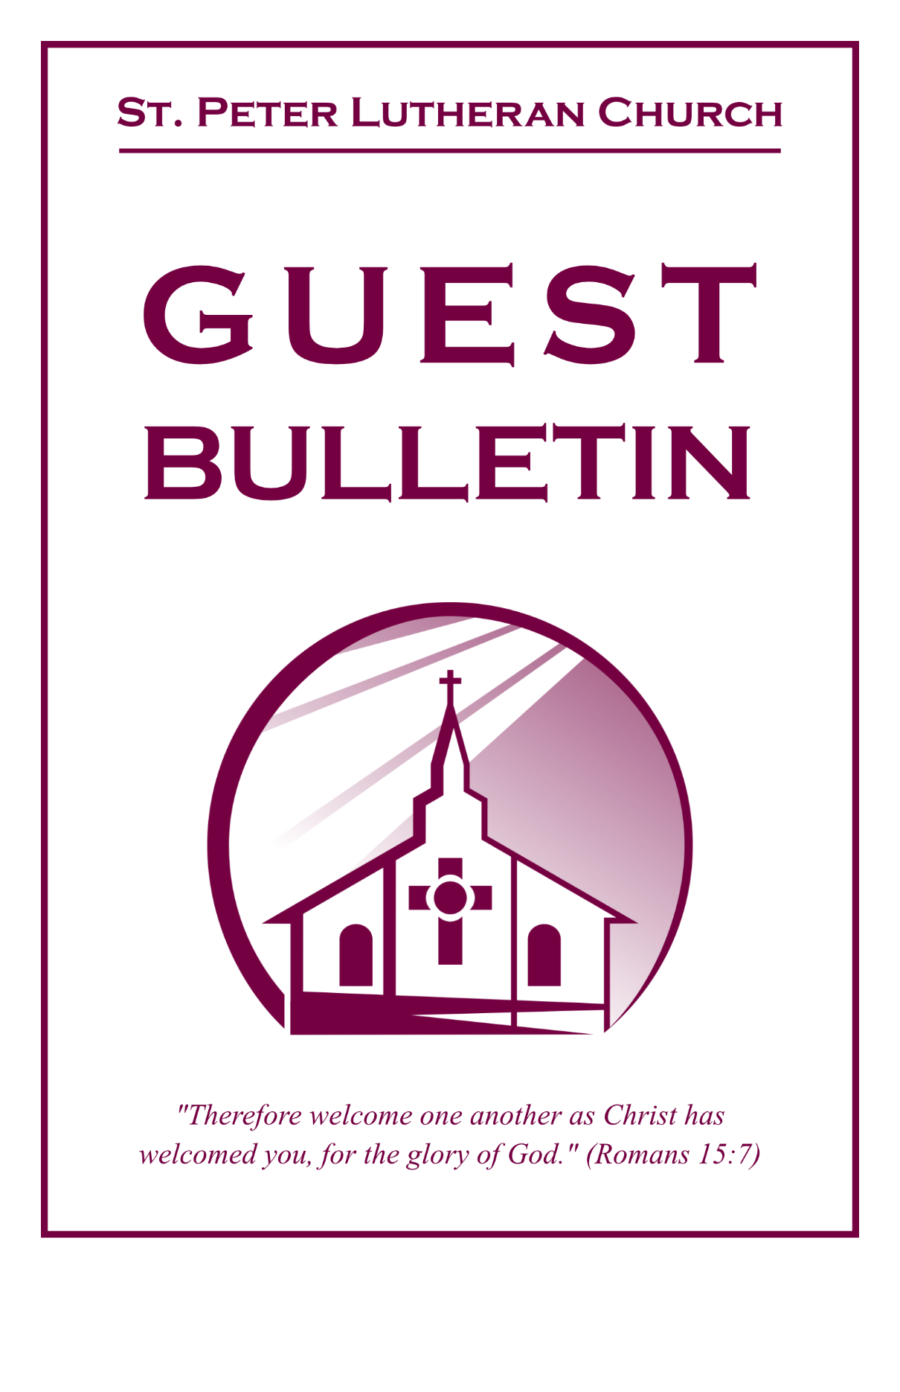

Palm Sunday

March 29, 2026


St. Peter Lutheran Church
Missouri Synod
906 Highway 59N, P.O. Box 133, Bowie, Texas 76230

Church (940) 872-1886; Fax ((940) 872-8837

Church E-mail: stpetertexscty@att.net; Website: www.stpetertex.com

To Our Guests and Visitors
We welcome all our friends in Christ who have come to worship with us. If you are a guest, please feel at home with us, sign our guest register, and worship with us whenever you are able. If you do not have a church home, we invite you to consider becoming a part of our church family.

Communion Statement
The Lord’s Supper is celebrated at this congregation in the confession and glad confidence that, as He says, our Lord gives into our mouths not only bread and wine but His very Body and Blood to eat and drink for the forgiveness of sins and to strengthen our union with Him and with one another.
Our Lord invites to His table those who trust in His words, repent of all sin, and set aside any refusal to forgive and love as He forgives and loves us, that they may show forth His death until He comes.

Because those who eat and drink our Lord’s Body and Blood unworthily do so to their great harm, and because Holy Communion is a confession of the faith which is confessed at this altar, guests who are not confirmed members of a LCMS congregation and have not previously communed at this altar, are asked to first speak with the Pastor or an Elder. If you are unable to do so before the service, it is out of Christian love and care for your souls that we ask you to refrain from communing this morning.
For further study, please see Matthew 5:23ff; 10:32ff; 18:15-35; 26:26-29; 1 Corinthians 11:17-34.
If you desire to receive a blessing for yourself or your children, please approach during communion, cross your arms over your chest and bow your head as you kneel at the altar rail.


Hosanna in the highest!

As We Gather
pas·sion (pash'n), n. [Lat. passio, suffering] 1. A powerful emotion or appetite, such as love, joy, hatred, anger, or greed. 2. Ardent, adoring love . . . 5. Passion. a. The sufferings of Christ in the period following the Last Supper and including the crucifixion.
‘Passion’ is a most appropriate word for today! What other word is synonymous for both love and suffering. Today we begin the final leg of our journey to Jerusalem, entering the Holy City with Jesus as palm branches wave. Then we conclude our Lenten pilgrimage on Good Friday, seeing His love for us in action—a love that knows no bounds!
Palm Sunday Gospel Matthew 21:1-11
¹Now when they drew near to Jerusalem and came to Bethphage, to the Mount of Olives, then Jesus sent two disciples, ²saying to them, “Go into the village in front of you, and immediately you will find a donkey tied, and a colt with her. Untie them and bring them to me. ³If anyone says anything to you, you shall say, ‘The Lord needs them,’ and he will send them at once.” ⁴This took place to fulfill what was spoken by the prophet, saying, ⁵“Say to the daughter of Zion, ‘Behold, your king is coming to you, humble, and mounted on a donkey, and on a colt, the foal of a beast of burden.’”
⁶The disciples went and did as Jesus had directed them. ⁷They brought the donkey and the colt and put on them their cloaks, and he sat on them. ⁸Most of the crowd spread their cloaks on the road, and others cut branches from the trees and spread them on the road. ⁹And the crowds that went before him and that followed him were shouting, “Hosanna to the Son of David! Blessed is he who comes in the name of the Lord! Hosanna in the highest!” ¹⁰And when he entered Jerusalem, the whole city was stirred up, saying, “Who is this?” ¹¹And the crowds said, “This is the prophet Jesus, from Nazareth of Galilee.”
P This is the Gospel of our Coming King!
C Thanks be to God!

Processional Hymn “All Glory, Laud, and Honor" (LSB 442; vs. 1-3)
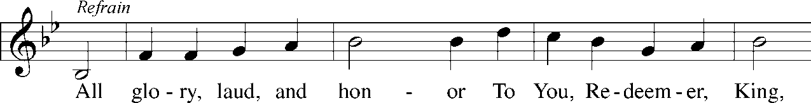
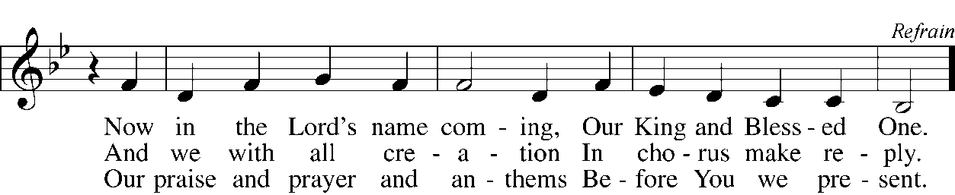
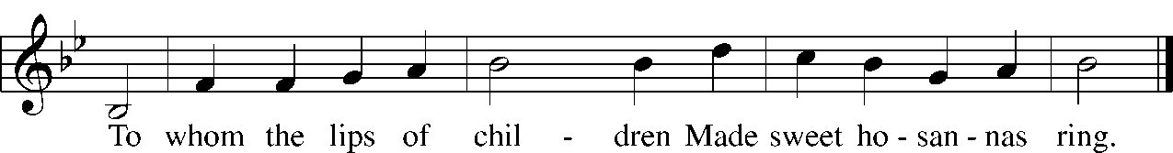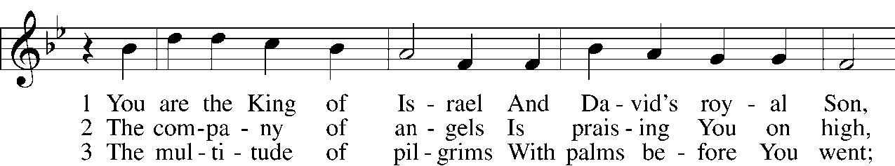

Palm Sunday Acclamation (P = Pastor; C = Congregation)
P In the name of the Father, and of the T Son, and of the Holy Spirit.
C Amen.
P Blessed is He who comes in the name of the Lord!
C Hosanna in the highest!

Confession and Absolution
P Lord Jesus Christ, had we been there, we certainly also would have been joyfully waving our palm branches before You on Palm Sunday as You rode into Jerusalem. We praise You today in word and song just as the people did then. But how things can change in just a short period of time. Only five days later, there were some from the crowd who had turned, and were demanding You be killed. We too, Lord, have turned against You through our sins, and need Your forgiveness. Hear now our confession, dear Lord:
C O God, we approach Your throne of mercy because we know we are sinners. We stand accused by Your Law. Our thoughts have been impure and rebellious, and have not focused on You. Our words have been unkind and unholy, and have failed to tell of Your love. Our deeds have been wrong and selfish, and we have not served You and others as we ought. Forgive us and help us to live, as we should, for Jesus' sake.
P It is true: You do stand accused of sin. But Christ, who was without sin, stood accused in your place, accepted your guilty verdict, and took upon Himself your death sentence. Through His Passion—His suffering and death—your sins are forgiven, in the name of the Father, and of the T Son, and of the Holy Spirit.
C Amen. Thanks be to God!

Hymn of Thanks “All Glory, Laud, and Honor” (LSB 442; vs. 5)
Refrain All glory, laud, and honor To You, Redeemer, King,
To whom the lips of children Made sweet hosannas ring.

As You received their praises, Accept the prayers we bring,
O Source of ev’ry blessing, Our good and gracious King. Refrain

Prayer of the Day
P The Lord be with you.
C And also with you.
P Most merciful God, as the people of Jerusalem, with palms in their hands, gathered to greet Your dearly beloved Son when He came into His Holy City, grant that we may ever hail Him as our King and, when He comes again, may we go forth to meet Him with trusting and steadfast hearts and follow Him in the way that leads to eternal life; who lives and reigns with You and the Holy Spirit, one God, now and forever.
C Amen.

Old Testament Lesson Isaiah 50:4-9a
⁴The Lord God has given me the tongue of those who are taught,
that I may know how to sustain with a word him who is weary.
Morning by morning he awakens;
he awakens my ear to hear as those who are taught.
⁵The Lord God has opened my ear,
and I was not rebellious;

I turned not backward.
⁶I gave my back to those who strike,
and my cheeks to those who pull out the beard;
I hid not my face
from disgrace and spitting.
⁷But the Lord God helps me;
therefore I have not been disgraced;
therefore I have set my face like a flint,
and I know that I shall not be put to shame.
⁸He who vindicates me is near.
Who will contend with me? Let us stand up together.
Who is my adversary? Let him come near to me.
⁹Behold, the Lord God helps me;
who will declare me guilty?
P This is the Word of the Lord.
C Thanks be to God!

Hymn 443 Hosanna, Loud Hosanna
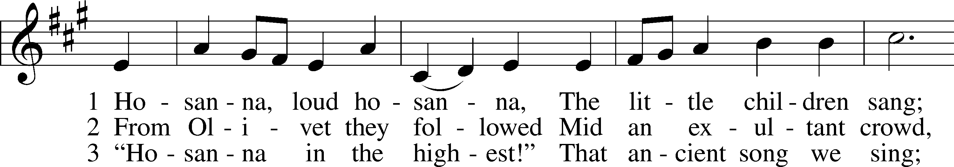
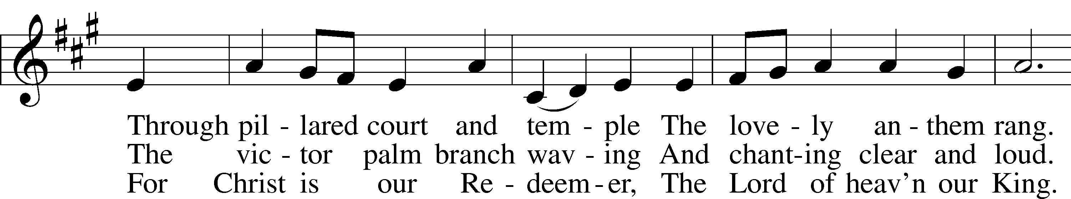
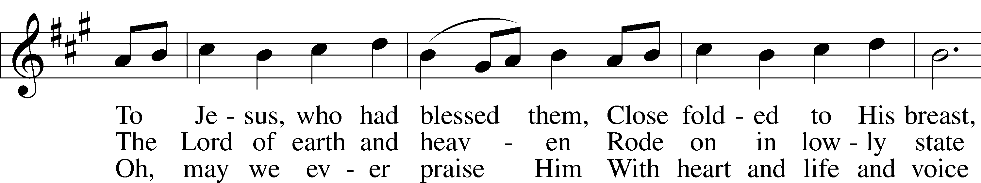
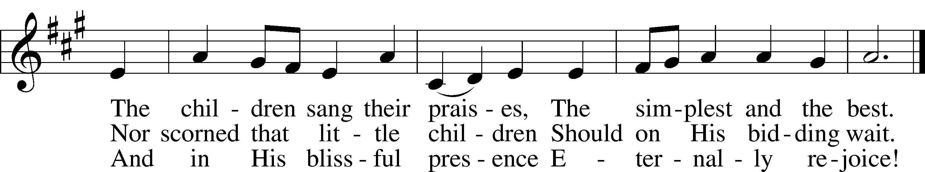
Text: Jeannette Threlfall, 1821–80, alt.
Tune: Gesangbuch der Herzogl. Hofkapelle, 1784, Württemberg
Text and tune: Public domain

Epistle Philippians 2:5-11
⁵Have this mind among yourselves, which is yours in Christ Jesus, ⁶who, though he was in the form of God, did not count equality with God a thing to be grasped, ⁷but made himself nothing, taking the form of a servant, being born in the likeness of men. ⁸And being found in human form, he humbled himself by becoming obedient to the point of death, even death on a cross. ⁹Therefore God has highly exalted him and bestowed on him the name that is above every name, ¹⁰so that at the name of Jesus every knee should bow, in heaven and on earth and under the earth, ¹¹and every tongue confess that Jesus Christ is Lord, to the glory of God the Father.
P This is the Word of the Lord.
C Thanks be to God!

Children’s Message

Sermon Hymn 441 Ride On, Ride On in Majesty
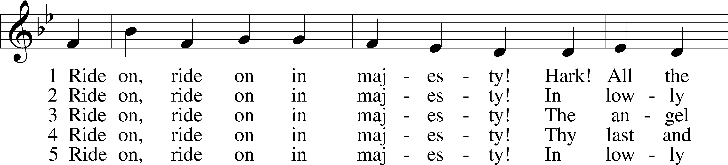
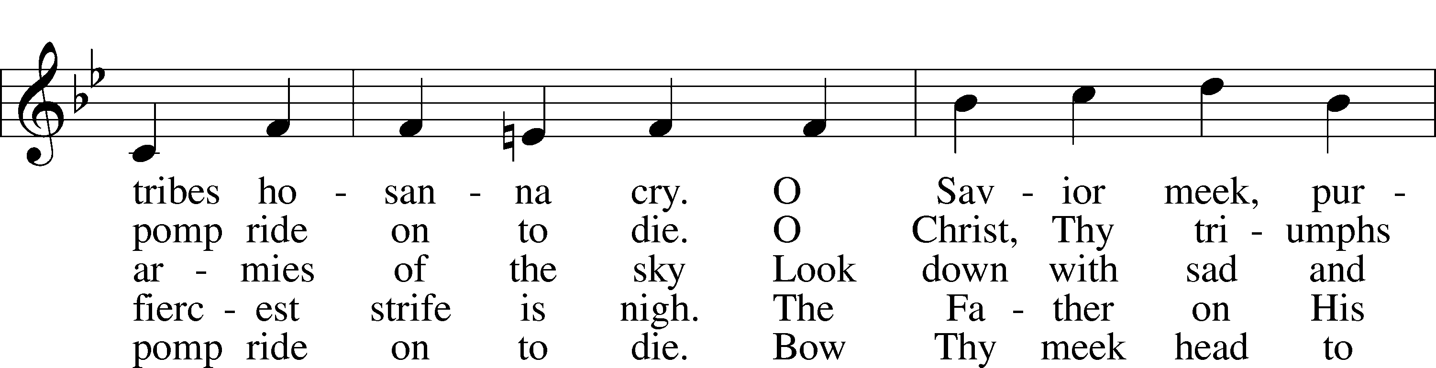
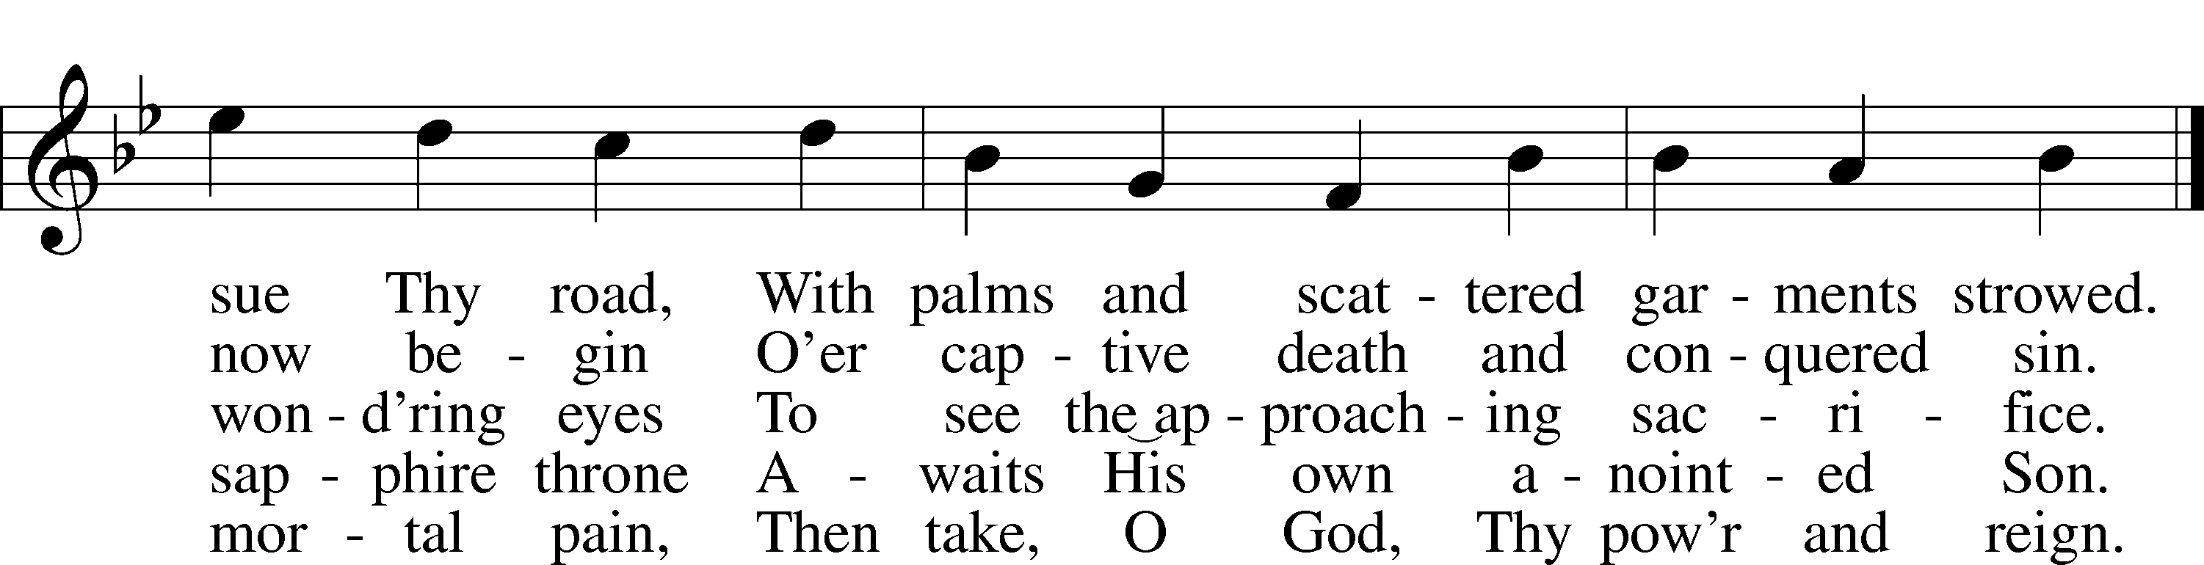
Text: Henry H. Milman, 1791–1868, alt.
Tune: Musicalisch Hand-Buch der Geistlichen Melodien, 1690, Hamburg, alt.
Text and tune: Public domain

Sermon “A Real Turn-around!” Philippians 2:5-11

Gathering of Tithes and Special Offerings

Hymn 805 Praise God, from Whom All Blessings Flow
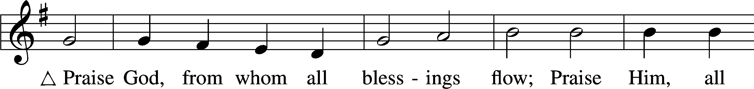
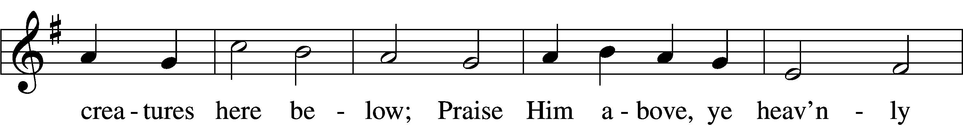
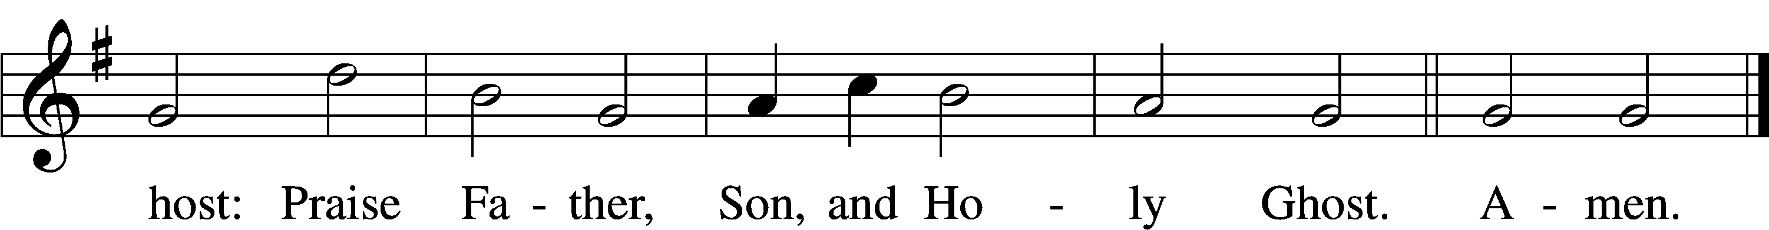
Text: Thomas Ken, 1637–1711
Tune: Trente quatre Pseaumes de David, 1551, Geneva, ed. Louis Bourgeois
Text and tune: Public domain

A Statement of What We Believe (Taken from the Augsburg Confession)
P The Augsburg Confession was presented before the Holy Roman Emperor on June 25, 1530, as a statement of what Lutheran Christians believe. Because it is based on the Word of God, we continue to boldly confess it to this day:
C It is taught among us that God the Son became man, born of the virgin Mary,
P and that the two natures, divine and human, are so inseparably united in one person that there is one Christ, true God and true man, who was truly born, suffered, was crucified, died, and was buried, in order to be a sacrifice not only for original sin, but also for all other sins in order to appease God’s wrath.
C The same Christ also descended into hell, truly rose from the dead on the third day, ascended into heaven, and sits on the right hand of God,

P that He would eternally rule and have dominion over all creatures, that through the Holy Spirit He would sanctify, purify, strengthen, and comfort all who believe in Him, that He would bestow on them life and every grace and blessing, and that He would protect and defend them against the devil and against sin.
C This same Lord Christ will return openly to judge the living and the dead.

Prayer of the Church
P O Lord, as we remember again Your Passion, we are tempted by our own flesh to judge those who failed You or attacked You. After Judas' betrayal, he despaired.
C Save us from forgetting that Your death was for our sins, too, and through Your sacrifice we are forgiven.
P After Peter's declaration of strength, he denied knowing You.
C Save us from failing You in less dramatic but in similar ways. Teach us to trust in You always, and to be faithful to You in witness.
P Pilate claimed to seek truth and then set aside his principles.
C Save us from compromising the truth, and giving in to worldly pressures. Give us strength to know right from wrong, and to always do what is right.
P We're tempted to blame the crowd in Jerusalem for pushing You to the cross.
C Give us grace to remember that our own sin put You there. Guide us in all humility, even as You humbled Yourself for our sake.
P Lord, You became one of us. You know how we feel. You share in our joys and sorrows and You help in time of need. Hear us now as we pray for . . . (Special petitions for God's people) . . . Lord, in Your mercy,
C Hear our prayer.
P Finally, Lord, we ask that You enrich and enable our devotion to You this Holy Week. By Your Spirit, grant meaning to our worship and new life to our faith. Restore to us the joy of Your salvation and uphold us with Your Spirit; for You reign with the Father and the Holy Spirit, one God, now and forever.
C Amen.

The Lord’s Prayer
P Jesus, remember us in Your kingdom, and teach us to pray:
C Our Father who art in heaven,
hallowed be Thy name, Thy kingdom come,
Thy will be done on earth as it is in heaven;
give us this day our daily bread;
and forgive us our trespasses
as we forgive those who trespass against us;
and lead us not into temptation,
but deliver us from evil.
For Thine is the kingdom and the power and the glory forever and ever. Amen.

Preface

P The Lord be with you.
C And also with you.
P Lift up your hearts.
C We lift them to the Lord.
P Let us give thanks to the Lord our God.
C It is right to give Him thanks and praise.
P It is truly good, right, and salutary that we should at all times and in all places give thanks to You, holy Lord, almighty Father, everlasting God, through Jesus Christ, our Lord, who accomplished the salvation of mankind by the tree of the cross that, where death arose, there also life would rise again, and that the serpent who overcame us by the tree in the garden might likewise by the tree of the cross be overcome. Therefore, with angels and archangels and with all the company of heaven we laud and magnify Your glorious name, evermore praising You and saying:

Sanctus (Holy) Isaiah 6:3; Matthew 21:9
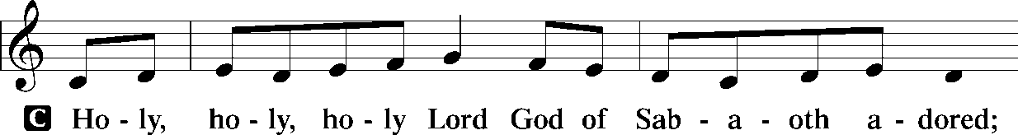
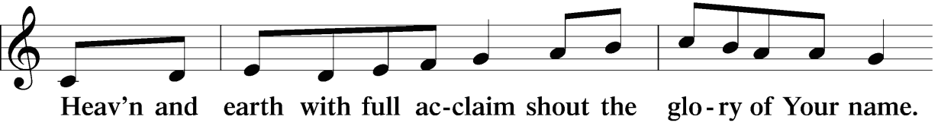
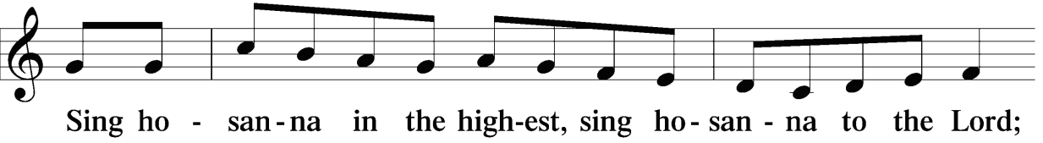
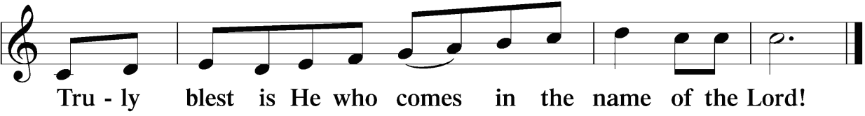

The Words of Our Lord / Pax Domini (Peace of the Lord) John 20:19
P The peace of the Lord be with you always.
C Amen

Agnus Dei “Lamb of God, Pure and Holy” (LSB 434; vs. 1)
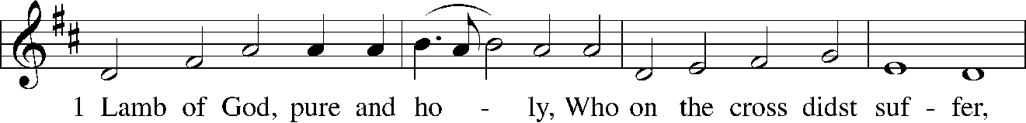
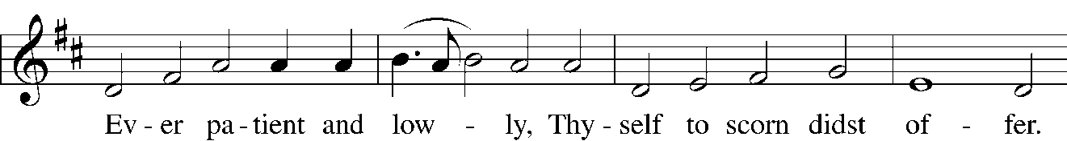
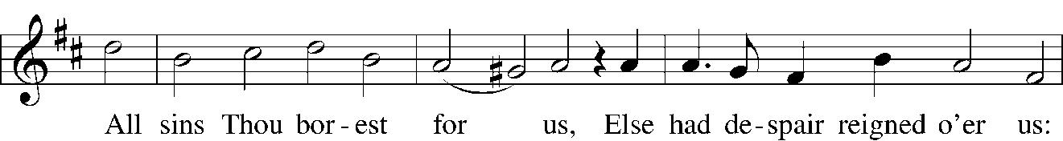
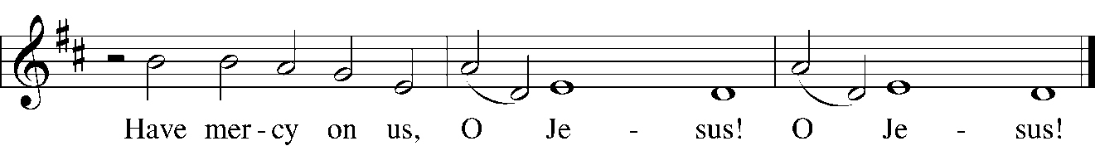
The congregation is seated.

Distribution

Distribution Hymns 624 The Infant Priest Was Holy Born
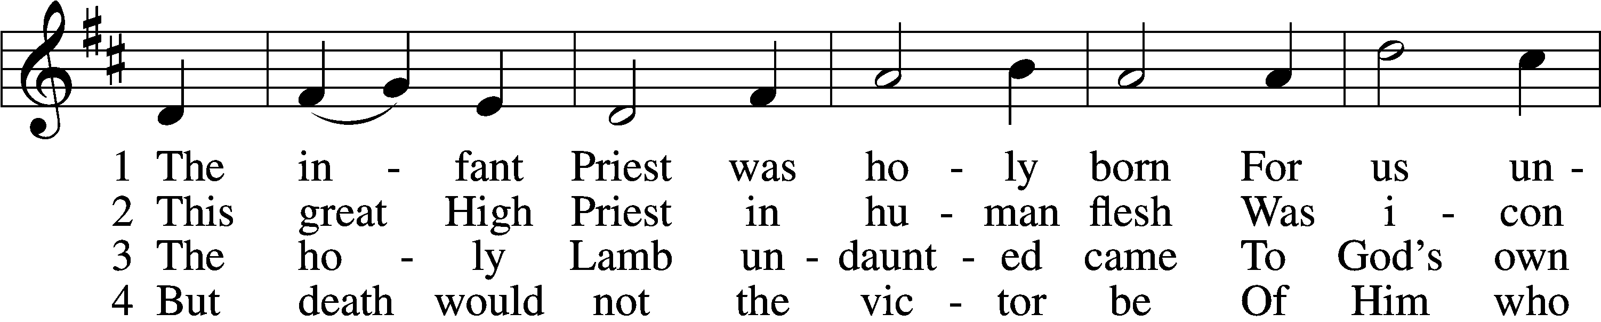
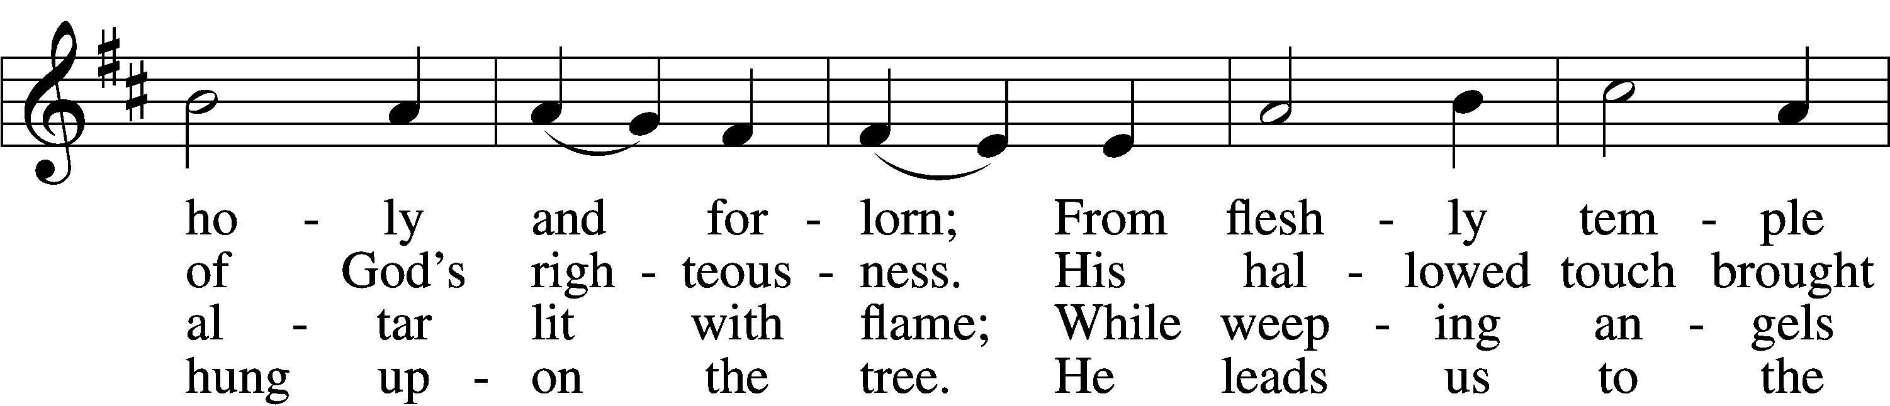
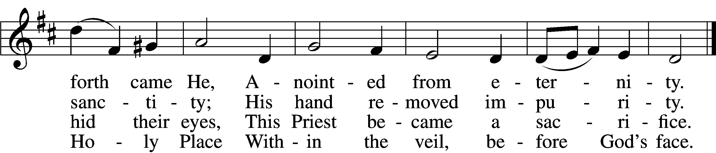

5 The veil is torn, our Priest we see,
As at the rail on bended knee
Our hungry mouths from Him receive
The bread of immortality.

6 The body of God’s Lamb we eat,
A priestly food and priestly meat;
On sin-parched lips the chalice pours
His quenching blood that life restores.

7 With cherubim and seraphim
Our voices join the endless hymn,
And “Holy, holy, holy” sing
To Christ, God’s Lamb, our Priest and King.
Text: Chad L. Bird, 1970
Tune: Second Supplement to Psalmody in Miniature, 1778, London; adapt. Edward Miller, 1731–1807
Text: © 1997, 2003 Chad L. Bird. Used by permission: LSB Hymn License no. 110005011
Tune: Public domain

560 Drawn to the Cross, Which Thou Hast Blessed
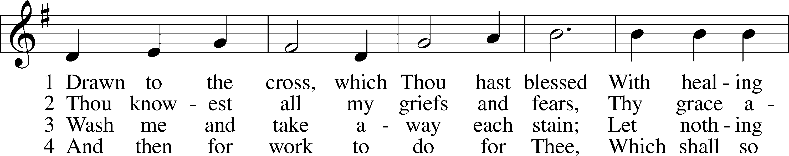
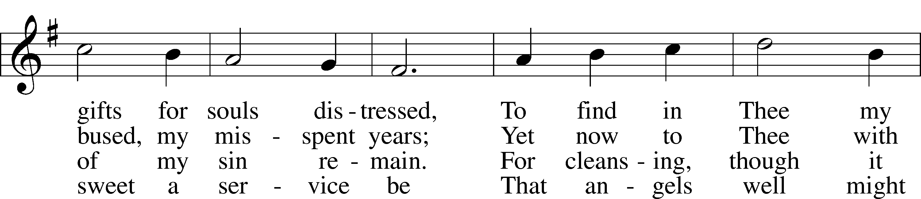
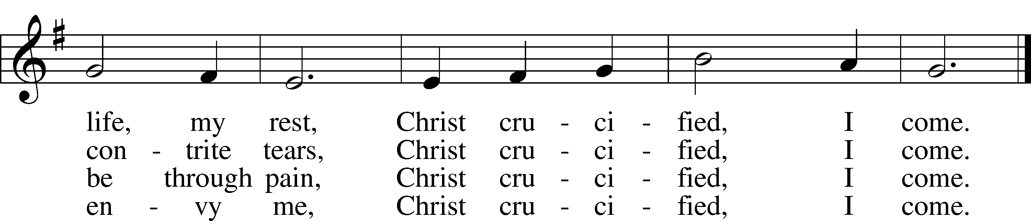
Text: Genevieve M. Irons, 1855–1928
Tune: Joseph Barnby, 1838–96
Text and tune: Public domain

420 Christ, the Life of All the Living
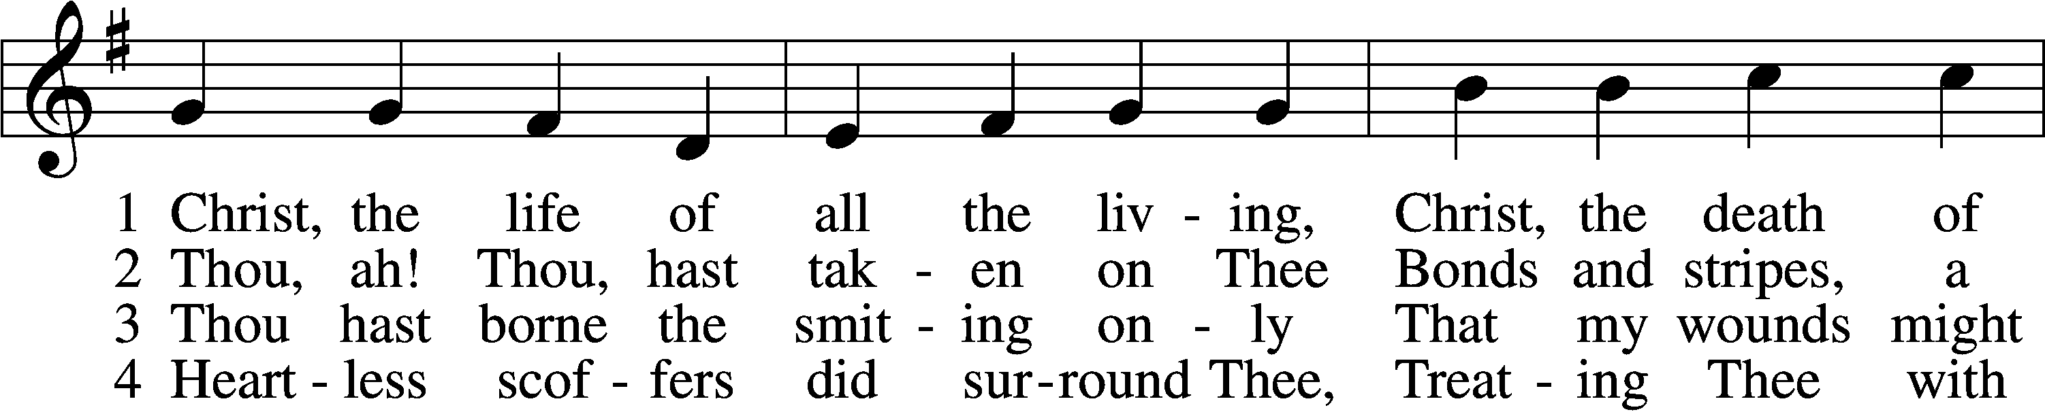
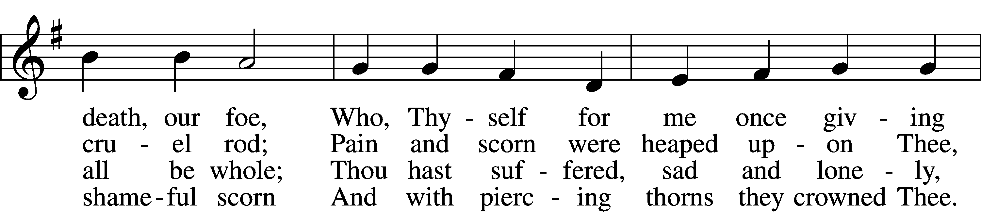
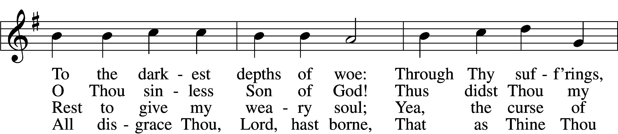
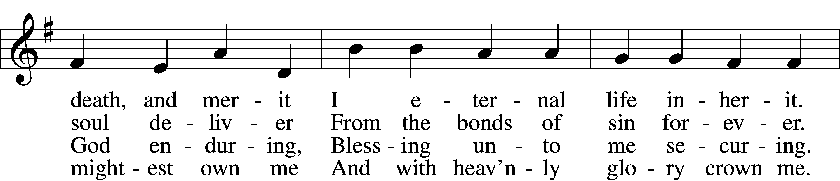
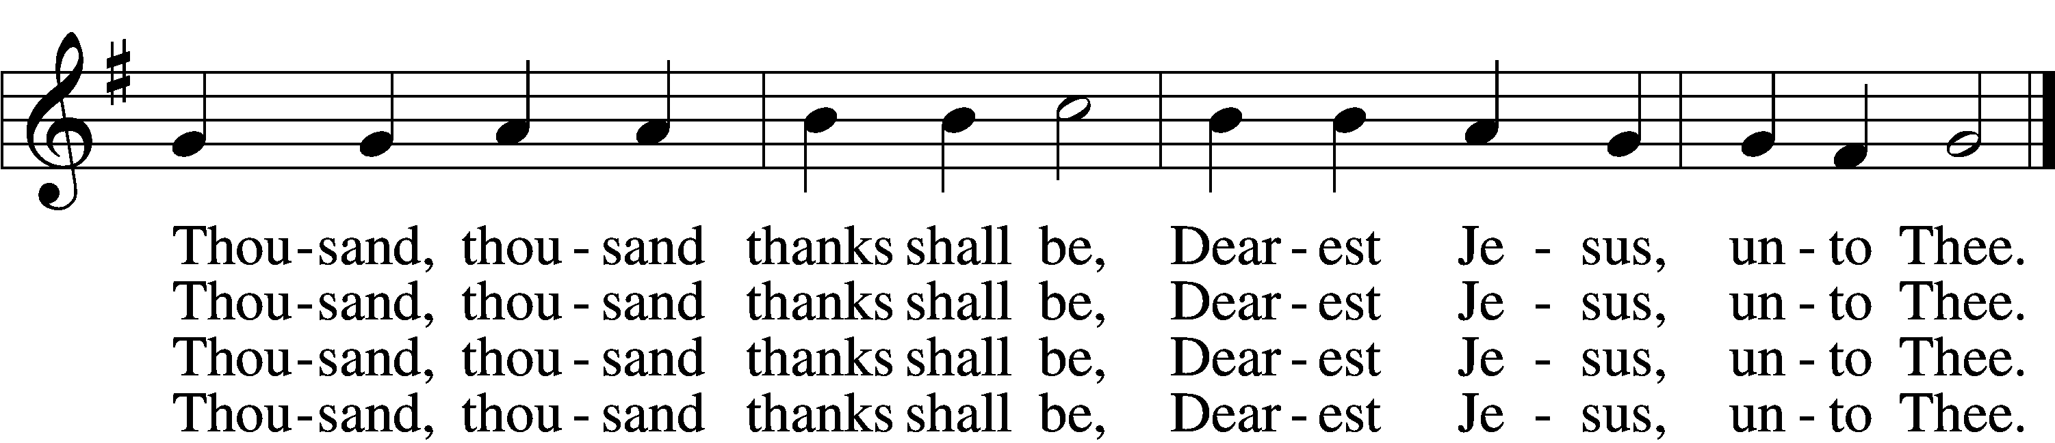

5 Thou hast suffered men to bruise Thee,
That from pain I might be free;
Falsely did Thy foes accuse Thee:
Thence I gain security;
Comfortless Thy soul did languish
Me to comfort in my anguish.
Thousand, thousand thanks shall be,
Dearest Jesus, unto Thee.

6 Thou hast suffered great affliction
And hast borne it patiently,
Even death by crucifixion,
Fully to atone for me;
Thou didst choose to be tormented
That my doom should be prevented.
Thousand, thousand thanks shall be,
Dearest Jesus, unto Thee.

7 Then, for all that wrought my pardon,
For Thy sorrows deep and sore,
For Thine anguish in the Garden,
I will thank Thee evermore,
Thank Thee for Thy groaning, sighing,
For Thy bleeding and Thy dying,
For that last triumphant cry,
And shall praise Thee, Lord, on high.
Text: Ernst Christoph Homburg, 1605–81; (sts. 1–2, 5, 7): tr. Catherine Winkworth, 1827–78, alt.; (sts. 3–4, 6): tr. Evangelical Lutheran Hymn-Book, 1912, St. Louis
Tune: Das grosse Cantional, 1687, Darmstadt
Text and tune: Public domain

619 Thy Body, Given for Me, O Savior
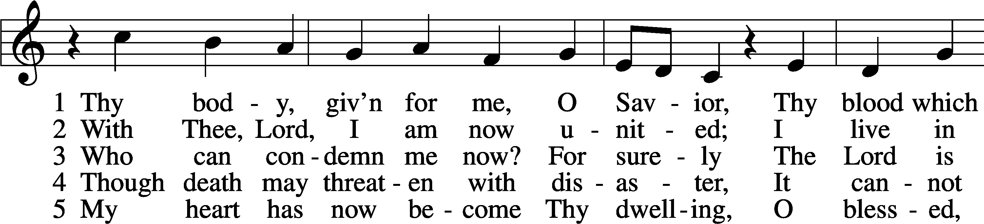
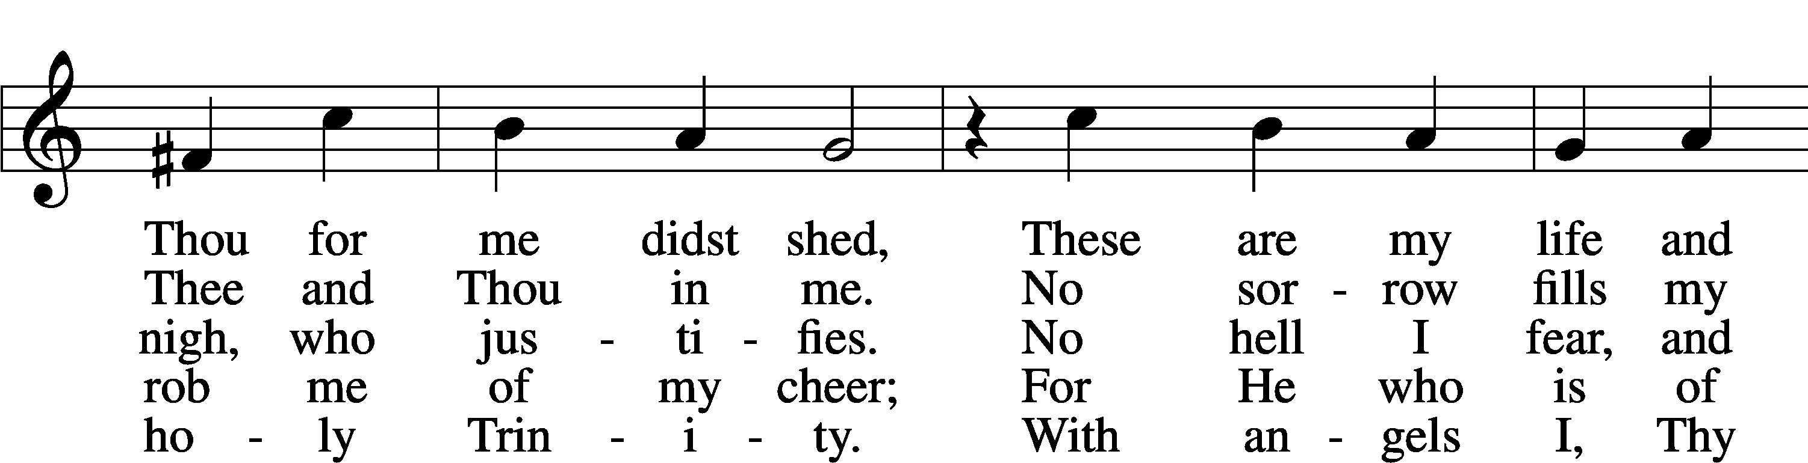
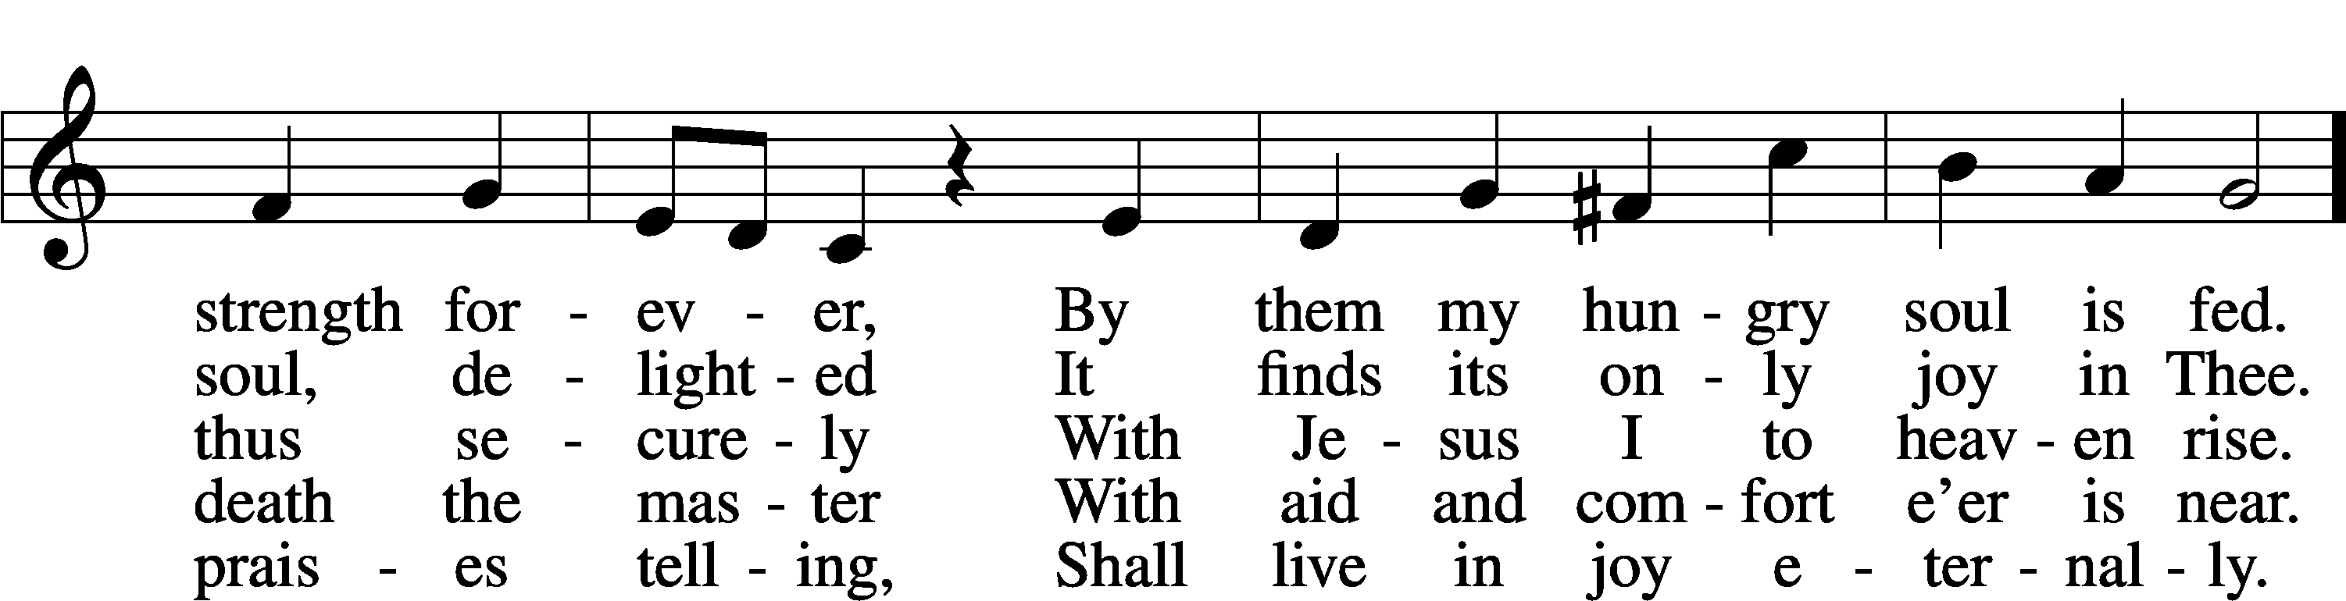
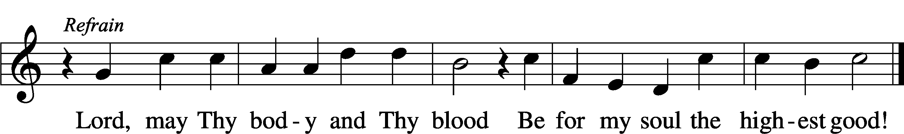
Text: Friedrich Christian Heyder, 1677–1754; tr. The Lutheran Hymnal, 1941, abr.
Tune: Emskirchner Choral-Buch, 1756, Leipzig
Text: © 1941 Concordia Publishing House. Used by permission: LSB Hymn License no. 110005011
Tune: Public domain

Prayer of Thanks
P O God the Father, the fountain and source of all goodness, who in loving-kindness sent Your only-begotten Son into the flesh, we thank You that for His sake You have given us pardon and peace in this Sacrament, and we ask You not to forsake Your children but always to rule our hearts and minds by Your Holy Spirit that we would be enabled constantly to serve You; through Jesus Christ, our Lord, who is One with You and the Holy Spirit, now and forever.
C Amen.

Benediction (2 Corinthians 13:14)
P The grace of our T Lord Jesus Christ, and the love of God, and the fellowship of the Holy Spirit be with you all.
C Amen.

Closing Hymn “The Son of God Goes Forth to War” (LSB 661; vs. 1, 4)

SERVING IN GODS HOUSE TODAY

Officiant | Rev. Dale Snyder
Elder | William Pickett
Reader | Lee Hughes
Acolytes | Parker Lawson, Kegann Gilmore, & Max Gilmore
Counters | David Geis / Gary Rainwater
Altar Guild | Sherry Hammer / Jeannine Yowell
Altar Care | Molly Atkinson / Amanda Gilmore / Karen George
Guest Monitor | Belinda Anderson / Jo Kleinhans / Viola Robinson

Our Stewardship 03/22/2026

General Fund | $ 3,975.00 | 67

Sunday | Sunday School | 9:30 a.m.
 | Worship w/Holy Communion | 10:30 a.m.
 | Potluck | Noon
Wednesday | Midweek | 4:00 p.m.
Thursday | Maundy Thursday | 7:00 p.m.
Friday | Good Friday | 7:00 p.m.

THIS WEEK AT
ST PETER

Sunday | Easter Breakfast | 9:30 a.m.
 | Worship w/Holy Communion | 10:30 a.m.
Wednesday | Midweek | 4:00 p.m.
Thursday | Voter’s Meeting | 7:00 p.m.

NEXT WEEK AT
ST PETER

Elder of the Month | William Pickett
Counters | David Geis / Gary Rainwater
Altar Guild | Sherry Hammer / Jeannine Yowell
Altar Care | Molly Atkinson / Amanda Gilmore / Karen George
Guest Monitor | Belinda Anderson / Jo Kleinhans / Viola Robinson

SERVING IN MARCH

Birthdays: March 31 Avni Vecetaj
April 02 Hattie Hammer
04 Belinda Anderson
Viola Robinson
Anniversaries: April 04 Paul & Char Lasch

News & Other Information

We welcome Rev Dale Snyder, retired, to St Peter this morning and thank him for his pulpit service during our vacancy.

Midweek School — If there is anything you think you can do for our midweek school, please contact Molly Atkinson.

Volunteer Call — Altar Guild very short on members and needs help. Please prayerfully consider serving in our church. To discuss becoming an Altar Guild member, please contact Rebecca Horton.

Hearing Assistance — A wireless communication system is available to assist those with hearing issues to better hear the sermon. You may request a receiving unit from Pastor or William Pickett.

To all members: if you need to speak to a Pastor at this time, Pastor Brummett is available to take calls at (940) 886-7468. For anything else, please contact the church elders or other church leaders.

Mary Atkinson, Graphic Designer and Secretary
- Email: stpetertexscty@gmail.com
- Office Phone: (940) 872-1886
- Personal Phone: (940) 634-3032

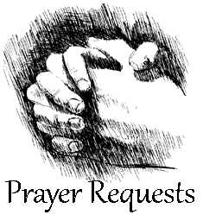
Please fill out a “Cares and Concerns” card located in the Narthex for prayer requests.

Patricia Brautigam – Diagnosed with a rare form of breast cancer (friend of Debbie De Young).
Jerry Burkhart – Diagnosed with kidney cancer (Art Noack’s Brother-in-Law).
Mike Dunn – Diagnosed with prostate cancer (Debra Keyes’s Stepfather).
Halle Foster – breast cancer, 6 weeks of radiation left then to undergo reconstruction surgery. Young mother and wife, 25 years old, has 9 month old little girl (friend of Chanda Lee).
Bryleigh Gresham – In remission for her acute lymphoblastic leukemia (student in Maci Ferguson’s class).
Beth Hiatt – Diagnosed with stage 4 breast cancer (friend of Ashley Keyes).
Michelle McCaniless – Undergoing chemotherapy treatment, they are unable to operate on lung tumors (friend of Malley Underwood).
Jessica Miller – Ovarian cancer terminal. Still on meds and treatments but has surpassed timeline the Drs. initially gave her, 24 months (friend of Chanda Lee).
Bill Miller – Recovering from surgery to remove colon cancer tumor (friend of Terry Henry).
Chris Mitchell – Has been put on several ‘trial options’ for Esophageal/tongue cancer; some seem to be working, still struggles with strength and side effects of treatments, not able to work. (friend of Chanda Lee).

Rick Baker – Compound Fracture to his leg. Had second surgery, all went well and will be non-weight bearing for 3 months possibly. The recovery will be longer (father-in-law of Reisha Baker).
Kevin Cox – Received a heart transplant (friend of Terisa Johnston).
Juliana & Katie Falbo – diagnosed with INAD, a rare and fatal genetic disorder that affects the nervous system (3 year and 6 month old great nieces of Susie and Mark Roth).
Bettie Hines – Slipped and broke her ankle.
Robert Johnston – Recovering at home.
Rhonda Pyle – Recovering from back surgery.
David Rhyne – health issues (father of Camerin Rhyne Dyson).
Thelma Roth – Recovering from Respiratory Distress in Sanger with her daughter.
Norma Scheppmann – Several medical issues.
Brooklynn Schissbauer – Her baby was diagnosed with Turner Syndrome in her last sonogram (granddaughter of Debbie Herriage).
Josh Smith – On dialysis for heart and kidneys (friend of Levi Yowell).
Billy Don Smith – At home and under hospice care.
Caden & Lucas Wolsey –

IN THE MILITARY

Sid Mayfield – US Navy Conor Ogrodnick – US Navy

SHUT -INS

Edwin Kleinhans Cholly Hargrove Charles Roth

Thank you for joining us, and we hope to see you again soon!

For any questions, feel free to ask another congregation member, our Pastor, or just visit our website at: www.stpetertex.com

You can also find the links to our socials on our website. Follow our Instagram or Facebook for important updates, verse-of-the-week posts, and more!

