
November 2024
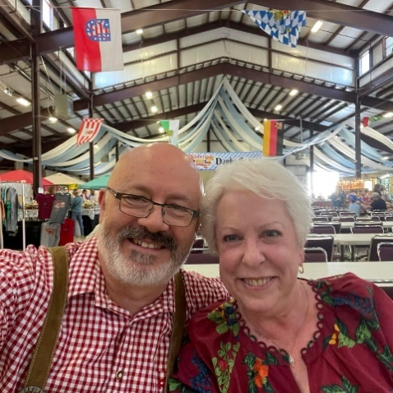
The times are getting exciting (part 2).

With all the activity in October, November should be a breeze. Nice thought. Oktoberfest was fun. By the way, I proposed to Deborah Theiss while at Oktoberfest. With that “under our belt,” there are a lot of activities that need to be done in preparation for my wedding in January (in Houston). The task of preparing my house, and also her house, for sale so that we can buy our new home demands a lot of our spare time.
The last Sunday in October is traditionally celebrated as Reformation Sunday. The readings and hymn selection will reflect this occasion. The first Sunday in November is celebrated as All–Saints Sunday. This is when we gather together to remember those who recently departed from us. Again, the readings and hymn selection will reflect this occasion.
With November comes the election. Please remember to vote. This is our constitutional right and duty as a citizen of this nation.
November also brings us Veterans Day (also called Armistice Day) on November 11th. This is when the nation honors all those who served in the armed services. If you served in the armed services (Army, Navy, Marine Corps, or the Air Force), please contact the church office so that we may extend a word of thanksgiving for your service to our nation.
Last, and certainly not least, November brings us Thanksgiving. We have much to be thankful for: God’s blessings including; our families, our homes, our employment, our state, our nation, our safety, and that we have been spared from natural disasters. We pray for those who lost loved ones, property, and their work due to the recent hurricanes.

- Pastor De Young
From the Pastor:
In our divine service, there are many parts of the liturgy (order of service) that should be explained. Over the next series of newsletters, we will be including an explanation of what is happening during each of these parts of the service (these explanations are found on the LCMS website).

About Lutheran Worship Parts of the Liturgy
Nunc Dimittis
Another Lutheran contribution to the church's liturgy is the use of the Nunc Dimittis as the post-communion canticle: “Lord, now let Your servant depart in peace.”
At first glance it appears that we're taking the words of Simeon completely out of context. After all, what does his experience have to do with ours?
How can Holy Communion ever compare to Simeon's unique honor of holding the infant Jesus in his arms during the child's first visit to the temple at the tender age of 40 days (Luke 2:25-38)?
Of course, we would love to have been in the temple and shared in the experience with Simeon. For that matter, we would give anything to have been the first — along with the shepherds — to see the infant Jesus, or to have been with the Magi as they offered their gifts to him.
But, as Luther so insightfully taught, we don't find Christ in those places. Through the events of his incarnation, birth, crucifixion, and resurrection our Lord has accomplished our salvation.
But the benefits of his saving work — forgiveness, life, and salvation — are distributed to us through his means of grace, his Word and Sacraments. We can't go back to stand with Simeon in the temple. The good news is that we don't have to.
So when, following our reception of the Lord's Supper, we sing Simeon's ancient song of faith — “Lord, now let your servant depart in peace” — nothing could be more appropriate. Indeed, our eyes have seen his salvation. Better yet, we have tasted and seen that the Lord is good (Ps. 34:8).
So, what could be better than holding the infant Jesus in our arms? How about eating and drinking his body and blood given for the forgiveness of our sins? This truly is heaven on earth, because here we have Jesus and all his benefits.
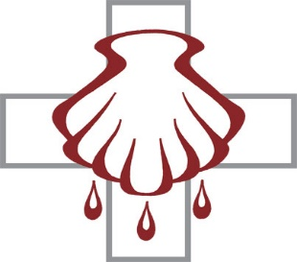
Celebrate November’s Baptism Birthdays
& their years as heirs of God’s kingdom!

Date | Name | Years
1st | Clara Novak | 89
4th | LeAnn Hoover | 12
 | Logan Hoover | 12
5th | Joanne Little | 80
7th | Lindsey Bohn | 31
8th | Aubrey Gill | 26
9th | Alexander Keyes | 10
15th | Cooper Hammer | 19
17th | Carrie Aune | 34
18th | Jaylen McComack | 3
23rd | Becky Geis | 38
24th | Rhett Lewis | 5
25th | Doris Long | 79
29th | Baylor Baker | 4
 | Paul Lasch | 54
 | Blakely Thomlinson | 4

Serving in God’s House this month

Elder of the Month | David Geis
Counters | Bryan Roth / Arn Anderson
Altar Guild | D’Ann Hammett / Sharon Rainwater
Altar Care | Debbie Jones / Karen Lee
Week | Acolytes | Reader
November 03 | Kegann Gilmore & Max Gilmore | Lee Hughes
November 10 | Davin George & Annalee Osbon | Arn Anderson
November 17 | Emily Keyes & Parker Lawson | Bryan Roth
November 24 | Karlee Hughes & Charlie Pace | William Pickett



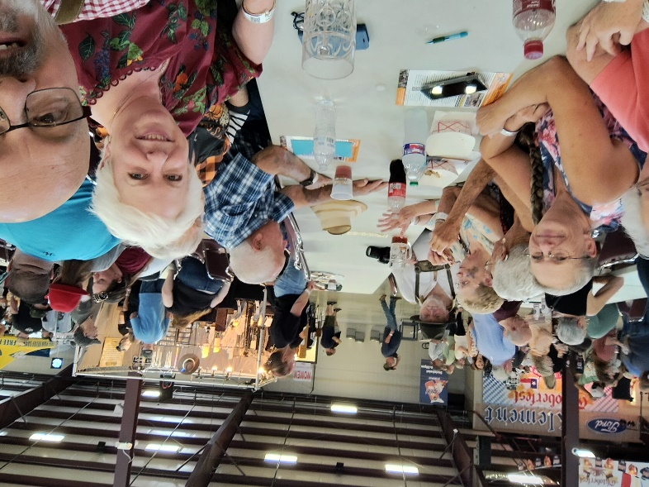







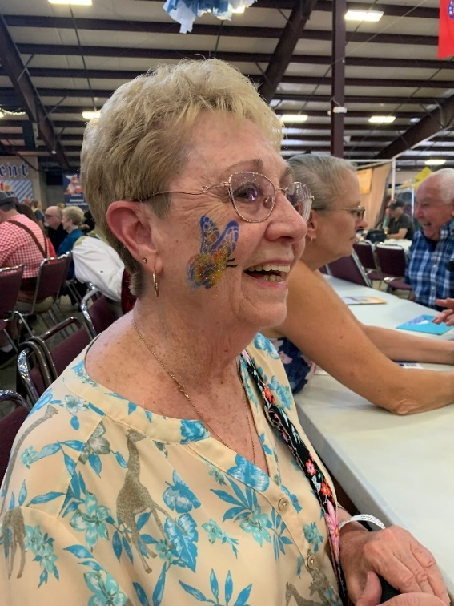

The Adult Fellowship Group had an Oktoberfest Outing






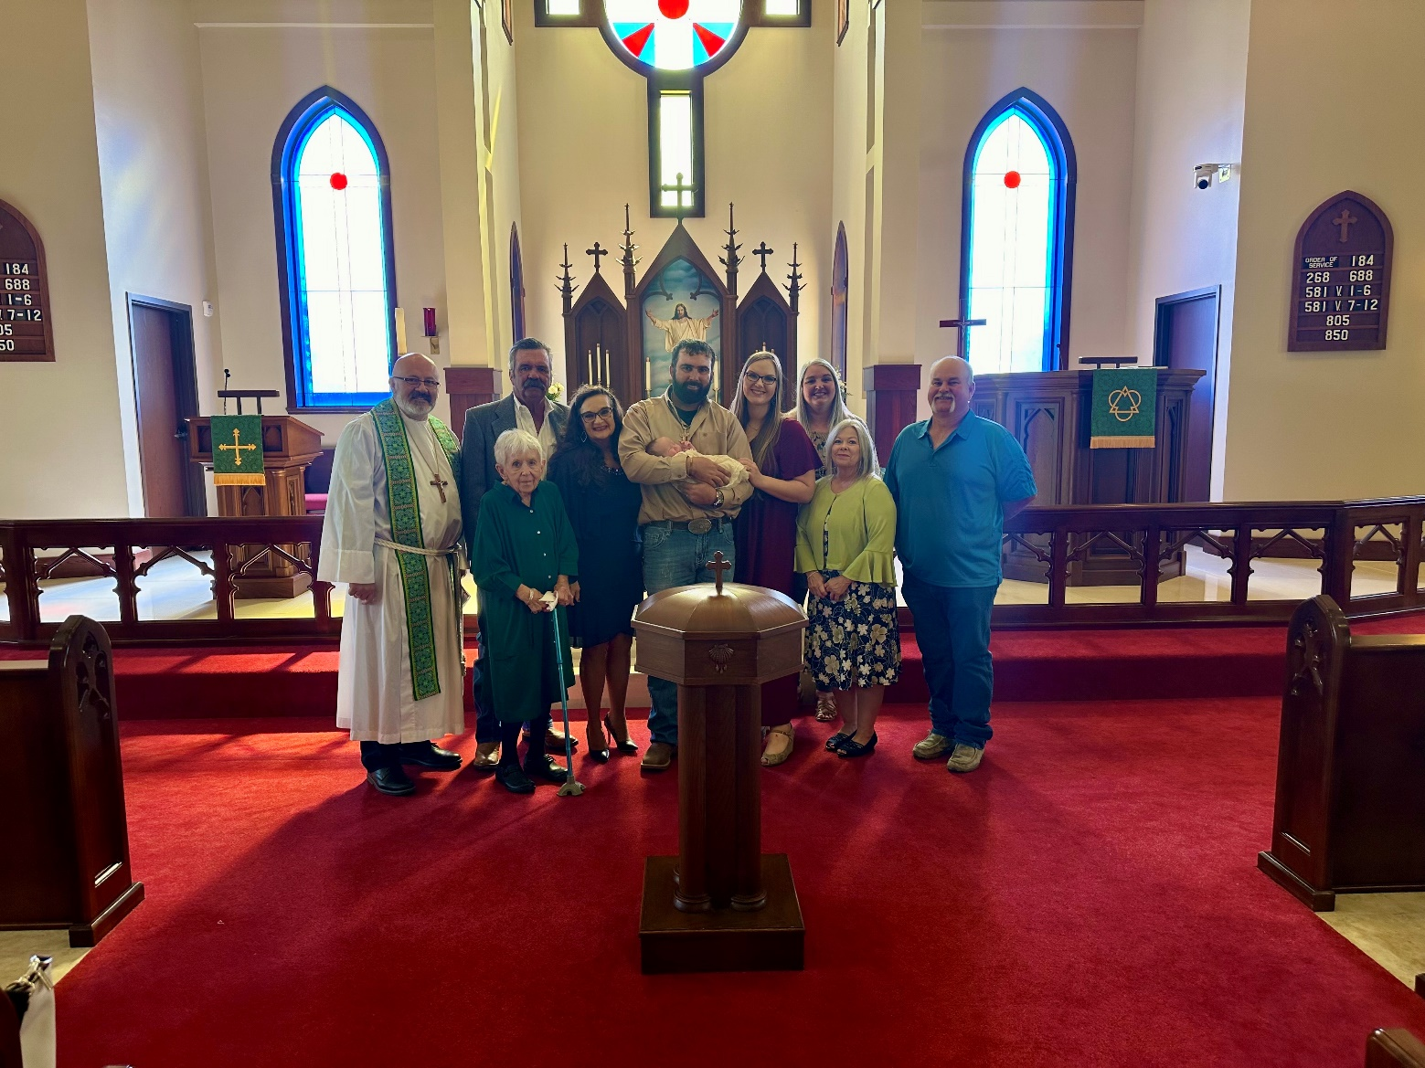
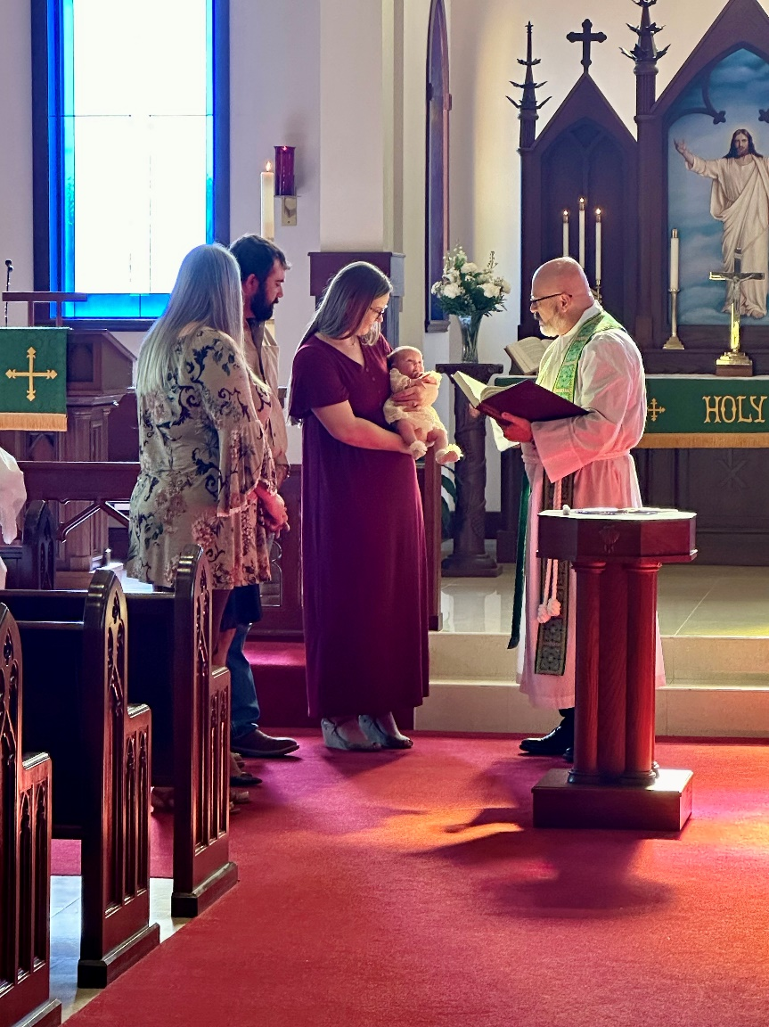
Elizabeth Ann Hammer was baptized
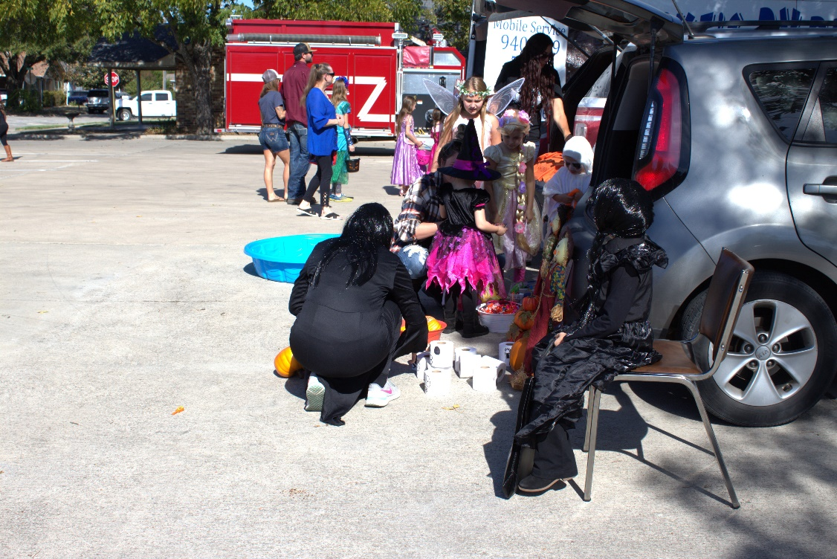






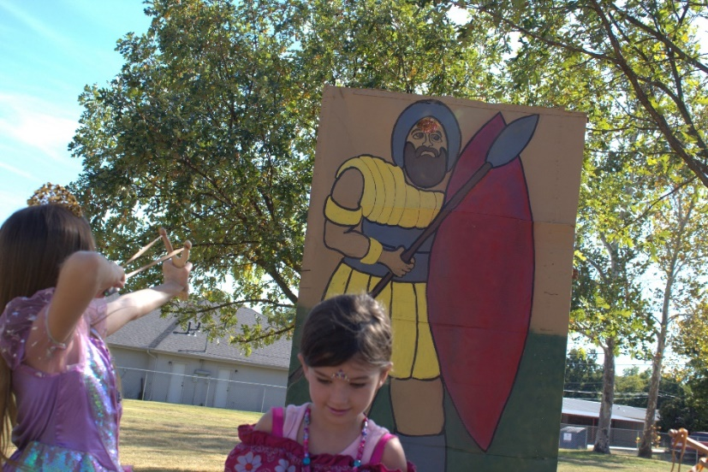
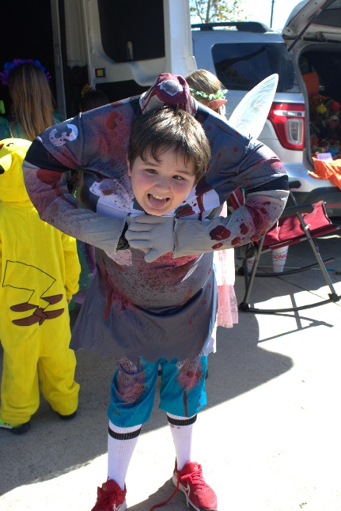
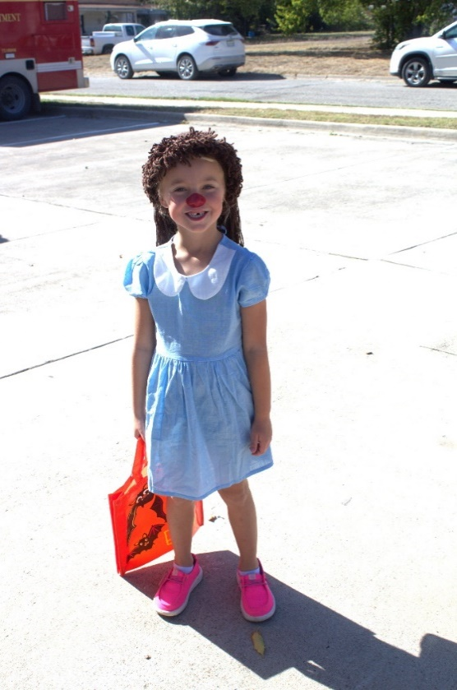
The Fall Festival was a success



