On entering the church

P Lord, I love the habitation of Your house and the place
where Your glory dwells. In the multitude of Your tender
mercies prepare my heart that I may enter Your house to
worship and confess Your holy name; through Jesus Christ,
my God and Lord.

Before worship

C O Lord, our creator, redeemer, and comforter, as we come
together to worship You in spirit and in truth, we humbly
pray that You would open our hearts to the preaching of
Your Word so that we may repent of our sins, believe in
Jesus Christ as our only Savior, and grow in grace and
holiness. Hear us for His sake.

435 Come to Calvary’s Holy Mountain
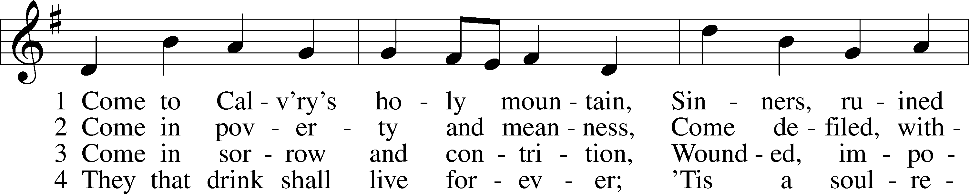
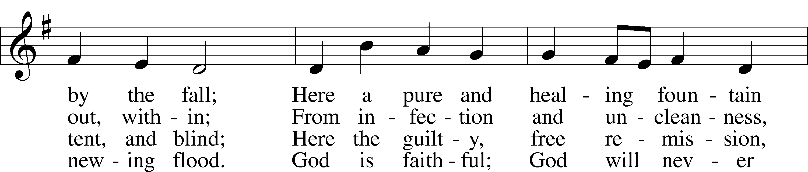
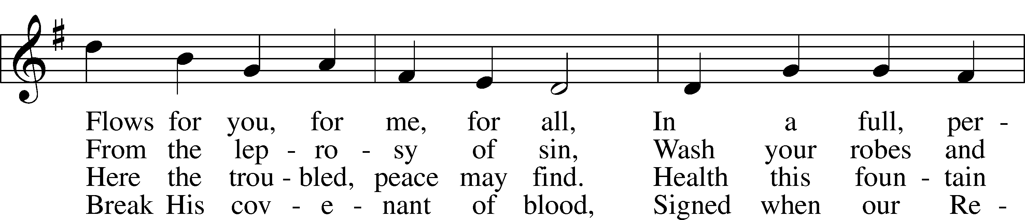
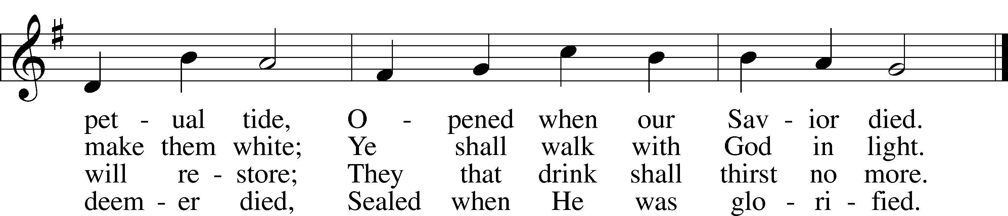
Text: James Montgomery, 1771–1854, alt.
Tune: Ludvig M. Lindeman, 1812–87
Text and tune: Public domain

Confession and Absolution

The sign of the cross may be made by all in remembrance of their Baptism.

Invocation Matthew 28:19b; 18:20
P In the name of the Father and of the T Son and of the Holy Spirit.
C Amen.

Exhortation Hebrews 10:22; Psalm 124:8; Psalm 32:5
P Beloved in the Lord! Let us draw near with a true heart and confess our sins unto God our Father, beseeching Him in the name of our Lord Jesus Christ to grant us forgiveness.

P Our help is in the name of the Lord,
C who made heaven and earth.
P I said, I will confess my transgressions unto the Lord,
C and You forgave the iniquity of my sin.

Silence for reflection on God’s Word and for self-examination.

Confession of Sins
P Almighty God, our maker and redeemer, we poor sinners confess unto You that we are by nature sinful and unclean and that we have sinned against You by thought, word, and deed. Wherefore we flee for refuge to Your infinite mercy, seeking and imploring Your grace for the sake of our Lord Jesus Christ.
C O most merciful God, who has given Your only-begotten Son to die for us, have mercy upon us and for His sake grant us remission of all our sins; and by Your Holy Spirit increase in us true knowledge of You and of Your will and true obedience to Your Word, to the end that by Your grace we may come to everlasting life; through Jesus Christ, our Lord. Amen.

Declaration of Grace Mark 16:16; John 1:12
P Almighty God, our heavenly Father, has had mercy upon us and has given His only Son to die for us and for His sake forgives us all our sins. To those who believe on His name He gives power to become the children of God and has promised them His Holy Spirit. He that believes and is baptized shall be saved.
Grant this, Lord, unto us all.
C Amen.

Service of the Word

Introit Psalm 34:2–4, 17; antiphon: Psalm 48:1a
Great is the Lord and greatly to be praised
in the city of our God!
My soul makes its boast in the Lord;
let the humble hear and be glad.
Oh, magnify the Lord with me,
and let us exalt his name together!
I sought the Lord, and he answered me
and delivered me from all my fears.
When the righteous cry for help, the Lord hears
and delivers them out of all their troubles.
Gloria Patri
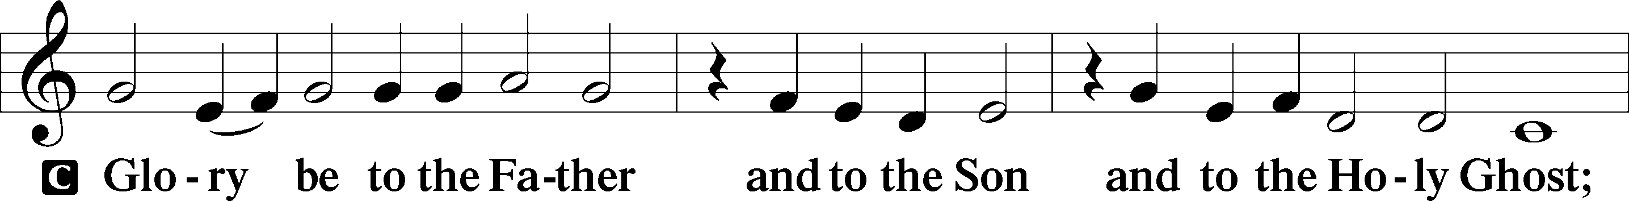
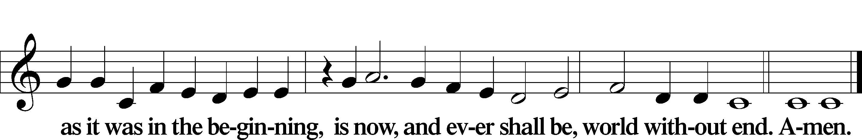

Kyrie Mark 10:47
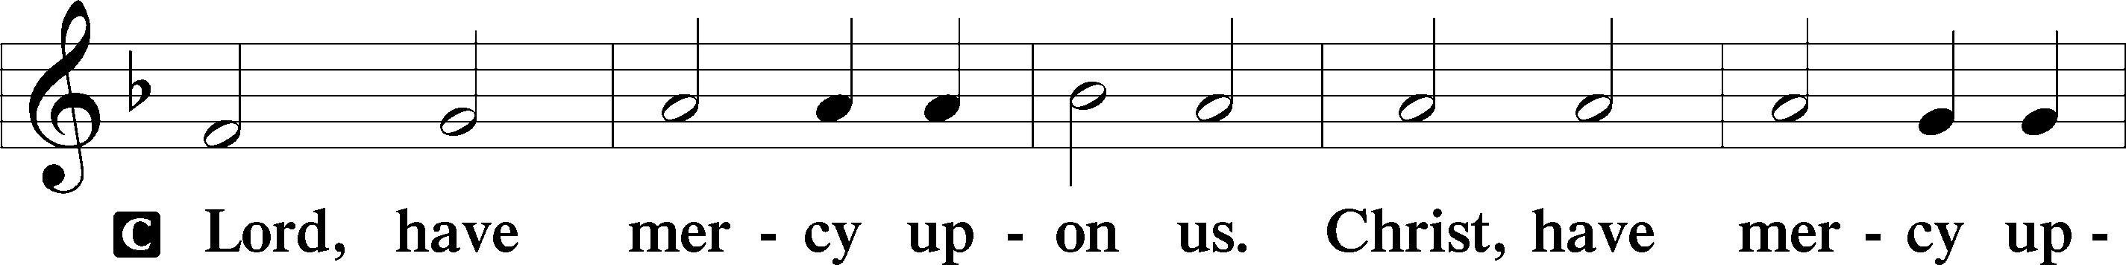
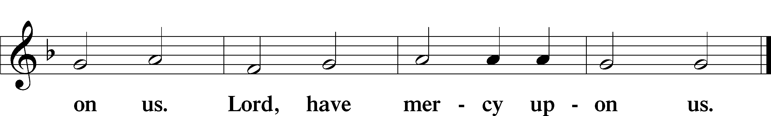

Gloria in Excelsis Luke 2:14; John 1:29
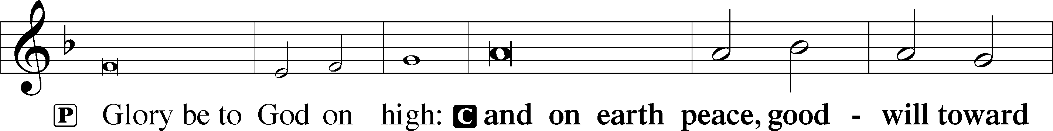
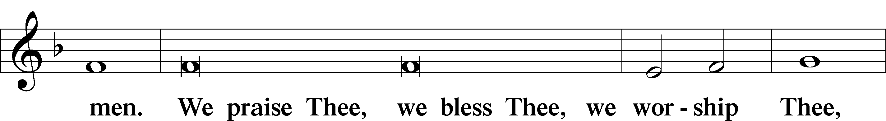
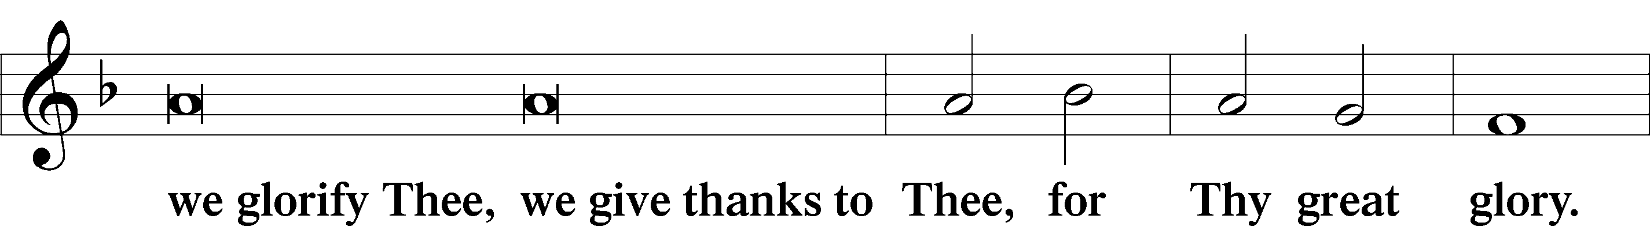
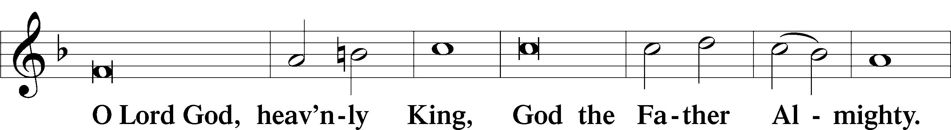
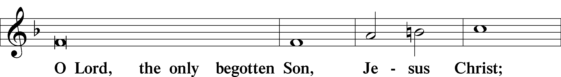
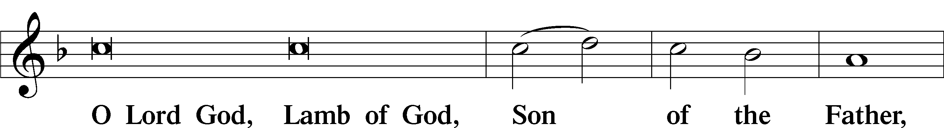
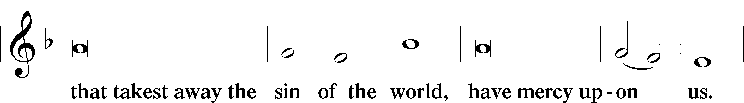
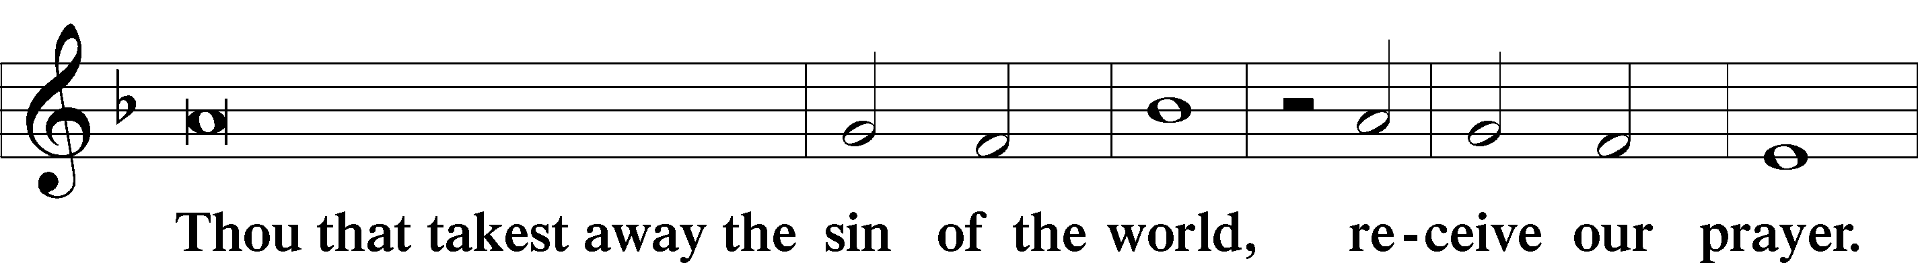
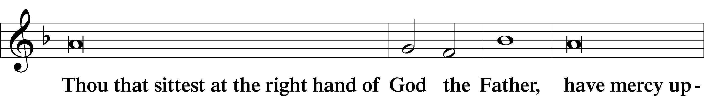
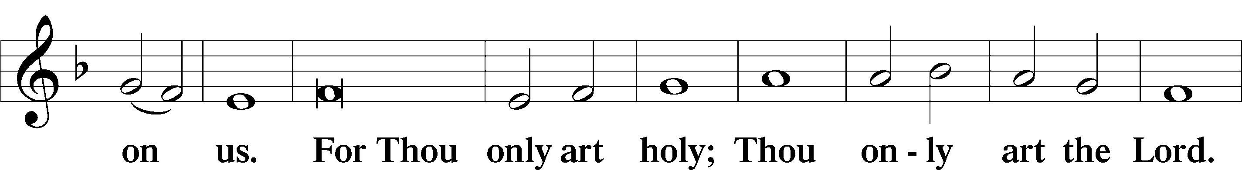
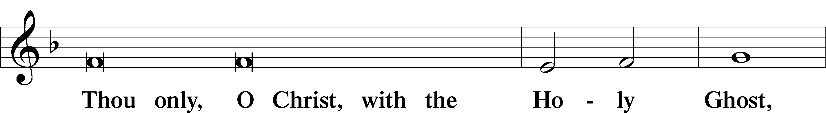
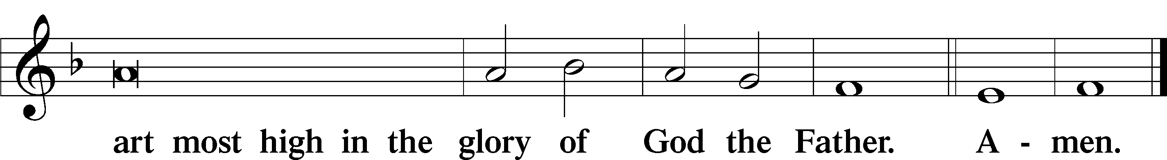

Salutation and Collect of the Day
P The Lord be with you.
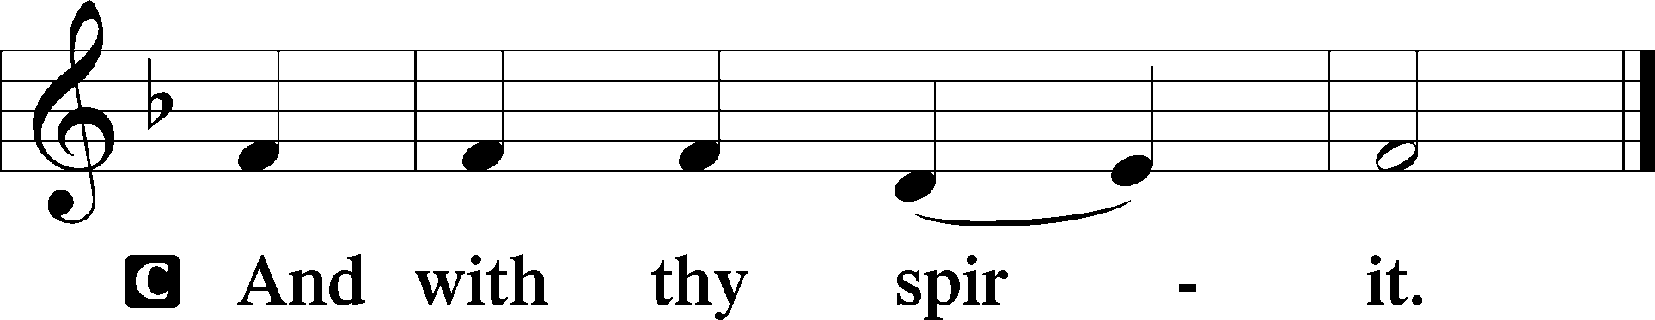

P Let us pray.
Almighty God, You show mercy to Your people in all their troubles. Grant us always to recognize Your goodness, give thanks for Your compassion, and praise Your holy name; through Jesus Christ, Your Son, our Lord, who lives and reigns with You and the Holy Spirit, one God, now and forever.

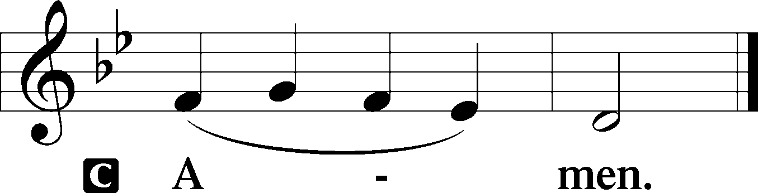

Sit

Old Testament Reading Ruth 1:1–19a
1In the days when the judges ruled there was a famine in the land, and a man of Bethlehem in Judah went to sojourn in the country of Moab, he and his wife and his two sons. 2The name of the man was Elimelech and the name of his wife Naomi, and the names of his two sons were Mahlon and Chilion. They were Ephrathites from Bethlehem in Judah. They went into the country of Moab and remained there. 3But Elimelech, the husband of Naomi, died, and she was left with her two sons. 4These took Moabite wives; the name of the one was Orpah and the name of the other Ruth. They lived there about ten years, 5and both Mahlon and Chilion died, so that the woman was left without her two sons and her husband.
6Then she arose with her daughters-in-law to return from the country of Moab, for she had heard in the fields of Moab that the Lord had visited his people and given them food. 7So she set out from the place where she was with her two daughters-in-law, and they went on the way to return to the land of Judah. 8But Naomi said to her two daughters-in-law, “Go, return each of you to her mother’s house. May the Lord deal kindly with you, as you have dealt with the dead and with me. 9The Lord grant that you may find rest, each of you in the house of her husband!” Then she kissed them, and they lifted up their voices and wept. 10And they said to her, “No, we will return with you to your people.” 11But Naomi said, “Turn back, my daughters; why will you go with me? Have I yet sons in my womb that they may become your husbands? 12Turn back, my daughters; go your way, for I am too old to have a husband. If I should say I have hope, even if I should have a husband this night and should bear sons, 13would you therefore wait till they were grown? Would you therefore refrain from marrying? No, my daughters, for it is exceedingly bitter to me for your sake that the hand of the Lord has gone out against me.” 14Then they lifted up their voices and wept again. And Orpah kissed her mother-in-law, but Ruth clung to her.
15And she said, “See, your sister-in-law has gone back to her people and to her gods; return after your sister-in-law.” 16But Ruth said, “Do not urge me to leave you or to return from following you. For where you go I will go, and where you lodge I will lodge. Your people shall be my people, and your God my God. 17Where you die I will die, and there will I be buried. May the Lord do so to me and more also if anything but death parts me from you.” 18And when Naomi saw that she was determined to go with her, she said no more.
19So the two of them went on until they came to Bethlehem.

A This is the Word of the Lord.
C Thanks be to God.

Gradual Psalm 91:11; 103:1
He will command his angels concerning you
to guard you in all your ways.
Bless the Lord, O my soul,
and all that is within me, bless his holy name!

Epistle 2 Timothy 2:1–13
1You then, my child, be strengthened by the grace that is in Christ Jesus, 2and what you have heard from me in the presence of many witnesses entrust to faithful men who will be able to teach others also. 3Share in suffering as a good soldier of Christ Jesus. 4No soldier gets entangled in civilian pursuits, since his aim is to please the one who enlisted him. 5An athlete is not crowned unless he competes according to the rules. 6It is the hard-working farmer who ought to have the first share of the crops. 7Think over what I say, for the Lord will give you understanding in everything.
8Remember Jesus Christ, risen from the dead, the offspring of David, as preached in my gospel, 9for which I am suffering, bound with chains as a criminal. But the word of God is not bound! 10Therefore I endure everything for the sake of the elect, that they also may obtain the salvation that is in Christ Jesus with eternal glory. 11The saying is trustworthy, for:
If we have died with him, we will also live with him;
12if we endure, we will also reign with him;
if we deny him, he also will deny us;
13if we are faithless, he remains faithful—
for he cannot deny himself.

Stand

Alleluia
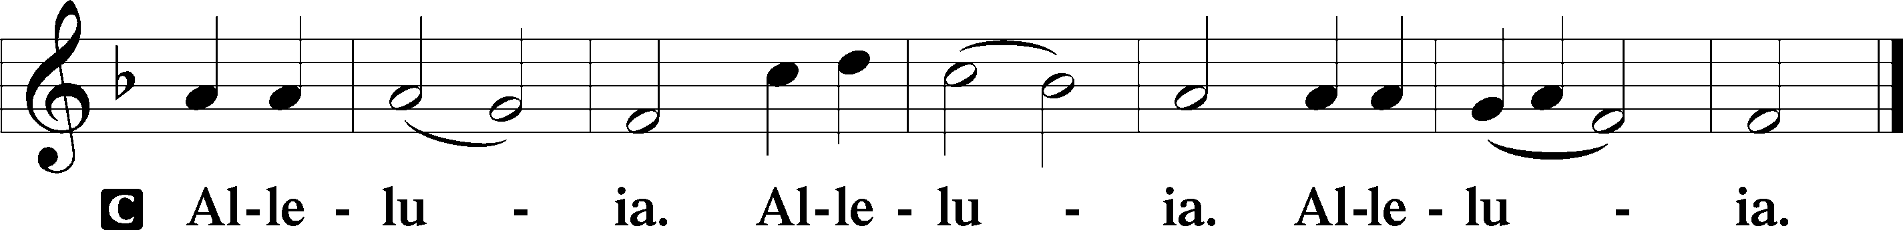

Holy Gospel Luke 17:11–19
P The Holy Gospel according to St. Luke, the seventeenth chapter.

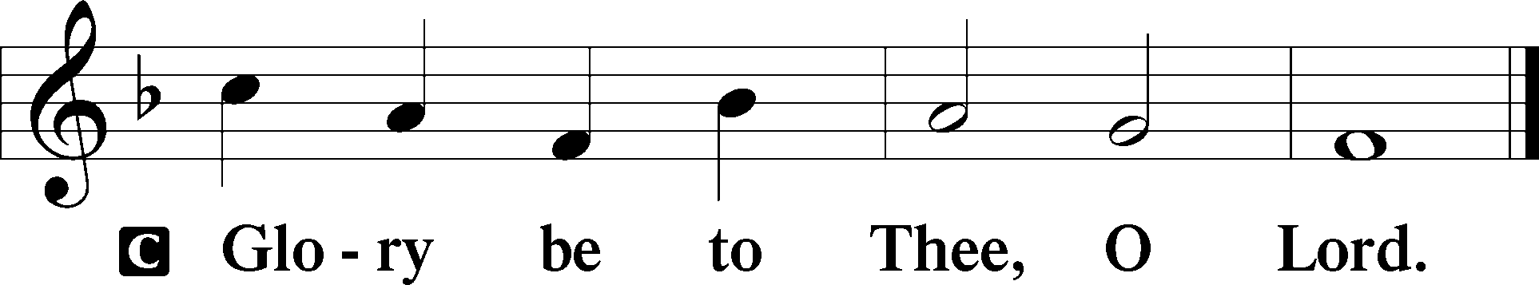

11On the way to Jerusalem [Jesus] was passing along between Samaria and Galilee. 12And as he entered a village, he was met by ten lepers, who stood at a distance 13and lifted up their voices, saying, “Jesus, Master, have mercy on us.” 14When he saw them he said to them, “Go and show yourselves to the priests.” And as they went they were cleansed. 15Then one of them, when he saw that he was healed, turned back, praising God with a loud voice; 16and he fell on his face at Jesus’ feet, giving him thanks. Now he was a Samaritan. 17Then Jesus answered, “Were not ten cleansed? Where are the nine? 18Was no one found to return and give praise to God except this foreigner?” 19And he said to him, “Rise and go your way; your faith has made you well.”

P This is the Gospel of the Lord.

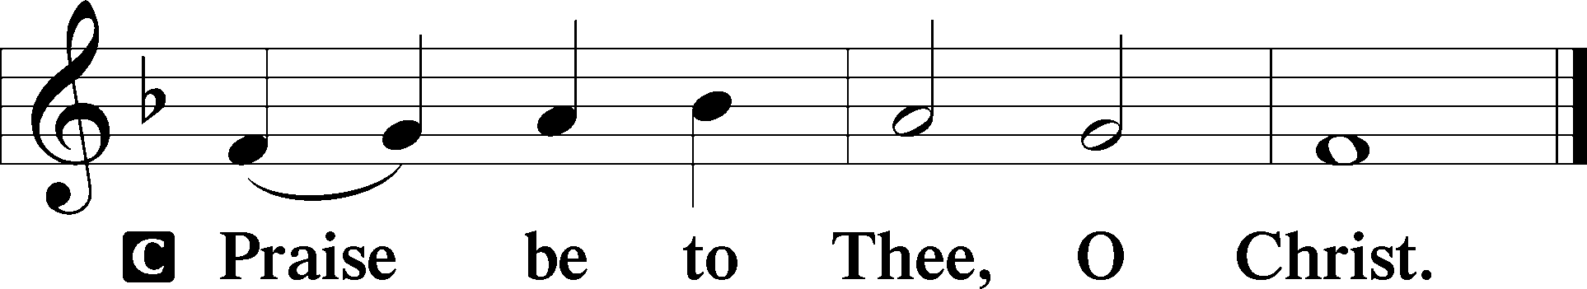

Apostles’ Creed
C I believe in God, the Father Almighty,
maker of heaven and earth.

And in Jesus Christ, His only Son, our Lord,
who was conceived by the Holy Spirit,
born of the virgin Mary,
suffered under Pontius Pilate,
was crucified, died and was buried.
He descended into hell.
The third day He rose again from the dead.
He ascended into heaven
and sits at the right hand of God the Father Almighty.
From thence He will come to judge the living and the dead.

I believe in the Holy Spirit,
the holy Christian Church,
the communion of saints,
the forgiveness of sins,
the resurrection of the body,
and the life T everlasting. Amen.

Sit

Children's Sermon

846 Your Hand, O Lord, in Days of Old
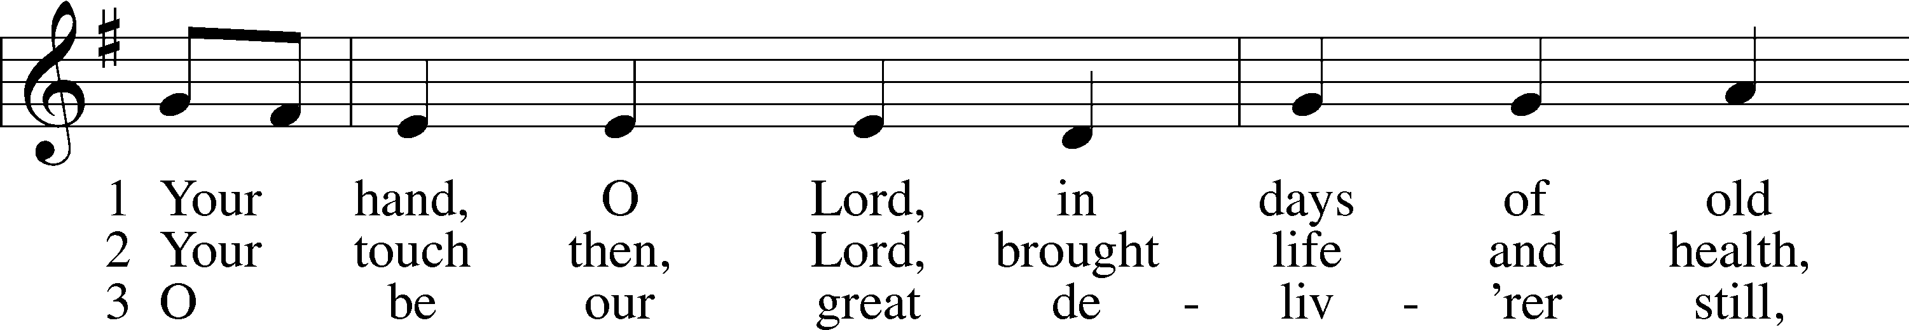
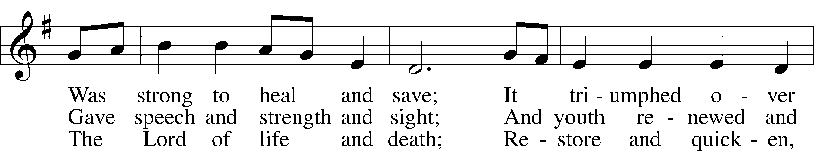
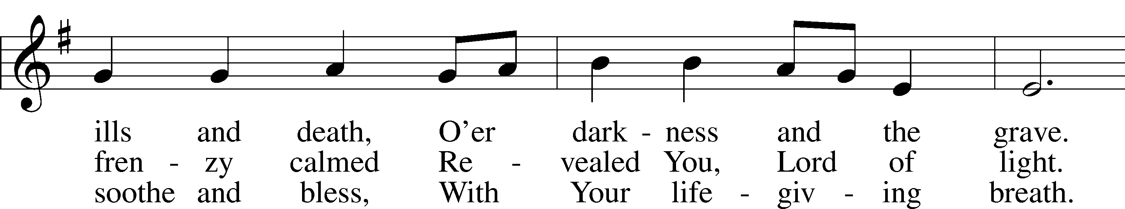
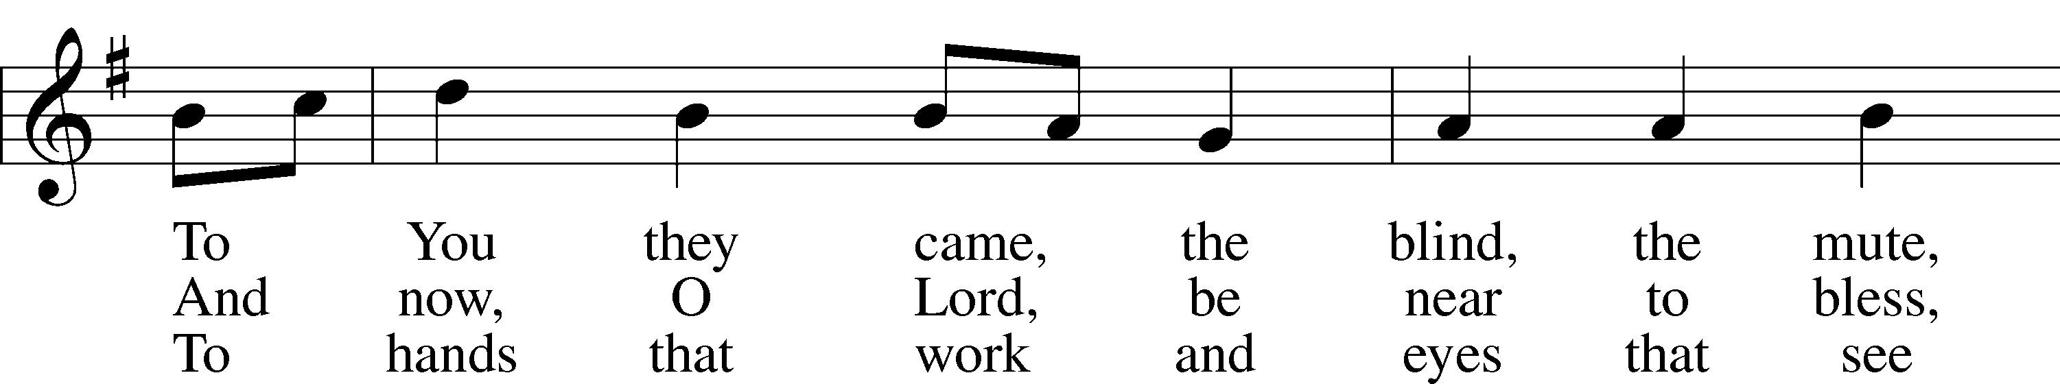
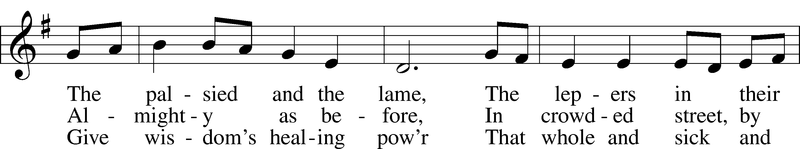
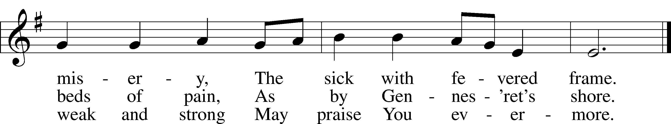
Text: Edward H. Plumptre, 1821–91, alt.
Tune: English; adapt. and harm. Ralph Vaughan Williams, 1872–1958, alt.
Text and tune: Public domain

Sermon

Votum
P The peace of God, which passes all understanding, keep your hearts and minds in Christ Jesus.
C Amen.

Stand

Offertory Psalm 51:10–12
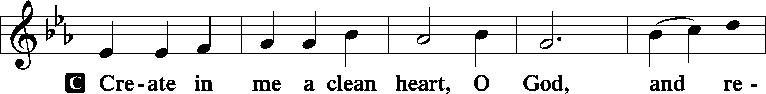
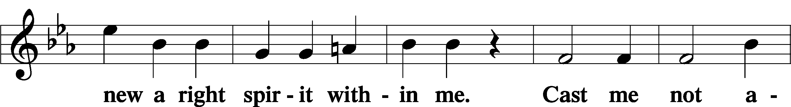
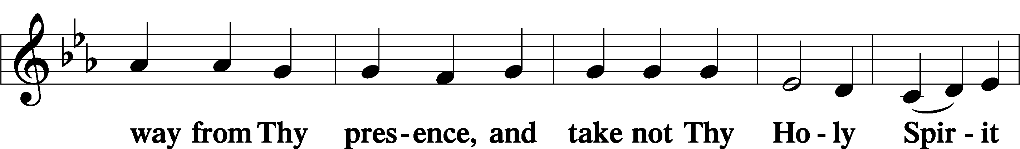
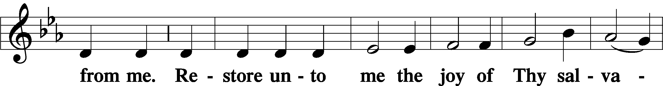
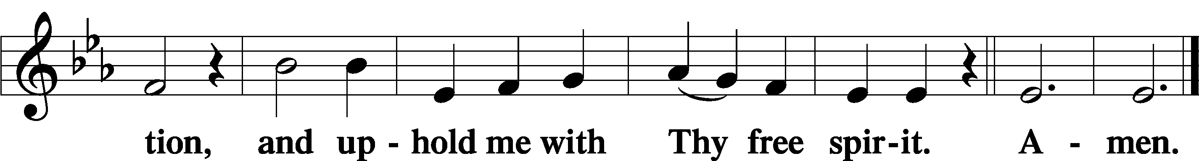

Offering

805 Praise God, from Whom All Blessings Flow
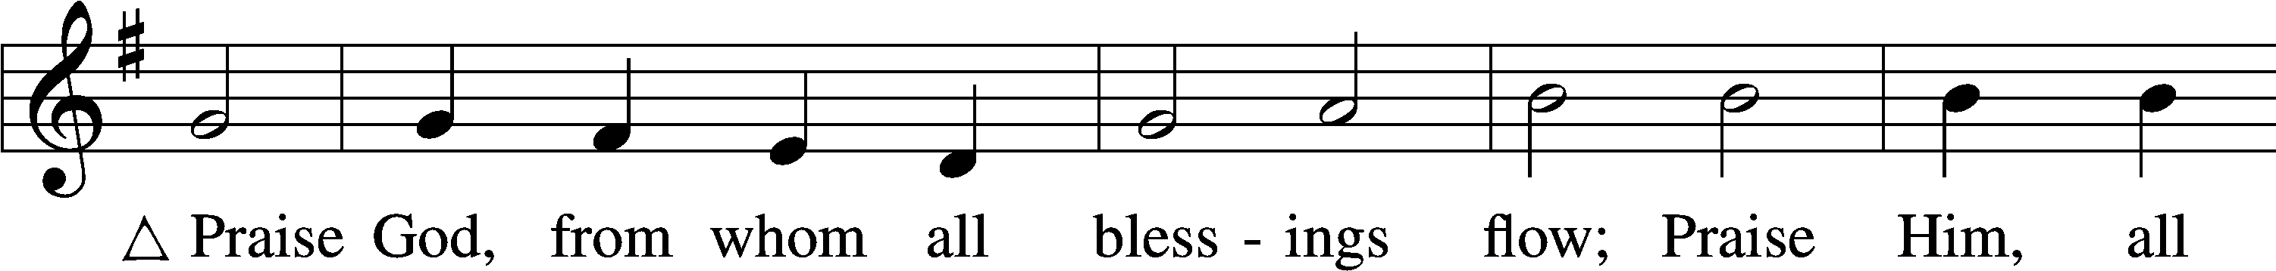
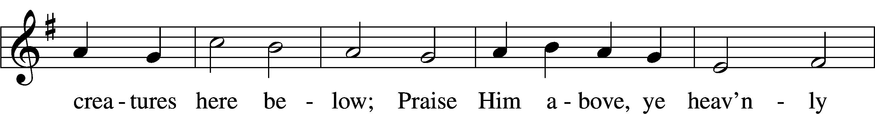
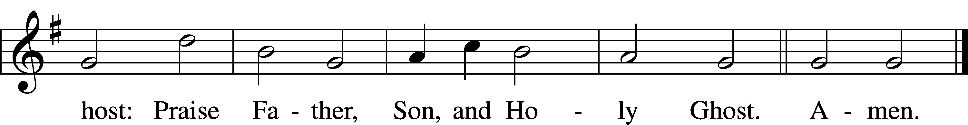
Text: Thomas Ken, 1637–1711
Tune: Trente quatre Pseaumes de David, 1551, Geneva, ed. Louis Bourgeois
Text and tune: Public domain

Prayer of the Church

Lord’s Prayer Matthew 6:9–13
P Lord, remember us in Your kingdom and teach us to pray:
C Our Father who art in heaven,
hallowed be Thy name,
Thy kingdom come,
Thy will be done on earth
as it is in heaven;
give us this day our daily bread;
and forgive us our trespasses
as we forgive those
who trespass against us;
and lead us not into temptation,
but deliver us from evil.
For Thine is the kingdom
and the power and the glory
forever and ever. Amen.

Collect for the Word

Blessed Lord, You have caused all Holy Scriptures to be written for our learning. Grant that we may so hear them, read, mark, learn, and inwardly digest them that, by the patience and comfort of Your holy Word, we may embrace and ever hold fast the blessed hope of everlasting life; through Jesus Christ, Your Son, our Lord, who lives and reigns with You and the Holy Spirit, one God, now and forever.

Benediction
P The Lord bless you and keep you.
The Lord make His face shine on you and be gracious to you.
The Lord look upon you with favor and T give you peace.
C Amen.

895 Now Thank We All Our God
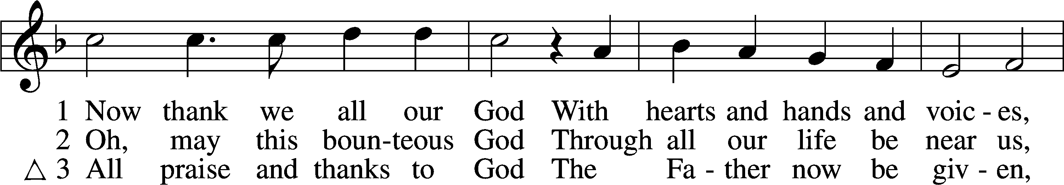
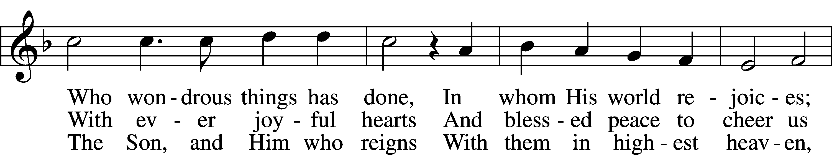
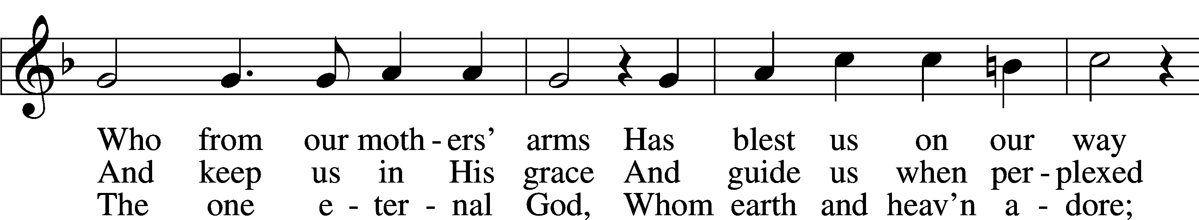
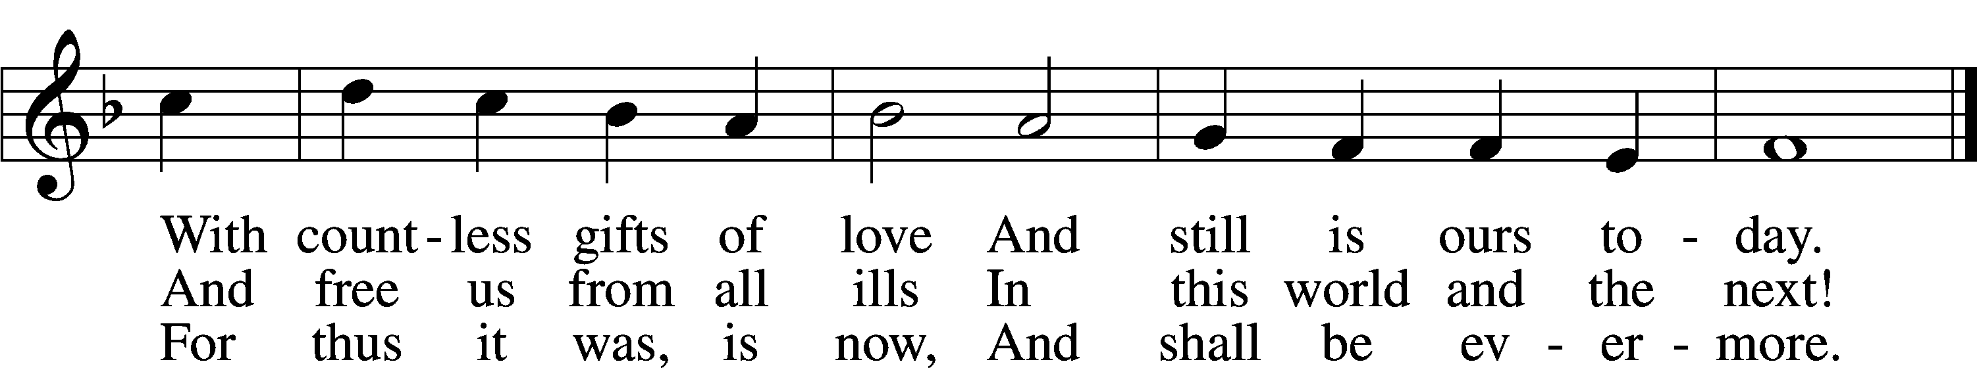
Text: Martin Rinckart, 1586–1649; tr. Catherine Winkworth, 1827–78, alt.
Tune: Johann Crüger, 1598–1662
Text and tune: Public domain

Acknowledgments
Unless otherwise indicated, Scripture quotations are from the ESV® Bible (The Holy Bible, English Standard Version®), copyright © 2001 by Crossway, a publishing ministry of Good News Publishers. Used by permission. All rights reserved.
Created by Lutheran Service Builder © 2025 Concordia Publishing House.

