On entering the church

P Lord, I love the habitation of Your house and the place

where Your glory dwells. In the multitude of Your tender

mercies prepare my heart that I may enter Your house to

worship and confess Your holy name; through Jesus Christ,

my God and Lord.

Before worship

C O Lord, our creator, redeemer, and comforter, as we come

together to worship You in spirit and in truth, we humbly

pray that You would open our hearts to the preaching of

Your Word so that we may repent of our sins, believe in

Jesus Christ as our only Savior, and grow in grace and

holiness. Hear us for His sake.

688 “Come, Follow Me,” the Savior Spake

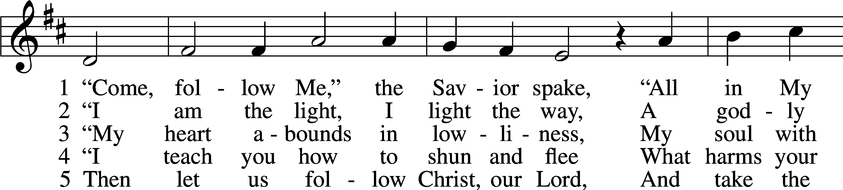

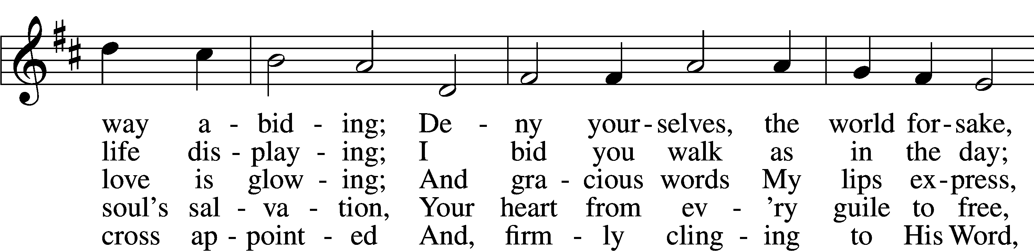

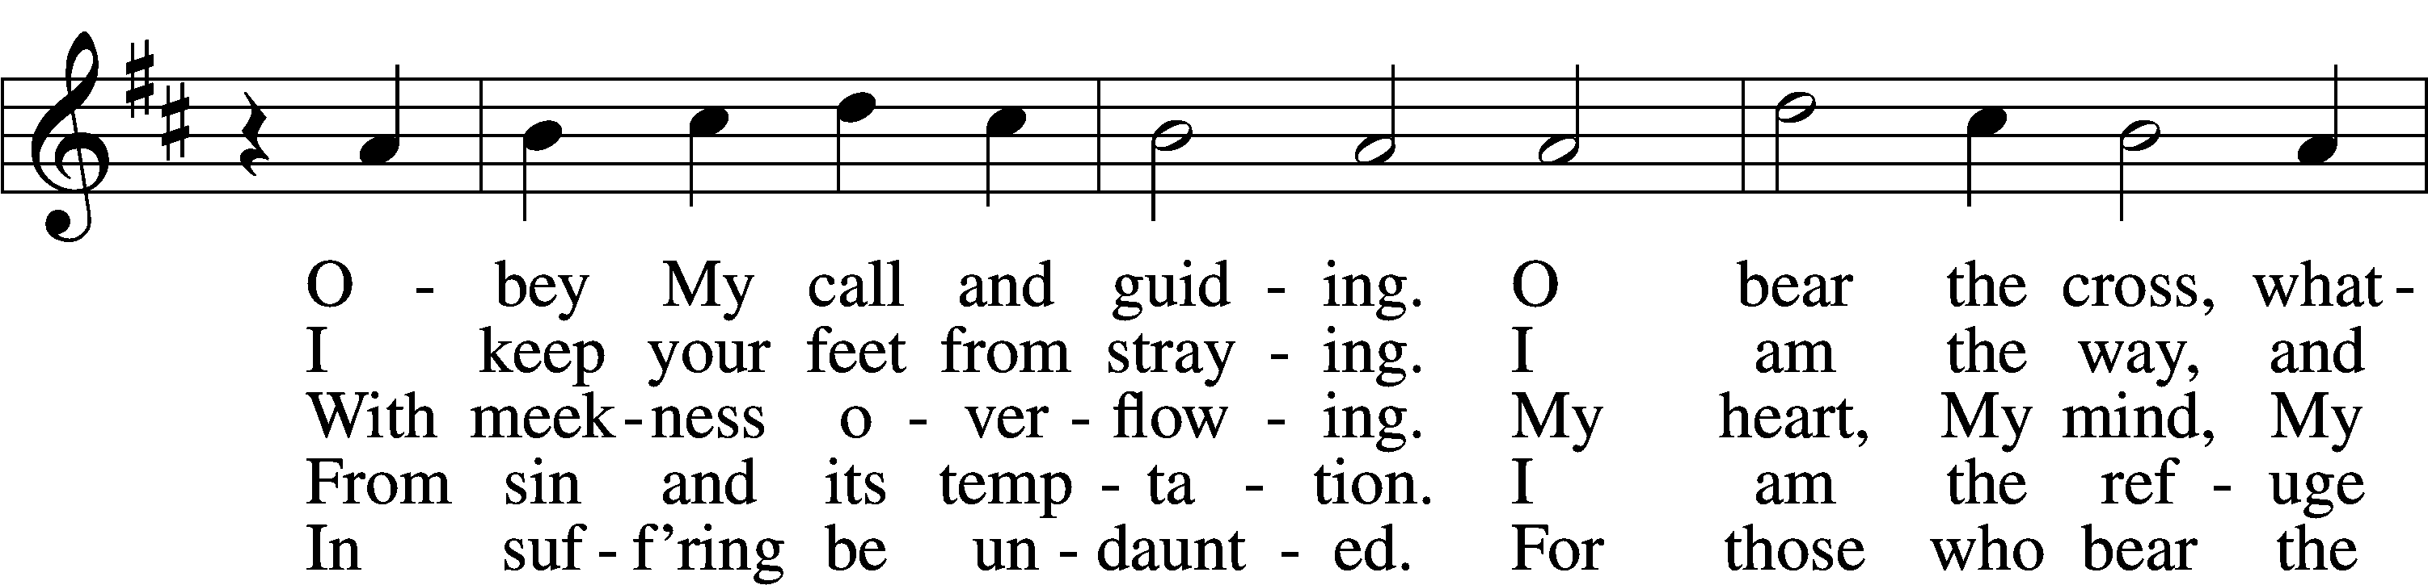

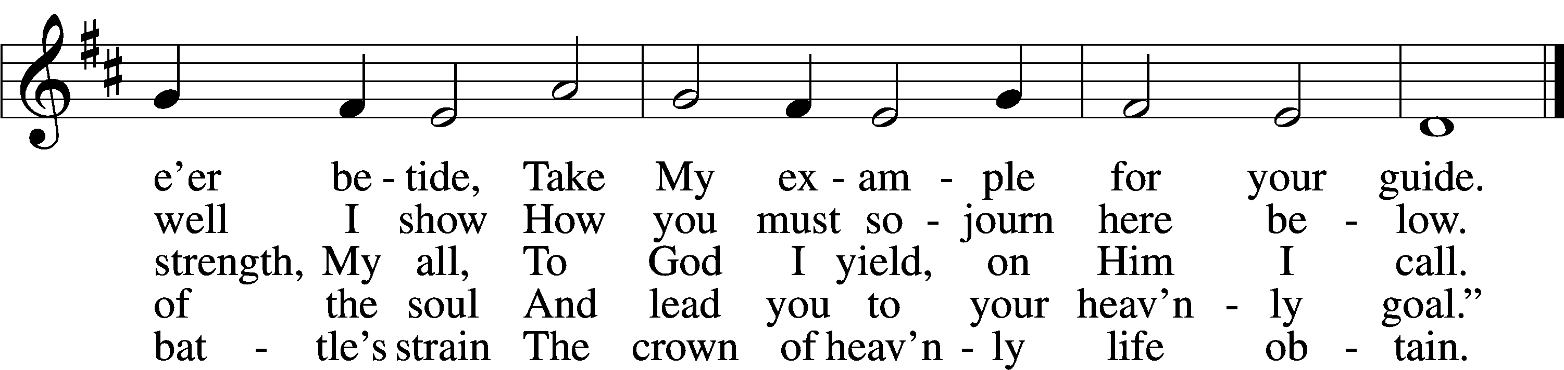

Text: tr. Charles W. Schaeffer, 1813–96; (sts. 1–3, 5): Johann Scheffler, 1624–77; (st. 4): Geistliche Lieder und Lobgesänge, 1695  
Tune: Bartholomäus Gesius, c. 1555–1613, adapt.  
Text and tune: Public domain

# Confession and Absolution

Stand

The sign of the cross may be made by all in remembrance of their Baptism.

Invocation Matthew 28:19b; 18:20

P In the name of the Father and of the T Son and of the Holy Spirit.

C **Amen.**

Exhortation Hebrews 10:22; Psalm 124:8; Psalm 32:5

P Beloved in the Lord! Let us draw near with a true heart and confess our sins unto God our Father, beseeching Him in the name of our Lord Jesus Christ to grant us forgiveness.

P Our help is in the name of the Lord,

C **who made heaven and earth.**

P I said, I will confess my transgressions unto the Lord,

C **and You forgave the iniquity of my sin.**

Kneel/Stand

Silence for reflection on God’s Word and for self-examination.

Confession of Sins

P O almighty God, merciful Father,

C **I, a poor, miserable sinner, confess unto You all my sins and iniquities with which I have ever offended You and justly deserved Your temporal and eternal punishment. But I am heartily sorry for them and sincerely repent of them, and I pray You of Your boundless mercy and for the sake of the holy, innocent, bitter sufferings and death of Your beloved Son, Jesus Christ, to be gracious and merciful to me, a poor, sinful being.**

Absolution [John 20:19–23]

P Upon this your confession, I, by virtue of my office, as a called and ordained servant of the Word, announce the grace of God unto all of you, and in the stead and by the command of my Lord Jesus Christ I forgive you all your sins in the name of the Father and of the T Son and of the Holy Spirit.

C **Amen.**

Stand

# Service of the Word

Introit Psalm 145:4–7, 9; antiphon: v. 10

All your works shall give thanks to you, O Lord,  
 and all your saints shall bless you!  
**One generation shall commend your works to another,  
 and shall declare your mighty acts.**  
On the glorious splendor of your majesty,  
 and on your wondrous works, I will meditate.  
**They shall speak of the might of your awesome deeds,  
 and I will declare your greatness.**  
They shall pour forth the fame of your abundant goodness  
 and shall sing aloud of your righteousness.  
**The Lord is good to all,  
 and his mercy is over all that he has made.**

Gloria Patri

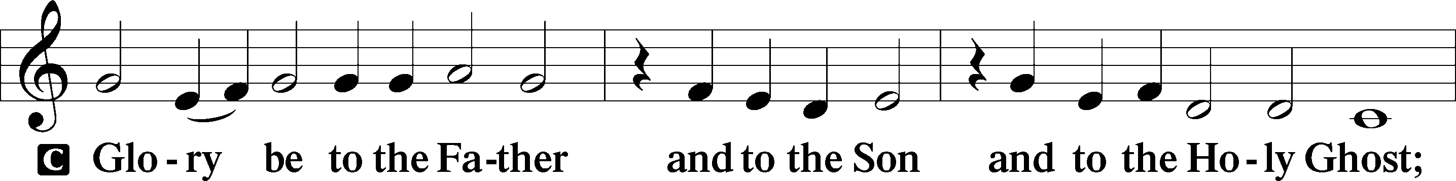

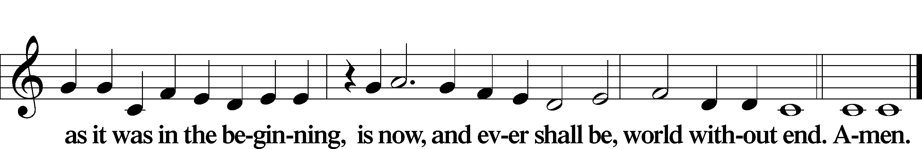

Kyrie Mark 10:47

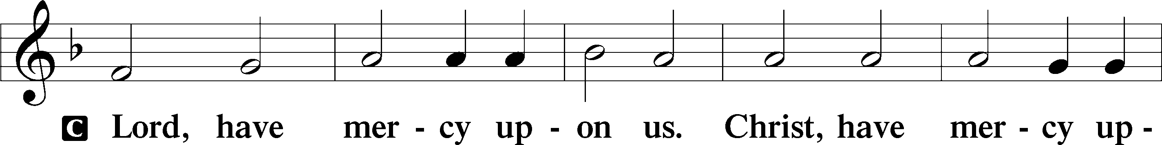

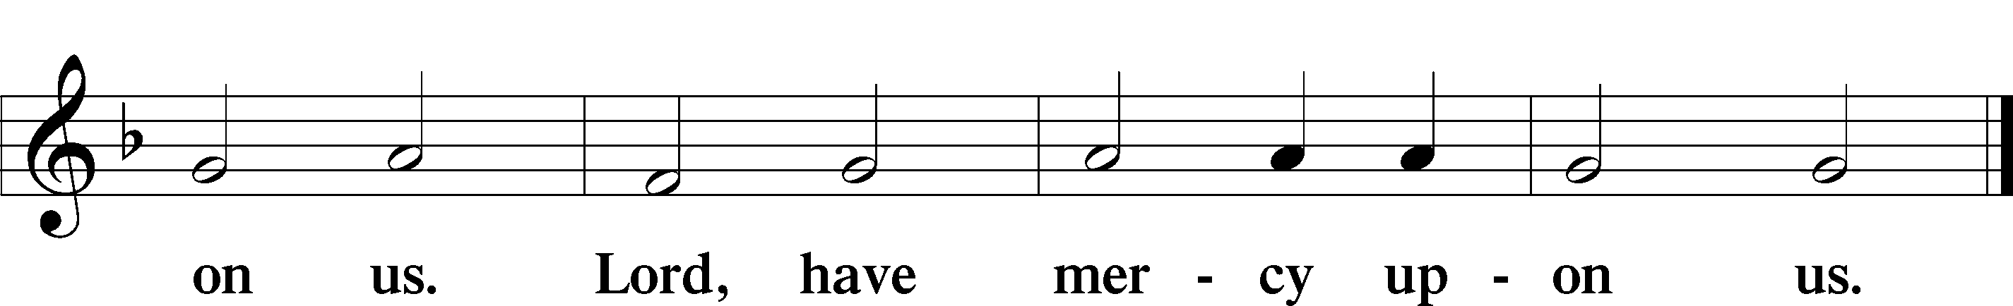

Gloria in Excelsis Luke 2:14; John 1:29

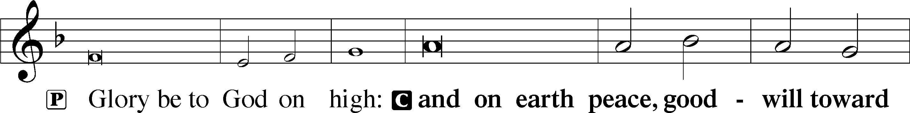

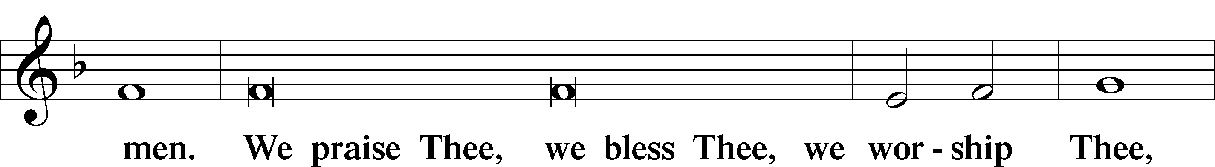

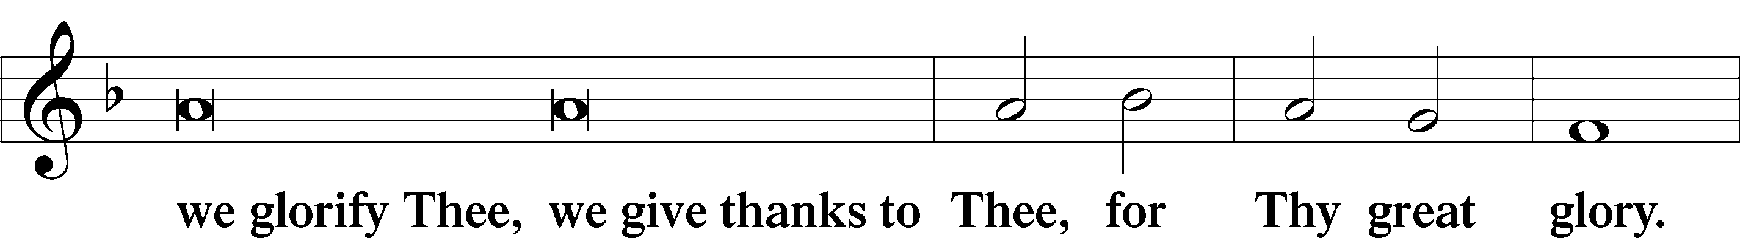

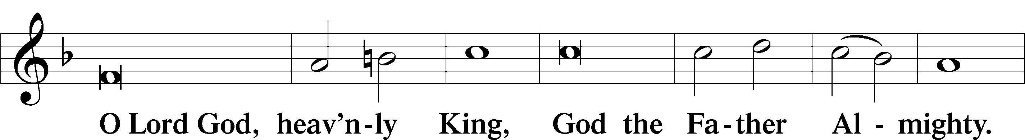

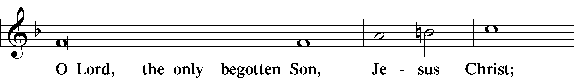

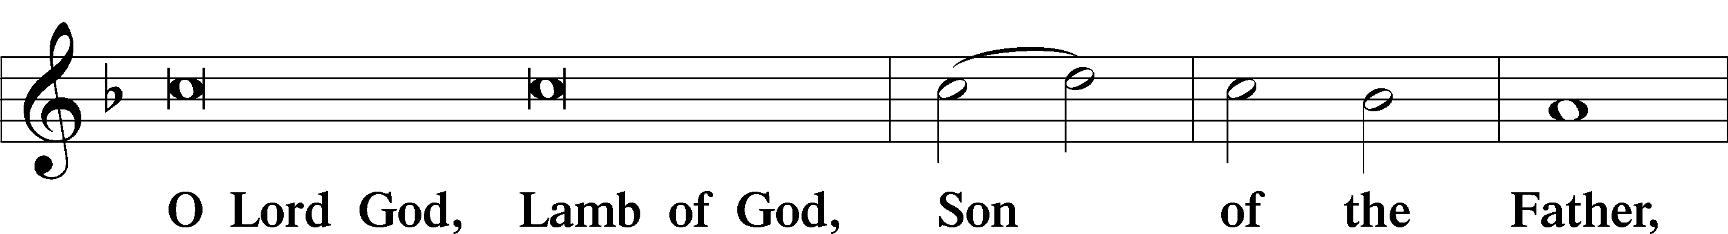

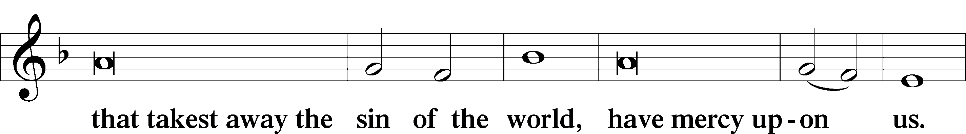

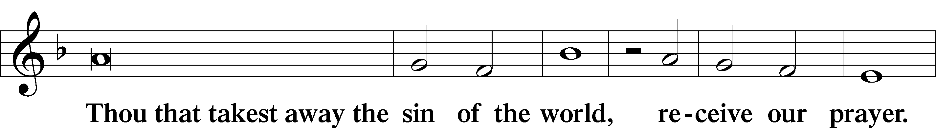

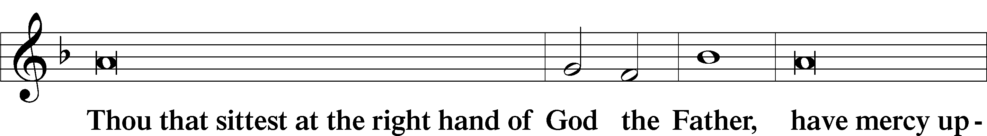

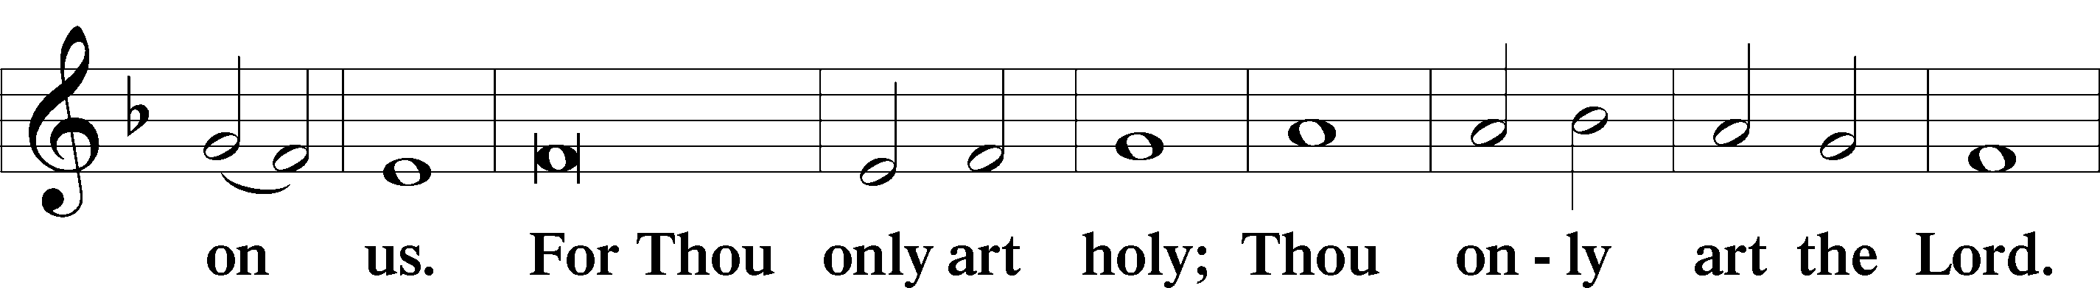

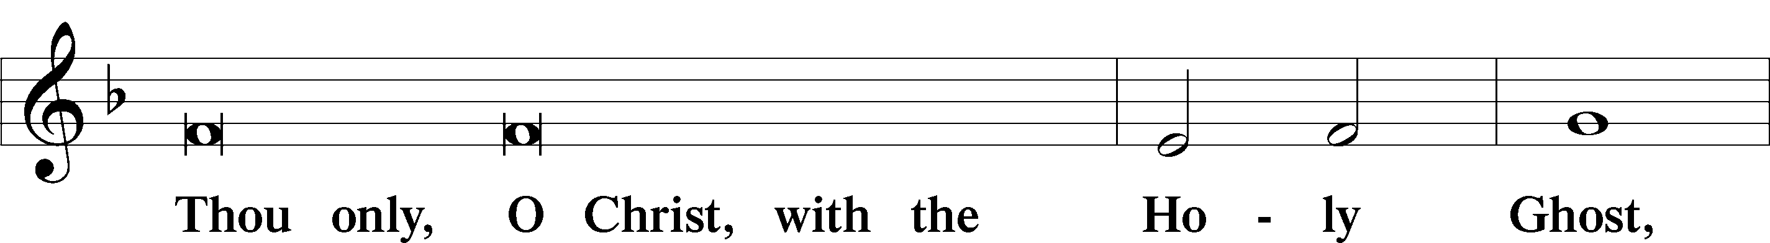

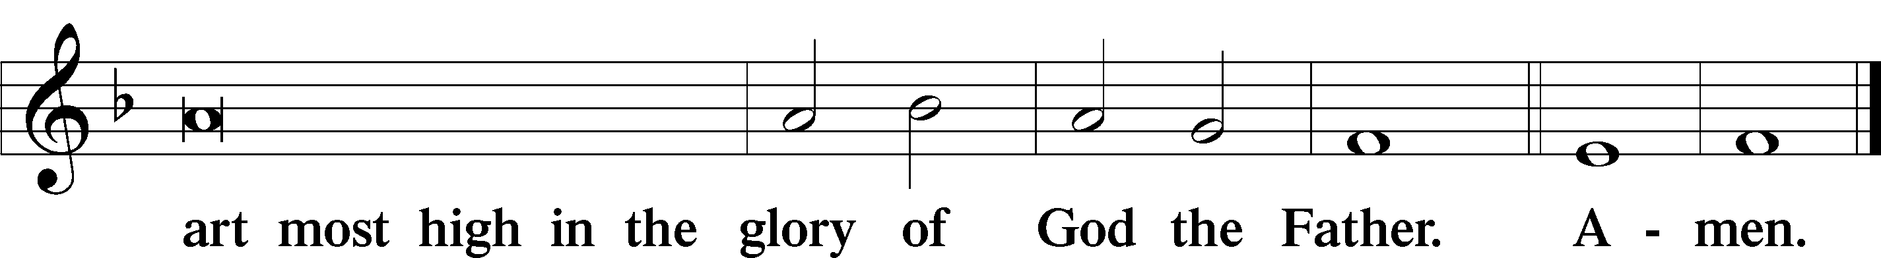

Salutation and Collect of the Day

P The Lord be with you.

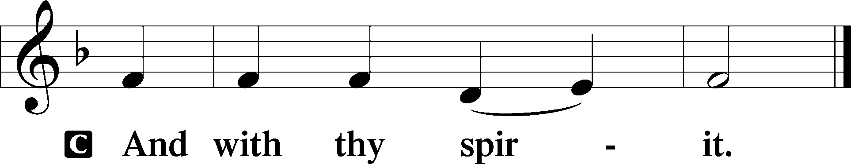

P Let us pray.

O God, through the humiliation of Your Son You raised up the fallen world. Grant to Your faithful people, rescued from the peril of everlasting death, perpetual gladness and eternal joys; through Jesus Christ, our Lord, who lives and reigns with You and the Holy Spirit, one God, now and forever.

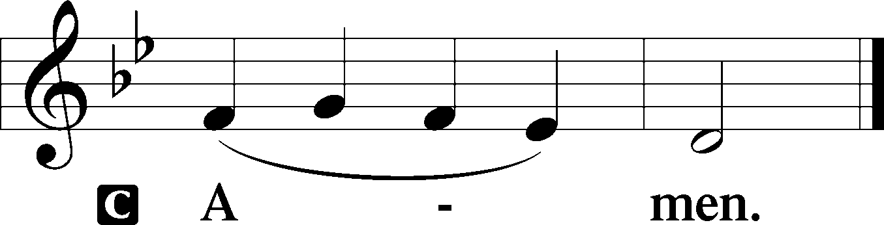

Sit

First Reading Acts 9:1–22

1But Saul, still breathing threats and murder against the disciples of the Lord, went to the high priest 2and asked him for letters to the synagogues at Damascus, so that if he found any belonging to the Way, men or women, he might bring them bound to Jerusalem. 3Now as he went on his way, he approached Damascus, and suddenly a light from heaven flashed around him. 4And falling to the ground he heard a voice saying to him, “Saul, Saul, why are you persecuting me?” 5And he said, “Who are you, Lord?” And he said, “I am Jesus, whom you are persecuting. 6But rise and enter the city, and you will be told what you are to do.” 7The men who were traveling with him stood speechless, hearing the voice but seeing no one. 8Saul rose from the ground, and although his eyes were opened, he saw nothing. So they led him by the hand and brought him into Damascus. 9And for three days he was without sight, and neither ate nor drank.

10Now there was a disciple at Damascus named Ananias. The Lord said to him in a vision, “Ananias.” And he said, “Here I am, Lord.” 11And the Lord said to him, “Rise and go to the street called Straight, and at the house of Judas look for a man of Tarsus named Saul, for behold, he is praying, 12and he has seen in a vision a man named Ananias come in and lay his hands on him so that he might regain his sight.” 13But Ananias answered, “Lord, I have heard from many about this man, how much evil he has done to your saints at Jerusalem. 14And here he has authority from the chief priests to bind all who call on your name.” 15But the Lord said to him, “Go, for he is a chosen instrument of mine to carry my name before the Gentiles and kings and the children of Israel. 16For I will show him how much he must suffer for the sake of my name.” 17So Ananias departed and entered the house. And laying his hands on him he said, “Brother Saul, the Lord Jesus who appeared to you on the road by which you came has sent me so that you may regain your sight and be filled with the Holy Spirit.” 18And immediately something like scales fell from his eyes, and he regained his sight. Then he rose and was baptized; 19and taking food, he was strengthened.

For some days he was with the disciples at Damascus. 20And immediately he proclaimed Jesus in the synagogues, saying, “He is the Son of God.” 21And all who heard him were amazed and said, “Is not this the man who made havoc in Jerusalem of those who called upon this name? And has he not come here for this purpose, to bring them bound before the chief priests?” 22But Saul increased all the more in strength, and confounded the Jews who lived in Damascus by proving that Jesus was the Christ.

A This is the Word of the Lord.

C **Thanks be to God.**

Gradual adapt. from Matthew 28:7; Hebrews 2:7; Psalm 8:6

Christ has risen from the dead.  
 [God the Father] has crowned him with glory and honor.  
**He has given him dominion over the works of his hands;  
 he has put all things under his feet.**

Epistle Revelation 5

1Then I saw in the right hand of him who was seated on the throne a scroll written within and on the back, sealed with seven seals. 2And I saw a strong angel proclaiming with a loud voice, “Who is worthy to open the scroll and break its seals?” 3And no one in heaven or on earth or under the earth was able to open the scroll or to look into it, 4and I began to weep loudly because no one was found worthy to open the scroll or to look into it. 5And one of the elders said to me, “Weep no more; behold, the Lion of the tribe of Judah, the Root of David, has conquered, so that he can open the scroll and its seven seals.”

6And between the throne and the four living creatures and among the elders I saw a Lamb standing, as though it had been slain, with seven horns and with seven eyes, which are the seven spirits of God sent out into all the earth. 7And he went and took the scroll from the right hand of him who was seated on the throne. 8And when he had taken the scroll, the four living creatures and the twenty-four elders fell down before the Lamb, each holding a harp, and golden bowls full of incense, which are the prayers of the saints. 9And they sang a new song, saying,

“Worthy are you to take the scroll  
 and to open its seals,  
for you were slain, and by your blood you ransomed people for God  
 from every tribe and language and people and nation,  
10and you have made them a kingdom and priests to our God,  
 and they shall reign on the earth.”

11Then I looked, and I heard around the throne and the living creatures and the elders the voice of many angels, numbering myriads of myriads and thousands of thousands, 12saying with a loud voice, “Worthy is the Lamb who was slain, to receive power and wealth and wisdom and might and honor and glory and blessing!” 13And I heard every creature in heaven and on earth and under the earth and in the sea, and all that is in them, saying, “To him who sits on the throne and to the Lamb be blessing and honor and glory and might forever and ever!” 14And the four living creatures said, “Amen!” and the elders fell down and worshiped.

A This is the Word of the Lord.

C **Thanks be to God.**

Stand

Alleluia

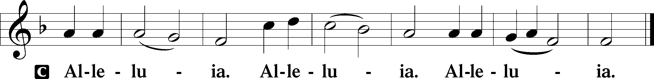

Holy Gospel John 21:1–19

P The Holy Gospel according to St. John, the twenty-first chapter.

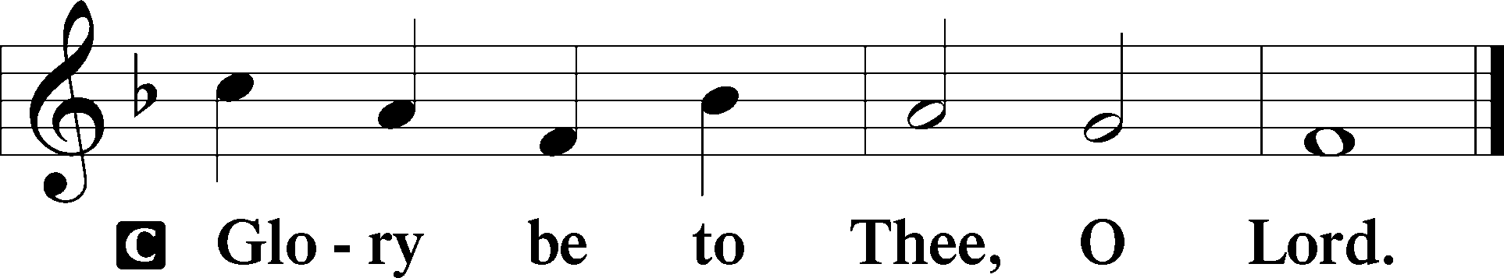

1After this Jesus revealed himself again to the disciples by the Sea of Tiberias, and he revealed himself in this way. 2Simon Peter, Thomas (called the Twin), Nathanael of Cana in Galilee, the sons of Zebedee, and two others of his disciples were together. 3Simon Peter said to them, “I am going fishing.” They said to him, “We will go with you.” They went out and got into the boat, but that night they caught nothing.

4Just as day was breaking, Jesus stood on the shore; yet the disciples did not know that it was Jesus. 5Jesus said to them, “Children, do you have any fish?” They answered him, “No.” 6He said to them, “Cast the net on the right side of the boat, and you will find some.” So they cast it, and now they were not able to haul it in, because of the quantity of fish. 7That disciple whom Jesus loved therefore said to Peter, “It is the Lord!” When Simon Peter heard that it was the Lord, he put on his outer garment, for he was stripped for work, and threw himself into the sea. 8The other disciples came in the boat, dragging the net full of fish, for they were not far from the land, but about a hundred yards off.

9When they got out on land, they saw a charcoal fire in place, with fish laid out on it, and bread. 10Jesus said to them, “Bring some of the fish that you have just caught.” 11So Simon Peter went aboard and hauled the net ashore, full of large fish, 153 of them. And although there were so many, the net was not torn. 12Jesus said to them, “Come and have breakfast.” Now none of the disciples dared ask him, “Who are you?” They knew it was the Lord. 13Jesus came and took the bread and gave it to them, and so with the fish. 14This was now the third time that Jesus was revealed to the disciples after he was raised from the dead.

15When they had finished breakfast, Jesus said to Simon Peter, “Simon, son of John, do you love me more than these?” He said to him, “Yes, Lord; you know that I love you.” He said to him, “Feed my lambs.” 16He said to him a second time, “Simon, son of John, do you love me?” He said to him, “Yes, Lord; you know that I love you.” He said to him, “Tend my sheep.” 17He said to him the third time, “Simon, son of John, do you love me?” Peter was grieved because he said to him the third time, “Do you love me?” and he said to him, “Lord, you know everything; you know that I love you.” Jesus said to him, “Feed my sheep. 18Truly, truly, I say to you, when you were young, you used to dress yourself and walk wherever you wanted, but when you are old, you will stretch out your hands, and another will dress you and carry you where you do not want to go.” 19(This he said to show by what kind of death he was to glorify God.) And after saying this he said to him, “Follow me.”

P This is the Gospel of the Lord.

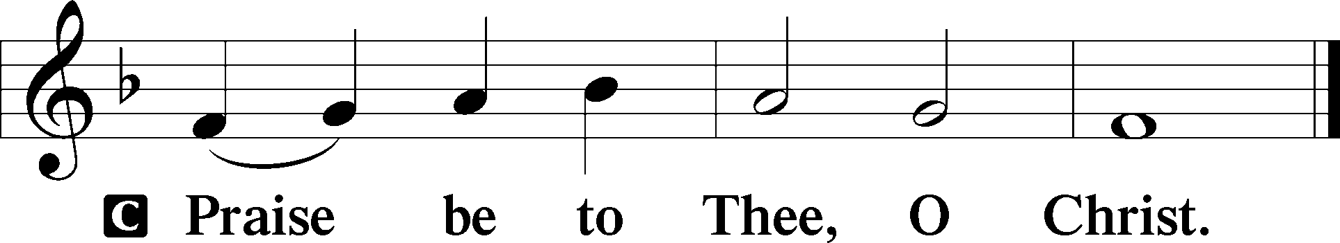

Nicene Creed

C **I believe in one God,**

**the Father Almighty,**

**maker of heaven and earth**

**and of all things visible and invisible.**

**And in one Lord Jesus Christ,**

**the only-begotten Son of God,**

**begotten of His Father before all worlds,**

**God of God, Light of Light,**

**very God of very God,**

**begotten, not made,**

**being of one substance with the Father,**

**by whom all things were made;**

**who for us men and for our salvation came down from heaven**

**and was incarnate by the Holy Spirit of the virgin Mary**

**and was made man;**

**and was crucified also for us under Pontius Pilate.**

**He suffered and was buried.**

**And the third day He rose again according to the Scriptures**

**and ascended into heaven**

**and sits at the right hand of the Father.**

**And He will come again with glory to judge both the living and the dead,**

**whose kingdom will have no end.**

**And I believe in the Holy Spirit,**

**the Lord and giver of life,**

**who proceeds from the Father and the Son,**

**who with the Father and the Son together is worshiped and glorified,**

**who spoke by the prophets.**

**And I believe in one holy Christian and apostolic Church,**

**I acknowledge one Baptism for the remission of sins,**

**and I look for the resurrection of the dead**

**and the life** T **of the world to come. Amen.**

Sit

Children's Sermon

507 Holy, Holy, Holy sts. 1–4

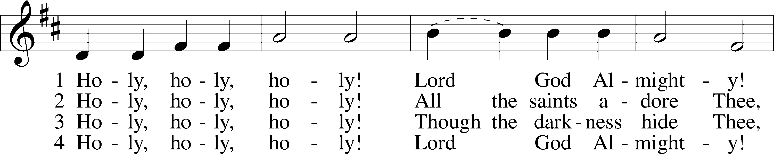

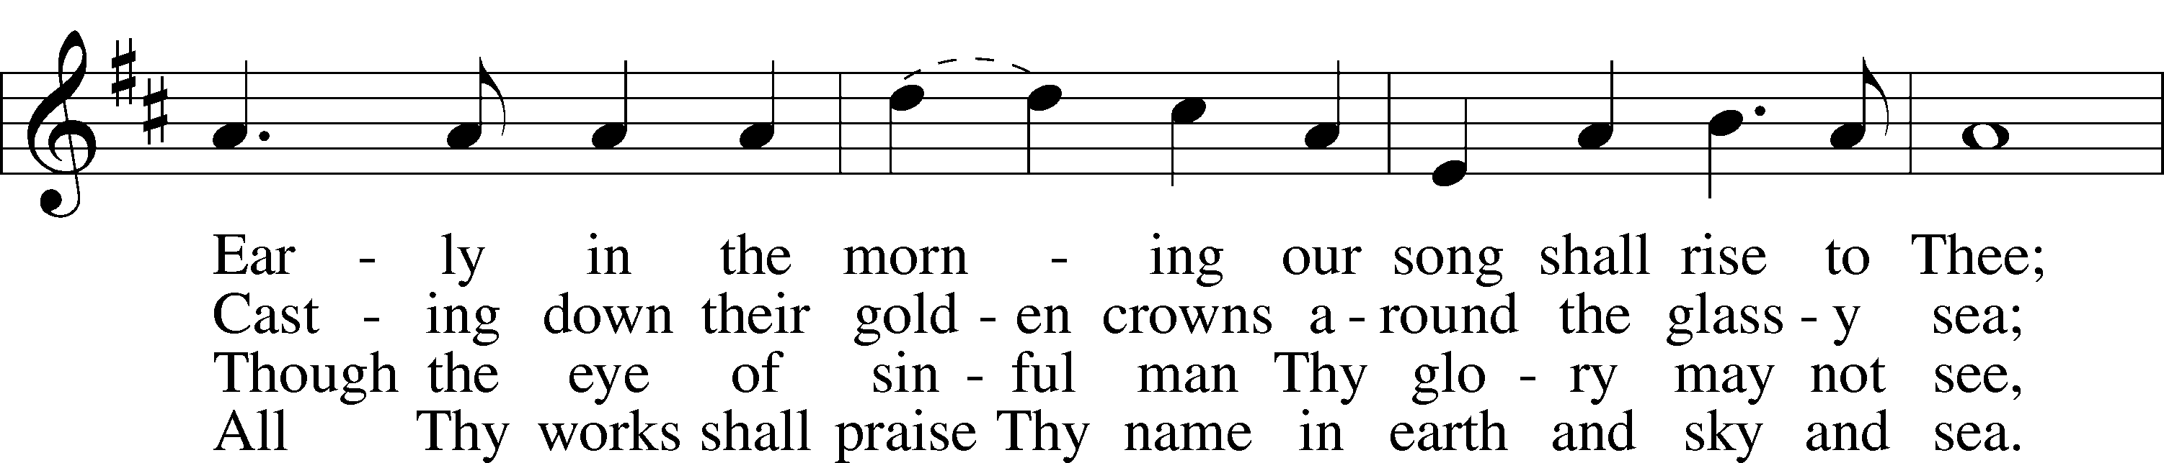

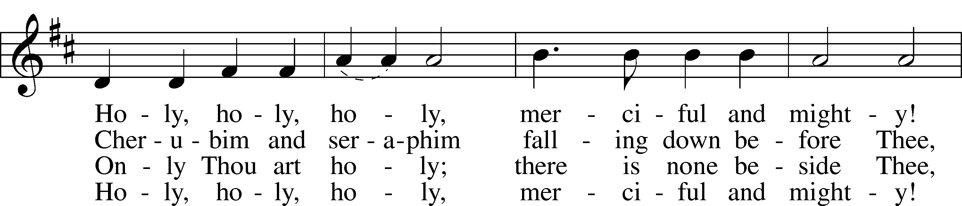

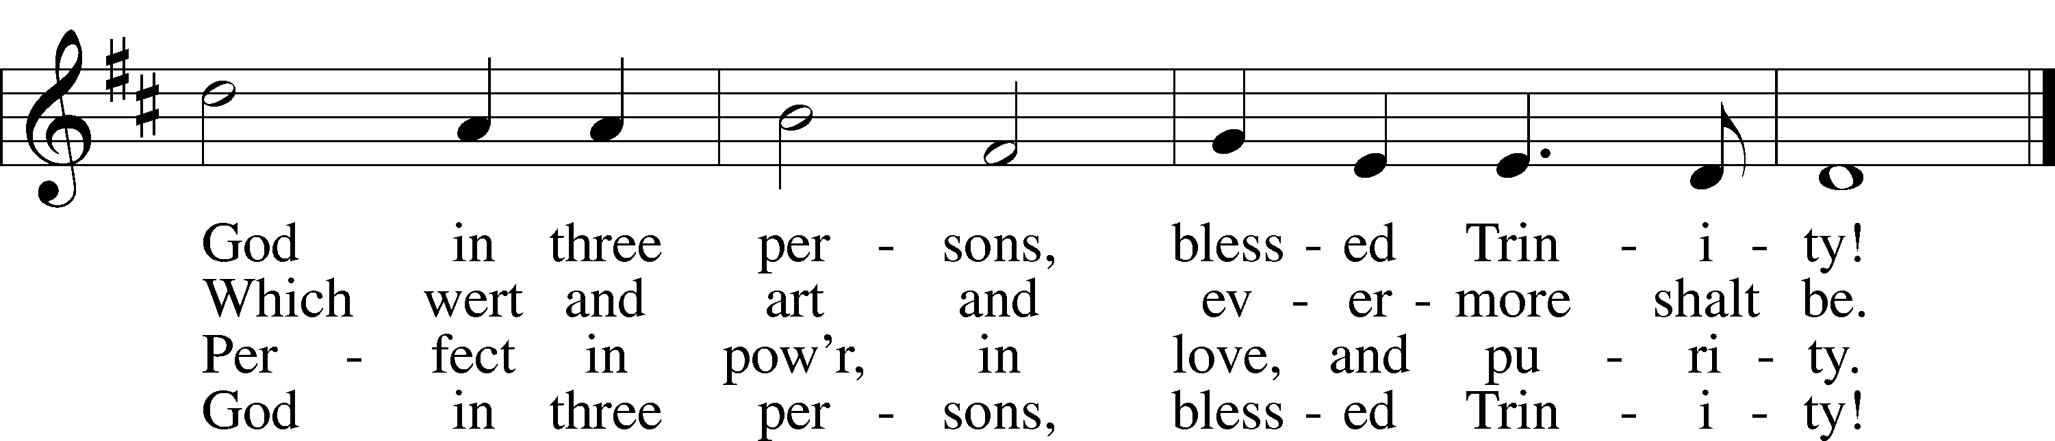

Text: Reginald Heber, 1783–1826  
Tune: John B. Dykes, 1823–76  
Text and tune: Public domain

Sermon

Votum

P The peace of God, which passes all understanding, keep your hearts and minds in Christ Jesus.

C **Amen.**

Stand

Offertory Psalm 51:10–12

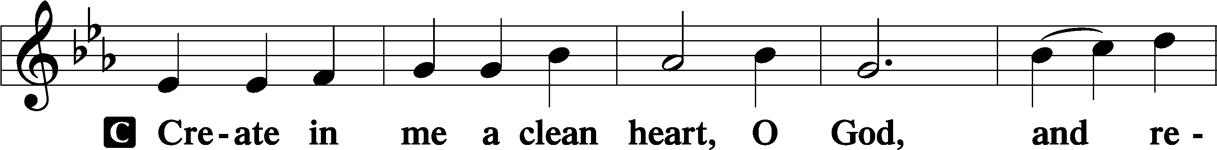

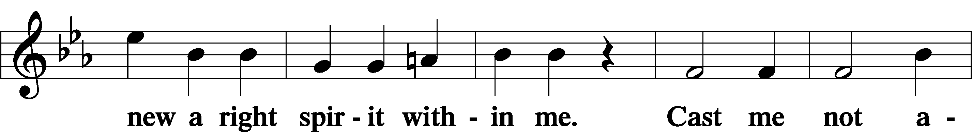

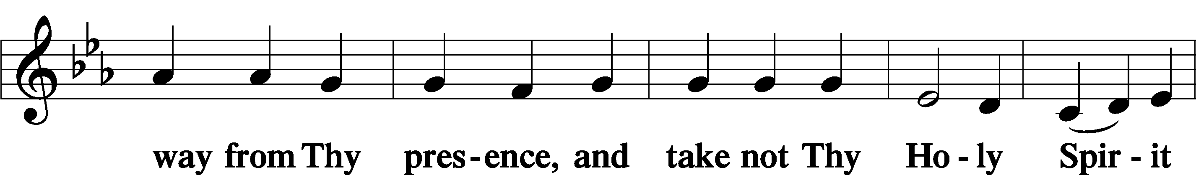

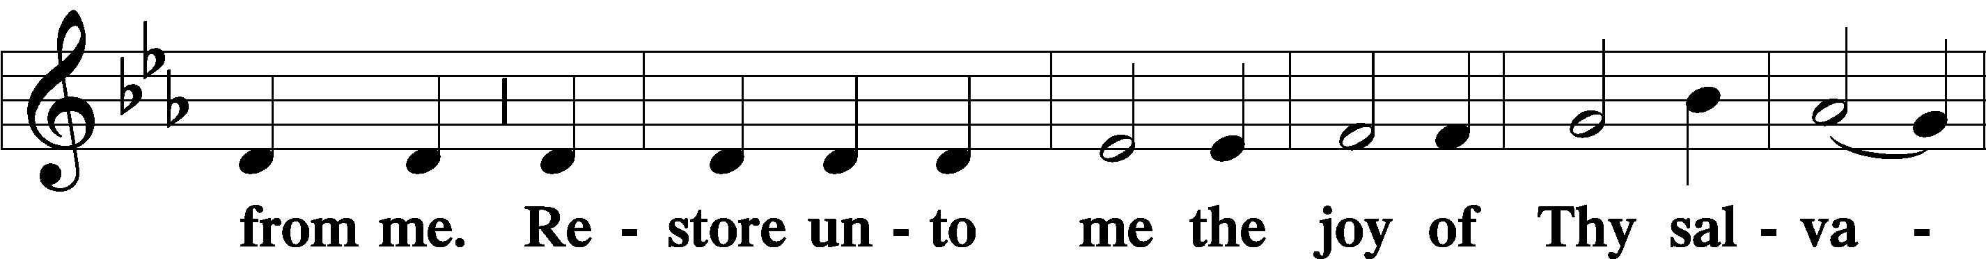

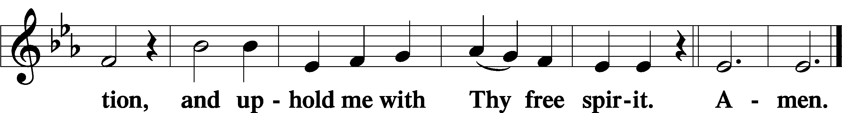

Sit

Offering

805 Praise God, from Whom All Blessings Flow

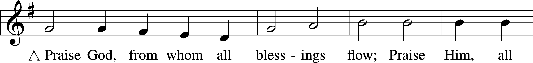

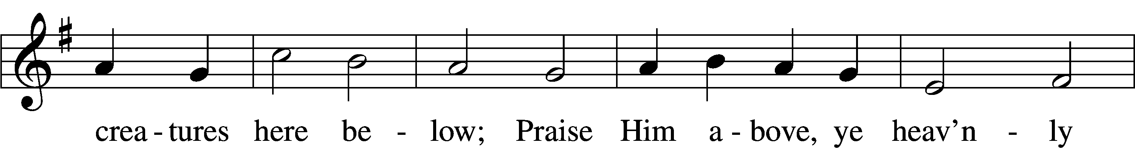

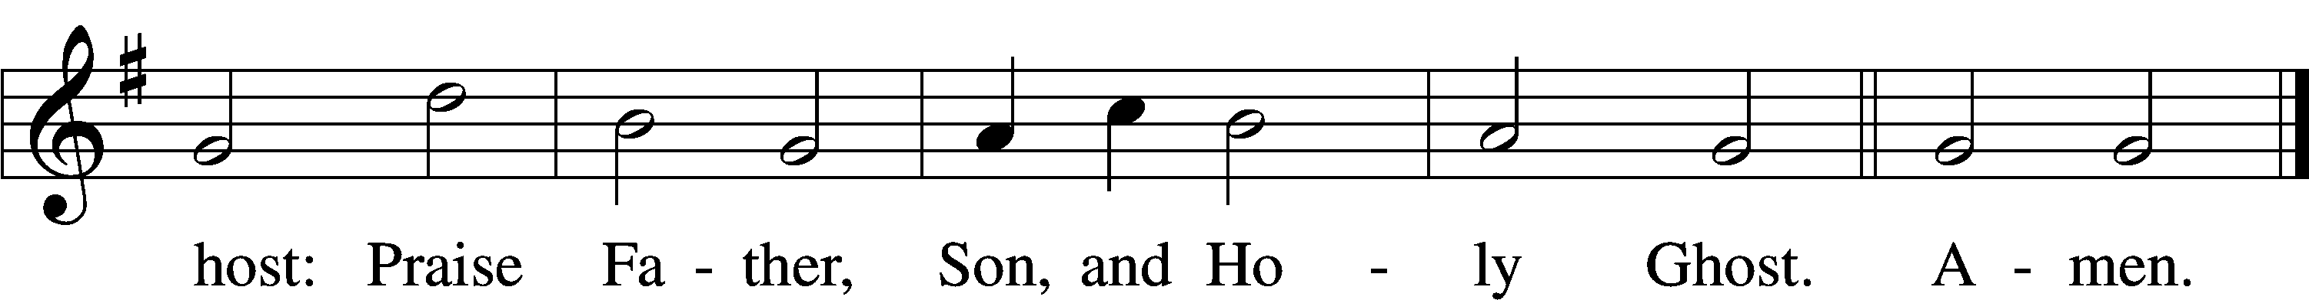

Text: Thomas Ken, 1637–1711  
Tune: Trente quatre Pseaumes de David, 1551, Geneva, ed. Louis Bourgeois  
Text and tune: Public domain

Stand

Prayer of the Church

# Service of the Sacrament

Preface 2 Timothy 4:22; [Colossians 3:1]; [Psalm 136]

P The Lord be with you.

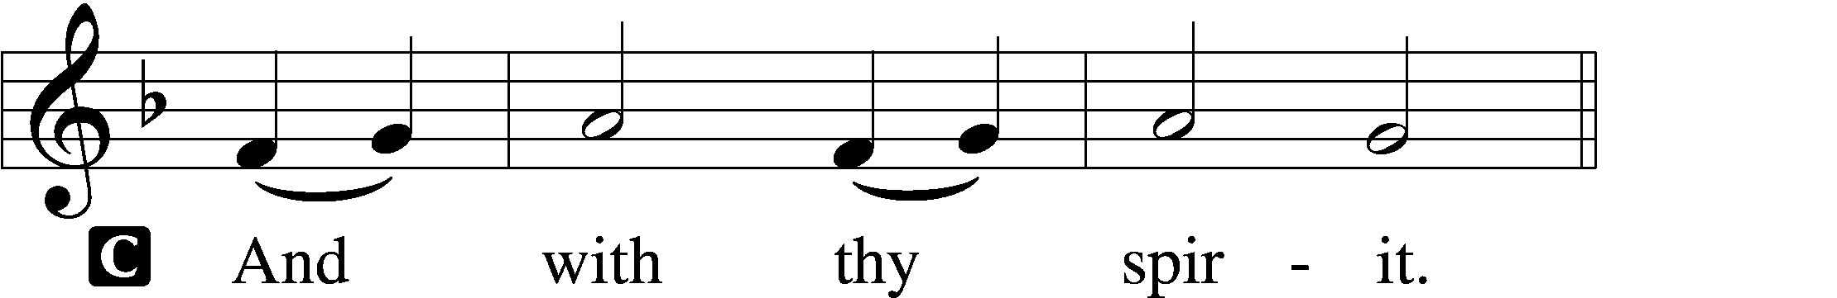

P Lift up your hearts.

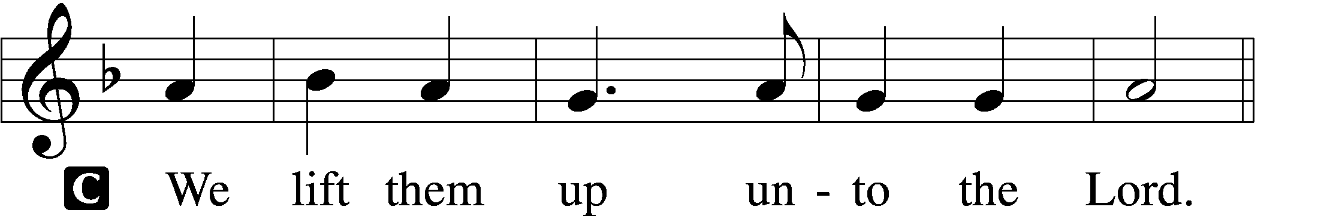

P Let us give thanks unto the Lord, our God.

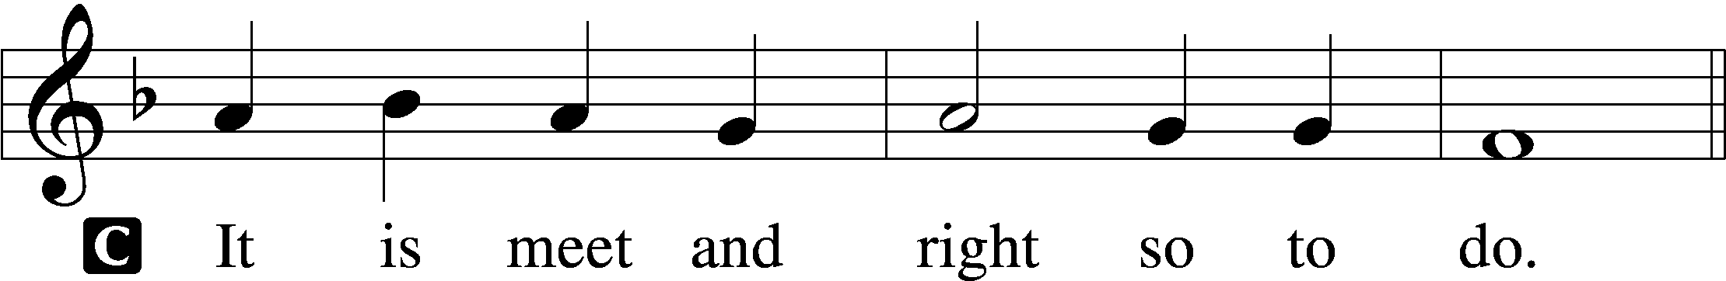

Proper Preface (Full)

P It is truly meet, right, and salutary that we should at all times and in all places give thanks to You, holy Lord, almighty Father, everlasting God. And most especially are we bound to praise You on this day for the glorious resurrection of Your Son, Jesus Christ, the very Paschal Lamb, who was sacrificed for us and bore the sins of the world. By His dying He has destroyed death, and by His rising again He has restored to us everlasting life. Therefore with Mary Magdalene, Peter and John, and with all the witnesses of the resurrection, with angels and archangels, and with all the company of heaven we laud and magnify Your glorious name, evermore praising You and saying:

Sanctus Isaiah 6:3; Matthew 21:9

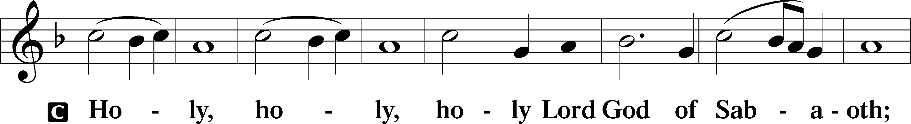

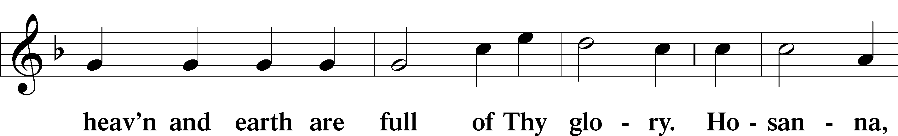

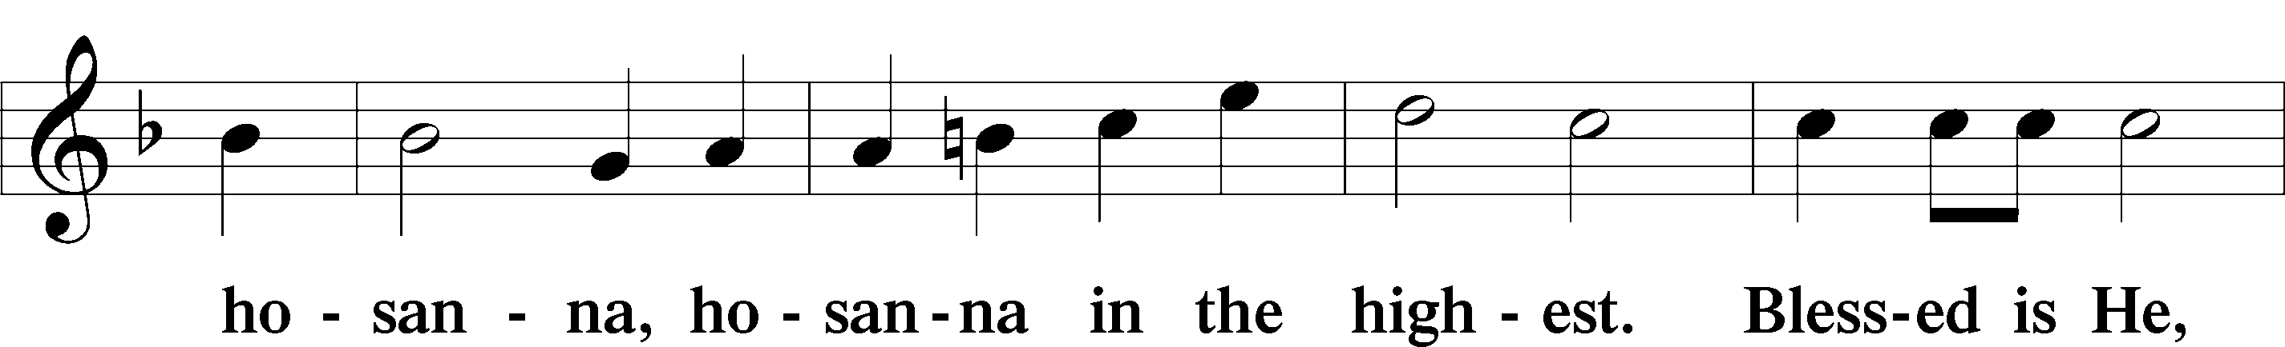

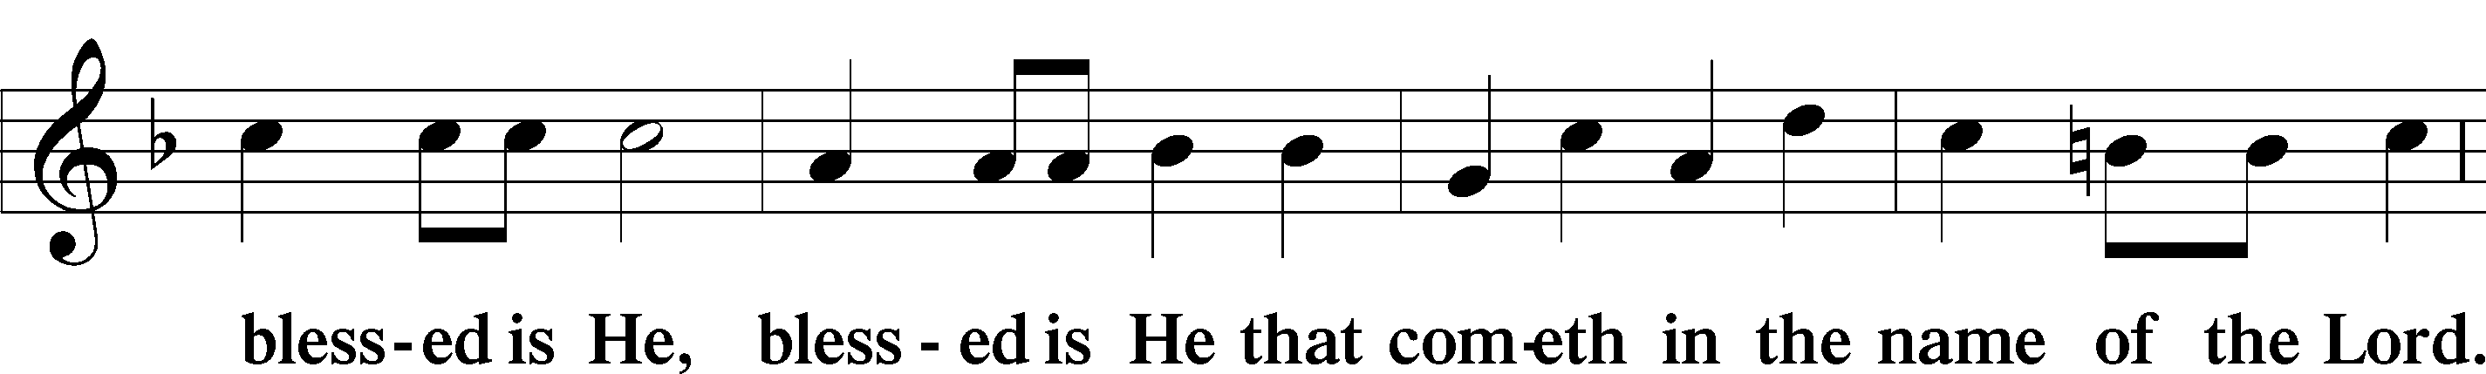

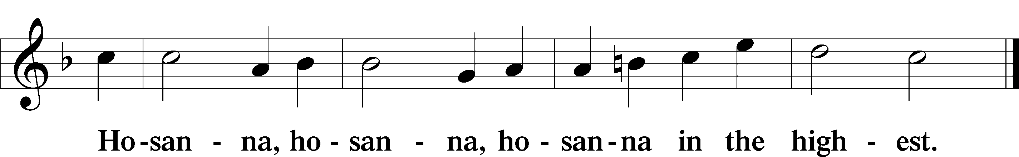

Lord’s Prayer Matthew 6:9–13

P Our Father who art in heaven,

hallowed be Thy name,

Thy kingdom come,

Thy will be done on earth as it is in heaven;

give us this day our daily bread;

and forgive us our trespasses as we forgive those who trespass against us;

and lead us not into temptation,

but deliver us from evil.

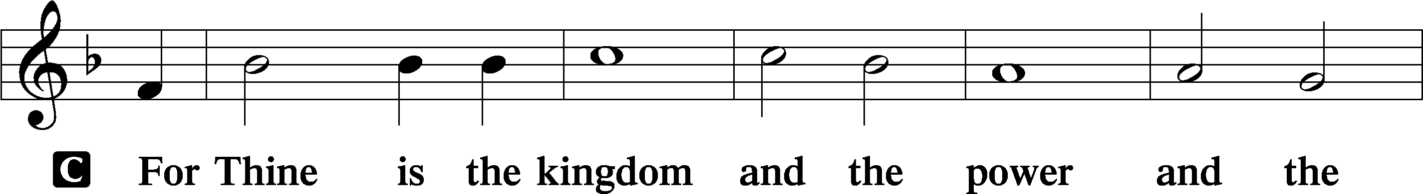

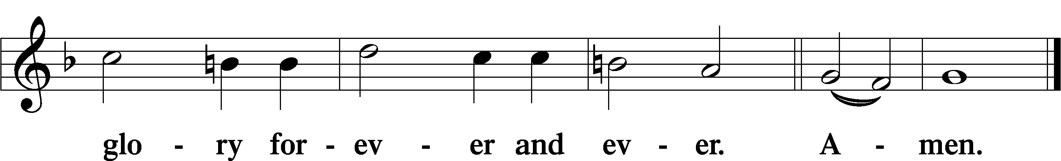

The Words of Our Lord Matthew 26:26–28; Mark 14:22–24; Luke 22:19–20; 1 Corinthians 11:23–25

P Our Lord Jesus Christ, on the night when He was betrayed, took bread, and when He had given thanks, He broke it and gave it to the disciples and said: “Take, eat; this is My T body, which is given for you. This do in remembrance of Me.”

In the same way also He took the cup after supper, and when He had given thanks, He gave it to them, saying: “Drink of it, all of you; this cup is the new testament in My T blood, which is shed for you for the forgiveness of sins. This do, as often as you drink it, in remembrance of Me.”

Pax Domini John 20:19

P The peace of the Lord be with you always.

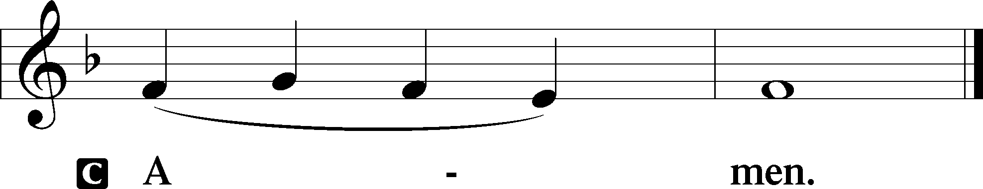

Agnus Dei John 1:29

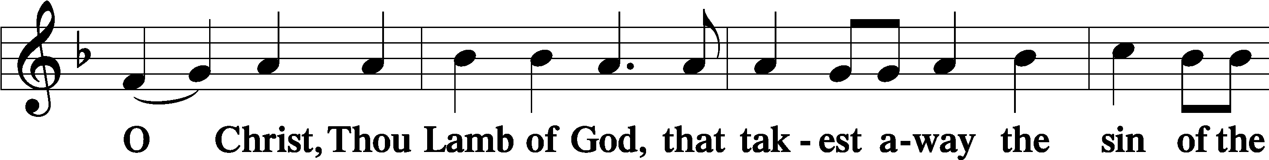

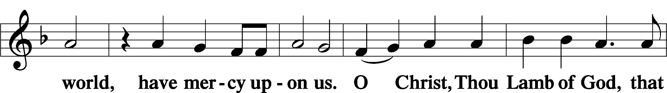

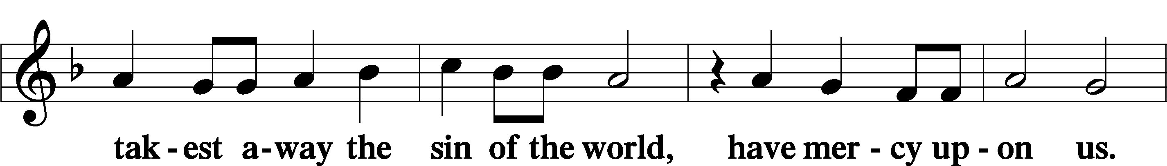

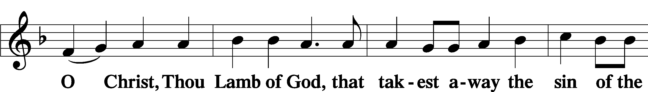

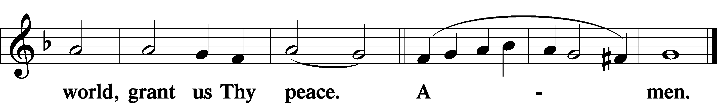

Sit

Distribution

The pastor and those who assist him receive the body and blood of Christ first and then distribute them to those who come to receive, saying:

Take, eat; this is the true body of our Lord and Savior Jesus Christ, given into death for your sins.

**Amen.**

Take, drink; this is the true blood of our Lord and Savior Jesus Christ, shed for the forgiveness of your sins.

**Amen.**

In dismissing the communicants, the following is said:

The Dismissal

P The body and blood of our Lord Jesus Christ strengthen and preserve you in body and soul to life everlasting. Depart T in peace.

C **Amen.**

633 At the Lamb’s High Feast We Sing

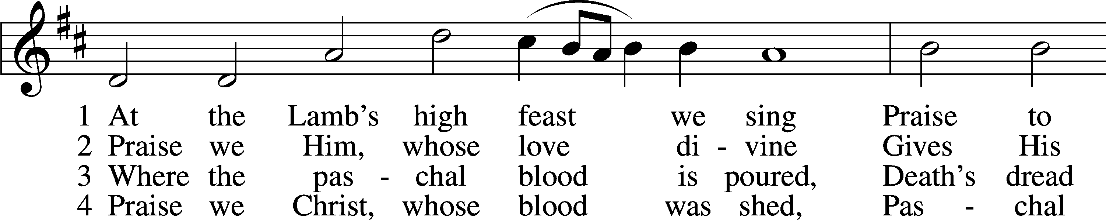

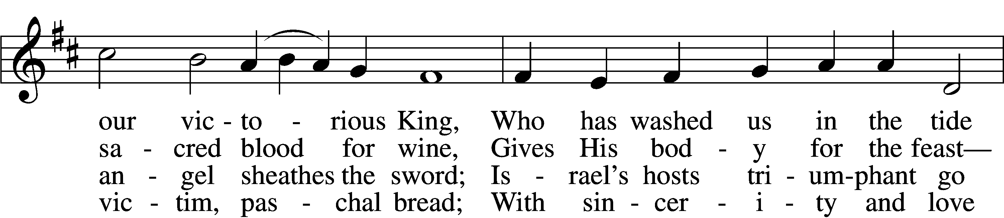

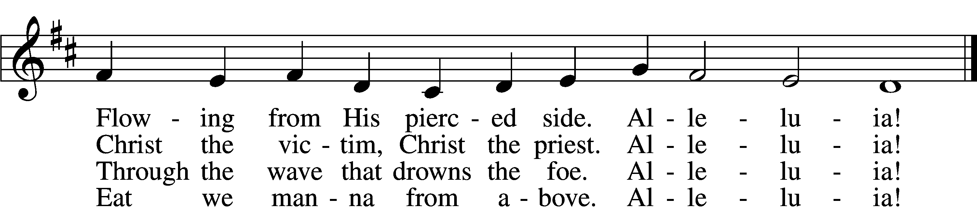

5 Mighty Victim from the sky,  
Hell’s fierce pow’rs beneath You lie;  
You have conquered in the fight,  
You have brought us life and light.  
 Alleluia!

6 Now no more can death appall,  
Now no more the grave enthrall;  
You have opened paradise,  
And Your saints in You shall rise.  
 Alleluia!

7 Easter triumph, Easter joy!  
This alone can sin destroy;  
From sin’s pow’r, Lord, set us free,  
Newborn souls in You to be.  
 Alleluia!

D 8 Father, who the crown shall give,  
Savior, by whose death we live,  
Spirit, guide through all our days:  
Three in One, Your name we praise.  
 Alleluia!

Text: Latin, c. 5th–10th cent.; tr. Robert Campbell, 1814–68, alt.  
Tune: Kirchengeseng, 1566, Ivancice  
Text and tune: Public domain

810 O God of God, O Light of Light

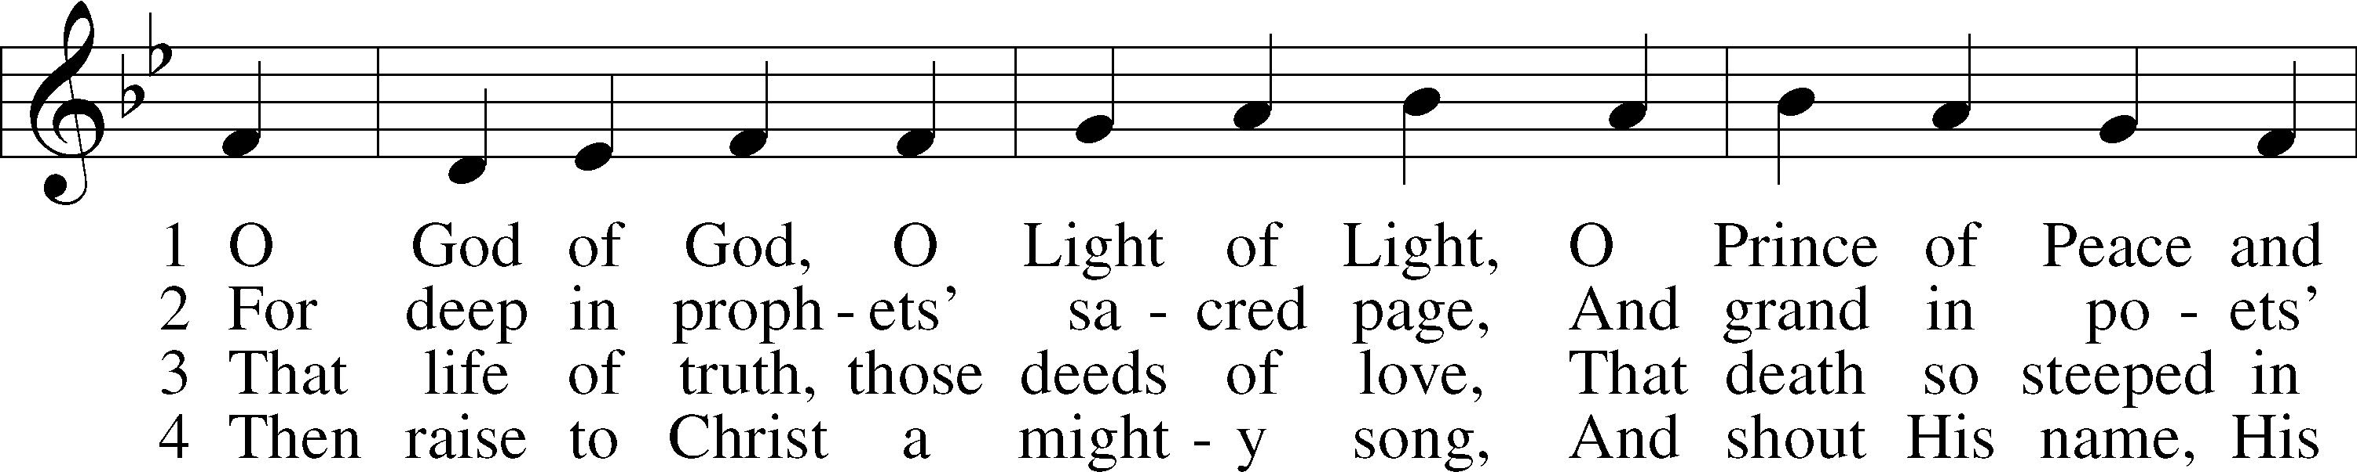

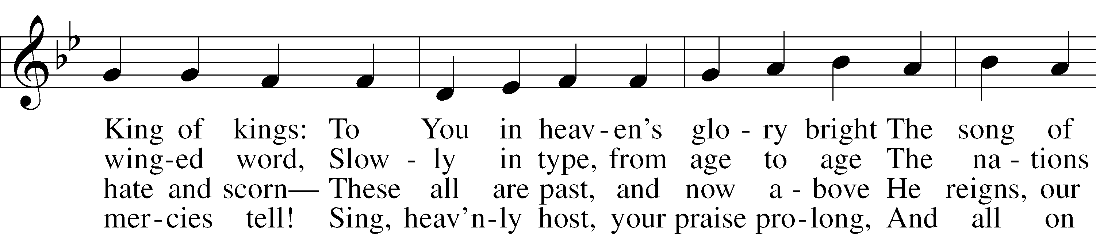

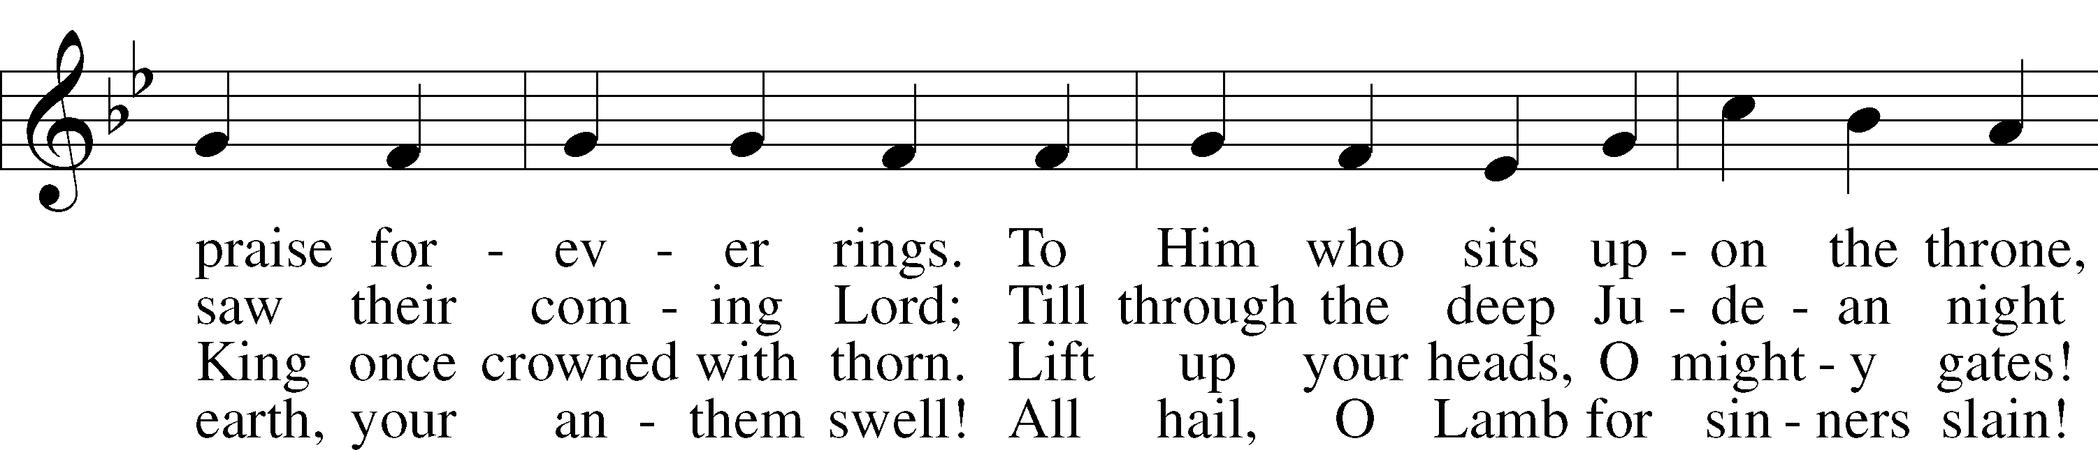

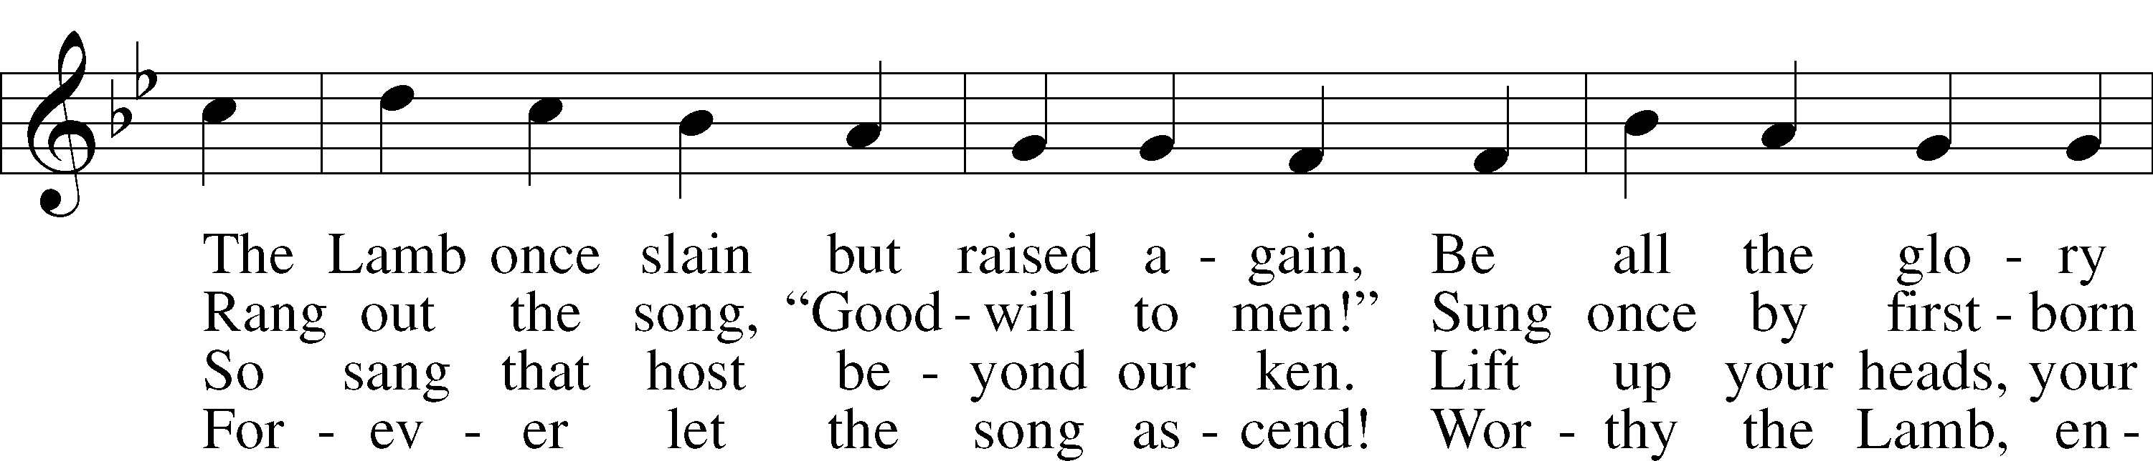

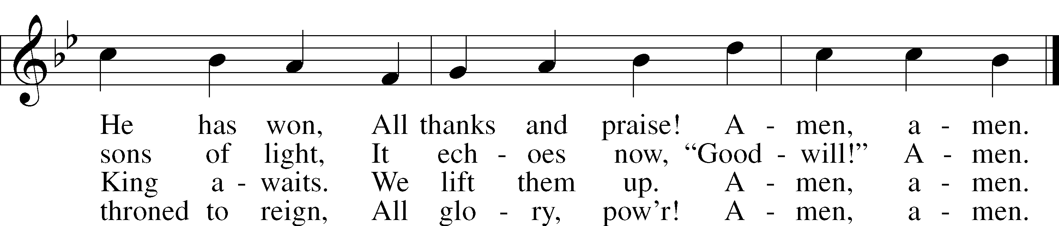

Text: John Julian, 1839–1913, alt.  
Tune: Johann Störls . . . Schlag- Gesang- Und Noten-Buch, 1744, Stuttgart  
Text and tune: Public domain

547 The Lamb

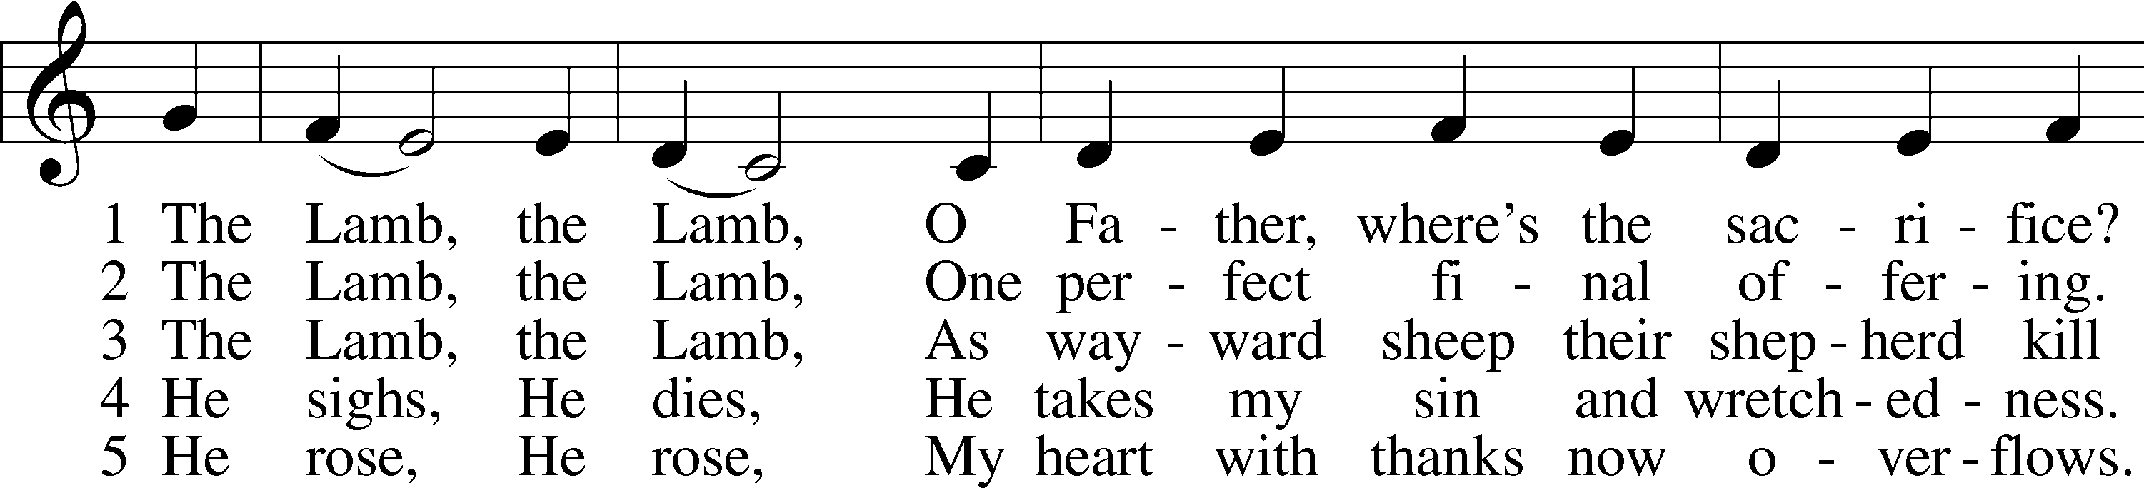

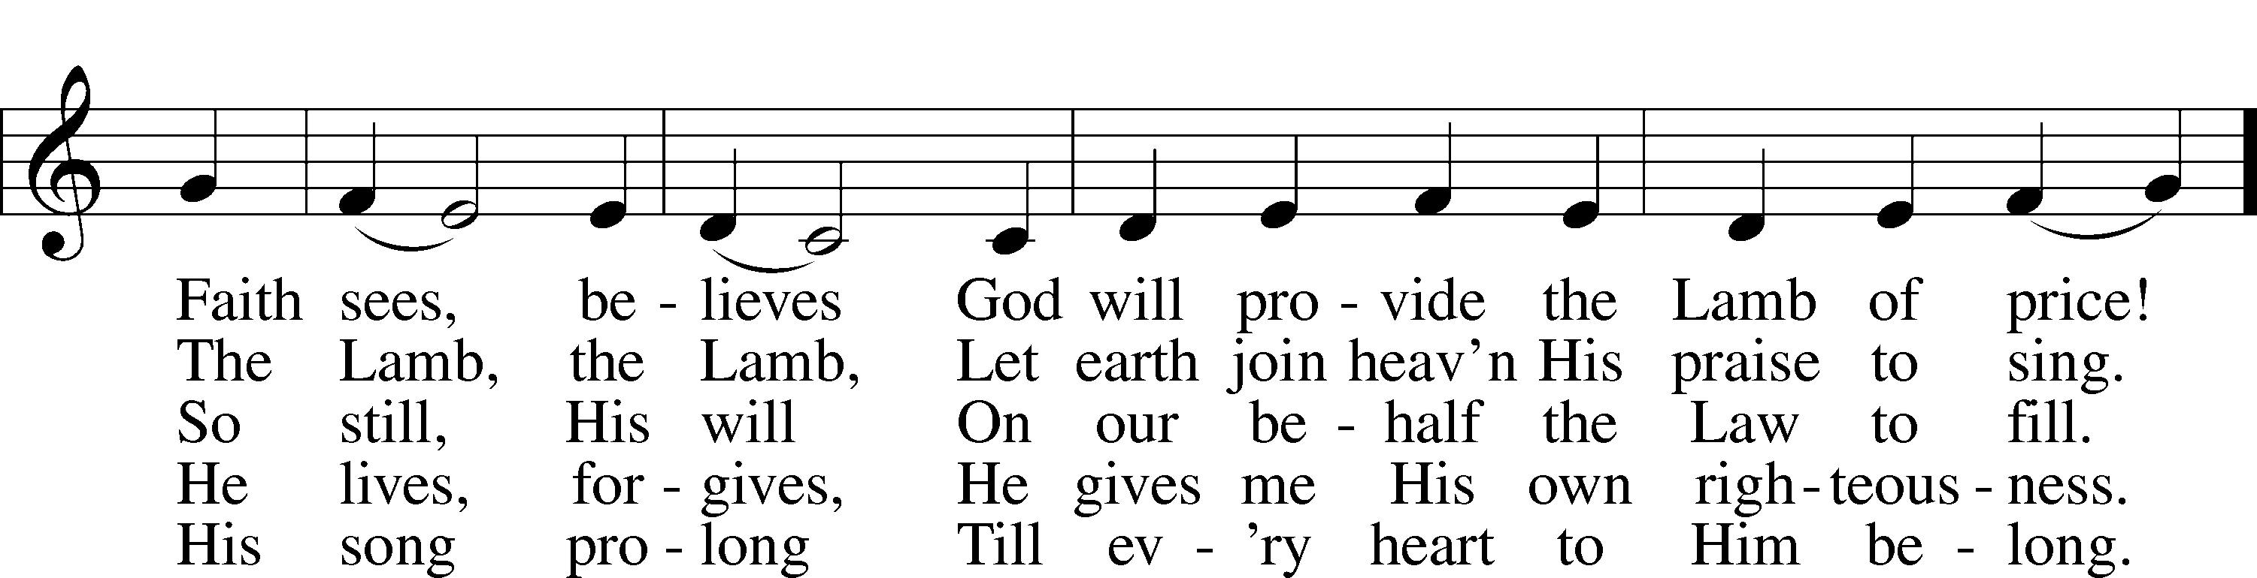

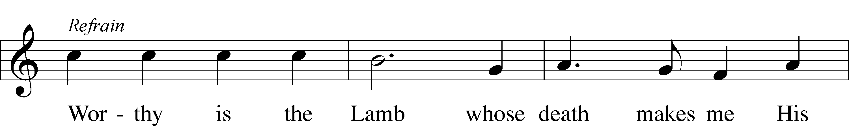



Text and tune: Gerald P. Coleman, 1953–2023  
Text and tune: © 1987 and 1997 MorningStar Music Publishers. Used by permission: LSB Hymn License no. 110005011

680 Thine the Amen, Thine the Praise

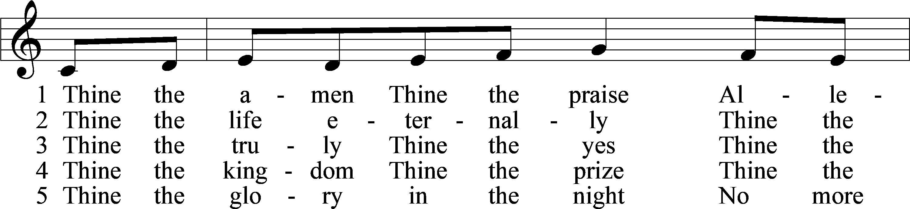

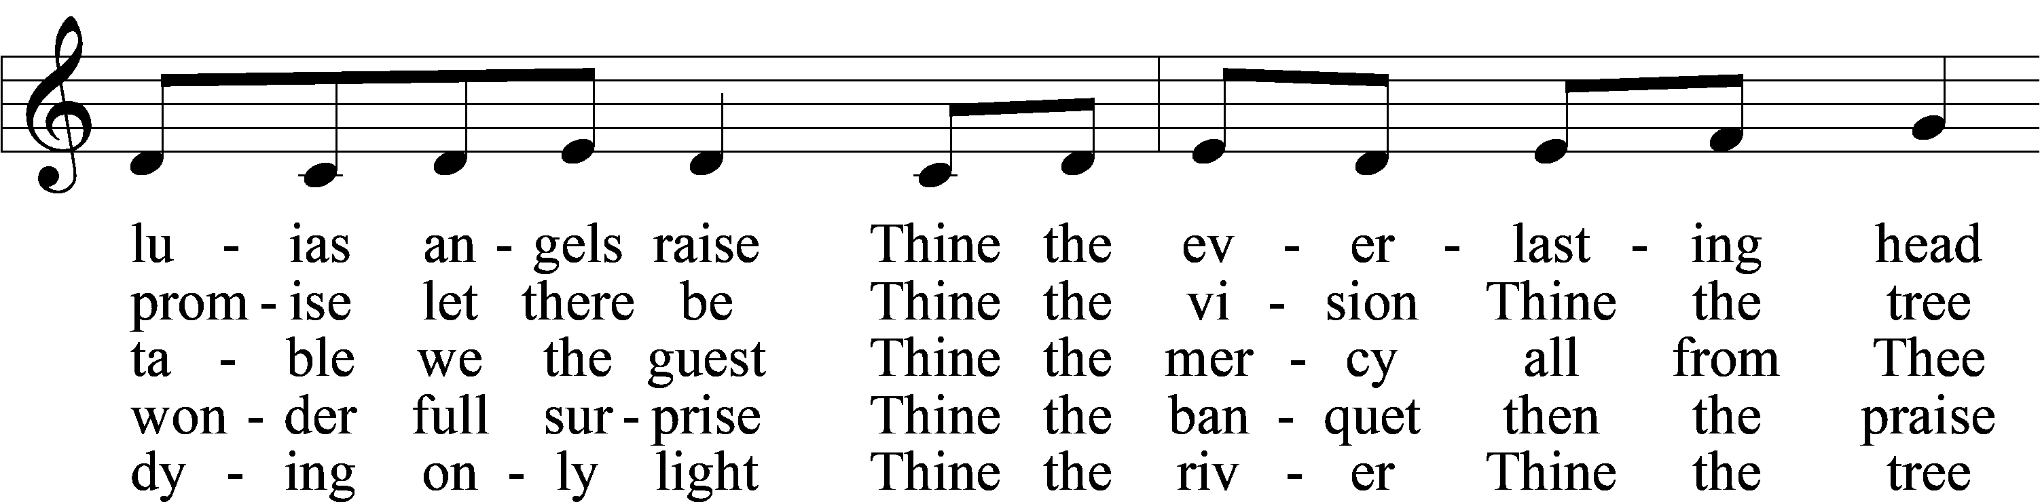

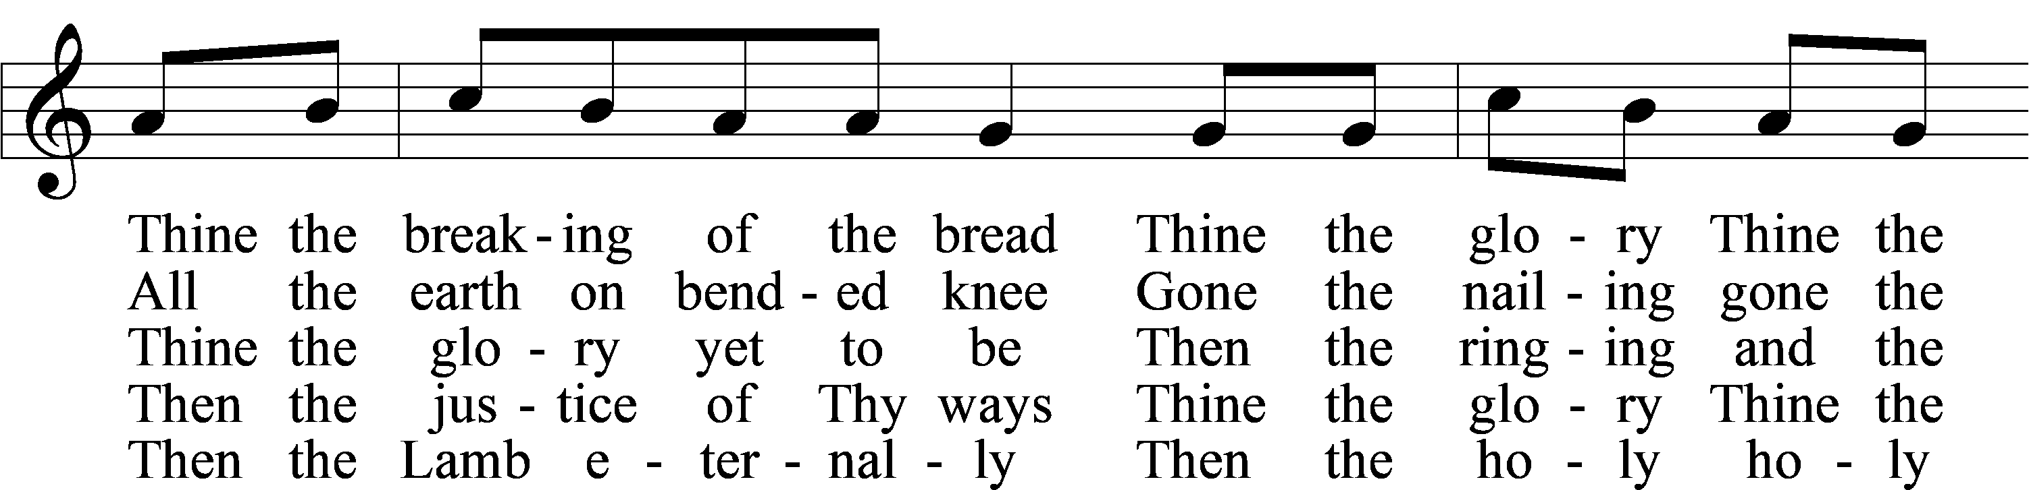

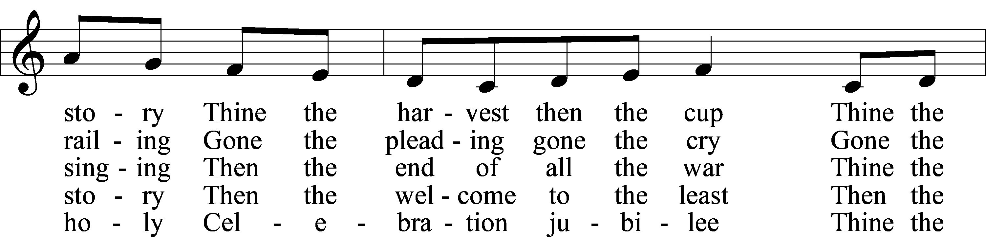

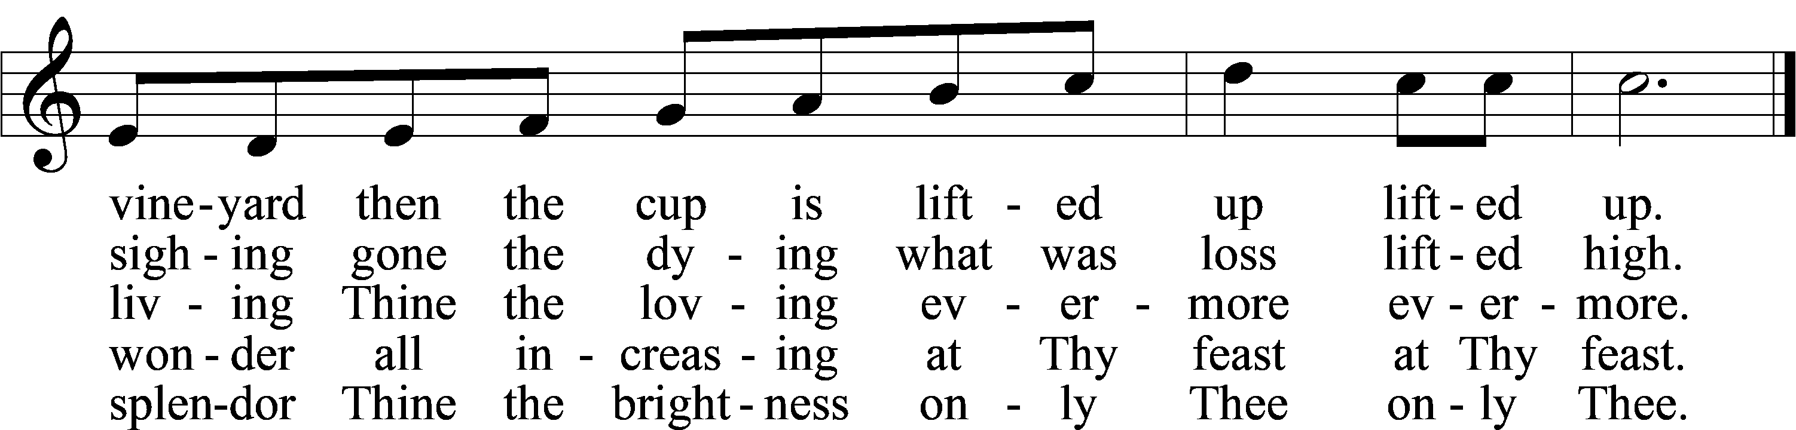

Text: Herbert F. Brokering, 1926–2009  
Tune: Carl F. Schalk, 1929–2021  
Text and tune: © 1983 Augsburg Publishing House. Used by permission: LSB Hymn License no. 110005011

Stand

Nunc Dimittis Luke 2:29–32

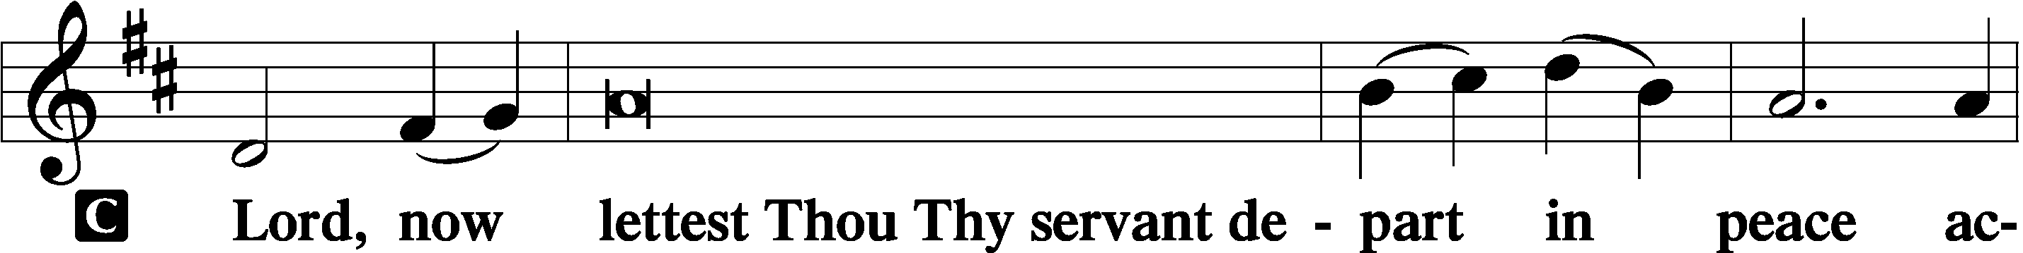

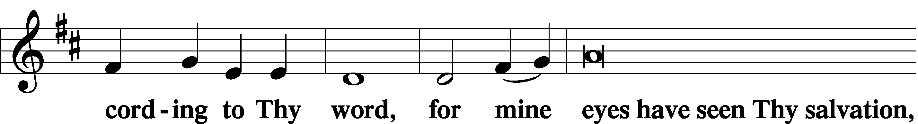

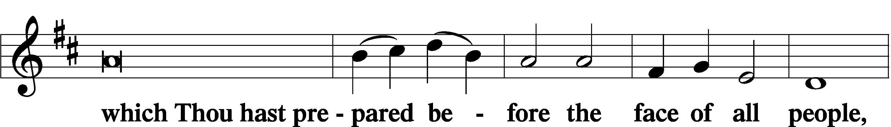

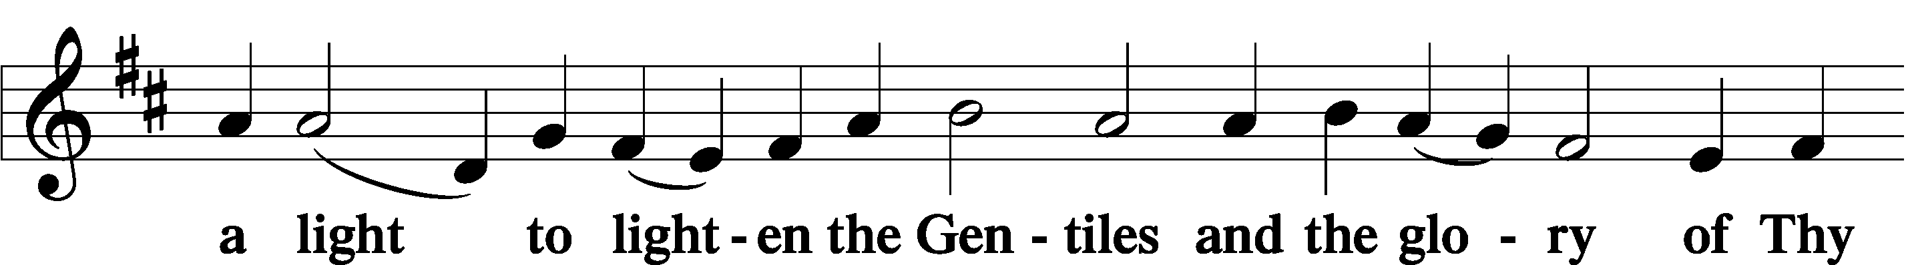

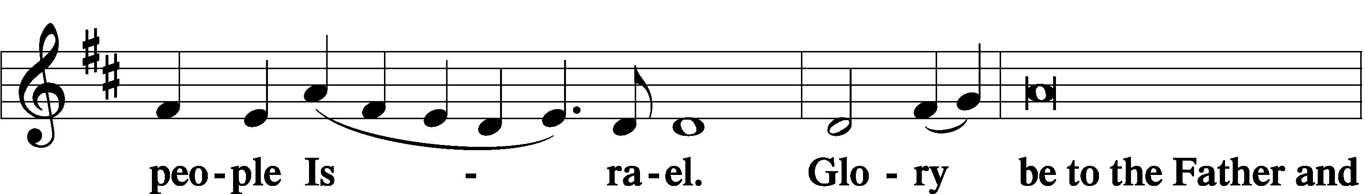

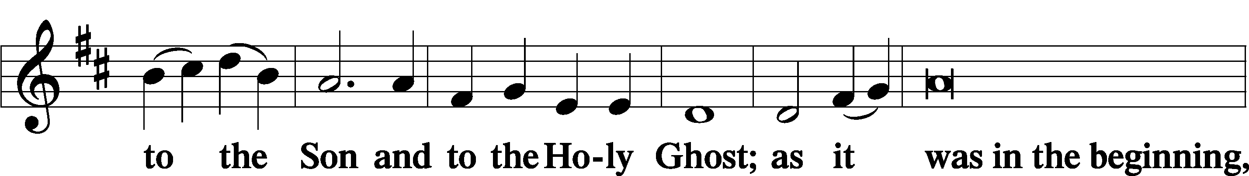

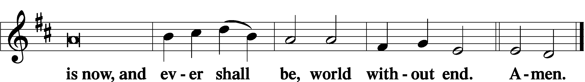

Thanksgiving Psalm 107:1

A O give thanks unto the Lord, for He is good,

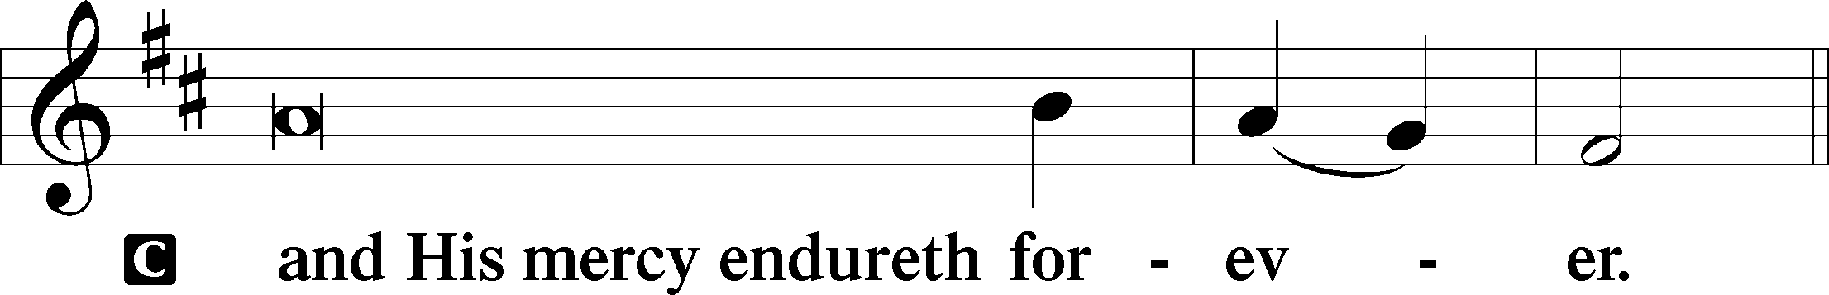

Post-Communion Collect

A Let us pray.

We give thanks to You, almighty God, that You have refreshed us through this salutary gift, and we implore You that of Your mercy You would strengthen us through the same in faith toward You and in fervent love toward one another; through Jesus Christ, Your Son, our Lord, who lives and reigns with You and the Holy Spirit, one God, now and forever.

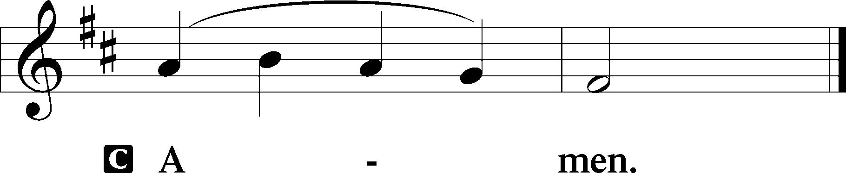

Salutation 2 Timothy 4:22

P The Lord be with you.

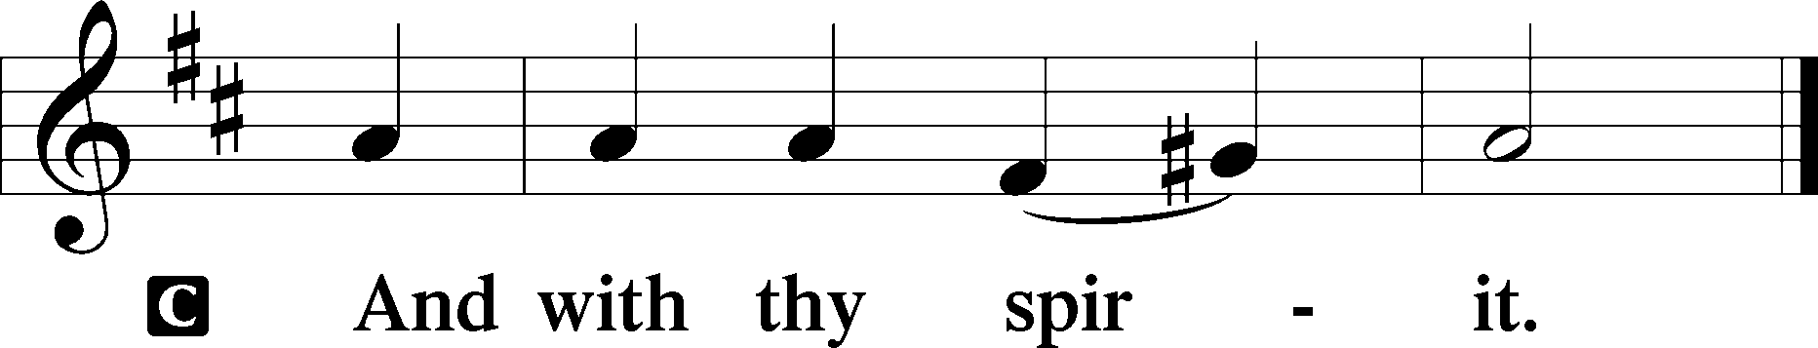

Benedicamus Psalm 103:1

A Bless we the Lord.

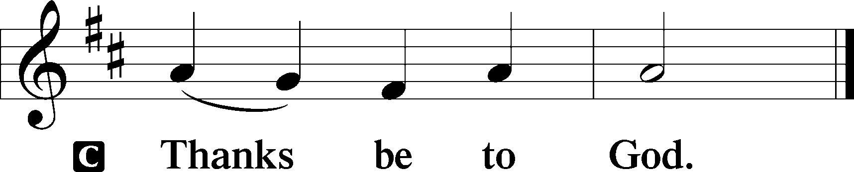

Benediction Numbers 6:24–26

P The Lord bless you and keep you.

The Lord make His face shine upon you and be gracious unto you.

The Lord lift up His countenance upon you and T give you peace.

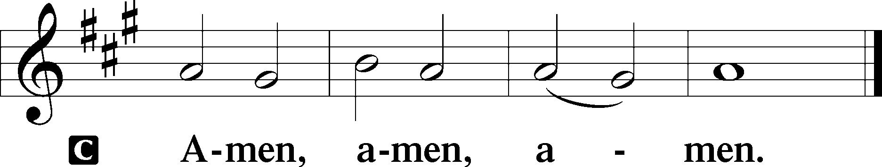

818 In Thee Is Gladness

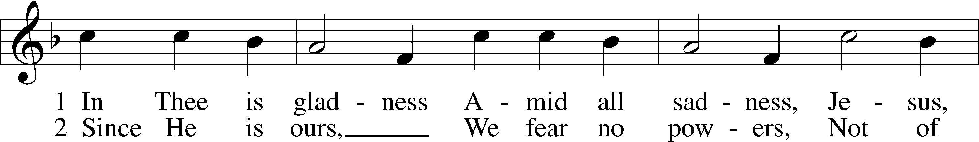

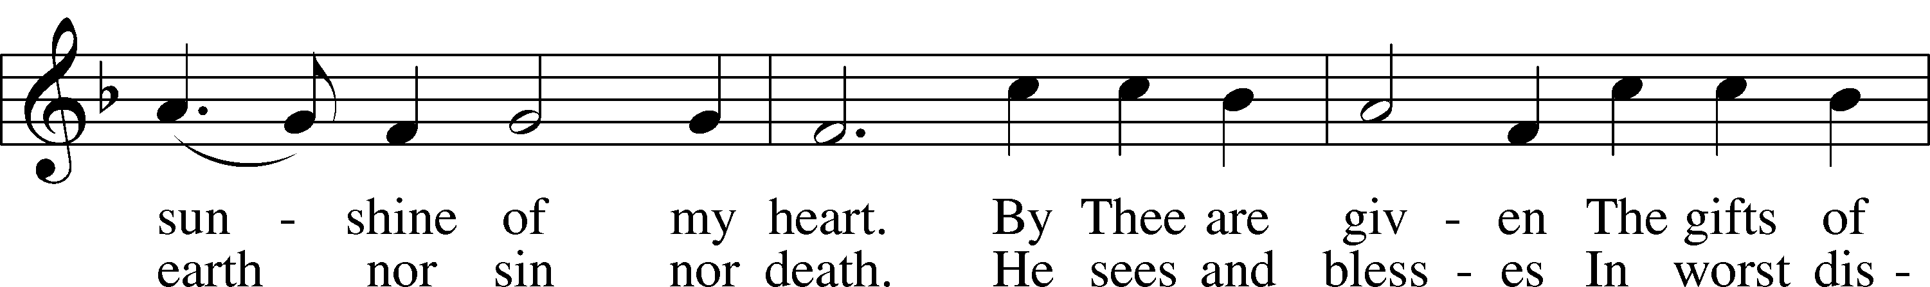

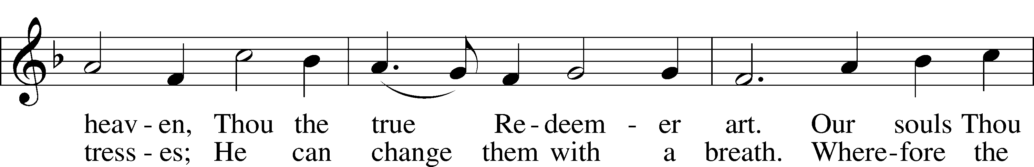

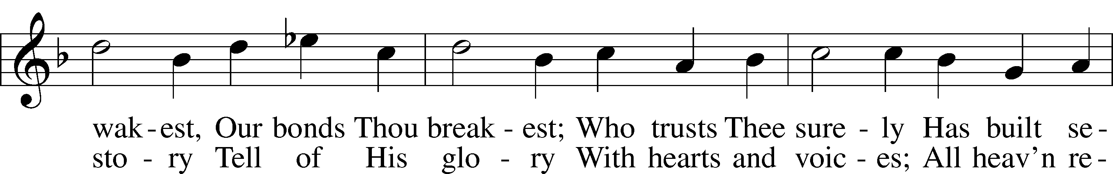

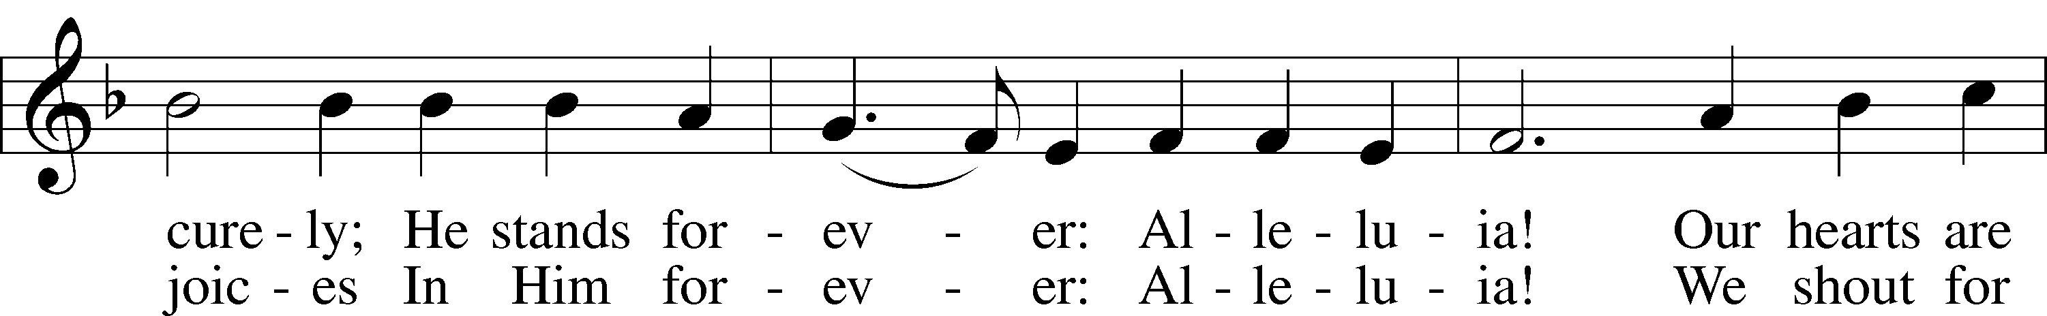

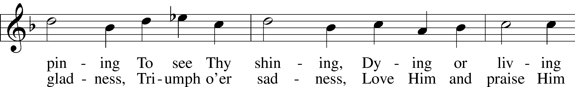

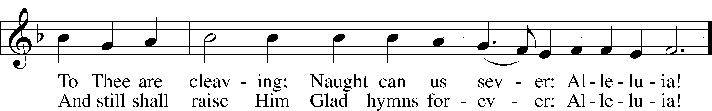

Text: Johann Lindemann, 1549–1631; tr. Catherine Winkworth, 1827–78, alt.  
Tune: Giovanni Giacomo Gastoldi, c. 1556–c. 1622  
Text and tune: Public domain

Acknowledgments

Divine Service, Setting Three from Lutheran Service Book

Unless otherwise indicated, Scripture quotations are from the ESV® Bible (The Holy Bible, English Standard Version®), copyright © 2001 by Crossway, a publishing ministry of Good News Publishers. Used by permission. All rights reserved.

Created by Lutheran Service Builder © 2025 Concordia Publishing House.