On entering the church

P Lord, I love the habitation of Your house and the place
where Your glory dwells. In the multitude of Your tender
mercies prepare my heart that I may enter Your house to
worship and confess Your holy name; through Jesus Christ,
my God and Lord.

Before worship

C O Lord, our creator, redeemer, and comforter, as we come
together to worship You in spirit and in truth, we humbly
pray that You would open our hearts to the preaching of
Your Word so that we may repent of our sins, believe in
Jesus Christ as our only Savior, and grow in grace and
holiness. Hear us for His sake.

562 All Mankind Fell in Adam’s Fall
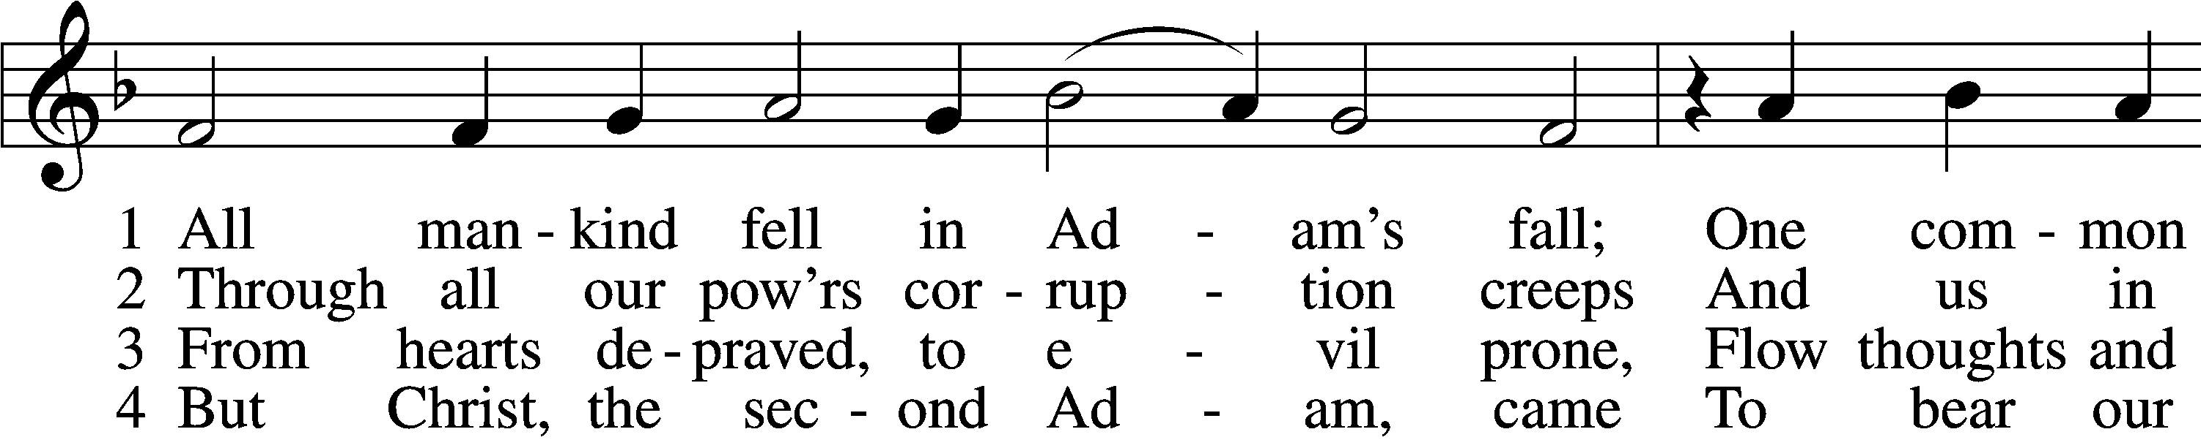
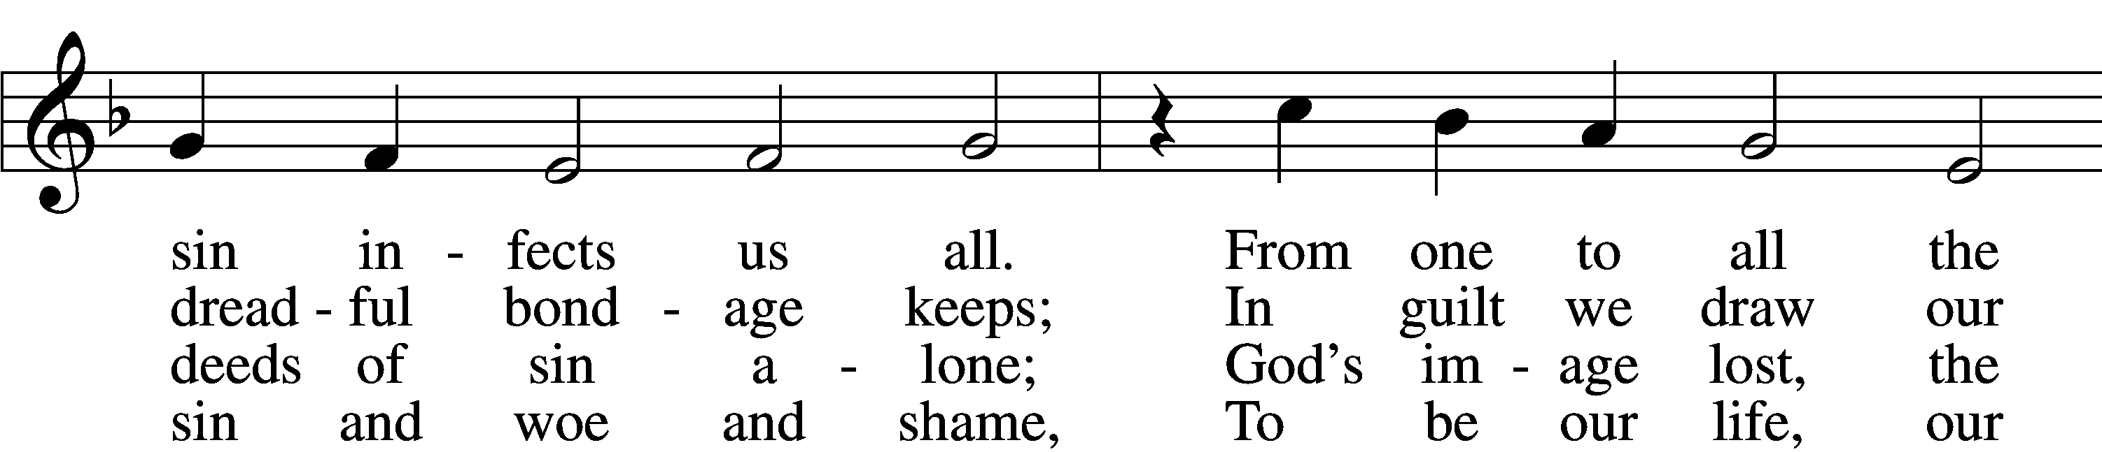
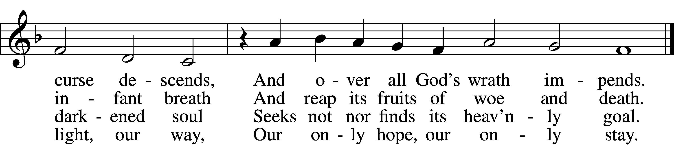

5 As by one man all mankind fell
And, born in sin, was doomed to hell,
So by one Man, who took our place,
We all were justified by grace.

6 We thank You, Christ; new life is ours,
New light, new hope, new strength, new pow’rs.
This grace our ev’ry way attend
Until we reach our journey’s end.
Text: Lazarus Spengler, 1479–1534; tr. Matthias Loy, 1828–1915, alt.
Tune: Louis Bourgeois, c. 1510–61
Text and tune: Public domain

Confession and Absolution

The sign of the cross may be made by all in remembrance of their Baptism.

Invocation Matthew 28:19b; 18:20
P In the name of the Father and of the T Son and of the Holy Spirit.
C Amen.

Exhortation Hebrews 10:22; Psalm 124:8; Psalm 32:5
P Beloved in the Lord! Let us draw near with a true heart and confess our sins unto God our Father, beseeching Him in the name of our Lord Jesus Christ to grant us forgiveness.

P Our help is in the name of the Lord,
C who made heaven and earth.
P I said, I will confess my transgressions unto the Lord,
C and You forgave the iniquity of my sin.

Silence for reflection on God’s Word and for self-examination.

Confession of Sins
P Almighty God, our maker and redeemer, we poor sinners confess unto You that we are by nature sinful and unclean and that we have sinned against You by thought, word, and deed. Wherefore we flee for refuge to Your infinite mercy, seeking and imploring Your grace for the sake of our Lord Jesus Christ.
C O most merciful God, who has given Your only-begotten Son to die for us, have mercy upon us and for His sake grant us remission of all our sins; and by Your Holy Spirit increase in us true knowledge of You and of Your will and true obedience to Your Word, to the end that by Your grace we may come to everlasting life; through Jesus Christ, our Lord. Amen.

Declaration of Grace Mark 16:16; John 1:12
P Almighty God, our heavenly Father, has had mercy upon us and has given His only Son to die for us and for His sake forgives us all our sins. To those who believe on His name He gives power to become the children of God and has promised them His Holy Spirit. He that believes and is baptized shall be saved.
Grant this, Lord, unto us all.
C Amen.

Service of the Word

Introit Psalm 34:1–2, 11, 22; antiphon: Psalm 119:46
I will speak of your testimonies before kings, [O Lord,]
and shall not be put to shame.
I will bless the Lord at all times;
his praise shall continually be in my mouth.
My soul makes its boast in the Lord;
let the humble hear and be glad.
Come, O children, listen to me;
I will teach you the fear of the Lord.
The Lord redeems the life of his servants;
none of those who take refuge in him will be condemned.
Gloria Patri
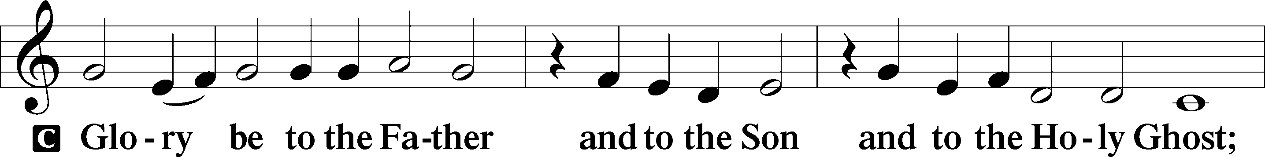
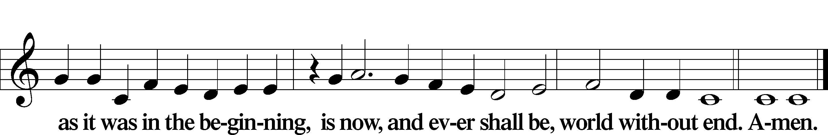

Kyrie Mark 10:47
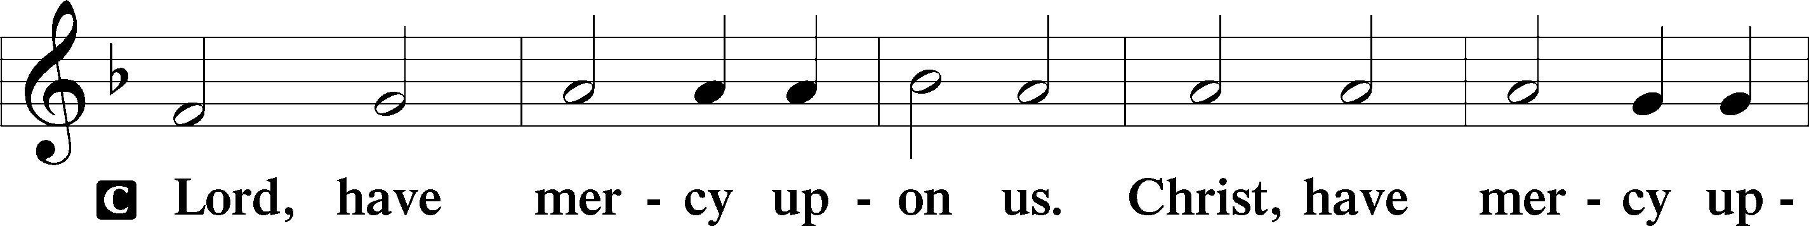
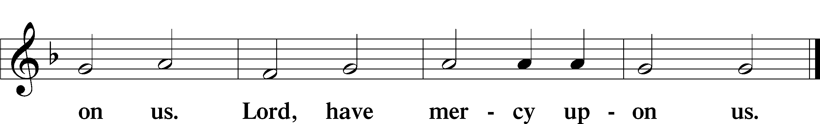

Gloria in Excelsis Luke 2:14; John 1:29
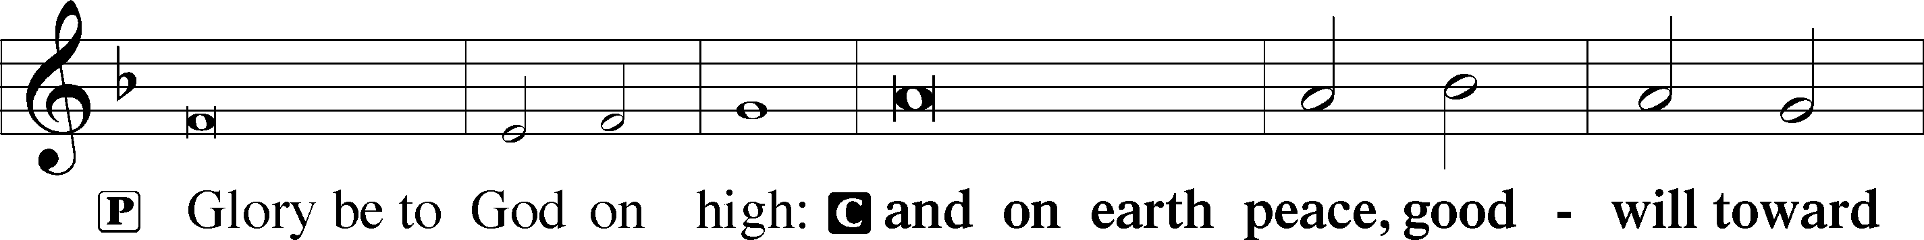
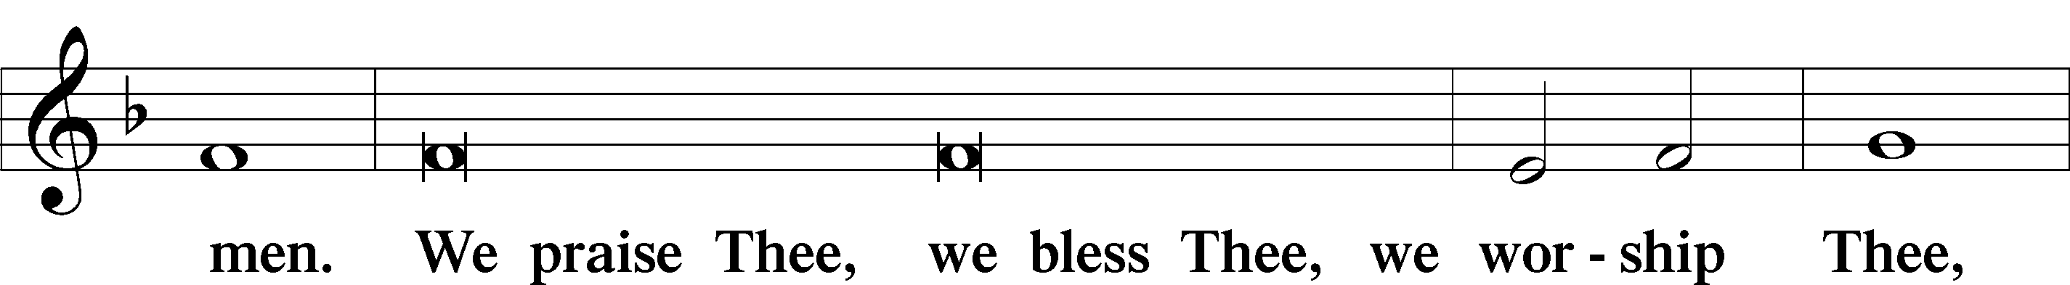
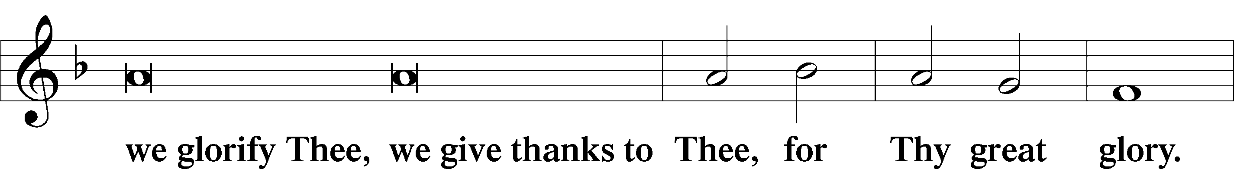
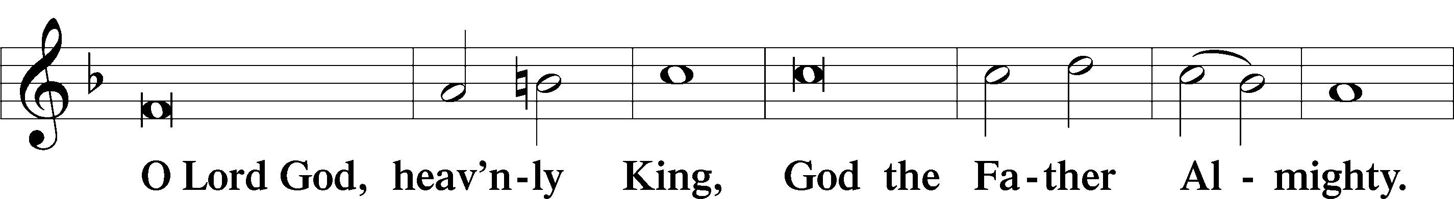
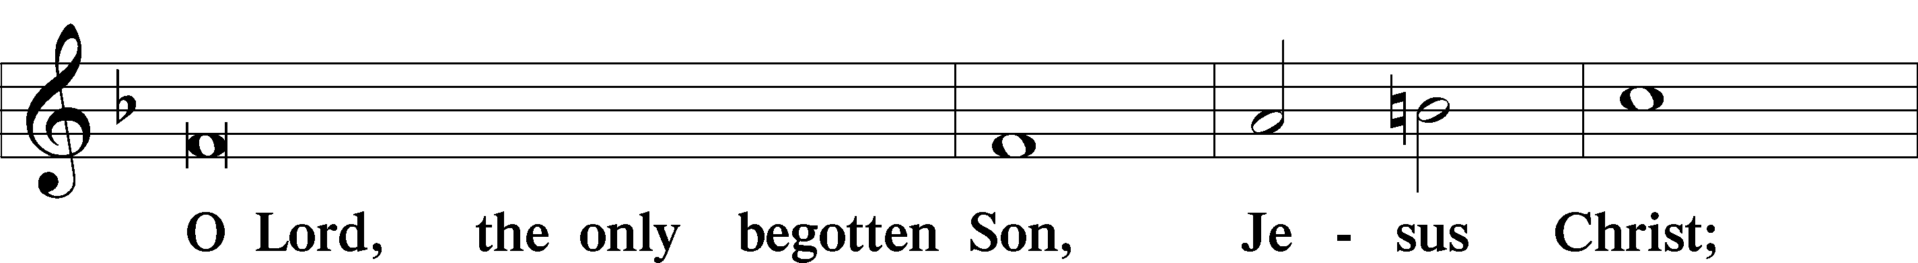
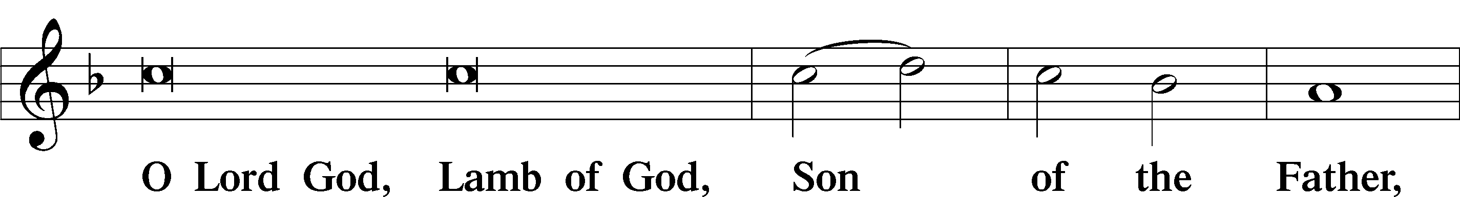
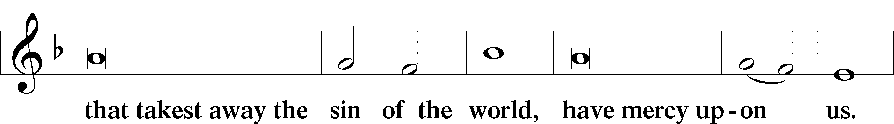
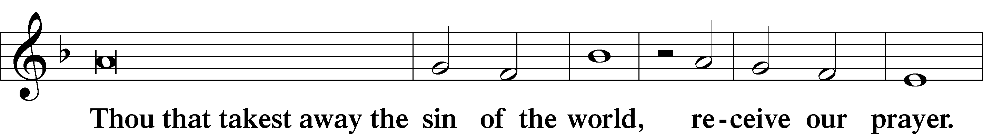
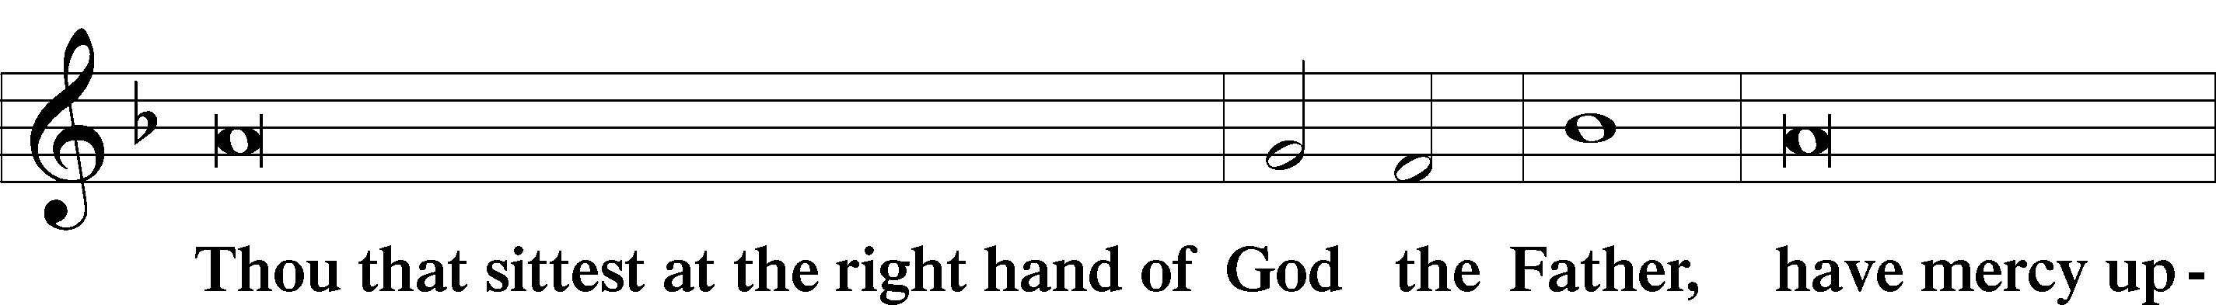
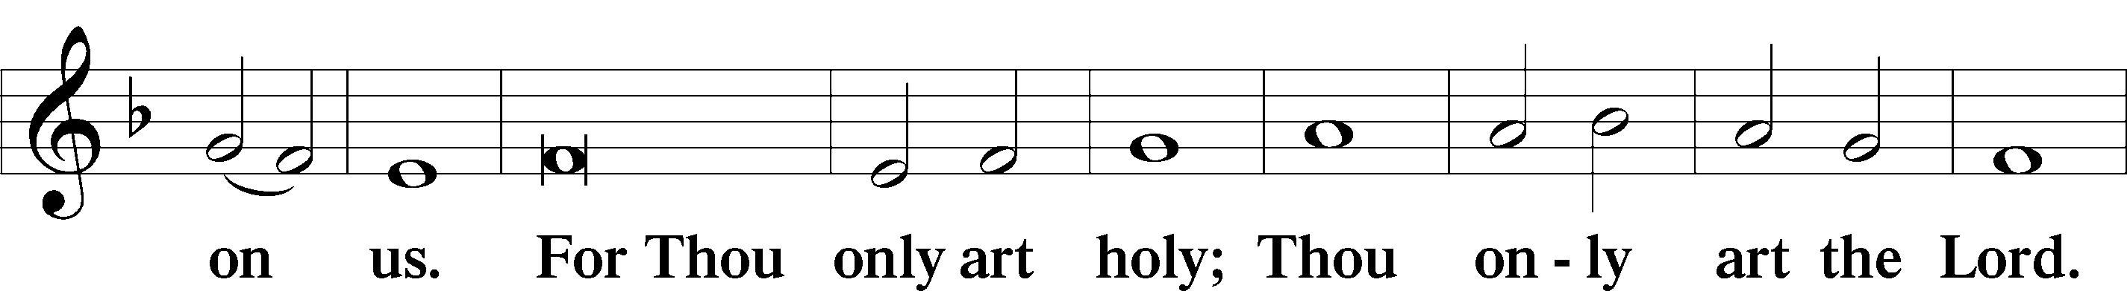
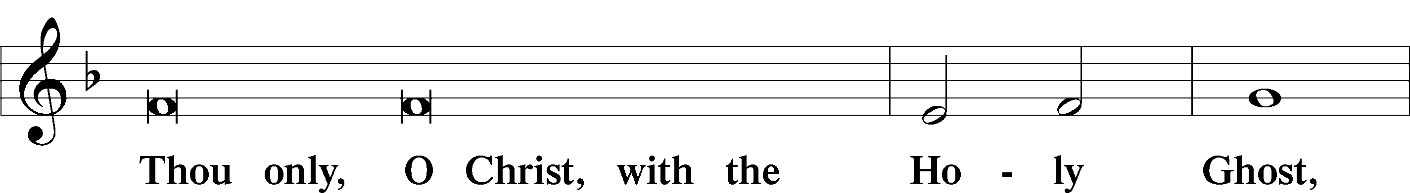
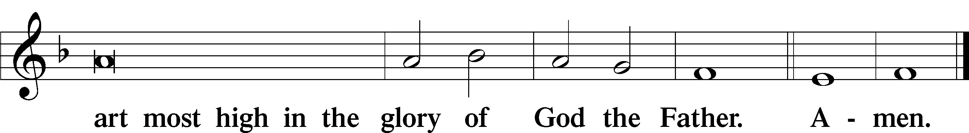

Salutation and Collect of the Day
P The Lord be with you.
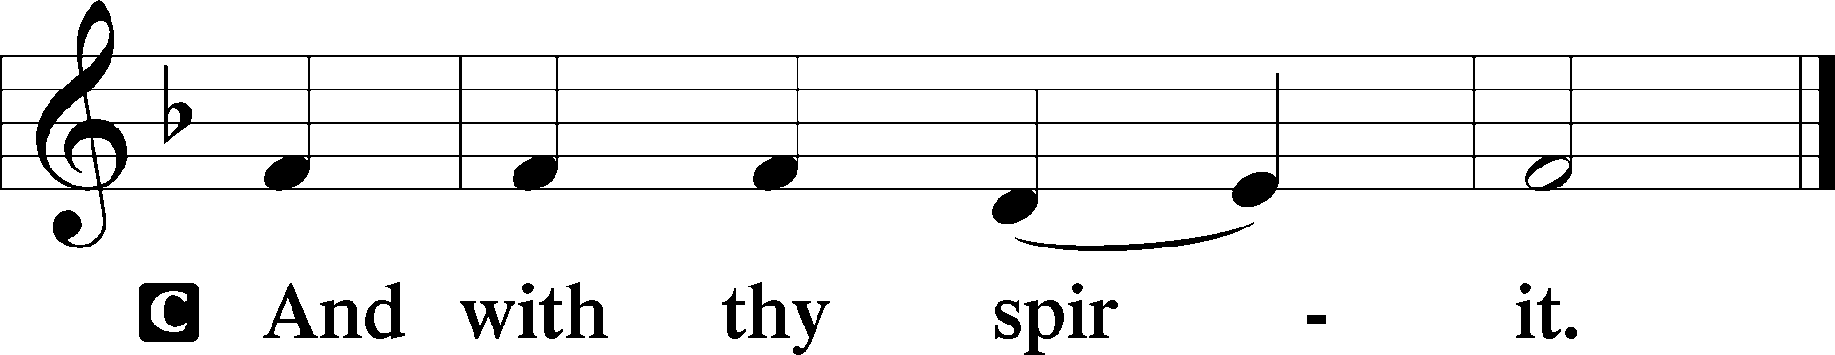

P Let us pray.
Almighty and gracious Lord, pour out Your Holy Spirit on Your faithful people. Keep us steadfast in Your grace and truth, protect and deliver us in times of temptation, defend us against all enemies, and grant to Your Church Your saving peace; through Jesus Christ, Your Son, our Lord, who lives and reigns with You and the Holy Spirit, one God, now and forever.

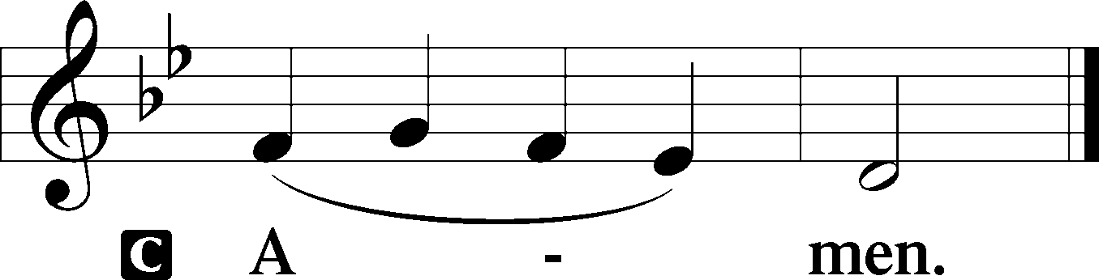

Sit

First Reading Revelation 14:6–7
6Then I saw another angel flying directly overhead, with an eternal gospel to proclaim to those who dwell on earth, to every nation and tribe and language and people. 7And he said with a loud voice, “Fear God and give him glory, because the hour of his judgment has come, and worship him who made heaven and earth, the sea and the springs of water.”

A This is the Word of the Lord.
C Thanks be to God.

Gradual Psalm 48:1a, 12–14a
Great is the Lord and greatly to be praised
in the city of our God!
Walk about Zion, go around her, number her towers,
consider well her ramparts, go through her citadels,
that you may tell the next generation
that this is God, our God forever and ever.

Epistle Romans 3:19–28
19Now we know that whatever the law says it speaks to those who are under the law, so that every mouth may be stopped, and the whole world may be held accountable to God. 20For by works of the law no human being will be justified in his sight, since through the law comes knowledge of sin.
21But now the righteousness of God has been manifested apart from the law, although the Law and the Prophets bear witness to it— 22the righteousness of God through faith in Jesus Christ for all who believe. For there is no distinction: 23for all have sinned and fall short of the glory of God, 24and are justified by his grace as a gift, through the redemption that is in Christ Jesus, 25whom God put forward as a propitiation by his blood, to be received by faith. This was to show God’s righteousness, because in his divine forbearance he had passed over former sins. 26It was to show his righteousness at the present time, so that he might be just and the justifier of the one who has faith in Jesus.
27Then what becomes of our boasting? It is excluded. By what kind of law? By a law of works? No, but by the law of faith. 28For we hold that one is justified by faith apart from works of the law.

Stand

Alleluia
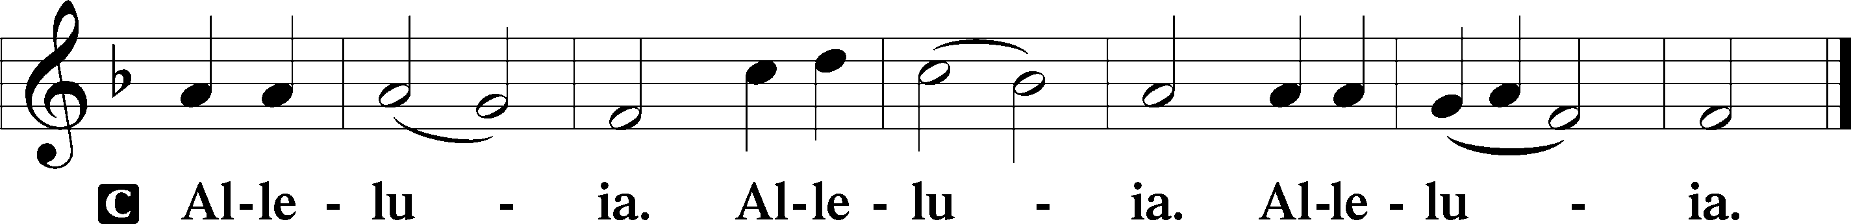

Holy Gospel John 8:31–36
P The Holy Gospel according to St. John, the eighth chapter.

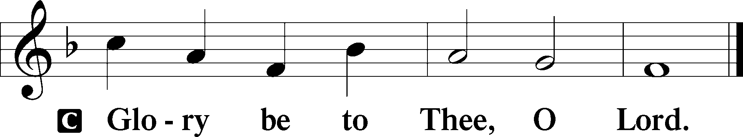

31So Jesus said to the Jews who had believed in him, “If you abide in my word, you are truly my disciples, 32and you will know the truth, and the truth will set you free.” 33They answered him, “We are offspring of Abraham and have never been enslaved to anyone. How is it that you say, ‘You will become free’?”
34Jesus answered them, “Truly, truly, I say to you, everyone who commits sin is a slave to sin. 35The slave does not remain in the house forever; the son remains forever. 36So if the Son sets you free, you will be free indeed.”

P This is the Gospel of the Lord.

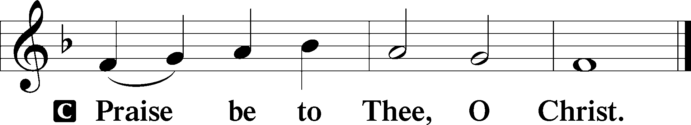

Apostles’ Creed
C I believe in God, the Father Almighty,
maker of heaven and earth.

And in Jesus Christ, His only Son, our Lord,
who was conceived by the Holy Spirit,
born of the virgin Mary,
suffered under Pontius Pilate,
was crucified, died and was buried.
He descended into hell.
The third day He rose again from the dead.
He ascended into heaven
and sits at the right hand of God the Father Almighty.
From thence He will come to judge the living and the dead.

I believe in the Holy Spirit,
the holy Christian Church,
the communion of saints,
the forgiveness of sins,
the resurrection of the body,
and the life T everlasting. Amen.

Sit

Children's Sermon

656 A Mighty Fortress Is Our God
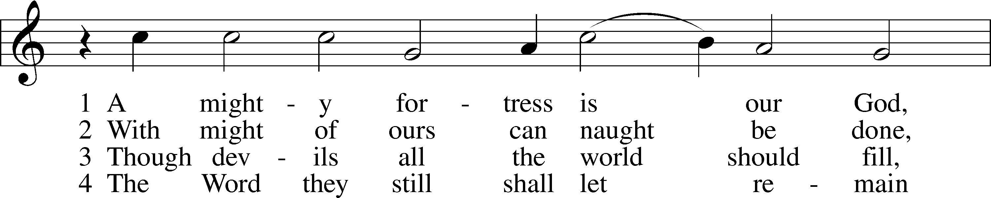
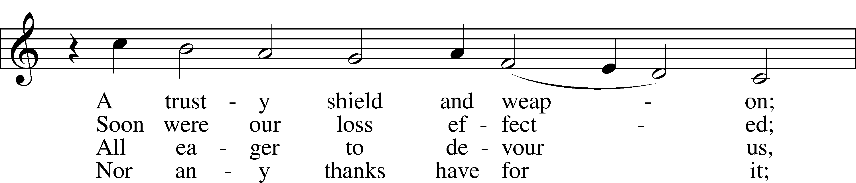
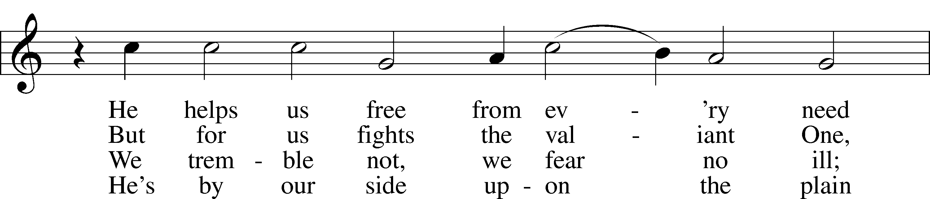
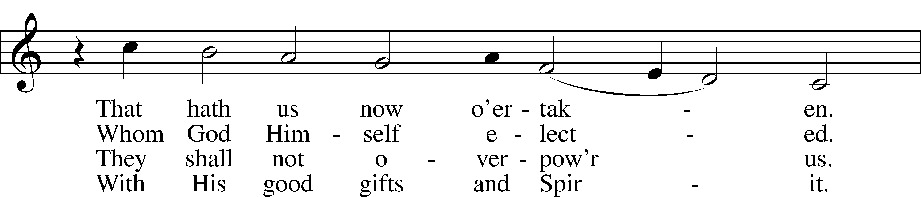
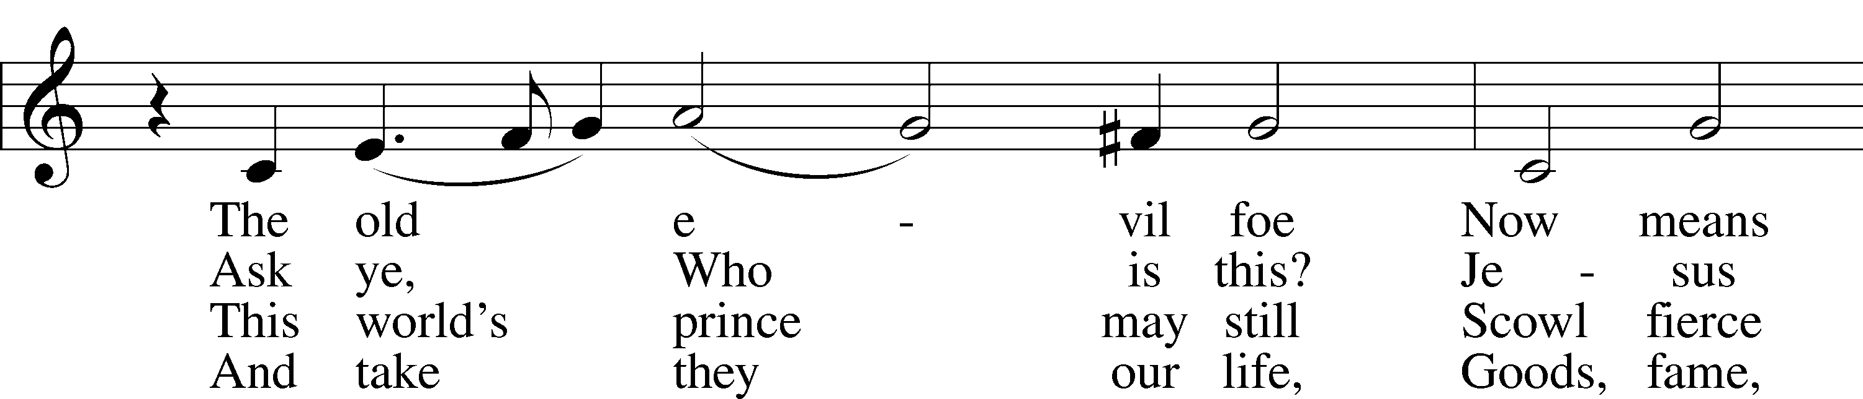
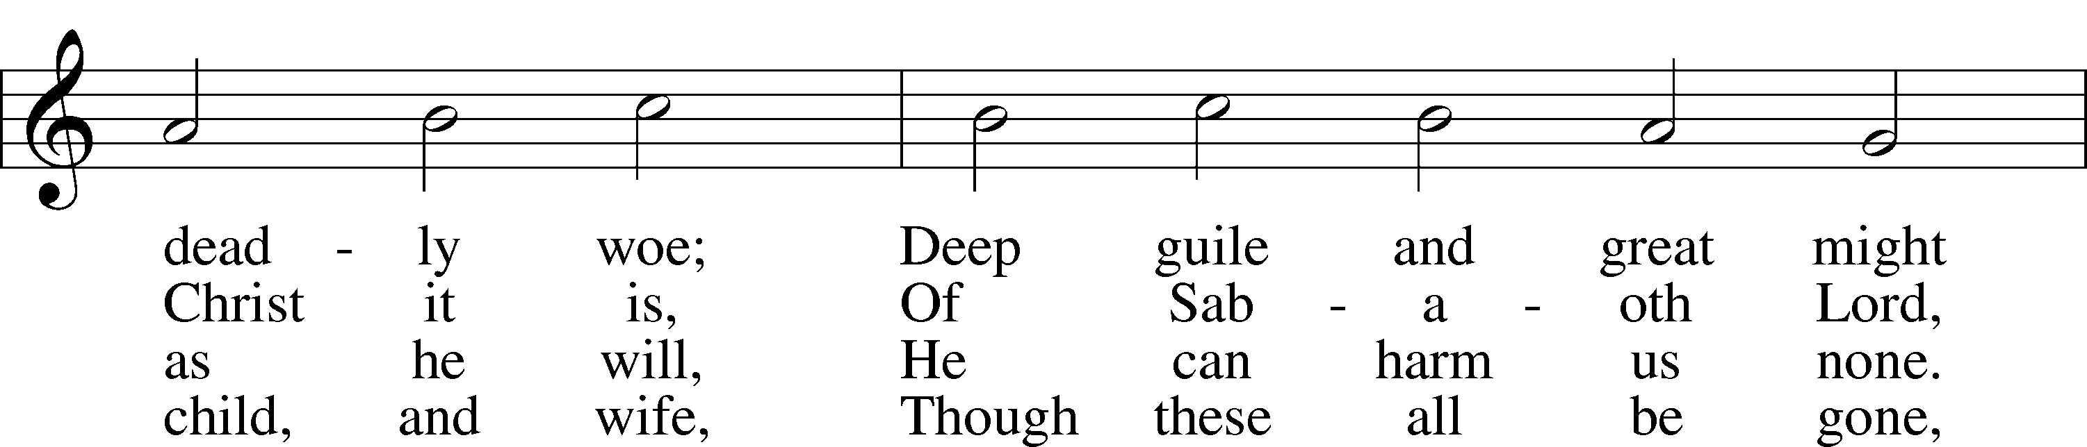
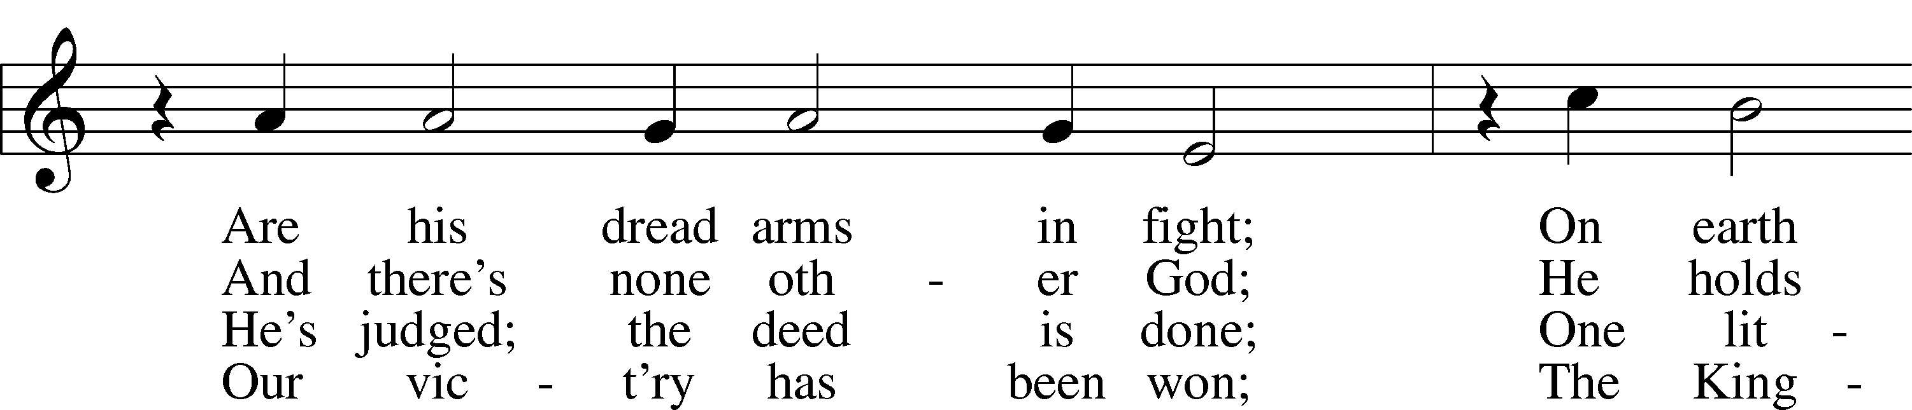
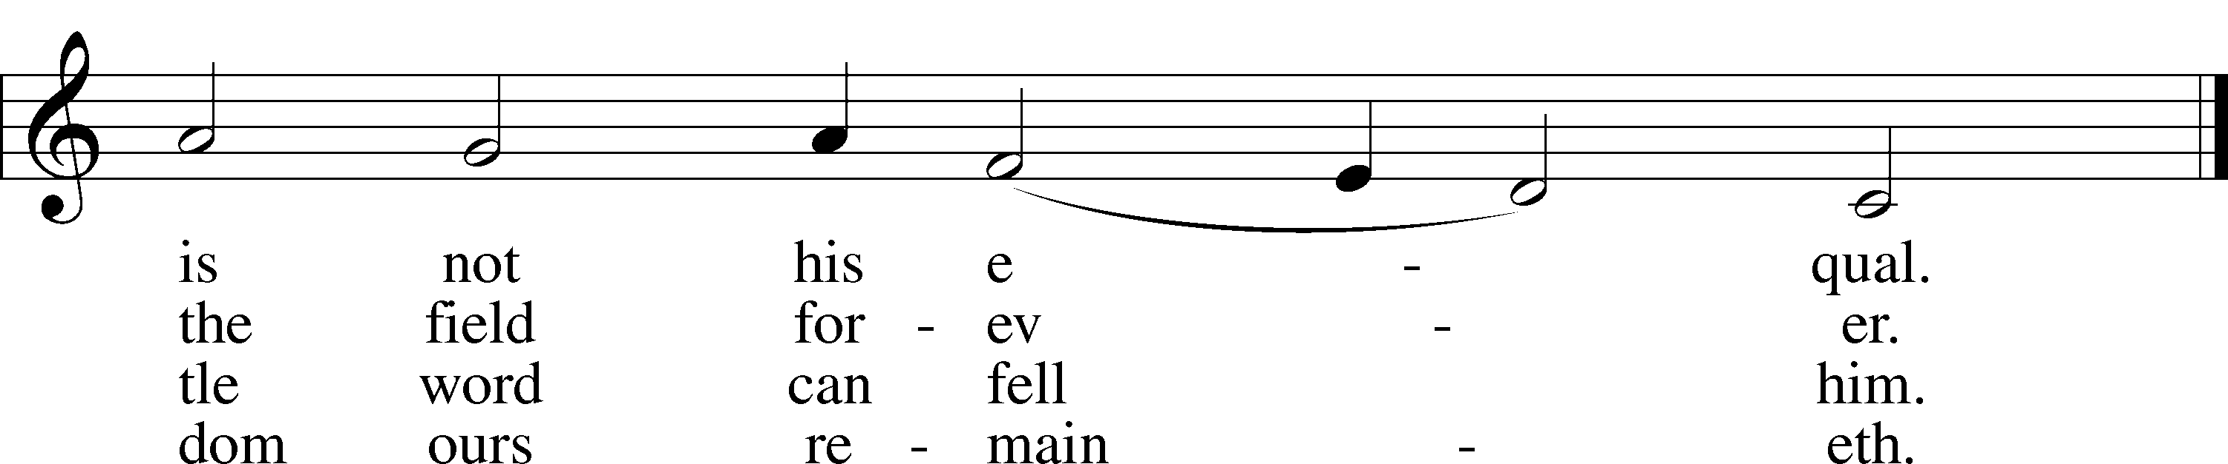
Text: tr. composite
Text and tune: Martin Luther, 1483–1546
Text and tune: Public domain

Sermon

Votum
P The peace of God, which passes all understanding, keep your hearts and minds in Christ Jesus.
C Amen.

Stand

Offertory Psalm 51:10–12
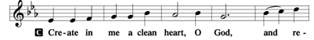

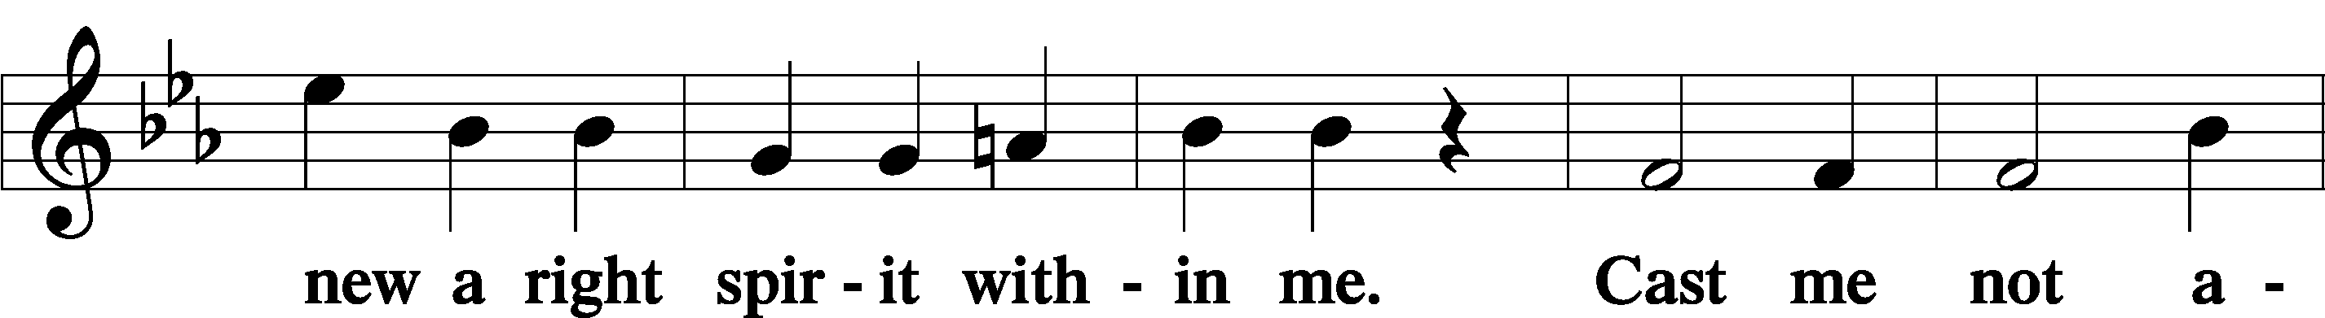
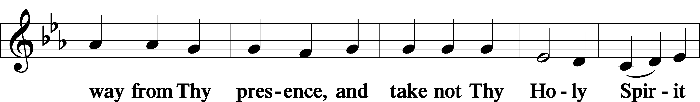
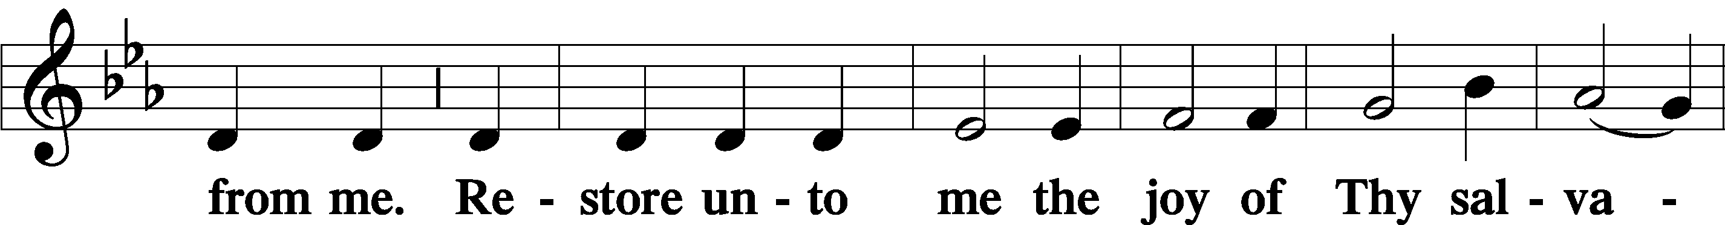
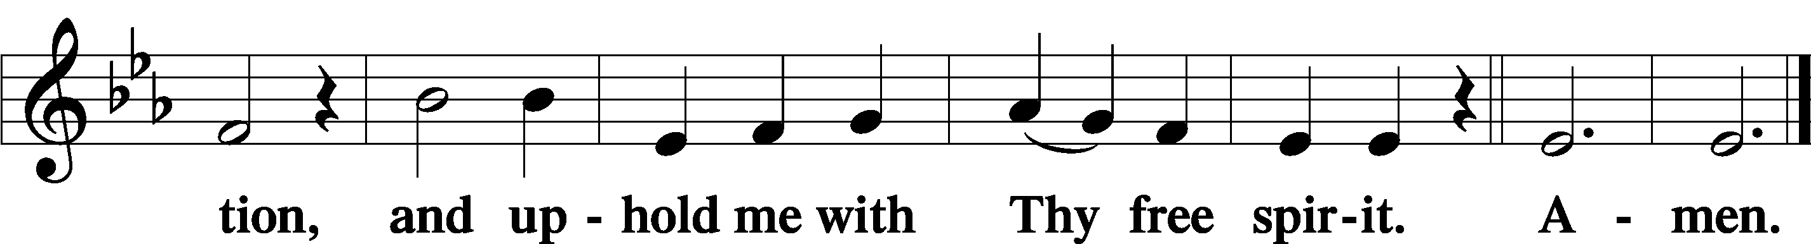

Offering

805 Praise God, from Whom All Blessings Flow
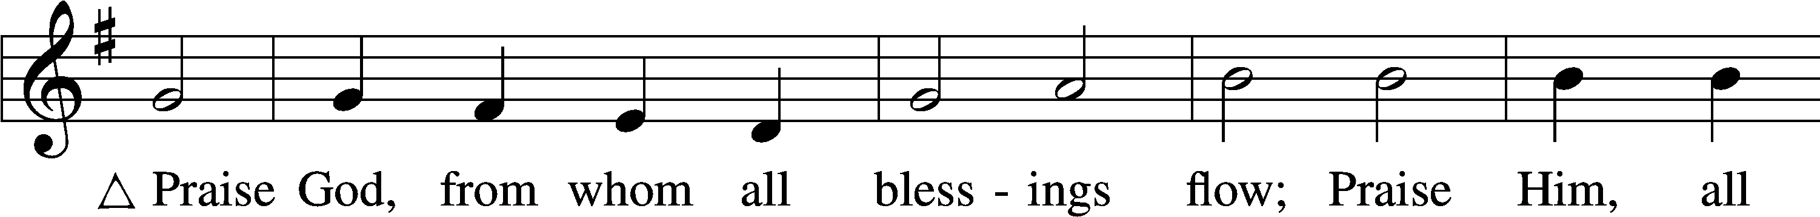
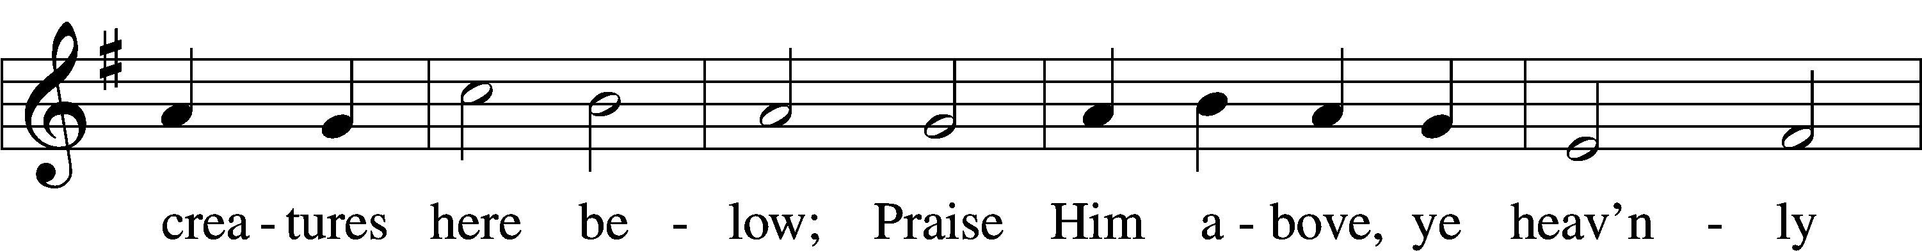
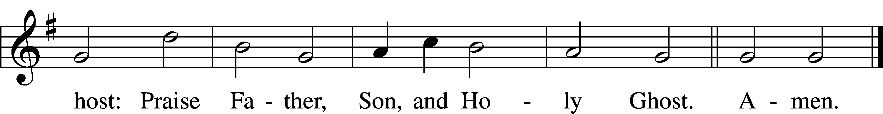
Text: Thomas Ken, 1637–1711
Tune: Trente quatre Pseaumes de David, 1551, Geneva, ed. Louis Bourgeois
Text and tune: Public domain

Prayer of the Church

Lord’s Prayer Matthew 6:9–13
P Lord, remember us in Your kingdom and teach us to pray:
C Our Father who art in heaven,
hallowed be Thy name,
Thy kingdom come,
Thy will be done on earth
as it is in heaven;
give us this day our daily bread;
and forgive us our trespasses
as we forgive those
who trespass against us;
and lead us not into temptation,
but deliver us from evil.
For Thine is the kingdom
and the power and the glory
forever and ever. Amen.

Collect for the Word

Blessed Lord, You have caused all Holy Scriptures to be written for our learning. Grant that we may so hear them, read, mark, learn, and inwardly digest them that, by the patience and comfort of Your holy Word, we may embrace and ever hold fast the blessed hope of everlasting life; through Jesus Christ, Your Son, our Lord, who lives and reigns with You and the Holy Spirit, one God, now and forever.

Benediction
P The Lord bless you and keep you.
The Lord make His face shine on you and be gracious to you.
The Lord look upon you with favor and T give you peace.
C Amen.

506 Glory Be to God the Father
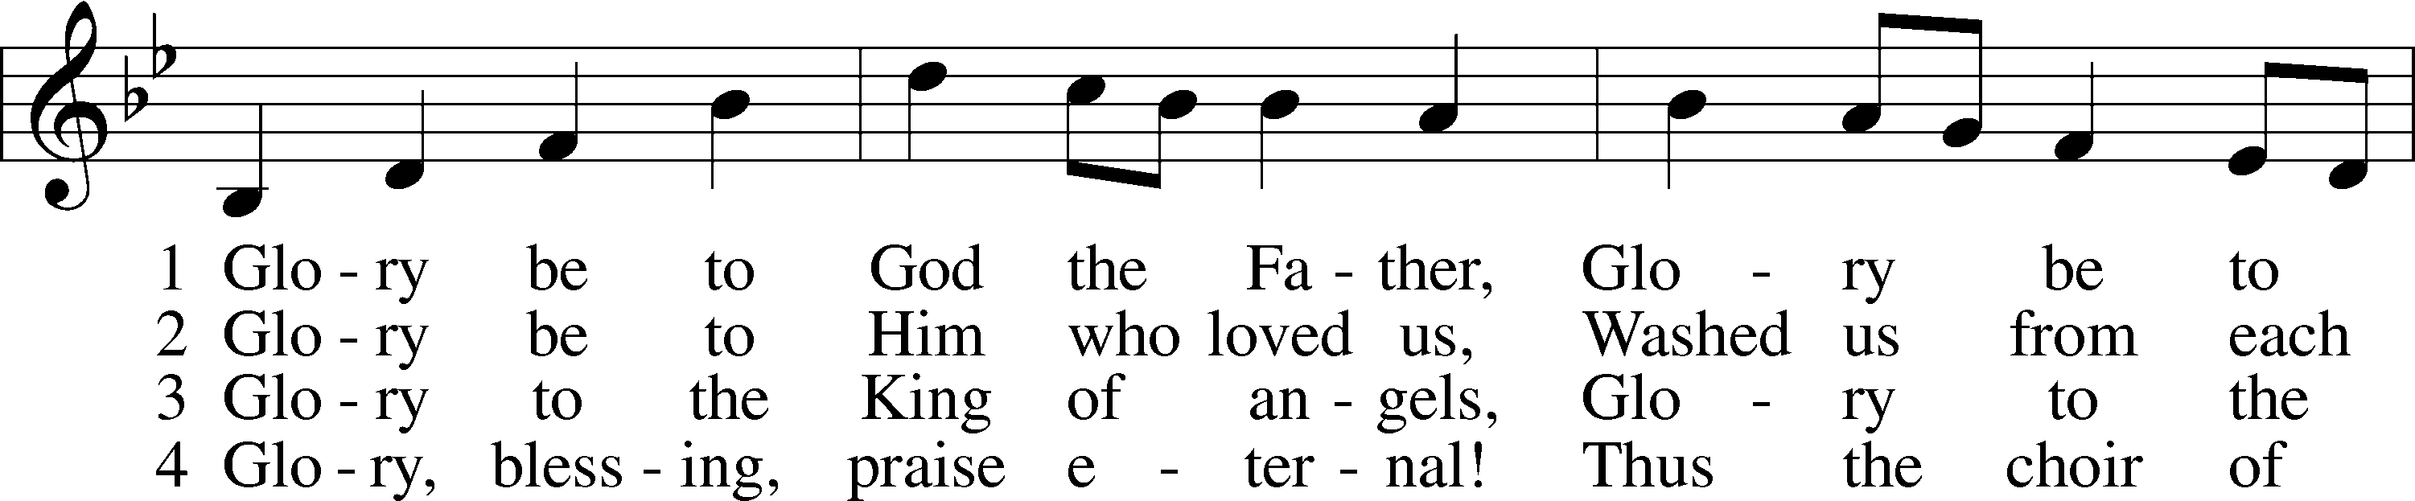
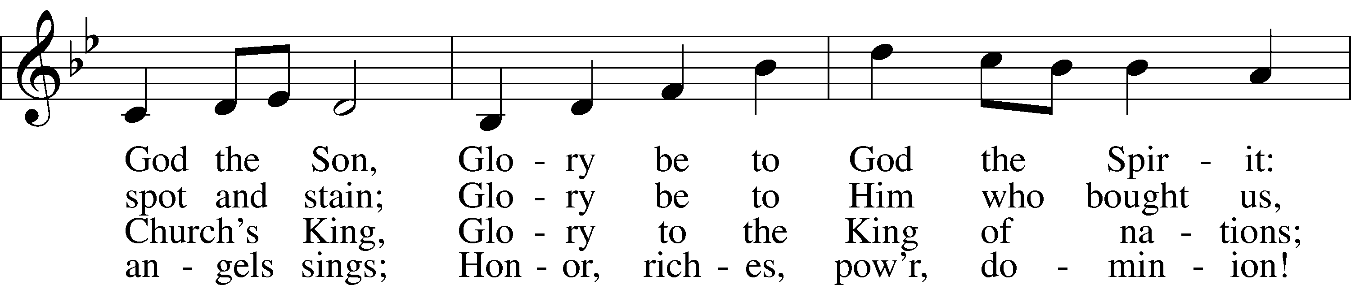
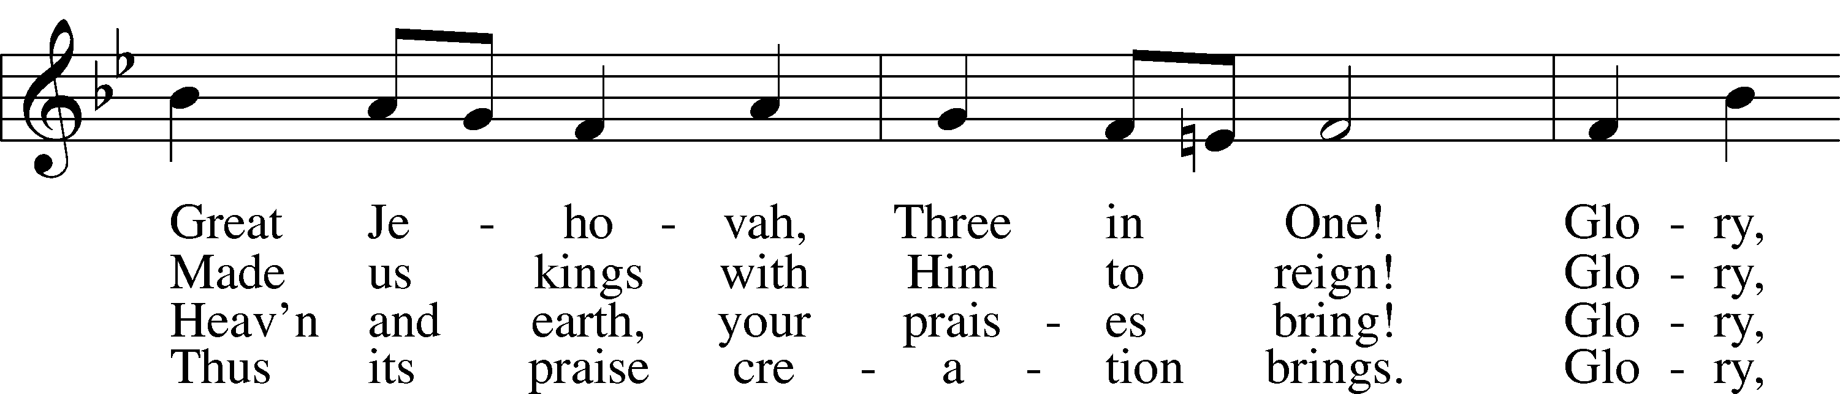
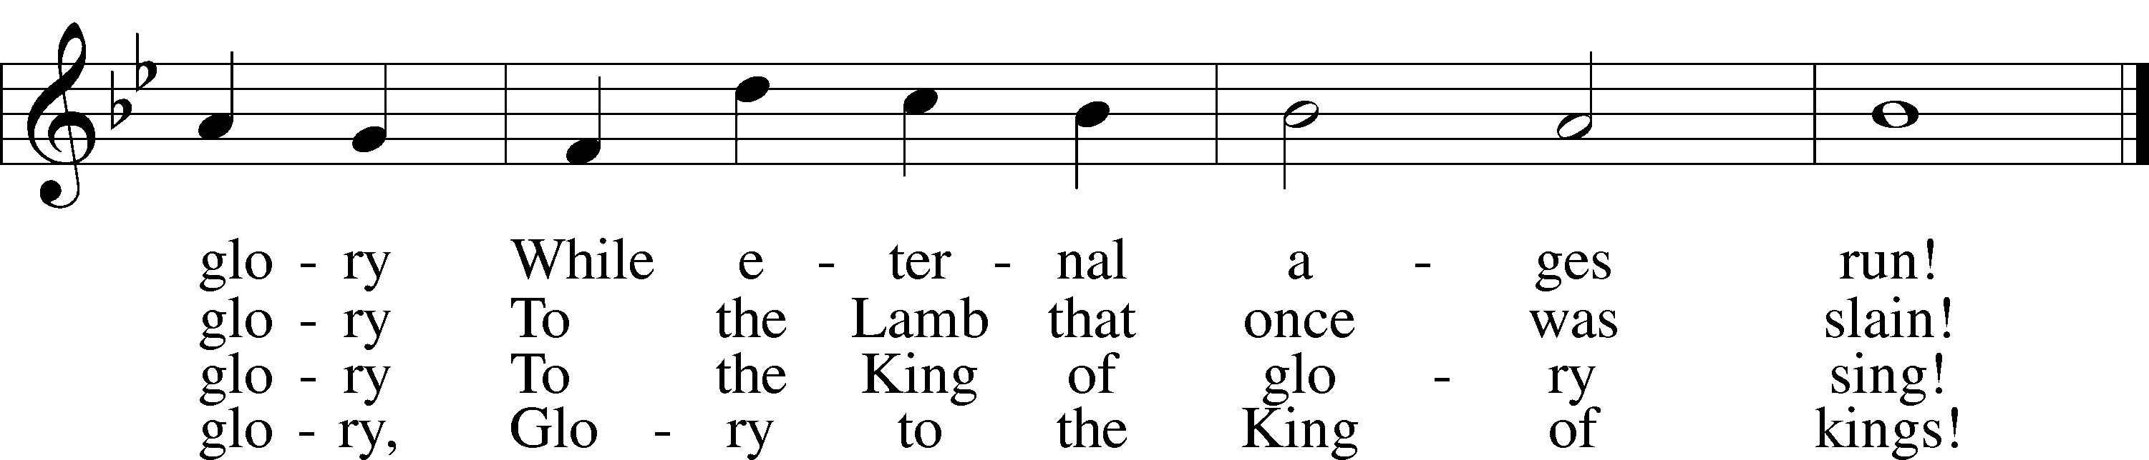
Text: Horatius Bonar, 1808–89
Tune: Walter G. Whinfield, 1865–1919
Text and tune: Public domain

Acknowledgments
Unless otherwise indicated, Scripture quotations are from the ESV® Bible (The Holy Bible, English Standard Version®), copyright © 2001 by Crossway, a publishing ministry of Good News Publishers. Used by permission. All rights reserved.
Created by Lutheran Service Builder © 2025 Concordia Publishing House.

